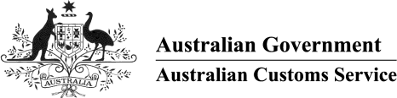

AUSTRALIAN CUSTOMS NOTICE NO. 2003/75

Updates to the Australian Harmonized Export Commodity Classification - 1 January 2004

The Australian Harmonized Export Commodity Classification (AHECC) is compiled by the Australian Bureau of Statistics (ABS) and is based on the six-digit international harmonized system developed by the World Customs Organization (WCO) for describing internationally traded goods.

The AHECC is designed for use by exporters, customs brokers and freight forwarders for the classification of goods when providing export declarations to the Australian Customs Service, and to assist users in the interpretation of export statistics published by the ABS. The classification is normally updated on 1 January and 1 July each year.

The ABS has finalised the changes required for the 1 January 2004 AHECC updates. These changes affect the Introduction, Key of changes, and some codes in Chapters 02, 08 and 99.

The 1 January 2004 updates will be available from the ABS website, from 12 December 2003, free of charge. Copies of the entire AHECC and previous AHECC updates will also be available from the web site at the same time, free of charge. In addition, a completely updated web-readable version of the AHECC will be available.

To access these documents, go to the ABS website [www.abs.gov.au](http://www.abs.gov.au/) then select Themes, International Trade, AHECC. To download the current or previous AHECC replacement pages, follow the links under the heading 'AHECC replacement pages'. If a complete AHECC is required, follow the link 'AHECC January 2004 issue' under 'Complete AHECC'.

Queries about this ACN should be directed to the Classifications Manager at the ABS on

(02) 6252 5409 or by email to [international.trade@abs.gov.au](mailto:international.trade@abs.gov.au)

Phil Burns National Director Cargo & Trade

For Chief Executive Officer December 2003

E:\ACN0375.doc