AUSTRALIAN CUSTOMS NOTICE NO. 2004/60

Export reporting for excisable and like customable goods in the Integrated Cargo System

The purpose of this Australian Customs Notice is to advise exporters of excisable and “like customable” goods of new requirements in reporting the export of these goods in the Integrated Cargo System (ICS). Like customable goods are excise equivalent goods that have been imported.

New Export Permission for Excisable Goods

On 29 June 2004, the *Excise and Other Legislation Amendment (Compliance Measures) Act 2004* came into effect, which introduces new compliance measures on the export of excisable goods. One of the new compliance measures is that from 30 December 2004 exporters of underbond excisable goods must obtain an export movement permission from the Australian Taxation Office (ATO) before they arrange for the goods to be moved to a place of export.

To assist the ATO in ensuring that underbond excisable goods have the appropriate export movement permission, all export declarations lodged through the ICS for excisable goods will need to have either a permission number or the appropriate Customs code for duty paid goods. All goods subject to excise must show their origin as being Australian.

Imported goods do not require a permission number in the ICS, unless they have been transferred to the excise regime at the time of importation (i.e. goods entered under item 44 of schedule 4 of the Customs Tariff).

An example of how the permission number is entered is shown on page 3 of this notice.

Exports of duty paid Australian origin products falling to the same classification as excisable goods, do not require an export movement permission from the ATO, however the appropriate code will need to be entered for excise paid goods as shown on page 3 of this notice. Exporters using this code may be asked to demonstrate that the duty has been paid on these goods upon request.

If you are an exporter of excisable goods, and have not yet applied to the ATO for an export permission, you should contact 1300657162 or go to [www.ato.gov.au](http://www.ato.gov.au/) for further information. Note, however that the Tax Office (including Excise) will be closed between 24 December 2004 and 3 January 2005.

Introduction of an Indicator for Prescribed Warehouse Goods

The introduction of the ICS also included the introduction of new reporting requirements for certain excisable and “like customable goods” known as prescribed warehouse goods. These goods are primarily tobacco and alcoholic spirits, and are listed in schedule 1AAA of the Customs Regulations.

A new indicator is to be introduced into the ICS from 9 January 2005, to properly identify these goods to ensure that appropriate warehouse and depot reporting is undertaken prior to export. The new field is referred to as the Prescribed Goods Indicator (PGI).



With the introduction of the PGI field, the function of the existing Customable/Excisable goods indicator field has been changed. Since the introduction of the ICS, exporters have been requested to identify only prescribed warehouse goods in the Customable/ Excisable Indicator field, rather than all Customable/Excisable goods. As from 9 January, all Customable and Excisable Goods should be again be flagged by using a “Y” in this field.

Inquiries concerning this notice may be directed to Export Policy on telephone number (02) 6275 6893 or email [export.policy.act@customs.gov.au.](mailto:export.policy.act@customs.gov.au)

Philomena Carnell National Manager Cargo Branch CANBERRA ACT

16 December 2004

**New PGI Field and Movement Permission**

Below is an example of the Customs Interactive screen showing the new Prescribed Goods Indicator field, used to identify prescribed warehouse goods from January 9 2005. Private EDI software design may differ.

Also shown is the method for entering an export movement permission for excisable goods from 30/12/04. The permit details are required for each line of excisable goods entered.

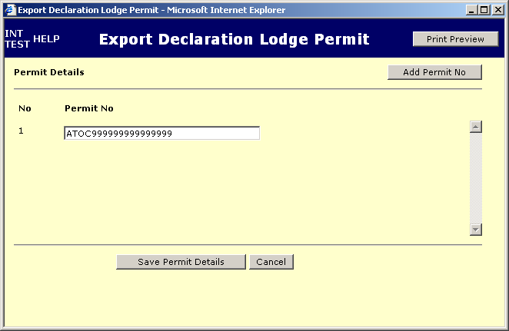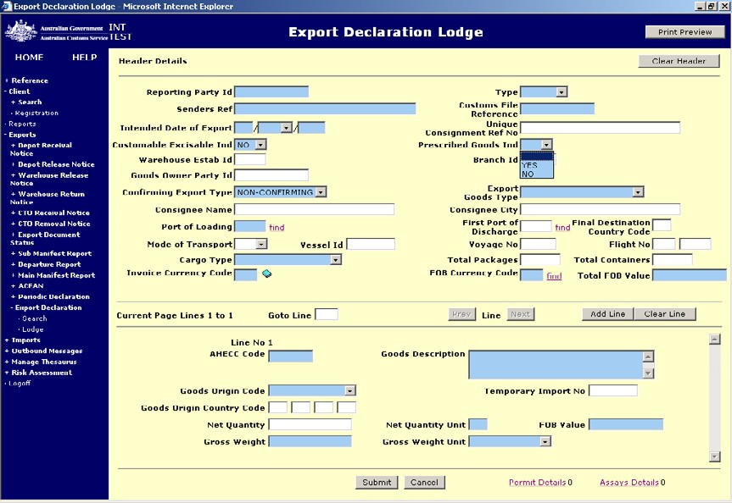

NOTE: For Excise Paid Goods, the Code “ATOCEXPAID” should be entered in place of a permission Number.