AUSTRALIAN CUSTOMS NOTICE NO. 2007/23

# Notices of Objection to Importation Trade Marks Act 1995

The *Trade Marks Act 1995* allows the registered owner, or in certain circumstances, the authorised user of a trade mark to lodge a Notice of Objection with the Australian Customs Service (Customs), objecting to the importation of goods which infringe their trade mark. Unless revoked, a Notice of Objection remains in force for a period of four years (effective 23 October 2006) from the date of commencement.

The attached Schedule sets out the registered owners and authorised users who have lodged Notices of Objection under the *Trade Marks Act 1995* since January 2007 (ACN 2007/06)*.* Descriptions of the relevant trade marks are also set out in the Schedule.

A detailed list of all current Notices of Objection is available on the Customs website at <http://www.customs.gov.au/site/page.cfm?u=493>

For each particular trade mark described, the Schedule makes reference to a particular “class” of goods. This refers to the classes of goods prescribed in Schedule 1 to the *Trade Marks Regulations 1995* and along with a description of the goods, is used to describe the type of goods for which the particular trade mark is registered. Prospective importers of such goods should seek further advice from Customs regarding the ambit of any Notice of Objection set out in the Schedule.

Goods referred to in this ACN, that are manufactured outside and imported into Australia, and are subject to the control of Customs under the meaning of the *Customs Act 1901* are liable to be seized by Customs if:

* they have applied to them, or in relation to them, a sign that is substantially identical with, or deceptively similar to, a trade mark listed in the attached Schedule; and
* are goods in respect of which the notified trade mark is registered;

unless it can be established that the goods do not infringe the relevant trade mark.

Part 12 of the *Trade Marks Act 1995* details the circumstances in which the use of a trade mark may, or may not, amount to an infringement. For example, a trade mark is not infringed where the mark in question has been applied to, or in relation to, goods with the consent of the registered owner of the trade mark.

However, where the trade mark is applied by, or with the consent of, an overseas owner of the trade mark and the goods are imported into Australia without the consent of the Australian trade mark owner, this may still represent an infringement.

People who are intending to import goods that potentially may be liable to seizure under the provisions of the *Trade Marks Act 1995* should consider seeking advice from Customs, or a suitably qualified legal practitioner, as to the implications of the trade marks legislation, and the meaning of terms such as "substantially identical with", "deceptively similar to" and "an infringement of" a trade mark.

Where a registered trade mark owner or an authorised user with a current Notice of Objection in place request additional trade marks to be added to their Notice, only the additional trade marks are included at the end of this ACN. The inclusion of additional trade marks in the ACN is to ensure that ACN subscribers have all the appropriate up-to-date information.

Copies of the relevant Notices of Objection have been forwarded to the Customs office in the capital city of each State and Territory. Importers, or their advisers, who require further information regarding the Notices of Objection, or Customs role in respect of those Notices, should contact the Customs Information and Support Centre on 1300 363 263 or the Intellectual Property Rights Group on (02) 6275 6577.

John Potter

A/g National Manager

Trade Policy & Regulation Branch CANBERRA ACT

May 2007



**SCHEDULE TO ACN NO. 2007/23 TRADE MARK NOTICES OF OBJECTION**

***ABN International Pty Ltd ABN International Pty Ltd***

***Ph: 0411 198 222/0411 724 433***

***Effective Date: 27 March 2007 File Reference: C07/04182 Trade Marks Class Goods***

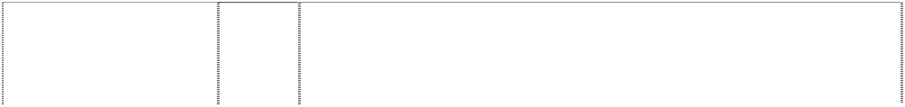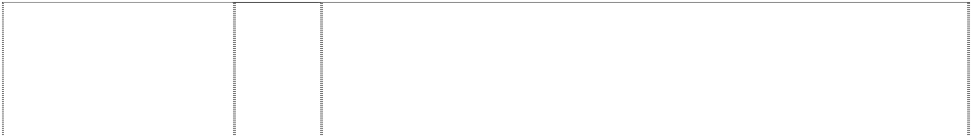

# AMINO OK

(1108653)

# GREEN TEA

japanese character atop thai character (1102198)

# OISHI GREEN TEA

japanese char. in disc; thai chars atop ltr g; leaves behind

(1102196)

japanese character in disc

(1102197)

japanese character in disc

(1102197)

32 Mineral and aerated waters and other non-alcoholic drinks; fruit drinks and fruit juices.

32 Mineral and aerated waters and other non-alcoholic drinks.

32 Minerals and aerated waters and other non-alcoholic drinks.

30 Coffee, tea, cocoa, sugar, rice, tapioca, sago, artificial coffee; flour and preparations made from cereals.

32 Mineral and aerated waters and other non-alcoholic drinks; fruit drinks and fruit juice.

***adidas Australia Pty Ltd adidas Australia Pty Ltd Ph: (03) 9263 5299***

***Effective Date: 23 February 2007 File Reference: C07/02791 Trade Marks Class Goods***



# ADICOLOR

(384642)

# ADICOURT

(283535)

# ADIDAS

(415160)

# ADIDAS

(579762)

# adidas

(711213)

# ADIDAS

(635121)

# ADIDAS

(226119)

# ADIDAS

(226123)

25 Shoes, in particular, sport and leisure shoes; insoles, spikes and cleats for sports shoes, articles of clothing (including woven and knitted articles), especially sportswear.

25 All goods included in this class including garments and footwear for sportsmen, particularly athletes.

3 All goods in this class, including soaps, perfumery, essential oils, cosmetics, hair and body lotions, dentrifices and deodorants.

9 Spectacle cases, spectacle frames, optical lenses, sunglasses; all other goods in this class.

9 Computer and video games included in class 9; computer software for games and electronic apparatus for games, including video games, included in class 9.

14 Watches, all other goods in this class.

18 Bags included in this class.

25 Garments for sportsmen.

# ADIDAS

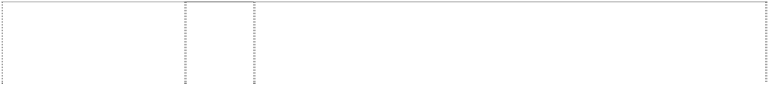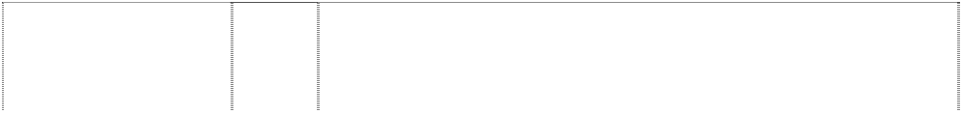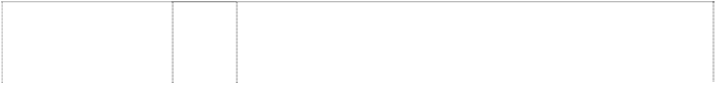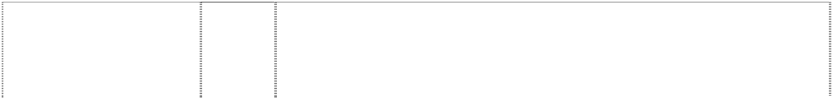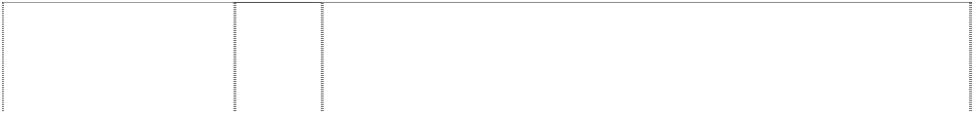

(342352)

# ADIDAS

(245702)

# adidas

(711213)

# ADIDAS

(288402)

# ADIDAS

(376664)

# ADIDAS

(904088)

# ADIDAS EQUIPMENT

3 trapeziums are striped triangle,irreg (543684)

# ADIDAS EQUIPMENT

3 trapeziums are striped triangle,irreg (543685)

# ADIDAS EQUIPMENT

3 trapeziums are striped triangle,irreg (543686)

# ADIDAS EQUIPMENT

3 trapeziums form striped triangle,irreg (635119)

# ADIDAS EQUIPMENT

3 trapeziums form striped triangle,irreg (579763)

# adidas the brand with the 3 stripes (120987)

**ADIDAS TORSION**

three stripes,curved forming text (496043)

# ADILETTE

(352330)

# ADIPRENE ; adiprene

(675928)

# ADIPROMED

(493950)

# ADISTAR

(287746)

# ADI-WEAR

(702465)

# PREDATOR

(617805)

1. All goods in this class including articles of clothing (footwear included), for sportswear and for leisure wear.
2. Miniature sports shoes.

28 Computer and video games included in class 28.

28 Sporting equipment including tennis racquets, ice and roller skates, skis and skiing equipment, balls of all kinds; and all other goods in this class.

28 All goods included in class 28, including sports equipment in general, in particular balls of every kind, racquets for tennis, squash or shuttlecock, ice- and roller-skates, ski and ski equipment, golf tees, toys, games.

32 Mineral and aerated waters and other non-alcoholic drinks; fruit drinks; syrups and other preparations for making beverages.

18 All goods in this class.

28 All goods in this class.

25 All goods in this class.

14 Watches, all other goods in this class.

9 Spectacle cases, spectacle frames, optical lenses, sunglasses; all other goods in this class.

25 Sports shoes, special sports shoes, more particularly football boots, runners, training shoes, and ice hockey boots and other sporting footwear included in this class.

25 Shoes, especially sport and leisure shoes.

25 All goods in this class including footwear in this class.

25 Footwear, including shoes.

25 Clothing, footwear, headgear; all goods in this class.

25 Articles of clothing and footwear including sport shoes.

25 Clothing including athletes, clothing and sports clothing; footwear including sports shoes, sports boots and leisure shoes; headgear.

25 Footwear for sport.

**SPIRIT OF THE GAMES** (399532)

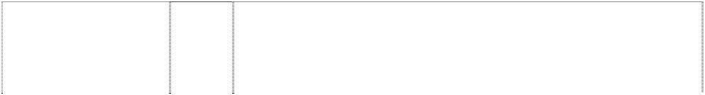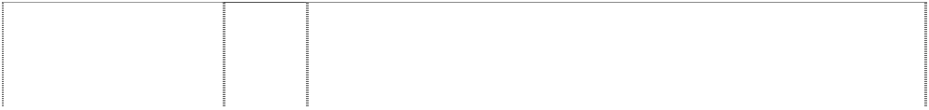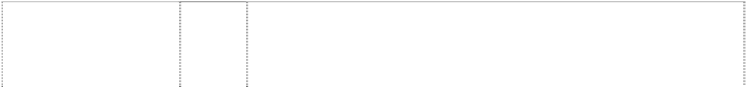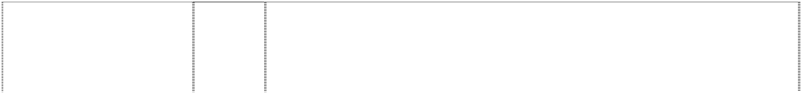

**SPIRIT OF THE GAMES** (399533)

**SPIRIT OF THE GAMES** (399534)

# STREETBALL

(649929)

# STREETBALL

(609354)

# STREETBALL

(609355)

# STREETBALL

(609356)

# TORSION

(488985)

# TRAXION

(700916)

*description of mark* 3 oblique stipes on shoe

(924921)

*description of mark* 3 stripes on clothing, shirt

(386758)

*description of mark* 3 vertical stripes on trousers

(1103709)

*Description of mark* shoe with stripes (131325)

*description of mark* stripes, curved, 3 across sole of shoe

(540524)

*description of mark* stripes three on clothing

(329409)

*description of mark* three stripes on clothing

(273337)

*description of mark* stripes three (276245)

18 Bags, travelling bags, sporting bags, trunks.

25 Articles of clothing (including woven and knitted ones), especially for the use as sports- and leisure wear, stockings, gloves, caps, hats, training suits, shorts, T-shirts, sweat-shirts, tights, tennis dresses, warm-up-suits; footwear, in particular sport and leisure shoes, insoles, spikes and cleats for sport shoes.

28 Sporting equipment, in particular balls of every kind, racquets for tennis and squash, miniature shoes, miniature balls.

14 Watches, clocks and horological instruments.

18 Bags, sportsbags, rucksacks, linings of leather for shoes; all other goods in this class.

25 Clothing, footwear, headgear, sportsclothes; sports shoes; all other goods in this class.

28 Bats, racquets, sporting equipment in this class, gloves in this class, cricket bags, balls, basketball backboards; all other goods in this class.

25 Footwear.

25 Footwear, including sports shoes and sports boots.

25 Footwear, including sport shoes and casual shoes.

25 Sportswear in the nature of shirts, jackets and pullovers.

25 Trousers, in particular sports trousers and casual trousers, including shorts.

25 Sports shoes, specials sports shoes, more particularly football boots, runners, training shoes and other sporting footwear in this class.

25 Footwear in class 25 including sports shoes, runners, training shoes, football boots; all other goods in this class.

25 Sportswear in the nature of jackets, shirts, trousers, skirts and combinations thereof.

25 Sportswear in the nature of jackets and trousers and jackets and trouser combinations.

25 Sportswear in the nature of shirts, jackets and pullovers.

3 leaves, grot with 3 horiz stripes (635117)

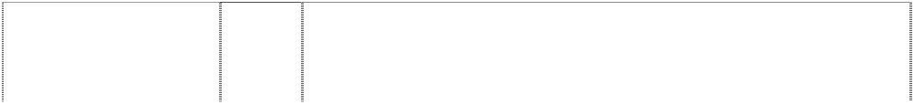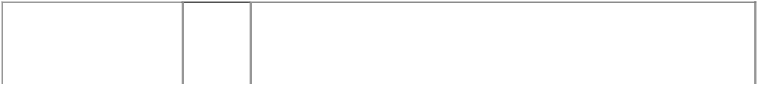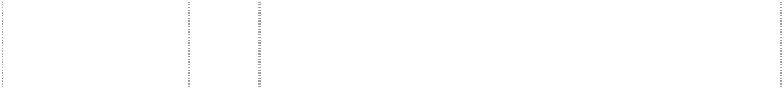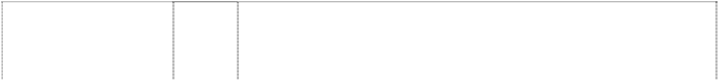

3 leaves with 3 stripes in fan shape

(579761)

3 trapeziums are striped triangle, irregular

(638734)

leaves,three stripes,horizontal, three trefoil

(415159)

leaves,three stripes,horizontal, three trefoil

(254757)

leaves, three stripes, horizontal, three trefoil (254755)

leaves,three stripes,horizontal, three trefoil

(254756)

stripes three on clothing (276250)

stripes three on clothing (276251)

14 Watches, all other goods in this class.

9 Spectacle cases, spectacle frames, optical lenses, sunglasses; all other goods in this class.

25 Clothing, footwear and headgear.

3 All goods in this class, including soaps, perfumery, essential oils, cosmetics, hair and body lotions, dentrifices and deodorants.

18 Travelling bags.

25 Sportswear, in particular athletic shoes, casual shoes, training shoes.

28 Sporting articles.

25 Sportswear in the nature of pants, shorts and tights.

25 Sportswear in the nature of shirts, jackets and pullovers.

***Australian Football League Middletons***

***Ph: (03) 9205 2000***

***Effective Date: 18 April 2007 File Reference: C07/06590 Trade Marks Class Goods***

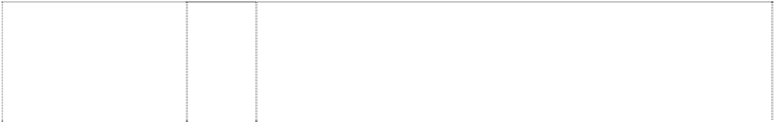

# ADELAIDE CROWS A

bird,crow & football in shield on shiled,divided

(546613)

# ADELAIDE CROWS A

bird,crow & football in shield on shiled,divided

(546614)

# ADELAIDE CROWS A

bird,crow & football in shield on shiled,divided

(546615)

16 Paper, cardboard, goods made from paper and cardboard not included in other classes, books, magazines, newspapers, pamphlets, printed matter, photographs, albums, posters, stationery, programs, writing instruments, diaries, office requisites expect furniture, instructional and teaching material expect apparatus, playing cards, and all other goods in class 16.

25 Clothing, underwear, underpants, shirts, T-shirts, shorts, pants, trousers, jeans, knitwear, jumpers, cardigans, sweatshirts, neckwear, neckties, jackets, blazers, suits, coats, scarves, rainwear, swimwear, sleepwear, pyjamas, nightshirts, dressing gowns, headwear, hats, caps, socks, stockings, hosiery, footwear, shoes, boots, slippers and all other goods in class 25.

28 Football and other sporting articles in class 28; exercise and physical training apparatus and articles; balls for games and sport; games and playthings; toys, dolls and all other goods in class 28.

# AFL



(707792)

# AFL

(707792)

# AFL

(707792)

# AFL

(707792)

3 Preparations and substances for laundry use; stain removers; cleaning, polishing, scouring and abrasive preparations; personal care products and personal cleaning products including cleansing creams and lotions; soaps, perfumed soaps; perfumes, perfumery, non-medicated skin products and preparations including body lotions, body creams and moisturizers; personal deodorants and anti- perspirants; suntan preparations; shaving preparations, shaving soaps and after-shave preparations; beauty care products and preparations, eye shadows; non-medicated toiletries, talcum powder for toilet use, bath articles in class 3; cosmetics and cosmetic preparations and substances; essential oils; hair care products, hair lotions, hair shampoos; dentifrices, and preparations for cleaning dentures.

9 Electric, photographic, cinematographic, video, optical, measuring, signalling and teaching apparatus and instruments; apparatus and instruments for recording and/or transmission and/or reproduction of sound/images; automatic vending machines, data processing equipment and computer apparatus and instruments; computer operating programs, computer programs, computer software and video game software; magnetic data carriers; audio, video, computer and laser tapes, discs, compact discs, cassettes and cartridges; pre- recorded audio, video, computer and laser tapes, discs, compact discs, cassettes and cartridges; video games and computer game tapes, discs, compact discs, cassettes and cartridges; games in class 9, coin operated games, coin freed games; video games and computer games for playing in game arcades and game playing venues; electronic video arcade game machines, games for use with television receivers and/or computer monitors and/or other separate display apparatus; parts, fittings and accessories in class 9 for the aforesaid goods.

14 Jewellery, costume jewellery, trinkets, horological instruments, chronometric instruments, sundials, clocks, watches, watch bands, watch straps, watch chains, cuff links, tie clips, tie pins, ornamental pins, earrings, jewellery bracelets, jewellery brooches, jewellery medallions, jewellery necklaces, jewellery rings, jewellery pendants, jewellery buckles, jewellery ornaments, jewellery chains, key chains, key ring trinkets, key ring fobs, medals, coins; goods of precious metal or coated therewith namely badges, boxes, cases, containers and household utensils; and parts, fittings and accessories in class 14 for the aforesaid goods.

16 Paper, cardboard, goods in class 16 made from paper and/or cardboard; wrapping paper, paper flags, paper pennants, paper bibs, paper placemats, paper napkins, paper coasters, cardboard coasters, printed matter, printed publications, books, magazines, newspapers, activity books, statistical books, guide books, reference books, newsletters, pamphlets, printed programs, printed entertainment programs, printed game programs, printed fixtures; printed matter for the radio, television and print media; stationery, exercise books, diaries, calendars, memo pads, folders, note books multi-ring binders, book covers, portfolios, printed statistics sheets, writing instruments, ball point pens, pencils, office requisites except furniture, drawing rulers, erasers, instructional and teaching materials except apparatus, cards, playing cards, trading cards, sports trading cards, football trading cards, dance team trading cards, mascot trading cards, entertainment trading cards, post cards, greeting cards, note cards, stamps, sports stamps, football stamps, posters, stickers, bumper stickers, decalcomanias, albums, scrap books, autograph books, photographs, mounted photographs, line art colouring boards, non-textile labels, tickets and control tokens.

# AFL



(707792)

# AFL

(707792)

# AFL

(707792)

# AFL

(707792)

# AFL

(707792)

# AFL

(707792)

18 Leather and imitations of leather; goods in class 18 made of leather and imitations of leather; pelts, hides, animal skins and fur skins; trunks, travelling trunks, cases, suitcases, brief cases, valises, haversacks, rucksacks, school satchels; vanity cases (not fitted) bags, game bags, travelling bags, bags for campers, bags for climbers, handbags, sling bags for carrying infants, garment bags used when travelling; purses, wallets, key cases; umbrellas, walking sticks; whips, harness and saddlery, parts, fittings and accessories in class 18 for all the aforesaid goods.

1. Furniture, office furniture and school furniture; massage tables, mirrors, picture frames; works of art, figures, stuffed animals; air cushions, air pillows (not for medical purposes); signboards in class 20, display boards, display stands and show cases; flag poles; non- metal registration plates and non-metal nameplates.
2. Household or kitchen utensils and containers (not of precious metal or coated therewith) combs, sponges and brushes (except paint brushes); brush-making materials; articles for cleaning purposes including abrasive pads for kitchen purposes, scouring pads of metal; steelwool; glassware, porcelain and earthenware not included in other classes; cooking utensils in class 21 including griddles, grills, pans, pressure cookers, saucepans and waffle irons; figurines and statuettes; works of art made of porcelain, terra-cotta or glass; insulating and other holders for bottles and for cans, cooling devices containing heat-exchange fluids and other refreezable packs; vacuum bottles, heat insulated beverage and food containers, refrigerating bottles; drinking vessels including cups and mugs (not of precious metal) drinking flasks.
3. Textiles and textile goods in class 24 including flags, banners, bath linen (except clothing), textile wall hangings, non-woven textile fabrics, bunting, household linen, brocades; textile blinds; loose furniture covers; plastic coverings for furniture; handkerchiefs; bed covers including quilts, blankets, eiderdowns, sheets, pillowcases, mattress covers and protectors, padded quilts, travelling rugs; table covers including textile table napkins and serviettes, textile table linen, textile table mats and coasters, table runners.
4. Clothing, leisure wear, sportswear, uniforms, babywear, underwear, underpants, boxer shorts, singlets, leotards, shirts, sports shirts, blouses, T-shirts, sweatshirts, tank tops, polo shirts, skivvies, rugby tops, grandpa tops, shorts, board shorts, tracksuits, warm-up suits, pants, warm-up pants, sweat pants, trousers, jeans, dresses, skirts, clothing belts, knitwear, jumpers, sweaters, guernseys, jerseys, cardigans, vests, neckwear, cravats, neckties, scarves, jackets, bomber jackets, blazers, formal wear, suits, coats, parkas, anoraks, rainwear, raincoats, swimsuits, sleepwear, pyjamas, nightshirts, night gowns, dressing gowns, bath robes, cloth bibs, aprons, gloves, mittens, headwear, hats, caps, berets, beanies, ear muffs, clothing hoods, visors, headbands, wristbands, socks, stockings, hosiery, footwear, shoes, boots, sandals and slippers.

27 Carpets, automobile carpets; rugs, mats, bath mats, door mats, gymnasium mats, gymnastic mats, non-slip mats, reed mats, matting, linoleum and other materials for covering existing floors, floor coverings including insulating floor coverings; wallpaper, non- textile wall hangings and tapestries; artificial turf.

# AFL



(707792)

# AFL

(707792)

# AFL

(707792)

# AFL

(707792)

# AFL

(707792)

# AFL

bird,cartoon,footballer with ball

(962188)

1. Games, playthings, sporting goods in class 28, balls for games, playballs, rubber action balls, foam action balls, balls for sports, golf balls, footballs, toy footballs, miniature footballs, pumps for inflating sporting balls, needles for such pumps, sports gloves, football gloves, golf gloves, golf bags, golf tees, exercise and physical training apparatus and articles, toys, toy vehicles, toy cards, dolls, jigsaw puzzles, board games; self contained apparatus and instruments for playing games including mechanical games, electronic games, computerised games, battery operated games, games that are portable, games that include a built-in display, games that include a built-in program, games that receive one or more programs; hand held portable self contained apparatus and instruments for playing games; parts, fittings and accessories in class 28 for the aforesaid goods; but excluding games that are adapted or intended for use with a separate television or computer monitor or other separate display apparatus and also excluding games that are coin and/or counter freed or coin and/or counter operated.
2. Meat, meat extracts, meat gravies, meat jellies, preserved meat, fish, fish fillets, preserved fish, foods prepared from fish, herrings and sardines, crayfish and lobsters (not live), shellfish including oysters and prawns (not live-; poultry and game (not live); preserved, dried and cooked fruits and vegetables including frozen and frosted fruits, fruit chips;-fruit peel, preserved fruit in alcohol, stewed fruit; fruit pulp, fruit salads and vegetables salads; jellies, jams, fruit sauces, eggs, powdered eggs, egg whites, milk, milk products including cream, cheese, butters, margarines, yoghurt; edible oils, coconut oil, corn oil, rape oil, sunflower oil, palm oil; edible fats, pastes and pates; pickles, bouillon and bouillon concentrates, caviar, potato chips and potato crisps.
3. Coffee, artificial coffee, coffee subsitutes and coffee-based beverages, tea, cocoa, and cocoa-based beverages, sugar and natural sweeteners, tapioca, sago; flour, flour-mill products and preparations made from cereals; bread, bread rolls, buns, cakes, biscuits, cookies, pasta, pancakes, waffles, meat pies, pasties, pastry, pastry tarts and confectionery, chocolate, golden syrup, honey, treacle; yeast, baking powder; salt, mustard, vinegar, sauces (condiments), seasonings, spices; ice; sherbert, sorbets, ice creams, pralines, salad dressings, malt and molasses for food; sandwiches.

32 Beers, malt beer, ginger beer, non-alcoholic beverages, non-alcholic fruit extracts, non-alcoholic fruit juice beverages, fruit juices, preparations for making mineral water, mineral water, aerated water, table water, water beverages; syrups, essences and other preparations in class 32 for making beverages.

34 Tobacco, products containing tobacco, cigarettes, cigarillos, cigars; cases and holders (not of precious metal) for tobacco products including jars and pouches; cigarette paper, cigar cutters; matches and lighters for smokers, tobacco pipes, cigarette holders not of precious metal, mouth pieces for cigarette holders, match boxes and match holders (not of precious metal), tobacco pipe cleaners, tobacco pipe packs; ashtrays not of precious metal, smokers sets, firestones.

9 Scientific, nautical, surveying, photographic, cinematographic, optical, weighing, measuring, signalling, checking (supervision), life- saving and teaching apparatus and instruments; apparatus and instruments for conducting, switching, transforming, accumulating, regulating or controlling electricity; apparatus for recording, transmission or reproduction of sound or images; magnetic data carriers, recording discs; automatic vending machines and mechanisms for coin-operated apparatus; cash registers, calculating machines, data processing equipment and computers; fire- extinguishing apparatus.

# AFL

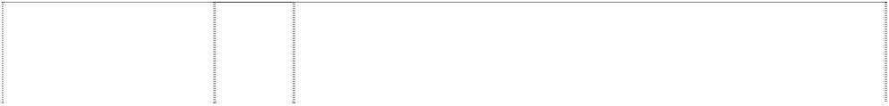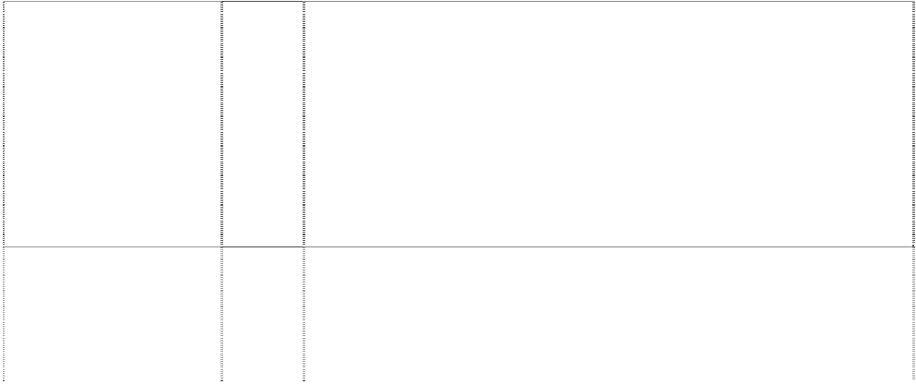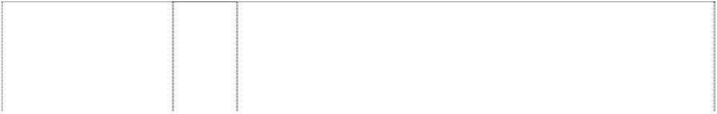

bird,cartoon,footballer with ball

(962188)

# AFL

bird,cartoon,footballer with ball

(962188)

# AFL

bird,cartoon,footballer with ball

(962188)

# AFL

bird,cartoon,footballer with ball

(962188)

# AFL

bird,cartoon,footballer with ball

(962188)

# AFL

cat,cartoon, footballer stands on ball wears striped shirt

(962298)

# AFL

cat,cartoon, footballer stands on ball wears striped shirt

(962298)

# AFL

cat,cartoon, footballer stands on ball wears striped shirt

(962298)

# AFL

cat,cartoon, footballer stands on ball wears striped shirt

(962298)

# AFL

cat,cartoon, footballer stands on ball wears striped shirt

(962298)

14 Precious metals and their alloys and goods in precious metals or coated therewith, not included in other classes; jewellery, precious stones; horological and chronometric instruments.

16 Paper, cardboard and goods made from these materials, not included in other classes; printed matter; bookbinding material; photographs; stationery; adhesives for stationery or household purposes; artists’ materials; paint brushes; typewriters and office requisites (except furniture); instructional and teaching material (except apparatus); plastic materials for packaging (not included in other classes); printers’ type; printing blocks.

21 Household or kitchen utensils and containers (not of precious metal or coated therewith); combs and sponges; brushes (except paint brushes); brush-making materials; articles for cleaning purposes; steelwool; unworked or semi-worked glass (except glass used in building); glassware, porcelain and earthenware not included in other classes.

25 Clothing, footwear, headgear.

28 Games and playthings; gymnastic and sporting articles not included in other classes; decorations for Christmas trees.

9 Scientific, nautical, surveying, photographic, cinematographic, optical, weighing, measuring, signalling, checking (supervision), life- saving and teaching apparatus and instruments; apparatus and instruments for conducting, switching, transforming, accumulating, regulating or controlling electricity; apparatus for recording, transmission or reproduction of sound or images; magnetic data carriers, recording discs; automatic vending machines and mechanisms for coin-operated apparatus; cash registers, calculating machines, data processing equipment and computers; fire extinguishing apparatus.

14 Precious metals and their alloys and goods in precious metals or coated therewith, not included in other classes; jewellery, precious stones; horological and chronometric instruments.

16 Paper, cardboard and goods made from these materials, not included in other classes; printed matter; bookbinding material; photographs; stationery; adhesives for stationery or household purposes; artists’ materials; paint brushes; typewriters and office requisites (except furniture); instructional and teaching material (except apparatus); plastic materials for packaging (not included in other classes); printers’ type; printing blocks.

21 Household or kitchen utensils and containers (not of precious metal or coated therewith); combs and sponges; brushes (except paint brushes); brush-making materials; articles for cleaning purposes; steelwool; unworked or semi-worked glass (except glass used in building); glassware, porcelain and earthenware not included in other classes.

25 Clothing, footwear, headgear.

# AFL

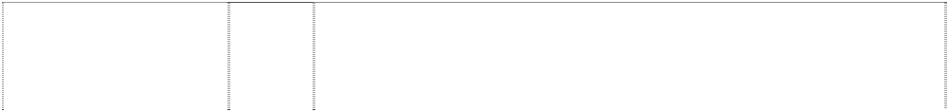

cat,cartoon, footballer stands on ball wears striped shirt

(962298)

# AFL

eagle,bird,cartoon, footballer (962189)

# AFL

eagle,bird,cartoon, footballer (962189)

# AFL

eagle,bird,cartoon, footballer (962189)

# AFL

eagle,bird,cartoon, footballer (962189)

# AFL

eagle,bird,cartoon, footballer (962189)

# AFL

eagle,bird,cartoon, footballer (962189)

# AFL

eagle,cartoon wears sunglasses is footballer; 3 footballs in nest beside

(963642)

# AFL

eagle,cartoon wears sunglasses is footballer; 3 footballs in nest beside

(963642)

28 Games and playthings; gymnastic and sporting articles not included in other classes; decorations for Christmas trees.

9 Scientific, nautical, surveying, photographic, cinematographic, optical, weighing, measuring, signalling, checking (supervision), life- saving and teaching apparatus and instruments; apparatus and instruments for conducting, switching, transforming, accumulating, regulating or controlling electricity; apparatus for recording, transmission or reproduction of sound or images; magnetic data carriers, recording discs; automatic vending machines and mechanisms for coin-operated apparatus; cash registers, calculating machines, data processing equipment and computers; fire extinguishing apparatus.

14 Precious metals and their alloys and goods in precious metals or coated therewith, not included in other classes; jewellery, precious stones; horological and chronometric instruments.

16 Paper, cardboard and goods made from these materials, not included in other classes; printed matter; bookbinding material; photographs; stationery; adhesives for stationery or household purposes; artists’ materials; paint brushes; typewriters and office requisites (except furniture); instructional and teaching material (except apparatus); plastic materials for packaging (not included in other classes); printers’ type; printing blocks.

21 Household or kitchen utensils and containers (not of precious metal or coated therewith); combs and sponges; brushes (except paint brushes); brush-making materials; articles for cleaning purposes; steelwool; unworked or semi-worked glass (except glass used in building); glassware, porcelain and earthenware not included in other classes.

25 Clothing, footwear, headgear.

28 Games and playthings; gymnastic and sporting articles not included in other classes; decorations for Christmas trees.

9 Scientific, nautical, surveying, photographic, cinematographic, optical, weighing, measuring, signalling, checking (supervision), life- saving and teaching apparatus and instruments; apparatus and instruments for conducting, switching, transforming, accumulating, regulating or controlling electricity; apparatus for recording, transmission or reproduction of sound or images; magnetic data carriers, recording discs; automatic vending machines and mechanisms for coin-operated apparatus; cash registers, calculating machines, data processing equipment and computers; fire extinguishing apparatus.

14 Precious metals and their alloys and goods in precious metals or coated therewith, not included in other classes; jewellery, precious stones; horological and chronometric instruments.

# AFL

eagle,cartoon wears sunglasses is footballer; 3 footballs in nest beside

(963642)

# AFL

eagle,cartoon wears sunglasses is footballer; 3 footballs in nest beside

(963642)

# AFL

eagle,cartoon wears sunglasses is footballer; 3 footballs in nest beside

(963642)

# AFL

eagle,cartoon wears sunglasses is footballer; 3 footballs in nest beside

(963642)

# AFL

footballer,cartoon is devil holds trident with ball,football

(962193)

# AFL

footballer,cartoon is devil holds trident with ball,football

(962193)

16 Paper, cardboard and goods made from these materials, not included in other classes; printed matter; bookbinding material; photographs; stationery; adhesives for stationery or household purposes; artists’ materials; paint brushes; typewriters and office requisites (except furniture); instructional and teaching material (except apparatus); plastic materials for packaging (not included in other classes); printers’ type; printing blocks.

21 Household or kitchen utensils and containers (not of precious metal or coated therewith); combs and sponges; brushes (except paint brushes); brush-making materials; articles for cleaning purposes; steel wool; unworked or semi-worked glass (except glass used in building); glassware, porcelain and earthenware not included in other classes.

25 Clothing, footwear, headgear.

28 Games and playthings; gymnastic and sporting articles not included in other classes; decorations for Christmas trees.

9 Scientific, nautical, surveying, photographic, cinematographic, optical, weighing, measuring, signalling, checking (supervision), life- saving and teaching apparatus and instruments; apparatus and instruments for conducting, switching, transforming, accumulating, regulating or controlling electricity; apparatus for recording, transmission or reproduction of sound or images; magnetic data carriers, recording discs; automatic vending machines and mechanisms for coin-operated apparatus; cash registers, calculating machines, data processing equipment and computers; fire extinguishing apparatus.

14 Precious metals and their alloys and goods in precious metals or coated therewith, not included in other classes; jewelleryPaper, cardboard and goods made from these materials, not included in other classes; printed matter; bookbinding material; photographs; stationery; adhesives for stationery or household purposes; artists’ materials; paint brushes; typewriters and office requisites (except furniture); instructional and teaching material (except apparatus); plastic materials for packaging (not included in other classes); printers’ type; printing blocks, precious stones; horological and chronometric instruments.

# AFL

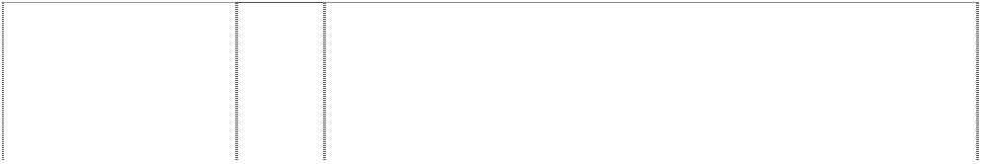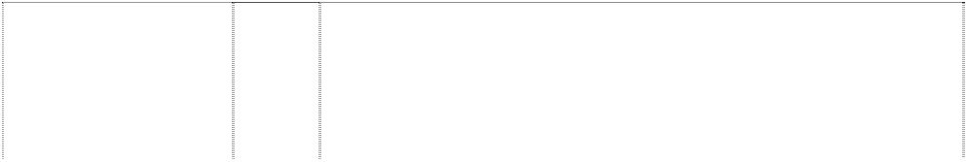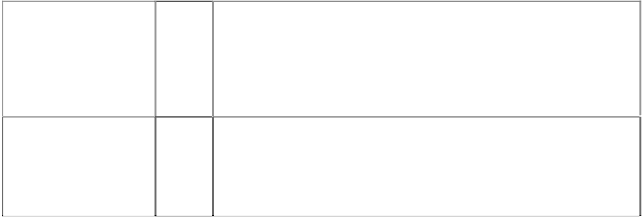

footballer,cartoon is devil holds trident with ball,football

(962193)

# AFL

footballer,cartoon is devil holds trident with ball,football

(962193)

16 Paper, cardboard and goods made from these materials, not included in other classes; printed matter; bookbinding material; photographs; stationery; adhesives for stationery or household purposes; artists’ materials; paint brushes; typewriters and office requisites (except furniture); instructional and teaching material (except apparatus); plastic materials for packaging (not included in other classes); printers’ type; printing blocks.

21 Household or kitchen utensils and containers (not of precious metal or coated therewith); combs and sponges; brushes (except paint brushes); brush-making materials; articles for cleaning purposes; steelwool; unworked or semi-worked glass (except glass used in building); glassware, porcelain and earthenware not included in other classes.

# AFL

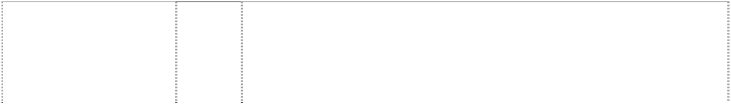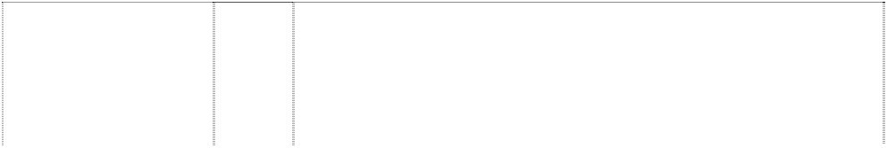

footballer,cartoon is devil holds trident with ball,football

(962193)

# AFL

footballer,cartoon is devil holds trident with ball,football

(962193)

# AFL

hornet,cartoon, standing, clothed wears goggles, scarf & shoes

(962289)

# AFL

hornet,cartoon, standing, clothed wears goggles, scarf & shoes

(962289)

# AFL

hornet,cartoon, standing, clothed wears goggles, scarf & shoes

(962289)

# AFL

hornet,cartoon, standing, clothed wears goggles, scarf & shoes

(962289)

# AFL

hornet,cartoon, standing, clothed wears goggles, scarf & shoes

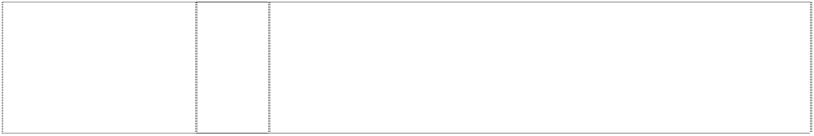(962289)

# AFL

hornet,cartoon, standing, clothed wears goggles, scarf & shoes

(962289)

25 Clothing, footwear, headgear.

28 Games and playthings; gymnastic and sporting articles not included in other classes; decorations for Christmas trees.

9 Scientific, nautical, surveying, photographic, cinematographic, optical, weighing, measuring, signalling, checking (supervision), life- saving and teaching apparatus and instruments; apparatus and instruments for conducting, switching, transforming, accumulating, regulating or controlling electricity; apparatus for recording, transmission or reproduction of sound or images; magnetic data carriers, recording discs; automatic vending machines and mechanisms for coin-operated apparatus; cash registers, calculating machines, data processing equipment and computers; fireextinguishing apparatus.

14 Precious metals and their alloys and goods in precious metals or coated therewith, not included in other classes; jewellery, precious stones; horological and chronometric instruments.

16 Paper, cardboard and goods made from these materials, not included in other classes; printed matter; bookbinding material; photographs; stationery; adhesives for stationery or household purposes; artists’ materials; paint brushes; typewriters and office requisites (except furniture); instructional and teaching material (except apparatus); plastic materials for packaging (not included in other classes); printers’ type; printing blocks.

21 Household or kitchen utensils and containers (not of precious metal or coated therewith); combs and sponges; brushes (except paint brushes); brush-making materials; articles for cleaning purposes; steelwool; unworked or semi-worked glass (except glass used in building); glassware, porcelain and earthenware not included in other classes.

25 Clothing, footwear, headgear.

28 Games and playthings; gymnastic and sporting articles not included in other classes; decorations for Christmas trees.

# AFL

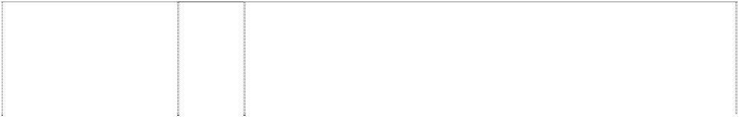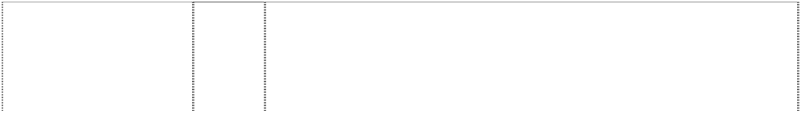

kangaroo,cartoon is boxer wears overalls,striped

(962369)

# AFL

kangaroo,cartoon is boxer wears overalls,striped

(962369)

# AFL

kangaroo,cartoon is boxer wears overalls,striped

(962369)

# AFL

kangaroo,cartoon is boxer wears overalls,striped

(962369)

# AFL

kangaroo,cartoon is boxer wears overalls,striped

(962369)

# AFL

kangaroo,cartoon is boxer wears overalls,striped

(962369)

# AFL

lion,cartoon, standing,clothed wears sunglasses with arm raised & finger pointing

(962175)

# AFL

lion,cartoon, standing,clothed wears sunglasses with arm raised & finger pointing

(962175)

# AFL

lion,cartoon, standing,clothed wears sunglasses with arm raised & finger pointing

(962175)

9 Scientific, nautical, surveying, photographic, cinematographic, optical, weighing, measuring, signalling, checking (supervision), life- saving and teaching apparatus and instruments; apparatus and instruments for conducting, switching, transforming, accumulating, regulating or controlling electricity; apparatus for recording, transmission or reproduction of sound or images; magnetic data carriers, recording discs; automatic vending machines and mechanisms for coin-operated apparatus; cash registers, calculating machines, data processing equipment and computers; fire extinguishing apparatus.

14 Precious metals and their alloys and goods in precious metals or coated therewith, not included in other classes; jewellery, precious stones; horological and chronometric instruments.

16 Paper, cardboard and goods made from these materials, not included in other classes; printed matter; bookbinding material; photographs; stationery; adhesives for stationery or household purposes; artists’ materials; paint brushes; typewriters and office requisites (except furniture); instructional and teaching material (except apparatus); plastic materials for packaging (not included in other classes); printers’ type; printing blocks

21 Household or kitchen utensils and containers (not of precious metal or coated therewith); combs and sponges; brushes (except paint brushes); brush-making materials; articles for cleaning purposes; steelwool; unworked or semi-worked glass (except glass used in building); glassware, porcelain and earthenware not included in other classes.

25 Clothing, footwear, headgear.

28 Games and playthings; gymnastic and sporting articles not included in other classes; decorations for Christmas trees.

9 Scientific, nautical, surveying, photographic, cinematographic, optical, weighing, measuring, signalling, checking (supervision), life- saving and teaching apparatus and instruments; apparatus and instruments for conducting, switching, transforming, accumulating, regulating or controlling electricity; apparatus for recording, transmission or reproduction of sound or images; magnetic data carriers, recording discs; automatic vending machines and mechanisms for coin-operated apparatus; cash registers, calculating machines, data processing equipment and computers; fire extinguishing apparatus.

14 Precious metals and their alloys and goods in precious metals or coated therewith, not included in other classes; jewellery, precious stones; horological and chronometric instruments.

16 Paper, cardboard and goods made from these materials, not included in other classes; printed matter; bookbinding material; photographs; stationery; adhesives for stationery or household purposes; artists’ materials; paint brushes; typewriters and office requisites (except furniture); instructional and teaching material (except apparatus); plastic materials for packaging (not included in other classes); printers’ type; printing blocks.

# AFL



lion,cartoon, standing,clothed wears sunglasses with arm raised & finger pointing

(962175)

# AFL

lion,cartoon, standing,clothed wears sunglasses with arm raised & finger pointing

(962175)

# AFL

lion,cartoon, standing,clothed wears sunglasses with arm raised & finger pointing

(962175)

# AFL

ltrs in football in oval (789478)

# AFL

ltrs in football in oval (789478)

# AFL

ltrs in football in oval (789480)

21 Household or kitchen utensils and containers (not of precious metal or coated therewith); combs and sponges; brushes (except paint brushes); brush-making materials; articles for cleaning purposes; steelwool; unworked or semi-worked glass (except glass used in building); glassware, porcelain and earthenware not included in other classes.

25 Clothing, footwear, headgear.

28 Games and playthings; gymnastic and sporting articles not included in other classes; decorations for Christmas trees.

3 Preparations and substances for laundry use; stain removers; cleaning, polishing, scouring and abrasive preparations; personal care products and personal cleansing products including cleansing creams and lotions; soaps, perfumed soaps; perfumes, perfumery, non-medicated skin products and preparations including body lotions, body creams and moisturizers; personal deodorants and anti- perspirants; suntan preparations; shaving preparations, shaving soaps and after-shave preparations; beauty care products and preparations, eye shadows; non-medicated toiletries, talcum powder for toilet use, bath articles in class 3; cosmetics and cosmetic preparations and substances; essential oils; hair care products, hair lotions, hair shampoos; dentifrices, and preparations for cleaning dentures.

9 Electric, photographic, cinematographic, video, optical, measuring, signalling and teaching apparatus and instruments; apparatus and instruments for recording and/or transmission and/or reproduction of sound and/or images; automatic vending machines, data processing equipment and computer apparatus and instruments; computer operating programs, computer programs, computer software and video game software; magnetic data carriers; audio, video, computer and laser tapes, discs, compact discs, cassettes and cartridges; pre- recorded audio, video, computer and laser tapes, discs, compact discs, cassettes and cartridges; video games and computer game tapes, discs, compact discs, cassettes and cartridges; games in class 9, coin operated games, coin freed games; video games and computer games for playing in game arcades and game playing venues; electronic video arcade game machines, games for use with television receivers and/or computer monitors and/or other separate display apparatus; parts, fittings and accessories in class 9 for the aforesaid goods.

14 Jewellery, costume jewellery, trinkets, horological instruments, chronometric instruments, sundials, clocks, watches, watch bands, watch straps, watch chains, cuff links, tie clips, tie pins, ornamental pins, earrings, jewellery bracelets, jewellery brooches, jewellery medallions, jewellery necklaces, jewellery rings, jewellery pendants, jewellery buckles, jewellery ornaments, jewellery chains, key chains, key ring trinkets, key ring fobs, medals, coins; goods of precious metal or coated therewith namely badges, boxes, cases, containers and household utensils; and parts, fittings and accessories in class 14 for the aforesaid goods.

# AFL



ltrs in football in oval (789481)

# AFL

ltrs in football in oval (789482)

# AFL

ltrs in football in oval (789483)

# AFL

ltrs in football in oval (789484)

# AFL

ltrs in football in oval (789485)

16 Paper, cardboard, goods in class 16 made from paper and/or cardboard; wrapping paper, paper flags, paper pennants, paper bibs, paper placemats, paper napkins, paper coasters, cardboard coasters, printed matter, printed publications, books, magazines, newspapers, activity books, statistical books, guide books, reference books, newsletters, pamphlets, printed programs, printed entertainment programs, printed game programs, printed fixtures; printed matter for the radio, television and print media; stationery, exercise books, diaries, calendars, memo pads, folders, note books, multi-ring binders, book covers, portfolios, printed statistics sheets, writing instruments, ball point pens, pencils, office requisites except furniture, drawing rulers, erasers, instructional and teaching materials except apparatus, cards, playing cards, trading cards, sports trading cards, football trading cards, dance team trading cards, mascot trading cards, entertainment trading cards, post cards, greeting cards, note cards, stamps, sports stamps, football stamps, posters, stickers, bumper stickers, decalcomanias, albums, scrap books, autograph books, photographs, pictures, mounted photographs, line art colouring boards, non-textile labels, tickets and control tokens.

18 Leather and imitations of leather; goods in class 18 made of leather and imitations of leather; pelts, hides, animal skins and fur skins; trunks, travelling trunks, luggage trunks, cases, suitcases, brief cases, valises, haversacks, rucksacks, back packs, school satchels; vanity cases (not fitted) bags, school bags, sports bags, game bags, travelling bags, bags for campers, bags for climbers, handbags, sling bags for carrying infants, garment bags used when travelling; purses, wallets, key cases; umbrellas, walking sticks; whips, harness and saddlery, parts, fittings and accessories in class 18 for all the aforesaid goods.

1. Furniture, office furniture and school furniture; massage tables, mirrors, picture frames; works of art, figures, stuffed animals; air cushions, air pillows (not for medical purposes), signboards in class 20, display boards, display stands and show cases; flag poles; non- metal registration plates and non-metal nameplates.
2. Household utensils and containers, kitchen utensils and containers, combs, sponges and brushes (except paint brushes); brush-making materials; articles for cleaning purposes including abrasive pads for kitchen and like purposes, scouring pads of metal; steelwool; glassware, jugs, drinking vessels, drinking glasses, decanters, mugs, drinking mugs, beer mugs, tankards and drinking flasks; bottle openers, corkscrews, coasters, cocktail stirrers, ice buckets, ice pails; clothes pegs; porcelain and earthenware not included in other classes; cooking utensils in class 21 including griddles, grills, pans, pressure cookers, saucepans and waffle irons; crockery, egg cups, cups; figurines and statuettes; works of art made of porcelain, terracotta or glass; insulating and other holders for bottles and for cans, cooling devices containing heat-exchange fluids and other refreezable packs; vacuum bottles, heat insulated containers, refrigerating bottles; drinking flasks, paper plates and domestic trays (none of the foregoing being goods made of precious metal or coated therewith).
3. Textiles and textile goods in class 24 including flags, banners, bath linen (except clothing), textile wall hangings, non-woven textile fabrics, bunting, household linen, brocades; textile blinds; loose furniture covers; plastic coverings for furniture; handkerchiefs; bed covers including quilts, blankets, eiderdowns, sheets, pillowcases, mattress covers and protectors, padded quilts, travelling rugs; table covers including textile table napkins and serviettes, textile table linen, textile table mats and coasters, table runners.

# AFL



ltrs in football in oval (789486)

# AFL

ltrs in football in oval (789487)

# AFL

ltrs in football in oval (789488)

# AFL

ltrs in football in oval (789489)

# AFL

ltrs in football in oval (789490)

# AFL

ltrs in football in oval (789491)

1. Clothing, leisure wear, sportswear, uniforms, babywear, underwear, underpants, boxer shorts, singlets, leotards, shirts, sports shirts, blouses, T-shirts, tank tops, skivvies, rugby tops, grandpa tops, shorts, board shorts, tracksuits, warm-up suits, pants, warm-up pants, sweat pants, trousers, jeans, dresses, skirts, clothing belts, knitwear, jumpers, sweaters, guernseys, jerseys, cardigans, vests, neckwear, cravats, neckties, scarves, jackets, bomber jackets, blazers, formal wear, suits, coats, parkas, anoraks, rainwear, raincoats, swimsuits, sleepwear, pyjamas, nightshirts, night gowns, dressing gowns, bath robes, cloth bibs, aprons, clothing gloves, mittens, headwear, hats, caps, berets, beanies, ear muffs, clothing hoods, visors, headbands, wristbands, socks, stockings, hosiery, footwear, shoes, boots, sandals and slippers.
2. Carpets, automobile carpets; rugs, mats, bath mats, door mats, gymnasium mats, gymnastic mats, non-slip mats, reed mats, matting, linoleum and other materials for covering existing floors, floor coverings including insulating floor coverings; wallpaper, non- textile wall hangings and tapestries; artificial turf.
3. Games, playthings, sporting goods in class 28, balls for games, playballs, rubber action balls, foam action balls, balls for sports, golf balls, footballs, toy footballs, miniature footballs, pumps for inflating sporting balls, needles for such pumps, sports gloves, football gloves, golf gloves, golf bags, golf tees, exercise and physical training apparatus and articles, toys, toy vehicles, toy cars, dolls, jigsaw puzzles, board games; self contained apparatus and instruments for playing games including mechanical games, electronic games, computerised games, battery operated games, games that are portable, games that include a built-in display, games that include a built-in program, games that receive one or more programs; hand-held portable self contained apparatus and instruments for playing games; parts, fittings and accessories in class 28 for the aforesaid goods.
4. Meat, meat extracts, meat gravies, meat jellies, preserved meat, fish, fish fillets, preserved fish, foods prepared from fish, herrings and sardines, crayfish and lobsters (not live), shellfish including oysters and prawns (not live); poultry and game (not live); preserved, dried and cooked fruits and vegetables including frozen and frosted fruits, fruit chips; fruit peel, preserved fruit in alcohol, stewed fruit; fruit pulp, fruit salads and vegetables salads; jellies, jams, fruit sauces, eggs, powdered eggs, egg whites, milk, milk products including cream, cheese, butters, margarine, yoghurt; edible oils, coconut oil, corn oil, rape oil, sunflower oil, palm oil; edible fats, pastes and pates; pickles, bouillon and bouillon concentrates, caviar, potato chips and potato crisps.
5. Baked beans, bakery goods, biscuits, bread, bread rolls, buns, cakes, chewing gum (non medicinal), cereal chips, chocolate, chocolate based beverages, chocolate coated nuts, cocoa, cocoa based beverages, coffee, coffee based beverages, confectionery, corn chips, cookies, dim sims, edible ices, farinaceous foods, flavourings (other than essential oils), foodstuffs in class 30, frozen yoghurt, glucose for food, hamburgers, honey, hot dogs, ice cream, ketchup, muesli, muesli bars, oatmeal, pancakes, pasta, pasties, pastries, pies, pizzas, popcorn, sandwiches, sauces (condiments), sausage rolls, spaghetti, spring rolls, tea, toffee coated apples, tomato sauce, yeast extract spreads.

32 Beers, malt beer, ginger beer, non-alcoholic beverages, non- alcoholic fruit extracts, non-alcoholic fruit juice beverages, fruit juices, preparations for making mineral water, drinkable waters, mineral waters, aerated waters, carbonated waters, flavoured waters, table waters, spring waters, water beverages; sports drinks, soft drinks, lemonade, cola drinks, syrups, essences, powders, concentrates and other preparations in class 32 for making fruit drinks, sports drinks, soft drinks and other non-alcoholic beverages.

# AFL



ltrs in football in oval (789492)

# AFL

strongman,cartoon, smiling with head is lightning bolt wears gloves, boots, cape & belts with lightning

(962371)

# AFL

strongman,cartoon, smiling with head is lightning bolt wears gloves, boots, cape & belts with lightning

(962371)

# AFL

strongman,cartoon, smiling with head is lightning bolt wears gloves, boots, cape & belts with lightning

(962371)

# AFL

strongman,cartoon, smiling with head is lightning bolt wears gloves, boots, cape & belts with lightning

(962371)

# AFL

strongman,cartoon, smiling with head is lightning bolt wears gloves, boots, cape & belts with lightning

(962371)

# AFL

strongman,cartoon, smiling with head is lightning bolt wears gloves, boots, cape & belts with lightning

(962371)

34 Tobacco, products containing tobacco, cigarettes, cigarillos, cigars; cases and holders (not of precious metal) for tobacco products including jars and pouches; cigarette paper, cigar cutters; matches and lighters for smokers, tobacco pipes, cigarette holders not of precious metal, mouth pieces for cigarette holders, match boxes and match holders (not of precious metal), tobacco pipe cleaners, tobacco pipe packs; ashtrays not of precious metal, smokers sets, firestones.

9 Scientific, nautical, surveying, photographic, cinematographic, optical, weighing, measuring, signalling, checking (supervision), life- saving and teaching apparatus and instruments; apparatus and instruments for conducting, switching, transforming, accumulating, regulating or controlling electricity; apparatus for recording, transmission or reproduction of sound or images; magnetic data carriers, recording discs; automatic vending machines and mechanisms for coin-operated apparatus; cash registers, calculating machines, data processing equipment and computers; fire extinguishing apparatus.

14 Precious metals and their alloys and goods in precious metals or coated therewith, not included in other classes; jewellery, precious stones; horological and chronometric instruments.

16 Paper, cardboard and goods made from these materials, not included in other classes; printed matter; bookbinding material; photographs; stationery; adhesives for stationery or household purposes; artists’ materials; paint brushes; typewriters and office requisites (except furniture); instructional and teaching material (except apparatus); plastic materials for packaging (not included in other classes); printers’ type; printing blocks.

21 Household or kitchen utensils and containers (not of precious metal or coated therewith); combs and sponges; brushes (except paint brushes); brush-making materials; articles for cleaning purposes; steeiwool; unworked or semi-worked glass (except glass used in building); glassware, porcelain and earthenware not included in other classes.

25 Clothing, footwear, headgear.

28 Games and playthings; gymnastic and sporting articles not included in other classes; decorations for Christmas trees.

# AFL



strongman,cartoon, masked,smiling with halo wears gloves, boots & briefs; shield,quartered on chest

(962365)

# AFL

strongman,cartoon, masked,smiling with halo wears gloves, boots & briefs; shield,quartered on chest

(962365)

# AFL

strongman,cartoon, masked,smiling with halo wears gloves, boots & briefs; shield,quartered on chest

(962365)

# AFL

strongman,cartoon, masked,smiling with halo wears gloves, boots & briefs; shield,quartered on chest

(962365)

# AFL

strongman,cartoon, masked,smiling with halo wears gloves, boots & briefs; shield,quartered on chest

(962365)

# AFL

strongman,cartoon, masked,smiling with halo wears gloves, boots & briefs; shield,quartered on chest

(962365)

# AFL

surfer with anchors on shirt & surfboard; hibiscus pattern on shorts

(962296)

9 Scientific, nautical, surveying, photographic, cinematographic, optical, weighing, measuring, signalling, checking (supervision), life- saving and teaching apparatus and instruments; apparatus and instruments for conducting, switching, transforming, accumulating, regulating or controlling electricity; apparatus for recording, transmission or reproduction of sound or images; magnetic data carriers, recording discs; automatic vending machines and mechanisms for coin-operated apparatus; cash registers, calculating machines, data processing equipment and computers; fire extinguishing apparatus.

14 Precious metals and their alloys and goods in precious metals or coated therewith, not included in other classes; jewellery, precious stones; horological and chronometric instruments.

16 Paper, cardboard and goods made from these materials, not included in other classes; printed matter; bookbinding material; photographs; stationery; adhesives for stationery or household purposes; artists’ materials; paint brushes; typewriters and office requisites (except furniture); instructional and teaching material (except apparatus); plastic materials for packaging (not included in other classes); printers’ type; printing blocks.

21 Household or kitchen utensils and containers (not of precious metal or coated therewith); combs and sponges; brushes (except paint brushes); brush-making materials; articles for cleaning purposes; steelwool; unworked or semi-worked glass (except glass used in building); glassware, porcelain and earthenware not included in other classes.

25 Clothing, footwear, headgear.

28 Games and playthings; gymnastic and sporting articles not included in other classes; decorations for Christmas trees.

9 Scientific, nautical, surveying, photographic, cinematographic, optical, weighing, measuring, signalling, checking (supervision), life- saving and teaching apparatus and instruments; apparatus and instruments for conducting, switching, transforming, accumulating, regulating or controlling electricity; apparatus for recording, transmission or reproduction of sound or images; magnetic data carriers, recording discs; automatic vending machines and mechanisms for coin-operated apparatus; cash registers, calculating machines, data processing equipment and computers; fire extinguishing apparatus.

# AFL



surfer with anchors on shirt & surfboard; hibiscus pattern on shorts

(962296)

# AFL

surfer with anchors on shirt & surfboard; hibiscus pattern on shorts

(962296)

# AFL

surfer with anchors on shirt & surfboard; hibiscus pattern on shorts

(962296)

# AFL

surfer with anchors on shirt & surfboard; hibiscus pattern on shorts

(962296)

# AFL

surfer with anchors on shirt & surfboard; hibiscus pattern on shorts

(962296)

# AFL

swan,cartoon is footballer spins football on finger; opera-house on singlet

(966668)

# AFL

swan,cartoon is footballer spins football on finger; opera-house on singlet

(966668)

# AFL

swan,cartoon is footballer spins football on finger; opera-house on singlet

(966668)

# AFL

swan,cartoon is footballer spins football on finger; opera-house on singlet

(966668)

14 Precious metals and their alloys and goods in precious metals or coated therewith, not included in other classes; jewellery, precious stones; horological and chronometric instruments.

16 Paper, cardboard and goods made from these materials, not included in other classes; printed matter; bookbinding material; photographs; stationery; adhesives for stationery or household purposes; artists’ materials; paint brushes; typewriters and office requisites (except furniture); instructional and teaching material (except apparatus); plastic materials for packaging (not included in other classes); printers’ type; printing blocks.

21 Household or kitchen utensils and containers (not of precious metal or coated therewith); combs and sponges; brushes (except paint brushes); brush-making materials; articles for cleaning purposes; steelwool; unworked or semi-worked glass (except glass used in building); glassware, porcelain and earthenware not included in other classes.

25 Clothing, footwear, headgear.

28 Games and playthings; gymnastic and sporting articles not included in other classes; decorations for Christmas trees.

9 Scientific, nautical, surveying, photographic, cinematographic, optical, weighing, measuring, signalling, checking (supervision), life- saving and teaching apparatus and instruments; apparatus and instruments for conducting, switching, transforming, accumulating, regulating or controlling electricity; apparatus for recording, transmission or reproduction of sound or images; magnetic data carriers, recording discs; automatic vending machines and mechanisms for coin-operated apparatus; cash registers, calculating machines, data processing equipment and computers; fire extinguishing apparatus.

14 Precious metals and their alloys and goods in precious metals or coated therewith, not included in other classes; jewellery, precious stones; horological and chronometric instruments.

16 Paper, cardboard and goods made from these materials, not included in other classes; printed matter; bookbinding material; photographs; stationery; adhesives for stationery or household purposes; artists’ materials; paint brushes; typewriters and office requisites (except furniture); instructional and teaching material (except apparatus); plastic materials for packaging (not included in other classes); printers’ type; printing blocks.

21 Household or kitchen utensils and containers (not of precious metal or coated therewith); combs and sponges; brushes (except paint brushes); brush-making materials; articles for cleaning purposes; steelwool; unworked or semi-worked glass (except glass used in building); glassware, porcelain and earthenware not included in other classes.

# AFL

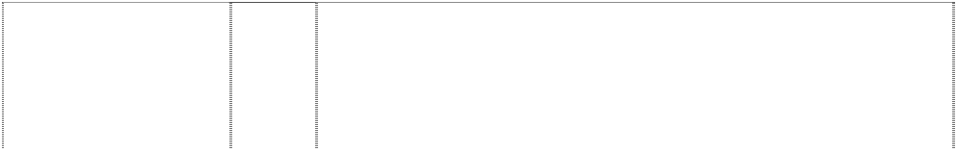

swan,cartoon is footballer spins football on finger; opera-house on singlet

(966668)

# AFL

swan,cartoon is footballer spins football on finger; opera-house on singlet

(966668)

# AFL

tiger,cartoon is footballer with ball & bandage on leg

(962373)

# AFL

tiger,cartoon is footballer with ball & bandage on leg

(962373)

# AFL

tiger,cartoon is footballer with ball & bandage on leg

(962373)

# AFL

tiger,cartoon is footballer with ball & bandage on leg

(962373)

# AFL

tiger,cartoon is footballer with ball & bandage on leg

(962373)

# AFL

tiger,cartoon is footballer with ball & bandage on leg

(962373)

# AFL 1954

bulldog,cartoon,footbal ler with arms crossed &

trophy on arm (962323)

25 Clothing, footwear, headgear.

28 Games and playthings; gymnastic and sporting articles not included in other classes; decorations for Christmas trees.

9 Scientific, nautical, surveying, photographic, cinematographic, optical, weighing, measuring, signalling, checking (supervision), life- saving and teaching apparatus and instruments; apparatus and instruments for conducting, switching, transforming, accumulating, regulating or controlling electricity; apparatus for recording, transmission or reproduction of sound or images; magnetic data carriers, recording discs; automatic vending machines and mechanisms for coin-operated apparatus; cash registers, calculating machines, data processing equipment and computers; fire extinguishing apparatus.

14 Precious metals and their alloys and goods in precious metals or coated therewith, not included in other classes; jewellery, precious stones; horological and chronometric instruments.

16 Paper, cardboard and goods made from these materials, not included in other classes; printed matter; bookbinding material; photographs; stationery; adhesives for stationery or household purposes; artists’ materials; paint brushes; typewriters and office requisites (except furniture); instructional and teaching material (except apparatus); plastic materials for packaging (not included in other classes); printers’ type; printing blocks.

21 Household or kitchen utensils and containers (not of precious metal or coated therewith); combs and sponges; brushes (except paint brushes); brush-making materials; articles for cleaning purposes; steelwool; unworked or semi-worked glass (except glass used in building); glassware, porcelain and earthenware not included in other classes.

25 Clothing, footwear, headgear.

28 Games and playthings; gymnastic and sporting articles not included in other classes; decorations for Christmas trees.

9 Scientific, nautical, surveying, photographic, cinematographic, optical, weighing, measuring, signalling, checking (supervision), life- saving and teaching apparatus and instruments; apparatus and instruments for conducting, switching, transforming, accumulating, regulating or controlling electricity; apparatus for recording, transmission or reproduction of sound or images; magnetic data carriers, recording discs; automatic vending machines and mechanisms for coin-operated apparatus; cash registers, calculating machines, data processing equipment and computers; fire extinguishing apparatus.

# AFL 1954

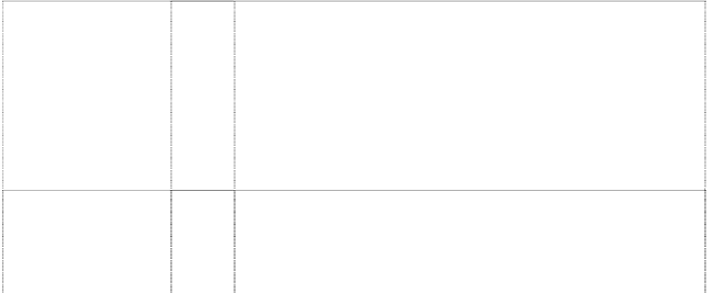

bulldog,cartoon,footbal ler with arms crossed &

trophy on arm (962323)

# AFL 1954

bulldog,cartoon,footbal ler with arms crossed &

trophy on arm (962323)

# AFL 1954

bulldog,cartoon,footbal ler with arms crossed &

trophy on arm (962323)

# AFL 1954

bulldog,cartoon,footbal ler with arms crossed &

trophy on arm (962323)

# AFL 1954

bulldog,cartoon,footbal ler with arms crossed &

trophy on arm (962323)

# AFL CFC

strongman,cartoon, masked,smiling wears gloves, boots & belt

(962284)

# AFL CFC

strongman,cartoon, masked,smiling wears gloves, boots & belt

(962284)

# AFL CFC

strongman,cartoon, masked,smiling wears gloves, boots & belt

(962284)

# AFL CFC

strongman,cartoon, masked,smiling wears gloves, boots & belt

(962284)

14 Precious metals and their alloys and goods in precious metals or coated therewith, not included in other classes; jewellery, precious stones; horological and chronometric instruments.

16 Paper, cardboard and goods made from these materials, not included in other classes; printed matter; bookbinding material; photographs; stationery; adhesives for stationery or household purposes; artists’ materials; paint brushes; typewriters and office requisites (except furniture); instructional and teaching material (except apparatus); plastic materials for packaging (not included in other classes); printers’ type; printing blocks.

21 Household or kitchen utensils and containers (not of precious metal or coated therewith); combs and sponges; brushes (except paint brushes); brush-making materials; articles for cleaning purposes; steelwool; unworked or semi-worked glass (except glass used in building); glassware, porcelain and earthenware not included in other classes.

25 Clothing, footwear, headgear.

28 Games and playthings; gymnastic and sporting articles not included in other classes; decorations for Christmas trees.

9 Scientific, nautical, surveying, photographic, cinematographic, optical, weighing, measuring, signalling, checking (supervision), life- saving and teaching apparatus and instruments; apparatus and instruments for conducting, switching, transforming, accumulating, regulating or controlling electricity; apparatus for recording, transmission or reproduction of sound or images; magnetic data carriers, recording discs; automatic vending machines and mechanisms for coin-operated apparatus; cash registers, calculating machines, data processing equipment and computers; fireextinguishing apparatus.

14 Precious metals and their alloys and goods in precious metals or coated therewith, not included in other classes; jewellery, precious stones; horological and chronometric instruments.

16 Paper, cardboard and goods made from these materials, not included in other classes; printed matter; bookbinding material; photographs; stationery; adhesives for stationery or household purposes; artists’ materials; paint brushes; typewriters and office requisites (except furniture); instructional and teaching material (except apparatus); plastic materials for packaging (not included in other classes); printers’ type; printing blocks.

21 Household or kitchen utensils and containers (not of precious metal or coated therewith); combs and sponges; brushes (except paint brushes); brush-making materials; articles for cleaning purposes; steelwool; unworked or semi-worked glass (except glass used in building); glassware, porcelain and earthenware not included in other classes.

# AFL CFC



strongman,cartoon, masked,smiling wears gloves, boots & belt

(962284)

# AFL CFC

strongman,cartoon, masked,smiling wears gloves, boots & belt

(962284)

# AFL CHAS BROWNLOW TROPHY

medal is oval in annulus with 2 scrolls (901178)

# AFL CHAS BROWNLOW TROPHY

medal is oval in annulus with 2 scrolls (901178)

# AFL CHAS BROWNLOW TROPHY

medal is oval in annulus with 2 scrolls (901178)

25 Clothing, footwear, headgear.

28 Games and playthings; gymnastic and sporting articles not included in other classes; decorations for Christmas trees.

9 Electric, photographic, cinematographic, video and teaching apparatus and instruments; apparatus and instruments for recording and/or transmission and/or reproduction of sound and/or images; automatic vending machines, computer apparatus and instruments; computer operating programs, computer programs, computer software and video game software; magnetic data carriers; audio, video, computer and laser tapes, discs, compact discs, cassettes and cartridges; pre-recorded audio, video, computer and laser tapes, discs, compact discs, cassettes and cartridges; video game and computer game tapes, discs, compact discs, cassettes and cartridges; games in class 9, coin operated games, coin freed games; video games and computer games for playing in game arcades and game playing venues; electronic video arcade game machines, games for use with television receivers and/or computer monitors and/or other separate display apparatus; parts, fittings and accessories in class 9 for the aforesaid goods.

14 Jewellery, costume jewellery, trinkets, horological instruments, chronometric instruments, clocks, watches, watch bands, watch straps, watch chains, cuff links, tie clips, tie pins, ornamental pins, earrings, jewellery bracelets, jewellery brooches, jewellery medallions, jewellery necklaces, jewellery rings, jewellery pendants, jewellery buckles, jewellery ornaments, jewellery chains, key chains, key ring trinkets, key ring fobs, medals; goods of precious metal or coated therewith namely badges, boxes, cases, containers and household utensils; and parts, fittings and accessories in class 14 for the aforesaid goods.

16 Paper, cardboard, goods in class 16 made from paper and/or cardboard; wrapping paper, paper flags, paper pennants, paper bibs, paper placemats, paper napkins, paper coasters, cardboard coasters, printed matter, printed publications, books, magazines, newspapers, activity books, statistical books, guide books, reference books, newsletters, pamphlets, printed programs, printed entertainment programs, printed game programs, printed fixtures; printed matter for the radio, television and print media; stationery, exercise books, diaries, calendars, memo pads, folders, note books, book covers, printed statistics sheets, writing instruments, ball point pens, pencils, office requisites except furniture, drawing rulers, erasers, instructional and teaching materials except apparatus, cards, trading cards, sports trading cards, football trading cards, dance team trading cards, mascot trading cards, entertainment trading cards, post cards, greeting cards, note cards, stamps, sports stamps, football stamps, posters, stickers, bumper stickers, decalcomanias, albums, scrap books, autograph books, photographs, mounted photographs, line art coloring boards, non- textile labels, tickets and control tokens.

# AFL CHAS BROWNLOW TROPHY



medal is oval in annulus with 2 scrolls (901178)

# AFL CHAS BROWNLOW TROPHY

medal is oval in annulus with 2 scrolls (901178)

# AFL RECORD

(779205)

# AUSKICK

(719807)

25 Clothing, leisure wear, sportswear, uniforms, babywear, underwear, underpants, boxer shorts, singlets, shirts, sports shirts, blouses, T- shirts, tank tops, skivvies, rugby tops, grandpa tops, shorts, board shorts, tracksuits, warm-up suits, pants, warm-up pants, sweat pants, trousers, jeans, dresses, skirts, clothing belts, knitwear, jumpers, sweaters, guernseys, jerseys, cardigans, vests, neckwear, cravats, neckties, scarves, jackets, bomber jackets, blazers, suits, coats, parkas, anoraks, rainwear, raincoats, swimsuits, sleepwear, pyjamas, nightshirts, night gowns, dressing gowns, bath robes, cloth bibs, aprons, clothing gloves, mittens, headwear, hats, caps, beanies, ear muffs, clothing hoods, visors, headbands, wristbands, socks, hosiery, footwear, shoes, boots and slippers.

28 Games, playthings, playing cards, sporting goods in class 28, balls for games, playballs, rubber action balls, foam action balls, balls for sports, golf balls, footballs, toy footballs, miniature footballs, pumps for inflating sporting balls, sports gloves, football gloves, golf gloves, golf bags, golf tees, exercise and physical training apparatus and articles, toys, toy vehicles, dolls, jigsaw puzzles, board games; self contained apparatus and instruments for playing games including mechanical games, electronic games, computerised games, battery operated games, games that are portable, games that include a built- in display, games that include a built-in program, games that receive one or more programs; hand held portable self contained apparatus and instruments for playing games; parts, fittings and accessories in class 28 for the aforesaid goods.

16 Paper, cardboard, goods in class 16 made from paper and/or cardboard; wrapping paper, paper flags, paper pennants, paper bibs, paper placemats, paper napkins, paper coasters, cardboard coasters, printed matter, printed publications, books, magazines, newspapers, activity books, statistical books, guide books, reference books, newsletters, pamphlets, printed programs, printed entertainment programs, printed game programs, printed fixtures; printed matter for the radio, television and print media; stationery, exercise books, diaries, calendars, memo pads, folders, note books, multi-ring binders, book covers, portfolios, printed statistics sheets, writing instruments, ball point pens, pencils, office requisites except furniture, drawing rulers, erasers, instructional and teaching materials except apparatus, cards, playing cards, trading cards, sports trading cards, football trading cards, dance team trading cards, mascot trading cards, entertainment trading cards, post cards, greeting cards, note cards, stamps, sports stamps, football stamps, posters, stickers, bumper stickers, decalcomanias, albums, scrap books, autograph books, photographs, mounted photographs, pictures, line art colouring boards, non-textile labels, tickets and control tokens.

14 Jewellery, costume jewellery, trinkets, horological instruments, chronometric instruments, sundials, clocks, watches, watch bands, watch straps, watch chains, cuff links, tie clips, tie pins, ornamental pins, earrings, jewellery bracelets, jewellery brooches, jewellery medallions, jewellery necklaces, jewellery rings, jewellery pendants, jewellery buckles, jewellery ornaments, jewellery chains, key chains, key ring trinkets, key ring fobs, medals, coins; goods of precious metal or coated therewith namely badges, boxes, cases, containers and household utensils; and parts, fittings and accessories in class 14 for the aforesaid goods.

# AUSKICK

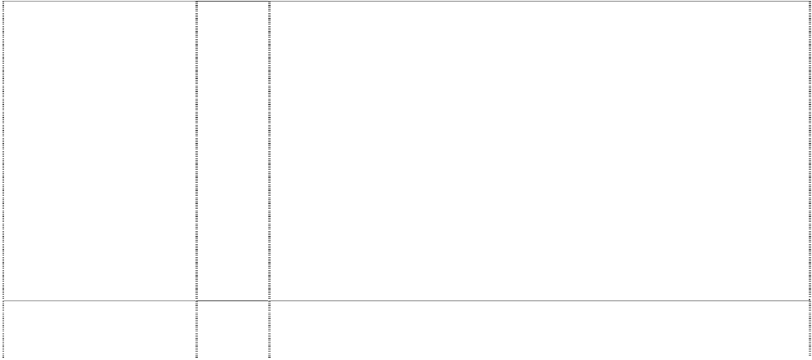

(719807)

# AUSKICK

(719807)

# AUSKICK

(707028)

# AUSKICK

(719807)

16 Paper, cardboard, goods in class 16 made from paper and/or cardboard; wrapping paper, paper flags, paper pennants, paper bibs, paper placemats, paper napkins, paper coasters, cardboard coasters, printed matter, printed publications, books, magazines, newspapers, activity books, statistical books, guide books, reference books, newsletters, pamphlets, printed programs, printed entertainment programs, printed game programs, printed fixtures; printed matter for the radio, television and print media; stationery, exercise books, diaries, calendars, memo pads, folders, note books, multi-ring binders, book covers, portfolios, printed statistics sheets, writing instruments, ball point pens, pencils, office requisites except furniture, drawing rulers, erasers, instructional and teaching materials except apparatus, cards, playing cards, trading cards, sports trading cards, football trading cards, dance team trading cards, mascot trading cards, entertainment trading cards, post cards, greeting cards, note cards, stamps, sports stamps, football stamps, posters, stickers, bumper stickers, decalcomanias, albums, scrap books, autograph books, photographs, mounted photographs, line art colouring boards non-textile labels, tickets and control tokens.

25 Clothing, leisure wear, sportswear, uniforms, babywear, underwear, underpants, boxer shorts, singlets, leotards, shirts, sports shirts, blouses, T-shirts, sweatshirts, tank tops, skivvies, rugby tops, grandpa tops, shorts, board shorts, tracksuits, warm-up suits, pants, warm-up pants, sweat pants, trousers, jeans, dresses, skirts, clothing belts, knitwear, jumpers, sweaters, guernseys, jerseys, cardigans, vests, neckwear, cravats, neckties, scarves, jackets, bomber jackets, blazers, formal wear, suits, coats, parkas, anoraks, rainwear, raincoats, swimsuits, sleepwear, pyjamas, nightshirts, night gowns, dressing gowns, bath robes, cloth bibs, aprons, clothing gloves, mittens, headwear, hats, caps, berets, beanies, ear muffs, clothing hoods, visors, headbands, wristbands, socks, stockings, hosiery, footwear, shoes, boots, sandals and slippers.

28 Footballs and soccerballs for junior football and/or soccer.

28 Games, playthings, sporting goods in class 28, balls for games, playballs, rubber action balls, foam action balls, balls for sports, golf balls, footballs, toy footballs, miniature footballs, pumps for inflating sporting balls, needles for such pumps, sports gloves, football gloves, golf gloves, golf bags, golf tees, exercise and physical training apparatus and articles, toys, toy vehicles, toy cars, dolls, jigsaw puzzles, board games; self contained apparatus and instruments for playing games including mechanical games, electronic games, computerised games, battery operated games, games hat are portable, games that include a built-in display, games that include a built-in program, games that receive one or more programs; hand held portable self contained apparatus and instruments for playing games; parts, fittings and accessories in class 28 for the aforesaid goods; but excluding games that are adapted or intended for use with a separate television or computer monitor or other separate display apparatus and also excluding games that are coin and/or counter freed or coin and/or counter operated.

# BRISBANE LIONS



(832783)

# BRISBANE LIONS

(832782)

# BRISBANE LIONS

(712144)

# BRISBANE LIONS

(712144)

9 Electric, photographic, cinematographic, video, optical, measuring, signalling and teaching apparatus and instruments; apparatus and instruments for recording and/or transmission and/or reproduction of sound and/or images; cameras and radios; automatic vending machines, data processing equipment and computer apparatus and instruments; computer operating programs, computer programs, computer software and video game software; magnetic data carriers; audio, video, computer and laser tapes, discs, compact discs, cassettes and cartridges; pre-recorded audio, video, computer and laser tapes, discs, compact discs, cassettes and cartridges; sound recordings, video recordings, sound and video recordings; video game and computer game tapes, discs, compact discs, cassettes and cartridges; games in class 9, coin operated games, coin freed games; video games and computer games for playing in game arcades and game playing venues; electronic video arcade game machines, games for use with television receivers and/or computer monitors and/or other separate display apparatus; helmets, parts, fittings and accessories in class 9 for the aforesaid goods.

14 Jewellery, costume jewellery, trinkets, horological instruments, chronometric instruments, sundials, clocks, watches, watch bands, watch straps, watch chains, cuff links, tie clips, tie pins, ornamental pins, earrings, jewellery bracelets, jewellery brooches, jeweflery medallions, jewellery necklaces, jewellery rings, jeweliery pendants, jewellery buckles, jewellery ornaments, jewellery chains, key chains, key ring trinkets, key ring fobs, medals, coins; goods of precious metal or coated therewith namely badges, boxes, cases, containers and household utensils; and parts, fittings and accessories in class 14 for the aforesaid goods.

16 Paper, cardboard, goods in class 16 made from paper and/or cardboard; wrapping paper, paper flags, paper pennants, paper bibs, paper placemats, paper napkins, paper coasters, cardboard coasters, printed matter, printed publications, books, magazines, newspapers, activity books, statistical books, guide books, reference books, newsletters, pamphlets,printed programs, printed entertainment programs, printed game programs, printed fixtures; printed matter for the radio, television and print media; stationery, exercise books, diaries, calendars, memo pads, folders, note books, multi-ring binders, book covers, portfolios, printed statistics sheets, writing instruments, pens, pencils; office requisites except furniture, rulers, erasers, instructional and teaching materials except apparatu~,cards, playing cards, trading cards, post cards, greeting cards, printed stamps,posters, stickers, bumper stickers, decalcomanias, albums, scrap books, autograph books, photographs, mounted photographs, pictures, line colouring boards, non-textile labels, tickets and control tokens; all the foregoing goods being used in or used by supporters ofor promoting or otherwise associated with or relating to Australian Rules football.

25 Clothing, apparel, leisure wear, sportswear, uniforms, babywear, underwear, underpants, boxer shorts, singlets, leotards, shirts, sports shirts, blouses, T-shirts, tank tops, skivvies, rugby tops, shorts, board shorts, tracksuits, warm-up suits, pants, warm-up pants, sweat pants, trousers, jeans, dresses, skirts, clothing belts, knitwear, jumpers, sweaters, guernseys, jerseys, cardigans, vests, neckwear, cravats, neckties, scarves, jackets, bomber jackets, blazers, formal wear, suits, coats, parkas, anoraks, rainwear, raincoats, swimsuits, sleepwear, pyjamas, nightshirts, night gowns, dressing gowns, bath robes, cloth bibs, aprons, clothing gloves, mittens, headgear, hats, caps, berets, beanies, ear muffs, clothing hoods, visors, headbands, wristbands, socks, stockings, hosiery, footwear, shoes, boots, sandals and slippers; all the foregoing goods being used in or used by supporters of or promoting or other wise associated with or relating to Australian Rules football.

# BRISBANE LIONS AFL



lion standing,paw on ball is ltr O; ltrs AFL on football; all in oval

(841782)

# BRISBANE LIONS AFL

lion standing,paw on ball is ltr O; ltrs AFL on football; all in oval

(841781)

# BRISBANE LIONS AFL

lion standing,paw on ball is ltr O; ltrs AFL on football; all in oval

(841780)

# BRISBANE LIONS AFL

lion standing,paw on ball is ltr O; ltrs AFL on football; all in oval

(841778)

9 Electric, photographic, cinematographic, video, optical, measuring, signalling and teaching apparatus and instruments; apparatus and instruments for recording and/or transmission and/or reproduction of sound and/or images; cameras and radios; automatic vending machines, data processing equipment and computer apparatus and instruments; computer operating programs, computer programs, computer software and video game software; magnetic data carriers; audio, video, computer and laser tapes, discs, compact discs, cassettes and cartridges; prerecorded audio, video, computer and laser tapes, discs, compact discs, cassettes and cartridges; sound recordings, video recordings, sound and video recordings; video game and computer game tapes, discs, compact discs, cassettes and cartridges; games in class 9, coin operated games, coin freed games; video games and computer games for playing in game arcades and game playing venues; electronic video arcade game machines, games for use with television receivers and1or computer monitors and/or other separate display apparatus; helmets, parts, fittings and accessories in class 9 for the aforesaid goods.

14 Jewellery, costume jewellery, trinkets, horological instruments, chronometric instruments, sundials, clocks, watches, watch bands, watch straps, watch chains, cuff links, tie clips, tie pins, ornamental pins, earrings, jewellery bracelets, jewellery brooches, jewellery medallions, jewellery necklaces, jewellery rings, jewellery pendants, jeweliery buckles, jewellery ornaments, jewellery chains, key chains, key ring trinkets, key ring fobs, medals, coins; goods of precious metal or coated therewith namely badges, boxes, cases, containers and household utensils; and parts, fittings and accessories in class 14 for the aforesaid goods.

16 Paper, cardboard, goods in class 16 made from paper and/or cardboard; wrapping paper, paper flags, paper pennants, paper bibs, paper placemats, paper napkins, paper coasters, cardboard coasters, printed matter, printed publications, books, magazines, newspapers, activity books, statistical books, guide books, reference books, newsletters, pamphlets, printed programs, printed entertainment programs, printed game programs, printed fixtures; printed matter for the radio, television and print media; stationery, exercise books, diaries, calendars, memo pads, folders, note books, multi-ring binders, book covers, portfolios, printed statistics sheets, writing instruments, ball point pens, pencils, office requisites except furniture, drawing rulers, erasers, instructional and teaching materials except apparatus, cards, playing cards, trading cards, sports trading cards, football trading cards, dance team trading cards, mascot trading cards, entertainment trading cards, post cards, greeting cards, note cards, stamps, sports stamps, football stamps, posters, stickers, bumper stickers, decalcomanias, albums, scrap books, autograph books, photographs, mounted photographs, pictures, line art colouring boards, non-textile labels, tickets and control tokens.

25 Clothing, apparel, leisure wear, sportswear, uniforms, babywear, underwear, underpants, boxer shorts, singlets, leotards, shirts, sports shirts, blouses, T-shirts, tank tops, skivvies, rugby tops, grandpa tops, shorts, board shorts, tracksuits, warm-up suits, pants, warm-up pants, sweat pants, trousers, jeans, dresses, skirts, clothing belts, knitwear, jumpers, sweaters, Guernseys, jerseys, cardigans, vests, neckwear, cravats, neckties, scarves, jackets, bomber jackets, blazers, formal wear, suits coats, parkas, anoraks, rainwear, raincoats, swimsuits, sleepwear, pyjamas, nightshirts, night gowns, dressing gowns, bath robes, cloth bibs, aprons, clothing gloves, mittens, headwear, hats, caps, berets, beanies, ear muffs, clothing hoods, visors, headbands, wristbands, socks, stockings, hosiery, footwear, shoes, boots, sandals and slippers.

# BRISBANE LIONS AFL



lion standing,paw on ball is ltr O; ltrs AFL on football; all in oval

(841775)

# BROWNLOW MEDAL

(564471)

# BROWNLOW MEDAL

(564472)

# BROWNLOW MEDAL

(564473)

**CFC CARLTON FOOTBALL CLUB** (1084066)

**CFC CARLTON FOOTBALL CLUB** (1084066)

28 Games, playthings, sporting goods in class 28, balls for games, playballs, rubber action balls, foam action bails, balls for sports, golf balls, footballs, toy footballs, miniature footballs, pumps for inflating sporting bails, needles for such pumps, sports gloves, football gloves, golf gloves, golf bags, golf tees, exercise and physical training apparatus and articles, toys, toy vehicles, toy cars, dolls, jigsaw puzzles, board games; self contained apparatus and instruments for playing games including mechanical games, electronic games, computerised games, battery operated games, games that are portable, games that include a built-in display, games that include a built-in program, games that receive one or more programs; hand held portable self contained apparatus and instruments for playing games; parts, fittings and accessories in class 28 for the aforesaid goods.

16 Paper, cardboard, goods made from paper and cardboard not included in other classes, books, magazines, newspapers, pamphlets, printed matter, photographs, albums, posters, stationery, programs, writing instruments, diaries, office requisites except furniture, instructional and teaching material except apparatus, playing cards, and all other goods in class 16.

25 Clothing, underwear, underpants, shirts, T-shirts, shorts, pants, trousers, jeans, clothing belts, knitwear, jumpers, cardigans, sweatshirts, neckwear, neckties, jackets, blazers, suits, coats, scarves, rainwear, swimwear, sleepwear, pyjamas, nightshirts, dressing gowns, headwear, hats, caps, socks, stockings, hosiery, footwear, shoes, boots, slippers, and all other goods in class 25.

28 Football and other sporting articles in class 28; exercise and physical training apparatus and articles; balls for games and sport; games and playthings; toys, dolls and all other goods in class 28.

9 Scientific, nautical, surveying, electric, photographic, cinematographic, video, optical, weighing measuring, signalling, checking, life-saving and teaching apparatus and instruments; apparatus and instruments for recording and/or transmission and/or reproduction of sound and/or images; cameras and radios; automatic vending machines, mechanisms for coin-operated apparatus; cash registers and calculating machines, data processing equipment and computer apparatus and instruments; computer operating programs, computer programs, computer software and video game software; magnetic data carriers; recording discs, audio, video, computer and laser tapes, discs, compact discs, cassettes and cartridges; pre- recorded audio, video, computer and laser tapes, discs, compact discs, cassettes and cartridges; CD-ROMS (compact disc ROMS), digital versatile disc ROMS, sound recordings, video recordings, sound and video recordings; video game and computer game tapes, discs, compact discs, cassettes and cartridges; games in class 9; games for usewith television receivers and/or computermonitors and/or other separate display apparatus; helmetsand fire- extinguishing apparatus; downloadable electronic publications; recorded video discs and tapes; downloadable digital image recordings; downloadable music recordings; parts, fittings and accessories in class 9 for the aforesaid goods.

14 Jewellery, costume jewellery, trinkets, horological instruments, chronometric instruments, sundials, clocks, watches, watch bands, watch straps, watch chains, cuff links, tie clips, tie pins, ornamental pins, earrings, jewellery bracelets, jewellery brooches, jewellery medallions, jewellery necklaces, jewellery rings, jewellery pendants, jewellery buckles, jewellery ornaments, jewellery chains, key chains, key ring trinkets, key ring fobs, medals, coins; goods of precious metal or coated therewith namely badges, boxes, cases, containers and household utensils; and parts, fittings and accessories in class 14 for the aforesaid goods.

**CFC CARLTON FOOTBALL CLUB** (1084066)



**CFC CARLTON FOOTBALL CLUB** (1084066)

**CFC CARLTON FOOTBALL CLUB** (1084066)

**CFC CARLTON FOOTBALL CLUB** (1084066)

16 Paper, cardboard, goods in class 16 made from paper and/or cardboard; wrapping paper, paper flags, paper pennants, paper bibs, paper placemats, paper napkins, paper coasters, cardboard coasters, printed matter, printed publications, books, magazines, newspapers, activity books, statistical books, guide books, reference books, newsletters, pamphlets, printed programs, printed entertainment programs, printed game programs, printed fixtures; printed matter for the radio, television and print media; bookbinding materials, stationery, exercise books, diaries, calendars, memo pads, folders, note books, multi-ring binders, book covers, portfolios, printed statistics sheets, adhesives, artists’ materials, paint brushes, writing instruments, ball point pens, pencils, typewriters, office requisites except furniture, drawing rulers, erasers, instructional and teaching materials except apparatus, plastic packaging materials, cards, trading cards, sports trading cards, football trading cards, dance team trading cards, mascot trading cards, entertainment trading cards, post cards, greeting cards, note cards, stamps, sports stamps, football stamps, posters, stickers, bumper stickers, decalcomanias, albums, scrap books, autograph books, photographs, mounted photographs, pictures, line art colouring boards, non-textile labels, tickets and control tokens.

21 Household or kitchen utensils and containers (not of precious metal or coated therewith); combs and sponges; brushes (except paint brushes); brush-making materials; articles for cleaning purposes; steelwool; unworked or semi-worked glass (except glass used in building); glassware, porcelain and earthenware not included in other classes.

25 Clothing, apparel, leisure wear, sportswear, uniforms, babywear, underwear, underpants, boxer shorts, singlets, leotards, shirts, sports shirts, blouses, T-shirts, tank tops, skivvies, rugby tops, grandpa tops, shorts, board shorts, tracksuits, warm-up suits, pants, warm-up pants, sweat pants, trousers, jeans, dresses, skirts, clothing belts, knitwear, jumpers, sweaters, guernseys, jerseys, cardigans, vests, neckwear, cravats, neckties, scarves, jackets, bomber jackets, blazers, formal wear, suits, coats, parkas, anoraks, rainwear, raincoats, swimsuits, sleepwear, pyjamas, nightshirts, night gowns, dressing gowns, bath robes, cloth bibs, aprons, clothing gloves, mittens, headwear, hats, caps, berets, beanies, ear muffs, clothing hoods, visors, headbands, wristbands, socks, stockings, hosiery, footwear, shoes, boots, sandals and slippers.

28 Games, playthings, playing cards, gymnastic and sporting goods in class 28, balls for games, playballs, rubber action balls, foam action balls, balls for sports, golf balls, footballs, toy footballs, miniature footballs, pumps for inflating sporting balls, needles for such pumps, sports gloves, football gloves, golf gloves, golf bags, golf tees, exercise and physical training apparatus and articles, toys, toy vehicles, toy cars, dolls, jigsaw puzzles, board games; coin operated games, coin freed games; self contained apparatus and instruments for playing games including mechanical games, electronic games, computerised games, battery operated games, games that are portable, games that include a built-in display, games that include a built-in program, games that receive one or more programs; hand held portable self contained apparatus and instruments for playing games; Christmas tree stands, synthetic Christmas trees and Christmas tree decorations; parts, fittings and accessories in class 28 for the aforesaid goods; video games and computer games for playing in game arcades and game playing venues; electronic video arcade game machines.

# COLLINGWOOD FOOTBALL CLUB EST 1892

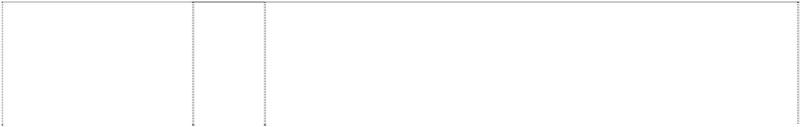

magpie in annulus with 2 flags,shield & wreath incomplete

(562737)

# COLLINGWOOD FOOTBALL CLUB EST 1892

magpie in annulus with 2 flags,shield & wreath incomplete

(562739)

# COLLINGWOOD FOOTBALL CLUB EST 1892

magpie in annulus with 2 flags,shield & wreath incomplete

(775235)

# CROWS

(670732)

# DEMONS

(432025)

# DEMONS

(435393)

# EAGLES

(759958)

16 Paper, cardboard, goods made from paper and cardboard not included in other classes, books, magazines, newspapers, pamphlets, printed matter, photographs, albums, posters, stationery, programs, writing instruments, diaries, office requisites except furniture, instructional and teaching material except apparatus, playing cards, and all other goods in class 16.

25 Clothing, underwear, underpants, shirts, T-shirts, shorts, pants, trousers, jeans, clothing belts, knitwear, jumpers, cardigans, sweatshirts, neckwear, neckties, jackets, blazers, suits, coats, scarves, rainwear, swimwear, sleepwear, pyjamas, nightshirts, dressing gowns, headwear, hats, caps, socks, stockings, hosiery, footwear, shoes, boots, slippers, and all other goods in class 25.

30 Baked beans, bakery goods, biscuits, bread, bread rolls, buns, cakes, chewing gum (non medicinal), cereal chips, chocolate, chocolate based beverages, chocolate coated nuts, cocoa, cocoa based beverages, coffee, coffee based beverages, confectionery, corn chips, cookies, dim sims, edible ices, farinaceous foods, flavourings (other than essential oils), foodstuffs in class 30, frozen yoghurt, glucose for food, hamburgers, honey, hot dogs, ice cream, ketchup, muesli, muesli bars, oatmeal, pancakes, pasta, pasties, pastries, pies, pizzas, popcorn, sandwiches, sauces (condiments), sausage rolls, spaghetti, spring rolls, tea, toffee coated apples, tomato sauce, yeast extract spreads.

25 Clothing, underwear, underpants, singles, leotards, shirts, blouses, T-shirts, sweatshirts, shorts, track suits, warm-up pants, pants, trousers, jeans, dresses, skirts, clothing belts, knitwear, jumpers, guernseys, cardigans, vests, cravats, neckties, scarves, jackets, blazers, suits, coats, rainwear, raincoats, swimsuits, sleepwear, pyjamas, nightshirts, night gowns, dressing gowns, bath robes, aprons, gloves, mittens, wristbands, headwear, hats, berets, beanies, caps, visors, headbands, socks, stockings, hosiery, footwear, shoes, boots and slippers.

16 Paper, cardboard, goods made from paper and cardboard not included in other classes, books, magazines, newspapers, pamphlets, printed matter, photographs, albums, posters, stationery, programs, writing instruments, diaries, office requisites except furniture, instructional and teaching material except apparatus, playing cards, and all other goods in class 16.

25 Clothing, underwear, underpants, shirts, T-shirts, shorts, pants, trousers, jeans, knitwear, jumpers, cardigans, sweatshirts, neckwear, neckties, jackets, blazers, suit, coats, scarves, rainwear, swimwear, sleepwear, pyjamas, nightshirts, dressing gowns, headwear, hats, caps, socks, stockings, hosiery, footwear, shoes, boots, slippers, and all other goods in class 25.

25 Clothing, underwear, singlets, leotards, shirts, blouses, T-Shirts, sweatshirts, shorts, track suits, warm-up pants, pants, trousers, jeans, dresses, skirts, clothing belts, knitwear, jumpers, guernseys, cardigans, vests, cravats, neckties, scarves, jackets, blazers, suits, coats, rainwear, raincoats, swimsuits, sleepwear, pyjamas, nightshirts, night gowns, dressing gowns, bath robes, aprons, gloves, mittens, wristbands, headwear, hats, berets, beanies, caps, visors, headbands, socks, stockings, hosiery, footwear, shoes, boots and slippers.

# ESSENDON



bomber in inverted triangle below word in shield

(738862)

# ESSENDON

bomber in inverted triangle below word in shield

(738861)

# ESSENDON

bomber in inverted triangle below word in shield

(738863)

# ESSENDON

bomber in inverted triangle below word in shield

(738864)

9 Electric, photographic, cinematographic, video, optical~measuring, signalling and teaching apparatus and instruments; apparatus and instruments for recording and/or transmission and/or reproduction of sound and/or images; automatic vending machines, data processing equipment and computer apparatus and instruments; computer operating programs, computer programs, computer software and video game software; magnetic data carriers; audio, video, computer and laser tapes, discs, compact discs, cassettes and cartridges; pre- recorded audio, video, computer and laser tapes, discs, compact discs, cassette and cartridges; video game and computer game tapes, discs, compact discs, cassettes and cartridges; games in class 9, coin operated games, coin freed games; video games and computer games for playing in game arcades and game playing venues; electronic video arcade game machines, games for use with television receivers and/or computer monitors andlor other separate display apparatus; parts, fittings and accessories in class 9 for the aforesaid goods.

14 Jewellery, costume jewellery, trinkets, horological instruments, chronometric instruments, sundials, clocks, watches, watch bands, watch straps, watch chains, cuff links, tie clips, tie pins, ornamental pins, earrings, jewellery braclets, jewellery brooches, jewellery medallions, jewellery necklaces, jewellery rings, jewellery pendants, jewellery buckles, jewellery ornaments, jewellery chains, key chains, key ring trinklets, key ring fobs, medals, coins; goods of precious metal or coated therewith namely badges, boxes, cases, containers and household utensils; and parts, fittings and accessories in class 14 for the aforesaid goods.

16 Paper, cardboard, goods in class 16 made from paper and/or cardboard; wrapping paper, paper flags, paper pennants, paper bibs, paper placemats, paper napkins, paper coasters, cardboard coasters, printed matter, printed publications, books, magazines, newspapers, activity books, statistical books, guide books, reference books, newsletters, pamphlets, printed programs, printed entertainment programs, printed game programs, printed fixtures; printed matter for the radio, television and print media; stationery, excercise books, diaries, calendars, memo pads, folders, note books, multi-ring binders, book covers, portfolios, printed statistics sheets, writing instruments, ball point pens, pencils, office requisites except furniture, drawing rulers, erasers, instructional and teaching materials except apparatus, cards, playing cards, trading cards, sports trading cards, football trading cards, dance team trading cards, mascot trading cards, entertainment trading cards, post cards, greeting cards, note cards, stamps, sports stamps, football stamps, posters, stickers, bumper stickers, decalcomanias, albums, scrap books, autograph books, photographs, mounted photographs, line art colouring boards, non-textilelabels, tickets and control tokens.

25 Clothing, leisure wear, sportswear, uniforms, babywear, underwear, underpants, boxer shorts, singlets, leotards, shirts, sports shirts, blouses, T-shirts, sweatshirts, tank tops, skivvies, rugby tops, grandpa tops, shorts, board shorts, track suits, warm-up suits, pants, warm-up pants, sweat pants, trousers, jeans, dresses, skirts, clothing belts, knitwear, jumpers, sweaters, guernseys, jerseys, cardigans, vests, neckwear, cravats, neckties, scarves, jackets, bomber jackets, blazers, formal wear, suits, coats, parkas, anoraks, rainwear, raincoats, swimsuits, sleepwear, pyjamas, nightshirts, night gowns, dressing gowns, bath robes, cloth bibs, aprons, gloves, mittens, headwear, hats, caps, berets, beanies, ear muffs, clothing hoods, visors, headbands, wristbands, socks, stockings, hosiery, footwear, shoes, boots, sandals and slippers.

# ESSENDON



bomber in inverted triangle below word in shield

(738864)

# ESSENDON

bomber in inverted triangle below word in shield

(775236)

# FREMANTLE FOOTBALL CLUB

man in singlet clasps anchor to chest,breaks shield

(765589)

# FREMANTLE FOOTBALL CLUB

man in singlet clasps anchor to chest,breaks shield

(765588)

28 Games, playthings, sporting goods in class 28, balls for games, playballs, rubber action balls, foam action balls, balls for sports, golf balls, footballs, toy footballs, miniature footballs, pumps for inflating sporting balls, needles for such pumps, sports gloves, football gloves, golf gloves, golf bags, golf tees, exercise and physical training apparatus and articles, toys, toy vehicles, toy cars, dolls, jigsaw puzzles, board games; self contained apparatus and instruments for playing games including mechanical games, electronic games, computerised games, battery operated games, games that are portable, games that include a built-in display, games that include a built-in program, games that receive one or more programs; hand held portable self contained apparatus and instruments for playing games; parts, fittings and accessories in class 28 for the aforesaid goods.

30 Baked beans, bakery goods, biscuits, bread, bread rolls, buns, cakes, chewing gum (non medicinal), cereal chips, chocolate, chocolate based beverages, chocolate coated nuts, cocoa, cocoa based beverages, coffee, coffee based beverages, confectionery, corn chips, cookies, dim sims, edible ices, farinaceous foods, fiavourings (other than essential oils), foodstuffs in class 30, frozen yoghurt, glucose for food, hamburgers, honey, hot dogs, ice cream, ketchup, muesli, muesli bars, oatmeal, pancakes, pasta, pasties, pastries, pies, pizzas, popcorn, sandwiches, sauces (condiments), sausage rolls, spaghetti, spring rolls, tea, toffee coated apples, tomato sauce, yeast extract spreads.

9 Electric, photographic, cinematographic, video, optical, measuring, signalling and teaching apparatus and instruments; apparatus and instruments for recording and/or tranmission and/or reproduction of sound and/or images; automatic vending machines, data processing equipment and computer apparatus and instruments; computer operating programs, computer programs, computer software and video game software; magnetic data carriers; audio, video, computer and laser tapes, discs, compact discs, cassettes and cartridges; pre- recorded audio, video, computer and laser tapes, discs, compact discs, cassettes and cartidges; video game and computer game tapes, discs, compact discs, cassettes and cartridges; games in class 9, coin operated games, coin freed games; video games and computer games for playing in game arcades and game playing venues; electronic video arcade game machines, games for use with television recievers and/or computer monitors and/or other separate display apparatus; parts, fittings and accessories in class 9 for the aforesaid goods.

14 Jewellery, costume jewellery, trinkets, horological instruments, chronometric instruments, sundials, clocks, watches, watch bands, watch straps, watch chains, cuff links, tie clips, tie pins, ornamental pins, earrings, jewellery bracelets, jewellery brooches, jewellery medallions, jewellery necklaces, jewellery rings, jewellery pendants, jewellery buckles, jewellery ornaments, jewellery chains, key chains, key ring trinkets, key ring fobs, medals, coins; goods of precious metal or coated therewith namely badges, boxes, cases, containers and household utensils; and parts, fittings and accessories in class 14 for the aforesaid goods.

# FREMANTLE FOOTBALL CLUB

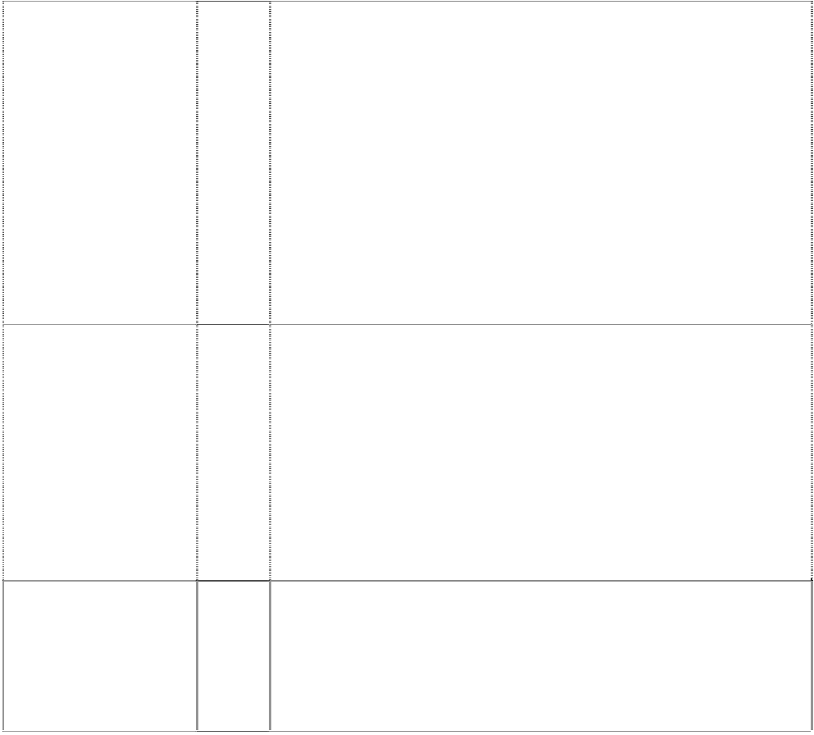

man in singlet clasps anchor to chest,breaks shield

(765590)

# FREMANTLE FOOTBALL CLUB

man in singlet clasps anchor to chest,breaks shield

(765592)

# FREMANTLE FOOTBALL CLUB

man holding anchor on shield atop inverted arc

(775238)

# FREMANTLE FOOTBALL CLUB

man in singlet clasps anchor to chest,breaks shield

(765593)

16 Paper, cardboard, goods in class 16 made from paper and/or cardboard; wrapping paper, paper flags, paper pennants, paper bibs, paper placemats, paper napkins, paper coasters, cardboard coasters, printed matter, printed publications, books, magazines, newspapers, activity books, statistical books, guide books, reference books, newsletters, pamphlets, printed programs, printed entertainment programs, printed game programs, printed fixtures; printed matter for the radio, television and print media; stationery, exercise books, diaries, calendars, memo pads, folders, note books, multi-ring binders, book covers, portfolios, printed statistics sheets, writing instruments, ball point pens, pencils, office requisites except furniture, drawing rulers, erasers, instructional and teaching materials except apparatus, cards, playing cards, trading cards, sports trading cards, football trading cards, dance team trading cards, mascot trading cards, entertainment trading cards, post cards, greeting cards, note cards, stamps, sports stamps, football stamps, posters, stickers, bumper stickers, decalcomanias, albums, scrap books, autograph books, photographs, mounted photographs, line art colour boards, non-textile labels, tickets and control tokens.

28 Games, playthings, sporting goods in class 28, balls for games, playballs, rubber action balls, foam action balls, balls for sports, golf balls, footballs, toy footballs, miniature footballs, pumps for inflating sporting balls, needles for such pumps, sports gloves, football gloves, golf gloves, golf bags, golf tees, exercise and physical training apparatus and articles, toys, toys vehicles, toy cars, dolls, jigsaw puzzles, board games; self contained apparatus and instruments for playing games including mechanical games, electronic games, computerised games, battery operated games, games that are portable, games that include a built-in display, games that include a built-in program, games that receive one or more programs; hand held portable self contained apparatus and instruments for playing games; parts, fittings and accessories in class 28 for the aforesaid goods.

30 Baked beans, bakery goods, biscuits, bread, bread rolls, buns, cakes, chewing gum (non medicinal), cereal chips, chocolate, chocolate based beverages, chocolate coated nuts, cocoa, cocoa based beverages, coffee, coffee based beverages, confectionery, corn chips, cookies, dim sims, edible ices, farinaceous foods, flavourings (other than essential oils), foodstuffs in class 30, frozen yoghurt, glucose for food, hamburgers, honey, hot dogs, ice cream, ketchup, muesli, muesli bars, oatmeal, pancakes, pasta, pasties, pastries, pies, pizza, popcorn, sandwiches, sauces (condiments), sausage rolls, spaghetti, spring rolls, tea, toffee coated apples, tomato sauce, yeast extract spreads.

32 Beers; non-alcoholic beverages, fruit juices and fruit drinks; drinkable waters, mineral waters, aerated waters and spring waters; mineral, carbonated, non-carbonated and other flavoured waters; sports drinks and soft drinks; syrups, powders, concentrates and other preparations for use in preparing fruit drinks, sports drinks, soft drinks and other non-alcoholic beverages.

# GEELONG FOOTBALL CLUB GFC



shield,striped (922015)

# GEELONG FOOTBALL CLUB GFC

shield,striped (922015)

# GEELONG FOOTBALL CLUB GFC

shield,striped (922015)

# GEELONG FOOTBALL CLUB GFC

shield,striped (922015)

9 Electric, photographic, cinematographic, video, optical, measuring, signalling and teaching apparatus and instruments; apparatus and instruments for recording and/or transmission and/or reproduction of sound and/or images; cameras and radios; automatic vending machines, data processing equipment and computer apparatus and instruments; computer operating programs, computer programs, computer software and video game software; magnetic data carriers; audio, video, computer and laser tapes, discs, compact discs, cassettes and cartridges; pre-recorded audio, video, computer and laser tapes, discs, compact discs, cassettes and cartridges; sound recordings, video recordings, sound and video recordings; video game and computer game tapes, discs, compact discs, cassettes and cartridges; games in class 9; video games and computer games for playing in game arcades and game playing venues; electronic video arcade game machines, games for use with television receivers and/or computer monitors and/or other separate display apparatus; helmets, parts, fittings and accessories in class 9 for the aforesaid goods.

14 Jewellery, costume jewellery, trinkets, horological instruments, chronometric instruments, sundials, clocks, watches, watch bands, watch straps, watch chains, cuff links, tie clips, tie pins, ornamental pins, earrings, jewellery bracelets, jewellery brooches, jewellery medallions, jewellery necklaces, jewellery rings, jewellery pendants, jewellery buckles, jewellery ornaments, jewellery chains, key chains, key ring trinkets, key ring fobs, medals, coins; goods of precious metal or coated therewith namely badges, boxes, cases, containers and household utensils; and parts, fittings and accessories in class 14 for the aforesaid goods.

16 Paper, cardboard, goods in class 16 made from paper and/or cardboard; wrapping paper, paper flags, paper pennants, paper bibs, paper placemats, paper napkins, paper coasters, cardboard coasters, printed matter, printed publications, books, magazines, newspapers, activity books, statistical books, guide books, reference books, newsletters, pamphlets, printed programs, printed entertainment programs, printed game programs, printed fixtures; printed matter for the radio, television and print media; stationery, exercise books, diaries, calendars, memo pads, folders, note books, multi-ring binders, book covers, portfolios, printed statistics sheets, writing instruments, ball point pens, pencils, office requisites except furniture, drawing rulers, erasers, instructional and teaching materials except apparatus, cards, trading cards, sports trading cards, football trading cards, dance team trading cards, mascot trading cards, entertainment trading cards, post cards, greeting cards, note cards, stamps, sports stamps, football stamps, posters, stickers, bumper stickers, decalcomanias, albums, scrap books, autograph books, photographs, mounted photographs, pictures, line art colouring boards, non-textile labels, tickets and control tokens.

25 Clothing, apparel, leisure wear, sportswear, uniforms, babywear, underwear, underpants, boxer shorts, singlets, leotards, shirts, sports shirts, blouses, T-shirts, tank tops, skivvies, rugby tops, grandpa tops, shorts, board shorts, tracksuits, warm-up suits, pants, warm-up pants, sweat pants, trousers, jeans, dresses, skirts, clothing belts, knitwear, jumpers, sweaters, guernseys, jerseys, cardigans, vests, neckwear, cravats, neckties, scarves, jackets, bomber jackets, blazers, formal wear, suits, coats, parkas, anoraks, rainwear, raincoats, swimsuits, sleepwear, pyjamas, nightshirts, night gowns, dressing gowns, bath robes, cloth bibs, aprons, clothing gloves, mittens, headwear, hats, caps, berets, beanies, ear muffs, clothing hoods, visors, headbands, wristbands, socks, stockings, hosiery, footwear, shoes, boots, sandals and slippers.

# GEELONG FOOTBALL CLUB GFC



shield,striped (922015)

# HAWKS

bird,prey holding football, all styl (713838)

# HAWKS

bird,prey holding football, all styl (713839)

# HAWKS

bird,prey holding football, all styl (713840)

28 Games, playthings, playing cards, sporting goods in class 28, balls for games, playballs, rubber action balls, foam action balls, balls for sports, golf balls, footballs, toy footballs, miniature footballs, pumps for inflating sportingballs, needles for such pumps, sports gloves, football gloves, golf gloves, golf bags, golf tees, exercise and physical training apparatus and articles, toys, toy vehicles, toy cars, dolls, jigsaw puzzles, board games; coin operated games, coin freed games; self contained apparatus and instruments for playing games including mechanical games, electronic games, computerised games, battery operated games, games that are portable, games that include a built-in display, games that include a built-in program, games that receive one or more programs; hand held portable self contained apparatus and instruments for playing games; parts, fittings and accessories in class 28 for the aforesaid goods.

14 Jewellery, costume jewellery, trinkets, horological instruments, chronometric instruments, sundials, clocks, watches, watch bands, watch straps, watch chains, cuff links, tie clips, tie pins, ornamental pins, earrings, jewellery bracelets, jewellery brooches, jewellery medallions, jewellery necklaces, jewellery rings, jewellery pendants, jewellery buckles, jewellery ornaments, jewellery chains, key chains, key ring trinkets, key ring fobs, medals, coins; goods of precious metal or coated therewith namely badges, boxes, cases, containers and household utensils; and parts, fittings and accessories in class 14 for the aforesaid goods.

16 Paper, cardboard, goods in class 16 made from paper and/or cardboard; wrapping paper, paper flags, paper pennants, paper bibs, paper placemats, paper napkins, paper coasters, cardboard coasters, printed matter, printed publications, books, magazines, newspapers, activity books, statistical books, guide books, reference books, newsletters, pamphlets, printed programs, printed entertainment programs, printed game programs, printed fixtures; printed matter for the radio, television and print media; stationery, exercise books, diaries, calendars, memo pads, folders, note books, multi-ring binders, book covers, portfolios, printed statistics sheets, writing instruments, ball point pens, pencils, office requisites except furniture, drawing rulers, erasers, instructional and teaching materials except apparatus, cards, playing cards, trading cards, sports trading cards, football trading cards, dance team trading cards, mascot trading cards, entertainment trading cards, post cards, greeting cards, note cards, stamps, sports stamps, football stamps, posters, stickers, bumper stickers, decalcomanias, albums, scrap books, autograph books, photographs, mounted photographs, line art colouring boards, non-textile labels, tickets and control tokens; all the foregoing goods promoting or otherwise relating to the sport of football.

25 Clothing, leisure wear, sportswear, uniforms, babywear, underwear, underpants, boxer shorts, singlets, leotards, shirts, sports shirts, blouses, T-shirts, sweatshirts, tank tops, skivvies, rugby tops, grandpa tops, shorts, board shorts, track suits, warm-up suits, pants, warm-up pants, sweat pants, trousers, jeans, dresses, skirts, clothing belts, knitwear, jumpers, sweaters, guerneys, jerseys, cardigans, vests, neckwear, cravats, neckties, scarves, jackets, bomber jackets, blazers, formal wear, suits, coats, parkas, anoraks, rainwear, raincoats, swimsuits, sleepwear, pyjamas, nightshirts, night gowns, dressing gowns, bath robes, cloth bibs, aprons, gloves, mittens, headwear, hats, caps, berets, beanies, ear muffs, clothing hoods, visors, headbands, wristbands, socks, stockings, hosiery, footwear, shoes, boots, sandals and slippers.

# HAWKS



bird,prey holding football, all styl (713841)

# HAWKS

bird,prey holding football, all styl (775239)

# KANGAROOS NORTH MELBOURNE FOOTBALL CLUB

kangaroo holds football in shield (1113770)

# KANGAROOS NORTH MELBOURNE FOOTBALL CLUB

kangaroo holds football in shield (1113770)

# KANGAROOS NORTH MELBOURNE FOOTBALL CLUB

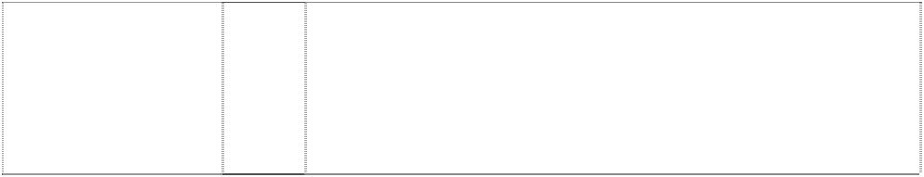kangaroo holds football in shield (1113770)

# KANGAROOS NORTH MELBOURNE FOOTBALL CLUB

kangaroo holds football in shield (1113770)

28 Games, playthings, sporting goods in class 28, balls for games, playballs, rubber action balls, foam action balls, balls for sports, golf balls, footballs, toy footballs, miniature footballs, pumps for inflating sporting balls, needles for such pumps, sports gloves, football gloves, golf gloves, golf bags, golf tees, exercise and physical training apparatus and articles, toys, toy vehicles, toy cars, dolls, jigsaw puzzles, board games; self contained apparatus and instruments for playing games including mechanical games, electronic games, computerised games, battery operated games, games that are portable, games that include a built-in display, games that include a built-in program, games that receive on or more programs; hand held portable self contained apparatus and instruments for playing games; parts, fittings and accessories in class 28 for the aforesaid goods; but excluding games that are adapted or intended for use with a separate television or computer monitor or other separate display apparatus and also excluding games that are coin and/or counter freed or coin and/or counter operated.

30 Baked beans, bakery goods, biscuits, bread, bread rolls, buns, cakes, chewing gum (non medicinal), cereal chips, chocolate, chocolate based beverages, chocolate coated nuts, cocoa, cocoa based beverages, coffee, coffee based beverages, confectionery, corn chips, cookies, dim sims, edible ices, farinaceous foods, flavourings (other than essential oils), foodstuffs in class 30, frozen yoghurt, glucose for food, hamburgers, honey, hot dogs, ice cream, ketchup, muesli, muesli bars, oatmeal, pancakes, pasta, pasties, pastries, pies, pizzas, popcorn, sandwiches, sauces (condiments), sausage rolls, spaghetti, spring rolls, tea, toffee coated apples, tomato sauce, yeast extract spreads.

9 Electric, photographic apparatus and instruments; magnetic data carriers, recording discs; computers; all of the foregoing goods promoting or marketing or otherwise relating to or associated with or indicating a connection with the game or sport of Australian Rules football.

14 Precious metals and their alloys and goods in precious metals or coated therewith; all of the foregoing goods promoting or marketing or otherwise relating to or associated with or indicating a connection with the game or sport of Australian Rules football.

16 Paper, cardboard and goods made from these materials; printed matter; photographs; stationery; plastic materials for packaging; all of the foregoing goods promoting or marketing or otherwise relating to or associated with or indicating a connection with the game or sport of Australian Rules football.

25 Clothing, footwear, headgear; all of the foregoing goods promoting or marketing or otherwise relating to or associated with or indicating a connection with the game or sport of Australian Rules football.

# KANGAROOS NORTH MELBOURNE FOOTBALL CLUB

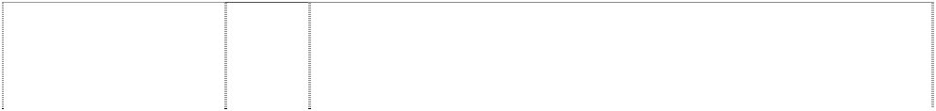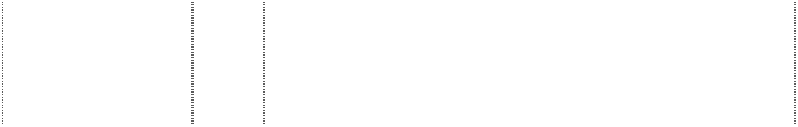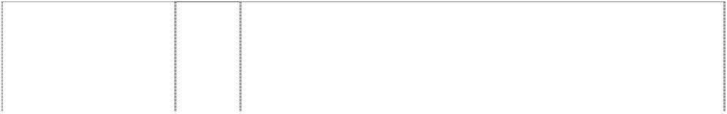

kangaroo holds football in shield (1113770)

# MELBOURNE

devil's face, or mask in flame,all stylised (643435)

# MELBOURNE

devil's face, or mask in flame,all stylised (643437)

# MELBOURNE

devil's face, or mask in flame,all stylised (643438)

# MELBOURNE

devil's face, or mask in flame,all stylised (643439)

# MELBOURNE

devil's face, or mask in flame,all stylised (775241)

**NORM SMITH MEDAL** (564464)

**NORM SMITH MEDAL** (564466)

**NORM SMITH MEDAL** (564468)

28 Games and playthings; sporting articles; all of the foregoing goods promoting or marketing or otherwise relating to or associated with or indicating a connection with the game or sport of Australian Rules football.

14 Jewellery, trinkets, watches, clocks, cuff links, tie clips, tie pins, badges of precious metal, brooches, and all goods in class 14.

16 Paper, cardboard, goods made from paper and cardboard not included in other classes, books, magazines, newspapers, pamphlets, printed matter, photographs, albums, posters, stationery, programs, writing instruments, diaries, office requisites except furniture, instructional and teaching material except apparatus, playing cards, transfers, bumper stickers, and all goods in class 16.

25 Clothing, underwear, underpants, singlets, leotards, shirts, blouses, T-shirts, sweatshirts, shorts, track suits, warm-up pants, pants, trousers, jeans, dresses, skirts, clothing belts, knitwear, jumpers, guernseys, cardigans, vests, neckwear, neckties, scarves, jackets, blazers, suits, coats, rainwear, raincoats, swimwear, sleepwear, pyjamas, nightshirts, night gowns, dressing gowns, bath robes, aprons, gloves, mittens, wristbands, headwear, hats, berets, beanies, caps, visors, headbands, socks, stockings, hosiery, footwear, shoes, boots, slippers, and all goods in class 25.

28 Football and other sporting articles in class 28; exercise and physical training apparatus and articles; balls for games and sport; games and playthings; toys, dolls, and all goods in class 28.

30 Baked beans, bakery goods, biscuits, bread, bread rolls, buns, cakes, chewing gum (non medicinal), cereal chips, chocolate, chocolate based beverages, chocolate coated nuts, cocoa, cocoa based beverages, coffee, coffee based beverages, confectionery, corn chips, cookies, dim sims, edible ices, farinaceous foods, flavourings (other than essential oils), foodstuffs in class 30, frozen yoghurt, glucose for food, hamburgers, honey, hot dogs, ice cream, ketchup, muesli, muesli bars, oatmeal, pancakes, pasta, pasties, pastries, pies, pizzas, popcorn, sandwiches, sauces (condiments), sausage rolls, spaghetti, spring rolls, tea, toffee coated apples, tomato sauce, yeast extract spreads.

16 Paper, cardboard, goods made from paper and cardboard not included in other classes, books, magazines, newspapers, pamphlets, printed matter, photographs, albums, posters, stationery, programs, writing instruments, diaries, office requisites except furniture, instructional and teaching material except apparatus, playing cards, and all other goods in class 16.

25 Clothing, underwear, underpants, shirts, T-shirts, shorts, pants, trousers, jeans, clothing belts, knitwear, jumpers, cardigans, sweatshirts, neckwear, neckties, jackets, blazers, suits, coats, scarves, rainwear, swimwear, sleepwear, pyjamas, nightshirts, dressing gowns, headwear, hats, caps, socks, stockings, hosiery, footwear, shoes, boots, slippers, and all other goods in class 25.

28 Football and other sporting articles in class 28; exercise and physical training apparatus and articles; balls for games and sport; games and playthings; toys, dolls and all other goods in class 28.

# PORT POWER



(667217)

# PORT POWER

(667218)

# PORT POWER

(667219)

# PORT POWER

(667220)

14 Jewellery, costume jewellery, trinkets, horological instruments, chronometric instruments, sundials, clocks, watches, watch bands, watch straps, watch chains, cuff links, tie clips, tie pins, ornamental pins, earrings, jewellery bracelets, jewellery brooches, jewellery medallions, jewellery necklaces, jewellery rings, jewellery pendants, jewellery buckles, jewellery ornaments, jewellery chains, key chains, key ring trinkets, key ring fobs, medals, coins; goods of precious metal or coated therewith namely badges, boxes, cases, containers, and household utensils; and parts, fittings and accessories in class 14 for the aforesaid goods.

16 Paper, cardboard, goods in class 16 made from paper and/or cardboard; wrapping paper, paper flags, paper pennants, paper bibs, paper placemats, paper napkins, paper coasters, cardboard coasters, printed matter, printed publications, books, magazines, newspapers, activity books, statistical books, guide books, reference books, newsletters, pamphlets, printed programs, printed entertainment programs, printed game programs, printed fixtures; printed matter for the radio, television and print media; stationery, exercise books, diaries, calendars, memo pads, folders, note books, multi-ring binders, book covers, portfolios, printed statistics sheets, writing instruments, ball point pens, pencils, office requisites except furniture, drawing rulers, erasers, instructional and teaching materials except apparatus, cards, playing cards, trading cards, sports trading cards, football trading cards, dance team trading cards, mascot trading cards, entertainment trading cards, post cards, greeting cards, note cards, stamps, sports stamps, football stamps, posters, stickers, bumper stickers, decalcomanias, albums, scrap books, autograph books, photographs, mounted photographs, line art colouring boards, non-textile labels, tickets and control tokens.

25 Clothing, leisure wear, sportswear, uniforms, babywear, underwear, underpants, boxer shorts, singlets, leotards, shirts, sports shirts, blouses, T-shirts, sweatshirts, tank tops, skivvies, rugby tops, grandpa tops, shorts, board shorts, track suits, warm-up suits, pants, warm-up pants, sweat pants, trousers, jeans, dresses, skirts, clothing belts, knitwear, jumpers, sweaters, guernseys, jerseys, cardigans, vests, neckwear, cravats, neckties, scarves, jackets, bomber jackets, blazers, formal wear, suits, coats, parkas, anoraks, rainwear, raincoats, swimsuits, sleepwear, pyjamas, nightshirts, night gowns, dressing gowns, bath robes, cloth bibs, aprons, gloves, mittens, headwear, hats, caps, berets, beanies, ear muffs, clothing hoods, visors, headbands, wristbands, socks, stockings, hosiery, footwear, shoes, boots, sandals and slippers.

28 Games, playthings, sporting goods in class 28, balls for games, playballs, rubber action bails, foam action balls, balls for sports, golf balls, footballs, toy footballs, miniature footballs, pumps for inflating sporting balls, needles for such pumps, sports gloves, football gloves, golf gloves, golf bags, golf tees, exercise and physical training apparatus and articles, toys, toy vehicles, toy cars, dolls, jigsaw puzzles, board games; self contained apparatus and instruments for playing games including mechanical games, electronic games, computerised games, battery operated games, games that are portable, games that include a built-in display, games that include a built-in program, games that receive one or more programs; hand held portable self contained apparatus and instruments for playing games; parts, fittings and accessories in class 28 for the aforesaid goods; but excluding games that are adapted or intended for use with a separate television or computer monitor or other separate display apparatus and also excluding games that are coin and/or counter freed or coin and/or counter operated.

# POWER



fist holds bolt of lightning in rect half striped

(839194)

# POWER

fist holds bolt of lightning in rect half striped

(839194)

# POWER

fist holds bolt of lightning in rect half striped

(839194)

# POWER

fist holds bolt of lightning in rect half striped

(839194)

9 Electric, photographic, cinematographic, video, optical, measuring, signalling and teaching apparatus and instruments; apparatus and instruments for recording and/or transmission and/or reproduction of sound and/or images; cameras and radios; automatic vending machines, data processing equipment and computer apparatus and instruments; computer operating programs, computer programs, computer software and video game software; magnetic data carriers; audio, video, computer and laser tapes, discs, compact discs, cassettes and cartridges; pre recorded audio, video, computer and laser tapes, discs, compact discs, cassettes and cartridges; sound recordings, video recordings, sound and video recordings; video game and computer game tapes, discs, compact discs, cassettes and cartridges; games in class 9, coin operated games, coin freed games; video games and computer games for playing in game arcades and game playing venues; electronic video arcade game machines, games for use with television receivers and/or computer monitors and/or other separate display apparatus; helmets, parts, fittings and accessories in class 9 for the aforesaid goods.

14 Jewellery, costume jewellery, trinkets, horological instruments, chronometric instruments, sundials, clocks, watches, watch bands, watch straps, watch chains, cuff links, tie clips, tie pins, ornamental pins, earrings, jewellery bracelets, jewellery brooches, jewellery medallions, jewellery necklaces, jewellery rings, jewellery pendants, jewellery buckles, jewellery ornaments, jewellery chains, key chains, key ring trinkets, key ring fobs, medals, coins; goods of precious metal or coated therewith namely badges, boxes, cases, containers and household utensils; and parts, fittings and accessories in class 14 for the aforesaid goods.

16 Paper, cardboard, goods in class 16 made from paper and/or cardboard; wrapping paper, paper flags, paper pennants, paper bibs, paper placemats, paper napkins, paper coasters, cardboard coasters, printed matter, printed publications, books, magazines, newspapers, activity books, statistical books, guide books, reference books, newsletters, pamphlets, printed programs, printed entertainment programs, printed game programs, printed fixtures; printed matter for the radio, television and print media; stationery, exercise books, diaries, calendars, memo pads, folders, note books, multi-ring binders, book covers, portfolios, printed statistics sheets, writing instruments, ball point pens, pencils, office requisites except furniture, drawing rulers, erasers, instructional and teaching materials except apparatus, cards, playing cards, trading cards, sports trading cards, football trading cards, dance team trading cards, mascot trading cards, entertainment trading cards, post cards, greeting cards, note cards, stamps, sports stamps, football stamps, posters, stickers, bumper stickers, decalcomanias, albums, scrap books, autograph books, photographs, mounted photographs, pictures, line art colouring boards, non-textile labels, tickets and control tokens.

28 Games, playthings, sporting goods in class 28, balls for games, playbalis, rubber action balls, foam action balls, balls for sports, golf balls, footballs, toy footballs, miniature footballs, pumps for inflating sporting balls, needles for such pumps, sports gloves, football gloves, golf gloves, golf bags, golf tees, exercise and physical training apparatus and articles, toys, toy vehicles, toy cars, dolls, jigsaw puzzles, board games; self contained apparatus and instruments for playing games including mechanical games, electronic games, computerised games, battery operated games, games that are portable, games that include a built-in display, games that include a built-in program, games that receive one or more programs; hand held portable self contained apparatus and instruments for playing games; parts, fittings and accessories in class 28 for the aforesaid goods.

# RICHMOND TIGERS



head,tiger in disc atop ribbon

(635398)

# RICHMOND TIGERS

head,tiger in disc atop ribbon

(635399)

# RICHMOND TIGERS

head,tiger in disc atop ribbon

(635400)

# RICHMOND TIGERS

head,tiger in disc atop ribbon

(775243)

# ST. K.F.C.

cross,latin in shield atop scroll (775244)

# SYDNEY SWANS V

swan's head on opera house; breaks ltr V (718368)

14 Jewellery, trinkets, watches, clocks, cuff links, tie clips, tie pins, badges of precious metal, brooches, and all goods in class 14.

16 Paper, cardboard, goods made from paper and cardboard not included in other classes, books, magazines, newspapers, pamphlets, printed matter, photographs, albums, posters, stationery, programs, writing instruments, diaries, office requisites except furniture, instructional and teaching material except apparatus, playing cards, transfers, bumper stickers, and all goods in class 16.

25 Clothing, underwear, underpants, singlets, leotards, shirts, blouses, T-shirts, sweatshirts, shorts, track suits, warm-up pants, pants, trousers, jeans, dresses, skirts, clothing belts, knitwear, jumpers, guernseys, cardigans, vests, neckwear, neckties, scarves, jackets, blazers, suits, coats, rainwear, raincoats, swimwear, sleepwear, pyjamas, nightshirts, night gowns, dressing gowns, bath robes, aprons, gloves, mittens, wristbands, headwear, hats, berets, beanies, caps, visors, headbands, socks, stockings, hosiery, footwear, shoes, boots, slippers, and all goods in class 25.

30 Baked beans, bakery goods, biscuits, bread, bread rolls, buns, cakes, chewing gum (non medicinal), cereal chips, chocolate, chocolate based beverages, chocolate coated nuts, cocoa, cocoa based beverages, coffee, coffee based beverages, confectionery, corn chips, cookies, dim sims, edible ices, farinaceous foods, flavourings (other than essential oils), foodstuffs in class 30, frozen yoghurt, glucose for food, hamburgers, honey, hot dogs, ice cream, ketchup, muesli, muesli bars, oatmeal, pancakes, pasta, pasties, pastries, pies, pizzas, popcorn, sandwiches, sauces (condiments), sausage rolls, spaghetti, spring rolls, tea, toffee coated apples, tomato sauce, yeast extract spreads.

30 Baked beans, bakery goods, biscuits, bread, bread rolls, buns, cakes, chewing gum (non medicinal), cereal chips, chocolate, chocolate based beverages, chocolate coated nuts, cocoa, cocoa based beverages, coffee, coffee based beverages, confectionery, corn chips, cookies, dim sims, edible ices, farinaceous foods, flavourings (other than essential oils), foodstuffs in class 30, frozen yoghurt, glucose for food, hamburgers, honey, hot dogs, ice cream, ketchup, muesli, muesli bars, oatmeal, pancakes, pasta, pasties, pastries, pies, pizzas, popcorn, sandwiches, sauces (condiments), sausage rolls, spaghetti, spring rolls, tea, toffee coated apples, tomato sauce, yeast extract spreads.

14 Jewellery, costume jewellery, trinkets, horological instruments, chronometric instruments, sundials, clocks, watches, watch bands, watch straps, watch chains, cuff links, tie clips, tie pins, ornamental pins, earrings, jewellery bracelets, jewellery brooches, jewellery medallions, jewellery necklaces, jewellery rings, jewellery pendants, jewellery buckles, jewellery ornaments, jewellery chains, key chains, key ring trinkets, key ring fobs, medals, coins; goods of precious metal or coated therewith namely badges, boxes, cases, containers and household utensils; and parts, fittings and accessories in class 14 for the aforesaid goods.

# SYDNEY SWANS V



swan's head on opera house; breaks ltr V (718368)

# SYDNEY SWANS V

swan's head on opera house; breaks ltr V (718368)

# SYDNEY SWANS V

swan's head on opera house; breaks ltr V (718368)

# SYDNEY SWANS V

swan's head on opera house; breaks ltr V (775245)

16 Paper, cardboard, goods in class 16 made from paper and/or cardboard; wrapping paper, paper flags, paper pennants, paper bibs, paper placemats, paper napkins, paper coasters, cardboard coasters, printed matter, printed publications, books, magazines, newspapers, activity books, statistical books, guide books, reference books, newsletters, pamphlets, printed programs, printed entertainment programs, printed game programs, printed fixtures; printed matter for the radio, television and print media; stationery, exercise books, diaries, calendars, memo pads, folders, note books, multi-ring binders, book covers, portfolios, printed statistics sheets, writing instruments, ball point pens, pencils, office requisites except furniture, drawing rulers, erasers, instructional and teaching materials except apparatus, cards, playing cards, trading cards, sports trading cards, football trading cards, dance team trading cards, mascot trading cards, entertainment trading cards, post cards, greeting cards, note cards, stamps, sports stamps, football stamps, posters, stickers, bumper stickers, decalcomanias, albums, scrap books, autograph books, photographs, mounted photographs, line art colouring boards, non-textile labels, tickets and control tokens.

25 Clothing, leisure wear, sportswear, uniforms, babywear, underwear, underpants, boxer shorts, singlets, leotards, shirts, sports shirts, blouses, T-shirts, sweatshirts, tank tops, polo shirts, skivvies, rugby tops, grandpa tops, shorts, board shorts, tracksuits, warm-up suits, pants, warm-up pants, sweat pants, trousers, jeans, dresses, skirts, clothing belts, knitwear, jumpers, sweaters, guernseys, jerseys, cardigans, vests, neckwear, cravats, neckties, scarves, jackets, bomber jackets, blazers, formal wear, suits, coats, parkas, anoraks, rainwear, raincoats, swimsuits, sleepwear, pyjamas, nightshirts, night gowns, dressing gowns, bath robes, cloth bibs, aprons, gloves, mittens, headwear, hats, caps, berets, beanies, ear muffs, clothing hoods, visors, headbands, wristbands, socks, stockings, hosiery, footwear, shoes, boots, sandals and slippers.

28 Games, playthings, sporting goods in class 28, balls for games, playballs, rubber action balls, foam action balls, balls for sports, golf balls, footballs, toy footballs, miniature footballs, pumps for inflating sporting balls, needles for such pumps, sports gloves, football gloves, golf gloves, golf bags, golf tees, exercise and physical training apparatus and articles, toys, toy vehicles, toy cars, dolls, jigsaw puzzles, board games; self contained apparatus and instruments for playing games including mechanical games, electronic games, computerised games, battery operated games, games that are portable, games that include a built-in display, games that include a built-in program, games that receive one or more programs; hand held portable self contained apparatus and instruments for playing games; parts, fittings and accessories in class 28 for the aforesaid goods; but excluding games that are adapted for or intended for use with a separate television or computer monitor or other separate display apparatus and also excluding games that are coin and/or counter freed or coin and/or counter operated.

30 Baked beans, bakery goods, biscuits, bread, bread rolls, buns, cakes, chewing gum (non medicinal), cereal chips, chocolate, chocolate based beverages, chocolate coated nuts, cocoa, cocoa based beverages, coffee, coffee based beverages, confectionery, corn chips, cookies, dim sims, edible ices, farinaceous foods, flavourings (other than essential oils), foodstuffs in class 30, frozen yoghurt, glucose for food, hamburgers, honey, hot dogs, ice cream, ketchup, muesli, muesli bars, oatmeal, pancakes, pasta, pasties, pastries, pies, pizzas, popcorn, sandwiches, sauces (condiments), sausage rolls, spaghetti, spring rolls, tea, toffee coated apples, tomato sauce, yeast extract spreads.

**WEST COAST EAGLES** (506299)



**WEST COAST EAGLES** (506301)

# WESTCOAST EAGLES

head & wing of eagle,styl (792008)

# WESTCOAST EAGLES

head & wing of eagle,styl (792007)

# WESTCOAST EAGLES

head & wing of eagle,styl (792006)

16 Paper, cardboard, goods made from paper and cardboard not included in other classes, books, magazines, newspapers, pamphlets, printed matter, photographs, albums, posters stationery, programs, writing instruments, diaries, office requisites except furniture, instructional and teaching material except apparatus, playing cards, and all other goods in class 16.

25 Clothing, underwear, underpants, shirts, T-shirts, shorts, pants, trousers, jeans, knitwear, jumpers, cardigans, sweatshirts, neckwear, neckties, jackets, blazers, suits, coats, scarves, rainwear, swimwear, sleepwear, pyjamas, nightshirts, dressing gowns, headwear, hats, caps, socks, stockings, hosiery, footwear, shoes, boots, slippers, and all other goods in class 25.

9 Electric, photographic, cinematographic, video, optical, measuring, signalling and teaching apparatus and instruments; apparatus and instruments for recording and/or transmission and/or reproduction of sound and/or images; automatic vending machines, data processing equipment and computer apparatus and instruments; computer operating programs, computer programs, computer software and video game software; magnetic data carriers; audio, video, computer and laser tapes, discs, compact discs, cassettes and cartridges; pre- recorded audio, video, computer and laser tapes, discs, compact discs, cassettes and cartridges; video games and computer game tapes, discs, compact discs, cassettes and cartridges; games in class 9, coin operated games, coin freed games; video games and computer games for playing in game arcades and game playing venues; electronic video arcade game machines, games for use with television receivers and/or computer monitors and/or other separate display apparatus; parts, fittings and accessories in class 9 for the aforesaid goods.

14 Jewellery, costume jewellery, trinkets, horological instruments, chronometric instruments, sundials, clocks, watches, watch bands, watch straps, watch chains, cuff links, tie clips, tie pins, ornamental pins, earrings, jewellery bracelets, jewellery brooches, jewellery medallions, jewellery necklaces, jewellery rings, jewellery pendants, jewellery buckles, jewellery ornaments, jewellery chains, key chains, key ring trinkets, key ring fobs, medals, coins; goods of precious metal or coated therewith namely badges, boxes, cases, containers and household utensils; and parts, fittings and accessories in class 14 for the aforesaid goods.

16 Paper, cardboard, goods in class 16 made from paper and/or cardboard; wrapping paper, paper flags, paper pennants, paper bibs, paper placemats, paper napkins, paper coasters, cardboard coasters, printed matter, printed publications, books, magazines, newspapers, activity books, statistical books, guide books, reference books, newsletters, pamphlets, printed programs, printed entertainment programs, printed game programs, printed fixtures; printed matter for the radio, television and print media; stationery, exercise books, diaries, calendars, memo pads, folders, note books, multi-ring binders, book covers, portfolios, printed statistics sheets, writing instruments, ball point pens, pencils, office requisites except furniture, drawing rulers, erasers, instructional and teaching materials except apparatus, cards, playing cards, trading cards, sports trading cards, football trading cards, dance team trading cards, mascot trading cards, entertainment trading cards, post cards, greeting cards, note cards, stamps, sports stamps, football stamps, posters, stickers, bumper stickers, decalcomartias, albums, scrap books, autograph books, photographs, mounted photographs, pictures, line art colouringboards, non-textile labels, tickets and control tokens.

# WESTCOAST EAGLES



head & wing of eagle,styl (792005)

# WESTCOAST EAGLES

head & wing of eagle,styl (792004)

# WESTCOAST EAGLES

head & wing of eagle,styl (792003)

# WESTERN BULLDOGS

bulldog's head,styl in oval divided by horiz,stripe

(761857)

25 Clothing, leisure wear, sportswear, uniforms, babywear, underwear, underpants, boxer shorts, singlets, leotards, shirts, sports shirts, blouses, T-shirts, tank tops, skivvies, rugby tops, grandpa tops, shorts, board shorts, tracksuits, warm-up suits, pants, warm-up pants, sweat pants, trousers, jeans, dresses, skirts, clothing belts, knitwear, jumpers, sweaters, guernseys, jerseys, cardigans, vests, neckwear, cravats, neckties, scarves, jackets, bomber jackets, blazers, formal wear, suits, coats, parkas, anoraks, rainwear, raincoats, swimsuits, sleepwear, pyjamas, nightshirts, night gowns, dressing gowns, bath robes, cloth bibs, aprons, clothing gloves, mittens, headwear, hats, caps, berets, beanies, ear muffs, clothing hoods, visors, headbands, wristbands, socks, stockings, hosiery, footwear, shoes, boots, sandals and slippers.

28 Games, playthings, sporting goods in class 28, balls for games, playballs, rubber action balls, foam action balls, balls for sports, golf balls, footballs, toy footballs, miniature footballs, pumps for inflating sporting balls, needles for such pumps, sports gloves, football gloves, golf gloves, golf bags, golf tees, exercise and physical training apparatus and articles, toys, toy vehicles, toy cars, dolls, jigsaw puzzles, board games; self contained apparatus and instruments for playing games including mechanical games, electronic games, computerised games, battery operated games, games that are portable, games that include a built-in display, games that include a built-in program, games that receive one or more programs; hand held portable self contained apparatus and instruments for playing games; parts, fittings and accessories in class 28 for the aforesaid goods.

30 Bakery goods, biscuits, bread, bread rolls, buns, cakes, chewing gum (non medicinal), cereal chips, chocolate, chocolate based beverages, chocolate coated nuts, cocoa, cocoa based beverages, coffee, coffee based beverages, confectionery, corn chips, cookies, dim sims, edible ices, farinaceous foods, flavourings (other than essential oils), foodstuffs in class 30, frozen yoghurt, glucose for food, hamburgers, honey, hot dogs, ice cream, ketchup, muesli, muesli bars, oatmeal, pancakes, pasta, pasties, pastries, pies, pizzas, popcorn, sandwiches, sauces (condiments), sausage rolls, spaghetti, spring rolls, tea, toffee coated apples, tomato sauce, yeast extract spreads.

9 Electric, photographic, cinematographic, video, optical, measuring, signalling and teaching apparatus and instruments; apparatus and instruments for recording and/or transmission and/or reproduction of sound and/or images; automatic vending machines, data processing equipment and computer apparatus and instruments; computer operating programs, computer programs, computer software and video game software; magnetic data carriers; audio, video, computer and laser tapes, discs, compact discs, cassettes and cartridges; pre- recorded audio, video, computer and laser tapes, discs, compact discs, cassettes and cartridges; video game and computer game tapes, discs, compact discs, cassettes and cartridges; games in class 9, coin operated games, coin freed games; video games and computer games for playing in game arcades and game playing venues; electronic video arcade game machines, games for use with television receivers and/or computer monitors and/or other separate display apparatus; parts, fillings and accessories in class 9 for the aforesaid goods.

# WESTERN BULLDOGS



bulldog's head,styl in oval divided by horiz,stripe

(761858)

**WESTERN BULLDOGS** (722070)

# WESTERN BULLDOGS

bulldog's head,styl in oval divided by horiz,stripe

(761859)

**WESTERN BULLDOGS** (722070)

14 Jewellery, costume jewellery, trinkets, horological instruments, chronometric instruments, sundials, clocks, watches, watch bands, watch straps, watch chains, cuff links, tie clips, tie pins, ornamental pins, earrings, jewellery bracelets, jewellery brooches, jewellery medallions, jewellery necklaces, jewellery rings, jewellery pendants, jewellery buckles, jewellery ornaments, jewellery chains, key chains, key ring trinkets, key ring fobs, medals, coins; goods of precious metal or coated therewith namely badges, boxes, cases, containers and household utensils; and parts, fittings and accessories in class 14 for the aforesaid goods.

14 Jewellery, costume jewellery, trinkets, horological instruments, chronometric instruments, sundials, clocks, watches, watch bands, watch straps, watch chains, cuff inks, tie clips, tie pins, ornamental pins, earrings, jewellery bracelets, jewelery brooches, jewellery medallions, jewellery necklaces, jewellery rings, jewellery pendants, jewellery buckles, jewellery ornaments, jewellery chains, key chains, key ring trinkets, key ring fobs, medals, coins; goods of precious metals or coated therewith namely badges, boxes, cases, containers and household utensils; and parts, fittings and accessories in class 14 for the aforesaid goods.

16 Paper, cardboard, goods in class 15 made from paper and/or cardboard; wrapping paper, paper flags, paper pennants, paper bibs, paper placemats, paper napkins, paper coasters, cardboard coasters, printed matter, printed publications, books, magazines, newspapers, activity books, statistical books, guide books, reference books, newsletters, pamphlets, printed programs, printed entertainment programs, printed game programs, printed fixtures; printed matter for the radio, television and print media; stationery, exercise books, diaries, calendars, memo pads, folders, note books, multi-ring binders, book covers, portfolios, printed statistics sheets, writing instruments, ball point pens, pencils, office requisites except furniture, drawing rulers, erasers, Instructional and teaching materials except apparatus, cards, playing cards, trading cards, sports trading cards, football trading cards, dance team trading cards, mascot trading cards, entertainment trading cards, post cards, greeting cards, note cards, stamps, sports stamps, football stamps, posters, stickers, bumper stickers, decalcomanias, albums, scrap books, autograph books, photographs, mounted photographs, line art colour boards, non-textile labels, tickets and control tokens.

16 Paper, cardboard, goods in class 16 made from paper and/or cardboard; wrapping paper, paper flags, paper pennants, paper bibs, paper placemats, paper napkins, paper coasters, cardboard coasters, printed matter, printed publications, books, magazines, newspapers, activity books, statistical books, guide books, reference books, newsletters, pamphlets, printed programs, printed entertainment programs, printed game programs, printed fixtures; printed matter for the radio, television and print media; stationery, exercise books, diaries, calendars, memo pads, folders, note books, multi-ring binders, book covers, portfolios, printed statistics sheets, writing instruments, ball point pens, pencils, office requisites except furniture, drawing rulers, erasers, instructional and teaching materials except apparatus, cards, playing cards, trading cards, sports trading cards, football trading cards, dance team trading cards, mascot trading cards, entertainment trading cards, post cards, greeting cards, note cards, stamps, sports stamps, football stamps, posters, stickers, bumper stickers, decalcomanias, albums, scrap books, autograph hooks, photographs, mounted photographs, line art colouring boards, non-textile labels, tickets and control tokens.

**WESTERN BULLDOGS** (722070)



# WESTERN BULLDOGS

bulldog’s head,styl. in oval divided by horiz.stripe

(761860)

**WESTERN BULLDOGS** (722070)

# WESTERN BULLDOGS

bulldog’s head,styl. in oval divided by horiz.stripe

(761861)

25 Clothing, leisure wear, sportswear, uniforms, babywear, underwear, underpants, boxer shorts, singlets, leotards, shirts, sports shirts, blouses, T-shirts, sweatshirts, tank tops, polo shirts, skivvies, rugby tops, grandpa tops, shorts, board shorts, tracksuits, warm-up suits, pants, warm-up pants, sweat pants, trousers, jeans, dresses, skirts, clothing belts, knitwear, jumpers, sweaters, guernseys, jerseys, cardigans, vests, neckwear, cravats, neckties, scarves, jackets, bomber jackets, blazers, formal wear, suits, coats, parkas, anoraks, rainwear, raincoats, swimsuits, sleepwear, pyjamas, nightshirts, night gowns, dressing gowns, bath robes, cloth bibs, aprons, clothing gloves, mittens, headwear, hats, caps, berets, beanies, ear muffs, clothing hoods, visors, headbands, wristbands, socks, stockings, hosiery, footwear, shoes, boots, sandals and slippers.

25 Clothing, leisure wear, sportswear, uniforms, babywear, underwear, underpants, boxer shorts, singlets, leotards, shirts, sports shirts, blouses, T-shirts, tank tops, skivvies, rugby tops, grandpa tops, shorts, board shorts, tracksuits, warm-up suits, pants, warm-up pants, sweat pants, trousers, jeans, dresses, skirts, clothing belts, knitwear, jumpers, sweaters, guernseys, jerseys, cardigans, vests, neckwear, cravats, neckties, scarves, jackets, bomber jackets, blazers, formal wear, suits, coats, parkas, anoraks, rainwear, raincoats, swimsuits, sleepwear, pyjamas, nightshirts, night gowns, dressing gowns, bath robes, cloth bibs, aprons, clothing gloves, mittens, headwear, hats, caps, berets, beanies, ear muffs, clothing hoods, visors, headbands, wristbands, socks, stockings, hosiery, footwear, shoes, boots, sandals and slippers.

28 Games, playthings, sporting goods in class 28, balls for games, playballs, rubber action balls, foam action balls, balls for sports, golf balls, footballs, toy footballs, miniature footballs, pumps for inflating sporting balls, needles for such pumps, sports gloves, football gloves, golf gloves, golf bags, golf tees, exercise and physical training apparatus and articles, toys, toy vehicles, toy cars, dolls, jigsaw puzzles, board games; self contained apparatus and instruments for playing games including mechanical games, electronic games, computerised games, battery operated games, games that are portable, games that include a built-in display, games that include a built-in program, games that receive one or more programs; hand held portable self contained apparatus and instruments for playing games; parts, fittings and accessories in class 28 for the aforesaid goods; but excluding games that are adapted or intended for use with a separate television or computer monitor or other separate display apparatus and also excluding games that are coin and/or counter freed or coin and/or counter operated.

28 Games, playthings, sporting goods in class 28, baIls for games, playballs, rubber action balls, foam action balls, balls for sports, golf balls, footballs, toy footballs, miniature footballs, pumps for inflating sporting balls, needles for such pumps, sports gloves, football gloves, golf gloves, golf bags, golf tees, exercise and physical training apparatus and articles, toys, toys vehicles, toy cars, dolls, jigsaw puzzles, board games; self contained apparatus and instruments for playing games including mechanical games, electronic games, computerised games, battery operated games, games that are portable, games that include a built-in display, games that include a built-in program, games that receive one or more programs; hand held portable self contained apparatus and instruments for playing games; parts, fittings and accessories in class 28 for the aforesaid goods.

# WESTERN BULLDOGS



bulldog’s head,stylin oval divided by horiz.stripe

(775246)

30 Baked beans, bakery goods, biscuits, bread, bread rolls, buns, cakes, chewing gum (non medicinal), cereal chips, chocolate, chocolate based beverages, chocolate coated nuts, cocoa, cocoa based beverages, coffee, coffee based beverages, confectionery, corn chips, cookies, dim sims, edible ices, farinaceous foods, flavourings (other than essential oils), foodstuffs in class 30, frozen yoghurt, glucose for food, hamburgers, honey, hot dogs, ice cream, ketchup, muesli, muesli bars, oatmeal, pancakes, pasta, pasties, pastries, pies, pizzas, popcorn, sandwiches, sauces (condiments), sausage rolls, spaghetti, spring rolls, tea, toffee coated apples, tomato sauce, yeast extract spreads.

***California Board Sports, Inc Halford & Co***

***Ph: (02) 9264 8388***

***Effective Date: 20 March 2007 File Reference: C07/01527 Trade Marks Class Goods***



# OSIRIS

disc, silh. indents bottom of larger disc (869603)

# OSIRIS SHOES

(765629)

disc, silh. indents bottom of larger disc (769600)

18 Luggage including travel packs, backpacks, daypacks, fanny packs, waist packs, garment bags for travel, duffle bags, all purpose athletic bags, travel bags, shoulder bags, wallets, briefcases, attache cases and toiletry cases sold empty, and umbrellas.

25 Clothing, footwear, headgear; including shorts, pants, sweatshirts, hats, shirts, socks.

25 Clothing, footwear, headgear; including shorts, pants, sweatshirts, hats, shirts and socks.

***Coca-Cola Company, The Philips Ormonde & Fitzpatrick Ph: (03) 9614 1944***

***Effective Date: 9 April 2007 File Reference: C07/06589***

***Trade Marks Class Goods***



**“PICCADILLY NATURAL SPRINGS”** (456864)

# A

parallelogram or stripe atop letter

(667026)

# ACTIVE FACTOR

(986278)

# ALIVE

(878842)

32 Natural spring water.

32 Sports drinks, including electrolyte replacement beverages for sports; dietetic and low calorie forms of all the foregoing goods; concentrates, syrups, powders and other preparations and substances for making the foregoing goods.

32 Beverages, namely drinking waters, flavoured waters, mineral and aerated waters; and other non-alcoholic beverages, namely, soft drinks, energy drinks and sport drinks; fruit drinks and juices; syrups, concentrates and powders for making beverages, namely flavoured waters, mineral and aerated waters, soft drinks, energy drinks, sports drinks, fruit drinks and juices.

32 Drinking water, flavoured water, mineral and aerated water; non- alcoholic beverages; soft drinks, energy drinks and sports drinks; fruit drinks and juices; syrups, concentrates and powders for making beverages including mineral and aerated waters, soft drinks, energy drinks, sports drinks, fruit drinks and juices.

**ALL SASS. NO SUGAR.** (1128210)

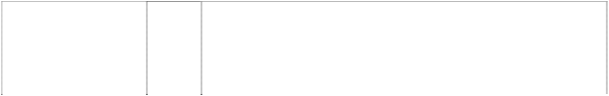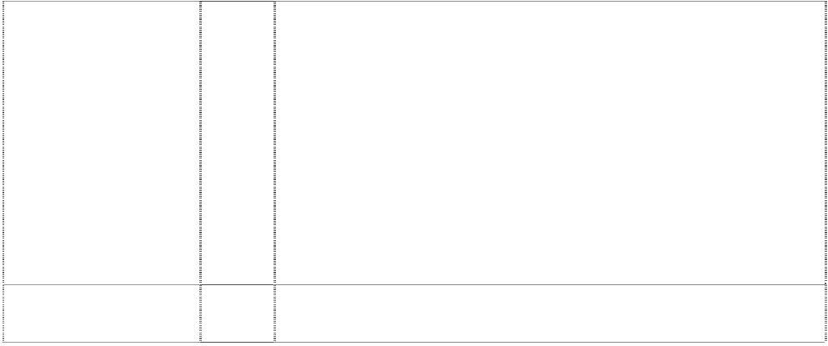

# ALWAYS

(591646)

# ALWAYS COCA- COLA

liquid in bottle in disc fading one side,cresent on other

(593522)

# AMORINO

(985950)

# AMORINO

(985950)

# AQUA SPORTZ

(967721)

# AQUANA

(890528)

# AQUARIUS

(242421)

32 Non-alcoholic beverages; drinking waters, flavoured waters, mineral and aerated waters; carbonated soft drinks, energy drinks and sports drinks; fruit drinks and juices; syrups, concentrates and powders for making beverages including syrups, concentrates and powders for making mineral and aerated waters, carbonated soft drinks, energy drinks, sports drinks, fruit drinks and juices.

32 All goods in class 32 including non-alcoholic drinks and beverages, mineral and aerated waters; soda water, dry ginger ale, tonic water, lemon squash, bitter lemon, lemonade, orangeade; fruit juices, fruit juice drinks and beverages containing fruit juice and fruit juice flavouring, including mineral and aerated water containing fruit juice or fruit juice flavouring; dietetic and low calorie forms of all the foregoing goods; concentrates, syrups and other preparations and substances for making all the foregoing goods.

32 All goods in class 32 including non-alcoholic drinks and beverages, mineral and aerated waters; soda water, dry ginger ale, tonic water, lemon squash, bitter lemon, lemonade, orangeade; fruit juices, fruit juice drinks and beverages containing fruit juice and fruit juice flavouring, including mineral and aerated water containing fruit juice or fruit juice flavouring; dietetic and low calorie forms of all the foregoing goods; concentrates, syrups and other preparations and substances for making all the foregoing goods.

30 Iced confections; ice drinks; sherbets; confectionery; coffee; tea; cocoa; sugar; breads and cereals; biscuits; cookies; boiled lollies; jelly lollies; candy; ices; honey; treacle; preparations in this class for the manufacture of beverages, beverages in this class including tea based beverages; flavourings for beverages; cakes; chewing gum; chocolate; essences for foodstuffs; frozen yoghurt and ice cream.

32 Beverages, namely drinking waters, flavoured waters, mineral and aerated waters; and other non-alcoholic beverages, namely, soft drinks, energy drinks and sports drinks; fruit drinks and juices; syrups, concentrates and powders for making beverages, namely flavoured waters, mineral and aerated waters, soft drinks, energy drinks, sports drinks, fruit drinks and juices.

32 Beverages; drinking waters, flavoured waters, mineral and aerated waters, natural spring waters and other non-alcoholic beverages; soft drinks and sports drinks; fruit drinks and juices; syrups, concentrates and powders for making beverages including mineral and aerated waters, soft drinks, energy drinks, sports drinks, fruit drinks and juices.

32 Beverages in class 32 excluding beers but including non-alcoholic drinks and beverages, drinking waters, mineral and aerated waters; soda water, dry ginger ale, tonic water, lemon squash, bitter lemon, lemonade, orangeade, cordial and cordial based beverages; fruit juices; fruit juice drinks and beverages containing fruit juice and fruit juice flavouring, including mineral and aerated water containing fruit juice or fruit juice flavouring; sports drinks including electrolyte replacement beverages for sports; energy drinks; dietetic and low calorie forms of all the foregoing goods; carbonated and non- carbonated soft drinks and concentrates for making same including beverages in containers; concentrates, syrups, powders and other preparations and substances for making all the foregoing goods.

32 Non-alcoholic beverages, syrups and other preparations for making such beverages, and fruit juices.

# AQUARIUS

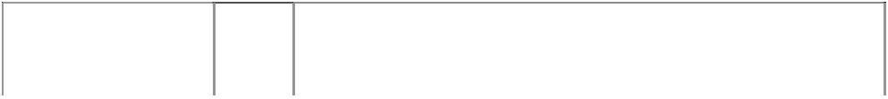

(923018)

# AQUARIUS

man in ellipse on mottled rect pours water

(625741)

# AQUARIUS A

(548828)

# AS IT SHOULD BE

(1027567)

# AVELLE

(808892)

# BAMBOOCHA

(1046792)

**BEVERAGE EXPRESS** (640558)

**BEVERAGE EXPRESS** (672411)

32 Beverages in class 32 excluding beers but including non- alcoholic drinks and beverages, drinking waters, mineral and aerated waters; soda water, dry ginger ale, tonic water, lemon squash, bitter lemon, lemonade, orangeade, cordial and cordial based beverages; fruit juices; fruit juice drinks and beverages containing fruit juice and fruit juice flavouring, including mineral and aerated water containing fruit juice or fruit juice flavouring; sports drinks including electrolyte replacement beverages for sports; energy drinks; dietetic and low calorie forms of all the foregoing goods; carbonated and non- carbonated soft drinks and concentrates for making same including beverages in containers; concentrates, syrups, powders and other preparations and substances for making all the foregoing goods.

32 All goods in class 32 including non-alcoholic drinks and beverages, but excluding non-alcoholic wines, mineral and aerated waters; soda water, dry ginger ale, tonic water, lemon squash, bitter lemon, lemonade, orangeade; fruit juices, fruit juice drinks and beverages containing fruit juice and fruit juice flavouring, including mineral and aerated water containing fruit juice or fruit juice flavouring; dietetic and low calorie forms ofall the foregoing goods; carbonated and non- carbonated soft drinks and concentrates for making same, including beverages in containers; concentrates, syrups, powders and other preparations and substances for making the foregoing goods.

32 Non-alcoholic beverages and preparations and substances in class 32 for making such beverages and all other goods in this class, but excluding non-alcoholic wines.

32 Non-alcoholic beverages; drinking waters; flavoured waters; mineral and aerated waters; soft drinks, energy drinks and sports drinks; fruit drinks and juices; syrups, concentrates and powders for making beverages including flavoured waters, mineral and aerated waters, soft drinks, energy drinks, sport drinks, fruit drinks and juices.

32 Beverages in class 32 excluding beers but including non-alcoholic drinks and beverages, mineral and aerated waters; drinking water, soda water, dry ginger ale, tonic water, lemon squash, bitter lemon, lemonade, orangeade; fruit juices, fruit juice drinks and beverages containing fruit juice and fruit juice flavouring, including mineral and aerated water containing fruit juice or fruit juice flavouring; sports drinks including electrolyte replacement beverages for sports; dietetic and low calorie forms of all the foregoing goods; carbonated and noncarbonated soft drinks and concentrates for making same including beverages in containers; concentrates, syrups, powders and other preparations and substances for making all the foregoing goods.

32 Non-alcoholic beverages; drinking waters, flavoured waters, mineral and aerated waters; soft drinks, energy drinks and sports drinks; fruit drinks and juices; syrups, concentrates and powders for making beverages; syrups, concentrates and powders for making flavoured waters, mineral and aerated waters, soft drinks, energy drinks, sports drinks, fruit drinks and juices.

11 Beverage vending machines; refrigerated apparatus; refrigerated cabinets including display cabinets, refrigerated apparatus for merchandising of beverages; parts and accessories therefor; all of the foregoing being included in class 11.

30 Tea; dietetic and low calorie forms of the foregoing foods; concentrates, syrups, powders and other preparations and substances for making the foregoing goods.

**BEVERAGE EXPRESS** (640559)

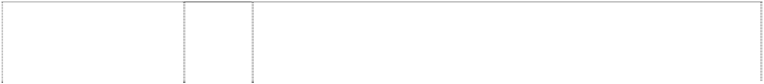

# BIBO

(850892)

# BIBO

(273185)

# BIBO

bottle,silhouette (896435)

# BIG CHILL

(622746)

# BITE INTO IT

(762216)

# BLUE BEAU

(967722)

# BONAQA

(256681)

# BONAQUA

(633938)

32 All goods in class 32 including non-alcoholic drinks and beverages, mineral and aerated waters; soda water, dry ginger ale, tonic water, lemon squash, bitter lemon, lemonade, orangeade; fruit juices, fruit juice drinks and beverages containing fruit juice and fruit juice flavouring, including mineral and aerated water containing fruit juice or fruit juice flavouring; dietetic and low calorie forms of all of the foregoing goods; carbonated and non-carbonated soft drinks and concentrates for making same, including beverages in containers; concentrates, syrups, powders and other preparations and substances for making the foregoing goods.

1. Mineral and aerated waters; fruit drinks and fruit juices; syrups, concentrates and other preparations for making beverages other than granita beverage powder; non-alcoholic drinks other than coconut milk.
2. All goods in Class 33.

32 Mineral and aerated waters; soft drinks; fruit juices and fruit drinks; syrups, concentrates and other preparations for making beverages other than granita beverage power; non-alcoholic beverages and drinks other than coconut milk.

32 Non-alcoholic drinks and beverages, mineral and aerated waters; soda water, dry ginger ale, tonic water, lemon squash, bitter lemon, lemonade, orangeade; fruit juices, fruit juice drinks and beverages containing fruit juice and fruit juice flavouring, including mineral and aerated water containing fruit juice or fruit juice flavouring; dietetic and low calorie forms of all the foregoing goods; carbonated and non-carbonated soft drinks and concentrates for making same, including beverages in containers; concentrates, syrups, powders and other preparations and substances for making the foregoing goods.

32 Beverages in class 32 excluding beers but including non-alcoholic drinks and beverages, mineral and aerated waters; soda water, dry ginger ale, tonic water, lemon squash, bitter lemon, lemonade, orangeade; fruit juices, fruit juice drinks and beverages containing fruit juice and fruit juice flavouring, including mineral and aerated water containing fruit juice or fruit juice flavouring; sports drinks including electrolyte replacement beverages for sports; dietetic and low calorie forms of all the foregoing goods; carbonated and non- carbonated soft drinks and concentrates for making same including beverages in containers; concentrates, syrups, powders and other preparations and substances for making all the foregoing goods.

32 Beverages; drinking waters, flavoured waters, mineral and aerated waters, natural spring waters and other non-alcoholic beverages; soft drinks and sports drinks; fruit drinks and juices; syrups, concentrates and powders for making beverages including mineral and aerated waters, soft drinks, energy drinks, sports drinks, fruit drinks and juices.

32 Non-alcoholic beverages, syrups and other preparations for making such beverages.

32 All goods in class 32 including non-alcoholic drinks and beverages, mineral, table, non-aerated and aerated waters; flavoured and non- flavoured waters; soda water, dry ginger ale, tonic water, lemon squash, bitter lemon, lemonade, orangeade; fruit juices, fruit juice drinks and beverages containing fruit juice and fruit juice flavouring, including mineral, table, non aerated and aerated water containing fruit juice or fruit juice flavouring; teas, dietic and low calorie forms of all the foregoing goods; carbonated and non-carbonated soft drinks and concentrates for making same, including beverages in containers; concentrates, syrups, powders and other preparations and substances for making the foregoing goods.

# BRAND VALUE BRAND LOVE

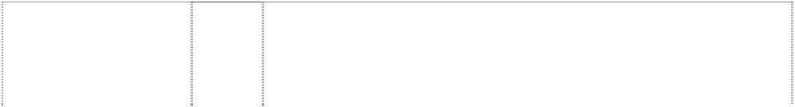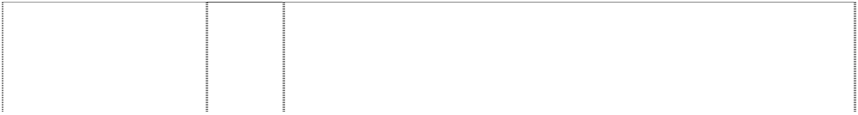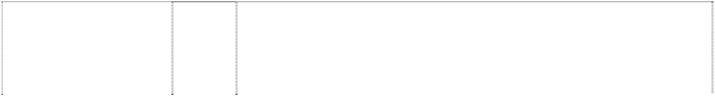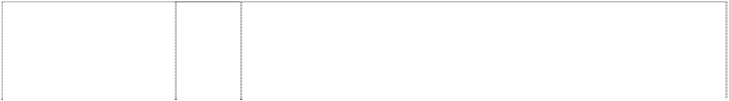

twist in heart (1143422)

# BREAKMATE II

(445217)

# BREAKMATE II

(443687)

# BUDDY

(379996)

# BURN

(843738)

# CHAQWA

(1138275)

# CHAQWA

(1138278)

# CHERRY COCA- COLA

(433936)

# CHERRY COCA- COLA

(433937)

# CHERRY COKE

(433935)

16 Publications, namely books, manuals, pamphlets and newsletters.

11 Apparatus for weighing, measuring and/or dispensing including refrigerated or non-refrigerated machines for mixing, carbonating and/or dispensing beverages, beverage vending machines, and machines for dispensing and merchandising beverages; all the foregoing being goods included in class 11.

9 Apparatus for weighing, measuring and/or dispensing including refrigerated or non-refrigerated machines for mixing, carbonating and/or dispensing beverages, beverage vending machines, and machines for dispensing and merchandising beverages; all the foregoing being goods included in class 9.

21 Small domestic utensils and containers (not of precious metal or coated therewith); kitchen utensils; containers in this class for foods and/or beverages; insulated containers in this class; lunch boxes in this class; picnic hampers in this class; beverage bottles; bottles in this class; and all other goods in this class excluding cleaning cloths.

32 Beverages in class 32 excluding beers but including non- alcoholic drinks and beverages, mineral and aerated waters; soda water, dry ginger ale, tonic water, lemon squash, bitter lemon, lemonade, orangeade; fruit juices, fruit juice drinks and beverages containing fruit juice and fruit juice flavouring, including mineral and aerated water containing fruit juice or fruit juice flavouring; sports drinks including electrolyte replacement beverages for sports; energy drinks including double-caffeine drinks; dietetic and low calorie forms of all the foregoing goods; carbonated and non-carbonated soft drinks and concentrates for making same including beverages in containers; concentrates, syrups, powders and other preparations and substances for making all the foregoing goods.

11 Electric apparatus for preparing warm or hot drinks; electric apparatus for boiling water; coffee filters, coffee machines, coffee percolators and espresso machines; apparatus for cooking food and beverages; apparatus for heating food and beverages; apparatus for cooling food and beverages; apparatus for water supply; apparatus for dispensing beverages.

30 Coffee, coffee essences, coffee extracts, decaffeinated coffee, coffee substitutes, artificial coffee, coffee flavourings; tea, powdered tea, fruit tea, herbal tea, flavoured tea, iced tea, instant tea, artificial tea, infusions (not medicinal); cocoa, drinking chocolate; beverages with coffee, cocoa or chocolate base; sugar, artificial sweetener and coffee whiteners.

32 Finished soft drinks and syrups and concentrates used for making finished soft drinks.

***\*\*The trade mark shall be used only in connection with goods that contain CHERRY flavouring or a flavour that is similar to that of cherries\*\****

32 Non-alcoholic beverages and preparations and substances for making such beverages.

***\*\*The trade mark shall be used only in connection with goods that contain CHERRY flavouring or a flavour that is similar to that of cherries\*\****

32 Finished soft drinks and syrups and concentrates used for making finished soft drinks.

***\*\*The trade mark shall be used only in connection with goods that contain CHERRY flavouring or a flavour that is similar to that of cherries\*\****

# CHERRY COKE

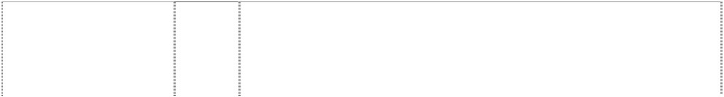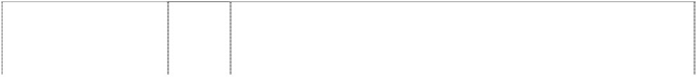

(433934)

# COCA COLA

*shape trade mark:* 3 views of bottle (1055635)

# COCA COLA

*shape trade mark:* 4 views of bottle (1057210)

**COCA COLA SIGNATURE LINE** (1077260)

**COCA COLA SIGNATURE LINE** (1077260)

**COCA COLA SIGNATURE LINE** (1077259)

# COCA-COLA

(357343)

# COCA-COLA

(357344)

# COCA-COLA

(580703)

# COCA-COLA

(357345)

# COCA-COLA

(398099)

# COCA-COLA

(357346)

# COCA-COLA

(357347)

# COCA-COLA

(357348)

# COCA-COLA

(357349)

# COCA-COLA

(384414)

# COCA-COLA

(337301)

# COCA-COLA

(357350)

# COCA-COLA

(357351)

32 Non-alcoholic beverages and preparations and substances for making such beverages.

***\*\*The trade mark shall be used only in connection with goods that contain CHERRY flavouring or a flavour that is similar to that of cherries\*\****

32 Non-alcoholic beverages; drinking waters; flavoured waters; mineral and aerated waters; soft drinks, energy drinks and sports drinks; fruit drinks and juices; syrups, concentrates and powders for making beverages including flavoured waters, mineral and aerated waters, soft drinks, energy drinks, sports drinks, fruit drinks and juices.

32 Non-alcoholic beverages; drinking waters; flavoured waters; mineral and aerated waters; soft drinks, energy drinks and sports drinks; fruit drinks and juices; syrups, concentrates and powders for making beverages including flavoured waters, mineral and aerated waters, soft drinks, energy drinks, sports drinks, fruit drinks and juices.

***\*\*The trade mark consists of the word COCA-COLA applied to the shape of a silver coloured 3-dimensional bottle as shown in the image contained in the Picture Register\*\****

1. Drinking straws and fizz stoppers.
2. Bottle storage containers; bottle carriers being insulated bottle holders; cooling sticks being cooling devices for beverages.

21 Drinking glasses; ice buckets; coasters; not of paper and other linen; bottle openers; coolers; bottle coolers; can/bottle sleeves; travel cups; trays for domestic purposes, not of precious metal; and ice trays.

11 All goods in this class.

1. All goods in this class.
2. All goods in class 15, including musical instruments, musical dioramas.
3. All goods in this class.

16 All goods included in this class.

18 All goods in this class.

1. All goods in this class.
2. Dispensers for drinking straws and all other goods in this Class.
3. All goods in this class.
4. All goods in this class.
5. All goods in this class.
6. All goods in this class.
7. All goods in this class.

# COCA-COLA



(357352)

# COCA-COLA

(230196)

# COCA-COLA

(940056)

# COCA-COLA

(93487)

# COCA-COLA

(806728)

# COCA-COLA

(438021)

# COCA-COLA

(27136)

# COCA-COLA

(357353)

# COCA-COLA

(428104)

# COCA-COLA

(579371)

# COCA-COLA

(357342)

# COCA-COLA

(944613)

# COCA-COLA

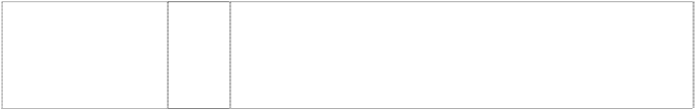bottle (172526)

# COCA-COLA

wavy stripes or rectangle twisted with bubbles

(941588)

1. All goods in this class.

30 Iced confections, sherberts and preparations for making the same all being goods containing Cola-nut extract.

30 Iced confections; ice drinks; sherbets; confectionery; coffee; tea; cocoa; sugar; breads and cereals; biscuits; cookies; boiled lollies; jelly lollies; candy; ices; honey; treacle; preparations in this class for the manufacture of beverages; beverages in this class including tea based beverages; flavourings for beverages; cakes; chewing gum; chocolate; essences for foodstuffs; frozen yoghurt and ice cream.

32 Syrups, concentrates, essences, extracts, beverages, and preparations for making beverages or for use as ingredients in beverages.

32 Mineral and aerated waters and other non-alcoholic drinks; fruit drinks and fruit juices; syrups, concentrates and other preparations for making beverages.

32 All goods in class 32 including aerated non-intoxicating beverages; beverages; mineral and aerated waters and other non-alcoholic drinks; syrups, concentrates, essences, extracts, and preparations for making beverages or for use as ingredients in beverages.

32 Aerated non-intoxicating beverages; beverages; syrup for making beverages.

34 All goods in this class.

6 Cans, boxes and containers of metal; and all other goods in class 6.

1. All goods in class 8 including non-electric can openers but excluding non-electronic bottle openers.
2. All goods in this class.

9 Scientific, photographic, cinematographic, optical, weighing, measuring and teaching apparatus and instruments; apparatus and instruments for recording, transmission or reproduction of sound or images; magnetic data carriers, recording discs; automatic vending machines including machines for dispensing beverages; cash registers; cell phones and other mobile communication devices; parts and accessories for mobile telephones in this class including mobile telephone covers; pre-recorded tapes; compact discs; CD-ROMs (compact disc-read only memories); computers and parts and accessories for computers in this class; computer software including computer games; DVDs (digital versatile discs); swimming floats for recreational use; cameras including digital cameras; video cameras; calculators; binoculars; eye glasses and contact lenses; eyeglass cases; radios and clock radios.

32 Mineral and aerated waters and other non-alcoholic drinks; syrups and other preparations for making beverages.

32 Beverages, namely drinking waters, flavoured waters, mineral and aerated waters; and other non-alcoholic beverages, namely, soft drinks, energy drinks and sports drinks; fruit drinks and juices; syrups, concentrates and powders for making beverages, namely flavoured waters, mineral and aerated waters, soft drinks, energy drinks, sports drinks, fruit drinks and juices.

# COCA-COLA ALWAYS

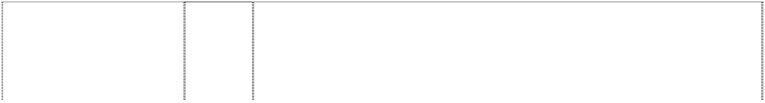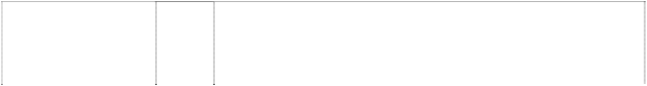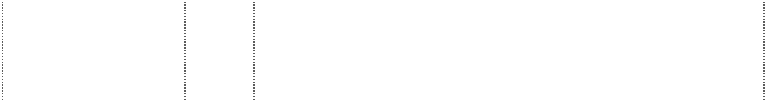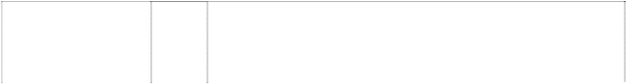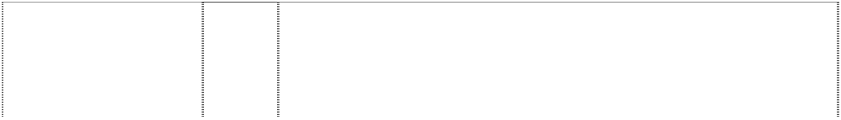

curved rect atop disc containing bottle (599386)

# COCA-COLA BLAK

(1023595)

# COCA-COLA BLAK

(1023596)

# COCA-COLA BOLD

(995569)

# COCA-COLA C2

(995570)

# COCA-COLA CL

(995568)

# COCA-COLA ENJOY FROZEN

stripe,curved dividing square

(393340)

# COCA-COLA ENJOY FROZEN

stripe,curved dividing square

(393340)

# COCA-COLA LIVE

(1101817)

**COCA-COLA LIVE’N LOCAL UP CLOSE** (1101816)

# COCA-COLA M5

(1089113)

32 All goods in class 32 including non-alcoholic drinks and beverages, mineral and aerated waters; soda water, dry ginger ale, tonic water, lemon squash, bitter lemon, lemonade, orangeade; fruit juices, fruit juice drinks and beverages containing fruit juice and fruit juice flavouring, including mineral and aerated water containing fruit juice or fruit juice flavouring; dietetic and low calorie forms of all the foregoing goods; concentrates, syrups and other preparations and substances for making all the foregoing goods.

30 Coffee, tea, cocoa, artificial coffee and ices and other non-alcoholic beverages in this class.

32 Non-alcoholic beverages; drinking waters; flavoured waters; mineral and aerated waters; soft drinks, energy drinks and sports drinks; fruit drinks and juices; syrups, concentrates and powders for making beverages including flavoured waters, mineral and aerated waters, soft drinks, energy drinks, sports drinks, fruit drinks and juices.

32 Non-alcoholic beverages; drinking waters; flavoured waters; mineral and aerated waters; soft drinks, energy drinks and sports drinks; fruit drinks and juices; syrups, concentrates and powders for making beverages including flavoured waters, mineral and aerated waters, soft drinks, energy drinks, sports drinks, fruit drinks and juices.

32 Non-alcoholic beverages; drinking waters; flavoured waters; mineral and aerated waters; soft drinks, energy drinks and sports drinks; fruit drinks and juices; syrups, concentrates and powders for making beverages including flavoured waters, mineral and aerated waters, soft drinks, energy drinks, sports drinks, fruit drinks and juices.

32 Non-alcoholic beverages; drinking waters; flavoured waters; mineral and aerated waters; soft drinks, energy drinks and sports drinks; fruit drinks and juices; syrups, concentrates and powders for making beverages including flavoured waters, mineral and aerated waters, soft drinks, energy drinks, sports drinks, fruit drinks and juices.

30 Edible ices including iced confections, sherbets and preparations for making any of the aforesaid.

32 Non-alcoholic beverages, syrups and other preparations for making such beverages.

32 Non-alcoholic beverages; drinking waters, flavoured waters, mineral and aerated waters; soft drinks, energy drinks and sports drinks; fruit drinks and juices; syrups, concentrates and powders for making beverages including syrups, concentrates and powders for making mineral and aerated waters, soft drinks, energy drinks, sports drinks, fruit drinks and juices.

32 Non-alcoholic beverages; drinking waters, flavoured waters, mineral and aerated waters; soft drinks, energy drinks and sports drinks; fruit drinks and juices; syrups, concentrates and powders for making beverages including syrups, concentrates and powders for making mineral and aerated waters, soft drinks, energy drinks, sports drinks, fruit drinks and juices.

32 Non-alcoholic beverages; drinking waters; flavoured waters; mineral and aerated waters; soft drinks; energy drinks and sports drinks; fruit drinks and juices; syrups, concentrates and powders for making beverages including flavoured waters, mineral and aerated waters, soft drinks, energy drinks, sports drinks, fruit drinks and juices.

# COCA-COLA M5

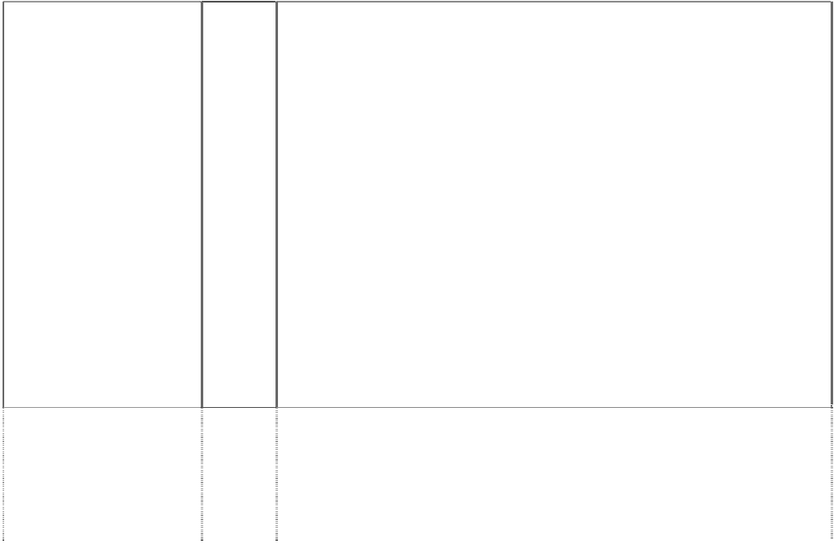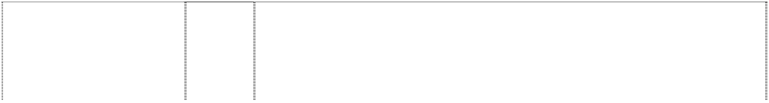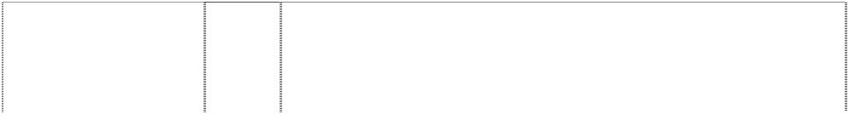

(1121376)

# COCA-COLA M5

(1089113)

# COCA-COLA M5

(1121376)

**COCA-COLA MAKKIO** (1023598)

**COCA-COLA MAKKIO** (1023597)

# COCA-COLA MAQIO

(1023593)

# COCA-COLA MAQIO

(1023594)

# COCA-COLA PLUS

(1097883)

**COCA-COLA REAL REFRESHMENT** (956644)

32 Non-alcoholic beverages; drinking waters, flavoured waters, mineral and aerated waters; soft drinks, energy drinks and sports drinks; fruit drinks and juices; syrups, concentrates and powders for making beverages including syrups, concentrates and powders for making mineral and aerated waters, soft drinks, energy drinks, sports drinks, fruit drinks and juices.

9 Scientific, photographic, cinematographic, optical, weighing, measuring and teaching apparatus and instruments; apparatus and instruments for recording, transmission or reproduction of sound or images; magnetic data carriers, recording discs; automatic vending machines including machines for dispensing beverages; cash registers; cell phones and other mobile communication devices; parts and accessories for mobile telephones in this class including mobile telephone covers; pre-recorded tapes; compact discs; CD-ROMs (compact disc-read only memories); computers and parts and accessories for computers in this class; computer software including computer games; DVDs (digital video discs); cameras including digital cameras; video cameras; calculators; binoculars; eye glasses including sun glasses and contact lenses; eyeglass and sun glass cases; radios and clock radios; pre-recorded CDs, video tapes, laser disks, software and DVDs featuring musical, dramatic, animation, mixed media and/or multimedia performances.

9 Apparatus for recording, transmission or reproduction of sound or images; prerecorded CDs, video tapes, laser disks, software and DVDs; pre-recorded CDs, video tapes, laser disks, software and DVDs featuring musical, dramatic, animation, mixed media and/or multimedia performances.

30 Coffee, tea, cocoa, artificial coffee and ices and other non-alcoholic beverages in this class.

32 Non-alcoholic beverages; drinking waters; flavoured waters; mineral and aerated waters; soft drinks, energy drinks and sports drinks; fruit drinks and juices; syrups, concentrates and powders for making beverages including flavoured waters, mineral and aerated waters, soft drinks, energy drinks, sports drinks, fruit drinks and juices.

30 Coffee, tea, coca, artificial coffee and ices and other non-alcoholic beverages in this class.

32 Non-alcoholic beverages; drinking waters; flavoured waters; mineral and aerated waters; soft drinks, energy drinks and sports drinks; fruit drinks and juices; syrups, concentrates and powders for making beverages including flavoured waters, mineral and aerated waters, soft drinks, energy drinks, sports drinks, fruit drinks and juices.

32 Non-alcoholic beverages, namely, carbonated soft drinks; syrups and concentrates for making beverages, namely carbonated soft drinks; all other non-alcoholic beverages; drinking waters, flavoured waters, mineral and aerated waters; soft drinks, energy drinks and sports drinks; fruit drinks and juices; syrups, concentrates and powders for making all other beverages including syrups, concentrates and powders for making mineral and aerated waters, soft drinks, energy drinks, sports drinks, fruits drinks and juices.

32 Beverages, namely drinking waters, bottled waters, flavoured waters, mineral and aerated waters; and other non-alcoholic beverages, namely soft drinks, energy drinks, and sports drinks; fruit drinks and fruit juices; syrups, concentrates and powders for making beverages, namely mineral and aerated waters, soft drinks, energy drinks, sports drinks, fruit drinks and fruit juices.

# COCA-COLA SPONSOR A FULLY GROWN MAN

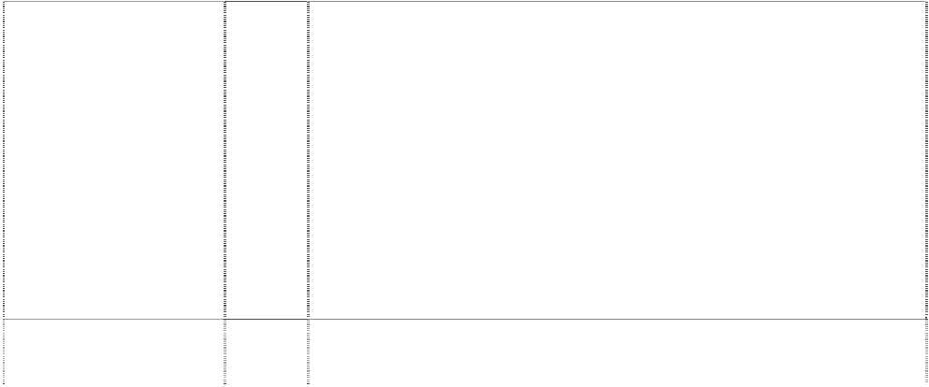

(1106177)

# COCA-COLA ZERO

(1073424)

# COCA-COLA ZERO

wavy stripes form twist (1078378)

# COCA-COLA ZERO REAL TASTE ZERO SUGAR

wavy stripes form twist (1078377)

**COCA-COLA, LIFE TASTES GOOD** (866143)

# COKE

(357331)

# COKE

(357332)

# COKE

(580702)

# COKE

(357333)

# COKE

(398098)

# COKE

(357334)

# COKE

(357335)

# COKE

(357336)

# COKE

(419165)

32 Non-alcoholic beverages; drinking waters, flavoured waters, mineral and aerated waters; soft drinks, energy drinks and sports drinks; fruit drinks and juices; syrups, concentrates and powders for making beverages including syrups, concentrates and powders for making mineral and aerated waters, soft drinks, energy drinks, sports drinks, fruit drinks and juices.

32 Beverages, namely soft drinks; syrups and concentrates for making the same.

32 Beverages; drinking waters, flavoured waters, mineral and aerated waters; and other non-alcoholic beverages; soft drinks, energy drinks, sports drinks; fruit drinks and juices; syrups, concentrates and powders for making beverages including syrups, concentrates and powders for making mineral and aerated waters, soft drinks, energy drinks, sports drinks, fruit drinks and juices.

***\*\*The Trade Mark consists of the combination of words and colours as shown in the image contained in the Picture Register\*\****

32 Beverages; drinking waters, flavoured waters, mineral and aerated waters; and other non-alcoholic beverages; soft drinks, energy drinks, sports drinks; fruit drinks and juices; syrups, concentrates and powders for making beverages including syrups, concentrates and powders for making mineral and aerated waters, soft drinks, energy drinks, sports drinks, fruit drinks and juices.

***\*\*The Trade Mark consists of the combination of words and colours as shown in the image contained in the Picture Register\*\****

32 Beverages in class 32 excluding beers but including non-alcoholic drinks and beverages, mineral and aerated waters; soda water, dry ginger ale, tonic water, lemon squash, bitter lemon, lemonade, orangeade; fruit juices, fruit juice drinks and beverages containing fruit juice and fruit juice flavouring, including mineral and aerated water containing fruit juice or fruit juice flavouring; sports drinks including electrolyte replacement beverages for sports; energy drinks including double-caffeine drinks; dietetic and low calorie forms of all the foregoing goods; carbonated and non-carbonated soft drinks and concentrates for making same including beverages in containers; concentrates, syrups, powders and other preparations and substances for making all the foregoing goods.

11 All goods in Cl. 11 excluding furnaces and other coke-fired appliances.

1. All goods in this class.
2. All goods in class 15, including musical instruments, musical dioramas.
3. All goods in this class.

16 All goods included in this class.

18 All goods in this class.

1. All goods in this class.
2. Dispensers for drinking straws and all other goods in this Class.
3. All goods in this class not being sacks or bags for packaging.

# COKE



(357337)

# COKE

(337300)

# COKE

(384413)

# COKE

(357338)

# COKE

(357339)

# COKE

(357340)

# COKE

(79791)

# COKE

(259964)

# COKE

(259965)

# COKE

(259966)

# COKE

(959804)

# COKE

(593832)

# COKE

(357341)

# COKE

(428105)

# COKE

(579372)

# COKE

(357330)

* 1. All goods in this class.
  2. All goods in this class.

1. All goods in this class.
2. All goods in this class.
3. All goods in this class.
4. All goods in this class.
5. Substances used as food or as ingredients in food.
6. Substances used as food or as ingredients in food.
7. Substances used as food or as ingredients in food.
8. Substances used as food or as ingredients in food included in this class including non-aerated non-alcoholic beverages and preparations for making aerated and non-aerated non-alcoholic beverages; mineral and aerated waters, natural and artificial, including ginger beer.

32 Beverages, drinking waters, flavoured waters, mineral and aerated waters, and other non-alcoholic beverages, namely soft drinks, energy drinks, and sports drinks; fruit drinks and juices; syrups, concentrates and powders for making beverages, namely mineral and aerated waters, soft drinks, energy drinks, sports drinks, fruit drinks and juices.

32 All goods in class 32 including non-alcoholic drinks and beverages, mineral and aerated waters; soda water, dry ginger ale, tonic water, lemon squash, bitter lemon, lemonade, orangeade; fruit juices, fruit juice drinks and beverages containing fruit juice; dietetic and low calorie forms of all the foregoing goods; concentrates, syrups and other preparations and substances for making all the foregoing goods.

34 All goods in this class.

6 Cans, boxes and containers of metal; and all other goods in class 6.

1. All goods in class 8 including non-electric can openers but excluding non-electric bottle openers.
2. All goods in this class.

# COKE



(944614)

# COKE LIGHT

(385316)

# COKE LIVE

(1034496)

# COKE LIVE’N LOCAL

(1034495)

# CONVERTIBLE

(558307)

# CONVERTIBLE

(558309)

# CROSS TRAINER

(1084068)

# DASANI

(885869)

9 Scientific, photographic, cinematographic, optical, weighing, measuring and teaching apparatus and instruments; apparatus and instruments for recording, transmission or reproduction of sound or images; magnetic data carriers, recording discs; automatic vending machines including machines for dispensing beverages; cash registers; cell phones and other mobile communication devices; parts and accessories for mobile telephones in this class including mobile telephone covers; pre-recorded tapes; compact discs; CD-ROMs (compact disc-read only memories); computers and parts and accessories for computers in this class; computer software including computer games; DVDs (digital versatile discs); swimming floats for recreational use; cameras including digital cameras; video cameras; calculators; binoculars; eye glasses and contact lenses; eyeglass cases; radios and clock radios.

32 Non-alcoholic beverages (including dietetic and/or low calorie non- alcoholic beverages) and preparations for making such beverages.

32 Non-alcoholic beverages; drinking waters; flavoured waters; mineral and aerated waters; soft drinks; energy drinks and sports drinks; fruit drinks and juices; syrups, concentrates and powders for making beverages including flavoured waters, mineral and aerated waters, soft drinks, energy drinks, sports drinks, fruit drinks and juices.

32 Non-alcoholic beverages; drinking waters; flavoured waters; mineral and aerated waters; soft drinks; energy drinks and sports drinks; fruit drinks and juices; syrups, concentrates and powders for making beverages including flavoured waters, mineral and aerated waters, soft drinks, energy drinks, sports drinks, fruit drinks and juices.

11 All goods in class 11 including apparatus for refrigerated or non- refrigerated machines for mixing, carbonating and/or dispensing beverages; manually operated apparatus for dispensing or vending liquids; beverage vending machines; and machines for dispensing and merchandising beverages; including beverage post-mix dispensers; parts and accessories therefor; all the foregoing being included in this class.

9 Apparatus for weighing, measuring and/or dispensing including vending machines; refrigerated or non-refrigerated machines for mixing, carbonating and/or dispensing beverages; electrical apparatus for the automated dispensing and mixing of measured quantities of beverages; beverage vending machines; and machines for dispensing and merchandising beverages; including beverage post-mix dispensers; parts and accessories therefor; all the foregoing being included in this class; excluding computers and computer programs in this class.

32 Beverages; drinking waters, flavoured waters, mineral and aerated waters; and other non-alcoholic beverages; soft drinks, energy drinks, and sports drinks; fruit drinks and juices; syrups, concentrates and powders for making beverages including syrups, concentrates and powders for making mineral and aerated waters, soft drinks, energy drinks, sports drinks, fruit drinks and juices.

32 Beverages in class 32 excluding beers but including non- alcoholic drinks and beverages, drinking waters, mineral and aerated waters; soda water, dry ginger ale, tonic water, lemon squash, bitter lemon, lemonade, orangeade, cordial and cordial based beverages; fruit juices; fruit juice drinks and beverages containing fruit juice and fruit juice flavouring, including mineral and aerated water containing fruit juice or fruit juice flavouring; sports drinks including electrolyte replacement beverages for sports; energy drinks; dietetic and low calorie forms of all the foregoing goods; carbonated and non- carbonated soft drinks and concentrates for making same including beverages in containers; concentrates, syrups, powders and other preparations and substances for making all the foregoing goods.

# DAYLIGHT



(1048209)

# DIET COCA-COLA

(385315)

# DIET COKE

(385318)

# DIET COKE

wavy stripe divides square,patt,dots, stripes,circles,dot on I is sun,rays wavy stripe divides square

(625742)

# DIET FANTA

(324420)

# DIET LEED

(466873)

# DIET LIFT

(540047)

# DIET SPRITE

(307350)

# DIRTY DOG

(816252)

**DO WHAT YOU WANT** (751047)

# E2

(782860)

# E2

(782860)

# E2

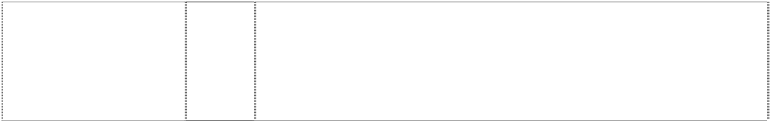(816255)

# EFL

(937074)

32 Non-alcoholic beverages; drinking waters, flavoured waters, mineral and aerated waters; soft drinks, energy drinks and sports drinks; fruit drinks and juices; syrups, concentrates and powders for making beverages; syrups, concentrates and powders for making flavoured waters, mineral and aerated waters, soft drinks, energy drinks, sports drinks, fruit drinks and juices.

32 Non-alcoholic beverages (including dietetic and/or low calorie non- alcoholic beverages) and preparations for making such beverages.

32 Non-alcoholic beverages (including dietetic and/or low calorie non- alcoholic beverages) and preparations for making such beverages.

32 All goods in class 32 including non-alcoholic drinks and beverages, mineral and aerated waters; soda water, dry ginger ale, tonic water, lemon squash, bitter lemon, lemonade, orangeade; fruit juices, fruit juice drinks and beverages containing fruit juice and fruit juice flavouring, including mineral and aerated water containing fruit juice or fruit juice flavouring; dietetic and low calorie forms of all the foregoing goods; carbonated and non-carbonated soft drinks and concentrates for making same, including beverages in containers; concentrates, syrups, powders and other preparations and substances for making the foregoing goods.

32 Non-alcoholic drinks and beverages, mineral and aerated waters; soda water, dry ginger ale, tonic water, lemon squash, bitter lemon, lemonade; low calorie forms of all the foregoing goods; syrups and other preparations for making all the foregoing goods; and all other goods in Cl. 32.

32 Non-alcoholic beverages and syrups and other preparations for making beverages.

32 All goods in class 32 including non-alcoholic beverages and syrups, including dietetic and/or low calorie non-alcoholic beverages and syrups; preparations for making such beverages and syrups.

32 Beer, ale and porter; mineral and aerated waters and other non- alcoholic drinks; syrups and other preparations for making beverages.

32 Medicated and dietary beverages.

32 Non-alcoholic drinks and beverages, mineral and aerated waters; soda water, dry ginger ale, tonic water, lemon squash, bitter lemon, lemonade, orangeade; fruit juices, fruit juice drinks and beverages containing fruit juice and fruit juice flavouring, including mineral and aerated water containing fruit juice or fruit juice flavouring; dietetic and low calorie forms of all the foregoing goods; carbonated and non-carbonated soft drinks and concentrates for making same, including beverages in containers; concentrates, syrups, powders and other preparations and substances for making the foregoing goods.

25 Clothing, footwear and headgear.

32 Mineral and aerated waters, other non alcoholic drinks, fruit drinks and fruit juices syrups and other preparations for making beverages.

5 Medicated and dietary beverages.

32 Beverages, namely drinking waters, flavoured waters, mineral and aerated waters; and other non-alcoholic beverages, namely soft drinks, energy drinks and sports drinks; fruit drinks and juices; syrups, concentrates and powders for making beverages, namely mineral and aerated waters, soft drinks, energy drinks, sports drinks, fruit drinks and juices.

# ENERGY FOR LIFE



(937075)

# ENJOY COCA-COLA

(959805)

# ENJOY COKE

rectangle divided by stripe,curved (532152)

# ENJOY FROZEN COCA-COLA

boy cartoon carrying icecream; stripe,curved divides square

(400312)

# ENJOY FROZEN COCA-COLA

boy cartoon carrying icecream; stripe,curved divides square

(400311)

# FANTA

(333812)

# FANTA

(940058)

# FANTA

(940058)

# FANTA

(182848)

# FANTA

(122692)

# FANTA

(182849)

# FANTA

*shape trade mark:* bulb shaped bottle with bubbles, 4-views

(1025353)

32 Beverages, namely drinking waters, flavoured waters, mineral and aerated waters; and other non-alcoholic beverages, namely soft drinks, energy drinks and sports drinks; fruit drinks and juices; syrups, concentrates and powders for making beverages, namely mineral and aerated waters, soft drinks, energy drinks, sports drinks.

32 Beverages, drinking waters, flavoured waters, mineral and aerated waters, and other non-alcoholic beverages, namely soft drinks, energy drinks, and sports drinks; fruit drinks and juices; syrups, concentrates and powders for making beverages, namely mineral and aerated waters, soft drinks, energy drinks, sports drinks, fruit drinks and juices.

32 All goods in class 32 including non-alcoholic drinks and beverages, mineral and aerated waters; soda water, dry ginger ale, tonic water, lemon squash, bitter lemon, lemonade, orangeade; fruit juices, fruit juice drinks and beverages containing fruit juice; dietetic and low calorie forms of all the foregoing goods; concentrates, syrups and other preparations and substances for making all the foregoing goods.

30 Edible ices including iced confections, sherbets and preparations for making any of the aforesaid.

32 Non-alcoholic beverages, syrups and other preparations for making such beverages.

5 Non-alcoholic drinks and beverages, mineral and aerated waters; soda water, dry ginger ale, tonic water, lemon squash, bitter lemon, lemonade; syrups and other preparations for making all the foregoing goods; all the forgoing goods being dietary foods, infants' and invalids' foods or low-calorie foods included in Class 5.

25 Articles of clothing including shirts, shorts, socks, T-shirts and jackets; headgear including hats and caps; footwear including boots and shoes.

28 Games and playthings; sporting articles including balls, bats and racquets; toys including toy cars; decorations for Christmas trees.

30 Flavourings for beverages, coffee, coffee substitutes, condiments, honey, ices, mate, pastries, sugar, syrup, tea.

1. Mineral and aerated waters, natural and artificial, including ginger beer; syrups, concentrates and other preparations for the making of beverages.
2. Wines, spirits, liqueurs, alcoholic essences, alcoholic fruit extracts, aperitifs, cider, cocktails, cordials, distillations of fruits for use as drinks, quinine wine and other alcoholic beverages.
3. Diary products; mile; flavoured milk; chocolate milk; butter milk; egg nog; cream; whipping cream; light cream; skim milk; half milk and half cream beverages; non-diary coffee creamer.

# FANTA

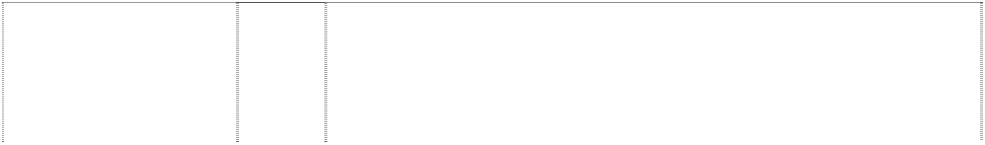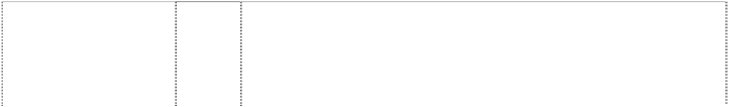

*shape trade mark:* bulb shaped bottle with bubbles, 4-views

(1025352)

# FANTA

*shape trade mark:* bulb shaped bottle with bubbles, 4-views

(1025351)

# FANTA

*shape trade mark:* bulb shaped bottle with bubbles, 4-views

(1025350)

# FANTA

dics,three & leaf (487139)

# FANTA

leaf or drop in stylised bottle-top

(741202)

# FANTA

leaf or flames,styl.& traing.irreg.with segment filling indent

(633090)

# FANTA SOURS

(1039138)

# FANTA SPIDER ORANGE

words break orange,styl.; leaf atop “Fanta”

(988823)

1. Coffee; tea; cocoa; artificial coffee and ices and other non-alcoholic beverages in this class.
2. Non-alcoholic beverages; drinking waters; flavoured waters; mineral and aerated waters; soft drinks, energy drinks and sports drinks; fruit drinks and juices; syrups, concentrates and powders for making beverages including flavoured waters, mineral and aerated waters, soft drinks, energy drinks, sports drinks, fruit drinks and juices.
3. Alcoholic beverages; distilled spirits; liqueurs; wines.

32 All goods in class 32 including non-alcoholic drinks and beverages, mineral and aerated waters; soda water, dry ginger ale, tonic water, lemon squash, bitter lemon, lemonade, orangeade; fruit juices, non- alcoholic fruit juice drinks and non-alcoholic beverages containing fruit juices; dietetic and low calorie forms of all the foregoing goods; concentrates, syrups and other preparations and substances for making all the foregoing goods.

32 Non-alcoholic drinks and beverages, mineral and aerated waters; soda water, dry ginger ale, tonic water, lemon squash, bitter lemon, lemonade, orangeade; fruit juices, fruit juice drinks and beverages containing fruit juice and fruit juice flavouring, including mineral and aerated water containing fruit juice or fruit juice flavouring; teas, dietetic and low calorie forms of all the foregoing goods; carbonated and non-carbonated soft drinks and concentrates for making same, including beverages in containers; concentrates, syrups, powders and other preparations and substances for making the foregoing goods.

32 All goods in class 32 including non-alcoholic drinks and beverages, mineral and aerated waters; soda water, dry ginger ale, tonic water, lemon squash, bitter lemon, lemonade, orangeade; fruit juices, fruit juice drinks and beverages containing fruit juice and fruit juice flavouring, including mineral and aerated water containing fruit juice or fruit juice flavouring; teas, dietetic and low calorie forms of all the foregoing goods; carbonated and non-carbonated soft drinks and concentrates for making same, including beverages in containers; concentrates, syrups, powders and other preparations and substances for making the foregoing goods.

32 Non-alcoholic beverages; drinking waters; flavoured waters; mineral and aerated waters; soft drinks; energy drinks and sports drinks; fruit drinks and juices; syrups, concentrates and powders for making beverages, including flavoured waters, mineral and aerated waters, soft drinks, energy drinks, sports drinks, fruit drinks and juices.

32 Beverages; drinking waters, flavoured waters, mineral and aerated waters, and other non-alcoholic beverages; soft drinks, energy drinks, and sports drinks; fruit drinks and juices; syrups, concentrates and powders for making beverages, including mineral and aerated waters, soft drinks, energy drinks, sports drinks, fruit drinks and juices.

***\*\*The trade mark registration is limited to the colours ORANGE, YELLOW, BLUE, GREEN and WHITE\*\****

# FANTA SPIDER STRAWBERRY



words break orange,styl,; leaf atop “Fanta”

(988824)

# FANTA ZERO

(1078376)

# FANTA ZERO

leaf atop word in whirlpool with bubbles (1075710)

# FANTASIZE WITH FANTA

(592599)

# FANZONE

(761615)

# FANZONE

(761615)

# FANZONE

(761615)

# FANZONE

(761615)

# FANZONE

(761615)

# FANZONE

(761615)

32 Beverages; drinking waters, flavoured waters, mineral and aerated waters, and other non-alcoholic beverages; soft drinks, energy drinks, and sports drinks; fruit drinks and juices; syrups, concentrates and powders for making beverages, including mineral and aerated waters, soft drinks, energy drinks, sports drinks, fruit drinks and juices.

***\*\*The trade mark registration is limited to the colours PINK, YELLOW, BLUE, GREEN and WHITE\*\****

32 Beverages; drinking waters, flavoured waters, mineral and aerated waters; and other non-alcoholic beverages; soft drinks, energy drinks, sports drinks; fruit drinks and juices; syrups, concentrates and powders for making beverages including syrups, concentrates and powders for making mineral and aerated waters, soft drinks, energy drinks, sports drinks, fruit drinks and juices.

32 Beverages; drinking waters, flavoured waters, mineral and aerated waters; and other non-alcoholic beverages; soft drinks, energy drinks, and sports drinks; fruit drinks and juices; syrups, concentrates and powders for making beverages including syrups, concentrates and powders for making mineral and aerated waters, soft drinks, energy drinks, sports drinks, fruit drinks and juices.

32 All goods in class 32 including non-alcoholic drinks and beverages, mineral and aerated waters; soda water, dry ginger ale, tonic water, lemon squash, bitter lemon, lemonade, orangeade; fruit juices, fruit juice drinks and beverages containing fruit juice and fruit juice flavouring, including mineral and aerated water containing fruit juice or fruit juice flavouring; dietetic and low calorie forms of all the foregoing goods; concentrates, syrups and other preparations and substances for making all the foregoing goods.

6 Common metals and their alloys; metal building materials; transportable buildings of metal; materials of metal for railway tracks; non-electric cables and wires of common metal; ironmongery, small items of metal hardware; pipes and tubes of metal; safes; goods of common metal not included in other classes; ores.

9 Scientific, nautical, surveying, electric, photographic, cinematographic, optical, weighing, measuring, signalling, checking (supervision), life-saving and teaching apparatus and instruments; apparatus for recording, transmission or reproduction of sound or images; magnetic data carriers, recording discs; automatic vending machines and mechanisms for coinoperated apparatus; cash registers, calculating machines, data processing equipment and computers; fire-extinguishing apparatus.

14 Precious metals and their alloys and goods in precious metals or coated therewith, not included in other classes; jewellery, precious stones; horological and chronometric instruments.

16 Paper, cardboard and goods made from these materials, not included in other classes; printed matter; bookbinding material; photographs; stationery; adhesives for stationery or household purposes; artists' materials; paint brushes; typewriters and office requisites (except furniture); instructional and teaching material (except apparatus); plastic materials for packaging (not included in other classes); playing cards; printers' type; printing blocks.

18 Leather and imitations of leather, and goods made of these materials and not included in other classes; animal skins, hides; trunks and travelling bags; umbrellas, parasols and walking sticks; whips, harness and saddlery.

20 Furniture, mirrors, picture frames; goods (not included in other classes) of wood, cork, reed, cane, wicker, horn, bone, ivory, whalebone, shell, amber, mother-of-pearl, meerschaum and substitutes for all these materials, or of plastics.

# FANZONE

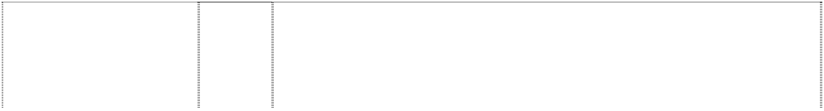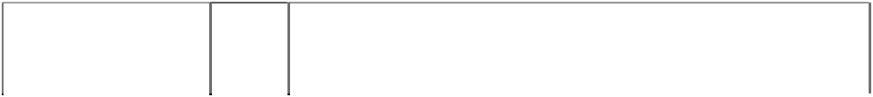

(761615)

# FANZONE

(761615)

# FANZONE

(761615)

# FANZONE

(761615)

# FAR COAST

(1072043)

# FAR COAST

(1072043)

# FAR COAST

(1044532)

# FIVE ALIVE

(343247)

# FIVE ALIVE

(343247)

# FIVE ALIVE

(369685)

# FIZZIMO

(937073)

# FIZZIMO

(943110)

# FLOW FORWARD

(1077398)

# FRIDGE MATE

(835557)

# FRIDGE MATE

(835557)

1. Household or kitchen utensils and containers (not of precious metal or coated therewith); combs and sponges; brushes (except paint brushes); brush-making materials; articles for cleaning purposes; steelwool; unworked or semi-worked glass (except glass used in building); glassware, porcelain and earthenware not included in other classes.
2. Textiles and textile goods, not included in other classes; bed and table covers.

25 Clothing, footwear, headgear.

28 Games and playthings; gymnastic and sporting articles not included in other classes; decorations for Christmas trees.

11 Apparatus for lighting, heating, steam generating, cooking, refrigerating, water supply and sanitary purposes; apparatus for preparing beverages; apparatus for preparing tea or coffee.

25 Clothing, footwear, headgear.

30 Coffee, tea, cocoa, sugar, rice, tapioca, sago, artificial coffee; flour and preparations made from cereals, breads, pastry and confectionery, ices; honey, treacle; yeast, bakingpowder; salt, mustard; vinegar, sauces (condiments); spices; ice.

32 Non-alcoholic drinks and other preparations for making beverages.

32 Non-alcoholic drinks and other preparations for making beverages.

32 Non-alcoholic drinks and beverages, mineral and aerated waters; soda water, dry ginger ale, tonic water, lemon squash, bitter lemon, lemonade; low calorie forms of all the foregoing goods, syrups and other preparations for making all the foregoing goods; and all other goods in Class 32.

29 Milk based beverages and products; dairy beverages; flavoured milk and carbonated milk beverages.

32 Beverages; drinking waters, flavoured waters, mineral and aerated waters; soft drinks, energy drinks, carbonated milk beverages, sports drinks and other non-alcoholic beverages; fruit drinks and juices; syrups, concentrates and powders for making beverages, mineral and aerated waters, soft drinks, energy drinks, sports drinks, fruit drinks and juices.

32 Beverages; drinking waters, flavoured waters, mineral and aerated waters; and other non-alcoholic beverages; soft drinks, energy drinks, and sports drinks; fruit drinks and juices; syrups, concentrates and powders for making beverages including syrups, concentrates and powders for making mineral and aerated waters, soft drinks, energy drinks, sports drinks, fruit drinks and juices.

16 Paper, cardboard and goods made from these materials not included in other classes; cardboard packaging; packaging materials in this class; printed material; packaging in this class for beverage containers.

32 Beverages in class 32 excluding beers but including non-alcoholic drinks and beverages, mineral and aerated waters; soda water, dry ginger ale, tonic water, lemon squash, bitter lemon, lemonade, orangeade; fruit juices, fruit juice drinks and beverages containing fruit juice and fruit juice flavouring, including mineral and aerated water containing fruit juice or fruit juice flavouring; sports drinks including electrolyte replacement beverages for sports; dietetic and low calorie forms of all the foregoing goods; carbonated and non- carbonated soft drinks and concentrates for making same including beverages in containers; concentrates, syrups, powders and other preparations and substances for making all the foregoing goods.

# FROZEN COCA COLA



(398983)

# FROZEN COCA COLA

(398981)

# FROZEN COKE

(398984)

# FROZEN COKE

(398982)

# FRUIT 2DAY

(1113742)

# FRUIT PUNCHES

(947147)

# FRUITOPIA

(646497)

# FRUITOPIA

(622957)

# FRUITOPIA J

orange,halved; dot on ltrs i are leaves (1048205)

# FRUITOPIA J CARNIVALE JUICE

apple, pineapple & oranges; dot on ltrs i are leaves

(1065300)

# FRUITOPIA J SUNTIME JUICE

apple, pineapple & oranges; dot on ltrs i are leaves

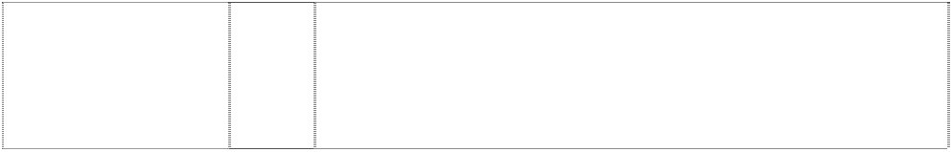(1079843)

# FRUTONIC

(902329)

30 Edible ices including iced confections, sherbets and preparations for making any of the aforesaid, all being goods included in this class.

32 Non-alcoholic beverages, syrups and other preparations for making such beverages included in this class.

30 Edible ices including iced confections, sherbets and preparations for making any of the aforesaid, all being goods included in this class.

32 Non-alcoholic beverages, syrups and other preparations for making such beverages included in this class.

32 Non-alcoholic beverages; drinking waters, flavoured waters, mineral and aerated waters; soft drinks, energy drinks and sports drinks; fruit drinks and juices; syrups, concentrates and powders for making beverages including syrups, concentrates and powders for making mineral and aerated waters, soft drinks, energy drinks, sports drinks, fruit drinks, and juices.

32 Beverages; drinking waters, flavored waters, mineral and aerated waters and other non-alcoholic beverages; soft drinks, energy drinks, and sports drinks; fruit drinks and juices; syrups, concentrates and powders for making beverages; mineral and aerated waters, soft drinks, energy drinks, sports drinks, fruit drinks and juices.

30 Teas including iced teas; dietetic and low calorie forms thereof; concentrates, syrups, powders and other preparations and substances for making the foregoing goods.

32 All goods in class 32 including non-alcoholic drinks and beverages, mineral and aerated waters; soda water, dry ginger ale, tonic water, lemon squash, bitter lemon, lemonade, orangeade; fruit juices, fruit juice drinks and beverages containing fruit juice and fruit juice flavouring, including mineral and aerated water containing fruit juice or fruit juice flavouring; dietetic and low calorie forms of all the foregoing goods in this class; carbonated and non-carbonated soft drinks and concentrates for making same, including beverages in containers; concentrates, syrups, powders and other preparations and substances for making the foregoing goods.

32 Non-alcoholic beverages; drinking waters, flavoured waters, mineral and aerated waters; soft drinks, energy drinks and sports drinks; fruit drinks and juices; syrups, concentrates and powders for making beverages; syrups, concentrates and powders for making flavoured waters, mineral and aerated waters, soft drinks, energy drinks, sports drinks, fruit drinks and juices.

32 Non-alcoholic beverages; drinking waters, flavoured waters, mineral and aerated waters; soft drinks, energy drinks and sports drinks; fruit drinks and juices; syrups, concentrates and powders for making beverages; syrups, concentrates and powders for making flavoured waters, mineral and aerated waters, soft drinks, energy drinks, sports drinks, fruit drinks and juices.

32 Beverages; drinking waters, flavoured waters, mineral and aerated waters; and other non-alcoholic beverages; soft drinks, energy drinks, and sports drinks; fruit drinks and juices; syrups, concentrates and powders for making beverages including syrups, concentrates and powders for making mineral and aerated waters, soft drinks, energy drinks, sports drinks, fruit drinks and juices.

32 Non-alcoholic beverages; drinking waters, flavoured waters, mineral and aerated waters; soft drinks, energy drinks and sports drinks; fruit drinks and juices; syrups, concentrates and powders for making beverages; syrups, concentrates and powders for making mineral and aerated waters, soft drinks, energy drinks, sports drinks, fruit drinks and juices.

# FUEL FOR YOUR BODY

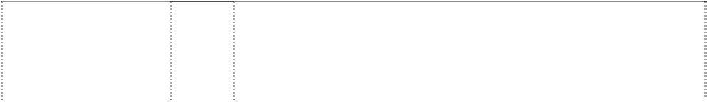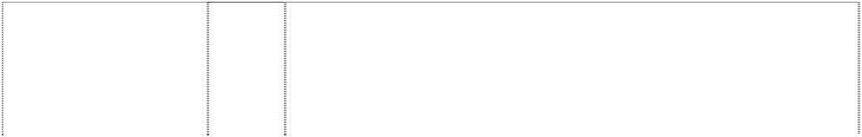

(1065299)

# GEORGIA

lines,vertical sun,rays,rising stars,five-point,several

(411525)

# GET CAUGHT RED HANDED

(828338)

# GOULBURN VALLEY

(1054378)

# GOULBURN VALLEY

words,curve atop oval,double breaks rect.

(1061455)

# GOULBURN VALLEY FRUIT JUICES

tree,silhouette & 3 hills in rectangle

(809071)

# HEALTHWORKS

(1110644)

# HEALTHWORKS

(1110644)

# HEALTHWORKS

(1110644)

# HEALTHWORKS

(1110644)

32 Non-alcoholic beverages; drinking waters, flavoured waters, mineral and aerated waters; soft drinks, energy drinks and sports drinks; fruit drinks and juices; syrups, concentrates and powders for making beverages; syrups, concentrates and powders for making flavoured waters, mineral and aerated waters, soft drinks, energy drinks, sports drinks, fruit drinks and juices.

30 Beverages in this class including coffee, iced coffee, tea, coca, artificial coffee, coffee substitutes, preparations for making the aforesaid; sugar, rice, tapioca, sago; flour and preparations made from cereals, bread, pastry and confectionery, ices; honey, treacle; yeast, baking-powder; salt, mustard; vinegar, sauces (except salad dressings); spices; ice.

32 Beverages in class 32 excluding beers but including non-alcoholic drinks and beverages, mineral and aerated waters; soda water, dry ginger ale, tonic water, lemon squash, bitter lemon, lemonade, orangeade; fruit juices, fruit juice drinks and beverages containing fruit juice and fruit juice flavouring, including mineral and aerated water containing fruit juice or fruit juice flavouring; sports drinks including electrolyte replacement beverages for sports; dietetic and low calorie forms of all the foregoing goods; carbonated and non- carbonated soft drinks and concentrates for making same including beverages in containers; concentrates, syrups, powders and other preparations and substances for making all the foregoing goods.

32 Beers; mineral and aerated waters and other non-alcoholic drinks; fruit drinks and fruit juices; syrups and other preparations for making beverages.

32 Beers; mineral and aerated waters and other non-alcoholic drinks; fruit drinks and fruit juices; syrups and other preparations for making beverages.

32 Non-alcoholic beverages including fruit juices and fruit drinks.

5 Chinese herb tea, medicinal tea, medicinal drinks, medicinal beverages; tonic water; tonic beverages; tonic drinks, herbal beverages (for medicinal use), herbal extracts (for medicinal purposes), herbal infusions (for medicinal use), herbal tea (medicinal use), herbal compounds for medicinal use, herbal preparations for medicinal purposes, medicinal herbal infusions.

1. Soups, soup preparations, soup powders, soup mixes, canned soups, deep frozen soups, ingredients for making soup (all non- medicinal).
2. Coffee, tea, cocoa, artificial coffee, herbal beverages (other than for medicinal use), herbal extracts (other than for medicinal purposes), herbal infusions (other than for medicinal use), herbal tea (other than for medicine use).

32 Fruit drinks, fruit juices, fruit juice beverages, drinks, beverages, tonic water, tonic drinks and tonic beverages, all being bottled; herbal beverages (does not contain nutritional function); fruit drinks, fruit juices, fruit juice beverages, drinks, beverages, tonic water, tonic drinks and tonic beverages, all being canned; fruit drinks, fruit juices, fruit juice beverages, drinks, beverages, tonic water, tonic drinks and tonic beverages, all being boxed; fruit drinks, fruit juices, fruit juice beverages, tonic water, tonic drinks and tonic beverages, all nonmedicated; made to order non-alcoholic beverages; non-alcoholic beverages in any other forms of packaging; syrup and other preparations for making drinks and beverages, powdered beverages (non-medicated and non-alcoholic).

# HEALTHWORKS



2 curls form whorl in disc; 4 characters,chinese

(1126533)

# HEALTHWORKS

2 curls form whorl in disc; 4 characters,chinese

(1126533)

# HEALTHWORKS

2 curls form whorl in disc; 4 characters,chinese

(1126533)

# HEALTHWORKS

2 curls form whorl in disc; 4 characters,chinese

(1126533)

**HEAVEN AND EARTH** (909025)

# HI-C

(166055)

# HI-C

(161221)

# Hidden Valley

(770825)

# HIT

(715956)

# HUG

(1034006)

5 Pharmaceutical and veterinary preparations; dietetic substances adapted for medical use, food for babies; Chinese herb tea, medicinal tea, medicinal drinks, medicinal beverages; tonic water, tonic beverages, tonic drinks, herbal beverages (all for medicinal use); herbal extracts (for medicinal use); herbal infusions (for medicinal use); herbal tea (medicinal use); herbal compounds for medicinal use; herbal preparations for medicinal use; medicinal herbal infusions; Chinese patent medicines; herbal jellies; turtle jellies; tonic medicines.

1. Meat, fish, poultry and game; meat extracts; preserved, dried and cooked fruits and vegetables; jellies, jams, fruit sauces; eggs, milk and milk products; edible oils and fats; soups, soup preparations, soup powders, soup mixes, canned soups, deep frozen soups, ingredients for making soup (all non-medicinal); food supplements and nutritional supplements (other than for medicinal use); natural products being herbal preparations (other than for medicinal use); food supplements with herbs (other than for medicinal uses).
2. Coffee, tea, cocoa, sugar, rice, tapioca, sago, artificial coffee; herbal beverages (other than for medicinal use); herbal extracts (other than for medicinal use); herbal infusions (other than for medicinal use); herbal tea (other than for medicinal use); flour and preparations made from cereals, bread, pastry and confectionery, ices; honey, treacle; yeast, bakingpowder; salt, mustard; vinegar, sauces (condiments); spices; ice; desserts; puddings; rice cakes; food supplements for human consumption; tonic food (other than for medicinal use).

32 Beers; mineral and aerated waters and other non-alcoholic drinks and beverages; fruit drinks and fruit juices; syrups and other preparations for making drinks and beverages; fruit juice beverages; drinks, beverages; tonic water, tonic drinks and tonic beverages; made to order non-alcoholic beverages; powdered beverages (non- alcoholic).

30 Tea based beverages or tea-flavoured beverages; tea; tea extracts; iced tea.

32 Mineral and aerated waters and other non-alcoholic drinks, syrups and other preparations for making beverages.

32 Fruit juice, fruit juice concentrates, fruit juice and fruit beverages and preparations for making the same.

32 Mineral and aerated waters and other non-alcoholic drinks; fruit drinks and fruit juices; water including spring water; treated water for drinking purposes.

32 Non-alcoholic drinks and beverages, mineral and aerated waters; soda water, dry ginger ale, tonic water, lemon squash, bitter lemon, lemonade, orangeade; fruit juices, fruit juice drinks and beverages containing fruit juice and fruit juice flavouring, including mineral and aerated water containing fruit juice or fruit juice flavouring; dietetic and low calorie forms of all the foregoing good in this class; carbonated and non-carbonated soft drinks and concentrates for making same, including beverages in containers; concentrates, syrups, powders and other preparations and substances for making the foregoing goods.

32 Non-alcoholic beverages; drinking waters; flavoured waters; mineral and aerated waters; soft drinks; energy drinks and sports drinks; fruit drinks and juices; syrups, concentrates and powders for making beverages including flavoured waters, mineral and aerated waters, soft drinks, energy drinks, sports drinks, fruit drinks and juices.

**I AIN’T AS SWEET AS I LOOK** (1128209)

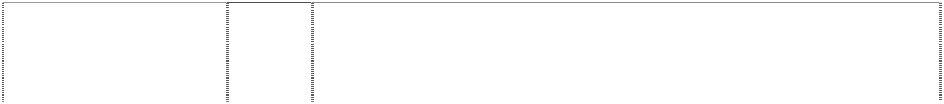

# ICE BOX

(637042)

# ICOKE

(1048208)

# ICOKE

(1048208)

# ICOKE

(1048208)

# ICOKE

(1048208)

# ICOKE

(1048208)

# IKON

(816251)

# IT’S NOT WHAT YOU THINK

(596374)

# J

oval atop hook forms ltr j

(1040200)

# Just Pumped

(919798)

32 Non-alcoholic beverages; drinking waters, flavoured waters, mineral and aerated waters; carbonated soft drinks, energy drinks and sports drinks; fruit drinks and juices; syrups, concentrates and powders for making beverages including syrups, concentrates and powders for making mineral and aerated waters, carbonated soft drinks, energy drinks, sports drinks, fruit drinks and juices.

32 Non-alcoholic drinks and beverages, mineral and aerated waters; soda water, dry ginger ale, tonic water, lemon squash, bitter lemon, lemonade, orangeade; fruit juices, fruit juice drinks and beverages containing fruit juice and fruit juice flavouring, including mineral and aerated water containing fruit juice or fruit juice flavouring; teas, dietetic and low calorie forms of all the foregoing goods; carbonated and non-carbonated soft drinks and concentrates for making same, including beverages in containers, including packaged beverages; concentrates, syrups, powders and other preparations and substances for making the foregoing goods.

16 Temporary tattoos; posters; calendars; daily, desktop and personal planners.

18 Backpacks, book bags, duffel bags, sport bags, athletic bags, gym bags, beach bags, luggage tags and umbrellas.

21 Plates, cups, drinking glasses, tankards not of precious metal, mugs, tumblers, drinking steins, pitchers, decanters, goblets, ice buckets, coasters not of paper and not being table linen, dinnerware, bottles sold empty, dishware, including plates, bowls, cups and saucers.

25 Clothing and clothing accessories, including shirts, shorts, sweatshirts, jackets, bathing suits, beachwear, night shirts, sleepwear, underwear, boxer shorts, bandanas, socks, ties, mittens, and gloves; baseball caps, headwear; and footwear.

28 Toys and games, including sand toys, board games, yoyos, toys made from plastic and metal, namely, spring toys, flying disks, water guns, bubble making wand and solution sets, balloons, and dart boards; golf balls and tees; footballs; baseballs; basketballs; soccer balls; beach balls; rubber and plastic balls; squish balls; spider balls; sporting goods, including inline skates, roller skates, skateboards, wake boards, and boogie boards; toy vehicles and plastic toy figures.

32 Non-alcoholic beverages including mineral water, aerated water, carbonated beverages, fruit drinks and fruit juices; syrups and other preparations for making beverages.

32 All goods in class 32 including non-alcoholic drinks and beverages, mineral and aerated waters; soda water, dry ginger ale, tonic water, lemon squash, bitter lemon, lemonade, orangeade; fruit juices, fruit juice drinks and beverages containing fruit juice and fruit juice flavouring, including mineral and aerated water containing fruit juice or fruit juice flavouring; dietetic and low calorie forms of all the foregoing goods, excluding dietetic beverages adapted for medical purposes; concentrates, syrups and other preparations and substances for making all the foregoing goods being goods included in class 32.

32 Beverages, namely, drinking waters, flavoured waters, mineral and aerated waters; and other non-alcoholic beverages, namely, soft drinks, energy drinks and sports drinks, fruit drinks and juices; syrups, concentrates and powders for making beverages, namely, flavoured waters, mineral and aerated waters, soft drinks, energy drinks, sports drinks, fruit drinks and juices.

32 Bottled still spring water; bottled carbonated spring water.

**KAZOO NATURAL SOFT DRINKS** (966391)

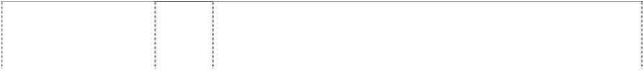

# KERI

(884607)

# kidsfruitz

(641121)

# KIN

(196863)

# KIN

crown,imperial and scrolls

(196863)

# KINTONIC

(202015)

# KIWI BLUE

(573691)

# LEED

(240055)

# LEED

(292810)

# LEED

(913097)

# LEED

disc (193013)

# LEED TUITY FRUITY

(941711)

# LEMON FIX PUMPED

(1118398)

32 Beverages; drinking waters, flavoured waters, mineral and aerated waters and other non-alcoholic beverages; soft drinks and sports drinks; fruit drinks and juices; syrups, concentrates and powders for making beverages including mineral and aerated waters, soft drinks, energy drinks, sports drinks, fruit drinks and juices.

32 Non-alcoholic beverages including mineral water, aerated water, carbonated beverages, fruit drinks and fruit juices; syrups and other preparations for making beverages.

21 Fruit juice cordials and other fruit based beverages.

32 All the goods.

32 Non-alcoholic drinks and beverages, mineral and aerated waters; soda water, dry ginger ale, tonic water, lemon squash, bitter lemon, lemonade; low calorie forms of all the foregoing goods; syrups and other preparations for making all the foregoing goods; and all other goods in Class 32.

32 Non-alcoholic beverages, fruit juices, and mineral waters, and preparations for the making of such.

32 Non-alcoholic beverages in this class including mineral, spring and aerated waters; aerated fruit juices; but specifically excluding beer, lager, ale and porter.

32 Non-alcoholic beverages.

32 Non-alcoholic beverages and syrups and other preparations for making beverages.

32 Beverages in class 32 excluding beers but including non- alcoholic drinks and beverages, drinking waters, mineral and aerated waters; soda water, dry ginger ale, tonic water, lemon squash, bitter lemon, lemonade, orangeade, cordial and cordial based beverages; fruit juices; fruit juice drinks and beverages containing fruit juice and fruit juice flavouring, including mineral and aerated water containing fruit juice or fruit juice flavouring; sports drinks including electrolyte replacement beverages for sports; energy drinks; dietetic and low calorie forms of all the foregoing goods; carbonated and non- carbonated soft drinks and concentrates for making same including beverages in containers; concentrates, syrups, powders and other preparations and substances for making all the foregoing goods.

32 Mineral and aerated waters and syrups and other preparations for making same.

***\*\*The trade mark is restricted to the specific colours green and white\*\****

32 Non-alcoholic beverages; drinking waters, flavoured waters, mineral and aerated waters; soft drinks, energy drinks and sports drinks; syrups, concentrates and powders for making beverages; excluding cordials, cordial extracts and fruit concentrates.

32 Non-alcoholic beverages; drinking waters, flavoured waters, mineral and aerated waters; carbonated soft drinks, energy drinks and sports drinks; fruit drinks and juices; syrups, concentrates and powders for making beverages including syrups, concentrates and powders for making mineral and aerated waters, carbonated soft drinks, energy drinks, sports drinks, fruit drinks and juices.

# LIFE TASTES GOOD



(866144)

# LIFT

(319996)

# LIFT

word in explosion,styl; all in rect

(758286)

**LIVE LIFE LIKE FOOTY** (1094501)

# LIVE’N LOCAL

words in rectangle, divided,notched- corners

(977508)

# LIVELIFELIGHT COCA COLA LIGHT

words on can; bubles atop word

(1055160)

# LOADED

(844614)

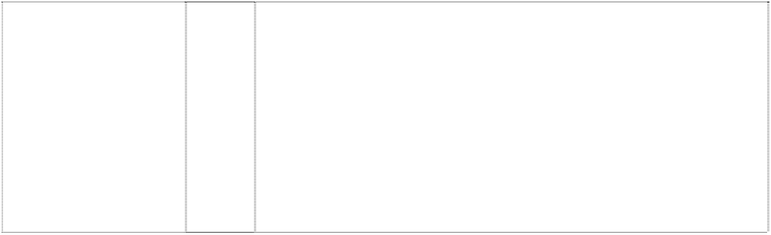**LOVE WHAT’S INSIDE** (890531)

32 Beverages in class 32 excluding beers but including non-alcoholic drinks and beverages, mineral and aerated waters; soda water, dry ginger ale, tonic water, lemon squash, bitter lemon, lemonade, orangeade; fruit juices, fruit juice drinks and beverages containing fruit juice and fruit juice flavouring, including mineral and aerated water containing fruit juice or fruit juice flavouring; sports drinks including electrolyte replacement beverages for sports; energy drinks including double-caffeine drinks; dietetic and low calorie forms of all the foregoing goods; carbonated and non-carbonated soft drinks and concentrates for making same including beverages in containers; concentrates, syrups, powders and other preparations and substances for making all the foregoing goods.

32 Non-alcoholic drinks and beverages, mineral and aerated waters; soda water, dry ginger ale, tonic water, lemon squash, bitter lemon, lemonade; low calorie forms of all the foregoing goods; syrups and other preparations for making all the foregoing goods; all being goods in Cl. 32 and all other goods in Cl. 32.

32 Beverages in class 32 excluding beers but including non-alcoholic drinks and beverages, mineral and aerated waters; soda water, dry ginger ale, tonic water, lemon squash, bitter lemon, lemonade, orangeade; fruit juices, fruit juice drinks and beverages containing fruit juice and fruit juice flavouring, including mineral and aerated water containing fruit juice or fruit juice flavouring; sports drinks including electrolyte replacement beverages for sports; dietetic and low calorie forms of all the foregoing goods; carbonated and non- carbonated soft drinks and concentrates for making same including beverages in containers; concentrates, syrups, powders and other preparations and substances for making all the foregoing goods.

32 Non-alcoholic beverages; drinking waters, flavoured waters, mineral and aerated waters; soft drinks, energy drinks and sports drinks; fruit drinks and juices; syrups, concentrates and powders for making beverages including syrups, concentrates and powders for making mineral and aerated waters, soft drinks, energy drinks, sports drinks, fruit drinks and juices.

32 Beverages; drinking waters, flavoured waters, mineral and aerated waters, natural spring waters and other non-alcoholic beverages; soft drinks and sports drinks; fruit drinks and juices; syrups, concentrates and powders for making beverages, including mineral and aerated waters, soft drinks, energy drinks, sports drinks, fruit drinks and juices.

32 Non-alcoholic beverages; drinking waters; flavoured waters; mineral and aerated waters; soft drinks; energy drinks and sports drinks; fruit drinks and juices; syrups, concentrates and powders for making beverages including flavoured waters, mineral and aerated waters, soft drinks, energy drinks, sports drinks, fruit drinks and juices.

32 Non-alcoholic beverages including mineral water, aerated water, carbonated beverages, fruit drinks and fruit juices; syrups and other preparations for making beverages.

32 Beverages in class 32 excluding beers but including non-alcoholic drinks and beverages, drinking waters, mineral and aerated waters; soda water, dry ginger ale, tonic water, lemon squash, bitter lemon, lemonade, orangeade, cordial and cordial based beverages; fruit juices; fruit juice drinks and beverages containing fruit juice and fruit juice flavouring, including mineral and aerated water containing fruit juice or fruit juice flavouring; sports drinks including electrolyte replacement beverages for sports; energy drinks; dietetic and low calorie forms of all the foregoing goods; carbonated and non- carbonated soft drinks and concentrates for making same including beverages in containers; concentrates, syrups, powders and other preparatons and substances for making all the foregoing goods.

# LOVEBEING

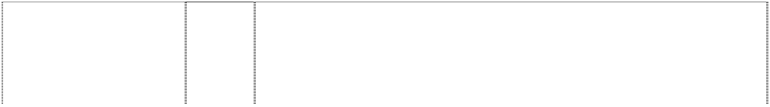

(1053316)

# LOVEBEING COCA- COLA

*shape trade mark:* bottle with stripes,wavy, hearts,

butterflys, trees &

hummingbird (1062060)

**LOW CALORIE FANTA** (325401)

# MAKE EVERY DROP COUNT

(1084287)

# MAKE EVERY DROP COUNT

(1084287)

# MAKE EVERY DROP COUNT

(1084287)

# MAKE EVERY DROP COUNT

5 drops

(1084286)

# MAKE EVERY DROP COUNT

5 drops

(1084286)

# MAKE EVERY DROP COUNT

5 drops

(1084286)

# MAKE EVERY DROP MATTER

(1111231)

32 Non-alcoholic beverages; drinking waters; flavoured waters; mineral and aerated waters; soft drinks; energy drinks and sports drinks; fruit drinks and juices; syrups, concentrates and powders for making beverages including flavoured waters, mineral and aerated waters, soft drinks, energy drinks, sports drinks, fruit drinks and juices.

32 Non-alcoholic beverages; drinking waters; flavoured waters; mineral and aerated waters; soft drinks; energy drinks and sports drinks; fruit drinks and juices; syrups, concentrates and powders for making beverages including flavoured waters, mineral and aerated waters, soft drinks, energy drinks, sports drinks, fruit drinks and juices.

32 Non-alcoholic drinks and beverages, mineral and aerated waters; soda water, dry ginger ales, tonic water, lemon squash, bitter lemon soft drinks, lemonade; syrups and other preparations for making all the foregoing goods; all of the foregoing goods being in low calorie form.

9 Pre-recorded CDs, video tapes, laser disks, software, and DVDs featuring musical, dramatic, animation, mixed media, and/or multimedia performances; apparatus and instruments for the recording, transmission or reproduction of sound and/or images; electronic games including video and computer games.

16 Publications, namely pamphlets, posters, newsletters; printed material and stationery in this class.

32 Beverages, namely, drinking waters, flavored waters, mineral and aerated waters; and other non-alcoholic beverages, namely, soft drinks, energy drinks and sports drinks; fruit drinks and juices; and syrups, concentrates and powders for making beverages, namely, flavored waters, mineral and aerated waters, soft drinks, energy drinks, sports drinks, fruit drinks and juices.

9 Pre-recorded CDs, video tapes, laser disks, software, and DVDs featuring musical, dramatic, animation, mixed media, and/or multimedia performances; apparatus and instruments for the recording, transmission or reproduction of sound and/or images; electronic games including video and computer games.

***\*\*The trade mark consists of the words in combination with five drops in colours as shown in the image contained in the Picture Register\*\****

16 Publications, namely pamphlets, posters, newsletters; printed material and stationery in this class.

***\*\*The trade mark consists of the words in combination with five drops in colours as shown in the image contained in the Picture Register\*\****

32 Beverages, namely, drinking waters, flavored waters, mineral and aerated waters; and other non-alcoholic beverages, namely, soft drinks, energy drinks and sports drinks; fruit drinks and juices; and syrups, concentrates and powders for making beverages, namely, flavored waters, mineral and aerated waters, soft drinks, energy drinks, sports drinks, fruit drinks and juices.

***\*\*The trade mark consists of the words in combination with five drops in colours as shown in the image contained in the Picture Register\*\****

32 Non-alcoholic beverages; drinking waters, flavoured waters, mineral and aerated waters; soft drinks, energy drinks and sports drinks; fruit drinks and juices; syrups, concentrates and powders for making beverages including syrups, concentrates and powders for making mineral and aerated waters, soft drinks, energy drinks, sports drinks, fruit drinks and juices.

**MANDARIN PREP PUMPED** (1118169)

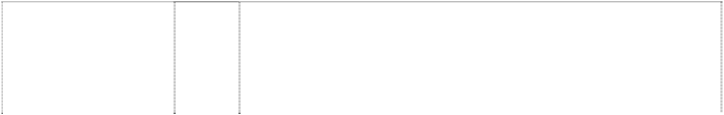

# MELLO YELLO

(321982)

# METRO METRO 6

(482274)

# METRO METRO 6

(482271)

# MINUTE MAID

(166057)

# MINUTE MAID

(1115739)

**MINUTE MAID BONEWISE** (1101812)

**MINUTE MAID HEARTWISE** (1101815)

**MINUTE MAID JOINTWISE** (1101813)

# MOTHER ...

word on oblique stripe with leaves & vine background

(1106174)

32 Non-alcoholic beverages; drinking waters, flavoured waters, mineral and aerated waters; carbonated soft drinks, energy drinks and sports drinks; fruit drinks and juices; syrups, concentrates and powders for making beverages including syrups, concentrates and powders for making mineral and aerated waters, carbonated soft drinks, energy drinks, sports drinks, fruit drinks and juices.

32 All goods in Cl. 32.

11 Refrigerated machines for dispensing beverages including combination mixing, carbonating and dispensing beverage machines including refrigerated beverage post-mix dispensers; parts and accessories therefore included in class 11.

7 Beverage dispensing machines including beverage dispensing and vending machines including machines for dispensing beverages in combination with mixing and carbonating, including beverage post- mix dispensing machines; parts and accessories therefore included in class 7.

32 Ready prepared mineral and aerated waters and other non-alcoholic drinks.

32 Non-alcoholic beverages; drinking waters, flavoured waters, mineral and aerated waters; soft drinks, energy drinks and sports drinks; fruit drinks and juices; syrups, concentrates and powders for making beverages including syrups, concentrates and powders for making mineral and aerated waters, soft drinks, energy drinks, sports drinks, fruit drinks and juices.

32 Non-alcoholic beverages; drinking waters, flavoured waters, mineral and aerated waters; soft drinks, energy drinks and sports drinks; fruit drinks and juices; syrups, concentrates and powders for making beverages including syrups, concentrates and powders for making mineral and aerated waters, soft drinks, energy drinks, sports drinks, fruit drinks and juices.

32 Non-alcoholic beverages; drinking waters, flavoured waters, mineral and aerated waters; soft drinks, energy drinks and sports drinks; fruit drinks and juices; syrups, concentrates and powders for making beverages including syrups, concentrates and powders for making mineral and aerated waters, soft drinks, energy drinks, sports drinks, fruit drinks and juices.

32 Non-alcoholic beverages; drinking waters, flavoured waters, mineral and aerated waters; soft drinks, energy drinks and sports drinks; fruit drinks and juices; syrups, concentrates and powders for making beverages including syrups, concentrates and powders for making mineral and aerated waters, soft drinks, energy drinks, sports drinks, fruit drinks and juices.

32 Non-alcoholic beverages; drinking waters, flavoured waters, mineral and aerated waters; soft drinks, energy drinks and sports drinks; fruit drinks and juices; syrups, concentrates and powders for making beverages including syrups, concentrates and powders for making mineral and aerated waters, soft drinks, energy drinks, sports drinks, fruit drinks and juices.

***\*\*The trade mark consists of the combination of words and colours as shown in the image contained in the Picture Register\*\****

# MOUNTAIN BLAST



(671722)

# MOVES WITH YOU

(1026128)

# MR. PIBB

(259888)

# MXXXXX

5 crosses are ltrs X beside ltr M (1098200)

# MXXXXX

5 crosses are ltrs X beside ltr M (1098200)

# NAN & NED NEVERFAIL THE SPRING WATER COUPLE

2 drops,cartoon with spring bodies holding hands,leaping

(907214)

# NEIL NEVERFAIL THE SPRING WATER MAN

drop,cartoon, smiling with arms, legs & spring body

(907227)

# NEVERFAIL

(566685)

# NEVERFAIL SPRING WATER AUSTRALIA’S PURE ALTERNATIVE

waves,two,stylised (515698)

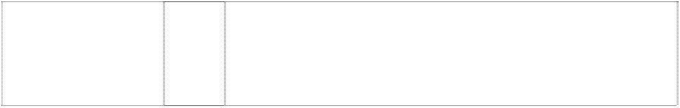**NEVERFAIL THE MINI SPRING** (1093545)

**NEVERFAIL THE MINI SPRING** (1093545)

32 All beverages in class 32, excluding beers but including non- alcoholic drinks and beverages, mineral and aerated waters; soda water, dry ginger ale, tonic water, lemon squash, bitter lemon, lemonade, orangeade; fruit juices, fruit juice drinks and beverages containing fruit juice and fruit juice flavouring, including mineral and aerated water containing fruit juice or fruit juice flavouring; electrolyte replacement beverages for sports included in this class; dietetic and low calorie forms of all the foregoing goods included in this class; concentrates, syrups, powders and other preparations and substances in this class for making all the foregoing goods.

32 Non-alcoholic beverages; drinking waters; flavoured waters; mineral and aerated waters; soft drinks, energy drinks and sports drinks; fruit drinks and juices; syrups, concentrates and powders for making beverages including flavoured waters, mineral and aerated waters, soft drinks, energy drinks, sport drinks, fruit drinks and juices.

32 Soft drinks.

9 Pre-recorded CD's, video tapes, laser disks, software, and DVD's featuring musical, dramatic, animation, mixed media, and/or multimedia performances.

32 Beverages, namely soft drinks; syrups and concentrates for making the same.

32 Mineral and aerated waters, purified waters and spring water for drinking purposes.

32 Mineral and aerated waters, purified waters and spring water for drinking purposes.

32 Mineral and aerated waters; purified water and spring water for drinking purposes.

32 Mineral and aerated waters; purified water and spring water for drinking purposes.

11 Apparatus for water supply and treatment; water filtering apparatus; water dispensers; water purifying apparatus and machines.

32 Non-alcoholic beverages; drinking waters, flavoured waters, mineral and aerated waters; soft drinks, energy drinks and sports drinks; fruit drinks and juices; syrups, concentrates and powders for making beverages including syrups, concentrates and powders for making mineral and aerated waters, soft drinks, energy drinks, sports drinks, fruit drinks and juices.

# NICKY NEVERFAIL THE SPRING WATER KID

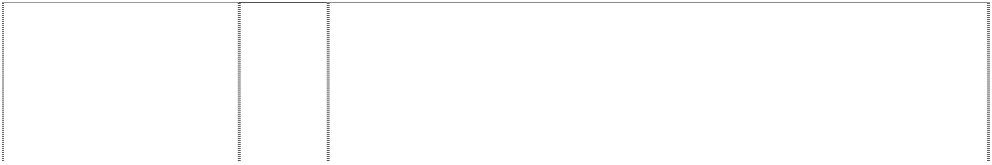

drop,cartoon, smiling with spring body,leaping

(907267)

# OBEY YOUR THIRST

(631514)

# P

stripe,wavy,pointed,an gled forms ltr P (955916)

# P POWERADE ISOTONIC

man,runner; hooked & angled stripe forms ltr P

(1100461)

# PACIFIC ORCHARD P

fruit (apple,orange & tomato) with brushstrokes,two

(481084)

**PEATS RIDGE SPRINGS** (657090)

# PICCADILLY

(988822)

# PICCADILLY PICCADILLY SPRING WATER

ltr P is drop,styl. or comma

(781296)

**PICCADILLY SPRINGS** (563982)

32 Mineral and aerated waters, purified waters and spring water for drinking purposes.

32 All goods in class 32 including non-alcoholic drinks and beverages, mineral and aerated waters; soda water, dry ginger ale, tonic water, lemon squash, bitter lemon, lemonade, orangeade; fruit juices, fruit juice drinks and beverages containing fruit juice and fruit juice flavouring, including mineral and aerated water containing fruit juice or fruit juice flavouring; teas, dietetic and low calorie forms of all the foregoing goods; carbonated and non-carbonated soft drinks and concentrates for making same, including beverages in containers; concentrates, syrups, powders and other preparations and substances for making the foregoing goods.

32 Beverages; drinking waters, flavoured waters, mineral and aerated waters; and other non-alcoholic beverages, including soft drinks, energy drinks, and sports drinks; fruit drinks and juices; syrups, concentrates and powders for making beverages, including mineral and aerated waters, soft drinks, energy drinks, sports drinks, fruit drinks and juices.

32 Non-alcoholic beverages; drinking waters, flavoured waters, mineral and aerated waters; soft drinks, energy drinks and sports drinks; fruit drinks and juices; syrups, concentrates and powders for making beverages including syrups, concentrates and powders for making mineral and aerated waters, soft drinks, energy drinks, sports drinks, fruit drinks and juices.

***\*\*The trade mark consists of the colours as shown in the image contained in the Picture Register\*\****

32 Fruit drinks and fruit juices.

32 Natural spring water.

32 Beverages; drinking waters, flavoured waters, mineral and aerated waters, natural spring waters and other non-alcoholic beverages; soft drinks and sports drinks; fruit drinks and juices; syrups, concentrates and powders for making beverages, including mineral and aerated waters, soft drinks, energy drinks, sports drinks, fruit drinks and juices.

32 Mineral and aerated waters; drinking water.

32 Natural spring water.

# POWER ON



(750663)

# POWER SHOTS

(718484)

**POWER TO PERFORM** (630888)

# POWERADE

(610972)

# POWERADE

footballer,cyclist & basketball hoop & quadrilateral all in rectangle

(665628)

# POWERADE ACTIVE WATER

(1003750)

# POWERADE ELECTRIC CHILL THRIST QUENCHER

(772155)

32 Beverages in class 32 excluding beers but including non-alcoholic drinks and beverages, mineral and aerated waters; soda water, dry ginger ale, tonic water, lemon squash, bitter lemon, lemonade, orangeade; fruit juices, fruit juice drinks and beverages containing fruit juice and fruit juice flavouring, including mineral and aerated water containing fruit juice and fruit juice flavouring; sports drinks including electrolyte replacement beverages for sports; dietetic and low calorie forms of all the foregoing goods; carbonated and non- carbonated soft drinks and concentrates for making same including beverages in containers; concentrates, syrups, powders and other preparations and substances for making all the foregoing goods.

32 Non-alcoholic drinks and beverages, mineral and aerated waters; soda water, dry ginger ale, tonic water, lemon squash, bitter lemon, lemonade, orangeade; fruit juices, fruit drinks and beverages containing fruit juice and fruit juice flavoring, including mineral and aerated water containing fruit juice or fruit juice flavoring; sports drinks including electrolyte replacement beverages for sports; dietetic and low calorie forms of all the foregoing goods; concentrates, syrups, powders, tablets, dissolvable tablets and other preparations and substances for making all the foregoing goods.

32 All goods in class 32 including non-alcoholic drinks and beverages, mineral and aerated waters; soda water, dry ginger ale, tonic water, lemon squash, bitter lemon, lemonade, orangeade; fruit juices, fruit juice drinks and beverages containing fruit juice and fruit juice flavouring, including mineral and aerated water containing fruit juice or fruit juice flavouring; sports drinks; dietetic and low calorie forms of all the foregoing goods in this class; concentrates, syrups and other preparations and substances for making all the foregoing goods.

32 All goods in class 32, excluding beers but including non-alcoholic drinks and beverages, mineral and aerated waters; soda water, dry ginger ale, tonic water, lemon squash, bitter lemon, lemonade, orangeade; fruit juices, fruit juice drinks and beverages containing fruit juice and fruit juice flavouring, including mineral and aerated water containing fruit juice or fruit juice flavouring; electrolyte replacement beverages for sports; dietetic and low calorie forms of all the foregoing goods; concentrates, syrups, powders and other preparations and substances for making all the foregoing goods.

32 Beverages in class 32 excluding beers but including non-alcoholic drinks and beverages, mineral and aerated waters; soda water, dry ginger ale, tonic water, lemon squash, bitter lemon, lemonade, orangeade; fruit juices, fruit drinks and beverages containing fruit juice and fruit juice flavouring, including mineral and aerated water containing fruit juice or fruit juice flavouring; sports drinks including electrolyte replacement beverages for sports; dietetic and low calorie forms of all the foregoing goods; concentrates, syrups, powders and other preparations and substances for making all the foregoing goods.

32 Non-alcoholic beverages; drinking waters; flavoured waters; mineral and aerated aters; soft drinks; energy drinks and sports drinks; fruit drinks and juices; syrups, concentrates and powders for making beverages including flavoured waters, mineral and aerated waters, soft drinks, energy drinks, sports drinks, fruit drinks and juices.

32 Beverages in class 32 excluding beers but including non-alcoholic drinks and beverages, mineral and aerated waters; soda water, dry ginger ale, tonic water, lemon squash, bitter lemon, lemonade, orangeade; fruit juices, fruit juice drinks and beverages containing fruit juice and fruit juice flavouring, including mineral and aerated water containing fruit juice or fruit juice flavouring; sports drinks including electrolyte replacement beverages for sports; dietetic and low calorie forms of all the foregoing goods; carbonated and non- carbonated soft drinks and concentrates for making same including beverages in containers; concentrates, syrups, powders and other preparations and substances for making all the foregoing goods.

# POWERADE PRO



(1048206)

**POWERADE SPORTS ENERGY** (1096960)

# POWERFLO

(736662)

# POWERFLO

(736662)

# POWERFLO

(736662)

# POWERLIFT

(620834)

# POWERPLUS

(620836)

# POWERPRO

(620909)

# POWERSOURCE

(620835)

32 Non-alcoholic beverages; drinking waters, flavoured waters, mineral and aerated waters; soft drinks, energy drinks and sports drinks; fruit drinks and juices; syrups, concentrates and powders for making beverages; syrups, concentrates and powders for making flavoured waters, mineral and aerated waters, soft drinks, energy drinks, sports drinks, fruit drinks and juices.

32 Non-alcoholic beverages; drinking waters, flavoured waters, mineral and aerated waters; soft drinks, energy drinks and sports drinks; fruit drinks and juices; syrups, concentrates and powders for making beverages including syrups, concentrates and powders for making mineral and aerated waters, soft drinks, energy drinks, sports drinks, fruit drinks and juices.

20 Packaging containers of all kinds in this class including dispensing packaging.

32 Beverages in class 32 excluding beers but including non-alcoholic drinks and beverages, mineral and aerated waters; soda water, dry ginger ale, tonic water, lemon squash, bitter lemon, lemonade, orangeade; fruit juices, fruit juice drinks and beverages containing fruit juice and fruit juice flavouring, including mineral and aerated water containing fruit juice or fruit juice flavouring; sports drinks including electrolyte replacement beverages for sports; dietetic and low calorie forms of all the foregoing goods; concentrates, syrups, powders and other preparations and substances for making all the foregoing goods.

6 Packaging containers of all kinds in this class including dispensing packaging.

32 All goods in class 32, excluding beers but including non-alcoholic drinks and beverages, mineral and aerated waters; soda water, dry ginger ale, tonic water, lemon squash, bitter lemon, lemonade, orangeade; fruit juices, fruit juice drinks and beverages containing fruit juice and fruit juice flavouring, including mineral and aerated water containing fruit juice or fruit juice flavouring; sports drinks; dietetic and low calorie forms of all the foregoing goods; concentrates, syrups and other preparations and substances for making all the foregoing goods.

32 All goods in class 32, excluding beers but including non-alcoholic drinks and beverages, mineral and aerated waters; soda water, dry ginger ale, tonic water, lemon squash, bitter lemon, lemonade, orangeade; fruit juices, fruit juice drinks and beverages containing fruit juice and fruit juice flavouring, including mineral and aerated water containing fruit juice or fruit juice flavouring; sports drinks; dietetic and low calorie forms of all the foregoing goods; concentrates, syrups and other preparations and substances for making all the foregoing goods.

32 All goods in class 32, excluding beers but including non-alcoholic drinks and beverages, mineral and aerated waters; soda water, dry ginger ale, tonic water, lemon squash, bitter lemon, lemonade, orangeade; fruit juices, fruit juice drinks and beverages containing fruit juice and fruit juice flavouring, including mineral and aerated water containing fruit juice or fruit juice flavouring; sports drinks; dietetic and low calorie forms of all the foregoing goods; concentrates, syrups and other preparations and substances for making all the foregoing goods.

32 All goods in class 32, excluding beers but including non-alcoholic drinks and beverages, mineral and aerated waters; soda water, dry ginger ale, tonic water, lemon squash, bitter lemon, lemondade, orangeade; fruit juices, fruit juice drinks and beverages containing fruit juice and fruit juice flavouring, including mineral and aerated water containing fruit juice or fruit juice flavouring; sports drinks; dietetic and low calorie forms of all the foregoing goods; concentrates, syrups and other preparations and substances for making all the foregoing goods.

# PUMP



(843628)

# PUMP

*shape trade mark:*

bottle (898943)

**PUMP SPORTS POWER BOOST** (760917)

# PUMPED

(1106577)

# QOO

(937548)

# QOO

(937548)

# QUATRO

(423762)

# RAINTREE

(264145)

# RECHARGE

(315652)

**RECYCLE-A- SAURUS** (602487)

# S

impeller,2-blade forms ltr S

(1102261)

# SAMSAN

(271557)

# SAMSAN

(271556)

32 Non-alcoholic drinks; water including mineral and aerated water; fruit drinks and fruit juices; syrups, concentrates and other preparations for making beverages.

32 Beverages in this class including drinking waters, flavored waters, mineral and aerated waters; non-alcoholic beverages, including soft drinks, energy drinks and sports drinks; fruit drinks and juices; syrups, concentrates and powders for making beverages, such as mineral and aerated waters, soft drinks, energy drinks, sports drinks, fruit drinks and juices.

***\*\*This trade mark consists of the combination of the word PUMP and the shape of the bottle as shown in the image contained in the Picture Register\*\****

32 Beers, mineral waters and aerated waters and other non-alcoholic drinks, fruit drinks and fruit juices.

32 Non-alcoholic beverages; drinking waters, flavoured waters, mineral and aerated waters; soft drinks, energy drinks and sports drinks; fruit drinks and juices; syrups, concentrates and powders for making beverages including syrups, concentrates and powders for making mineral and aerated waters, soft drinks, energy drinks, sports drinks, fruit drinks and juices.

25 Clothing, footwear and headgear.

32 Beverages, namely drinking waters, flavoured waters, mineral and aerated waters; and other non-alcoholic beverages, namely soft drinks, energy drinks, and sports drinks; fruit drinks and juices; syrups, concentrates and powders for making beverages, namely mineral and aerated waters, soft drinks, energy drinks, sports drinks, fruit drinks and juices.

32 Non-alcoholic beverages and fruit juices and concentrates and preparations for making such beverages.

32 Non-alcoholic beverages and preparations for making such beverages.

32 Non-alcoholic beverages.

32 All goods in class 32 including non-alcoholic drinks and beverages, mineral and aerated waters; soda water, dry ginger ale, tonic water, lemon squash, bitter lemon, lemonade, orangeade; fruit juices, fruit juice drinks and beverages containing fruit juice and fruit juice flavouring, including mineral and aerated water containing fruit juice or fruit juice flavouring; dietetic and low calorie forms included in this class of all the foregoing goods; concentrates, syrups and other preparations and substances for making all the foregoing goods; including beverages in containers.

32 Non-alcoholic beverages, namely, carbonated soft drinks; syrups and concentrates for making non-alcoholic beverages, namely carbonated soft drinks.

29 Whey and preparations containing whey; milk, and preparations and substances containing milk; all included in Class 29.

32 Non-alcoholic beverages and preparations for making the same.

# SCORE! 1 WORLD:1 SPORT



soccer ball wrapped in flag,striped

(903202)

# SNOW CROP

(207446)

# SNOW CROP

(207447)

# SNOW CROP

(207449)

# SNOW CROP

(207448)

# SNOW CROP

(109633)

# SPARLETTA

(203796)

spida (951995)

# SPRITE

(194260)

# SPRITE

(194261)

# SPRITE

(940059)

# SPRITE

(1019354)

# SPRITE

(940059)

# SPRITE

(194262)

# SPRITE

(194263)

# SPRITE

(166058)

# SPRITE

(378669)

# SPRITE

(194264)

# SPRITE

(186885)

32 Beverages in this class; drinking waters, flavoured waters, mineral and aerated waters and other non-alcoholic beverages; soft drinks, energy drinks and sports drinks; fruit drinks and juices; syrups, concentrates and powders for making beverages including mineral waters and aerated waters, soft drinks, energy drinks and sports drinks, fruit drinks and juices.

***\*\*The trade mark is depicted in the colours RED, LIME GREEN, LIGHT GREEN, DARK GREEN and ORANGE as shown in the image contained in the Picture Register\*\****

1. Colouring substances for liquors.
2. Fruit essences (non-alcoholic, being essential oils).
3. Beverages (milk) without alcohol; frozen dairy products (for food), fruit pulp, yoghurt.
4. Ice cream, ice for refreshment, ices (edible) binding materials for (food), flavourings for beverages (other than essential oils).

32 Mineral and aerated waters and other non-alcoholic, non-medicated, non-aerated beverages, frozen concentrates, syrups and other preparations for making beverages.

5 Dietetic foods, dietetic beverages, and preparations and ingredients for the same.

32 Carbonated soft drinks.

3 Perfumery, essential oils, cosmetics, hair lotions and dentifrices.

5 Dietetic foods and dietetic beverages.

25 Articles of clothing including shirts, shorts, socks, T-shirts and jackets; headgear including hats and caps.

25 Footwear including boots and shoes.

1. Games and playthings; sporting articles including balls, bats and racquets; toys including toy cars; decorations for Christmas trees.
2. Meat, fish, poultry and game, meat extracts, preserved, dried and cooked fruits and vegetables, jellies, jams, eggs, milk and other dairy products, edible oils and fats, preserves, pickles.
3. Coffee, tea, cocoa, sugar, rice, tapioca, sago, coffee substitutes, flour and preparations made from cereals, bread, biscuits, cakes, pastry and confectionery, ices, honey, treacle, yeast, baking powder, salt, mustard, pepper, vinegar, sauces, spices, ice.

32 Mineral and aerated waters and other non-alcoholic drinks; syrups and other preparations for making beverages.

1. Non-alcoholic drinks and beverages, mineral and aerated waters; soda water, dry ginger ale, tonic water, lemon squash, bitter lemon, lemonade; low calorie forms of all the foregoing goods, syrups and other preparations for making all the foregoing goods; and all other goods in Class 32.
2. Wines, spirits and liqueurs.
3. Tobacco, raw or manufactured; smoker’s articles; matches.

# SPRITE LIGHT

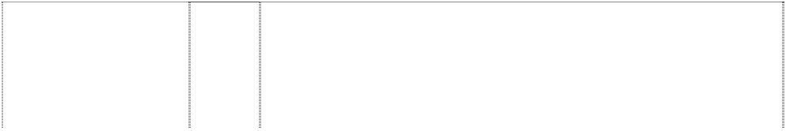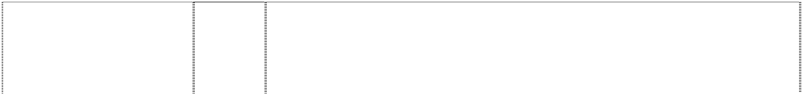

(735112)

# SPRITE QUENCH

(1036936)

# SPRITE ZERO

(1078375)

# SPRITE ZERO

words break oval with bubbles; lemon is dot of ltr i

(1078379)

# STAY PUMPED

woman,stylised holds bottle; group of woman,silh, dancing in background

(1090903)

# SUN FILLED

(373537)

# SUN FILLED

fruit, citrus oranges (373536)

# SUN FILLED

fruit, citrus oranges tree, fruit, stylised (373535)

# SUNFILLED

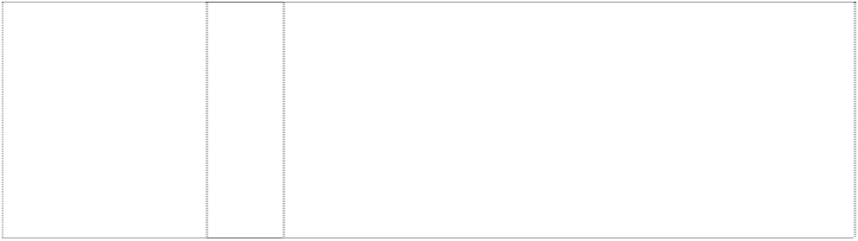(161552)

# SUNSPLASH

(843633)

32 Non-alcoholic drinks and beverages, mineral and aerated waters; soda water, dry ginger ale, tonic water, lemon squash, bitter lemon, lemonade, orangeade; fruit juices, fruit juice drinks and beverages containing fruit juice and fruit juice flavouring, including mineral and aerated water containing fruit juice or fruit juice flavouring; dietetic and low calorie forms of all the foregoing goods; carbonated and non-carbonated soft drinks and concentrates for making same, including beverages in containers; concentrates, syrups, powders and other preparations and substances for making the foregoing goods.

32 Beverages, namely, drinking waters, flavoured waters, mineral and aerated waters, and other non-alcoholic beverages, namely soft drinks, energy drinks and sports drinks; fruit drinks and juices; syrups, concentrates and powders for making beverages, namely, flavoured waters, mineral and aerated waters, soft drinks, energy drinks, sports drinks, fruit drinks and juices.

32 Beverages; drinking waters, flavoured waters, mineral and aerated waters; and other non-alcoholic beverages; soft drinks, energy drinks, sports drinks; fruit drinks and juices; syrups, concentrates and powders for making beverages including syrups, concentrates and powders for making mineral and aerated waters, soft drinks, energy drinks, sports drinks, fruit drinks and juices.

32 Beverages; drinking waters, flavoured waters, mineral and aerated waters; and other non-alcoholic beverages; soft drinks, energy drinks, sports drinks; fruit drinks and juices; syrups, concentrates and powders for making beverages including syrups, concentrates and powders for making mineral and aerated waters, soft drinks, energy drinks, sports drinks, fruit drinks and juices.

***\*\*The Trade Mark consists of the combination of words and colours as shown in the image contained in the Picture Register\*\****

32 Beverages; drinking waters, flavoured waters, mineral and aerated waters; and other non-alcoholic beverages; soft drinks, energy drinks, and sports drinks; fruit drinks and juices; syrups; concentrates and powders for making beverages including syrups, concentrates and powders for making mineral and aerated waters, soft drinks, energy drinks, sports drinks, fruit drinks and juices.

32 All goods in Class 32.

32 All goods in Class 32.

32 All goods in Class 32.

32 Non-alcoholic beverages, particularly unfrozen citrus juices.

32 Beverages in class 32 excluding beers but including non-alcoholic drinks and beverages, mineral and aerated waters; soda water, dry ginger ale, tonic water, lemon squash, bitter lemon, lemonade, orangeade; fruit juices, fruit juice drinks and beverages containing fruit juice and fruit juice flavouring, including mineral and aerated water containing fruit juice or fruit juice flavouring; sports drinks including electrolyte replacement beverages for sports; dietetic and low calorie forms of all the foregoing goods; carbonated and non- carbonated soft drinks and concentrates for making same including beverages in containers; concentrates, syrups, powders and other preparations and substances for making all the foregoing goods.

# SUNTIME JUICE



(1079842)

# SURGE

(703279)

# TAB

(181996)

# TAB

(596372)

# TAB

(181995)

# TAI

(273826)

**THE BEACH IS CALLING** (1027568)

# THE BEVERAGE INSTITUTE FOR HEALTH &

**WELLNESS**

disc-head with arms & legs

outstretched atop ribbon

(1139708)

# THE COCA COLA COMPANY A WORLD REFRESHMENT COCA

**COLA FANTA SPRITE FRUITOPIA PUMP POWERADE NEVERFAIL**

# COCA COLA ZERO DIET COKE

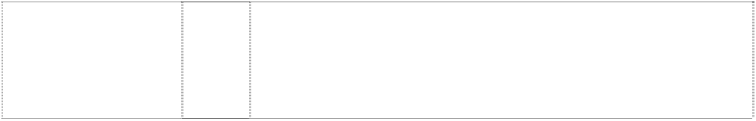bottle with disc pattern (1079841)

**THE COCA-COLA SIDE OF LIFE** (1117452)

32 Beverages; drinking waters, flavoured waters, mineral and aerated waters; and other non-alcoholic beverages; soft drinks, energy drinks, and sports drinks; fruit drinks and juices; syrups, concentrates and powders for making beverages including syrups, concentrates and powders for making mineral and aerated waters, soft drinks, energy drinks, sports drinks, fruit drinks and juices.

32 Mineral and aerated waters and other non-alcoholic drinks; fruit drinks and fruit juices; syrups and other preparations for making beverages.

32 Beer, ale and porter; mineral and aerated waters and other non- alcoholic drinks; syrups and other preparations for making beverages.

32 All goods in class 32 including non-alcoholic drinks and beverages, mineral and aerated waters; soda water, dry ginger ale, tonic water, lemon squash, bitter lemon, lemonade, orangeade; fruit juices, fruit juice drinks and beverages containing fruit juice and fruit juice flavouring, including mineral and aerated water containing fruit juice or fruit juice flavouring; dietetic and low calorie forms of all the foregoing goods; concentrates, syrups and other preparations and substances for making all the foregoing goods.

5 Dietetic beverages.

32 Non-alcoholic beverages and preparations for making the same.

32 Non-alcoholic beverages; drinking waters; flavoured waters; mineral and aerated waters; soft drinks, energy drinks and sports drinks; fruit drinks and juices; syrups, concentrates and powders for making beverages including flavoured waters, mineral and aerated waters, soft drinks, energy drinks, sport drinks, fruit drinks and juices.

32 Non-alcoholic beverages; drinking waters, flavoured waters, mineral and aerated waters; carbonated soft drinks; energy drinks and sports drinks; fruit drinks and juices; syrups, concentrates and powders for making beverages including syrups, concentrates and powders for making mineral and aerated waters, carbonated soft drinks, energy drinks, sports drinks, fruit drinks and juices.

32 Beverages; drinking waters, flavoured waters, mineral and aerated waters; and other non-alcoholic beverages; soft drinks, energy drinks, and sports drinks; fruit drinks and juices; syrups, concentrates and powders for making beverages including syrups, concentrates and powders for making mineral and aerated waters, soft drinks, energy drinks, sports drinks, fruit drinks and juices.

32 Non-alcoholic beverages; drinking waters, flavoured waters, mineral and aerated waters; carbonated soft drinks, energy drinks and sports drinks; fruit drinks and juices; syrups, concentrates and powders for making beverages including syrups, concentrates and powders for making mineral and aerated waters, carbonated soft drinks, energy drinks, sports drinks, fruit drinks and juices.

# THE COKE SIDE OF LIFE



(1116766)

# THE TASTE OF COOL

(622370)

# THEXTONS

(884615)

# TO SPONSOR IS TO BELIEVE

(628616)

# TRESCA

(205256)

# TWIN CHILL

(622748)

# VITAWATER BALANCE

equal sign in oval in rect.

(1022091)

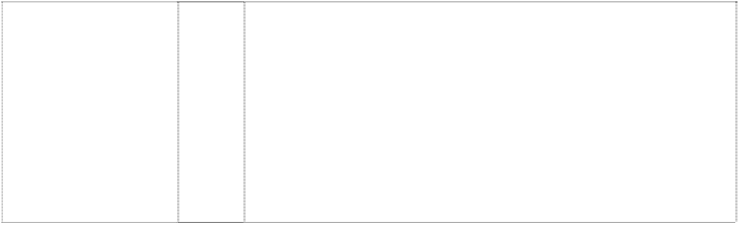**WHAT GETS YOU MOVING?** (890530)

32 Non-alcoholic beverages; drinking waters, flavoured waters, mineral and aerated waters; carbonated soft drinks, energy drinks and sports drinks; fruit drinks and juices; syrups, concentrates and powders for making beverages including syrups, concentrates and powders for making mineral and aerated waters, carbonated soft drinks, energy drinks, sports drinks, fruit drinks and juices.

32 All goods in class 32 including non-alcoholic drinks and beverages, mineral and aerated waters; soda water, dry ginger ale, tonic water, lemon squash, bitter lemon, lemonade, orangeade; fruit juices, fruit juice drinks and beverages containing fruit juice and fruit juice flavouring, including mineral and aerated water containing fruit juice or fruit juice flavouring; dietetic and low calorie forms of all the foregoing goods; carbonated and non-carbonated soft drinks and concentrates for making same, including beverages in containers; concentrates, syrups, powders and other preparations and substances for making the foregoing goods.

32 Non-alcoholic beverages including mineral water, aerated water, carbonated beverages, fruit drinks and fruit juices; syrups and other preparations for making beverages.

32 All goods in class 32 including non-alcoholic drinks and beverages, mineral and aerated waters; soda water, dry ginger ale, tonic water, lemon squash, bitter lemon, lemonade, orangeade; fruit juices, fruit juice drinks and beverages containing fruit juice and fruit juice flavouring, including mineral and aerated water containing fruit juice or fruit juice flavouring; dietetic and low calorie forms of all the foregoing goods; carbonated and non-carbonated soft drinks and concentrates for making same, including beverages in containers; concentrates, syrups, powders and other preparations and substances for making the foregoing goods.

32 A low calorie, non-alcoholic aerated beverage, including pre parations for making such beverages.

32 Non-alcoholic drinks and beverages, mineral and aerated waters; soda water, dry ginger ale, tonic water, lemon squash, bitter lemon, lemonade, orangeade; fruit juices, fruit juice drinks and beverages containing fruit juice flavouring, including mineral and aerated water containing fruit juice or fruit juice flavouring; dietetic and low calorie forms of all the foregoing goods; carbonated and non-carbonated soft drinks and concentrates for making same, including beverages in containers; concentrates, syrups, powders and other preparations and substances for making the foregoing goods.

32 Non-alcoholic beverages; drinking waters; flavoured waters, mineral and aerated waters; soft drinks, energy drinks and sports drinks; fruit drinks and juices; syrups, concentrates and powders for making non- alcoholic beverages; syrups, concentrates and powders for making flavoured waters, mineral and aerated waters, soft drinks, energy drinks, sports drinks, fruit drinks and juices.

32 Beverages in class 32 excluding beers but including non-alcoholic drinks and beverages, drinking waters, mineral and aerated waters; soda water, dry ginger ale, tonic water, lemon squash, bitter lemon, lemonade, orangeade, cordial and cordial based beverages; fruit juices; fruit juice drinks and beverages containing fruit juice and fruit juice flavouring, including mineral and aerated water containing fruit juice or fruit juice flavouring; sports drinks including electrolyte replacement beverages for sports; energy drinks; dietetic and low calorie forms of all the foregoing goods; carbonated and non- carbonated soft drinks and concentrates for making same including beverages in containers; concentrates, syrups, powders and other preparatons and substances for making all the foregoing goods.

*shape trade mark:*



bottle (767355)

*shape trade mark:*

bottle (812511)

*shape trade mark:*

bottle (812512)

*shape trade mark:*

bottle (812720)

*shape trade mark:*

bottle (877676)

32 Beverages in class 32 excluding beers but including non-alcoholic drinks and beverages, mineral and aerated waters; soda water, dry ginger ale, tonic water, lemon squash, bitter lemon, lemonade, orangeade; fruit juices, fruit juice drinks and beverages containing fruit juice and fruit juice flavouring, including mineral and aerated water containing fruit juice or fruit juice flavouring; sports drinks including electrolyte replacement beverages for sports; dietetic and low calorie forms of all the foregoing goods; carbonated and non- carbonated soft drinks and concentrates for making same including beverages in containers; concentrates, syrups, powders and other preparations and substances for making all the foregoing goods.

32 Beverages in class 32 excluding beers but including non- alcoholic drinks and beverages, mineral and aerated waters; soda water, dry ginger ale, tonic water, lemon squash, bitter lemon, lemonade, orangeade; fruit juices, fruit juice drinks and beverages containing fruit juice and fruit juice flavouring, including mineral and aerated water containing fruit juice or fruit juice flavouring; sports drinks including electrolyte replacement beverages for sports; dietetic and low calorie forms of all the foregoing goods; carbonated and non- carbonated soft drinks and concentrates for making same including beverages in containers; concentrates, syrups, powders and other preparations and substances for making all the foregoing goods.

***\*\*The Trade Mark consists of the shape of a bottle as shown in the image contained in the Picture Register\*\****

32 Beverages in class 32 excluding beers but including non- alcoholic drinks and beverages, mineral and aerated waters; soda water, dry ginger ale, tonic water, lemon squash, bitter lemon, lemonade, orangeade; fruit juices, fruit juice drinks and beverages containing fruit juice and fruit juice flavouring, including mineral and aerated water containing fruit juice or fruit juice flavouring; sports drinks including electrolyte replacement beverages for sports; dietetic and low calorie forms of all the foregoing goods; carbonated and non- carbonated soft drinks and concentrates for making same including beverages in containers; concentrates, syrups, powders and other preparations and substances for making all the foregoing goods.

***\*\*The Trade Mark consists of the shape of a bottle as shown in the image contained in the Picture Register\*\****

32 Beverages in class 32 excluding beers but including non-alcoholic drinks and beverages, mineral and aerated waters; soda water, dry ginger ale, tonic water, lemon squash, bitter lemon, lemonade, orangeade; fruit juices, fruit juice drinks and beverages containing fruit juice and fruit juice flavouring, including mineral and aerated water containing fruit juice or fruit juice flavouring; sports drinks including electrolyte replacement beverages for sports; dietetic and low calorie forms of all the aforegoing goods; carbonated and non- carbonated soft drinks and concentrates for making same including beverages in containers; concentrates, syrups, powders and other preparations and substances for making all the aforegoing goods.

***\*\*The Trade Mark consists of the shape of a bottle as shown in the image contained in the Picture Register\*\****

32 Beverages in class 32 excluding beers; non-alcoholic drinks and beverages; mineral and aerated waters; soda water, dry ginger ale, tonic water, lemon squash, bitter lemon, lemonade, orangeade; fruit juices, fruit juice drinks and beverages containing fruit juice and fruit juice flavouring, including mineral and aerated water containing fruit juice or fruit juice flavouring; sports drinks including electrolyte replacement beverages for sports; dietetic and low calorie forms of all the aforegoing goods; carbonated and non-carbonated soft drinks and concentrates for making same including such beverages in containers; concentrates, syrups, powders and other preparations and substances for making all the foregoing goods.

***\*\*The Trade Mark consists of the shape of a bottle as shown in the image contained in the Picture Register\*\****

*shape trade mark:* bottle,indented bottom,bubbles on



body

(959476)

*shape trade mark:* bottle: 4 views of five different bottles

(812147)

2 curls form whorl in disc

(1126531)

2 curls form whorl in disc

(1126531)

2 curls form whorl in disc

(1126531)

2 curls form whorl in disc

(1126531)

bottle (940060)

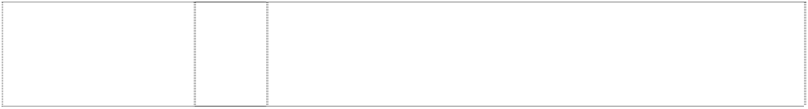bottle (940053)

32 Beverages, drinking waters, flavoured waters, mineral and aerated waters and other non-alcoholic beverages; soft drinks, energy drinks and sports drinks; fruit drinks and juices; syrups, concentrates and powders for making beverages including syrups, concentrates and powders for making mineral and aerated waters, soft drinks, energy drinks, sports drinks, fruit drinks and juices.

***\*\*The Trade Mark consists of the shape of a bottle as shown in the image contained in the Picture Register\*\****

32 Beverages in class 32 excluding beers but including non-alcoholic drinks and beverages, mineral and aerated waters; soda water, dry ginger ale, tonic water, lemon squash, bitter lemon, lemonade, orangeade; fruit juices, fruit juice drinks and beverages containing fruit juice and fruit juice flavouring, including mineral and aerated water containing fruit juice or fruit juice flavouring; sports drinks including electrolyte replacement beverages for sports; dietetic and low calorie forms of all the foregoing goods; carbonated and non- carbonated soft drinks and concentrates for making same including beverages in containers; concentrates, syrups, powders and other preparations and substances for making all the foregoing goods.

***\*\*The Trade Mark consists of the shape of a bottle as shown in the image contained in the Picture Register\*\****

5 Pharmaceutical and veterinary preparations; dietetic substances adapted for medical use, food for babies; Chinese herb tea, medicinal tea, medicinal drinks, medicinal beverages; tonic water, tonic beverages, tonic drinks, herbal beverages (all for medicinal use); herbal extracts (for medicinal use); herbal infusions (for medicinal use); herbal tea (medicinal use); herbal compounds for medicinal use; herbal preparations for medicinal use; medicinal herbal infusions; Chinese patent medicines; herbal jellies; turtle jellies; tonic medicines.

1. Meat, fish, poultry and game; meat extracts; preserved, dried and cooked fruits and vegetables; jellies, jams, fruit sauces; eggs, milk and milk products; edible oils and fats; soups, soup preparations, soup powders, soup mixes, canned soups, deep frozen soups, ingredients for making soup (all non-medicinal); food supplements and nutritional supplements (other than for medicinal use); natural products being herbal preparations (other than for medicinal use); food supplements with herbs (other than for medicinal uses).
2. Coffee, tea, cocoa, sugar, rice, tapioca, sago, artificial coffee; herbal beverages (other than for medicinal use); herbal extracts (other than for medicinal use); herbal infusions (other than for medicinal use); herbal tea (other than for medicinal use); flour and preparations made from cereals, bread, pastry and confectionery, ices; honey, treacle; yeast, bakingpowder; salt, mustard; vinegar, sauces (condiments); spices; ice; desserts; puddings; rice cakes; food supplements for human consumption; tonic food (other than for medicinal use).

32 Beers; mineral and aerated waters and other non-alcoholic drinks and beverages; fruit drinks and fruit juices; syrups and other preparations for making drinks and beverages; fruit juice beverages; drinks, beverages; tonic water, tonic drinks and tonic beverages; made to order non-alcoholic beverages; powdered beverages (non- alcoholic).

25 Articles of clothing including shirts, shorts, socks, T-shirts and jackets; headgear including hats and caps; footwear including boots and shoes.

30 Iced confections; ice drinks; sherbets; confectionery; coffee; tea; cocoa; biscuits; cookies; boiled lollies; jelly lollies; candy; ices; preparations in this class for the manufacture of beverages in this class including tea based beverages; flavourings for beverages; chewing gum; chocolate; frozen yoghurt and ice cream.

bottle (63697)

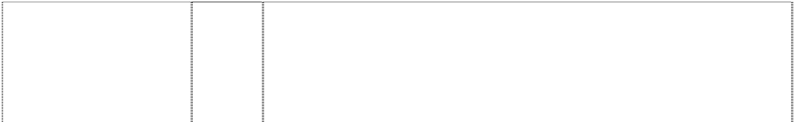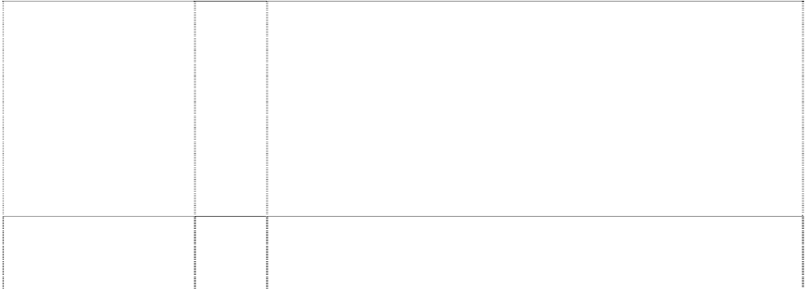

dots form concentric circles,incomplete in square

(1140996)

dots form concentric circles,incomplete in square

(1140996)

man wears spectacles,drawing with drops around

(1109869)

outline of bottle in circle,incomplete (941709)

patchwork of geom.- shapes & stars,crescents, ellipses trailing with dots

(629618)

stripe, curved, dividing square

(293717)

stripe/ribbon curved (612660)

stripe/ribbon curved (529928)

stylised person running (612561)

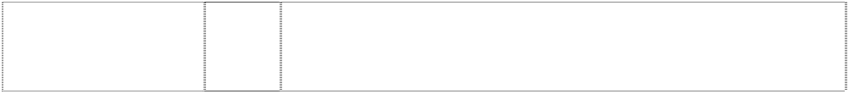water drop (678947)

wavy stripe or rectangle twisted (804644)

32 Beverages and syrups for the manufacture of such beverages.

11 Electric apparatus for preparing warm or hot drinks; electric apparatus for boiling water; coffee filters, coffee machines, coffee percolators and espresso machines; apparatus for cooking food and beverages; apparatus for heating food and beverages; apparatus for cooling food and beverages; apparatus for water supply; apparatus for dispensing beverages.

30 Coffee, coffee essences, coffee extracts, decaffeinated coffee, coffee substitutes, artificial coffee, coffee flavourings; tea, powdered tea, fruit tea, herbal tea, flavoured tea, iced tea, instant tea, artificial tea, infusions (not medicinal); cocoa, drinking chocolate; beverages with coffee, cocoa or chocolate base; sugar, artificial sweetener and coffee whiteners.

32 Non-alcoholic beverages; drinking waters, flavoured waters, mineral and aerated waters; soft drinks, energy drinks and sports drinks; fruit drinks and juices; syrups, concentrates and powders for making beverages including syrups, concentrates and powders for making mineral and aerated waters, soft drinks, energy drinks, sports drinks, fruit drinks and juices.

32 Beverages, including drinking waters, flavoured waters, mineral and aerated waters; and other non-alcoholic beverages, including, soft drinks, energy drinks and sports drinks; fruit drinks and juices; syrups, concentrates and powders for making beverages, including flavoured waters, mineral and aerated waters, soft drinks, energy drinks, sports drinks, fruit drinks and juices.

32 All goods in class 32 including non-alcoholic drinks and beverages, mineral and aerated waters; soda water, dry ginger ale, tonic water, lemon squash, bitter lemon, lemonade, orangeade; fruit juices, fruit juice drinks and beverages containing fruit juice and fruit juice flavouring, including mineral and aerated water containing fruit juice or fruit juice flavouring; dietetic and low calorie forms of all the foregoing goods; carbonated and non-carbonated soft drinks and concentrates for making same, including beverages in containers; concentrates, syrups, powders and other preparations and substances for making the foregoing goods.

32 Non-alcoholic beverages and syrups for making such beverages.

***\*\*The trade mark is limited to the colours red and white\*\****

30 Confectionery, including chocolates, lollies and candies; edible ices including frozen beverages, coffee, iced coffee, tea, cocoa, artificial coffee, coffee substitutes, preparations for making the aforesaid; ice.

32 Non-alcoholic beverages and syrups for making such beverages.

32 All goods in class 32 including non-alcoholic drinks and beverages, mineral and aerated waters; soda water, dry ginger ale, tonic water, lemon squash, bitter lemon, lemonade, orangeade; fruit juices, fruit juice drinks and beverages containing fruit juice and fruit juice flavouring, including mineral and aerated water containing fruit juice or fruit juice flavouring; dietetic and low calorie forms in this class of all foregoing goods; sports drinks in this class; non-carbonated soft drinks and concentrates for making the same; including beverages in containers; concentrates, syrups and other preparations and substances for making the foregoing goods.

32 Non alcoholic beverages including filtered and sterilized drinking water.

30 Confectionery including chocolates, lollies and candies; biscuits, cakes and cookies; edible ices including frozen beverages; coffee, ice coffee, tea, cocoa, artificial coffee, coffee substitutes and preparations for making any of the aforesaid; ice.

***DaimlerChrysler AG Baker & McKenzie***

***Ph: (02) 9225 0200***

***Effective Date: 13 February 2007 File Reference: C07/02775 Trade Marks Class Goods***

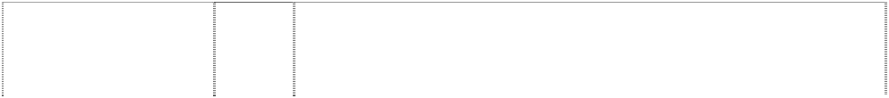

# A-CLASS

(813535)

# ACTROS

(718809)

# ACTROS LIGHT

(768705)

# ACTROS-LIGHT

(768705)

# ACTROS-LIGHT

(768705)

# ACTROS-LIGHT

(768705)

# ACTROS-LIGHT

(768705)

# ACTROS-LIGHTWAY

(768704)

# ACTROS-LIGHTWAY

(768704)

# ACTROS-LIGHTWAY

(768704)

# ACTROS-LIGHTWAY

(768704)

# ACTROS-LIGHTWAY

(768704)

# AFFALTERBACH AMG

tree, shock-absorber & muffler in circle,halved, truncated, all in annulus with 2 twigs,styl.

(931743)

# AFFALTERBACH AMG

tree, shock-absorber & muffler in circle,halved, truncated, all in annulus with 2 twigs,styl.

(931743)

12 Motor vehicles; parts and fittings for the aforesaid goods.

12 Motor vehicles and parts therefore.

25 Articles of clothing including T-shirts, sweatshirts, ties, gloves, overcoats, anoraks, ponchos, jackets, waistcoats, sweaters, polo shirts, trousers, scarves, belts; footwear; headgear, including hats, caps, hoods and motor caps.

6 Keys, key rings.

12 Vehicles, and parts therefore.

14 Clocks, watches, clock or watch accessories.

18 Bags, handbags, cases, brief cases, shopping bags, rucksacks, suitcases and hand luggage, umbrellas, parasols, covers, wallets, and purses.

6 Keys, key rings.

12 Vehicles, and parts therefore.

14 Clocks, watches, clock or watch accessories.

18 Bags, handbags, cases, brief cases, shopping bags, rucksacks, suitcases and hand luggage, umbrellas, parasols, covers, wallets, and purses.

25 Articles of clothing including T-shirts, sweatshirts, ties, gloves, overcoats, anoraks, ponchos, jackets, waistcoats, sweaters, polo shirts, trousers, scarves, belts; footwear; headgear, including hats, caps, hoods and motor caps.

3 Cosmetics, eau de toilette, aftershaves, foams, hair lotions, perfumeries, ethereal oils, soaps, toothpaste, nail polish, nail care products, lipsticks, eyebrow pencils, mascara.

9 Sound and image carriers, namely cassettes, tapes, compact discs, video cassettes, compasses.

# AFFALTERBACH AMG



tree, shock-absorber & muffler in circle,halved, truncated, all in annulus with 2 twigs,styl.

(931743)

# AFFALTERBACH AMG

tree, shock-absorber & muffler in circle,halved, truncated, all in annulus with 2 twigs,styl.

(931743)

# AFFALTERBACH AMG

tree, shock-absorber & muffler in circle,halved, truncated, all in annulus with 2 twigs,styl.

(931743)

# AFFALTERBACH AMG

tree, shock-absorber & muffler in circle,halved, truncated, all in annulus with 2 twigs,styl.

(931743)

# AFFALTERBACH AMG

tree, shock-absorber & muffler in circle,halved, truncated, all in annulus with 2 twigs,styl.

(931743)

# AFFALTERBACH AMG

tree, shock-absorber & muffler in circle,halved, truncated, all in annulus with 2 twigs,styl.

(931743)

# AMG

line of 5 parallelograms,decrea sing in size

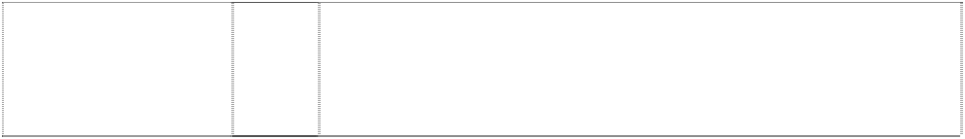(933181)

# AMG

line of 5 parallelograms,decrea sing in size

(933181)

12 Motor vehicles and parts thereof (included in this class).

14 Key rings; watches and watch accessories, namely watch straps of metal, leather or plastic, chains and pouches for watches, jewellery.

16 Printing products, namely newspapers, magazines, brochures and books whose content is dedicated uniquely to automobiles and/or automobile sport.

18 Leather and imitation leather goods, namely handbags, attachi cases, small leather goods, especially purses, wallets, key cases; large and small suitcases; umbrellas, parasols, walking sticks.

1. Carpets and foot mats.
2. Games, toys, model vehicles.

12 Motor vehicles and parts thereof (included in this class).

14 Clocks and their accessories, namely cases for clocks, watch bands made of metal or leather or synthetics, watch chains, watch pouches, jewellery.

# AMG

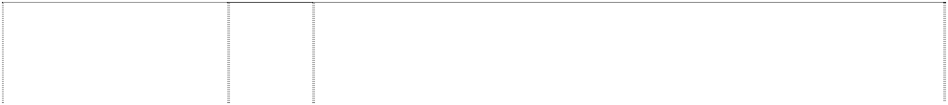

line of 5 parallelograms,decrea sing in size

(933181)

# AMG

line of 5 parallelograms,decrea sing in size

(933181)

# AMG

line of 5 parallelograms,decrea sing in size

(933181)

# AMG

line of 5 parallelograms,decrea sing in size

(933181)

# ASSYST

(727827)

# ATEGO

(1003198)

# AUTOTRONIC

(456915)

# AXOR

(768707)

# AXOR

(768707)

# AXOR

(768707)

# AXOR

(768707)

# AXOR

(768707)

# BENZ

(990615)

# BENZ

(990615)

16 Newspapers, magazines, brochures and books, articles of paper and/or cardboard, namely paper towels, paper napkins, packing cardboard boxes, packing paper bags, photographs, stationery, packing material made of plastic, namely general purpose envelopes, bags and plastic films.

18 Leather and imitation leather and goods made thereof, namely handbags, attachi cases, small leather goods, especially purses, wallets, key cases; trunks and travelling bags; umbrellas, parasols and walking sticks.

1. Carpets and foot mats.
2. Games, toys, model vehicles.

9 Electrical and/or electronic apparatus for determining and indicating maintenance intervals in motor vehicles and for motors.

12 Motor vehicles; parts and fittings therefor.

12 Control mechanisms for motor vehicles.

6 Keys, key rings.

12 Vehicles, and parts therefore.

14 Clocks, watches, clock or watch accessories.

18 Bags, handbags, cases, brief cases, shopping bags, rucksacks, suitcases and hand luggage, umbrellas, parasols, covers, wallets, and purses.

25 Articles of clothing including T-shirts, sweatshirts, ties, gloves, overcoats, anoraks, ponchos, jackets, waistcoats, sweaters, polo shirts, trousers, scarves, belts; footwear; headgear, including hats, caps, hoods and motor caps.

9 Scientific, nautical, surveying, photographic, cinematographic, optical, weighing, measuring, signalling, checking (supervision), life- saving and teaching apparatus and instruments; apparatus and instruments for conducting, switching, transforming, accumulating, regulating and controlling electricity; apparatus for recording, transmission or reproduction of sound or images; magnetic data carriers, recording discs, in particular cassettes, tapes, compact discs, videocassettes; data processing equipment and computers; software stored on data carriers; sunglasses, spectacles, spectacle frames; spectacle cases; compasses; fire-extinguishing apparatus; ticket dispensers.

14 Precious metals and their alloys and goods of precious metals or coated therewith (included in this class); jewellery, precious stones; horological and chronometric instruments; accessories for watches, namely cases for watches, watch straps of metal, leather or plastic, watch chains; cufflinks; key rings of precious and non-precious metals.

# BENZ



(990615)

# BENZ

(990615)

# BENZ

(990615)

# BENZ

(990615)

# BENZ

(990615)

# BENZ

(990615)

# BLUETEC

(1038057)

# BLUETEC

(1070283)

# BLUETEC

(1038057)

# BLUETEC

(1070283)

# BLUETEC

(1038057)

# BLUETEC

(1070283)

# C-CLASS

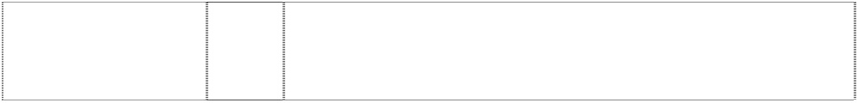(760578)

# CE

ltr e in eccentric circles form ltrs

(838802)

16 Paper, cardboard and goods made from these materials (included in this class); towels of paper, napkins of paper, packaging container and bags of paper; stationery; adhesives for stationery; artist's materials; paint brushes; photographs; printed matters; pictures, posters, brochures, magazines, writing implements and office articles such as ballpoint and fountain pens, pencils and coloured pencils; conference cases; note blocks, postcards, calendars, telephone and address registers, stickers, transparencies (included in this class); paper weight, packaging material made of plastic (included in this class).

18 Leather and imitations of leather and goods made of these materials (included in this class); handbags, briefcases, small leather goods, in particular purses, pocket wallets, key cases; trunks and travelling bags, umbrellas, parasols, walking sticks.

1. Textiles and textile goods, included in this class; travel covers; textile towels, textile bath towels, flags (included in this class); textile labels.
2. Clothing, footwear, headgear.

28 Games and playthings; gymnastic and sporting articles (included in this class); model vehicles; playing cards.

34 Smokers' articles; lighters; matches.

7 Exhaust systems; installations for exhaust gas treatment as part of the vehicle drive system; emission control systems; single components of emission control systems such as catalytic converters, exhaust gas filters, diesel particulate filters and equipment for the aforementioned products, included in this class, including the required supports and fasteners; filter installations for engines as part of the vehicle drive system; carburetors and other installations for controlling the fuel/air mixtures composition all for internal combustion engines for land vehicles; engine control units.

7 Exhaust systems; installations for exhaust gas treatment as part of the vehicle drive system; emission control systems; single components of emission control systems such as catalytic converters, exhaust gas filters, diesel particulate filters, and parts and fittings for the aforementioned products, included in this class, including supports and fasteners; filter installations for engines as part of the vehicle drive system; carburetors and other installations for controlling the fuel/air mixture composition, all for internal combustion engines for land vehicles; engine control units; parts of motors for land vehicles.

9 Electronic control units for the operation of carburetors and other installations for controlling the fuel/air mixture composition for internal combustion engines.

9 Electronic control units for the operation of carburetors and other installations for controlling the fuel/air mixture composition for internal combustion engines.

12 Motor vehicles and parts thereof (included in this class); motors for land vehicles and parts thereof.

12 Motor vehicles and parts thereof (included in this class); motors for land vehicles.

12 Motor vehicles, parts and fittings for the aforesaid goods.

9 Information, transmitting and receiving apparatus, antennae, programs stored on data carries of all kinds, jammers; devices for electronic warfare; signal intelligence and control devices; cryptographical devices.

# CITARO

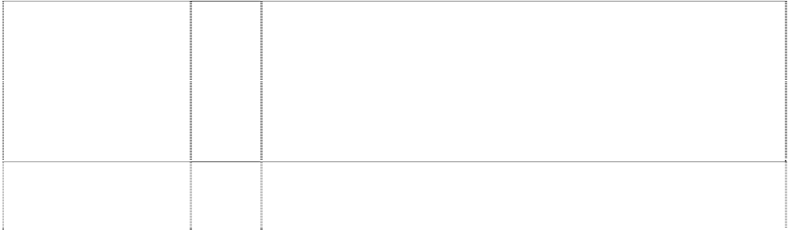

(728433)

# CITO

(770481)

# CL 63

(1086357)

# CL-CLASS

(813539)

# CLK 63

(1086361)

# CLK-CLASS

(680027)

# CLS 63

(1086360)

# CLS 65

(1090163)

# CLS-CLASS

(837299)

# CSK-CLASS

(837300)

**DAIMLER CHRYSLER** (777253)

**DAIMLER CHRYSLER** (777253)

**DAIMLER CHRYSLER** (777253)

**DAIMLER CHRYSLER** (777253)

**DAIMLER CHRYSLER** (777253)

**DAIMLER CHRYSLER** (777253)

**DAIMLER CHRYSLER** (777253)

**DAIMLER CHRYSLER** (777253)

**DAIMLER CHRYSLER** (777253)

12 Motor vehicles; parts and fittings for motor vehicles; all included in class 12.

12 Motor vehicles and parts and fittings therefore.

12 Motor vehicle parts and fittings therefor.

12 Motor vehicles; parts and fittings for the aforesaid goods.

12 Motor vehicles and parts and fittings therefor.

12 Apparatus for locomotion by land or air; land vehicles including motor vehicles; parts, fittings and accessories for the aforesaid goods including motors and engines for land vehicles.

12 Motor vehicles and parts and fittings therefor.

12 Motor vehicles and parts and fittings therefor.

12 Motor vehicles; parts and fittings therefor.

12 Motor vehicles; parts and fittings therefor.

1. Paints, varnishes, lacquers; preservatives against rust and against deterioration of wood; colorants; mordants; raw natural resins; metals in foil and powder form for painters, decorators, printers and artists.
2. Bleaching preparations and other substances for laundry use; cleaning, polishing, scouring and abrasive preparations; soaps; perfumery, essential oils, cosmetics, hair lotions; dentifrices.
3. Industrial oils and greases; lubricants; dust absorbing, wetting and binding compositions; fuels (including motor spirit) and illuminants; candles, wicks.
4. Common metals and their alloys; metal building materials; transportable buildings of metal; materials of metal for railway tracks; non-electric cables and wires of common metal; ironmongery, small items of metal hardware; pipes and tubes of metal; safes; goods of common metal not included in other classes; ores.
5. Machines and machine tools; motors and engines (except for land vehicles); machine coupling and transmission components (except for land vehicles); agricultural implements other than hand-operated.
6. Hand tools and implements (hand operated); cutlery; side arms; razors.
7. Scientific, nautical, surveying, electric, photographic, cinematographic, optical, weighing, measuring, signalling, checking (supervision), life-saving and teaching apparatus and instruments; apparatus for recording, transmission or reproduction of sound or images; magnetic data carriers, recording discs; automatic vending machines and mechanisms for coin-operated apparatus; cash registers, calculating machines, data processing equipment and computers; fire-extinguishing apparatus.
8. Apparatus for lighting, heating, steam generating, cooking, refrigerating, drying, ventilating, water supply and sanitary purposes.
9. Vehicles, apparatus for locomotion by land, air or water.

**DAIMLER CHRYSLER** (777253)

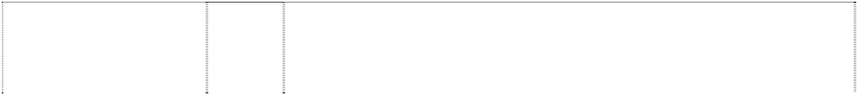

**DAIMLER CHRYSLER** (777253)

**DAIMLER CHRYSLER** (777253)

**DAIMLER CHRYSLER** (777253)

**DAIMLER CHRYSLER** (777253)

**DAIMLER CHRYSLER** (777253)

**DAIMLER CHRYSLER** (777253)

**DAIMLER CHRYSLER** (777253)

**DAIMLER CHRYSLER** (777253)

**DAIMLER CHRYSLER** (777253)

**DAIMLER CHRYSLER** (777253)

**DAIMLER CHRYSLER** (777253)

**DAIMLER CHRYSLER** (777253)

**DAIMLER CHRYSLER** (777253)

**DAIMLER CHRYSLER** (777253)

1. Firearms, ammunition and projectiles; explosives; fireworks.
2. Precious metals and their alloys and goods in precious metals or coated therewith, not included in other classes; jewellery, precious stones; horological and chronometric instruments.
3. Paper, cardboard and goods made from these materials, not included in other classes; printed matter; bookbinding material; photographs; stationery; adhesives for stationery or household purposes; artists' materials; paint brushes; typewriters and office requisites (except furniture); instructional and teaching material (except apparatus); plastic materials for packaging (not included in other classes); playing cards, printers' type, printing blocks.
4. Rubber, gutta-percha, gum, asbestos, mica and goods made from these materials and not included in other classes; plastics in extruded form for use in manufacture; packing, stopping and insulating materials; flexible pipes, not of metal.
5. Leather and imitations of leather, and goods made of these materials and not included in other classes, animal skins, hides; trunks and travelling bags; umbrellas, parasols and walking sticks, whips, harness and saddlery.
6. Furniture, mirrors, picture frames; goods (not included in other classes) of wood, cork, reed, cane, wicker, horn, bone, ivory, whalebone, shell, amber, mother-of-pearl, meerschaum and substitutes for all these materials, or of plastics.
7. Household or kitchen utensils and containers (not of precious metal or coated therewith); combs and sponges; brushes (except paint brushes); brush-making materials; articles for cleaning purposes; steel wool; unworked or semi-worked glass (except glass used in building); glassware, porcelain and earthenware not included in other classes.
8. Ropes, string, nets, tents, awnings, tarpaulins, sails, sacks and bags (not included in other classes); padding and stuffing materials (except of rubber or plastic); raw fibrous textile materials.
9. Yarns and threads, for textile use.
10. Textiles and textile goods, not included in other classes; bed and table covers.
11. Clothing, footwear, headgear.
12. Lace and embroidery, ribbons and braid; buttons, hooks and eyes, pins and needles; artificial flowers.
13. Carpets, rugs, mats and matting, linoleum and other materials for covering existing floors; wall hangings (non-textile).
14. Games and playthings; gymnastic and sporting articles not included in other classes; decorations for Christmas trees.
15. Meat, fish, poultry and game; meat extracts; preserved, dried and cooked fruits and vegetables; jellies, jams, fruit sauces; eggs, milk and milk products; edible oils and fats.

**DAIMLER CHRYSLER** (777253)

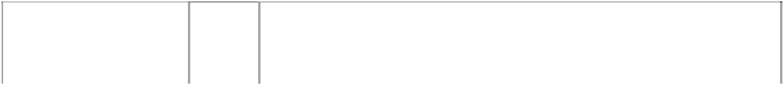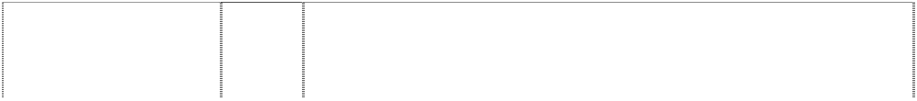

**DAIMLER CHRYSLER** (777253)

**DAIMLER CHRYSLER** (777253)

**DAIMLER CHRYSLER** (777253)

# DC LINK

ltrs form chain,styl. of 2 links

(952873)

# DISCOS

(768925)

# E-CLASS

(760581)

# ESP

(903857)

# ESP

(903857)

# EWATION

(838801)

# F-CELL

(934786)

# F-CELL

(934786)

# F-CELL

(934786)

# FLEETBOARD

(784790)

# FLEETBOARD

(784790)

# FLEETSTAR

(833581)

# FLEXIVAN

(764009)

# FLEXRAY

(858267)

1. Coffee, tea, cocoa, sugar, rice, tapioca, sago, artificial coffee; flour and preparations made from cereals, bread, pastry and confectionery, ices; honey, treacle; yeast, baking-powder; salt, mustard, vinegar, sauces (condiments); spices; ice.
2. Beers, mineral and aerated waters and other non-alcoholic drinks; fruit drinks and fruit juices; syrups and other preparations for making beverages.
3. Alcoholic beverages (except beers).
4. Tobacco; smokers' articles; matches.

9 Computer software.

12 Axles, drive shafts and transmission shafts, and parts and fittings therefor, for vehicles; and being formed substantially of metal.

12 Motor vehicles, parts and fittings for the aforesaid goods.

9 Electric and electronic measuring and controlling mechanisms for driving and braking systems in automobiles.

12 Automobiles and parts thereof (included in this class).

9 Information, transmitting and receiving apparatus, antennae, programs stored on data carriers of all kinds, jammers; devices for electronic warfare; signal intelligence and control devices; cryptographical devices.

9 Fuel cells for motor vehicles.

12 Automobiles and parts thereof (included in this class).

28 Model vehicles.

9 Electronic apparatus and instruments, radio and data transmission apparatus, telecommunication equipment, equipment for navigation, location and detection; transmitters, transceivers, receivers, antennae, sensors, control equipment; apparatus for obtaining, transmitting and evaluating data/information; magnetic data carriers, machine readable data carriers of all types, computer software; parts and fittings for the aforesaid goods including apparatus made from these goods and/or their parts.

12 Motor vehicles; parts and fittings therefore.

12 Motor vehicles, parts and fittings therefor.

12 Motor vehicles and their parts.

7 Control mechanisms for machines and motors.

# FLEXRAY



(858267)

# GL 65

(1098791)

# GL 65

(1098791)

# GLK 63

(1098792)

# GLK 63

(1098792)

# GLK 65

(1098792)

# GLK 65

(1098792)

# GOTIS

(1084687)

# IMAGINATION

(937347)

# MAYBACH

(952956)

# MAYBACH

(952956)

# MAYBACH

(952956)

# MAYBACH

(832967)

# MAYBACH

(763808)

# MAYBACH

(952956)

# MAYBACH

(952956)

# MAYBACH

(832967)

# MAYBACH

(763808)

# MAYBACH

(832967)

9 Data cables, equipment for recording, transferring and reproducing data, data networks, data processing equipment, data media, computers, control instruments and computer systems, integrated communication circuits in computer systems, integrated circuits, semiconductors.

12 Motor vehicles; parts and fittings therefor.

28 Motor vehicles.

12 Motor vehicles; parts and fittings therefor.

28 Motor vehicles.

12 Motor vehicles; parts and fittings therefor.

28 Motor vehicles.

9 Computer software; data carriers of all kind.

12 Motor vehicles and parts thereof (included in this class).

1. Paints, lacquers, rust protection products.
2. Bleaching preparations and other substances for laundry use; cleaning, polishing, grease removing and abrasive preparations; soaps; perfumery, essential oils, cosmetics, hair lotions; dentifrices.
3. Industrial oils and greases; lubricants; dust absorbing, wetting and binding compositions; fuel (including petrol) and illuminants; candles and wicks for lighting.

6 Keyrings.

6 Key rings; car badges.

1. Hand tools and implements; cutlery, side arms; razors.
2. Scientific, nautical, surveying, electric apparatus and instruments namely apparatus and instruments for conveying, distributing, transforming, storing, regulating or controlling electric current, transformers, electric batteries, photographic, cinematographic, optical, weighing, measuring, signalling, monitoring (inspection), rescue (emergency) and teaching apparatus and instruments; apparatus for recording, transmitting or reproducing sound or images; magnetic recording media, phonographic recordings, automatic vending machines and mechanisms for coin-operated apparatus, cash registers, calculators; data processing equipment and computers; fire extinguishers.

9 Sound and image carriers, namely cassettes, sound recordings, compact discs, video cassettes; spectacles; spectacle frames; spectacle cases; compasses.

9 Sound and image storage devices, including cassettes, tapes, compact discs, video cassettes; spectacles; spectacle frames, spectacle cases, compasses; computers; data storage devices; integrated circuits; modems; telephones; fire extinguishing apparatus; navigational equipment; remote control apparatus.

12 Motor vehicles, parts and fittings therefore.

# MAYBACH

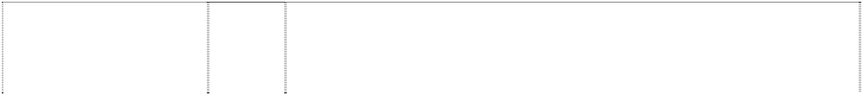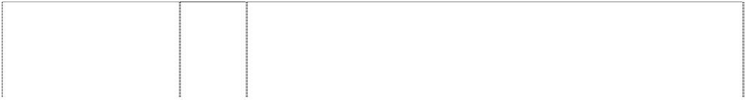

(681234)

# MAYBACH

(952956)

# MAYBACH

(965740)

# MAYBACH

(952956)

# MAYBACH

(832967)

# MAYBACH

(763808)

# MAYBACH

(952956)

# MAYBACH

(832967)

# MAYBACH

(763808)

# MAYBACH

(952956)

# MAYBACH

(832967)

# MAYBACH

(763808)

# MAYBACH

(952956)

# MAYBACH

(952956)

12 Vehicles including motor vehicles; apparatus for locomotion by land, air or water; parts, fittings and accessories for the aforesaid goods including motors and engines for land vehicles.

12 Vehicles; apparatus of locomotion by land, air or water.

12 Private passenger vehicles and parts thereof.

14 Precious metals and alloys thereof and products made of these materials (precious metals and alloys thereof) not included in other classes namely figurines of precious metals, ashtrays for smokers (of precious metals), cigarette cases (of precious metals), cigarette holders of precious metals, boxes of precious metals, key holders of precious metals; jewellery, precious stones; timepieces and chronometric instruments.

14 Watches, clocks; parts and fittings therefore, namely cases, straps of metal, leather or plastic; watch chains and pouches.

14 Watches and accessories therefore including cases for watches, watch straps made of metal, leather or plastic, watch chains, watch pouches.

16 Paper, cardboard, printed publications in the field of the motor car industry, bookbinding items; photographs; stationery; adhesives for stationery or household purposes; artists' supplies; paintbrushes, typewriters and office articles (except furniture); instructional or teaching equipment (excluding apparatus); printer's type; letterpress printing blocks.

16 Newspapers, magazines, brochures, books, goods made of paper and/or cardboard, namely paper towels, paper serviettes, packaging containers and bags; photographic materials; writing implements, packaging made of plastic, namely wrapping, pouches and films.

16 Newspapers, magazines, brochures, books, goods made of paper and all cardboard, including paper hand towels, serviettes, packaging, photographs; writing materials; packaging material made of plastic including wrapping, bags/pouches, sheets.

18 Leather and imitations thereof, goods made thereof not included in other classes namely key purses (leatherware), document wallets, wallets, purses not made of precious metal, travel bags, garment bags (for travel purposes), boxes of leather or leather board, leather trimmings for furniture; animal skins and hides; trunks and suitcases; umbrellas, parasols and walking sticks; whips and saddlery.

18 Leather and imitation leather, goods made there from, namely handbags, briefcases, small leather goods in particular purses, attache cases, key holders; travel and hand luggage, umbrellas and parasols, walking sticks.

18 Leather and imitation leather as well as goods made there from including handbags, briefcases, small leather goods in particular purses, cases, keyholders; trunks and travelling bags including suitcases; umbrellas, parasols, walking sticks.

1. Furniture, mirrors, frames; goods (not included in other classes) of wood, cork, reed, cane, wicker, horn, bone, ivory, whalebone, shell, amber, mother-of-pearl, meerschaum, substitutes of all these materials or plastics namely wooden or plastic boxes, wooden or plastic figurines (statuettes).
2. Household or kitchen utensils and containers (neither of precious metal nor coated therewith); combs and sponges; brushes (excluding paintbrushes), brush-making materials; cleaning equipment; steel wool; unworked or semi-worked glass (except for building glass); glassware, porcelain and earthenware not included in other classes namely glass boxes, figurines of porcelain or glass.

# MAYBACH



(952956)

# MAYBACH

(952956)

# MAYBACH

(832966)

# MAYBACH

(952956)

# MAYBACH

(952956)

# MAYBACH

(832967)

# MAYBACH

(763808)

# MAYBACH

(952956)

# MAYBACH

(832967)

# MAYBACH

(952956)

# MAYBACH

(952956)

# M-CLASS

(813536)

# MEGASPACE

(718811)

# MERC

(742001)

# MERCEDES

(475)

# MERCEDES

(28844)

# MERCEDES

(990614)

# MERCEDES

(477)

# MERCEDES

(28845)

# MERCEDES

(990614)

1. Textile fabrics; bed and table covers.
2. Clothing, shoes (excluding orthopaedic shoes); headwear.
3. Clothing, footwear, headgear.
4. Lace and embroidery, ribbons and braids; buttons, hooks and eyelets, pins and needles; artificial flowers.
5. Mats and mattings.

27 Carpets and foot mats.

1. Carpets and floor mats.
2. Games and toys; gymnastics and sports articles (except clothing, footwear and mats); Christmas tree decorations; playing cards.

28 Toys, games, playthings, model vehicles.

1. Alcoholic beverages (except beer).
2. Tobacco; smokers' requisites; matches.

12 Motor vehicles; parts and fittings for the aforesaid goods.

12 Motor vehicles and parts therefore.

12 Motor vehicles and their parts.

7 Machinery of all kinds included in this class and parts of machinery included in this class, including explosion motors of all kinds.

7 Agricultural and horticultural machinery and parts of such machinery.

9 Scientific, nautical, surveying, photographic, cinematographic, optical, weighing, measuring, signalling, checking (supervision), life- saving and teaching apparatus and instruments; apparatus and instruments for conducting, switching, transforming, accumulating, regulating and controlling electricity; apparatus for recording, transmission or reproduction of sound or images; magnetic data carriers, recording discs, in particular cassettes, tapes, compact discs, videocassettes; data processing equipment and computers; software stored on data carriers; sunglasses, spectacles, spectacle frames; spectacle cases; compasses; fire-extinguishing apparatus; ticket dispensers.

12 Carriages of all kinds including motor cars, motor lorries, motor cycles, and cycles included in this class.

12 Tyres of all descriptions included in this class and parts of such tyres.

14 Precious metals and their alloys and goods of precious metals or coated therewith (included in this class); jewellery, precious stones; horological and chronometric instruments; accessories for watches, namely cases for watches, watch straps of metal, leather or plastic, watch chains; cufflinks; key rings of precious and non-precious metals.

# MERCEDES



(990614)

# MERCEDES

(990614)

# MERCEDES

(990614)

# MERCEDES

(990614)

# MERCEDES

(432598)

# MERCEDES

(990614)

# MERCEDES

(990614)

# MERCEDES BENZ

3-D tricuspid in annulus (Mercedes Benz symbol); wreath in annulus

(54307)

# MERCEDES BENZ

3-D tricuspid in annulus (Mercedes Benz symbol); wreath in annulus

(267717)

# MERCEDES BENZ

3-D tricuspid in annulus (Mercedes Benz symbol); wreath in annulus

(267718)

# MERCEDES BENZ

3-D tricuspid in annulus (Mercedes Benz symbol); wreath in annulus

(267719)

**MERCEDES BENZ SPRINTER** (751295)

# MERCEDES-BENZ

(452658)

# MERCEDES-BENZ

(452659)

16 Paper, cardboard and goods made from these materials (included in this class); towels of paper, napkins of paper, packaging container and bags of paper; stationery; adhesives for stationery; artist's materials; paint brushes; photographs; printed matters; pictures, posters, brochures, magazines, writing implements and office articles such as ballpoint and fountain pens, pencils and coloured pencils; conference cases; note blocks, postcards, calendars, telephone and address registers, stickers, transparencies (included in this class); paper weight, packaging material made of plastic (included in this class).

18 Leather and imitations of leather and goods made of these materials (included in this class); handbags, briefcases, small leather goods, in particular purses, pocket wallets, key cases; trunks and travelling bags, umbrellas, parasols, walking sticks.

1. Textiles and textile goods, included in this class; travel covers; textile towels, textile bath towels, flags (included in this class); textile labels.
2. Clothing, headgear.

25 Clothing.

28 Games and playthings; gymnastic and sporting articles (included in this class); model vehicles; playing cards.

34 Smokers' articles, matches but excluding cigarettes, cigars, tobacco and tobacco products.

6 Unwrought and partly wrought common metals and their alloys; anchors, anvils, bells, rolled and cast building materials; rails and other metallic materials for railway tracks; chains (except driving chains for vehicles); cables and wires (non-electric); locksmiths' work; metallic pipes and tubes; safes and cash boxes; steel balls; horseshoes; nails and screws; other goods in non-precious metal not included in other classes; ores; being good included in this Class.

6 Unwrought and partly wrought common metals and their alloys; anchors, anvils, bells, rolled and cast building materials; rails and other metallic materials for railway tracks; chains (except driving chains for vehicles); cables and wires (non-electric); locksmiths' work; metallic pipes and tubes; safes and cash boxes; steel balls; horseshoes; nails and screws; other goods in non-precious metal not included in other classes; ores; being good included in this Class.

1. Hand tools and instruments; cutlery, forks and spoons; side arms; parts, accessories and spare parts for the aforesaid goods included in this class.
2. Scientific, nautical, surveying and electrical apparatus and instruments (including wireless), photographic, cinematographic, optical, weighing, measuring, signalling, checking (supervision), life- saving and teaching apparatus and instruments; coin or counter- freed apparatus; talking machines; cash registers; calculating machines; fire-extinguishing apparatus; parts, accessories and spare parts for the aforesaid goods included in this class.

12 Motor vehicles; parts and fittings therefore.

1. All goods in this class.
2. All goods in this class.

# MERCEDES-BENZ



(452660)

# MERCEDES-BENZ

(452661)

# MERCEDES-BENZ

(452662)

# MERCEDES-BENZ

(137155)

# MERCEDES-BENZ

(272742)

# MERCEDES-BENZ

(272743)

# MERCEDES-BENZ

(272744)

# MERCEDES-BENZ

(990618)

# MERCEDES-BENZ

(452663)

# MERCEDES-BENZ

(272745)

# MERCEDES-BENZ

3-D tricuspid in annulus (Mercedes Benz symbol); wreath in annulus

(267720)

# MERCEDES-BENZ

(272746)

# MERCEDES-BENZ

3-D tricuspid in annulus (Mercedes Benz symbol); wreath in annulus

(267721)

1. All goods in this class.
2. All goods in this class.
3. All goods in this class excluding cigarettes (tobacco-free) for medical purposes.
4. Unwrought and partly wrought common metals and their alloys; anchors, anvils, bells, rolled and cast building materials; rails and other metallic materials for railway tracks; chains (except driving chains for vehicles); cables and wires (non-electric); locksmiths' work; metallic pipes and tubes; safes and cash boxes; steel balls; horseshoes; nails and screws; other goods in non-precious metal not included in other classes; ores; being goods included in this class.
5. Machine and machine tools; engines and motors (except for land vehicles); machine couplings and belting (except for land vehicles); large size agricultural implements; incubators; parts, accessories and spare parts for the aforesaid goods included in this class.
6. Hand tools and instruments; cutlery, forks and spoons; side arms; parts, accessories and spare parts for the aforesaid goods included in this class.
7. Scientific, nautical, surveying and electrical apparatus and instruments (including wireless), photographic, cinematographic, optical, weighing, measuring, signalling, checking (supervision), life- saving and teaching apparatus and instruments; coin or counter- freed apparatus; talking machines; cash registers; calculating machines; fire-extinguishing apparatus; parts, accessories and spare parts for the aforesaid goods included in this class.
8. Scientific, nautical, surveying, photographic, cinematographic, optical, weighing, measuring, signalling, checking (supervision), life- saving and teaching apparatus and instruments; apparatus and instruments for conducting, switching, transforming, accumulating, regulating and controlling electricity; apparatus for recording, transmission or reproduction of sound or images; magnetic data carriers, recording discs, in particular cassettes, tapes, compact discs, videocassettes; data processing equipment and computers; software stored on data carriers; sunglasses, spectacles, spectacle frames; spectacle cases; compasses; fire-extinguishing apparatus; ticket dispensers.
9. All goods in this class including parts, spare parts and accessories therefore.
10. Installation for lighting heating, steam generating, cooking, refrigerating, drying, ventilating, water supply and sanitary purposes; parts, accessories and spare parts for the aforesaid goods included in this class.
11. Installations for lighting heating, steam generating, cooking, refrigerating, drying, ventilating, water supply and sanitary purposes; parts, accessories and spare parts for the aforesaid goods included in this class.
12. Vehicles; apparatus for locomotion by land, air or water; parts, accessories and spare parts for the aforesaid goods included in this class.
13. Vehicles; apparatus for locomotion by land, air or water; parts, accessories and spare parts for the aforesaid goods included in this class.

# MERCEDES-BENZ



(452664)

# MERCEDES-BENZ

(990618)

# MERCEDES-BENZ

(452665)

# MERCEDES-BENZ

(452666)

# MERCEDES-BENZ

(990618)

# MERCEDES-BENZ

(452667)

# MERCEDES-BENZ

(452668)

# MERCEDES-BENZ

(990618)

# MERCEDES-BENZ

(452669)

# MERCEDES-BENZ

(452670)

# MERCEDES-BENZ

(452671)

# MERCEDES-BENZ

(272747)

# MERCEDES-BENZ

(452672)

# MERCEDES-BENZ

3-D tricuspid in annulus (Mercedes Benz symbol); wreath in annulus

(267722)

# MERCEDES-BENZ

(452673)

# MERCEDES-BENZ

(452674)

1. All goods in this class including parts, spare parts and accessories therefore.
2. Precious metals and their alloys and goods of precious metals or coated therewith (included in this class); jewellery, precious stones; horological and chronometric instruments; accessories for watches, namely cases for watches, watch straps of metal, leather or plastic, watch chains; cufflinks; key rings of precious and non-precious metals.
3. All goods in this class including parts, spare parts and accessories therefore.
4. All goods in this class including parts, spare parts and accessories therefore.
5. Paper, cardboard and goods made from these materials (included in this class); towels of paper, napkins of paper, packaging container and bags of paper; stationery; adhesives for stationery; artist's materials; paint brushes; photographs; printed matters; pictures, posters, brochures, magazines, writing implements and office articles such as ballpoint and fountain pens, pencils and coloured pencils; conference cases; note blocks, postcards, calendars, telephone and address registers, stickers, transparencies (included in this class); paper weight, packaging material made of plastic (included in this class).
6. All goods in this class including parts, spare parts and accessories therefore.
7. All goods in this class including parts, spare parts and accessories therefore.
8. Leather and imitations of leather and goods made of these materials (included in this class); handbags, briefcases, small leather goods, in particular purses, pocket wallets, key cases; trunks and travelling bags, umbrellas, parasols, walking sticks.
9. All goods in this class.
10. All goods in this class including parts, spare parts and accessories therefore.
11. All goods in this class including parts, spare parts and accessories therefore.
12. Household coffee grinders, egg whisks, trouser stretchers, carpet sweepers not being machines, vacuum cleaners not included in Class 9, metal dishes, metal basins, metal buckets, wire brushes, non-electric cooking utensils, domestic bird cages, metal coffee pots, metal coolers for wine, water etc; kettles non-electric, parts, accessories and spare parts of all the foregoing goods included in this class.

21 All goods in this class including parts, spare parts and accessories therefore.

1. Household coffee grinders, egg whisks, Trouser stretchers, carpet sweepers not being machines, vacuum cleaners not included in Class 9, metal dishes, metal basins, metal buckets, wire brushes, non-electric cooking utensils, domestic bird cages, metal coffee pots, metal coolers for wine, water etc.; kettles non-electric, parts, accessories and spare parts of all the foregoing goods included in this class.
2. All goods in this class including parts, spare parts and accessories therefore.
3. All goods in this class.

# MERCEDES-BENZ

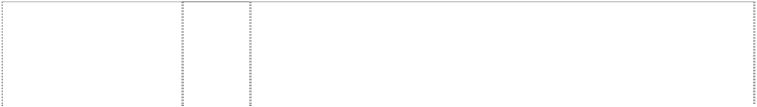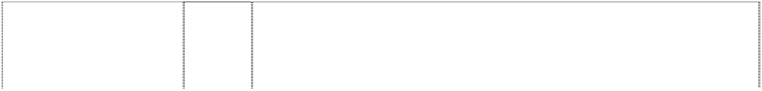

(990618)

# MERCEDES-BENZ

(452675)

# MERCEDES-BENZ

(990618)

# MERCEDES-BENZ

(452676)

# MERCEDES-BENZ

(452677)

# MERCEDES-BENZ

(452678)

# MERCEDES-BENZ

(990618)

# MERCEDES-BENZ

(452679)

# MERCEDES-BENZ

(990618)

# MERCEDES-BENZ

(272748)

# MERCEDES-BENZ

(452680)

# MERCEDES-BENZ

3-D tricuspid in annulus (Mercedes Benz symbol); wreath in annulus

(267723)

# MERCEDES-BENZ CLUB

3 point star in annulus with 2 twigs & berries (597283)

**MERCEDES-BENZ TRANSPORTER** (741999)

# MIXTO

(962863)

# ML 63

(1086367)

# ML 65

(1090158)

# MM

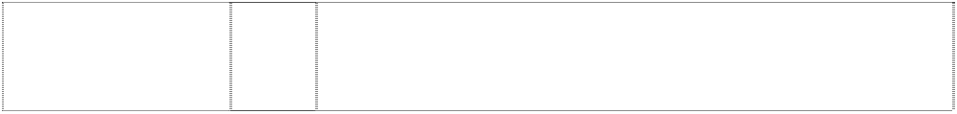ltrs MM intersect in triangle curved sides (924823)

# MM

ltrs MM intersect in triangle curved sides (924823)

1. Textiles and textile goods, included in this class; travel covers; textile towels, textile bath towels, flags (included in this class); textile labels.
2. All goods in this class.
3. Clothing, footwear, headgear.
4. All goods in this class.
5. All goods in this class.
6. All goods in this class.
7. Games and playthings; gymnastic and sporting articles (included in this class); model vehicles; playing cards.

28 All goods in this class.

34 Smokers' articles; lighters; matches.

34 Smokers' articles (not included in other classes) being goods included in this class.

34 Smokers' articles in this class and matches.

34 Smokers articles (not included in other classes) being goods included in this class.

25 Articles of clothing included in this class, including T-shirts, sweat shirts and polo shirts; shirts; trousers; jackets; coats; dresses; suits; ties (for wear); stockings; handkerchiefs, shawls, scarves and headscarves; footwear; headgear for wear, including hats and caps; all included in this class.

12 Motor vehicles and their parts.

12 Motor vehicles and parts thereof (included in this class).

12 Motor vehicles and parts and fittings therefor.

12 Motor vehicles and parts and fittings therefor.

1. Paints, lacquers, preservatives against rust.
2. Bleaching preparations and other substances for laundry use; cleaning, polishing, scouring and abrasive preparations; soaps; perfumery, essential oils, cosmetics, hair lotions; dentifrices.

# MM



ltrs MM intersect in triangle curved sides (924823)

# MM

ltrs MM intersect in triangle curved sides (832965)

# MM

ltrs MM intersect in triangle curved sides (924823)

# MM

ltrs MM intersect in triangle curved sides (924823)

# MM

ltrs MM intersect in triangle curved sides (832965)

# MM

ltrs MM intersect in triangle curved sides (924823)

# MM

ltrs MM intersect in triangle curved sides (832965)

# MM

ltrs MM intersect in triangle curved sides (924823)

# MM

ltrs MM intersect in triangle curved sides (832965)

# MM

ltrs MM intersect in triangle curved sides (924823)

# MM

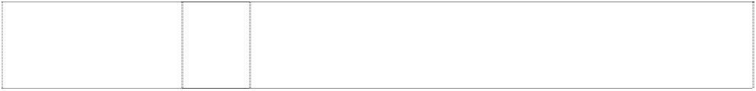ltrs MM intersect in triangle curved sides (832965)

# MM

ltrs MM intersect in triangle curved sides (924823)

1. Industrial oils and greases; lubricants; dust absorbing, wetting and binding compositions; fuels (including motor spirit) and illuminants; candles, wicks.

6 Keyrings.

1. Hand tools and implements (hand-operated); cutlery; side arms; razors.
2. Scientific, nautical, surveying, electric, photographic, cinematographic, optical, weighing, measuring not included in other classes, signalling, checking (supervision), life-saving and teaching apparatus and instruments; apparatus for recording, transmission or reproduction of sound or images; magnetic data carriers, phonograph records; automatic vending machines and mechanisms for coin-operated apparatus; cash registers, calculating machines, data processing equipment and computers; fire-extinguishing apparatus.

9 Sound and image carriers, namely cassettes, sound recordings, compact discs, video cassettes; spectacles; spectacle frames; spectacle cases; compasses.

12 Vehicles; apparatus for locomotion by land, air or water.

12 Motor vehicles, parts and fittings therefore.

14 Precious metals and their alloys and goods in precious metals or coated therewith, not included in other classes; jewellery, precious stones; horological and chronometric instruments.

14 Watches, clocks; parts and fittings therefor, namely cases, straps of metal, leather or plastic; watch chains and pouches.

16 Paper, cardboard and goods made from these materials, not included in other classes; printed publications in the field of motor vehicles; bookbinding material; photographs; stationery; adhesives for stationery or household purposes; artists' materials; paint brushes; typewriters and office requisites (except furniture); instructional and teaching material (except apparatus); plastic materials for packaging (not included in other classes); printers' type; printing blocks.

16 Newspapers, magazines, brochures, books, goods made of paper and/or cardboard, namely paper towels, paper serviettes, packaging containers and bags; photographic materials; writing implements, packaging made of plastic, namely wrapping, pouches and films.

18 Leather and imitations of leather, and goods made of these materials and not included in other classes; animal skins, hides; trunks and travelling bags; umbrellas, parasols and walking sticks; whips, harness and saddlery.

# MM

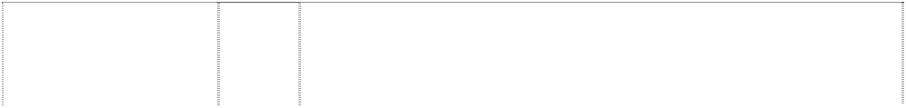

ltrs MM intersect in triangle curved sides (832965)

# MM

ltrs MM intersect in triangle curved sides (924823)

# MM

ltrs MM intersect in triangle curved sides (924823)

# MM

ltrs MM intersect in triangle curved sides (924823)

# MM

ltrs MM intersect in triangle curved sides (924823)

# MM

ltrs MM intersect in triangle curved sides (832965)

# MM

ltrs MM intersect in triangle curved sides (924823)

# MM

ltrs MM intersect in triangle curved sides (924823)

# MM

trs MM intersect in triangle curved sides (832965)

# MM

ltrs MM intersect in triangle curved sides (924823)

# MM

ltrs MM intersect in triangle curved sides (832965)

# MM

ltrs MM intersect in triangle curved sides (924823)

# MOBILO

(879816)

# MOBILO LIFE

(788092)

18 Leather and imitation leather, goods made there from, namely handbags, briefcases, small leather goods in particular purses, attache cases, key holders; travel and hand luggage, umbrellas and parasols, walking sticks.

1. Furniture, mirrors, picture frames; goods (not included in other classes) of wood, cork, reed, cane, wicker, horn, bone, ivory, whalebone, shell, amber, mother-of-pearl, sea foam and substitutes for all these materials, or of plastics.
2. Household or kitchen utensils and containers (not of precious metal or coated therewith); combs and sponges; brushes (except paint brushes); brush-making materials; articles for cleaning purposes; steelwool; unworked or semi-worked glass (except glass used in building); glassware, porcelain and earthenware not included in other classes.
3. Textiles and textile goods, not included in other classes; bed and table covers.
4. Clothing, footwear, headgear.
5. Clothing, footwear, and headgear.
6. Lace and embroidery, ribbons and braid; buttons, hooks and eyes, pins and needles; artificial flowers.
7. Mats and matting.
8. Carpets and foot mats.
9. Games and playthings; gymnastic and sporting articles not included in other classes; decorations for christmas trees, playing cards.

28 Toys, games, playthings, model vehicles.

34 Tobacco; smokers' articles; matches.

9 Machine readable data carriers in particular magnetic cards and chip cards equipped with programs and/or data; accounting software.

9 Machine-readable data carriers in particular magnetic cards and chip cards equipped with programs and/or data; book-keeping and accounting software programs.

# O-BAHN



(351487)

# OC 500

(1009851)

# S-CLASS

(760585)

# SERVER

(741997)

# SILVER ARROW

(789141)

# SILVER ARROW

(789141)

# SILVER ARROW

(789141)

# SILVER ARROW

(789141)

# SILVER ARROW

(789141)

# SILVER ARROW

(789141)

# SILVER ARROW

(789141)

# SILVER ARROW

(789141)

# SILVER ARROW

(789141)

# SILVER ARROW

(789141)

# SILVER ARROW

(789141)

# SILVER ARROW

(789141)

# SILVER ARROW

(789141)

12 Motor vehicles and parts therefore in this class, and all other goods in this class.

12 Motor vehicles; chassis; parts and fittings therefor.

12 Motor vehicles, parts and fittings for the aforesaid goods.

12 Motor vehicles and their parts.

1. Chemicals used in industry, science and photography, as well as in agriculture, horticulture and forestry; unprocessed artificial resins, unprocessed plastics; manures; fire extinguishing compositions; tempering and soldering preparations; chemical substances for preserving foodstuffs; tanning substances; adhesives used in industry; but excluding bread improving preparations or chemical substances in this class used in the preparation of dough in bread making.
2. Paints, varnishes, lacquers; preservatives against rust and against deterioration of wood; colorants; mordants; raw natural resins; metals in foil and powder form for painters, decorators, printers and artists.
3. Bleaching preparations and other substances for laundry use; cleaning, polishing, scouring and abrasive preparations; soaps; perfumery, essential oils, cosmetics, hair lotions, dentifrices.
4. Industrial oils and greases; lubricants; dust absorbing, wetting and binding compositions; fuels (including motor spirit) and illuminants; candles, wicks.
5. Pharmaceutical, veterinary and sanitary preparations; dietetic substances adapted for medical use, food for babies; plasters, materials for dressings; material for stopping teeth, dental wax; disinfectants.
6. Common metals and their alloys; metal building materials, transportable buildings of metal; materials of metal for railway tracks; non-electric cables and wires of common metal; ironmongery, small items of metal hardware; pipes and tubes of metal; safes; goods of common metal not included in other classes; ores; but excluding road barriers and crash barriers, carports and garages, window and door frames, window and door fittings and hardware, awnings, blinds and parts and fittings therefore.
7. Machines and machine tools; motors and engines (except for land vehicles); machine coupling and transmission components (except for land vehicles); incubators for eggs; the aforegoing excluding machine tools being vertical machining center, labelling machines, and farm, agricultural and ground engaging implements and machinery and parts thereof.
8. Hand tools and implements (hand operated); cutlery; side arms; razors.
9. Optical goods, sunglasses, spectacles, spectacle frames; radios, televisions, computer games.
10. Apparatus for lighting, steam generating, refrigerating, drying, ventilating, water supply and sanitary purposes but excluding apparatus related to heating, cooking, stoves and fireplaces.
11. Vehicles; apparatus for locomotion by land, air or water.
12. Firearms, ammunition and projectiles; explosives; fireworks, but excluding arrows.
13. Precious metals and their alloys and goods in precious metals or coated therewith, not included in other classes; jewellery, precious stones; horological and chronometric instruments.

# SILVER ARROW

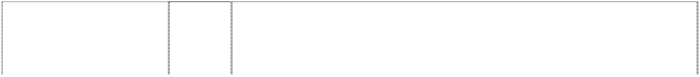

(789141)

# SILVER ARROW

(789141)

# SILVER ARROW

(789141)

# SILVER ARROW

(789141)

# SILVER ARROW

(789141)

# SILVER ARROW

(789141)

# SILVER ARROW

(789141)

# SILVER ARROW

(789141)

# SILVER ARROW

(789141)

# SILVER ARROW

(789141)

# SILVER ARROW

(789141)

# SILVER ARROW

(789141)

# SILVER ARROW

(789141)

# SL 63

(1086359)

# SL 65

(1090157)

# SL-CLASS

(760586)

# SLK 63

(1086365)

# SLK-CLASS

(680018)

1. Musical instruments.
2. Rubber, gutta-percha, gum, asbestos, mica and goods made from these materials and not included in other classes; plastics in extruded form for use in manufacture; packing, stopping and insulating materials; flexible pipes, not of metal but excluding vinyl tapes and other tapes in this class.
3. Leather and imitations of leather, and goods made of these materials and not included in other classes; animal skins, hides, trunks and travelling bags; umbrellas, parasols and walking sticks, whips, harness and saddlery.
4. Building materials (non-metallic); non-metallic rigid pipes for building; asphalt, pitch and bitumen; non-metallic transportable buildings; monuments, not of metal but excluding road barriers and crash barriers, carports, garages, window and door hardware and fittings including screens for windows and doors, and parts and fittings for blinds and awnings.
5. Furniture, mirrors, picture frames, goods (not included in other classes) of wood, cork, reed, cane, wicker, horn, bone, ivory, whalebone, shell, amber, mother-of-pearl, meerschaum and substitutes for all these materials, or of plastics; the aforesaid goods excluding window and door furniture, awnings, blinds, screens.
6. Household or kitchen utensils and containers (not of precious metal or coated therewith); combs and sponges; brushes (except paint brushes) but excluding tooth brushes; brush making materials except for toothbrushes; articles for cleaning purposes; steelwool; unworked or semi-worked glass (except glass used in building); glassware, porcelain and earthenware not included in other classes.

23 Yarns and threads, for textile use.

1. Lace and embroidery, ribbons and braid, buttons, hooks and eyes, pins and needles; artificial flowers.
2. Carpets, rugs, mats and matting, linoleum and other materials for covering existing floors; wall hangings (nontextile).
3. Games and playthings; gymnastic and sporting articles not included in other classes; decorations for Christmas trees; all the aforesaid goods excluding arrows.
4. Meat, fish, poultry and game; meat extracts; preserved, dried and cooked fruits and vegetables; jellies, jams, fruit sauces; eggs, milk and milk products, edible oils and fats.

31 Agricultural, horticultural and forestry products and grains not included in other classes; live animals; fresh fruits and vegetables; seeds, natural plants and flowers; foodstuffs for animals, malt.

34 Tobacco; smokers' articles; matches.

12 Motor vehicles and parts and fittings therefor.

12 Motor vehicles and parts and fittings therefor.

12 Motor vehicles, parts and fittings for the aforesaid goods.

12 Motor vehicles and parts and fittings therefor.

12 Vehicles including motor vehicles; apparatus for locomotion by land, air or water; parts, fittings and accessories for the aforesaid goods including motors and engines for land vehicles.

# SLR

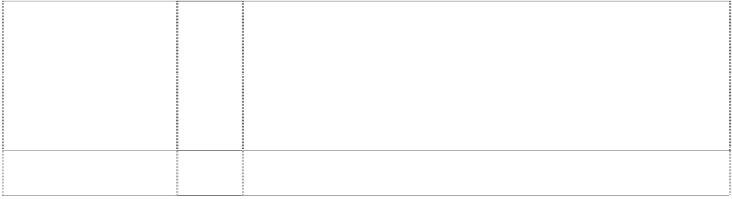

(1035239)

# SLR

(1035239)

**SLR SAFETY & SPEED ACADEMY** (1078364)

**SLR SAFETY & SPEED ACADEMY** (1078364)

**SLR SAFETY & SPEED ACADEMY** (1078364)

**SLR SAFETY & SPEED ACADEMY** (1078364)

**SLR SAFETY & SPEED ACADEMY** (1078364)

**SLR SAFETY & SPEED ACADEMY** (1078364)

# SPRINTER STREET

(835831)

# SPRINTSHIFT

(809375)

# STARMARQUE

(917402)

# TARGOS

(768706)

# TARGOS

(768706)

# TARGOS

(768706)

# TARGOS

(768706)

# TELLIGENT

(718810)

# TELLIGENT

(718810)

12 Motor vehicles; parts and fittings therefor.

28 Games, toys, model cars.

12 Automobiles and their structural parts.

14 Precious metals and their alloys and goods in precious metals or coated therewith, not included in other classes; jewellery, precious stones; horological and chronometric instruments.

16 Paper, cardboard and goods made from these materials, not included in other classes; printed matter; bookbinding material; photographs; stationery; adhesives for stationery or household purposes; artists' materials; paint brushes, typewriters and office requisites (except furniture); instructional and teaching material (except apparatus); plastic materials for packaging (not included in other classes); printers type; printing blocks.

18 Leather and imitations of leather, and goods made of these materials and not included in other classes; animal skins, hides; trunks and travelling bags; umbrellas, parasols and walking sticks; whips, harness and saddlery.

25 Clothing, footwear, headgear.

28 Games and playthings; gymnastic and sporting articles not included in other classes; decorations for Christmas trees, playing cards.

12 Motor vehicles; parts and fittings therefor.

12 Transmission for motor vehicles, parts and fittings therefor; gear change levers for automatic transmissions; none of the foregoing being for use in relation to sprint cars.

12 Motor vehicles, parts and fittings therefor.

6 Keys, key rings.

12 Light commercial vehicles, and parts and fittings thereof.

14 Clocks, watches, clock or watch accessories.

25 Articles of clothing including T-shirts, sweatshirts, ties, gloves, overcoats, anoraks, ponchos, jackets, waistcoats, sweaters, polo shirts, trousers, scarves, belts; footwear; headgear, including hats, caps, hoods and motor caps.

9 Electrical and electronic measuring, control apparatus for motor vehicles, data processing equipment; communication equipment, programs stored on data carriers of all types; all the foregoing for use in relation to motor vehicles; all being for use in electronic systems in commercial vehicles in order to identify electronic components such as flexible service systems, air bags, electronic pneumatic gear lift mechanisms, electronic driving controls, electronic driving clutches, electronic pneumatic brakes.

12 Motor vehicles and parts therefore.

# TEMPO

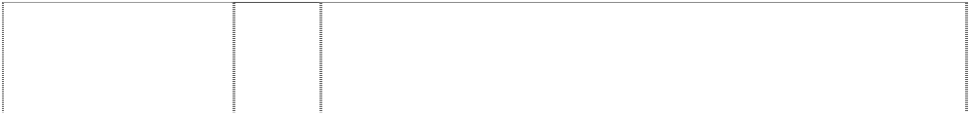

concentric circles (107233)

# TRITON

(795021)

# UNIMOG

(137159)

# UNIMOG

(272713)

# UNIMOG

(272714)

# UNIMOG

(272715)

# UNIMOG

(272716)

# UNIMOG

(272717)

# UNIMOG

(272718)

# UNIMOG

(272719)

# UNIMOG

bull, head with ring through nose (108357)

# UNIMOG

bull, head with ring through nose (205495)

# UNIMOG

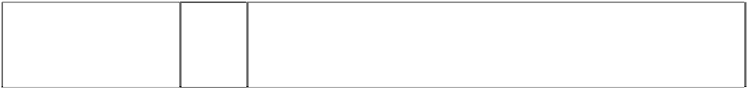bull, head with ring through nose (108355)

# UNIMOG

bull, head with ring through nose (205388)

1. Land vehicles, including motor cars and structural parts thereof, motor cycles, and structural parts thereof.
2. Firearms, ammunition, missiles, explosives, projectiles, weapon systems appropriate hereto and parts thereof.
3. Unwrought and partly wrought common metals and their alloys; anchors, anvils, bells, rolled and cast building materials; rails and other metallic materials for railway tracks; chains (except driving chains for vehicles); cables and wires (non-electric); locksmiths' work; metallic pipes and tubes; safes and cash boxes; steel balls; horseshoes; nails and screws; other goods in non-precious metal not included in other classes; ores; being goods included in this class.
4. Machines and machine tools; engines and motors (except for land vehicles); machine couplings and belting (except for land vehicles); large size agricultural implements; incubators; parts, accessories and spare parts for the aforesaid goods included in this class.
5. Hand tools and instruments; cutlery, forks and spoons; side arms; parts, accessories and spare parts for the aforesaid goods included in this class.
6. Scientific, nautical, surveying and electrical apparatus and instruments (including wireless), photographic, cinematographic, optical, weighing, measuring, signalling, checking (supervision), life- saving and teaching apparatus and instruments; coin or counter- freed apparatus; talking machines; cash registers; calculating machines; fire-extinguishing apparatus; parts, accessories and spare parts for the aforesaid goods included in this class.
7. Installations for lighting, heating, steam generating, cooking, refrigerating, drying, ventilating, water supply and sanitary purposes; parts, accessories and spare parts for the aforesaid goods included in this class.
8. Vehicles; apparatus for locomotion by land, air or water; parts, accessories and spare parts for the aforesaid goods included in this class.

21 Household coffee grinders, egg whisks, trouser stretchers, carpet sweepers not being machines, vacuum cleaners not included in Class 9, metal dishes, metal basins, metal buckets, wire brushes, non-electric cooking utensils, domestic bird cages, metal coffee pots, metal coolers for wine, water etc.; kettles non-electric, parts, accessories and spare parts of all the foregoing goods included in this class.

34 Smokers' articles (not included in other classes) being goods included in this class.

1. Goods of non-precious metals.
2. Agricultural machinery and parts thereof.
3. Machines and machine tools; motors (except for vehicles); machine couplings (except for vehicles); machinery of all kinds including agricultural and horticultural machinery; and parts of all the foregoing goods.
4. Hand tools and instruments; and parts of all the foregoing goods.

# UNIMOG



bull, head with ring through nose (205488)

# UNIMOG

bull, head with ring through nose (205489)

# UNIMOG

bull, head with ring through nose (205490)

# UNIMOG

bull, head with ring through nose (205491)

# UNIMOG

bull, head with ring through nose (205492)

# UNIMOG

bull, head with ring through nose (205493)

# UNIMOG

bull, head with ring through nose (205494)

# VANEO

(832701)

# VIANO

(836015)

# VIANO

(836015)

# VIRTUS

(760954)

# VITO

(681640)

# XENTRY

(1030019)

# XENTRY

(1030019)

# XENTRY

(1030019)

3-D tricuspid (Mercedes symbol) (215521)

3-D tricuspid (Mercedes symbol) (215520)

1. Fire extinguishing apparatus, electrical switches.
2. Goods of non-precious metal in this class for use in relation to installations for lighting, heating, steam generating, cooking, refrigerating, drying, ventilating, water supply and sanitary purposes.
3. Goods of non-precious metals, and non-metallic parts and accessories being parts and accessories for vehicles and included in this class; vehicles; apparatus for locomotion by land, and air, automobiles, passenger cars, commercial motor vehicles, omnibuses, motor vans, freight trucks; lorries, tractors, aeroplanes and parts and accessories of any of the foregoing.

16 Goods of non-precious metals being stationery requisites.

21 Small domestic utensils and containers of non-precious metals; steelwool.

26 Press buttons, hooks and eyes of non-precious metals; pins and needles.

34 Smokers articles of non-precious metals.

12 Motor vehicles; parts and fittings therefore.

7 Parts and fittings for motor vehicles.

12 Motor vehicles; parts and fittings therefore.

7 Generators and parts thereof; propulsive engines for generators; electric generators.

12 Motor vehicles and their parts.

9 Electrical and/or electronic measuring, controlling, regulating and diagnostic apparatus for motor vehicles; parts of motor vehicles (included in this class); magnetic and/or optical data carriers.

12 Motor vehicles and parts thereof (included in this class).

16 Documentation of diagnosis and repairs (printed matter).

2 Paints.

6 Fuel, oil, water, pressure, injection and leaked-oil pipes of metal, instrument panels of metal.

3-D tricuspid (Mercedes symbol) (215519)

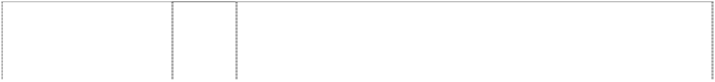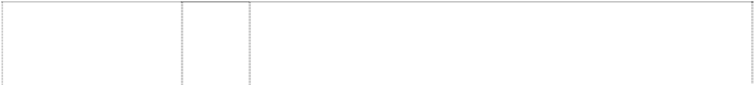

3-D tricuspid (Mercedes symbol) (215518)

3-D tricuspid (Mercedes symbol) (215517)

3-D tricuspid (Mercedes symbol) (11266)

3-D tricuspid (Mercedes symbol) (215516)

3-D tricuspid in circle (Mercedes Benz symbol)

(215510)

3-D tricuspid in circle (Mercedes Benz symbol)

(212106)

3-D tricuspid in circle (Mercedes Benz symbol)

(212107)

3-D tricuspid in circle (Mercedes Benz symbol)

(215509)

3-D tricuspid in circle (Mercedes Benz symbol)

(215508)

1. Hand tools.
2. Gearing control systems, polyphase apparatus, electrical equipment and instruments for combustion machines, electrical switching apparatus and leads, electric batteries, apparatus and arrangements for radio interference suppression, electrical, mechanical, optical and acoustical apparatus, instruments and arrangements for controlling, regulating, supervising, checking and recording, instrument panels, sacrificial anodes for tubular and built-on heat exchangers, flexible shafts (electrical) for instruments; and parts of all the aforementioned goods included in Class 9.
3. Fans and drives therefore, ventilators, heat exchanges, oil coolers, cooling water regulators, drinking water cooling equipment, fitted pipes for cooling water apparatus, heating apparatus for stationary and mobile drive machines for industrial purposes, fuel, oil and electric heating apparatus, fuel, oil and air filters not being parts of the lubrication systems of internal combustion engines; and parts of all the aforementioned goods included in Class 11.
4. Land vehicles including automobiles, passenger cars, commercial motor vehicles, omnibuses, motor vans, freight trucks, lorries, motor cycles and cycles; motors for vehicles and parts of the same being goods included in this class.

17 Fuel, oil, water, pressure injection and leaked-oil pipes (non- metallic).

2 Paints.

1. Machines and machine tools; engines and motors (except for vehicles); machine couplings (except for vehicles); machinery of all kinds; agricultural and horticultural machinery; boilers and boiler tubes; carburettors; metal goods included in this class; and parts of all the foregoing goods.
2. Hand tools and instruments; and parts of all the foregoing goods.
3. Hand tools.
4. Gearing control systems, polyphase apparatus, electrical equipment and instruments for combustion machines, electrical switching apparatus and leads, electric batteries, apparatus and arrangements for radio interference suppression, electrical, mechanical, optical and acoustical apparatus, instruments and arrangements for controlling, regulating, supervising, checking and recording, instrument panels, sacrificial anodes for tubular and built-on heat exchangers, flexible shafts (electrical) for instruments; and parts of all the aforementioned goods included in Class 9.

3-D tricuspid in circle (Mercedes Benz symbol)



(990616)

3-D tricuspid in circle (Mercedes Benz symbol)

(212109)

3-D tricuspid in circle (Mercedes Benz symbol)

(215507)

3-D tricuspid in circle (Mercedes Benz symbol)

(205374)

3-D tricuspid in circle (Mercedes Benz symbol)

(212110)

3-D tricuspid in circle (Mercedes Benz symbol)

(990616)

3-D tricuspid in circle (Mercedes Benz symbol)

(990616)

3-D tricuspid in circle (Mercedes Benz symbol)

(215506)

9 Scientific, nautical, surveying, photographic, cinematographic, optical, weighing, measuring, signalling, checking (supervision), life- saving and teaching apparatus and instruments; apparatus and instruments for conducting, switching, transforming, accumulating, regulating and controlling electricity; apparatus for recording, transmission or reproduction of sound or images; magnetic data carriers, recording discs, in particular cassettes, tapes, compact discs, videocassettes; data processing equipment and computers; software stored on data carriers; sunglasses, spectacles, spectacle frames; spectacle cases; compasses; fire-extinguishing apparatus; ticket dispensers.

11 Goods of non-precious metal in this class for use in relation to installations for lighting, heating, steam generating, cooking, refrigerating, drying, ventilating, water supply and sanitary purposes, lamps for vehicles, metal automobile reflectors, metal anti-dazzle shades for automobiles, metal lampshades, metal baths, metal burners, metal cisterns and metal frames, refrigerating machines, ventilating fans, ceiling fans, electric fans; and parts of all the foregoing goods.

1. Fans and drives therefore, ventilators, heat exchangers, oil coolers, cooling water regulators, drinking water cooling equipment, fitted pipes for cooling water apparatus, heating apparatus for stationary and mobile drive machines for industrial purposes, fuel, oil and electric heating apparatus, fuel, oil and air filters not being parts of the lubrication systems of internal combustion engines; and parts of all the aforementioned goods included in Class 11.
2. Carriages equipped with diesel engines; diesel engines.

12 Vehicles; apparatus for locomotion by land, air and water, automobiles, passenger cars, commercial motor vehicles, omnibuses, motor vans, freight trucks, lorries, agricultural vehicles for tractors, bicycles, motor cycles, aeroplanes, locomotives, motors or engines for vehicles, chassis for vehicles, ships' propellers; parts and accessories wholly or mainly of metal and included in class 12 for any of the foregoing goods; and non-metallic parts and accessories, being parts of machinery and included in class 12, for any of the foregoing goods; machinery and parts thereof.

14 Precious metals and their alloys and goods of precious metals or coated therewith (included in this class); jewellery, precious stones; horological and chronometric instruments; accessories for watches, namely cases for watches, watch straps of metal, leather or plastic, watch chains; cufflinks; key rings of precious and non-precious metals.

1. Paper, cardboard and goods made from these materials (included in this class); towels of paper, napkins of paper, packaging container and bags of paper; stationery; adhesives for stationery; artist's materials; paint brushes; photographs; printed matters; pictures, posters, brochures, magazines, writing implements and office articles such as ballpoint and fountain pens, pencils and coloured pencils; conference cases; note blocks, postcards, calendars, telephone and address registers, stickers, transparencies (included in this class); paper weight, packaging material made of plastic (included in this class).
2. Fuel, oil, water, pressure, injection and leaked-oil pipes (non- metallic).

3-D tricuspid in circle (Mercedes Benz symbol)

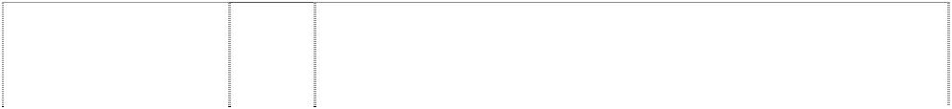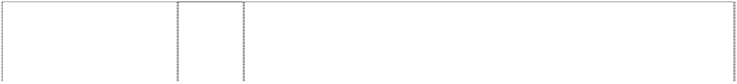

(990616)

3-D tricuspid in circle (Mercedes Benz symbol)

(990616)

3-D tricuspid in circle (Mercedes Benz symbol)

(990616)

3-D tricuspid in circle (Mercedes Benz symbol)

(990616)

3-D tricuspid in circle (Mercedes Benz symbol)

(990616)

3-D tricuspid in circle (Mercedes Benz symbol)

(212111)

circle ring star, three- point tricuspid wheel, steering

(70712)

circle ring star, three- point tricuspid wheel, steering

(212108)

fish,stingray,silhouette (934015)

star 4 point in ring (196667)

star 4 point in ring (196668)

star 4 point in ring (196669)

star, 4 point, in circles, concentric

(103907)

1. Leather and imitations of leather and goods made of these materials (included in this class); handbags, briefcases, small leather goods, in particular purses, pocket wallets, key cases; trunks and travelling bags, umbrellas, parasols, walking sticks.
2. Textiles and textile goods, included in this class; travel covers; textile towels, textile bath towels, flags (included in this class); textile labels.
3. Clothing, footwear, headgear.

28 Games and playthings; gymnastic and sporting articles (included in this class); model vehicles; playing cards.

34 Smokers' articles; lighters; matches.

34 Smokers' articles of non-precious metals.

6 Tanks or containers for liquid fuel, oil or water, exhaust boxes, gear cases, nuts, bolts, washers, sleeves, pins, collars, screws, oil sprayers, oil save-alls, or catches, oil rings, and discs, floats, pipes, pipe unions, joints, oil cans funnels, and oil syringes, all being metal goods.

9 Fire extinguishing apparatus, signalling apparatus, sparking plugs, balances, blowers, electrical switches and contacts, commutators, electrical vacuum cleaners, electrical floor polishers, dust extractors, compasses, cash registers, scales, weighing machines, metal weights and measures, coin-freed machines, junction boxes fusible metal electric cut-outs, metal electric terminals, metal electric fittings, electric flat irons, mechanical signs for advertising and steam sirens and whistles; machinery included in this class; parts of all the foregoing goods included in class 9; and metal goods.

9 Control devices for machines and engines; data cables, apparatus for recordal, transmission and display of data, data networks, data processing apparatus, data carriers, computers, control instruments, integrated circuits for communication in computer systems, integrated circuits, semiconductors.

9 Electric vacuum cleaners, electric floor polishers, cash registers, scales and weighing machines.

1. Ceiling fans, electric fans, refrigerators.
2. Motors for vehicles and parts thereof; land vehicles, tractors, motor cycles, chassis for vehicles; and aeroplanes.

7 Machines and machine tools, motors (except for vehicles), machine couplings; machinery of all kinds including agricultural and horticultural machinery; and parts of all the foregoing goods in class 7; boilers, boiler tubes in this class, but not including fluid pressure regulating devices, steam pumps and steam engines and parts thereof.

star, three-point or tricuspid

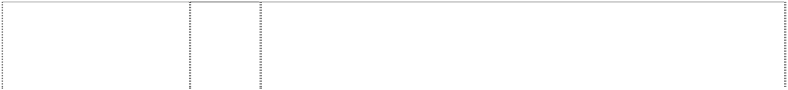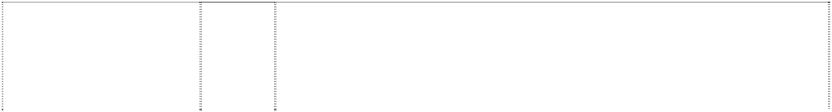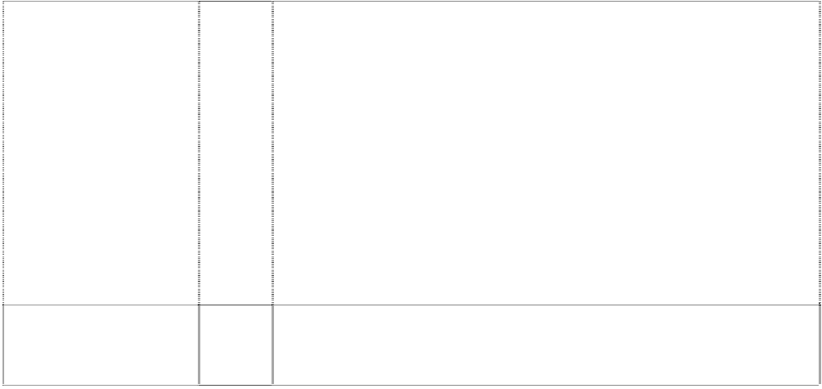

(137422)

star, three-point or tricuspid

(265414)

star, three-point or tricuspid within circle (137151)

star, three-point tricuspid in ring; wheel, steering

(70710)

star, three-point, within circle

(272709)

stripes form front view of car grot

(747342)

stripes form front view of car grot

(747342)

stripes form front view of car grot

(747342)

stripes form front view of car grot

(747342)

stripes form front view of car grot

(747342)

stripes form front view of car grot

(747342)

7 Machinery and parts of machinery (except agricultural and horticultural machinery and parts thereof), motors (except for land vehicles) including internal combustion motors, electrical motors, steam engines, fluid flow machines such as turbines and rocket propulsion motors, aeroplane and boat motors and engines; machine couplings and belting (except for land vehicles) and parts, accessories and spare parts of the foregoing goods included in this class.

12 Machinery and parts of machinery being motors for land vehicles, including internal combustion motors, electric motors, steam engines, fluid flow machines such as turbines and rocket propulsion motors; aeroplanes; parts, accessories and spare parts of the foregoing goods included in this class.

1. Unwrought and partly wrought common metals and their alloys; anchors, anvils, bells, rolled and cast building materials, rails and other metallic materials for railway tracks; chains (except driving chains for vehicles); cables and wires (non-electric); locksmiths' work; metallic pipes and tubes; safes and cash boxes; steel balls; horseshoes; nails and screws; other goods in non-precious metal not included in other classes; ores; being goods included in this class.
2. Diesel engines and parts thereof, and machines equipped with diesel engines including agricultural and horticultural machines.

11 Installations for lighting, heating steam generating, cooking, refrigerating, drying, ventilating, water supply and sanitary purposes; parts, accessories and spare parts for the aforesaid goods included in this class.

3 Body care and cosmetic products, eaux de toilette, shaving lotions and foams, hair lotions, perfumes, essential oils, soaps, toothpastes, nail varnish, nail care products, lipsticks, eyebrow pencils, mascaras; bleaching preparations and other substances for laundry use; car cleaning and polishing products.

1. Pharmaceutical preparations; plasters, materials for dressings; First Aid boxes.
2. Non-electric cables and wires of common metal; ironmongery, small items of metal hardware; key rings, tow ropes and bars; tobacco tins.
3. Hand tools and implements; side arms; razors; cutlery, pocket knives, manicure cases, travel shavers, scissors.
4. Scientific, nautical, surveying, electric, photographic, cinematographic, optical, weighing, measuring, life saving and teaching apparatus and instruments; apparatus for recording, transmission or reproduction of sound or images; magnetic data carriers, recording discs; automatic vending machines and mechanisms for coin operated apparatus; cash registers, calculating machines, data processing equipment and computers, fire extinguishing apparatus; audio/video media, including cassettes, audio tapes, compact disks, video cassettes; pre-recorded audio/video media; spectacles, spectacle frames, spectacle cases; compasses; sunglasses, protective glasses for drivers of convertible cars, magnifying glasses, car thermometers, tape measures, safety jackets, pocket calculators, spectacle cases.

11 Apparatus for lighting, heating, drying, and ventilating purposes; torches and reading lights, travel hair dryers.

stripes form front view of car grot



(747342)

stripes form front view of car grot

(747342)

stripes form front view of car grot

(747342)

stripes form front view of car grot

(747342)

stripes form front view of car grot

(747342)

stripes form front view of car grot

(747342)

stripes form front view of car grot

(747342)

stripes form front view of car grot

(747342)

stripes form front view of car grot

(747342)

stripes form front view of car grot

(747342)

stripes form front view of car grot

(747342)

tricuspid in circle (mercedes benz symbol)

(452723)

tricuspid in circle (mercedes benz symbol)

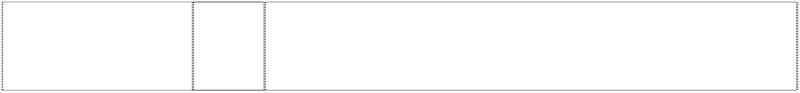(452724)

tricuspid in circle (mercedes benz symbol)

(215515)

14 Watches/clocks and watch/clock accessories, precious and costume jewellery including tie pins and other pins/brooches, cufflinks, rings, bracelets, necklaces, brooches, earrings, badges, insignia, coins, trophy cups, metal key rings, clocks, travel alarms, powder compacts, pill boxes.

16 Printed materials, pictures, posters, brochures, magazines and periodicals, writing and office products including ball-point and fountain pens, pencils and coloured pencils, conference folders, note blocks, postcards, calendars, telephone and address books, note dispensers; stickers, posters, banners, pennants, playing cards, maps and street plans, beer mats, labels not of textiles.

18 Handbags, briefcases, shopping bags, hand luggage and suitcases, umbrellas and parasols, blankets, wallets, purses, suitcases, bags, handbags, wallets and billfolds, travel bags, suit carriers, and rucksacks, duffel bags, key cases, make-up and tool bags, sponge bags, leather or imitation leather luggage labels, picnic cases in this class.

1. Mirrors, including pocket mirrors, furniture; bottle stoppers, picnic cases in this class.
2. Household or kitchen utensils and containers; glasses, beakers, jugs, wall plates, sponges, chamois leathers, window cloths, insulated flasks, powder compacts, pill boxes, combs, brushes, comb cases.
3. Ropes, string, nets, sails, sacks and bags; hammocks.
4. Textiles and textile goods, bed and table covers; flags and pennants; cloth labels.
5. Items of clothing including T-shirts, shirts, sweatshirts, ties, gloves, anoraks, ponchos, jackets and waistcoats, sweaters, polo shirts, trousers, socks, coats, dresses, suits, shawls and head squares, head scarves and pocket handkerchiefs, belts; footwear; headgear including hats, caps, bonnets, caps for drivers of convertible cars.
6. Badges included in class 26, sewing cases.

28 Toys and games including toy cars, balls, soft toys, jigsaw puzzles, domino and boules games, yo-yos, board games including chess, Chinese chequers, nine men's morris, model cars, balloons; gymnastic and sporting articles.

34 Tobacco; smokers' articles including ashtrays, matches, lighters, tobacco jars, cigar and cigarette cases.

1. All goods in this class.
2. All goods in this class.

2 Paints.

tricuspid in circle (mercedes benz symbol)



(452725)

tricuspid in circle (mercedes benz symbol)

(452726)

tricuspid in circle (mercedes benz symbol)

(452727)

tricuspid in circle (mercedes benz symbol)

(272706)

tricuspid in circle (mercedes benz symbol)

(272707)

tricuspid in circle (mercedes benz symbol)

(215514)

tricuspid in circle (mercedes benz symbol)

(272708)

tricuspid in circle (mercedes benz symbol)

(215513)

tricuspid in circle (mercedes benz symbol)

(452728)

tricuspid in circle (mercedes benz symbol)

(215512)

tricuspid in circle (mercedes benz symbol)

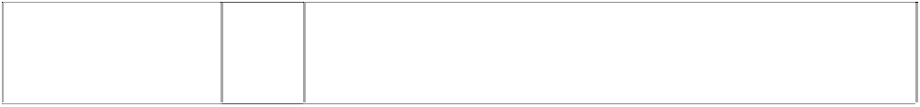(452729)

tricuspid in circle (mercedes benz symbol)

(452730)

1. All goods in this class.
2. All goods in this class.
3. All goods in this class.
4. Machines and machine tools; engines and motors (except for land vehicles); machine couplings and belting (except for land vehicles); large size agricultural implements; incubators; parts, accessories and spare parts for the aforesaid goods included in this class.
5. Hand tools and instruments; cutlery, forks and spoons; side arms; parts, accessories and spare parts for the aforesaid goods included in this class.
6. Hand tools.
7. Scientific, nautical, surveying and electrical apparatus and instruments (including wireless), photographic, cinematographic, optical, weighing, measuring, signalling, checking (supervision), life- saving and teaching apparatus and instruments; coin or counter- freed apparatus; talking machines; cash registers; calculating machines; fire-extinguishing apparatus; parts, accessories and spare parts for the aforesaid goods included in this class.
8. Gearing control systems, polyphase apparatus, electrical equipment and instruments for combustion machines, electrical switching apparatus and leads, electric batteries, apparatus and arrangements for radio interference suppression, electrical, mechanical, optical and acoustical apparatus, instruments and arrangements for controlling, regulating, supervising, checking and recording, instruments panels, sacrificial anodes for tubular and built-on heat exchangers, flexible shafts (electrical) for instruments; and parts of all the aforementioned goods included in Class 9.
9. All goods in this class including parts, spare parts and accessories therefore.
10. Fans and drives therefore, ventilators, heat exchangers, oil coolers, cooling water regulators, drinking water cooling equipment, fitted pipes for cooling water apparatus, heating apparatus for stationery and mobile drive machines for industrial purposes, fuel, oil and electric heating apparatus, fuel, oil and air filters not being parts of the lubrication systems of internal combustion engines; and parts of all the aforementioned goods included in Class 11.
11. All goods in this class including parts, spare parts and accessories therefore.
12. All goods in this class including parts, spare parts and accessories therefore.

tricuspid in circle (mercedes benz symbol)

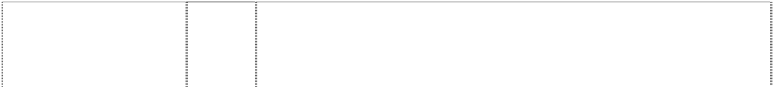

(272710)

tricuspid in circle (mercedes benz symbol)

(452731)

tricuspid in circle (mercedes benz symbol)

(452732)

tricuspid in circle (mercedes benz symbol)

(452733)

tricuspid in circle (mercedes benz symbol)

(452734)

tricuspid in circle (mercedes benz symbol)

(452735)

tricuspid in circle (mercedes benz symbol)

(215511)

tricuspid in circle (mercedes benz symbol)

(452736)

tricuspid in circle (mercedes benz symbol)

(452737)

tricuspid in circle (mercedes benz symbol)

(452738)

tricuspid in circle (mercedes benz symbol)

(272711)

tricuspid in circle (mercedes benz symbol)

(452739)

tricuspid in circle (mercedes benz symbol)

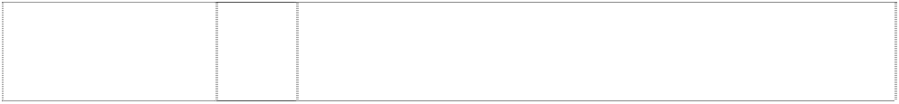(452740)

tricuspid in circle (mercedes benz symbol)

(452741)

1. Vehicles, apparatus for locomotion by land, air or water; parts, accessories and spare parts for the aforesaid goods included in this class.
2. All goods in this class including parts, spare parts and accessories therefore.
3. All goods in this class including parts, spare parts and accessories therefore.
4. All goods in this class including parts, spare parts and accessories therefore.
5. All goods in this class including parts, spare parts and accessories therefore.
6. All goods in this class including parts, spare parts and accessories therefore.
7. Fuel, oil, water, pressure injection and leaked-oil pipes (non- metallic).
8. All goods in this class including parts, spare parts and accessories therefore.
9. All goods in this class including parts, spare parts and accessories therefore.
10. All goods in this class including parts, spare parts and accessories therefore.
11. Household coffee grinders, egg whisks, trouser stretchers, carpet sweepers not being machines, vacuum cleaners not included in Class 9, metal dishes, metal basins, metal buckets, wire brushes, non- electric cooking utensils, domestic bird cages, metal coffee pots, metal coolers for wine, water etc.; kettles non-electric, parts, accessories and spare parts of all the foregoing goods included in this class.
12. All goods in this class including parts, spare parts and accessories therefore.
13. All goods in this class including parts, spare parts and accessories therefore.
14. All goods in this class.

tricuspid in circle (mercedes benz symbol)



(452742)

tricuspid in circle (mercedes benz symbol)

(452743)

tricuspid in circle (mercedes benz symbol)

(452744)

tricuspid in circle (mercedes benz symbol)

(452745)

tricuspid in circle (mercedes benz symbol)

(452746)

tricuspid in circle (mercedes benz symbol)

(452747)

tricuspid in circle (mercedes benz symbol)

(272712)

tricuspid in circle is badge

(1093319)

tricuspid in circle is badge

(1093319)

tricuspid in circle is badge

(1093319)

tricuspid in circle is badge

(1093319)

1. All goods in this class.
2. All goods in this class excluding golf shoes, golf clothing and golf headwear.
3. All goods in this class.
4. All goods in this class.
5. All goods in this class including parts, spare parts and accessories therefore.

34 All goods in this class.

34 Smokers' articles (not included in other classes) being goods included in this class.

9 Scientific, nautical, surveying, electric, photographic, cinematographic, optical, weighing, measuring, signalling, checking (supervision), life-saving and teaching apparatus and instruments; apparatus and instruments for conducting, switching, transforming, recording, regulating or controlling electricity; apparatus for recording, transmission or reproduction of sound or images; magnetic data carriers, recording discs, in particular cassettes, tapes, compact discs, video cassettes; data processing equipment and computers; software stored on data carriers; sunglasses, spectacles, spectacle frames; spectacle cases; compasses; fire- extinguishing apparatus; ticket dispensers.

14 Precious metals and their alloys and goods in precious metals or coated therewith, not included in other classes; jewellery, precious stones; horological and chronometric instruments; watch accessories, namely cases for watches, watch straps of metal, leather or plastic, watch chains; cuff links, key rings of precious and non-precious metals.

16 Paper, cardboard and goods made from these materials, not included in other classes; paper hand towels, paper serviettes, packaging containers and bags of paper; stationery; adhesives for stationery or household purposes; artists' materials; paint brushes; photographs; printed matter; pictures, posters, brochures, magazines, writing implements and office articles such as ballpoint and fountain pens; pencils and coloured pencils; conference cases (writing cases); note-blocks, postcards, calendars, telephone and address books, transfers (decalcomania), transparencies, letter openers, packaging made of plastic.

18 Leather and imitations of leather, and goods made of these materials and not included in other classes; handbags, briefcases, small leather goods, in particular, purses, attache cases, key cases (leatherware); trunks and traveling bags; umbrellas, parasols, walking sticks.

tricuspid in circle is badge



(1093319)

tricuspid in circle is badge

(1093319)

tricuspid in circle is badge

(1093319)

tricuspid in circle is badge

(1093319)

tricuspid or star, three- point in ring

(72962)

1. Woven and textile goods; travelling rugs; textile hand towels, textile bath towels, flags; textile labels.
2. Clothing, footwear, headgear.

28 Games and playthings; gymnastic and sporting articles not included in other classes; model vehicles; playing cards.

34 Smokers' articles; lighters; matches.

6 Goods of non-precious metals not included in other classes; including frames, plates, pillars, posts, rails, struts, rods, panels, mouldings, links, linkages, arms, bars, keys, keyrings and blanks, locks, hoses, pipes, tubes, tanks, containers, boxes, covers, hinges, caps, levers, plugs, buffers, nozzles, seals, strips, clamps, chains, collars, shackles and hooks and eyes, cages, cables and wires, nails, pivots, balls, rollers, pins, washers, nuts, fittings, bolts, bushings, sleeves, discs, shims, studs, rivets, screws, springs, flanges, rings, valves, nipples.

***Denis Kevin McFadden Slaters Intellectual Property Lawyers Ph: (02) 9818 1813***

***Effective Date: 27 April 2007 File Reference: C07/06173 Trade Marks Class Goods***



# JUST CUTS STYLE CUTS FOR EVERYBODY

scissors in parallelogram, incomplete,rounded- corners

3 All goods included in this class.

***Dragon Alliance South Pacific Pty Ltd Dragon Alliance South Pacific Pty Ltd Ph: (03) 5261 6660***

***Effective Date: 3 April 2007 File Reference: C07/04893 Trade Marks Class Goods***



# DRAGON

dragon,styl. with wings outstretched in circle (881955)

# DRAGON

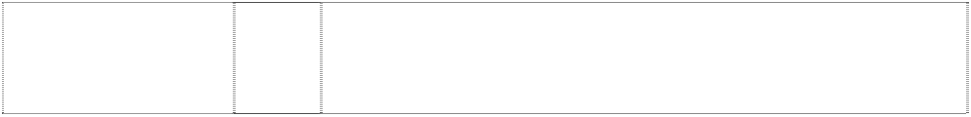dragon,styl. with wings outstretched in circle (881955)

# DRAGON

dragon,styl. with wings outstretched in circle (881955)

9 Optical goods and accessories including; sunglasses, goggles, spectacles, sunglasses frames, lenses and parts, spectacle frames and lenses, and packaging specifically adapted for sunglasses, goggles and spectacles.

14 Jewellery and time pieces, including watches.

18 Travelling bags, gearbags, luggage, packs and rucksacks.

# DRAGON

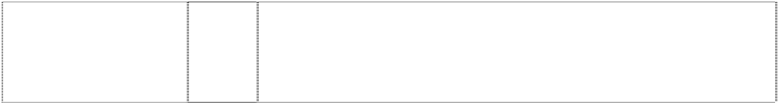

dragon,silh. in circle (805650)

# DRAGON ALLIANCE

(896849)

# DRAGON ALLIANCE

(896849)

# DRAGONS

(600632)

dragon,styl. silhouette has wings & tail, in circle

(714505)

25 Clothing including swim suits, coverups, shorts, pants, T-shirts, jackets, knit shirts, sandals, slacks, tank tops, warm up suits, sweaters, caps, hats, visors, jeans, shoes, sweatshirts, sweat pants, wet suits, rain gear, bandannas, headbands, sweatbands, wristbands, and socks.

9 Protective and/or antiglare eyewear, including, sunglasses and goggles; and parts and accessories therefor including, replacement lenses, ear stems, frames, nose pieces and foam strips; and cases specially adapted for protective and/or antiglare eyewear.

25 Clothing, including, T-shirts, shirts, tank-tops, hats, caps, visors, headbands, shorts, swim-suits, sweatshirts, sweatpants, pants, jackets; socks and shoes.

9 Protective and/or anti-glare eyewear including sunglasses and their parts and accessories including replacement lenses, earstems, frames, nose pieces and foam strips; cases specially adapted for sunglasses and their parts and accessories; the foregoing all being goods included in class 9.

9 Protective and/or anti-glare eyewear, including sunglasses, goggles and their parts and accessories, including replacement lenses, earstems, frames, nose pieces and foam strips used therewith, cases especially adapted for storage of protective and/or anti-glare eyewear, and their parts and accessories.

***Eros Australia Pty Ltd Eros Australia Pty Ltd Ph: (02) 9623 3480***

***Effective Date: 30 March 2007 File Reference: C07/04886 Trade Marks Class Goods***

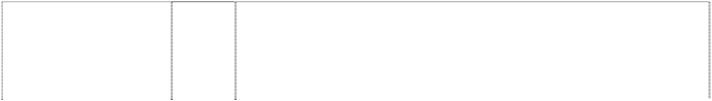

# EROS ENTERTAINMENT

ribbon breaks earth,globe (949546)

# EROS INTERNATIONAL RELEASE [WWW.EROSENTERT](http://WWW.EROSENTERT/) AINMENT.COM

ribbon breaks earth,globe (932158)

9 DVDs, VCDs, audio CDs, audio cassettes, compact discs, music and film recordings, DVX, cinema movie reels.

9 DVDs, CDs, audio CDs, VCDs, video music recordings.

***Fendi Adele S.r.L Corrs Chambers Westgarth Ph: (03) 9672 3000***

***Effective Date: 22 March 2007 File Reference: C07/03141***

Leather and imitations of leather, and goods made of these materials and not included in other classes; animal skins, hides; trunks and travelling bags; umbrellas, parasols and walking sticks; whips, harness and saddlery.

18

**BAGUETTE**

(846340)

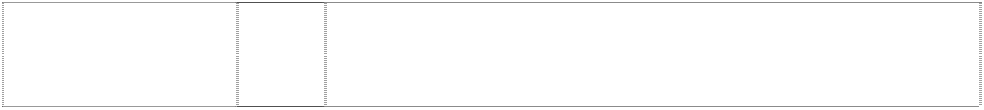

***Trade Marks***

***Class***

***Goods***

# FENDI

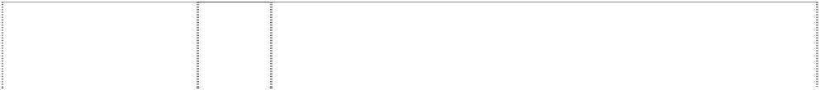

(1112820)

# FENDI

(1112820)

# FENDI

(501372)

# FENDI

(1112820)

# FENDI

(303036)

# FENDI

(335109)

# FENDI

(1112820)

# FENDI

(303035)

# FENDISSIME

(847405)

# FENDISSIME

(608487)

# FF

(501373)

9 Scientific, nautical, surveying, photographic, cinematographic, optical, weighing, measuring, signalling, checking (supervision), life- saving and teaching apparatus and instruments; apparatus and instruments for conducting, switching, transforming, accumulating, regulating or controlling electricity; apparatus for recording, transmission or reproduction of sound or images; magnetic data carriers, recording discs; automatic vending machines and mechanisms for coin-operated apparatus; cash registers, calculating machines, data processing equipment and computers; fire- extinguishing apparatus.

14 Precious metals and their alloys and goods in precious metals or coated therewith, not included in other classes; jewellery, precious stones; horological and chronometric instruments.

14 Precious metals and their alloys and goods in precious metals or coated therewith (except cutlery, forks and spoons); jewellery; precious stones; horological and other chronometric instruments and all other goods in this class.

18 Leather and imitations of leather, and goods made of these materials and not included in other classes; animal skins, hides; trunks and travelling bags; umbrellas, parasols and walking sticks; whips, harness and saddlery.

18 Luggage, beauty cases, shirt cases, desk accessories and brief cases, all included in this class; hand and shoulder bags, trunks, travel bags, rucksacks, key cases, attaché cases, wallets (pocket), purses (not of precious metal), card cases, umbrellas and parasols; and all other products included in Class 18.

1. Shirt cases manufactured wholly or principally of textile material.
2. Clothing, footwear, headgear.

25 Fur coats, fur stoles, fur pieces, rainwear, coats, jackets, trousers, dresses, hosiery, shirts, blouses, headwear, scarves, foulards, gloves, ties, neckwear, socks, stockings, lingerie, footwear, belts, swimwear, bedwear and all the foregoing being goods in Class 25, and all other goods in this class.

9 Scientific, nautical, surveying, electric, photographic, cinematographic, optical, weighing, measuring, signalling, checking (supervision), life-saving and teaching apparatus and instruments; apparatus for recording, transmission or reproduction of sound or images; magnetic data carriers, recording discs; automatic vending machines and mechanisms for coin operated apparatus; cash registers, calculating machines, data processing equipment and computers; fire-extinguishing apparatus.

25 All goods in this class including aprons; baby pants; bath robes; bath sandals; bath slippers; bathing caps; bathing drawers; bathing suits; bathing trunks; beach clothes; beach shoes; belts; boots; coats; cuffs; dressing gowns; footwear; fur stoles; furs; galoshes; gloves; gymnastic shoes; half-boots; hats; headgear for wear; hosiery; knitwear; neckties; overalls; overcoats; pants; pelerines; pockets for clothing; pullovers; pyjamas; sandals; sashes for wear; scarves; shawls; shirts; shoes; skirts; slippers; socks; sports shoes; stocking suspenders; stockings; suits; sweaters; swimsuits; trouser straps; trousers; underwear; vests; waistcoats; wristbands.

14 Precious metals and their alloys and goods in precious metals or coated therewith (except cutlery, forks and spoons); jewellery; precious stones; horological and other chronometric instruments and all other goods in this class.

# FF



(303037)

# FF

(321333)

# FF

(303042)

# FF

(303043)

# FF

rectangle, rounded- corners

(274997)

# FF FENDI

(584408)

# FF FENDI

(501371)

# FF FENDI

(453492)

# FF FENDI

(453493)

# FF FENDI

square formed by letters

(412007)

# FF FENDI SELLERIA

belt; ltrs ff form square,divided (1112772)

# FF FENDI SELLERIA

belt; ltrs ff form square,divided (1112772)

# FF FENDI SELLERIA

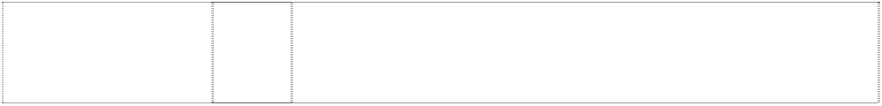belt; ltrs ff form square,divided (1112772)

# FF FENDI SELLERIA

belt; ltrs ff form square,divided (1112772)

18 Luggage, beauty cases, shirt cases, desk accessories and brief cases all included in this class; hand and shoulder bags, trunks, travel bags, rucksacks, key cases, attache cases, wallets (pocket) purses (not of precious metal), card cases, umbrellas and parasols; and all other products included in Class 18.

1. Shirt cases manufactured wholly or principally of textile material.
2. Clothing, including boots, shoes and slippers.
3. Lace and embroidery, ribands and braid; buttons, press buttons, hooks and eyes, pins and needles; artificial flowers.

25 Footwear and all other goods in this class.

9 Eyeglasses, spectacles and their cases, chains, cords and frames.

14 Precious metals and their alloys and goods in precious metals or coated therewith (except cutlery, forks and spoons); jewellery; precious stones; horological and other chronometric instruments and all other goods in this class.

18 Leather and imitations of leather and articles made from these materials and not included in other classes; skins, hides; trunks and travelling bags; umbrellas, parasols and walking sticks; whips, harness and saddlery; and all other goods included in this class.

25 Clothing, including boots, shoes and slippers; and all other goods included in this class.

3 Soaps, anti-perspiration soaps, anti-perspiration toilet articles, essential oils, bath-salts not for medical purposes, bath preparations in this class, beauty masks, detergent milk, make-up sets, cosmetics, cosmetic cotton, tooth-paste, deodorant soap, depilatory products, detergents other than for use in manufacturing operations or for medical purposes, shadows, make-up, fard, eau-de-cologne, eye make-up, eye pencils, hair tinctures, hair lotions, perm preparations, lip-sticks, cosmetic lotions, make-up powder, make-up detergents, nail polish enamels, perfumes, shampoo, shaving preparations.

18 Leather and imitations of leather, and goods made of these materials and not included in other classes; animal skins, hides; trunks and travelling bags; umbrellas, parasols and walking sticks; whips, harness and saddlery.

1. Textiles and textile goods, not included in other classes; bed and table covers.
2. Clothing, footwear, headgear.
3. Lace and embroidery, ribbons and braid; buttons, hooks and eyes, pins and needles; artificial flowers.

***Hugo Boss Trade Mark Management GmbH & Co. KG Corrs Chambers Westgarth***

***Ph: (03) 9672 3000***

***Effective Date: 23 February 2007 File Reference: C07/02995 Trade Marks Class Goods***



# BOSS

(902472)

# BOSS

(647104)

# BOSS

(461858)

# BOSS

(902472)

# BOSS

(647105)

# BOSS

(461875)

# BOSS

(902472)

# BOSS

(647106)

# BOSS

(461861)

# BOSS

(908173)

# BOSS

(902472)

# BOSS

(908173)

# BOSS

(647107)

# BOSS

(516998)

# BOSS

(902472)

# BOSS

(647108)

# BOSS

(345175)

# BOSS

(442954)

9 Eyewear and parts thereof.

9 Spectacles, sunglasses, and parts and accessories therefore including spectacle frames and cases for spectacles and sunglasses.

9 Spectacles and parts and accessories therefore, all being goods in class 9.

14 Clocks and watches, jewellery.

14 Jewellery, clocks and watches.

14 Articles made of or coated with precious metals and precious metal alloys; jewellery; clocks and watches; all goods in class 14.

18 Goods made of leather and leather imitations (included in this class); belts made of textile or plastic materials, suitcases and bags, umbrellas and parasols.

18 Leather goods and imitation leather goods in class 18, including wallets, key cases, hand bags, trunks, travelling bags, purses, small articles of leather, briefcases, travelling sets, bags for climbers (rucksacks) and belts of leather and of imitations of leather; umbrellas and parasols.

18 Leather goods, cases in class 18, bags in class 18, umbrellas and parasols, belts made of leather.

1. Yarns and threads for textile use.
2. Table linen and bed linen, woven fabrics, curtains, bathroom textiles, namely towels; handkerchiefs made of textile material.

24 Textile goods, namely textile fabric, curtains; blinds, household linen, table and bed linen, bath linen, travelling rugs, handkerchiefs.

24 Textiles and textile goods in this class, including cloths, curtains, blinds, household linen, table linen, bed covers, table covers and handkerchiefs.

1. Textiles and textile goods, including cloths, curtains, blinds, household linen, table linen, bed linen, bed covers and table covers, all the aforesaid goods being goods in class 24.
2. Articles of clothing for ladies, gentlemen and children, especially suits, coats, jackets, trousers, shirts, raincoats, outer garments and underwear, socks, stockings, tricots, pullovers, knitted shirts; footwear and head coverings, ties, gloves, belts, braces, bathrobes.

25 Clothing, clothing accessories in this class, headgear and footwear.

25 Clothing of all kinds, including headwear and footwear.

25 Clothing, clothing accessories, headgear, footwear, all being goods in Class 25 and all other goods in class 25.

# BOSS



(908173)

# BOSS

(902472)

# BOSS

(647109)

# BOSS

(461860)

# BOSS

(902472)

# BOSS HUGO BOSS

(889514)

# BOSS HUGO BOSS

(920015)

# BOSS HUGO BOSS

(889514)

# BOSS HUGO BOSS

(889514)

# BOSS HUGO BOSS

(920015)

# BOSS HUGO BOSS

(889514)

# BOSS HUGO BOSS

(889514)

# BOSS HUGO BOSS

(920015)

# BOSS HUGO BOSS

(442956)

# BOSS HUGO BOSS

(889514)

# BOSS HUGO BOSS

(889514)

**BOSS HUGO BOSS SELECTION** (1010853)

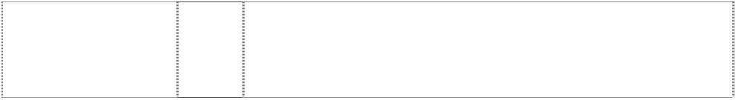**BOSS HUGO BOSS SELECTION** (1010853)

**BOSS HUGO BOSS SELECTION** (1010853)

1. Haberdashery, included in this class; lace and embroidery, ribbons and braid; hook and pile fastening tapes; buttons, hooks and eyes, snap fasteners, belt clasps, fastenings for clothings; zip fasteners and buckles; pins and needles; collar ribs, shoulder pads, badges, brooches as clothing accessories.

28 Gymnastic and sports equipment; balls.

28 Gymnastic and sports articles and equipment included in class 28, games, toys and playthings.

28 Gymnastic and sports articles in this class; games, toys and playthings; all goods in class 28.

34 Tobacco products, lighters.

9 Spectacles and parts thereof.

9 Spectacles and parts thereof, especially sunglasses.

14 Precious metals and their alloys as well as goods made thereof or coated therewith (included in this class); jewellery, costume jewellery; clocks and watches.

18 Leather and leather imitations as well as goods made therefrom (included in this class); in particular, small articles of leather; trunks and suitcases; bags; umbrellas and parasols.

18 Leather and leather imitations as well as goods made therefrom (included in this class), in particular, small articles of leather; trunks and suitcases; bags; umbrellas and parasols; belts made of leather.

1. Woven fabrics and textile goods (included in this class), in particular, handkerchiefs and towels; bed and table linen; textile wallpapers.
2. Articles of clothing for ladies, gentlemen and children; socks and stockings; headgear, underwear; nightwear; swimwear; bathrobes; belts; scarves and shawls; accessories, namely head scarves, neck scarves, shoulder scarves, pocket kerchiefs; ties; gloves; footwear; belts made of leather.

25 Articles of clothing for ladies, gentlemen and children; stockings; head coverings; underwear; nightwear; swimwear; bathrobes; belts; scarves; accessories, namely head scarves, neck scarves, shoulder scarves, pocket kerchiefs; ties; gloves; footwear.

25 Clothing, clothing accessories, headgear, footwear, all being goods in Class 25 and all other goods in Class 25.

28 Games, toys; gymnastic and sports equipment, in particular, skies, golf clubs and tennis rackets; balls; gymnastic and sports articles (included in this class).

34 Tobacco and tobacco products; smokers` articles; matches.

18 Leather and leather imitations as well as goods made therefrom (included in this class), in particular, small articles of leather; trunks and suitcases; bags; umbrellas and parasols.

1. Woven fabrics and textile goods (included in this class), in particular, handkerchiefs and towels; bed and table linen, textile wallpapers.
2. Clothing for ladies, gentleman and children; socks and stockings; headgear; underwear; nightwear; swimwear; bathrobes; belts; scarves and shawls; accessories, namely head scarves, neck scarves, shoulder scarves, pocket kerchiefs; ties; gloves; shoes and boots.

# BOSS SELECTION



(1010852)

# BOSS SELECTION

(1010852)

# BOSS SELECTION

(1010852)

# HUGO

(706184)

# HUGO

(706184)

# HUGO

(706184)

# HUGO

(706184)

# HUGO

(907586)

# HUGO

(706184)

# HUGO

(907586)

# HUGO

(706184)

# HUGO

(907586)

# HUGO

(706184)

# HUGO BOSS

(901052)

# HUGO BOSS

(647110)

# HUGO BOSS

(461877)

# HUGO BOSS

(901052)

# HUGO BOSS

(647111)

18 Leather and leather imitations as well as goods made therefrom (included in this class), in particular, small articles of leather; trunks and suitcases; bags; umbrellas and parasols.

1. Woven fabrics and textile goods (included in this class), in particular, handkerchiefs and towels; bed and table linen, textile wallpapers.
2. Clothing for ladies, gentleman and children; socks and stockings; headgear; underwear; nightwear; swimwear; bathrobes; belts; scarves and shawls; accessories, namely head scarves, neck scarves, shoulder scarves, pocket kerchiefs; ties; gloves; shoes and boots.

9 Spectacles and parts thereof, including sunglasses; apparatus for recording, transmitting and reproducing sound and images; entertainment equipment as accessories for television sets; computers, also as game or entertainment equipment; machine- readable data storage media equipped with programs, recorded magnetic storage media and records.

14 Precious metals and alloys thereof as well as goods made thereof or coated therewith (as far as included in class 14); jewellery, costume jewellery; clocks and watches.

16 Paper, paperboard (cardboard) and goods made from these materials (as far as included in class 16): printed matter; packaging containers made of plastic, paper or cardboard; adhesive labels, playing cards.

18 Leather and leather imitations as well as goods made there from (as far as included in class 18), in particular small leather goods; trunks and suitcases; bags; umbrellas and parasols; belts made of leather.

1. Yarns and threads for textile use.
2. Woven fabrics and textile goods (as far as included in class 24), in particular handkerchiefs and towels; bed and table linen, textile wallpapers class.
3. Textile goods, namely textile fabrics, curtains; blinds, household linen, table and bed linen, bath linen, travelling rugs, handkerchiefs.
4. Articles of clothing for ladies, gentleman and children; socks and stockings; headgear; belts; scarves and shawls; accessories, namely head scarves, neck scarves, shoulder scarves, pocket- handkerchiefs; ties; gloves; shoes; underwear, nightwear, swimwear, bathrobes.
5. Haberdashery, included in this class; lace and embroidery, ribbons and braid; hook and pile fastening tapes; buttons, hooks and eyes, snap fasteners, belt clasps, fastenings for clothing; zip fasteners and buckles; pins and needles; collar ribs, shoulder pads, badges, brooches as clothing accessories.

28 Games, toys; gymnastic and sports equipment, in particular skis, golf clubs and tennis racquets; balls; gymnastic and sports articles (as far as included in class 28).

9 Spectacles and parts thereof.

9 Spectacles, sunglasses, and parts and accessories therefore including spectacle frames and cases for spectacles and sunglasses, all included in class 9.

9 Spectacles and parts and accessories therefore, all being goods in class 9.

14 Precious metals and their alloys and goods made of or coated with these materials not included in other classes; jewellery, bijouterie; timepieces.

14 Jewellery, clocks and watches.

# HUGO BOSS

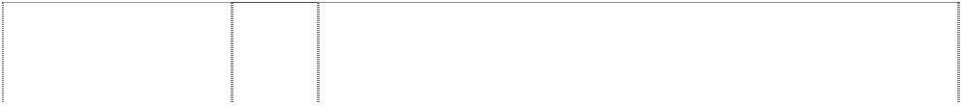

(461881)

# HUGO BOSS

(901052)

# HUGO BOSS

(901052)

# HUGO BOSS

(647112)

# HUGO BOSS

(461882)

# HUGO BOSS

(901052)

# HUGO BOSS

(901052)

# HUGO BOSS

(647113)

# HUGO BOSS

(442955)

# HUGO BOSS

(901052)

# HUGO BOSS

(647114)

# HUGO BOSS

(461880)

# HUGO BOSS

(901052)

# HUGO HUGO BOSS

(796516)

# HUGO HUGO BOSS

(603400)

# HUGO HUGO BOSS

(603401)

# HUGO HUGO BOSS

(796516)

# HUGO HUGO BOSS

(603402)

14 Articles made of or coated with precious metals and precious metal alloys; jewellery; clocks and watches; all goods in class 14.

16 Paper, cardboard and goods made thereof, not included in other classes; printers' products; stationery and writing instruments; packaging containers of plastic, paper or cardboard; stickers; playing cards.

18 Leather and imitation leather, products made of these materials, not included in other classes; trunks and suitcases; bags; umbrellas, parasols.

18 Leather goods and imitation leather goods in class 18, including wallets, key cases, hand bags, trunks, travelling bags, purses, small articles of leather, briefcases, travelling sets, bags for climbers (rucksacks) and belts of leather and of imitations of leather; umbrellas and parasols.

18 Leather goods, cases in class 18, bags in class 18, umbrellas and parasols, belts made of leather.

1. Fabrics and textile products, not included in other classes, in particular handkerchiefs and towels; bed and table linen, wall hangings of textile.
2. Men's, women's and children's wear, stockings; headwear; belts and leather belts; foulards; accessories, namely foulards, fichus, shawls, clutch bags; ties; gloves; footwear, headwear.

25 Clothing, clothing accessories in this class, headgear and footwear, all being goods in class 25.

25 Clothing, clothing accessories, headgear, footwear, all being goods in Class 25 and all other goods in Class 25.

28 Games, toys; gymnastics and sports apparatus, in particular skis, golf clubs and tennis rackets; balls; gymnastics and sports goods not included in other classes.

28 Gymnastic and sports articles and equipment included in class 28, games, toys and playthings.

28 Gymnastic and sports articles in this class; games, toys and playthings; all goods in class 28.

34 Tobacco and tobacco goods; smokers' articles; matches.

9 Eyewear and parts thereof.

9 Spectacles and parts therefore.

18 Leather and imitations of leather, and goods made there from (as far as included in class 18), in particular small articles of leather; trunks and travelling bags; handbags; umbrellas and parasols; belts made of leather.

25 Articles of clothing for ladies, gentlemen and children; socks and stockings; head coverings; underwear; nightwear; swimwear; bathrobes; belts; scarves and shawls; accessories, namely head scarves, neck scarves, shoulder scarves, pocket kerchiefs; ties; gloves; shoes.

25 Articles of clothing for men, women and children; socks and stockings; headgear; belts; scarves and shawls; accessories, namely head scarves, neck scarves, shoulder scarves, pocket kerchiefs; ties; gloves; shoes.

***Joop! GmbH Clark McNamara Lawyers***

***Ph: (02) 9299 2223***

***Effective Date: 15 April 2007 File Reference: C07/03978 Trade Marks Class Goods***

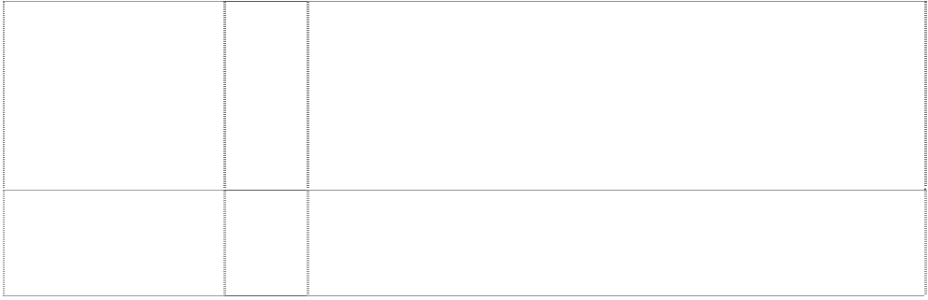

# JOOP!

(553373)

# BERLIN JOOP!

ltr I is exclamation mark

(896328)

3 Perfumery; eau de toilette; soaps; non-medicated bath and shower gel and oil; sun screen lotion; sun tan lotion, all for non-medicated purposes and sun care; antiperspirant; deodorants for personal use; cosmetic preparations for body and beauty care, in particular, cremes, powder, rouge, eyebrow pencil, eyeshadow, eyelash black, lipsticks, lotions, face lotions, face masks, articles for hair care, hair shampoo, depilatory, shaving crème, shaving foam, aftershave, skin cleaner, body lotion.

3 Soaps; perfumery, essential oils, cosmetics, hair lotions; dentifrices.

***New Era Cap Co., Inc Freehills***

***Ph: (03) 9288 1577***

***Effective Date: 17 April 2007 File Reference: C07/05782 Trade Marks Class Goods***

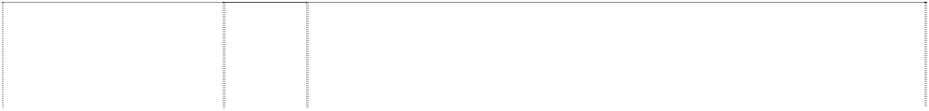

# 59FIFTY

(827131)

# NE

2 Horiz. & wavy stripes are ltr in rect.,wavy (827133)

# NEW ERA

(711862)

# NEW ERA

(899345)

# NEW ERA

(899346)

# NEW ERA FITS

(1059958)

# PROUD TO PLAY

(827132)

**PROUD TO PLAY IN A NEW ERA** (827134)

25 Headgear including athletic caps.

25 Headgear including athletic caps.

25 Clothing, headwear.

25 Headgear, including athletic caps, but excluding turbans.

25 Headgear, including athletic caps, but excluding turbans.

25 Athletic Caps.

25 Headgear including athletic caps.

25 Headgear including athletic caps.

***Nokia Corporation Corrs Chambers Westgarth Ph: (03) 9672 3000***

***Effective Date: 3 March 2007 File Reference: C07/02208 Trade Marks Class Goods***

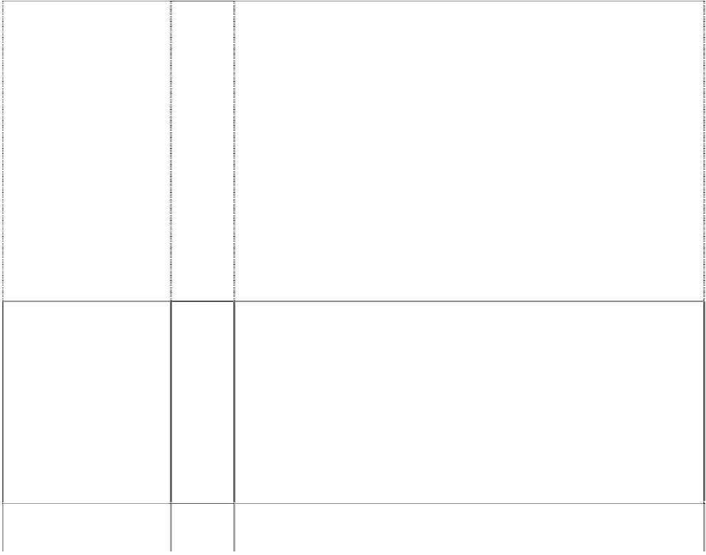

# CLUB NOKIA

(878812)

# CREEBIES

(1131216)

# CREEBIES

(1131216)

**HUMAN TECHNOLOGY** (751545)

# N-GAGE

(981422)

# N-GAGE

(981422)

9 Telephones, cordless, wireless or satellite telephones, facsimiles, communicators, smart phones, media phones, payphones, public telephones; antennas, batteries, battery chargers, power supplies, housings or casings or covers, clips, carrying cases for communications apparatus and its accessories, holders, desktop stands, microphones, speakers, headsets, hands free devices for communications apparatus, car kits for the adaptation of portable communication apparatus and instruments for vehicular use, being antennas, antenna transmission wires, telephones stands (parts of telephones), electric adaptor cables, telephone cables, microphones, speakers and battery chargers; cards for communications purposes, all for use with communications apparatus; electronic games; computer utility software; computer game software; computer software and programs featuring music, movies, animation, electronic books, games, and data bases.

9 Scientific, nautical, surveying, photographic, cinematographic, optical, weighing, measuring, signalling checking (supervision), life- saving and teaching apparatus and instruments; apparatus and instruments for conducting switching, transforming, accumulating, regulating or controlling electricity; apparatus for recording, transmission or reproduction of sound or images; magnetic data carriers, recording discs; automatic vending machines and mechanisms for coin-operated apparatus; cash registers, calculating machines; data processing equipment and computers; fire- extinguishing apparatus.

28 Games and playthings; gymnastic and sporting articles not included in other classes; decorations for Christmas trees.

9 Apparatus for recording, transmission or reproducing of sound or images, wireless communication equipment, analog and digital radio transceivers for data and voice communication; telephones, mobile telephones, facsimiles, accessories for communications apparatus; namely microphones, speakers, headsets, housing, cases, batteries, battery chargers, car kits for the adaptation of portable communication apparatus and instruments to vehicular use, data processing equipment and computers, computer software (recorded); parts and fittings for all the aforesaid goods.

9 Computer game software for communication devices; computer game software and programs enabling users to play games with mobile phones; computer software and programs enabling users of communication devices to simultaneously access databases and global computer networks; software enabling transfer of data between mobile communication apparatus; virtual reality game software; mobile telephones and mobile telephones with additional features such as short messaging, Internet access, MP3 player and radio; MP3 players and radios; hand-held unit for playing video games; data cards for electronic games and communication purposes.

28 Hand-held unit for playing electronic games; electronic game equipment with a watch function; equipment packaged as a unit for playing board games, puzzles, remote control toys.

# NOKIA



(458364)

# NOKIA

(867057)

# NOKIA

(808735)

# NOKIA

(867057)

# NOKIA

(867057)

9 Scientific, optical, weighing, measuring, signalling, checking (supervision), electrical and telecommunications apparatus and instruments; apparatus for the recording, transmission or reproduction of sound or images; data processing apparatus; cash registers; apparatus and instruments, all for use in telephone exchanges; modems, multiplex apparatus and instruments; electrical conductors; insulated electrical wires; electrical cables and wiring ducts therefor; electrical conduits; insulated telecommunications cables; capacitors; coils and resistors, all being electrical; optical fibres and cables; work gloves of plastic; all included in class 9.

9 Apparatus for recording, storing, transmission, receiving or reproducing of data, sound, images and/or video; electronic systems and apparatus for scrambling, descrambling, encoding and/or decoding of voice, data, image and video transmissions; electronic data input and output apparatus; data processing equipment and computers; radar equipment, ciphering equipment, scanner equipment, computer software (recorded); equipment, apparatus, computer software and programs for fixed, wireless and radiotelephone networks, communications networks and/or dedicated networks and global computer and communication networks; base stations, radio links, microwave radios, exchanges, base station controllers, transmission equipment for use in communications; access nodes and switching apparatus for telephone connections and public telephones; servers, routers, data cards, modems, multiplexers, electrical cables and optical fibres; apparatus for heating, refrigerating and ventilating of communication network elements, apparatus and instruments; power sources for communication network elements; substations or repeaters; multimedia systems and terminals; satellite, cable and/or terrestrial receivers and antennas, switches and motors therefor, software applications; monitors, displays and user interface units, video walls; analog and digital radio transceivers or receivers for data, voice, image and video communication; telephones, cordless, wireless or satellite telephones, dedicated network terminals, facsimiles, communicators, personal digital assistants, media phones, smart phones and payphones; games, cameras and videocameras; systems and apparatus for electric money transactions, remote control units and systems, calculators; antennas, batteries, battery chargers, power supplies, housings or casings or covers, clips, carrying cases for communications apparatus and its accessories; holders, desktop stands, microphones, speakers, headsets, handsfree devices, car kits for the adaptation of portable communication apparatus and instruments for vehicular use; cards for communications purposes, all for use with communications apparatus; manuals and marketing material (in digital form); accessories and spare parts for all aforesaid goods; all included in class 9.

16 Brochures, catalogues, printed matter, books, magazines, calendars, stationery, newsletters, pamphlets, leaflets, directories and manuals.

18 Leather and imitations of leather, and goods made of these materials and not included in other classes; animal skins, hides; trunks and travelling bags; umbrellas, parasols and walking sticks; whips, harness and saddlery.

25 Articles of clothing for men, women, and children; shirts, T-shirts, sweatshirts, sweaters, vests, pants, parkas, jackets, overcoats, raincoats, hats, caps, mittens, gloves, socks, headbands, boots, shoes, slippers, neckties, aprons, bathing suits, bathing trunks, bathrobes, belts, blouses, bow ties, boxer shorts, dresses, ear muffs, garter belts, gym shorts, gym suits, jogging suits, sportswear, night shirts, pocket squares, vests, robes, sleep wear, sun visors and wrist bands.

# NOKIA



lines trail from chevrons 3

(490781)

# NOKIA CARE

(808120)

# NOKIA OK

(908151)

**NOKIA ORIGINAL ENHANCEMENTS** (1095922)

9 Scientific, optical, weighing, measuring, signalling, checking (supervision), electrical and telecommunications apparatus and instruments; apparatus for the recording, transmission or reproduction of sound or images; data processing apparatus; cash registers; apparatus and instruments, all for use in telephone exchanges; modems, multiplex apparatus and instruments; electrical conductors; insulated electrical wires; electrical cables and wiring ducts therefor; electrical conduits; insulated telecommunications cables; capacitors; coils and resistors, all being electrical; optical fibres and cables; work gloves of plastic; all included in class 9.

9 Communications apparatus, namely, telephones, cordless, wireless or satellite telephones, facsimiles, mobile phones, communicators, smart phones, payphones; antennas, batteries, battery chargers, power supplies, housings or casings or covers, clips, carrying cases for communications apparatus and their accessories, holders, desktop stands, microphones, speakers, headsets, handsfree devices, car kits for the adaptation of portable communication apparatus and instruments for vehicular use, cards for communications purposes, all for use with communications apparatus.

9 Apparatus for recording, storing, transmission, receiving or reproducing of data, sound, images and/or video; telephones, cordless, wireless or satellite telephones, communicators; smart phones, namely phones with the capability of transmitting data, voice and images and accessing the internet, sending and receiving facsimiles and email; pay-phones, public telephones; antennas, batteries, battery chargers, power supplies, housings, casings or covers, clips, carrying cases for communications apparatus and its accessories, holders, desktop stands, microphones, speakers, headsets, hands free devices for mobile phones in the form of mobile phone accessories, car kits for the adaptation of portable communication apparatus and instruments for vehicular use, comprising antennas, antenna transmission wires, antenna adapters, cables, earphones, handsfree microphones, phone holders, speakers, car chargers, data cables and electrical wires; telephone stands being parts of telephones, electric adaptor cables, telephone cables, microphones, speakers and battery chargers; computers, computer software and programs used for transmission or reproducing or receiving of sound, images, video or data over a telecommunications network or system between terminals and for enhancing and facilitating use and access to computer networks and telephone networks and between the aforementioned; computer software for use in general purpose database management; computer e-commerce software to allow user to safely place orders and make payments in the field of electronic business transactions via a global computer network or telecommunications network; training and product support software for computers and mobile phones in the field of communications; computer utility software for performing computer maintenance work; computer game software; computer software and programs featuring music, movies, animation, electronic books, games in the field of general entertainment; computer application software for mobile phones.

9 Telephones, cordless, wireless or satellite telephones, dedicated network computer terminals for telecommunications, facsimiles, communicators; smart phones, namely, phones with capability of transmitting data voice and images and accessing the Internet, sending and receiving faxes and e-mail; payphones, public telephones; antennas, batteries, battery chargers, power supplies, housings or casings or covers, clips, carrying cases for mobile telephones, PDAs and computers and carrying cases for accessories therefor, namely, microphones, speakers, headsets, batteries, covers and battery chargers; holders, desktop stands, microphones, speakers, headsets, mobile phone accessories in the nature of hands free holders, headsets, microphones and speakers for mobile

phones; car kits for the adaptation of portable communication apparatus and instruments for vehicular use, comprising antennas, antenna transmission wires, antenna adapters, cables, earphones, handsfree microphones, phone holders, speakers, car chargers, data cables and electrical wires; telephone stands being parts of telephones, electric adaptor cables, telephone cables, microphones, speakers and battery chargers; apparatus for recording, storing, transmission, receiving or reproducing of data, sound, images and/or video, namely, base stations comprising directional antennas, electronic base station controllers, directional antennas, microwave radios, telephone exchanges, access nodes, switches for telecommunication purposes, servers, routers, data smart cards, modems, multiplexers; electrical cables and optical fibers cables, electronic systems and apparatus, namely, scramblers, descramblers, encoders and decoders, for scrambling, descrambling, encoding and/or decoding of voice, data, image and video transmissions, electronic data input and output apparatus, namely terminals, receivers, transmitters, decoders, and transceivers capable of processing broadcast, satellite, facsimile, television, telecommunication, network, infrared, video game, and computer data signals and for transmission, reproducing or receiving of sound, images, video, multimedia or data; data processing equipment, namely digital signal processors; computers, computer software and programs used for transmission or reproducing or receiving of sound, images, video or data over a telecommunications network or system between terminals and for enhancing and facilitating use and access to computer networks and telephone networks and there between; computer software for use in general purpose database management; computer ecommerce software to allow user to safely place orders and make payments in the field of electronic business transactions via a global computer network or telecommunications network; training and product support software for computers and mobile phones in the field of communications; computer utility software for performing computer maintenance work; computer game software; computer software and programs featuring music, movies, animation, electronic books, games in the field of general entertainment; power sources for communication network elements, namely batteries and power supplies; substations or repeaters, namely signal amplifiers or repeater amplifiers; multimedia systems, namely software for the distribution of information and interactive content containing text, images, video and sound to users in the field of communications and multimedia terminals for computers, satellite, cable and/or terrestrial receivers and antennas, switches and motors thereof; monitors, displays for mobile phones; user interface units, namely keyboards, keypads, key rolls, buttons, switchboards and screens; computer software and programs for management and operation of wireless telecommunications devices, computer software for accessing, searching, indexing and retrieving information and data from global computer networks and global communication networks, and for browsing and navigating through web sites on said networks, and computer software for sending and receiving short messages and electronic mail and for filtering non- text information from the data; computer games; computer game software; game consoles; data cards containing computer game software; analog and digital radio transceivers or receivers for data, voice, image and video communication; electronic game software for mobile handsets; cameras, namely photographic cameras, digital cameras, motion picture cameras, video cameras; systems and apparatus for electric money transactions, namely smart cards, smart card readers; calculators; cards for communications purposes, namely, data cards, modem cards and fax modem cards for communication purposes, all for use with communications apparatus; electronic publications, namely, computer user manuals recorded on computer media; blank audio and video cassettes, tapes, CD's; pre- recorded audio and video cassettes, tapes and CD's featuring music, animation, video games; audio and video tape, cassette, digital video



# NOKIA- CONNECTING PEOPLE

(619404)

# POP-PORT

(929996)

# V

arrow,folded,double- headed,halved is ltr V (1126155)

# VERTU

(899879)

# VERTU

(899879)

# XPRESS-ON

(753945)

child's hand reaches for man’s hand (1003446)

child's hand reaches for man’s hand; child’s & man’s hands clasped

(995653)

disc (DVD), video-CD (VCD), CD-i, laser disc, minidiscs, MP3 and CD recorders and players; televisions; headphones; binoculars; sunglasses; eyeglasses; mouse pads; burglar and fire alarms; stereo equipment, namely stereo receivers and amplifiers, CD, MP3 and minidisk players and speakers.

9 Scientific, optical, weighing, measuring, signalling, checking (supervision), electrical and telecommunications apparatus and instruments; apparatus for the recording, transmission or reproduction of sound or images; data processing apparatus; cash registers; apparatus and instruments, all for use in telephone exchanges; modems, multiplex apparatus and instruments; electrical conductors; insulated electrical wires; electrical cables and wiring ducts therefor; electrical conduits; insulated telecommunication cables; capacitors; coils and resistors, all being electrical; optical fibres and cables; work gloves of plastic, all included in class 9.

9 Adaptors for connecting mobile communication devices to accessories or compatible electronic equipment; software to enable mobile communication devices to connect accessories or compatible electronic equipment.

9 Scientific, nautical, surveying, electric, photographic, cinematographic, optical, weighing, measuring, signalling, checking (supervision), life-saving and teaching apparatus and instruments; apparatus and instruments for conducting, switching, transforming, accumulating, regulating or controlling electricity; apparatus for recording, transmission or reproduction of sound or images; magnetic data carriers, recording discs; automatic vending machines and mechanisms for coin-operated apparatus; cash registers, calculating machines, data processing equipment and computers; computer programs; electrical apparatus for production, recording, editing and transmission of sound, images and data.

9 Scientific, nautical, surveying, electric, photographic, cinematographic, optical, weighing, measuring, signalling, checking (supervision) and teaching apparatus and instruments; apparatus for recording, transmission or reproduction of sound or images; magnetic data carriers, recording discs; automatic vending machines and mechanisms for coinoperated apparatus; cash registers, calculating machines, data processing equipment and computers.

25 Clothing, footwear, headgear.

9 Accessories for communications apparatus, namely microphones, speakers, coloured covers, housings, cases, antennas, batteries, battery chargers; parts and fittings for all the aforesaid goods.

9 Scientific, nautical, surveying, photographic, cinematographic, optical, weighing, measuring, signalling, checking (supervision), life- saving and teaching apparatus and instruments; apparatus and instruments for conducting, switching, transforming, accumulating, regulating or controlling electricity; apparatus for recording, transmission or reproduction of sound or images; magnetic data carriers, recording discs; automatic vending machines and mechanisms for coin-operated apparatus; cash registers, calculating machines, data processing equipment and computers; fire- extinguishing apparatus.

9 Scientific, nautical, surveying, photographic, cinematographic, optical, weighing, measuring, signalling, checking (supervision), life- saving and teaching apparatus and instruments; apparatus and instruments for conducting, switching, transforming, accumulating, regulating or controlling electricity; apparatus for recording, transmission of reproduction of sound or images; magnetic data carriers, recording discs; automatic vending machines and mechanisms for coin-operated apparatus; cash registers, calculating machines, data processing equipment and computers; fire- extinguishing apparatus.

***NoWet Products Pty Ltd NoWet Products Pty Ltd Ph: (08) 8331 7485***

***Effective Date: 26 March 2007 File Reference: C07/05565***

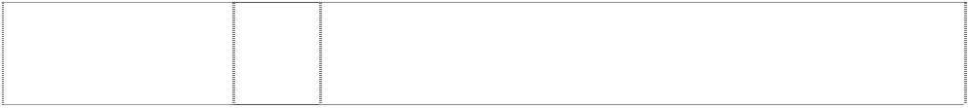

***Trade Marks***

***Class***

***Goods***

**NO WET**

(991101)

3

A product which washes, waxes, polishes, seals and UV protects: cars, bikes, trucks, caravans, boats, helicopters, and any hard surface including protecting stainless steel against finger marks, without using water.

***PZ Cussons Australia Pty Ltd Allens Arthur Robinbson Ph: (03) 9614 1011***

***Effective Date: 20 April 2007 File Reference: C07/05887 Trade Marks Class Goods***



# MORNING FRESH

(299349)

# MORNING FRESH

(323419)

# MORNING FRESH

(299351)

3 Anti-perspirants, perfumes, non-medicated toilet preparations, cosmetic preparations, dentifrices, shampoos and soaps, being goods included in Class 3.

3 Anti-perspirants, perfumes, non-medicated toilet preparations, cosmetic preparations, dentifrices, shampoos, soaps and detergents in this class.

5 Deodorants, medicated creams and medicated lotions; and medicated preparations for the treatment of the skin and scalp, being goods included in Class 5.

***The Timberland Company Mallesons Stephen Jaques Ph: (02) 9296 2000***

***Effective Date: 6 April 2007 File Reference: C07/04183 Trade Marks Class Goods***



# PRO

tree, stylised in disc form ltr O

(874314)

# PRO

tree, stylised in disc form ltr O

(874314)

# PRO

tree, stylised in disc form ltr O

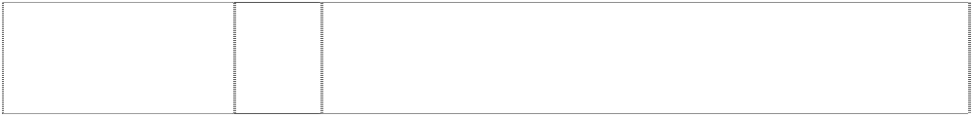(874314)

# PRO

tree, stylised in disc form ltr O

(874314)

1. Utility knives, hand tools, cutlery, forks and spoons; razors.
2. Eyeglass frames, eyeglasses, sunglasses, eyeglass cases, eye shades, eyeglass chains, eyeglass cords, protective eye wear and eye wear for sports; protective gloves.

11 Flashlights and lamps for lighting.

14 Watches and other horological and chronometric instruments; jewellery belonging in class 14 including jewellery made of precious and non-precious metals; key rings.

# PRO

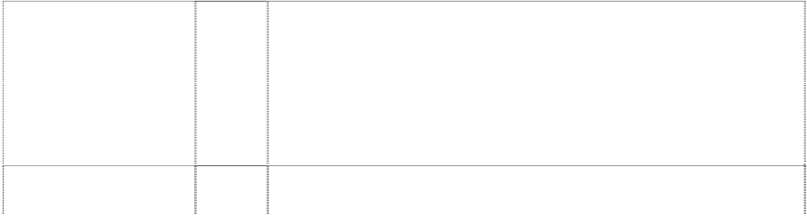

tree, stylised in disc form ltr O

(874314)

# PRO

tree, stylised in disc form ltr O

(874314)

# PRO

tree, stylised in disc form ltr O

(874314)

# TIMBERLAND

(806252)

# TIMBERLAND

(806252)

# TIMBERLAND

(643288)

# TIMBERLAND

(806252)

# TIMBERLAND

(488586)

# TIMBERLAND

(806252)

# TIMBERLAND

(336895)

# TIMBERLAND

tree, stylised (405482)

# TIMBERLAND PRO

(883456)

# TIMBERLAND PRO

(883456)

# TIMBERLAND PRO

(883456)

18 Carrying cases, bags, travelling bags and shoulder bags; backpacks and other strap-on packs; luggage, suitcases, attache cases and brief cases; handbags and purses; wallets, credit card cases, key cases, identification tags, portfolios, appointment books, address books and check book covers, all made of leather; travel kits made of leather for toiletries; umbrellas; tool belts.

21 Portable coolers and lunch boxes; vacuum bottles and mess kits.

25 Footwear; clothing including headgear; gloves and belts not belonging in any other class; baby buntings.

3 Bleaching preparations and other substances for laundry use; cleaning, polishing, scouring and abrasive preparations; soaps; perfumery, essential oils, cosmetics, hair lotions; dentrifices.

9 Scientific, nautical, surveying, electric, photographic, cinematographic, optical, weighing, measuring, signalling, checking (supervision), life-saving and teaching apparatus and instruments; apparatus for recording, transmission or reproduction of sound or images; magnetic data carriers, recording discs; automatic vending machines and mechanisms for coin operated apparatus; cash registers, calculating machines, data processing equipment and computers; fire-extinguishing apparatus.

14 Jewellery, watches and chronological instruments, parts and accessories therefore in this class.

16 Paper, cardboard and goods made from these materials, not included in other classes; printed matter; bookbinding material; photographs; stationery; adhesives for stationery or household purposes; artists' materials; paint brushes; typewriters and office requisites (except furniture); instructional and teaching material (except apparatus); plastic materials for packaging (not included in other classes); playing cards; printers' type; printing blocks.

18 Leather and imitations of leather and goods made from these materials, boot liners, laces made of leather, leather leashes, leather thongs, leather thread, shoulder belt straps of leather, purses (not of precious metal), wallets, briefcases, attache cases, bags made of leather, game bags, haversacks, handbags, trunks and travelling bags, luggage, umbrellas, saddlery and all other goods in class 18.

20 Furniture, mirrors, picture frames; goods (not included in other classes) of wood, cork, reed, cane, wicker, horn, bone, ivory, whalebone, shell, amber, mother-of-pearl, meerschaum and substitutes for all these materials, or of plastics excluding blinds in this class, including indoor venetian blinds.

25 Footwear including shoes and slippers in Cl. 25

25 All goods in class 25 excluding men's shirts.

1. Utility knives, hand tools, cutlery, forks and spoons; razors.
2. Eyeglass frames, eyeglasses, sunglasses, eyeglass cases, eye shades, eyeglass chains, eyeglass cords, protective eye wear and eye wear for sports; protective gloves.

11 Flashlights and lamps for lighting.

# TIMBERLAND PRO

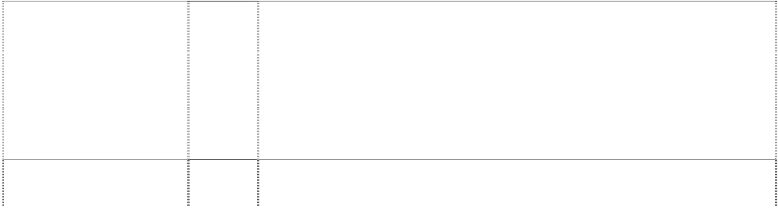

(883456)

# TIMBERLAND PRO

(883456)

# TIMBERLAND PRO

(883456)

# TIMBERLAND PRO

(883456)

tree, stylised & stripes, oblique forming soil; circle, incomplete

(488587)

tree, stylised in disc (806253)

tree, stylised in disc (806253)

tree, stylised in disc (643287)

tree, stylised in disc (806253)

tree, stylised in disc (806253)

tree, stylised in disc (336896)

14 Watches and other horological and chronometric instruments; jewellery belonging in class 14 including jewellery made of precious and non-precious metals; key rings.

18 Carrying cases, bags, travelling bags and shoulder bags; backpacks and other strap-on packs; luggage, suitcases, attache cases and brief cases; handbags and purses; wallets, credit card cases, key cases, identification tags, portfolios, appointment books, address books and check book covers, all made of leather; travel kits made of leather for toiletries; umbrellas; tool belts.

21 Portable coolers and lunch boxes; vacuum bottles and mess kits.

25 Footwear; clothing including headgear; gloves and belts not belonging in any other class; baby buntings.

18 Leather and imitations of leather and goods made from these materials, boot liners, laces made of leather, leather leashes, leather thongs, leather thread, shoulder belt straps of leather, purses (not of precious metal), wallets, briefcases, attache cases, bags made of leather, game bags, haversacks, handbags, trunks and travelling bags, luggage, umbrellas, saddlery and all other goods in class 18.

3 Bleaching preparations and other substances for laundry use; cleaning, polishing, scouring and abrasive preparations; soaps; perfumery, essential oils, cosmetics, hair lotions; dentrifices.

9 Scientific, nautical, surveying, electric, photographic, cinematographic, optical, weighing, measuring, signalling, checking (supervision), life-saving and teaching apparatus and instruments; apparatus for recording, transmission or reproduction of sound or images; magnetic data carriers, recording discs; automatic vending machines and mechanisms for coin operated apparatus; cash registers, calculating machines, data processing equipment and computers; fire-extinguishing apparatus.

14 Jewellery, watches and chronological instruments, parts and accessories therefore in this class.

16 Paper, cardboard and goods made from these materials, not included in other classes; printed matter; bookbinding material; photographs; stationery; adhesive for stationery or household purposes; artists' materials; paint brushes; typewriters and office requisites (except furniture); instructional and teaching material (except apparatus); plastic materials for packaging (not included in other classes); playing cards; printers' type; printing blocks.

20 Furniture, mirrors, picture frames; goods (not included in other classes) of wood, cork, reed, cane, wicker, horn, bone, ivory, whalebone, shell, amber, mother-of-pearl, meerschaum and substitutes for all these materials, or of plastics.

25 All goods in this class.

***Triton Boats (Aust) Pty Ltd Triton Boats (Aust) Pty Ltd Ph: (07) 5564 9336***

***Effective Date: 1 May 2007 File Reference: C07/06312***

Marine products being boats and accessories.

12

**Triton Boats**

(1070949)



***Trade Marks***

***Class***

***Goods***

***Torquay Enterprises Limited AJ Park***

***Ph: +64 9 356 6996***

***Effective Date: 12 March 2007 File Reference: C07/03955 Trade Marks Class Goods***



# BABY PATCH

(770634)

# KID CULTURE

(1051637)

# PATCH MATERNITY

(1004554)

# PATCH PRINCESS

(901805)

# PUMPKIN PATCH

(932617)

# PUMPKIN PATCH

(702124)

# PUMPKIN PATCH. EST. 1990

pumpkin in annulus (932500)

# TRIBAL CULTURE

(1058281)

# URBAN ANGELS

(774960)

# URBAN SISTER

(1108941)

25 Clothing, footwear and headgear.

25 Clothing, footwear and headgear.

25 Clothing, footwear and headgear.

25 Clothing, footwear, headgear and neckwear.

1. Textile and textile goods in this class; bed and table linen.
2. Clothing, headgear and footwear.

25 Clothing; footwear; headgear.

25 Clothing, footwear and headgear.

25 Clothing; footwear; headgear.

25 Clothing; footwear; headgear.

**ADDITIONAL TRADE MARKS**

***Estee Lauder Pty Ltd Baker & McKenzie***

***Ph: (02) 9225 0200***

***Effective Date: 21 December 2006 File Reference: C07/06159 Trade Marks Class Goods***



# CLINIQUE HAPPY

(725153)

# ORIGINS SHIMMER STICKS

(725466)

3 Soaps; perfumery, hair lotions and non-medicated hair preparations, cosmetics, toiletries and essential oils.

Soaps; perfumery, hair lotions and non-medicated hair preparations,

3 cosmetics, toiletries and essential oils.

***Foster’s Australia Limited Corrs Chambers Westgarth Ph: (03) 9672 3000***

***Effective Date: 2 January 2007 File Reference: C07/00069 Trade Marks Class Goods***



# CORONA

(497755)

# CORONA

(481685)

# CORONA

(990740)

# CORONA

(990740)

# CORONA

(990741)

# CORONA

(990741)

# CORONA

(990741)

# CORONA EXTRA

(464456)

# CORONA EXTRA

(464455)

# CORONA EXTRA LA CERVEZA MAS FINA BEER BIERE BIER BIRRA

2 dragons,styl either side of crown atop double disc incomplete

(591232)

25 Clothing and headgear in this class excluding footwear.

32 Beers; ales and porters.

8 Can and bottle openers; cutlery; side arms; razors.

24 Textiles and textile goods, not included in other classes; bed and table covers; towels.

8 Can and bottle openers; cutlery; side arms; razors.

1. Textiles and textile goods, not included in other classes; bed and table covers; towels.
2. Clothing, footwear, headgear.

25 Clothing, including T-shirts.

32 Beers; ales and porters.

32 Beers; ales and porters.

***Pacific Brands Sport & Leisure Pty Ltd Freehills***

***Ph: (03) 9288 1577***

***Effective Date: 23 September 2005 File Reference: C05/16186 Trade Marks Class Goods***



# Mooks

(964148)

# Mooks

(964148)

# Mooks

(964148)

# Mooks

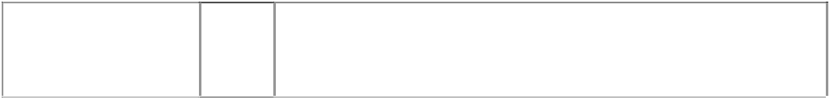(964148)

# MOOKS

trident in electric bulb with horns

(597881)

9 Eyewear including sunglasses and sunglass cases.

18 Leather and imitations of leather, and goods made of these materials and not included in other classes; travelling bags.

25 Clothing, headgear, footwear.

28 Games and playthings, gymnastics and sporting articles not included in other classes.

25 Clothing, footwear, headgear.

trident in light bulb with horns



(964149)

trident in light bulb with horns

(964149)

9 Optics including sunglasses and sunglasses cases.

18 Leather and imitations of leather, and goods made of these materials and not included in other classes; travelling bags.

***Sony Corporation Allens Arthur Robinson***

***Ph: (02) 9230 4000***

***Effective Date: 7 August 2006 File Reference: C06/13655***

All goods in this class.

16

**SONY**

(355450)



***Trade Marks***

***Class***

***Goods***