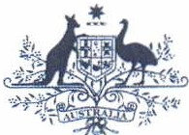**Australian Government**

# Australian Customs and Border Protection Service

AUSTRALIAN CUSTOMS AND BORDER PROTECTION NOTICE NO. 2012 *I* 04

# New Autonomous Sanctions Laws

The Australian Government has expanded existing laws to impose autonomous sanctions against foreign governments and individuals in situations of international concern. These laws restrict or prevent the export of certain goods to certain people, entities and places. For example, they restrict export of arms or related materiel to foreign governments committing human rights abuses against their own people.

Autonomous sanctions are *not* sanctions imposed by United Nations Security Council Resolutions, though they may support and supplement those resolutions.

Until recently, Australia's autonomous sanctions were implemented under a range of separate legal instruments. On 27 May 2011 the *Autonomous Sanctions Act 2011* (the Act) commenced, providing a new legislative framework to create, administer and enforce Australia's autonomous sanctions. In effect, the Act consolidates a range of sanctions legislation and also widens the range of punitive measures that the Australian Government can implement as a matter of foreign policy. The *Autonomous Sanctions Regulations 2011* were subsequently enacted on 15 December 2011.

Customs and Border Protection contributes to Australia's sanction efforts through the administration and enforcement of Customs Regulations. Customs and Border Protection has amended the *Customs (Prohibited Exports) Regulations 1958* to give effect to the *Autonomous Sanctions Regulations 2011.* New Division 2A makes it prohibited to export goods subject to autonomous sanctions unless the Minister for Foreign Affairs has given permission.

The new regulations within Division 2A are as follows:

Regulation 11 - prohibits the exportation of export sanctioned goods to countries listed in subregulation 4(2) of the *Autonomous Sanctions Regulations 2011* or designated under sub regulation 4 (3) of those regulations;

Regulation 11A - prohibits the exportation of goods to designated persons and entities listed at paragraph 6(1) (a) or 2(a) of the *Autonomous Sanctions Regulations 2011;* and

Regulation 11B - prohibits the exportation of controlled assets, where controlled assets are defined as assets belonging to a person or entity listed as paragraph 6(1) (a) or 2(a) of the *Autonomous Sanctions Regulations 2011.*

Therefore, trade that contravenes these regulations is an offence and carries penalties for individuals of imprisonmentfor not more than 10 years, or a fine not exceeding three times the value of the goods or $275 000, whichever is the greater, or both. Penalties for bodies corporate are a fine not exceeding three times the value of the goods or $1 100 000 whichever is the greater.

Further information on countries, entities and persons subject to Australia's autonomous sanctions can be found at [www.dfat.gov.au.](http://www.dfat.gov.au/)

Public enquiries on permit requirements and applications to export goods that are subject to Australia's autonomous sanctions laws should be directed to:

Director

Sanctions and Transnational Crime Department of Foreign Affairs and Trade Email: [sanctions@dfat.gov.au](mailto:sanctions@dfat.gov.au) Facsimile: 61-2-6261 2144

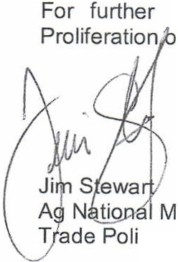information regarding this notice, please contact the Manager, Counter n (02) 6275 6189 orfax (02) 6275 6699.

anager

cy and Regulation Branch

*}O* January 2012