

**AUSTRALIAN CUSTOMS AND BORDER PROTECTION NOTICE 2012/60**

**Customs duty refund – tobacco and tobacco products**

This notice advises of changes to the *Customs Regulations 1926* (Customs Regulations) to allow a refund of customs duty on imported, duty paid, tobacco and tobacco products.

The new refund circumstance is included as regulation 126F of the Customs Regulations which is applicable to tobacco and tobacco products which have been destroyed and which do not meet the retail packaging requirements of the *Tobacco Plain Packaging Act 2011* that come into effect on 1 December 2012.

A refund is only available where the application for refund is for at least 100,000 cigarettes, 100kg of tobacco or other tobacco products, or a combination of cigarettes and tobacco or other tobacco products weighing at least 100kg.

Further requirements that need to be met for this refund circumstance are included under amended regulation 127 of the Customs Regulations as follows:

* Customs and Border Protection is given a notice of the intended destruction of the tobacco or tobacco products at least 7 day prior to the goods being destroyed; and
* when the notice of the intended destruction is given, the goods are in a warehouse licensed under section 79 of the *Customs Act 1901* to warehouse excise equivalent goods, in particular tobacco and tobacco products; and
* Customs and Border Protection is given a reasonable opportunity to supervise the destruction.

A notification of intended destruction is to be given to Customs and Border Protection on approved form B1223 ‘Notice of Intended Destruction – Tobacco Products’. The form is available on the Customs and Border Protection web site [www.customs.gov.au](http://www.customs.gov.au/) by clicking on the link to ‘media, publications and forms’, then clicking on ‘forms’. Details of where the notice is to be sent are included on the form. The costs of destruction are to be borne by the applicant.

An application for refund of duty on tobacco and tobacco products is to be given to Customs and Border Protection on approved form B1224 ‘Application for Refund of Duty – Tobacco Products’. This form is also available on the Customs and Border Protection website by following the above links. Details of where the application is to be sent are included on the form.

Applications for refund must be made on or before 30 April 2013.

The default customs duty rates for tobacco and tobacco products that Customs and Border Protection will use to calculate refunds will be the rates in effect six months prior to the receipt of the refund application. However, if there is sufficient evidence provided by the applicant that the goods were customs duty paid from the current rate period, Customs and Border Protection will calculate using those rates.

This methodology is consistent with Australian Customs Notice 2002/51 regarding use of duty rates for applications for drawback of customs duty under the Duty Drawback Scheme .

Where the volume threshold to apply for a refund of tobacco or tobacco products cannot be met, owners of imported tobacco or tobacco products who obtained their goods through an Australian supply chain should contact their suppliers to see if the unsold tobacco or tobacco products can be returned.

Otherwise, owners can apply for a duty drawback under the Duty Drawback Scheme but they will need to satisfy certain requirements. Please refer to Australian Customs and Border Protection Notice 2012/61 for these details.

Inquiries concerning this notice may be directed by email to [TobaccoRefund@customs.qov.au.](mailto:TobaccoRefund@customs.qov.au)

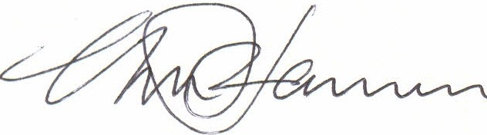

Geoff Johannes National Manager

Trade, Policy & Implementation Branch

0

**CANBERRA ACT**

November 2012