Australian Government

**Australian Customs and Border Protection Service**

**AUSTRALIAN CUSTOMS AND BORDER PROTECTION NOTICE**

**NO: 2012/71**

**Repeal of regulation 9AAA - export of bulk wheat**

Under the wheat export marketing arrangements established in 2008, the export of bulk wheat was prohibited by regulation 9AAA of the *Customs (Prohibited Exports) Regulations 1958* (PE Regulations) unless the wheat was exported by an accredited wheat exporter. An accredited wheat exporter was defined under the *Wheat Export Marketing Act 2008 (WEM Act).*

A Productivity Commission report into the wheat export marketing arrangements recommended a number of changes to the current procedures. On 29 November 2012, the *Wheat Export Marketing Amendment Act 2012* was passed by the Australian Parliament as a direct result of the Productivity Commission report. This Act amends the WEM Act and ensures that owners, operators or controllers of port terminal facilities , that also export bulk wheat, must provide fair and transparent access to their facilities to other exporters.

From 10 December 2012, the Department of Agriculture, Fisheries and Forestry (DAFF) will be administering requirements for Port Terminal Operators that also export wheat, to satisfy an access test to their facilities. The purpose of this test is to avoid regional monopolies unfairly controlling infrastructure required to export wheat in bulk quantities. A Port Terminal Operator will be required to have either an access undertaking in place under Division 6 of Part IIIA of the *Competition and Consumer Act 2010* or a state or territory regime in place under Division 2A of Part IIIA of the *Competition and Consumer Act 2010* and adhere to continuous disclosure rules as set out in the amended 2008 WEM Act. The Australian Competition and Consumer Commission (ACCC) will monitor a Port Terminal Operator's compliance with the access undertaking and the continuous disclosure rules.

To enable the new arrangements to commence, regulation 9AAA of the PE Regulations will be repealed from 10 December 2012. There will no longer be a requirement to provide a permit to Customs and Border Protection when exporting bulk wheat.

For enquiries regarding the new arrangements , please visit the DAFF website at [www.daff.gov.au](http://www.daff.gov.au/)

If you have a query regarding the provision of continuous disclosure rules, please email the ACCC at [WheatPortsCDR@accc .gov.au](mailto:WheatPortsCDR@accc.gov.au)

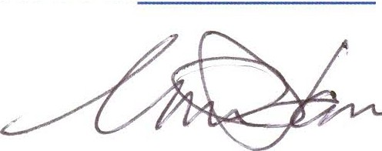

Geoff Johannes

National Manager Trade, Policy and Implementation Branch

*/1..* December 2012