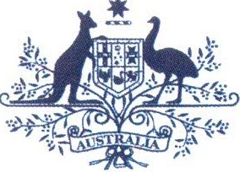Australian Government

**Australian Customs and Border Protection Service**

**AUSTRALIAN CUSTOMS AND BORDER PROTECTION NOTICE NO: 2012/72**

**New prohibition on the import of illegally logged timber**

The Australian Government has introduced legislation controlling illegally logged timber and timber products imported into Australia .

The new laws are designed to reduce the harmful environmental, social and economic impacts of illegal logging and promote the trade in legal timber. The laws apply to timber importers as well as to processors of raw logs grown in Australia . The law is consistent with Austra lia's international trade obligations.

The *Illegal Logging Prohibition Act 2012* (the Act) makes it an offence to import timber or timber products that have been harvested in contravention of laws in force in the place (whether or not in Australia) where the timber was harvested.

Under the new legislation, illegally logged timber is timber that is not harvested in accordance with the applicable laws in the country in which the timber was sourced.

Substantial penalties can apply to those who knowingly, intentionally or recklessly import or process illegally logged timber.

The penalty provisions in the Act are listed under:

* Section 8: Prohibition on the importation of timber and timber products containing illegally logged timber.
* Section 15: Prohibition on the processing of raw logs that have been illegally logged.

Under the Act, penalties may apply to those who import or process illegal timber or timber products and:

* know that the timber or timber products have been sourced from illegal logging activities; or
* believe that the timber or timber products have been sourced from illegal logging activities; or
* are aware that there is a substantial risk that timber or timber products have been sourced from illegal logging activities.

The maximum penalty is five years imprisonment , 500 penalty units, or both.

There are no additional requirements that importers and domestic processors are obliged to meet at this time.

The Department of Agriculture, Fisheries and Forestry (DAFF) will administer the implementation of the Act. DAFF will work closely with importers, processors, industry associations , retailers, conservation groups and key trading partners to ensure that the new laws are communicated and complied with.

I .

- 2 -

Customs and Border Protection has powers under the Act to detain and seize any products deemed to be prohibited timber.

The Federal Government will release regulations in mid-2013, eighteen months before the regulations come into effect. This is to give industry sufficient time to establish processes to comply with due diligence that importers of regulated timber products and processors will be required to meet.

Further information about the Act can be found at [www.daff.gov.au/illegallogging](http://www.daff.gov.au/illegallogging)

Public enquiries about the Act should be directed to DAFF at [illegallogging@daff.gov.au](mailto:illegallogging@daff.gov.au)

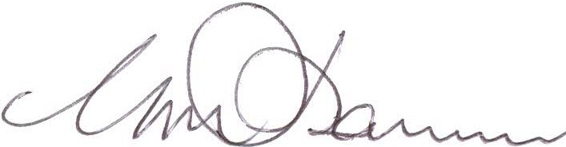

Geoff Johannes

National Manager Trade, Policy and Implementation Branch

*/-l* December 2012