Australian Government

# Australian Customs and Border Protection Service

**AUSTRALIAN CUSTOMS AND BORDER PROTECTION NOTICE NO. 2013** / **18**

# Additional restrictions on trade with Syria and Iran

The Australian Government has introduced additional autonomous sanctions against Syria and Iran.

In relation to Syria, the Government has placed restrictions on:

* dealings with the oil, petroleum and financial sectors;
* trade in luxury goods;
* trade in equipment intended for monitoring or intercepting telecommunications; and
* trade in precious metals and gems.

Secondly, in relation to Iran, sanctions have been introduced to restrict:

* + trade in graphite, raw or semi-finished metals, software for integrating industrial processes; naval equipment and technology for ship building and maintenance; and
  + importation of natural gas.

Customs and Border Protection has now amended the *Customs (Prohibited Imports) Regulations 1956* and the *Customs (Prohibited Exports) Regulations 1958* to give effect to these measures at the Australian border.

Trade that contravenes these regulations is an offence and carries penalties for individuals of imprisonment for not more than 10 years, or a fine not exceeding three times the value of the goods or $425 000, whichever is the greater, or both. Penalties for bodies corporate are a fine not exceeding three times the value of the goods or

$170 000 whichever is the greater.

Further information on countries, entities and persons subject to United Nations and / or Australia's autonomous sanctions can be found at [www.dfat.gov.au.](http://www.dfat.gov.au/)

Public enquiries on permit requirements and applications to import or export goods that are subject to Australia's sanctions laws should be directed to:

Director

Sanctions and Transnational Crime Department of Foreign Affairs and Trade Email: [sanctions@dfat.gov.au](mailto:sanctions@dfat.gov.au) Facsimile: 61-2-6261 2144

For further information regarding this notice, please contact the Manager, Counter Proliferation on (02) 6275 6189 or fax (02) 6275 6699.

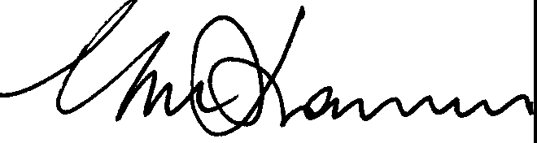

Geoff Johannes National Manager

Trade Policy and Implementation Branch

*/o* April 2013