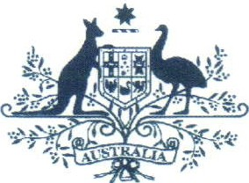Australian Government

# Australian Customs and Border Protection Service

**AUSTRALIAN CUSTOMS AND BORDER PROTECTION NOTICE NO. 2013** / **23**

# Australia - US Defence Trade Treaty

**Amendment to regulation 13E of the *Customs (Prohibited Exports) Regulations* 1958**

In 2007, the Australian Government signed the *'Treaty between the Government of Australia and the Government of the United States of America concerning Defense Trade Cooperation'* (the Treaty). Among other things, the Treaty creates a framework for the transfer of certain defence articles between approved parties in Australia and the United States without the need to apply for individual export permits or licences.

Regulation 13E of the *Customs (Prohibited Exports) Regulations 1958* states that the export of any item within the *Defence and Strategic Goods List* (DSGL) is prohibited unless permission has been granted prior to export. The DSGL covers a range of defence and dual-use goods applicable for use in military or weapons of mass destruction programs and is administered by the Defence Export Control Office within the Department of Defence. Some of the defence articles to which the Treaty applies are included in the DSGL.

To give effect to the Treaty, regulation 13E has been amended to allow the 'permit free' export of certain defence articles from Australia to the United States, so long as companies or individuals engaging in the trade are members of either the US or Australian 'Approved Community'.

In addition regulation 13E states that, to be exempt from the control, these defence articles must be exported for specific activities including:

1. combined military or counter-terrorism operations between the US and Australia;
2. US and Australian cooperative security and defence research, development, production and support programs;
3. Specifically determined security and defence projects where the Australian Government is the end-user; and
4. US government end use.

If the exportation of these specific defence articles is not for one or more of these activities, then permission under regulation 13E must be sought for the export to take place.

'Defence articles' are defined in section 4 of *Defence Trade Control Regulations 2013* and section 5 of the *Defence Trade Controls Act 2012.*

More information on the Treaty can be found at: <http://www.defence.qov.au/UStradeTreaty/index.htm>

Enquiries relating to the Treaty should be directed to:

The Australia US Trade Treaty Team Telephone: 1800 00 57 57 (within Australia)

+61 2 6265 7111 (outside Australia)

Facsimile: + 61 2 6265 6313

Email: [ustradetreaty@defence.gov.au](mailto:ustradetreaty@defence.gov.au)

Additional information on the DSGL can be found at: <http://www.defence.gov.au/deco/> Enquiries on the DSGL should be directed to:

Defence Export Control Office

Telephone: 1800 66 10 66 (within Australia)

+61 2 626 7222 (from outside Australia)

Facsimile: Email:

(02) 6265 4583

[DECO@defence.gov.au](mailto:DECO@defence.gov.au)

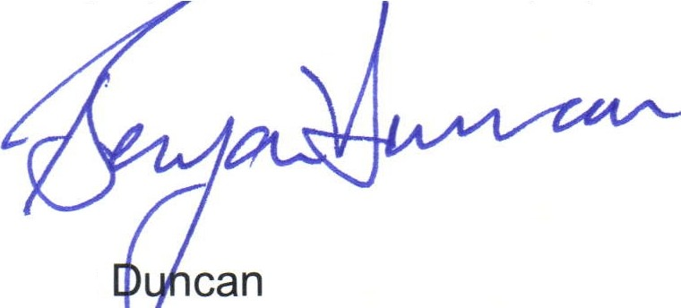For further information regarding this notice, please contact the Manager, Counter Proliferation on (02) 6 75 6189 or fax (02) 6275 6815.

Ben

Ag N 1onal Manager

Trade Policy and Implementation Branch June 2013