**Australian Government**

**Australian Customs and Border Protection Service**

# AUSTRALIAN CUSTOMS AND BORDER PROTECTION NOTICE NO. 2013/35

**Luxury Car Tax Threshold and Fuel Efficient Vehicle Limit** -

# Changes

This notice is to advise of the recent increase in the luxury car tax (LCT) threshold for the 2013-14 financial year.

The Australian Taxation Office has determined that from 1 July 2013 the following are effective:

* LCT Threshold
* Fuel efficient vehicle limit

$60,316 (increased from $59,133)

$75,375 (unchanged)



The increased LCT threshold limit advised in this notice supersedes that advised in ACN 2012/40.

The Integrated Cargo System (ICS) has been amended to reflect the threshold increase. Further information on:

* fuel efficient cars is available from: [www.infrastructure.gov.au](http://www.infrastructure.gov.au/)
* quoting for LCT is available from: [www.ato.gov.au](http://www.ato.gov.au/)
* exemptions from LCT from: [www.customs.gov.au](http://www.customs.gov.au/)

For queries concerning this notice, please contact the Customs Information & Support Centre

CANBERRA ACT

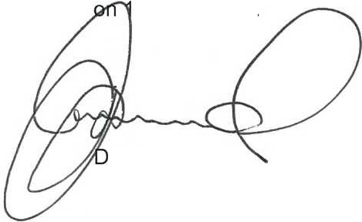

300 363 263.

avid Leonard

A/g National Director Cargo and Trade Division

***J.***

***S"*** Ju l y 2012