..

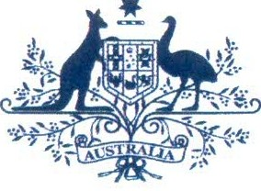**Australian Government**

# Australian Customs and Border Protection Service

**AUSTRALIAN CUSTOMS NOTICE NO. 2014/35**

# AMENDMENT TO REGULATION 4K {WOOLPACKS) CUSTOMS (PROHIBITED IMPORTS) REGULATIONS 1956

Regulation 4K of the *Customs (Prohibited Imports) Regulations 1956* (Pl Regulations) has been amended to align the import requirements in Regulation 4K with the new Australian Wool Exchange Standard No. 3, published on 1 July 2013 (the new standard).

The new standard provides for greater st ruct ur al integrity of wool bales and improved road safety and transport measures.

Importers of woolpacks are required to obtain an import permit from the Department of Agricult ure , or in the case of unused woolpacks, a certificate from a prescribed testing authority (from within Australia or overseas) stating that the woolpacks conform to Standard No.3. The certificate must be produced to the Australian Customs and Border Protection Service (ACBS) if request ed.

The amendment also removes references in Regulation 4K to industry terms, standards and organisations that are now obsolete including woolpack caps.

The amendment will assist the ACBPS to regulate the importation of woolpacks and ensure that importers comply with Australian woolpack stan dar ds.

The amendment came into effect on 24 July 2014 .

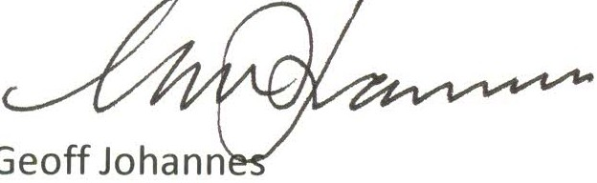Enquiries regarding this notice should be direct ed via email to community .protect ion@customs .gov.au or telephone (02) 6275 6114.

National Manager

Trade, Policy and Implementation CANBERRA ACT

$/July 2014