**Australian Government**

**Australian Customs and Border Protection Service**

AUSTRALIAN CUSTOMS AND BORDER PROTECTION NOTICE NO. 2014/58

New exemption for low volume imports of Ozone Depleting Substances and Synthetic Greenhouse Gas Equipment

From 15 November 2014, a licence is no longer required for a low volume import of equipment containing Ozone Depleting Substances (ODS) or Synthetic Greenhouse Gases (SGG), if **all** of the following conditions are met:

* there are no more than five units of ODS/SGG equipment in a single consignment; and
* there is less than 10 kg in total of HCFC, HFC, PFC, or SFs; and
* the importer has not had an import of ODS/SGG equipment in the past two years.

Ozone Depleting Substances and Synthetic Greenhouse Gases are commonly found in refrigeration and air-conditioning equipment (as well as in electrical switchgear, aerosols and a wide range of other products).

Previously, one-off, low volume importers of ODS/SGG equipment required a Low Volume Import Licence (LVIL) costing $400. This licence has now been abolished.

Regular importers of ODS/SGG equipment or importers exceeding the above threshold will continue to require a full ODS/SGG Equipment Licence (EQPL), costing $3,000.

The online application for an EQPL can be found on the Department of the Environment's website (under the heading 'Licence Application Forms') at:

[http://www. environment. gov.au/protection/ozone/Iicences-and-reporting/forms](http://www.environment.gov.au/protection/ozone/Iicences-and-reporting/forms) General information for Customs Brokers is on the Department 's website at: [http://www.environmen t.qov.au/protection/ozone/licences/customs-brokers](http://www.environment.qov.au/protection/ozone/licences/customs-brokers)

For further information please contact the Department of the Environment's Import Operations Section on (02) 6274 1373 or email: [ozone@environment.gov.au](mailto:ozone@environment.gov.au)

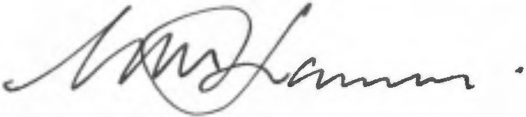Inquiries concerning this notice may be directed to Manager Environment and Wildlife Team on telephone number (02) 6229 3825 or by email on [environment.wildlife@customs.gov.au](mailto:environment.wildlife@customs.gov.au)

Geoff Johannes Assistant Secretary Trade

CANBERRA ACT

/ December 2014