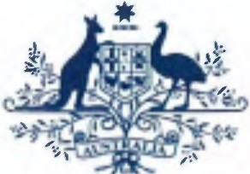Australian Government

**Australian Customs and Border Protection Service**

**AUSTRALIAN CUSTOMS AND BORDER PROTECTION NOTICE NO. 2014/59**

**New illegal logging laws now apply to timber importers**

A new element of the Australian Government's illegal logging laws, as outlined in the *Illegal Logging Prohibition Amendment Regulation 2013,* came into *effect* on 30 November 2014.

Importers of regulated timber and timber products (as defined in Schedule 1 of the Regulation) now need to assess and manage the risk that the timber may have been illegally logged before importing that product. This is known as carrying out due diligence.

Due diligence requires an importer of regulated timber and timber products to gather inform ation, assess the risk that the timber product they are importing may have been illegally logged and then, unless assessed as low risk, undertake reasonable steps to mitigate any risk.

The regulated timber products are identified using Customs Tariff Codes and fit within Chapters 44, 47, 48 and 94. This includes most timber and wood-based products such as sawn timber, veneer, mouldings, wood panels, plywood, pulp, paper and wooden furniture.

The following products are exempt from the due diligence requirements: products made out of recycled materials

products imported into Australia where the combined value of the regulated products does not exceed AUD$1,000

packaging material used to support, protect or carry another product

The importer will also be asked to make a declaration to Australian Customs and Border Protection Service about compliance with these requirements. This will be in the form of a new illegal logging community protection question, which will be answered as part of the full import declaration process.

Further information on the new requirements can be found on the Department of Agriculture's website: agriculture.gov.au/illegallogging. You can also contact them by emailing: [illegallogging@agriculture.gov.au](mailto:illegallogging@agriculture.gov.au) or calling on 1800 657 313 (during business hours).

Further Inquiries concerning this notice may be directed to Manager Environment and Wildlife Team on telephone number (02) 6229 3825 or by email on [environment.wildlife@customs.gov.au](mailto:environment.wildlife@customs.gov.au)

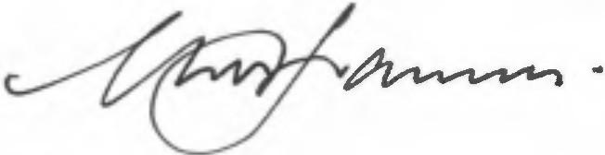

*Geoff* Johannes Assistant Secretary Trade

**CANBERRA ACT**

/ December 2014