**Australian Government**

'?.-;._':.:t , ,.ir ·{' **Australian Customs and**

**Border Protection Service**

AUSTRALIAN CUSTOMS AND BORDER PROTECTION NOTICE NO. 2015/02

Review of the Harmonized Customs Tariff

The Harmonized Commodity Description and Coding System (Harmonized System) is a multipurpose international product nomenclature developed by the World Customs Organization (WCO). The system is used by more than 200 countries and economies, including Australia, as a basis for their Customs tariffs and for the collection of international trade statistics. Over 98 per cent of the merchandise in international trade is classified using the HS.

In order to keep pace with developments in technology and changes in international trading patterns, the Harmonized System is regularly reviewed and amended, with major updates implemented every five years.

The WCO is commencing work on the 6th Review Cycle, the results of which are scheduled to be operative on and from 1 January 2022.

The Australian Customs and Border Protection Service is seeking input to assist with developing the Australian agenda of submissions to the WCO. This is an opportunity for users of the Harmonized System to influence changes that will better reflect current trading patterns and technologies.

Interested parties wishing to make submissions are invited to do so no later than 28 February 2015. Submissions should be addressed to -

Director Trade Policy and Negotiation

Australian Customs and Border Protection Service 5 Constitution Avenue

CANBERRA ACT 2601

Submissions can be emailed to [tariff@customs.gov.au](mailto:tariff@customs.gov.au)

The contact point for inquiries is Manger Tariff Policy telephone number (02) 6275 6434 or fax number (02) 6275 6471.

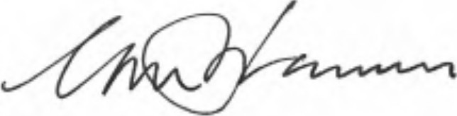

Geoff Johannes National Manager Trade Branch CANBERRA ACT

/ January 2015