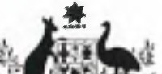**Australian Government**

.- - l · **Department oflmmigration**

**and Border Protection**

# DEPARTMENT OF IMMIGRATION AND BORDER PROTECTION NOTICE

**No.2015/27**

# Declaration of asbestos in certain children's toys

The importation of asbestos or goods containing asbestos into Australia without permission is prohibited under the *Customs (Prohibited Imports) Regulations 1956.* The onus is upon the importer to ensure all border requirements are met for goods containing asbestos.

To assist in the identification at the border of certain toys at risk of being manufactured with asbestos, or components containing asbestos, a Community Protection Question will be required to be answered upon lodgement of shipments containing children's crayons and toys in sets, with Country of Origin: China (CN).

The importation of asbestos is permitted under the following limited circumstances:

* the goods are raw materials that contain naturally occurring traces of asbestos; or
* the goods are 'hazardous waste' as defined in the *Hazardous Waste (Regulation of Exports and Imports) Act 1989,* or
* ministerial exemption1 is granted and confirmed in accordance with relevant Commonwealth of Australia law in respect to workplace health and safety, and the goods are for research, analysis or display, or
* the importation is from the Australian Antarctic Territory

Where an exemption is granted, the valid written exemption must be produced to a Collector at the border.

For exemption application information contact the Asbestos Safety and Eradication Agency (ASEA) at email: [enquiries@asbestossafety.gov.au .](mailto:enquiries@asbestossafety.gov.au)

Industry enquiries regarding ICS entry issues resulting from this new question should be directed to Cargo Support at email: [cargosupport@border.gov.au.](mailto:cargosupport@border.gov.au)

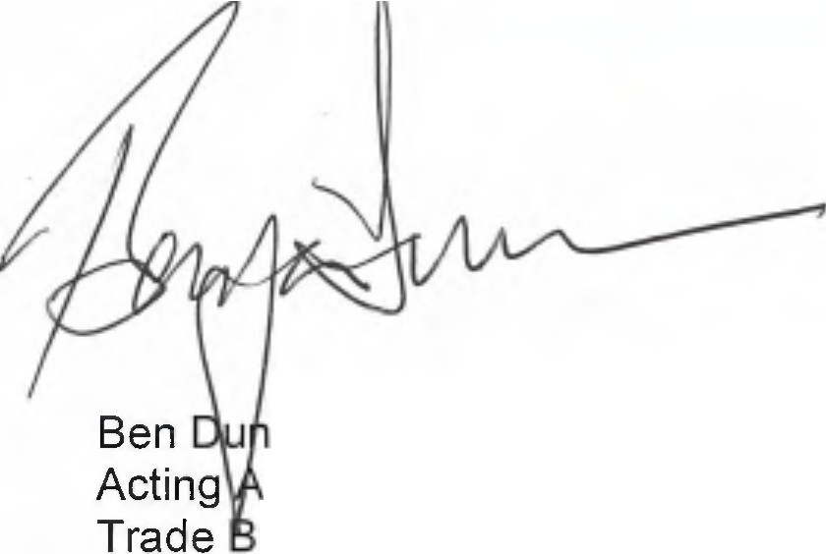

can

ssistant Secretary ranch

) "t" July 2015

1 *By the Federal Minister for Employment*