**Australian Government**

**Department of Immigration and Border Protection**

DEPARTMENT OF IMMIGRATION AND BORDER PROTECTION NOTICE

No.2016/24

# PROCESSING REFUND APPLICATIONS

**Purpose**

To articulate the Department of Immigration and Border Protection's (the Department's) policy position regarding the timely processing of duty refund applications.

# Policy

An owner or an authorised agent acting on behalf of the owner may apply for a refund electronically through the Integrated Cargo System or by submitting a completed and signed Form B653 - Refund Application.

The Department must satisfy itself that a refund application meets all of the relevant requirements before a refund is approved. This may include requesting additional information from the owner as part of an assessment of the refund application. The approval of a refund application may be delayed if, without this additional information, the Department is unable to satisfy itself that the refund application meets the relevant requirements.

At the same time, the Department may also request information about lines on an import declaration that are not part of the refund application. For example, without limiting the circumstances where the Department may request information, there may be circumstances where there are connections between lines on an import declaration, or changes to an import declaration that are so extensive that it is unclear what has been changed. In these circumstances, the Department may need to check and verify other lines on an import declaration to satisfy itself that a refund application meets the relevant requirements.

Approval and payment of the refund will not be withheld due to delays in receiving information about matters unrelated to the refund application.

In circumstances where the person who lodges the refund application does not possess documents relating to the original import declaration, the person lodging the refund application should facilitate communication with the owner regarding any request for this information.

If information or documents unrelated to the refund application are requested, and not provided, consideration may be given to:

* issuing a notice to produce commercial documents under section 240AA of the *Customs Act 1901* (the Act); and/or
* issuing a notice to verify records under section 240AC of the Act1; and/or
* exercising monitoring powers under sections 214AA-214B of the Act.

1 Notices issued under sections 240AA and 240AC may be issued in relation to a customs broker who makes a refund application, a broker who submitted the original import declaration, and/or the importer of the subject goods.

Further information about monitoring powers can be found at [www.border.gov.au/Busi/Comp/Comp/monitoring-export-examination-powers.](http://www.border.gov.au/Busi/Comp/Comp/monitoring-export-examination-powers)

**Further information**

Inquiries about this notice should be directed to the Department's Cargo Support Centre at [cargosupport@border.gov.au.](mailto:cargosupport@border.gov.au)

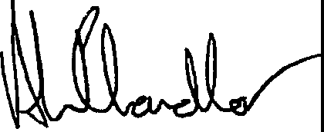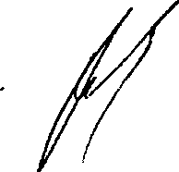

Andrew Chandler Assistant Secretary

Trade and Customs Branch Canberra, ACT

June 2016

Kynan Gowland

Acting Commander Customs Compliance Australian Border Force

Canberra, ACT

Page 2 of 2