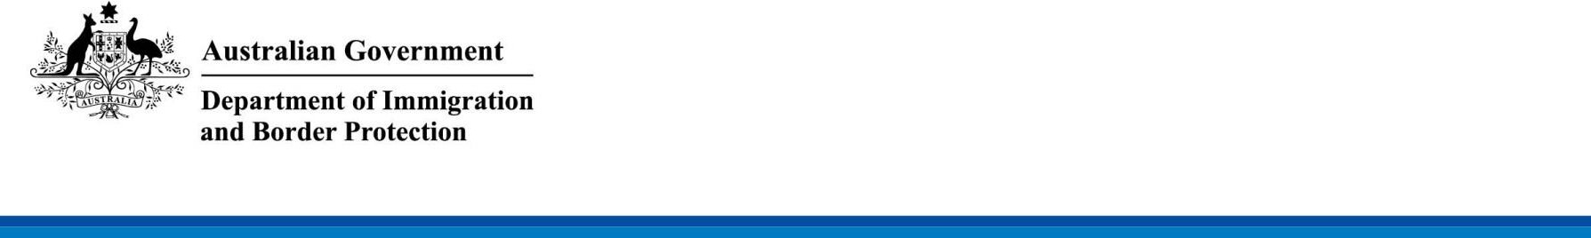

DEPARTMENT OF IMMIGRATION AND BORDER PROTECTION NOTICE No. 2017/41

Hydrofluorocarbons import phase-down

From 1 January 2018, Australia is phasing down the import of hydrofluorocarbons (HFCs) by gradually reducing the maximum amount of bulk HFCs permitted to be imported into Australia. This will be managed through a quota system on imports.

To import bulk HFCs after 31 December 2017, you must hold a controlled substances licence for the import of synthetic greenhouse gases and a HFC import quota, both issued by the Department of the Environment and Energy (DoEE).

# What the HFC phase-down covers

The HFC phase-down only applies to bulk imports of HFCs (such as ISO tanks, cylinders and canisters), and includes the HFC portion of any blend, which will count towards HFC quota. The HFC phase-down does not apply to HFCs imported in pre-charged equipment, such as air-conditioners or refrigerators.

# HFC Quota allocation

The DoEE is responsible for issuing quota and licences for import and export of synthetic greenhouse gases. HFC Quota has already been allocated to importers for the 2018–2019 import period. The phase-down will have reductions at the start of each two-yearly quota allocation period, aligned with licensing periods under the *Ozone Protection and Synthetic Greenhouse Gas Management Act 1989* and associated Regulations. The next opportunity to apply for an import quota will be in 2019.

# Enquiries

Enquiries regarding HFC import quota and controlled substance licences should be directed to the Ozone and Synthetic Gas Team in the DoEE, on Phone: +61 2 6274 1373 or by email at [ozone@environment.gov.au](mailto:ozone@environment.gov.au). You can also find further information about the HFC phase-down on the DoEE website at <https://www.environment.gov.au/protection/ozone/hfc-phase-down>.

[signed] David Coyles

Acting Assistant Secretary Trade and Customs Branch

20 December 2017