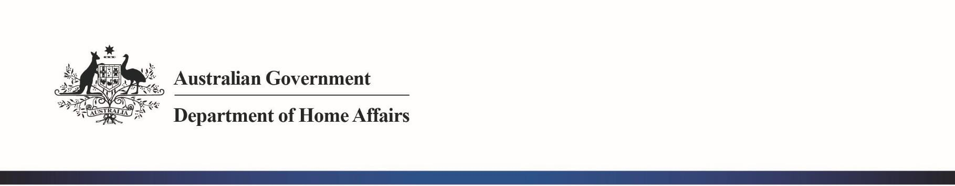DEPARTMENT OF HOME AFFAIRS NOTICE

No. 2018/04

**Applications for Customs Broker Licence**

The following individuals have applied to the Comptroller-General of Customs for a customs broker licence:

|  |
| --- |
| Sona Fullerton |
| Kumar Karuppusamy |
| Yuwen Van Tijn |
| Ying Yu |
| Eun-Woo Kim |
| Joshua Steven Loney |
| Kahlia Moana Maree McNamara |

Any person wishing to make written representation in respect of any of these applications should address the correspondence by 28 February 2018 to:

|  |  |
| --- | --- |
| Broker Licensing Australian Border Force 5 Constitution Avenue  CANBERRA ACT 2601 | Or email: [brokers.licensing@border.gov.au](mailto:brokers.licensing@border.gov.au) |

Principles of procedural fairness in respect of information that is potentially adverse to the applicant will be applied and if information is received that is considered credible, relevant and significant, the applicant will be made aware of the substance of the representation and given the opportunity to respond to the representation.

[signed] Lyn Foster

Acting Superintendent

Trade and Goods Operational Policy CANBERRA ACT

9 February 2018

6 Chan Street Belconnen ACT 2617

PO Box 25 Belconnen ACT 2616 • Telephone: 02 6264 1111 • Fax: 02 6225 6970 • [www.homeaffairs.gov.au](http://www.homeaffairs.gov.au/)