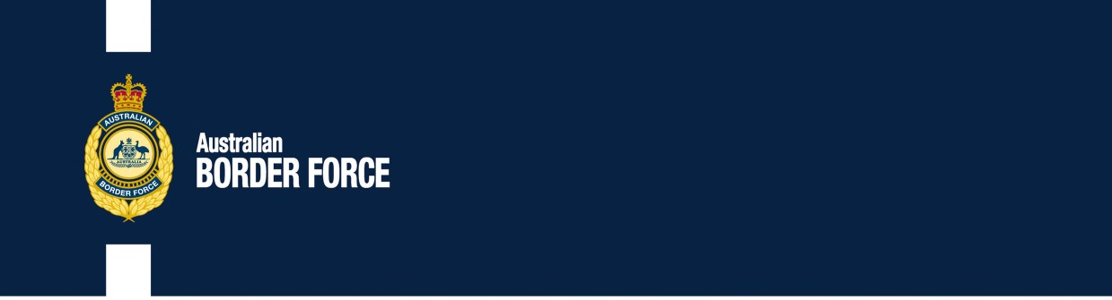

Australian Customs Notice No. 2020/15

Export control on goods essential to controlling and preventing the spread of COVID-19

On 30 March 2020, the *Customs (Prohibited Exports) Amendment (COVID-19 Human Biosecurity Emergency)*

*Regulations 2020* (the Amendment) amended the *Customs (Prohibited Exports) Regulations 1958*

(the Regulations) to implement a temporary prohibition on the non-commercial export of certain goods that contribute to controlling and preventing the spread of the COVID-19 virus. Exemptions to this prohibition are detailed below.

# The Amendment

The Amendment limits the means by which goods essential to preventing the spread of the COVID-19 virus can be exported from Australia. The Amendment is part of the Government’s measures to restrict hoarding, profiteering and non-commercial exporting of certain products that are essential to combating the current COVID-19 pandemic.

The Amendment prohibits the export of the following goods for the period that the *Biosecurity (Human Biosecurity Emergency) (Human Coronavirus with Pandemic Potential) Declaration 2020* is in force:

* personal protective equipment in the form of disposable face masks, disposable gloves, disposable gowns, protective eye wear in the form of goggles, glasses or visors, which can be worn by individuals to limit the transmission of organisms; and
* alcohol wipes and hand sanitizer.

The Minister for Home Affairs is also able to determine additional goods that are subject to the export prohibition.

The Amendment prohibits the export of these goods by post absolutely. It remains possible to export these goods by other means, such as courier services or cargo, in any of the circumstances exempt from the export prohibition as described below.

The export prohibition does not apply when the goods are exported in the following circumstances:

* for personal use by a passenger or crew member in their accompanied personal or household effects;
* by a person to a relative of the person, for the relative’s personal use;
* by a humanitarian organisation for non-commercial purposes;
* by an Australian manufacturer of the goods; or
* by a person who exported those types of goods in the course of their ordinary business, and is registered for Australian Goods and Services Tax and has an Australian Business Number.

***Australia’s customs service***

The exemptions to the export prohibition enable legitimate exporters to continue to trade in goods essential to combatting the pandemic, including commercial trade. The exemptions also preserve the ability to export these goods in support of humanitarian efforts.

These exemptions reflect the Government’s commitment to maintaining an open global trading system and preserving legitimate supply chains to support the response to COVID-19.

# Further information

For further information regarding these changes please consult the Australian Border Force website ([www.abf.gov.au/importing-exporting-and-manufacturing/prohibited-goods/categories](http://www.abf.gov.au/importing-exporting-and-manufacturing/prohibited-goods/categories)) or the legislation directly ([www.legislation.gov.au/Series/F1996B03403](http://www.legislation.gov.au/Series/F1996B03403)).

[signed]

Matthew Duckworth Assistant Secretary

Customs and Border Revenue Branch Customs Group

30 March 2020

| 3