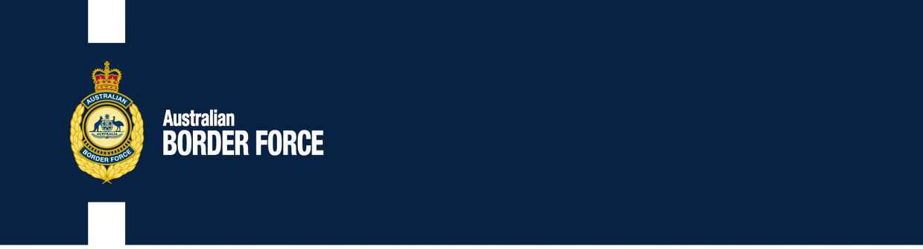Australian Customs Notice No. 2020/24

Application for Customs Broker Licences

The following individuals and companies have applied to the Comptroller-General of Customs for a customs broker licence:

# INDIVIDUALS: PARTNERSHIP/SOLE TRADER:

J.M Branigan & J.S Branigan

Lorin Dillon

# Trading Name

Just Mainly Broking ABN 75 624 004 452

31 Bullanoo Court

Greensborough VIC 3088

Person in Authority Jeremy Branigan

Nominee Broker Jeremy Branigan

Any person wishing to make written representation in respect of any of these applicants should address the correspondence, by 1 July 2020, to:

Broker Licensing

Australian Border Force Or email:

3 Molongolo Drive [brokers.licensing@abf.gov.au](mailto:brokers.licensing@abf.gov.au) Canberra Airport

CANBERRA ACT 2609

Principles of procedural fairness in respect of information that is potentially adverse to the applicant will be applied and if information is received that is considered credible, relevant and significant, the applicant will be made aware of the substance of the representation and given the opportunity to respond to the representation.

[SIGNED]

Steve Moore

Director, Customs Licensing

Trusted Trader and Trade Compliance Branch | Customs Group Australian Border Force

CANBERRA ACT 15 June 2020