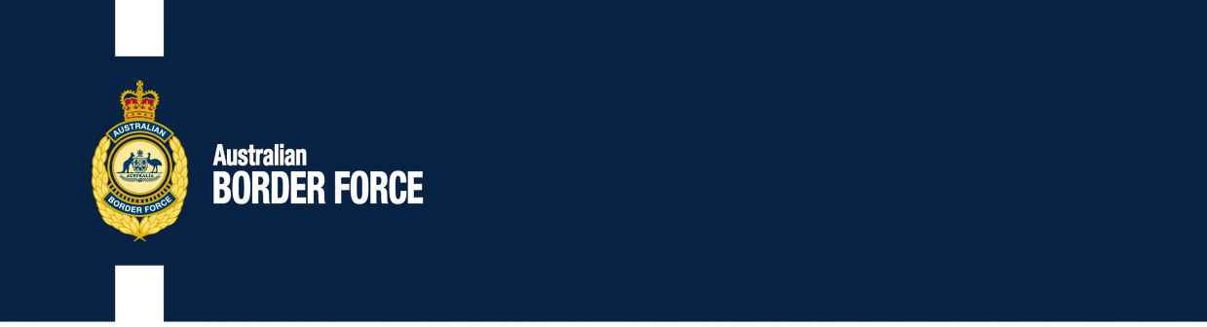Australian Customs Notice No. 2020/28

Application for Customs Broker Licences

The following individuals and companies have applied to the Comptroller-General of Customs for a customs broker licence:

# INDIVIDUAL: CORPORATE:

John Sorbara The Trustee for SAC Import Clearance Unit Trust ABN 30 741 996 264

Unit 3, 81 West Street

Brompton, SA 5007

# Trading Name:

SAC Import Clearance Pty Ltd

Person in Authority Chris McKirdy Hangzhen Yu

Nominee Brokers Chris McKirdy Sean McKirdy

Any person wishing to make written representation in respect of any of these applicants should address the correspondence, by 23 July 2020, to:

Broker Licensing

Australian Border Force Or email:

3 Molongolo Drive [brokers.licensing@abf.gov.au](mailto:brokers.licensing@abf.gov.au) Canberra Airport

CANBERRA ACT 2609

Principles of procedural fairness in respect of information that is potentially adverse to the applicant will be applied and if information is received that is considered credible, relevant and significant, the applicant will be made aware of the substance of the representation and given the opportunity to respond to the representation.

[SIGNED]

Steve Moore

Director, Customs Licensing

Trusted Trader and Trade Compliance Branch | Customs Group Australian Border Force

CANBERRA ACT

7 July 2020