**SPECIAL SECTION ON GREEN COMMUNICATIONS ON WIRELESS NETWORKS**

Received February 13, 2020, accepted February 24, 2020, date of publication March 2, 2020, date of current version March 12, 2020.

*Digital Object Identifier 10.1109/ACCESS.2020.2977403*

An Efficiency-Improved Clustering Algorithm Based on KNN Under Ultra-Dense Network

YANXIA LIANG1, CHANGYIN SUN1, JING JIANG1, (Member, IEEE), XIN LIU2, HUA HE1, AND YONGBIN XIE1



* Shaanxi Key Laboratory of Information Communication Network and Security, Xi’an University of Posts and Telecommunications, Xi’an 710121, China

2School of Information Engineering, Xi’an Eurasia University, Xi’an 710000, China

Corresponding author: Yanxia Liang (liangyanxia201@xupt.edu.cn)

This work was supported in part by the National Natural Science Foundation of China under Grant 61871321, in part by the Innovation Team Project of Shaanxi Province under Grant 2017KCT-30-02, and in part by the Shaanxi STA International Cooperation and Exchanges Project under Grant 2017KW-011 and Grant 2019KW-005.

 **ABSTRACT** Ultra-Dense Network (UDN) is one of the key techniques for the next generation of mobilenetwork due to providing high system throughput. However, severe interference often occurs in UDN, which greatly impact the data rates of cell-edge users. User-centric wireless access virtualization has been widely adopted in UDN to mitigate the interference of cell-edge users by sharing resources and eliminating cell boundary. However, it’s only effective for moderate scale networks. Moreover, the ef ciency needs further improvement. In this paper, we study effective cooperative clustering method for large scale UDN with less computations in order to improve the throughput of cell-edge users. We formulate a convex optimization problem in which the objective is to maximize the system throughput with overlapping virtual cells. We propose a clustering method to solve this optimization problem. We design a fast-convergent iterative algorithm called K-Nearest Neighbor (KNN) algorithm to perform users clustering. Simulation results show that our proposed algorithm has better throughput performance for both average and cell-edge users. Especially, the per-carrier throughput is improved, which leads to more serviceable users with limited resources.



 **INDEX TERMS** Ultra-dense networks, virtual cell, interference mitigation, green communications, clustering.



**I. INTRODUCTION**

With the rapid development of wireless communications, the mobile traf c volume is exponentially increasing. Huge data demands in cellular networks will be one of the biggest challenges in the next decade. Traditional spectrum man-agement and cell division techniques have been unable to meet the increasing traf c demand. Ultra-Dense Network (UDN) [1] is considered to be a key technology to addresses the issues of indoor coverage and capacity in the next-generation of cellular networks [2], [3].

Large numbers of low power small base stations (BSs) are deployed in UDN, which inevitably results in signi cant interference and large power consumption. In fact, the total

The associate editor coordinating the review of this manuscript and approving it for publication was Wei Wei .



throughput of the system would increase by interference suppression. Thus, more users can be served by limited resources, which leads to energy conservation and emission reduction. This paper research on green communication from the perspective of interference suppression.

Traditional interference suppression techniques could not work effectively. Recent years, cooperated Multi-Point (CoMP) technology has become a common method to deal with the complex resource allocation and network inter-ference problems caused by the increase of network den-sity [4], [5].

However, UDN [2], [6] improves network throughput by reducing the path loss between BSs and users, which increases the effective received signal but also ampli es the interference signals. In other words, UDN reduces the impact of thermal noise on the capacity of wireless network systems,

|  |  |  |  |
| --- | --- | --- | --- |
| 43796 | This work is licensed under a Creative Commons Attribution 4.0 License. For more information, see http://creativecommons.org/licenses/by/4.0/ | VOLUME 8, 2020 |  |
|  |  |

Y. Liang *et al.*: Efficiency-Improved Clustering Algorithm Based on KNN Under UDN

and becomes an interference-limited system. Effective inter-ference cancellation and coordination have become impor-tant resolutions for the consideration of improving system capacity in UDN. With the drastic increase in cell den-sity, interference becomes extremely complicated. Not only does the network need to use more advanced interference cancellation technology at the receiving end, but also it is needed a more effective inter-cell interference coordination mechanism.

Wireless access virtualization (WAV) ful ls the next gen-eration mobile network’s pledge of ubiquitous user experi-ence, because it stands to be a promising technology with providing dramatic improvements in terms of spectral and power ef ciencies [7]. There are BS-centric cooperation and user-centric cooperation. In BS-centric cooperation, adaptive cooperation can eliminate the cluster-edge effect, namely inter-cluster interference [8]. User-centered virtual cell tech-nology [9] can reduce interference through multi-cell coor-dinated transmission technology, but it is only effective for moderate scale UDN. For UDNs with highly deployed cells, the intensity of signals received by users from surrounding BSs is almost the same. Therefore, users are interfered while interfering with other users. In this case, the performance gains are very limited by simple cooperation or interference cancellation and resource allocation strategies.

Cell clustering schemes can also be divided into three categories: network-based, user-based, and hybrid cluster-ing schemes. Network-based clustering, also known as static cooperative clustering [10] scheme or xed cooperative clus-tering scheme, determines collaborative BSs during network planning and has nothing to do with users. Cooperative clus-ters are composed of xed cells which are selected based on certain established criteria. In general, cells that have strong interference with each other are merged as far as possible in order to eliminate interference from the strongest interfering cells and effectively improve the user’s signal-to-interference and noise ratio (SINR). The cooperative clusters selected by this scheme are xed and do not overlap. BSs in clusters are scheduled, which is easy to implement. However, for users in different geographical locations, the interfer-ence source that generates the strongest interference may not come from the cluster. This clustering scheme cannot elim-inate the strongest interference, which will result in limited system throughput and restricted average throughput gain. In addition, the strongest interfering cell may change during the user’s movement in the network. Overall, the network-based clustering scheme is simple to implement but less exible.

The user-based clustering scheme is also called dynamic cooperative clustering [11] [13] scheme. The cooperative BSs are not determined in advance and are completely deter-mined by the actual measurement results of users in the net-work. The main serving BS of each user dynamically selects the cooperative BSs based on the measured interference sig-nal strength. The BSs in the collaborative cluster are updated dynamically according to the channel state information (CSI)

VOLUME 8, 2020

of long-term or short-term statistics. In user-based clus-tering scheme, each user can freely choose the suitable cooperative cluster. From the perspective of users, inter-ference between cells has been minimized in formulating cooperative clusters, and higher system throughput gain is obtained. But from the perspective of network, different users in the same cell would choose overlapping clusters due to the freedom of users selecting cooperative clusters, which will cause con icts in resource allocation and greatly increase the complexity of system scheduling. In addition, users need to continuously measure the CSIs of more cells around them and report them periodically. As a result, the feedback overhead will increase accordingly.

Given the advantages and disadvantages of the above two typical clustering schemes, a compromise solution is pro-posed, which is called hybrid clustering scheme or semi-dynamic(/static) cooperative clustering [14], [15] scheme. This is a scheme joint with user-based and network-based clustering Methods. Firstly, the network determines the set of candidate cells participating in CoMP. Then the BSs (or eNodeBs) forms a cooperative cluster from the candidates with the best channel conditions according to the results mea-sured by the user. The cooperative cluster is a subset of the CoMP candidate cell set. Scheduling occurs in the inter-cells of the candidate cell set. At the same time, the cooperative cluster can be updated according to the information reported by the user at regular intervals, which increases the exibility of the system.

In the user-centered clustering strategy, all users in the researched area is grouped rst. Then the cells, which the users in each group belong to, are formed into cell clusters. Therefore, users need to be clustered rst before clustering cells. On the other hand, due to the strong coupling of multi-dimensional resources and strategies, it is very complex that joint optimization of multi-dimensional resource allocation and optimization strategies. In order to reduce the com-plexity of resource allocation and to minimize information exchanges, user clustering has become an important technol-ogy in virtual cell architecture.

Literatures focus on user clustering based on virtual cell.

1. proposed a dynamic clustering algorithm, which only dispatched non-overlapping cooperative clusters at a time. In [17], a dormant clustering algorithm was proposed to improve the system energy ef ciency, which was called

dynamic clustering of interest tree based on cofactors. It transformed BS group into weighted connected graph and turned clustering into interest tree generation. However, the algorithm failed to consider the impact of inter-cluster inter-ference, and the system performance was not optimal. In the precoding scheme based on anchor node [9], the authors proposed a user-centered overlapping BS clustering scheme combined with the mixed mode CoMP scheme. Compared with traditional static non-overlapping virtual cell clustering, this scheme improved the throughput gains of average and cell-edge users, but it was limited by the number of antennas of transmitters and receivers.

43797

Y. Liang *et al.*: Efficiency-Improved Clustering Algorithm Based on KNN Under UDN

1. proposed a user clustering scheme by using the difference and correlation between different channel gains in non-orthogonal multiple access (NOMA). However, the MIMO-NOMA system model is suitable for single cell scenarios, and cannot be directly applied to UDN scenar-ios because of its high computational complexity. In order

to improve the spectral ef ciency of user deployment, a user clustering method based on density combined with noise was proposed in [19]. Users perform signal pro-cessing independently after clustered, which reduces the complexity of the algorithm. However, there’s no user den-sity distribution detection under heterogeneous networks, which results in different clustering results in different densities.

*k*-means algorithm has been widely used in clustering usersor BSs. In [5], the authors proposed a clustering-based radio resource management scheme. In this scheme, *k*-means algo-rithm was used to obtain clusters of nano-cellular. They used the maximum and minimum distance algorithm to overcome the disadvantage of depending on initial cluster heads of *k-*means algorithm. It was proposed a two-stage resourceallocation scheme for three-tier ultra-dense network in [20]. *k-*means algorithm was used in the second stage to clusterthe nano-cells, in order to realize interference management. In this paper, revised *k-means* algorithm, joint with cosine angle method, is introduced to improve cluster head selection.

1. proposed a clustering-based resource allocation scheme with QoS guarantee. In this scheme, *k*-means algorithm was used to cluster the nano-cellular according to the distribution density, which can bring about the dynamic clustering under different dynamic topologies. These algorithms can avoid *k*-means algorithm falling into local optimum by improvingthe selection of cluster heads, but it still needs to design cluster heads. In [22], authors proposed a new algorithm called improved LBG, which provided the research basis for this work.

In this paper, a user-centric clustering algorithm based on K-Nearest Neighbor (KNN) algorithm is proposed. The main innovations are listed as follows:

* 1. We formulate a convex optimization problem, aiming to maximize the system throughput under the condition of nonoverlapping virtual cells.
  2. We design a fast-convergent iterative algorithm called K-Nearest Neighbor (KNN) algorithm in order to clus-ter users. Compared with *k*-means algorithm, results show that our proposed algorithm has promising improvement in system throughput especially for cell-edge users with different *K* s.
  3. We analyze the complexity of our proposed algorithm. Extensive simulation results show that our KNN algorithm has low running time.

**II. SYSTEM MODEL**

In UDN scenario, the following assumptions are made for downlink multi-user virtual cell: each BS or user is equipped with one transmitting or receiving antenna; each BS belongs

43798

**FIGURE 1.** System model.

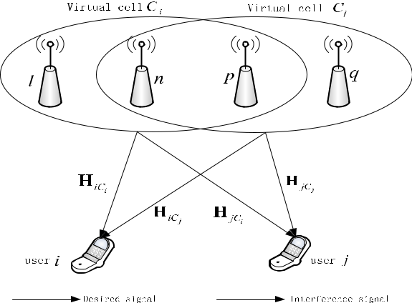

to different overlapping virtual cell and can schedule multiple users at the same time. *L* BSs form a virtual cell to serve certain users. As shown in Fig. 1, the service cells of user *i* consist of BS {*l*, *n*, *p*}, for example.

Let *C* represent a collection of all virtual cells, in which the virtual cell serving user *i* is identi ed as *Ci*, including *L* BS. *Uj* represents the set of all users served by the *jth* virtual cell. The channel vector of user *i* served by virtual cell*Ci* can be expressed asV

|  |  |  |
| --- | --- | --- |
|  |  |  |
| ***H****i*;*Ci* D *gi*;*m*1; *gi*;*m*2;; *gi*;*mL* | ; | (1) |

in which *gi*;*mk* represents the channel gain between the BS *mk* and user *i*, and *mk* 2 *Ci*, *k* D 1; 2; ; *L*.

On the premise of the above assumptions, the received signal vector of user *i* can be expressed as

|  |  |  |  |  |
| --- | --- | --- | --- | --- |
| *j*2X6D | | ***W*** *j****x****j*C ***n****i*; |  |  |
| ***y****i* D***H****i*;*Ci* ***W*** *i****x****i* C | *Hi*;*Cj* | (2) |  |
| *U* ;*j* | *i* |  |  |  |

where ***x****i* represents the signal vector transmitted to user *i* by all BSs in virtual cell *Ci*, and each element is assumed with a power of *Ptx* ; ***n****i* represents the additive white Gaussian noise vector, ***n****i* *CN* 0; *n*2***I*** ; ***x****i*; ***y****i* and ***n****i* are all in size of j*Ui*j 1.

Assuming that BSs in virtual cell transmit signals coop-eratively, and zero forcing algorithm precoding is utilized to eliminate the interference between users in a virtual cell. We use ***W*** *i* to represent the precoding matrix of users in *Ui*, which is expressed as

|  |  |  |  |  |  |  |  |  |  |  |  |
| --- | --- | --- | --- | --- | --- | --- | --- | --- | --- | --- | --- |
| 1 | | |  |  | 1 | | | ***H****i*H,C*i* | ***H****i*;*Ci* ***H****i*H,C*i* | 1 |  |
|  |  |
| ***W*** *i*D | ~~p~~ |  |  | ***W*** *i*D | | ~~p~~ |  | :(3) |  |
| *~~c~~~~i~~* | *~~c~~~~i~~* |  |

In the formula, ***H****i*;*ci* H is the conjugate transposition of ***H****i*;*ci* . *ci* represents the power constraints of the precoding matrix.According to [16], we have

|  |  |  |  |  |  |  |  |  |
| --- | --- | --- | --- | --- | --- | --- | --- | --- |
|  |  |  |  | 1 | |  |  |  |
| *ci* Dmax*j* | ***W*** *i****W*** *i*H | | | [*j*; *j*] |  | ; | (4) |  |
| j*Ci*j |  |

where ***X*** [*j*; *j*] refers to the [*j*; *j*] *th* element in matrix ***X***, and j*Y* j refers to the number of elements in *Y* .

VOLUME 8, 2020

Y. Liang *et al.*: Efficiency-Improved Clustering Algorithm Based on KNN Under UDN

Because the interference intra virtual cell has been elimi-nated by zero-forcing precoding, the user set in the *gth* cluster is represented as *Vg*, and *V* denotes the set of user clusters. In order to calculate the achievable rate of users in a cluster, it is assumed that user *u* and user *e* in virtual cell *i* are in the same cluster *g* without losing generality. The achievable rate of user *e* in cluster *g* is

|  |  |  |  |  |  |  |  |  |  |  |  |
| --- | --- | --- | --- | --- | --- | --- | --- | --- | --- | --- | --- |
|  |  |  | 0 |  |  |  | 1 | |  |  |  |
| *Re*[*g*] |  | log2 |  | 1 |  |  | *ptx* |  | : | (5) |  |
| D | @ | C | *ci* | *n*2 C *Ze*[*g*] A | |  |
|  |  |  |  |  |  |

In (5), *Ptx* and *n*2 represent the power of BS and noise, respectively, Z[*eg*] denotes the interference between virtual cells of user *e* in cluster *g*, which is calculated as

|  |  |  |  |  |  |  |  |
| --- | --- | --- | --- | --- | --- | --- | --- |
| *Ze*[*g*]D *c* |  | *Ucg* | ***h****e*[*c*]***w****c*;*d* | 2 | *Ptx* : | (6) |  |
| *C i d* |  |  |
|  | 2X X | |  |  |  |  |  |
|  | 2 |  |  |  |  |  |
|  |  |  |  |  |  |  |  |

nf g

In (6), ***h***[*ec*] is the channel vector with a size of 1 jV*c*j, which indicates the channel gain between each BS in virtual cell *c* and user *e* in cluster *g*. *Ucg* is the user set in cluster *g*. ***w****c*;*d* is the *dth*column of precoding matrix ***W*** *c* in virtual cell *c*. Table 1 gives the brief meaning of these symbols.

In order to maximize the system weighted sum rate with

* orthogonal resources, such as sub-band in LTE system,

**TABLE 1.** Meanings of symbols.

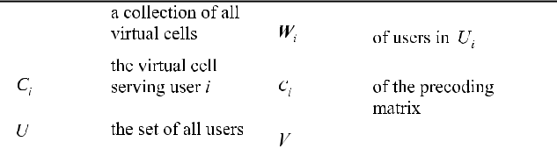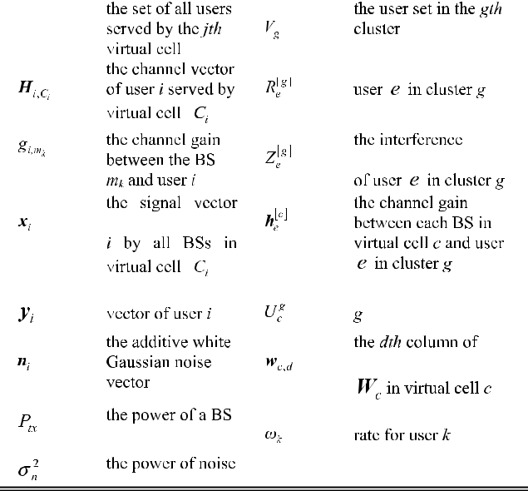

VOLUME 8, 2020

**FIGURE 2.** Interference graph.

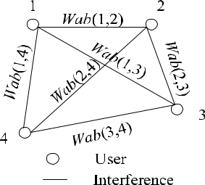

we de ne the optimization problem ***P***opt, aiming at gener-ating the clusters of users, which is denoted as f*V*1; ; *VM* g

|  |  |  |  |  |  |  |  |
| --- | --- | --- | --- | --- | --- | --- | --- |
|  | 0 |  | 1 |  |  |  |  |
|  | *M* |  | A |  |  |  |  |
| max | @X X | | ; | ; | (7) |  |
|  |  | !*k* *Rk*[*m*] |  |  |
| *V*1; ;*VM* *m*D1 *k*2*Vm* | | |  |  |  |  |  |
| *Subject to C*1 | | V j*Vm*j *K* | | *for all m* |  | (8) |  |
|  | *C*2 | V *V*1[*V*2[ [*VM* D*U*; | | | | (9) |  |
|  | *C*3 | V *Vm* \ *Vn* D ; *for all m* | | | |  |  |
|  |  | *and n* with *m* 6D*n* | | |  | (10) |  |

In (7), !*k* represents the weight of the sum rate for user *k*.

* denotes the maximum number of users in each cluster in (8). Formulas (9) and (10) denote that one user can only be assigned to one cluster. With the increase of users in the network, the number of clusters increases exponentially, which makes the optimization problem more complex. There-fore, this optimization problem is transformed into a low complexity heuristic user clustering algorithm.
  1. **CLUSTERING ALGORITHMS**

In the mixed ultra-dense cooperative transmission network scenario, users interfere and are interfered by other users at the same time. Cell-edge users are interfered seriously. Multi-dimensional cooperation strategy is taken into account in order to improve the user experience at edge and reduce the impact caused by interference.

**A. INTERFERENCE WEITHT DESIGN**

We use a mathematical graph to apply clustering algorithm. A graph consists of a set of vertices together with a set of edges that connect two vertices. [18] Thus, we rst build a suitable graph for a given network. Each user is mapped in the network to a vertex in the graph. Then a set of vertices are denoted as *V* D f*v*1; *v*2; *vN* g. Any pair of two vertices are connected by an edge. The set of edges is denoted by *E* D

f*Wab*(*i*; *j*) *the vertices i and j are connected* g *Wab*(*i*, *j*) is expressed by equation(11). An example of the network graph is shown in Fig. 2. In this way, we can get a matrix whose elements are interferences, noted as *Wab*(*i*, *j*), between every two users.

43799



Y. Liang *et al.*: Efficiency-Improved Clustering Algorithm Based on KNN Under UDN

For example, in Fig. 2, taking 4 users into consideration, we might get a matrix as

|  |  |  |  |  |  |  |  |  |
| --- | --- | --- | --- | --- | --- | --- | --- | --- |
| 0 | 0 | *a* | *b* | *c* | 1 |  |  |  |
| B | C |  |  |  |
| *a* | 0 | *d* | *e* | : | (11) |  |
| *c* | *e* | *f* | 0 |  |  |  |
| B | *b* | *d* | 0 | *f* | C |  |  |  |
| @ | A |  |  |  |
|  |  |  |  |  |  |  |
| In (11), *a*, *b*, *c*, *d*, | *e*, *f* |  | represent | | the interference value | | |  |

respectively. In this example, *a* D *Wab*(1,2), which means the interference between user 1 and user 2 in Fig.2. It also means the element of the 1st row and the 2nd column of matrix (11). Similarly, *b* D *Wab*(1,3), *c* D *Wab*(1,4), *d* D *Wab*(2,3), *e* D *Wab*(2,4), *f* D *Wab*(3,4). The matrix is symmetric becausewe assume that the interference between users is undirected, which means *Wab*(*i*; *j*) D *Wab*(*j*; *i*). The diagonal elements are 0s, which illustrates a user cannot be an interference to itself. The number of non-zero interference values in interference matrix is (*N* 1) C (*N* 2) C 1 D *N* (*N* 1)=2 under assuming *N* users.

Overlap between cells is considered in weight design. The overall system performance is dependent on multidimen-sional joint optimization of radio resources, power spectrum and space. Hence, the weight design takes channel amplitude and channel direction into account, which effectively re ect the mixed cooperative transmission gain. The vector angles of channels between users can be acquired from the selected channels.

We take user *i* and user *j* as candidates in one cluster, and assume the composite channel vector as *Hi*;*Ci* (composite channel vector of user *i* in virtual cell *Ci*), and *Hj*;*Cj* (com-posite channel vector of user *j* in virtual cell *Cj*). The weight between user *i* in virtual cell *Ci* and user *j* in virtual cell *Cj* is

|  |  |  |  |  |  |  |  |  |  |  |  |  |  |  |  |  |  |  |  |  |  |  |  |  |  |  |  |  |  |  |
| --- | --- | --- | --- | --- | --- | --- | --- | --- | --- | --- | --- | --- | --- | --- | --- | --- | --- | --- | --- | --- | --- | --- | --- | --- | --- | --- | --- | --- | --- | --- |
| noted as |  | 01 | | |  |  |  |  |  |  |  |  | ***H****i*;*Ci* ***H****i*H;*Cj* | | | | | | |  |  |  | 1 | |  |  |  |  |  |  |
| *Wab*(*i*; *j*) | D | C | |  | |  |  |  |  |  |  |  |  |  |  |  |  |  |
|  |  |  |  |  | | | | | | |  |  |  |  |  |  |  |  |
|  |  | @ | |  |  |  |  |  |  | |  |  |  |  | |  |  |  |  | F A | | | | | |  |  |  |  |  |
|  |  |  |  |  |  |  |  |  |  |  |  |  |  |  |  |  |  |  |  |  |  |  |  |  |  |
|  |  |  |  |  |  |  |  |  |  | |  |  |  |  | |  |  |  |  |  |  |  |  |  |  |  |  |  |  |  |
|  |  |  | 0 | 1 | | C | |  | |  |  |  | ***H****i*;*Ci* ***H****j*H;*Ci* | | | | | | |  |  |  |  | 1 | |  |  | ***H****i*;*Ci* | F |  |
|  |  |  |  |  |  | | | | | | |  |  |  |  |  |  |
|  |  |  |  |  |  |  |  |  | ***H****i*;*Ci* | | | F | |  | ***H****j*;*Ci* | | | F | | | | |  |  |  |  |
|  |  |  | @ |  |  |  |  |  |  |  |  |  |  | |  |  |  |  |  |  |  |  |  |  |  |  |  |  |  |  |
|  |  |  |  |  |  |  |  |  |  |  | |  |  |  |  |  | |  |  |  |  |  |  |  |  |  |  |  |  |  |
|  |  |  |  |  |  |  |  |  |  |  | |  |  |  |  |  | |  |  |  |  |  |  |  |  |  |  |  |  |  |
|  |  | C | | 01 | | |  | C | |  | | |  | ***H****j*;*Ci* ***H****j*H;*Cj* | | | | | | |  |  |  |  |  | 1 | |  |  |  |
|  |  |  |  |  |  |  |  |  |  | ***H****j*;*Ci* | | F ***H****j*;*Cj* | | | | | | |  |  |  |  |  |  |  |  |
|  |  |  |  | @ | | |  |  |  |  |  |  |  |  |  |  |  |  |  |  |  |  |  | F | | A | |  |  |  |
|  |  |  |  |  |  |  |  |  |  |  |  |  |  |  |  |  |  |  |  |  | |  |  |  |  |  |  |
|  |  |  |  |  |  |  |  |  |  |  |  |  |  |  |  |  |  |  |  |  |  |  |  | |  |  |  |  |  |  |
|  |  |  | 0 | 1 | | C | |  | |  |  |  | ***H****i*;*Cj* ***H****j*H;*Cj* | | | | | | |  |  |  |  | 1 | |  |  | ***H****j*;*Cj* | F ; (12) |  |
|  |  |  |  |  |  | | | | | | |  |  |  |  |  |  |
|  |  |  |  |  |  |  |  |  | ***H****i*;*Cj* | | | F | |  | ***H****j*;*Cj* | | | F | | | | |  |  |  |  |
|  |  |  | @ |  |  |  |  |  |  |  |  |  |  | |  |  |  |  |  |  |  |  |  |
|  |  |  |  |  |  |  |  |  |  |  | |  |  |  |  |  | |  |  |  |  |  |  |  |  |  |  |  |  |  |
|  |  |  |  |  |  |  |  |  |  |  | |  |  |  |  |  | |  |  |  |  |  |  |  |  |  |  |  |  |  |

where coef cients and denote the proportions of power and space in multi-dimensional cooperation respectively. k k*F* represents the *F* norm of the matrix, where *F* is 2. This equation is suitable for the overlapped cells scenario. Users in overlapped cells adopt joint transmission mode to obtain cooperative transmission gain. When the cells are non-overlap or part-overlap, the spatial coordinated transmission

43800

**TABLE 2.** Weights design in different scenarios.

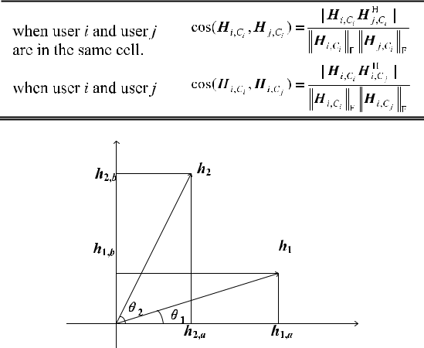

**FIGURE 3.** Channel vector diagram.

for users is adopted to eliminate the inter-user interference. The nearer orthogonal the users’ channels are, the less inter-ference between users and the higher energy and frequency ef ciency gains we get. In this case, weights are designed as follows in Table 2.

There are some assumptions as:

1. BS *a* and *b* are in cell *i* in this model, and

2) ***H****i* D [***h***1I ***h***2] D *h*1,*ah*1,*b*I *h*2,*ah*2,*b* is the composite channel in cell *i*, where the subscript parameters 1 and 2 in *Hi* refer to the users scheduled by BS *a* and *b* respectively.Fig.3 shows the meaning of channels. *h*1,*a* is the channel between user 1 and BS *a*. Similarly, *h*1,*b* denotes the chan-nel between user 1 and BS *b*. These two channels, asso-ciated with user 1, are vectors, which are combined into ***h***1.1is the angle between ***h***1and*h*1,*a*, which is the anglebetween ***h***1 and its projection on BS *a*. Therefore, 2 is the angle between ***h***2, the combined vector of user 2, and its projection on BS *a*.

The ZF-based precoding matrix of cell *i* is

|  |  |  |  |  |  |  |  |
| --- | --- | --- | --- | --- | --- | --- | --- |
| ***W*** *i* Dp*ci* |  | *h*1;*ah*2,*b* | *h*1,*bh*2,*a* |  | *h*2,*a* | *h*1,*a* | : (13) |
| 1 |  | 1 |  |  | *h*2,*b* | *h*1,*b* |  |

The power division factor of each user is applied to precoding matrix. The per-BS power is constraint. So, the parameter *ci* can be written as

|  |  |  |  |  |  |  |  |  |  |  |  |  |  |  |  |  |  |  |  |  |  |  |  |  |  |  |  |
| --- | --- | --- | --- | --- | --- | --- | --- | --- | --- | --- | --- | --- | --- | --- | --- | --- | --- | --- | --- | --- | --- | --- | --- | --- | --- | --- | --- |
| *ci* Dmax*j* |  |  |  | | | H 2[*j*; *j*] | | | |  | |  |  |  |  |  |  |  |  |  |  |  | |  |  |  |  |
| ***W*** *i****W*** *i* | | | | 2 | |  | 2 ; |  | *h*1, | |  | 2 | C |  |  | 2 | |  | 2 | ) : |  |
| D max | ( | |  | *h*1;*ah*2;*b* | | | | C*h*1;*bh*2 | | | ;*a* |  |  | *ah*2;*b* | | *h*1;*bh*2, | | | *a* |  |  |
|  |  |  |  |  | *h*1;*b* | |  |  | *h*2;*b* |  |  |  |  |  |  | *h*1;*a* | |  |  |  | *h*2;*a* |  |  |  |  |  |  |
|  |  | |  |  |  |  |  |  |  |  |  |  | (14) | |  |
|  |  | | |  |  |  |  |  |  |  |  |  |  |  |  |  |  |  |  |  |  |  |  |  |  |  |  |

We assume that the rst term is greater than the second term. Without loss of generality, the improvement of the SINR of the user 1, which is obtained through the clustering,

VOLUME 8, 2020

Y. Liang *et al.*: Efficiency-Improved Clustering Algorithm Based on KNN Under UDN

|  |  |  |  |  |  |  |  |  |  |  |  |  |  |  |  |  |  |  |  |  |  |  |  |  |  |  |  |  |  |  |  |  |  |  |  |  |  |  |  |  |  |  |  |  |
| --- | --- | --- | --- | --- | --- | --- | --- | --- | --- | --- | --- | --- | --- | --- | --- | --- | --- | --- | --- | --- | --- | --- | --- | --- | --- | --- | --- | --- | --- | --- | --- | --- | --- | --- | --- | --- | --- | --- | --- | --- | --- | --- | --- | --- |
| is calculated in |  |  |  |  |  |  |  |  |  |  |  |  |  |  |  |  |  |  |  |  |  |  |  |  |  |  |  |  |  |  |  |  |  |  |  |  |  |  |  |  |  | **TABLE 3.** KNN algorithm for user clustering. | |  |
| 1SINR D SINR*i* | | | | | | |  |  |  | SINR*a* | | | | | | | | | |  |  |  |  |  | 2 *ptx* | | | |  |  |  |  |  |  |  |  |  |  |  |  |  |  |  |  |
|  |  |  |  |  |  |  |  |  |  |  |  |  |  |  |  |  |  |  |  |  |  |  |  |
|  |  |  |  |  |  |  |  |  |  |  |  |  |  |  |  |  |  |  |  |  |  |  |  |
|  | *ptx* | | |  | 1 | | |  |  |  |  |  |  |  |  |  | *h*1;*a* | | | | | | |  |  |  |  |  |  |  |  |  |  |  |  |  |  |  |  |  |
| D |  |  |  |  |  |  | |  |  |  |  |  |  | *h*1;*b* | | | | |  |  | 2 *ptx* | | | | | |  |  |  |  | |  |  |  |  |  |  |  |  |  |  |  |  |  |
| *n*2 | |  |  | *ci* | |  |  |  |  |  |  |  |  | C | |  | 2 | |  |  |  |  |  |  |  |  |  |  |  |  |  |
|  | *p* |  |  |  |  |  |  |  |  |  | ***h***1 | | | |  |  |  |  |  |  |  |  |  |  | |  | *n* | |  |  |  | *h*1;*a* | | |  | 2 *ptx* | | |  |  |  |  |
|  |  |  |  |  |  |  |  |  | j |  | ***w***1 | | | | | j | 2 | |  |  |  |  |  |  |  |  |  |  |  |  |  |  |  |
| D |  | *tx* | |  |  |  |  |  |  |  |  | |  |  |  |  |  | |  |  |  |  |  |  |  |  |  | *h*1;*b* | | | |  | 2 *ptx* | | | |  |  |  |  |  |
| *n*2 | |  |  |  | *h*1;*b* 2 | | | | | | | | C | |  |  |  | *h*2;*b* | | | | | |  | 2 |  |  |  |  | C | 2 |  |  |  |
|  |  |  |  |  |  | |  |  |  | ***h***1 | | |  |  |  | ***h*** | | |  |  |  |  |  |  |  |  |  | 2 | |  |  |  |  |  |  |  |  | *n* | | |  |
|  | *ptx* | | |  |  | k | |  |  | 2 | k | | 2 | | k | | 2 |  |  |  |  |  |  |  |  |  |  |  |  |  |  |  |
|  |  |  |  |  |  |  |  |  |  | k | | |  |  | |  |  |  |  |  |  | sin | |  |  | h | ***h***1; ***h***2 | | | | | | i |  |  |  |  |  |
| D 2 | | | |  | *h*1;a | | | | | |  | | |  |  | |  | |  |  |  |  |  |  |  | 2 |  |  |  |  |  |  |
|  |  | 2 | |  |  |  |  |  |  |  |  |  |  |  |  |  |  |  |  |  |  |  |  |  |  |  |  |
|  |  | *n* | |  |  | | *h*1;b | | | | |  |  |  | C | |  |  | | *h*2;b | | | | | |  |  |  |  |  |  |  |  |  |  |  |  |  |  |  |  |  |  |  |
|  |  |  | |  |  | |  |  |  |  |  |  |  |  | C | | |  |  |  | *n* | | |  |  |  |  |  |  |  |  |  |  |  |  |  |  |  |  |  |  |  |  |  |
|  |  |  | | *h*1,b | | | |  | 2 *ptx* | | | | | |  |  |  | 2 | | | | | |  |  |  |  |  |  |  |  |  |  |  |  |  |  |  |  |  | (15) | |  |  |
|  |  |  |  |  |  |  |  |  |  |  |  |  |  |  |  |  |  |  |  |  |  |  |  |  |  |  |  |  |  |  |  |  |  |  |  |  |  |  |  |  |  |



where SINR*i* represents the SINR of user 1 after clustering, and SINR*a* denotes the SINR of user 1 under the service of BS *a*. Because UDN is an interference-limited system, the noise can be ignored. So, the interference signal satis es j*h*1;*k* j2*Ptx n*2. When user *i* is at the edge of an overlapped cell, the channel intensity satis es j*h*1,*a*j j*h*1,*b*j. Thus equation (15) can be simpli ed as

|  |  |  |  |  |  |  |  |  |  |  |  |  |  |  |  |  |  |  |  |  |
| --- | --- | --- | --- | --- | --- | --- | --- | --- | --- | --- | --- | --- | --- | --- | --- | --- | --- | --- | --- | --- |
| 1SINR |  | *ptx* |  |  | k***h***1k2 k***h***2k2 | | | | | |  |  | sin2 | h | ***h*** |  | ; ***h*** | 2i | 1: (16) |  |
| D 2 | |  |  |  | | | | | |  | 2 | 1 |  |
|  |  | *h*1;*b* |  | 2 | C |  | *h*2;*b* |  |  |  |  |  |  |
|  |  | *n* |  | |  |  |  |  |  |  |  |  |  |  |
|  |  |  |  | |  |  |  |  |  |  |  |  |  |  |  |  |  |  |  |  |

We can see from equation (16) that the improvement of the SINR of user 1 is closely related to the intensity of the cooperative channel ***h***2 and the orthogonality of Channel ***h***1and ***h***2. Therefore, it is proved that the weight design isreasonable.

**B. KNN CLUSTERING ALGORITHM**

The K-Nearest Neighbour (KNN) algorithm is proposed in this paper on the basis of the interference weights designed above. We use the elements of matrix *Wab* to denote the interference between users. For example, the element in row *i* column *j* of *Wab*, which is *W* ab(*i*; *j*), represents the interfer-ence between user *i* and user *j*.

We propose this KNN algorithm to allocate users into clusters under UDN. The algorithm can cluster *K* users at a time which speeds up the clustering. Steps of the algorithm are shown in Table 3.

If *N* (*N* 2) clusters are needed, we need *N* initial users. These initial users must be representative. It is dif cult to get

* initial users due to the complicated computation. We get them by performing the proposed method repeatedly. After getting two clusters according to Table 3, we perform KNN algorithm in each cluster to get the clusters we need.

**IV. SIMULATION AND ANALYSIS**

* is key to choose due to its impacts on the process time and the result of the algorithm. We simulate weight design and KNN algorithm for user clustering by MATLAB. This algorithm is compared to an algorithm in [23] and [24], which is called *k*-means algorithm. *k*-means algorithm is one of the most commonly used clustering algorithms, which is simple,

easy to understand and fast to operate. The main idea of *k*-means algorithm is roughly as follows: rstly, randomlyselect *k* samples from the sample set as the cluster centers; secondly, calculate the distances between all samples and the *k* centers; thirdly, divide each sample into the cluster with the nearest cluster center; nally, calculate *k* new clus-ter centers of each cluster. The above process is iterated until a certain condition is satis ed, for example, the cluster centers do not change, or the number of iterations reach the speci ed value. In the simulation, *k*-means algorithm is based on the following 3 premises: (a) The two initial cluster centers are not randomly selected, but the two users with the largest interference. (b) The number of iterations is 1.



1. Each cluster is the input of *k*-means algorithm and then divided into two new clusters. so the number of clusters is the power of 2.

**A. SIMULATION CONDITIONS**

In simulation, we use KNN algorithm to allocate users into clusters based on virtual cells. In each cluster, users are scheduled among cells which are coordinated to adapt to beam forming and power allocation. Scheduled users are selected by greedy scheduling algorithm, in consid-eration of proportional fairness and rate maximization. Cooperative beamforming adopts reciprocity strategy. For the BSs in overlapping virtual cells, the power is allo-cated by the intensity of the instantaneous channel of the scheduled user. We control power through water- lling algorithm.

In clustering process, The criteria for the merger is to minimize the sum of weights intra cluster and maximize weights inter cluster. Simulation parameters are shown in Table 4.

|  |  |
| --- | --- |
| VOLUME 8, 2020 | 43801 |

Y. Liang *et al.*: Efficiency-Improved Clustering Algorithm Based on KNN Under UDN

**TABLE 4.** Simulation parameters.

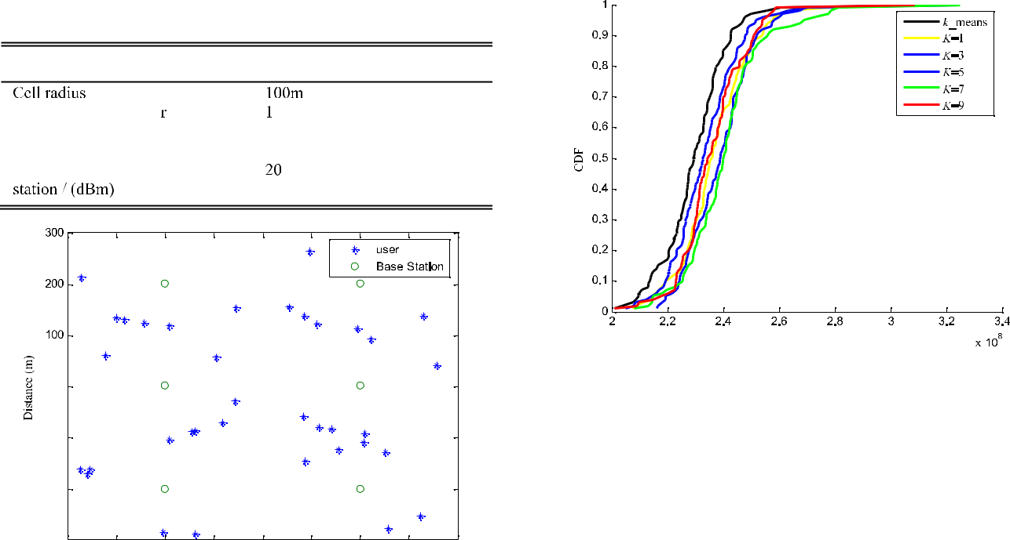

**FIGURE 5.** CDF of KNN and k-means algorithm with 6cells, 36 users.

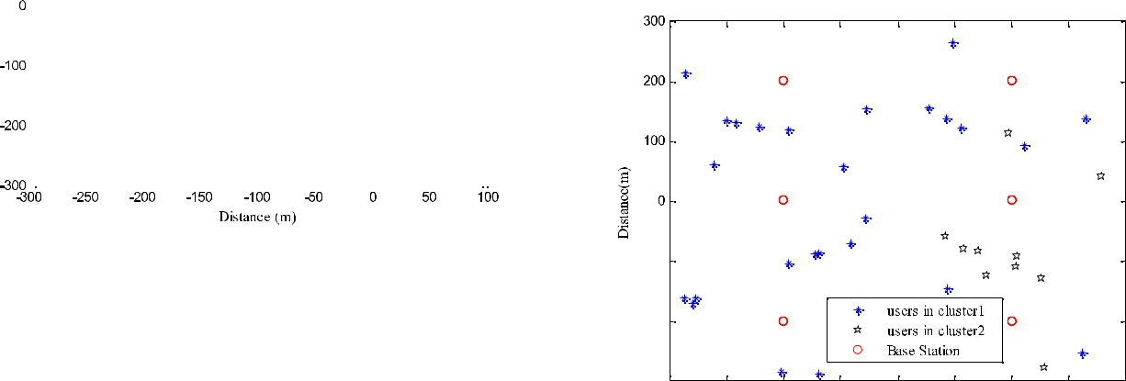

**FIGURE 4.** Map of randomly distributed users.



For fairness and authenticity of the simulation results, parameter setting, power partition and power control algorithms are identical in the compared algorithm and the proposed KNN algorithm.

**B. RESULTS AND ANALYSIS**

We x the location of BSs and disperse users randomly. Fig.4 shows the geographical distribution of random users and xed BSs. We distribute users at the edge of the cell as far as possible to observe the performance improvement of the proposed algorithm.

1) 2 CLUSTERS WITH 6 CELLS AND 36 USERS

Fig.5 illustrates the cumulative distribution function (CDF) to system throughput by *k*_means algorithm and KNN with

* D 1; 3; 5; 7; 9 respectively. Targeting the 10th percentile of the CDF as QoS measure, 2.72%, 2.70%, 4.96%, 5,59%and 4.43% improvement is observable of KNN with *K* D 1; 3; 5; 7; 9 over Ref. algorithm respectively. Targeting the 90th percentile, the improvement is also promising (4.77%, 2.31%,3.98%,5.56% and 3.50% over Ref. of improved KNN with *K* D 1; 3; 5; 7; 9; respectively).

Due to KNN with *K* D 7 having the most improve-ment, we compare the clustering results with *k*-means algo-rithm, which are shown in Fig.6 and Fig.7. we can see the numbers of users in the two clusters are closer in KNN than *k*-means. The KNN clustering algorithm re ects the users’ fairness, which makes the resource arrangement more balanced.

43802

**FIGURE 6.** Clustering results by k-means algorithm with 36 users.

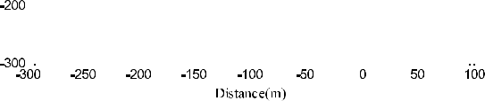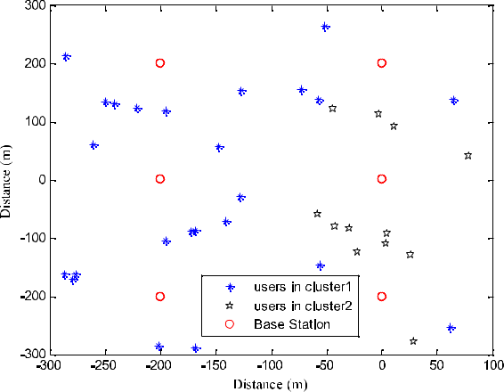

**FIGURE 7.** Clustering results by KNN algorithm (KD7) with 36 users.

1. 2 CLUSTERS WITH DIFFERENT NUMBERS OF CELLS AND USERS

In order to see the effectiveness of the proposed algorithm We select 8,9 and 10 cells with 48,54 and 66 users respectively to observe the CDF of *k*-means and KNN.

From Fig. 8-10, we can see promising improvement by KNN over *k*-means algorithm, no matter what *K* is. However,

VOLUME 8, 2020

Y. Liang *et al.*: Efficiency-Improved Clustering Algorithm Based on KNN Under UDN

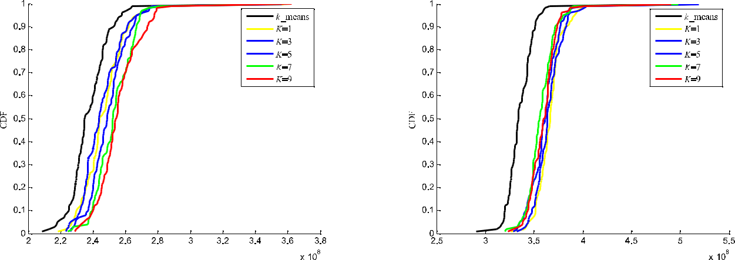

**FIGURE 8.** CDF of KNN and **k**-means algorithm with 8 cells, 48 users.

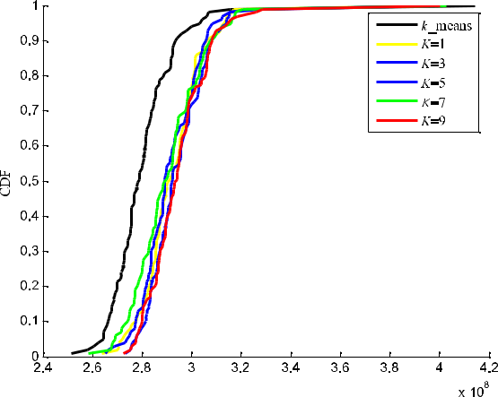

**FIGURE 10.** CDF of KNN and k-means algorithm with 10 cells, 66 users.

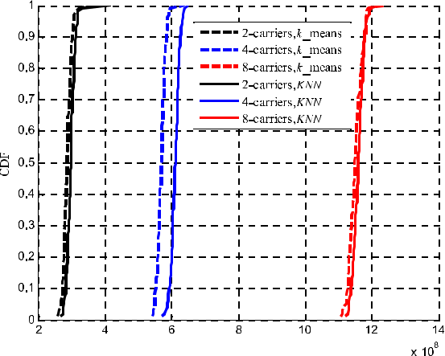

**FIGURE 9.** CDF of KNN and k-means algorithm with 9 cells, 54 users.

**FIGURE 11.** CDF of KNN and k-means algorithm with 2,4 and 8 carriers.

the algorithm is not always proper, which we didn’t show them. Because each BS, who has only two assignable channel resources (the reason that we need 2 clusters), cannot serve more users better. Moreover, in a real scenario, we often need more than 2 clusters according to the resources allocated to BSs. We compare the two algorithms in situation of multiple clusters.

3) MULTIPLE CLUSTERS

Fig. 11 shows the CDF of the throughputs of all users in the network, where we use 8 cells with 48 users. Different numbers of carriers are taken into consideration. In situation of more carriers, both algorithms achieve better throughputs due to more allocated resources. Without imposing further constraints, the proposed *KNN* algorithm leads to better per-formance on the throughput analysis compared with *k*-means algorithm.

However, it is not appropriate to compare the total system throughput under different carriers because the resources used are different. More resources will inevitably lead to better system performance. Therefore, we compare the sys-tem throughput on each carrier. The performance is inves-tigated in Fig.12. For different numbers of carriers, we use

VOLUME 8, 2020

**FIGURE 12.** CDF of KNN and k-means algorithm with 10 cells, 66 users.

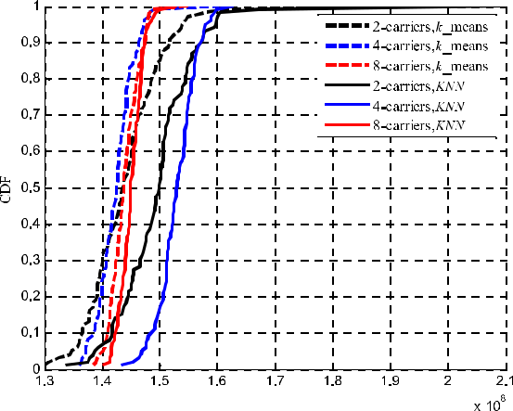

different colors. For *k*-means algorithm, we use dashed lines, and solid lines for KNN algorithm. It can be seen from Fig. 12 that the KNN algorithm has a promising advantage over the *k*-means algorithm, regardless of targeting the 10%, 50%, or 90% of CDF. The number of carriers is not the main factor that affects the signal throughput on a single carrier.

43803

Y. Liang *et al.*: Efficiency-Improved Clustering Algorithm Based on KNN Under UDN

The value of *K* needs to be determined according to speci c circumstances.

**C. COMPUTATION COMPELXITY**

We assume follows: *N* nodes are processed; the number of iterations is *n*; and *m*is the number of clusters. The time complexity of *k*-means algorithm is *O*(*n m N* ). Space complexity is *O*(*n N* ). In general, *n* and *k* can be considered constant. Therefore, both time and space complexity can be reduced to *O*(*N* ).

In our proposed KNN algorithm, *K* is the step length of processed data in each iteration in stead of 1 in *k*-means algorithm. Thus, both time and space complexity are reduced to *O*(*N* /*K* ). However, the same nodes are deleted from one of the clusters in each step, which increases the time complexity. We take 2 clusters as an example to observe the runtimes of *k*-means and *KNN* with different *K* s in Table 5.

**TABLE 5.** Computational complexity of different clustering schemes.



We compare the average runtime in 10 frames and take *k*-means algorithm as a benchmark. It is straightforwardthat the runtimes of the KNN scheme are less than that of *k*-means. Because we cluster more than one user at a timein the proposed algorithm. But the running time does not decrease all along as *K* get larger. The larger *K* is, the greater the possibility that the same users are divided into different clusters. It will take time to remove the same ones, thereby the running time gets longer. As a result, the runtime of KNN is a little less than *k*-means when *K* D 1; 3; 5; 7, but is slightly larger when *K* D 9 in Table 5.

**V. CONCLUSION**

In this paper, we have investigated user clustering for down-link cooperative receiving in virtual-cell wireless networks. The focus of the study has been placed on cell-edge users, which are de ned by achievable downlink rates when coop-eration is not available. A cluster problem has been for-mulated to achieve maximum total throughput for cell-edge users through cooperative processing of clustered users. The cluster problem that maximizes throughput of cell-edge users has been solved by a KNN algorithm, which depends on the inter-user interference weight (*Wab*). By imposing con-straints on the number of clusters, an KNN algorithm has been proposed to address the further constrained clustering problem. Numerical results have shown that the proposed KNN algorithm signi cantly outperforms *k*-means clustering algorithm in system throughput, which indicates superior per-formance provisioning property. The KNN algorithm, on the other hand, has achieved good tradeoff between the gain and cost due to clustering and cooperative processing, with slightly less computational complexity. Speci cally, it has

43804

exhibited the highest rate gain per unit cooperation resource consumption. Energy saving is realized by more servable users with limited resources.

**ACKNOWLEDGMENT**

The authors would like to thank J. Du for assistance with the valuable help in writing and discussion. They would also like to thank W. Yang, S. Liang, C. Lai, Y. Jiao, X. Yang, and R. Jin with consistent encouragement who gave us great help by providing necessary materials, advice of great value and inspiration of new ideas. They express our gratitude to our families for their spiritual and material support.

**REFERENCES**

1. X. Zhu, J. Zeng, X. Su, C. Xiao, J. Wang, and L. Huang, ‘‘On the virtual cell transmission in ultra dense networks,’’ *Entropy*, vol. 18, nos. 10 374,
   1. 1 18, Oct. 2016.
2. H. Peng, Y. Xiao, Y. N. Ruyue, and Y. Yifei, ‘‘Ultra dense network: Chal-lenges, enabling technologies and new trends,’’ *China Commun.*, vol. 13, no. 2, pp. 30 40, Feb. 2016.
3. D. Lopez-Perez, M. Ding, H. Claussen, and A. H. Jafari, ‘‘Towards 1 Gbps/UE in cellular systems: Understanding ultra-dense small cell deploy-ments,’’ *IEEE Commun. Surveys Tuts.*, vol. 17, no. 4, pp. 2078 2101, Jun. 2015.
4. L. Liang, W. Wang, Y. Jia, and S. Fu, ‘‘A cluster-based energy-ef cient resource management scheme for ultra-dense networks,’’ *IEEE Access*, vol. 4, pp. 6823 6832, 2016.
5. R. Wei, Y. Wang, and Y. Zhang, ‘‘A two-stage cluster-based resource man-agement scheme in ultra-dense networks,’’ in *Proc. IEEE/CIC Int. Conf.* *Commun. China (ICCC)*, Shanghai, China, Oct. 2014, pp. 738 742.
6. S. Zhao, T. Zhang, and X. Zhu, ‘‘A Handover algorithm based on predic-tion of adjustable threshold hysteresis margin in ultra dense network,’’ *J. Electron. Inf. Technol.*, vol. 38, no. 3, pp. 649 654,2016.
7. S. Zaidi, B. Hmidet, S. Affes, U. Vilaipornsawai, and L. Zhang, ‘‘User-centric wireless access virtualization strategies for future 5G networks,’’ in *Proc. IEEE Int. Conf. Ubiquitous Wireless Broadband (ICUWB)*, Nanjing,China, Oct. 2016, pp. 1 4.
8. Y. Zhang, S. Bi, and Y.-J.-A. Zhang, ‘‘User-centric joint transmission in Virtual-Cell-Based ultra-dense networks,’’ *IEEE Trans. Veh. Technol.*, vol. 67, no. 5, pp. 4640 4644, May 2018.
9. H. S. Kang and D. K. Kim, ‘‘User-centric overlapped clustering based on anchor-based precoding in cellular networks,’’ *IEEE Commun. Lett.*, vol. 20, no. 3, pp. 542 545, Mar. 2016.
10. P. Marsch and G. Fettweis, ‘‘Static clustering for cooperative multi-point (CoMP) in mobile communications,’’ in *Proc. IEEE Int. Conf. Commun.* *(ICC)*, Kyoto, Jepan, Jun. 2011, pp. 1 6.
11. S. Nam, J. Oh, and Y. Han, ‘‘A dynamic transmission mode selection scheme for CoMP systems,’’ in *Proc. IEEE 23rd Int. Symp. Pers., Indoor* *Mobile Radio Commun. (PIMRC)*, Sydney, NSW, Australia, Sep. 2012,
    1. 483 487.
12. B. Makki, T. Eriksson, and T. Svensson, ‘‘On an HARQ-based coordinated multi-point network using dynamic point selection,’’ *EURASIP J. Wireless* *Commun. Netw.*, vol. 2013, no. 1, p. 209, Aug. 2013.
13. A. Papadogiannis, D. Gesbert, and E. Hardouin, ‘‘A dynamic cluster-ing approach in wireless networks with multi-cell cooperative process-ing,’’ in *Proc. IEEE Int. Conf. Commun.*, Beijing, China, May 2008,
    1. 4033 4037.
14. D. Matsuo, R. Rezagah, G. K. Tran, K. Sakaguchi, K. Araki, S. Kaneko, N. Miyazaki, S. Konishi, and Y. Kishi, ‘‘Shared remote radio head archi-tecture to realize semi-dynamic clustering in CoMP cellular networks,’’ in *Proc. IEEE Globecom Workshops*, Anaheim, CA, USA, Dec. 2012,
    1. 1145 1149.
15. D. Liu, S. Han, C. Yang, and Q. Zhang, ‘‘Semi-dynamic user-speci c clustering for downlink cloud radio access network,’’ *IEEE Trans. Veh.* *Technol.*, vol. 65, no. 4, pp. 2063 2077, Apr. 2016.
16. K. Kinoshita, S. Shibata, K. Kawano, and T. Watanabe, ‘‘A CoMP clus-tering method in consideration of spectrum sharing for fairness improve-ment,’’ in *Proc. 9th Int. Congr. Ultra Modern Telecommun. Control Syst.* *Workshops (ICUMT)*, Munich, Germany, Nov. 2017, pp. 137 142.

VOLUME 8, 2020

Y. Liang *et al.*: Efficiency-Improved Clustering Algorithm Based on KNN Under UDN

1. J. Liu, ‘‘Research on energy-saving technology of base station in 5G ultra dense network,’’ M.S. thesis, School Electr. Inf. Eng., Beijing Jiaotong Univ., Beijing, China, 2017.
2. M. S. Ali, E. Hossain, and D. I. Kim, ‘‘Non-orthogonal multiple access (NOMA) for downlink multiuser MIMO systems: User clustering, beam-forming, and power allocation,’’ *IEEE Access*, vol. 5, pp. 565 577, 2017.
3. M. Kurras, S. Fahse, and L. Thiele, ‘‘Density based user clustering for wireless massive connectivity enabling Internet of Things,’’ in *Proc. IEEE* *Globecom Workshops (GC Wkshps)*, San Diego, CA, USA, Dec. 2015,
   1. 1 6.
4. J. Huang, P. Zhou, K. Luo, Z. Yang, and G. He, ‘‘Two-stage resource allocation scheme for three-tier ultra-dense network,’’ *China Commun.*, vol. 14, no. 10, pp. 118 129, Oct. 2017.
5. W. Li and J. Zhang, ‘‘Cluster-based resource allocation scheme with QoS guarantee in ultra-dense networks,’’ *IET Commun.*, vol. 12, no. 7,
   1. 861 867, Apr. 2018, doi: [10.1049/iet-csom.2017.1331.](http://dx.doi.org/10.1049/iet-csom.2017.1331)
6. Y. Liang, Y. Liu, C. Sun, X. Liu, J. Jiang, Y. Gao, and Y. Xie, ‘‘An improved LBG algorithm for user clustering in ultra-dense network,’’ in *Proc. 5th Euro-China Conf. Intell. Data Anal. Appl.*, Xi’an, Shaanxi, China, Dec. 2018, pp. 44 52.
7. J. X. Wang, S. Y. Tang, and C. Y. Sun, ‘‘Resource allocation based on user clustering in ultra-dense small cell networks,’’ *J. Xi’an Univ. Posts* *Telecommun.*, vol. 21, no. 1, pp. 16 20, Jan. 2016.
8. B. Stefano, ‘‘Finding a maximal weighted independent set in wireless net-works,’’ *Telecommun. Syst. Model. Anal. Des. Manage.*, vol. 18, nos. 1 3,
   1. 155 168, 2001.

YANXIA LIANG received the M.Sc. and Ph.D. degrees in military communications from Xidian University, in 2007 and 2011, respectively. She is currently a Researcher with the Shaanxi Key Lab-oratory of Information Communication Network and Security and an Associate Professor with the School of Communication and Information Engi-neering, Xi’an University of Posts and Telecom-munications. Her research interests include inter-ference management, radio resource management,



and information compression in mobile communication systems.

CHANGYIN SUN received the Ph.D. degree from Xidian University, in 2000. He is currently an Associate Professor with the School of Commu-nication and Information Engineering, Xi’an Uni-versity of Posts and Telecommunications. He had hosted some ZTE Industry-University-Research Projects and is hosting Shaanxi Key Industry Inno-vation Chain Project. His research interests include interference management and radio resource man-agement in the evolved mobile communication systems.

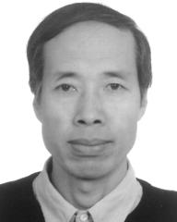

JING JIANG (Member, IEEE) received the M.Sc. degree from Xidian University, in 2005, and the Ph.D. degree in information and communication engineering from North Western Polytechnic Uni-versity, China, in 2009. She had been a Researcher and a Project Manager with the ZTE Corpora-tion, China, from 2006 to 2012. She is currently a Professor with the Shaanxi Key Laboratory of Information Communication Network and Secu-rity, Xi’an University of Posts and Telecommuni-



cations, Xi’an, China. Her research interests include massive multiple-input multiple-output systems and millimeter-wave communications. She has been a member of 3GPP.

XIN LIU received the M.Sc. degree in informa-tion and communication engineering from Xidian University, China, in 2007. He had been involved in wireless network planning and optimization at the Shaanxi Branch of China Mobile, from 2007 to 2008. He had been an MKT Director and a Project Manager with ZTE Corporation in Overseas Department, from 2008 to 2015. He is currently an Assistant Dean of the School of Information Engineering, Xi’an Eurasia Univer-

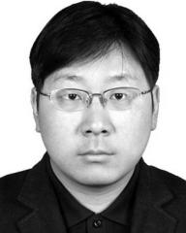

sity, China. His research interests include quantum compression and radio resource management.

HUA HE received the M.Sc. degree in information and communication engineering and the Ph.D. degree in microelectronics and solid state elec-tronics from the Xi’an University of Technology, Xi’an, China, in 2008 and 2011, respectively. She is currently a Lecturer with the School of Com-munication and Information Engineering, Xi’an University of Posts and Telecommunications. Her research interests include massive multiple-input multiple-output systems and millimeter-wave communications.



YONGBIN XIE is currently pursuing the Ph.D. degree. He is also a professor-level Senior Engi-neer. In 2007, he was named an expert enjoy-ing special government allowances. His research direction is wireless communication technology. He has had 29 invention patents at home and abroad, published more than 30 articles of var-ious types, and participated in the submission of more than 100 international standardization manuscripts. As the person in charge of the project,



he has undertaken and completed three 863 projects of the Ministry of Science and Technology, with a total project funding of 34 million yuan. TD-SCDMA base station system key technology research, equipment devel-opment and industrialization project won the second prize of National Sci-ence and Technology Progress (ranked as the rst winner).



|  |  |
| --- | --- |
| VOLUME 8, 2020 | 43805 |