

**Open Access**

**Multi-Antenna GNSS-Over-Fiber Architecture for Extensive Remote Multi-Baseline Network**

**Volume 12, Number 3, June 2020**

**Puyu Liu**

**Yang Li, *Member, IEEE***

**Xihua Zou, *Member, OSA***

**Jia Ye**

**Wei Pan**

**Lianshan Yan**

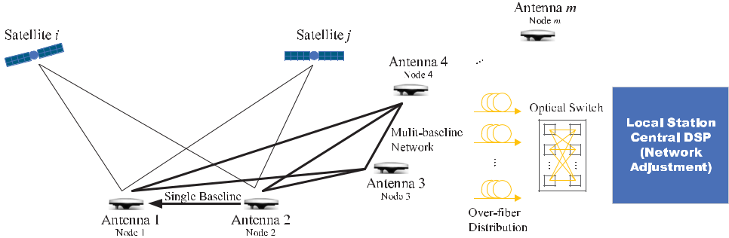

DOI: 10.1109/JPHOT.2020.2986358



IEEE Photonics Journal Multi-Antenna GNSS-Over-Fiber Architecture

**Multi-Antenna GNSS-Over-Fiber Architecture for Extensive Remote Multi-Baseline Network**

**Puyu Liu****,**1,2 **Yang Li****,**1 ***Member, IEEE*,**



**Xihua Zou** **,**1 ***Member, OSA*, Jia Ye,**1 **Wei Pan,**1 **and Lianshan Yan**

1

1. School of Information Science and Technology, Southwest Jiaotong University, Chengdu

611756, China

1. State Grid Zigong Power Supply Company, Zigong 643000, China

*DOI:10.1109/JPHOT.2020.2986358*

*This work is licensed under a Creative Commons Attribution 4.0 License. For more information, see*

*https://creativecommons.org/licenses/by/4.0/*

Manuscript received March 4, 2020; revised March 31, 2020; accepted April 3, 2020. Date of publication April 13, 2020; date of current version May 26, 2020. This work was supported in part by the National Key Research and Development Program of China under Grant 2019YFB2203204, in part by National Natural Science Foundation of China under Grants 61922069 and 61901397, in part by the Sichuan Science and Technology Programnder Grant (2019JDJQ0022, 2020YJ0014), and in part by the “111” Plan under Grant B18045. Corresponding authors: Yang Li; Xihua Zou (e-mail: yang.li@swjtu.edu.cn; zouxihua@swjtu.edu.cn).

**Abstract:** GNSS carrier-phase-based double-difference positioning has been widely usedin various precision positioning systems. This paper proposes a cost-effective scheme for an extensive multi-antenna remote multi-baseline network using a single GNSS-over-fiber system. First, GNSS signals are acquired by multiple remote antennas and transmitted to the local station through long microwave photonic links. Second, the GNSS receivers are reused in time division multiplexing mode via fast multi-port optical switches, providing enhanced temporal resolution and low cost for supporting massive monitoring antennas. Finally, compared with a single baseline, the standard deviation of the three-dimensional coordinate in the multi-baseline network is significantly reduced from millimeter to sub-millimeter level (from 2.9 mm to 0.5 mm). It demonstrates that a smaller number of receivers can support more synchronous observation loops, as well as an asynchronous group of them by fast switching, in this proposed scheme. The main contributions are twofold. First, the GNSS-over-fiber architecture is exploited and extended from single to multiple baselines, extending the spatial coverage. Second, the GNSS receivers are reused via optical switches in a fast surveying campaign, providing enhanced temporal resolution cost-effectively. This work will find applications in the large-scale GNSS baseline network, such as civil engineering and natural environment measurement.

**Index Terms:** GNSS-over-fiber, network adjustment, structural deformation monitoring.

**1. Introduction**

Global Navigation Satellite System (GNSS) positioning technology has extraordinary characteris-tics such as high precision, all-weather operation, and easy automation. For this reason, the GNSS system has also been widely and successfully applied in the structural deformation monitoring of bridges and highway slope [1]–[3].

In a static environment, a GNSS loop is formed by three or more simultaneously observed base-lines through the same number of receivers. The closure difference of the coordinate increment

Vol. 12, No. 3, June 2020 5501210

IEEE Photonics Journal Multi-Antenna GNSS-Over-Fiber Architecture

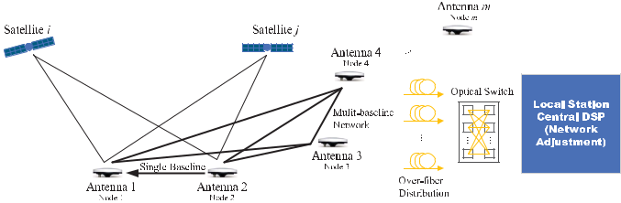

Fig. 1. Illustration of carrier-phase based double difference for extensive remote multi-baseline netork with a cost-effective multi-antenna GNSS-over-fiber architecture.

from each baseline (edge) should equal zero in the synchronization loop. Based on this principle, the measurement accuracy can be improved according to the error correlation among baselines in a GNSS baseline network [4], [5]. The network adjustment is a classical technique in GNSS surveying [6] and widely used in practice, e.g., the study of tectonic activity and earthquake hazards [7], the development of online control and alarm system [8], Continuously Operating Reference Stations (CORS) network for modern cities [9], and Precipitable Water Vapor (PWV) monitoring for meterorology [10].

For the construction of an extensive GNSS baseline network that covers a broad area, a large number of control points are required. In such large configurations, the quality and efficiency of the measurement campaign depend on the number of GNSS receivers [11]. First, multiple GNSS receivers are required in synchronous observations when the atmosphere error factors can be sampled in a spatially and temporally correlated way. Second, it is easy to deploy the measurement baseline network when the GNSS receivers are attached to the receiving antennas that defined the control points and the points to be measured. One disadvantage of the conventional scheme is the cost of high-end GNSS receivers or long duration of measurement campaign due to a limited number of receivers. Therefore the challenge lies in that whether the GNSS receivers can be reused fast in an extensive baseline network and also how to distribute the GNSS signals to the GNSS receivers reused.

With the rapid development of microwave photonics [12]–[14], the GNSS-over-fiber system was proposed, which is an ideal GNSS signal distribution scheme due to its low-loss, low-cost, and light-weight characteristics. The GNSS signals are acquired and applied to modulate the optical carrier in a directly modulated laser, which is then transmitted over tens of kilometers. After that, GNSS primary signals can be recovered by the photodetector without deteriorating measurement accuracy in the GNSS-over-fiber system [15], [16]. Meanwhile, since the phase variations in microwave photonic links by local oscillator signals are calibrated in real-time, the measurement accuracy of vertical accuracy can be increased to the same level as horizontal. For example, the 3.2 mm versus 9.2 mm vertical positioning Root Mean Square (RMS) results are obtained in a one-meter-long-baseline experiment [17]. The applications of multi-antenna GNSS-over-fiber ar-chitecture to attitude determination of large platforms were also reported with promising ambiguity resolution success rate and measuring accuracy with search-based algorithm [18]–[20] as well with search-free long-short algorithm [21]–[23]. One notable feature of the GNSS-over-fiber architecture is that it enables the Single Difference (SD) solution. Compared with the Double Difference (DD) based baseline calculating, the SD solution has better accuracy from an analytical analysis of the baseline covariance [19] as well as a Cramér-Rao Bound comparison.

In this paper, a multi-antenna remote baseline network based on a single GNSS-over-fiber architecture is proposed and designed to address the cost and distribution challenges simul-taneously, as depicted in Fig. 1. The GNSS signals are transmitted through a long microwave photonic link, and two different observation loops are established simultaneously with the aid of an optical switch. The over-fiber signal distribution and fast receiver reuse via the optical switch provides critical capabilities of the proposed system. In the experiment, the measurements of three baselines in each loop that includes navigation message and carrier phase observations are

Vol. 12, No. 3, June 2020 5501210

IEEE Photonics Journal Multi-Antenna GNSS-Over-Fiber Architecture

obtained. After the post-processing of the full measurements with the same software, the standard deviation of the multiple-baseline positioning results is enhanced to a sub-millimeter level compared with the single baseline occasion. Therefore, the proposed system can use a small number of receivers to establish more simultaneous and non-simultaneous observation loops, thus providing a cost-effective scheme for the extensive GNSS baseline networks.

**Notations:** Scalars, column vectors, and matrices are expressed by regular, bold lowercaseand bold uppercase letters, respectively. The superscript *T* corresponds to the transpose. Other

conventional notations, e.g., for the Euclidean norm of a vector, *d i ag*(·) for the diagonal matrix operator with the parameters as its diagonal elements, R for the real numbers, and Z for the domain of integer numbers, are also adopted.

**2. Principle of the Network Adjustment**

Relative positioning is usually applied in a single baseline of the high accuracy application sce-narios. The relative position between two different GNSS antennas, namely the baseline vector, is obtained by differential technology with simultaneous observations from two different GNSS receivers. The illustration of single baseline positioning by double-difference is demonstrated in Fig. 1, where the temporally and spatially correlated error factors are eliminated by the difference operation. According to the first-order Taylor series expansion (around **p**1), the linearized phase observation equation for double-difference processing is [11], [24], [25],

*φ*12*ij*

**b**12

|  |  |  |  |  |  |  |  |  |  |  |  |  |  |  |  |
| --- | --- | --- | --- | --- | --- | --- | --- | --- | --- | --- | --- | --- | --- | --- | --- |
| = | 1 | | (**e***i* | | − **e** *j* )*T* **b**12 | | | + *N*12*ij* + *ε*12*ij* *,* | | |  |  |  |  |  |
|  |  |  |  |  |  |  |
|  | *λ* |  |  |  |  |  |
| = | **p** | |  | − | **p** | *,* **e** |  | **p***i*− **p**1 | *,* **e** |  | = | **p** *j*− **p**1 | *,* | (1) |  |
|  |  | **p***i*− **p**1 |  | **p** *j*− **p**1 |  |
| 1 | | | 2 | *i* = | |  | *j* |  |  |  |

where *φ*12*ij* ∈ R is the double-differenced carrier phase observation, defined as *φ*12*ij* = (*φ*1*i* − *φ*2*i* ) − (*φ*1*j* − *φ*2*j* ), the subscripts 1 and 2 are the antennas’ indices, the superscripts *i* and *j* represent the satellites, *λ* is the carrier wavelength, **p**1*,* **p**2*,* **p***i* *,* **p** *j* are the position vectors (expressed in the Earth-Centered Earth-Fixed (ECEF) coordinate) of antenna 1, 2 and satellite *i* and *j* , respectively, *N* ∈ Z is the carrier phase integer ambiguity, *ε* is the remaining unmodeled biases and measurement noise. The ionosphere and troposphere delay factors, together with the errors introduced by the microwave links of the short-reach occasion (within 10 km), are eliminated by the double-difference operation and thus neglected in the modeling [26]. Once the ambiguity is fixed, one can solve the baseline vector expressed in the ECEF coordinate system, e.g., the WGS84 system.

After the ambiguity resolution, the solution of the single baseline vector **b**12 = **b**1 − **b**2 between the first and the second receiving antennas can be derived from eq. (1). The Real-Time Kine-matic (RTK) technology that resolves the ambiguity and solves the baseline vector in real-time is well developed and offered by commercial GNSS receivers, which is mainly based on the search-based Least-squares AMBiguity Decorrelation Adjustment (LAMBDA) method [27]. The variance-covariance matrix **D**12 of the corresponding baseline vector **b**12 is obtained in the baseline determination process.

Multiple baseline vector solutions together with their variance-covariance matrices are used for the baseline network adjustment.

|  |  |  |  |
| --- | --- | --- | --- |
| ˆ | = **p**1 − **p**2 + **v**12*,* |  |  |
| **b**12 |  |  |
|  | . |  |  |
|  | . |  |  |
|  | . |  |  |
| ˆ | = **p***m*−1 − **p***m* + **v***m*−1*,m* *,* | (2) |  |
| **b***m*−1*,m* |  |

Vol. 12, No. 3, June 2020 5501210

IEEE Photonics Journal Multi-Antenna GNSS-Over-Fiber Architecture

where *m* − 1 independent baselines are assumed, the uncertainties of the estimated baseline

|  |  |  |  |  |  |  |  |  |  |  |  |  |  |  |  |  |  |
| --- | --- | --- | --- | --- | --- | --- | --- | --- | --- | --- | --- | --- | --- | --- | --- | --- | --- |
| ˆ |  |  |  |  |  |  |  |  |  |  |  |  |  |  |  |  |  |
| vector **b** is modeled by **v**. The equations above can be cast into a single model as, | | | | | | | | | | | | | | | |  |  |
|  | ˆ | **I** | | −**I** ··· | |  |  | **p**1 | |  | **v**12 | | |  |  |  |  |
| **b**12 | **0** | | **p** |  |  |  |  |  |
|  | .. |  | .. | .. | .. | .. |  |  | 2 |  | .. |  |  | *,* | (3) |  |
| . | . | .. | | . |  | .. | |  | . |  |  |  |  |
|  |  | = |  |  |  |  |  | . | | + | |  |  |  |  |  |  |
| **b**ˆ*m* 1*,m***0** | | | | · · · | **I** | **I** |  |  |  |  | **v***m* | − | 1*,m* | |  |  |  |
|  | − |  |  |  | − | **p***m*−1*,m* | | | |  |  |  |  |  |  |

where **I** is the three-dimensional identity matrix, the overall variance-covariance matrix is denoted as **D** = *d i ag*(**D**12*, . . . ,* **D***m*−1*,m* ). The inverse variance-covariance matrix is used as the optimal weighting matrix,

|  |  |  |  |  |
| --- | --- | --- | --- | --- |
| **W** | = | **D**−1*.* | (4) |  |
|  |  |  |  |

The control node should be introduced from the coordinate of a certain position so that one can carry out the network adjustment. Then the correction of the single baseline vector can be obtained for improving the positioning accuracy of the target node.

In a practical surveying campaign, e.g., the engineering survey for high-speed railway [28], there are various control networks comprised of control nodes with known high-accuracy positions of various level, e.g., frame control network (CP 0), basic horizontal control network (CP I), route horizontal control network (CP II), and track control network (CP III).

The position of a control node could come from a known control network in practice. In addition, the control network itself can be constructed by other surveying means, e.g., a long time averaging of single-point position (SPP) or precise point position (PPP). Also, a lower-level control network can be derived from a higher-level control network, e.g., CP I can be obtained from CP 0 by network adjustment as well. These control nodes can be used as the starting point of the network adjustment processing. Specifically, the known positions of the control nodes are introduced into eq. (3) as equality constraints, and the variance-covariance matrices of the control-node baselines are constructed from their uncertainty level that is further incorporated into eq. (4) to solve the constrained-and-weighted Least Square (LS) problem eq. (3). In the simplest case, no control network is available, or the absolute positions are less concerned, an arbitrary antenna with its SPP can be chosen as the control node. To sum up, the accuracy improvement of the network adjustment process comes from at least three aspects, i.e., the control nodes with known positions, the geometric consistency constraint, and the multi-epoch observations in the time-dimension. The reader is referred to [29] for details about the constrained least-squares method.

When there is only one control node, the absolute position error of the control node does not influence the baseline measurement since a baseline corresponds to the difference between two positions. In the case of multiple control nodes with a certain level of uncertainties, the prior information is incorporated into the constrained-and-weighted LS problem with equality constraints and the weight matrix eq. (4). If the position errors of the control nodes are adequately taken into consideration, the best possible baseline measurement is still attainable due to the optimality of the solution to the constrained-and-weighted LS problem.

**3. Proposed GNSS-Over-Fiber Architecture for Multi-Baseline Network**

According to the analysis, we design the multi-antenna remote baseline network system based on a single GNSS-over-fiber architecture. The system not only establishes multiple simultaneous observation loops in a cost-effective way but also improve the standard deviation of the three-dimensional coordinate, i.e., enhanced accuracy. The experiment scheme is shown in Fig. 2. The remote unit consists of four GNSS measurement nodes (antennas), Bias-T, LNA (20 dB) and DML (1550 nm). The local station comprises an optical switch (OS), an integrated optical transceiver module (OTIM) of which the PDs are used, GNSS receivers, and a computer. The GNSS antenna receives the GNSS signals from the satellites, of which the power level reaching the antennas at or slightly above the ground is weak (around −130 dBm, well under the thermal noise level). The

Vol. 12, No. 3, June 2020 5501210

IEEE Photonics Journal Multi-Antenna GNSS-Over-Fiber Architecture

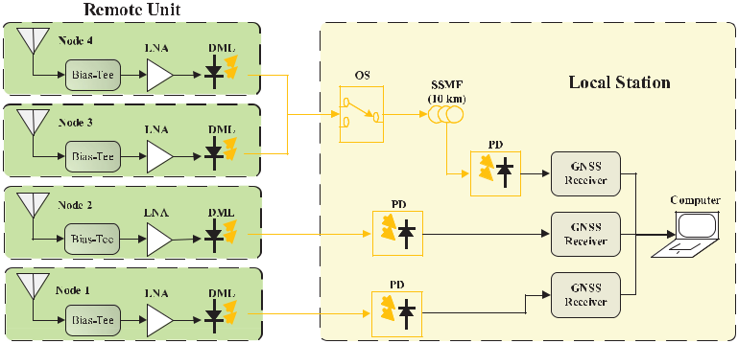

Fig. 2. Block diagram of a multi-antenna baseline network system based on a single GNSS-over-fiber architecture. LNA: low noise amplifier. DML: directly modulated laser. OS: optical switch. SSMF: standard single-mode fiber.

Bias-T is used to power the LNA (40 dB) built into the GNSS antennas, and an additional LNA is used to ensure that the receivers effectively receive the GNSS signals after the long-distance microwave photonic link transmission.

It is also worth noting that the SSMF is used to indicate a long-distance transmission in an actual system, either in the node-to-station segment or the suggested backbone network at the local station as Fig. 2. In a measurement campaign, the long SSMF can be placed both before and after the OS, which should be planned according to the specific condition. Furthermore, in the cases that the among-nodes distance is short, e.g., less than a few meters, Radio Frequency (RF) cables and switches are fine. However, in a typical small scale measurement, e.g., large buildings and bridges, and a large scale measurement like a city, the distances among nodes reach from hundreds of meters up to 10 km. It is the case when the proposed multi-baseline GNSS-over-fiber network can be used to combat the high loss of RF cables and the high cost of measuring receivers.

In the proposed experimental system, the two types of LNAs offer a total amplification of 60 dB, among which the first LNA (40 dB) built into the antenna plays a crucial role in controlling the overall Noise Figure (NF) of the system. The second LNA (20 dB) before the DML is used for compensating the signal loss during the electric-to-optic conversion, over-fiber transmission, and the optic-to-electric conversion. In a traditional short-reach configuration, the second LNA can be saved when the antenna is directly connected to the GNSS receivers with RF cables. In practice, the signal conditioning circuit should be carefully designed according to the specific scenario.

In the remote unit, the GNSS signals are converted into the optical domain by the modulation of DML before transmission, and the modulated optical signals pass through the optical switch (switch time is less than 8 ms, loss of each channel is about 0.8 dB). The optical switch is used to switch the channels according to the signal timing set beforehand so that multiple synchronous observation loops with fewer GNSS receivers of the measurement campaign can be carried out cost-effectively and as fast as possible.

In the local station, the optical signals are converted back into the GNSS signals by the PDs in the OTIM first; the GNSS signals are then sent to the receivers to demodulate the navigation message and carrier phase observation information. Finally, the measurement data of the demodulated GNSS signals are processed and analyzed in the computer. In the experiment, the OTIM is made at the Center for Information Photonics and Communications of Southwest Jiaotong University, which integrates four DMLs and PDs (photodetectors).

**4. Experiment Results**

The outdoor experiment is carried out at the 9th teaching building of Xipu campus in the South-west Jiaotong University, where the four measurement nodes are mounted on the building roof.

Vol. 12, No. 3, June 2020 5501210

IEEE Photonics Journal Multi-Antenna GNSS-Over-Fiber Architecture

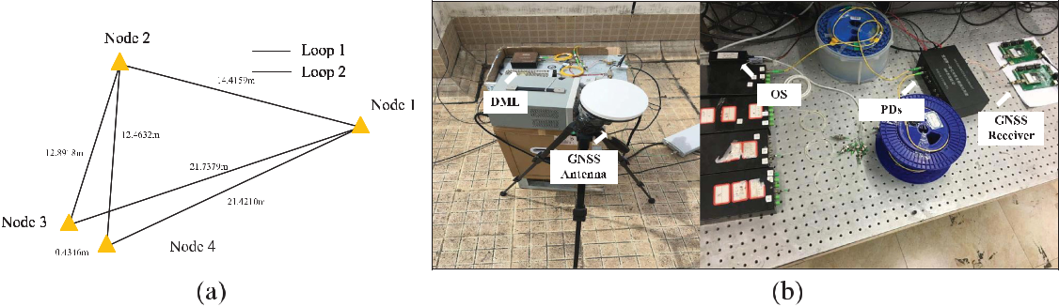

Fig. 3. (a) Schematic diagram of the antenna nodes, among which the baseline lengths are measured by the network adjustment processing and annotated; (b) Remote antennas distributed on the building roof and the indoor local station.

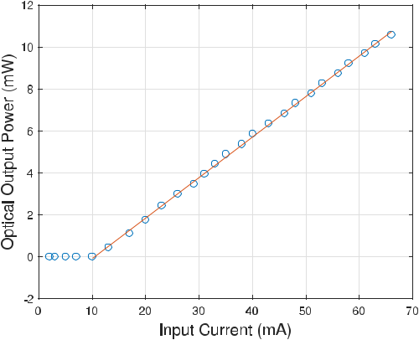

Fig. 4. Relationship between the input current and optical power of DML.

The GNSS signals are sent back to the indoor local station over a 10-km fiber. Fig. 3 demonstrates the remote antennas distributed on the building roof and the inddor prototype, respectively.

In the experiment, the logging rate of all receivers was set to be 1 Hz. Meanwhile, the satellite cut-off angle of each receiver is set to be 15 degrees for better performance. In the following, the observation time of node-1 and node-2 lasts 60 minutes. The observation time of the two different simultaneous observation loops lasts 30 minutes, which are established by the optical switch that is used to switch between node-3 to node-4.

GNSS signals reside in the L-band (1 to 2 GHz range); thus, they are chosen to be modulated by the optical signal through a DML in the experiment. Fig. 4 shows the measurement relationship between input current and optical output power. As can be seen, the threshold current of the DML is approximately 10 mA. When the input current ranges from 20 to 40 mA, the DML has good relative linearity and electro-optical conversion efficiency. Because the DML has limited current protection measures, the input current and optical output power do not change as the reverse voltage changes. Thus, the saturated zone does not exist in Fig. 4.

During the experiment, to obtain a good electro-optical conversion efficiency and control the output optical power of DML to be about from 2 to 5 mW before entering PD, the corresponding input current of DML is from 24 to 40 mA. The relationship between the response and frequency at different input currents is shown in Figs. 5(a). As can be seen, the DML has a relatively flat response to microwave signals at different input currents in the 1 to 2 GHz range according to the 3 dB standard. Besides, the GNSS signals are located at specific frequencies, with approximately a

Vol. 12, No. 3, June 2020 5501210

IEEE Photonics Journal Multi-Antenna GNSS-Over-Fiber Architecture

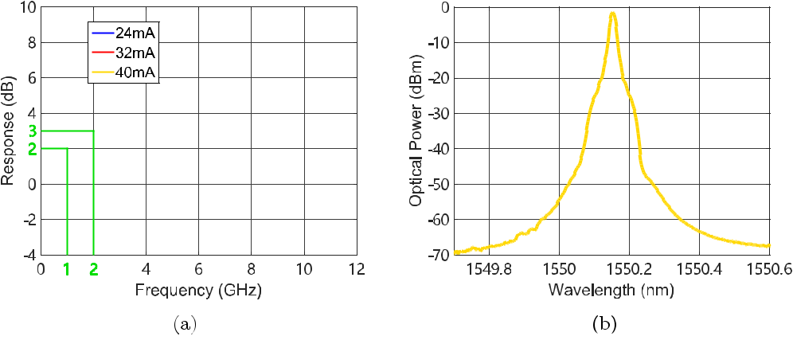

Fig. 5. (a) Relationship between the response and frequency of DML at different input currents; (b) The optical spectrum of the modulated GNSS signals.

maximum of 20 MHz of the frequency band. Thus the modulation performance for GNSS signals is relatively good. Although for experienced readers who are familiar with the low-power-level feature of GNSS signals (well below the thermal noise), it is well understood that the spectrum of GNSS signals is not visible, Figs. 5(a) and (b) are presented to show the suitability of the over-fiber transmission of GNSS signals from the perspective of frequency and power response.

It is well understood that the DML is mainly defined by its threshold current (*It h* ), saturation current (*Isat* ), and differential quantum efficiency (*SL* ). The *Isi g* (*t* ) and *Ibi as* denote the signal and bias current, respectively, which modulate the optical signal of the laser. The output optical power in the linear zone is written as,

|  |  |
| --- | --- |
| *Pout* (*t* )= *SL* (*Ibi as* + *Isi g* (*t* )− *It h* )*.* | (5) |

After the signal is recovered from the PD, the output signal current is written as,

|  |  |
| --- | --- |
| *Io* (*t* )≈ *RP D ηPout* (*t* )= *RP D ηSL* (*Ibi as* + *Isi g* (*t* )− *It h* )*,* | (6) |

where *RP D* and *η* are the responsivity of the reference PD and the link loss, respectively. The response of the DML is defined as the response of the output signal *Io* (*t* ) to the input signal *Isi g* (*t* ). A vector network analyzer tests the overall response as a two-port network. The *S*21 parameter versus frequency gives the desired results in Figs. 5(a) at different bias currents. The reference PD used in the test is a standard instrument level PD (Agilent 11982). The parameters of the DML used in the experiment can be obtained from the power-current (PI) curve Fig. 4.

In the local station, the standard Receiver Independent Exchange Format (RINEX) files that include observation data and navigation messages are obtained from the GNSS receivers. The GNSS carrier phase measurement of node-3 and node-4 in order with the aid of the optical switch and a single GNSS receiver is shown in Fig. 6. The GPS satellites (G14 and G31) are captured and tracked by the receiver before some time (less than 5 s) when the GNSS signals are switched. Once the GNSS receiver baseband locks the satellites and outputs valid distance measurements, the carrier-phase-based double-difference calculation solves the second baseline. The interrupt time is mainly determined by the reacquisition capability of the GNSS receivers, and the geolocation of the two antennas switched. The CHCNAV HGO software is applied to process the observation and ephemeris data for analyzing the measurement accuracy of each baseline before and after the network adjustment. The error bars of the positioning results from each baseline vector in different loops are shown in Fig. 7, which includes the mean and variance of every baseline vector. The mean value of each baseline is reduced by 100 times in the figures, which helps a comparison with

Vol. 12, No. 3, June 2020 5501210

IEEE Photonics Journal Multi-Antenna GNSS-Over-Fiber Architecture

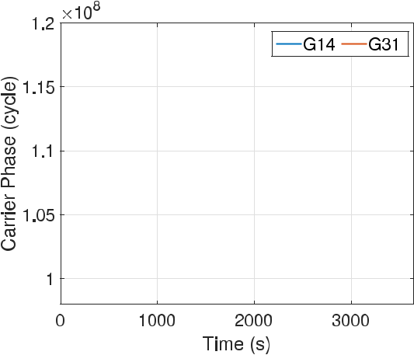

Fig. 6. The variation in the carrier phase measurement when using the optical switch.

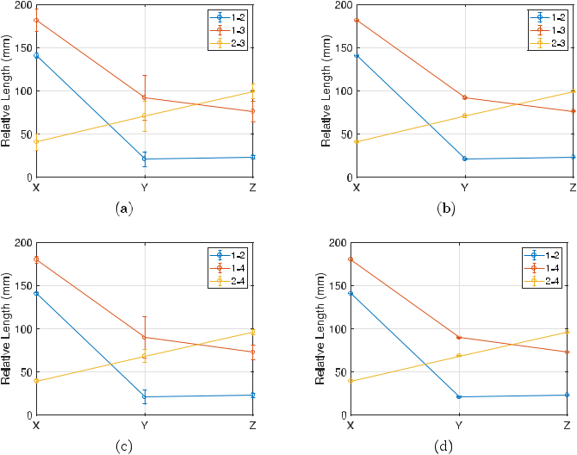

Fig. 7. Error-bar plot of each baseline: (a) and (c) are the error-bar plot before the proposed network adjustment of loop-1 and loop-2 respectively; (b) and (d) are the error-bar plot after the proposed network adjustment of loop-1 and loop-2 respectively.

its variance directly. As can be seen, the variance of the results after the network adjustment has been reduced significantly.

Meanwhile, the three-dimensional coordinate standard deviation of every single baseline is presented for a better demonstration of the network adjustment. The results of every baseline vector in loop-1 and loop-2 before network adjustment are shown in Table 1. The bold-faced numbers in the table indicate a notable improvement in the variation of the standard deviation of the three-dimensional coordinate after the network adjustment processing. As can be seen from Table 1, compared with the results of a single baseline without network adjustment, the standard deviation of the three-dimensional coordinate of multiple baselines is improved from a level of several millimeters to a lower level of sub-millimeter. It is demonstrated that a single GNSS receiver can receive multiple remote GNSS signals to establish multiple simultaneous observation loops in the proposed system, and the positioning accuracy of every baseline is significantly improved after network adjustment processing.

Vol. 12, No. 3, June 2020 5501210

IEEE Photonics Journal Multi-Antenna GNSS-Over-Fiber Architecture

TABLE 1

The Standard Deviation (STD) of Each Baseline Before and After the Network Adjustment

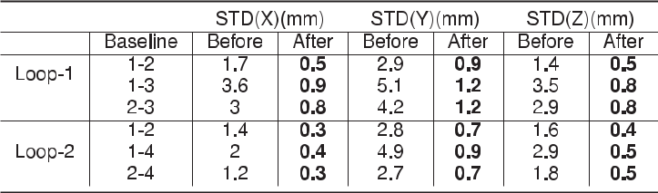

The accuracy of the Y direction is worse than the X and Z directions both before and after the network adjustment. It is because GNSS has better horizontal than vertical observations. Most of the components of the vertical direction are projected to the Y direction. It is easily understood from the transformation between East-North-Up (ENU) and ECEF coordinates [25], *X* = − sin(*λ*) *E* − sin(*φ* ) cos(*λ*) *N* + cos(*φ* ) cos(*λ*) *U* , *Y* = cos(*λ*) *E* − sin(*φ* ) sin(*λ*) *N* + cos(*φ* ) sin(*λ*) *U* , where *λ, φ* are the longitude and latitude of the reference position, respectively. The location of theexperiment is at *λ* = 103*.*992084◦ , *φ* = 30*.*773973◦ ; thus, the projection coefficients from the UP component to X and Y components are −0.2077 and 0.8337, respectively.

**5. Conclusion**

The multi-antenna remote baseline network system was based on the single baseline GNSS-over-fiber system in this paper, which combined the microwave photonics with GNSS network positioning technology. Unlike existing works that pursue the SD processing for enhanced accuracy, the proposed scheme extends the GNSS-over-fiber architecture from single to multiple baselines, enhancing the surveying accuracy even with the simplified DD processing. Furthermore, the multi-ple remote GNSS signals could be received by a single GNSS receiver so that more synchronous and asynchronous observation loops could be established fast by a smaller number of receivers in a cost-effective way. After the baseline network adjustment, the three-dimensional coordinate positioning accuracy has a significant improvement. This architecture will find critical applications for the large-scale establishment of the GNSS baseline networks, such as some civil engineering and natural environment measurement scenarios.

**References**

1. F. Xie and Q. W. Li, “Highway slope monitoring system based multi-antenna GPS network,” *Adv. Mater. Res.*, vol. 261-263, pp. 1151–1155, May 2011.
2. C. Xiong, H. Lu, and J. Zhu, “Operational modal analysis of bridge structures with data from GNSS/accelerometer measurements,” *Sensors*, vol. 17, no. 3, p. 436, Feb. 2017.
3. R. Xi, W. Jiang, X. Meng, H. Chen, and Q. Chen, “Bridge monitoring using BDS-RTK and GPS-RTK techniques,” *Measurement*, vol. 120, pp. 128–139, May 2018.
4. Y. Wang, H. Liu, J. Chen, and L. Wu, “Joint data processing of multi-period GNSS network observation in CGCS2000,” *J. Geomatics*, vol. 42, no. 4, pp. 65–68, 2017.
5. E. Small, C. Roesler, and K. Larson, “Vegetation response to the 2012–2014 California drought from GPS and optical measurements,” *Remote Sens.*, vol. 10, no. 4, p. 630, Apr. 2018.
6. C. Shi, J. Liu, and Y. Yao, “The systematical error analysis of high precision GPS network adjustment,” *Geomatics Inf.* *Sci. Wuhan University*, vol. 27, no. 2, pp. 148–152, 2002.
7. C. J. Xu, L. X. Dong, C. Shi, Y. X. Li, and X. K. Hu, “A study on annual accumulation of strain energy density significance by using GPS measurements in North China,” *Chinese J. Geophys.-Chinese Ed.*, vol. 45, no. 4, pp. 497–506, Jul. 2002.
8. S. Kaelber, R. Jaeger, and R. Schwaeble, “A GPS-based online control and alarm system,” *GPS Solut.*, vol. 3, no. 3, pp. 19–25, Jan. 2000.
9. J. Li, J. Liu, J. Xiao, and H. Wang, “Data processing and stability analysis of continuouly operating reference stations base-network,” *Geomatics Inf. Sci. Wuhan University*, vol. 35, no. 7, pp. 825–829, 2010.
10. I. Ferrando, B. Federici, and D. Sguerso, “2D PWV monitoring of a wide and orographically complex area with a low dense GNSS network,” *Earth Planets Space*, vol. 70, Apr. 2018.
11. Z. Li and J. Huang, *GPS Surveying and Data Processing*. Wuhan: Wuhan Univ. Press, 2005.

Vol. 12, No. 3, June 2020 5501210

IEEE Photonics Journal Multi-Antenna GNSS-Over-Fiber Architecture

1. X. Zou, B. Lu, W. Pan, L. Yan, A. Stöhr, and J. Yao, “Photonics for microwave measurements,” *Laser Photon. Rev.*, vol. 10, no. 5, pp. 711–734, Sep. 2016.
2. X. Zou *et al.*, “A multifunctional photonic integrated circuit for diverse microwave signal generation, transmission, and processing,” *Laser Photon. Rev.*, vol. 13, no. 6, p. 1800240, Jun. 2019.
3. Y. Zhao, C. Huang, A.-Y. Qing, and X. Luo, “A frequency and pattern reconfigurable antenna array based on liquid crystal technology,” *IEEE Photon. J.*, vol. 9, no. 3, Jun. 2017, Art, no. 4600307.
4. J. M. B. Oliveira, L. M. Pessoa, H. M. Salgado, G. Proudley, D. Charlton, and H. White, “Experimental evaluation of a differential GPS-over-fiber system for aircraft attitude determination,” in *Proc. IEEE Avionics, Fiber-Opt. Photon.* *Technol. Conf. (AVFOP)*. San Diego, CA, USA: IEEE, Oct. 2013, pp. 75–76.
5. L. M. Pessoa, J. M. B. Oliveira, D. Coelho, J. C. S. Castro, H. M. Salgado, and M. Fames, “Transmission of differential GPS signals over fiber for aircraft attitude determination,” in *Proc. IEEE Avionics, Fiber-Opt. Photon. Digest CD*, Cocoa Beach, FL, USA: IEEE, Sep. 2012, pp. 80–81.
6. D. Macias-Valadez, R. Santerre, S. Larochelle, and R. Landry, “Improving vertical GPS precision with a GPS-over-fiber architecture and real-time relative delay calibration,” *GPS Solutions*, vol. 16, no. 4, pp. 449–462, Oct. 2012.
7. X. Jiang, X. Wang, and S. Pan, “A multi-antenna GNSS-over-fiber system with high vertical precision,” in *Proc. Int.* *Topical Meeting Microw. Photon.*, Toulouse: IEEE, Oct. 2018, pp. 1–4.
8. X. Jiang, X. Wang, A. Zhao, J. Yao, and S. Pan, “A multi-antenna GNSS-over-fiber system for high accuracy three-dimensional baseline measurement,” *J. Lightw. Technol.*, vol. 37, no. 17, pp. 4201–4209, Sep. 2019.
9. X. Wang, X. Jiang, S. Li, and S. Pan, “Multi-antenna GPS-over-fiber system for attitude determination using phase-derived range measurement,” vol. 11, no. 4, p. 5501610, Aug. 2019.
10. Y. Li, X. Zou, B. Luo, W. Pan, L. Yan, and P. Liu, “A 2q-order difference-set approach to eliminate phase ambiguity of a single-frequency signal,” *IEEE Signal Process. Lett.*, vol. 26, no. 10, pp. 1526–1530, 2019.
11. Y. Li *et al.*, “Extended long-short ambiguity resolution in multi-antenna GNSS-over-fiber systems for enhanced attitude determination,” *Opt. Express*, vol. 27, no. 24, p. 34721, Nov. 2019.
12. Y. Li, X. Zou, P. Liu, B. Luo, W. Pan, and L. Yan, “Four-element array for GNSS attitude determination using IRLS: An

improved rounding of long-short baseline approach,” *IEEE Trans. Veh. Technol.*, doi:[10.1109/TVT.2020.2978862](https://dx.doi.org/10.1109/TVT.2020.2978862), early access, 2020.

1. E. D. Kaplan and C. Hegarty, *Understanding GPS: Principles and Applications*, 2nd ed. Norwood, MA, USA: Artech House, 2006.
2. G. Xie, *Principles of GPS and Receiver Design*. Beijing: Publishing house of electronics industry, 2009.
3. P. J. G. Teunissen, C. C. J. M. Tiberius, and P. J. de Jonge, “The least-squares ambiguity decorrelation adjustment: Its performance on short GPS baselines and short observation spans,” *J. Geodesy*, vol. 71, no. 10, pp. 589–602, Sep. 1997.
4. P. J. G. Teunissen, “The least-squares ambiguity decorrelation adjustment: A method for fast GPS integer ambiguity estimation,” *J. Geodesy*, vol. 70, no. 1/2, pp. 65–82, Nov. 1995.
5. Ministry of Railways of the People’s Republic of China, “Code for engineering survey of high speed railway,” China Railway Publishing Co., Ltd., Beijing, Standards TB 10601-2009, 2010.
6. G. H. Golub and C. F. Van Loan, *Matrix Computations*, 4th ed., ser. Johns Hopkins studies in the mathematical sciences. Baltimore, MD, USA: The Johns Hopkins Univ. Press, 2013.

Vol. 12, No. 3, June 2020 5501210