Received March 26, 2020, accepted April 10, 2020, date of publication April 22, 2020, date of current version May 7, 2020.

*Digital Object Identifier 10.1109/ACCESS.2020.2989443*

Spatiotemporal Data Fusion in Graph Convolutional Networks for Traffic Prediction

BAOXIN ZHAO1,2, (Student Member, IEEE), XITONG GAO2, (Member, IEEE), JIANQI LIU3, (Member, IEEE), JUANJUAN ZHAO2,



AND CHENGZHONG XU4, (Fellow, IEEE)

* Shenzhen College of Advanced Technology, University of Chinese Academy of Sciences, Shenzhen 518055, China

2Shenzhen Institutes of Advanced Technology, Chinese Academy of Sciences, Shenzhen 518055, China 3School of Automation, Guangdong University of Technology, Guangzhou 510006, China

4State Key Laboratory of IoTSC, Faculty of Science and Technology, University of Macau, Macao, China

Corresponding author: Xitong Gao (xt.gao@siat.ac.cn)

This work was supported in part by the National Key Research and Development Program of China under Grant 2019YFB2102100, in part by the National Natural Science Foundation of China under Grant 61701122, Grant 61806192, and Grant 61802387, in part by the Science and Technology Development Fund of Macao (FDCT) under Grant 0015/2019/AKP, in part by the Shenzhen Engineering Research Center for Beidou Positioning Service Improvement Technology under Grant XMHT20190101035, in part by the Shenzhen Discipline Construction Project for Urban Computing and Data Intelligence, in part by the Basic Research Program of Shenzhen under

Grant JCYJ20180302145731531 and Grant JCYJ20190812160003719, and in part by the Research Center for Ecology and Environment of Central Asia, Chinese Academy of Sciences.

 **ABSTRACT** A plethora of information is now readily available for traf c prediction, making an effectiveuse of them enables better traf c planning. With data coming from multiple sources, and their features spanning spatial and temporal dimensions, there is an increasing demand to exploit them for accurate traf c prediction. Existing methods, however, do not provide a solution for this, as they tend to require expertise feature engineering. In this paper, we propose a general architecture for **S**patio**T**emporal **D**ata **F**usion (STDF) with parameter ef ciency. To make heterogeneous multi-source data fusion effectiveness, we separate all data into traf c directly related data and traf c indirectly related data. With traf c indirectly related data as the input to **S**patial **E**mbedding by **T**emporal convoluti**ON** (SETON) that simultaneously encodes each feature in both space and time dimensions and traf c directly related data as the input to the graph convolutional network(GCN), we designed a ne-grained feature transformer to match the ones generated by GCN. This is then followed by a fusion module to combine all features to make nal prediction. Compared to using GCNs training with only traf c directly related data, experimental results show that our model can achieve a 6.1% improvement in prediction accuracy measured by Root Mean Squared Error.



 **INDEX TERMS** Data fusion, graph convolutional networks, multi-source data, traf c prediction.



**I. INTRODUCTION**

The traf c is playing a vital role of human life and sig-ni cantly in uenced every aspect of life. With the rapid increase of vehicles, the traf c jam has attracted a national concern for urban management. Smart city is considered as a potential solution, which uses intelligent technologies to predict the traf c ow, and smooth the peaks and valleys by offering residents travel guidance [1]. Traf c prediction is of great importance for smart cities and has attracted

The associate editor coordinating the review of this manuscript and approving it for publication was Keli Xiao .



attention from research to industry for many years. Accurate real-time road traf c prediction is critical for the realization of intelligent cities [2], [3]. Traf c authorities require reliable prediction to facilitate the related process of policy-making, regulatory, and implementation. With the development of sensors, the traf c data is collected by sensors equipped within vehicles or installed along the roads. Examples of traf c data include license number of vehicles, GPS data of vehicles, video or image records of surveillance devices, temperature, wind speed and level of sunlight data of weather sensors [4]. These multi-source data converge to the data center by vehicle ad hoc networks (VANET), or the upcoming

|  |  |  |  |
| --- | --- | --- | --- |
| 76632 | This work is licensed under a Creative Commons Attribution 4.0 License. For more information, see https://creativecommons.org/licenses/by/4.0/ | VOLUME 8, 2020 |  |
|  |  |

B. Zhao *et al.*: STDF in GCNs for Traffic Prediction

5G cellular network [5]. Many traf c prediction algorithms have proposed to guide convenient travel for citizens based on these mass traf c data, and there have been some works showing the advantages of multi-source data fusion in the spatio-temporal data prediction tasks [6].

Unlike traditional data fusion methods, multi-source traf c data includes not only traf c directly related data, *e.g.*, vehi-cle speed, vehicle density, traf c ow, but also indirectly related data, *e.g.*, weather, points of interests (PoIs), *etc.*. All these data span both spatial and temporal dimensions [4],

1. As shown in Figure 1, our goal is to predict traf c condition at each road segment. The residence areas in the morning tend to have many people going out for fun or work, while in the evening many people go home, or to a place of entertainment. These information therefore must be incorpo-rated in the model for accurate traf c prediction. However, merging all these data straightforwardly could not explore the semantics changing of traf c indirectly related data over time. To tackle this, in this paper we propose a **S**patio**T**emporal **D**ata **F**usion (STDF) framework, which is a general architec-ture to improve traf c prediction performance in metro-city scales by using data fusion.

Traf c prediction using data fusion needs to consider both spatial and temporal features from multi-source data. It is notable that the distribution of urban traf c exhibit high variability both in spatial and temporal domain. Traf c pre-diction in urban cities is challenging because of their complex environment. It is thus essential to nd an ef cient and effec-tive way to make traf c prediction more accurate by using them jointly. There have been many works on data fusion. According to the model parameters size, the work in traf c prediction by data fusion can be classi ed into two categories, *i.e.*, traditional machine learning method and deep neural net-works. Many effective methods have been proposed, such as XGBOOST [8], random forest [9], LightGBM [10], embed-ding learning [11]. Although these methods can nd the relationship between traf c prediction and traf c indirectly related data, they require signi cant human effort because the features extracted from multi-source data play a vital role in the prediction accuracy. Meanwhile, it is computa-tion consuming if we apply these methods into large scale data fusion for urban cities. To overcome it, an end-to-end learning method is thus a desirable alternative at the cost of computation power. For example, some works use deep neural networks [12] [14] to automate the processing of multi-source data fusion and extraction of useful features. They merge multi-source data straightforwardly into a vector and treat traf c directly related and indirectly related data equally. As a result, they ignore the semantics changing of traf c indirectly related data. In this paper, we explore an effective and ef cient way to fuse multi-domain data con-sidering both the spatial and temporal properties based on the GCN.

Multi-source data fusion with the consideration of its spa-tial and temporal properties is challenging for the follow-ing reasons. The rst challenge is the large scale feature

VOLUME 8, 2020

representation. It is infeasible to encode each node at dif-ferent time into a uni ed vector in metro-city scales. For example, the parameter size is over 10G for a Small city containing 10,000 road segment and 100 external factors for each node on average if each factor is represented by a 10-tuple vector at one time interval, which will easily result in an over-parameterized model and over- tting when training. Second, an automated but ef cient facility is urgently needed to nd the spatio-temporal representation for all multi-source data. Third, fusing traf c indirectly related data into traf c prediction may cause negative effect on prediction accuracy. Besides, there are practical concern when applied into the real traf c prediction in metro city scales.

To tackle the aforementioned challenges, we proposed a general STDF framework. STDF adopts branching-transfer-fuse strategy. STDF rst separates the prediction model into two branches with each branch processing traf c directly related data and traf c indirectly related data cor-respondingly. The traf c directly realted data is processed by GCN to get the spatio-temporal representation from the middle layer of GCN. While the traf c indirectly related data is process by two parts successively. The rst part is called static **S**patial **E**mbedding by **T**emporal convoluti**ON** (SETON). SETON rst encodes each feature in both space and time dimensions simultaneously, followed by an con-volutional operation with spatial embeddings as input and temporal embeddings as convolutional kernel to get the spatio-temporal representation. Meanwhile, all nodes share the same spatial and temporal embeddings, which are tranin-able in the model as well as to avoid the overparameterized problem. The second part is a feature transform module which is to map the spatio-temporal representation generated by SETON to the feature map space generated by GCN. At last, the feature map generated by GCN and feature transform module are fused together followed by several full connec-tion output layers. In summary, this paper has the following contributions.

Generic Architectures for Deep Spatio-temporal Data Fusion - The STDF framework is a general neu-ral network architectures, which can ef ciently fuse multi-source data both in spatial domain and temporal domain in large scales.

Deep Spatio-temporal Data Fusion Operator- We designed a new type of deep spatio-temporal data fusion operator *i.e.*SETON. The operator has the ability to capture both the spatial representation and temporal rep-resentation simultaneously.

Computation Ef ciency and Practical - Both the compo-nents in the STDF framework have the parameter shar-ing strategy to avoid model over-parameterized, which is applicable in the complex urban computing with high computation ef ciency.

Performance Improvement in Spatiotemporal Data Pre-diction - We apply our method into real traf c speed prediction and human ow prediction in metro. Experi-mental results demonstrate that our spatiotemporal data

76633

B. Zhao *et al.*: STDF in GCNs for Traffic Prediction

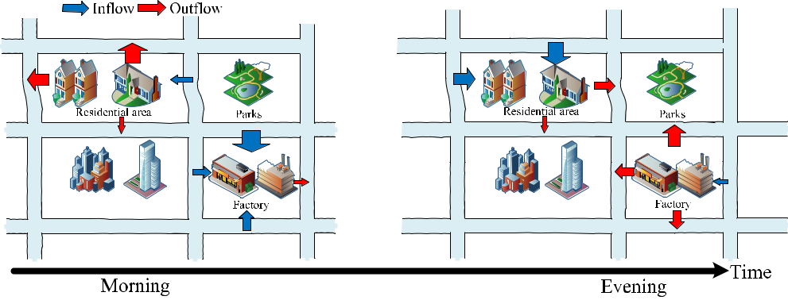

**FIGURE 1.** Semantics changing over time. Multi-source data fusion will benefit the traffic prediction accuracy.

At the same time, the representation of different factors is changing over time. Traffic prediction using data fusion needs to consider both the spatial and temporal representation simultaneously.

fusion method performs signi cantly better than the one without data fusion or only spatial data fusion.

The rest of this paper is organized as follows. Section II gives a brief literature review of related work from traf c prediction and data fusion perspective. Section III formulates the traf c prediction problem and an overview of the architecture of solution. Section IV details the process of spatiotemporal rep-resentation with parameter ef ciency. With the extracted fea-tures, a feature transformer module and data fusion method are introduced at Section V. We conduct comprehensive experiments in section VI and give a discussion of our model. Section VII offers the conclusion of our work and outlines our future work.

**II. RELATED WORK**

In this section, we review the recent studies that are relevant to traf c prediction and data fusion. We rst introduce the traf c prediction methods from mathematical model perspective. Then data fusion methods are detailed both in feature level and semantic level.

**A. TRAFFIC PREDICTION**

There are many achievements made in traf c predic-tion, including traf c ow, vehicle speed, vehicle den-sity, etc. Traf c prediction can be models as a time series data prediction. The statistical modes including history average (HA), Autoregressive Integrated Moving Average (ARIMA) [15], Seasonal Autoregressive Integrated Mov-ing Average (SARIMA) [16] and spatiotemporal correla-tions [17] are widely used in real traf c condition prediction for its computation ef ciency. However, all these methods require the input data to meet a certain condition, which consequently perform poorly in the complex urban traf c prediction.

To make traf c prediction model have the ability to deal with complex data, there are continuous applying trying machine learning methods into the urban traf c prediction, such as XGBOOST [8], random forest [9], LightGBM [10], embedding learning [11]. Although these methods have the

76634

inherent advantage to deal with multi-source data, they need a lot of domain knowledge and careful feature engineering, which is not only computation consuming but also has some scalability issues.

Because of the strong self-adapting and self-learning abil-ity of arti cial neural network, deep learning has been used in different domains, such as computer vision [18], natural lan-guage processing and auto driving, and brings many signi - cant breakthroughs. At the same time, a great deal of studies have been done on improving traf c prediction performance by using different types of neural network architectures, such as multi-layers perception [19], long short-term memory [20] and auto encoders [21]. Although these works can effectively extract the local patterns of data, they can only be applied for the standard structure data and are lack of awareness of the global prediction. With the ability of processing data of graph structures, the graph convolutional networks are widely used to deal with complex graph data in a global perspective. Yu proposed a Spatio-Temporal Graph Convo-lutional Networks (STGCN) with the ability to capture com-prehensive spatial and temporal dependencies for long-term traf c prediction [22]. Guo applies attention strategy into GCN to predict traf c ow with considering the dynamic spatial-temporal correlations of traf c data [23]. Li proposed a diffusion convolutional recurrent neural network (DCRNN) to model the traf c ow as a diffusion process [24]. Dif-ferent from our work, these models did not deal with the multi-source data problem.

**B. DATA FUSION**

Data fusion [25] in traf c scenario often implies the com-bination of traf c related data sets that present an enor-mous diversity on the basis of location, weather, points of interests, traf c ow, density and speed. These data sets are differently represented in different perspective, but they represent the same real world object and complement each other. A straightforward method [26], [27] in the feature level is that all the object-related features are extracted equally and all features are concatenated sequentially into a equal-sized

VOLUME 8, 2020

B. Zhao *et al.*: STDF in GCNs for Traffic Prediction

or unequal-sized vector to be injected into the kernel task. The low-level representation might exist redundancies and the sampled data may be not independent, it is easy to lead to model instability.

Feature engineering is an especially good idea that makes machine learning algorithms work. Lakhinaet analyzed the distributions of packet features in ow traces in details, which showed signi cant advantages for anomalies detection [28]. Samant and Adeli extracted traf c incident related features by using wavelet transform and linear discriminant analy-sis [29]. The two-stage feature extraction algorithm made the traf c incidents detection model more robust. Although a good feature engineering can get better performance, it needs a deep understanding of domain knowledge. Besides, it is time consuming and computation consuming for large scale data fusion. An end-to-end learning technology with better exibility provides a consistent alternative for the ability of auto feature extraction.

Deep neural networks (DNN) is an excellent solution for end-to-end learning when geta uni ed feature representa-tion from disparate data sets. An end-to-end structure of ST-ResNet [12] was proposed to predict citywide crowd ows, where the input with unique properties of spatiotem-poral data is feed into ST-ResNet simultaneously. Bojarski trained a convolutional neural network (CNN) to map raw pixels from three cameras directly to steering commands [30]. The system automatically learns internal representations of the necessary processing steps such as detecting useful road features. With the ability to self-learn feature representation, these end-to-end based data fusion methods need lots of com-putation cost. At the same time, the feature representations are extracted in a grid scale, but not in the road segments level. Different from them, we are more interested in the graph structure data.

Feature based data fusion approaches take all the feature equally and ignore the semantic meaning of each feature. On the contrary, semantics based data fusion methods try to understand the meaning of each feature and nd the rela-tionships between features by mining the insight of each data. For example, many works tried to nd the relationship between emotion and audio signals in the emotion recogni-tion [31] [33]. The fusion results combining the acoustic and facial emotion recognition were achieved in the semantic level. DeepFM [34] is an end-to-end deep learning framework for click-through rate prediction, where data representation is realized by feature embedding. DeepFM fuses the feature by a factorization-machine with a deep neural network. However, all these feature representation are static and only related to its input data correspondingly. In this paper, we will tackle the spatiotemporal data fusion problem in traf c prediction scenarios because the spatial features in semantics level are dynamically changing with time.

**III. PRELIMINARIES**

*De nition 1: (Spatial Network): The traf c network G is a weighted directed graph G* D(*V* ; *E*; *A*)*, where set* j*V* j D *N*

VOLUME 8, 2020

*is a set of nodes that can represent road segments or metro stations, N is the number of nodes, and E denotes the set of edges, A* 2R*N N is the weighted adjacent matrix of network G.*

*De nition 2: (Multi-Source Data): The multi-source data includes two types of data, traf c directly related data and traf c indirectly related data. The traf c directly related data means the graph signal matrix XGt* 2R*N C , where C is the number of traf c condition of interests (e.g., traf c speed, traf c ow, traf c density, etc.). The traf c indirectly related data represents external factors that can in uence traf c con-dition indirectly, which is denoted by FG* 2R*N M , where M is the number of elds including categorical elds (e.g., res-idential area, hi-tech zones, entertainment place, rain, etc.) and continuous elds (e.g., PoI density, PoI number).*

**A. PROBLEM STUDIED**

The problem of traf c prediction by data fusion can be

described as: given the observations at *N* nodes of historical *P* time stepsXD(*XGt P*C1; *XGt P*C2; ; *XGt*)2R*P N C* and the external factors *FG* collected from other domain,

we aim to learn a mapping function *f* which can map the input data into the future observation of traf c condition

* D (*XGt*C1; *XGt*C2; ; *XGt*C*Q*), i.e., *Y* D *f* (X; *FG*), where *Q* denotes the length of the target of traf c condition to predict.

Figure 2 illustrates the architecture of STDF framework to solve the problem. As the studies about GCN have gotten state-of-the-art performance in spatio-temporal data predic-tion and there have been many completed GCN architectures widely used in time series data prediction, we select one type of GCN [22] to demonstrate the framework of STDF.

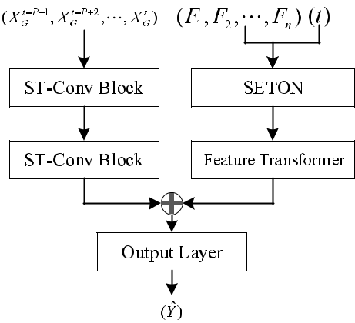

**FIGURE 2.** STDF architecture. The SETON operator aims to getting thelow-level spatio-temporal features from the input including spatial features and temporal factors. The feature transformer component is to map the low-level features to a high level feature that has the same size with the high-level features generated by GCN. The ST-Conv Block is the basic block for GCN.

**B. GRAPH CONVOLUTIONAL NETWORK**

Graph convolutional network (GCN) is a neural network that operates on graphs, which is able to extract local fea-tures with different reception elds from translation variant

76635

B. Zhao *et al.*: STDF in GCNs for Traffic Prediction

non-Euclidean structure [35]. As depicted in [22], GCN is designed to solve the time-series prediction problem, i.e., pre-dicting the future traf c measurements under given input with a xed temporal length, which is written as

b*Y* D *GCN* (*XGt P*C1; *XGt P*C2; ; *XGt*):

The feature map *FMg* generated by the second ST-Conv Block in GCN as demonstrated in Figure 2 is denoted by

*FMg* D *fg*(*XGt P*C1; *SGt P*C2; ; *SGt*).

However, there are many external factors that have in u-ence on traf c pattern. For each node *v*, the external factors are written as a vector *Fv*. Spatio-temporal data fusion is not a simple data integration process. STDF is designed to nd an ef cient and effective data fusion strategy that is one kind of practical methods for large scale traf c data prediction in real world. STDF consists of three parts: SETON and Feature Matching. The SETON is to nd a computation ef cient spatio-temporal representation for external traf c related variables. Feature transformer maps spatio-temporal representation to a feature space that has the same feature shape with the feature map *FMg* for each node. Then a fusion module is followed to combine the two features into one tensor. We introduce the three parts in details as follows.

**IV. SETON**

The STEON consists of three components: spatial feature embedding layer, temporal feature embedding layer and embedding vector fusion layer. The spatial feature embedding layer maps the external factors to a xed sized embedding vector. The vector length *k* is determined in advance. Sim-ilarly, the temporal feature embedding layer maps the time interval to a 3-D tensor, with the length of the rst and second dimension equal to *k* and the length of the third dimension equal to the number of time slots, and embedding vector fusion layer is to get the spatio-temporal embedding vectors using the output of the aforementioned two components as input, which is the spatio-temporal representation of traf-c indirect related data in low level. At the same time, all vectors in SETON can be self-learned without any feature engineering.

**A. SPATIAL FEATURE EMBEDDING**

Because the traf c network is complex and the environment around each node is different from each other, the size of external data related to traf c prediction is too large if we give each factor a spatiotemporal representation in neural net-works, which may cause over-parameterized and over tting when training. To overcome the over-parameterized problem, we proposed a data sharing strategy for all nodes.

We rst classify the indirect traf c data into an m- elds data according to the way how the PoI will in uence people travel pattern. They may include categorical elds (e.g., residential area, hi-tech zones, entertainment place) and continuous elds (e.g., PoI density, PoI number). Different categorical elds may contains different size of data denoted by an one hot encoding. The continuous elds are represented

76636

**FIGURE 3.** SETON architecture. The STEON consists of spatial featureembedding layer, temporal feature embedding layer and spatiotemporal feature product layer. SETON is designed to get the feature representation of indirect traffic data both in spatial and temporal dimension simultaneously with parameter efficiency.

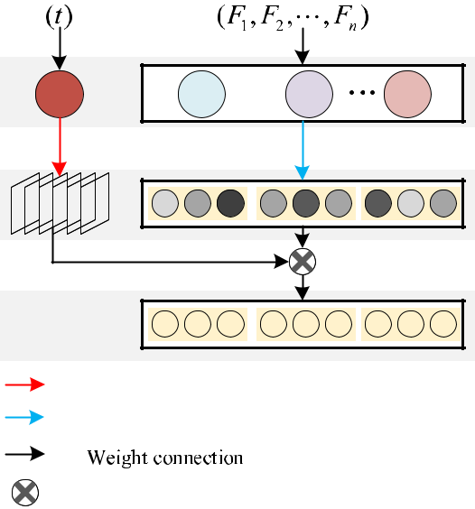

by the value itself. The instance for node *v* is written as

*Fv* D f*f eld*1; *f eld*2; ; *f eldm* g, where *f eldj* stands for the *j*-th eld of *Fv*. Then the instance for all node *V* is *F* Df*F*1; *F*2; ; *Fn*g. The task for spatial feature embedding is to nd a parameter ef cient method to allocate each value in *F* to a equal sized embedding vector. The length of embedding vector is a prede ned as *k*.

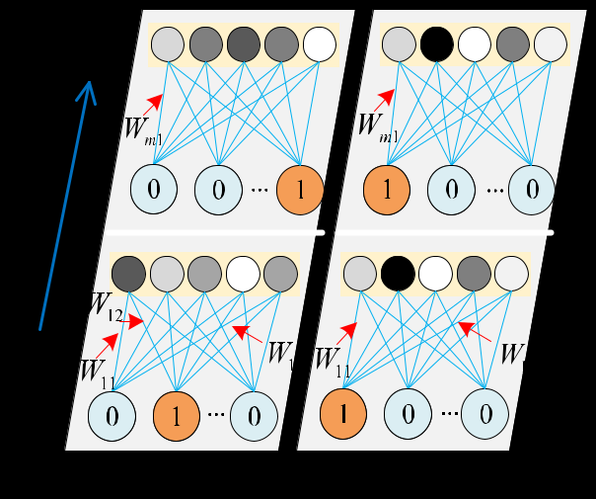

**FIGURE 4.** Spatial feature embedding. All nodes share a same latentfeature vectors **W** . The tensor **W** serves as network weights which are trainable and acts as a role in mapping the input data to fixed sized embedding vectors, which makes our model salable when appled into large urban computing.

Figure 4 highlights the detail of spatial feature embedding from the input layer *F* to the embedding layer for all nodes,

VOLUME 8, 2020

B. Zhao *et al.*: STDF in GCNs for Traffic Prediction

where the length of embedding vector is set to 5. The left part stands for the embedding process for node 1 and the right part stands for the same process for node *n*. All nodes share a same latent feature vectors *W* . By the way, there is no need of pre-training for the latent feature vectors *W* . The tensor *W* serves as network weights, which can be learned by the network itself. Besides, the tensor *W* acts as a role in mapping the input data to xed sized embedding vectors, which denoted asV

*ai* D[*ei*;1; *ei*;2; ; *ei*;*m*];

where *ei*;*j* stands for the embedding vector of *j*-th eld for node *i* and *m* is the number of elds. More speci cally, the embedding output for each node is a *k m* tensor. The parameter that needs to be learned is of a size of *M k*, where *M* is equal to P*mj*D1 j*f* *eldj* j. The parameter size has no relationship with the node number, which is the foundation for large scale data fusion in urban cities.

**B. TEMPORAL FEATURE EMBEDDING**

In the application of traf c prediction, time factor plays an important role in understanding people travel patterns [7]. For example, people would like to go out in the morning and get back home in the evening. So the embedding vector for residential area is different at different time. Meanwhile, the spatial semantics changing is also needed for other kinds of categories. Because the characteristics of traf c data has a property of cyclical, we divide the time in one day into

* time intervals. As we all know, urban traf c has different patterns and people travel patterns also differs from each other at different time. So each time interval has a distinct transmission matrix in our model, which is used to transfer the spatial embedding vector to a corresponding vector.

We use a tensor W to represent the temporal embeddings for all time intervals. At the same time, W serves as network weights which can be learned by the network itself. To make the temporal embeddings matching with the spatial embed-dings, the tensor W is of a 3-D shape *T k k*.

Taking *k* D 5 as an example, we highlight the tempo-ral feature embedding process from the input layer to the embedding layer as shown in Figure 5. For the time factor *t*, we encode it to a one hot vector after discretization, where the vector length is equal to *T* . Similarly, the latent feature vectors W for temporal embedding process serves as network weights which can be learned by the network itself. After the embedding process, we get the temporal embedding matrix *t* corresponding to the time interval *t*.

*t* D *f* (W; *t*) D W[*t*; V; V];

where *f* is a look up function to get its corresponding vector. And the output matrix *t* has a shape of *k k*, which stands for how the spatial meaning of each categories changes over its corresponding time *t*. The size of parameters W has relationship only with time intervals and embedding size but not determined by node number *n*, which bene ts large scale data fusion in urban cities. Therefore, the spatial embeddings

VOLUME 8, 2020

**FIGURE 5.** Temporal feature embedding. The temporal embeddingsserves as network weights with a size of **T k k**. Each time interval **t** has its own temporal embedding.

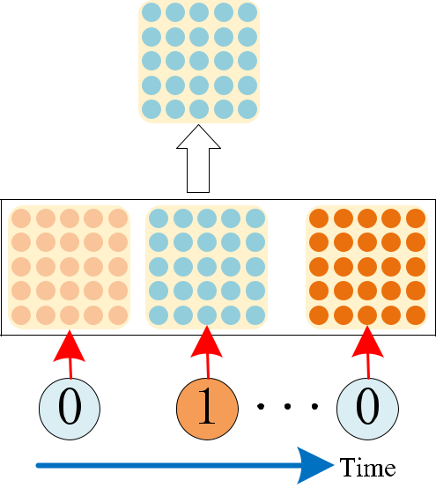

and temporal embeddings make our model scalable without the in uence from graph size.

1. **SPATIO-TEMPORAL FEATURE REPRESENTATION IN LOW LEVEL**

To get both the spatial and temporal feature representation, we apply temporal embedding matrix *t* to every eld of spa-tial embedding vector for all nodes. For a node *i* at time *t*, its spatiotemporal feature embedding vectors is calculated byV

|  |  |  |
| --- | --- | --- |
| *ait* D[ *t ei*;1; | *t ei*;2;; *t* *ei*;*m*] |  |
| D [*eit*;1; *eit*;2; | ; *eit*;*m*]; | (1) |

where means the convolutional operator.

In summary, the number of parameters learned by the network itself is only *M k* C *T k k*. And the output spatiotemporal feature embedding vectors *A*0*t* after SETON operation is of a shape of *n k m*. As similar to the concept in convolutional neural network for computer vision task, this feature representation is in low level.

**V. FEATURE TRANSFORMER AND DATA FUSION**

This section introduces a feature transformer method that is to get the representation in high level and match the feature map *FMg* calculated by GCN.

1. **EXTRACT SPATIOTEMPORAL REPRESENTATION IN HIGH LEVEL**

As illustrated in Figure 2, the feature transformer component is a bridge between SETON and the feature map *FMg*, which achieves shape alignment between the two layers. The feature transformer part stacks *q* convolutional layers. Each con-volutional layer contains a 1-D convolutional kernel which enables all nodes in graph *G* share the same convolutional

76637

B. Zhao *et al.*: STDF in GCNs for Traffic Prediction

kernel, recti ed linear units and batch normalization except the last layer containing only convolutional operation.

*Alt* D *bn*(*relu*(*conv*(*Alt* 1; *kl* )));

where *kl* is a 1-D vector that can be learned by network itself,

* 2 f1; 2; ; *q*g stands for the layer number. All nodes share the same convolutional kernel *kl* at layer *l*, which not only makes parameters ef cient but also avoid over tting when training. What’s more, the padding operation, incidentally, depends on whether up-sampling is necessary. For example, the feature map *FMg* 2 R*n kg* *cg* with *cg* channels generated by GCN is regarded as a representation for the objective traf c data in high level. If *k* < *kg*, up-sampling is neces-sary and experimental results tell us will cause performance degradation sharply. So it is better to keep the value of *kg* is less than *k*. After the node-wised convolutional operation, the output feature map *Aqt* is denoted by *FMst* , which has the same size with *FMg*.
  1. **FEATURE MAP FUSION**

There are many feature map fusion methods widely used in neural networks. But in the large urban cities computing, we prefer to directly merge the feature map *FMst* generated by STDF with that of GCN as shown in Figure 2, which is denoted by *FM* followed by recti ed linear units and batch normalization and written asV

*FM* D *FMg* C *FMst* :

This type of feature map fusion method has two bene ts used in large scale data fusion. The rst is to reduce the compu-tation overload when add more data into traf c prediction. Besides it would not bring more parameters into our model, thus it can avoid over tting problem.

To get the predicted value, several full connected layers are stacked to map the feature map to the object value.

**C. LOSS FUNCTION**

In the training process, the goal is to minimize the gap between the real traf c condition*Y* and the predicted valueb*Y*. Different from other tasks, traf c prediction has data incom-plete and data bias problem. In statistics, the Huber loss is a loss function used in robust regression, that is less sensitive to outliers in data than the squared error loss. To minimize the in uence of traf c outliers, we select Huber loss as the loss function.

|  |  |  |  |  |  |  |  |  |
| --- | --- | --- | --- | --- | --- | --- | --- | --- |
| *L*(*Y*;*Y*) | 8 | 2 | (*Y* | | *Y* )2 | *for* j*Y Y* j | (2) |  |
|  |  | 1 |  |  |  |  |  |  |
|  | D < | |  | *Y* | *Y* | *otherwise*: |  |  |
| b | : | j | |  | bj | b |  |  |
|  |  |  | b |  |  |  |

where is a threshold parameter which controls the range of squared error loss.

**VI. EXPERIMENTS**

In this section, we present the experiment and comparison results. We rst present the experiment settings with base-line algorithms and datasets introduced, then demonstrate the

76638

overall performance of STDF with its components analysis. Finally we detail the training process, testing performance and hyperparameters selection.

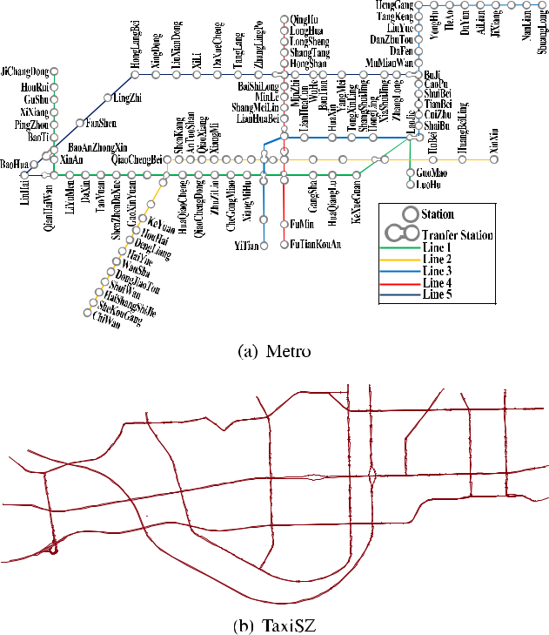

**FIGURE 6.** Physical map in Shenzhen: (a) metro station; (b) road network.

* 1. **EXPERIMENT SETUPS**

1. DATESETS

*Metro:* The dataset used in this study is the smart cardtransaction records and train operation logs in Shenzhen, China. The metro system has 5 metro lines by 2015 as shown in Figure 6(a). The whole data collected from around 4 million smart cards have more than 300 million smart card transaction records, covering 184 consecutive days from January 1, 2015 to July 30, 2015. We use 144 days of data to train the network and 20 days for cross validation and 20 days for testing. The standard time interval is set to 30-minutes. The prediction task for Metro is to forecast the passenger number at each metro station.

*TaxiSZ:* We collect the data from City Traf c Bureauof Shenzhen (China) for as long as one year from January 1, 2015 to December 31, 2015. There are about 15,000 taxis equipped with high-resolution GPS devices reporting 32,205,000 records per day on average. There are 341 days of valid data, where 281 days of data is used for training, 30 days for cross validation and 30 days for testing. The standard time interval is set to 15 minutes. We use this data to predict the traf c speed at every road segment as shown in Figure 6(b).

VOLUME 8, 2020

B. Zhao *et al.*: STDF in GCNs for Traffic Prediction

**TABLE 1.** Statistics on datasets.

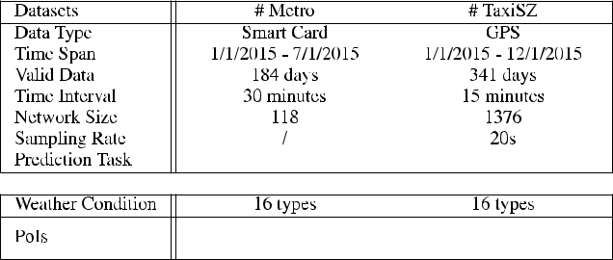

*Traf c indirectly related data:* We collect the traf cindirectly related data at Shenzhen. It includes weather conditions and PoIs. The weather conditions consist of 16 types, such as sunny, rainy, etc. The PoIs has 659,494 records. Each record includes name, longi-tude, latitude, primary category, secondary category and address. The primary category has 20 types, such as incorporated business, real estate, nancial area, educa-tion zone, etc. Each primary category includes different number of secondary category. For example, there are three secondary categories for real estate and twelve sec-ondary categories for education zone. There are 135 sec-ondary categories all together.

1. BASELINES

For evaluation, we use the Root Mean Squared Error (RMSE) and Mean Absolute Errors (MAE). We compare our model with the following baselinesV

*HA:* We predict traf c condition by the average value ofhistory value in the corresponding periods, e.g., 6:00am-6:15am on Monday, its corresponding time spans are all historical time intervals from 6:00am to 6:15am on all historical Monday.

*ARIMA:* Auto-Regressive Integrated Average is tted totime series data either to better understand the data or to predict future points in the series [15]

*SARIMA:* The SARIMA is an extension of ARIMA thatexplicitly supports univariate time series data with a seasonal component [36].

*GCN:* We use STGCN [22] as an example. The channels

of three layers in STGCN are 64, 32, 128 respectively. To evaluate each component of our model, we also com-

pare it the difference of fusion layers.

*GCN-SDF-logits:* GCN-SDF-logits only considers datafusion in spatial domain and the fusion layer is located at the logits layer.

*GCN-SDF-FM:* GCN-SDF-FM only considers datafusion in spatial domain and the fusion operation is located at the middle layer as depicted in Section III-B.

*GCN-STDF-logits:* GCN-STDF-logits considers datafusion both in spatial domain and temporal domain. But the fusion layer is located at the logits layer.

*GCN-STDF-FM:* GCN-STDF-FM considers datafusion both in spatial domain and temporal domain.

The fusion layer is located at the middle layer as depicted in Section III-B.

All above methods are evaluated and compared using datasets: Metro and TaxiSZ. All GCN-based networks are trained using ne-tuned hyper-parameters. We use ve-fold cross validation for calculating its average performance. All networks have been trained using 50 epochs under the same settings with TensorFlow implementations. We use Adam optimizer [37] to train all networks. For each node, the traf-c indirectly related data contains all the features within one-kilometer radius.

**TABLE 2.** Overall performance.

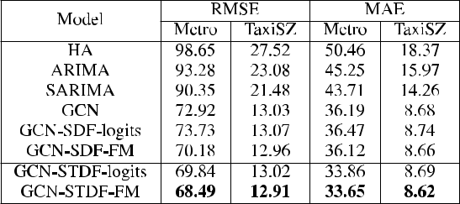

**B. OVERALL COMPARISONS**

Table 2 demonstrates the results of STDF and the base-lines on the datasets Metro and TaxiSZ. ARIMA gets the worst results because of its low capacity in handling spatio-temporal data prediction. GCN get a better perfor-mance than ARIMA. However, GCN-SDF-logits gets a worse results compared with GCN only. Although data fusion is believed to be more effective than the one without data fusion, we can see that data fusion by putting more data into one model may bring negative effects on the model performance. GCN-SDF-FM and GCN-SDF-logits, which only consider the spatial property but ignore the temporal dependency, have much higher RMSE. We call this phenomenon as nega-tive fusion. GCN-SDF-FM and GCN-STDF-FM get a better performance than GCN-SDF-logits and GCN-STDF-logits, which suggests it is better to locate the fusion layer at the middle layer but not at the logits layer. Our proposed model GCN-STDF-FM consistently achieves the best performance on the datasets Metro and TaxiSZ, which shows the effective-ness of using spatial property and temporal property simulta-neously. The intuition is that STDF gives the model the ability to capture the dynamic traf c demands and relationships between the node and its surroundings.

**C. TRAINING EFFICIENCY AND GENERALIZATION**

In order to further investigate the overload caused by adding more data when predicting, we calculate the parameters size and training time consumption (second per epoch) as shown in Table 3. For TaxiSZ dataset, the GCN only model has 1,090,824 parameters and consumes 21.950s seconds per epoch on the training process. Meanwhile, our model only consume 64,640 more parameters, i.e., it cause only 5.59%

|  |  |
| --- | --- |
| VOLUME 8, 2020 | 76639 |

B. Zhao *et al.*: STDF in GCNs for Traffic Prediction

**TABLE 3.** Training efficiency.

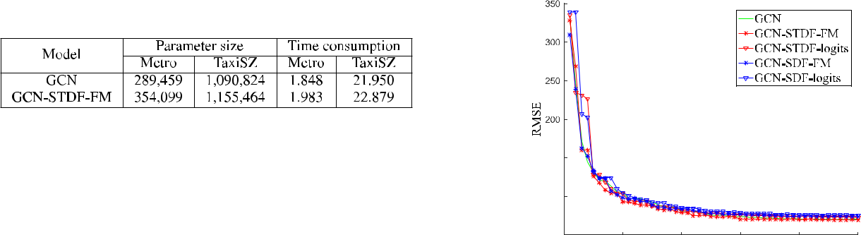

of parameters increasing. And the training time of our model only cause 0.909 seconds longer than GCN per epoch, which is practical for the real traf c prediction. Similar observations have been also obtained for Metro dataset. GCN has been improved with 6.1% lower testing error by using the method STDF.

**D. CASE STUDIES**

To understand the performance of STDF, we conduct the following case studies.

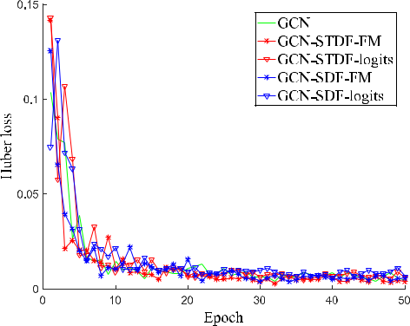

**FIGURE 7.** Training process.

1) FITTING CAPACITY

Figure 7 demonstrates the comparison of training process of GCN, GCN-STDF-FM, GCN-STDF-logits, GCN-SDF-FM and GCN-SDF-logits. We randomly select one of ve-fold cross validation to show the training process. Each network is trained for 50 epoches. The X axis stands for the epoch number. and the Y axis is the loss value. Taking the metro data as an example, we can see that GCN-STDF-FM achieves the lowest training loss and GCN-SDF-logits with the highest training loss. Similar phenomenon can be seen at the test-ing performance demonstrated at Figure 8 corresponding to Figure 7. It can be clearly observed that STDF provides GCN both (1) enhanced capacity to t training data as well as (2) the generalizability to adapt testing samples.

2) LEARNING RATE

Con guring the learning rate is challenging and time-consuming. We use ve-fold cross validation for search-ing the best con gurations of the learning rate for each experiment by grid search. We set the learning rate to be 0.00001, 0.0001, 0.001, 0.01, 0.1. As observed from Figure 9, the test RMSE reaches to the best performance 68.49 when the learning rate is set to 0.001. The learning rate is xed to 0.001 in all experiments for STDF.

76640

**FIGURE 8.** Testing performance.

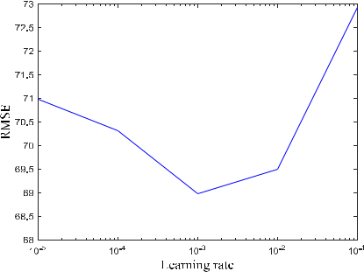

**FIGURE 9.** Learning rate curve.

**VII. CONCLUSION**

In this paper, we propose a novel framework STDF for traf-c prediction to handle multi-source data fusion. A split-transform-merge strategy is used in STDF. We rst separate multi-source data into directly related data and indirectly related data, which are input to GCN and SETON, corre-spondingly. The feature transformer module is designed to extract spatiotemporal representation for traf c indirectly related data. We get the spatiotemporal representation for traf c directly related data from the middle layer of GCN. This is then followed by a fusion module to combine all features to make nal prediction. By using a data sharing strategy, our model is scalable and the overload caused by fusing traf c indirectly related data is acceptable in the real traf c prediction. Experimental results show that our model achieves the best performance compared with other state-of-the-art methods on two real world datasets. In summary, STDF can successfully capture the spatial features changing over time from multi-domain data, which not only can be used into traf c prediction, but also can be applied into other spatiotemporal data prediction. In the future, we will predict the traf c congestion diffusion via representation learning, where the representation vectors are extracted from the fusion layer of STDF. A traf c congestion control policy will be made according to the traf c congestion diffusion model.

**REFERENCES**

1. A. M. Nagy and V. Simon, ‘‘Survey on traf c prediction in smart cities,’’ *Pervas. Mobile Comput.*, vol. 50, pp. 148 163, Oct. 2018.

VOLUME 8, 2020

B. Zhao *et al.*: STDF in GCNs for Traffic Prediction

1. L. Zhu, F. R. Yu, Y. Wang, B. Ning, and T. Tang, ‘‘Big data analytics in intelligent transportation systems: A survey,’’ *IEEE Trans. Intell. Transp.* *Syst.*, vol. 20, no. 1, pp. 383 398, Jan. 2019.
2. J. Zhang, F.-Y. Wang, K. Wang, W.-H. Lin, X. Xu, and C. Chen, ‘‘Data-driven intelligent transportation systems: A survey,’’ *IEEE Trans. Intell.* *Transp. Syst.*, vol. 12, no. 4, pp. 1624 1639, Dec. 2011.
3. B. Zhao, C. Xu, and S. Liu, ‘‘A data-driven congestion diffusion model for characterizing traf c in metrocity scales,’’ in *Proc. IEEE Int. Conf. Big* *Data (Big Data)*, Dec. 2017, pp. 1243 1252.
4. J. Liu, J. Wan, D. Jia, B. Zeng, D. Li, C.-H. Hsu, and H. Chen, ‘‘High-ef ciency urban traf c management in context-aware computing and 5G communication,’’ *IEEE Commun. Mag.*, vol. 55, no. 1, pp. 34 40, Jan. 2017.
5. Y. Zheng, ‘‘Methodologies for cross-domain data fusion: An overview,’’ *IEEE Trans. Big Data*, vol. 1, no. 1, pp. 16 34, Mar. 2015.
6. J. Zhao, Q. Qu, F. Zhang, C. Xu, and S. Liu, ‘‘Spatio-temporal analysis of passenger travel patterns in massive smart card data,’’ *IEEE Trans. Intell.* *Transp. Syst.*, vol. 18, no. 11, pp. 3135 3146, Nov. 2017.
7. T. Chen and C. Guestrin, ‘‘XGBoost: A scalable tree boosting system,’’ in *Proc. 22nd ACM SIGKDD Int. Conf. Knowl. Discovery Data Mining* *(KDD)*, 2016, pp. 785 794.
8. A. Liaw and M. Wiener, ‘‘Classi cation and regression by randomforest,’’ *R News*, vol. 2, no. 3, pp. 18 22, 2002.
9. G. Ke, Q. Meng, T. Finley, T. Wang, W. Chen, W. Ma, Q. Ye, and T.-Y. Liu, ‘‘Lightgbm: A highly ef cient gradient boosting decision tree,’’ in *Proc.* *Adv. Neural Inf. Process. Syst.*, 2017, pp. 3146 3154.
10. T. G. Dietterich, ‘‘Ensemble learning,’’ *The Handbook of Brain Theory* *Neural and Network*, vol. 2. 2002, pp. 110 125.
11. J. Zhang, Y. Zheng, and D. Qi, ‘‘Deep spatio-temporal residual networks for citywide crowd ows prediction,’’ in *Proc. 31st AAAI Conf. Artif.* *Intell.*, 2017.
12. Z. Pan, Y. Liang, W. Wang, Y. Yu, Y. Zheng, and J. Zhang, ‘‘Urban traf c prediction from spatio-temporal data using deep meta learning,’’ in *Proc.* *25th ACM SIGKDD Int. Conf. Knowl. Discovery Data Mining (KDD)*,2019.
13. H. Yao, F. Wu, J. Ke, X. Tang, Y. Jia, S. Lu, P. Gong, J. Ye, and Z. Li, ‘‘Deep multi-view spatial-temporal network for taxi demand prediction,’’ in *Proc. 32nd AAAI Conf. Artif. Intell.*, 2018.
14. B.-S. Chen, S.-C. Peng, and K.-C. Wang, ‘‘Traf c modeling, prediction, and congestion control for high-speed networks: A fuzzy AR approach,’’ *IEEE Trans. Fuzzy Syst.*, vol. 8, no. 5, pp. 491 508, 2000.
15. B. M. Williams and L. A. Hoel, ‘‘Modeling and forecasting vehicular traf c ow as a seasonal ARIMA process: Theoretical basis and empirical results,’’ *J. Transp. Eng.*, vol. 129, no. 6, pp. 664 672, Nov. 2003.
16. W. Min and L. Wynter, ‘‘Real-time road traf c prediction with spatio-temporal correlations,’’ *Transp. Res. C, Emerg. Technol.*, vol. 19, no. 4, pp. 606 616, Aug. 2011.
17. X. Gao, Y. Zhao, . Dudziak, R. Mullins, and C.-z. Xu, ‘‘Dynamic channel pruning: Feature boosting and suppression,’’ 2018, *arXiv:1810.05331*. [Online]. Available: http://arxiv.org/abs/1810.05331
18. M. Aqib, R. Mehmood, A. Alzahrani, I. Katib, A. Albeshri, and S. M. Altowaijri, ‘‘Smarter traf c prediction using big data, in-memory computing, deep learning and GPUs,’’ *Sensors*, vol. 19, no. 9, p. 2206, 2019.
19. X. Ma, Z. Tao, Y. Wang, H. Yu, and Y. Wang, ‘‘Long short-term memory neural network for traf c speed prediction using remote microwave sensor data,’’ *Transp. Res. C, Emerg. Technol.*, vol. 54, pp. 187 197, May 2015.

VOLUME 8, 2020

1. Y. Lv, Y. Duan, W. Kang, Z. Li, and F.-Y. Wang, ‘‘Traf c ow prediction with big data: A deep learning approach,’’ *IEEE Trans. Intell. Transp. Syst.*, vol. 16, no. 2, pp. 865 873, 2014.
2. B. Yu, H. Yin, and Z. Zhu, ‘‘Spatio-temporal graph convolutional net-works: A deep learning framework for traf c forecasting,’’ in *Proc.* *27th Int. Joint Conf. Artif. Intell.*, Jul. 2018, pp. 3634 3640, doi:[10.24963/ijcai.2018/505.](http://dx.doi.org/10.24963/ijcai.2018/505)
3. S. Guo, Y. Lin, N. Feng, C. Song, and H. Wan, ‘‘Attention based spatial-temporal graph convolutional networks for traf c ow forecasting,’’ *Proc. AAAI Conf. Artif. Intell.*, vol. 33, Jul. 2019, pp. 922 929.
4. Y. Li, R. Yu, C. Shahabi, and Y. Liu, ‘‘Diffusion convolutional recurrent neural network: Data-driven traf c forecasting,’’ 2017, *arXiv:1707.01926*. [Online]. Available: http://arxiv.org/abs/1707.01926
5. J. Bleiholder and F. Naumann, ‘‘Data fusion,’’ *ACM Comput. Surveys*, vol. 41, no. 1, p. 1, 2009.
6. Z. Wang, D. Zhang, X. Zhou, D. Yang, Z. Yu, and Z. Yu, ‘‘Discover-ing and pro ling overlapping communities in location-based social net-works,’’ *IEEE Trans. Syst., Man, Cybern. Syst.*, vol. 44, no. 4, pp. 499 509, Apr. 2014.
7. D. Yang, D. Zhang, Z. Yu, and Z. Yu, ‘‘Fine-grained preference-aware location search leveraging crowdsourced digital footprints from LBSNs,’’ in *Proc. ACM Int. joint Conf. Pervas. ubiquitous Comput. (UbiComp)*, 2013, pp. 479 488.
8. A. Lakhina, M. Crovella, and C. Diot, ‘‘Mining anomalies using traf c feature distributions,’’ *ACM SIGCOMM Comput. Commun. Rev.*, vol. 35, no. 4, pp. 217 228, Oct. 2005.
9. A. Samant and H. Adeli, ‘‘Feature extraction for traf c incident detection using wavelet transform and linear discriminant analysis,’’ *Comput.-Aided Civil Infrastruct. Eng.*, vol. 15, no. 4, pp. 241 250,Jul. 2000.
10. M. Bojarski, D. Del Testa, D. Dworakowski, B. Firner, B. Flepp,

P. Goyal, L. D. Jackel, M. Monfort, U. Müller, J. Zhang, X. Zhang, J. Zhao, and K. Zieba, ‘‘End to end learning for self-driving cars,’’ 2016, *arXiv:1604.07316*. [Online]. Available: http://arxiv.org/abs/1604.07316

1. D. Datcu and L. J. Rothkrantz, ‘‘Semantic audio-visual data fusion for auto-matic emotion recognition,’’ in *Emotion Recognition: A Pattern Analysis* *Approach*. 2014, pp. 411 435.
2. E. Bozkurt, E. Erzin, C. C. E. Erdem, and A. T. Erdem, ‘‘Improving automatic emotion recognition from speech signals,’’ in *Proc. 10th Annu.* *Conf. Int. Speech Commun. Assoc.*, 2009.
3. C. M. Lee, S. S. Narayanan, and R. Pieraccini, ‘‘Combining acoustic and language information for emotion recognition,’’ in *Proc. 7th Int. Conf.* *Spoken Lang. Process.*, 2002.
4. H. Guo, R. Tang, Y. Ye, Z. Li, and X. He, ‘‘DeepFM: A factorization-machine based neural network for CTR prediction,’’ in *Proc. 26th Int. Joint* *Conf. Artif. Intell.*, Aug. 2017, pp. 1 8, doi:[10.24963/ijcai.2017/239.](http://dx.doi.org/10.24963/ijcai.2017/239)
5. D. K. Hammond, P. Vandergheynst, and R. Gribonval, ‘‘Wavelets on graphs via spectral graph theory,’’ *Appl. Comput. Harmon. Anal.*, vol. 30, no. 2,
   1. 129 150, Mar. 2011.
6. T.-M. Choi, Y. Yu, and K.-F. Au, ‘‘A hybrid SARIMA wavelet trans-form method for sales forecasting,’’ *Decis. Support Syst.*, vol. 51, no. 1,
   1. 130 140, Apr. 2011.
7. D. P. Kingma and J. Ba, ‘‘Adam: A method for stochastic opti-

mization,’’ 2014, *arXiv:1412.6980*. [Online]. Available: http://arxiv. org/abs/1412.6980



76641