This article has been accepted for publication in a future issue of this journal, but has not been fully edited. Content may change prior to final publication. Citation information: DOI

10.1109/ACCESS.2020.2995649, IEEE Access

Date of publication xxxx 00, 0000, date of current version xxxx 00, 0000.

Digital Object Identifier xx.xxxx/ACCESS.2020.DOI

**Wireless Powered Mobile Edge Computing for Industrial Internet of Things Systems**



**HAO WU 1,2, (Student Member, IEEE), HUI TIAN 1, (Senior Member, IEEE), GAOFENG NIE 1, (Member, IEEE), and PENGTAO ZHAO 1, (Student Member, IEEE).**



* State Key Laboratory of Networking and Switching Technology, Beijing University of Posts and Telecommunications, Beijing 100876, China

2 Center for Complex Network Research, Northeastern University, Boston, MA 02115, USA

Corresponding author: Hui Tian (e-mail: [tianhui@bupt.edu.cn)](mailto:tianhui@bupt.edu.cn).

This work was supported in part by the National Natural Science Foundation of China under Grant No. 61801046, and in part by the Beijing University of Posts and Telecommunications (BUPT) Excellent Ph.D. Students Foundation under Grant CX2019108.

 **ABSTRACT** The convergence of wireless power transfer (WPT) and mobile edge computing (MEC) hasfostered the rise of wireless powered MEC, which is taken as a crucial technology for the sustainability of the Industrial Internet of Things (IIoT) systems. This article provides an overview of wireless powered MEC enabled IIoT systems, including use cases, network requirements, system architecture, and resource management. First, we highlight four key requirements to drive operational efficiency from the perspective of being transformed IIoT projects. Then an integration architecture of wireless powered MEC for IIoT is proposed. Designed with joint consideration of energy, communication, and computing resources, the architecture is enabled by an efficient system schedule mechanism to achieve age-aware data update, green and sustainable energy supply, as well as hierarchical and resilient computation. Finally, a case study is provided to verify the feasibility of the proposed architecture and demonstrate the efficiency of the proposed resource management approach.

 **INDEX TERMS** Wireless power transfer, mobile edge computing, Industrial Internet of Things, networkarchitecture, resource management.

**I. INTRODUCTION**

HE Industrial Internet of Things (IIoT) consists of a Tmultitude of industrial devices connected by commu-nication technologies that enable advanced data analytics to drive an unprecedented level of efficiency, productivity, and performance [1]–[3]. It allows companies to predict failures, increase automation, and manufacture more quickly. These applications, however, are often data- and computation- in-tensive and will fast deplete the constrained computing ca-pability and energy of wireless IIoT devices. The current wireless network architectures and conventional cloud-based systems are far from being satisfactory to meet the demands of these emerging applications in terms of data collection, delivery, and analysis. To support new requirements and unleash the potential of IIoT, new business models are be-ing created with both focuses on mobile edge computing (MEC) [4]–[7] and wireless power transfer (WPT) [8]–[10] technologies.

MEC, first proposed in 2014 by European Telecommu-nications Standards Institute (ETSI) [11], is considered a good supplementary of the current centralized cloud by geographically distributing computation resources at close proximity to end devices. Given the proximity, MEC expects to relieve network congestion, speed up response, achieve high energy efficiency, and preserve context-awareness in 5G and beyond [4]–[7]. To embrace heterogeneous access technologies and reflect non-cellular network requirements, in 2017, ETSI officially changed the name of MEC to multi-access edge computing. In this article, the acronym MEC is used interchangeably to stand for mobile edge computing and multi-access edge computing, since their main idea, advances in performance, realization, and benefits in terms of computing are the same. Over the past few years, MEC has attracted massive attention from tech giants such as Huawei, Ericsson, and AT&T, and has been standardized as a key technology in future IIoT by Industrial Internet Consortium

|  |  |
| --- | --- |
| VOLUME 4, 2016 | 1 |

This work is licensed under a Creative Commons Attribution 4.0 License. For more information, see https://creativecommons.org/licenses/by/4.0/.

This article has been accepted for publication in a future issue of this journal, but has not been fully edited. Content may change prior to final publication. Citation information: DOI 10.1109/ACCESS.2020.2995649, IEEE Access



H. Wu et al.: Wireless Powered Mobile Edge Computing for Industrial Internet of Things Systems

(IIC) [12]. In general, there are two operation modes in MEC, i.e., partial and binary computation offloading [8],

1. Partial offloading requires a computation task to be divided into two parts with one executed locally and the other offloaded to MEC for computing. Binary offloading, on the other hand, only allows a task to be executed either locally or remotely. In practice, partial offloading is favorable for production visibility that composes of multiple parallel segments, while binary offloading is suitable for simpler tasks like environmental monitoring. In terms of computa-tion efficiency maximization, partial computation offloading would perform better than the binary [14]. Although MEC is not a new concept and has been extensively studied, its application to the IIoT scenario is quite a new direction owing to IIoT’s device heterogeneity, time-varying environment, and scalability requirement.

Aiming at raising automation level and reducing manufac-turing costs, IIoT is expected to support a massive number of small-size and low-cost devices to operate in a self-sufficient manner for a long time. The conventional wire-based power supply and battery-changing method would be cost-prohibitive and inconvenience, which boosts the re-search of energy harvesting (EH) technologies. Generally, there are two types of EH technologies: passive EH and active EH. Passive EH focus on harvesting conventional renewable energy resources, such as solar and wind, which are unpredictable and intermittent. Active EH, also known as WPT, on the contrary, leverages dedicated power beacon to provide stable and controllable wireless power supply for devices [15], [16], making it a promising solution to cope with the insufficient battery capacity problem facing IIoT.

Recently, commercial WPT transmitter is able to transfer tens of microwatts power to more than ten meters, which is sufficient to power most activities of IIoT devices [8]. Compared with passive EH, WPT is also superior in large-scale applications due to its small form factor, predictable and stable nature, as well as low cost [9]. However, wireless energy transmission consumes spectrum resources and needs to be jointly designed with the decisions of data delivery and computation. How to support WPT functionality in IIoT without much modification of current system architecture also raise questions in system management and resilience.

The integration of MEC and WPT has fostered a new paradigm called wireless powered MEC [13], [17]–[20], where MEC server and WPT entity are embedded into one edge node to provide self-sustainable computing. Apart from those challenges facing separate MEC/WPT scenar-ios, including limited bandwidth, intermittent connectivity, doubly near-far problem, and energy causality, scheduling in wireless powered MEC is also confronted with more tricky multiple resource dependency problems. There are some interesting studies on this topic, typically from the perspectives of dynamically adjusting CPU frequencies, of-floading time portions, and power allocations to maximize computation rate [13], [17] or minimize energy consump-tion [18], [19]. Nevertheless, all of them assume that new

generated/arrived data can be transmitted/processed in a one-slot-based manner. Such an assumption makes the optimiza-tion more tractable but impractical for IIoT applications that have limited edge computing capacity and certain data fresh-ness requirements, e.g., equipment monitoring and predictive maintenance. Besides, all these schemes require the full knowledge of up-to-date network states, whereas, in practice, only partial and outdated state information is available due to delay or scalability considerations. Different from previous works, [20] aims to improve the system utility comprising of throughput and fairness by exploiting heterogeneity in IIoT. A practical energy-aware resource allocation algorithm was proposed considering the overhead for state feedback. However, the algorithm developed there still requires devices to send back their state information every time they get the opportunity for offloading.

There have been separate reviews of application or use cases over MEC [4], [5] and WPT [8], [15], [16]. How-ever, the architectures and resource management strategies proposed in these separate networks cannot be readily ap-plied to wireless powered MEC systems in IIoT, where data offloading and energy constraints are highly coupled with each other. Some articles have noticed these limitations and provided up-to-date surveys to tackle the emerging chal-lenges. In particular, the authors in [9] described four future extensions of the wireless powered communication network (WPCN) [8]–[10], which include full-duplex, multi-antenna, cognitive, and large-scale WPCN, to address the energy scarcity problem from an IoT point of view. Mohammad et al in [1] gave an overview architecture of IIoT on the definition, application and also architecture with the support of fog computing. Most recently, studies in [11] provided a comprehensive review work from a perspective of technolo-gy integration with multi-access edge computing. Different technologies such as EH, IoT, and machine learning are separately discussed on how to be embedded into MEC sce-narios. However, none of the existing works can meet all the system requirements of IIoT in practical implementation due to the following reasons. First, IIoT devices (e.g., sensors and actuators) have heterogeneous computing/storage capacities. Such inhomogeneity would necessitate specific algorithms for different types of devices. Second, given manufacturing costs, the computation capacity of MEC servers is finite in practice, which leads to data freshness considerations. For example, data with validity within one second would lose its value for analysis when it waits for three seconds to be offloaded and processed. Third, these schemes may not perform well in reality as perfect network state information is not always available.

In this article, we investigated a systematic way to address the mentioned concerns by abstracting features of IIoT, ana-lyzing system architecture, and presenting efficient manage-ment mechanisms for the overall system performance. To the best of the authors’ knowledge, there are no other reviews to integrate wireless powered MEC with IIoT networks in the literature. The practical considerations from an IIoT

2 VOLUME 4, 2020

This work is licensed under a Creative Commons Attribution 4.0 License. For more information, see https://creativecommons.org/licenses/by/4.0/.

This article has been accepted for publication in a future issue of this journal, but has not been fully edited. Content may change prior to final publication. Citation information: DOI 10.1109/ACCESS.2020.2995649, IEEE Access



H. Wu et al.: Wireless Powered Mobile Edge Computing for Industrial Internet of Things Systems

perspective make our proposal differ from existing works both in purpose and required changes. The key contributions of this article are summarized as follow:

We introduce potential sectors for wireless powered MEC from the perspective of some IIoT projects that have already begun transformation and highlight their network requirements.

An integration architecture for wireless powered MEC in IIoT is proposed, which supports age-aware data update, green and sustainable energy supply, as well as hierarchical and resilient computation.

Following the proposed architecture, the major concerns for system resource management in IIoT is considered, including joint design of uplink and downlink transmis-sion, age aware data update decision, as well as scalabil-ity and practical considerations. Potential solutions are proposed and a case study is presented to illustrate their merits.

The rest of this article is organized as follows. In Section II, we provide the use cases, present their network requirements, and propose the four-layer integration architecture. Next, sys-tem management of energy, communication and computing resources is presented in Section III. A case study is followed to evaluate the performance of the proposed approach by simulations in Section IV. Finally, we highlight some future research directions and conclude the article.

**II. NETWORK REQUIREMENTS AND ARCHITECTURE**

In this section, we describe some potential sectors for wire-less powered MEC in IIoT, highlight the network require-ments the system has, and propose a fundamental architecture to support its potential realizations.

**A. USE CASES: AN INDUSTRIAL PERSPECTIVE**

The focus of IIoT, on industry at large, is broad. Instead of giving new business models from a vendor’s perspective, we concentrate on the application of wireless powered MEC in some IIoT projects that have already begun transformation.

As shown in Fig. 1, according to their targets, they can be categorized into three groups: 1) production visibility, where sensors and edge nodes are used to give plant engineers and managers a real-time view of their teams’ yield. A represen-tative example is the Factory of the Future initiative launched by Airbus, which visualizes streamline operations through wearable glasses [21]; 2) facility management, where smart robotics can be powered through wireless channels to em-brace the concept of predictive maintenance as proposed by ABB’s YuMi model [22]; and 3) supply chain optimization, where wireless powered MEC can be implemented to map material flow and track manufacturing cycle times. A typical scenario is Amazon’s ambition to reinvent warehousing [23].

**B. NETWORK REQUIREMENTS**

Although the specific metrics each use case expects are distinctly different in terms of delay, reliability and energy

**FIGURE 1.** The key requirements for supporting various IIoT use cases withwireless powered MEC.

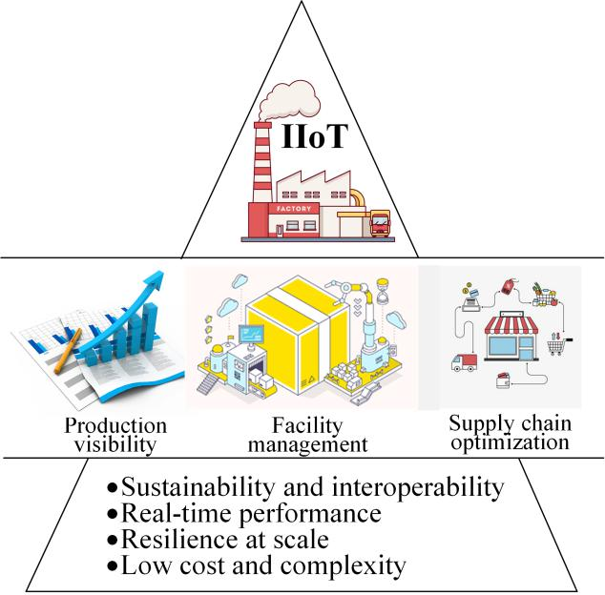

efficiency. There are some basic requirements that all of them meet in order to drive operational efficiency through connectivity and analysis.

1) SUSTAINABILITY AND INTEROPERABILITY

In IIoT, multiple subsystems with different kind of coexisting wireless devices would be deployed in close proximity. Pro-viding enough energy supplies for them to guarantee their sustainability is critical yet challenging due to the hetero-geneity of devices. For example, battery-powered devices can use stored energy for operations, while capacitor-embedded devices relay on energy supplies at every slot to work due to their high self-discharge rate. A lack of interoperability among those devices would significantly increase the com-plexity and cost of IIoT deployment and operation. Since many of the tasks in IIoT (e.g., safety monitoring in food industries) require an uninterrupted supply of energy, sched-ule and interoperability have to be not only continuous and seamless, but also provide high performance.

2) REAL-TIME PERFORMANCE

Given the dynamic environment and mission-critical applica-tions, IIoT typically has stringent data freshness requirements on proper collection of ambient data and timely delivery of control decisions. An example of such a service is fault detection whose timelines are important to prevent the en-tire manufacturing from being hindered. A time-slot based dynamic data schedule would play a critical role for IIoT to achieve the desired real-time performance. However, the data collected from the environment are usually in large volumes and raw form. Not all data are favorable for analysis and diagnosis. It is pivotal to extract interpretable information

|  |  |
| --- | --- |
| VOLUME 4, 2020 | 3 |

This work is licensed under a Creative Commons Attribution 4.0 License. For more information, see https://creativecommons.org/licenses/by/4.0/.

This article has been accepted for publication in a future issue of this journal, but has not been fully edited. Content may change prior to final publication. Citation information: DOI 10.1109/ACCESS.2020.2995649, IEEE Access



H. Wu et al.: Wireless Powered Mobile Edge Computing for Industrial Internet of Things Systems

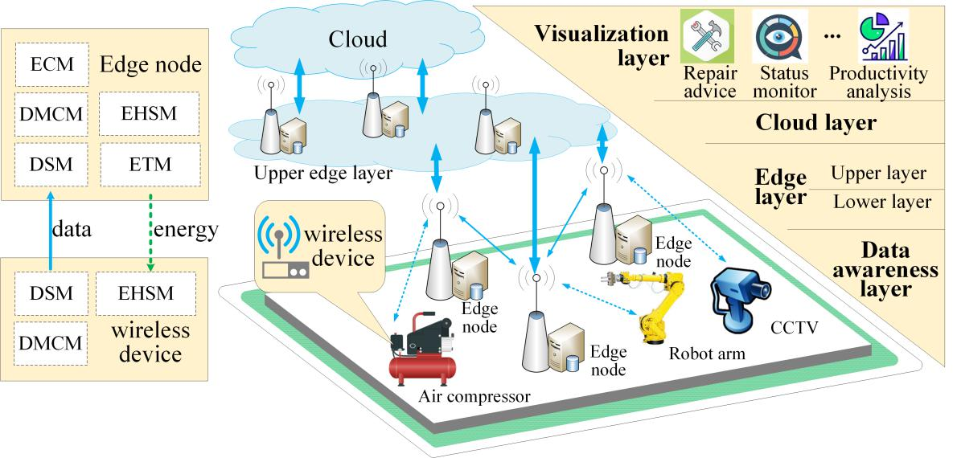

**FIGURE 2.** Network architecture and key components of wireless powered MEC for IIoT

and reduce the data set to a manageable size before further operations.

3) RESILIENCE AT SCALE

The time-slot based schedule would require frequent feed-back of network state information, leading to considerable network overheads which take up the bandwidth for desired data transmission. Although most of the feedback is of small size, a massive number of devices contribute to an explosive overhead that could prevent the system from working. As a result, most of the time, we could only obtain partial and out-dated knowledge of network state for system optimization. The design under wireless powered MEC in IIoT is required to be scaled to respond to environmental disturbances in the presence of incomplete information.

4) LOW COST AND COMPLEXITY

The capital expenditure (CAPEX) is one of the most impor-tant concerns that stakeholders have in IIoT. It determines that the computational capability of edge nodes cannot be infinite, which necessitates specific and meticulous design to match the data to be offloaded and to be processed. Meanwhile, the massive IIoT devices have to offload most of their computing demands to the edge and only operate some simple but necessary calculations locally. Therefore, the algorithm performed at IIoT devices needs to be capable of supporting the optimization of data services with low computational complexity.

1. **FUTURE IIOT ARCHITECTURE AND PROPOSED COMPONENTS**

The future IIoT architecture would be in tandem with tra-ditional cloud-based networks in a hierarchical manner to drive efficiencies and launch new business models [3], [24].

However, the integration of the cloud, WPT, MEC, and IIoT remains challenging in terms of data update, energy supply, and resilient computation. Therefore, to meet network re-quirements and address the challenges, we propose a novel integration network architecture for IIoT with wireless pow-ered MEC on the basis of the Industrial Internet Reference Architecture proposed by IIC [24]. In this subsection, we also present the main component design of the proposed integration architecture and illustrate the advantages of the framework.

1) NETWORK ARCHITECTURE OVERVIEW

Figure 2 illustrates the overview of the proposed architecture, which adopts decentralized control on the system level to meet the desired network requirements. The architecture consists of four layers: data awareness, edge, cloud and visu-alization layers. At the bottom of the network, the data aware-ness layer is a combination of sensing systems that comprises plenty of wireless sensors and smart devices. Those devices are retrofit into existing infrastructures to collect and extract useful data from the changing environments over time and offload the data to the edge layer for analysis. The analysis results will then be forward to the cloud layer for aggregation and be shown to the manufacturing decision-makers through the visualization layer.

The edge layer is comprised of two sub-layers. The lower sub-layer consists of edge nodes that have direct association with groups of sensors. Edge nodes in this sub-layer are re-sponsible for powering devices with wireless energy signals, performing timely data analysis, and controlling dynamic schedules on the basis of time-varying channels. The upper sub-layer takes the role of an intermediate computing con-troller. The group of edge nodes in the upper sub-layer sustain the workloads during peak hours and report data processing

4 VOLUME 4, 2020

This work is licensed under a Creative Commons Attribution 4.0 License. For more information, see https://creativecommons.org/licenses/by/4.0/.

This article has been accepted for publication in a future issue of this journal, but has not been fully edited. Content may change prior to final publication. Citation information: DOI 10.1109/ACCESS.2020.2995649, IEEE Access



H. Wu et al.: Wireless Powered Mobile Edge Computing for Industrial Internet of Things Systems

results to the cloud layer. It is worth mentioning that the edge layer here has similar characteristics as hierarchical edge computing [11] in aggregating peak loads, but is different in layer function since the lower sub-layer also takes the responsibility for WPT. The detailed edge node architecture is discussed below.

2) EDGE NODE AND DEVICE ARCHITECTURE

The realization of the IIoT depends on incorporating some important building blocks. Keeping all of the network re-quirements in mind, we propose the edge node and device architecture for a wireless powered MEC network as shown in Fig. 2. Besides the energy transfer module (ETM) and the edge computing module (ECM) that used for wireless power transfer and data processing, we envision three other key modules: data service, energy harvesting and storage, as well as decision making and configuration modules.

Data Service Module (DSM): This module offers data ser-vice such as data collection, storage, and transmission. Rather than collecting and transmitting the large volume of raw data to the upper layer, DSM adds value to the transmitted data through context-aware data filtering. Only fresh data favor-able for analysis are stored. Its distributed database provides faster data retrieval and enhanced scalability compared with centralized storage, which in turn facilitates the location-awareness and task-awareness [25].

Energy Harvesting and Storage Module (EHSM): For de-vices in the data awareness layer, this module is the only source of energy due to devices’ small size and manufactur-ing cost considerations. It captures the power signals emitted by edge nodes, converts them into electric energy, and stores the energy for later use. While for edge nodes, the module serves as a good supplementary source other than grid power. Perpetual residual energy harvested from the natural envi-ronment (e.g., solar and wind power) or industrial process (e.g., mechanical vibration and industrial waste heat) could be stored to reduce the operational expenditure (OPEX) of industries’ electricity bills.

Decision Making and Configuration Module (DMCM): As the core of scheduling algorithm implementer, this module is capable of supporting resource allocation optimization and determining when to collect and transmit data. On the basis of the dynamic requirements of systems, it can capture the decision-making rules and parameters, make optimal assign-ment of energy, communication and computing resources, and then send the decisions to other modules for execution. Similar to DSM, the decision making and resource configu-ration also work in a distributed manner, depending only on the available knowledge of network state the edge node or device holds.

3) FEATURES OF THE PROPOSED ARCHITECTURE

The proposed architecture is similar to but distinct from the conventional cloud-edge-user architecture we usually come across. First, it aims to stand in a stakeholder’s point to provide a complete network that could be applied in IIoT,

from a macroscopical framework to microcosmic compo-nents. Second, unlike conventional architectures, the pro-posed one considers the three most unique features that is vital for wireless powered MEC in IIoT as highlighted in the following.

Age-aware Data Update: Data age, which measures the amount of time elapsed since the data was generated, is an important metric to quantify data freshness [26]. It is also the basis for providing real-time services in IIoT. On the basis of the age of the data stored at the DSM, DMCM at a device can make its own decision to collect new data and discard the stale one in a distributed manner. Given the finite data storage of devices, those operations will provide memory for fresher data, thus provide more favorable information for system analysis and control. The distributed decision also contributes to devices to adaptively tune their update frequency so as to meet the age demands of data services. Moreover, the data update can reduce the transmission demands and release the burden on wireless transmission with little or even no damage on the system performance, since the dropped data often reflect some outdated or useless information.

Green and Sustainable Energy Supply: Edge nodes can harvest green energy like solar from the ambient environment as a supplementary for grid power. Although highly variable and unpredictable, the green energy can still be directly em-ployed for some delay-tolerant services [27] or be stored in EHSM before it accumulates to a certain level for use. Differ-ent from edge nodes with relatively complicated facilities to collect energy, low-cost devices such as sensors and actuators depend on edge nodes to continuously recharge their EHSMs through WPT to prolong lifetime. With the assistance of DMCM, the recharging process becomes controllable and is thus suitable for maintaining system sustainability.

Hierarchical and Resilient Computation: The multi-tier data process is supported by the hierarchical structure in the edge layer, by which device/service profiles can be formed at their respective domains through information extraction from long-term behaviors. When there are simultaneous computa-tional requirements from a vast number of wireless devices, the light-weight edge node that has a direct connection with wireless devices may be incapable of dealing with the surging workloads, leading to long latency and instability. In this case, the heavy-loaded edge node can deliver its tasks to edge nodes at the upper sub-layer according to the latency constraints of services. Hence, providing resilient processing ability for time-varying computing demands.

1. **SYSTEM MANAGEMENT OF ENERGY, COMMUNICATION AND COMPUTING RESOURCES**

In IIoT, system performance depends on efficient joint op-timization management of energy, communication, and com-puting resources. Due to the time and spatial coupling among multiple resources, the integration of wireless powered MEC into IIoT makes the management more intricate and chal-lenging than the conventional cloud-based system, especially for the data awareness and edge layers. Specifically, on the

|  |  |
| --- | --- |
| VOLUME 4, 2020 | 5 |

This work is licensed under a Creative Commons Attribution 4.0 License. For more information, see https://creativecommons.org/licenses/by/4.0/.

This article has been accepted for publication in a future issue of this journal, but has not been fully edited. Content may change prior to final publication. Citation information: DOI 10.1109/ACCESS.2020.2995649, IEEE Access



H. Wu et al.: Wireless Powered Mobile Edge Computing for Industrial Internet of Things Systems

one hand, the transfer and storage of energy make system decisions at different time slots are dependent on each other. For example, exhausting a sensor’s energy at the current slot would prevent the sensor from transmitting data at the next slot, even if wireless channels become better as time goes by. On the other hand, the tradeoff for bandwidth allocation between WPT and offloading are doubly coupled with avail-able computational capacity at edge nodes. A mismatch of uplink rate and available computational capacity would either result in backlog at edge sides or lead to unsatisfactory low throughput.

Generally, there are two effective ways to solve the time and spatial coupling problem: deep reinforcement learn-ing (DRL) based technologies (e.g. deep Q-learning) and Lyapunov optimization. Due to the time-varying nature of wireless environments, models of DRL-based technologies require an online learning process [7], which is computation and storage demanding. Very deep learning method may not be suitable for edge nodes with limited computation capacity in IIoT. In [28], the authors proposed a deep learning-based online offloading framework for wireless powered MEC, which makes real-time and optimal offloading even in a fast fading environment. However, since DRL-based technolo-gies are largely black boxes and have low interpretability, businesses would rather continue to employ methods that can provide lower bound of optimal performance. Lyapunov optimization is an ideal one for them. It is high interpretabil-ity and can decouple the original coupling problem over independent time slots and transfer the major concern of system management to the following three subtasks.

1. **JOINT DESIGN OF UPLINK AND DOWNLINK TRANSMISSION**

A typical model of wireless powered MEC is depicted in Fig. 3, where the single-antenna edge node transfers energy (downlink) and receives offloaded data (uplink) in a slot-based time division multiple access (TDMA) manner. At each time slot, there are two different phases: the WPT phase and the data offloading phase. In the first 0(t) fraction of time, the edge node empowers all the wireless sensors through energy signal broadcast. The sensors then use the harvested energy to transmit their collected data to the edge node in a non-overlap sequence. The edge node and its covered wireless devices together form a small cell.

As edge nodes in IIoT are usually connected with a stable power grid, energy consumption concerns in the joint design are mostly coming from the device side. Generally, a device’s energy consumption Etotal comprises of four parts:

|  |  |
| --- | --- |
| Etotal = Ecol + Etrans + Elocal + Ecir: | (1) |

where Ecol, Etrans, Elocal and Ecir represents the energy consumption for data collection, data transmission, local processing and basic circuit operations, respectively. In IIoT, data transmission often dominates the total energy consump-tion, especially when intensive processing is prohibited by local components [29]. The transmission relays on the energy

**FIGURE 3.** The wireless powered MEC network. (a) network model. (b)protocol for downlink WPT and uplink data offloading.

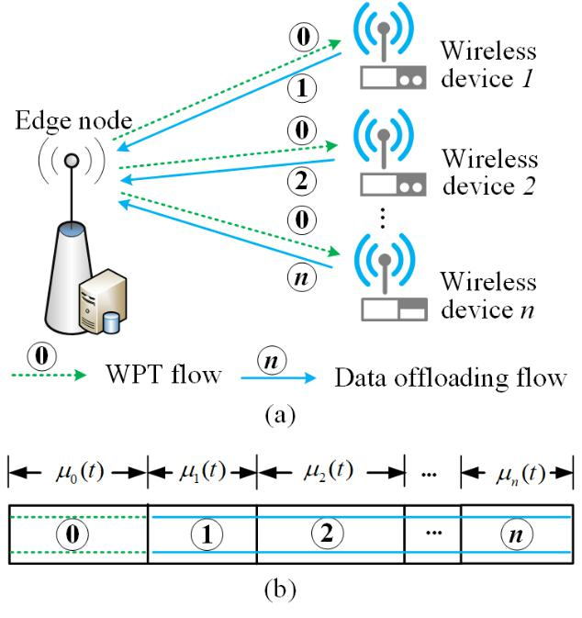

harvested from the WPT phase. Although the non-linear EH model achieves a better performance in reality to reflect the circuit sensitivity limitations and current leakage [30], many related works still adopt the linear EH model for its better treatability and simplicity [13], [17], [18], [29].

Individual devices are selfish and short-sighted. When it comes to resource assignment, it is hard for them to achieve consensus in a distributed manner, since they are inclined to maximize their own interests, resulting in the prisoner’s dilemma. Therefore, in each small cell, the edge node takes the role to jointly coordinate the time portion allocation for uplink and downlink. For fairness concerns, there are typically three schemes to tackle the doubly near-far problem in WPCN: 1) deploying devices physical location delicately [8]; 2) leveraging device cooperations [18]; and 3) designing fairness embedded system utility functions [20],

1. Unlike WPCN, which only considers the doubly near-far problem, wireless powered MEC in IIoT also needs to put device heterogeneity and available computing resources in mind during its scheduling mechanism design. When the data backlog at an edge node is much larger than its served device, the device should be prohibited from offloading until more computing resources are released.

**B. AGE AWARE DATA UPDATE DECISION**

Intuitively, collecting data once transmission bandwidths for delivery are allocated (i.e., zero-wait policy) is the ideal way to provide up-to-date information. However, when data transfer is positively correlated over time, which is a common condition in IIoT, the zero-wait policy would be far from the

6 VOLUME 4, 2020

This work is licensed under a Creative Commons Attribution 4.0 License. For more information, see https://creativecommons.org/licenses/by/4.0/.

This article has been accepted for publication in a future issue of this journal, but has not been fully edited. Content may change prior to final publication. Citation information: DOI 10.1109/ACCESS.2020.2995649, IEEE Access



H. Wu et al.: Wireless Powered Mobile Edge Computing for Industrial Internet of Things Systems

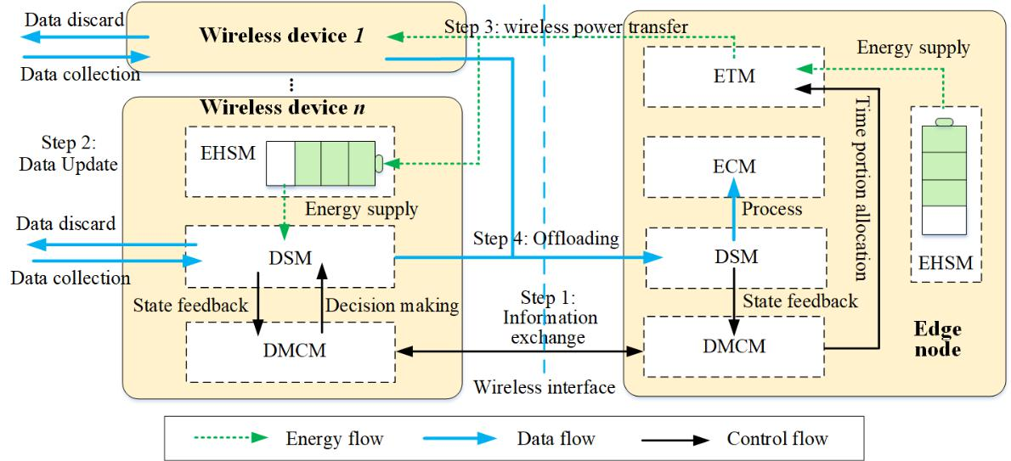

**FIGURE 4.** Working procedure for resource management between data awareness and edge layers.

freshest [31]. Besides, the data collection does not happen in an instant but lasts for a continuous amount of time. It determines that devices have to use the DSM to enqueue the gathered data before their transmission, and drop the stale da-ta waiting in the queue when there are new samples arriving. A frequent data update (i.e., collection and discard) can keep freshness, but it also leads to a waste of device resources. For instance, continuous data collection and discard processes would deplete available energy for data offloading, which hampers the lifetime of wireless devices. To handle this, a utility function that consists of two parts is required. The first part is a monotonically increasing profit function of collected data volume as more data means more valuable information. The second part is a monotonically decreasing function of the discarded data volume, which represents the price for data dropping. On the basis of the utility function, the DMCM in each device can make their own decision to adaptively tune its update frequency to meet the age requirements of different data services in a distributed manner. Although the distribut-ed decision is suitable for devices to adapt to the time-varying environment, a low complexity algorithm must be carefully designed considering devices’ limited processing capability.

**C. SCALABILITY AND PRACTICAL CONSIDERATIONS**

As mentioned above, the joint design of uplink and downlink transmission in each cell requires a centralized schedule. It could avoid the selfish and short-sighted decision made by in-dividual devices, and achieve an optimal resource allocation with a comprehensive knowledge of network states. Never-theless, to obtain the network knowledge requires frequent state feedback (e.g., queueing data backlog report) from wireless devices. The feedback would occupy the bandwidth for data offloading, which may exacerbate the problem of scarce transmission bandwidths in IIoT and even prevent

VOLUME 4, 2020

the system from working when a vast amount of devices are connected. Besides, the time difference between state collection and computation makes the obtained state infor-mation at the edge layer not always up-to-date. In practice, feedback delay from devices to the edge node causes the network state information to be at least a time slot duration late. Therefore, in practical implementation, the system has to use partial and outdated network state information for optimization. For this reason, we can proceed to optimize system performance by approximating the latest feedback as the current network state information, and using asymptotic optimization to diminish the optimality loss caused by the approximation.

In this article, we consider the TDMA protocol illustrated in Fig. 3 because the current industrial wireless standards (WirelessHART, ISA100.11a, and WIAPA) are all TDMA-based [32]. The proposed architecture and resource man-agement method in this paper can thus be easily applied to a real industrial scenario. When the number of edge nodes and wireless devices is not proportional, TDMA manner alone may not able to support that a massive number of connectivity demands. In this case, grant-free nonorthogonal multiple access (NOMA) is a good supplementary option. We can replace each wireless device in Fig. 3 to a cluster of devices that share the same bandwidth during their allocation time portion. Within each cluster, devices employ grant-free NOMA to increase the connection numbers. However, applying NOMA in IIoT may still need a long way to go before its technology becomes mature.

**IV. CASE STUDY**

In this section, we consider a case in precision agriculture, where sensors are deployed to measure soil nutrients, humidi-ty, and temperature of a greenhouse for boosting productivity. Besides throughput, precision agriculture also pays attention

7

This work is licensed under a Creative Commons Attribution 4.0 License. For more information, see https://creativecommons.org/licenses/by/4.0/.

This article has been accepted for publication in a future issue of this journal, but has not been fully edited. Content may change prior to final publication. Citation information: DOI 10.1109/ACCESS.2020.2995649, IEEE Access



H. Wu et al.: Wireless Powered Mobile Edge Computing for Industrial Internet of Things Systems

to device fairness and data freshness, since unfair or stale data collection and offloading cause data locality and resource waste. Given the importance and complexity of the resource management between the edge and device layers, we only consider the scenario of a single edge node. The proposed approaches can be readily extended to the scenario with multiple edge nodes by applying frequency reuse techniques for different edge nodes.

Consider ten sensors (represented by N) whose distances from the edge node are di = i+2 meters. The parameters used in the simulation are taken from 3GPP specifications [33],

1. and existing synthetic data set [18], [20], to capture the features of practical dynamic environments. Specifically, the channel is modeled after the Rayleigh fading model in [20] with 0.2MHz bandwidth and 109 W receiver noise power. The transmission power of the edge node is 2W and the energy harvesting efficiency of devices is set as 0.8. Without loss of generality, we denote the utility function of data

P

update as i2N [log(ai + 1) idi], where log( ) denotes the natural logarithm, i is the price for data dropping, and

ai(t) and di(t) are the amount of data collected and dropped at time slot t, respectively. Using such a function with a decreasing marginal utility for different sensors can ensure system fairness, as a preference for some devices violates the utility maximization principle. For fairness consideration, different sensors’ prices for dropping data are assumed to be the same and denoted as . The aim of the optimization is to maximize the long-term time-average of the utility function under the following constraints:

1. The data backlogs in any device i 2 N at time slot t (henceforth referred to as Qi(t)) and the amount of data waiting to be processed at the edge node (referred to as S(t)) should always maintain stable. In another word, the long-term average expectation of all Qi(t) and S(t) need to be bounded by a finite value. In this case, no node in the system would be overloaded with endless data arrival.
2. The energy consumption of each device should not exceed what it has harvested.

Unfortunately, the objective function of the problem involves functions of time averages, thus cannot conform to a tradi-tional drift-plus-penalty framework employed in Lyapunov optimization. To address this issue and achieve age aware-ness, virtual queues [26] and -persistent service queues [29] are introduced to transform the original problem to a standard Lyapunov optimization form. Subsequently, we can decouple the equivalently transformed problem into three deterministic per-slot sub-problems as we discussed in Section III, which can be efficiently solved by convex optimization techniques and Lambert W function [18]. In each slot duration, the step by step workflow is illustrated in Figure 4 and described below.

Step 1 (Information Exchange): The edge node broad-casts its data backlog information to all sensors under its coverage. Sensors that have a long data backlog then send

**FIGURE 5.** The average system throughput comparison of benchmarks andthe proposed approach.

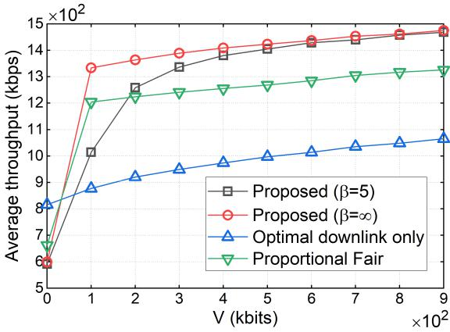

their pilots to the edge node for channel measurements and give feedback of their device state for resource allocation. As only a small portion of devices that have long data backlog need to send feedback, much system overheads could be avoided.

Step 2 (Data Update): On the basis of the optimization decision made by DMCM, DSM at each individual sensor collects or drops data according to the optimization results ai(t) and di(t). The computational complexity of the op-timization is O(1), which is suitable for resource-limited sensors.

Step 3 (Wireless Power Transfer): The DMCM at the edge node determines the optimal time portions based on the edge node’s state and the outdated information exchanged in Step 1. Subsequently, the edge node’s ETM takes 0(t) fraction time of the slot to recharge the EHSMs of sensors by emitting a baseband signal.

Step 4 (Data Offloading): With the harvested energy, DSMs at sensors use their allocated time portions to offload in turns. At the edge node side, arrived data will first be queued into the node’s DSM, and then transfer to the ECM for processing.

For comparison, we stimulate two benchmark approaches:

1. optimal downlink only [20], where downlink WPT time portions are optimized with all sensors having equal offload-ing time, and 2) proportional fair [26], where the allocation of time portions is based on proportional fairness method with-out the ability to discard stale data. Besides, for self-contrast, the proposed mechanism with different data dropping price is also simulated to illustrate its self-adaption. The numerical results are obtained by averaging over 1000 independen-t realizations, in which wireless channel and background computing capacity are randomly selected within certain boundaries [20], [26] to model the real dynamics in IIoT.

Figures 5 and 6 show the system throughput and fairness of the proposed and benchmark schemes with different V , where V is a control parameter that often used in Lyapunov optimization to achieve a balance between different system

8 VOLUME 4, 2020

This work is licensed under a Creative Commons Attribution 4.0 License. For more information, see https://creativecommons.org/licenses/by/4.0/.

This article has been accepted for publication in a future issue of this journal, but has not been fully edited. Content may change prior to final publication. Citation information: DOI 10.1109/ACCESS.2020.2995649, IEEE Access



H. Wu et al.: Wireless Powered Mobile Edge Computing for Industrial Internet of Things Systems

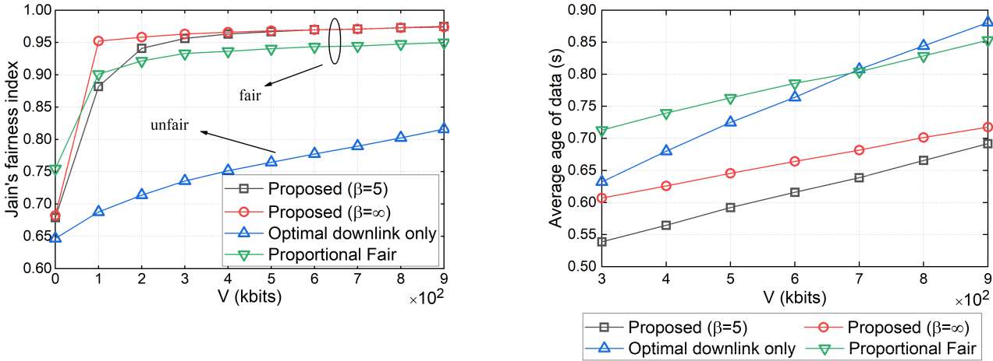

**FIGURE 6.** The fairness comparison of different approaches under varyingcontrol parameter V.

requirements. We use Jain’s fairness index [26] to measure fairness. The closer the index is to one, the fairer the schedule is. It can be seen that the proposed method with an infinite

has better performance on both throughput and fairness than the counterpart with = 5, meaning a higher system utility. This is because DSM is enforced to accumulate stale data since the price for data dropping is unbearable when = 1. The absence of the discard process leads to longer data backlogs, increasing the opportunity for sensors to reach the condition for offloading, consequently, promoting the throughput. As expected, the optimal downlink only method suffers from the doubly near-far problem [8], [9], hence is unfair, since the differential channel states caused by dif-ferent distances between the edge node and sensors are not involved in its optimization. By contrast, the proposed and the proportional fair algorithms are effective at dealing with the problem and can ensure fairness with high throughput when V is large. With a more comprehensive consideration of data backlogs at different DSMs, the proposed mechanism outperforms the proportional fair algorithm by 11 percent in terms of throughput when V equals 900.

Higher throughput and fairness can be achieved when V becomes larger, however, it is not the larger the better. As illustrated in Fig. 7, the age of data increases linearly with the growth of V . When V changes from 300 to 900, the throughput of the proposed approach increases by 6.5% at the cost of more than 28% rise in the data age. Besides, we can also observe that, due to reluctant to discard stale data, implementing the proposed approach with a larger results in an explicit increase in average age. Therefore, selecting the appropriate V and would be important for the proposed method to meet the data freshness demands while realizing high throughput with enough fairness. Nevertheless, even with an infinite (i.e., an unfavorable condition for keeping freshness), the proposed approach still ensures data fresher than the benchmarks, thanks to its adaptive to the stochastic channels and awareness of data age.

VOLUME 4, 2020

**FIGURE 7.** The average age of data using the benchmarks and the proposedapproach.

**V. FUTURE RESEARCH DIRECTIONS**

The variability of IIoT network demands makes the "one-size-fits-all" management approach inadequate. In different wireless powered MEC scenarios, there remain several im-portant topics for further exploration.

Task dependency: It is a relationship between two tasks, describing how tasks link to and rely on each other. During data offloading or processing, a successor task could not be completed until the predecessor task is finished. Obtaining internal and external dependencies in IIoT is not easy since many devices and nodes perform in a distributed manner. Arranging the order of different tasks would require them to cooperate in a more transparent and efficient way, which requires sophisticated models beyond simply adopting a ran-dom computing sequence.

Millimeter wave: Edge nodes and massive sensors are often closely deployed. The wireless communication distance between them is usually short and line-of-sight, which is especially beneficial for the implementation of millimeter wave (mmWave). Operations with mmWave can provide pre-dictable and controlled interference, thus ensure reliability and QoS. In addition, the broad bandwidth of mmWave enables the system to support a large number of wireless devices. However, mmWave also adds more complexity to the analysis of wireless channels and device discovery.

Contextual information mining: Wireless devices, such as sensors on smart trucks and robots, and even edge nodes can be in mobility. It would be difficult to allocate system resources for applications with varying locations and network topologies. Fortunately, mobility may have certain temporal and spatial characteristics due to the fixed workplace of factories. Contextual information can be mined to support intelligent management of wireless powered MEC networks in IIoT.

9

This work is licensed under a Creative Commons Attribution 4.0 License. For more information, see https://creativecommons.org/licenses/by/4.0/.

This article has been accepted for publication in a future issue of this journal, but has not been fully edited. Content may change prior to final publication. Citation information: DOI 10.1109/ACCESS.2020.2995649, IEEE Access



H. Wu et al.: Wireless Powered Mobile Edge Computing for Industrial Internet of Things Systems

**VI. CONCLUSION**

In this article, we studied the use of wireless powered MEC as a promising solution to provide sustainability and sufficient computational capacity for IIoT. Use cases together with net-work requirements for wireless powered MEC in IIoT were discussed, on the basis of which we proposed a four-layer system architecture. It has been shown that enabled by the proposed integration architecture, IIoT has the potential to provide age-aware data update, green and sustainable energy supply, as well as hierarchical and resilient computation. An efficient system resource management approach was also presented to coordinate the coupling energy, communication, and computing resources in IIoT. Numerical results from a precision agriculture case verified the efficiency of our pro-posed approach and emphasized the importance of a highly efficient scheduling mechanism in IIoT. Finally, this paper raised several challenging directions in the considered IIoT scenario for future research.

**ACKNOWLEDGMENT**

We are very grateful to Prof. Wei Ni at University of Tech-nology Sydney for helpful discussions.

**REFERENCES**

1. M. Aazam, S. Zeadally, and K. A. Harras, “Deploying Fog Computing in Industrial Internet of Things and Industry 4.0,” IEEE Trans. Ind. Inf., vol. 14, no. 10, pp. 4674–4682, Oct. 2018.
2. H. Xu, W. Yu, D. Griffith et al., “A survey on industrial internet of things: A cyber-physical systems perspective,” IEEE Access, vol. 6, pp. 78 238– 78 259, 2018.
3. E. Sisinni, A. Saifullah, S. Han et al., “Industrial internet of things: Challenges, opportunities, and directions,” IEEE Trans. Ind. Inf., vol. 14, no. 11, pp. 4724–4734, Nov 2018.
4. X. Lyu, H. Tian, L. Jiang et al., “Selective offloading in mobile edge computing for the green Internet of Things,” IEEE Netw., vol. 32, no. 1, pp. 54–60, Jan 2018.
5. Y. Mao, C. You, J. Zhang et al., “A survey on mobile edge computing: The communication perspective,” IEEE Commun. Surveys & Tutorials, vol. 19, no. 4, pp. 2322–2358, 4rd Quart. 2017.
6. X. Lyu, C. Ren, W. Ni et al., “Optimal online data partitioning for geo-distributed machine learning in edge of wireless networks,” IEEE J. Sel. Areas Commun., vol. 37, no. 10, pp. 2393–2406, Oct 2019.
7. ——, “Distributed online learning of cooperative caching in edge cloud,” IEEE Trans. Mobile Comput., pp. 1–1, 2020.
8. S. Bi, Y. Zeng, and R. Zhang, “Wireless powered communication network-s: An overview,” IEEE Wireless Commun., vol. 23, no. 2, pp. 10–18, Apr. 2016.
9. P. Ramezani and A. Jamalipour, “Toward the evolution of wireless pow-ered communication networks for the future Internet of Things,” IEEE Netw., vol. 31, no. 6, pp. 62–69, Nov. 2017.
10. B. Lyu, T. Qi, H. Guo et al., “Throughput maximization in full-duplex dual-hop wireless powered communication networks,” IEEE Access, vol. 7, pp. 158 584–158 593, 2019.
11. Q. Pham, F. Fang, V. N. Ha et al., “A survey of multi-access edge computing in 5g and beyond: Fundamentals, technology integration, and state-of-the-art,” arXiv preprint arXiv:1906.08452, 2019.
12. M. Tseng, T. Edmunds, and L. Canaran, “Introduction to Edge Computing in IIoT,” Industrial Internet Consortium (IIC) White Paper, Tech. Rep., June 2018.
13. F. Zhou, Y. Wu, R. Q. Hu et al., “Computation rate maximization in UAV-enabled wireless-powered mobile-edge computing systems,” IEEE J. Sel. Areas Commmun., vol. 36, no. 9, pp. 1927–1941, Sep. 2018.
14. F. Zhou and R. Q. Hu, “Computation efficiency maximization in wireless-powered mobile edge computing networks,” IEEE Trans. Wireless Com-mun., pp. 1–1, 2020.
15. I. Krikidis, S. Timotheou, S. Nikolaou et al., “Simultaneous wireless information and power transfer in modern communication systems,” IEEE Commun. Mag., vol. 52, no. 11, pp. 104–110, 2014.
16. D. W. K. Ng, T. Q. Duong, C. Zhong et al., Wireless Information and Power Transfer: Theory and Practice. John Wiley & Sons, 2019.
17. S. Bi and Y. J. Zhang, “Computation rate maximization for wireless powered mobile-edge computing with binary computation offloading,” IEEE Trans. Wireless Commun., vol. 17, no. 6, pp. 4177–4190, June 2018.
18. X. Hu, K. Wong, and K. Yang, “Wireless powered cooperation-assisted mobile edge computing,” IEEE Trans. Wireless Commun., vol. 17, no. 4,
    1. 2375–2388, April 2018.
19. F. Wang, J. Xu, X. Wang et al., “Joint offloading and computing optimiza-tion in wireless powered mobile-edge computing systems,” IEEE Trans. Wireless Commun., vol. 17, no. 3, pp. 1784–1797, March 2018.
20. H. Wu, X. Lyu, and H. Tian, “Online optimization of wireless powered mobile-edge computing for heterogeneous industrial internet of things,” IEEE Internet Things J., vol. 6, no. 6, pp. 9880–9892, Dec 2019.
21. A. Bridgwater, “Airbus: engineering the future of intelligent

factories,” 2017. [Online]. Available: [https://internetofbusiness.com/](https://internetofbusiness.com/airbus-engineering-intelligent-factories/) [airbus-engineering-intelligent-factories/](https://internetofbusiness.com/airbus-engineering-intelligent-factories/)

1. ABB, “Yumi: Creating an automated future together,” 2015. [On-

line]. Available: [https://new.abb.com/products/robotics/industrial-robots/](https://new.abb.com/products/robotics/industrial-robots/irb-14000-yumi) [irb-14000-yumi](https://new.abb.com/products/robotics/industrial-robots/irb-14000-yumi)

1. N. Taylor, “Three key elements to Amazon’s supply chain strategy,” 2019. [Online]. Available: [https://new.abb.com/products/](https://new.abb.com/products/robotics/industrial-robots/irb-14000-yumi) [robotics/industrial-robots/irb-14000-yumi](https://new.abb.com/products/robotics/industrial-robots/irb-14000-yumi)
2. S.-W. Lin, B. Miller, J. Durand et al., “The Industrial Internet of Things Volume G1: Reference Architecture,” Industrial Internet Consortium (IIC) White Paper, Tech. Rep., Jan. 2017.
3. H. Wu, H. Tian, and G. Nie, “Energy-efficient inter-frequency small cell discovery in dense urban environments,” IEEE Wireless Commun. Lett., vol. 8, no. 1, pp. 41–44, 2019.
4. X. Lyu, W. Ni, H. Tian et al., “Optimal schedule of mobile edge computing for internet of things using partial information,” IEEE J. Sel. Areas Commun., vol. 35, no. 11, pp. 2606–2615, Nov. 2017.
5. Z. Niu, B. He, and F. Liu, “JouleMR: Towards cost-effective and green-aware data processing frameworks,” IEEE Trans. Big Data, vol. 4, no. 2,
   1. 258–272, June 2018.
6. L. Huang, S. Bi, and Y. J. Zhang, “Deep reinforcement learning for on-line computation offloading in wireless powered mobile-edge computing networks,” IEEE Trans. Mobile Comput., pp. 1–1, 2019.
7. H. Wu, H. Tian, S. Fan et al., “Data age aware scheduling for wireless powered mobile-edge computing in industrial internet of things,” IEEE Trans. Ind. Inf., pp. 1–1, 2020.
8. E. Boshkovska, D. W. K. Ng, N. Zlatanov et al., “Practical non-linear energy harvesting model and resource allocation for swipt systems,” IEEE Commun. Lett., vol. 19, no. 12, pp. 2082–2085, 2015.
9. Y. Sun, E. Uysal-Biyikoglu, R. D. Yates et al., “Update or wait: How to keep your data fresh,” IEEE Trans. Inf. Theory, vol. 63, no. 11, pp. 7492– 7508, Nov. 2017.
10. D. Raposo, A. Rodrigues, S. Sinche et al., “Industrial iot monitoring: Technologies and architecture proposal,” Sensors, vol. 18, no. 10, p. 3568, 2018.
11. 3GPP, “Study on NR Industrial Internet of Things,” Rep. TR 38.825 v16.0.0, Tech. Rep., Mar. 2019.
12. ——, “Cellular system support for ultra-low complexity and low through-put Internet of Things,” Rep. TR 45.820 v13.1.0, Tech. Rep., Nov. 2015.

HAO WU [(wh9405@bupt.edu.cn)](mailto:wh9405@bupt.edu.cn) received the B.S. degree in communication engineering from the Beijing University of Posts and Telecommu-nications (BUPT), Beijing, China, where he is currently working toward the Ph.D. degree in in-formation and communications engineering.



He is currently a Visiting Student with the Cen-ter for Complex Network Research, Northeastern University, Boston, MA, USA. His current re-search interests include edge computing, industrial

Internet of Things, radio resource management and complex networks.

10 VOLUME 4, 2020

This work is licensed under a Creative Commons Attribution 4.0 License. For more information, see https://creativecommons.org/licenses/by/4.0/.

This article has been accepted for publication in a future issue of this journal, but has not been fully edited. Content may change prior to final publication. Citation information: DOI 10.1109/ACCESS.2020.2995649, IEEE Access



H. Wu et al.: Wireless Powered Mobile Edge Computing for Industrial Internet of Things Systems

HUI TIAN [(tianhui@bupt.edu.cn)](mailto:tianhui@ bupt.edu.cn) received the



M.S. degree in microelectronics and the Ph.D. de-

gree in circuits and systems from the Beijing Uni-

versity of Posts and Telecommunications (BUPT),

Beijing, China, in 1992 and 2003, respectively.

She is currently a Professor with BUPT, where

she is also the Network Information Processing

Research Center director of the State Key Labo-

ratory of Networking and Switching Technology.

Her current research interests include radio re-

source management, mobile-edge computing, industrial Internet of Things,

and mobile social network.

GAOFENG NIE [(niegaofeng@bupt.edu.cn)](mailto:niegaofeng@bupt.edu.cn) re-



ceived the B.S. degree in Communications Engi-

neering and Ph.D. degree in Telecommunications

and Information system from the Beijing Univer-

sity of Posts and Telecommunications (BUPT) in

2010 and 2016, respectively.

He is currently a Lecturer with BUPT. His re-

search interests are SDN over Wireless Networks

and key technologies in 5G/B5G wireless net-

works.

PENGTAO ZHAO [(zpt@bupt.edu.cn)](mailto:zpt@bupt.edu.cn) received



the B.S. degree in communications engineering

from Beijing Jiaotong University (BJTU), Beijing,

China, in 2014. He is currently pursuing the Ph.D.

degree in information and communications engi-

neering with the Beijing University of Posts and

Telecommunications (BUPT), Beijing.

His research interests include mobile edge com-

puting, radio resource allocation, and convex opti-

mizations.



|  |  |
| --- | --- |
| VOLUME 4, 2020 | 11 |

This work is licensed under a Creative Commons Attribution 4.0 License. For more information, see https://creativecommons.org/licenses/by/4.0/.