This article has been accepted for publication in a future issue of this journal, but has not been fully edited. Content may change prior to final publication. Citation information: DOI

10.1109/ACCESS.2020.3010059, IEEE Access

Date of publication xxxx 00, 0000, date of current version xxxx 00, 0000.

Digital Object Identifier 10.1109/ACCESS.2017.DOI

**Load Balancing for 5G Integrated Satellite-Terrestrial Networks**

**SYED MAAZ SHAHID1, SEYOUM YEMANE TEKLAY1, SEOK HO WON2, and SUNGOH KWON1, (SENIOR MEMBER, IEEE)**

* School of Electrical Engineering, University of Ulsan, Ulsan 44610, Korea (e-mail:{maaz.shahid, yemaneteklay}@gmail.com and sungoh@ulsan.ac.kr)

2 Future Mobile Communication Division, ETRI, Deajon, South Korea (e-mail:shwon@etri.re.kr)

Corresponding author: Sungoh Kwon (e-mail: sungoh@ulsan.ac.kr).

This work was partly supported by Basic Science Research Program through NRF funded by the Ministry of Education (NRF-2018R1D1A3B07050215), and by Institute of Information & Communications Technology Planning & Evaluation (IITP) grant funded by the Korea government(MSIT) (No.2018-0-00175, 5G AgiLe and fLexible integration of SaTellite And cellulaR).

 **ABSTRACT** We propose a load balancing algorithm for a multi-RAT (radio access technology) networkincluding a non-terrestrial network (NTN) and a terrestrial network (TN). Fifth generation (5G) and beyond-5G networks consider NTNs to provide connectivity and data delivery to large numbers of user equipments (UEs). However, previous load balancing algorithms do not consider the coexistence of NTNs and TNs and ignore the different resource allocation units in a multi-RAT network. Hence, we define a radio resource utilization ratio (RRUR) as a common load metric to measure the cell load of each RAT and employ an adaptive threshold to determine overloaded cells. The proposed algorithm consists of two steps to overcome the uneven load distribution across 5G cells: intra-RAT load balancing and inter-RAT load balancing. Based on the RRUR of a cell, the algorithm first performs intra-RAT load balancing by offloading the appropriate edge UEs of an overloaded cell to underutilized neighboring cells. If the RRUR of the cell is still higher than a predefined threshold, then inter-RAT load balancing is performed by offloading the delay-tolerant data flows of UEs to a satellite link. Furthermore, the algorithm estimates the impact of moving loads to the target cell load to avoid unnecessary load balancing actions. Simulation results show that the proposed algorithm not only distributes the load across terrestrial cells more evenly but also increases network throughput and the number of quality of service satisfied UEs more than previous load balancing algorithms.

 **INDEX TERMS** 5G, cellular network, satellite, NTN, radio access network, multi-RAT, QoS, load balancing, data flows, load measurement.

**I. INTRODUCTION**

IFTH generation (5G) technology is expected to provide Fhigh-speed broadband, low-latency services and many devices connected to the Internet at one time. The 5G use cases are classified in terms of requirements for different types of communication. One of the use cases is enhanced mobile broadband (eMBB) which needs to support high bandwidth and high throughput [1], [2]. Furthermore, accord-ing to a Cisco forecast, demand for wireless data is expected to reach 77 exabytes per month and online video will make up 82% of internet traffic in 2022 [3], [4]. The amount of bandwidth consumed will grow as more and higher-quality videos are watched. To satisfy the high data rate demand and high bandwidth requirements, there is a need to redesign the cellular network. This leads to the use of non-terrestrial networks (NTNs) in cellular networks. The role of the NTN

in 5G networks leads to a heterogeneous global system, and increases the available spectrum and coverage area by providing services in underserved areas [5].

NTNs use spaceborne vehicles, i.e., satellites, to host ac-cess nodes, which are already deployed and can be integrated to 5G terrestrial system to support 5G key performers indi-cators. In the past, terrestrial and satellite networks evolved independently of each other. The 5G paradigm provides a unique opportunity for terrestrial and other radio access tech-nologies (RATs) communities to define a harmonized, full-fledged architecture [6]. Different RATs, including 5G and NTNs, are integrated to guarantee seamless coverage, and to support high data-rate transmissions and data offloading [7]. It is expected that satellite systems will provide radio access networks (RANs), called satellite RANs, with more than 100 high-throughput satellite systems using a geostationary earth

|  |  |
| --- | --- |
| VOLUME 4, 2016 | 1 |

This work is licensed under a Creative Commons Attribution 4.0 License. For more information, see https://creativecommons.org/licenses/by/4.0/.

This article has been accepted for publication in a future issue of this journal, but has not been fully edited. Content may change prior to final publication. Citation information: DOI  10.1109/ACCESS.2020.3010059, IEEE Access

orbit (GEO) by 2020-2025 [8]. The integration of terrestrial networks (TNs) with GEO satellite support would be benefi-cial for global, large-capacity coverage [6]. Moreover, satel-lites can deliver very high data rates (100 Mbps to 1 Gbps) in broadcast mode to outdoor radio access points [9], and can be used to support the eMBB usage scenarios of 5G [10]. Thus, integration of the satellite into 5G systems will increase the quality of service (QoS) of the user equipments (UEs) by intelligently routing traffic between multiple RAT [11]. Furthermore, this integration provides a larger spectrum to the 5G network and broadband connectivity in rural and remote areas. The 3rd Generation Partnership Project (3GPP) also included NTN in 5G systems to support many services in Release 17 work items [12].

In 5G RAT, the network of cells is densely deployed to provide connectivity to a large number of users. The mobility of UEs causes a load imbalance across the cells in the network [13]. The imbalance in the network affects the QoS of UEs and is an inefficient utilization of available resources. Furthermore, the requirement for high data rates for UEs and the uneven distribution of UEs in the network lead to overutilization of resources in some cells. To overcome these problems, it is necessary to share the load among the cells so that network resources are utilized efficiently to balance the network. For that purpose, intra-RAT load balancing is performed to balance load distributions in order to maintain an appropriate end-user experience and good network perfor-mance.

With intra-RAT load balancing, the load from an over-loaded cell moves to underloaded neighboring cells. The source and target cells are part of the same RAT. However, sometimes UEs cannot move to neighboring cells due to a scarcity of resources and limited coverage. This affects efficient load balancing among cells, and decreases QoS of the users. The combination of multiple RATs, referred to as a multi-RAT network, is considered for wireless networks to increase resource availability as well as coverage. The multi-RAT network enhances the QoS of UEs, because different RATs can support different services. Furthermore, the UEs access the radio resources of multiple RATs and dynamically route particular traffic to a RAT to satisfy QoS. In the multi-RAT network, it is necessary to determine which RAT should serve which UEs to increase network performance and satisfy QoS of the UEs. Both intra-RAT and inter-RAT load transfers from overloaded cells in the multi-RAT network lead to a well-balanced network and increase network throughput. Moreover, a common load metric is also necessary to mea-sure the load of each RAT for the load balancing in a multi-RAT network. Based on the load metric, radio resources utilization of RATs can be determined and used to divide the network load among the cells of different RATs.

Several research works have studied the problem of mobil-ity load balancing in a cellular network. In [14], the authors resolved the mismatch between the distribution of network resources and traffic demand by handing over UEs of an overloaded cell to a neighboring cell. A utility-based mobility

2

load balancing algorithm in [13] considered operator utility and user utility for the handover process in 5G networks. A load balancing efficiency factor was introduced to consider the load of neighbouring cells and the edge UEs of an overloaded cell. An adaptive algorithm for mobility load bal-ancing in a Long Term Evolution (LTE) small-cell network was proposed in [15]. An adaptive threshold is employed to identify overloaded cells and the UE handovers to can-didate target cells from overloaded cells. In [16], a cluster-based mobility load balancing algorithm was proposed for heterogeneous LTE networks. The algorithm dynamically constructs clusters of cells by considering overloaded cells and their neighbors, and performs load balancing in those clusters. Previous work considered a single RAT and per-formed intra-RAT load handover (i.e., terrestrial-terrestrial) for load balancing. whereas in a multi-RAT network, inter-RAT load balancing in conjunction with intra-RAT load balancing is also performed. In the multi-RAT network, it is necessary to determine suitable RATs for UEs in order to provide the required resources. Furthermore, a common load-measure metric is required in the multi-RAT network to measure the resource utilization of each RAT and to compare the loads of multiple RATs. Therefore, these load balancing algorithms are not applicable in a multi-RAT network for balancing the load of terrestrial cells.

In the literature, multiple RATs were also considered in heterogeneous cellular network for enhancing QoS. In [17], the authors proposed an algorithm for traffic-splitting and aggregation in heterogeneous networks. In the algorithm, the UEs’ traffic is split across multiple RATs that consti-tute terrestrial cells and wireless LANs. In [18], the au-thors proposed a probabilistic RAT selection approach in 5G heterogeneous networks that included Wi-Fi and cellular networks. The previous work used a multi-RAT network to increase capacity and coverage of the TNs, but did not consider load balancing in terrestrial RAT. Further, previous work did not devise a common metric to measure RAT traffic loads, which is necessary in a multi-RAT network because different RATs use different time frequency resource units. Furthermore, load balancing in TNs using multiple RATs increases convergence as well as satisfying-QoS of the UEs providing resource availability to UEs. Thus, the integration of NTNs and 5G networks would balance the terrestrial cells by increasing spectrum availability and the coverage area.

In this paper, we propose a load balancing algorithm to balance the 5G RAT in a multi-RAT network, with NTNs and 5G networks assumed for the multi-RAT network. For load balancing in terrestrial cells, we consider intra-RAT and inter-RAT offloading of the UEs from the overloaded cells. For that purpose, we introduce the radio resource utilization ratio (RRUR), a common metric to represents the load of each RAT. Based on the RRUR of the cells, the algorithm offloads UEs from overloaded terrestrial cells to neighboring cells, as well as to a satellite cell, considering the data flows of the UEs. To offload the UEs, the algorithm estimates the load status of the currently overloaded cells and the candidate

VOLUME 4, 2016

This work is licensed under a Creative Commons Attribution 4.0 License. For more information, see https://creativecommons.org/licenses/by/4.0/.

This article has been accepted for publication in a future issue of this journal, but has not been fully edited. Content may change prior to final publication. Citation information: DOI

10.1109/ACCESS.2020.3010059, IEEE Access

target cells and chooses the UEs for offloading in order to effectively distribute the load to avoid candidate target cells that might become overlaoded. An adaptive threshold is used to adopt the network traffic and measure the overload status of a cell. Furthermore, a 5G QoS model is exploited to maintain different queues for delay-sensitive and delay-tolerant data flows. Simulation results show that the proposed algorithm ensures a balanced load among terrestrial cells.

The remainder of this paper is organized as follows. Section II presents the details of the network architecture, load measurement, and the problem formulation. Section III presents the proposed load balancing algorithm aimed at balancing 5G cells. Section IV describes the simulation envi-ronment and results, and Section V concludes the paper.

**II. SYSTEM MODEL**

This section defines the network architecture to be used throughout the paper. Furthermore, the section explains how to measure cell load, and discusses the load balancing prob-lem in 5G multi-RAT network.

**A. NETWORK ARCHITECTURE**

In this paper, we consider the coexistence of TNs and NTNs, as shown in Figure 1. The TN includes a set of 5G cells, T , with next-generation node B (en-gNB or gNB). An Xn interface is considered for direct communication between the neighboring gNBs. For the NTN, we consider a GEO satellite that is connected to the NTN gNB through a ground station. The GEO satellite is always in the same relative position and therefore, inter-satellite handoff is unnecessary, and there is no Doppler shift. The terrestrial gNB connects with the NTN gNB via Xn to share control information. Management of traffic loads is provided over the Xn interface. For the core network (CN) connection, an NG interface is considered be-tween gNBs and the 5G CN. The multi-connectivity feature for UEs is adopted in which a terrestrial gNB acts as an anchor and the satellite as a slave node. We consider the 3C configuration for the control plane and the 1A configuration for the user plane [19]. The 3C configuration splits the bearer in the anchor, which is the control plane only at the cellular gNBs, whereas the 1A configuration has a separate radio bearer for each of the UEs, and splitting of the user plane occurs in the CN. Figure 2 shows the 1A and 3C configurations for the radio protocol architecture.

There are two classes of the UEs’ data flow; one class has a delay-tolerant flow, and the other class has a delay-sensitive flow. The packet delay budget (PDB) is defined by 3GPP for data flows in 5G system [20]. The PDB of flows greater than the satellite propagation delay are considered delay-tolerant flows, and flows with a PDB less than the satellite propaga-tion delay are considered delay-sensitive flows. To support multiple data flows, different numerologies are introduced in 5G [21]. Based on the data flows, each UE uses different 5G numerologies, i.e., carrier spacing (CS). Multiple numerolo-gies for 5G New Radio (NR) are shown in Table 1. A physical resource block (PRB) is the smallest unit of a resource block

VOLUME 4, 2016

**FIGURE 1.** Access network architecture.

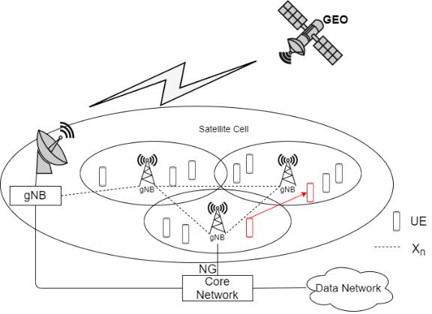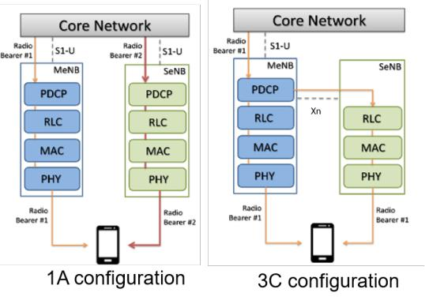

**FIGURE 2.** Radio protocol architecture for multi-connectivity [23].

allocated to UEs by a gNB. Each 5G terrestrial cell has some available PRBs based on the system bandwidth and the CS. Furthermore, the PRB bandwidth depends on the CS, and one PRB occupies bandwidth equal to the number of consecutive sub-carriers into the CS. For the NTN, satellite bandwidth is assigned to UEs according to their required data rates using the Shannon capacity formula [22].

**B. MEASUREMENT REPORT TRIGGERING**

The purpose of the measurement report is to transfer mea-surement results from the UEs to the network. In 5G, reference signal received power (RSRP) measurements are important for mobility management. A network lets UEs report the signal quality of the current cell, i.e., serving

**TABLE 1.** Supported 5G transmission numerology [21]

|  |  |  |  |
| --- | --- | --- | --- |
| Subcarrier | Slot | Duration | Max. Bandwidth |
| Spacing (KHz) | (ms) |  | (MHz) |
| 15 | 1 |  | 50 |
|  |  |  |  |
| 30 | 0.5 |  | 100 |
|  |  |  |  |
| 60 | 0.25 |  | 200 |
|  |  |  |  |
| 120 | 0.125 |  | 400 |
|  |  |  |  |
|  |  |  |  |

3

This work is licensed under a Creative Commons Attribution 4.0 License. For more information, see https://creativecommons.org/licenses/by/4.0/.

This article has been accepted for publication in a future issue of this journal, but has not been fully edited. Content may change prior to final publication. Citation information: DOI  10.1109/ACCESS.2020.3010059, IEEE Access

cell, and the target cell. The 3GPP defined several sets of predefined measurement report mechanisms to be executed by UEs and these predefined measurement report types are called event. For 5G, there are six events (A1, A2, A3, A4, A5 and A6) for intra-RAT measurements and two events (B1 and B2) for inter-RAT measurements were specified and discussed in [24]. We consider both intra-RAT and inter-RAT offloading for load balancing among 5G cells. However, events for intra-RAT measurements are used in this work to determine edge UEs and target neighboring cells for intra-RAT offloading. UEs are in the coverage area of a satellite cell, therefore, there is no need to determine edge UEs and target neighboring cells for inter-RAT offloading. Data flows of the UEs and traffic loads of the serving cells are considered for inter-RAT offloading.

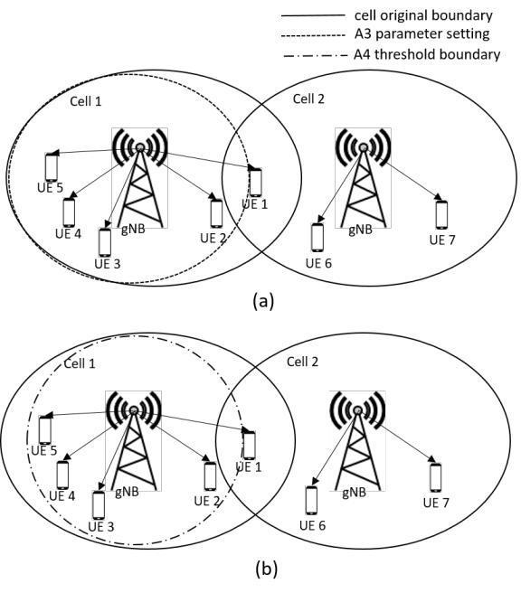

Two events (A3 and A4) are considered for intra-RAT load balancing in this paper. Event A3 is the most suitable for finding the best neighboring cells for handover of UEs [15], and A3 is widely used for inter-RAT handovers in wireless networks [25]. Event A3 is triggered when the signal of a neighboring cell is offset better than the serving cell, and UEs report measurements to the serving cell. The following

|  |  |  |  |  |  |
| --- | --- | --- | --- | --- | --- |
| equation shows the trigger condition of the A3 event | | |  | **FIGURE 3.** Events A3 and A4 for the algorithm: (a) A3 event parameter |  |
|  | settings for load balancing, and (b) getting candidate edge UEs and target cell |  |
| Mn + Of n + Ocn | Hys > Mp + Of p + Ocp + Of f | | | information using A4 event parameters. |  |
|  |  |
| where Mn and Mp are the RSRP of the neighboring cell | | | | Measurement reports by UEs after triggering event A3 are |  |
| and the current cell, | respectively. Of n and Of p | | are the |  |
| used to determine the threshold for A4 events, as done |  |
| frequency-specific offsets, and Ocn and Ocp are the cell in- | | | |  |
| in [15]. UEs that satisfy condition (1) will report the RSRP |  |
| dividual offsets for the target and serving cells, respectively; | | | |  |
| for the serving cell as well as neighboring cells. For example, |  |
| Hys is the hysteresis parameter; and Of f is the A3 event off- | | | |  |
| in Figure 3b, UE 1 reports measurements to cell 1 because it |  |
| set between the serving cell and the target neighboring cell. | | | |  |
| is outside the A4 event boundary of serving cell 1. Hence, |  |
| The frequency-specific offsets are used for inter-frequency | | | |  |
| cell 1 reduces the Ocn of target cell 2 to offload UE 1 to |  |
| handover, and therefore, we forgo Of n and Of p | | | in this |  |
| the target cell. Based on the event A4 boundary, a cell will |  |
| paper. The intra-RAT handover decision changes based on | | | |  |
| obtain edge UEs’ information and will list candidate UEs, |  |
| the values of Ocn, Ocp, and Of f. Based on the load status | | | |  |
| E = fe1; :::; eng where ei is the edge UE i for 0 i n, |  |
| of a cell load, the A3 variables (Ocn, Ocp and Of f) are | | | |  |
| changed to intentionally delay or hasten the handovers of | | | | for intra-RAT load balancing. |  |
|  |  |
| UEs. |  |  |  | **C. FLOW CLASSIFICATION IN 5G** |  |
| Consider Figure 3a, where cell 1 is overloaded with five | | | |  |
| To exploit multi-RAT connectivity in 5G networks, it is |  |
| UEs, and neighboring cell 2 has less of a load. There are | | | |  |
| necessary to steer traffic across the available access networks |  |
| two edge UEs in cell 1, i.e., UE 1 and UE 2, which can | | | |  |
| optimally. A delay incurred by satellite access is orders of |  |
| be moved to a neighboring cell to reduce the cell 1 load. | | | |  |
| magnitude higher than its terrestrial counterpart. That is, in |  |
| Either by decreasing Ocn and increasing Ocp, the range of | | | |  |
| addition to achieving balanced radio resource utilization, we |  |
| cell 1 decreases and UE 1 can be offloaded to the cell 2 gNB | | | |  |
| need to guarantee that delay-sensitive traffic is forwarded |  |
| to balance the network. For offloading UEs to a particular | | | |  |
| only through terrestrial access, whereas delay-tolerant traffic |  |
| neighboring cell, only the Ocn parameter is adjusted, based | | | |  |
| can be served through a satellite when the terrestrial network |  |
| on the RRUR of the | serving | cell. Hence, event A3 will | |  |
| load surpasses a given threshold. To do so, it is necessary to |  |
| be used to find a suitable target cell for offloading UEs of | | | |  |
| classify data flows into different QoS classes. |  |
| overloaded cells for intra-RAT load balancing. Moreover, | | | |  |
| In the 5G CN, a session management function (SMF) is |  |
| information on the edge UEs of the overloaded cells is also | | | |  |
| introduced for the 5G QoS model [20]. The SMF manages |  |
| needed prior to handover. For that purpose, event A4 is used | | | |  |
| the protocol data unit (PDU) session, which is a logical |  |
| to sort the outskirt UEs of the cell. Since event A4 is triggered | | | |  |
| connection between UEs and the data network (DN), and |  |
| when the RSRP of neighboring cell Mn becomes better than | | | |  |
| the related QoS flows in the CN. The SMF assigns a QoS |  |
| a provided threshold, T hresh. So, event A4 is defined as | | | |  |
| flow identifier (QFI) and a QoS profile to a flow based on |  |
|  |  |  |  |  |
| Mn + Of n + Ocn | | Hys > T hresh | (1) | information provided by the policy control function. A QFI |  |
| 4 |  |  |  | VOLUME 4, 2016 |  |

This work is licensed under a Creative Commons Attribution 4.0 License. For more information, see https://creativecommons.org/licenses/by/4.0/.

This article has been accepted for publication in a future issue of this journal, but has not been fully edited. Content may change prior to final publication. Citation information: DOI

10.1109/ACCESS.2020.3010059, IEEE Access

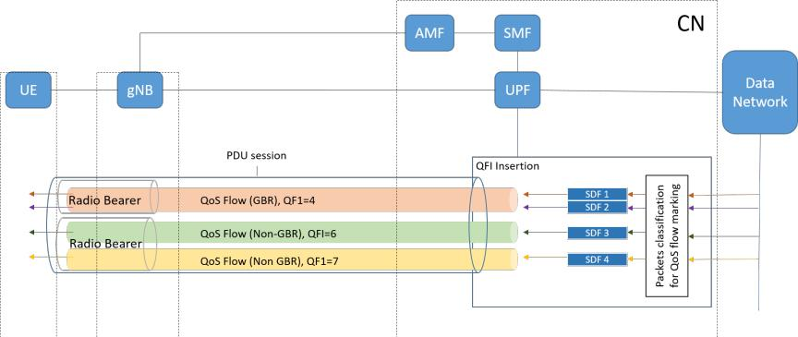

**FIGURE 4.** The 5G QoS model.

value corresponds to a particular QoS flow, and each QoS flow is identified by the QFI. The service data flows (SDFs), which are groups of IP flows/packets, are classified based on IP flows received from a DN. Later, SDFs with the same QoS characteristics are grouped together in the 5G QoS flow and are marked with the same QFI. The SMF provides the user plane function (UPF) with the packet detection rules (PDRs) for mapping SDFs to the QoS flows. Each QoS flow is defined by a QoS profile, and the QoS profile identifies the 5G QoS characteristics with a 5G QoS Identifier (5QI). Based on the 5QI value, 5QI-to-QoS characteristic mapping is provided [20]. Furthermore, the PDB is defined for a QoS flow based on the 5QI value of the flow [20]. For example, the PDB is 150 ms for a 5QI value equal to 2, and the flow is considered delay-sensitive. The QoS flow model based on [26] is shown in Figure 4.

For the multi-RAT network, SDFs with same QoS flow can be directed to a particular RAT, and then, the SMF sends the QoS profile to the gNB via the access and mobility management function (AMF). Our work exploits the SMF service to maintain different queues for delay-sensitive and delay-tolerant flows by offloading flows to different RATs. Based on the QoS flows of the UEs, the data planes of the UEs switch to different RATs using the 5G QoS model.

**D. LOAD MEASUREMENT IN 5G MULTI-RATS**

Proper load measurement of cells is crucial for optimizing the performance of a network through load balancing. For that purpose, a common load measurement metric is needed to measure the load of each RAT in a multi-RAT network. For LTE networks, PRB allocation information, called the resource block utilization ratio (RBUR), is mainly used to determine overloaded cells. For any given time, T , the aver-age RBUR of a cell n, RBn, is expressed in [15] as

|  |  |  |  |  |  |  |  |
| --- | --- | --- | --- | --- | --- | --- | --- |
|  |  |  |  | 1 | 2(X | (2) |  |
|  |  |  |  |  |
|  |  |  |  |  |  |
| RBn = T | | |  | NPRB |  |
|  | RBn ; |  |
|  |  |  |  |  | tT;t) |  |  |

where RBn and NP RB are the number of allocated resource blocks and the total number of resource blocks in the cell, respectively. Similarly, PRB allocation information can also

be used to measure the load of 5G RAT. However, the total number of PRBs, NP RB, in 5G changes dynamically with changes in subcarrier spacing [21]. Therefore, the RBUR cannot be directly used to measure the cell load in 5G RAT. Furthermore, radio resources are not allocated in terms of the PRBs in an NTN. Since, we need a common met-ric/parameter to measure the radio resources utilization of different RATs for a 5G multi-RAT network.

In this paper, we introduce the radio resource usage ra-tio (RRUR) as a load measurement metric for the multi-RAT network. We defined RRUR as the ratio of bandwidth used by RAT to the total RAT bandwidth. For 5G RAT, the RRUR is calculated based on PRB allocation information and resource block bandwidth. For any given time, T , the RRUR of cell n in 5G RAT is calculated as

|  |  |  |  |  |  |  |
| --- | --- | --- | --- | --- | --- | --- |
|  |  | 1 | | 2(X | (3) |  |
|  |  |  |  |  |
| n = T | |  | !n |  |
|  | & ; |  |
|  |  |  |  | tT ;t) |  |  |

where !n is the total bandwidth of 5G cell n, and and & are the allocated PRBs and resource block bandwidth at time , respectively. The resource block bandwidth depends on the numerologies.

In NTN RAT, bandwidth utilization by the satellite de-termines the satellite load. The RRUR of satellite cell S is calculated as

|  |  |  |  |  |  |  |
| --- | --- | --- | --- | --- | --- | --- |
|  |  |  | 1 | 2(X | (4) |  |
|  |  |  |  |  |
| S = T | |  | !sat |  |
|  | ; |  |
|  |  |  |  | tT ;t) |  |  |

where is the bandwidth allocated to UEs based on the Shannon formula and !sat is the total bandwidth of the satellite at time .

Based on the common load measure metric, i.e., RRUR, load distribution among cells of different RATs is deter-mined. A higher RRUR of a cell indicates that the cell has a higher load to serve and fewer available resources. If RRUR is more than a predefined threshold, the cell is over-loaded, and UEs moving to that cell will either be dropped or will experience low data rates. Hence, new UEs in an overloaded cell will reduce the per UE data rates. Therefore, it is necessary to reduce the load of the overloaded cell by

|  |  |
| --- | --- |
| VOLUME 4, 2016 | 5 |

This work is licensed under a Creative Commons Attribution 4.0 License. For more information, see https://creativecommons.org/licenses/by/4.0/.

This article has been accepted for publication in a future issue of this journal, but has not been fully edited. Content may change prior to final publication. Citation information: DOI  10.1109/ACCESS.2020.3010059, IEEE Access

switching the data plane of some UEs to a lightly loaded cell or another RAT. Furthermore, the RRUR overcomes the different physical layer channels properties of each RAT in a 5G multi-RAT network. Hence, the physical layer channel of each RAT does not affect the problem formulation of load balancing in 5G integrated satellite-terrestrial networks.

**E. PROBLEM FORMULATION**

In a network, if the RRUR of a RAT cell is close to 1, a user that moves into the cell will either be dropped or will experience a low data rate. Hence, a new user in an overloaded cell will reduce the per-user data rate, which affects the QoS of the UEs. To reduce the RRUR of a cell, load balancing among cells is necessary. In load balancing, the total network load is shared among the cells. For that purpose, loads from overloaded cells offload to underloaded neighboring cells in the same RAT, referred to as intra-RAT load balancing. Another option is inter-RAT load balancing in which UEs of the overloaded cell move to another RAT to balance the cellular network.

We formulate the problem of load balancing as one of reducing the RRUR of the terrestrial cells to a target RRUR,

, such that the square distance between the cell RRUR and is minimized. A multi-RAT network consists of a set of cells, N , in which there is a set of terrestrial cells, T , and a satellite cell, S , i.e., N = T [ S, and I users. The problem can be expressed as

X

min j nj2

8n2T (5)

subject to: S T hradp;

i ; 2 N

i

where n is the RRUR of terrestrial cell n, S is the RRUR of a satellite cell S, T hradp is the adaptive threshold, i is the resource allocated to user i by cell , and i is the resources required by user i, from which i is calculated based on the minimum data rate required by UE i. The cell allocates resources to UEs based on the UEs’ required data rates and the channel quality.

To estimate , mean square estimation of n can be phrased as was done in [27]. Consider random variable y and the mean square estimation of y by constant c as follows:

* 1

|  |  |  |  |  |
| --- | --- | --- | --- | --- |
| E[(c y)2] = | | | (c y)2f(y)dy |  |
| The difference, jc yj, is minimum if | | | |  |
|  | de |  | = 0 |  |
|  | dc | |  |
|  |  |  |

Because the difference depends on c, constant c is equal to

* 1

c = yf(y)dy

6

Algorithm 1 Proposed load balancing algorithm

1. function Load_Balance (void)
2. info_gather ()
3. for all o 2 O do
4. intRAlb ( o; T hradp)
5. Determine S using (4)
6. if S T hradp and o T hradp then
7. intERlb ( o; S; T hradp)
8. end if
9. end for

**TABLE 2.** Definitions of notations used in the proposed algorithm

|  |  |  |  |  |
| --- | --- | --- | --- | --- |
|  | Notations | | Definitions |  |
|  |  |  |  |  |
|  |  |  | Average RRUR of 5G cells |  |
|  | |  |  |
|  | n | | RRUR of terrestrial cell n |  |
|  | S | | RRUR of the satellite cell |  |
|  | ^i | | Estimated resource utilization of cell n |  |
|  | n | |  |
|  |  |  | by UE i |  |
|  | i | | Required PRBs by UE i |  |
|  |  | i | Allocated bandwidth assigned to UE i |  |
|  |  |  | by the satellite |  |
|  | T hradpt | | Adaptive threshold to find an overloaded |  |
|  |  |  | cell |  |
|  | thrinit | | Initial threshold |  |

and E[y] = R 1 yf(y)dy, and thus

|  |  |
| --- | --- |
| c = E[y] | (6) |

Considering (5) and (6), is equal to

|  |  |
| --- | --- |
| = E[ n] | (7) |

Hence, is expected RRUR of terrestrial cells.

**III. THE PROPOSED ALGORITHM**

The proposed algorithm balances the load in 5G RAT based on data flows of UEs and by considering cell load status in a 5G multi-RAT network. The algorithm runs in each 5G gNB and initiates load balancing when terrestrial cells are overloaded. The proposed algorithm consists of three parts: information gathering, intra-RAT load balancing, and inter-RAT load balancing. For load balancing in 5G cells, the algorithm first gathers information on the load status of the cells using a function call info_gather. After that, loads from overloaded 5G cells are released to underloaded cells by calling a function called intRAlb. At the end, based on the load status of the cells, the algorithm calls a function called intERlb to transfer terrestrial loads to NTN RAT. Each part of the proposed algorithm is described in the subsections below. Algorithm 1 shows the proposed algorithm’s process and Table 2 defines the notations used in the algorithm.

**A. INFORMATION GATHERING**

For gathering the information, the function, info_gather (), measures the load of terrestrial cells, i.e., the RRUR, us-

VOLUME 4, 2016

This work is licensed under a Creative Commons Attribution 4.0 License. For more information, see https://creativecommons.org/licenses/by/4.0/.

This article has been accepted for publication in a future issue of this journal, but has not been fully edited. Content may change prior to final publication. Citation information: DOI

10.1109/ACCESS.2020.3010059, IEEE Access

Algorithm 2 Information gathering

1. function info_gather ()
2. Get RRUR of terrestrial cells T
3. Compute average 5G cell load
4. Determine T hradpt
5. Establish a set of overloaded cells, O ( T
6. T hradpt; O

bandwidth of target cell k. Before offloading UE e1 to cell k, the algorithm checks the following conditions in order to restrict the target cell load to below overload status and to avoid unnecessary offloading of UEs to neighboring cells,

|  |  |  |  |  |  |  |  |
| --- | --- | --- | --- | --- | --- | --- | --- |
| i.e., to avoid ping-pongs: | |  |  |  |  |  |  |
|  | ^e1 | | < T hradpt | |  | (11) |  |
| k + | k |  |  |
|  |  |  |  |  |  |  |
| o | ^e1 | > | | ^e1 | : | (12) |  |
| o | k + k |  |

|  |  |  |  |  |  |  |  |  |  |  |  |  |  |  |  |  |  |  |  |  |  |  |  |  |
| --- | --- | --- | --- | --- | --- | --- | --- | --- | --- | --- | --- | --- | --- | --- | --- | --- | --- | --- | --- | --- | --- | --- | --- | --- |
| ing (3), and then, the average load of 5G cells is calculated | | | | | | | | | | If the above conditions are satisfied, UE e1 moves to target | | | | | | | | | | | | | |  |
| using (7). To estimate the overload status of a cell, adaptive | | | | | | | | | | cell | k. After offloading UE e1, the RRURs of the previous | | | | | | | | | | | | |  |
| threshold T hradpt is determined as follows | | | | | | | | |  | and current serving cells are updated as follows: | | | | | | | | | | | | |  |  |
|  |  |  |  |  |  |  |  |  | (8) |  |  |  |  |  |  | o = o | | | | | ^i |  |  |  |
| T hradpt = max( ; thrinit) | | | | | | | | |  |  |  |  |  |  |  |  |  |
|  |  |  |  |  |  | o; and | |  |  |
|  |  |  |  |  |  |  |  |  |  |  |  |  |  |  |  |  | |  |  | = k | ^e1 | : |  |  |
| where thrinit is the fixed initial threshold used to determine | | | | | | | | | |  |  |  |  |  |  | k | | + |  |  |
|  |  |  |  |  |  |  |  |  |  |  | k |  |  |  |
| whether there is a need for load balancing in the network. | | | | | | | | | |  |  |  |  |  |  |  |  |  |  |  |  |  |  |  |
| The adaptive threshold, T hradpt, is used to adopt the network | | | | | | | | | |  |  |  |  |  |  |  |  |  |  |  |  |  |  |  |
| Then, and T hradpt are updated. The same process repeats | | | | | | | | | | | | | |  |
| load. The network load can vary over time because of user | | | | | | | | | |  |
| for each UE in Eo based on the cell loads. Algorithm 3 | | | | | | | | | | | | | |  |
| mobility and variances in required data rates of the UEs. | | | | | | | | | |  |
| summarizes the function intRAlb ( o; T hradp). | | | | | | | | | | | | |  |  |
| After that, the algorithm estimates the overload status of a | | | | | | | | | |  |  |
|  |  |  |  |  |  |  |  |  |  |  |  |  |  |  |
| cell by using the following condition | | | | | | | | |  |  |  |  |  |  |  |  |  |  |  |  |  |  |  |  |
|  | Algorithm 3 Intra-RAT load balancing | | | | | | | | | | | | |  |  |
|  |  |  |  |  |  |  |  |  |  |  |  |
| n > T hradpt; | | | | | | | n 2 T | | (9) | 1: | function intRAlb ( o; T hradp) | | | | | | | | | | |  |  |  |
| and establishes a set, O, of terrestrial cells that satisfy the | | | | | | | | | | 2: Get candidate edge UEs, Eo | | | | | | | | | | | |  |  |  |
| 3: | Sort Eo in ascending order of RSRP and arrange accord- | | | | | | | | | | | | |  |
| above condition, where O ( T . The process of information | | | | | | | | | |  | ing to data flow type. | | | | | | | | | |  |  |  |  |
| gathering is summarized in Algorithm 2. | | | | | | | | |  | 4: | for i | | | 1 : jEoj do | | | | | |  |  |  |  |  |
|  |  |  |  |  |  |  |  |  |  |  |  |  |  |  |
| **B. INTRA-RAT LOAD BALANCING** | | | | | | | | |  | 5: |  |  | Determine set | | | | |  | ei of target cells for UE ei | | | |  |  |
|  | 6: |  |  | for | k | 1 : | j |  |  |  |  |  |  |  |  |
| In intra-RAT load balancing, UEs from an overloaded cell, | | | | | | | | | |  |  |  | e | |  |  |  |  |  |
| 7: |  |  |  |  | ^ei1 j do | | | |  |  |  |  |
| o 2 O, move to underloaded neighboring cells. The function | | | | | | | | | |  |  |  | Estimate | | | |  |  | using (10) | |  |  |  |
| 8: |  |  |  | if (11) and (12) are satisfied then | | | | | | | | |  |  |
|  |  |  |  |  |  |  |  |  |  |  |  |  |  |  |  |  |  |  | k |  |  |  |  |  |
| gathers information on the edge UEs that are moved from | | | | | | | | | | 9: |  |  |  |  | Offload flow of UE ei to the target cell | | | | | | | | k |  |
| overloaded cell o. For that purpose, the function establishes | | | | | | | | | |  |  |  |  |  |
| 10: |  |  |  |  | Update RRUR information | | | | | | | |  |  |
| a set, o, of edge UEs that report measurements to serving | | | | | | | | | |  |  |  |  |  |  |
|  |  |  |  |  |  |  |  |  |  | ^ei |  |  |  |  |
| cell o based on the A3 event measurement reports. Then, | | | | | | | | | | 11: |  |  |  |  | o |  | o | | | o |  |  |  |  |
|  |  |  |  |  | k |  |  |  |  | ^ei | |  |  |  |
| another set of UEs is created, Eo | | | | | | |  | o, which report the | | 12: |  |  |  |  |  |  |  | | k + |  |  |  |  |
|  | 13: |  |  |  |  | Update and T hradpt | | | | | | |  |  |  |
|  |  |  |  |  |  |  |  |  |  |  |  |  |  |  |  |  |  |  |  |  | k |  |  |  |
| RSRPs of neighboring cells to the serving cell o during an | | | | | | | | | | 14: |  |  |  |  | break; | | |  |  |  |  |  |  |  |
| event A4. The UEs in Eo | | = fe1; ::; eng are then sorted | | | | | | | |  |  |  |  |  |  |  |  |  |  |  |
| 15: |  |  |  | end if | |  |  |  |  |  |  |  |  |  |
| in ascending order of serving cell RSRPs and the UEs are | | | | | | | | | | 16: |  |  | end for | | |  |  |  |  |  |  |  |  |  |
| arranged according to data flow type. For intra-RAT load | | | | | | | | | |  |  |  |  |  |  |  |  |  |  |  |
| 17: |  |  | if o T hradpt then | | | | | | | |  |  |  |  |
| balancing, first the UEs of Eo with delay-sensitive flows, | | | | | | | | | |  |  |  |  |  |  |
| and then UEs with delay-tolerant flows, move to underloaded | | | | | | | | | | 18: |  |  |  | break; | |  |  |  |  |  |  |  |  |  |
| 19: |  |  | end if | |  |  |  |  |  |  |  |  |  |  |
| neighboring cells one by one based on the load status of cell | | | | | | | | | |  |  |  |  |  |  |  |  |  |  |  |  |
| 20: end for | | | | |  |  |  |  |  |  |  |  |  |  |
| o. |  |  |  |  |  |  |  |  |  |  |  |  |  |  |  |  |  |  |  |
|  |  |  |  |  |  |  |  |  | 21: return o, T hradpt | | | | | | | | | |  |  |  |  |  |
| Based on event A3, the target neighboring cell is deter- | | | | | | | | | |  |  |  |  |  |
|  |  |  |  |  |  |  |  |  |  |  |  |  |  |  |
| mined in order to offload UE e1 2 Eo. from overloaded cell | | | | | | | | | |  |  |  |  |  |  |  |  |  |  |  |  |  |  |  |
| o. The set e1 = f 1; | 2; :::; | |  | mg denotes the neighboring | | | | | | **C. INTER-RAT LOAD BALANCING** | | | | | | | | | | | |  |  |  |
| cells reported by UE e1 to serving cell o under event A4. | | | | | | | | | |  |  |  |
| The neighboring cells are listed in descending order of RSRP | | | | | | | | | | After intra-RAT load balancing, the algorithm again checks | | | | | | | | | | | | | |  |
| values, i.e., the RSRP for | | 1 is greater than | | | | | | | 2. To offload | the load status of the cell o. If the cell is still overloaded, | | | | | | | | | | | | | |  |
|  |  |  |  | ^e1 | | | , the resource utilization | | | i.e., o > T hradp, the algorithm performs inter-RAT load | | | | | | | | | | | | | |  |
| UE e1, the algorithm estimates | | | | | | |  |
| of target cell by UE e1 | . ^ | k |  |  | k | | | |  | balancing by transferring the load of cell o to satellite cell S | | | | | | | | | | | | | |  |
| is calculated based on (3) as | | | | | | |  |
|  | e1 | |  |  |  |  |  |  |  |  |  |  |  |  |  |  |  |  |  |  |  |  |  |  |
| follows: | ^e1 |  |  | e1 & | | | |  |  | by offloading the delay-tolerant flows of UEs if | | | | | | | | | | | | |  |  |
|  |  |  | (10) |  |  |  |  |  |  |  |  |  |  |  |  |  |  |  |
|  | k | = |  | ! k | | | | |  |  |  |  |  |  |  |  |  | S < T hradp | | |  | (13) |  |
| where e1 is the PRB of cell | | |  | k required by UE e1, & is | | | | | | To release the load of 5G cells to a satellite cell, the function | | | | | | | | | | | | | |  |
| the bandwidth of the resource block, and ! k is the total | | | | | | | | | | generate a set of UEs Eo = f"1; :::; "ng, where Eo denotes | | | | | | | | | | | | | |  |
| VOLUME 4, 2016 |  |  |  |  |  |  |  |  |  |  |  |  |  |  |  |  |  |  |  |  |  |  | 7 |  |

This work is licensed under a Creative Commons Attribution 4.0 License. For more information, see https://creativecommons.org/licenses/by/4.0/.

This article has been accepted for publication in a future issue of this journal, but has not been fully edited. Content may change prior to final publication. Citation information: DOI  10.1109/ACCESS.2020.3010059, IEEE Access

the UEs of cell o with delay-tolerant data flows. After that, UEs in Eo are sorted in ascending order of RSRPs from cell o and data flows of UEs in Eo are offloaded to a satellite link one by one. Before offloading UE "1, the function first

^"

estimates S1 , i.e., the resource utilization of the satellite by ^"

UE "1. Then, S1 is calculated using the Shannon formula based on the data rate required by the UE:

^ "

"1 1

S = !sat

where "1 is the bandwidth allocated to UE "1. Then, the algorithm checks the following condition to offload UE "1 to NTN user plane:

|  |  |  |  |
| --- | --- | --- | --- |
| ^"1 | < T hradp | (14) |  |
| S + S |  |

The above condition prevents the satellite from being over-loaded. For the offloading of data flows, the UPF directs the flow of UE "1 to NTN gNB as we considered the separate user plane for each RAT. And the SMF sends QoS policy information based on the 5QI to the NTN gNB through AMF as described II-C. The proposed algorithm offloads the UEs to the satellite cell irrespective of the position of UEs in the cell, since all UEs are within the coverage area of the satellite. After offloading of UE "1, the algorithm updates the RRURs of terrestrial cell o and satellite cell S as follows:

|  |  |  |  |
| --- | --- | --- | --- |
| ^"1 | | ; and |  |
| S=S+S |  |  |
| ^"1 | : |  |  |
| o = oo |  |  |

Then the algorithm updates and T hradp. The algorithm again checks the RRURs of the satellite and cell o and repeats the process for each UE of Eo. Algorithm 4 summarizes the function intERlb ( o; S; T hradp).

Algorithm 4 Inter-RAT load balancing

1. function intERlb ( o; S; T hradp)
2. Get list of UEs with delay-tolerant flows, Eo
3. Sort UEs in ascending order of RSRP
4. for i 1 : jEoj do
5. if S < T hradpt then

|  |  |  |  |  |  |
| --- | --- | --- | --- | --- | --- |
| 6: |  | ^"i | | using (14) |  |
| Estimate S | | |  |
| 7: | if (14) is satisfied then | | | |  |
| 8: | UPF offloads flow of UE to satellite gNB | | | |  |
| 9: | Update RRUR | | | |  |
| 10: | S |  |  | ^"i |  |
| S + S | | |  |
| 11: | o | o | | ^"i |  |
| o |  |
| 12: | Update | |  | and T hradp |  |
| 13: | end if |  |  |  |  |
| 14: | else |  |  |  |  |
| 15: | break; |  |  |  |  |
| 16: | end if |  |  |  |  |
| 17: | if o T hradp then | | | |  |
| 18: | break; |  |  |  |  |
| 19: | end if |  |  |  |  |

20: end for

8

When UEs moves to a satellite, they will experience a long delay. However, offloading UEs with delay-tolerant data flows will not affect the QoS of the UEs, whereas UEs with delay-sensitive data are served by the 5G RAT. Similar to NTNs, the proposed algorithm can be extended to other RATs, i.e., unmanned aerial vehicle (UAV) communication systems [28]. Based on the RRUR, the load status of a RAT can be determined and UEs from an overloaded cell move to the RAT, taking into account the minimum QoS requirements of the users.

We analyzed the computational complexity of the pro-posed algorithm using big O notation1. For load balancing of a terrestrial cell network, the considered number of cells in a multi-RAT network under the proposed algorithm is jNj, which represents the number of cells in set N . Set

* consists of jT j terrestrial cells and a satellite cell S. Therefore, the maximum numbers of cells to be considered for intra-RAT and inter-RAT load balancing are jT j and jNj, respectively. Similarly, the maximum numbers of target cells in intra-RAT and inter-RAT offloading are limited by the jT j terrestrial cells and satellite cell S, respectively. In addition to the number of cells for load balancing, the algorithm also considers UEs in the network, and the number of considered UEs under the algorithm is I.

Since there are, at most, jT j serving and target cell pairs and I UEs involved in intra-RAT offloading, the loop in the intra-RAT offloading function of Algorithm 3 should take O(jT j) + O(I). In the case of inter-RAT offloading, there are, at most, I UEs, and only one pairing of a terrestrial serving cell and a target satellite cell involved. Hence, the loop in the inter-RAT offloading function of Algorithm 4 should take O(I). Furthermore, the number of overloaded cells is bounded by the number of terrestrial cells, jT j. So, the overall computational complexity of the proposed load balancing algorithm becomes O(jT j2)+O(IjT j). Generally, I >> jT j, so we can say that the computational complexity for the proposed load balancing algorithm is O(IjT j).

**IV. PERFORMANCE EVALUATION**

**A. SIMULATION ENVIRONMENTS**

We considered a 5G multi-RAT network including a satellite RAT and a 5G RAT. In the satellite RAT, a GEO satellite was connected to an NTN gNB through a ground station. The gNB was connected with a 5G CN that provided access to the public data network. There were seven 5G small cells deployed in a hexagonal pattern. A single satellite cell covered the whole terrestrial network. We considered 110 UEs in the network, and the required data rates for each UE were 5 Mbps to 15 Mbps. Regarding the UEs’ distribution over the network area, UEs were randomly distributed among the cells. Half of them were static, and half were in random motion.

* Big O is a notation for asymptotic behavior of functions. Suppose f and g are real valued functions; therefore, f(x) = O(g(x)) if and only if there exists a positive integer, N, and a positive constant, c, such that jf(x)j cjg(x)j, 8x > N.

VOLUME 4, 2016

This work is licensed under a Creative Commons Attribution 4.0 License. For more information, see https://creativecommons.org/licenses/by/4.0/.

This article has been accepted for publication in a future issue of this journal, but has not been fully edited. Content may change prior to final publication. Citation information: DOI

10.1109/ACCESS.2020.3010059, IEEE Access

**FIGURE 5.** Uniformly deployed 5G cell network.

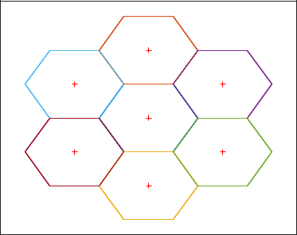

**TABLE 3.** Simulation parameters

|  |  |
| --- | --- |
| Parameters | Values |
|  |  |
| Number of terrestrial cells | 7 |
| Tx power of terrestrial RAT | 46 dBm |
| Terrestrial RAT bandwidth | 20 MHz |
| Terrestrial path loss | P L = 147:4 + 43:3log10(d) |
| Satellite bandwidth | 500 MHz (C band) |
| Satellite altitude | 35780 Km |
| Number of transponders | 12 |
| Number of UEs | 110 |
| UEs data rates | 5-15 Mbps |
| Initial threshold | 75% |
|  |  |

In the network, 70% of the UEs had delay-tolerant traffic, while the remaining UEs had delay-sensitive traffic. The UEs with delay-tolerant data flows had carrier spacing of 15KHz, and UEs with delay-sensitive data flows had either 15 KHz or 30 KHz carrier spacing. Transmission power was set to 46 dBm for 5G cells, and the bandwidth was 20 MHz. For the satellite, the C band was used for communications, and bands of frequencies from 3.7 to 4.2 GHz were used for downlink. The satellite had a channel bandwidth of 500 MHz and 12 transponders. Each transponder had a bandwidth of 36 MHz and a guard band of 4 MHz between adjacent transponders to avoid interference. The simulation parameters are summa-rized in Table 3.

For the performance evaluation, we investigated the ef-fect of the proposed algorithm on load distribution across the network and on network throughput. RRUR, which is defined in equation (3), was used to check load distribution among the cells. To validate the performance of the proposed algorithm, which is based on intra-RAT and inter-RAT load balancing, we compared it with an adaptive mobility load balancing algorithm [15]. Further scenarios with various numbers of UEs and cell bandwidths were simulated to show the effectiveness of the proposed algorithm. For the sake of simplicity, we denote the proposed mobility load balancing (MLB) algorithm as adaptive multi-RAT MLB, the adaptive mobility load balancing algorithm as adaptive intra-

VOLUME 4, 2016

RAT MLB, and simulations without an MLB algorithm are denoted no MLB.

1. **IMPACT OF THE PROPOSED ALGORITHM ON LOAD DISTRIBUTION**

The algorithm’s impact on load distribution across the net-work cells in terms of RRUR was compared with adaptive intra-RAT MLB and no MLB algorithms. The scenario with the initial setting was simulated without the MLB algorithm as well as with the MLB algorithms, and the RRUR of the terrestrial cells are shown in Figure 6. Each time instance shows the RRUR of seven 5G cells. Figure 6a shows the RRUR of the cells when no MLB was considered, and some terrestrial cell loads were more than the threshold, showing the cells were overloaded. The blue dotted line in each plot of Figure 6 shows the adaptive threshold, which changed with the network load. As we can see in Figure 6a, some cells had an RRUR greater than the threshold, i.e.,0.82, and some cells were underloaded, with an RRUR of less than 0.7. Consider time instance 2, cell 4 shows a maximum RRUR of 0.99, whereas cell 1 shows a minimum RRUR of 0.71, and the gap is 0.28. The RRURs of the cells with the adaptive intra-RAT MLB are shown in Figure 6b. As we can see in the figure, load from the overloaded cell moves to the underutilized cell to balance the network, and the gap between the maximum RRUR and the minimum RRUR was reduced to 0.10 in time instance 5. Although the adaptive intra-RAT MLB algorithm reduced the RRUR of the overloaded cells, cells had an RRUR greater than the threshold.

The RRURs of 5G cells were reduced to defined threshold under the adaptive multi-RAT MLB, as shown in Figure 6c. With the adaptive multi-RAT MLB, first the load from over-loaded cells was released to underloaded neighboring cells, which increased the resource utilization of the underloaded cells and decreased the load on highly utilized cells. After that, the excess load from the overloaded cell, i.e., center UEs with a delay-tolerant data flow, moved to the satellite cell, which further reduced the load of the overloaded cells to the defined threshold. This eventually reduced the gap between the maximum RRUR and minimum RRUR until it reached 0.019. The RRUR of each terrestrial cell decreased to the threshold and the terrestrial cells network was evenly balanced under the adaptive multi-RAT MLB, as shown in Figure 6c. The satellite serves the UEs with delay-tolerant flows by keeping the RRUR at less than the threshold, which is shown in Figure 7. Considering the load status of the satel-lite, new users can easily be accommodated in the network and the satellite can assign more resources to satisfy the QoS of the users.

Figure 8 shows the standard deviation of 5G cell loads with and without load balancing algorithms. The standard deviation of the RRUR under the adaptive multi-RAT MLB algorithm is close to zero, and less than the adaptive intra-RAT MLB due the fact that the data flows of the center UEs in the overloaded cell can be offloaded to the satellite. Hence, the adaptive multi-RAT MLB performs load balanc-

9

This work is licensed under a Creative Commons Attribution 4.0 License. For more information, see https://creativecommons.org/licenses/by/4.0/.

This article has been accepted for publication in a future issue of this journal, but has not been fully edited. Content may change prior to final publication. Citation information: DOI  10.1109/ACCESS.2020.3010059, IEEE Access

|  |
| --- |
| RRUR |

1

0.9

0.8

0.7

0.6

|  |  |  |
| --- | --- | --- |
|  | 1 |  |
|  | 0.8 |  |
| RRUR | 0.6 |  |
| 0.4 |  |
|  |  |
|  | 0.2 |  |
|  | 0 |  |

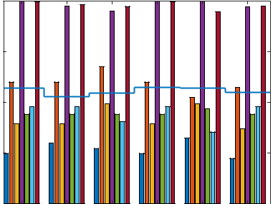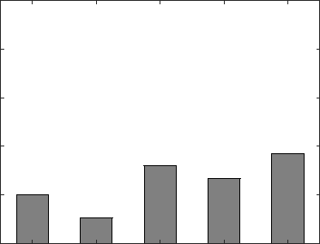

|  |  |  |  |  |  |  |  |  |  |  |  |
| --- | --- | --- | --- | --- | --- | --- | --- | --- | --- | --- | --- |
|  |  |  |  |  |  | 1 | 2 | 3 | 4 | 5 |  |
| 0 | 1 | 2 | 3 | 4 | 5 |  |
|  |  | TIME INSTANCE |  |  |  |
|  |  |  |  |  |  |  |  |  |  |  |
|  |  | TIME INSTANCE | |  |  |  |  |  |  |  |  |
|  |  |  | (a) |  |  | **FIGURE 7.** RRUR of the satellite. | |  |  |  |  |

|  |  |
| --- | --- |
|  | 1 |
|  | 0.9 |
| RRUR | 0.8 |
|  | 0.7 |
|  | 0.6 |

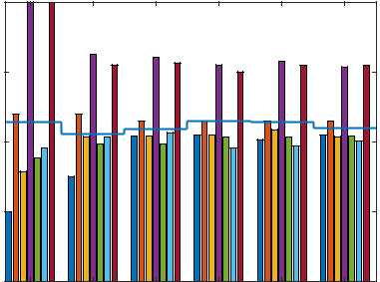

0 1 2 3 4 5

TIME INSTANCE

(b)

|  |  |
| --- | --- |
|  | 1 |
|  | 0.9 |
| RRUR | 0.8 |
|  | 0.7 |
|  | 0.6 |

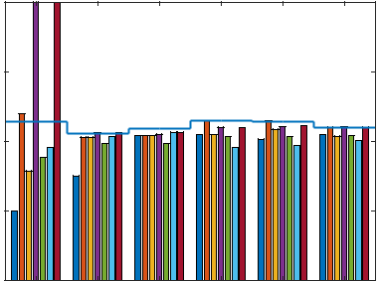

0 1 2 3 4 5

TIME INSTANCE

(c)

**FIGURE 6.** RRUR of terrestrial cells in the network (a) without the MLBalgorithm (b) with the adaptive intra-RAT MLB algorithm, and (c) with the adaptive multi-RAT MLB algorithm.

ing considering 5G RAT and NTN RAT resources together and effectively released the load to balance the terrestrial network. Furthermore, the proposed algorithm considers the limitations of adaptive MLB as well as QoS of the UEs.

1. **IMPACT OF THE MLB ALGORITHM ON NETWORK THROUGHPUT AND QOS**

The network performance in terms of average throughput and QoS of the UEs is shown in Figure 9. Without MLB, the resources of some cells were underutilized, whereas the UEs in overloaded cells could not have the required resources due to the scarcity of available resources. Therefore, the network

10

|  |  |  |  |  |  |  |  |
| --- | --- | --- | --- | --- | --- | --- | --- |
|  | 0.15 |  |  | no MLB |  |  |  |
|  |  |  |  | Adaptive intra-RAT MLB | |  |  |
| Deviation |  |  |  | Adaptive multi-RAT MLB | |  |  |
| 0.1 |  |  |  |  |  |  |
|  |  |  |  |  |  |  |
| Standard | 0.05 |  |  |  |  |  |  |
|  |  |  |  |  |  |  |
|  | 0 |  |  |  |  |  |  |
|  | 0 | 1 | 2 | 3 | 4 | 5 |  |

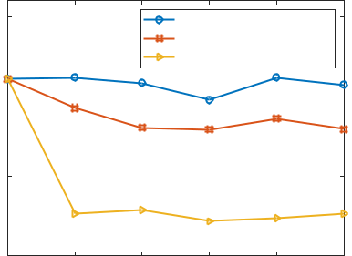

time instance

**FIGURE 8.** Standard deviation of RRUR among the cells of the 5G RAT.

had minimum throughput and fewer UEs getting the required resources, compared to load balancing algorithms. The adap-tive intra-RAT MLB increased both the number of satisfied UEs and network throughput, but it was still less than the adaptive multi-RAT MLB, as shown in Figure 9. Considering the intra-RAT and inter-RAT offloading of UEs, the adaptive multi-RAT MLB allocated enough resources to all the UEs. More resources were available to UEs from multiple RATs that fulfilled the UEs’ required data rates. The offloading of UEs from the overloaded cell to the neighboring cells, as well as to the satellite cell decreased the cell load and released more resources of the cells. This allowed the cells to allocate more resources to satisfy QoS of the UEs, and offloaded UEs got their required resources from the underloaded cells of different RATs, which satisfied the QoS of all UEs in the network, as shown in Figure 9a. These factors eventually led to an increase in overall network throughput, as shown in Figure 9b. Thus, from Figures 6, 8 and 9, we can say that the adaptive multi-RAT MLB not only increased network capacity but also satisfied the QoS of the UEs Furthermore, the adaptive multi-RAT MLB balanced the terrestrial cells efficiently by keeping the RRURs of the cells of each RAT to less than the defined threshold.

VOLUME 4, 2016

This work is licensed under a Creative Commons Attribution 4.0 License. For more information, see https://creativecommons.org/licenses/by/4.0/.

This article has been accepted for publication in a future issue of this journal, but has not been fully edited. Content may change prior to final publication. Citation information: DOI

10.1109/ACCESS.2020.3010059, IEEE Access

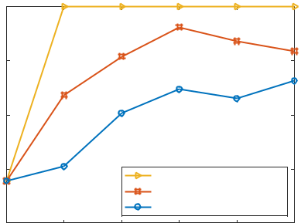

|  |  |  |  |  |  |  |  |
| --- | --- | --- | --- | --- | --- | --- | --- |
|  | 100 |  |  |  |  |  |  |
| UEs (%) | 95 |  |  |  |  |  |  |
| 90 |  |  |  |  |  |  |
| Satisfied |  |  |  |  |  |  |
| 85 |  |  | Adaptive multi-RAT MLB | |  |  |
|  |  |  |  |  |
|  |  |  |  |  |  |
|  |  |  |  | Adaptive intra-RAT MLB | |  |  |
|  |  |  |  | no MLB |  |  |  |
|  | 80 |  |  |  |  |  |  |
|  | 0 | 1 | 2 | 3 | 4 | 5 |  |

time instance

|  |  |  |  |  |  |  |  |
| --- | --- | --- | --- | --- | --- | --- | --- |
|  |  |  |  | (a) |  |  |  |
|  | 22 |  |  |  |  |  |  |
|  |  |  |  | Adaptive multi-RAT MLB | |  |  |
|  |  |  |  | Adaptive intra-RAT MLB | |  |  |
| (Gbps) | 20 |  |  | no MLB |  |  |  |
|  |  |  |  |  |  |
|  |  |  |  |  |  |  |
| throughput | 18 |  |  |  |  |  |  |
| 16 |  |  |  |  |  |  |
|  | 14 |  |  |  |  |  |  |
|  | 0 | 1 | 2 | 3 | 4 | 5 |  |

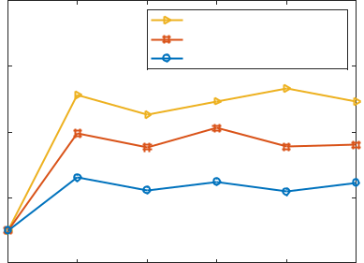

time instance

(b)

**FIGURE 9.** (a) The number of satisfied UEs in the network (b) Averagethroughput of the network.

**D. IMPACT OF VARIOUS NUMBERS OF USERS**

We studied the impact of various numbers of UEs in the network on the different approaches to load balancing. The network throughput and the standard deviation of the RRURs among terrestrial cells were observed. Network throughput increased under both of the MLB algorithms by increasing the number of UEs, as shown in Figure 10a. The adaptive multi-RAT MLB had more throughput as the resources of multiple RATs were efficiently utilized to satisfy the QoS flows of the UEs. However, the standard deviation in RRURs among terrestrial cells increased with the increasing numbers of UEs, as shown in Figure 10b. The standard deviation of the RRUR increased by a very small amount under the adaptive multi-RAT MLB, and by less than the adaptive intra-RAT MLB. The gap between maximum RRUR and minimum RRUR increased more under the adaptive intra-RAT MLB, compared to the adaptive multi-RAT MLB with the increasing numbers of UEs. The adaptive multi-RAT MLB with intra-RAT and inter-RAT offloading transferred loads that cannot move to terrestrial neighboring cells to the satellite cell. The RRUR of the satellite is shown in Figure 11, and the utilized resources of the satellite were less than half of the available resources with large number of UEs in the network. Thus, the proposed algorithm keeps the network balanced with a large number of UEs, keeping the RRUR of

VOLUME 4, 2016

|  |  |  |  |  |  |  |
| --- | --- | --- | --- | --- | --- | --- |
|  | 24 |  |  |  |  |  |
|  |  | Adaptive multi-RAT MLB | |  |  |  |
|  |  | Adaptive intra-RAT MLB | |  |  |  |
| (Gbps) | 22 |  |  |  |  |  |
|  |  |  |  |  |  |
| throughput | 20 |  |  |  |  |  |
| 18 |  |  |  |  |  |
|  | 16 |  |  |  |  |  |
|  | 110 | 120 | 130 | 140 | 150 |  |

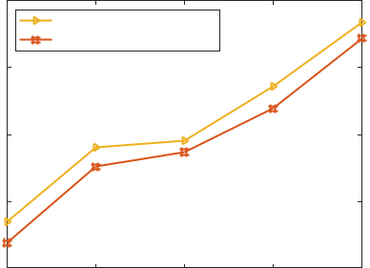

Number of UEs

|  |  |  |  |  |  |  |
| --- | --- | --- | --- | --- | --- | --- |
|  |  |  | (a) |  |  |  |
|  | 0.2 |  |  |  |  |  |
|  |  |  | Adaptive intra-RAT MLB | |  |  |
|  |  |  | Adaptive multi-RAT MLB | | |  |
| Deviation | 0.15 |  |  |  |  |  |
| 0.1 |  |  |  |  |  |
| Standard |  |  |  |  |  |
| 0.05 |  |  |  |  |  |
|  | 0 |  |  |  |  |  |
|  | 110 | 120 | 130 | 140 | 150 |  |

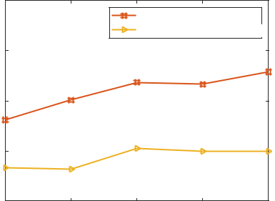

Number of UEs

(b)

**FIGURE 10.** Performance of the load balancing algorithms with differentnumbers of UEs: (a) average throughput of the network, and (b) standard deviation of RRUR among the cells of 5G RAT.

|  |  |  |
| --- | --- | --- |
|  | 1 |  |
|  | 0.8 |  |
| RRUR | 0.6 |  |
| 0.4 |  |
|  |  |
|  | 0.2 |  |

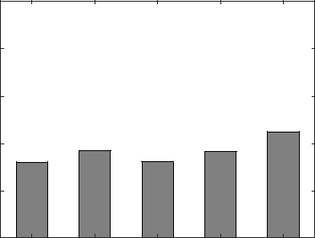

110 120 130 140 150

NUMBER OF UES

**FIGURE 11.** RRUR of the satellite cell.

the satellite minimal.

**E. IMPACT OF DIFFERENT CHANNEL BANDWIDTH**

We changed the terrestrial cell bandwidth to observe the impact on the load balancing algorithms. The standard de-viation of RRURs among terrestrial cells with different 5G cell bandwidth is shown in Figure 12. The standard deviation keeps decreasing when increasing the channel bandwidth in the adaptive intra-RAT MLB above the 30MHz bandwidth, and came close to matching the adaptive multi-RAT MLB. The available resources were increasing in the 5G RAT

11

This work is licensed under a Creative Commons Attribution 4.0 License. For more information, see https://creativecommons.org/licenses/by/4.0/.

This article has been accepted for publication in a future issue of this journal, but has not been fully edited. Content may change prior to final publication. Citation information: DOI  10.1109/ACCESS.2020.3010059, IEEE Access

|  |  |  |  |  |  |
| --- | --- | --- | --- | --- | --- |
|  | 0.1 |  |  |  |  |
|  |  |  | Adaptive intra-RAT MLB |  |  |
|  |  |  | Adaptive multi-RAT MLB |  |  |
| Deviation | 0.08 |  |  |  |  |
| 0.06 |  |  |  |  |
|  |  |  |  |  |
| Standard | 0.04 |  |  |  |  |
| 0.02 |  |  |  |  |
|  |  |  |  |  |
|  | 20 | 30 | 40 | 50 |  |

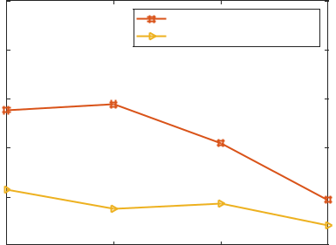

Bandwidth (MHz)

**FIGURE 12.** Standard deviation of RRURs among the terrestrial cells withvaried 5G cell bandwidths.

|  |  |  |  |  |  |
| --- | --- | --- | --- | --- | --- |
|  | 45 |  |  |  |  |
|  |  | Adaptive multi-RAT MLB |  |  |  |
|  | 40 | Adaptive intra-RAT MLB |  |  |  |
|  |  |  |  |  |
| (Gbps) | 35 |  |  |  |  |
|  |  |  |  |  |
| throughput | 30 |  |  |  |  |
| 25 |  |  |  |  |
|  |  |  |  |  |
|  | 20 |  |  |  |  |
|  | 15 |  |  |  |  |
|  | 20 | 30 | 40 | 50 |  |

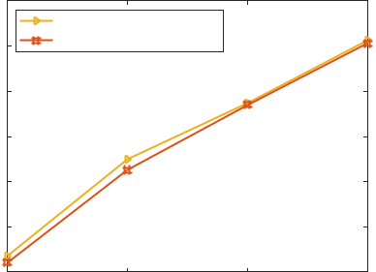

Bandwidth (MHz)

**FIGURE 13.** Average throughput of the network with varied terrestrial RATbandwidths.

|  |  |  |  |  |  |  |  |  |
| --- | --- | --- | --- | --- | --- | --- | --- | --- |
|  | 18 |  |  |  |  |  |  |  |
| (Gbps) | 17.5 |  |  |  |  |  |  |  |
|  |  |  |  |  |  |  |  |
| throughput | 17 |  |  |  |  |  |  |  |
| 16.5 |  |  | Adaptive multi-RAT MLB | | |  |  |
|  |  | Adaptive intra-RAT MLB | | |  |  |
|  |  |  |  |  |
|  |  |  |  |  |  |
|  |  |  |  | High network load | | |  |  |
|  |  |  |  | Low network load | | |  |  |
|  | 0 | 5 | 10 | 15 | 20 | 25 | 30 |  |

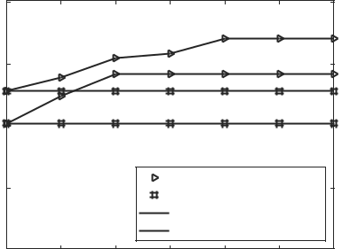

delay-tolerant flows (%)

|  |  |  |  |  |  |  |  |  |
| --- | --- | --- | --- | --- | --- | --- | --- | --- |
|  |  |  |  | (a) |  |  |  |  |
|  | 100 |  |  |  |  |  |  |  |
| UEs (%) | 95 |  |  |  |  |  |  |  |
| 90 |  |  | Adaptive multi-RAT MLB | | |  |  |
| Satisfied |  |  |  |  |
|  |  | Adaptive intra-RAT MLB | | |  |  |
|  |  |  |  |  |
|  |  |  | Low network load | | |  |  |
|  |  |  | High network load | | |  |  |
| 85 |  |  |  |  |  |  |  |
|  |  |  |  |  |  |  |  |
|  | 80 |  |  |  |  |  |  |  |
|  | 0 | 5 | 10 | 15 | 20 | 25 | 30 |  |

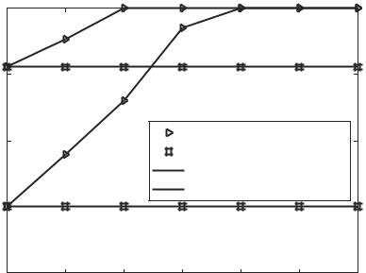

delay-tolerant flows (%)

(b)

**FIGURE 14.** (a) Average throughput of the network, and (b) the number ofsatisfied UEs in the network with different delay-tolerant and delay-sensitive traffic ratios.

when increasing the channel bandwidth, which reduced the gap between maximum RRUR and minimum RRUR. The network throughput increased with increasing bandwidths under both MLB algorithms. Network throughput under the adaptive intra-RAT MLB increases more rapidly, compared to the adaptive multi-RAT MLB, as shown in Figure 13. However, the adaptive multi-RAT MLB had more throughput because racecourses of multiple RATs were available to more UEs at the same time. Hence, the proposed algorithm was able to achieve more even load balancing, and increased the capacity of the network at the same time.

1. **IMPACT OF DELAY-TOLERANT FLOWS WITH DIFFERENT NETWORK LOAD**

We varied the delay-tolerant flow ratio in the network to ob-serve the impact on the proposed algorithm. For a given total number of UEs, the percentage of UEs with delay-tolerant flows was changed from 0 to 30 for different network loads. For the different network load, we changed the required data rate of each UE. The required data rates for each UE were 5-10 Mbps and 10-15 Mbps for low and high network load, re-spectively. Figures 14a and 14b show the network throughput and the number of satisfied UEs, respectively, for different delay-tolerant flow ratios under different network loads. The adaptive multi-RAT MLB has better performance than the

12

adaptive intra-RAT MLB when there are UEs with delay-tolerant flows in the network. When there is no delay-tolerant traffic, i.e., all UEs have delay-sensitive flows, the adaptive multi-RAT MLB only performs intra-RAT offloading. So, the performance of the adaptive multi-RAT MLB returns to the adaptive intra-RAT MLB when there is no UE with a delay-tolerant flow for inter-RAT offloading.

The performance of the adaptive intra-RAT MLB remains constant for different delay-tolerant and delay-sensitive ra-tios, as shown in Figure 14. The reason is that the adaptive intra-RAT MLB performs terrestrial to terrestrial offloading of the UEs irrespective of the data flow type to balance cell loads, whereas, the performance of the adaptive multi-RAT MLB increases with increases in delay-tolerant traffic. By increasing delay-tolerant traffic, the adaptive multi-RAT MLB finds more UEs with delay-tolerant flows, and offloads the UEs from overloaded cells to a satellite to balance the network. As a result, more UEs get the required resources from multiple RATs, and the network throughput and per-centage of satisfied UEs increases. After a required minimum amount of delay-tolerant flows, the network throughput and number of satisfied UEs become constant under the adaptive multi-RAT MLB under different network load conditions. When the network load is high, the adaptive multi-RAT MLB requires a higher ratio of delay-tolerant flows to balance the

VOLUME 4, 2016

This work is licensed under a Creative Commons Attribution 4.0 License. For more information, see https://creativecommons.org/licenses/by/4.0/.

This article has been accepted for publication in a future issue of this journal, but has not been fully edited. Content may change prior to final publication. Citation information: DOI

10.1109/ACCESS.2020.3010059, IEEE Access

terrestrial cells. Hence, we can say that the adaptive multi-RAT MLB depends on the availability of delay-tolerant flows for inter-RAT offloading to achieve better performance.

**V. CONCLUSION**

In this paper, we proposed a load balancing algorithm for a multi-RAT network that consisted of an NTN and a TN. The uneven distribution of the UEs in cells of the 5G network led to imbalanced load distribution across the cells and degraded network performance such as throughput and QoS of UEs. A multi-RAT network uses different time frequency resource units for resource allocation, and therefore, to develop a load balancing algorithm, we the defined RRUR as a common load measurement metric, and employed an adaptive threshold to determine the overload status of the cell based on the network load. To avoid unnecessary offloading of UEs, the proposed algorithm estimates the impact of moving loads on the RRUR of the target cells. Based on intra-RAT and inter-RAT offload-ing, the load across terrestrial cells became more balanced and the number of satisfied UEs increased in the network. UEs of an overloaded cell that cannot move to neighboring cells are offloaded to a satellite cell, and the cell load is reduced to the defined threshold. Simulation results showed that the proposed algorithm balances terrestrial cell networks and increases the throughput as well as QoS of the UEs better than previous load balancing algorithm. Furthermore, the proposed algorithm assigns enough resources to all UEs from multiple RATs, and 100% of the UEs get their required data rate. The proposed algorithm depends on the availability of delay-tolerant flows to achieve better performance.

**REFERENCES**

1. T. Doukoglou, V. Gezerlis, K. Trichias, N. Kostopoulos, N. Vrakas,
   1. Bougioukos, and R. Legouable, “Vertical industries requirements anal-ysis targeted kpis for advanced 5G trials,” in 2019 European Conference on Networks and Communications (EuCNC), June 2019, pp. 95–100.
2. 3GPP, “Study on Scenarios and Requirements for Next Generation Access Technologies,” 3rd Generation Partnership Project (3GPP), Technical Specification (TS) 38.913, 06 2018, version 15.0.0. [Online]. Available: https://portal.3gpp.org/
3. A. Emear, “Cisco visual networking index (vni) complete forecast update 2017–2022,” December, pp. 2017–2022, 2018.
4. C. V. Forecast, “Cisco visual networking index: Global mobile data traffic forecast update, 2017–2022 white paper,” 2019.
5. K. Liolis, A. Geurtz, R. Sperber, D. Schulz, S. Watts, G. Poziopoulou,
   1. Evans, N. Wang, O. Vidal, B. Tiomela Jou et al., “Satellite use cases and scenarios for 5G eMBB,” 2018.
6. A. Guidotti, A. Vanelli-Coralli, M. Conti, S. Andrenacci, S. Chatzinotas,
   1. Maturo, B. Evans, A. Awoseyila, A. Ugolini, T. Foggi, L. Gaudio,
   2. Alagha, and S. Cioni, “Architectures and key technical challenges for 5G systems incorporating satellites,” IEEE Transactions on Vehicular Technology, vol. 68, no. 3, pp. 2624–2639, March 2019.
7. V. W. Wong, Key technologies for 5G wireless systems. Cambridge university press, 2017.
8. G. Giambene, S. Kota, and P. Pillai, “Satellite-5G integration: A network perspective,” IEEE Network, vol. 32, no. 5, pp. 25–31, Sep. 2018.
9. K. Liolis, A. Geurtz, R. Sperber, D. Schulz, S. Watts, G. Poziopoulou,
   1. Evans, N. Wang, O. Vidal, B. Tiomela Jou et al., “Use cases and scenarios of 5G integrated satellite-terrestrial networks for enhanced mo-bile broadband: The SaT5G approach,” International Journal of Satellite Communications and Networking, vol. 37, no. 2, pp. 91–112, 2019.
10. E. Zeydan and Y. Turk, “On the impact of satellite communications over mobile networks: An experimental analysis,” IEEE Transactions on Vehicular Technology, vol. 68, no. 11, pp. 11 146–11 157, Nov 2019.

VOLUME 4, 2016

1. B. Evans, O. Onireti, T. Spathopoulos, and M. A. Imran, “The role of satellites in 5G,” in 2015 23rd European Signal Processing Conference (EUSIPCO), Aug 2015, pp. 2756–2760.
2. 3GPP. Release 17. [Online]. Available: https://www.3gpp.org/release-17.
3. K. M. Addali, S. Y. Bani Melhem, Y. Khamayseh, Z. Zhang, and
   1. Kadoch, “Dynamic mobility load balancing for 5G small-cell networks based on utility functions,” IEEE Access, vol. 7, pp. 126 998–127 011, 2019.
4. J. Park, Y. Kim, and J. Lee, “Mobility load balancing method for self-organizing wireless networks inspired by synchronization and matching with preferences,” IEEE Transactions on Vehicular Technology, vol. 67, no. 3, pp. 2594–2606, March 2018.
5. M. M. Hasan, S. Kwon, and J. Na, “Adaptive mobility load balancing algorithm for LTE small-cell networks,” IEEE Transactions on Wireless Communications, vol. 17, no. 4, pp. 2205–2217, April 2018.
6. M. M. Hasan and S. Kwon, “Cluster-based load balancing algorithm for ultra-dense heterogeneous networks,” IEEE Access, vol. 8, pp. 2153–2162, 2020.
7. S. Singh, S. Yeh, N. Himayat, and S. Talwar, “Optimal traffic aggregation in multi-RAT heterogeneous wireless networks,” in 2016 IEEE Interna-tional Conference on Communications Workshops (ICC), May 2016, pp. 626–631.
8. B. Soleymani, A. Zamani, S. H. Rastegar, and V. Shah-Mansouri, “RAT selection based on association probability in 5G heterogeneous networks,” in 2017 IEEE Symposium on Communications and Vehicular Technology (SCVT), Nov 2017, pp. 1–6.
9. C. Rosa, K. Pedersen, H. Wang, P. Michaelsen, S. Barbera, E. Malkamäki,
   1. Henttonen, and B. Sébire, “Dual connectivity for LTE small cell evolution: functionality and performance aspects,” IEEE Communications Magazine, vol. 54, no. 6, pp. 137–143, June 2016.
10. 3GPP, “System architecture for the 5G System; Stage 2,” 3rd Generation Partnership Project (3GPP), Technical Specification (TS) 23.501, 12 2019, version 16.3.0. [Online]. Available: https://portal.3gpp.org
11. E. Dahlman, S. Parkvall, and J. Skold, 5G NR: The next generation wireless access technology. Academic Press, 2018.
12. C. E. Shannon, “A mathematical theory of communication,” ACM SIG-MOBILE mobile computing and communications review, vol. 5, no. 1, pp. 3–55, 2001.
13. R. P. Antonioli, G. C. Parente, C. F. M. e Silva, D. A. Sousa, E. B. Rodrigues, T. F. Maciel, and F. R. P. Cavalcanti, “Dual connectivity

for LTE-NR cellular networks: Challenges and open issues,” Journal of Communication and Information Systems, vol. 33, no. 1, 2018.

[24] 3GPP, “Radio Resource Control (RRC) protocol specification,” 3rd Generation Partnership Project (3GPP), Technical Specification (TS) 38.331, 12 2019, version 15.8.0. [Online]. Available: https://portal.3gpp.org/

1. R. Kwan, R. Arnott, R. Paterson, R. Trivisonno, and M. Kubota, “On mobility load balancing for LTE systems,” in 2010 IEEE 72nd Vehicular Technology Conference-Fall. IEEE, 2010, pp. 1–5.
2. 3GPP, “NR; NR and NG-RAN Overall Description,” 3rd Generation Partnership Project (3GPP), Technical Specification (TS) 38.300, 12 2019, version 16.0.0. [Online]. Available: https://portal.3gpp.org
3. A. Papoulis and S. U. Pillai, Probability, random variables, and stochastic processes. Tata McGraw-Hill Education, 2002.
4. Y. Sun, D. Xu, D. W. K. Ng, L. Dai, and R. Schober, “Optimal 3D-trajectory design and resource allocation for solar-powered uav commu-nication systems,” IEEE Transactions on Communications, vol. 67, no. 6, pp. 4281–4298, 2019.

SYED MAAZ SHAHID received the B.E degree in electrical engineering from National University of Sciences and Technology (NUST), Pakistan, in 2015. He is currently pursuing the Ph.D. de-gree in electrical engineering with the University of Ulsan, South Korea. His research interests in-clude cellular networks and applications of ma-chine learning in signal processing and wireless networks.



13

This work is licensed under a Creative Commons Attribution 4.0 License. For more information, see https://creativecommons.org/licenses/by/4.0/.

This article has been accepted for publication in a future issue of this journal, but has not been fully edited. Content may change prior to final publication. Citation information: DOI  10.1109/ACCESS.2020.3010059, IEEE Access

SEYOUM YEMANE TEKLAY received BSc de-



gree in computer science from Bahir Dar Univer-

sity, Ethiopia, in 2008. He is currently pursuing an

integrated masters and Ph.D. degree in electrical

engineering with the University of Ulsan, South

Korea. His research interests include cellular net-

works, edge computing, and artificial intelligence

for 5g and beyond networks

SEOK HO WON received his B.S. degree in



clinical pathology and electrical engineering from

Kwangwoon University, in 1985 and 1990, respec-

tively, and his Ph.D. degree in electrical engineer-

ing from Chungnam National University, Rep. of

Korea, in 2002. Since 1985, he has been a medical

technician at Sin-Chon General Hospital, Rep. of

Korea. Since 1990, he has been a principal engi-

neer at ETRI, Rep. of Korea. He was a research

faculty member at Virginia Tech, USA, in 2005,

where his duty was developing cognitive radios. His research interests

include physical, MAC, and application layers of LTE based 5G New Radio

with an emphasis on machine learning.

SUNGOH KWON (Senior Member, IEEE) re-



ceived the B.S. and M.S. degrees in electrical en-

gineering from KAIST, Daejeon, South Korea, in

1994 and 1996, respectively, and the Ph.D. degree

in electrical and computer engineering from Pur-

due University, West Lafayette, IN, USA, in 2007.

From 1996 to 2001, he was a Research Staff Mem-

ber with Shinsegi Telecomm Inc., Seoul, South

Korea. From 2007 to 2010, he was a Principal En-

gineer with Samsung Electronics Company Ltd.,

South Korea, where he developed LTE schedulers. Since 2010, he has joined

the University of Ulsan, South Korea, as an Assistant Professor of the School

of Electrical Engineering. He is currently a Professor at the same university.

His research interest includes wireless communication networks.



14 VOLUME 4, 2016

This work is licensed under a Creative Commons Attribution 4.0 License. For more information, see https://creativecommons.org/licenses/by/4.0/.