This article has been accepted for publication in a future issue of this journal, but has not been fully edited. Content may change prior to final publication. Citation information: DOI 10.1109/ACCESS.2020.3011472, IEEE Access



Date of publication xxxx 00, 0000, date of current version xxxx 00, 0000.

*Digital Object Identifier 10.1109/ACCESS.2017.Doi Number*

**Optimization of the Deployment of Relay Nodes in Cellular Networks**

**RANA M. MOKHTAR1, HEBA M. ABDEL-ATTY1, (Senior Member, IEEE), AND KORANY R. MAHMOUD2,3**

1Electrical Engineering Department, Faculty of Engineering, Port Said University, Port Said 42524, Egypt

2Department of Electronics and Communications, Faculty of Engineering, Helwan University, Cairo, Egypt

3National Telecommunications Regulatory Authority, Ministry of Communication and Information Technology, Giza 12577, Egypt

Corresponding author: Rana M. Mokhtar (rana14232.pg15@eng.psu.edu.eg).

**ABSTRACT** Significant and continuous contributions related to 4G/5G cellular networks are stillaccelerating the investigation of the approaches that can boost the cell characteristics following the new aspirations of the users. The challenge of achieving sufficient coverage at the cell edge; represents a constant concern for both users and operators; in addition to ensuring a reasonable cost, are the most important search fields and in our scope of interest. As relay nodes can provide a solution, a scenario for a plan of relay nodes deployment at the cell edge is proposed, taking into account the interference due to the relay nodes. Since optimization algorithms are effective in terms of planning, an advanced hybrid particle swarm optimization and gravitational search algorithm (PSOGSA) is applied to the proposed scenario to detect the optimum solution. The optimum solution represents the optimum plan that attains the best coverage with the minimum cost. We submit cost analysis depends on three trails of construction cost, power and channel cost efficiency. To highlight that the optimal plan has been revealed, another recently developed optimization algorithm, a simplified adaptive bat algorithm based on frequency (FSABA) and a classic particle swarm optimization (PSO) algorithm are also applied to the suggested scenario. The obtained results are compared with the related findings of the PSOGSA. From the simulations, it is found that the PSOGSA achieves better performance than the other two algorithms with fruitful and promising results, and the optimal plan featuring great coverage at the cell edge and cost-saving is attained.

**INDEX TERMS** A simplified adaptive bat algorithm based on frequency (FSABA), cell edge, particleswarm optimization and gravitational search algorithm (PSOGSA), relay nodes.

**I. INTRODUCTION**

The coverage area still plays a pivotal role in cellular network studies. In addition, in the most exhaustive section, the users on the cell edge suffer from the instability and interruption of the service due to the coverage deficiency. Therefore, a solution for the coverage absence at the cell edge is needed. One of the important and useful features that represents a leap in the telecommunication domain and can be employed to improve the coverage at the cell edge is the relay node.

Relay nodes (RNs), which are low-power nodes, can offer a solution to improve the coverage at the cell edge by supporting the connectivity between the evolved node-B (eNB) and the users. Nevertheless, planning the deployment of relay nodes and choosing their numbers, power and

locations in the cell still needs to be investigated, especially to realize the combination of enhancing the coverage area at the cell edge and harnessing the benefits of the RNs as it is low-cost technology due to its flexible installation.

From the numerous studies associated with cellular planning over time, we mention some of the researchers' efforts related to this field. In [1], the authors proposed a concept of cell zooming that adaptively adjusts the cell size according to traffic conditions. The authors in [2] proposed a mixed integer programming model of the Pareto front and a multi-objective Tabu search for a network configuration. Other authors have suggested dividing a region into sub-regions with almost equal traffic when the balance degree of

1

This work is licensed under a Creative Commons Attribution 4.0 License. For more information, see https://creativecommons.org/licenses/by/4.0/.

This article has been accepted for publication in a future issue of this journal, but has not been fully edited. Content may change prior to final publication. Citation information: DOI 10.1109/ACCESS.2020.3011472, IEEE Access



the network is broken [3]. Another component of the search is mathematical analysis, but this may be difficult and complicated, like in [4], where the authors proposed an O (log R) approximation algorithm to plan the macro-cell only and

͂

then developed an O (log R) approximation algorithm for HetNet cell planning.

The papers of [5], [6], [7], and [8] belong to a group of researchers that have contributed to this area, and their contributions shall be described hereinafter. In [5], the authors proposed an enhanced tree (E-tree) algorithm to place the eNB and relay stations (RSs) at the location with the lowest construction cost compared with the tree algorithm; while in [6], a super-graph tree algorithm was proposed to place base stations (BSs) and relay stations at the lowest cost positions, and then the authors proposed another interference aware algorithm (IA) that considers the interference between BSs in the network. In [7], the authors suggested a set covering algorithm to achieve better network coverage and performance for LTE-Advanced relay networks. This algorithm reduced the number of uncovered users, but it had a higher construction cost generated from the S-tree algorithm and IA. Then, in [8], the authors deployed two types of RNs as in-band and out-band RNs in the LTE-A network with the eNB and compared the deployment results with their proposed interference coordination (IC) algorithm. These proposed algorithms depend on graph theory, but in the case of using an optimization algorithm, we believe that they will yield better results.

In [9], two site planning strategies were formulated in terms of SNR- and SINR-based selection criteria to analyze the effects of site planning on the backhaul link, but the authors mentioned the usage of the RNs as a low-cost feature only.

1. Presented a comparative simulation study for various suburban macro-only and macro-relay deployment scenarios in emerging markets. In [11], the authors proposed a partially combinatorial optimization algorithm that exploits a channel quality indicator (CQI), which segments the total number of possible locations into smaller randomly selected groups and performs an exhaustive search for each smaller group. In [12], the authors discussed developing the coverage probability due to deploy the decode-and-forward relays according to a Poisson point process model.

The authors introduced in [13], two relay cell range extension techniques; a bias to cell selection and handover thresholds, with decreasing the power of the eNB. Genetic algorithm scheme was proposed in [14] to find the minimum number of positions to place sensor nodes in the network to achieve k-coverage and m-connectivity. In [15], the authors focus on the employment of relay nodes and small cells to enhance the energy efficiency of the network. [16] introduced a deployment scheme called four-stage fuzzy logic-based cost and power effective to determine the type, number and placements of the HetNet Nodes to meet an expected coverage. The authors in [17] submitted an approach called adaptive cost-based RS deployment to form a cost function

2

that leads to finding the relay station location with minimum network cost. Two hop links treat with the low or null coverage locations and enhance the physical layer were suggested in [18]. The authors’ work in [19] is concerned with the relay node deployment in LTE-A networks to increase the coverage with energy-efficient constraints. In [20], a cross-layer routing for secondary multihop was examined following the signal to interference noise ratio (SINR) constraints.

As the cost question should be taken into consideration for all researchers interested in optimization, it can be noted that each researcher examines the cost issue through his perspective. For instance, some papers focus on the construction cost like [21], [22], [23], [24], and [25]. Where in [21], the authors considered in the cost equation the deployment of the most expensive components for their proposed system architecture, and also [22] which relied basically on the deployment cost. The authors in [23], set a total budget constraint of the system so as the deployed relay nodes is not exceeded. [24] Depended on CAPEX and OPEX, which represent the deployment cost and the operational cost respectively; but [25] connected the CAPEX and OPEX with the energy consumption. Whereas other researchers interested in linking the calculation of the cost with the data rate of the network as in [26], [27], [28], and [29]. In which the authors in [26] connected between the number of infrastructures deployed and the downlink throughput in the network. [27] Calculated the cost based on the data delivery and the successful transmission between two sensors. The authors in both [28], [29] associated between the deployment cost of the nodes and the cell throughput. The authors in [30] were concerned with increasing requirement for high data rates in order to make the network able to continue its normal operation when the breakdowns occur in a HetNet.

Earlier, we have introduced an initial scenario of the cell plan through the relay nodes where two stages of the relay nodes are deployed; edge relay nodes and the supporting intermediate relay nodes. Furthermore, to increase the efficiency of the cell, we applied the PSO optimization algorithm to the said scenario to reach an optimum plan in

1. Consequently, in this work, we continue to improve the cell plan through the relay nodes deployment under a robust environment, following the advanced optimization algorithms.

Our proposal consists of two phases: a cell planning phase and an optimization phase that examines the variables within a specific criterion to investigate their optimal values that produce outstanding cell characteristics. In cell planning, we impose a cell plan that introduces an approach that permits studying several variables, which enhances the coverage area at the cell edge where the interference between the eRNs is considered and saves cost. The use of optimization algorithms is also expected to experience rapid growth as it yields an optimum solution. Therefore, with the help of global optimization algorithms, we intend to reach the optimum cell plan. Hence, our suggested strategies are:

This work is licensed under a Creative Commons Attribution 4.0 License. For more information, see https://creativecommons.org/licenses/by/4.0/.

This article has been accepted for publication in a future issue of this journal, but has not been fully edited. Content may change prior to final publication. Citation information: DOI 10.1109/ACCESS.2020.3011472, IEEE Access



|  |  |  |  |  |  |  |  |  |  |  |  |  |  |  |  |  |  |  |  |  |  |  |  |  |  |  |  |  |  |
| --- | --- | --- | --- | --- | --- | --- | --- | --- | --- | --- | --- | --- | --- | --- | --- | --- | --- | --- | --- | --- | --- | --- | --- | --- | --- | --- | --- | --- | --- |
| • Deploy a number of relay nodes and alter their related | | | | | | whereis the signal-to-noise ratio from the eNB to | | | | | | | | | | | | | | | | | | | | | | |  |
| particular variables within a specific range according to the | | | | | | each edge relay node,is the eNB transmitting power, | | | | | | | | | | | | | | | | | | | | | | |  |
| proceedings of the proposed plan. | | | | |  | is the noise power of the channel and is the NLOS path | | | | | | | | | | | | | | | | | | | | | | |  |
| • As the cost dilemma is also paramount for operators | | | | | | loss power between the transmitter and the receiver. | | | | | | | | | | | | | | | | | | | | |  |  |  |
| considering the principle of cost savings in each plan, we | | | | | |  |  |  |  |  |  | | | |  | = | |  |  | | |  | |  |  |  | (2) | |  |
| present a coverage to cost index, which is an objective | | | | | |  |  |  |  |  |  |  | . | | | | |  |  |  |  |
|  |  |  |  |  |  |  |  |  |  |  |  |  |  |  |  |  |  |  |
| function proposed to sift through the plans. | | | | |  | where | | | | is the signal-to-noise ratio from each edge | | | | | | | | | | | | | | | | | | |  |
| • The particle swarm optimization and gravitational search | | | | | | relay node to each user,is the relay node transmitting | | | | | | | | | | | | | | | | | | | | | | |  |
| algorithm (PSOGSA) is proposed to sweep the search space | | | | | |  |
| power. | |  |  |  |  |  |  |  |  |  |  |  |  |  |  |  |  |  |  |  |  |  |  |
| of variables, and then we compared results with those of its | | | | | |  | Considering the interference that represents the interfered | | | | | | | | | | | | | | | | | | | | | |  |
| counterpart FSABA and PSO algorithm to determine the | | | | | | signals can be expressed by = ∑ ˋ≠ | | | | | | | | | | | | | | | | | | where *i* refer to the | | | | |  |
| optimum plan that realizes a trade-off target between a large | | | | | | connected relay node, *iˋ* refers to the interfered relay nodes. | | | | | | | | | | | | | | | | | | | | | | |  |
| coverage area and a low cost. | | |  |  |  | So, | can be calculated as follow: | | | | | | | | | | | | | | | | |  |  |  |  |  |  |
| This paper is | organized | as follows: Section | | | II judiciously |  |  |  |  |  | = | | | |  |  |  |  |  | |  |  |  |  |  |  | (3) | |  |
| explains the proposed system model. Section III expounds a | | | | | |  |  |  |  |  |  |  |  |  |  |  |  |  |  |  |  |  |  |
|  |  |  |  |  |  |  | . | | | | + | | |  |  |  |  |
|  |  |  |  |  |  |  |  |  |  |  |  |  |  |  |  |  |
| description of the optimization analysis of the cell planning | | | | | |  |  |  |  |  |  |  |  |  |  |  |  |  |  |  |  |  |
|  |  |  |  |  |  |  |  |  |  |  |  |  |  |  |  |  |  |  |  |  |  |  |  |
| problem for the introduced scenario. The optimization phase | | | | | | where | | is the transmitted power that represents theas | | | | | | | | | | | | | | | | | | | | |  |
| is presented in section IV. The concept of all the suggested | | | | | |  |
| we are concerned with the relay nodes affecting on the cell | | | | | | | | | | | | | | | | | | | | | | |  |
| optimization | algorithms | is described, and | | | the proposed |  |
| edge. | |  |  |  |  |  |  |  |  |  |  |  |  |  |  |  |  |  |  |  |  |  |  |
| algorithm is connected to our deployment scenario. The results | | | | | |  |  |  |  |  |  |  |  |  |  |  |  |  |  |  |  |  |  |  |  |  |  |
|  |  |  |  |  | ⁄ | |  |  |  |  |  |  |  |  |  |  | ⁄ | | |  |  |  |  |
| of the discussion and comparative study are | | | | | presented in |  |  |  |  |  |  |  |  |  |  |  |  |  |  |  |  |  |  |  |
| details in section V. Finally, the conclusions are presented in | | | | | |  | = | |  |  |  |  | | |  |  |  | = | |  |  |  |  | . | | |  | (4) |  |
|  |  |  | + ∑ |  | ⁄ | | |  |  | 1 + ∑ | | | |  | ⁄ | |  |  |
|  |  |  |  |  |  |  |  |  |  |  |  |  |
| section VI. |  |  |  |  |  |  |  |  |  |  |  |  |  |  |  |  |  |  |
|  |  |  |  |  |  |  |  |  | |  | ˋ≠ |  |  |  | | |  |  |  |  |  |  | ˋ≠ | | . | | |  |
|  |  |  |  |  |  |  |  |  |  |  |  |  |  |  |  |  |  |  |  |  |  |  |  |  |
| **II. SYSTEM MODEL** | |  |  |  |  | So, , that represents the signal to interference plus | | | | | | | | | | | | | | | | | | | | | | |  |
|  |  |  |  | noise ratio for the link between the *eRN* (*i*), and the user (*j*) | | | | | | | | | | | | | | | | | | | | | | |  |
| We consider a square area represents a macro cell containing | | | | | | will be as follows: | | | | | |  |  |  |  |  |  |  |  |  |  |  |  |  |  |  |  |  |  |
| one eNB placed at the centre of the cell with an | | | | | |  |  | ,  = | | | | |  |  |  |  |  | , | | | | | |  |  |  | (5) | |  |
| omnidirectional antenna. A set of in band (both its backhaul | | | | | |  |  |  |  |  |  |  |  |  |  |  |  |  |  |  |  |  |
|  |  |  | 1 + ∑ ˋ≠ ˋ, | | | | | | | | | | | |  |  |
| and access links operate on the same frequency) edge relay | | | | | |  |  |  |  |  |  |  |  |  |  |  |  |
|  |  |  |  |  |  |  |  |  |  |  |  |  |  |  |  |  |  |  |  |  |  |  |  |
| nodes *eRNs*, *Ne*, is initially deployed in fixed positions by a | | | | | |  |  |  |  |  |  |  |  |  |  |  |  |  |  |  |  |  |  |  |  |  |  |  |  |
| uniform distribution at the cell edge, that we define as the area | | | | | | ***A. Coverage Analysis*** | | | | | | |  |  |  |  |  |  |  |  |  |  |  |  |  |  |  |  |  |
| located out of the eNB effect on the users toward the cell | | | | | |  |  |  |  |  |  |  |  |  |  |  |  |  |  |  |  |  |
| Check the links between the eNB and eRNs by calculating | | | | | | | | | | | | | | | | | | | | | | |  |
| borders. |  |  |  |  |  |  |
|  |  |  |  |  | theat each eRN. If thereceived at the node from | | | | | | | | | | | | | | | | | | | | | | |  |
| To estimate the performance of the links in the cell plan, we | | | | | |  |
| the eNB is more than or equal to the threshold line of the | | | | | | | | | | | | | | | | | | | | | | |  |
| mainly depend on both the | | | signal-to-noise ratio | | |  |
| power ℎ, referred to | | | | | | | | |  |  | as the least accepted | | | | | | | | | | received | |  |
| equations for the link between the user and the particular eRN | | | | | |  |  |  |
| power at the node, considering the link as a success link. So, | | | | | | | | | | | | | | | | | | | | | | |  |
| and concurrently, on the signal-to-interference plus noise ratio | | | | | |  |
| we | define | the | |  | link | from | | |  |  | *eNB* | | | | to | | | *eRNs* | | as | ( ) = | |  |
| equations between the user and the interfered eRNs on | | | | | |  |  |  |  |
| the correlated link. | |  |  |  |  | [ (1), (2), … … … … , ( )], | | | | | | | | | | | | | | | where *i* | | | | | represent the | | |  |
| For a non-line of sight (NLOS) connections considered | | | | | | number of the *eRN*. | | | | | |  |  |  |  |  |  |  |  |  |  |  |  |  |  |  |  |  |  |
|  |  |  |  |  |  |  |  |  |  |  |  |  |  |  |  |  |  |  |  |  |  |  |  |
| between the transmitter and the receiver, we can calculate the | | | | | |  |  |  |  |  |  |  |  |  |  |  |  |  |  |  |  |  |  |  |  |  |  |  |  |
| *SNR* equation | = /( | | ∙ ) as a ratio between the | | |  |  |  |  |  | 1 |  |  |  |  |  | ( ) ≥ ℎ | | | | | | | | | |  |  |  |
| received powerto the | | power of the noise -due to the | | | |  | ( ) = { | | | |  |  |  |  |  |  |  |
|  | 0 |  |  |  |  |  | ℎ | | | | | | | | |  | (6) | |  |
| proposed additive white Gaussian noise (AWGN ) distributed | | | | | |  |  |  |  |  |  |  |  |  |  |  |  |
|  |  |  |  |  |  |  |  |  |  |  |  |  |  |  |  |  |  |  |  |  |  |
| channel that expressed by ( ) = ( ) + ( ) where ( ) is | | | | | |  |  |  |  |  |  | ; = 1,⋯, | | | | | | | | | | | |  |  |  |  |  |  |
| the received signal, ( ) is the transmitted signal and ( ) is | | | | | |  |  |  |  |  |  |  |  |  |  |  |  |
|  |  |  |  |  |  |  |  |  |  |  |  |  |  |  |  |  |  |  |  |  |  |  |  |
| the AWGN added to this signal through the channel-and to the | | | | | | In order to calculate the coverage area at the cell edge, we | | | | | | | | | | | | | | | | | | | | | | |  |
| NLOS distance-dependent path loss . | | | | |  | randomly distributed the number of users ***Nu***. To enhance the | | | | | | | | | | | | | | | | | | | | | | |  |
| Accordingly, |  |  |  |  |  | coverage area at the cell edge, we neutralize the impact of the | | | | | | | | | | | | | | | | | | | | | | |  |
|  |  |  |  |  |  | *eNB* at the cell edge and study the effect of deploying the relay | | | | | | | | | | | | | | | | | | | | | | |  |
|  | = | |  |  | (1) | nodes. In the same time, we take into account the interference | | | | | | | | | | | | | | | | | | | | | | |  |
|  | ∙ | | which is likely to result from dense relay nodes at the cell edge. | | | | | | | | | | | | | | | | | | | | | | |  |
|  |  |  |  |  |
|  |  |  |  |  |  | 3 |  |  |  |  |  |  |  |  |  |  |  |  |  |  |  |  |  |  |  |  |  |  |  |

This work is licensed under a Creative Commons Attribution 4.0 License. For more information, see https://creativecommons.org/licenses/by/4.0/.

This article has been accepted for publication in a future issue of this journal, but has not been fully edited. Content may change prior to final publication. Citation information: DOI 10.1109/ACCESS.2020.3011472, IEEE Access



The links from the eRNs to the users ***U*** represented by the

(1,1) ⋯ (1, )

matrix ( , ) = [ ⋮ ⋱ ⋮ ] , whereas

( , 1) ⋯ ( , )

ℎ is the threshold power, referred to as the least received power accepted by the user.

|  |  |  |  |  |
| --- | --- | --- | --- | --- |
|  |  | ( , ) |  |  |
| 1 |  | ( , ) ≥ ℎ | |  |
| **=**{ |  |  |  |  |
|  | ( , ˋ) ≥ ℎ | |  |
|  |  |  |
| 0 |  | ℎ | (7) |  |
|  | ; = 1,⋯, | |  |  |
|  | , | = 1,⋯, & | ≠ ˋ |  |

throughput for each user link from each edge relay node depending on (11) that derived from the well-known Shannon capacity as in [13], is the system operation bandwidth,

is the bandwidth efficiency, is the signal to interference plus noise ratio efficiency.

If the user received a signal from the relay node less than the ℎ and an interfered signals from the other relay nodes

less than ℎ, we would consider the for this link equal zero. Since the covered user can receive links from more

than edge relay node; we can calculate the throughput link as

|  |  |  |  |  |  |
| --- | --- | --- | --- | --- | --- |
|  |  | ∑ |  |  |  |
|  | = | =1 |  | (12) |  |
| ∑ . | |  |
|  |  |
|  |  |  |  |

Consequently,

|  |  |  |
| --- | --- | --- |
| We consider the user would be covered if he received a link |  |  |
| from one eRN with a signal to noise ratio more than or equal |  |  |
| the ℎ and a signal to interference plus noise ratio from |  |  |
| the others eRNs more than or equal the ℎ at the same |  |  |
| time. Hence, we can define the user coverage areaas, | ***C. Cost Analysis*** |  |
|  |  |

|  |  |
| --- | --- |
| = ∑ | (13) |
|  |  |
| =1 |  |

|  |  |  |  |  |  |
| --- | --- | --- | --- | --- | --- |
|  | |  |  | The main objective in our work is to obtain the optimum |  |
|  |  | plan for the cell, which is a trade-off between enhancing the |  |
| = ∑ [ ( , ), ⋯ , ( , )] | | | (8) |  |
| coverage area at the cell edge and saving cost. The cost |  |
| =1 | |  |  |  |
|  |  | calculation is based on three suggested concepts. The first |  |
|  |  |  |  |  |
| Therefore, the coverage percentage for each plan will be: | | | | concept is the fixed cost represented by the construction cost |  |
| of the site, licenses, rent, and equipment. The second concept |  |
|  |  |  |  |  |
|  |  |  |  | is the variable cost represented by the transmitting power of |  |
| (%) = | × 100 | (9) | each RN, which we indicate by a power factor ***x*** that is the |  |
|  |  |
|  | ratio between the power of the relay node to the power of the |  |
|  |  |  |  | eNB. Lastly, the third concept involves the impact of the |  |
| To examine the impact of each node on the users, we | | | | channel resources into the cost analysis, so we called channel |  |
| determine the station effectivenessfor each *eRN* as | | | | cost-efficiency, modified from the equation (2) in [28], |  |
| follows: | |  |  | and can be calculated as follows: |  |

|  |  |  |  |
| --- | --- | --- | --- |
|  | ( , ) |  |  |
| = ∑ | (10) |  |
| =1 |  |  |

; = 1,⋯,

***B. Throughput Analysis***

To evaluate the significance of the proposed plan of the relay nodes deployment effect, we calculate the throughput for each covered link and the total cell-edge throughput

|  |  |  |  |  |  |  |  |  |
| --- | --- | --- | --- | --- | --- | --- | --- | --- |
|  | as follows: | |  |  |  |  |  |  |
|  | = . . 2(1+ | | | | ) | (11) |  |
|  |  |  |
|  |  |  |  |  |  |  |  |
| where |  | is | |  | a | matrix | |  |
|  |  | (1,1) | ⋯ | (1, ) | |  |  |  |
|  | = [ | ⋮ | ⋱ | ⋮ | ] | contains | the |  |
|  |  | ( , 1) | ⋯ | ( , ) | |  |  |  |

|  |  |  |  |  |  |
| --- | --- | --- | --- | --- | --- |
| = |  |  |  | (14) |  |
|  | |  |  |
| . (1 + ∑ . ( + [ | | ])) |  |
|  |  |  | |  |  |

where represents the initial fixed cost when constructing the relay node regardless of its power, represents the variable cost due to the power of the relay node (an increase in the power leads to an increase in the relay node cost), refers to the resultant valuable relay nodes chosen at each plan, and represents the edge relay node power factor.

Thus, we suggest the cost equation as follows:

|  |  |  |  |
| --- | --- | --- | --- |
| = | + ∑ . ( + [ ]) | (15) |  |
|  |  |
| ∑( + ∀[ ]) |  |
|  |  |  |

Where, represents the maximum power value of the power factor.

4

This work is licensed under a Creative Commons Attribution 4.0 License. For more information, see https://creativecommons.org/licenses/by/4.0/.

This article has been accepted for publication in a future issue of this journal, but has not been fully edited. Content may change prior to final publication. Citation information: DOI 10.1109/ACCESS.2020.3011472, IEEE Access

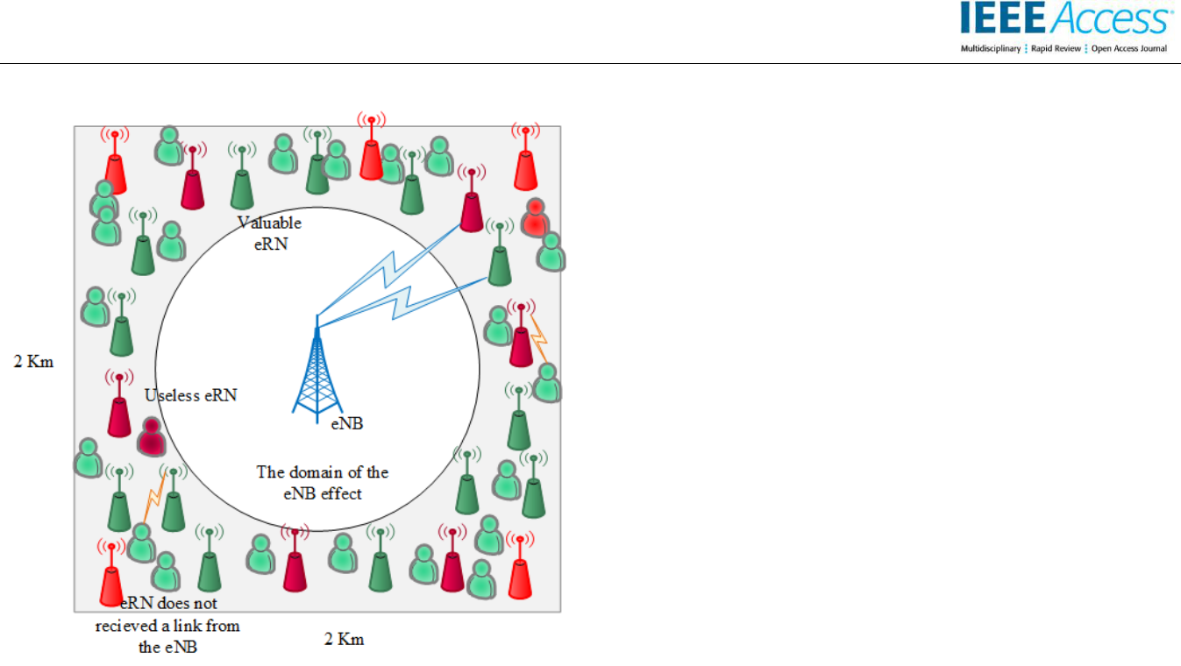

**FIGURE 1. The cell plan of the proposed scenario.**

The cost equation is a normalization between the cost of each plan due to both their number and transmit power value and the maximum possible cost when all relay nodes are used and each one has the maximum relay node transmit power.

From (9) and (15), we call our objective function the coverage to cost index , where the maximum value of this index represents the optimum plan.

|  |  |  |  |
| --- | --- | --- | --- |
| = |  | (16) |  |
|  |  |



1. **A SUGGESTED OPTIMIZATION APPROACH FOR THE SUBMITTED CELL PLANNING**

As shown in Figure 1, we consider a square area represents a macro cell with a 2 km × 2 km cell size and the eNB position at the center of the cell with an omnidirectional antenna. Therefore, the domain of the eNB effect for the users is shown as a white circle, and we define the distance from the circle to the square border as a cell edge. As one of the main pillars of the upcoming trends is a dense network with the help of a multi-tier heterogeneous cellular network [32], we initially deploy **52** eRNs as a result to form a uniform grid around the cell edge to cover **5000** users. For users, the threshold power of the eRN link ℎ is **20** dB and the threshold power of the interfered links from the other eRNs ℎ is **-7** dB to distinguish the accepted links, also **20** dB is the threshold power ℎ for the relay nodes from the eNB.

To optimize the suggested cell plan means to achieve a trade-off between enhancing the coverage area at the cell edge and at the same time, decrease the cost of the proposed cell plan as possible. Consequently, we will regard here on reducing the number of eRNs as it leads to a lessening in the

5

cost of construction, power, and channel resources without affecting coverage in the cell edge.

As a result of the optimum cell plan, we can define three varieties of the deployed eRNs at the cell edge as follows:

* Valuable eRN indicated in dark green colour represents the chosen eRN in the final cell plan.
* Useless eRN in dark red colour represents the eRN that serves an insufficient number of users where its presence becomes more expensive than its usefulness.
* The eRN in red colour that basically, does not receive a link from the eNB.

Accordingly, the problem optimization will take three successive steps:

**[1]**

A relationship is established between the eRNs and the number of users by checking the links received at each user from all the eRNs in (7). Thus, we introduce a user station matrix where each row represents the user number and each column represents the eRN number. This one-zero matrix clarifies the relationship between each user and each eRN in the grid.

|  |  |  |  |  |  |  |
| --- | --- | --- | --- | --- | --- | --- |
|  |  |  | , |  |  |  |
| = ⇒ | users | [ |  | ] |  |  |
| → |  |  | × | (17) |  |
| ⋮ |  |  |
|  |  |  |  |  |  |

( : 27= . 27)

⇑ ⋯ ↑

( : 10 = . 10)

Thus, we designate an array called station vector where the number of elements equals the number of eRNs ***Ne***. This array demonstrates the impact of each relay node where each element represents the number of users served solely by each correlated relay node.

= [ 1 2 ………… ]1×

(18)

; = 1,…,

The element values in the array generated from the two conditions at the are explained with the following procedures:

* Detect the relationship between each relay node and all the users.
* If there is a link from the eRN to the user, then the element value = 1 (first condition verification).
* To guarantee that this user covered only by the correlated eRN, check if the sum of this row represents the user =1. (second condition verification).
* Apply these two conditions for all users to know exactly how many users are covered only from this eRN.
* Apply these procedures to each eRN.

This work is licensed under a Creative Commons Attribution 4.0 License. For more information, see https://creativecommons.org/licenses/by/4.0/.

***A. PSO***

***The PSO algorithm was proposed by Kennedy and Eberhart 1995 [36]. It is inspired by natural behavior, such as the flocking of birds and insects. Candidate solutions represented by a number of particles are initially deployed randomly in the search space to look for the best solution. Each particle is expressed by both its velocity and position.***

***The PSO equations for a particle a are:***

***The idea of the optimization is to find a search procedure that obtains the optimal solution through the search space. Stochastic optimization algorithms that depend on random variables initially deployed in the search space have attracted the attention of researchers in recent years [33]-[35]. We have proposed three optimization algorithms to obtain the optimum solution, which we refer to as our optimum cell plan. Two advanced algorithms, the PSOGSA and FSABA, are proposed in addition to the PSO algorithm.***

***= 0***

***IV. OPTIMIZATION PHASE***

***where ℎ is a relative coefficient that helps to indicate from the minimum number of users that each eRN should cover in the ideal case.***

***Compare each element in the array with ℎ, if the element has a value larger than or equal to ℎ, then we will keep this valuable eRN; otherwise, eliminate this useless eRN.***

***[3]***

***Furthermore, adding two constraints, and , to the objective function in (16) to represent a condition that assists in obtaining the optimum plan with the maximum coverage and minimum cost. Therefore, the objective function will be as follows:***

This article has been accepted for publication in a future issue of this journal, but has not been fully edited. Content may change prior to final publication. Citation information: DOI 10.1109/ACCESS.2020.3011472, IEEE Access



**[2]**

Remove any useless relay nodes from the grid. Based on the suggested user threshold number , we define ℎ as the minimum number of users that the eRN should serve to be valuable.

|  |  |  |
| --- | --- | --- |
|  | (19) |  |
| = ℎ × ( .) |  |



|  |  |
| --- | --- |
| ( + )= ( )+ 1× |  |
| × ( − ( )) + 2 | (21) |
| ×× ( − ( )) |  |
| ( + ) = ( ) + ( + 1) | (22) |

where ( ) is the velocity of particle *a* in iteration *t*; is the inertia weight; 1 and 2 represent the recognition parameter and social parameter, respectively; is a random number in between [0, 1]; ( + ) is the new velocity of particle *a* in iteration *t+1*; and ( + ) is the new position of particle *a* in iteration *t+1*.

The new velocity and position of each particle are updated in each iteration depending on the previous velocity of the particle, the self-experience of the particle and the mutual cooperative experience between the particles.

***B. PSOGSA***

≥ ≤

∴ =



The PSOGSA was proposed by Mirjalili and Hashim in 2010 [37]; it is a hybridization of two different metaheuristic algorithms [38], where it called a heterogeneous algorithm, the PSO algorithm [36] and the GSA [39], that cooperate and run in parallel to attain the optimal solution.

The main goal of the PSOGSA is to combine and integrate the exploitation feature of PSO and the exploration feature of GSA to achieve better search performance with a global optimum solution [37]. In other words, the PSOGSA gathers

1. between the ( ), as a result to a cooperative experience between the agents from the PSO and the cleverness of the agents that locally explores the search space by attracting the other agents according to the heavier masses from the GSA.

Accordingly, the PSOGSA procedure is as follows:

* + Initially, distribute a random number of agents in the search space as a candidate solution.

During the iterations:

* For all agents, sequentially, should be obtained and updated. It acts as a memory that stores the best solution yet to help all agents approaching the solution to reach the global optima [40]. And the following GSA equations are calculated.

|  |  |  |  |
| --- | --- | --- | --- |
| ( ) = × exp (− × |  | ) | (23) |

°

where ( ) is the gravitational constant in iteration *t*; ° represents the initial gravitational constant value; is the descending coefficient; is the current iteration; and is the maximum number of iterations.

( ) =

( ) ( ) × ( ) ( ( ) − ( )) (24) ( ) + Ɛ



where ( ) is the gravitational force from agent *b* on

agent *a*; ( ) is the gravitational mass of the withdrawn

agent *a*; ( ) is the gravitational mass of the drawer agent

6

This work is licensed under a Creative Commons Attribution 4.0 License. For more information, see https://creativecommons.org/licenses/by/4.0/.

This article has been accepted for publication in a future issue of this journal, but has not been fully edited. Content may change prior to final publication. Citation information: DOI 10.1109/ACCESS.2020.3011472, IEEE Access



*b*;( )is the Euclidian distance between the two agents *a* and *b* in iteration *t*; Ɛ is a small constant; ( ) is the position

of agent *b* in iteration *t*; and ( ) is the position of agent *a* in iteration *t*.

As we have ***N*** agents in a search space, the total force that affects agent *a* by the other agents in iteration *t* is:

|  |  |
| --- | --- |
| ( ) = ∑( ) | (25) |
| =1, ≠ |  |

where is a random number between [0, 1]. From here, we can calculate the acceleration of agent *a* according to the law of motion, taking into consideration the inertial mass

( ) of agent *a* in iteration *t*.

|  |  |  |  |
| --- | --- | --- | --- |
| ∴( ) = | ( ) | (26) |  |
| ( ) |  |
|  |  |  |

The PSOGSA combines the local search from the GSA by the acceleration of the agents and the global search from the PSO new position equation [41]. Thus, the velocities and therefore the positions of all agents can be calculated by:

|  |  |  |  |
| --- | --- | --- | --- |
|  | ( + )= ( )+ ′ × | |  |
|  |  | 1 |  |
|  | × | ( )+ ′ × | (27) |
|  |  | 2 |  |
|  | × ( − ( )) | |  |
| ( + ) = ( ) + ( + 1) | | | (28) |

where ( ) is the velocity of agent *a* in iteration *t*; is the inertia weight; 1′ is the exploration parameter; 2′ is the exploitation parameter; is a random number in between [0, 1]; ( ) is the acceleration of agent *a* in iteration *t*; and

is the best solution obtained by all agents.

Both 1′, 2′ should be adjusted to the values that balance between the recognition component and the social component and encourage the agents to converge to the global best solution [42].

* The updating will stop when the end criterion, the maximum number of iterations, is met.

***C. FSABA***

In 2010, Xin-She Yang introduced a new natural inspired algorithm called the Bat Algorithm (BA) [43] that depends on the echolocation phenomenon of bats. A simplified adaptive bat algorithm based on frequency (FSABA) is an algorithm proposed by Zhen Chen in 2013 [44] to overcome the shortcomings of the BA, such as the premature convergence due to a lack of exploration, and then can obtain the local optimum [45]. The FSABA algorithm adopts several amendments [43]:

* The algorithm modifies the search equations as the reliance on the velocity equation is eliminated, and then the search is dominated by updating the position equation.

|  |  |
| --- | --- |
| ( + ) = |  |
| ( ) + 1( ) × ( − ( )) + 2( ) | (29) |
| × ( − ( )) |  |
| = ( )×2× | (30) |

where ( ) is the location of bat *a* in iteration *t*; is the inertia weight; 1( ) and 2( ) are the frequencies; is the random position of the bat in the present iteration; is the global optimum position in the present iteration; and is

a normal distribution of random numbers.

* The algorithm adjusts the inertia weight as random values to enhance the global search.

|  |  |  |  |  |  |  |  |
| --- | --- | --- | --- | --- | --- | --- | --- |
| =µ +(µ −µ )× | | | | + | |  |  |
| × ( | 1 |  | ×+ | 1 |  |  |  |
|  |  |  | (31) |  |
| 2 | | |  | 2 |  |  |
|  |  |  |  |

× )

where µ and µ are the minimum and maximum values of the random weight average; is the variance of the random

weight; and is a Poisson distribution of random numbers.

* The algorithm alters between the separate frequencies values in the period search, with 2 values over 1 values tending to diversify and vice versa in the latest period search to obtain the optimum solution.

|  |  |  |  |  |  |  |
| --- | --- | --- | --- | --- | --- | --- |
| ( )=1− | | (−| ( )− ( )|) | | | (32) |  |
|  |  |  |  |
| ( ) = 1 − 1( ) | | | | | (33) |  |
| ( ) = |  |  | 1 |  | (34) |  |
|  | |  |  |  |
| ∑ | | ( ( ( ))) | |  |
|  |  | =1 |  | |  |  |

where ( ) and ( )correspond to the adaptation value of the average and the optimal locations for the bat

colony in iteration *t*, respectively, and is the number of iterations.

* The algorithm updates the declining loudness and the increasing pulse emission rate of the bats according to the following equations:

|  |  |  |  |  |
| --- | --- | --- | --- | --- |
| = A˳ × (e(−0.1×t)) | | | (35) |  |
| = ×(1− |  | ) | (36) |  |
|  |  |
| ˳ | ˳ | |  |  |
|  |  |  |

where and ˳are the loudness and its initial value, and and ˳ are the pulse emission rate and its initial value, respectively.

7

This work is licensed under a Creative Commons Attribution 4.0 License. For more information, see https://creativecommons.org/licenses/by/4.0/.

This article has been accepted for publication in a future issue of this journal, but has not been fully edited. Content may change prior to final publication. Citation information: DOI 10.1109/ACCESS.2020.3011472, IEEE Access



TABLE I

SIMULATION PARAMETERS

|  |  |  |  |
| --- | --- | --- | --- |
|  | Parameter | | Value |
|  |  |  |  |
|  | Ne |  | 52 |
|  |  |  |  |
|  | Nu |  | 5000 |
|  |  |  |  |
|  | nSNRth |  | 20 dB |
|  |  |  |  |
|  | uSNRth |  | 20 dB |
|  |  |  |  |
|  | uSINRth |  | -7 dB |
|  |  |  |  |
|  | SINReff |  | 1.25 |
|  |  |  |  |
|  | *a* |  | 0.60 |
|  |  |  |  |
|  | *b* |  | 0.40 |
|  |  |  |  |
|  | *c* |  | 0.65 |
|  |  |  |  |
|  | B |  | 10 MHz |
|  |  |  |  |
|  | Beff |  | 0.88 |
|  |  |  |  |
|  | PeNB |  | 46 dBm |
|  |  |  |  |
|  | PRN |  | 30 dBm |
|  |  |  |  |
|  | Pn |  | -104 dBm |
|  | | |  |
| eNB antenna Pattern | | | Omnidirectional. |
|  | | |  |
| RN antenna pattern | | | Omnidirectional. |
|  |  |  |  |
| Pl |  | (R) | 125.2+36.3 log10 (R) |
| NLos(eNB→RN) | |  |  |
| PlNLos(RN→UE) (R) | | | 145.4+37.5 log10 (R) |
| Pl | NLos(eNB→UE) | (R) | 131.1+42.8 log10 (R) |
|  | Min**C** |  | 0.75 |
|  |  |  |  |
|  | Max**Ct** |  | 0.80 |
|  |  |  |  |

***D. PSOGSA APPROACH FOR THE PROPOSED SCENARIO***

The path of the deployment scenario for each of the PSOGSA, the FSABA, and the PSO algorithms procedures are shown in Figure 2. where initially we determined the number of iterations also generated the agents of each algorithm. Then the agents start to search on the optimal solution according to the suggested fitness function. Hence; each algorithm differentiates in the processing path. For the PSO algorithm; the velocity and positions for all agents have updated, then the end criterion for the iteration will be examined. As for the FSABA algorithm, the bat position, the inertia weight, and the frequencies values have updated. Next, the loudness has updated and the pulse emission rate has increased. Concerning the PSOGSA procedure; the total force and acceleration for all agents are calculated then the velocity and position for agents have updated, later the end criterion for the iteration will be checked.

8

**V. RESULTS AND DISCUSSION**

***A. SIMULATION MODEL***

We used Matlab R2015a to implement a simulation of our deployment scenario with the optimization algorithms by a computer with a 2.20 GHz core i7 processor and 6 GB of RAM.

We tended to decrease the number of variables that the optimization algorithm searches for the optimal solution in our scenario, and we determined to deploy the edge relay nodes in a uniform grid at the cell edge.

For the simulation, we employ **50** iterations to ensure that **10** agents that act as candidate solutions for the search spacewill fully converge to the optimum solutions for **2** variables in the optimization algorithms:

* is introduced to detect the optimum power factor for all the edge relay nodes that grant the best coverage area.
* is introduced to detect the optimum value that represents the minimum number of covered users that makes the edge relay node useful.

Table I and Table II include our simulated parameters [13], [46].

Since each iteration in the PSOGSA is based on the previous iteration result, we logically chose a wide domain range for the search space for our two constraints to support the agents in converging to the optimum solution. acts as the lower bound for the search space that refers to the coverage value, and we aspire to reach 0.75 and regulate to be 0.80. As a result of many runs, the power factor of the edge relay node permanently approaching to the upper bound value, which refers to the maximum transmitting power; thus, we have considered its search space from 0.50 to 0.65. The *Th* bounds from 0.40 to 0.70 indicate to the number of the chosen edge relay nodes to maintain the balance between both coverage and cost.

TABLE II

SIMULATION PARAMETERS OF THE OPTIMIZATION ALGORITHMS FOR THE PROPOSED SCENARIO

|  |  |  |  |
| --- | --- | --- | --- |
| Parameter | Definition | Value |  |
|  |  |  |  |
|  | Represent the |  |  |
| Variables | problems that we | 2 |  |
| search to find the |  |
|  |  |  |
|  | best solutions. |  |  |
|  |  |  |  |
|  |  | The search space lower |  |
| *eRNx* | The power factor of | bound is 0.50. |  |
| the eRN. | The search space upper |  |
|  |  |
|  |  | bound is 0.65. |  |
|  | Represents the | The search space lower |  |
|  | minimum number of |  |
|  | bound is 0.40. |  |
| *Th* | users that should be |  |
| The search space upper |  |
|  | covered by the eRN |  |
|  | bound is 0.70. |  |
|  | to keep on this eRN. |  |
|  |  |  |
|  |  |  |  |

This work is licensed under a Creative Commons Attribution 4.0 License. For more information, see https://creativecommons.org/licenses/by/4.0/.

This article has been accepted for publication in a future issue of this journal, but has not been fully edited. Content may change prior to final publication. Citation information: DOI 10.1109/ACCESS.2020.3011472, IEEE Access



***B. RESULTS OF THE COMPARATIVE STUDY***

Our attractive results highlight the ability of the proposed objective function to achieve our main idea and the virtues of each optimization algorithm. Clearly, the PSOGSA exhibited greater performance than the PSO algorithm and even the FSABA. For this reason, we exhibit the optimum cell plan obtained from the PSOGSA, and then the distinctive results of the three algorithms will be assessed in details.

The important correlation between the coverage and cost of the resulting plan is illustrated in the coverage to cost index value, where a higher index value corresponds to a better cell edge plan.

As depicted in Figure 3a, which exhibits an emulation of the optimum cell plan in reality, we can see that the massive green area represents the covered users throughout the cell edge without considering the impact of the eNB, which stresses the importance of the relay nodes existence and the awareness of their optimal distribution, whereas the tiny red area corresponds to the uncovered users. The selected eRNs in the optimum plan are expressed in the black triangle ∆, while the blue relay nodes represent the rejected eRNs either from the farthest ones at the cell edge that do not receive a link from the eNB [***eRN1***, ***eRN11***, ***eRN42***, ***eRN52***] or it becomes a useless relay node as we define [***eRN2,*** ***eRN3***, ***eRN5***: ***eRN7***, ***eRN9***, ***eRN18***, ***eRN21***, ***eRN24***: ***eRN29***, ***eRN32***, ***eRN35***, ***eRN44***, ***eRN46***: ***eRN48***, ***eRN50***].

The valuable eRNs adopted in the optimum plan are [***eRN4***,

***eRN8***, ***eRN10***, ***eRN12***: ***eRN17***, ***eRN19***, ***eRN20***, ***eRN22***, ***eRN23***, ***eRN30***, ***eRN31***, ***eRN33***, ***eRN34***, ***eRN36***: ***eRN40***, ***eRN41***, ***eRN43***, ***eRN45***, ***eRN49***, ***eRN51***].

The trajectory of either the agents, bats, or particles for the related PSOGSA, FSABA and PSO algorithm in the search space until reaching the maximum coverage to cost index value in accordance with the objective function is shown in Figure 3b. Further runs due to the random distribution of users are performed; thus, an average of 20 runs selected as samples for each algorithm are also displayed.

Figure 3c explains the proportion of the participation of each valuable relay node chosen at the optimum plan for the cell edge coverage based on the selected values for both *eRNx* and *Th*.

Of particular interest in Figure 3b, we can observe that the average of the PSOGSA that achieves 96.8% from the maximum coverage to cost index surpasses its counterpart, the average of the FSABA and the average of the PSO algorithm, by 3.4% and 2.61%, respectively.

TABLE III

ITEMIZED RESULTS FOR THE OPTIMUM PLAN OF EACH

ALGORITHM

|  |  |  |  |  |  |  |
| --- | --- | --- | --- | --- | --- | --- |
|  |  |  | PSOGSA | FSABA | PSO |  |
|  |  | |  |  |  |  |
| Coverage of the | | | 79.54% | 80.40% | 80.86% |  |
| optimum solution | | |  |
|  |  |  |  |
| Cost of the optimum | | | 52.24% | 54.14% | 54.41% |  |
| solution | |  |  |
|  |  |  |  |  |
| Number of endorsed | | |  |  |  |  |
| eRNs in the optimum | | | 27 | 28 | 28 |  |
| plan | |  |  |  |  |  |
| Number of endorsed | | |  |  |  |  |
| eRNs for different | | | 27-31 | 28-31 | 28-33 |  |
| runs | |  |  |  |  |  |
| Variables | | *eRNx* | 0.6500 | 0.6479 | 0.6500 |  |
|  |  |  |  |  |  |  |
| Values | | *Th* | 0.6000 | 0.5995 | 0.6000 |  |
|  |  |  |  |
|  |  |  |  |  |  |  |

In a related manner, the optimum solution of the PSOGSA represented by the blue curve performs the best but still precedes the optimum solution of the FSABA coloured in green by 3% and the PSO curve coloured in red by 2%. It is also clear that the imminent optimum solution of PSOGSA outperforms the average PSOGSA by 3.2%.

With insight into Figure 3b, it shows that the average of both the PSOGSA and the PSO converges to the best solution at a preceding iteration earlier than the FSABA by 34%. The optimum plan of both the PSOGSA and the PSO converges at a transcend iteration previous the optimum plan of the FSABA by 17%. In addition, the optimum plan and the average of the PSOGSA achieve the best solution without a change in performance at the third iteration.

When tracking the processing time that each run is supposed to consume to obtain and confirm the optimum plan, we considered the average of the processing time for 20 runs for each of the three optimization algorithms. The average of the PSOGSA takes 33.68 sec, which is faster than the average of both the PSO and the FSABA algorithms by more than half a minute.

From the data presented in Table III, it can be found that the proposed scenario has been able to achieve a distinctive coverage percentage of more than 79.5% of the cell edge. Although the coverage percentage from the FSABA and the PSO is slightly more than the coverage of the PSOGSA plan, the outputted cost from the PSOGSA is significantly lower than the FSABA and the PSO. Thereupon, the importance of using the PSOGSA algorithm is evident in finding the optimum plan that achieves the trade-off between the coverage and the cost. The cost decreasing of the PSOGSA optimum plan attributed to that plan has the minimum number of the selected relay nodes, whereas the optimum plans of the

9

This work is licensed under a Creative Commons Attribution 4.0 License. For more information, see https://creativecommons.org/licenses/by/4.0/.

This article has been accepted for publication in a future issue of this journal, but has not been fully edited. Content may change prior to final publication. Citation information: DOI 10.1109/ACCESS.2020.3011472, IEEE Access

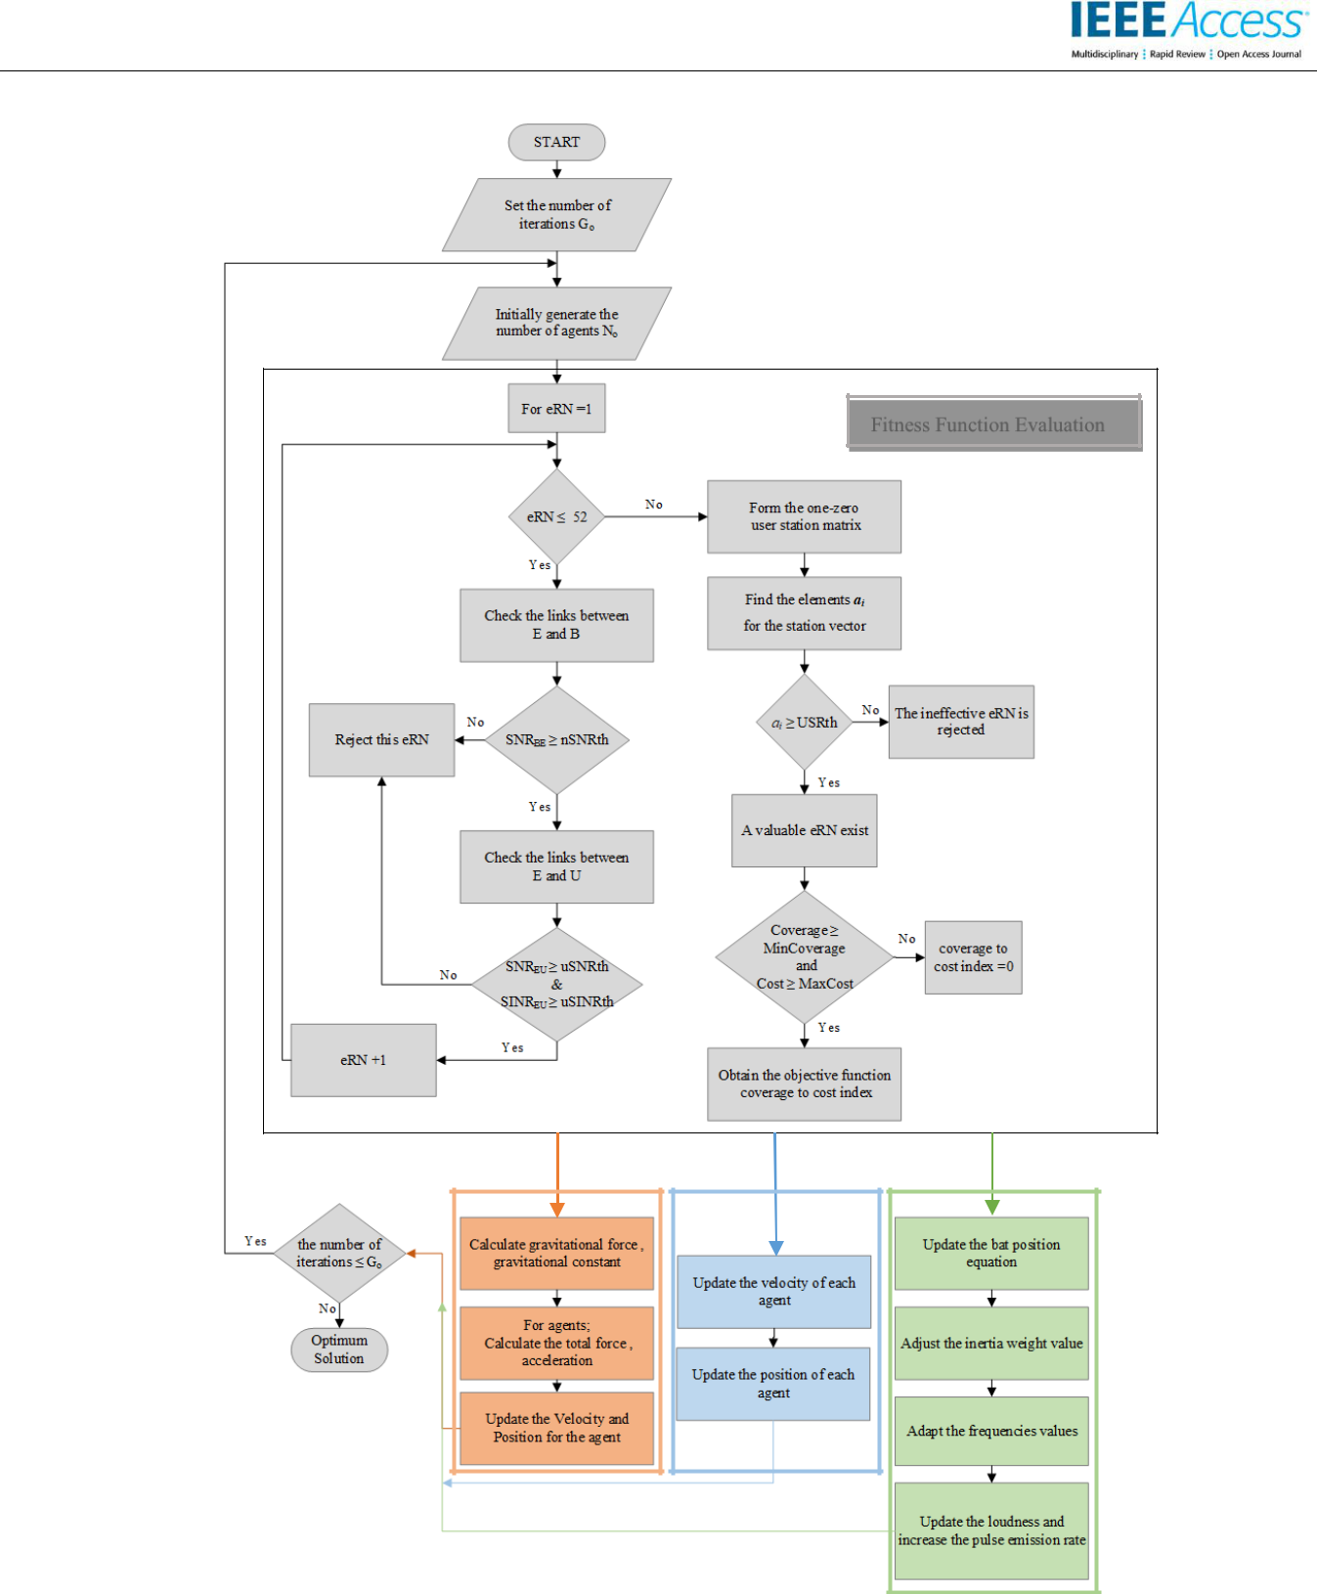

Fitness Function Evaluation

**PSOGSA** **PSO** **FSABA**

**FIGURE 2. Proposed scenario with each of the PSOGSA, PSO, and FSABA algorithms.**

10

This work is licensed under a Creative Commons Attribution 4.0 License. For more information, see https://creativecommons.org/licenses/by/4.0/.

This article has been accepted for publication in a future issue of this journal, but has not been fully edited. Content may change prior to final publication. Citation information: DOI 10.1109/ACCESS.2020.3011472, IEEE Access

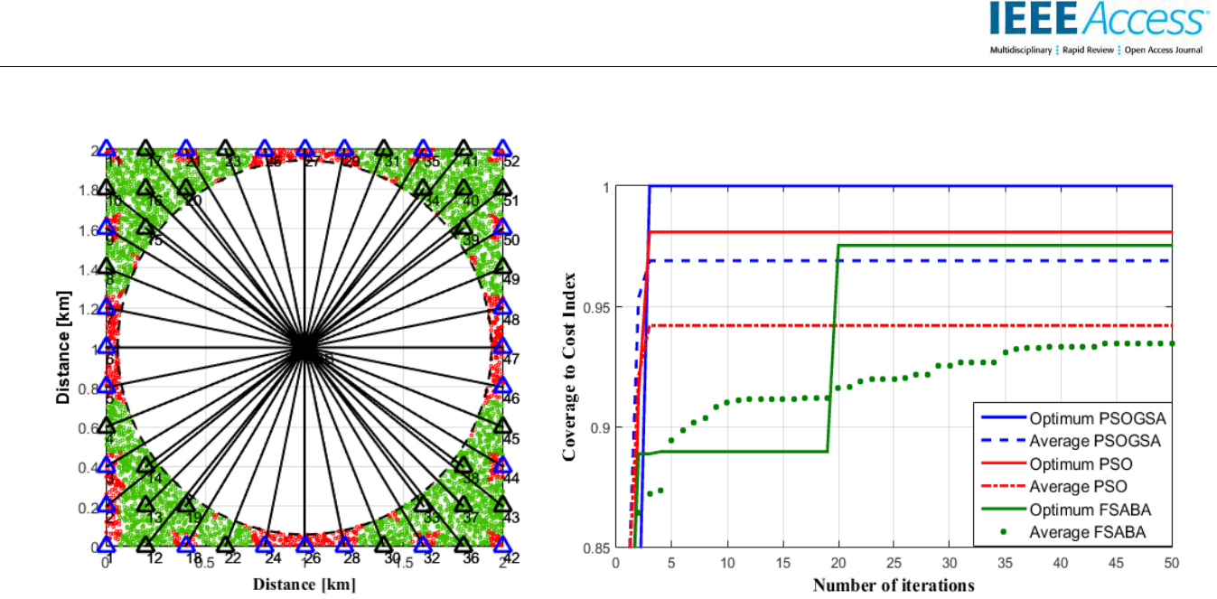

(a) (b)

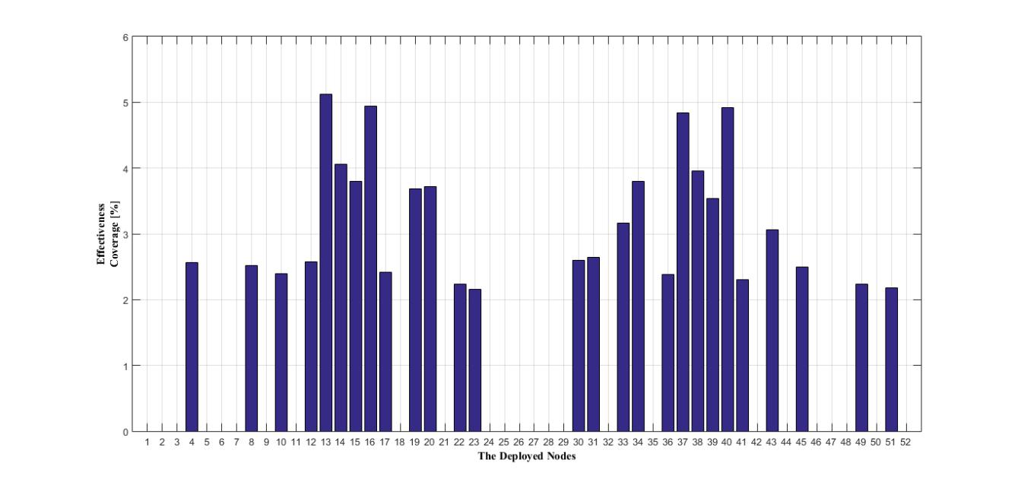

(c)

**Figure 3. The optimum plan of the proposed deployment scenario: (a) the PSOGSA cell plan with the deployment of the edge relay nodes; (b) the coverage to cost index of the optimum plans obtained from the three optimization algorithms and for an average of 20 runs; (c) the effectiveness of each edge relay node in the cell.**

FSABA and the PSO selected 28 edge relay nodes, as a consequence of the *Th* values.

On the other hand, the values of the power factors for the chosen relay nodes of each plan are convergent. Equally important, the total cell edge throughput for 3977 covered users randomly distributed is 134 Gbps, due to the optimum plan of the PSOGSA.

We find that the PSOGSA achieves a notable performance through our deployment scenario for the cell edge, superior to that of the parallel FSABA and the PSO algorithm in the objective function values. Also, the agents of the PSOGSA converge efficiently to the optimum.

11

This work is licensed under a Creative Commons Attribution 4.0 License. For more information, see https://creativecommons.org/licenses/by/4.0/.

This article has been accepted for publication in a future issue of this journal, but has not been fully edited. Content may change prior to final publication. Citation information: DOI 10.1109/ACCESS.2020.3011472, IEEE Access

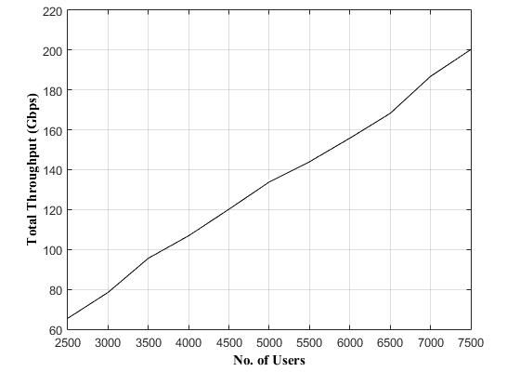

**Figure 4. The optimum plan cell edge throughput.**

Moreover; Figure 4 introduces an optimum cell plan study after endorsing in case the number of the distributed users changes up and down.

In comparison to [19] where the authors proposed an energy-efficient and optimal RN placement (EEORNP) algorithm, we can notice from the results that this algorithm needs 57 relay nodes to cover 500 users whereas our optimum plan needs just 27 relay nodes to cover 3977 users. Furthermore, the algorithm in [19] requires 100 relay nodes to attain 88% coverage whereas our optimum cell plan with the PSOGSA algorithm demands 27 relay nodes to achieve 79.54% coverage means a fewer number of relay nodes by a third.

**VI. CONCLUSION**

In this paper, we aimed to achieve a trade-off between an optimal coverage area at the cell edge, which is considered to be problematic for the users, and a moderate cost. This problem can be settled by the advancement in the relay node track that plays a vital role through its merits. First, we designed the plan and explained our problem. Second, we proposed a deployment scenario for the relay nodes in the cell edge, considering the interference that emerges from these nodes to reach the optimal plan and realize our target. Then, a sophisticated PSOGSA optimization was employed to obtain the optimum plan and increase the leverage of the results. Therefore, we compared the results with another advanced algorithm, the FSABA, in addition to the PSO algorithm. From the essence of the results, the PSOGSA performs better than other algorithms, in which the plan of the cell edge has a coverage percentage is 79.54% from the impact of the relay nodes only, with the lowest cost. The cell edge throughput of the optimum plan is calculated. Consequently, the throughput is presented whether the number of users increase or decrease through the cell edge. The simulations patently prove the enhanced performance of the proposed plan using the optimization of the PSOGSA.

**REFERENCES**

1. Z. Niu, Y. Wu, J. Gong, and Z. Yang, “Cell zooming for cost-efficient green cellular networks,” *IEEE Commun. Magazine*, vol. 48, no. 11, pp. 74-79, Nov. 2010.
2. F. G. Sanchez and J. Zhang, “LTE access network planning and optimization: a service oriented and technology-specific perspective,” in *Proc. 2009 IEEE. Glob. Telecommun. Conf. (GLOBECOM 2009)*, Honolulu, HI, USA, Dec. 2009, pp. 1-5.
3. S. Wang and C. Ran, “Rethinking cellular network planning and optimization,” *IEEE J. Wireless Commun.*, vol. 23, no. 2, pp. 118-125, April 2016.
4. W. Zhao, S. Wang, C. Wang, and X. Wu, “Approximation algorithms for cell planning in heterogeneous networks,” *IEEE J. Transact. on* *Vehicular Technol.*, vol. 66, no. 2, pp. 1561-1572, Feb. 2017.
5. F. H. Tseng, C. Y. Chen, L. D. Chou, T. Y. Wu, and H. C. Chao, “A

study on coverage problem of network planning in LTE-Advanced relay networks,” in *proc. IEEE 26th Int. Conf. on Adv. Information* *Networking and Applications*, Fukuoka, Japan, March 2012, pp. 944-950.

1. C. Y. Chen, F. H. Tseng, C. F. Lai, and H. C. Chao, “Network planning for mobile multi- hop relay networks,” *Wirel. Commun. Mob. Comput.* *J*, vol. 15, no. 7, pp. 1142–1154, July 2013. [Online]. Available:<https://onlinelibrary.wiley.com/doi/full/10.1002/wcm.2396>
2. F. H. Tseng, L. D. Chou, H. C. Chao, and W. J. Yu, “Set cover problem of coverage planning in LTE-Advanced relay networks,” *Int. J. of* *Electronic Commerce Studies*, vol. 5, no. 2, pp. 181-198, 2014, doi:10.7903/ijecs.1159.
3. F. H. Tseng, L. D. Chou, and H. C. Chao, “Network planning for Type 1 and Type 1a relay nodes in LTE-Advanced networks,” *Wirel.* *Commun. Mob. Comput. J*, vol. 16, no. 12, pp. 1526-1536, Aug. 2016.
4. Ö. Bulakci, S. Redana, B. Raaf, and J. Hämäläinen, “Performance enhancement in LTE- Advanced relay networks via relay site planning” in *proc. 2010 IEEE 71st Vehicular Technol. Conf.*, Taipei, Taiwan, May 2010, pp. 1-5.
5. O. N. C. Yilmaz, E. Mutafungwa, and J. Hämäläinen, “Performance of relay enhanced LTE-Advanced networks for selected suburban scenarios in emerging market environments,” in *proc.* [*2012 Int.*](https://ieeexplore.ieee.org/xpl/mostRecentIssue.jsp?punumber=6324001)[*Symposium on Wirel. Commun. Sys. (ISWCS)*,](https://ieeexplore.ieee.org/xpl/mostRecentIssue.jsp?punumber=6324001) *Paris,* France, Aug.2012, pp. 914-918.
6. I. K. Valavanis, G. E. Athanasiadou, D. Zarbouti, and G. V. Tsoulos, “Base-station location optimization for LTE systems with genetic algorithms,” in *proc.* [*20th Europ. Wirel. Conf.*](https://ieeexplore.ieee.org/xpl/mostRecentIssue.jsp?punumber=6843047) *(European Wireless 2014)*, Barcelona, Spain, May 2014, pp. 473-478.
7. K. Belbase, Z. Zhang, H. Jiang, and C. Tellambura, “Coverage analysis of millimeter wave decode-and-forward networks with best relay selection,” *IEEE Access*, vol. 6, pp. 22670-22683, April 2018.
8. A. B. Saleh, Ö. Bulakci, S. Redana, and J. Hämäläinen, “On cell range extension in LTE-Advanced Type 1 inband relay networks,” *Wirel.* *Commun. Mob. Comput. J*, vol. 15, no. 4, pp. 770-786, March 2015.
9. S. K. Gupta, P. Kuila, and P. K. Jana, “Genetic algorithm approach for k-coverage and m-connected node placement in target based wireless sensor networks,” *Computers and Electrical Engineering (Elsevier)*, vol. 56, pp. 544-556, Nov. 2016.
10. A. Abrol and R. K. Jha, “Power Optimization in 5G Networks: A Step Towards GrEEn Communication,” *IEEE Access*, vol. 4, pp. 1355-1374, April 2016.
11. M. Arthi and P. Arulmozhivarman, “A Flexible and Cost-Effective

Heterogeneous Network Deployment Scheme for Beyond 4G,” *Arab.* *J Sci. Eng. (Springer)*, vol. 41, no. 12, pp. 5093-5109, May 2016.

1. B. J. Chang, Y.H. Liang, and S. S. Su, “Analyses of QoS-based Relay Deployment in 4G LTE-A Wireless Mobile Relay Networks,” in *Proc.* *2015* [*21st Asia-Pacific Conf. on Comm. (APCC)*,](https://ieeexplore.ieee.org/xpl/conhome/7400333/proceeding) *Kyoto,* Japan, Oct.2015, pp. 62-67.
2. E. C. Bardera, M. S. Fern´andez, A. G. Armada, A. G. Mart´ın, and A.

F. Dur´an, “Analysis of a LTE-based Textile Massive MIMO Proposal for Public Safety Networks,” in *Proc.* [*2017 IEEE 86th Vehicul.*](https://ieeexplore.ieee.org/xpl/conhome/8283330/proceeding)[*Technol. Conf. (VTC-Fall)*,](https://ieeexplore.ieee.org/xpl/conhome/8283330/proceeding) *Toronto,* Canada, Sept. 2017, pp. 1-5.

1. A. D. Mafuta, T. Walingo, and T. M. N. Ngatched, “Energy Efficient

Coverage Extension Relay Node Placement in LTE-A Networks,” *IEEE Communications Letters*, vol. 21, no. 7, pp. 1617-1620, July2017.

12

This work is licensed under a Creative Commons Attribution 4.0 License. For more information, see https://creativecommons.org/licenses/by/4.0/.

This article has been accepted for publication in a future issue of this journal, but has not been fully edited. Content may change prior to final publication. Citation information: DOI 10.1109/ACCESS.2020.3011472, IEEE Access



1. A. Salah, H. M. Abdel-Atty, and R. Y. Rizk, “Joint Channel

Assignment and Power Allocation Based on Maximum Concurrent

Multicommodity Flow in Cognitive Radio Networks,” *Wireless* *Communications and Mobile Computing (Hindawi)*, vol. 2018, pp. 1-14, July 2018.

1. F. M. Al-Turjman, A. E. Al-Fagih, and H. S. Hassanein, “A Novel

Cost-Effective Architecture and Deployment Strategy for Integrated

RFID and WSN Systems,” in *Proc.* [*2012 Int. Conf. on Comput.,*](https://ieeexplore.ieee.org/xpl/conhome/6163567/proceeding)[*Network. and Commun. (ICNC)*,](https://ieeexplore.ieee.org/xpl/conhome/6163567/proceeding) *Maui,* USA, 2012, pp. 835-839.

1. Z. Cheng, M. Perillo, and W. B. Heinzelman, “General Network

Lifetime and Cost Models for Evaluating Sensor Network

Deployment Strategies,” *IEEE Transactions on Mobile Computing*, vol. 7, no. 4, pp. 484-497, April 2008.

1. J. Huang, Y. Meng, X. Gong, Y. Liu, and Q. Duan, “A Novel

Deployment Scheme for Green Internet of Things*,” IEEE Internet of* *Things Journal*, vol. 1, no. 2, pp. 196-205, Jan. 2014.

1. C. Kirallah, J. S. Thompson, H. Rashvand, “Energy and cost impacts of relay and femtocell deployments in long-term-evolution advanced,” *IET Communications*, vol. 5, no. 18, pp. 2617-2628, July 2011.
2. G. Piro, M. Miozzo, G. Forte, N. Baldo, L. A. Grieco, G. Boggia, and

P. Dini, “HetNets Powered by Renewable Energy Sources:

Sustainable Next-Generation Cellular Networks,” *IEEE Internet* *Computing*, vol. 17, no. 1, pp. 32-39, Feb. 2013.

1. N. Lu, N. Zhang, N. Cheng, X. Shen, J. W. Mark, and F. Bai, “Vehicles Meet nfrastructure: Toward Capacity–Cost Tradeoffs for Vehicular

Access Networks,” *IEEE Transact. on Intellig. Transport. Sys.*, vol. 14, no. 3, pp. 1266-1277, Sept. 2013.

1. M. Z. A. Bhuiyan, G. Wang, J. Cao, and J. Wu, “Deploying Wireless Sensor Networks with Fault Tolerance for Structural Health

Monitoring,” *IEEE Transactions on Computers*, vol. 64, no. 2, pp. 382-395, Feb. 2015.

1. M. Werner, P. Moberg, P. Skillermark, M. Naden, W. Warzanskyj, P.

Jesus, and C. Silva, “Cost Assessment and Optimization Methods for Multi-Node Radio Access Networks,” in Proc. [*VTC Spring 2008 -*](https://ieeexplore.ieee.org/xpl/conhome/4525555/proceeding)

[*IEEE Vehicul. Techno.*](https://ieeexplore.ieee.org/xpl/conhome/4525555/proceeding) *Conf.*, Singapore, May 2008, pp. 2601-2605.

[29] Y. Wang, G. Feng, and Y. Zhang, “Cost-efficient Deployment of Relays for LTE-Advanced Cellular Networks,” in *Proc.* [*2011 IEEE*](https://ieeexplore.ieee.org/xpl/conhome/5962386/proceeding)[*Inter. Conf. on Commun. (ICC)*,](https://ieeexplore.ieee.org/xpl/conhome/5962386/proceeding) *Kyoto,* Japan, July 2011.

1. M. Selim, A. Kamal, K. Elsayed, H. M. Abd-El-Atty, and M. Alnuem,

“A Novel Approach for Back-haul Self-Healing in 4G/5G HetNets,” in *proc.* [*2015 IEEE Inter. Conf. on Commun. (ICC),*](https://ieeexplore.ieee.org/xpl/conhome/7225357/proceeding) *London, UK, June 2015, pp. 3927-3932.*

1. R. M. Mokhtar, H. M. Abdel-Atty, and K. R. Mahmoud, “Cell

Planning Based on Relay-nodes Positions and Power Using Particle

Swarm Optimization,” in *proc. 2019 7th Inter. Japan-Africa Conf. on* *Elect., Commun., and Comput., (JAC-ECC)*, Alexandria, Egypt, Dec.2019, pp. 1-6.

1. E. Hossain and M. Hasan, “5G Cellular: Key enabling technologies and research challenges,” *IEEE Instrument. & Measure. Magazine*, vol. 18, no. 3, pp. 11-21, June 2015.
2. A. Kaveh and M. I. Ghazaan, “Meta-heuristic Algorithms for Optimal Design of Real-Size Structures,” in *Springer*, Cham, April 2018.
3. O. Ertenlice and C. B. Kalayci, “A survey of swarm intelligence for portfolio optimization: Algorithms and applications,” *Swarm and* *Evolutionary Computation (Elsevier)*, vol. 39, pp. 36-52, April 2018.
4. O. Bozorg-Haddad, “Advanced Optimization by Nature-Inspired

Algorithms,” in *Springer*, Singapore, 2018.

1. J. Kennedy and R. Eberhart, “Particle swarm optimization,” in *proc.* [*Int. Conf. on Neural Networks (ICNN'95)*](https://ieeexplore.ieee.org/xpl/mostRecentIssue.jsp?punumber=3505),Perth, WA, Australia, Dec.1995, pp. 1942-1948.
2. S. Mirjalili and S. Z. M. Hashim, “A new hybrid PSOGSA algorithm for function optimization,” in *proc.* [*Int. Conf. on Comp. and Info.*](https://ieeexplore.ieee.org/xpl/mostRecentIssue.jsp?punumber=6135533)[*Application*](https://ieeexplore.ieee.org/xpl/mostRecentIssue.jsp?punumber=6135533) *(ICCIA 2010)*, Tianjin, China, Dec. 2010, pp. 374-377.
3. Z. Beheshti and S. M. Hj. Shamsuddin, “A review of population-based meta-heuristic algorithm,” *Int. J. Advance. Soft Comput. Appl.*, vol. 5, no. 1, pp. 1-35, March 2013.
4. E. Rashedi, H. Nezamabadi-pour, and S. Saryazdi, “GSA: A gravitational search algorithm,” *Information Sciences J. (Elsevier)*, vol. 179, no. 13, pp. 2232-2248, March 2009.
5. W. S. Tan, M. Y. Hassan, H. A. Rahman, M. P. Abdullah, and F. Hussin, “Multi-distributed generation planning using hybrid particle swarm optimisation- gravitational search algorithm including voltage

rise issue,” *IET Gener. Transm. Distrib.*, vol. 7, no. 9, pp. 929-942, April 2013.

1. S. Jayaprakasam, S. K. A. Rahim, and C. Y. Leow, “PSOGSA-

Explore: A new hybrid metaheuristic approach for beampattern

optimization in collaborative beamforming,” *Applied Soft Comput. J.*

*(Elsevier)*, vol. 30, pp. 229-237, 2015.

1. K. R. Mahmoud and A. M. Montaser, “Performance of Tri-Band Multi-Polarized Array Antenna for 5G Mobile Base Station Adopting

Polarization and Directivity Control,” *IEEE Access*, vol. 6, pp. 8682-8694, Feb. 2018.

1. X. S. Yang, “A New Metaheuristic Bat-Inspired Algorithm,” in *Nature* *Inspired Cooperative Strategies for Optimization (NISCO 2010)*, J. R.Gonzalez et al. eds., 1st ed., Studies in Computational Intelligence, Heidelberg, Springer-Verlag Berlin Heidelberg, vol. 284, 2010, pp. 65-74.
2. Z. Chen, Y. Zhou, and M. Lu, “A simplified Adaptive Bat Algorithm

Based on Frequency,” *J. of Comput. Info. Sys.*, vol. 9, pp. 6451-6458, Aug., 2013.

1. S. Yilmaz and E. U. Kucuksille “Improved Bat Algorithm (IBA) on Continuous Optimization Problems,” *Lecture Notes on Software* *Engineering*, vol. 1, no. 3, pp. 279-283, Aug., 2013.
2. 3GPP TR 36.826, “Evolved universal terrestrial radio access (E-UTRA)”, Relay radio transmission and reception, Release 11, Version 11, Dec. 2012.



**RANA M. MOKHTAR** receivedthe B.Sc. degree in communication and electronics engineering from Suez Canal University, Port Said, Egypt, in 2009. She is currently pursuing the M.Sc. degree in communication engineering with the Faculty of Engineering. Her current research interests include cellular network planning, relaying

network, and optimization techniques.

**DR. HEBA M.** **Abdel-Atty**

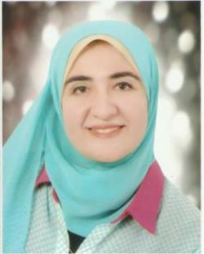

received the Ph.D. degree in Electronics and Communications Engineering from the Faculty of Engineering-Port Said University, Egypt 2012. She is working as an

associate professor at the Electronics and Communications Engineering Department from 2018 until now. She is founder and counselor of IEEE in Port-Said University student branch. She is a

member of IoT Egypt Forum She published a lot of papers in international journals and conferences and she is a reviewer at a lot of international journals. Her current

12

This work is licensed under a Creative Commons Attribution 4.0 License. For more information, see https://creativecommons.org/licenses/by/4.0/.

This article has been accepted for publication in a future issue of this journal, but has not been fully edited. Content may change prior to final publication. Citation information: DOI 10.1109/ACCESS.2020.3011472, IEEE Access



research interests are in wireless communication systems,

multimedia processing, cognitive radio, security of wireless

networks, artificial intelligence(AI), Internet of Things(IoT),

Smart cities technologies, Sustainable development, and

Field Programmable Gate Array.

**K. R. MAHMOUD** received his B.S.

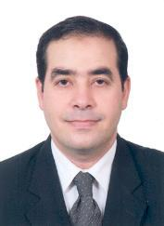

and M.S. degrees in Communications

and Electronics Engineering from

Helwan University in 1998 and 2003.

His Ph.D. degree from Helwan

University in collaboration with the

University of Connecticut, USA in

2008. He is currently an associate

professor at the department of communications and

electronics engineering in the same faculty. Since 2012, Dr.

Mahmoud served as a Consultant in the R&D department,

National Telecommunications Regulatory [Authority](http://www.google.com.eg/url?sa=t&rct=j&q=&esrc=s&source=web&cd=4&ved=0CDIQFjAD&url=http%3A%2F%2Fwww.tra.gov.eg%2Fenglish%2Fmain.asp&ei=dOpIULvOFu2P4gSmn4D4Bw&usg=AFQjCNGl6rTPWNi6dO6kYpiwfNPKiBpuuQ)

(NTRA), Egypt. Also, he has been working as a Post-

Doctoral Fellow at the CPSM Center (Center for Photonics

and Smart Materials), Zewail City, Egypt. His current

research interests include the areas of 5G mm-Wave and

optical antennas design, optimization techniques.

12

This work is licensed under a Creative Commons Attribution 4.0 License. For more information, see https://creativecommons.org/licenses/by/4.0/.