This article has been accepted for publication in a future issue of this journal, but has not been fully edited. Content may change prior to final publication. Citation information: DOI 10.1109/ACCESS.2020.3012829, IEEE Access



**Intelligent Machine Tool Based on Edge-Cloud Collaboration**

**PING LOU 1,2, SHIYU LIU 1,2, JIANMIN HU 1,2, RUIYA LI 3, ZHENG XIAO 3, AND JUNWEI YAN 1,2**

1School of Information Engineering, Wuhan University of Technology, Wuhan, 430070, China

2Hubei Key Laboratory of Broadband Wireless Communication and Sensor Networks (Wuhan University of Technology), Wuhan 430070, China

3School of Mechanical and Electronic Engineering, Wuhan University of Technology, Wuhan 430070, China

Corresponding author: Junwei Yan (junweiyan@whut.edu.cn)

This research was funded by the National Natural Science Foundation Committee (NSFC) of China, grant number 51905397 and the Fundamental Research Funds for the Central Universities (WUT: 2018III069GX and WUT:2019III071GX).

**ABSTRACT** As a key equipment of manufacturing, the intelligence of CNC machine tools affects thedevelopment and progress of intelligent manufacturing. At the same time, the rapid development of various technologies in recent years, such as cloud computing and edge computing, has brought new methods to improve the intelligence of CNC machine tools. This paper proposes a new architecture of intelligent machine tools based on edge-cloud collaboration (IMT-ECC). The hierarchical structure of IMT-ECC is introduced and consists of three layers, data acquisition, network communication and edge-cloud collaboration. Combining the real-time characteristic of edge computing and complex problem processing ability of cloud computing, the edge-cloud collaboration is designed to improve the intelligence of machine tools through data collaboration, information collaboration and knowledge collaboration. Finally, the feasibility of the new intelligent machine tool architecture based on edge-cloud collaboration is verified by experiments with gantry heavy-duty CNC machine tools.

**INDEX TERMS** Machine tool 4.0, edge-cloud collaboration, edge computing, cloud computing, intelligentmachine tool.

**I.INTRODUCTION**

With the continuous growth of national economy and the continuous innovation of science and technology, the development of machinery manufacturing industry has achieved a qualitative leap. As the "master machine" in the industry, CNC machine tools have been receiving widespread attention. At the same time, "Industry 4.0", "Future Factory" and "Made in China 2025" have deeply combined information technology with manufacturing [1]. They make CNC machine tools more intelligent, interconnected and autonomous [2].

Most CNC machine tools in the industry have obvious disadvantages in terms of status perception, information interaction, data processing and real-time feedback [3]. All these characteristics are required by the intelligent manufacturing industry. Therefore, Machine Tool 4.0 proposes a new definition of machine tools-intelligent machine tools, which are more intelligent, well connected, more adaptive and more autonomous [4]. Compared with CNC machine tools, intelligent machine tools can make judgments and decisions on the manufacturing process. In intelligent machine tools, the data during processing will be collected and aggregated. Then the data is analyzed and

processed to realize real-time feedback control of machine tools [5]. The processing of data relies on information technology. At the same time, real-time feedback is used to realize the automatic control and autonomous adjustment of machine tools. It can more effectively control the processing quality of machine tool and achieve emergency response during processing. In order to realize the intelligence and autonomy of the intelligent machine tools, reliable and fast communication is necessary. It can be used to realize effective and correct information interaction with machine tools. At the same time, real-time feedback control puts forward higher requirements for data processing and response efficiency.

During the manufacturing process, the machine tool accumulates a large amount of data. The data has an important impact on dynamically understanding the status of machine tool and improving the productivity of machine tool [5]. Techniques such as edge computing and cloud computing are indispensable for processing, modeling, and feedback of machine data. Edge computing is a system that is distributed near objects or data sources. It has the functions of communication, storage, and computing processing. It can provide key technologies such as fast

|  |  |
| --- | --- |
| VOLUME 5, 2020 | 1 |

This work is licensed under a Creative Commons Attribution 4.0 License. For more information, see https://creativecommons.org/licenses/by/4.0/.

This article has been accepted for publication in a future issue of this journal, but has not been fully edited. Content may change prior to final publication. Citation information: DOI 10.1109/ACCESS.2020.3012829, IEEE Access



P. Lou *et al*.: Intelligent Machine Tool Based on Edge-Cloud Collaboration



connection, real-time services, data processing, security protection and privacy encryption. Edge computing can be offloaded model algorithms, decision information and related data from the cloud. Edge computing is widely used due to its low latency and real-time access [6]. It can also relieve flow pressure. However, computing and storage resources for edge computing are insufficient. When performing complex calculations, edge computing will increase the delay instead. Cloud computing can use storage resources to save large amounts of raw data, while using computing resources for big data processing [5]. Cloud computing is rich in computing and storage resources. It is easy to perform complex operations, such as optimization of models, algorithmic iterations, and other relatively flexible deployment methods. But with the Internet of Things, countless terminal devices are connected to the network, and data is exploding. A wide range of data sources, large amounts of data, and rapid data changes bring huge challenges to cloud computing. They make the data hugely delayed from generation to decision to execution through the cloud. Therefore, edge computing or cloud computing can't meet the requirements of intelligent machine tools respectively.

Since cloud computing has abundant computing and storage resources, it can perform complex big data processing and analysis. But its real-time performance needs to be strengthened. At the same time, edge computing is close to the data source. Its real-time performance is more advantageous, and simple data processing can be performed. In order to realize self-awareness, self-comparison, self-prediction and self-configuration of machine tools [7], this paper proposes a new architecture of intelligent machine tools based on edge-cloud collaboration (IMT-ECC). It can improve the deficiencies of CNC machine tools in status perception, information interaction, data processing and real-time feedback. The new architecture takes advantage of the real-time response characteristics of edge computing, and timely feeds back decisions to the machine tool. Therefore, the machine tool can dynamically adjust processing parameters, improve production efficiency and production quality, and enhance intelligence. Finally, the implementation of IMT-ECC on a gantry heavy CNC machine is introduced to verify the proposed method in the paper.

The rest structure of this paper is organized as follows: Section 2 introduces related work about the intelligent research of CNC machine tools and the application scenarios of edge-cloud collaboration; Section 3 introduces the architecture of intelligent machine tool based on edge-cloud collaboration and related functional modules, which provides methodological guidance for the design of IMT-ECC; Section 4 details the main connotations of the edge-cloud collaboration technology. Section 5 verified the rationality and feasibility of the proposed architecture through experiments; Conclusions are shown at the end of the paper.

**II. RELATED WORKS**

***A.INTELLIGENT MACHINE TOOLS***

With the development of information technology, the intelligence of CNC machine tools has been continuously improved. In Industry 4.0, researchers have different understandings of intelligent machine tools in their research directions. Kong et al. [1] considered that machine tool 4.0 gave a new definition of machine tools. They were more intelligent, well connected, more accessible and adaptable. Besides, they had a higher degree of autonomy. Chen et al.

1. believed that intelligent machine tools included a variety of advanced manufacturing technologies. They contained sensor systems and communication networks. It is capable of training models and algorithms, and can make autonomous decisions and controls. Intelligent machine tools have the characteristics of high precision, high efficiency, low consumption, high reliability and good safety in the manufacturing process. At the same time, intelligent machine tools have a good ability to learn, accumulate and utilize knowledge. "Made in China 2025" also proposes to organize the development of high-end CNC machine tools with deep perception, intelligent decision-making and automatic execution [1], [9]. Thus, intelligent machine tools can realize automatic control of production lines, automatic scheduling of workpieces, automatic monitoring and automatic detection of workpiece quality. It can also realize online wear monitoring of tools, automatic compensation and automatic alarming. Therefore, intelligent machine tools can be self-monitoring, and analyze information related to processing status of machine tools and environment. Then they can realize self-decision and self-control.

***B. TECHNOLOGIES FOR INTELLIGENT MACHINE TOOLS***

In order to make machine tools more flexible and adaptable, researchers have also made great efforts to enhance connectivity of machine tools and increase digitization and intelligence of machine tools [4]. Zhao et al. [10] established a digital dual-drive cyber-physical system. They also proposed a machine tool automatic control method through context-aware micro-point punching. Kim et al. [11] presented a knowledge evolution system based on agent in the machine-to-machine environment. The system automatically collects data and generates knowledge during processing through perception, communication and decision agents. Then it makes decisions based on knowledge. Liu et al. [12] improved the intelligence of machine tools by implementing the comprehensive thermal error compensation of the machine tool system. The simulation data was used to analyze the impact on physics-based predictive model under the influence of screw discretization and single or multiple heat sources. Zhou et al. [3] used technologies such as CPS and fog computing to enhance the autonomy and collaboration of machine tools.

2 VOLUME 5, 2020

This work is licensed under a Creative Commons Attribution 4.0 License. For more information, see https://creativecommons.org/licenses/by/4.0/.

This article has been accepted for publication in a future issue of this journal, but has not been fully edited. Content may change prior to final publication. Citation information: DOI 10.1109/ACCESS.2020.3012829, IEEE Access



P. Lou *et al*.: Intelligent Machine Tool Based on Edge-Cloud Collaboration



In order to make the current machine tools more intelligent and autonomous, Zhang et al. [7] presented a data-driven architecture with additional CPS. This architecture was used to intelligently control CNC machine tools during the manufacturing process. The architecture is designed and achieved through multiple layers of CPS to collect data from sensor networks. Then optimal control rules are obtained by analyzing the data. Xu [13] established a CPS model of CNC machine tools by analyzing a large amount of data generated during the work process. This model can be used to optimize the process of the machine.

***C.APPLICATION OF EDGE-CLOUD COLLABORATION***

Edge computing and cloud computing work together in different scenarios. Edge-cloud collaboration can reduce latency, increase scalability, increase access to information, and make business development more agile. Li et al. [14] thought the management of traditional resources was more flexible and sufficient to predict the demand for resources. However, the neglect of cloud resource billing had made the cost of leasing in the cloud too high. So, they proposed an adaptive resource allocation algorithm to minimize costs in edge-cloud systems. Wang et al. [15] presented a framework based on tensor with edge computing and cloud computing. In this framework, cloud computing was used for a large amount of data processing to gain decision information such as rule sets. Edge computing was applied to process small local data with real-time feedback. Santa et al. [16] proposed a platform using edge-cloud collaboration for the management of precision agriculture. The platform met the needs of soilless cultivation at full cycle room temperature. Tang et al. [17] used the edge-cloud system to realize the dynamic allocation of resources. They used the best algorithm to schedule data from the cloud to the edge server, and then matched the resources of the edge tasks. Li et al. [18] used the edge-cloud system to implement a copy management strategy with time and resource constraints, which saved resources and has fault tolerance. Shao et al.

1. used edge-cloud collaboration to process data-intensive IoT workflows. Based on the edge-cloud collaboration, Yang et al. [20] proposed an evolutionary architecture of the intelligent cloud manufacturing system, using layered gateways for real-time response. The "Industrial Internet Platform White Paper (2017)" pointed out that high-frequency data acquisition in industrial production brought huge pressure. The pressure was mainly reflected in the performance and cost of network transmission, platform storage and computing processing. The edge-cloud collaboration realized the synergistic linkage between edge computing and cloud computing, and jointly released the data value. The cloud has abundant computing and storage resources. Models can be established, analyzed and optimized in the cloud. The edge is close to the machine tool. The data can be directly processed and fed back at the edge, which improves the

response speed of the machine tool. The collaboration of cloud computing and edge computing enables machine tools to self-perceive and self-process, self-decision and self-control. At the same time, edge computing can respond to low-latency applications in a timely manner. The edge-cloud collaboration improves the intelligence of the machine tool.

1. **ARCHITECTURE OF INTELLIGENT MACHINE TOOLS BASED ON EDGE-CLOUD COLLABORATION**

The overall architecture of machine tools is shown in Figure 1, which can be divided into three parts: data acquisition, network communication, and edge-cloud collaboration. Data acquisition is mainly achieved by multi-source sensors deployed on the machine tool. The sensors acquire the static properties and working parameters of machine tools, cutting tools and workpieces in real time. Then the data will be transmitted to the edge platform near machine tools, which performs preliminary data processing operations. And the edge transfers the historical data of machine to the cloud for long-term storage. The cloud can not only perform complex data processing (such as data modeling and model optimization) on the data collected during machine operation. It can also offload models or intelligent algorithms to the edge, which use newly acquired data as input to improve response speed. Decisions would be made in the cloud and transferred to machine tools. The CNC controller controls the machining process of machine tools according to the decision. As a result, the machine data collected by a data acquisition module will change accordingly. A data acquisition module, an edge computing platform and a cloud platform realize the information exchange through the network communication. The information is from bottom to top and then forms a closed loop from top to bottom.

***A.DATA ACQUISITION***

In order to understand the structure and operating status of machine tools, as well as processing information, it is necessary to obtain various data from the machine tool. The data of machine tools is mainly obtained through various sensors and measuring devices deployed on the surface or internal of machine tools, such as RFID tags, temperature sensors, acoustic emission sensors, and piezoelectric acceleration sensors. The relevant parameters of the machine tool include attribution data, machining data, and measurement data. The attribution data is physical data of machine tools, cutting tools and workpieces. It includes manufacturer, date of manufacture and tool type of cutting tools, manufacturer and machine type of machine tool. The machining data is the data generated in real time during the processing of machine tools, such as cutting force, strain field as well as temperature field. The data represents the actual status of machining process from different aspects and will change the machining process. Measurement data refers to measurement results which reflect machining

|  |  |
| --- | --- |
| VOLUME 5, 2020 | 3 |

This work is licensed under a Creative Commons Attribution 4.0 License. For more information, see https://creativecommons.org/licenses/by/4.0/.

This article has been accepted for publication in a future issue of this journal, but has not been fully edited. Content may change prior to final publication. Citation information: DOI 10.1109/ACCESS.2020.3012829, IEEE Access



P. Lou *et al*.: Intelligent Machine Tool Based on Edge-Cloud Collaboration

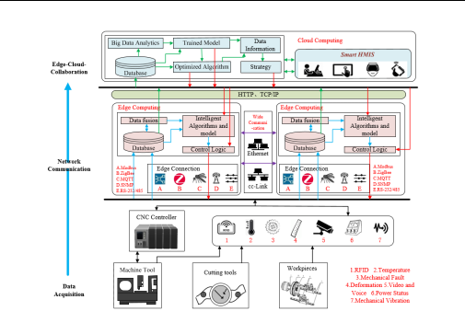

**FIGURE 1. Architecture of intelligent machine tool.**

**TABLE 1. Parameters of the machine tool.**

|  |  |  |  |
| --- | --- | --- | --- |
| Types | Sensors | Items |  |
|  |  |  |  |
|  |  | Manufacturer and Machine Type of Machine Tool; |  |
| Attribution Data | RFID Tags | Manufacturer, Date of Manufacture and Tool Type of Cutting Tools; |  |
|  |  | Material and Machining Program of Workpieces |  |
|  | CNC Controller; Strain Sensors; Temperature | Positions, Speeds, Alarms, Spindle Parameters and Axis |  |
| Machining Data | Sensors, Acoustic Emission Sensors，Vibration | Coordinates; Cutting Force; Temperature Data and Sound Data of |  |
|  | Sensors，Piezoelectric Acceleration Sensors | Machine Tools; Vibration Data of Machine Tools and Cutting Tools |  |
| Measurement Data | CCD Sensors, Laser Interferometer, | Surface Roughness and Accuracy of Workpieces; Cutting Tool |  |
| Optical Sensors | Wear |  |
|  |  |

performances, such as geometrical accuracy and surface roughness of workpieces, wear data of cutting tools. The parameters of the machine tool are shown in Table 1.

***B.NETWORK COMMUNICATION***

Whether transmitting data to the edge after being collected by sensors, or interconnecting between edge and cloud is inseparable from fast and stable network communication. Network communication is shown in Figure 2. As can be seen from Figure 2. Network communication can be divided into three parts: device-edge network, edge-edge network and edge-cloud network. In edge-cloud collaboration, edge devices transmit the collected data to the edge platform through the device-edge network. The protocols include modbus, MQTT, ZigBee, RS-232, RS-

485, OPC UA and TSN protocols. Information exchange takes place among different endpoints via fieldbus technology and industrial Ethernet technology. Fieldbus technology can realize interconnection between intelligent devices, actuators and controllers in the industrial field. At the same time, it enables network communication between industrial field devices and control systems. The edge-edge network mainly implements information exchange between different edge platforms through fieldbus protocols such as EtherCAT and Ethernet Powerlink. Industrial Ethernet is a kind of industrial production Ethernet that integrates TCP/IP protocol, such as Profinet, EtherNet/IP, etc. In order to realize the collaboration between edge and cloud, the edge-cloud network mainly relies on the public Internet, such as HTTP, TCP/IP protocols to transmit information.

4 VOLUME 5, 2020

This work is licensed under a Creative Commons Attribution 4.0 License. For more information, see https://creativecommons.org/licenses/by/4.0/.

This article has been accepted for publication in a future issue of this journal, but has not been fully edited. Content may change prior to final publication. Citation information: DOI 10.1109/ACCESS.2020.3012829, IEEE Access



P. Lou *et al*.: Intelligent Machine Tool Based on Edge-Cloud Collaboration

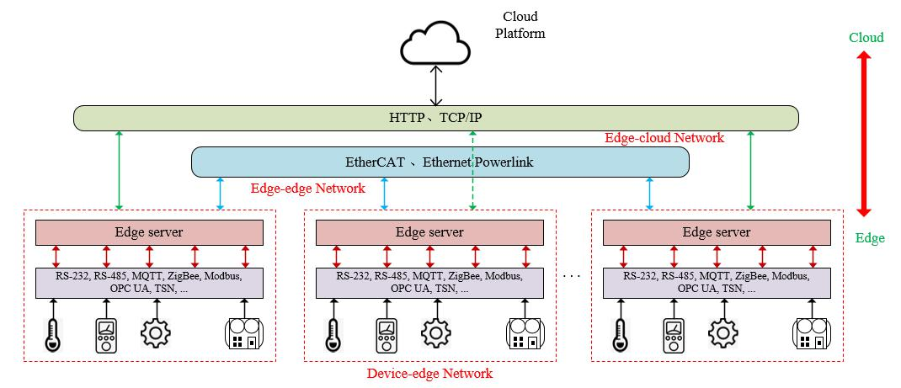

**FIGURE 2. Network communication.**

***C.EDGE-CLOUD COLLABORATION***

The most significant distinction between IMT-ECC and traditional CNC machine tools depends on edge-cloud collaboration. Edge-cloud collaboration refers to the collaborative work of edge computing and cloud computing. Among them, edge computing platform includes data fusion, lightweight model algorithms, logic control and database modules. Cloud computing platform includes database, big data analysis, model algorithm optimization, cloud services, data information and strategy modules. The collaboration between edge computing and cloud computing has realized the functions of efficient data processing, real-time feedback and decision-making of machine tools. It has improved the intelligence of machine tools.

The data obtained by machine tools is first cached in the database on the edge. Since the data is multi- source, the data needs to be processed at the edge and the edge transfers the machine's raw data and all processed data to the cloud for storage and backup. Then a knowledge base of the machine tool will be formed in the cloud. Due to abundant computing resources in the cloud, big data analysis and processing of machine tool data can be performed. After processing, the relevant status of machine tools can be obtained, so that the operating parameters of machine tools can be adjusted in time. Tthe cloud can train models and optimize algorithms based on demand to retrieve and predict relevant parameters of machine tools. At the same time, visual tools such as augmented reality can be used to communicate status of machine tools to the operator, so that the operator can monitor the machine. Since the rapid response to machine tools can improve the intelligence of machine tools, and the edge is close to the device, which can respond with low latency. Therefore, the models and algorithms optimized by the cloud are offloaded to the edge. Then the processed data

at the edge is used as the input of intelligent algorithms. The output of algorithms controls the CNC controller of a machine tool through the logic control module. Then, a CNC controller adjusts the machine parameters to achieve fast response and feedback control.

**IV.DEVELOPMENT METHODOLOGIES FOR EDGE-CLOUD COLLABORATION**

Edge-cloud collaboration is the fundamental element that distinguishes intelligent machine tool from a traditional CNC machine tool. In edge-cloud collaboration, the edge data will be uploaded to the cloud and stored as historical data. The cloud uses historical data to train the model, while the edge transmits the data collected in real time to the cloud to continuously optimize the model. After that, the cloud offloads the trained model to the edge, and the data is processed directly at the edge to solve real-time tasks. At the same time, the cloud can also call different lightweight algorithms at the edge in an orderly manner through logical control statements to process tasks at the edge. The realization of edge-cloud collaboration of machine tools is mainly reflected in three aspects: data collaboration, information collaboration, and knowledge collaboration.

***A.DATA COLLABORATION***

Data is an abstract representation of the quantity, attributes, location and interrelationship of objective things. It is the source of information and knowledge. In industrial production, a large amount of data is generated all the time. Speed, energy consumption, temperature and machine deformation are all data during the production process. Whether it is to understand the machining status of the machine tool, or to carry out data-driven evaluation for the running status of complex processes, data is indispensable and the foundation of the research.

|  |  |
| --- | --- |
| VOLUME 5, 2020 | 5 |

This work is licensed under a Creative Commons Attribution 4.0 License. For more information, see https://creativecommons.org/licenses/by/4.0/.

This article has been accepted for publication in a future issue of this journal, but has not been fully edited. Content may change prior to final publication. Citation information: DOI 10.1109/ACCESS.2020.3012829, IEEE Access



P. Lou *et al*.: Intelligent Machine Tool Based on Edge-Cloud Collaboration

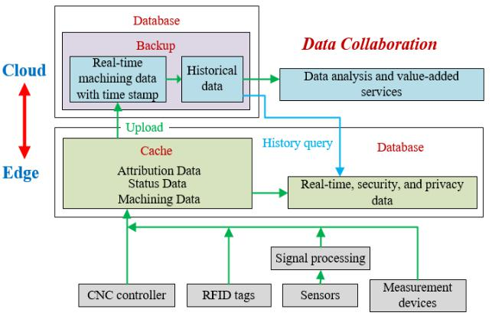

**FIGURE 3. Principle of data collaboration.**

Data collaboration refers to the data interaction between edge and cloud. Because the speed of data acquisition in the industrial field is too fast, the amount of data collected is huge, and the storage resources of the edge are limited. A large amount of data will bring great pressure to the edge and even cause loss of important machine tool parameters. The cloud has abundant storage resources. But during the production process, the delay of data transmission will not meet the real-time requirements of operations in the industrial field. Therefore, the cloud and the edge require data collaboration. The principle of data collaboration between cloud and edge is shown in Figure 3.

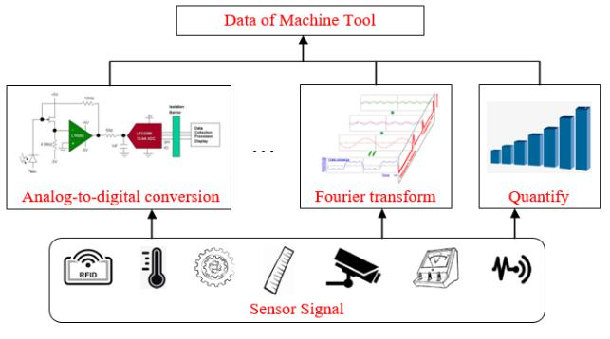

**FIGURE 4. Data acquisition.**

Figure 3 shows that a machine tool acquires data through various sensors, CNC controllers, RFID and measurement devices. A sensor signal needs to be processed by analog-to-digital conversion and Fourier transform before it becomes readable and operable data, as shown in Figure 4. Data acquired from machine tools can be divided into attribution data, machining data and measurement data. Details of data are shown in Figure 5. All data of machine tools is first transferred to the edge through the device-edge network, and the edge will cache all data. In data collaboration, data will be processed in different ways. For all data of machine tools, it is used to construct the database. Therefore, the real-time requirement is not strong, and it can be periodically transmitted to the cloud. At the same time, the edge regularly

deletes data to release storage resources. The cloud receives the data uploaded from the edge and stores it in the database. The database stores processing data with time stamps as historical data, then provides it to the cloud for in-depth analysis. A part of the data needs to be transferred to the cloud in real time for model training. A part of data such as real-time, security, and privacy data is stored at the edge, which is easy to read for quick response through timely processing in the next process. Data will be stored and backed up in the cloud. When the edge computing fails, the data stored in the cloud will not be lost. At the same time, the data is also convenient for the edge to remotely view real-time and local data and conduct historical query.

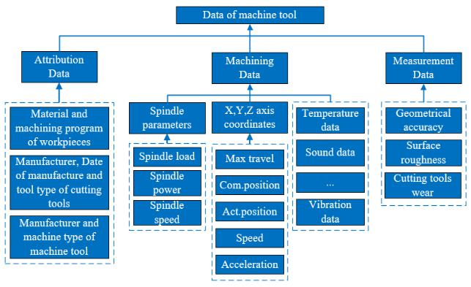

**FIGURE 5. Data of CNC machine tools during production process.**

***B.INFORMATION COLLABORATION***

Information is specific data formed by processing, which can deepen the receiver's understanding of external and objective things. It can also provide a basis for the receiver's decisions and actions. In industrial sites, machine tools acquire large amounts of data through sensors and measuring devices. But the raw data is sometimes confusing, irregular, and redundant. It is impossible to grasp the status of machine tools through these data. So it is necessary to process the raw data to obtain machine tool information.

The machine tool information more intuitively displays the attributes and machining status of machine tools, making it easier to make further decisions on machine tools. Since the data collaboration between edge and cloud cannot control machine tools dynamically in real time, information collaboration is also required. Information collaboration refers to the effective transmission and sharing of information between different subjects or different organizations. The principle of information collaboration between edge and cloud in the new architecture of intelligent machine tools is shown in Figure 6. It can be seen that after all the raw data of machine tools is cached at the edge, the edge performs preliminary data processing on part of raw data to obtain information of machine tools. The data processing process at the edge is shown in Figure 7.

Data processing is mainly divided into four parts, namely data cleansing, data preprocessing, data standardizing and

6 VOLUME 5, 2020

This work is licensed under a Creative Commons Attribution 4.0 License. For more information, see https://creativecommons.org/licenses/by/4.0/.

This article has been accepted for publication in a future issue of this journal, but has not been fully edited. Content may change prior to final publication. Citation information: DOI 10.1109/ACCESS.2020.3012829, IEEE Access



P. Lou *et al*.: Intelligent Machine Tool Based on Edge-Cloud Collaboration

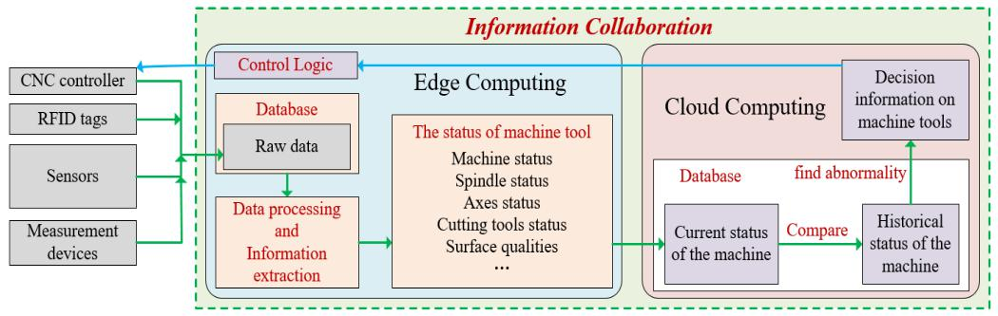

**FIGURE 6. Principle of information collaboration.**

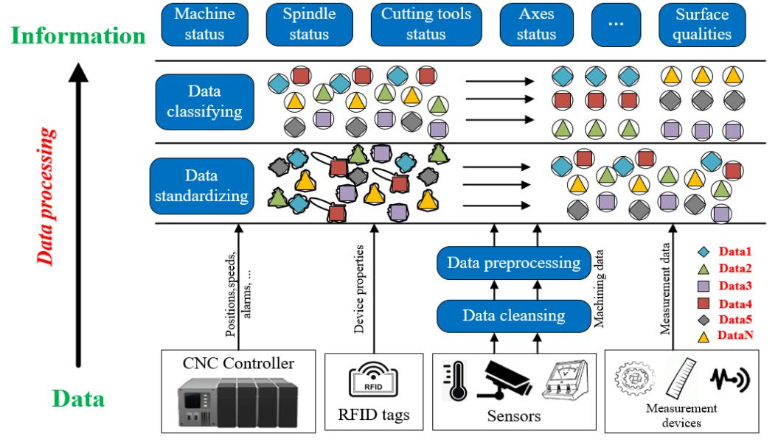

**FIGURE 7. Data processing in information collaboration.**

data classifying. Data cleansing and preprocessing make the data obtained from machine tools reliable, accurate and effective. The specific process is shown in Figure 8 and Figure 9. Data cleansing is mainly achieved by deleting the duplicate data in the raw data, interpolating the missing data and removing the noisy data. Data standardizing is responsible for converting all manufacturing data after preliminary processing into a unified data format. It can facilitate data storage, reading and identification. Data classifying is based on the primary key of each data item, and divides data from different sources into related categories.

The attribution data, machining data and measurement data obtained from machine tools can be processed at the edge to obtain various status information of machine tools. They include machine status, spindle status, axes status, cutting tools status, surface qualities and so on. These information can be uploaded to the cloud through the edge-cloud network. The cloud stores the new status information of machine tools in the database. The cloud will compare new status with historical status of machine tools to dynamically monitor whether machine tools are working properly. The status

information shows that a machine tool is abnormal. On the one hand, the cloud will transmit abnormal information to the employees through the human-machine interface (HMI) to repair and maintain the machine tool. On the other hand, the cloud feeds back the decision information for processing the abnormal machine tool to the edge. The decision information

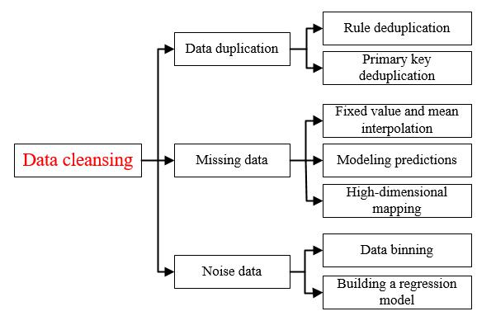

**FIGURE 8. Data cleansing.**

|  |  |
| --- | --- |
| VOLUME 5, 2020 | 7 |

This work is licensed under a Creative Commons Attribution 4.0 License. For more information, see https://creativecommons.org/licenses/by/4.0/.

This article has been accepted for publication in a future issue of this journal, but has not been fully edited. Content may change prior to final publication. Citation information: DOI 10.1109/ACCESS.2020.3012829, IEEE Access



P. Lou *et al*.: Intelligent Machine Tool Based on Edge-Cloud Collaboration

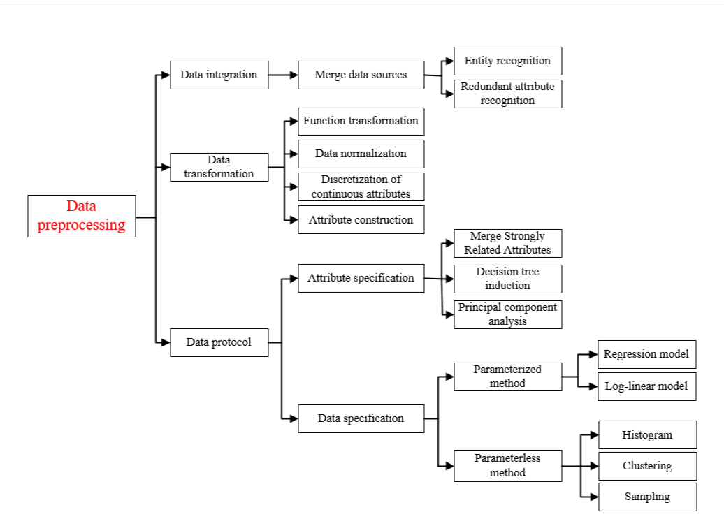

**FIGURE 9. Data preprocessing.**

uses logic control module on the edge to drive a CNC controller to adjust the relevant operating parameters of machine tools, or to cut off the power in time and stop the industrial production to reduce losses. The machine tool does not start working until the status returns to normal. Information collaboration between edge and cloud realizes information transmission, control, feedback, and dynamically obtains the machining status of machine tools. It also effectively controls the machining process of machine tools in real time, and improves the machining accuracy and productivity of machine tools.

***C.KNOWLEDGE COLLABORATION***

Knowledge is structured information used to solve problems. In the new architecture of intelligent machine tools, a large amount of data and information will be uploaded to the cloud. However, raw data is chaotic and the amount of data is large. At the same time, the machining data and status information of machine tools are constantly changing with the machining process, which makes machine tool information rich and disorderly in the cloud. Unprocessed data and information cannot be dug deeply to gain a deeper understanding of the characteristics of the machine tool. And it is difficult to intelligently control the machine tool. Therefore, it is necessary to extract useful information from complex data

and information, which is knowledge. Knowledge can assist machine tools in tracing the process, mining related factors, reducing errors and detecting faults.

Through data collaboration, the data of machine tools can be effectively saved and the database of machine tools can be formed. Through information collaboration, the machining status of machine tools can be dynamically acquired in real time, and the parameters of machine tools can be adjusted initially. However, it is impossible to build a model for a machine tool by relying solely on these two kinds of collaboration. Nor can it delve into the correlation between machine tool parameters. Besides, it is difficult to accurately adjust the operating parameters of machine tools. And it is impossible to implement fault detection and precise positioning of machine tools. Therefore, knowledge collaboration is also required to greatly improve the intelligence of machine tools. The knowledge collaboration between edge and cloud is shown in Figure 10. In order to achieve knowledge collaboration, first, the edge transmits all raw data of a machine tool to the cloud for long-term storage, and builds information models of the machine tool. Second, the cloud uses data uploaded from the edge to train accurate optimization models through long-term learning. In addition, the cloud continues to receive real-time data collected from industrial sites for new models training. It further improves

8 VOLUME 5, 2020

This work is licensed under a Creative Commons Attribution 4.0 License. For more information, see https://creativecommons.org/licenses/by/4.0/.

This article has been accepted for publication in a future issue of this journal, but has not been fully edited. Content may change prior to final publication. Citation information: DOI 10.1109/ACCESS.2020.3012829, IEEE Access



P. Lou *et al*.: Intelligent Machine Tool Based on Edge-Cloud Collaboration

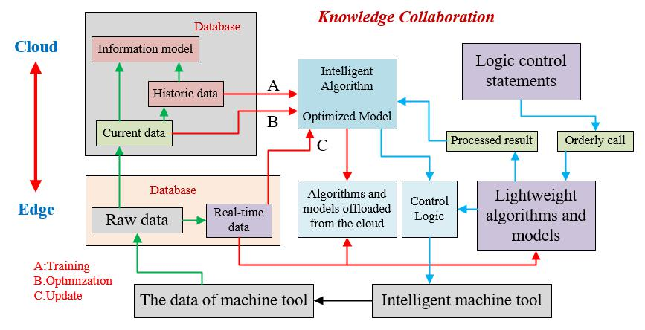

**FIGURE 10. Principle of knowledge collaboration.**

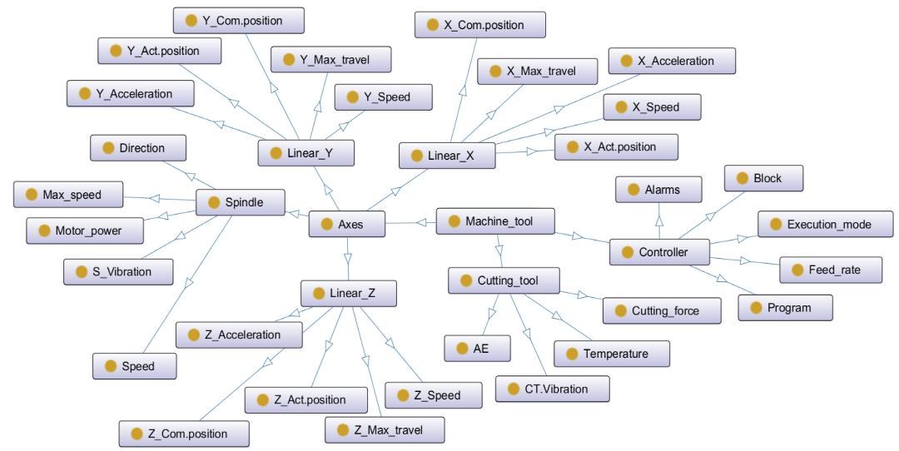

**FIGURE 11. Information model of machine tool.**

the optimization effect of models. At the same time, it avoids the failure of old models due to external input changes. Thus, the compatibility of models have been improved. Then, the cloud transfers the trained models or algorithms to the edge to update the edge optimization models. Third, when models or algorithms are complex, the data needs to be transmitted to the cloud for further processing, and then fed back. At this point, the edge and the cloud cooperate in processing. The edge can use lightweight algorithms to process data first. Then emergency decisions can be made directly at the edge and responded to the machine in time (for example, when the machine tool serious failure needs emergency braking). At the same time, the edge transfers the results (knowledge) to the cloud after preliminary data processing (such as data cleaning, feature extraction, feature reduction, etc.). Transmitting data to the cloud after processing at the edge reduces flow pressure and speeds up the transmission. And then the cloud performs different in-depth processing based

on different results. Finally, the decision information is fed back to the edge. Fourth, there are many different lightweight algorithms on the edge. According to the needs of the actual problem, the cloud writes logical control statements (knowledge) to orderly call the algorithms on the edge, which forms a complete processing flow and deals with problems at the edge.

In knowledge collaboration, the information model of machine tools needs to be constructed, as shown in Figure 11. In the information model, machine tool is the highest parent class of all classes. Different components of machine tools such as cutting tools, axes, and controllers are used as the first-level subclass of the parent class. Under each level of sub-categories, the components can be divided carefully to form the second-level sub-categories. For example, the axis in the first-level subclass can be divided into the spindle, linear X-axis, Y-axis, and Z-axis to form the second-level subclass and so on. At the same time, each subclass has its

|  |  |
| --- | --- |
| VOLUME 5, 2020 | 9 |

This work is licensed under a Creative Commons Attribution 4.0 License. For more information, see https://creativecommons.org/licenses/by/4.0/.

This article has been accepted for publication in a future issue of this journal, but has not been fully edited. Content may change prior to final publication. Citation information: DOI 10.1109/ACCESS.2020.3012829, IEEE Access



P. Lou *et al*.: Intelligent Machine Tool Based on Edge-Cloud Collaboration



own attributes. They represent the real-time data and static attributes of the subclass. When data is continuously uploaded from the edge, the information model will also change and restructure accordingly. At the same time, intelligent models and algorithms as knowledge also provide powerful support for controlling machine tools. For example, the cloud can train an augmented reality (AR) algorithm to retrieve real-time processed video, spindle speed and axis position. At the same time, the algorithm enables AR-based monitoring and simulation. A fuzzy inference system can be trained to search for cutting depth, feed speed and spindle speed. Also it can predict surface roughness. The principle of converting information into knowledge is shown in Figure 12. It can be seen from Figure 12 that new information is continuously acquired to train the model, and the model that finally meets the demand is knowledge. Through the mutual cooperation among data collaboration, information collaboration and knowledge collaboration, it can master the machining status of the machine tool in real time and dynamically adjust the machining parameters. It can also make independent decisions and control, and realize the machining process of the machine tool accurately and efficiently.

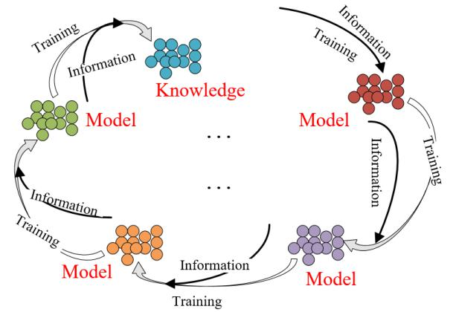

**FIGURE 12. Information conversion into knowledge.**

**V.CASE STUDY**

***A.IMPLEMENTATION***

In this section, the application of IMT-ECC architecture is illustrated by taking the intelligent architecture of the ZK5540A gantry heavy-duty CNC machine tool as an example. The machine tool based on edge-cloud collaboration includes machine tool entity, HNC-848 CNC controller, data acquisition systems, edge computing platform, network communication and cloud platform.

In the intelligent architecture, data of the machine tool is mainly obtained through a variety of sensors. ZK5540A has abundant embedded sensors, which are grating ruler, travel switch, current sensors, voltage sensors and liquid level sensors. The data collected by these sensors will be obtained from the CNC controller in the machine tool. Through these data, basic information of the machine tool can be got. But

the basic information cannot fully reflect the processing status of the machine tool. So in addition to the internal sensors, many sensors (such as temperature sensors, acoustic emission sensors, and piezoelectric accelerometers) are also installed on the machine. These sensors can acquire more processing data of the machine tool. Then the processing status of the machine tool can be obtained through processing. It is helpful for controlling the machining process of the machine tool and diagnosing the failure of the machine tool. In the ZK5540A machine tool, the ARM board with edge computing framework called EdgeX Foundry is used as a hardware device. At the same time, node-red is also installed in the EdgeX Foundry framework for data processing at the edge. On the cloud platform, Hadoop, Spark, TensorFlow and Tomcat are installed. These software use edge upload data to model and continuously optimize, and at the same time output decision information through the model. Then the human-machine interface is used to display the results to the operator. This way they can make decisions about troubleshooting and manufacturing planning, or feedback the decision information to the edge to control the machine parameters. The practical IMT-ECC for the ZK5540A gantry heavy-duty CNC machine tool will be shown in Figure 13.

In the intelligent architecture of the ZK5540A gantry heavy-duty CNC machine tool, the edge computing platform is close to the machine tool. So the data processing is more timely, and the response speed can be improved. At the same time, the data is initially processed at the edge and then transmitted to the cloud. On the one hand, it can reduce the pressure of network traffic and calculation quantity on the cloud platform. Therefore, the data collected by sensors will be transmitted to the edge through device-edge network. The data will be stored in the core data of core services in the EdgeX Foundry. And node-red can be connected to the core-data database on the edge to acquire machine data. There are Python function nodes in the node-red, which can be used to

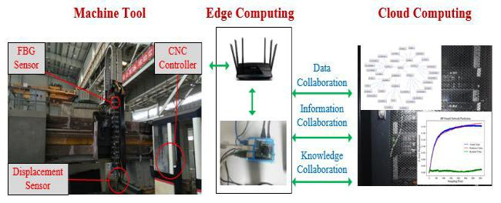

**FIGURE 13. IMT-ECC for the ZK5540A.**

write programs to process data directly at the edge to obtain machine status information. All processed data and obtained information will be stored in the edge, and the status information will be judged in node-red. When the machine tool abnormally needs emergency braking, node-red directly feeds the decision information to the machine tool through the command in core services, which adjusts the machine tool related parameters. At the same time, all processed or

10 VOLUME 5, 2020

This work is licensed under a Creative Commons Attribution 4.0 License. For more information, see https://creativecommons.org/licenses/by/4.0/.

This article has been accepted for publication in a future issue of this journal, but has not been fully edited. Content may change prior to final publication. Citation information: DOI 10.1109/ACCESS.2020.3012829, IEEE Access



P. Lou *et al*.: Intelligent Machine Tool Based on Edge-Cloud Collaboration

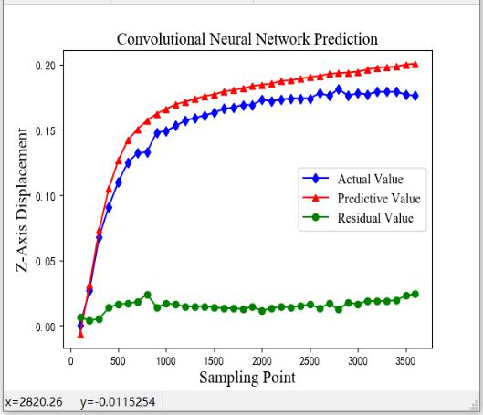

unprocessed data and information in the edge database will be transmitted to the cloud platform through export services. After the cloud platform deeply mines the data, it returns the decision information to the edge. The edge and cloud exchange data and information through protocols based on TCP/IP or HTTP. Then the edge controls the machine tool through command.

***B.EXPERIMENT AND ANALYSIS***

This article has performed experiments about thermal error compensation on a gantry heavy-duty CNC machine tools (ZK5540A) to verify the feasibility for the new architecture. Many factors will influence the machining accuracy of the machine tool, but the main factor is thermal error. 70% of machining workpiece errors are caused by thermal errors. In order to improve the machining accuracy of the machine tool, it is particularly important to be able to control the thermal error in time. In the method of reducing errors caused by heat, thermal error compensation is reliable. In the thermal error compensation experiment, it is mainly divided into three steps: acquiring temperature data and thermal error value, establishing a model to predict thermal error, and performing thermal error compensation on the machine tool according to the predicted value. These steps are achieved through data acquisition in IMT-ECC, network communication and edge-cloud collaboration.

In the experiment, the ZK5540A machine tool continuously collects temperature data and displacement deviation data during processing through the CCD displacement sensors and FBG temperature sensors. After thermal error data and temperature data of the machine tool are acquired, they are first transmitted to the edge through the modbus protocol. These data will be stored in core-data. The edge uses MQTT Exporter and MQTT to transfer data to the cloud for storage and backup. The MQTT Exporter is a microservice of export services in the EdgeX Foundry framework, which is used to export data. And MQTT is based on TCP/IP protocols. Then the cloud uses historical temperature data and thermal error data to train a thermal error prediction model. As the temperature and thermal errors are non-linear relationships, two layers of convolutional neural networks, multiple linear regression, and BP neural networks are used to train the data in the cloud to build a model. Then the newly collected data is used to test the model. The test results of the three models are shown in Figure 14, and the average effective accuracy rate of the three models is shown in Table 2.

As we can see from the Table 2, the average effective accuracy of the two-layer convolutional neural network is 90.54%, the average effective accuracy of the BP neural network is 96.58%, and the average effective accuracy of the multiple linear regression is 93.92%. As can be seen from Figure 14, the thermal error value predicted by the BP neural network gets closer to the actual value. That is, the trained model of BP neural network can predict thermal errors more

**FIGURE 14. Test results of the three models.**

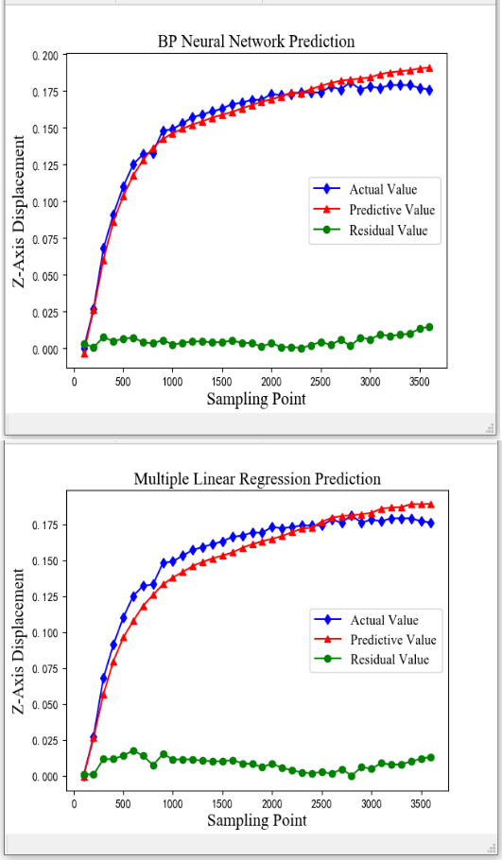

**TABLE 2. Average effective accuracy rate of the three models.**

|  |  |  |  |  |  |
| --- | --- | --- | --- | --- | --- |
|  | Method | CNN | BP | Multiple linear |  |
|  | regression |  |
|  |  |  |  |  |
|  | Average effective | 90.54% | 96.58% | 93.92% |  |
|  | accuracy |  |
|  |  |  |  |  |

accurately. In this experiment, a BP neural network was used to build the model. And the newly acquired machine tool temperature data and thermal error data were continuously optimized to the model. After the model be trained, the cloud offloads the thermal error prediction model into node-red

|  |  |
| --- | --- |
| VOLUME 5, 2020 | 11 |

This work is licensed under a Creative Commons Attribution 4.0 License. For more information, see https://creativecommons.org/licenses/by/4.0/.

This article has been accepted for publication in a future issue of this journal, but has not been fully edited. Content may change prior to final publication. Citation information: DOI 10.1109/ACCESS.2020.3012829, IEEE Access



P. Lou *et al*.: Intelligent Machine Tool Based on Edge-Cloud Collaboration



under the EdgeX Foundry framework. The temperature data collected in real time will be stored in the core-data, and node-red is connected to the database. The real-time temperature data is used as input to the thermal error model at the edge. After the data is processed by the model in node-red, the predicted thermal error will be output. Then node-red uses the restful API to write control statements into the command of core services. After that, the predicted thermal error is fed back to the CNC controller of the machine tool through the command. The CNC controller compensates by changing the cutting path according to the thermal error predicted. Figure 15 shows that the maximum thermal error before compensation is 84.5um, and the maximum thermal error after compensation is 25.1um, and the overall thermal error after compensation is much lower than that before compensation, which proves the feasibility of the new architecture of ZK5540A gantry-type heavy-duty CNC machine tool based on edge-cloud collaboration.

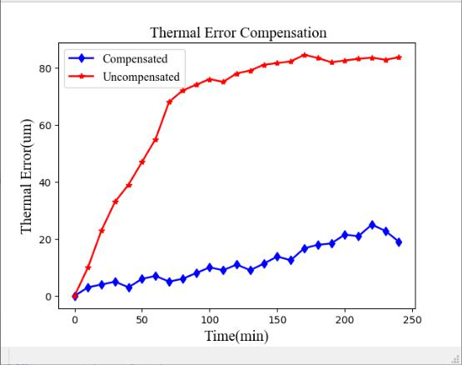

**FIGURE 15. Thermal error compensation.**

**VI.CONCLUSION AND FUTURE WORK**

This paper proposes a new intelligent machine tool architecture based on edge-cloud collaboration. First, the overall framework of the intelligent machine tool is presented, and the function of each module in the architecture is introduced. In IMT-ECC, cloud servers are used to optimize model algorithms, while edge computing is used to fuse, process, and analyze data. Edge computing and cloud computing collaborate to effectively process data while responding with real-time feedback. Then, detailed and comprehensive description of the main connotation of the edge-cloud collaboration in the architecture. It is divided into three progressive levels: data collaboration, information collaboration and knowledge collaboration. By analyzing the specific implementation of each level of collaboration, the detailed process of dynamically adjusting machine tool parameters and improving product accuracy through edge-cloud collaboration is clarified. Finally, in order to prove the feasibility of the IMT-ECC architecture, the edge-cloud collaboration architecture of the ZK5540A heavy-duty CNC machine tool was developed. And thermal error

compensation experiments were conducted to verify the new machine tool architecture. Experiments show that the new IMT-ECC architecture is feasible, which makes the machine tool more intelligent.

In the future, we will focus on the following research points: 1) Protocol standardization: Due to the variety of data collected from industrial sites, the protocols for different types of data are also different. In order to collect data, different protocols need to be converted separately at the edge. Therefore, it is necessary to develop a microservice that can make different protocols "plug and play" instead of processing each protocol separately. It can greatly improve the efficiency and convenience of data acquisition. 2) The interconnection between edge terminals. There are many devices on the industrial site. Different edge devices are interconnected and managed by the cloud platform to improve the intelligence of the industrial site. 3) Security and privacy: Edge computing migrates computing from the cloud to the edge. Data is directly processed and decided locally. To a certain extent, the long-distance transmission of data in the network is avoided, and the risk of privacy leakage is reduced. However, because edge devices obtain first-hand data, they can obtain a large amount of sensitive private data. To ensure data security, different levels of access control need to be set to prevent illegal intrusion.

**REFERENCES**

1. W. Liu, C. P. Kong, Q. Niu et al.,” A method of NC machine tools intelligent monitoring system in smart factories,” Robotics and

Computer-Integrated Manufacturing, vol.61, 2020.

1. C. Liu, H. Vengayil, Y. Q. Lu, X. Xu. "A Cyber-Physical Machine Tools Platform using OPC UA and MTConnect," Journal of Manufacturing Systems, vol.51, pp.61-74, 2019.
2. Z .D. Zhou, J. M. Hu, Q. Liu et al.,” Fog Computing-Based Cyber-Physical Machine Tool System,” IEEE Access, vol.6, pp.44580-44590, 2018.
3. C. Liu, H. Vengayil, R. Y. Zhong et al.,” A systematic development method for cyber-physical machine tools,” Journal of Manufacturing

Systems, vol.48, pp.13-24, 2018.

1. C. Liu, S. Cao, Wayne. Tse et al.,” Augmented Reality-assisted Intelligent Window for Cyber-Physical Machine Tools,” Journal of

Manufacturing Systems, vol.44, pp.280-286, 2017.

1. Wazir Zada Khan, Ejaz Ahmed, Saqib Hakak and Ibrar Yaqoob et al.”Edge computing: A survey,” Future Generation Computer

Systems, vol.97, pp.219-235, 2019.

1. C. Y. Zhang, P. Y. Jiang, K. Cheng et al.,” Configuration Design of the Add-on Cyber-physical System with CNC Machine Tools and its Application Perspectives,” Procedia CIRP, vol.56, pp.360-365, 2016.
2. J. H. Chen, P. C. Hu, H. C. Zhou et al., ”Toward Intelligent Machine Tool,” Engineering, vol.5, no.4, pp.679-690, 2019.
3. C. Liu, X. Xu, “Cyber-physical Machine Tool – The Era of Machine Tool 4.0,” Procedia CIRP, vol.63, pp.70-75, 2017, 50th CIRP Conference on Manufacturing Systems, CIRP CMS 2017.
4. R. L. Zhao, D. X. Yan, Q. Liu, et al, “Digital twin-driven cyber-physical system for autonomously controlling of micro punching system,” IEEE Access, vol.7, pp.9459-9469, 2019.
5. D. H. Kim, J. Y. Song, J. H. Lee et al.,” Development and evaluation of intelligent Machine tools based on knowledge evolution in M2M environment,” Journal of Mechanical Science and Technology, vol.23, no.10, pp.2807-2813, 2009.
6. K. Liu, H. B. Liu, T. Li et al.,” Intelligentization of machine tools: comprehensive thermal error compensation of machine-workpiece system,” International Journal of Advanced Manufacturing

Technology, vol.102, no.9-12, pp.3865-3877, 2019.

12 VOLUME 5, 2020

This work is licensed under a Creative Commons Attribution 4.0 License. For more information, see https://creativecommons.org/licenses/by/4.0/.

This article has been accepted for publication in a future issue of this journal, but has not been fully edited. Content may change prior to final publication. Citation information: DOI 10.1109/ACCESS.2020.3012829, IEEE Access



P. Lou *et al*.: Intelligent Machine Tool Based on Edge-Cloud Collaboration



1. X. Xu. ”Machine Tool 4.0 for the new era of manufacturing,”

International Journal of Advanced Manufacturing Technology, vol.92, no.5-8, pp.1893-1900, 2017.

1. C. L. Li, H. Z. Sun, H. L. Tang et al.,” Adaptive resource allocation based on the billing granularity in edge-cloud architecture,” Computer Communications, vol.145, pp.29-42, 2019.
2. X. K. Wang, L. T. Yang, X. Xie et al.,” A Cloud-Edge Computing

Framework for Cyber-Physical-Social Services,” IEEE Communications Magazine, vol.55, no.11, pp.80-85, 2017.

1. M. A. Zamora-lzquierdo, J. Santa et al.,” Smart farming IoT platform based on edge and cloud computing,” Biosystems Engineering, vol.177, pp.4-17, 2019.
2. H. L. Tang, C. L. Li, J. P. Bai et al.,” Dynamic resource allocation strategy for latency-critical and computation-intensive applications in cloud–edge environment,” Computer Communications, vol.134,

pp.70-82, 2019.

[18] C. L. Li, Y. P. Wang, Y. Chen et al.,” Energy-efficient fault-tolerant replica management policy with deadline and budget constraints in edge-cloud environment,” Journal of Network and Computer Applications, vol.143, pp.152-166, 2019.

[19] Y. L. Shao, C. L. Li, H.L. Tang et al.,” A data replica placement strategy for IoT workflows in collaborative edge and cloud environments,” Computer Networks, vol.148, pp.46-59, 2019.

[20] C. Yang, et al., “Big Data Driven Edge-Cloud Collaboration Architecture for Cloud Manufacturing: A Software Defined Perspective,” IEEE Access, Vol. 8, pp. 45938-45950, 2020.

1. C. Liu, H. Vengayil, R. Y. Zhong et al.,” A systematic development

method for cyber-physical machine tools,” Journal of Manufacturing Systems, vol.48, pp.13-24, 2018.

[22] C. Liu, S. Cao, Tse W, X. Xu. “Augmented reality-assisted intelligent window for cyber-physical machine tools,” Journal of Manufacturing Systems, vol.44, pp.280-286, 2017.

[23] Palanisamy P, Rajendran I, Shanmugasundaram S. “Prediction of tool wear using regression and ANN models in end-milling operation,” International Journal of Advanced Manufacturing Technology, vol.37, pp.29-41, 2018.

1. Ho W-H, Tsai J-T, Lin B-T, Chou J-H. “Adaptive network-based fuzzy inference system for prediction of surface roughness in end milling process using hybrid Taguchi-genetic learning algorithm,”

Expert Systems with Applications, vol.36, pp.3216-3222, 2009.

[25] J. H. Chen, P. C. Hu, H. C. Zhou et al., ”Toward Intelligent Machine Tool,” Engineering, vol.5, no.4, pp.679-690, 2019.

1. Q. Li, H. L. Li,” A general method for thermal error measurement and modeling in CNC machine tools’ spindle,” The International Journal of Advanced Manufacturing Technology, vol.103, pp.2739–

2749,2019.

[27] P. Fantini, M. Pinzone, M. Taisch.” Placing the operator at the centre of Industry 4.0 design: Modelling and assessing human activities within cyber-physical systems,” Computers and Industrial Engineering, In Press, Corrected Proof, 2018.

[28] S. Y. Ma, Y. F. Zhang, J. X. Lv et al.,” Energy-cyber-physical system enabled management for energy-intensive manufacturing industries,” Journal of Cleaner Production, vol.226, pp.892-903, 2019.

[29] A. Selmani, H. Oubehar, M. Outanoute et al.,” Agricultural cyber-physical system enabled for remote management of solar-powered precision irrigation,” Biosystems Engineering, vol.177, pp.18 -30, 2019.

[30] P. O’Donovan, C. Gallagher, K. Bruton et al.,” A fog computing industrial cyber-physical system for embedded low-latency machine learning Industry 4.0 applications,” Industry 4.0 and Smart Manufacturing, vol.15, pp.139-142, 2018.

[31] S. K. Sood, I. Mahajan.” Fog-cloud based cyber-physical system for distinguishing, detecting and preventing mosquito borne diseases,” Future Generation Computer Systems, vol.88, pp.764-775, 2018.

[32] W. Liu, C. P. Kong, Q. Niu et al.,” A method of NC machine tools intelligent monitoring system in smart factories,” Robotics and Computer-Integrated Manufacturing, vol.61, 2020.

1. X. Fei, N. Shah, N. Verba et al.,” CPS data streams analytics based on machine learning for Cloud and Fog Computing: A survey,” Future

Generation Computer Systems, vol.90, pp.435-450, 2019.

[34] A. Celesti, M. Fazio, A. Galletta et al.,” An approach for the secure management of hybrid cloud–edge environments,” Future Generation Computer Systems, vol.90, pp.1-19, 2019.

[35] S. C. Sui, X. H. Li, W. Y. Li.” Research on Edge Computing Architecture for Intelligent NC Machining Monitoring CPS,” Lecture Notes in Electrical Engineering, vol.459, pp.1477-1485, 2019.

**PING LOU** is a Professor at Wuhan Universityof Technology, P. R. China. She received her Ph.D. from Mechanical Engineering from Huazhong University of Science and Technology, P. R. China, in 2004. She was a Research Fellow of National University of Singapore, Singapore, Senior Research Assistant of City University of Hong Kong, Hong Kong, and a Visiting Scholar of University of Toronto, Canada. Ping Lou specializes in research and development of multi-



agent system, digital manufacturing and industrial big data.

**SHIYU LIU** received the bachelor’s degreefromthe Wuhan University of Technology, China, in 2018, where she is currently pursuing the master’s degree. Her research interests include edge computing, industrial big data analysis, and intelligent manufacturing applications.



**JIANMIN HU** is currently pursuing the Ph.D.degree at Wuhan University of Technology, P. R. China. He received his master degree at Wuhan University of Technology, P. R. China, in 2011. He was a Visiting Scholar of Northwestern University, USA. His research interests include the development of switching mode power supply, 3D printer, applications of embedded system and intelligent manufacturing. He has published 6 articles as author or co-



author.

**RUIYA LI** received his B.Sc. degree inmechanical engineering from Wuhan University of Technology, China, in 2012, where he is now working toward the Doctoral degree in the Optical Fiber Sensing Group. His main research interests include fiber Bragg grating sensing technology, robotic disassembly, and thermal error of machine tool.



|  |  |
| --- | --- |
| VOLUME 5, 2020 | 13 |

This work is licensed under a Creative Commons Attribution 4.0 License. For more information, see https://creativecommons.org/licenses/by/4.0/.

This article has been accepted for publication in a future issue of this journal, but has not been fully edited. Content may change prior to final publication. Citation information: DOI 10.1109/ACCESS.2020.3012829, IEEE Access



P. Lou *et al*.: Intelligent Machine Tool Based on Edge-Cloud Collaboration



**ZHENG XIAO** was born in Wuhan, Hubei,China, in 1985. She received the B.S. degree in communication engineering and the M.S. and Ph.D. degree in mechanical engineering from the Wuhan University of Technology, Wuhan, in 2006, 2009, and 2013, respectively.

She is currently an Assistant Professor with the School of Mechanical and Electronic Engineering, Wuhan University of Technology. Her research interests include the intelligent manufacturing, data mining, and enterprise informatization.

**JUNWEI YAN** received the M.Eng. degree incommunication and information system from Wuhan University of Technology, China, in 2009. He was a joint Ph. D. student in the school of



mechanical engineering, University of Birmingham, UK, 2014-2016. He received the Ph. D. degree from Wuhan University of Technology in 2018. His research interests include cloud manufacturing, digital twin, FBG sensors applications and machine learning.

14 VOLUME 5, 2020

This work is licensed under a Creative Commons Attribution 4.0 License. For more information, see https://creativecommons.org/licenses/by/4.0/.