This article has been accepted for publication in a future issue of this journal, but has not been fully edited. Content may change prior to final publication. Citation information: DOI 10.1109/JIOT.2019.2957441, IEEE Internet of Things Journal

|  |  |
| --- | --- |
| JOURNAL OF INTERNET OF THINGS | 1 |

AMACoT: A Marketplace Architecture for Trading Cloud of Things Resources

Ahmed Salim Alrawahi, Member, IEEE, Kevin Lee, Senior Member, IEEE,

and Ahmad Lotfi, Senior Member, IEEE

Abstract—Cloud of Things (CoT) is increasingly viewed as a paradigm that can satisfy the diverse requirements of emerging IoT applications. The potential of CoT is not yet realised due to challenges in sharing and reusing IoT physical resources across multiple applications. Existing approaches provide small-scale and hardware-dependent shared access to IoT resources. This paper considers using market mechanisms to commoditise CoT resources as the approach to enable shared access to CoT resources and to improve their reusability. In order to achieve this, the requirements for trading CoT resources are discussed to conceptualise the proposed approach. A generic description model for CoT resource is introduced to quantify the value of CoT resources. In this paper, a marketplace architecture for trading CoT resources referred to as AMACoT is proposed. By formulating the trading of CoT resources as an optimisation problem, the proposed approach is experimentally validated. The evaluation measures the system performance and verifies the optimisation problem using three evolutionary algorithms. The evaluation of the optimisation algorithms demonstrates the optimality of trading CoT resources solutions in terms of resource cost, resource utilisation, provider lock-in and provider profit.

Index Terms—Cloud of Things, IoT, Marketplace, Optimisa-tion

1. INTRODUCTION

Cloud of Things (CoT) integrates Cloud Computing and Internet of Things (IoT) to complement each other. It aims to address the requirements of emerging IoT applications where either technology alone does not work. This includes applications that require Cloud resources but also interact with real-world objects/events that are far away from Cloud data-centres. The adoption of CoT is hindered by many challenges despite its benefits. These include latency, security [2] and resource management of IoT physical resources [3], [4].

Challenges in CoT resource management include load bal-ancing, resource allocation and scheduling [5]. The complexity of resource allocation in CoT comes from the following. The heterogeneity of IoT resources, the constrained capacities of IoT resources, the scalability of IoT systems and the dynamism of IoT resources. These challenges lead to missing/limiting shared access to the IoT physical resources and consequently lessen the reusability of the resources across multiple applica-tions. These also result in over-provisioned IoT infrastructure

A. S. Alrawahi is with the School of Science and Technology, Nottingham Trent University, Nottingham, UK, NG11 8NS and with Nizwa College of Applied Sciences, Nizwa, Oman, P. O. Box 699, PC: 611. E-mail: ahmed@alrawahi.org

A. Lotfi is with the School of Science and Technology, Nottingham Trent University, Nottingham, UK, NG11 8NS. E-mail: ahmad.lotfi@ntu.ac.uk

K. Lee is with School of Information Technology, Deakin University, Melbourne, Australia, VIC 3125. E-mail: kevin.lee@deakin.edu.au

to meet the unpredictable application requirements in which resources may be significantly underutilised.

This paper aims to improve shared access to CoT resources by proposing a marketplace architecture which can provide efficient resource allocation and deal with the complex issues present in the CoT. The solution re-imagines CoT resources as commodities rather than as organisational assets. It considers the business model of a marketplace whereby consumers re-quest access (lease) to providers’ resources. A marketplace that potentially can automate the trading between CoT resources and CoT applications. The proposed approach is motivated as follows. The deployments of IoT remain costly despite the increasing demand for IoT applications, the reduction in software and hardware costs [6]. This makes IoT adoption in-feasible to many prospective users and emerging applications. Commoditisation of CoT enables the development of IoT ap-plications independently from the infrastructure deployments. It also enables shared access to IoT physical resources. These likely lead to cost reduction in IoT resources and management as well as empowering new IoT applications and services.

There are various use cases for the CoT marketplace. For instance, an event management agency manages event facilities in a metropolitan area where it aims to improve its operational efficiency. The agency wants to develop an application that performs the following tasks. Find the least congested routes to an exhibition centre leavers. Crowd monitoring of fans attend-ing games in a nearby stadium for better incidents response. Waste monitoring to efficiently automate the waste collection after organised events if needed. Having a dedicated CoT infrastructure for this application may require a significant upfront investment. In CoT marketplace, the agency would request a bundle of CoT resources to perform the tasks. For instance, footfall sensors and motion detection cameras around event facilities to guide people to the least congested tracks. The bundle may include sensors, actuators, cameras and other resources. The application consumes the required resources for a specific time and then releases them back to the marketplace when lease-time elapses. In this case, the application utilises the required resources without considerable investment nor dedicated infrastructure. Similarly, providers deploy their CoT resources without being tied-up to particular applications.

The remainder of this paper is organised as follows. The related work is reviewed in Section II. Section III describes the trading requirements of CoT resources followed by the description of the proposed marketplace architecture in Section IV. Section V analyses the security threats to AMACoT. The experimental setup and evaluation are presented in Section VI.

2327-4662 (c) 2019 IEEE. Personal use is permitted, but republication/redistribution requires IEEE permission. See http://www.ieee.org/publications_standards/publications/rights/index.html for more information.

This article has been accepted for publication in a future issue of this journal, but has not been fully edited. Content may change prior to final publication. Citation information: DOI 10.1109/JIOT.2019.2957441, IEEE Internet of Things Journal

|  |  |
| --- | --- |
| JOURNAL OF INTERNET OF THINGS | 2 |

Section VII concludes this paper and describes the planned future work.

1. RELATED WORK

Market-based mechanisms for trading Cloud and IoT re-sources are intensively studied. Cloud-based approaches are more mature than the ones dedicated to IoT that are still emerging. As CoT relies heavily on IoT resources, this section focuses on IoT related market-based mechanisms. It reviews the recent literature and categorises them into one of the two categories described in the following sections.

A. IoT Marketplace Architectures

The concept of a marketplace for IoT-related resource is gaining prominence. A marketplace architecture for trading IoT data in real-time is proposed in [7]. The architecture en-ables providers to offer their IoT data streams for consumption by IoT applications. The proposed work differs from others by implementing the architecture and addressing various aspects, including scalability and compatibility. A generic Cloud-based marketplace architecture is proposed in [8] to enable trading of IoT deployments. The architecture addresses the Cloud-IoT integration and vendor lock-in issues. A marketplace for IoT resources is introduced as part of the broader architecture of the IoT ecosystem in [9]. The trading model of IoT information and functions is presented as a solution to five IoT interoperability issues.

A different approach is taken by [10] to establish a de-centralised marketplace for IoT data based on blockchain technology. The proposed marketplace architecture uses sim-ple contracts to simplify the trading of IoT data among participants. IDMoB is another decentralised marketplace for IoT data built on blockchain [11]. The marketplace enables trading of IoT data for none time-sensitive IoT applications. DataBroker DAO is another blockchain-based marketplace implemented to trade IoT data [12]. IoT generated data is traded using smart contracts among buyers and sellers via the Ethereum network.

A decentralised peer-to-peer marketplace for IoT data is pre-sented in [13]. The proposed architecture differs from others by adopting fog computing model and blockchain technology. IoT data is prepared (e.g. filtered, processed) at a fog nodes layer while traded directly among the marketplace participants at the application layer. Another decentralised architecture is designed in [14] with the focus of IoT traffic metering and contract compliance. The presented system aims to improve transparency, fairness and interoperability while reducing the cost. The study also conceptualises a tracking model for the traded IoT data flows between IoT and Cloud Computing.

B. IoT Trading Mechanisms

Several market-based approaches are depicted and discussed in [15]. The study also proposes a game-theory based model to study the pricing of two IoT sensing services. Another set of market-based mechanisms is studied in [16]. This includes an analysis of IoT marketplace incentives, service patterns, infor-mation timeliness and social impacts. Two bidding algorithms

to support IoT resource trading are introduced in [17]. The first algorithm aims to maximise the provider’s revenue while the second is to lock the highest bid in the recurrent auction. Both algorithms are intended to protect the marketplace from collapse in certain trading scenarios.

A semantic matching model for IoT marketplace is pre-sented in [18]. The model facilitates the matching process between providers’ offerings and consumers’ queries in a marketplace of the BIG IoT project [19]. A composition mech-anism for IoT offerings is presented in [20]. The approach is based on a web-semantic model to describe IoT things and services for trading.

A feedback mechanism is proposed in [21] to support IoT data marketplaces. The blockchain-based approach enables consumers to rate the providers who have to maintain and improve their reputation based on feedback received. A mar-ketplace model is also proposed in [22] to support the quality of trading. It introduces a credibility rating mechanism for providers based on the quality of their data. Another IoT marketplace model based on Stackelberg game is presented in

1. to model the trading processes in IoT environments. The model aims to minimise the complexities for IoT consumers while trading with IoT providers.

To support automation in IoT trading, a blockchain-based automated payment system is proposed in [24]. The system uses Ethereum contracts to automate payments without a need to intermediaries. An architecture is presented in [25] to support service level agreements (SLAs) while trading IoT data. The architecture uses three criteria model to improve satisfaction, payment and the SLA. Security mechanisms for protecting the IoT data marketplace is studied in [26]. The study also proposes authentication and authorisation model to control access to the traded resources.

C. Gap Analysis

The related work presented above shows it is merely focused on commoditising IoT data-sets/streams but not on IoT phys-ical devices. Further limitations of the existing work are sur-veyed in [27]. This includes limited IoT resources integration, resource sharing and interoperability. Further limitations of existing shared access to IoT resources revolve around small-scale and hardware-specific support mechanisms [28], [6]. Our approach fills that gap by proposing a generic description model for CoT resources and a scalable architecture for trading them. To the best of authors’ knowledge, these are the first dedicated to trading CoT resources.

1. TRADING COT RESOURCES

Trading CoT resources is a multifaceted process. It involves mapping resources to applications, optimising the proposed maps, performing resource allocation and scheduling of the optimal map. To shape this approach, the following consider-ations are taken into account.

1. CoT resources and applications are heterogeneous. To decompose this complexity and improve interoperability, resource deployment and application development are considered distinct from each other. This lowers the

2327-4662 (c) 2019 IEEE. Personal use is permitted, but republication/redistribution requires IEEE permission. See http://www.ieee.org/publications_standards/publications/rights/index.html for more information.

This article has been accepted for publication in a future issue of this journal, but has not been fully edited. Content may change prior to final publication. Citation information: DOI 10.1109/JIOT.2019.2957441, IEEE Internet of Things Journal

|  |  |
| --- | --- |
| JOURNAL OF INTERNET OF THINGS | 3 |

**Consumers** **CoT Marketplace** **Providers**

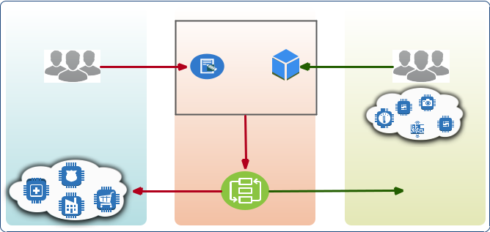

|  |  |  |  |  |
| --- | --- | --- | --- | --- |
|  | submit | submit |  |  |
|  | requests | resources |  |  |
| Applications | performs |  | Resources |  |
|  |  |  |
|  | resources | providers receive | **$$$** |  |
|  | consumed by |  |  |
|  |  |  |  |

Matching

Figure 1. CoT marketplace concept.

investment required for infrastructure deployments, accel-erate application prototyping and enable efficient trading.

1. CoT systems are large-scale and their commoditisation mechanisms, therefore, have to be scalable. In particular, having the ability to handle significant large numbers of resources and application requests simultaneously.
2. CoT resources are naturally constrained in terms of computing and power capabilities. Due to such challenge, concurrent shared access to those resources may not be possible but has to be resolved.

Based on the above-mentioned considerations, the following requirements of the proposed approach are identified.

A. The marketplace system

CoT marketplace concept is illustrated in Figure 1. The idea is to have a marketplace - denoted by M - where providers offer their deployed CoT resources and applications request access to the offered resources. The marketplace matches requests to resources by forming a bundle of resources from multiple providers based on the application requirements. More details about the marketplace architecture are provided in the proceeding Section IV. Table II provides trading vocab-ularies used with their description.

B. The marketplace participants

The marketplace consists of two categories of partici-pants namely providers and consumers. Providers are CoT infrastructure owners/deployers and are denoted by P = (p1; : : : ; pm). pm represents an individual, organisation or a broker who manages resources on behalf of others. P submit their resources R = (r1; : : : ; rj) to M.

Consumers are application owners/developers and are set to C = (c1; : : : ; cn). cn represents an individual, organisation or a broker who manages applications on behalf of others.

* submit requests RQ = (rq1; : : : ; rqi) to M for their CoT applications A = (a1; : : : ; az) to access and utilise a set of R.

C. A multi-attribute description model for CoT resource

The heterogeneity of CoT resources poses a challenge in defining and describing what a resource is? How can a wide range of heterogeneous resources be described generically? How can the value of CoT resources be quantified to enable

monetising them? The solution to these challenges is to pro-pose a description model to 1) define CoT resource, 2) provide a generic description of their properties and 3) quantify the resources based on their described properties. The model is described as follows.

CoT resources can be defined generically based on their main physical components and functionalities. A CoT re-source/node/device/thing is defined as a device with one or more basic computing functionalities (I/O, Processing, Storage) that interacts with its surrounding (using Sensor(s), Camera(s), Actuator(s)) and communicates with other entities of a network (using Communication unit(s)).

The model uses a multi-attribute description of the resources based on their physical and functional properties. Each re-source rj has a set of attributes RA = (ra1; : : : ; rat) that contributes to its monetary value when traded as a commodity. This includes multi-attributes of physical components (e.g. processing, actuating, sensing, power) and non-physical func-tions or features (e.g. security, location, redundancy). Each property or feature can be expanded into a multilevel sub-attributes to improve the presence of the commodity resource in the marketplace. A snapshot of a single resource description is provided in Table I.

The value of the multi-attributes presented in the previous step can be quantified by assigning corresponding numerical values. This is a vital step to monetise heterogeneous resources generically and to enable them to be traded. This can be achieved by assigning lower numerical values to attributes representing low resource specification and vice versa. Zero is a corresponding value for a missing resource component while a positive number corresponds to an attribute. This can be formulated as follows.

|  |  |  |  |  |  |
| --- | --- | --- | --- | --- | --- |
| ra = ( | > 0; | if raj can be described from | rj | (1) |  |
| 0; | otherwise |  |  |

For instance, a power capacity attribute of rj can be quan-tified as either [P ower = [P ermanent; 2]] or [P ower =

Table I

SNAPSHOT OF COT RESOURCE DESCRIPTION.

|  |  |  |  |  |
| --- | --- | --- | --- | --- |
| Components | Attributes | |  |  |
| Properties |  | Example Values |  |
|  |  |  |
| Processor | Clock speed |  | 320MHz |  |
| Memory | RAM |  | 256KB |  |
| Flash |  | 1MB |  |
|  |  |  |
|  | Type(s) |  | Footfall, light |  |
|  | Sensing Range |  | 20 meter |  |
| Sensor(s) | Max. Transmission Power |  | 13.5dBm |  |
|  | Num. of sensors |  | 4 |  |
|  | accuracy |  | +/- 0.2 meter |  |
| Actuator(s) | Type(s) |  | Light |  |
| Num. of Actuator |  | 1 |  |
|  |  |  |
| Camera | Type(s) |  | Motion detection |  |
| Num. of cameras |  | 1 |  |
|  |  |  |
|  | Type(s) |  | WiFi |  |
| Communication | Protocols |  | IEEE 802.11b/g/n |  |
|  | Bandwidth |  | 16Mbps |  |
| Power | Mode |  | Permanent |  |
| capacity |  | 5V |  |
|  |  |  |
| Security | Not available |  | 0 |  |

2327-4662 (c) 2019 IEEE. Personal use is permitted, but republication/redistribution requires IEEE permission. See http://www.ieee.org/publications_standards/publications/rights/index.html for more information.

This article has been accepted for publication in a future issue of this journal, but has not been fully edited. Content may change prior to final publication. Citation information: DOI 10.1109/JIOT.2019.2957441, IEEE Internet of Things Journal

|  |  |
| --- | --- |
| JOURNAL OF INTERNET OF THINGS | 4 |

[Battery; 1]]. In this case, a resource with permanent power supply is assigned a higher value than the one operates by a battery and is likely to have a better monetary value when commoditised. This offers the flexibility required in quantifying the value of heterogeneous CoT resources before the trading process starts.

D. The optimisation model

After CoT resources being described and their value quan-tified, resources can be matched with the application requests. This paper takes a unique approach to perform the matching by using gradient-free optimisation algorithms as a mapper for resources/requests. Using this type of optimisation algorithms (a.k.a. derivative-free algorithms) is justified as follows. This type of optimisation does not require the calculation of the gradient or derivative to find the optimal solution. The com-putation of the gradient can be impractical or computationally costly for large-scale optimisation problems such as trading CoT resources. This approach provides the following advan-tages that justify the use of optimisation algorithms.

1. Using optimisation algorithms provides improved archi-tectural flexibility over a specially designed component (e.g. auctioneer, mapper). This means there is minimal or no need to change the optimisation algorithm to support any changes in other marketplace system components or CoT resources/requests.
2. Optimisation algorithms are known to find optimal solu-tions to NP-hard problems similar in complexity and scal-ability to the trading CoT resources problem presented in this paper.
3. The speed of many optimisation algorithms meets well with the requirements of the CoT marketplace in trading CoT resources promptly.

The optimisation model is presented in Figure 2 and de-scribed as follows. The optimiser receives resources from the providers and requests from the consuming applications. Both resources and requests are filtered to generate a potential map of matched resources to requests. Once the map is formed, the optimiser evaluates the map by minimising or maximising one or more trading objectives to find the most optimal set of requests matched to resources. The evaluation process continues till either the maximum number of iterations reached or specific criteria met (e.g. time elapsed, no improvement in finding optimal solutions for many iterations). Further description of the optimisation model is presented in Section IV.

E. Trading objectives

Trading objectives represent the goals of providers P and consumers C from participating in trading CoT resources. These goals are formulated as objective functions to pro-vide significant flexibility for the trading model. Using this approach minimises the re-development effort of the system components that may be required in case of resource changes. Changes can be implemented as a new objective function without or with minimal changes in the system side.

Resources Applications

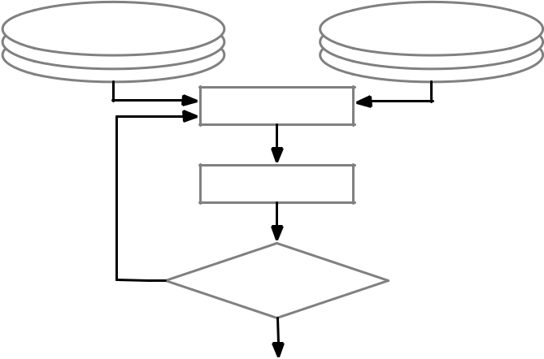

Optimiser

Filters

No Potential

map?

Yes

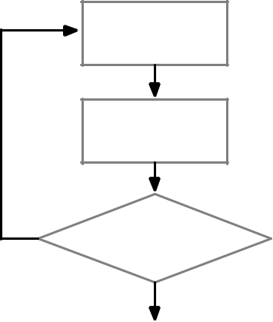

Generate

a map

Map

Evaluation

No Termination

criteria met?

Yes



Optimal map

allocated

Figure 2. The optimisation model.

|  |  |
| --- | --- |
|  | Table II |
|  | TRADING VOCABULARIES USED |
|  |  |
| Vocabulary | Description |
| M | the marketplace |
| P | providers (p1; :::; pm) in M |
| R | traded resources (r1; :::; rj ) in M |
| C | consumers (c1; :::; cn) in M |
| RQ | requests (rq1; :::; rqi) submitted by C |
| A | applications (a1; :::; az) of C to utilise R |
| RA | resource attributes quantified numerically |
| csj | cost of a resource |
| bi | a bid from consumer |
| ti | utilisation time of resource requested by consumer |
| tqij | estimated transmission and delay time b/w a resource and application |
| rpj | reputation of a provider |
| pui | requested utilisation time of a resource |
| acj | available resource components |
| uci | utilised components of a resource |
| pyj | provider policy |
| ptj | proprietary technologies of a provider |
| mcj | the marketplace charges |

2327-4662 (c) 2019 IEEE. Personal use is permitted, but republication/redistribution requires IEEE permission. See http://www.ieee.org/publications_standards/publications/rights/index.html for more information.

This article has been accepted for publication in a future issue of this journal, but has not been fully edited. Content may change prior to final publication. Citation information: DOI 10.1109/JIOT.2019.2957441, IEEE Internet of Things Journal

|  |  |
| --- | --- |
| JOURNAL OF INTERNET OF THINGS | 5 |

|  |  |  |  |  |  |  |  |  |
| --- | --- | --- | --- | --- | --- | --- | --- | --- |
| The trading of CoT resources is presented as a multi- | | | | | | | 1 5, where 1 is the most flexible policy towards consumer |  |
| objective optimisation problem as follows: | | | |  |  |  | migration and lowest proprietary technologies that may hinder |  |
|  |  | n | m |  |  |  | consumers from migrating to different providers. |  |
| Minimise | | CS = | rcj (ti + tqij) rpj | | | (2) | Objective 4. Providers always aim to maximise their profit |  |
|  |  | Xi | X |  |  |  | P R. Equation 5 presents the profit objective function. This can |  |
|  |  | =1 j=1 | |  |  |  |  |  |
|  |  | n | m |  |  |  | be achieved by maximising the cost of resources rcj and their |  |
| Maximise | | RU = | pui (acj | uci) |  | (3) |  |
|  | utilisation time ti while considering the marketplace charges |  |
|  |  | =1 j=1 | |  |  |  | mcj as expenses. |  |
|  |  | Xi | X |  |  |  |  |
|  |  | m | |  |  |  | In addition to the objectives, constraints are used to iden- |  |
| Minimise | | Plock = | pyj + ptj |  |  | (4) |  |
|  |  | tify feasible solutions to the resource trading problem. This |  |
|  |  | =1 | |  |  |  |  |
|  |  |  |  |  | significantly minimises the search space of such scalable and |  |
|  |  | Xj | |  |  |  |  |
|  |  | n | m |  |  |  | complex set of candidate solutions. Constraint 6 illustrates that |  |
| Maximise | | P R = | rcj (ti + tqij) | | mcj | (5) |  |
| costs and bids have to be positive, and bids are always greater |  |
|  |  | =1 j=1 | |  |  |  | than or equal resource costs. The energy constraint presented |  |
| subject to | | Xi | X |  |  | (6) |  |
| 0 < csj bi | |  |  | in Constraint 7 ensures the required energy Eri to perform |  |
|  |  | 0 < Eri Epj | |  |  | (7) | application tasks does not exceed the available resource energy |  |
|  |  | sei sej |  |  |  | (8) | Epj. Constraint 8 specifies the security requirements of the |  |
|  |  | rpi rpj |  |  |  | (9) | application sei to be satisfied by the security capabilities of |  |
|  |  |  |  |  | the resource sej. Constraint 9 provides credibility insurance |  |
|  |  | rai raj |  |  | (10) | | to the marketplace participants based on their performance. |  |
| where i = 1; :::; n; j = 1; :::; m for Constraints 6, 7, 8, 9 and | | | | | | | Providers have to maintain a certain reputation level rpj |  |
| 10. Descriptions of the objectives and constraints are provided | | | | | | | in the marketplace while consumers specify their providers’ |  |
| below: |  |  |  |  |  |  | credibility requirements rpi. Constraint 10 enable participants |  |
| Objective 1. Minimising the resource cost is one of the | | | | | | | to specify participant-specific requirements or limitations in |  |
| usual motivations of the consumers. Consumers are likely to | | | | | | | responding to some applications or resources attributes. This |  |
| bid for minimal cost resources. The cost objective function | | | | | | | constraint is part of this approach genuineness and flexibility |  |
| is presented in Function 2. The following contributors to the | | | | | | | to handle heterogeneous CoT resources and applications. |  |
| total cost CS are considered when minimising the cost of | | | | | | |  |  |
| requested resources. Let bi be the bid from a consumer and | | | | | | | F. Other requirements |  |
| csj the provider’s cost. The initial cost rcj can be calculated as | | | | | | |  |
| Other requirements of the marketplace can be implemented |  |
| rcj = (bi | csj). The requested utilisation time of a resource | | | | | |  |
| is set to | ti while tqij denotes the estimated transmission | | | | | | based on its design and operational goals. This paper justifies |  |
| and delay time. Provider reputation rpj | | | | is set | based | on | those requirements as follows. |  |
| the credibility measures of the marketplace to determine the | | | | | | | Scalability. A marketplace for CoT resources is expected |  |
| trustworthiness of the provider. The reputation is assumed | | | | | | | to handle a considerable number of consumer requests and |  |
| as part of the resource cost for two reasons. 1) It enables | | | | | | | provider resources simultaneously. This can impact system |  |
| the marketplace to use any feedback mechanism that allows | | | | | | | performance and consequently fail to trade CoT resources. The |  |
| consumers to rate their providers’ trustworthiness. 2) The | | | | | | | marketplace system should have the ability to handle various |  |
| reputation of the provider has an indirect effect on the cost | | | | | | | scales of consumer requests and provider resources. |  |
| of resources. A provider with a higher reputation is enabled | | | | | | | Security. Security is vital for any marketplace architecture. |  |
| to offer its resources with better cost than a low-rated provider. | | | | | | | Security analysis is performed in Section V to address the |  |
| Objective 2. CoT applications are assumed to monopolise | | | | | | | potential security threats to the proposed system. |  |
| access to a set of resources for a given time[29]. This can cause | | | | | | | Multiple Business Models. To satisfy the requirements of |  |
| low utilisation of the allocated resources due to the light re- | | | | | | | different CoT applications, the marketplace should support dif- |  |
| quirements of some applications. For trading CoT resources to | | | | | | | ferent business models. This includes consumer-to-consumer, |  |
| be efficient, resource utilisation has to be optimised. Resource | | | | | | | provider-to-consumer and provider-to-provider. It may also |  |
| utilisation objective function is presented in Equation 3. The | | | | | | | consider implementing the system to support one or more |  |
| objective considers the requested resource utilisation time pui, | | | | | | | of the following market structures: broker system, monopoly |  |
| the available resource components acj and the actually utilised | | | | | | | market, oligopoly market, single-side auction and double-side |  |
| components of a resource uci. | | | |  |  |  | auction. |  |
| Objective 3. Function 4 presents the objective of minimis- | | | | | | | Multiple Participant Objectives. Marketplace participants |  |
| ing provider lock-in. Vendor lock-in is a common challenge | | | | | | | have different requirements/goals. For instance, consumers are |  |
| for commoditised computing services. It describes the situation | | | | | | | likely to bid for the lowest cost possible while providers aim |  |
| where consumers can not migrate their data or applications to | | | | | | | to maximise their revenues. Consumers may have conflicting |  |
| different providers due to various reasons. This objective aims | | | | | | | objectives at the same time (e.g. maximising resource coverage |  |
| to minimise the lock-in by considering the provider policy | | | | | | | while minimising the response time). The marketplace system |  |
| pyj that enables consumers to migrate and the proprietary | | | | | | | should provide a mechanism to maintain the balance among |  |
| technologies of the provider ptj. Both factors are rated from | | | | | | | conflict objectives. |  |

2327-4662 (c) 2019 IEEE. Personal use is permitted, but republication/redistribution requires IEEE permission. See http://www.ieee.org/publications_standards/publications/rights/index.html for more information.

This article has been accepted for publication in a future issue of this journal, but has not been fully edited. Content may change prior to final publication. Citation information: DOI 10.1109/JIOT.2019.2957441, IEEE Internet of Things Journal

|  |  |
| --- | --- |
| JOURNAL OF INTERNET OF THINGS | 6 |

|  |  |  |  |  |  |
| --- | --- | --- | --- | --- | --- |
|  | Providers |  |  | Consumers |  |
| Submission | submit |  |  | submit |  |
| resources |  |  | applications |  |
|  |  |  |  |
|  | Resource Manager | | Request Manager | |  |
|  | Resources |  |  | Applications |  |
|  | Specifications |  |  | Requirements |  |
| Mapping | Mapping |  |  | Mapping |  |
|  | Library |  |  | Library |  |
|  | Bids |  |  | Bids |  |
|  | Resource |  |  | Resource |  |
|  | Discovery |  |  | Discovery |  |
|  | Resource |  |  | Application |  |
|  | Bids |  |  | Bids |  |
|  | Multiplexer |  |  | Multiplexer |  |
| Optimisation | Pluggable |  |  | Pluggable |  |
| Filters | Optimiser | | Filters |  |
|  |  |
|  |  |  |  | Utility |  |
|  |  |  | Optimal |  |  |
|  |  |  | maps |  |  |
|  | Resource Allocation Manager | | | |  |
| Allocation | Scheduler | Allocator | | Monitor |  |
|  |  |  |  |  |

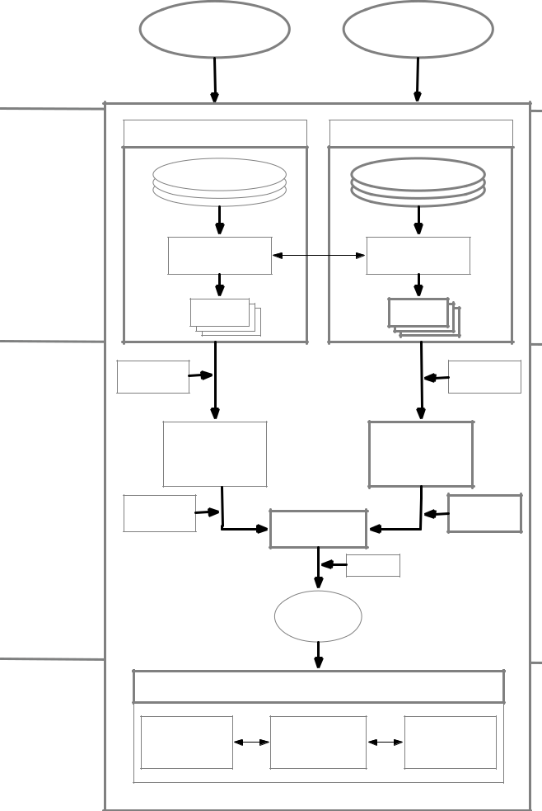

Figure 3. CoT Marketplace Architecture (AMACoT)

IV. THE MARKETPLACE ARCHITECTURE

The proposed marketplace architecture is illustrated in Figure 3. The architecture is structured into four functional layers as follows. Submission layer represents the marketplace entry point where participants are authenticated and granted authorised access to trade.

The mapping layer consists of resource and request man-agers. Resource manager provides interfaces that enable re-source providers to submit, update and remove their resource specifications. Resources are described and quantified based on the description model discussed in Section III-C. Resource descriptions include connectivity options and resources are assumed to be connected already to the Internet via IoT gateways. Similarly, the request manager’s interfaces receive application requirements from consumers. Application require-ments are high-level descriptions of the computing and budget needs as illustrated in Table III. Consumers can also update and remove their applications using the request manager. Mapping libraries of both resource and request managers provide early local coordination to turn resource specifications and application requirements into bids.

Optimisation layer represents the operational tier of the

system. Applications can discover resources that are already stored in the resource manager. Bids flow from resource and request managers to multiplexers where they are selected to form bundles. Resource bundles represent a set of resources from multiple providers that can potentially be utilised by multiple applications. Whilst being forwarded to the optimiser, resource bundles and application requests are filtered. Plug-gable filters include a wide range of filtering criteria such as location, resource coverage, computing and energy require-ments. Filtered resource bundles and application requests are forwarded to the optimiser. The optimiser performs a two-stage process as follows; 1) construct optimal maps that consist of resource bundles and application requests ready for allocation,

1. evaluate the optimal maps based on the participants’ goals using utility functions presented in Section III-E. One optimal map is forwarded to the resource allocation manager for resources to be allocated to the applications.

Allocation layer consists mainly of the resource allocation manager. The scheduler manages the utilisation time of the resources based on the application requirements. It also coordi-nates with the allocator to enable resources joining the applica-tion network and dis-joining when the lease-time elapses. The monitor captures resource allocation events in real-time and provides interfaces where consumers and providers oversee their transactions.

1. THREAT ANALYSIS

The marketplace system should enforce different security measures to secure its operations. Security threats are analysed using STRIDE model [1] to help the design of the architecture by identifying potential threats. STRIDE model is used due to its maturity among other threat modelling techniques and due to its simplicity. Table IV illustrates the STRIDE threats, security propriety violated and the impacted layers of the proposed architecture.

As Table IV shows, each layer of AMACoT components may be impacted by one or more type of threats. At submission layer, an attacker can illegally gain access and use a con-sumer’s or a provider’s credentials to access the marketplace. AMACoT can mitigate this threat by using authentication pro-tocols that do not require a password or use signed certificates to verify the authenticity of consumers/providers. The attacker can also tamper at the submission layer by maliciously modify a consumer’s request or a provider’s offerings. These types

Table III

SNAPSHOT OF COT APPLICATION REQUIREMENTS.

|  |  |
| --- | --- |
| Requirements | Example Value |
| Processing | 1GHz |
| Memory | 1GB |
| Storage | Any |
| Network | Heterogeneous |
| Energy | Battery/Permanent |
| Sensing | Environmental |
| Actuator | 0 |
| Security | Basic |
| Location | [52.95610793607633, -1.1453494058431906] |
| Provider’s Rating | 3/5 |
| Budget | $10 per hour |

2327-4662 (c) 2019 IEEE. Personal use is permitted, but republication/redistribution requires IEEE permission. See http://www.ieee.org/publications_standards/publications/rights/index.html for more information.

This article has been accepted for publication in a future issue of this journal, but has not been fully edited. Content may change prior to final publication. Citation information: DOI 10.1109/JIOT.2019.2957441, IEEE Internet of Things Journal

|  |  |
| --- | --- |
| JOURNAL OF INTERNET OF THINGS | 7 |

of threats may occur using bit-flipping or injection attacks. AMACoT can mitigate these attacks by integrating adequate users’ input/output validation tools for proper data integrity validation. Submission layer is also susceptible to denial of service (DoS) attacks where the attacker aims to interrupt the marketplace making it unavailable or unstable to providers/-consumers. This can occur when the system is flooded with a large number of concurrent requests. The security manager can alleviate DoS attacks by employing requests/offers limiter to maintain the number of submissions at an acceptable level.

The mapping layer can be vulnerable to the threats of information disclosure and elevation of privileges. Information disclosure threats the confidentiality of marketplace users when the attacker maliciously gets hold of the users’ sen-sitive data stored in the resource manager and/or the request manager. AMACoT can use a common practice to mitigate this threat by encrypting users’ sensitive data. Elevation of privileges also poses a considerable risk at the mapping layer. An attacker can attempt to gain some privileges that enable him to perform some actions that he cannot achieve. This may include manipulating bids at either resource or requests manager or both. The system should implement robust authorisation techniques and operate the components at the mapping layer using non-root users. The optimisation layer can also be vulnerable to both threats, in addition to the DoS attacks. AMACoT can prevent such attacks using the same mitigating mechanisms discussed earlier for the submission and mapping layers.

The resource allocation manager is vulnerable to data tam-pering. This may occur when a user tries to manipulate a schedule before resources are allocated to take advantage of other users. Mitigation may include validating users’ input/out-put to detect and prevent data tampering.

Although the security aspects are crucial to the marketplace architecture, the focus of this paper is on demonstrating the feasibility and performance of AMACoT in CoT resource allocation using optimisation algorithms. For deployment of this architecture if it is important to take security as the aim of the study. It would be necessary to take standard IoT security precautions such as those identified in [36] Those precautions and any deployment of specific security mechanisms, therefore, fall out of this paper’s scope.

VI. EXPERIMENTAL EVALUATION

This section presents the experimental evaluation of the proposed work. After the experimental setup explanation in Section VI-A, Section VI-B provides system verification aim-ing to evaluate the system footprint and Section VI-C presents algorithmic evaluation of proposed approach using different optimisation algorithms.

A. Experimental Setup

The architecture is developed using Python in a computer with 2.3 GHz Xeon processor, a 125GB memory and Linux OS. In order to simulate the behaviour of distributed systems, Python Remote Object (Pyro4) is used to connect the main components of the system as well as consumers and providers.

The optimisation engine of AMACoT integrates optimisa-tion algorithms to map requests to resources and to evaluate the optimal resource allocation. The following optimisation algorithms are implemented as follows.

NSGAII. Non-dominated Sorting Genetic Algorithm II

1. is an improved genetic algorithm that is widely used in real-world multi-objective optimisation applications. The population size is set to 200 with a maximum number of 200 iterations for all experiments.

NSGAIII. This algorithm is an extension of the NSGAII that uses reference points to diversify the Pareto points during the search[31]. Besides the same settings used for NSGAII, the number of divisions is set to 12.

SPEA2. Strength Pareto Evolutionary Algorithm 2 [32] is designed and used to optimise combinatorial problems. The population size is set to 200 with a maximum number of 200 iterations for all experiments.

B. Implementation Verification

Stress tests are performed to evaluate the footprint of the system components when they interact with each other as well as interacting with providers and consumers. Three experiments are performed using three different scale factors as shown in Table V. The scale factors aim to evaluate the scalability of AMACoT system and measure the overheads generated. In these three experiments, SPEA2 algorithm is used to minimise the resource cost while maximising the provider profit. This evaluation measures the following system footprints; 1) CPU usage, 2) Memory usage, 3) Latency that is measured from the time of request submission to the time of resource allocation confirmation and 4) Throughput to measure the number of requests/resources handled by AMACoT over the trading time.

Experiment 1. 10; 000 requests and 200; 000 resources are submitted to AMACoT by 100 consumers and 100 providers respectively. Experiment 1 requires 10% of CPU, 3GB of memory and 57 second to produce an optimal resource alloca-tion. AMACoT handles 175 requests and over 3500 resources per second.

Experiment 2. 20; 000 requests and 400; 000 resources are submitted to AMACoT by 200 consumers and 200 providers respectively. Experiment 2 consumes 11% of CPU, 7GB of memory and 119 second to produce an optimal resource allocation. The maximum throughput of this experiment is 168 requests and 3361 resources per second.

Experiment 3. 30; 000 requests and 600; 000 resources are submitted to AMACoT by 300 consumers and 300 providers respectively. The peak CPU load of Experiment 3 is 13% while 11GB of memory used. Producing an optimal resource allocation requires 185 second for experiment 3. AMACoT processed 162 requests and 3243 resources per second.

The results of the verification tests are summarised in Table VI. Results show that CPU usage increases from 10% in experiment 1 to 11% in experiment 2 when experiment 2 scales up by 100%. The CPU load also increases from 11% in experiment 2 to 13% in experiment 3 that scales up by 100%. This implies a reasonable CPU usage when

2327-4662 (c) 2019 IEEE. Personal use is permitted, but republication/redistribution requires IEEE permission. See http://www.ieee.org/publications_standards/publications/rights/index.html for more information.

This article has been accepted for publication in a future issue of this journal, but has not been fully edited. Content may change prior to final publication. Citation information: DOI 10.1109/JIOT.2019.2957441, IEEE Internet of Things Journal

|  |  |
| --- | --- |
| JOURNAL OF INTERNET OF THINGS | 8 |

Table IV

STRIDE MODEL OF AMACOT

|  |  |  |  |  |  |  |  |
| --- | --- | --- | --- | --- | --- | --- | --- |
|  | Threat | Property Violated |  | Impacted Layer | |  |  |
|  | Submission | Mapping | Optimisation | Allocation |  |
|  |  |  |  |
| S | Spoofing identity | Authentication |  |  |  |  |  |
| T | Tampering with data | Integrity |  |  |  |  |  |
| R | Repudiation | Nonrepudiation |  |  |  |  |  |
| I | Information disclosure | Confidentiality |  |  |  |  |  |
| D | Denial of service | Avaiability |  |  |  |  |  |
| E | Elevation of privilege | Authorisation |  |  |  |  |  |

marketplace participants increase significantly. Memory usage is also measured for the three experiments as follows. Ex-periment 1 requires 3GB of memory, 7GB for experiment 2 and 11GB for experiment 3. Memory consumption increases from 3GB in experiment 1 to 7GB in experiment 2 when the marketplace participants rise by 100%. In experiment 3, the memory consumption increases up to 11GB when the experiment scales up by further 100%. Results indicate a fair memory usage across the three experiments when different scale factors are considered.

Latency relies significantly on three aspects as follows.

1. The optimisation algorithm used, 2) The complexity of optimised objectives and 3) The number of optimised ob-jectives. The latency results presented are obtained from SPEA2 algorithm optimising two objectives. The latency of experiment 2 is about 2 times the latency of experiment 1 while the latency of experiment 3 is about 1:5 times the latency of experiment 2. This implies that the latency is doubled as the experiment scales up by 100%. The throughput results show that request throughput decreases 4% only when the marketplace participants rise by 100% in experiment 2 from experiment 1. The request throughput declines 3:5% further in experiment 3 when compared to experiment 2. The resource throughput in experiment 2 shows 4% reduction in comparison to experiment 1 while it decreases 3:5% in experiment 3 when compared to experiment 2. The overall evaluation of throughput shows sensible throughput variations across the three experiments.

Table V

SIMULATED MARKETPLACE PARTICIPANTS.

|  |  |  |  |
| --- | --- | --- | --- |
| Parameter | Experiment 1 | Experiment 2 | Experiment 3 |
|  | (scale factor 1) | (scale factor 2) | (scale factor 3) |
| Number of Requests | 10K | 20K | 30K |
| Number of Resources | 200K | 400K | 600k |
| Number of Consumers | 100 | 200 | 300 |
| Number of Providers | 100 | 200 | 300 |

Table VI

PERFORMANCE COMPARISON.

|  |  |  |  |
| --- | --- | --- | --- |
| Parameter | Experiment 1 | Experiment 2 | Experiment 3 |
| Peak CPU(%) | 10 | 11 | 13 |
| Peak memory(GB) | 3 | 7 | 11 |
| Latency(sec) | 57 | 119 | 185 |
| Throughput(Request/sec) | 175 | 168 | 162 |
| Throughput(Resource/sec) | 3508 | 3361 | 3243 |

Figure 4. Optimising the resource cost at the end of each iteration.

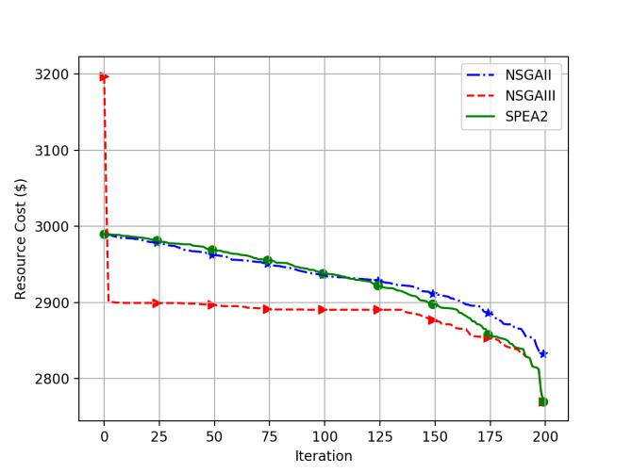

C. Algorithmic Evaluation

In order to evaluate the performance of the optimisation algorithms used and the quality of their optimal solutions, a set of ten experiments are performed using the same scale factor of experiment 3. The following experiments optimise a single objective and compare the results of the three algorithms used.

Experiment 4. This experiment minimises the resource cost as presented in Function 2. Figure 4 shows the comparative evaluation results for resource cost optimality. All algorithms compete towards optimal solutions but NSGAIII and SPEA2 find better cost than NSGAII.

Experiment 5. This aims to minimise the possibility of provider lock-in as presented in Function 4. Figure 5 illustrates that NSGAII and NSGAIII algorithms converged into an optimal solution that is approximately 24% lower than the solution of SPEA2.

Experiment 6. This experiment is intended to maximise the provider profit as described in Function 5. Figure 6 demonstrates the competition between NSGAII and SPEA2 in which both algorithms take approximately the same direction to the optimal profit. In contrast, NSGAIII improves its solu-tions significantly during early iterations and maintain steady improvements towards the last iteration. NSGAII and NSGAIII provide slightly better profit for providers than SPEA2.

Experiment 7. Resource optimisation is performed in this experiment to maximise the resource utilisation by consumers

2327-4662 (c) 2019 IEEE. Personal use is permitted, but republication/redistribution requires IEEE permission. See http://www.ieee.org/publications_standards/publications/rights/index.html for more information.

This article has been accepted for publication in a future issue of this journal, but has not been fully edited. Content may change prior to final publication. Citation information: DOI 10.1109/JIOT.2019.2957441, IEEE Internet of Things Journal

|  |  |
| --- | --- |
| JOURNAL OF INTERNET OF THINGS | 9 |

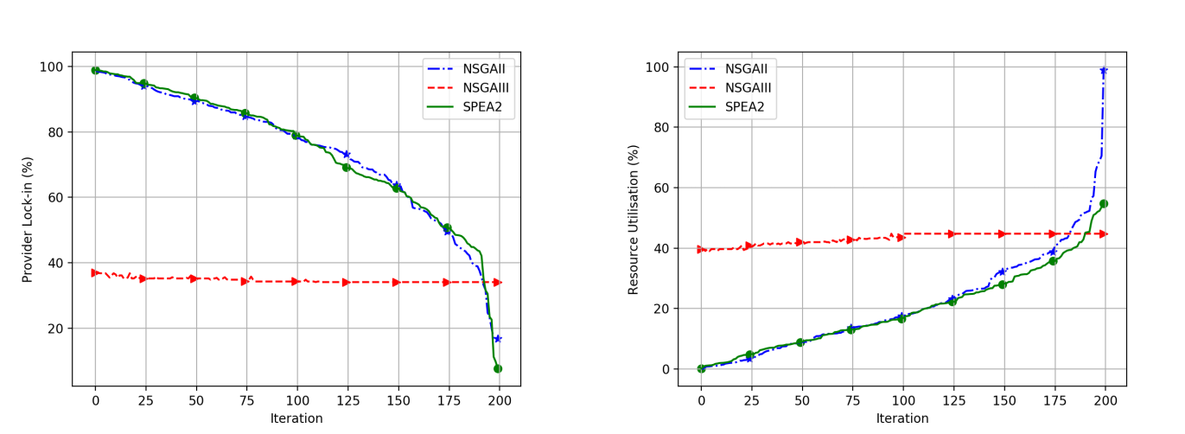

Figure 5. Optimising the provider lock-in utility at the end of each iteration. Figure 7. Optimising the resource utilisation at the end of each iteration.

The provider lock-in rate is minimised, so consumers avoid being locked-in

using resources from a single or very few providers.

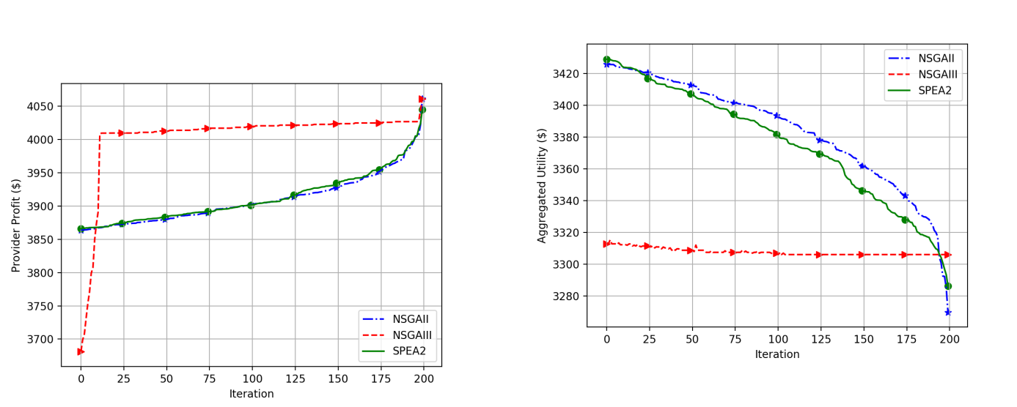

Figure 8. Optimising the aggregated utility of resource cost and provider profit.

Figure 6. Optimising the provider profit at the end of each iteration.

as presented in Function 3. Figure 7 illustrates NSGAII outperforms other algorithms in maximising the resource util-isation. In contrast to the other algorithms, NSGAIII shows insignificant changes throughout the process.

Experiments 4-7 perform the standard optimisation of a single objective that may not be practical for many real-world CoT applications. CoT applications often involve multiple objectives and therefore require multi-objective optimisation to find optimal solutions for two or more objectives including conflicting ones (e.g. min. resource cost while max. resource utilisation). This conflict is commonly addressed by using Pareto approach [33] to evaluate a set of trade-off solutions. The following experiments show the progression of optimising multiple objectives using different approaches.

Experiment 8. This experiment optimises resource cost and provider profit as presented in Functions 2 and 5, respectively.

A way of performing this is to aggregate both objectives into a single one using weight factors as follows.

|  |  |  |
| --- | --- | --- |
| Minimise | AU = w1CS w2P R | (11) |
| RQ;R |  |  |
| subject to | 6; 7; 8; 9; 10 | (12) |

where w1 and w2 are the weights for resource cost and provider profit respectively. Weighting factors are used to prioritise objectives. To maintain the balance between the two objectives, the value of w1 and w2 is equally set to 0:5 where w1 + w2 = 1. Figure 8 shows that NSGAII and SPEA2 outperforms NSGAIII despite the lower start of NSGAIII.

Prioritising objectives for CoT applications is challenging for the following reasons. First, it requires prior knowledge of the problem to assign appropriate weights. This prior knowl-edge may not always be available to CoT applications. Second, optimisation objectives are application-specific and therefore

2327-4662 (c) 2019 IEEE. Personal use is permitted, but republication/redistribution requires IEEE permission. See http://www.ieee.org/publications_standards/publications/rights/index.html for more information.

This article has been accepted for publication in a future issue of this journal, but has not been fully edited. Content may change prior to final publication. Citation information: DOI 10.1109/JIOT.2019.2957441, IEEE Internet of Things Journal

|  |  |
| --- | --- |
| JOURNAL OF INTERNET OF THINGS | 10 |

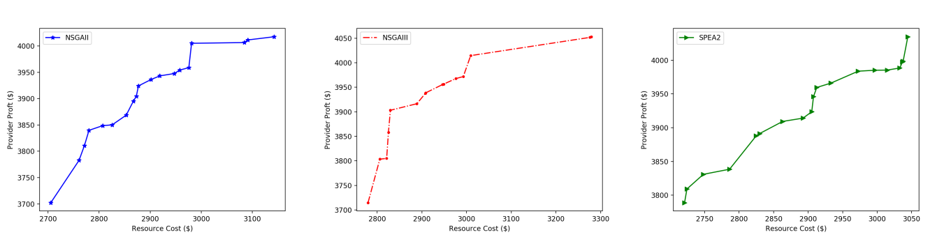

(a) NSGAII (b) NSGAIII (c) SPEA2

Figure 9. Optimising the resource cost and the provider profit. NSGAII produces the largest set of solutions, the lowest resource cost and the lowest provider profit. NSGAIII provides lowest set of solutions, the highest resource cost and the highest provider profit. SPEA2 yields various optimal solutions that maintain the balance when compared to the bi-objective optimality of the other algorithms.

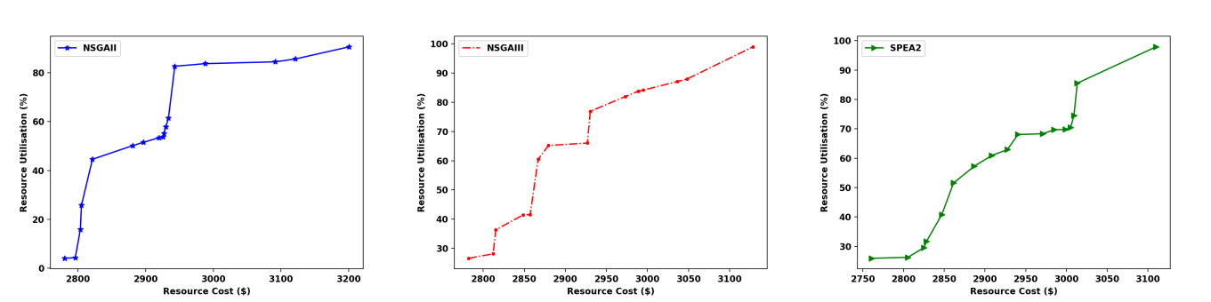

(a) NSGAII (b) NSGAIII (c) SPEA2

Figure 10. Optimising resource cost and the resource utilisation. NSGAII generates the lowest resource utilisation and the most expensive resource cost.

NSGAIII produces the maximum resource utilisation while SPEA2 yields the minimum resource cost.

need re-prioritisation more frequently using weighting factors. Third, this approach yields one optimal solution only. This gives the decision-maker no other solutions to the problem. Although this method may benefit specific applications with prior knowledge about the problem, the following experiments consider using Pareto approach [33] to evaluate a set of optimal solutions rather than one solution only. Experiments 9-12 evaluate conflicting bi-objectives that reflect real-world business requirements. Using the Pareto approach produces a set of optimal solutions for both objectives where an optimal solution of an objective does not worsen the solution of the other objective. Using this approach aims to maintain the balance among conflicting objectives of consumers and providers.

The challenge is how to measure the quality of Pareto-generated solutions of different optimisation algorithms. To overcome this shortcoming, each set of optimal solutions produced in the following experiments is evaluated using the hypervolume indicator (HV) [34]. HV measures the size of the covered space by the generated set of Pareto solutions. A higher value of HV indicates the better distribution of the Pareto solutions and approximately closer to the optimality.

Experiment 9. This experiment optimises resource cost and provider profit as presented in Functions 2 and 5, respectively. Figure 9 shows there is an insignificant difference among

the optimal solutions of the three algorithms. The HV values of NSGAII, NSGAIII and SPEA2 are 0:57; 0:56 and 0:62; respectively as shown in Figure 14. This implies that SPEA2 generates slightly better optimal solutions for minimising resource cost and maximising provider profit.

Experiment 10. Another business requirement for CoT ap-plications is to optimise resource cost and resource utilisation benefiting the resource consumers. Experiment 10 is intended to minimise the resource cost and maximise the resource utilisation as described in Function 2 and 3, respectively. As illustrated in Figure 10, all algorithms provide multiple solutions that maintain the balance between minimising the cost and maximising the resource utilisation. It can also be noted that the resource cost increases as the resource utilisation increases. This implies there is a trad-off between resource cost and utilisation as resource providers may enable higher resource utilisation with higher cost. Figure 14 shows an overall high HV indicator for the three algorithms with slight differences among them.

Experiment 11. This experiment optimises provider profit and provider lock-in as presented in Functions 5 and 4, respectively. It aims to benefit both providers and consumers by maximising the provider profit while minimising the chance of consumers being locked in one or very few providers’ infrastructures. Figure 11 shows that NSGAII and SPEA2

2327-4662 (c) 2019 IEEE. Personal use is permitted, but republication/redistribution requires IEEE permission. See http://www.ieee.org/publications_standards/publications/rights/index.html for more information.

This article has been accepted for publication in a future issue of this journal, but has not been fully edited. Content may change prior to final publication. Citation information: DOI 10.1109/JIOT.2019.2957441, IEEE Internet of Things Journal

|  |  |
| --- | --- |
| JOURNAL OF INTERNET OF THINGS | 11 |

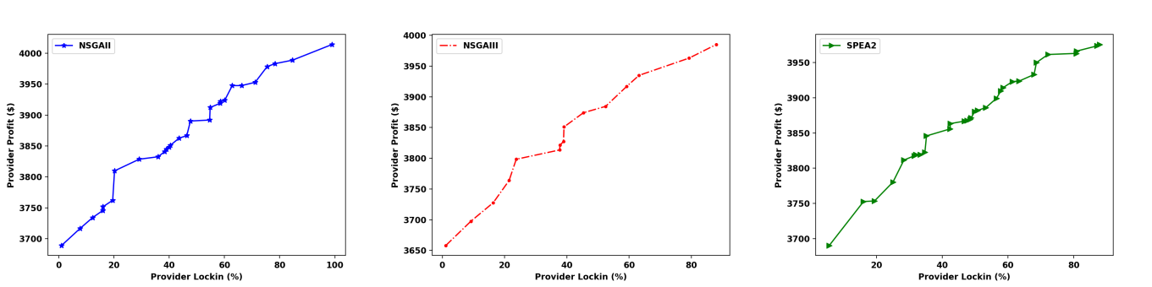

(a) NSGAII (b) NSGAIII (c) SPEA2

Figure 11. Optimising provider profit and provider lock-in. NSGAII provides the largest set of solutions, the the maximum provider profit and the highest provider lock-in. NSGAIII produces the smallest set of solutions and the minimum provider lock-in. SPEA2 maintans the balance between the number of generated solutions, the minimum provider lock-in and the maximum provider profit.

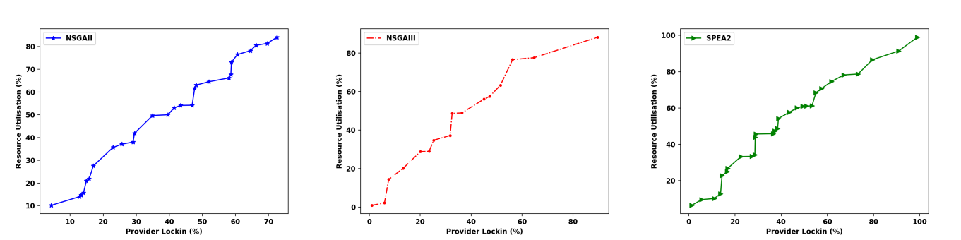

(a) NSGAII (b) NSGAIII (c) SPEA2

Figure 12. Optimising resource utilisation and provider lock-in. NSGAIII provides the smallest set of solutions, the lowest resource utilisation and the minimum provider lock-in. SPEA2 produces the largest set of solutions, the maximum resource utilisation and the highest rate of provider lock-in.

provide numbers of solutions that are approximately twice as NSGAIII does. NSGAIII, however, generates a similar distribution of Pareto-generated solutions. Figure 11a and 11c, respectively, illustrate that NSGAII and SPEA2 find over 50% of the solutions with provider lock-in rate of 40% or more. This may indicate providers’ preference of locking consumers to maximise the profit. Figure 14 shows that NSGAII outper-forms NSGAIII by 7% and SPEA2 by approximately 10%.

Experiment 12. This experiment addresses the require-ment of CoT applications to optimise resource utilisation and provider lock-in as presented in Function 3 and 4. Figure 12 shows that all algorithms produce over 60% over their solutions with provider lock-in rate of 30% or more. This may imply that resources with high utilisation rates are associated with high chances of provider lock-in. Figure 14 illustrates that all algorithms attain similar HV values. This suggests a similar performance of the algorithms in finding the optimality of resource utilisation and provider lock-in utility.

Experiment 13. This experiment aims to optimise resource cost, resource utilisation, provider lock-in and provider profit and as described in Function 2, 3, 4 and 5. It explores the potential optimality of multiple conflicting objectives as well as the performance of the optimisation algorithms. Visualising the Pareto fronts of large-dimensional multi-objective optimi-sation problems is known to be a challenge [35]. One of the

ways to visualise the results of this experiment is to use the scatter plot matrix as illustrated in Figure 13.

In this experiment, Pareto fronts can be identified as shown in Figure 13d, 13e and 13f. Figures 13a, 13b and 13c show the solutions scattered across the solution space while Pareto fronts are not typically formed yet. This can be clearly seen in Figure 13b as a typical front should be formed towards the left side of both axes when both objectives are minimised. This may imply the following. 1) Generating Pareto optimal solutions is possible in the case of a high-dimensional optimi-sation problem. 2) The optimiser parameters may need to be improved to address the increase in the number of objectives. The number of iterations and the population size have not been changed in this experiment to be consistent with other experiments performed with the same parameters.

Experiments presented in this section demonstrate the pro-gression of optimising various objectives. Experiments 4-7 optimise single objective, Experiment 8 optimises multiple objectives using the weighted sum method while Experiments 9-12 optimise multiple objectives using Pareto approach. Ex-periment 13 optimises all functions presented earlier using Pareto approach. Experiments 4-8 generate one optimal so-lution each while Experiments 9-13 provide a set of optimal solutions each. The evaluation of Experiments’ results using HV indicator suggests the following. Experiment 8 (weighted

2327-4662 (c) 2019 IEEE. Personal use is permitted, but republication/redistribution requires IEEE permission. See http://www.ieee.org/publications_standards/publications/rights/index.html for more information.

This article has been accepted for publication in a future issue of this journal, but has not been fully edited. Content may change prior to final publication. Citation information: DOI 10.1109/JIOT.2019.2957441, IEEE Internet of Things Journal

|  |  |
| --- | --- |
| JOURNAL OF INTERNET OF THINGS | 12 |

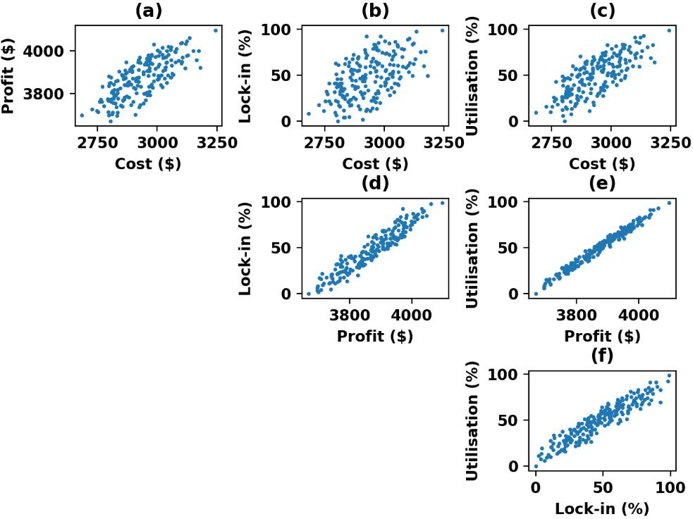

Figure 13. Scatter plot matrix showing Pareto solutions of all bi-objective combinations of Experiment 13.

Figure 14. Evaluating the Pareto-generated solutions using HV indicator.

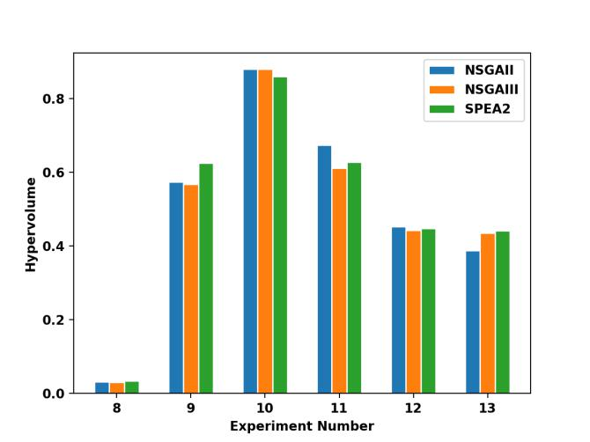

sum approach) produces the lowest HV score. This is likely because the approach produces one optimal solution only that cannot contribute to the volume calculation. In Experiments 9-13, HV values indicate that NSGAII performs better than the other algorithms on three experiments while SPEA2 out-performs others on two experiments.

D. Discussion

AMACoT incurs insignificant CPU and memory overheads when marketplace participants are doubled in Experiment 2 and tripled in Experiment 3. AMACoT also maintains a good level of throughput with a minimal reduction below 5% across all the three experiments. The overall stress results imply the advantage of reducing the architectural complexity in CoT by using an optimisation algorithm as the core of the trading manager rather than a specific-purpose system component.

Latency becomes a limitation for AMACoT performance with respect to scalability. The latency increases by approxi-mately two-fold when resources and requests are doubled. This may imply the dependency of optimisation algorithms on the hardware setup. Performing the same experiments in higher hardware specifications may reduce the latency of the system significantly. Running the optimiser on multi-processing setup can also provide further improvement to the system latency.

The evaluation of optimisation algorithms presented in Section VI-C provide comparative results of the algorithms performance and the optimality of their solutions. The evalua-tion validates the use of objective functions in quantifying the value of CoT resources. This implies the heterogeneity of CoT resources and the dynamic requirements of CoT consumers can be formulated as objective functions that are likely to be optimised. It can be concluded that using optimisation-based approaches as market mechanisms for CoT resource is feasible and promising.

VII. CONCLUSIONS AND FUTURE WORK

The performance results presented in Section VI-B show reasonable system overheads and demonstrate good scalability.

This paper proposes a trading approach for CoT resources consisting of a multi-attribute description model for CoT

2327-4662 (c) 2019 IEEE. Personal use is permitted, but republication/redistribution requires IEEE permission. See http://www.ieee.org/publications_standards/publications/rights/index.html for more information.

This article has been accepted for publication in a future issue of this journal, but has not been fully edited. Content may change prior to final publication. Citation information: DOI 10.1109/JIOT.2019.2957441, IEEE Internet of Things Journal

|  |  |
| --- | --- |
| JOURNAL OF INTERNET OF THINGS | 13 |

resources, the trading objectives and the marketplace architec-ture. In contrast to other approaches, the proposed approach separates between CoT application development and hardware deployment considering CoT resources as commodities. Ex-perimental evaluation validates the system and algorithmic per-formance. AMACoT generates optimal solutions using single optimisation, weighted sum and Pareto fronts approaches. The optimality of resource cost, provider lock-in, resource utilisa-tion and provider profit is evaluated. HV indicator is used to measure the performance of the optimisation algorithms and the quality of the optimal solutions they produced.

In order to address the limitations of this work, the fol-lowing future work is planned. The adaptivity requirements of trading CoT resources will be investigated. Improving the system latency by potentially performing the optimisation on multiprocessor setup and exploring further trading objectives to address more consumer and provider requirements (e.g. QoS attributes).

ACKNOWLEDGEMENT

The first author would like to acknowledge the Ministry of Higher Education, Oman, for the scholarship number PGE023347 that enabled him to work on this project. He would also like to thank Dr. Abubaker Elbayoudi for his feedback on the system architecture and Pedro Machado for facilitating the experimental setup.

REFERENCES

1. Shawn Hernan, Scott Lambert, Tomasz Ostwald, and Adam Shostack. Threat modeling-uncover security design flaws using the stride approach.

MSDN Magazine-Louisville, pages 68–75, 2006.

1. C. Chang, S. N. Srirama, and R. Buyya, “Internet of things (iot) and new computing paradigms,” Fog Edge Computing: Principles Paradigms, pp. 1–23, 2019.
2. Z. Ning, X. Kong, F. Xia, W. Hou, and X. Wang, “Green and sus-tainable cloud of things: Enabling collaborative edge computing,” IEEE Commun. Mag., vol. 57, no. 1, pp. 72–78, 2019.
3. M. Aazam, I. Khan, A. A. Alsaffar, and E.-N. Huh, “Cloud of things: Integrating internet of things and cloud computing and the issues involved,” in Appl. Sci. Technol. (IBCAST), 2014 11th International Bhurban Conference on. IEEE, 2014, pp. 414–419.
4. T. Kumrai, K. Ota, M. Dong, J. Kishigami, and D. K. Sung, “Multiob-jective optimization in cloud brokering systems for connected internet of things,” IEEE Internet Things J., vol. 4, no. 2, pp. 404–413, 2017.
5. S. Akkermans, W. Daniels, G. Sankar R, B. Crispo, and D. Hughes, “Cerberos: a resource-secure os for sharing iot devices,” in Proc. of the 2017 International Conference on Embedded Wireless Syst. Netw.. Junction Publishing, 2017, pp. 96–107.
6. B. Krishnamachari, J. Power, S. H. Kim, and C. Shahabi, “I3: An iot marketplace for smart communities,” in Proc. of the 16th Annual International Conference on Mobile Syst., Appl., Services. ACM, 2018, pp. 498–499.
7. A. Juan-Verdejo and B. Surajbali, “Xaas multi-cloud marketplace archi-tecture enacting the industry 4.0 concepts,” in Doctoral Conference on Computing, Electrical Industrial Syst.. Springer, 2016, pp. 11–23.
8. A. Broring,¨ S. Schmid, C.-K. Schindhelm, A. Khelil, S. Kabisch, D. Kramer, D. Le Phuoc, J. Mitic, D. Anicic, and E. Teniente Lopez,´ “Enabling iot ecosystems through platform interoperability,” IEEE soft-ware, vol. 34, no. 1, pp. 54–61, 2017.
9. G. S. Ramachandran, R. Radhakrishnan, and B. Krishnamachari, “To-wards a decentralized data marketplace for smart cities,” in 4th IEEE

Annual International Smart Cities Conference. IEEE, 2018.

¨

[11] K. R. Ozyilmaz, M. Dogan,˘ and A. Yurdakul, “Idmob: Iot data market-place on blockchain,” in 2018 Crypto Valley Conference on Blockchain Technol. (CVCBT). IEEE, 2018, pp. 11–19.

[12] M. Niekerk and R. Veer, “Global market for local data,” Whitepaper,

2016.

1. F. de la Vega, J. Soriano, M. Jimenez, and D. Lizcano, “A peer-to-peer architecture for distributed data monetization in fog computing scenarios,” Wireless Commun. Mobile Computing, vol. 2018, 2018.
2. P. Missier, S. Bajoudah, A. Capossele, A. Gaglione, and M. Nati, “Mind my value: a decentralized infrastructure for fair and trusted iot data trading,” in Proc. of the Seventh International Conference on the Internet of Things. ACM, 2017, p. 15.
3. D. Niyato, X. Lu, P. Wang, D. I. Kim, and Z. Han, “Economics of internet of things: An information market approach,” IEEE Wireless Commun., vol. 23, no. 4, pp. 136–145, 2016.
4. Y. Zhang, Z. Xiong, D. Niyato, P. Wang, and Z. Han, “Market-oriented information trading in internet of things (iot) for smart cities,” arXiv preprint arXiv:1806.05583, 2018.
5. M. B. Safianowska, R. Gdowski, and C. Huang, “Revenue maximizing auction for perishable iot resources,” in Information Communication Technol. Convergence (ICTC), 2016 International Conference on. IEEE, 2016, pp. 417–422.
6. V. Charpenay, H. Nguyen, M. Ibrahim, A. Zappa, and A. Broring,¨ “Matching offerings and queries on an internet of things marketplace,” in European Semantic Web Conference. Springer, 2018, pp. 66–71.
7. E. I. P. Initiative, “IoT Marketplace,” [https://market.big-iot.org/,](https://market.big-iot.org/) 2018, [Online; accessed 15-November-2018].
8. A. S. Thuluva, A. Broring,¨ G. P. Medagoda, H. Don, D. Anicic, and J. Seeger, “Recipes for iot applications,” in Proc. of the Seventh International Conference on the Internet of Things. ACM, 2017, p. 10.
9. J.-S. Park, T.-Y. Youn, H.-B. Kim, K.-H. Rhee, and S.-U. Shin, “Smart contract-based review system for an iot data marketplace,” Sensors,

vol. 18, no. 10, p. 3577, 2018.

ˇ

[22] K. Misuraˇ and M. Zagar, “Data marketplace for internet of things,” in Smart Syst. Technol. (SST), International Conference on. IEEE, 2016, pp. 255–260.

[23] Y. Zhang, Z. Xiong, D. Niyato, P. Wang, and J. Jin, “Joint optimization of information trading in internet of things (iot) market with external-ities,” in Wireless Commun. Netw. Conference (WCNC), 2018 IEEE. IEEE, 2018, pp. 1–6.

[24] A. Suliman, Z. Husain, M. Abououf, M. Alblooshi, and K. Salah, “Monetization of iot data using smart contracts,” IET Netw., 2018.

[25] T.-V. Nguyen, L.-S. Le,ˆ H.-L. Truong, K. Nguyen-An, and P. H. Ha, “Handling service level agreements in iot= minding rules+ log analytics?” in 2018 IEEE 22nd International Enterprise Distrib. Object Computing Conference (EDOC). IEEE, 2018, pp. 145–153.

[26] A. Blazquez´ Rodr´ıguez, “Security and aaa architectures in an iot marketplace,” 2014.

[27] J. Mineraud, O. Mazhelis, X. Su, and S. Tarkoma, “A gap analysis of internet-of-things platforms,” Comput. Commun., vol. 89, pp. 5–16, 2016.

[28] S. Akkermans, N. Small, W. Joosen, and D. Hughes, “Niflheim: End-to-end middleware for applications across all tiers of the iot,” in Proc. of the 15th ACM Conference on Embedded Netw. Sensor Syst.. ACM, 2017, p. 41.

[29] A. S. Al Rawahi, K. Lee, J. Robinson, and A. Lotfi, “Enabling exclusive shared access to cloud of things resources,” in Proc. of the 2018 Workshop on Theory Practice for Integrated Cloud, Fog Edge Computing Paradigms. ACM, 2018, pp. 15–20.

[30] K. Deb, A. Pratap, S. Agarwal, and T. Meyarivan, “A fast and elitist multiobjective genetic algorithm: Nsga-ii,” IEEE transactions on evolu-tionary computation, vol. 6, no. 2, pp. 182–197, 2002.

[31] K. Deb and H. Jain, “An evolutionary many-objective optimization algorithm using reference-point-based nondominated sorting approach, part i: solving problems with box constraints,” IEEE Transactions on Evolutionary Computation, vol. 18, no. 4, pp. 577–601, 2014.

[32] E. Ziztler, M. Laumanns, and L. Thiele, “Spea2: Improving the strength pareto evolutionary algorithm for multiobjective optimization,” Evolu-tionary Methods for Design, Optimization, Control, pp. 95–100, 2002.

[33] D. A. Van Veldhuizen and G. B. Lamont, “Evolutionary computation and convergence to a pareto front,” in Late breaking papers at the genetic programming 1998 conference, 1998, pp. 221–228.

[34] E. Zitzler, L. Thiele, M. Laumanns, C. M. Fonseca, and V. Da Fon-seca Grunert, “Performance assessment of multiobjective optimizers: An analysis and review,” TIK-Report, vol. 139, 2002.

[35] R. H. Koochaksaraei, I. R. Meneghini, V. N. Coelho, and F. G. Guimaraes,˜ “A new visualization method in many-objective optimization with chord diagram and angular mapping,” Knowledge-Based Syst., vol. 138, pp. 134–154, 2017.

[36] Kai Zhao and Lina Ge. A survey on the internet of things security. In 2013 Ninth international conference on computational intelligence and security, pages 663–667. IEEE, 2013.

2327-4662 (c) 2019 IEEE. Personal use is permitted, but republication/redistribution requires IEEE permission. See http://www.ieee.org/publications_standards/publications/rights/index.html for more information.

This article has been accepted for publication in a future issue of this journal, but has not been fully edited. Content may change prior to final publication. Citation information: DOI 10.1109/JIOT.2019.2957441, IEEE Internet of Things Journal

|  |  |
| --- | --- |
| JOURNAL OF INTERNET OF THINGS | 14 |

Ahmed Salim Alrawahi (M’12) received his BSc.



in Information Systems from University of Nizwa

Oman in 2009. He received his MSc. in Network

Management and Security from Murdoch University,

Perth, Australia in 2012. He worked as a teaching

assistant in Nizwa College of Applied Sciences,

Nizwa Oman since then. Ahmed is currently pursu-

ing his PhD in computer science at Nottingham Trent

University, Nottingham, UK. His research interests

include IoT, Cloud Computing and Optimisation

approaches for combinatorial exchange problems.

Kevin Lee (SM’11) is a Senior Lecturer in Soft-



ware Engineering and Internet of Things (IoT) at

the School of Information Technology in Deakin

University, Australia. Before joining Deakin Uni-

versity in 2018 he held the position of Senior Lec-

turer in Computing and Technology at Nottingham

Trent University, UK (2015-2018). Previously, he

held the position of Senior Lecturer in Information

Technology at Murdoch University, Australia (2010-

2015). He was a postdoctoral research fellow at the

University of Mannheim, Germany (2009-2010). He

was a research associate at the University of Manchester, UK (2006-2009).

He received his PhD in Computer Science from Lancaster University, UK in

2006. He is currently also an appointed external examiner for the Department

of Computing and Technology, Ulster University, for the Computing suite of

degrees (2017-2018). He has over 70 publications in high quality journals

and conferences, with a H-Index of 13 and over 1100 citations. His research

has mainly been in the Distributed Systems and Autonomic Computing areas.

He has published in the areas of IoT, Cloud Computing, Robotics, Embedded

Systems, Big Data, P2P network monitoring and physiological computing.

His current main active research area is in IoT and its integration with Cloud

Computing in support of dynamic IoT applications.

Ahmad Lotfi (M’96-SM’08) received his BSc. and



MTech. in control systems from Isfahan Univer-

sity of Technology, Iran and Indian Institute of

Technology Delhi, India respectively. He received

his PhD degree in Learning Fuzzy Systems from

University of Queensland, Australia in 1995. He is

currently a Professor of Computational Intelligence

at Nottingham Trent University, where he is leading

the research group in Computational Intelligence and

Applications. His research focuses on the identifica-

tion of progressive changes in behaviour of elderly

people suffering from Dementia or any other cognitive impairments. Accurate

identification of progressive changes through utilisation of unobtrusive sensor

network or robotics platform will enable carers (formal and informal) to

intervene when deemed necessary. Research collaboration is established with

world-leading researchers. He has worked in collaboration with many health-

care commercial organisations and end-users including Tunstall Healthcare

Group and Nottingham Adult Care. He has received external funding from

Innovate UK, EU and industrial companies to support his research. He

has authored and co-authored over 150 scientific papers in the area of

computational intelligence, internet of things, abnormal behaviour recognition

and ambient intelligence in highly prestigious journals and international

conferences. He has been invited as an Expert Evaluator and Panel Member

for many European and International Research Programmes.

2327-4662 (c) 2019 IEEE. Personal use is permitted, but republication/redistribution requires IEEE permission. See http://www.ieee.org/publications_standards/publications/rights/index.html for more information.