**SPECIAL SECTION ON CLOUD - FOG - EDGE COMPUTING IN CYBER-PHYSICAL-SOCIAL SYSTEMS (CPSS)**

Received March 9, 2020, accepted April 16, 2020, date of publication April 22, 2020, date of current version May 7, 2020.

*Digital Object Identifier 10.1109/ACCESS.2020.2988951*

A Blockchain-Based Access Control Framework for Cyber-Physical-Social System Big Data

LIANG TAN1,2, NA SHI1, CAIXIA YANG1, AND KEPING YU3,4, (Member, IEEE)

* College of Computer Science, Sichuan Normal University, Chengdu 610101, China
* Institute of Computing Technology, Chinese Academy of Sciences, Beijing 100190, China
* Global Information and Telecommunication Institute, Waseda University, Tokyo 169-8050, Japan

4Shenzhen Boyi Technology Company Ltd., Shenzhen 518125, China

Corresponding author: Liang Tan (tanliang2008cn@126.com)

This work was supported in part by the National Natural Science Foundation of China under Grant 61373162, in part by the Sichuan Science and Technology Support Project under Grant 2019YFG0183, and in part by the Japan Society for the Promotion of Science (JSPS) Grants-in-Aid for Scienti c Research (KAKENHI) under Grant JP18K18044.

 **ABSTRACT** Cyber-Physical-Social System (CPSS) big data is speci ed as the global historical data whichis usually stored in cloud, the local real-time data which is usually stored in the fog-edge server (*FeS*) of the mobile terminal devices or sensors, and the social data which is usually stored in the social data server (*SdS*), moreover adopts a centralized access control mechanism to offer users’ access strategy which can easily cause CPSS big data to be tampered with and to be leaked. Therefore, a blockchain-based access control scheme called BacCPSS for CPSS big data is proposed. In BacCPSS, account address of the node in blockchain is used as the identity to access CPSS big data, the access control permission for CPSS big data is rede ned and stored in blockchain, and processes of authorization, authorization revocation, access control and audit in BacCPSS are designed, and then a lightweight symmetric encryption algorithm is used to achieve privacy-preserving. Finally, a credible experimental model on EOS and Aliyun cloud is built. Results show that BacCPSS is feasible and effective, and can achieve secure access in CPSS while protecting privacy.



 **INDEX TERMS** CPSS, CPS, access control, blockchain, transaction.



**I. INTRODUCTION**

Cyber-Physical-Social System (CPSS) [1] [3] integrates the cyber, physical and social spaces together. One of the ulti-mate goals of CPSS is to make our lives more convenient and intelligent by providing prospective and personalized services for users [4] [7]. CPSS big data is complex and heterogeneous, and records all aspects of users’ lives in the forms of image, audio, video and text. Generally, the col-lected or generated data in CPSS satis es 4Vs (volume, variety, velocity, and veracity) of big data. CPSS big data is speci ed as the global historical data, the local real-time data and the extensive social data. Firstly, cloud computing [8], [9] in processing global historical data, which acts as a powerful paradigm for implementing the data-intensive appli-cations, has an irreplaceable role; secondly, with the increas-ing computing capacity and communication capabilities of mobile terminal devices and sensors, fog-edge computing [10] [12], as an important and effective supplement of cloud computing, has been widely used to process the local real-

The associate editor coordinating the review of this manuscript and approving it for publication was Md. Arafatur Rahman .



time data; nally, for coordination between physical system, information system and social networks composed of human beings, social data server [13], [14] which integrates human knowledge, mental capabilities, and sociocultural elements has become a more and more essential part.

Whether cloud platform, fog-edge server or social data server, they adopt a centralized access control mechanism to offer users’ access. However, the security and privacy issues of CPSS big data [15] have been widely concerned [16], the access right in authorization database of cloud platform, fog-edge server and social server is easily being tampered by administrator or attackers, this centralized management method is prone to lead to disclose CPSS big data.

In this paper, we propose an access control scheme called BacCPSS for CPSS that is based on the blockchain [17]

1. which has the characteristics of decentralization, without tampering and trustworthiness. The main contributions are as follows:
   1. Formally analyze the threats existing in the distributed architecture of CPSS big data and the traditional access control model.

|  |  |  |  |
| --- | --- | --- | --- |
| VOLUME 8, 2020 | This work is licensed under a Creative Commons Attribution 4.0 License. For more information, see https://creativecommons.org/licenses/by/4.0/ | 77215 |  |
|  |  |

L. Tan *et al.*: Blockchain-Based Access Control Framework for CPSS Big Data

**FIGURE 1.** Distributed architecture for CPSS big data.

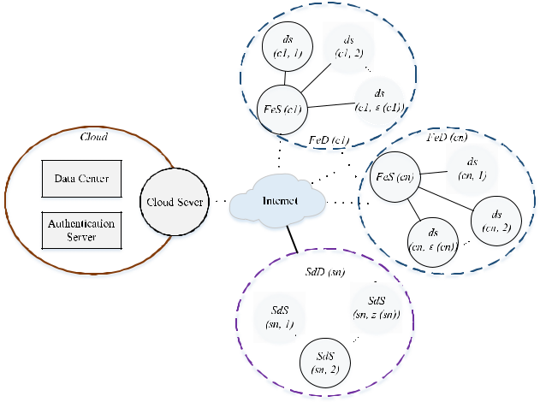

1. The BacCPSS access control architecture is proposed, using the account address of the blockchain node as the identity, rede ning access permissions, designing the initialization, access control, authorization, autho-rization revocation and audit processes, and using lightweight symmetric encryption algorithm to achieve privacy protection.
2. Establish an experimental model on EOS and Alibaba Cloud, and prove the effectiveness of BacCPSS by evaluating the three indicators of de ned computation overhead, storage overhead, and throughput.

This manuscript is organized as follows, background and threat model are summarized in section II, followed by related work in section III. We propose the detailed construction of our blockchain-based access control scheme for CPSS in section IV. Section V is the security and performance analysis respectively. Section VI is experiment and evaluation. Finally, we end up with a conclusion and future work in section VII.

**II. BACKGROUND AND THREAT MODEL**

1. **DISTRIBUTED ARCHITECTURE FOR CPSS BIG DATA**

The distributed architecture for CPSS big data is shown in Figure 1. Including cloud (*Cloud*), decentralized dis-tributed fog-edge domains (*FeD*) and decentralized dis-tributed social data domains (*SdD*).

Firstly, the decentralized cloud architecture is considered. Cloud (*Cloud*) connects a large number of fog-edge servers (*FeS*) and social data servers (*SdS*), and communicates these fog-edge servers by Internet and achieves real-time data, meanwhile communicates these social data servers by Inter-net too and achieves social data. Cloud can achieve a reli-able and collaborative control and management by integrat-ing, storing and coordinating social resources, computing resources and physical resources. Cloud domain contains cloud server, data center, and authentication server. As the entrance and exit of cloud, the cloud server is used to comput-ing and responding to external request. The data center is used to store data that will be computing or consolidated from fog-

77216

edge servers and social data servers. The authentication server provides access control services and identity authentication services. In Figure 1, Cloud represents the cloud domain.

Secondly, decentralized distributed fog-edge architecture is considered. Fog-edge server integrates a large number of resource-constrained devices, such as mobile terminal devices, sensors, and so on, into a topological structure with decentralized features. Each device belongs to a unique fog-edge manager which called fog-edge server, and each fog-edge server has many different devices. The fog-Edge server and all its subordinate devices form a fog-edge domain, devices can cooperate within or between fog-edge domains to achieve speci c needs, and fog-edge domains can cooperate with each other [20]. To this end, the fog-edge server of fog-edge domains needs to establish, evaluate, and update trust relationships with each other. In Figure 1, *FeS*(*x*) represents the fog-edge server, *ds*(*x*; *y*) represents devices managed by *FeS*(*x*), *FeD*(*x*) represents the fog-edge domain, and"(*x*) rep-resents the maximum number of devices in *FeD*(*x*). Formally, we have *x* 2 f 2 *N* j1 ; 2 *N* g, *y* 2 f! 2

* j1 ! "(*x*); "(*x*) 2 *N* g, where is the number of fog-edge domain in the network. In Figure 1, 1 *c*1 , 1 *cn* , and other fog-edge domains except *FeD*(*c*1) and *FeD*(*cn*) are omitted. In this architecture, we assume that there is a secure and stable communication link between *FeS* and devices, which are implemented by their own protocols and communication mechanisms in each fog-edge domain.

Finally, the decentralized distributed social data system architecture is considered. Social data system includes many social data collection systems which can collect social data, many social data search systems which can search social data and many social intelligent systems which can mine, analyze, depth learn social data. Every system is able to upload social data to data center of cloud via internet by communicating with cloud server. In Figure 1, *SdS*(*x*) represents the social data server, *SdD* represents the social data domain, *z*(*x*) rep-resents the maximum number of *SdS* in *SdD*. Formally, *x* 2

f 2 *N* j1 ; 2 *N* g, *y* 2 f 2 *N* j1 *z*(*x*); *z*(*x*)2 *N* g, where is the number of social data systemin the network. In Figure 1, 1 *sn* , and other social data system except *SdS*(*sn*) are omitted.

**B. TRADITIONAL ACCESS CONTROL MODEL**

Traditional access control framework is shown in Figure 2, it is divided into identity authentication, access control, access permission and audit [21], [22]. When a user sends a request, the system’s access control module rst veri es the user’s identity, and once the veri cation is passed, then performs corresponding operations on the resource according to the access policy and the corresponding permissions in the authorization database. Finally, access is recorded in a log for auditing and tracking.

1. **ACCESS CONTROL MODEL OF CPSS BIG DATA**

Furthermore, in distributed CPSS, *Cloud* identi es, authenti-cates, and connects *FeS* and *SdS*, *FeS* identi es, authenticates,

VOLUME 8, 2020

L. Tan *et al.*: Blockchain-Based Access Control Framework for CPSS Big Data

**TABLE 1.** Access matrix M of users.

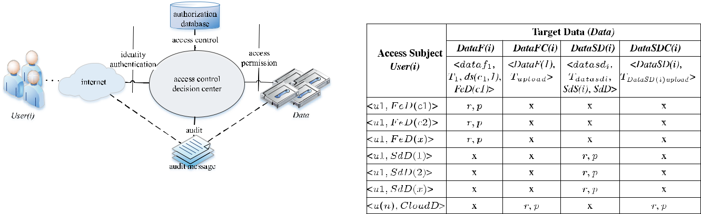

**FIGURE 2.** Traditional access control framework.

and connects and manages all decentralized *ds*, moreover, *SdS* identi es, authenticates, and manage all social data.Therefore, it is important for users to obtain permission to access the target data on the *FeS*, *SdS* and data center of *Cloud* through access control framework. In order to more clearly describe the access control framework in distributed CPSS, some notations are de ned next as follow.

***User(i)***. Represents user identity that generatesaccess requests, includes the user’s *ID* and the management domain which belongs to. Formally, *User*(*i*)D h*UIDi*; *Domain*i, in which, *Domain* Df*FeD*; *SdD*; *CloudD*g, in which, *FeD* D f*FeD*(*c*1), *FeD*(*c*2); ; *FeD*(*cn*)g, which represents the physi-cal devices management domain in CPSS, *SdD* D f*SdD*(*s*1); *SdD*(*s*2); ; *SdD*(*sn*)g, which represents the social data management domain in CPSS, and *CloudD* represents the cloud domain in CPSS.

***DataF(i)***. Represents the local real-time data set storedin a *FeS*, includes data block *i*, the time of data block *i* collection, devices which data belongs to and the man-agement domain which belongs to. Formally, *DataF*(*i*) D h*datafi*; *Tdatafi* ; *ds*(*ci*; 1); *FeD*(*ci*)i.

***DataFC(i)***. Represents the global historical data setstored in the data center of *Cloud*, includes *DataF*(*i*) and the upload time of *DataF*(*i*). Formally, *DataFC*(*i*) D

h*DataF*(*i*); *TDataF*(*i*)*upload* i, where *TDataF*(*i*)*upload* rep-

resents the upload time of *DataF*(*i*).

***DataSD(i)***. Represents the social data set stored inthe social data sever, includes data block *i*, the pro-duction time of the social data block *i*, the social data sever and domain. Formally, *DataSD*(*i*) D h*datasdi*; *Tdatasdi* ; *SdS*(*i*); *SdD*i.

***DataSDC(i)***. Represents the social data set stored inthe data center of cloud sever, includes *DataSD*(*i*) and the upload time of *DataSD*(*i*). Formally, *DataSDC*(*i*) D

h*DataSD*(*i*); *TDataSD*(*i*)*upload* i, where *TDataSD*(*i*)*upload*

represents the upload time of *DataSD*(*i*).

***Data***. Represents all data in CPSS, including all*DataF*(*i*), all *DataFC*(*i*), all *DataSD*(*i*) and all *DataSDC*(*i*).

***Right***. Represents the set of permission. Formally,*Right*D {*own*; *execute*; *read*; *write*; *delete*; *download*}.

VOLUME 8, 2020

***A***. Represents a set of access which describes a requestsubject, target data, access mode and access strategy. Here, *A* D (*u*; *d*; *r*; *p*), where *u* represents the subject attribute, *d* represents the data attribute, *r* represents the permission attribute, *p* represents the policy attribute. And *u User*(*i*), *d Data*, *r Right*. *A* must contain *u*, *d*, and *r*, where *p* is optional. If *p* does not exist, it means using the default access policy called Discretionary Access Control (DAC).

***M***. Represents the user access matrix, ensuring that onlyoperations authorized in the permission set matrix can be performed, as shown in Table 1.

1. **THREAT MODELS**

In CPSS, since the domain management server involves oper-ations on the security attributes of data, users have security requirements for the data they want to access [23]. Generally, users’ security requirements for information system are based on the following aspects:

1. Con dentiality: to prevent information from being leaked to unauthorized users.
2. Integrity: to prevent the unauthorized users from mod-ifying the information.
3. Availability: to ensure the accessibility of authorized users to system information.

Due to the centralized nature of the traditional access control framework for CPSS, there are two kinds of security threats to the above security requirements and one problem as follows.

*Attack 1. Stealing or Modifying* ***Data****:* An attacker illegallysteals or modi es the target data on *FeD*, *SdD* or *CloudD* management server leading to the leakage of the target data and destroying its con dentiality and integrity requirements. Speci c operations including SQL injection, identity hijack-ing etc. can enable an attacker to bypass identity veri cation and directly steal or modify target data stored in *FeD*, *SdD* and *CloudD* management server.

*Attack 2. Modifying* ***M*** *in the Authorization Database:* An attacker illegally tampers or destroys the authorization database on *FeD*, *SdD* and *CloudD* management server,

77217

L. Tan *et al.*: Blockchain-Based Access Control Framework for CPSS Big Data

resulting in tampered data or unavailability of permissions in *M*. The speci c operation is that after the attacker modi esthe authorization database by adding himself as an authorized user, and then legally passing access control through this identity. This attack modi es the access control policy of the decision center, which will be more serious and worrying than the previous threat.

*Problem 1. It Is Dif cult for Users to Manage Their Identi-ties:* The number of domains has increased dramatically withthe development of CPSS. Users accessing different domains need to register different accounts, which greatly increases dif culties of them in identity management.

**III. RELATED WORK**

Since 2007, American government has treated Cyber-Physical System (CPS) as a new development strategy. Some researchers from various countries discussed the related concepts, technologies, applications and challenges during CPS week and the international conference on CPS subject

1. The results of these researches are mainly divided into energy control, security control, transmission and manage-ment, model-based software design, control technique, and system resource allocation [25] [27], moreover, access con-trol in CPS has caused widespread concern [28], [29].

With the development of arti cial intelligence, deep learn-ing and other technologies, on the basis of CPS, CPSS fur-ther incorporates social information, expands the scope of research to social network system, and has been applied in many elds such as smart enterprises, smart transportation, smart homes, and smart medical care [30] [34]. In litera-ture [35], many necessary constraints in CPSS are being considered together, e.g., the execution time, energy con-sumption, economic cost, security as well as reliability. Yang *et al.* proposed a general model for tensor computation thatoptimizes the execution time, energy consumption, and eco-nomic cost with acceptable security and reliability. To pro-vide high-quality, proactive, and personalized services for humans, Wang *et al.* [36] proposed a tensor-based cloud-edge computing framework which includes the cloud and edge planes, in which the cloud plane is used to process large-scale, long-term, global data, which can be used to obtain deci-sion making information. The edge plane is used to process small-scale, short-term, local data, which is used to present the real-time situation and provide personalized services for humans. To provide lower-latency, real-time, more effective, and proactive services for human, Wang *et al.* [37] proposed an edge cloud-assisted CPSS framework for smart cities which migrates some tasks from the cloud center to network edge devices and puts the services and resources closer to users. Sharma *et al.* [38] proposed a privacy aware access control model with k- anonymity for CPSS. While enabling functionality, it allows users access at different privacy levels by generating an anonymized data set in accordance with the privacy clearance of a certain request. To solve the big deal of computation and the complexity of networking contextual, Hussein *et al.* [3] proposed a dynamic social structure of

77218

things called DSSoT and proposed a novel smart services framework in CPSS. Moreover, they did a proof of concept for an application scenario called Airport Dynamic Social by using DSSoT. In order to protect the important data stored in CPS, Akhuseyinoglu *et al.* [39] proposed an access con-trol framework composed of a cyber-physical access control model (CPAC) and a generalized action generation model (GAGM), and provided a CPS example scheme for medical treatment by using an algorithm which is enforcing authoriza-tion policies.

In summary, there are few researches on the realization of data security access in the system by constructing an access control model in CPSS. We propose a blockchain-based secure access control framework called BacCPSS to achieve granted and security access in cloud domain, fog-edge domain and social domain. It will be described in detail later in section IV.

**IV. OVERVIEW OF BacCPSS IN CPSS**

To solve problems described in section II, we propose Bac-CPSS. BacCPSS is a novel access control scheme based on blockchain which can preserve privacy, as shown in Figure 3. It removes the central authorization database from the tradi-tional architecture and adds blockchain. This scheme mainly includes *DO*, *DV*, *FeS*, *SdS*, *Cloud* and *Blockchain* six entities. We next describe some notations that will be later used.

***DO***. A data owner information set,*DO*D f*DOAddr*,*PKDO*, *SKDO*, *Enc*(), *Dec*()}, including DO’s useraddress, public key *PKDO* and private key *SKDO*, the function *Enc*() which is to encrypt, and the function *Dec*() which is to decrypt, both *Enc*() and *Dec*() select alightweight symmetric encryption and decryption algo-rithm, and the same as follow.

***DV***. A data visitor information set,*DV*D f*DVAddr*,*PKDV* , *SKDV* , *Enc*(), *Dec*()}, including DV’s useraddress, public key *PKDV* and private key *SKDV* .

***FeS***. A fog-edge server information set,*FeS*D f*FeS*-*Addr*, *PKFeS* , *SKFeS* , *Enc*(), *Dec*()}, including useraddress, public key *PKFeS* , and private key *SKFeS* .

***SdS***. A social data server information set,*SdS*Df*SdS*-*Addr*, *PKSdS* , *SKSdS* , *Enc*(), *Dec*()}, including user address, public key *PKSdS* , and private key *SKSdS* .

***Cloud***. A cloud information set,*Cloud*D f*CloudAddr*,*PKCloud* , *SKCloud* , *Enc*(), *Dec*()}, including user address,public key *PKCloud* , and private key *SKCloud* .

***right***. A permission ag set. An 8-bit binary number isused to represent the above-formed permission set right. Without this permission, the bit is represented as 0. If the number of permissions is insuf cient, it is reserved as an extension bit. Therefore, the permission set ag of *DO* is initialized to ‘‘11111100’’, and the permission set ag of the *DV* is initialized to ‘‘00000000’’.

***permiCap***. A capability set of users,*permiCap*D f*DVA*-*ddr*, <*FeSAddr*:*data*, *CloudAddr*:*data*, *SdSAddr*:*da*-*ta*>, *right*}, which includes the visitor’s address

VOLUME 8, 2020

L. Tan *et al.*: Blockchain-Based Access Control Framework for CPSS Big Data

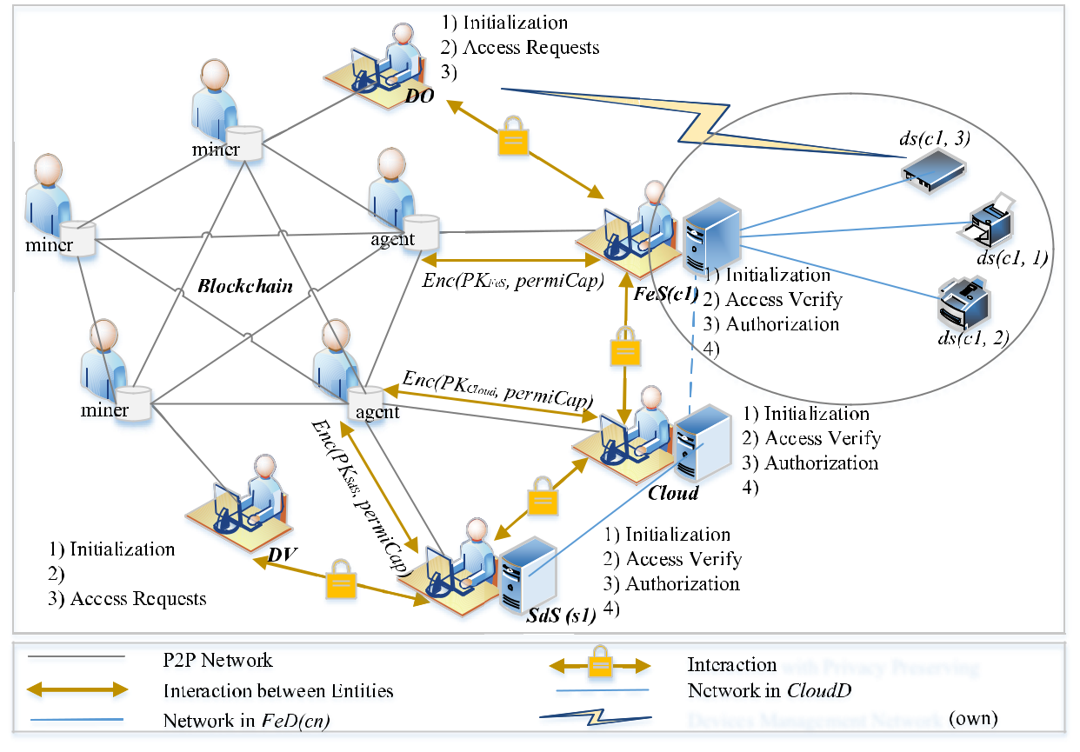

**FIGURE 3.** system framework of BacCPSS.

*DVAddr*, target data in this *FeS*, *SdS* or *Cloud*, andthe speci c permissions the visitor has. Where *data* *Data*.

***Blockchain***. A database of decentralization, withouttampering and trustworthiness. *Blockchain* stores *perm-iCap* of user and *accesslog* which is user access log for *Data*.

Here we introduce the trading interface in blockchain:

***sendTransaction (from, to, value, data)***. Where*from*represents the address of sender, *to* represents the address of receiver, and *value* represents the amount of transaction, default is 0, and *data* indicates additional information. In the scenario of this article, we add the relevant access control information to *data*. This func-tion returns hash value of this transaction.

In BacCPSS, access control mainly includes initialization, access, authorization and authorization revocation. We have listed the main functions of each entity, including but not the only. In order to protect the privacy of sensitive data, we have designed an interactive process between entities. Throughout BacCPSS, we use Dif e-Hellman (DH) method to consult and obtain the shared key (*Ks*) between entities. Given the ef ciency of asymmetric encryption, we only use

**FIGURE 4.** Interaction for shared key.

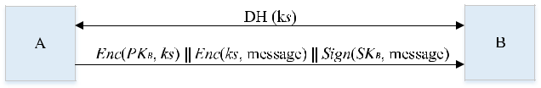

public keys to protect symmetric keys, as shown in Figure 4. Next, we give detailed function introductions of each entity in BacCPSS.

**A. INITIALIZATION**

The main function of initialization is registering *DO*, *DV*, *FeS*, *SdS* and *Cloud* to *Blockchain*, let them become legallight nodes of Blockchain. Firstly, *DO*, *DV*, *FeS*, *SdS* and *Cloud* all need to download and install ‘‘Geth’’ and connectto *Blockchain* service, and then generate respective key pairs and send the public key to *Blockchain* to generate account addresses. Speci c steps are shown in Figure 5. It is worth mentioning that if you need to manage your account system-atically, you can use a wallet program, such as ‘‘MetaMask’’, which can synchronize all block data. Finally, *FeS* publishes permiCap of *DO* in its *FeD* to *Blockchain*, *SdS* publishes

|  |  |
| --- | --- |
| VOLUME 8, 2020 | 77219 |

L. Tan *et al.*: Blockchain-Based Access Control Framework for CPSS Big Data

**FIGURE 5.** Generation of address.

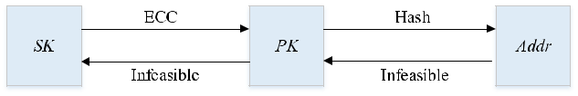

permiCap of *DO* in its *SdD* to *Blockchain*, and *Cloud* pub-lishes permiCap of *DO* in this *CloudD* to *Blockchain*. These three processes are basically same, and each process is imple-mented by function *initPublish*.

***initPublish (FeSAddr (or SdSAddr, or CloudAddr), DOAddr, permiCap)***. The function is to encrypt andpublish the permiCap of *DO* who owns the data and stores in *FeS*, *SdS* or *Cloud* to *Blockchain*. Parameters include the address of *FeS*, *SdS* or *Cloud*, the address of *DO* and speci c access permission capability *per-miCap*, which is equal to {*DOAddr*, *FeSAddr*:*data* (or *SdSAddr*:*data*, or *CloudAddr*:*data*), ‘‘11111100’’}, the executor of this function is *FeS*, *SdS* or *Cloud*, which returns ‘‘True’’ for success and ‘‘False’’ for failure, as shown in Algorithm 1.

**Algorithm 1 *initPublish***

**Input** *FeSAddr/SdSAddr/CloudAddr, DOAddr, permi-Cap*

**Output** True or False

Begin

1. if(*permiCap. right*! = "11111100") then
2. return False;
3. end if;
4. if(*permiCap. DVAddr*! = DOAddr) then
5. return False;
6. end if;
7. data = *Enc* (*PKFeS* , *permiCap* k*initTime)*; or data = *Enc* (*PKSdS* , *permiCap* k*initTime)*;

or data = *Enc* (*PKCloud* , *permiCap* k*initTime)*;

1. tx = *sendTransaction* (*FeSAddr*, *DOAddr*, 0, data);

or tx = *sendTransaction* (*SdSAddr*, *DOAddr*, 0, data);

or tx = *sendTransaction* (*CloudAddr*, *DOAddr*, 0, data);

1. return True;

End

In Algorithm 1, it needs to rst check whether the pub-lished *permiCap* is owned by *DO* and determine the bene - ciary of this *permiCap* as the *DO*. Then *FeS* (or *SdS*, or *Cloud*) uses its public key *PKFeS* (or *PKSdS* , or *PKCloud* ) to encrypt *permiCap*k*initTime*, and nally call *sendTransaction* through *FeS* (or *SdS*, or *Cloud*) to publish the *permiCap* of the *DO* to *Blockchain*.

77220

**B. ACCESS PROCESS WITH PRIVACY PRESERVING**

After initializing successfully, the *DV* may initiate a visit request to *FeS* or *Cloud* with ‘‘*accessRight*’’. We set the ag ‘‘auth’’, when its value equal 0, it means a visit request, that a value equal 1 indicates authorization request, and that a value equal 2 indicates authorization revocation request. ‘‘True’’ and ‘‘False’’ in the message indicate whether the operation was successful, and # indicates the transaction *ID*. To clearly describe this process, we next de nite a function called *accessVerify*.

***accessVerify (DVAddr, FeSAddr.data (or SdSAddr.data, or CloudAddr.data), accessRight)***. The function is toverify whether this visitor has the access right, param-eters include address of *DV*, target data and access right. When this access request veri cation is success-ful, it returns ‘‘True’’, otherwise, it returns ‘‘False’’, as shown in Algorithm 2.

**Algorithm 2 *accessVerify***

**Input** *DVAddr, FeSAddr.data/SdSAddr.data /CloudAddr.data, accessRight*

**Output** True or False

Begin

1. search from *Blockchain* by *DVAddr* and *FeSAddr.data*

(or *SdSAddr.data*, or *CloudAddr.data*) to get *permiCap*;

1. *Dec* (*SKFeS* , result);or *Dec* (*SKSdS* , result);

or *Dec* (*SKCloud* , result);

1. if(*permiCap.right* & *accessRight* == 0) then
2. return False;
3. end if;
4. return True;

End

In Algorithm 2, *FeS* (or *SdS*, or *Cloud*) needs to search the lat-est *permiCap* from *Blockchain* by *DVAddr* and *FeSAddr.data* (or *SdSAddr.data*, or *CloudAddr.data*), and decrypt it with *SKFeS* (or *SKSdS* , or *SKCloud* ), speci c search methods arenot introduced here. By doing bitwise AND (‘‘&’’) oper-ations between *permiCap.right* and *accessRight* to get a result. If the result equals 0, it means the *DV* has no access, otherwise, *FeS*, *SdS*, or *Cloud* can let this *DV* visit. After using *PKFeS* (or *PKSdS* , or *PKCloud* ) to encrypt this message ‘‘*DVAddr*k*FeSAddr* (or *SdSAddr*, or *CloudAddr*) k*accessRight*k*accessTime*’’, *FeS* (or *SdS*, or *Cloud*) publishes the access record with privacy preserving to *Blockchain*. Performer of this function is *FeS*, *SdS* or *Cloud*. The speci c access process is shown in Figure 6. And detailed steps are as follows:

VOLUME 8, 2020

L. Tan *et al.*: Blockchain-Based Access Control Framework for CPSS Big Data

**FIGURE 6.** Access process with privacy protection.

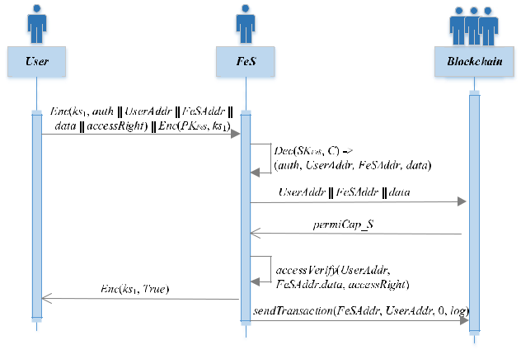

* 1. *User* -> *FeS*: *Enc*(*ks*1, *auth*k*UserAddr*k*FeSAddr*k*data*k *accessRight*)k*Enc*(*PKFeS* , *ks*1). User sends a request fordata to *FeS*, where *auth* is a ag indicating the type of request.
  2. *FeS* -> *Blockchain*: *UserAddr*k*FeSAddr*k*data*. *FeS* decrypts *Enc*(*PKFeS* , *ks*1) by *SKFeS* to get *ks*1, and decrypts *Enc*(*ks*1, *auth*k*UserAddr*k*FeSAddr*k*data* k*acc-essRight*) by *ks*1 to get *auth*, *UserAddr*, *FeSAddr*, *data* and *accessRight*, and then sends a request to *Blockchain* with *UserAddr*k*FeSAddr*k*data*.
  3. *Blockchain* -> *FeS*: *permiCap_S*. *Blockchain* searchesand returns *permiCap_S* to *FeS*.
  4. *FeS*: *accessVerify* (*UserAddr*, *FeSAddr*. *data*, *access-Right*), *FeS* decrypts *permiCap_S* by *SKFeS* to get *per-miCap*, and calls *accessVerify*() to verify whether the *User* can access the data by comparing *accessRight* with *permiCap*, if no, it is over, else, got to next step.
  5. *FeS* -> *User*: *Enc*(*ks*1, *True*). *FeS* returns *Enc*(*ks*1, *True*)to *User*. *User* decrypts it, and accesses the data by *accessRight*.
  6. *FeS* -> *Blockchain*: *sendTransaction*(*FeSAddr*, *User-Addr*, 0, *log*). *FeS* sends access log which is *Enc*(*PKFeS* , *permiCap*k*accessTime*) to *Blockchain* by calling *send-Transaction*(), where *log* is a ag indicating the type oflog.

1. **AUTHORIZATION PROCESS WITH PRIVACY PRESERVING**

In this section, we will present a privacy-protected autho-rization process for how to authorize *DV* to access to the data in *FeS* (or *SdS*, or *Cloud*). In this case, the value of ‘‘auth’’ is equal to 1. In fact, authorization can be divided into direct authorization and indirect authorization. Due to the real needs of CPSS, only direct authorization is considered here. To clearly describe this process, we next de nite a function called *authGrant*.

***authGrant (DVAddr, FeSAddr.data (or SdSAddr.data, or CloudAddr.data), addRight)***. The function is to grantnew rights to a visitor, parameters include address of

VOLUME 8, 2020

requester, address of *FeS*, *SdS* or *Cloud* where the target data is requested, and the new rights will be granted. Success or failure will return the latest *permiCap* of this user, as shown in Algorithm 3.

**Algorithm 3 *authGrant***

**Input** *DVAddr, FeSAddr.data/SdSAddr.data*

*/CloudAddr.data, addRight*

**Output** *permiCap*

Begin

1. search from *Blockchain* by *DVAddr* and *FeSAddr.data*

(or *SdSAddr.data*, or *CloudAddr.data*) to get *permiCap*;

1. *Dec* (*SKFeS* , result);or *Dec* (*SKSdS* , result);

or *Dec* (*SKCloud* , result);

1. *permiCap.right* = *permiCap.right* | *addRight*;
2. return *permiCap*;

End

In Algorithm 3, *FeS* (or *SdS*, or *Cloud*) also needs to search the latest *permiCap* from *Blockchain* by *DVAddr* and *FeSAddr.data* (or *SdSAddr.data*, or *CloudAddr.data*), and decrypt it with *SKFeS* (or *SKSdS* , or *SKCloud* ). By doing bitwise OR (‘‘|’’) operations between *permiCap.right* and *addRight* to get the latest *permiCap*. Since the right initialization value of each *DV* is not null, if the *FeS* (or *SdS*, or *Cloud*) grants successfully, this operation nally returns the latest *permiCap* and *FeS* (or *SdS*, or *Cloud*) will using *PKFeS* (or *PKSdS* , or *PKCloud* ) to encrypt "*DVAddr*k*FeSAddr* (or *SdSAddr*, or *CloudAddr*)k*permiCap*k*grantTime*" and pub-lish the authorization record with privacy preserving to *Blockchain*. Performer of this function is *FeS*, *SdS* or *Cloud*.

1. **AUTHORIZATION REVOCATION PROCESS WITH PRIVACY PRESERVING**

In this section, we will present a privacy-preserving autho-rization revocation process detailing how to revoke *DV*’s right. In this case, the value of ‘‘auth’’ is equal to 2. To clearly describe this process, we next de nite a function called *authRevoke*.

***authRevoke (DVAddr, FeSAddr.data (or SdSAddr.data, or CloudAddr.data), deleteRight)***. The function is torevoke the right of *DV* to the target data in *FeS* (or *SdS*, or *Cloud*). Parameters include the address of *DV* who needs to be revoked, target data, and revoked rights. Success or failure will return the latest *permiCap* of this user, as shown in Algorithm 4.

In Algorithm 4, *FeS* (or *SdS*, or *Cloud*) also needs to search the latest *permiCap* from *Blockchain* by *DVAddr* and *FeSAddr.data* (or *SdSAddr.data*, or *CloudAddr.data*), and decrypt it with *SKFeS* (or *SKSdS* , or *SKCloud* ). By doing bit-wise AND (‘‘&’’) operations between *permiCap.right* and

77221

L. Tan *et al.*: Blockchain-Based Access Control Framework for CPSS Big Data

**Algorithm 4 *authRevoke***

**Input** *DVAddr, FeSAddr.data/SdSAddr.data /CloudAddr.data, deleteRight*

**Output** True or False

Begin

1. search from *Blockchain* by *DVAddr* and *FeSAddr.data*

(or *SdSAddr.data*, or *CloudAddr.data*) to get *permiCap*;

1. *Dec* (*SKFeS* , result);or *Dec* (*SKSdS* , result);

or *Dec* (*SKCloud* , result);

1. if(*permiCap. right* & *deleteRight* == 0) then
2. return *permiCap*;
3. end if;

06. *permiCap.right* = *permiCap.right* ^ *deleteRight*;

1. return *permiCap*;

End

*deleteRight* to get a result. If the result equals 0, it meansthe *DV* does not have this permission which not need to revoke. If the result equals 1, it means *deleteRight per-miCap.right*, then *FeS* (or *SdS*, or *Cloud*) needs do XOR(‘‘^’’) operation to get the latest *permiCap*. If the *FeS* (or *SdS*, or *Cloud*) revokes successfully, then using *PKFeS* (or *PKSdS* , or *PKCloud* ) to encrypt ‘‘*DVAddr*k*FeSAddr* (or *SdSAddr*, or *CloudAddr*)k*permiCap*k*revokeTime*’’ and pub-lishing the authorization revocation record with privacy pre-serving to *Blockchain*. Performer of this function is *FeS*, *SdS* or *Cloud*.

**V. SECURITY AND FEATURE ANALYSIS**

Blockchain is a kind of distributed ledger technology based on peer-to-peer (P2P) network that provides services by using consensus mechanism and encryption algorithm. It links a large number of data blocks and has tamper-proof, com-pletely transparent and block veri ability characteristics. In BacCPSS, after user, *FeS*, *SdS* or *Cloud* becomes normal non-malicious node in the blockchain through the initializa-tion phase, the entire traditional centralized access control becomes decentralized. Moreover, each behavior triggers a transaction. Next, we will conduct a detailed security analysis of BacCPSS to address the threat models proposed above.

**A. SECURITY ANALYSIS**

In CPSS, our solution is able to resist Attack 1 and Attack 2 existing in section II by taking advantage of the features of decentralization and transaction mechanism. Firstly, once the attacker uses the identity *DVAddr* to initiate access to the target data in a *FeS*, or a *SdS*, or *Cloud* without autho-rization, it will trigger the *FeS* (or *SdS*, or Cloud) to query {*DVAddr, FeSAddr.data, right*} (or {*DVAddr, SdSAddr.data,*

77222

*right*}, or {*DVAddr, CloudAddr.data, right*}) from *Blockchain* to obtain the *permiCap* which is the latest access capability of this *DV* for target Data, so as to prevent Data tamper-ing and disclosure. Secondly, since *permiCap* is stored in *Blockchain* and shared by all participating nodes, an attackercannot agree to pass even if he tampers with the local *permiCap*, which results in the invalid operation and pro-tects the authorized data *M* in the *FeS* (or *SdS*, or *Cloud*) from being tampered with and destroyed. Then, because of *DVAddr*, *DOAddr* and *FeSAddr* (or *SdSAddr*, or *CloudAddr*)authenticating during the whole access control process, *SKDO*, *SKDV* and *SKFeS* (or *SKSdS* , or *SKCloud* ) are muchmore secure and infeasible than the current normal iden-tity (username/password), so BacCPSS greatly reduces the possibility that an attacker impersonates an authorized user to log in and improves the security of access con-trol of target data. Finally, in BacCPSS, since every valid behavior of a node in *Blockchain* includes access records ‘‘*DVAddr*k*FeSAddr*k*Enc*(*PKFeS* , *permiCap*k*accessTime*)(or *Enc*(*PKSdS* , *permiCap*k*accessTime*), or *Enc*(*PKCloud* , *permiCap*k*accessTime*))’’, authorization records ‘‘*DVAddr*k *F-eSAddr*k*Enc*(*PKFeS* , *permiCap*k*grantTime*) (or *Enc*(*PKSdS* , *permiCap*k*grantTime*), or *Enc*(*PKCloud* , *permiCap*k*gran-tTime*))’’ and authorization revocation records ‘‘*DVAddr*k *FeS-Addr*k*Enc*(*PKFeS* , *permiCap*k*revokeTime*) (or *Enc*(*PKSdS* , *permiCap*k*revokeTime*), or *Enc*(*PKCloud* , *permiCap*k*revoke-Time*))’’, they will be generated as a transaction and recordedto *Blockchain*. Therefore, it can guarantee the security requirements of the recorded information during the process of audit.

**B. FEATURE ANALYSIS**

In BacCPSS, Due to the whole access control is done with *Blockchain*, after initialization, *DO*, *DV*, *FeS*, *SdS* and *Cloud* have their own *DOAddr*, *DVAddr*, *FeSAddr*, *SdSAddr* and *CloudAddr*, no additional identity registration is required.They can use this global account address when accessing target data in different domains. Therefore, BacCPSS can solve the problem of dif cult identity management for users.

**VI. EXPERIMENT AND EVALUATION**

**A. EXPERIMENTAL ENVIRONMENT**

In this section, we build a prototype of the BacCPSS framework. First, all experimental environments were con-gured based on Alibaba cloud Linux ubuntu 16.04 (2 core 8G, 100G storage), we use 4 machines to play *FeS*, *SdS*, *Cloud* and *DO* (or *DV*). Second, the Kylintest chain on EOS was used as *Blockchain* of BacCPSS, version is v1.8.4, and chainNode of Kylin test chain is ‘‘5fff1dae8dc8e2fc4d5b23b2c7665c97f9e9d8edf2b6485a86b-a311c25639191’’. Then, before processes of publishing, access, authorization and authorization revocation, *perm-iCap* needs to be encrypted. After being searched from *Blockchain*, *permiCap* needs to be decrypted. Therefore,we use a lightweight algorithm eosjs-ecc for encryption

VOLUME 8, 2020

L. Tan *et al.*: Blockchain-Based Access Control Framework for CPSS Big Data

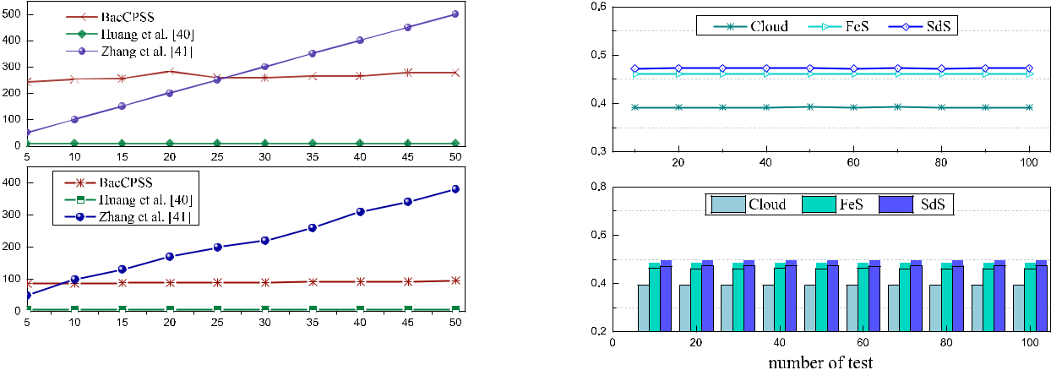

**FIGURE 7.** comparison of computational overhead for encryption and

decryption. **FIGURE 8.** comparison of time overhead for **FeS**, **SdS**, and **Cloud** in

BacCPSS.

and decryption. Moreover, we use the SEA algorithm to implement information interaction between various entities with privacy preserving. Finally, we implemented a prototype of the BacCPSS framework and performed performance analysis.

**B. PERFORMANCE EVALUATION**

In order to evaluate the scheme, we de ne three evaluation indicators as follows:

**Computation overhead**. In BacCPSS, we need to sacri-ce a certain amount of computing cost to take security measures for *permiCap* and off chain transaction infor-mation, mainly refers to time overhead.

**Storage overhead**. That is, the storage space requiredfor access control rights storage. As the number of rights (attributes) increases, so does the space for storing attributes. In BacCPSS, we need to functionalize the user’s rights and publish them to the blockchain for storage through transactions, so we focus on the storage consumption of *permiCap*.

**Throughput**. That is, the number of transactions(accesses) that can be processed per second. The throughput is always an important index to evaluate online system of network. In BacCPSS, because we store *permiCap* by publishing transactions, the network latency and throughput are the same as normal publish-ing transactions, and are closely related to how to select chains. Choosing different chains will lead to different results.

For BacCPSS, we focused on time performance overhead. The complete access control process includes four parts: identity authentication, access control, access permission, and audit. In BacCPSS, the access control part includes encrypting and decrypting *permiCap*, and publishing the encrypted *permiCap*. Therefore, we rst tested the encryption and decryption time in BacCPSS. Since BacCPSS contains *FeS*, *SdS* and *Cloud*, we multiplied the encryption and decryp-tion time by 3 types, as shown in Figure 7. The number of attributes used in the experiment ranged from 5 to 50, with

**FIGURE 9.** comparison of time and storage overhead.

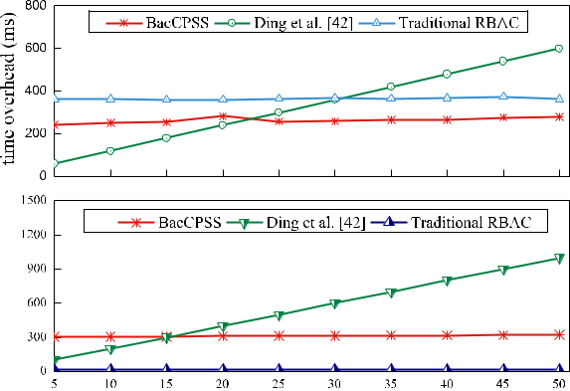

each group averaging 10 measurements. Although there are differences in speci c experimental environments, we use similar data for experiments, and we can see that BacCPSS has a low computing cost and a good operation.

Then, we tested the time of the authorization publish, including the authorization costs of *FeS*, *SdS*, and *Cloud*. As shown in Figure 8, the three are very close in terms of authorization time.

As access control divided into 4 steps, we compared time of every part between traditional scheme and our work. The result shows in Figure 9. Since traditional access control only requires storage permissions, the time and storage overhead remain the same. Experiments show that although BacCPSS uses *Blockchain*, it costs less storage than Ding *et al.* [42].

Since there are two cases for *DV* to access data of *FeS* or *SdS* in BacCPSS. Case 1, when *DV* directly accessesdata of *FeS* or *SdS* or accesses data they owned in *Cloud*, it only needs one access control process (*DV* accesses to *FeS*, or *DV* accesses to *SdS*, or *DV* accesses to *Cloud*). Case 2,When *DV* applies to *Cloud* for access to data which are not owned in *FeS* or *SdS*, *DV* needs to go through two access control processes (*DV* rst access *FeS* or *SdD*, and then *DV* access *Cloud*).

|  |  |
| --- | --- |
| VOLUME 8, 2020 | 77223 |

L. Tan *et al.*: Blockchain-Based Access Control Framework for CPSS Big Data

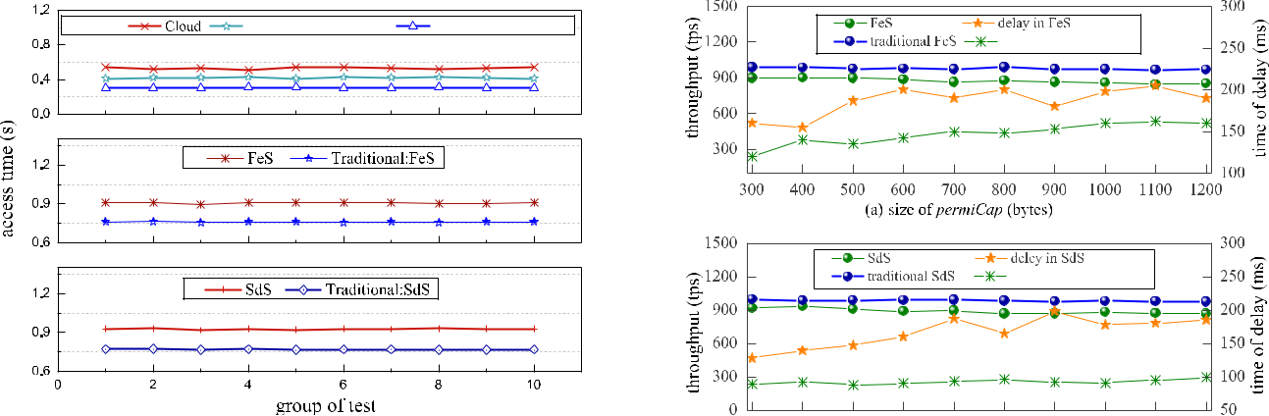

**FIGURE 10.** comparison of access time for **Cloud**, **FeS** and **SdS** in BacCPSS



with traditional access control.

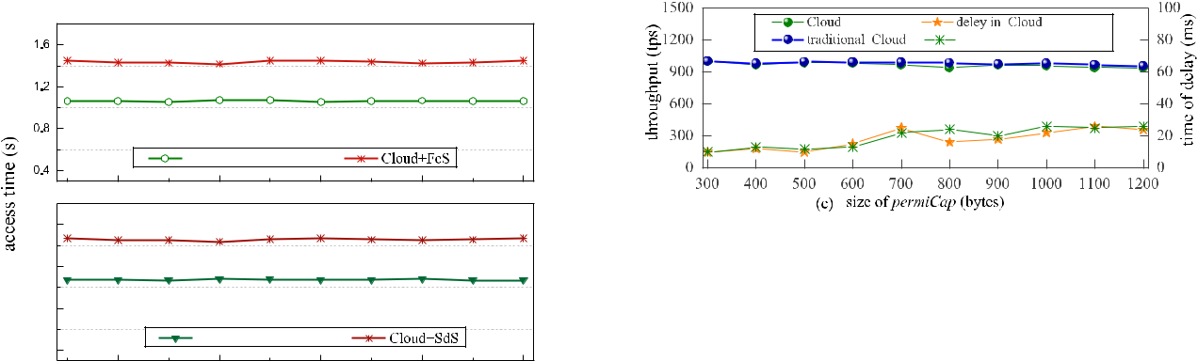

**FIGURE 12.** separate comparison of throughput and delay for **FeS** and



traditional **FeS**, **SdS** and traditional **SdS**, **Cloud** and traditional **Cloud**.



**FIGURE 11.** comparison of access time for **Cloud** + **FeS**, **Cloud** + **SdS** inBacCPSS with traditional access control.



Therefore, we rst discuss case 1. For comparing access control of *Cloud*, *FeS*, *SdS* in BacCPSS with that in traditional access control, we tested 10 times respectively, as shown in Figure 10.

Then, we discussed case 2. For comparing *FeS* + *Cloud* and *SdS* + *Cloud* in BacCPSS with that in traditional access con-trol, we tested 10 times respectively, as shown in Figure 11. It can be seen from Figure 10 and Figure 11 that no matter in case 1 or case 2, the time overhead of BacCPSS is slightly higher than that of traditional access control. Analyzing the reasons, we believe that there are two main aspects. One is that when accessing, BacCPSS needs to query the permission on *Blockchain*; the other is that when making access control judgments, BacCPSS need to decrypt *permiCap*, because *permiCap* are cipher texts stored in *Blockchain*.

In process of access, we need to search the latest *permiCap* from *Blockchain*, it is a great impact on the ef ciency of BacCPSS. Therefore, we test throughput of *FeS*, *SdS* and *Cloud*. Because the storage overhead is at least 300 bytesbut does not increase inde nitely, the size of the *permiCap* used in the experiment ranged from 300 to 1200 bytes is suf cient, with an average of 10 measurements each time, as shown in Figure 12. The results show that in (a) and (b), because *FeS* and *SdS* need to read *permiCap* from the *Cloud*,

77224

the throughput of *FeS* and *SdS* is about 900tps, which is slightly lower than the traditional method, and because of the network, the delay will be higher than the traditional method. In (c), because *Cloud* is a full node, and it can read directly from the local. So, the throughput of *Cloud* is between 950tps and 1000tps, which is not much different from the traditional method, and the delay time is less than *FeS* and *SdS*.

In short, although *Blockchain* is used in BacCPSS, the experimental results show that the performance is rela-tively good. Furthermore, BacCPSS can effectively prevent attacks caused by the two threat models mentioned in section

1. At the same time, no matter whether it is *FeS*, *SdS*, or *Cloud*, *permiCap* is encrypted and stored in *Blockchain*,which facilitates the management of access control.

**VII. CONCLUSION AND FUTURE WORK**

It is an important research direction to solve the security of access control in CPSS big data by utilizing the features of blockchain. This paper proposes a blockchain-based access control scheme called BacCPSS for privacy preserve in CPSS big data. Given the nature of CPSS big data, we rede ned the rights in access and used lighter weight encryption algorithms to ensure privacy. In BacCPSS, all access control transactions are encrypted and issued by the domain management server, such as *FeS*, *SdS*, *Cloud*, and so on. Experiments have proved that this scheme is feasible and effective, and secure to imple-ment access control for CPSS big data.

Since the whole authorization access process is recorded through the blockchain, there are two problems in this scheme. One is that it will take time to protect privacy, so we can nd more lightweight and suitable methods to protect

VOLUME 8, 2020

L. Tan *et al.*: Blockchain-Based Access Control Framework for CPSS Big Data

privacy for mobile terminal devices. Secondly, it is that for the operation of permission function and the chain of access records, we need to nd an effective retrieval method to match encryption parameters in blockchain. In the future, we will work to address these shortcomings and focus on achieving more ef cient and secure access control in CPSS big data.

**REFERENCES**

1. Z. Liu, D.-S. Yang, D. Wen, W.-M. Zhang, and W. Mao, ‘‘Cyber-physical-social systems for command and control,’’ *IEEE Intell. Syst.*, vol. 26, no. 4,
   1. 92 96, Jul. 2011.
2. F.-Y. Wang, ‘‘The emergence of intelligent enterprises: From CPS to CPSS,’’ *IEEE Intell. Syst.*, vol. 25, no. 4, pp. 85 88, Jul. 2010.
3. D. Hussein, S. Park, S. N. Han, and N. Crespi, ‘‘Dynamic social structure of things: A contextual approach in CPSS,’’ *IEEE Internet Comput.*, vol. 19, no. 3, pp. 12 20, May 2015.
4. X. Wang, L. T. Yang, Y. Wang, L. Ren, and M. J. Deen, ‘‘ADTT: A highly-ef cient distributed tensor-train decomposition method for IIoT big data,’’ *IEEE Trans. Ind. Informat.*, early access, Jan. 2020, doi: [10.1109/TII.2020.2967768.](http://dx.doi.org/10.1109/TII.2020.2967768)
5. X. Zhou, W. Liang, S. Huang, and M. Fu, ‘‘Social recommendation with large-scale group decision-making for cyber-enabled online service,’’ *IEEE Trans. Comput. Social Syst.*, vol. 6, no. 5, pp. 1073 1082, Oct. 2019,doi: [10.1109/TCSS.2019.2932288.](http://dx.doi.org/10.1109/TCSS.2019.2932288)
6. X. Wang, L. T. Yang, Y. Wang, X. Liu, Q. Zhang, and M. J. Deen, ‘‘A distributed tensor-train decomposition method for cyber-physical-social services,’’ *ACM Trans. Cyber-Phys. Syst.*, vol. 3, no. 4, pp. 1 15, Oct. 2019.
7. X. Zhou, W. Liang, K. I.-K. Wang, and S. Shimizu, ‘‘Multi-modality behavioral in uence analysis for personalized recommendations in health social media environment,’’ *IEEE Trans. Comput. Social Syst.*, vol. 6, no. 5,
   1. 888 897, Oct. 2019, doi: [10.1109/TCSS.2019.2918285.](http://dx.doi.org/10.1109/TCSS.2019.2918285)
8. H. Li, K. Ota, M. Dong, and M. Guo, ‘‘Mobile crowdsensing in software de ned opportunistic networks,’’ *IEEE Commun. Mag.*, vol. 55, no. 6,
   1. 140 145, Jun. 2017.
9. X. Wang, L. T. Yang, J. Feng, X. Chen, and M. J. Deen, ‘‘A tensor-based big service framework for enhanced living environments,’’ *IEEE Cloud* *Comput.*, vol. 3, no. 6, pp. 36 43, Nov. 2016.
10. K. C. Okafor, ‘‘Dynamic reliability modeling of cyber-physical edge computing network,’’ *Int. J. Comput. Appl.*, early access, pp. 1 11, Apr. 2019, doi: [10.1080/1206212X.2019.1600830.](http://dx.doi.org/10.1080/1206212X.2019.1600830)
11. M. S. de Brito, S. Hoque, R. Steinke, A. Willner, and T. Magedanz, ‘‘Application of the fog computing paradigm to smart factories and cyber-physical systems,’’ *Trans. Emerg. Telecommun. Technol.*, vol. 29, no. 4,
    1. e3184, Apr. 2018.
12. Y. Xu, G. Wang, J. Yang, J. Ren, Y. Zhang, and C. Zhang, ‘‘Towards secure network computing services for lightweight clients using blockchain,’’ *Wireless Commun. Mobile Comput.*, vol. 2018, pp. 1 12, Nov. 2018,Art. no. 2051693.
13. X. Zhou, W. Liang, K. Wang, R. Huang, and Q. Jin, ‘‘Academic in uence aware and multidimensional network analysis for research collaboration navigation based on scholarly big data,’’ *IEEE Trans. Emerg. Topics Com-put.*, early access, Jul. 2018, doi:[10.1109/TETC.2018.2860051.](http://dx.doi.org/10.1109/TETC.2018.2860051)
14. B. Omoniwa, R. Hussain, M. A. Javed, S. H. Bouk, and S. A. Malik, ‘‘Fog/Edge computing-based IoT (FECIoT): Architecture, applications, and research issues,’’ *IEEE Internet Things J.*, vol. 6, no. 3, pp. 4118 4149, Jun. 2019.
15. W. Guo, Y. Zhang, and L. Li, ‘‘The integration of CPS, CPSS, and ITS: A focus on data,’’ *Tsinghua Sci. Technol.*, vol. 20, no. 4, pp. 327 335, Aug. 2015.
16. X. Zhou, J. Chen, B. Wu, and Q. Jin, ‘‘Discovery of action patterns and user correlations in task-oriented processes for goal-driven learning recommendation,’’ *IEEE Trans. Learn. Technol.*, vol. 7, no. 3, pp. 231 245, Jul. 2014, doi: [10.1109/TLT.2013.2297701.](http://dx.doi.org/10.1109/TLT.2013.2297701)
17. Y. Yuan and F. Wang, ‘‘Development status and prospect of blockchain technology,’’ *J. Automat.*, vol. 42, no. 4, pp. 481 494, 2016.
18. S. Wang, L. Ouyang, Y. Yuan, X. Ni, X. Han, and F.-Y. Wang, ‘‘Blockchain-enabled smart contracts: Architecture, applications, and future trends,’’ *IEEE Trans. Syst., Man, Cybern. Syst.*, vol. 49, no. 11, pp. 2266 2277,Nov. 2019.

VOLUME 8, 2020

1. Y. Xu, J. Ren, G. Wang, C. Zhang, J. Yang, and Y. Zhang, ‘‘A blockchain-based nonrepudiation network computing service scheme for industrial IoT,’’ *IEEE Trans. Ind. Informat.*, vol. 15, no. 6, pp. 3632 3641, Jun. 2019.
2. X. Wang, L. T. Yang, L. Kuang, X. Liu, Q. Zhang, and M. J. Deen, ‘‘A tensor-based big-data-driven routing recommendation approach for heterogeneous networks,’’ *IEEE Netw.*, vol. 33, no. 1, pp. 64 69, Jan. 2019.
3. R. S. Sandhu and P. Samarati, ‘‘Access control: Principle and practice,’’ *IEEE Commun. Mag.*, vol. 32, no. 9, pp. 40 48, Sep. 1994.
4. Y. Xu, J. Ren, Y. Zhang, C. Zhang, B. Shen, and Y. Zhang, ‘‘Blockchain empowered arbitrable data auditing scheme for network storage as a service,’’ *IEEE Trans. Services Comput.*, vol. 13, no. 2, pp. 289 300, Mar. 2019, doi: [10.1109/TSC.2019.2953033.](http://dx.doi.org/10.1109/TSC.2019.2953033)
5. K. L. Liu, ‘‘Formal modeling and implementation of secure linux operating system and secure Web system,’’ Inst. Softw., Chinese Acad. Sci., Beijing, China, 2001.
6. (2019). *Cyber-Physical Systems and Internet-of-Things Week*. [Online]. Available: http://cpslab.cs.mcgill.ca/cpsiotweek2019/
7. J. Shi, J. Wan, and H. Yan, ‘‘A survey of cyber-physical systems,’’ in *Proc. Int. Conf. Wireless Commun. Signal Process. (WCSP)*, 2011,
   1. 1 6.
8. J. Z. Li, H. Gao, and B. Yu, ‘‘Concepts, features, challenges, and research progresses of CPSs,’’ China Comput. Sci., CCF, Beijing, China, Tech. Rep. CCFP 0012, 2009, pp. 1 17. [Online]. Available: https://max.book118.com/html/2017/0803/125796656.shtm
9. D. Ding, Q.-L. Han, Y. Xiang, X. Ge, and X.-M. Zhang, ‘‘A survey on secu-rity control and attack detection for industrial cyber-physical systems,’’ *Neurocomputing*, vol. 275, pp. 1674 1683, Jan. 2018.
10. J. Lopez and J. E. Rubio, ‘‘Access control for cyber-physical systems inter-connected to the cloud,’’ *Comput. Netw.*, vol. 134, pp. 46 54, Apr. 2018.
11. Y. Xu, Q. Zeng, G. Wang, C. Zhang, J. Ren, and Y. Zhang, ‘‘An ef cient privacy enhanced attribute based access control mechanism,’’ *Concur-rency Comput., Pract. Exper.*, vol. 32, no. 5, p. e5556, Mar. 2020, doi:[10.1002/cpe.5556.](http://dx.doi.org/10.1002/cpe.5556)
12. X. S. Dong, Z. Shen, and G. Xiong, ‘‘Research on construction of CPSS platform for urban rail transit,’’ *Acta Automatica Sinica*, vol. 45, no. 4,
    1. 48 58, 2019.
13. G. Xiong, F. Zhu, X. Liu, X. Dong, W. Huang, S. Chen, and K. Zhao, ‘‘Cyber-physical-social system in intelligent transportation,’’ *IEEE/CAA J.* *Automatica Sinica*, vol. 2, no. 3, pp. 320 333, Jul. 2015.
14. X. Zheng, Z. Cai, J. Yu, C. Wang, and Y. Li, ‘‘Follow but no track: Privacy preserved pro le publishing in cyber-physical social systems,’’ *IEEE Internet Things J.*, vol. 4, no. 6, pp. 1868 1878, Dec. 2017.
15. J. Zeng, L. T. Yang, M. Lin, Z. Shao, and D. Zhu, ‘‘System-level design optimization for security-critical cyber-physical-social systems,’’ *ACM* *Trans. Embedded Comput. Syst.*, vol. 16, no. 2, pp. 1 21, Apr. 2017.
16. S. M. M. Rahman, ‘‘Cyber-physical-social system between a humanoid robot and a virtual human through a shared platform for adaptive agent ecology,’’ *IEEE/CAA J. Automatica Sinica*, vol. 5, no. 1, pp. 190 203, Jan. 2018.
17. X. Wang, L. T. Yang, X. Chen, J.-J. Han, and J. Feng, ‘‘A tensor compu-tation and optimization model for cyber-physical-social big data,’’ *IEEE* *Trans. Sustain. Comput.*, vol. 4, no. 4, pp. 326 339, Oct. 2019.
18. X. Wang, L. T. Yang, X. Xie, J. Jin, and M. J. Deen, ‘‘A cloud-edge computing framework for cyber-physical-social services,’’ *IEEE Commun.* *Mag.*, vol. 55, no. 11, pp. 80 85, Nov. 2017.
19. P. Wang, L. T. Yang, and J. Li, ‘‘An edge cloud-assisted CPSS framework for smart city,’’ *IEEE Cloud Comput.*, vol. 5, no. 5, pp. 37 46, Sep. 2018.
20. T. Sharma, J. C. Bambenek, and M. Bashir. (2020). *Preserving Privacy in Cyber-Physical-Social Systems: An Anonymity and Access Control Approach*. [Online]. Available:https://www.ideals.illinois.edu/handle/2142/106049
21. N. B. Akhuseyinoglu and J. Joshi, ‘‘A risk-aware access control framework for cyber-physical systems,’’ in *Proc. IEEE 3rd Int. Conf. Collaboration* *Internet Comput. (CIC)*, Oct. 2017, pp. 349 358.
22. Q. Huang, Y. Yang, and L. Wang, ‘‘Secure data access control with cipher-text update and computation outsourcing in fog computing for Internet of Things,’’ *IEEE Access*, vol. 5, pp. 12941 12950, 2017.
23. P. Zhang, Z. Chen, J. K. Liu, K. Liang, and H. Liu, ‘‘An ef cient access control scheme with outsourcing capability and attribute update for fog computing,’’ *Future Gener. Comput. Syst.*, vol. 78, pp. 753 762, Jan. 2018.
24. S. Ding, J. Cao, C. Li, K. Fan, and H. Li, ‘‘A novel attribute-based access control scheme using blockchain for IoT,’’ *IEEE Access*, vol. 7,
    1. 38431 38441, 2019.

77225

L. Tan *et al.*: Blockchain-Based Access Control Framework for CPSS Big Data

LIANG TAN received the Ph.D. degree in com-puter science from the University of Electronic Science and Technology of China, in 2007. He is a Professor with the School of Computer Science, Sichuan Normal University. His research interests include cloud computing, big data, trusted comput-ing, and network security.

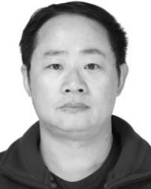

NA SHI was born in Meishan, Sichuan, China, in 1996. She received the B.S. degree in engi-neering from Sichuan Normal University, in 2018, where she is currently pursuing the master’s degree in software engineering. Her researches focus on information security and the IoT access control.



CAIXIA YANG was born in Chengdu, Sichuan, China, in 1995. She received the bachelor’s degree in engineering from Sichuan Normal University, in 2018, where she is currently pursuing the mas-ter’s degree in computer science and technol-ogy. Her main research direction is information security.



KEPING YU (Member, IEEE) received the M.E. and Ph.D. degrees from the Graduate School of Global Information and Telecommunication Stud-ies, Waseda University, Tokyo, Japan, in 2012 and 2016, respectively. He was a Research Associate with the Global Information and Telecommuni-cation Institute, Waseda University, from 2015 to 2019. He is currently a Junior Researcher with the Global Information and Telecommunication Institute, Waseda University. He has hosted and

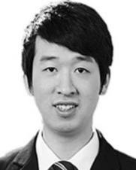

participated in a lot of research projects, including the Ministry of Internal Affairs and Communication (MIC) of Japan, the Ministry of Economy, Trade and Industry (METI) of Japan, the Japan Society for the Promotion of Science (JSPS), the Advanced Telecommunications Research Institute International (ATR) of Japan, the Keihin Electric Railway Corporation of Japan, and the Maspro Denkoh Corporation of Japan. He is also the Leader and a coauthor of the comprehensive book *Design and Implementation of* *Information-Centric Networking* (Cambridge University Press, 2020). Hewas involved in many standardization activities organized by ITU-T and ICNRG of IRTF, and contributed to the ITU-T Standards ITU-T Y.3071: Data Aware Networking (Information Centric Networking) Requirements and Capabilities and Y.3033-Data Aware Networking-Scenarios and Use Cases. His research interests include smart grids, information-centric networking, the Internet of Things, blockchain, and information security.

Dr. Yu has had experience with editorial and conference organizations. He has served as a Leading Guest Editor of *Sensors* special issue Emerging Blockchain Technology Solutions for Real-world Applications (EBTSRA), the General Co-Chair and the Publicity Co-Chair of the IEEE VTC2020-Spring EBTSRA Workshop, the TPC Co-Chair of SCML2020, the Local Chair of MONAMI 2020, and the Session Chair of ITU Kaleidoscope 2016. Moreover, he has served as a TPC Member of the ITU Kaleidoscope 2020, the IEEE VTC2020-Spring, the IEEE CCNC 2020, the IEEE WCNC 2020, the IEEE VTC2019-Spring, the ITU Kaleidoscope 2019, the IEEE HotICN 2019, the IEEE ICCC 2019, the IEEE WPMC 2019, EEI 2019, and ICITVE 2019. He is also an Editor of the IEEE OPEN JOURNAL OF VEHICULAR

TECHNOLOGY (OJVT).



77226 VOLUME 8, 2020