This article has been accepted for publication in a future issue of this journal, but has not been fully edited. Content may change prior to final publication. Citation information: DOI

10.1109/ACCESS.2020.2995384, IEEE Access

Date of publication xxxx 00, 0000, date of current version xxxx 00, 0000.

Digital Object Identifier 10.1109/ACCESS.2020.DOI

**Communication and Computing Cost Optimization of Meshed Hierarchical NFV Datacenters**

**BINAYAK KAR1, (Member, IEEE), ERIC HSIAO-KUANG WU2, (Member, IEEE)**

**AND YING-DAR LIN3, (Fellow, IEEE)**

1 Department of Computer Science and Information Engineering, National Taiwan University of Science and Technology, Taipei, 10607, Taiwan

* Department of Computer Science and Information Engineering, National Central University, Chung-Li, 32001, Taiwan (e-mail: hsiao@csie.ncu.edu.tw)

3 Department of Computer Science, National Chiao Tung University, Hsinchu, 300, Taiwan (e-mail: ydlin@cs.nctu.edu.tw)

Corresponding author: Binayak Kar (e-mail: bkar@mail.ntust.edu.tw).

This work was supported in part by the H2020 Collaborative Europe/Taiwan Research Project 5G-CORAL under Grant 761586 and in part by the Ministry of Science and Technology (MOST), Taiwan.

 **ABSTRACT** Telecommunication carriers of 5G-MEC are re-architecting their central offices and mobilebase stations as datacenters with network function virtualization (NFV) technology. These datacenters (DCs) are known as edge datacenters that help network operators speed deployment and reduce costs. Previously, the use of NFV was limited to within a datacenter (DC) known as intra-DC. Recently, many studies have been conducted into the use of NFV across DCs, i.e., inter-DC. However, these NFV inter-DC architectures have limited communication between DCs with either horizontal or vertical connectivity. In this paper, we propose a generic architecture of such edge NFV datacenters with both horizontal and vertical connectivity, and demonstrate the consequences of both vertical and horizontal connectivity between DCs in terms of communication and computing costs. We formulate a cost optimization problem with latency and capacity as constraints by estimating the traffic dispatch rate between DCs. We propose a vertical-horizontal communication (VHC) heuristic solution to the NP-hard problem. Compared to horizontal connectivity, our results show that vertical connectivity helps to reduce computing costs by 10-30%. However, both vertical and horizontal communications together can help to reduce such costs by 20-30% compared to only vertical communication.

 **INDEX TERMS** Inter-DC connectivity, VNF placement, service chaining, communication, computing

**I. INTRODUCTION**

ETWORK function virtualization (NFV) [1] is a new Nalternative technology in the revolution of the commu-nication network that has emerged as an appealing solution to transform dedicated hardware implementations to software instances running in a virtualized environment. In NFV, a requested service is implemented by a sequence of Virtual Network Functions (VNF) that can run on generic servers by leveraging virtualization technology. These VNFs are pitched with a predefined order. This is also known as Service Func-tion Chaining (SFC) [2]. NFV is being adopted by telecom-munication service providers (TSPs) to avoid the problems caused by the application of traditional techniques over the years. NFV brings flexibility, easy deployment, dynamic adjustment on demand, and easy and faster up-gradation [4]. NFV offers a new way to design, deploy, and manage net-

working services by decoupling the network functions, such as network address translation, firewalls, intrusion detection, domain name service, etc., from dedicated hardware devices so they can run in software [1], [3]. Hence, TSPs such as AT&T are re-architecting their central offices as datacenters, popularly known as CORD (Central Office Re-architected as a Datacenter) [5], [6]. To improve the user-perceived service response time in 5G-MEC [7] architecture and deliver faster services, service providers are upgrading their base stations (BS) to NFV-enabled datacenters [8]. These NFV-enabled central offices and base stations are called edge datacenters (EDC) [9]. Such NFV datacenters with software defined net-working (SDN) help service providers speed up deployment and reduce costs [10].

Over the past few years, some research has been con-ducted on the integration of NFV and service chaining in

|  |  |
| --- | --- |
| VOLUME 8, 2020 | 1 |

This work is licensed under a Creative Commons Attribution 4.0 License. For more information, see https://creativecommons.org/licenses/by/4.0/.

This article has been accepted for publication in a future issue of this journal, but has not been fully edited. Content may change prior to final publication. Citation information: DOI  10.1109/ACCESS.2020.2995384, IEEE Access

datacenters [11], [12]. However, such integration of NFV is limited to within a datacenter, i.e., intra-DC [13]. When the communication takes place between two virtual machines (VMs) in the same or different servers but in the same DC we called it intra-DC communication. However, if two VMs in two different servers and those two servers are in different DCs we called it inter-DC communication. In recent years, a few published research papers have extended NFV across the datacenters, i.e., inter-DC [14]. Such inter-DC architectures focus on either horizontal [15] or vertical communication [14], [16]. In a multi-tier topology, the com-munication between two sibling is called horizontal com-munication (example: communication between node 2.1 and node 2.2 in Figure 1) whereas the communication between parent and child is called vertical communication (example: communication between node 2.1 and node 3.1 in Figure 1). However, in a single-tier topology, the communication is horizontal by default. The connectivity of DCs depends on various factors, such as the number of DCs, their location, capital expenditure, and so on. Similarly, the number of DCs also plays a significant role in the selection of particular connectivity architecture.

In the USA a service provider like AT&T has about 4700 central offices [5], while in Taiwan, a service provider like Chunghwa Telecom has only about 450. India, which is the second largest telecom subscriber, has around 1.1 million base stations that provide 86% of the coverage for the total population [18]. To date, there are two ways to connect these edge NFV datacenters (NFV-enabled CO and BS): a horizontal connection (where the DCs are connected to its siblings) or a vertical connection (where the DCs are connected to both parent and child DCs). However, there is an alternative connection, the combination of both horizontal and vertical connections, where the DCs can be connected to parent, child, and sibling DCs. The detailed architecture of this NFV inter-DC connectivity is discussed in Section II-A.

In NFV, a VNF runs as a virtual machine (VM) on a physi-cal device of the DC to continuously serve packets belonging to one or more flows. By doing this, the computing cost is re-duced when a single VNF is shared between different flows, reducing the number of active VMs. However, in inter-DC architecture, communication costs are still an issue. Although the intra-DC communication delay can be neglected (as it is relatively very low compared to the inter-DC communication delay [17]), as well as the communication costs within the datacenter [11], [23], however, in inter-DC, the distance between DCs and the location of the DCs will affect the inter-DC communication cost [19]. Communication costs depend mostly on the flow, its size, which and how many DCs it is traveling between. Again, the path of the flow depends on the service chain demand of the flow and available VNFs of the DCs. While adopting certain connectivity for these NFV-DCs, a few questions arise immediately:

1. Which connectivity helps more—vertical or horizon-tal?
2. Which capacity helps more on inter-DC architec-

2

ture—the communication capacity between DCs, or computing capacity within a DC?

1. Does higher inter-DC communication capacity help reduce the required computing capacity?

In this paper, we attempt to solve these issues. This novel contribution can be summarized as

1. First, we propose a generic inter-DC architecture, which can have one or multiple tiers. Each DC may have vertical and horizontal connectivity.
2. Second, we design a model to estimate the inter-DC traffic rate and formulate an optimization problem to minimize the cost of the network with capacity and delay as the constraints.
3. We propose a heuristic algorithm for the inter-DC network communication. By a MATLAB experiment, we demonstrate the performance of different types of networks.

The remainder of the paper is organized as follows. In Section II, we discuss inter-DC architecture and related works. We discuss system models and formulate optimization problems in Section III. A heuristic solution is presented in Section IV, and in Section V, we analyze the results, and draw conclusions in Section VI.

**II. BACKGROUND**

In this section, we first discuss possible inter-DC network topologies and their properties. In the second part, we will discuss work related to our paper.

**A. GENERIC INTER-DC ARCHITECTURE**

For communication between DCs, connectivity is a key factor [20], [21]. This connectivity can be either horizontal (i.e., between siblings) or vertical/hierarchical (i.e., between parent and child), or both. Again, in hierarchical connectivity, a parent DC may have multiple child DCs and a child DC can have multiple parents. Taking these factors into account, we have considered five different topologies such as the partial mesh (M), tree (T), fat-tree (FT) [22], tree with partial mesh (TwM), and fat-tree with partial mesh (FTwM) that demonstrate the degree of DC connectivity (There are two kinds of degree of connectivity: (1) The horizontal degree of connectivity defines a node horizontally and directly con-nected to how many of its siblings (2) The vertical degree of connectivity means a node vertically and directly connected to how many of its parent nodes.) in all possible scenarios. Of these topologies, the tree topology is used in [14] and partial mesh topology is used in [15] for datacenter connec-tivity. Again, the type of connectivity of the datacenters also influences the single point of failure problem of the network. If the connectivity topology is a single parent topology like tree topology or TwM topology, the single point failure is obvious. The single point failure possibility of the partial mesh topology is purely depending on the connectivity of the nodes. However, in topologies like FT topology or FTwM topology, where we have multiple path connectivity due to

VOLUME 8, 2020

This work is licensed under a Creative Commons Attribution 4.0 License. For more information, see https://creativecommons.org/licenses/by/4.0/.

This article has been accepted for publication in a future issue of this journal, but has not been fully edited. Content may change prior to final publication. Citation information: DOI

10.1109/ACCESS.2020.2995384, IEEE Access

**TABLE 1.** Degree of Connectivity of Datacenters

|  |  |  |
| --- | --- | --- |
| Topology | Degree of Connec- | Degree of Connec- |
|  | tivity (horizontal) | tivity (vertical) |
| Tree | 0 | 1 |
| Fat-tree | 0 | Multiple |
| Partial mesh | Multiple | 0 |
| Tree w/ partial mesh | Multiple | 1 |
| Fat-tree w/ partial mesh | Multiple | Multiple |
|  |  |  |

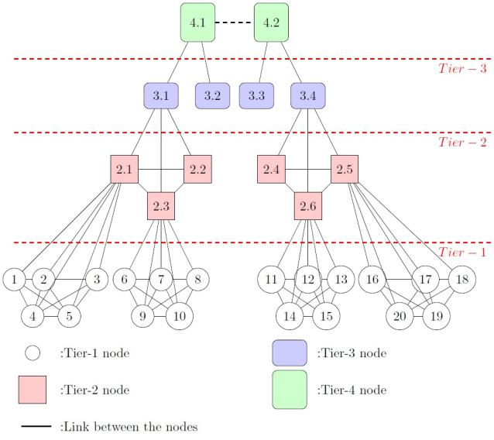

**FIGURE 1.** Multi-tier tree with partial mesh inter-DC architecture.

multiple parents, the single point failure problem is very rare. Table 1 shows the degree of horizontal and vertical connectivity of DCs for the different topologies. In the partial mesh topology, all DCs are in one tier and are connected horizontally in an arbitrary manner without any predefined structure. The tree (T), fat-tree (FT), tree with partial mesh (TwM), and fat-tree with partial mesh (FTwM) topologies are multi-tier structures. In these multi-tier topologies, the tier-1 nodes represent the NFV-enabled base stations and tier-2 nodes represent the CORD; each CORD has multiple base stations. For example, as shown in Figure 1, the base stations i.e., tier-1 nodes which are directly connected to the node in tier-2 are under that CORD. Other top-tier nodes are NFV DCs that establish the connection between these edge DCs. The T and FT connect vertically, whereas, TwM and FTwM connect both vertically and horizontally. In T and TwM, each child will have a single parent, whereas, in FT and FTwM, a child may have multiple parents. In TwM and FTwM, siblings of the same parents are connected horizontally. In this paper, we have considered that sibling nodes are connected horizontally in tier-1 in TwM and FTwM and in tier-2 in TwM. An example of TwM topology is shown in Figure 1.

**B. RELATED WORKS**

VOLUME 8, 2020

1) Intra-DC

A survey of the literature revealed that several works have re-ported on intra-DC network architecture [11]–[13], [23]–[26] and addressed different optimization issues separately. The service chain composition problem in NFV networks was discussed by D’Oro et al. in [23]. They proposed a distributed and privacy-preserving algorithm using the non-cooperative game theory in polynomial time. In [24], D’Oro et al. used the game theory to model for the interaction between a user’s demand and a server’s availability and response in which they focus on the distributed resource allocation and orchestration of a softwarized network. An Eigen-decomposition-based approach for the placement of network function chains was presented in [25]. Sun et al. in [26] proposed a reliability cost saving algorithm to condense the capital expenditures (CAPEX) and operational expenditures (OPEX) of telecom-munication service providers, by reducing the reliability of the SFC deployments. In [12], Liu et al. discussed the optimal deployment of new service function chains and readjustment of the in-service chains dynamically. Bari et al. [13] solve the problem of determining the number of VNFs required and their placement to optimize operational expenses dy-namically while adhering to service level agreements using an integer linear programming (ILP). Kar et al. proposed an m=m=c queuing model in [11] to dynamically optimize the energy consumption cost of the NFV datacenter network with the minimum capacity policy, where a certain amount of load is required to start the physical machine (PM), increasing the utilization of the PM, and avoiding frequent changes of the PM’s states. It uses VNF chaining to minimize energy consumption cost within a datacenter, where only computing cost is taken into consideration as the communication costs within a datacenter is minimal compared to computation costs. However, this paper focuses on the optimal deployment of service functions across datacenters to minimize the total cost, including both computation and communication costs.

2) Inter-DC

The service chaining across datacenter is still in its early stage. However, Gharbaoui et al., in [35] shows experi-mental validation of an orchestration system for geograph-ically distributed Edge/NFV clouds, supporting end-to-end latency-aware and reliable network service chaining. To do the service changing across datacenters, they set up their experiment on top of the Fed4FIRE+ experimentation plat-form with three datacenters. VirtPhy, a fully programmable NFV orchestration architecture for edge datacenters based on server-centric topologies, was discussed in [29]. It is mainly a distributed service function chaining scheme, which inte-grates NFV and SDN to benefit from the physical network topology and enable SFC in datacenter environments based on software switches. In [30], Chen et al. provided the first study on traffic dynamics among multiple datacenters using the network traces collected at five major Yahoo! datacenters. The results show that Yahoo! employs a hierarchical way of deploying its datacenters. Yang et al. in [31] presented an op-

3

This work is licensed under a Creative Commons Attribution 4.0 License. For more information, see https://creativecommons.org/licenses/by/4.0/.

This article has been accepted for publication in a future issue of this journal, but has not been fully edited. Content may change prior to final publication. Citation information: DOI  10.1109/ACCESS.2020.2995384, IEEE Access

timal resource allocation method in an NFV-enabled Mobile Edge-Cloud environment. In this work, they addressed where and when to allocate the resources as well as how many resources could be allocated. A jointly optimized network delay and energy saving mechanism were studied in [32] and considered intra-and-inter datacenter VM placement issues. In this large-scale cloud system, they considered multiple medium-size DCs geographically distributed, connected via the backbone network. In [33], Bouet et al. considered a geo-clustering approach for mobile edge computing (MEC) resource optimization. In their paper, they presented a graph-based algorithm which enables identifying a section of MEC areas where traffic is consolidated at the edge of the MEC servers. Obadia et al. presented a novel game-theory ap-proach for exploiting excessive resources, offering service function chains which point to a new business model and revenue opportunities for NFV operators in [34]. A low-cost VNF placement and the routing and spectrum assignment (RSA) on the multicast tree was discussed in [36], where both static network planning and dynamic network provisioning is addressed.

Gu et al. proposed a general model framework for inter-DC that describes the relationship of geo-distributed data-centers and formulate the communication cost minimization problem for big data stream processing (BDSP) in [19]. CARPO, a correlation aware power optimization scheme for datacenter networks was proposed by Wang et al. in [28], in which they dynamically consolidate traffic flows onto a small set of links and switches in a datacenter network and then shut down unused network devices for energy saving. Krishnaswamy et al. propose partitioning the VNF types according to their latency sensitivity [27] where the resources in the datacenters can be allocated hierarchically for NFV. In [14], Lin et al. propose hierarchical NFV/SDN-integrated architecture in which datacenters are organized into a multi-tree overlay network to collaboratively process user traffic flows. However, the results are yet to be optimized, and they have not considered inter-DC service chaining. The articles [14], [16] and [27] discuss layered architecture but only vertical connectivity, and not the horizontal connectivity issue. The major differences of this paper compared to the other work noted are:

1. First, all of the papers on inter-DC focus on either cost and latency or cost and capacity but not all three together, which is the key contribution of this paper.
2. Second, these papers address either communication cost or computing cost; however, in this paper, we address both the communication and computing costs.
3. Finally, these papers consider either horizontal or ver-tical connectivity, whereas in this paper, we are con-sidering not only horizontal and vertical connectivity individually, but also vertical-horizontal connectivity by considering topologies like TwM and FTwM where a node can communicate to its parent, child, and sibling directly.

4

**FIGURE 2.** Inter-DC tier classification.

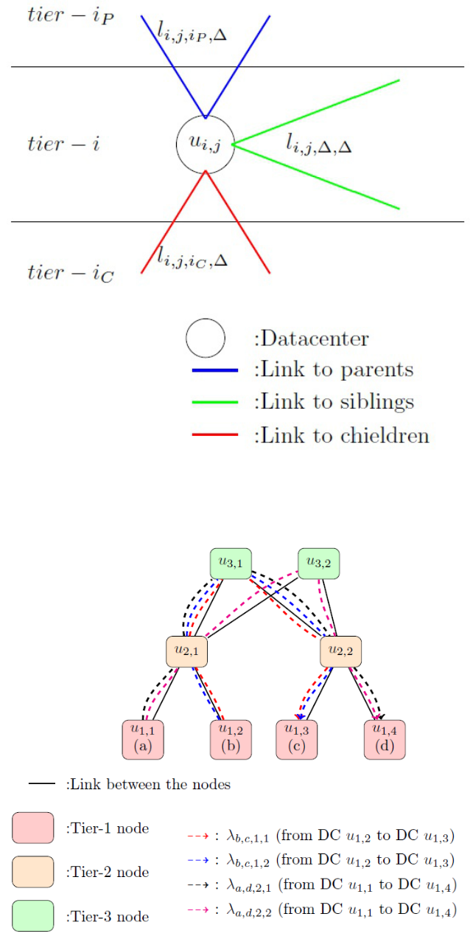

**FIGURE 3.** An example of Inter-DC traffic flow.

**III. SYSTEM MODEL AND PROBLEM FORMULATION**

In this section, we develop our system model and state our objective. In Table 2, we list the variables used to estimate the traffic rate between the DCs, both within and across the tiers, and formulate an optimization problem to minimize the total cost, which includes the communication cost and computing cost. The mathematical modeling of the VNF placement across DCs is a complex task. In this paper, to simplify our formulation, we assumed the datacenters are single server datacenters.

VOLUME 8, 2020

This work is licensed under a Creative Commons Attribution 4.0 License. For more information, see https://creativecommons.org/licenses/by/4.0/.

This article has been accepted for publication in a future issue of this journal, but has not been fully edited. Content may change prior to final publication. Citation information: DOI

10.1109/ACCESS.2020.2995384, IEEE Access

**A. SYSTEM MODEL**

We consider a generic inter-EDC architecture composed of multi-tier topology where DCs may have zero-to-multiple degrees of connectivity, both horizontally and vertically. Ui denotes the set of DCs in tier-i. ui;j denotes the j-th DC

|  |  |  |  |
| --- | --- | --- | --- |
| i;j | ^ | denotes the set of |  |
| in i-th tier, and ^c | is its capacity. U |  |

DCs in tier-1 from where traffic originates and terminates.

|  |  |
| --- | --- |
| L denotes the set of links, and li;j;i0;j0 denotes the link | |
| between ui;j and ui0;j0 ; if both ends of the links are in the | |
| same tier, then j =j0. The capacity of the link li;j;i0;j0 | |
| is denoted as ^Mi;j;i60;j0 | . We classify the DCs according to |
| tiers, where tier-iP and tier-iC (i.e., tier-(i + 1) and tier- | |
| (i 1)) are the parent tier and child tier of tier-i. li;j;4;4, | |
| li;j;iP ;4, and li;j;iC;4 stands for the links between DC ui;j | |
| and DCs in tier-i, tier-iP , and tier-iC , respectively, as shown | |

u3;1 ! u2;2 ! u1;3. The flow a;d;2;1 travels along the path u1;1 ! u2;1 ! u3;1 ! u2;2 ! u1;4, and due to capacity limitation in DC u3;1, the flow a;d;2;2 travels along the path u1;1 ! u2;1 ! u3;2 ! u2;2 ! u1;4. Then the total traffic passing through link l2;1;3;1 (i.e., from DC u2;1 to DC u3;1) is b;c;1;1 + b;c;1;2 + a;d;2;1.

**C. INTER-DC TRAFFIC ESTIMATION**

In this section, we estimate the traffic rate between the datacenters both within a tier and across the tiers. The total traffic arrival rate at the DC from all DCs in the tier-i, tier-iP (i.e., the parent tier of tier-i or tier-(i+1), and tier-iC (i.e., the child tier of tier-i or tier-(i 1) are presented in Equations (1),

(2) and (3), respectively, as

in Figure 2. F and SC denote the set of network functions

and service chains, respectively, and nC is the capacity of

fn. If jF j = w, and the length of a service chain is some

integer between [p; q], where q p, then theoretically we can have jSCj = q(q+1)p( p1) w! number of service chains

2

* (considering duplication of network functions in the service

|  |  |  |  |  |  |  |  |
| --- | --- | --- | --- | --- | --- | --- | --- |
| chains). The notation | ^ | stands for the t-th flow with k- | | | | |  |
|  | s;^d;k;t | |  |  |  |  |  |
|  |  | ^ | ^ | is the summation of | | |  |
| th service chain from s^ to d and | | |  |
|  |  |  | s;^d;k | |  |  |  |
|  |  |  |  | ^ |  |  |  |
| all traffic with k-th service chain from s^ to d. The set of paths | | | | | | |  |
|  |  | ^ |  |  | ^, and p | ^ |  |
| between two host DCs, s^ and d is denoted by P | | | | |  |
|  |  |  |  |  | s;^d | s;^d;k |  |

^

is the path of a flow with k-th service chain from s^ to d. The

|  |  |  |  |  |  |  |  |  |  |  |
| --- | --- | --- | --- | --- | --- | --- | --- | --- | --- | --- |
|  |  | 8 | |  | X | 8 | X2 | | jSCj |  |
| tai;ji = | |  | X X |  |
|  |  |  |  |  |  |  |  |  |
|  |  |  |  | l | i;4;i;j |  | ^ |  | ^ k=1 t=0 |  |
|  |  |  |  |  |  | s;^d | U | |  |
|  | 8 |  |  | X | | 8 | X2 | | jSCj |  |
| taiP |  |  | X X |  |
| = |  |  |  |  |  |  |  |  |  |
| i;j |  |  |  |  |  |  |  |  |  |  |
|  |  | l | iP ;4;i;j | | |  | ^ |  | ^ k=1 t=0 |  |
|  |  |  |  | s;^d | U | |  |
|  | 8 |  | X | | | 8 | X2 | | jSCj |  |
| taiC |  | X X |  |
| = |  |  |  |  |  |  |  |  |  |
| i;j |  |  |  |  |  |  |  |  |  |  |
|  |  | l | iC;4;i;j | | |  | ^ |  | ^ k=1 t=0 |  |
|  |  |  |  | s;^d | U | |  |

gi;4^;i;j s;^d;k;t

giP^;4;i;j s;^d;k;t

giC^;4;i;j s;^d;k;t

^

s;M^d;k;t;

^

s;M^d;k;t;

^

s;M^d;k;t:

(1)

(2)

(3)

maximum tolerable latency of a flow with k-th service chain

|  |  |  |
| --- | --- | --- |
| ^ | and lyi;j;i0;j0 is the latency |  |
| from s^ to d is presented by Ys;^d;k^ |  |
| of the link li;j;i0;j0 . |  |  |

**B. EXAMPLE OF INTER-DC TRAFFIC FLOW**

In this section, we will discuss the inter-DC traffic flow using

And the total traffic departure rate from the DC ui;j to all DCs in tier-i, tier-iP , and tier-iC are presented in Equa-tions (4), (5) and (6), respectively, as

|  |  |  |  |  |  |
| --- | --- | --- | --- | --- | --- |
| tdi;j = | jSCj | gs;^d;k;t^ | ^ | ; (4) |  |
| X XXX | M |  |
| i |  | i;j;i;4 | s;^d;k;t |  |  |

one example. Figure 3 shows a 3-tier topology with 4 DCs in tier-1 and two DCs in tier-2 and tier-3 each. We have four flows i.e., b;c;1;1; b;c;1;2; a;d;2;1; a;d;2;2. The first two

flows (i.e., b;c;1;1; b;c;1;2) are from DC u1;2 (‘b’) to DC u1;3 (‘c’) with service chain 1 and the last two flows (i.e., a;d;2;1; a;d;2;2) are from DC u1;1 (‘a’) to DC u1;4 (‘d’) with service chain 2, as shown in Figure 3. When a flow travels from source to destination across DCs, the path of the flow will be selected from of multiple available paths, based

|  |  |  |  |  |  |  |  |  |  |  |  |
| --- | --- | --- | --- | --- | --- | --- | --- | --- | --- | --- | --- |
|  |  | 8li;j;i;4 8s;^d^2U^ k=1 | | | | | | | t=0 |  |  |
|  |  |  |  |  |
|  | 8 | XP 4 | | | 8 | X2 | | jSCj |  |  |  |
| tdiP | X X | | i;j;iP ;4 |  |
| = |  |  |  |  |  |  |  | g |  |
| i;j |  |  |  |  |  |  |  |  |  | ^ |  |
|  |  |  |  |  |  |  |  | ^ k=1 t=0 | | s;^d;k;t |  |
|  |  | li;j;i | ; |  |  | ^ |  |  |  |
|  |  |  |  |  |  | s;^d | U | |  |  |  |
|  | 8 | X |  | 4 | 8 | X2 | | jSCj |  |  |  |
| tdiC |  | X X | | i;j;iC;4 |  |
| = |  |  |  |  |  |  |  | g |  |
| i;j |  |  |  |  |  |  |  |  |  | ^ |  |
|  |  |  |  |  |  |  |  | ^ k=1 t=0 | | s;^d;k;t |  |
|  |  | li;j;i | ; |  |  | ^ |  |  |  |
|  |  | C |  |  |  | s;^d | U | |  |  |  |

^

s;M^d;k;t;

^

s;M^d;k;t:

(5)

(6)

on the service chain of that flow and the available service function of the DCs, the available capacity of the DCs and the link capacity along the path. Let us assume the flows b;c;1;1 and b;c;1;2 travel along the path u1;2 ! u2;1 !

* In theory, duplicating a service function (SF) so that it occurs more than once in a chain is possible. This is a case when Network Service Header (NSH) or Segment Routing (SR) is used as chaining methods. In SR, the Source Routing Header (SRH) contains a segment left index which is decremented each time we go through a SF. In NSH, the routing information is distributed in the Service Forward Function (of the switches), and the packer has a chain ID, and an index in its NSH header. So, in both cases, a SF can be hit several times, each one with a different index. Other service chaining methods or implementations may not support this capability though. For example, if service chaining is implemented by chaining the destination MAC address to be one of the next hops, then a SF cannot appear twice in the chain.

VOLUME 8, 2020

The aggregate traffic arrival rate (tai;j) at DC ui;j is the sum of the all incoming traffic to DC ui;j from all the DCs in tier-i, tier-iP , and tier-iC . By summing Equations (1), (2) and (3), we can estimate the aggregate traffic arrival rate at the DC ui;j, shown in Equation (7) as

|  |  |  |  |  |  |  |  |  |  |  |
| --- | --- | --- | --- | --- | --- | --- | --- | --- | --- | --- |
| 8 4X | | | 8 | X2 | | jSCj |  | ^ |  |  |
| X X | 4;4;i;j | s;^d;k;t | : (7) |  |
| tai;j = |  |  |  |  |  | g | s;^d;k;t^ | M |  |
|  | l | ;4;i;j |  | ^ |  | ^ k=1 t=0 |  |  |  |  |
|  |  |  | s;^d | U | |  |  |  |  |

Similarly, Equation (8) gives the aggregate traffic depar-ture rate (tdi;j) from DC ui;j, which is sum of all departure traffics from DC ui;j to DCs in tier-i, tier-iP , and tier-iC can be estimated by summing Equations (4), (5) and (6) as

5

This work is licensed under a Creative Commons Attribution 4.0 License. For more information, see https://creativecommons.org/licenses/by/4.0/.

This article has been accepted for publication in a future issue of this journal, but has not been fully edited. Content may change prior to final publication. Citation information: DOI  10.1109/ACCESS.2020.2995384, IEEE Access

**TABLE 2.** List of Commonly used Variables and Notations

|  |  |  |  |  |  |  |  |  |  |  |  |  |  |  |  |  |  |  |  |  |
| --- | --- | --- | --- | --- | --- | --- | --- | --- | --- | --- | --- | --- | --- | --- | --- | --- | --- | --- | --- | --- |
| Notations | | | | |  |  |  |  | Descriptions | | |  |  |  |  |  |  |  |  |  |
| H | |  |  |  |  |  |  |  | Number of tiers in the topology | | | | |  |  |  |  |  |  |  |
| ui;j 2 Ui | | | | |  |  |  |  | Ui is the set of DCs in tier-i , and is j-th DC in i-th tier | | | | | | |  |  |  |  |  |
|  | ^ | |  | ^ |  |  |  |  |  |  | ^ |  |  | ^ |  |  |  |  |  |  |
| s;^ d | | 2 U | | |  | L |  |  | s^ is DC u1;s and d is DC u1;d. | | | | | U U1 is the set of host DCs where traffic originates and terminates | | | | | |  |
| li;j;i ;j | | | | 0 2 | |  |  | Set of links between DCs and link between ui;j and u | | | | | | i0 | ;j0 | if i == i0 then j | 6 | =j0 |  |
|  | n | 0 |  |  |  |  |  |  |  | n |  |  |  |  |  |
| fn | | 2 F | | |  |  |  |  | F is the set of VNFs, and f | | |  | is the network function n | | |  |  |  |  |  |
| g^i;j | |  |  |  |  |  |  |  | A binary variable. Value will be 1 if network function n running on DC ui;j, 0 otherwise | | | | | | | | | | |  |
| ri;jn | |  |  |  |  |  |  |  | Number of VMs of network function running on DC ui;j | | | | | | | |  |  |  |  |
| SC | |  |  |  |  |  |  |  | Set of service chains | | |  |  |  |  |  |  |  |  |  |
| ^ |  | ^ |  | = |  |  |  | ^ | ^ | ^ | is the flow with k-th service chain from DC u1;s | | | | | to DC u1;d, and | | ^ | is the t-th flow with k-th service chain from |  |
|  |  |  |  | t |  |  |
|  | s;^d;k | |  |  |  |  | s:^d:k;t |  | s;^d;k |  |  |  |  |  |  | s;^d;k;t | | |  |
| gi;j;i^0;j0 | | | | | P | |  |  | DC u1;s to DC u1;d, if t == 0, then no flow | | | | | |  |  |  |  |  |  |
|  |  |  |  | A binary variable. Value will be 1, if t-th flow with k-th service chain from DC u1;s to DC u1;d passes through link li;j;i0;j0 , | | | | | | | | | | |  |
| s;^d;k;t | | | | |  |  |  |  | 0 otherwise | | |  |  |  |  |  |  |  |  |  |
|  |  |  |  |  |  |  |  |  |  |  |  |  |  |  |  |  |  |
|  |  |  | 2 Ps;^d^ | | | | |  | Amount of traffic with k-th service chain from DC u1;s to DC u1;d | | | | | | | | |  |  |  |
| ps;^d;k^ | | |  | Ps;^d^ is the set of paths from DC u1;s to DC u1;d, and ps;^d;k^ is the path of a flow with k-th service chain from DC u1;s to DC | | | | | | | | | | |  |
|  |  |  |  |  |  |  |  |  | u1;d | |  |  |  |  |  |  |  |  |  |  |

lyi;j;i0;j0 ; Y ^ s;^d;k

|  |  |  |
| --- | --- | --- |
| cn; ^ci;j | ; s;^d;k;t^ |  |
| ^i;j;i0;j0 |  |
| M | M |  |

^

M ; C

;M;C tai;j; tdi;j

taii;j; taii;jP ; taii;jC

tdii;j; tdii;jP ; tdii;jC tii;j; tti;j

lyi;j;i0;j0 is the latency from DC ui;j to DC ui0;j0 , and Y ^ is the tolerable latency of the flow with k-th service chain from s;^d;k

DC u1;s to DC u1;d

Computing capacity of one instance of VM running network function n and computing capacity of DC ui;j.

Communication capacity of link li;j;i0;j0 , and communication capacity consumed by t-th flow with k-th service chain from DC u1;s to DC u1;d

Cost of one unit of communication capacity and computing capacity

Total cost, communication cost, and computing cost

Aggregate traffic arrival to DC ui;j and aggregate traffic departure from DC ui;j Total traffic arrival rate from all DCs in the tier-i, tier-iP and tier-iC to DC ui;j

Total traffic departure rate from DC ui;j to all DCs in the tier-i, tier-iP and tier-iC Total traffic initiated from DC ui;j and total traffic terminated at DC ui;j

|  |  |  |  |  |  |  |  |  |  |  |
| --- | --- | --- | --- | --- | --- | --- | --- | --- | --- | --- |
| 8 |  | X | 8 | X2 | | jSCj |  | ^ |  |  |
|  | X X | i;j;4;4 | s;^d;k;t | : (8) |  |
| tdi;j = |  |  |  |  |  | g | s;^d;k;t^ | M |  |
|  | l | i;j;4;4 |  | ^ |  | ^ k=1 t=0 |  |  |  |  |
|  |  |  | s;^d | U | |  |  |  |  |

The above traffic estimation is applicable when the DC ui;j is not a host datacenter which that means neither any traffic is initiated nor terminated in that datacenter. If DC ui;j is a host datacenter, then the aggregate arrival traffic with destination ui;j i.e., traffic terminate at DC ui;j (tti;j) and the aggregate departure traffic with source DC ui;j i.e., traffic initiated from ui;j (tii;j) can be estimated by Equations (9) and (10), respectively, as

|  |  |  |  |  |  |  |  |  |  |  |  |  |  |  |  |  |
| --- | --- | --- | --- | --- | --- | --- | --- | --- | --- | --- | --- | --- | --- | --- | --- | --- |
| 8 | |  | 4X |  | 8 | | X2 | | | jSCj |  |  | ^ |  |  |  |
|  |  | X X | | gs;^4^j;k;t;4;i;j | Ms;^j;k;t; | | (9) |  |
| tti;j = |  | l | ;4;i;j | |  |  | ^ |  |  | ^ k=1 t=0 | |  |
|  |  |  |  |  | s;^j |  | U | |  |  |  |  |  |  |
| 8 |  | X | | 8 | | X2 | | |  | jSCj |  |  | ^ ^ |  |  |  |
|  |  | X X | | i;j;4;4 | j;d;k;t |  | (10) |  |
| tii;j = |  |  |  |  |  |  |  |  |  |  | g^j;d;k;t^ | | M | : |  |
|  | l | i;j;4;4 | |  | ^ ^ | | |  | ^ k=1 t=0 | | |  |  |  |  |  |
|  |  |  |  | j;d | | U | | |  |  |  |  |  |  |

Then the aggregate traffic departure rate from a host DC ui;j can be estimated as tai;j + tii;j tti;j.

a generic inter-DC network, with given traffic arriving with a set of service chains in the given topology with deployed service functions, subject to constraints on the end-to-end delay.” Here, the total cost is the sum of computing cost and communication cost, i.e., = C + M , where C and M are the computing cost and communication cost shown in Equations (11) and (12), respectively, as

|  |  |  |  |  |  |  |  |  |  |  |  |  |  |
| --- | --- | --- | --- | --- | --- | --- | --- | --- | --- | --- | --- | --- | --- |
|  |  |  | H | | jF j |  |  |  |  |  |  |  |  |
|  | C = | | X X X | | | n | n |  | n | ^ | ; | (11) |  |
|  | i=1 j2Ui n=1 | | | g^i;j | C | ri;j | | C |  |
|  |  | X0 0 |  |  |  |  |  |  |  |  |
| 8 |  | 8 | X2 | X X | | i;j;i0;j | 0 | s;^d;k;t^ | |  |  |  |
|  |  |  |  |  | jSCj |  | M : (12) | |  |
| M = |  |  |  |  |  | g | s;^d;k;t^ |  | M |  |  |
|  | l | i;j;i ;j |  | ^ | ^ k=1 t=0 | |  |  |  |  |  |  |  |
|  |  |  | s;^d U | |  |  |  |  |  |  |  |  |

Our objective is to minimize( ). The set of operational constraints to be noticed are

|  |  |  |  |  |  |
| --- | --- | --- | --- | --- | --- |
| X | ^ | ; 8li;j;i0j0 | 2 ps;^d;k^; 8ps;^d;k^ | 2 Ps;^d^; |  |
| lyi;j;is;^d;k0;j0 Ys;^d;k^ |  |
|  | jF j |  |  | (13) |  |
|  |  |  |  |  |
|  | X |  | ^Ci;j; 8ui;j; |  |  |
|  | g^i;jn Cn ri;jn | | (14) |  |

n=1

**D. OBJECTIVE FUNCTION AND CONSTRAINTS**

In this section, we will use the notations given in Table 2 to formulate the optimization problem. In this problem, "by determining the computing capacity of the datacenters, com-munication capacity between DCs and traffic dispatch rate between DCs, our objective is to minimize the total cost in

|  |  |  |  |  |  |  |  |
| --- | --- | --- | --- | --- | --- | --- | --- |
| jSCj |  |  | M | ^M | ; 8li;j;i0j0 | : (15) |  |
| X X Xgs;^d;k;t^ | | 0 |  |
| i;j;i0 | ;j | s;^d;k;t^ | i;j;i0j | 0 |  |  |

* + ^2 ^ k=1 t=0 s;^d U

1. Latency Constraint: The inequality in Equation (13) en-sures the total sum of latency of a flow along the path must

6 VOLUME 8, 2020

This work is licensed under a Creative Commons Attribution 4.0 License. For more information, see https://creativecommons.org/licenses/by/4.0/.

This article has been accepted for publication in a future issue of this journal, but has not been fully edited. Content may change prior to final publication. Citation information: DOI

10.1109/ACCESS.2020.2995384, IEEE Access

|  |  |  |  |  |  |  |  |  |  |  |  |  |  |  |  |
| --- | --- | --- | --- | --- | --- | --- | --- | --- | --- | --- | --- | --- | --- | --- | --- |
| be less than or equal to the maximum tolerable latency of the | | | | | | | | | | | reductions method [42]. Hence, our optimization problem is | | | |  |
| flow. |  |  |  |  |  |  |  |  |  |  | NP-hard. | |  |  |  |
| 2) Computing Capacity Constraints: The inequality in Equa- | | | | | | | | | | | **IV. HEURISTIC APPROACH** | |  |  |  |
| tion (14) ensures the total sum of VM capacities in a DC must | | | | | | | | | | |  |  |  |
| be less than or equal to the maximum capacity of that DC. | | | | | | | | | |  | In this paper, as we are neglecting the communication delay | | | |  |
| 3) Communication Capacity Constraint: The inequality in | | | | | | | | | | | within the datacenters, hence, all the physical machines in a | | | |  |
| Equation (15) is the communication capacity constraint. It | | | | | | | | | | | datacenter assumed to be one PM and all the VMs in a DC | | | |  |
| shows that the sum of flow capacities through a link should | | | | | | | | | | | can be considered to be in one server. In such a scenario, | | | |  |
| not exceed that link’s maximum capacity. | | | | | | |  |  |  |  | the VNF placement approach of the inter-DC is similar to | | | |  |
|  |  |  |  |  |  |  |  |  |  |  | the approach of VNF placement of intra-DC. An illustrative | | | |  |
| **E. PROBLEM ANALYSIS** | | | | |  |  |  |  |  |  | example of traffic flow and VNF placement within the intra- | | | |  |
| In this section, we will show that our proposed optimization | | | | | | | | | | | DC was presented in [11] where each node represents one | | | |  |
| problem can be NP-hard, by reducing the Network Testbed | | | | | | | | | | | PM. In this paper, we followed a similar placement approach | | | |  |
| Mapping (NTM) problem [37], [38], (which is known to be | | | | | | | | | | | discussed in [11], but here each node represents one datacen- | | | |  |
| NP-hard), to our problem in polynomial time. In the first | | | | | | | | | | | ter. Therefore, we neglect the intra-DC communication cost | | | |  |
| step, we state the NTM problem. In the second step, we | | | | | | | | | | | but consider the inter-DC communication cost. | | | |  |
| demonstrate that the NTM problem could be reduced to our | | | | | | | | | | | In this section, we propose a heuristic algorithm which | | | |  |
| we have termed as vertical-horizontal communication (VHC) | | | |  |
| problem. | |  |  |  |  |  |  |  |  |  |  |
|  |  |  |  |  |  |  |  |  | algorithm (shown in Figure 4) for VNF placement in the | | | |  |
| 1) | Network Testbed | | | Mapping | (NTM) problem [38]: | | | | | |  |
| inter-DC network for both single and multi-tier topologies. | | | |  |
| Given | a network of | | | switches, | s1; : : : ; sn | | | with | capac- | |  |
| We follow the physical and virtual path mapping as described | | | |  |
| ities C1; : : : ; Cn | | | and | inter-switch | | bandwidth capacities | | | | |  |
| in [11] and used the 2Assign and 3Release operations for the | | | |  |
| B1;1; : : : ; B1;n; B2;1; : : : ; Bn;n, and | | | | | | a | test | network | | of |  |
| placement of VNFs. Assign operation is used to assign a flow | | | |  |
| node N1; : : : ; Nm with inter-node bandwidth requirements | | | | | | | | | | |  |
| to the VM to process its packets and Release operation is | | | |  |
| b1;1; : : : ; bm;m. If there is an injective assignment A : N ! s | | | | | | | | | | |  |
| used to release a flow from the VM when processing of all | | | |  |
| such that: | |  |  |  |  |  |  |  |  |  | packets of the flow completed by the VM. The computing | | | |  |
|  |  |  |  |  |  |  |  |  |  |  |  |
|  | jA(u) = ij Ci; 8i; 1 i n; | | | | | | |  | (16) | | cost is estimated based on how long the VM remains active in | | | |  |
|  |  | packet processing and processing capacity of the respective | | | |  |
|  |  |  |  | bu;v Bi;j; 8i; j: | | | |  | (17) | | VNFs. However, the communication cost is estimated based | | | |  |
|  |  |  |  |  | on how many flows and of what capacity are transferred | | | |  |
|  | A | (u)=1;A(v)=j | | |  |  |  |  |  |  |  |  |  |  |  |
|  |  | X |  |  |  |  |  |  |  | from one datacenter to another, and as the communication | | | |  |
| The mapping | | | that satisfies Equations | | | | (16) | and | (17) | is |  |
| cost doubles from one tier to the next tier above. We apply | | | |  |
| feasible where the summation is taken over all A(u); | | | | | | | | | A(v), | |  |
| another operation Zone, described in Definition 1, to classify | | | |  |
| satisfying the equalities. | | | |  |  |  |  |  |  |  | the zone of each flow according to its source and destination | | | |  |
| 2) NP-hard proof: Our problem has two parts: (1) The | | | | | | | | | | |  |
| datacenters. To estimate the zones of the traffics, in a multi- | | | |  |
| cost objective with latency and capacity constraints, and (2) | | | | | | | | | | |  |
| tier topology, we named the nodes in each tier sequentially | | | |  |
| Placement of VNF in the DCs to process the traffic with | | | | | | | | | | |  |
| and classified them into multiple groups where all siblings | | | |  |
| required service chains. The first part can be proved NP-hard | | | | | | | | | | |  |
| of the same parents are considered a group (e.g., tier-1 of | | | |  |
| as the capacitated set covering problem (CSCP) [39] is NP- | | | | | | | | | | |  |
| Figure 1 has four groups). When a flow is initiated, based | | | |  |
| hard. For the second part, if we map variables of the existing | | | | | | | | | | |  |
| on its destination node, we confirm its destination group and | | | |  |
| NTM NP-hard problem to the variables of our optimization | | | | | | | | | | |  |
| estimate its zone. | |  |  |  |
| problem, such as switches to Datacenters, switch capacities | | | | | | | | | | |  |  |  |
|  | ^ | ^ | (source DC u1;s |  |
|  |  |  |  |  |  |  |  |  |  |  | Definition 1: [Zone] For a traffic | |  |
| to Datacenter computing capacities, inter-switch bandwidth | | | | | | | | | | |  |  | s;^d;k |  |  |
| and destination DC u1;d), the DC u1;d is in: | | |  |  |
| to inter-DC communication capacity, test network nodes to | | | | | | | | | | |  |  |
|  | [Zone-1] if u1;d is a sibling of u1;s | |  |  |
| traffic with service chains, and inter-node bandwidth require- | | | | | | | | | | |  |  |
|  | [Zone-2] if u1;d is a descendant of parent’s sibling of | | |  |
| ments to required capacity of traffic, we have, | | | | | | | |  |  |  |  |
|  |  |  |  | u1;s |  |  |  |
|  |  |  |  |  |  |  |  |  |  |  |  |  |  |  |

|  |  |  |  |  |  |  |  |  |  |  |
| --- | --- | --- | --- | --- | --- | --- | --- | --- | --- | --- |
| 8 | 1 | (C1;n: : | !:;Cn)C | | | |  | 9 |  |  |
| > | (s | ; : : : ; s ) | (ui;j; : : : ; uH;j) | | | | | > | : (18) |  |
| (B1;1; : : : ; B1;n; B2;1; : :!:; Bn;n) ^M | | | | | | |  |
| > |  |  |  |  |  |  |  | > |  |  |
| > |  |  |  |  |  |  | ! | > |  |  |
| > |  | (N1; : : : ; Nm) | |  | ^ |  |  | > |  |  |
| > |  | ! | ^ | |  | > |  |  |
| > | (b1;1; : : : ; bm;m) | | |  | ^ |  | > |  |  |
|  | Ms;^d;k;t | | |  |  |
| < |  |  |  | ! |  | s;^d;k |  | = |  |  |
| > |  |  |  |  |  |  | > |  |  |
| > |  |  |  |  |  |  |  | > |  |  |
| > |  |  |  |  |  |  |  | > |  |  |
| > |  |  |  |  |  |  |  | > |  |  |
| : |  |  |  |  |  |  |  | ; |  |  |

With definition 5 of [9] and Equation (18), we can map and reduce the NTM NP-hard problem to our optimization problem in polynomial time by polynomial-time mapping

[Zone-3] if u1;d is a descendant of grandparent’s sibling of u1;s

...

[Zone-H] if u1;d is a descendant of root-parent’s sibling

of u1;s.

The VHC algorithm works as follows: When a new flow arrives with its service chain, we first compute the traffic zone

* Definition 3 of [11].

3Definition 4 of [11].

|  |  |
| --- | --- |
| VOLUME 8, 2020 | 7 |

This work is licensed under a Creative Commons Attribution 4.0 License. For more information, see https://creativecommons.org/licenses/by/4.0/.

This article has been accepted for publication in a future issue of this journal, but has not been fully edited. Content may change prior to final publication. Citation information: DOI  10.1109/ACCESS.2020.2995384, IEEE Access

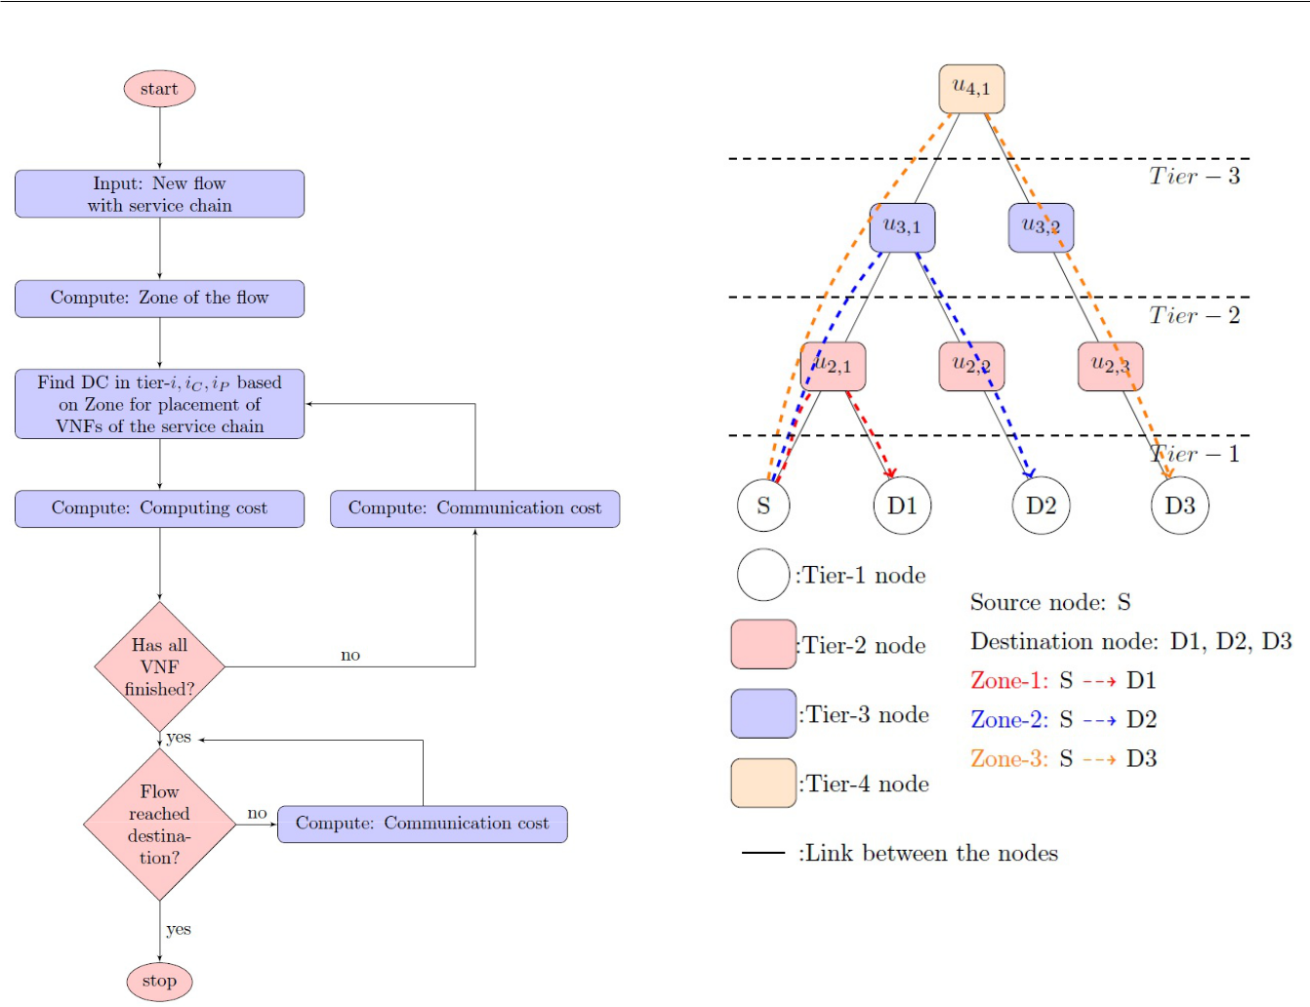

**FIGURE 4.** Vertical-horizontal communication algorithm.

of the flow based on its source and destination as described in Definition 1. An example of traffic zone estimation is pre-sented in Figure 5. Figure 5 shows a four-tier tree topology, with one source node ‘S’ and three destination nodes ‘D1’, ‘D2’ and ‘D3’. For traffic from S to D1, the zone is Zone-1 as the destination node is a sibling of the source node. For traffic from S to D2, since D2 is the descendant of S’s parent’s sibling, the zone is Zone-2. Similarly, for traffic from S to D3, the zone is Zone-3, as D3 is a descendant of S’s grandparent’s sibling. For each VNF of the service chain, we estimate the appropriate DC for placement in the appropriate tier based on its traffic zone. The placement function in this paper is a modified version of the algorithm DPVC described in [11]. The DPVC focused on the minimization of the energy cost consumption in a datacenter by reducing the active physical machines and maximizing the utilization of the machines. In DPVC, only the computing cost was taken into consideration to achieve its objective. However, this heuristic approach takes both communication (inter-DC) and computing cost into consideration to minimize the total cost. Since, this paper considers each node a datacenter, we cannot turn OFF a DC

8

**FIGURE 5.** An example of estimating traffic zone.

completely. Therefore, we use only two operations (Assign and Release), out of the four operations (Assign, Release, Add, and Delete) used in DPVC. Since each node in DPVC is physical machine, the Add and Delete operations are used to turn ON and OFF the machines. In this heuristic approach, if the VNF for next service function of a flow’s service chain is available in the same DC, the flow will be directed to that VNF in that DC, otherwise, the flow will be directed to another DC towards its destination based on cheaper com-munication cost. If two paths have the same communication cost, then the selection will be based on cheaper computing cost. After each iteration, we update the computing cost, and after each hop count of the flow, the communication cost is updated. The flow will terminate after all the packets of the flow have reached the destination after being processed by all VNFs of its service chain.

**A. HEURISTIC COMPLEXITY ANALYSIS**

Let there are N flows. The maximum length of each flow is

* packets and the length of the assigned service chain is W (assumed to be the maximum length of the service chain). If Q is the minimal processing capacity of each function, and each flow passes through E number of edges to reach the destination, then by assuming that a VNF can process a single flow at a time and the lifetime of all flows are sequential (after the termination of one flow, next flow will be initiated), the

VOLUME 8, 2020

This work is licensed under a Creative Commons Attribution 4.0 License. For more information, see https://creativecommons.org/licenses/by/4.0/.

This article has been accepted for publication in a future issue of this journal, but has not been fully edited. Content may change prior to final publication. Citation information: DOI

10.1109/ACCESS.2020.2995384, IEEE Access

worst case computing time of the algorithm is O(E N +N WQK ). However, in practice, all VNFs can process multiple flows simultaneously and flows are not sequential. If there are x group of flows running together in the network and a VNF of a service chain shared by y number of flows, then the running time of the algorithm is O(E logx (N) + WQK logy (N)).

**V. RESULTS**

In this section, we discuss the experimental setup, which was used in this work to evaluate the performance of our proposed algorithms on different topologies. In this experiment, we considered five different types of topologies: tree (T), fat-tree (FT), partial mesh (M), tree with partial mesh (TwM), and fat-tree with partial mesh (FTwM). Out of these topologies, the partial mesh topology was a single-tier topology and the others were multi-tier.

**A. EXPERIMENT SETUP**

We used MATLAB to compare the performance of our al-gorithm on different topologies. For this simulation, we con-sidered randomly-generated flows (i.e., source, destination, number of packets and service chain) as the input (maximum one flow per iteration) from a set of source DCs to a set of destination DCs, where for each flow, the source and destination nodes were not equal. All flows were initiated and terminated in the bottom tier of the topologies. The flows ranged from a minimum length of 10 packets to a maximum length of 1000 packets, and all packets were of equal size. We considered 10 types of network functions and each type had a different processing time. For each flow, the service chains were randomly generated of lengths consisting of a minimum one function to a maximum 10 functions without duplication of network functions in a service chain, i.e., a chain of length 10 functions had to contain all types of network functions considered in this experiment. We considered three different cases, where the maximum number of VMs of equal capaci-ties on the nodes were 10, 20, and 30. For the flow processing limit of the VMs, we also assumed three different values, i.e., 5, 10 and 20 flows. A VM cannot process more flows than its capacity. When the number of input flow exceeds the capacity of the VM, a new VM will be added. The computing cost depended on how long the VNF remained active to process the packets of the flows. Again, this duration depended on the processing capacity of the VNF. For example: if we had two functions, A and B, with processing capacities of 10 and 25 packets per second, respectively, then processing a flow of 100 packets, the computing cost for A and B would be 10 and 4 units, respectively. When multiple flows shared a VNF, the cost was estimated based on when the first packet of the first arrival flow to that VNF started processing and when the last packet was served by that VNF. We considered this scenario since the property of NFV allowed us to consolidate multiple flows to process the packets in a single VNF [40] to reduce computing cost. The communication cost was esti-mated based on the number of packets transferred from one

VOLUME 8, 2020

**FIGURE 6.** Total cost consumption of different networks per number of flows.

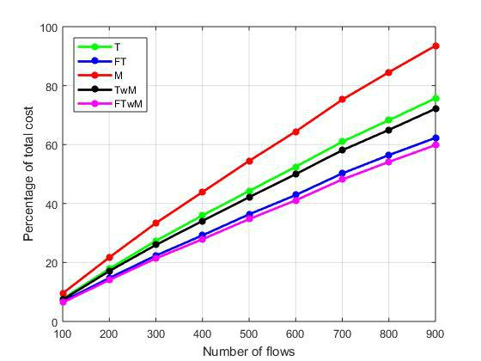

DC to another. Since the bottom tier nodes represent NFV-enabled base stations in our architecture, we considered the communication cost is one unit for transferring 800 packets from one DC to another DC in tier-1, as these DCs are relatively close to each other compared to the DCs in the top tiers. The cost is doubled if the communication takes place between the DCs in tier-1 and tier-2 or within the DCs in tier-2 (i.e., between two CORDs). The cost is further doubled for the next top tier, and so on. In the multi-tier topologies, we considered four tiers, and we neglected the communication cost within a DC. In this MATLAB experiment, we ran our algorithm ten times for each setup and calculated the average results and presented them in a normalized form.

**B. HEURISTIC PERFORMANCE ANALYSIS**

Here we demonstrate the performance of our heuristic algo-rithm on multiple types of single and multi-tier topologies. In this evaluation, we considered the scenario where the network functions are distributed over different DCs. For each service of the flow’s service chain, our algorithm will find a more suitable VNF for placement so as to minimize the cost.

1) Total Cost Analysis

Figure 6 presents the total cost of different networks. The total cost is the sum of communication and computing cost of a network after each iteration. We discuss the communication and computing cost in detail in the following subsections. As the result in Figure 6 shows, hierarchical topologies are more cost-efficient compared to a horizontal topology. In particular, the partial mesh topology has the highest cost compared to all other topologies. Figure 6 shows that the partial mesh topology consumes 15-20%, 20-25%, 25-35%, and 30-35% more cost than the T, TwM, FT, and FTwM topologies, respectively. However, in multi-tier topologies, both horizontal and vertical communications help to decrease costs compared to only vertical communication. For exam-

9

This work is licensed under a Creative Commons Attribution 4.0 License. For more information, see https://creativecommons.org/licenses/by/4.0/.

This article has been accepted for publication in a future issue of this journal, but has not been fully edited. Content may change prior to final publication. Citation information: DOI  10.1109/ACCESS.2020.2995384, IEEE Access

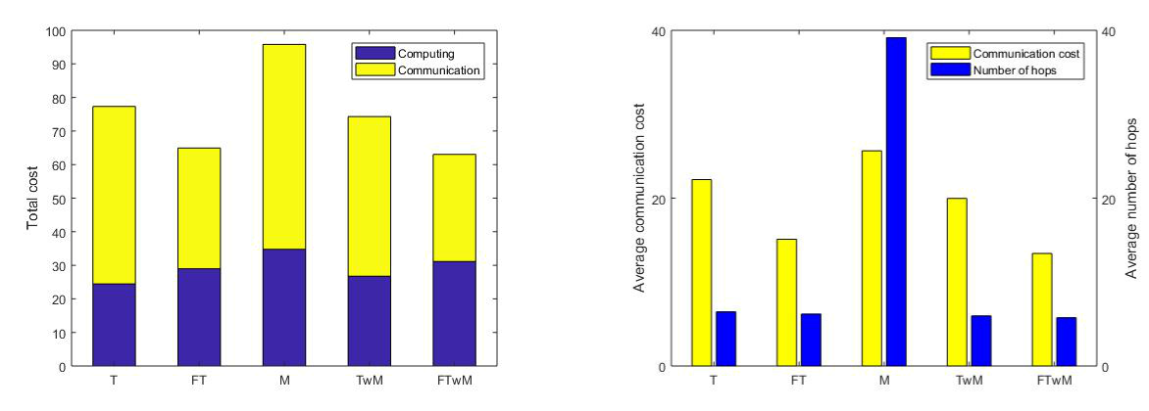

**FIGURE 7.** Comparison of communication and computing costs of different **FIGURE 9.** Comparison of average communication cost with number of hops.

networks.

**FIGURE 8.** Cumulative communication cost per number of flows of differentnetworks.

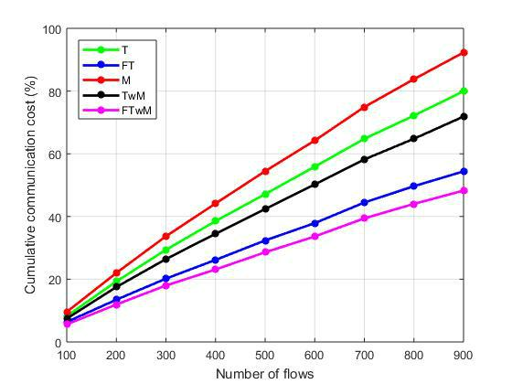

ple, as shown in Figure 6, TwM and FTwM decrease costs more than the tree and fat-tree topology, respectively.

2) Communication Cost vs. Computing Cost

The communication and computing cost comparisons of dif-ferent networks in Figure 7 shows that the ratio of communi-cation cost is relatively more than the computing cost in all networks. Since the DCs of our networks are NFV-enabled, we can consolidate multiple flows demanding similar service into a single VNF, reducing computing costs significantly. However, the communication cost depends solely on the number of packets transferred between the DCs. Hence, the ratio of communication costs is relatively higher compared to computing costs.

3) Communication Cost Analysis

The detailed communication cost analysis is presented in Figures 8, 9, 10 and 11. Figure 8 shows the percentage of

10

cumulative communication cost per flow. The communica-tion cost in multi-tier topologies is relatively low compared to single-tier topology. In particular, the T, FT, TwM, and FTwM topologies save by 10-15%, 35-40%, 15-25%, and 40-50%, respectively, of communication cost compared to par-tial mesh topology. However, between the multi-tier topolo-gies, the communication cost of multi-tier, multiple parents topologies (FT, FTwM) is less than the multi-tier, single parent topologies (T, TwM). For example, Figure 8 shows that FT and FTwM reduce the communication cost by 20-30% compared to T and TwM, respectively, because, in FT and FTwM, an alternative path always exists in the same tier for the placement of VNF, which reduces the communication cost. However, if we do not have an appropriate DC for the placement of the VNF, we have to move to the next tier above. Again, as we described in the experimental setting, the communication cost is doubled when the packet flows from one tier to the next tier above. The results also reveal that the cost in vertical with horizontal communication being relatively less than only vertical communication. Figure 8 shows that the communication cost of TwM and FTwM is 5-15% less compared to T and FT, respectively, because, in TwM and FTwM, an option always exists to avoid the placement of VNFs in the top tiers to reduce communication cost.

Because communication costs depend on how many pack-ets are transferred from one DC to another and the location of the sender and receiver DCs, the number of hops the packets of flow travel plays a key role in the communication cost estimates. Figure 9 gives the comparison of communication cost and number of hops. The left y-axis shows the average communication cost, and the right y-axis shows the average number of hops of the flows. The result shows that in all networks as the number of hops increases the cost also increases. The number of hops in the partial mesh is very high as it only follows horizontal communication. Although the communication cost in the partial mesh topology is highest

VOLUME 8, 2020

This work is licensed under a Creative Commons Attribution 4.0 License. For more information, see https://creativecommons.org/licenses/by/4.0/.

This article has been accepted for publication in a future issue of this journal, but has not been fully edited. Content may change prior to final publication. Citation information: DOI

10.1109/ACCESS.2020.2995384, IEEE Access

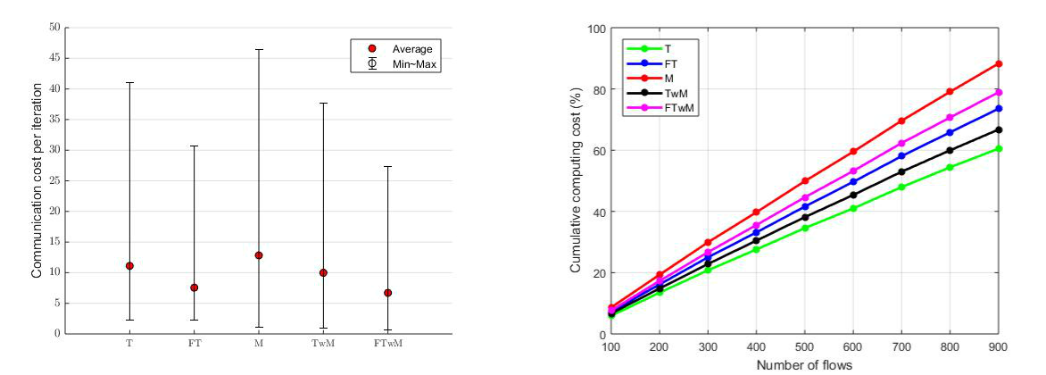

**FIGURE 10.** Max~mindifference of communication cost per iteration. **FIGURE 12.** Cumulative computing cost per number of flows of differentnetworks.

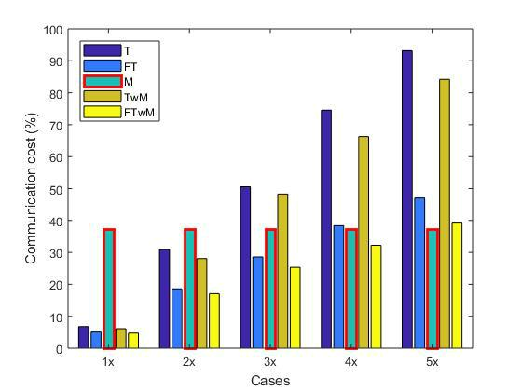

**FIGURE 11.** Change in percentage of communication cost with different unitvalues of communication cost from tier-1 to the next tier above.

compared to other topologies, its unit communication cost does however not change as in other networks, since all nodes of the partial mesh topology are in tier-1, and communication cost within tier-1 is the lowest.

Figure 10 shows the average-max-min chart of commu-nication cost per iteration. The average communication cost in multi-tier, multiple parent topologies (FT and FTwM) is less than multi-tier, single parent topologies (T and TwM). However, the average communication cost of the partial mesh topology is relatively high compared to all multi-tier topolo-gies. Similarly, the max~min difference of communication cost per iteration in the partial mesh topology is the highest and lowest in FTwM.

All previous results on communication cost are from cases where the communication cost of tier-2 is twice the commu-nication cost of tier-1, and the value is doubled from one tier to the next tier above. Figure 11 shows a unique result where we have considered five different values of the unit cost of

VOLUME 8, 2020

communication from tier-1 to the next tiers above. Tier-1 cost is equal in all case; however, it changes from tier-2 and upwards. In case-1x, we considered the communication cost to be equal in all tiers. Case-2x is the general case where the cost grows as 2x, 4x, 8x, and so on. In case-3x, it grows 3x, 6x, 12x, and so on; in case-4x: 4x, 8x, 16x, and so on; and in case-5x: 5x, 10x, 20x, and so on, in tier-2, tier-3, tier-4, and so on, respectively. As the results show, the communication cost of partial mesh topology is the same in all 5 cases as all the nodes in this topology are in tier-1. The cost of T, FT, TwM, and FTwM topologies, in case-1x, and case-2x, is relatively less than partial mesh. In case-3x, the cost of T and TwM exceeds the limit of partial mesh, but the cost of FT and FTwM are still relatively less than partial mesh. The cost of FT and FTwM come closer to the cost of the partial mesh in case-4x and case-5x, respectively. The results in Figure 11 shows case-2x is the threshold for multi-tier, single parent topologies, and case-4x and case-5x are the threshold for FT and FTwM, respectively. The multi-tier multiple parents’ topologies (FT, FTwM) save more communication costs, and fat-tree with partial mesh topology saves maximum costs compared to all other topologies considered in this work.

4) Computing Cost Analysis

The detailed computing cost analysis is presented in Fig-ures 12, 13, 14 and 15. Figure 12 shows the percentage of cumulative computing cost per flow. The computing cost in multi-tier topologies is relatively low compared to single-tier topologies. However, computing costs in multi-tier, single parent topologies (T, TwM) is less than the multi-tier, mul-tiple parent topologies (FT, FTwM). Figure 12 shows, both FT and FTwM have 10-15% higher computing cost than T and TwM, respectively, because in T and TwM, there is no alternative path for the flow. The VNFs have to be placed in the only parent DC or have to move to the next top tier. If the function is available on the parent node, all the VNFs

11

This work is licensed under a Creative Commons Attribution 4.0 License. For more information, see https://creativecommons.org/licenses/by/4.0/.

This article has been accepted for publication in a future issue of this journal, but has not been fully edited. Content may change prior to final publication. Citation information: DOI  10.1109/ACCESS.2020.2995384, IEEE Access

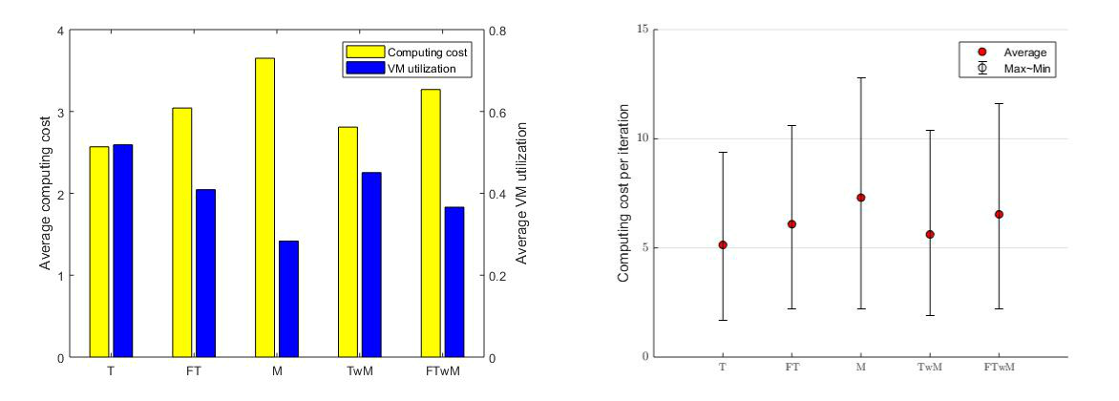

**FIGURE 13.** Comparison of average computing cost with average utilization **FIGURE 14.** Max~mindifference of computing cost per iteration.

of VMs.

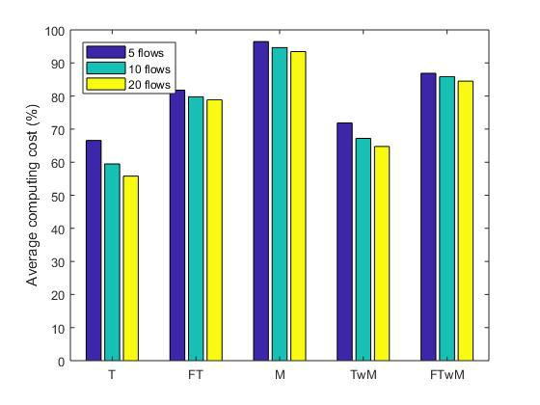

will be placed in that node until the DC exceeds its capacity. This helps increase the utilization of the VMs and reduces the computing cost. The result in Figure 12 also shows that the computing cost in vertical communication is relatively less than in vertical with horizontal communication. In par-ticular, T and FT save 5-10% on computing cost compared to TwM and FTwM, respectively. In TwM and FTwM, due to the horizontal connectivity between the siblings, an option always exists to place VNF in the same tier to reduce the communication cost by preventing some flows to proceed to the top tier. This reduces the utilization of the VMs and increases the computing cost.

Since the computing cost depends on how many VMs are utilized for flow processing and for how long, the utilization of the active VMs plays a key role in estimating computing cost, because, if the utilization of the VMs decreases, the number of VMs to process the flows will increase causing the computing cost to increase. Here, the utilization of VM means that if the VM has the capacity to process a maximum of five flows together and it is processing three flows, then the utilization of VM is 60%. Figure 13 shows a comparison of computing costs and utilization of the VMs. The left y-axis is the average computing cost, and the right y-axis is the average utilization of VMs in the DCs. The results for all networks show that as the number of utilization of VMs decreases, the computing cost increases, because of the decrease in utilization, the number of active VMs increase. The computing cost of tree topology is lowest when its utilization of VMs is highest among all topologies, whereas the computing cost of partial mesh topology is highest when its utilization is lowest.

Figure 14 shows the average-max-min chart of computing cost per iteration. The average computing cost in multi-tier, single parent topologies (T, TwM) is less than multi-tier, mul-tiple parent topologies (FT, FTwM). However, the average computing cost of the partial mesh topology is relatively high

12

**FIGURE 15.** Percentage of computing cost decreases with the increases inVM’s flow-sharing limit.

compared to all multi-tier topologies. Similarly, the max~min difference of computing cost per iteration in the partial mesh topology is the highest and lowest in the tree topology.

Figure 15 shows computing cost variation with the change of flow-sharing limits in the VNFs. Here we have considered all three values (5, 10 and 20) separately and compared the changes in computing cost. The results show that in all topologies with an increase in the flow-sharing limits of the VNFs the computing cost decreases: when VMs limits increase, more flows with similar service function demands can share a common VM for their packet processing. As a result, the number of active VMs in the network is reduced, causing a decrease in computing cost.

5) Flow-drop with Hop Constraints

Here we estimate the end-to-end delay in terms of the number of hops from the ingress to the egress node, where each node represents one datacenter, i.e., in this experiment, the inter-

VOLUME 8, 2020

This work is licensed under a Creative Commons Attribution 4.0 License. For more information, see https://creativecommons.org/licenses/by/4.0/.

This article has been accepted for publication in a future issue of this journal, but has not been fully edited. Content may change prior to final publication. Citation information: DOI

10.1109/ACCESS.2020.2995384, IEEE Access

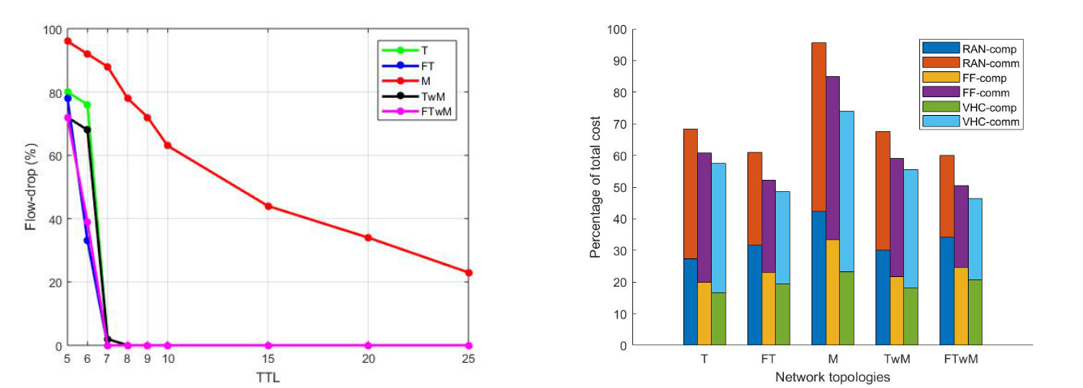

**FIGURE 16.** The percentage of flow-drop with hop constraints. **FIGURE 17.** Performance comparison of the VHC algorithm with otherexisting algorithms.

DC communication delay has been taken into consideration and intra-DC communication delay has been neglected. We have coined the term flow-drop for delay estimates.

Flow-drop means is used for when a flow is unable to reach its destination as a result of time-to-live (TTL) or hop limit. The TTL is a mechanism that limits the lifespan of a flow in the network within which the flow has to reach its destination. If it fails to reach the destination within the time limit, we consider it a flow-drop. Figure 16 shows that as the TTL increases the amount of flow-drop decreases. It also decreases faster in multi-tier topologies because of their hierarchical architecture where we can reach any destination with few hops. However, in a single-tier topology, with its horizontal architecture, the hop count is relatively higher than others. Although the flow-drop decreases in a partial mesh network, it is not as sharp a drop as in the other four networks.

1. **PERFORMANCE COMPARISON OF THE HEURISTIC**

In this section, we will compare the performance of the VHC algorithm with some other algorithms. We compare our VHC algorithm with random [43] and first-fit [44] placement algorithms. In the random placement algorithm (RAN), we randomly select a node with sufficient capacity for the place-ment of the function to process the packets of the flows. In the first-fit placement algorithm (FF), we select the first node with available capacity for the placement of the function.

Figure 17 shows the total cost comparison of the VHC algorithm with other algorithms for all five topologies that we have considered in our experiments where the ‘-comm’ and ‘-comp’ represent the communication cost and computing cost, respectively. The result shows in all algorithms percentage of total cost in partial mesh topology is very high compared to all other topologies due to its single-tier architecture. As in the partial mesh topologies, the number of hop count from source node to destination node is relatively very high which causes to increase the communication cost. But in all other four multi-tier topologies (T, FT, TwM, and FTwM), the

VOLUME 8, 2020

difference of the communication cost may not be much due to nearly equal hop counts as shown in Figure 9. However, the computing cost in our HVC algorithm is low compared to other algorithms. In the VHC algorithm, the flow will be placed in the active VMs and the VMs try to accom-modate more flows for maximum utilization of its available capacities. Whereas in FF, the flow will be placed in the first available VM having required function and in RAN, the placement is done randomly. As a result, the utilization of VMs in FF and RAN decreases and they used more VMs to process the flow which results in high computing cost.

**D. OPTIMALITY OF THE HEURISTIC**

In this section, we check the optimality of the heuristic. We implemented the optimization problem in AMPL (A Modeling Language for Mathematical Programming) [41] to solve the formulation. However, when a network is large, its time cost factor is not acceptable. At the same time, we need to discuss the performance of the heuristic solution in large networks. Simulations of a small network were run to compare the performance of the optimal solution and the heuristic solution. We conducted this experiment on a partial mesh topology. The result in Figure 18 shows that with low traffic, the performance of the heuristic is closer to the optimal results. Although with an increase in traffic, the total cost consumption of the network increases compared to the optimal result, the computation time in the optimal solution is relatively much higher, at least 70–80 times that of the heuristic solution.

**VI. CONCLUSIONS**

In this paper, we analyzed the connectivity issue in an inter-DC network. We proposed a generic inter-DC NFV network architecture and estimated the traffic rate between the DCs. We formulated an optimization problem to minimize the total cost, i.e., communication and computing cost of the network,

13

This work is licensed under a Creative Commons Attribution 4.0 License. For more information, see https://creativecommons.org/licenses/by/4.0/.

This article has been accepted for publication in a future issue of this journal, but has not been fully edited. Content may change prior to final publication. Citation information: DOI  10.1109/ACCESS.2020.2995384, IEEE Access

**FIGURE 18.** Performance comparison between heuristic and optimalsolutions.

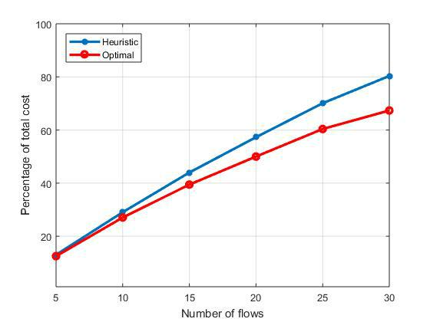

which we proved to be NP-hard. We proposed a heuristic algorithm for vertical and horizontal communication between DCs with VNF placement and service chaining in different network types. The heuristic results show that both vertical and horizontal connectivity is required to reduce costs. Verti-cal connectivity helps reduce the computing cost significantly compared to horizontal connectivity. However, horizontal connectivity with vertical connection plays a significant role in reducing communication costs.

In particular, FTwM and TwM have 5-15% less commu-nication cost than FT and T, respectively. FTwM reduces communication cost by 40-45%, 30-35%, 20-25%, and 5-10% compared to M, T, TwM, and FT, respectively, as a result of its multi-tier, multiple parents’ horizontal and vertical connectivity, which helps increase communication with fewer hop counts. However, the tree topology reduces computing cost by 25-30%, 15-20%, 10-15%, and 5-10% compared to M, FTwM, FT, and TwM, respectively, as a re-sult of its multi-tier, single parent vertical connectivity which maximizes the utilization of the VMs of the DCs. Although the communication cost in tier-1 is reduced, a partial mesh network still has a higher communication because of the high hop count from the ingress to the egress node, and it also has a higher computing cost because of poor utilization of VMs. In terms of total cost, which includes both communication cost and computing cost, FTwM saves more compared to all topologies.

In summary, the results demonstrate that although vertical connectivity helps to reduce cost compared to horizontal connectivity, it is better to consider horizontal connectivity between siblings in multi-tier architecture to reduce cost even further.

**REFERENCES**

1. Rashid Mijumbi, Joan Serrat, Juan-Luis Gorricho, Niels Bouten, Filip De Turck, and Raouf Boutaba, "Network function virtualization: State-of-the-

14

art and research challenges," IEEE Communications Surveys & Tutorials, vol. 18, no. 1, pp. 236-262, 2015.

1. Sevil Mehraghdam, Matthias Keller, and Holger Karl, "Specifying and placing chains of virtual network functions," IEEE 3rd International Conference on Cloud Networking (CloudNet), pp. 7-13, October, 2014.
2. Vincenzo Eramo, Emanuele Miucci, Mostafa Ammar, and Francesco Giac-into Lavacca, "An approach for service function chain routing and virtual function network instance migration in network function virtualization architectures," IEEE/ACM Transactions on Networking, vol. 25, no. 4, pp. 2008-2025, 2017.
3. A. U. Rehman, Rui L. Aguiar, and João Paulo Barraca, "Network functions virtualization: The long road to commercial deployments," IEEE Access, vol. 7, pp. 60439–60464, 2019.
4. Peterson, Larry, Ali Al-Shabibi, Tom Anshutz, Scott Baker, Andy Bavier, Saurav Das, Jonathan Hart, Guru Palukar, and William Snow, “Central office re-architected as a data center,” IEEE Communications Magazine, vol. 54, no. 10, pp. 96–101, 2016.
5. CORD Design Notes, “Central Office Re-Architected as a Data Center (CORD)", White Paper, Mar. 2015.
6. T. X. Tran, A. Hajisami, P. Pandey, and D. Pompili, “Collaborative mobile edge computing in 5G networks: New paradigms, scenarios, and challenges,” IEEE Communications Magazine, vol. 55, no. 4, pp. 54–61, 2017.
7. White Paper, “NFV Everywhere: A Micro-datacenter in-a-box for the Network Edge.” [Available Online] https://networkbuilders.intel.com/docs/nfv-everywhere-a-micro-datacenter-in-a-box-for-the-network-edge.pdf
8. Ting Ao, Internet-Draft IETF Trust “The use case in Edge Datacenter network,” 2017.
9. Yong Li, and Min Chen, "Software-defined network function virtualiza-tion: A survey," IEEE Access, vol. 3, pp. 2542–2553, 2015.
10. Binayak Kar, Eric Hsiao-Kuang Wu, and Ying-Dar Lin, "Energy cost op-timization in dynamic placement of virtualized network function chains,” IEEE Transactions on Network and Service Management, vol. 15, no. 1, pp. 372–386, Mar. 2018.
11. J. Liu, W. Lu, F. Zhou, P. Lu, and Z. Zhu, “On dynamic service function chain deployment and readjustment,” IEEE Transactions on Network and Service Management, vol. 14, no. 3, pp. 543–553, Sep. 2017.
12. F. Bari, S. R. Chowdhury, R. Ahmed, R. Boutaba, and O. C. M. B. Duarte, “Orchestrating virtualized network functions,” IEEE Transactions on Network and Service Management, vol. 13, no. 4, pp. 725–739, Dec. 2016.
13. Ying-Dar Lin, Chih-Chiang Wang, Chien-Ying Huang, Yuan-Cheng Lai, "Hierarchical NFV datacenters: Resource allocation with cost-latency tradeoff,” IEEE Network, vol. 32, no. 5, pp. 124–130 Apr. 2018.
14. Susant Jain, Alok Kumar, Subhasree Mandal, Joon Ong, Leon Poutievski, Arjun Singh, Subbaiah Venkata et al. “B4: Experience with a globally-deployed software defined WAN,” ACM SIGCOMM Computer Communi-cation Review, vol. 43, no. 4, pp. 3–14, 2013.
15. Chih-Chiang Wang, Ying-Dar Lin, Jang-Jiin Wu, Po-Ching Lin, Ren-Hung Hwang, "Towards optimal resource allocation of virtualized network functions for hierarchical datacenter," IEEE Transactions on Network and Service Management, vol. 15, no. 4, pp. 1532–1544, Dec. 2018.
16. W. Cerroni, L. Foschini, G.Y. Grabarnik, L. Shwartz, and M. Tortonesi, “Estimating delay times between cloud datacenters: A pragmatic modeling approach,” textitIEEE Communications Letters, vol. 22 no. 3, pp.526–529, 2017.
17. Trai Telecom Subscription Data as on 30th. New Delhi, India: Press

Release No.97/2017, Sep. 2017. [Online]. Available: www.trai.gov.in

1. L. Gu, Deze Zeng, Song Guo, Yong Xiang, and Jiankun Hu, “A general communication cost optimization framework for big data stream process-ing in geo-distributed datacenters,” IEEE Transactions on Computers, vol. 65, no. 1, pp. 19–29, 2016.
2. I. Karimov, Miradham Kamilov, Eunyong Park, Jungwook Song, Heemin Kim, and Sunyoung Han, "Managing alternative parent peers for providing fast reconnection between peers," 2009 11th IEEE International Confer-ence on Advanced Communication Technology, vol. 3, 2009.
3. Wenfeng Xia, Peng Zhao, Yonggang Wen, and Haiyong Xie, “A survey on datacenter networking (DCN): infrastructure and operations,” IEEE Communications Surveys & Tutorials, vol. 19, no. 1, pp. 640–656, Mar. 2016.
4. M. Al-Fares, A. Loukissas, and A. Vahdat, “A scalable, commodity data-center network architecture,” ACM SIGCOMM Computer Communication Review, vol. 38, no. 4, 2008.

VOLUME 8, 2020

This work is licensed under a Creative Commons Attribution 4.0 License. For more information, see https://creativecommons.org/licenses/by/4.0/.

This article has been accepted for publication in a future issue of this journal, but has not been fully edited. Content may change prior to final publication. Citation information: DOI

10.1109/ACCESS.2020.2995384, IEEE Access

1. S. D’Oro, L. Galluccio, and S. P. G. Schembra, "Exploiting congestion games to achieve distributed service chaining in NFV networks," IEEE Journal on Selected Areas in Communications, vol. 35, no. 2, pp. 407–420, Feb. 2017.
2. S. D’Oro, L. Galluccio, S. Palazzo, and G. Schembra, “A game theoretic approach for distributed resource allocation and orchestration of soft-warized networks,” IEEE Journal on Selected Areas in Communications, vol. 35, no. 3, pp. 721–735, Mar. 2017.
3. M. Mechtri, C. Ghribi, and D. Zeghlache, “A scalable algorithm for the placement of service function chains,” IEEE Transactions on Network and Service Management, vol. 13, no. 3, pp. 533–546, Sep. 2016.
4. Jian Sun, Guangyang Zhu, Gang Sun, Dan Liao, Yao Li, Arun Kumar Sangaiah, Muthu Ramachandran, and Victor Chang, "A reliability-aware approach for resource efficient virtual network function deployment," IEEE Access, vol. 6, pp. 18238–18250, 2018.
5. D. Krishnaswamy, R. Kothari, and V. Gabale, "Latency and policy aware hierarchical partitioning for NFV systems," 2015 IEEE Conference on Net-work Function Virtualization and Software Defined Network, pp. 205–211, 2015.
6. Xiaodong Wang, Xiaorui Wang, Kuangyu Zheng, Yanjun Yao, and Qing Cao, “Correlation-aware traffic consolidation for power optimization of datacenter networks,” IEEE Transactions on Parallel and Distributed Systems, vol. 27, no. 4, pp. 992–1006, 2016.
7. Cristina K. Dominicini, Gilmar L. Vassoler, Leonardo F. Meneses, Rodolfo
   1. Villaca, Moises RN Ribeiro, and Magnos Martinello, “VirtPhy: Fully programmable NFV orchestration architecture for edge data centers,” IEEE Transactions on Network and Service Management, vol. 14, no. 4, pp. 817–830, Dec. 2017.
8. Yingying Chen, Sourabh Jain, Vijay Kumar Adhikari, Zhi-Li Zhang, and Kuai Xu, “A first look at inter-data center traffic characteristics via yahoo! Datasets,” 2011 Proceedings IEEE INFOCOM, pp. 1620–1628, 2011.
9. B. Yang, Z. X. W. K. Chai, K. V. Katsaros, and G. Pavlou, “Cost-efficient NFV-enabled mobile edge-cloud for low latency mobile applications,” IEEE Transactions on Network and Service Management, vol. 15, no. 1, pp. 475–488, Mar. 2018.
10. B. Kantarci, L. Foschini, A. Corradi, and H. T. Mouftah, "Inter-and-intra data center VM-placement for energy-efficient large-scale cloud systems," 2012.
11. M. Bouet and V. Conan, “Mobile edge computing resources optimization: a geo-clustering approach,” IEEE Transactions on Network and Service Management, vol. 15, no. 2, pp. 787–796, 2018.
12. M. Obadia, M. Bouet, V. Conan, L. Iannone, and J.-L. Rougier, “Elastic network service provisioning with VNF auctioning,” 2016 28th IEEE International Teletraffic Congress, vol. 1, pp. 340–348, 2016.
13. M. Gharbaoui, C. Contoli, G. Davoli, G. Cuffaro, B. Martini, F. Paganelli,
    1. Cerroni, P. Cappanera, and P. Castoldi. "Experimenting latency-aware and reliable service chaining in Next Generation Internet testbed facility." IEEE Conference on Network Function Virtualization and Software De-fined Networks (NFV-SDN), IEEE, 2018, pp. 1-4.
14. M. Zeng, W. Fang, and Z. Zhu, “Orchestrating tree-type VNF forwarding graphs in inter-DC elastic optical networks,” Journal of Lightwave Tech-nology, vol. 34, no. 14 pp. 3330–3341, 2016.
15. R. Ricci, C. Alfeld, and J. Lepreau, “A solver for the network testbed mapping problem,” ACM SIGCOMM Computer Communication Review, vol. 33, no. 2, pp. 65–81, 2003.
16. R. McGeer, D. G. Andersen, and S. Schwab, "The network testbed mapping problem," International Conference on Testbeds and Research Infrastructures, pp. 383–398. Springer, Berlin, Heidelberg, 2010.
17. J. R. Current and J. E. Storbeck, "Capacitated covering models," Environ-ment and planning B: Planning and Design, vol. 15, no. 2, pp. 153–163, 1988.
18. E. Hernandez-Valencia, S. Izzo, and B. Polonsky, “How will NFV/SDN transform service provider opex,” IEEE Network, vol. 29, no. 3, pp. 60–67, Jun. 2015.
19. R. Fourer, D. M. Gay, and B. W. Kernighan, AMPL: A Modeling Language for Mathematical Programming. Belmont, CA, Duxbury Press, Second Edition 2003.
20. Michael Sipser, "Introduction to the Theory of Computation," Cengage learning, 2012.
21. C. Rose and M. Hluchyj, “The performance of random and optimal scheduling in a time-multiplex switch,” IEEE Trans. Commun., vol. 35, no. 8, pp. 813–817, Aug. 1987.

VOLUME 8, 2020

1. X. Tang, Y. Li, R. Ren, and W. Cai, “On first fit bin packing for online cloud server allocation,” Proc. IEEE Int. Parallel Distrib. Process. Symp., Chicago, IL, USA, 2016, pp. 323–332.

BINAYAK KAR is an Assistant Professor of com-puter science and information engineering at Na-tional Taiwan University of Science and Tech-nology (NTUST), Taiwan. He received his Ph.D. degree in computer science and information en-gineering from the National Central University (NCU), Taiwan in 2018. He was a post-doctoral research fellow in computer science with Na-tional Chiao Tung University (NCTU), Taiwan from 2018 to 2019. His research interests include



network softwarization, cloud/edge/fog computing, optimaization, queueing theory and network security.

ERIC HSIAO-KUNAG WU received the B.S. degree in computer science and information engi-neering from National Taiwan University, Taipei, Taiwan, in 1989 and the M.S. and Ph.D. degrees in computer science from the University of Califor-nia, Los Angeles, in 1993 and 1997, respectively. He is currently a Professor of computer science and information engineering with the Department of Computer Science and Information Engineer-ing, National Central University, Chung-Li, Tai-



wan. His research interests include wireless networks, mobile computing, and broadband networks.

YING-DAR LIN is a Chair Professor of com-puter science at National Chiao Tung University (NCTU), Taiwan. He received his Ph.D. in com-puter science from the University of California at Los Angeles (UCLA) in 1993. He was a visit-ing scholar at Cisco Systems in San Jose during 2007–2008, CEO at Telecom Technology Center, Taiwan, during 2010-2011, and Vice President of National Applied Research Labs (NARLabs), Taiwan, during 2017-2018. He cofounded L7 Net-



works Inc. in 2002, later acquired by D-Link Corp. He also founded and directed Network Benchmarking Lab (NBL) from 2002, which reviewed network products with real traffic and automated tools, also an approved test lab of the Open Networking Foundation (ONF), and spun off O’Prueba Inc. in 2018. His research interests include network security, wireless communications, and network softwarization. His work on multi-hop cel-lular was the first along this line, and has been cited over 900 times and standardized into IEEE 802.11s, IEEE 802.15.5, IEEE 802.16j, and 3GPP LTE-Advanced. He is an IEEE Fellow (class of 2013), IEEE Distinguished Lecturer (2014–2017), ONF Research Associate (2014-2017), and received K. T. Li Breakthrough Award in 2017 and Research Excellence Award in 2017 and 2020. He has served or is serving on the editorial boards of several IEEE journals and magazines, and is the Editor-in-Chief of IEEE Communications Surveys and Tutorials (COMST). He published a textbook, Computer Networks: An Open Source Approach (www.mhhe.com/lin), with Ren-Hung Hwang and Fred Baker (McGraw-Hill, 2011).



15

This work is licensed under a Creative Commons Attribution 4.0 License. For more information, see https://creativecommons.org/licenses/by/4.0/.