

**Theme Article: Agile and Open-Source Hardware**

OpenFPGA: An Open-Source Framework for Agile Prototyping Customizable FPGAs

Xifan Tang, Edouard Giacomin,

Baudouin Chauviere, Aurelien Alacchi, and

Pierre-Emmanuel Gaillardon

University of Utah

Abstract—Demanded by ever-evolving data processing algorithms, field-programmable gate arrays (FPGAs) have become essential components of modern computing systems, thanks to their reconfigurable and distributed computing capabilities. However, FPGAs are among the very few integrated chips that still require long development cycles and high human efforts, even for industrial vendors. In this article, we introduce OpenFPGA, an open-source framework that can automate and significantly accelerate the development cycle of customizable FPGA architectures. OpenFPGA allows users to customize their FPGA architectures down to circuit-level details using a high-level architecture description language and autogenerate associated Verilog netlists which can be used in a backend flow to generate production-ready layouts. A generic Verilog-to-Bitstream generator is also provided, allowing end-users to implement practical applications on any FPGAs that OpenFPGA can support. Using OpenFPGA, we demonstrate less than 24-h layout generation of two FPGA fabrics, which are based on a Stratix-like architecture built with a commercial 12-nm standard cell library and 40-nm custom cells, respectively.

* HETEROGENEOUS COMPUTING HAS become

the mainstream solution to executing high-performance data processing applications. Field-

Digital Object Identifier 10.1109/MM.2020.2995854

Date of publication 21 May 2020; date of current version

30 June 2020.

programmable gate arrays (FPGAs) are ubiq-uitous components in modern heterogeneous computing systems, playing an enabling role for programmable accelerators.1 To maximize their execution efficiency, FPGA fabrics have to be tailored for domain-specific applications so that they can cooperate seamlessly with other



|  |  |  |  |  |
| --- | --- | --- | --- | --- |
| July/August 2020 | Published by the IEEE Computer Society | This work is licensed under a Creative Commons | 41 |  |
|  |  | Attribution 4.0 License. For more information, see |  |

https://creativecommons.org/licenses/by/4.0/

Agile and Open-Source Hardware

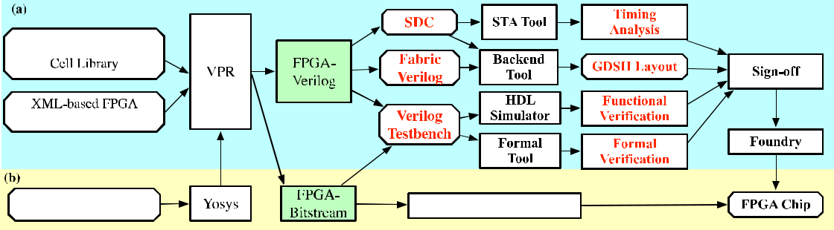

Figure 1. OpenFPGA design flow. (a) Production flow. (b) End-user flow.

computing resources.2 For example, existing FPGA products cannot all offer the large number of mem-ory blocks and multipliers required by AI accelera-tors. However, FPGAs are among the last few digital integrated circuits that require significant full-custom optimizations and long development cycles, even for industrial leaders. The major bar-rier for chip designers is the strong expertise required on both the hardware and software com-ponents, which may take years to acquire. From a hardware perspective, manual layouts are still widely used in FPGA fabrics, imposing significant manual efforts when porting to a new technology node. From a software perspective, associated electronic design automation (EDA) tools, e.g., bit-stream generation, have to be tuned for each FPGA architecture. Due to such high development costs, commercial products widely adopt general-purpose but not domain-specific FPGA architec-tures, which may miss the peak efficiency required by modern data science applications. Driven by these applications, embedded FPGA (eFPGA) industrial players and academic researchers have developed automated methodologies,3–8 where FPGA fabrics are described with Verilog netlists and implemented using a semicustom design tool suite. However, these pioneering works are still in their infancy, and their tools are closed-source as they often contain proprietary information.

In this article, we introduce OpenFPGA, an open-source framework that enables agile proto-typing for modern and customizable FPGA archi-tectures. As illustrated in Figure 1, OpenFPGA framework consists of two design flows. (a) The production flow, which can translate an XML-based FPGA architecture description to gate-level Verilog netlists of the whole FPGA fabric that can be fed into a physical design backend



flow to obtain a complete GDSII layout. Besides, the production flow can autogenerate test-benches to perform pre- and post-layout verifica-tion. Synopsys design constraint (SDC) files are also autogenerated to enable timing-driven back-end flows and to conduct post-layout timing anal-ysis. Once the signoff is completed, the GDSII layout is ready for tapeout. (b) The end-user flow, that allows FPGA developers to transcript appli-cations written in Verilog to configuration bit-stream and implement them on the FPGA fabric. This is similar to standard vendor tools, e.g., Xilinx Vivado. We demonstrate the capability of OpenFPGA by prototyping a medium-size het-erogeneous FPGA fabric whose architecture is similar to Stratix IV. Both layout generations are completed within 24 h. Using OpenFPGA, stan-dard cell FPGAs can be ported to advanced tech-nology nodes with few manual efforts and benefit significant performance improvement. As for custom FPGAs, OpenFPGA can produce an initial layout with a 60%/20% area/performance gap when compared to a commercial state-of-the-art.

RELATED WORKS

Previous works have proven the feasibility of agile production for customized FPGA fabrics by exploiting semicustom design flows.3–8 These works share the same principle with the produc-tion flow of the OpenFPGA framework, as depicted in Figure 1(a), where complete layout generation is achieved in two steps: 1) describe an FPGA archi-tecture as Verilog netlists and 2) use commercial ASIC design tools to synthesize RTL designs into standard cell libraries. Early attempts rely on man-ually crafted RTL netlists for FPGA architectures

|  |  |  |
| --- | --- | --- |
| 42 | IEEE Micro |  |
|  |  |

We propose a novel OpenFPGA framework, providing a complete toolchain to prototype customizable FPGA fabrics and implement applications on the FPGAs.

as well as transistor-level circuit designs.3,4 How-ever, such methodology is inefficient to support a wide range of FPGA architectures necessary to enable domain-specific applications. Early works focus only on developing fabric generators while neglecting associated bitstream generators.3,4 Recent works typically build Verilog and bitstream generation backends on the popular VTR frame-work,9 so that customizable FPGAs and overlays

can be easily supported by leveraging the rich VTR’s XML-based architecture description language.5–8,10 Note that previ-ous works all show that semicus-tom designed FPGAs have a considerable performance gap when compared to commercial products. This is mainly due to missing many pragmatic features of modern FPGAs.

1. Multimode logic blocks, which can effectively

improve resource utilization rate, are only supported in recent works.5,6

1. Heterogeneous blocks, which are ubiquitous

in commercial FPGAs. However, only Grady et al.6 has investigated this.

1. Tile-based architecture, an essential feature

to develop million-of-LUT FPGAs, while only an early work covered this.3

1. Bitstream generation, a fundamental EDA

support for FPGAs, which is missing in a few works.3,4,7

1. Custom cell support, a key to high-performance FPGAs. For instance, commercial FPGAs use transmission gates to build routing multi-plexers rather than standard cells. This has not been supported in any previous works.

Besides, lack of verification techniques and backend codesign techniques are common prob-lems, which may limit the usability of these tools. OpenFPGA is so far the only tool that supports all of these features.

OpenFPGA FRAMEWORK

We propose a novel OpenFPGA framework, providing a complete toolchain to prototype customizable FPGA fabrics and implement appli-cations on the FPGAs. To achieve these

purposes, we developed two backends, FPGA-Verilog and FPGA-bitstream generators, on top of the VPR tool suite, as highlighted in green in Figure 1. We also extend the XML-based FPGA architecture language to support detailed cir-cuit-level description and binding to standard/ customized cell libraries. As a result, OpenFPGA can support any FPGA architecture that VPR can model as well as a versatile circuit implementa-

tion of primitive blocks, such as rout-ing multiplexers and lookup tables (LUTs). Note that FPGA-Verilog and FPGA-bitstream generators are the core engines of the OpenFPGA frame-work, driving two types of design flows: (a) the production flow, which aims at achieving production-ready GDSII from an XML-based FPGA archi-tecture description file; (b) the end-

user flow, which provides Verilog-to-Bitstream compilation for user applications.

FPGA-Verilog Generator: FPGA-Verilog converts an XML-based FPGA architecture description to technology-mapped full-fabric Verilog netlists. The autogenerated fabric netlists include both a programmable fabric with configuration-chain cir-cuits embedded. As shown in Figure 2(a), the pro-grammable fabric consists of an array of tiles where a few columns may be replaced by hetero-geneous blocks. Note that FPGA-Verilog generates highly hierarchical fabrics, where large FPGAs can be built with a small number of repeatable tiles. This can significantly simplify the backend pro-cess, where only a few unique tiles are P&Red and then are assembled in a final layout. FPGA-Verilog can support flexible routing architectures even inside each tile, which can be customized by the VPR architecture description language. The con-figuration-chain circuits consist of configurable memory elements, i.e., configuration-chain flip-flops (CCFFs), connected to a configuration chain, where configuration bitstreams are loaded seri-ally. Currently, OpenFPGA adopts a configuration chain because it is straightforward to implement and easy to debug. In the future, OpenFPGA will support more versatile configuration circuitry, e.g., frame-based, which can efficiently enable par-tial reconfiguration during FPGA runtime. More-over, FPGA-Verilog can autogenerate netlists that are mapped to a standard cell library and even



July/August 2020 43

Agile and Open-Source Hardware

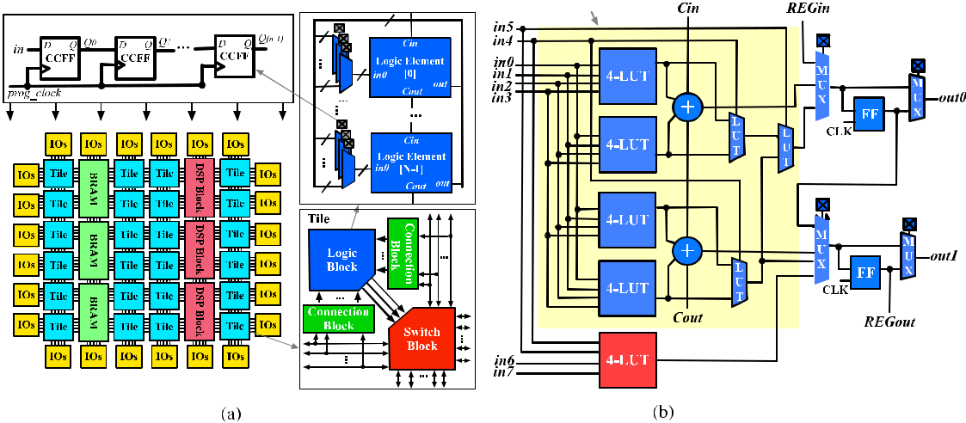

Figure 2. Tile-based heterogeneous FPGA architecture. (a) Tile organization and configuration circuits.

(b) LE architecture considered in the showcased fabrics in Figure 4.

customized logic cells, approaching current state-of-the-art FPGA technologies. For instance, one-level and multilevel routing multiplexers, as well as fracturable LUTs, are commonly used in com-mercial FPGAs while being unavailable in standard cell libraries. We refer interested readers to11,12 for more details.

Verilog Testbench Generator: FPGA-Verilog can autogenerate two types of Verilog testbenches to validate the correctness of the fabric before tapeout: full and formal-oriented. Both test-benches share the same organization, as depicted in Figure 3(a). To enable self-testing, the FPGA and user’s RTL design (simulated using an HDL simula-tor) are driven by the same input stimuli, and any

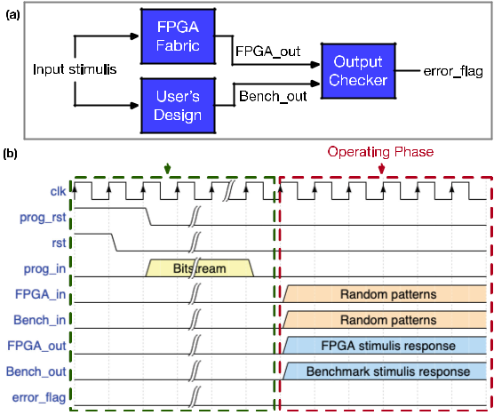

Figure 3. Principles of testbenches organization.

(a) Block diagram. (b) Waveforms.



mismatch on their outputs will raise an error flag. Full testbench aims at simulating an entire FPGA operating period, consisting of two phases:

1. the configuration phase, where the synthesized design bitstream is loaded to the programmable fabric, as highlighted by the green rectangle of Figure 3(b); 2) the operating phase, where random input vectors are autogenerated to drive both devices under test (DUTs), as highlighted by the red rectangle of Figure 3(b). Using the full test-bench, users can validate both the configuration circuits and programming fabric of an FPGA. How-ever, the testing vectors used in the full testbench may lead to only a small set of functional coverage. To guarantee a higher coverage, we developed the formal-oriented testbench, where a programmed FPGA is instantiated with the user’s bitstream. The module of the programmed FPGA is encapsu-lated with the same port mapping as the user’s RTL design and thus can be fed to a formal tool for a 100% coverage formal verification. Compared to the full testbench, this skips the time-consuming configuration phase, reducing the simulation time, potentially also significantly accelerating the functional verification, especially for large FPGAs. As the size of the bitstream increases quadrati-cally with the FPGA size, the number of clock cycles required to load the bitstream becomes a dominating factor in the verification runtime. In summary, OpenFPGA allows designers and test engineers to customize the testbenches by apply-ing a different combination of benchmarks and

|  |  |  |
| --- | --- | --- |
| 44 | IEEE Micro |  |
|  |  |

testing vectors. We believe that with proper use of the self-testing testbenches, the verification pro-cess for FPGAs can be significantly simplified or even automated.

SDC Generator: FPGA-Verilog can also gener-ate two sets of SDC files. The first set of SDCs is intended for backend tools, which constrains pin-to-pin timing for all the resources in the FPGA to obtain homogeneous delays across the fabric. Each pin-to-pin timing can be specified by users in the XML-based architecture language. The SDCs also break all the combinational loops, which do legally exist across an FPGA fabric. Note that this is an exclusive challenge in the backend strategy for FPGAs, as combinational loops are considered illegal in the ASIC backend flow. The second set of SDCs is designed for STA tools, which disable unused resources in the mapped FPGA fabric, to perform timing analysis of a specific benchmark at the post layout stage. More details are available in the OpenFPGA online documentation.11

Bitstream Generator: FPGA-Bitstream generates a configuration bitstream, which can be directly loaded into the configuration circuit of the FPGA fabric [see Figure 2(a)]. FPGA-Bitstream is a generic bitstream generator, natively supporting any FPGA architecture that can be modeled by VPR as well as various circuit designs, such as fracturable LUTs, one/multilevel multiplexers, etc. This indicates that instant EDA support for the FPGA fabric is ready for users once the XML-based architecture description is finalized. More details are available in the work by Tang et al.11

EXPERIMENTAL RESULTS

We demonstrate OpenFPGA’s capabilities by implementing two FPGA fabrics: 1) a 20 20 homogeneous FPGA using a commercial 40-nm technology; 2) a 32 32 heterogeneous FPGA using a commercial 12-nm technology. In both FPGAs, each tile includes ten logic elements (LEs) and a local routing architecture with 50% connectivity. To showcase the customization level that OpenFPGA can offer, we consider a mul-timode LE architecture for the homogeneous FPGA, as shown in Figure 2(b), with a similar logic capacity as the Stratix-IV. The LE consists of a 6-input fracturable LUT, a 4-input LUT, two 1-bit

Table 1. Comparison on the FPGAs in Figure 4.

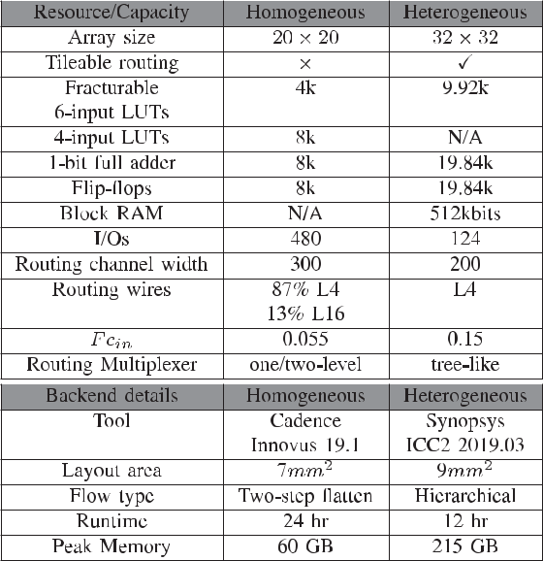

adders, and two flip-flops, which can operate in six different modes. The heterogeneous FPGA employs a similar LE without the 4-input LUT, as highlighted red in Figure 2(b). A column of 512-kb block RAMs (BRAMs), generated by a foundry memory compiler, is located in the center of the heterogeneous fabric. Note that even though our FPGA fabric is smaller than the Stratix IV, it has a similar LUT/RAM density, guaranteeing a high uti-lization of both resources. Full details about the showcased FPGA fabrics are listed in Table 1.

Fabric Implementation: To showcase the agility of OpenFPGA, the two FPGA architectures are implemented using two different PnR strategies. The homogeneous FPGA was implemented using a two-step backend flow where configurable logic blocks (CLBs) are P&Red first and then instanti-ated at the top-level as hard macros. To leverage the symmetry of an FPGA fabric, the heteroge-neous FPGA adopted a more hierarchical backend flow, where a first library of hard macros for CLBs, connection blocks, and switch blocks is built and then assembled in the final layout. The hierarchi-cal backend flow allows us to optimize each hard macro with respect to the timing constraints gen-erated by our tool with few combinational loops to be broken. Therefore, the heterogeneous FPGA is larger in array size, while its backend is 2 faster than the homogeneous. The runtime and memory usage are well within our server’s capability,



July/August 2020 45

Agile and Open-Source Hardware

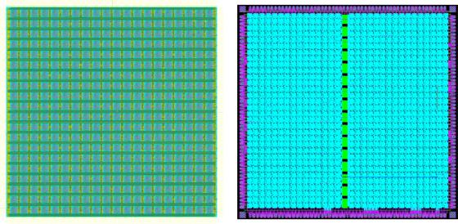

Table 2. Area and delay comparison between previous works,6 OpenFPGA, and Stratix IV.

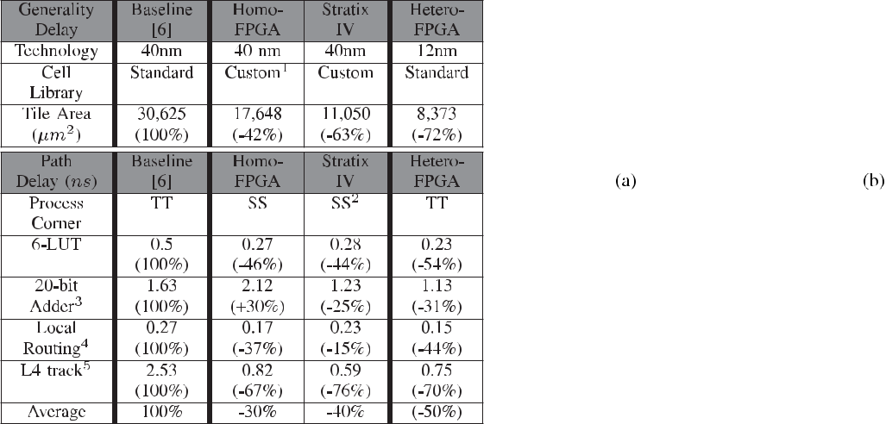

which operates a 64-bit RedHat Linux on 64 Intel Xeon Processors clocked at 2.6 GHz and 512-GB memory. Note that the statistics are shown to demonstrate the capability of OpenFPGA to accommodate different backend strategies, rather than discussing the differences between both backend tools. Commercial signoff tools are then used to ensure that both fabrics are DRC-clean.



Custom FPGA Evaluation: For a comprehen-sive analysis, we consider the area, pin-to-pin delays as well as the delays of the implemented benchmarks when evaluating the FPGA fabrics. In Table 2, the homogeneous FPGA is compared to two baselines, a commercial Stratix-IV FPGA and a resembled academic counterpart.6 We believe it is a fair comparison since these FPGAs are similar in architecture and also implemented using 40-nm technologies. Our results prove the high value of using one-level and two-level multi-plexing structures as well as an optimized cell library, which can improve the area by 42% and path delay by 30% when compared to a standard cell FPGA. Indeed, our fabric is 60% larger in area and 20% slower in path delays than the well-optimized commercial FPGA. We believe that the performance gap can be reduced through a careful codesign between backend strategies and custom cell implementations.



Figure 4. Complete layout of FPGA fabrics.

(a) Homogeneous (40 nm). (b) Heterogeneous (12 nm).

For performance benchmarking, we selected eight MCNC circuits that fit all the 40-nm FPGAs. Each benchmark is verified through the self-test-ing Verilog testbenches in Figure 3, using Mentor ModelSim and Synopsys Formality. Quartus 18.1.0 is used to implement the same benchmark set as the industry baseline, and the device model is set to the Stratix IV EP4S40G2F40C2. Figure 5(a) shows that our custom cell FPGA is 2 slower on average than the Stratix IV. The gap comes from the hardware lags in perfor-mance, with an average of 20%. When critical paths consist of multiple routing paths listed in Table 2, the delay difference will aggregate.

Standard Cell FPGA Evaluation: We compare the heterogeneous FPGA in Figure 4(b) to a

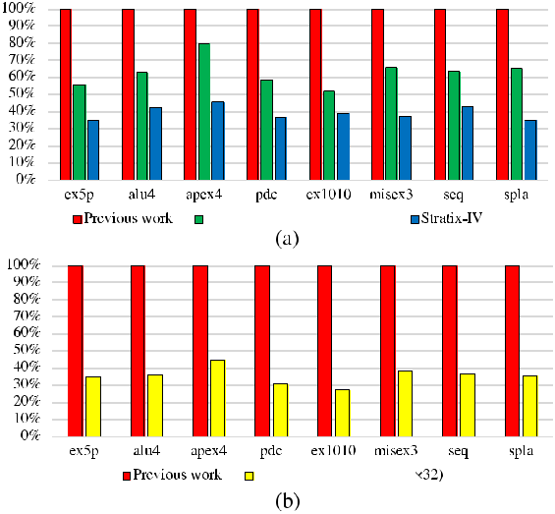

Figure 5. Delay comparison between OpenFPGA and previous works6 using selected MCNC benchmarks. (a) Impact of custom cells and multiplexers on FPGAs at 40 nm. (b) Standard cell FPGAs scaling from 40 to 12 nm.

|  |  |  |
| --- | --- | --- |
| 46 | IEEE Micro |  |
|  |  |

previous work,6 using the same methodology as for the 40-nm FPGAs. Note that both FPGAs are implemented by standard cells and also similar in architecture while using different tech-nologies. Our results show that using OpenFPGA, FPGA architectures can be portable between different technology nodes and benefit signifi-cant performance improvements. In Table 2, the 12-nm FPGA is 72% smaller in area and 50% faster in path than the 40-nm baseline. In Figure 5 (b), the heterogeneous FPGA is 3 faster on average in benchmark delays than the 40-nm baseline.

ACKNOWLEDGMENTS

This material is based on research sponsored by the Air Force Research Laboratory (AFRL) and the Defense Advanced Research Projects Agency (DARPA) under agreement number FA8650-18-2-7855. The U.S. Government is authorized to repro-duce and distribute reprints for governmental purposes notwithstanding any copyright nota-tion thereon. The views and conclusions con-tained herein are those of the authors and should not be interpreted as necessarily representing the official policies or endorsements, either expressed or implied, of AFRL and DARPA or the U.S. Government.

CONCLUSION

In this article, we introduced OpenFPGA, an open-source framework that enables rapid prototyping of customizable FPGA architectures through a semicustom design approach. We pro-posed an XML-to-Prototype design flow, where

|  |  |
| --- | --- |
| & REFERENCES | |
| 1. | C. Zhang et al., “Optimizing FPGA-based accelerator |
|  | design for deep convolutional neural networks,” in Proc. |
|  | ACM/SIGDA Int. Symp. FPGA, 2015, pp. 161–170. |
| 2. | J. Cong, Z. Fang, M. Huang, L. Wang, and D. Wu, |

the Verilog netlists of a full FPGA fabric can be autogener-ated and then fed into a backend flow. We also devel-oped a Verilog-to-Bitstream design flow for the associ-ated CAD tools, especially

In this article, we introduced OpenFPGA, an open-source framework that enables rapid prototyping of customizable FPGA architectures through

1. semicustom design approach.

|  |  |
| --- | --- |
|  | “CPU-FPGA coscheduling for big data applications,” |
|  | IEEE Design. Test, vol. 35, no. 1, pp. 16–22, Feb. 2018. |
| 3. | I. Kuon et al., “Design, layout and verification of an |
|  | FPGA using automated tools,” in Proc. ACM/SIGDA |
|  | Int. Symp. FPGA, 2005, pp. 215–226. |
| 4. | V. Aken’Ova and R. Saleh, “A soft++ eFPGA physical |
|  | design approach with case studies in 180 nm and |
|  | 90 nm,” in Proc. IEEE Comput. Soc. Annu. Symp. Emerg. |
|  | VLSI Technol. Archit., 2006, pp. 1–6. |
| 5. | J. Kim et al., “Synthesizable standard cell FPGA |
|  | fabrics targetable by the Verilog-to-Routing (VTR) |

a generic bitstream generator supporting any FPGA architectures that can be described by the XML language. To demonstrate OpenFPGA’s capabilities, we implemented a 20 20 homoge-neous and a 32 32 heterogeneous FPGA fabric whose architectures are similar to the Stratix IV, using commercial 40-nm and 12-nm technolo-gies, respectively. Both layout generations are completed within 24 h. Using OpenFPGA, stan-dard cell FPGAs can be ported to advanced tech-nology nodes with few manual efforts and benefit significant performance improvements. As for custom FPGAs, OpenFPGA can produce an initial layout with a 60%/20% area/performance gap when compared to a commercial state-of-the-art FPGA. OpenFPGA, including source codes, documentation, and architectures shown in this article, is publicly available.11

|  |  |
| --- | --- |
|  | CAD flow,” ACM Trans. Reconfigurable Technol. Syst., |
|  | vol. 10, no. 2, Apr. 2017, Art. no. 11. |
| 6. | B. Grady and J. H. Anderson, “Synthesizable |
|  | heterogeneous FPGA fabrics,” in Proc. IEEE Int. Conf. |
|  | FPT, 2018, pp. 1–8. |
| 7. | H. Liu, “Archipelago—An open source FPGA with |
|  | Toolflow support,” Master Thesis, Univ. California, |
|  | Berkeley, 2014. |
| 8. | A. Li et al., “PRGA: An open-source framework for |
|  | building and using custom FPGAs,” in Proc. Workshop |
|  | Open Source Des. Autom., 2019. |
| 9. | J. Luu et al., “VTR 7.0: Next generation architecture and |
|  | CAD system for FPGAs,” ACM Trans. Reconfigurable |
|  | Technol. Syst., vol. 7, no. 2, Jul. 2014, Art. no. 6. |
| 10. | A. Brant and G. G. F. Lemieux, “ZUMA: An open FPGA |
|  | overlay architecture,” in Proc. IEEE 20th Int. Symp. |
|  | Field-Programmable Custom Comput. Mach., 2012, |
|  | pp. 93–96. |



July/August 2020 47

Agile and Open-Source Hardware

1. X. Tang et al., “OpenFPGA: An opensource framework enabling rapid prototyping of customizable FPGAs,” in Proc. Int. Conf. FPL, 2019, pp. 367–374.
2. X. Tang, E. Giacomin, A. Alacchi, and P. Gaillardon, “A study on switch block patterns for tileable FPGA routing architectures,” in Proc. IEEE Int. Conf. FPT, 2019, pp. 247–250.

Xifan Tang is currently a Research Assistant Professor with the University of Utah. His current research interests include computer-aided design for programmable architecture and emerging technologies. Tang received the B.Sc. degree in microelectronics from Fudan University, in 2011, and the M.Sc. degree in electrical engineering and the

Ph.D. degree in computer science from the Ecole

Polytechnique Federale de Lausanne, in 2013 and 2017, respectively. He is a recipient of the 2015 Chinese Government Award for Outstanding Self-Financed Students Abroad. He is a member of IEEE. Contact him at [xifan.tang@utah.edu.](mailto:xifan.tang@utah.edu)

Edouard Giacomin is currently working toward the Ph.D. degree in computer engineering with the University of Utah. He was a Research Intern with IMEC, Belgium, and Advanced Micro Devices (AMD), TX, USA. His research is focused on develop-ing digital systems using emerging technologies and paradigms such as resistive RAM, 3-D logic integra-tion, etc. Giacomin received the M.Sc. degree in electrical and computer engineering from CPE Lyon, in 2016. He is a student member of IEEE. Contact him at [edouard.giacomin@utah.edu.](mailto:edouard.giacomin@utah.edu)



48

Baudouin Chauviere is currently working toward the Ph.D. degree with the University of Utah, working on an open-source tool allowing the prototyping of FPGAs. His other area of focus is resistive memory in the aim of building ReRAM-based FPGA designs. Chauviere received the master’s degree in electrical engineering from CPE Lyon, in 2018. Contact him at [baudouin.chauviere@utah.edu.](mailto:baudouin.chauviere@utah.edu)

Aurelien Alacchi is currently working toward the Ph.D. degree in computer engineering. His research interests are linked to FPGA design, architecture, and reliability. Alacchi received the M.Sc. degree in microelectronics and telecommu-nications from Polytech Marseille, in 2018. Contact him at [aurelien.alacchi@utah.edu.](mailto:aurelien.alacchi@utah.edu)

Pierre-Emmanuel Gaillardon is currently an Associate Professor and the Associate Chair for aca-demics and strategic initiatives with the Electrical and Computer Engineering Department, University of Utah. He was a Research Associate with the Swiss Federal Institute of Technology (EPFL). His research interests include the development of novel comput-ing systems exploiting emerging device technolo-gies and novel EDA techniques. Gaillardon received the Electrical Engineer degree from CPE-Lyon, the M.Sc. degree in electrical engineering from INSA Lyon, and the Ph.D. degree in electrical engineering from CEA-LETI, Grenoble, and the University of Lyon. He is the recipient of the 2017 NSF CAREER award, the 2018 IEEE CEDA Pederson Award, the 2019 DARPA Young Faculty Award, and the 2019 IEEE CEDA Ernest S. Kuh Early Career Award. He is a senior member of IEEE. Contact him at [pierre-emmanuel.gaillardon@utah.edu.](mailto:pierre-emmanuel.gaillardon@utah.edu)

IEEE Micro