This article has been accepted for publication in a future issue of this journal, but has not been fully edited. Content may change prior to final publication. Citation information: DOI 10.1109/ACCESS.2020.3008820, IEEE Access



Date of publication xxxx 00, 0000, date of current version xxxx 00, 0000.

*Digital Object Identifier 10.1109/ACCESS.2020.Doi Number*

**Autonomous Coordinated Control Strategy for Complex Process of Traffic Information Physical Fusion System Based on Big Data**

**Gongxing Yan1,a, Hongzhi Wang2,b\***

1. College of Civil Engineering, Chongqing Vocational Institute of Engineering, Chongqing 402260, China
2. School of Management, Qingdao Agricultural University, Qingdao266109, Shandong, China
3. yaaangx@163.com

Corresponding author: Hongzhi Wang (email: b 410751138@qq.com)

This work was supported by Shandong Province Social Science Project (No. 18CGLJ35), Project of Teaching Steering Committee of Logistics Management and Engineering Specialty（NO.JZW2019123）, Qingdao Shuangbai Research Project 2019 Project（2019-C-01）, 2019Shandong Humanities and Social Sciences Project（NO. 19-ZZ-GL-09）, 2019 Qingdao Social Science Planning Research Project（QDSKL1901168）.

**Abstract** In the era of big data, the global data is growing explosively. The huge growth rate makes dataprocessing and storage difficult, especially in the field of transportation. Based on the above background, this paper aims to study the autonomous coordinated control strategy for the complex process of traffic information physical fusion system based on big data. In this paper, the information physical fusion system is applied to the modern transportation system, and it is used to realize the high integration of computation, communication and control. Realize the independent and coordinated control of the transportation system. This paper proposes an autonomous traffic management mechanism based on multi-agent CPS system. In view of the instability and untimely of the original control strategy, a new traffic optimization control strategy conflict reduction control strategy is proposed. In order to solve the complexity of traffic system, the generation method of CPS autonomous control strategy based on multi-agent is studied and analyzed. Through the evaluation and verification of the conflict reduction control strategy and the online simulation of the incremental data synchronization strategy, it can be seen that the inconsistency ratio curves of message quantity and byte transmission quantity are always kept at a relatively low level, 1% and 2%, respectively. During the whole experiment, the average number of inconsistent messages and byte transmission of the agent are ideally controlled at 1.2 messages / train and 0.5kb/train.

**Keywords:** Information Physics Fusion Production System, Multi-agent System, Complex Process, ControlStrategy

**I. INTRODUCTION**

CPS perceives the environment through sensors, and then communicates the data and signals collected by sensors with computing devices through the network. Computing devices process the data and make decisions in real time and comprehensively, and then send decisions or instructions to actuators through the network for control. With ubiquitous interconnection, pervasive computing, Internet of things and network Technology. With the development of fields and technologies, frequent interaction and close integration between the physical world and the information space become possible. CPS deeply integrates the information world and the physical world through the above-mentioned real-time feedback loop, which has the properties of real-time, reliability, security, diversity (heterogeneity) and autonomy (autonomy, adaptability). CPS is widely used in many fields, such as highway and rail transit, aerospace, power grid, water resource scheduling, intelligent medical treatment, advanced industrial manufacturing, automation and intelligent

manufacturing, as well as the emerging fields of smart home, smart city and intelligent agriculture in recent years.

In order to solve the problem of multi-source heterogeneous, massive storage and information sharing of traditional railway signal multi information positioning data, Gong P proposed the architecture of information physical fusion system (CPS) based on cloud physics on the basis of analyzing the railway big data environment [1]. Hintz kJ proposed that in the information fusion system, the integration of hard (physical) and soft (metaphysical) environments needs to determine the specific task-oriented goals that it expects to achieve [2]. Fritze a proposed that industrial applications are transitioning to modular and flexible architectures that can be self configured and optimized. Due to the requirement of mass customization and the increasing complexity of industrial systems, various tasks need to be reconsidered, such as information processing, extensive networking or system monitoring using sensors and information fusion systems. He proposed an automatic design and update method of sensor and information fusion system based on self describing intelligent sensor node network,

|  |  |
| --- | --- |
| VOLUME XX, 2020 | 1 |

This work is licensed under a Creative Commons Attribution 4.0 License. For more information, see https://creativecommons.org/licenses/by/4.0/.

This article has been accepted for publication in a future issue of this journal, but has not been fully edited. Content may change prior to final publication. Citation information: DOI 10.1109/ACCESS.2020.3008820, IEEE Access



Author Name: Autonomous Coordinated Control Strategy for Complex Process

of Traffic Information Physical Fusion System Based on Big Data

including the configuration and adaptation of fusion system and communication, and the manual interaction with the flexible system was reduced to the minimum [3].

Aiming at the characteristics of large-scale distribution, strong dynamics and high complexity of traffic complex process control system, this paper studies an open system model with layered structure, including the functions of each layer, the definition and design of relevant protocols or specifications for the realization of CPS autonomous control. This paper introduces the idea of multi-agent into the control of complex traffic process, and studies the implementation of CPS in the control of complex traffic process. Then, on the basis of FCFS intersection control strategy and ksync strategy, a kind of intersection independent management mechanism based on reservation idea is proposed, which enables the intersection management agent to integrate the global factors, make it have a higher forward-looking and global quick and reasonable decision-making, maximize the efficiency of the system, effectively avoid traffic problems, and ultimately greatly improve the service of the whole system Quality. Under the guidance of agent theory, the software and hardware entity of CPS is designed and developed, which verifies the realization of CPS self coordination control strategy in practical application, as well as the efficiency and superiority of CPS in complex traffic process.

**II. PROPOSED METHOD**

***A. ARCHITECTURE OF CPS***

The three-tier architecture of CPS includes physical layer (PL), network layer (NL) and application layer (AL) [4-5]. The physical layer refers to the execution device, sensing device and wireless / wired network unit with specific functions or existing in specific areas which are closely combined with the physical environment in CPS. The network layer refers to the cross regional network, similar to the Internet in the computer network, which realizes the interconnection and interoperability of CPS nodes in the super region. The network of this layer is called the next generation network, which is the development direction of the Internet [6]. In CPS, a LAN with specific functions is similar to a wireless sensor network, which is composed of the interconnection between sensor or executive node devices. The connection mode, communication technology and transmission protocol of this network are very different from the Internet. The goal of CPS is to realize the networking of all physical devices. Due to the limitation of address space and network technology, it is impossible to directly connect all devices to the next generation network, and it is also unscientific in terms of efficiency and necessity [7 -8]. Based on the above considerations, the interconnection of nodes to form a local connection with specific functions is attributed to the physical layer. The network layer realizes the interconnection and interoperability of devices, with the main functions of resource sharing and data transmission. The characteristics of the next generation network is that data can be effectively integrated in the transmission process [9]. The application layer is the interface of CPS for human service. The main function of this layer is to provide various CPS services for users, so that users can interact with the system without needing to know the following two layers in detail [10-11].

***B. CHARACTERISTIC POINTS OF CPS***

The application of embedded computing system makes the equipment more intelligent, the application of network information technology enables the equipment to communicate with each other, the application of sensor network enables the equipment to have the perception ability, and the control system is like the limbs of the equipment, which together make the computer have the ability to embed into the physical equipment and process [12]. The combination of the four forms CPS, and with their continuous development, in addition to the characteristics of the original computer technology, more and more powerful performance characteristics and functional requirements are added[13-14]:

1. Fusion: through a series of processes such as perception, calculation, communication and control, the control link and physical link can be more closely integrated, and the information and physical world can be more integrated.
2. Safety and reliability: the physical world in reality is extremely complex, with changeable and uncertain nature, which makes CPS must be able to resist all kinds of interference brought by the physical world in this environment, and still provide relatively safe and reliable services in this environment.
3. Real time: real time requires that any information in the physical world can be perceived at any time, and can be affected and changed at any time. The delay time must be limited to a very small range to ensure effective control of the physical world.
4. Timeliness: refers to the time limit of each specific task in the CPS, which is meaningless if it is not completed within the specified time limit.
5. Concurrency: concurrency is a major feature of nature and the physical world. CPS must adapt to this feature to work normally. Therefore, CPS needs to be able to support the concurrency model well, instead of using a simple sequential calculation method.
6. Heterogeneous heterogeneity: CPS has heterogeneous physical components, heterogeneous communication networks and heterogeneous computing and control systems. Therefore, only when they are well correlated, can the CPS perform complex tasks without obstacles.
7. Resource limitation: CPS is composed of physical components and software systems, which have the characteristic of "one loop", that is, the resources of calculation, storage and transmission are limited, so CPS resource limitation is also a major feature of CPS, and it is also a major problem in CPS research.
8. Autonomy: autonomy refers to the ability of CPS to generate control methods and strategies based on perceived data, which is also a great embodiment of CPS intelligence.
9. Data cognition: as the name implies, data cognition mainly refers to the feedback of CPS on the accuracy of the perceived physical world, which mainly depends on the correct cognition and interpretation of the collected environmental data, so the detection, cognition, judgment and reasoning process of these data is particularly important.
10. Distribution: CPS is composed of a large number of heterogeneous nodes, so it forms a distributed computing network, in which there must be a large number of network computing processes.

2 VOLUME XX, 2020

This work is licensed under a Creative Commons Attribution 4.0 License. For more information, see https://creativecommons.org/licenses/by/4.0/.

This article has been accepted for publication in a future issue of this journal, but has not been fully edited. Content may change prior to final publication. Citation information: DOI 10.1109/ACCESS.2020.3008820, IEEE Access



Author Name: Autonomous Coordinated Control Strategy for Complex Process

of Traffic Information Physical Fusion System Based on Big Data

***C. CPS RELATED TECHNOLOGY***

The information world and the physical world in CPS are two interactive worlds: the object in the physical world is the real thing, and the objects are connected with each other; the "information" world is composed of many intelligent devices [15-16]. The logical structure of CPS is shown in Figure 1. The information world and the physical world realize the transmission of information, data, instructions and the interaction between the information world and the physical world through the utilization of 3C technology (computation, communication, control). CPS centers on data or information and realizes the perception and control of the physical world [17-18].

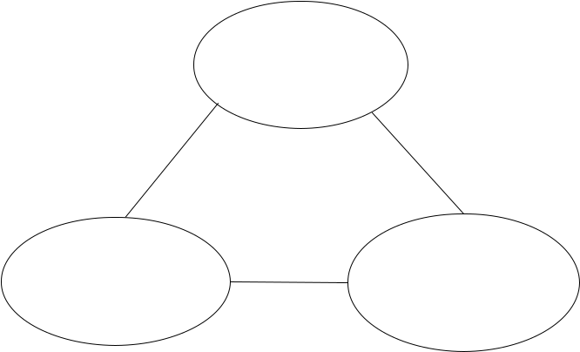

|  |
| --- |
| hierarchy |



|  |  |  |  |  |  |  |  |  |  |  |
| --- | --- | --- | --- | --- | --- | --- | --- | --- | --- | --- |
|  |  |  |  |  | Storage Agent |  | | |  |  |
|  |  |  |  |  |  |  | distributed | | | |
|  |  |  |  |  |  |  |  | |  |  |
|  |  |  |  |  | Management |  |  |  |  |  |
|  |  |  |  |  | decisions Agent |  |  | |  |  |
|  | Monitoring Agent |  |  |  |  |  |  |  |  |  |
|  |  |  | Management decisions Agent | | | | |  |  |  |
|  |  |  |  | Management decisions | | |  |  | The man-machine interface |  |
|  |  |  |  |  | Agent | |  |  |  |  |
| Agent |  |  |  |  | Agent | | | | Agent | |

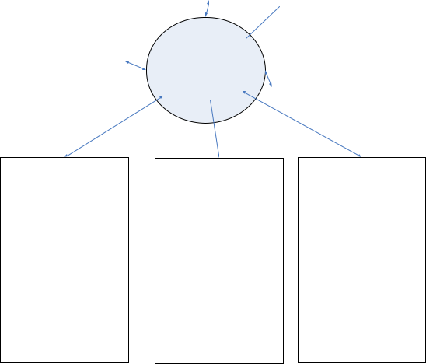

|  |  |  |  |
| --- | --- | --- | --- |
| Control Agent | Control Agent | Control |  |
| Control Agent |  |
|  |  | CommuniAgent |  |
| Communication | Communication Agent | Communication |  |
|  | AgentAgent |  |
| Agent |  |  |
|  |  |  |

|  |  |  |  |  |  |  |
| --- | --- | --- | --- | --- | --- | --- |
| Field Agent | | Field Agent | |  | Field |  |
| Field Agent | |  |
|  |  |  |  |  | Agent |  |
| Field Agent | Field Agent | Field Agent | Field Agent | Field Agent | Field Agent |  |



**Computation**

**message** **physics**

**Information**

**Communication Control system**

**FIGURE 1** 3C conception of CPS

1. ***RESEARCH ON CPS AUTONOMOUS CONTROL STRATEGY BASED ON MULTI-AGENT***

Each CPS node represents one or more agents, which interact through the CPS network. The structure of multi-agent system is divided into hierarchical structure, alliance structure and distributed structure. In the CPS architecture, the hierarchical structure is adopted between the sensor control layer, network layer and application layer, and the alliance structure is adopted for each task execution unit and data sensing unit. In the same layer (sensor control layer, network layer and data transmission layer), the CPS proxy node is a distributed node [19-20]. Therefore, in the CPS architecture, the vertical structure is a combination of hierarchies, while the horizontal structure is a combination of distributed structures. Here, in order to facilitate the analysis and research of CPS control strategy, each CPS node is described as an agent, for example, the communication node is a communication agent, and the decision node is represented as a decision agent [21-22]. According to the CPS system structure designed above, the multi-agent system structure shown in Figure 2:

Distributed structure

**FIGURE 2** The distributed MAS diagram of CPS

***E. AUTONOMOUS CONTROL STRATEGY***

Generally speaking, the autonomous control strategy of CPS can be embodied in two aspects, one is task generation, the other is task execution. When CPS is in the stage of task generation, the agent in the application layer of CPS will receive new requirements, and at the same time, the agent will transfer the requirements to the decision group, and each decision group in the decision group corresponds to an execution unit and a perception unit, so CPS will coordinate with each other to select the most appropriate execution mode

1. When the CPS is in the task execution stage, when the task is handed over to the CPS unit for execution, the perception unit will continuously perceive the task to generate decision data, and the agent will detect and predict whether the task will succeed or not. If the prediction task cannot succeed, it will transmit information to the agent to make adjustments until it succeeds [24-25].

|  |  |  |  |  |  |  |  |  |  |  |  |  |  |
| --- | --- | --- | --- | --- | --- | --- | --- | --- | --- | --- | --- | --- | --- |
| ***F. CORE IDEAS*** | | |  |  |  |  |  |  |  |  |  |  |  |
| In *T*proc , the | | conflict | | | matrix | |  | of | order |  | n（n > 0） | |  |
| composed of | *R* | | and | *R*rcv* | | *C* | curr | | , and the number of | | | |  |
|  | rsv |  | is |  |  |
| row conflicts of request | | | | rvi | defined as | | | | *V*i is | nc（rvi）, | | |  |
|  |  |  |  |  | n |  |  |  |  |  |  |  |  |
|  | nc（rvi）= ∑*Ccurr* (*i*, | | | | | | | | *j*) |  |  |  |  |
|  |  |  |  |  | *j*=1 |  |  |  |  |  | *C*curr | (1) |  |
| The number of conflicts defined as | | | | | | | | | | | is |  |
| nc（ curr）max | | , | r | e | s u | l | | t | i n | g | i | n |  |

1. ≤ *nc*(*rvi* ) ≤ *nc*(*Ccurr* )max ≤ *n* −1.

nc（*C*curr）max = max{nc（rvi）丨1 ≤ i ≤ n，rvi ∈ *R*rcv*}

(2)

The reduction is performed from row I in *C*curr , and ro

1. I satisfiesnc(*rvi* )= *nc*(*Ccurr* )maxandrvi∈ *R*rcv*. Thealgorithm selects a row of *C*curr to simplify, updates th

|  |  |
| --- | --- |
| VOLUME XX, 2020 | 3 |

This work is licensed under a Creative Commons Attribution 4.0 License. For more information, see https://creativecommons.org/licenses/by/4.0/.

This article has been accepted for publication in a future issue of this journal, but has not been fully edited. Content may change prior to final publication. Citation information: DOI 10.1109/ACCESS.2020.3008820, IEEE Access



Author Name: Autonomous Coordinated Control Strategy for Complex Process

of Traffic Information Physical Fusion System Based on Big Data

|  |  |  |  |  |  |  |
| --- | --- | --- | --- | --- | --- | --- |
| e conflict relationship of *C*curr | | in | time | | after | simplificatio |
| n, and then iterates repeatedly. | | At last, | | there is no confli | | |
| ct relationship | in *C*curr , and a | conflict | | free | | matrix *C*\* is |
| obtained. All | matrix row sets | in | *C*curr | | are | defined as |

*R*ows（*C*\*）, and the final set of solutions for the inte

|  |  |  |  |  |  |
| --- | --- | --- | --- | --- | --- |
| rsection manager agent is | |  |  |  |  |
| *R* | = {r丨i ∈ *R*ows（*C*\*），r | | ∈*R*\*} | (3) |  |
| max | vi | vi | rcv |  |
| ***G. INTRODUCTION OF REQUEST PRIORITY FACTOR*** | | | |  |  |
| The priority | index of reservation | request | rv defining | veh |  |

i c l e *V* i s p（rv） u n d e r t h e c o n d i t i o n o f

|  |  |  |  |  |  |  |  |  |  |  |  |  |  |  |  |  |  |
| --- | --- | --- | --- | --- | --- | --- | --- | --- | --- | --- | --- | --- | --- | --- | --- | --- | --- |
| 0 ≤ p（rv）≤ 1. | | | | The priority index of any reservation re | | | | | | | | | | | | |  |
| quest | set *R* is | | | *P*(*R*) , with | | | | | | | |  |  |  |  |  |  |
|  |  |  |  | *P*(*R*) | = |  |  | 1 |  |  | ∑*P*(rvi ) | | | |  |  |  |
|  |  |  |  |  |  | *R* |  |  |  |  |  |
|  |  |  |  |  |  |  |  |  |
|  |  |  |  |  |  |  |  |  |  | rvi∈*R* | |  |  |  | (4) |  |
|  | *T*proc |  |  |  |  |  |  |  |  |  |  | *RCR* | |  |  |  |
| In | , | the optimal | | solution | | | | | | | of | n（n ≥ 0）gr | |  |
|  |  | maxi |  |
| oups | is and | | the | solution set is | | | | | | | | *RCR* | |  | further deduce | |  |
|  | max . We | |  |
| that |  |  | *CR* |  |  |  |  |  |  |  |  |  |  |  |  |  |  |
|  |  |  | *CR* | | | | | | | |  |  | ∈ *N*} | |  |  |
|  |  |  | *R* | = {*R* | 丨1 ≤ i ≤ n，n | | | | | | | | | (5) |  |
|  |  |  | max | max | | | | | | | |  |  |  |  |  |

After the introduction of conflict reduction control strat

|  |  |  |  |  |  |  |  |
| --- | --- | --- | --- | --- | --- | --- | --- |
| egy, we also need | to meet the | | following requirements: | | |  |  |
| *P*(*RCR*\*)=max{*P*(*RCR* | | 丨)1 ≤ i ≤ n，n ∈ *N*, *RCR* | |  | } |  |  |
| ∈ *RCR* | (6) |  |
| max | maxi |  | maxi | max |  |  |

***H. TRANSMISSION COST***

Suppose that the total cost of consistent transmission is

|  |  |  |  |  |  |  |  |  |  |  |  |  |  |  |  |  |  |  |  |  |
| --- | --- | --- | --- | --- | --- | --- | --- | --- | --- | --- | --- | --- | --- | --- | --- | --- | --- | --- | --- | --- |
| *C* =c（ | | p*N*dst | | | | | ） | | |  |  |  |  |  |  |  |  |  |  |  |
| 1 | 1 |  | k | |  |  | , and the | | | | |  |  | total cost of inconsistent trans | | | | | |  |
|  |  |  |  |  |  |  |  |
|  |  |  | *C* | |  |  | = c（ | | |  | p*N*dst |  |  | ）+（*N* | |  | − p*N* | | ） |  |
|  |  |  |  |  |  | k |  |  |  |  |
| mission is | | |  |  | 2 | | 2 | | |  |  |  |  |  | src |  |  | dst . So the tot |  |
| al cost is | | |  |  |  |  |  |  |  | *C*total | | =*C*1 +*C*2 | | | | |  |  |  |  |
|  |  |  |  |  |  |  |  |  |  |  |  |  |  |
|  | = c（ | | | p*N*dst | | | | | ）+ c（ | | | | p*N*dst | | ）+（*N* | | | src | − p*N* ） |  |
|  |  | |  | |  |  | |  |
|  |  |  | 1 |  |  |  | k | | | 2 | |  |  | k | |  |  | dst |  |
|  |  |  |  |  |  |  |  |  |  |  |  |  |  | (7) |  |
|  |  |  |  |  |  |  | =（ | c1 + c2 | | | |  |  | −1）p*N*dst + *N*src | | | | | |  |
|  |  |  |  |  |  |  |  | | | k |  |  |  |
| If K is 32, there is | | | | | | | | | |  |  |  |  |  |  |  |  |  |  |
|  |  |  |  |  |  |  |  |  |  |  |
|  |  |  | （ | | | c1 + *c*2 | | | |  | −1）*pNdst* + *Nsrc* ≤ *Nsrc* | | | | | | | | |  |
|  |  |  |  | | | |  |  |
|  |  |  |  |  |  |  | *k* | | |  |  |  |  |  |  |  |  |  | (8) |  |

**III. EXPERIMENTS**

1. ***EXPERIMENTAL DATA SETTINGS***

In order to make the experimental data reasonable, we select 8 urban road networks in the real traffic. Take 1000 vehicles as the cycle, and the speed limit is 70 km / h. The measured social traffic data include: the traffic volume of each intersection, the traffic volume of the East-West section, the traffic volume of the North-South section, and the queue length. According to the change of P value, the traffic flow data corresponding to each P value is collected, and the experimental indexes are obtained to verify the self-made coordination relationship of the traffic system.

***B. Experimental Steps***

By using traffic flow data and conflict reduction algorithm, the running time of traffic is counted, so as to evaluate the algorithm.

Through the data acquisition of different P values under the CR strategy, FCFS strategy and signal control strategy, the deficiencies are found out, and then on this basis, the typical fuzzy control and the type II fuzzy control are carried out to collect data. The advantages of typical fuzzy control and two type fuzzy control are verified by comparing data.

Under the ksync strategy, change the p value and collect data to evaluate the ksync strategy.

***C. FITNESS CONTRAST***

In the process of algorithm running, the fitness function can not only evaluate the quality of individuals, but also drive the algorithm to make natural selection in a better direction. At first, if there are individuals with abnormal fitness in the initial population, the algorithm will fall into local optimum. With the continuous convergence of the algorithm, a large number of individuals with similar fitness appear in the group, which limits the further optimization and selection of the algorithm, resulting in the result deviating from the optimal solution. In order to solve the above problems, it is necessary to calibrate the fitness of individuals reasonably. In this chapter, the maximum estimate of the objective function (mean delay time) is subtracted from the objective function as the fitness function.

**IV. DISCUSSION**

1. ***EVALUATION AND VERIFICATION OF INTERSECTION CONTROL STRATEGY FOR CONFLICT REDUCTION***

In order to evaluate the algorithm, the node search rate under traffic condition is calculated, and the results are shown in Table 1.

TABLE I

AVERAGE NODE SEARCH RATE OF CONFLICT REDUCTION ALGORITHM

|  |  |  |  |  |  |  |  |  |  |  |
| --- | --- | --- | --- | --- | --- | --- | --- | --- | --- | --- |
|  | Percentage | 12 | 13 | 14 | 15 | 16 | 17 | 18 | 19 | 20 |
|  | Strong Ratio | 0.391 | 0.262 | 0.150 | 0.112 | 0.049 | 0.031 | 0.023 | 0.012 | 0.007 |
|  | Weak Ratio | 0.225 | 0.148 | 0.750 | 0.053 | 0.025 | 0.019 | 0.013 | 0.008 | 0.002 |

The effect of evaluating the offline runtime node search rate

is shown in Figure 3.

4 VOLUME XX, 2020

This work is licensed under a Creative Commons Attribution 4.0 License. For more information, see https://creativecommons.org/licenses/by/4.0/.

This article has been accepted for publication in a future issue of this journal, but has not been fully edited. Content may change prior to final publication. Citation information: DOI 10.1109/ACCESS.2020.3008820, IEEE Access



Author Name: Autonomous Coordinated Control Strategy for Complex Process

of Traffic Information Physical Fusion System Based on Big Data

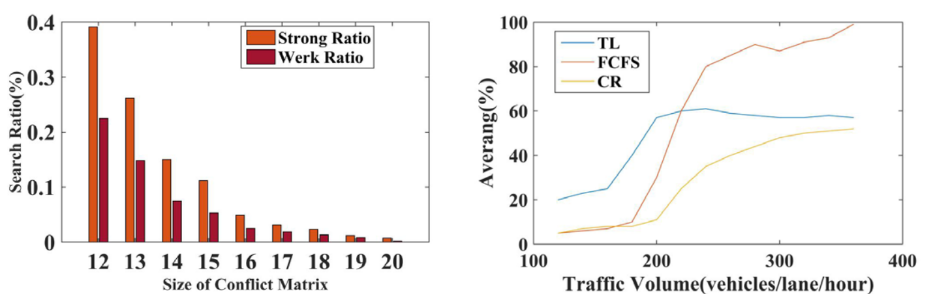

**FIGURE 3.** Avg. search ratio of CR algorithm **FIGURE 4** Avg. traffic delay for CR policy

In Figure 3, the traffic states are classified as 1-strong ratio and 2-weak ratio. It can be seen from the figure that the search rate of nodes has been kept in a very low state. It can be seen that the conflict reduction algorithm is reliable and efficient in the transportation system. The experimental results show that the improved algorithm takes into account the different influence degree of each index on the traffic state recognition results, so that the number of inaccurate time periods is less than the traditional algorithm, which is closer to the actual traffic state. In order to further clarify the recognition rate of the improved algorithm, the data samples with the ratio value between 0 and 0.4 and consistent with the actual traffic status are regarded as the correct recognition samples. Compared with the traditional fuzzy clustering algorithm, the total number of wrong sample groups identified by the conflict reduction algorithm is less than that of the wrong sample groups before and after the improvement, and the error rate is reduced by 7.14%. After the improvement, the algorithm calculates the weight of all the data collected in 5 working days by using the information entropy theory. Experimental results show that the conflict reduction algorithm is effective and avoids the consequences of inaccurate recognition caused by subjective weight determination.

***B. ONLINE SIMULATION EVALUATION***

In addition to the off-line evaluation and Optimization Based on a large number of test cases, in order to further obtain more convincing experimental data and more objective performance evaluation results of the algorithm, we use the improved fuzzy clustering algorithm to carry out traffic state identification simulation based on the measured data of the urban road network, and make use of the more real intelligent road environment Verify it to get more perfect experimental results. The following data effect is shown in Figure 4.

Figure 4 is a comparison of three strategies (CR strategy, FCFS strategy and signal control strategy). The results show that the average delay time of vehicles under different control methods in the same time period is different. With the increase of traffic flow, the average delay time is higher than before, and individual average delay time changes greatly (such as FCFS strategy), while CR strategy has been stable at about 50. The scheme under the timing control will not change with the change of time period and traffic flow, and the flexibility is poor, while the typical fuzzy control and type II fuzzy control will change adaptively according to the change of time period and traffic flow. After the improvement of type II fuzzy control, the average delay time of vehicles is significantly reduced, This proves that the improved fuzzy clustering algorithm is more suitable for CR strategy. In the same method, the optimization effect of different traffic flows is different, and the FCFS strategy has the largest amount of improvement, which also proves that the more the traffic flow is, the more difficult the control is, the less the amount of improvement is. Therefore, the effect of Cr strategy proposed in this paper on the improvement of fuzzy control is obvious.

***C. Online Simulation of Ksync Strategy***

We also adopt the ksync strategy, by constantly adjusting the value of P, in the north-south road section and the east-west road network area, to investigate the impact of changing the value of P on the data compression rate.

With the increase of P value, the average data compression rate has a monotonic decreasing trend while the average data transmission volume has an opposite trend. The results are recorded as shown in Table 2 and Table 3.

TABLE II

AVG. COMPRESSION RATE

|  |  |  |  |  |  |  |  |  |  |
| --- | --- | --- | --- | --- | --- | --- | --- | --- | --- |
|  | ％ | 1 | 2 | 3 | 4 | 5 | 6 | 7 | 8 |
|  | P=16 | 84 | 88 | 87 | 86 | 87 | 87 | 87 | 87 |
|  | P=32 | 73 | 81 | 80 | 80 | 81 | 81 | 81 | 81 |
|  | P=64 | 74 | 73 | 71 | 70 | 70 | 70 | 70 | 70 |
|  | P=128 | 63 | 59 | 56 | 56 | 55 | 55 | 55 | 55 |

|  |  |
| --- | --- |
| VOLUME XX, 2020 | 5 |

This work is licensed under a Creative Commons Attribution 4.0 License. For more information, see https://creativecommons.org/licenses/by/4.0/.

This article has been accepted for publication in a future issue of this journal, but has not been fully edited. Content may change prior to final publication. Citation information: DOI 10.1109/ACCESS.2020.3008820, IEEE Access



Author Name: Autonomous Coordinated Control Strategy for Complex Process

of Traffic Information Physical Fusion System Based on Big Data

TABLE III

AVG. TRANSMISSION

|  |  |  |  |  |  |  |  |  |  |
| --- | --- | --- | --- | --- | --- | --- | --- | --- | --- |
|  | kb | 1 | 2 | 3 | 4 | 5 | 6 | 7 | 8 |
|  | P=16 | 0 | 8 | 10 | 12 | 13 | 14 | 14 | 15 |
|  | P=32 | 0 | 7 | 13 | 15 | 16 | 18 | 19 | 19 |
|  | P=64 | 7 | 17 | 20 | 22 | 24 | 26 | 27 | 30 |
|  | P=128 | 7 | 30 | 35 | 36 | 38 | 38 | 38 | 40 |
|  | ODA | 18 | 53 | 75 | 79 | 86 | 90 | 93 | 100 |

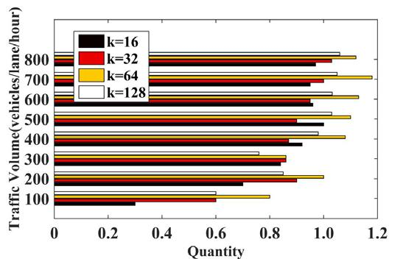

The effect of average data compression rate is shown in Figure 5

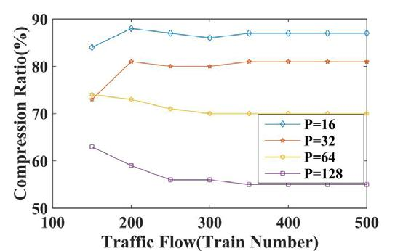

**FIGURE 5** Avg. compression rate (%)

From the above figure, it can be concluded that under the effect of ksync strategy, reducing agent, that is to say, the value of improved P can obviously see the change of compression rate, and the smaller the p value, the higher the compression rate. In the figure, we can also see that with the change of P value, the traffic flow is different when the compression ratio of different P values tends to be stable. Therefore, we can predict the p value through the traffic flow in the traffic system, or use the p value to determine the traffic flow to determine the traffic situation.

In order to further verify the impact of the value of P on data transmission, we take four typical P values to investigate the effect of ksync strategy on data consistency. The specific rendering is shown in the figure below (where Figure 6 and Figure 7 are the ratio of inconsistent requests and the average number of inconsistent requests respectively, and figure 8 is the ratio of inconsistent request bytes)

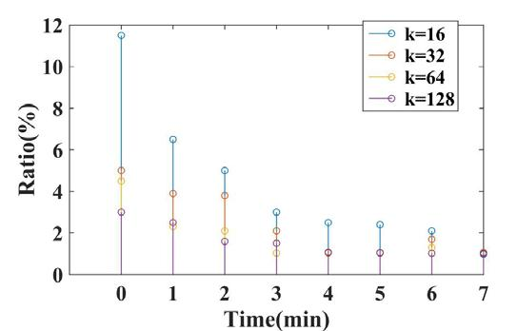

**FIGURE 6** Avg. inconsistent number rate (%)

**FIGURE 7** Avg. inconsistent number

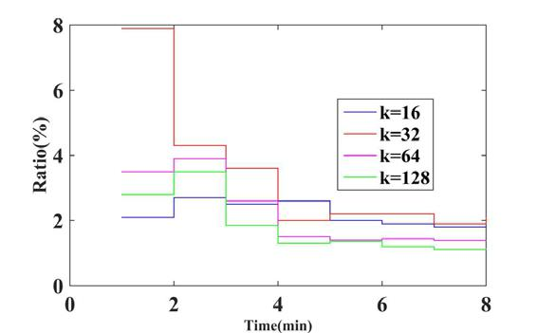

**FIGURE 8** Avg. inconsistent byte rate (%)

As can be seen from the above figure, when the traffic flow is small, the p value has little impact on the inconsistent rate of message quantity and byte transmission, and has been kept within the lower level of 1% and 2%, and with the increase of traffic flow, the average inconsistent message consumption and byte transmission of the agent have been stable within 1.2 message / train and 0.5kb/train. Although the change of P value will make the synchronization of data transmission inconsistent, but the error is very low, which is within the allowable range. This also shows that ksync strategy is suitable for data consistency.

**V. CONCLUSION**

The information physical fusion system can realize the interaction between the information world and the physical world, and has a wide range of applications in the fields of transportation, industry and so on. In recent years, the rapid development of CPS and its related technologies has promoted the upgrading and leapfrog development of key technologies in the fields of automobile, industrial automation, medical care, emergency response, industrial control system, intelligent

6 VOLUME XX, 2020

This work is licensed under a Creative Commons Attribution 4.0 License. For more information, see https://creativecommons.org/licenses/by/4.0/.

This article has been accepted for publication in a future issue of this journal, but has not been fully edited. Content may change prior to final publication. Citation information: DOI 10.1109/ACCESS.2020.3008820, IEEE Access



Author Name: Autonomous Coordinated Control Strategy for Complex Process

of Traffic Information Physical Fusion System Based on Big Data

building, intelligent road, intelligent transportation system, power system, etc. Based on the requirements of reliable perception, real-time transmission, pervasive computing, precise control and reliable service of CPS in the complex traffic process, in order to improve the flexibility, autonomy and intelligence of modern traffic, this paper studies the autonomous coordinated control strategy of CPS.

In this paper, the CPS system is applied to the information collection and coordination system in the transportation system. The real-time perception of the transportation system is based on the characteristics of the reliable perception and precise control of the CPS system, and the traffic flow is regulated according to the actual environment, so as to achieve the purpose of "maximum regulation, minimum energy consumption and best safety". Aiming at the complex and changeable environment of transportation, this paper establishes the information perception framework of transportation CPS. Fully obtain the information parameters inside and outside the traffic, and monitor the traffic flow information on the traffic road, which provides great help for the smooth traffic. Monitoring the information transmission mode and speed at all levels in the transportation system lays a foundation for the regulation and control of the information system and the control system. Aiming at the output efficiency of agent, this paper also establishes the distributed structure and information terminal control model of CPS based on multi-agent, analyzes whether CR strategy, FCFS strategy or signal control strategy, and compares their shortcomings, then puts forward ksync strategy and type II fuzzy control, and through simulation experiments, It is proved that they are effective in reducing the complexity of system communication. Aiming at the problem of CPS coordinated control, the conflict reduction control strategy is used to simulate the algorithm of the traffic section to solve the problem of information transfer rate. Through experimental comparison, it can be seen that the traffic information transmission speed is faster and the output duty cycle is more accurate under the conflict reduction control strategy, which can achieve better transmission and control effect.

Starting from the concept of precise control and CPS autonomy, this paper studies the agent-based CPS technology, the purpose of which is to solve the requirements of precise control and autonomy in the real complex traffic process. From the effect of experimental simulation data, this study achieves the required effect. The research of CPS autonomous coordinated control strategy based on multi agent technology has more advantages and autonomy in the application of complex traffic process. Compared with the traditional process control method, the control strategy has more independent control ability, and can meet the needs of modern transportation for intelligence and information. However, for more complex traffic environment and a large number of traffic data transmission, the multi-agent autonomy strategy only using real-time data cannot meet the requirements of CPS. Therefore, the study of CPS autonomous coordinated control strategy based on multi agent technology will be one of the key factors to achieve traffic autonomous control.

**REFERENCE**

[1]Gong P, Cao Y, Cai B, et al. Multi-information location data fusion system of railway signal based on cloud computing [J]. Future generation computer systems, 2018, 88(NOV.):594-598.

[2]Hintz K J. Embracing cyber-physical system as cross-platform to enhance fusion-application value of spatial information [J]. Spatial Information Research, 2017, 25(3):439-447.

[3]Fritze A, MANks U,Lohweg V. A Support System for Sensor and Information Fusion System Design [J]. Procedia Technology, 2016, 26(Complete):580-587.

[4]Lyu Y, Yan F, Chen Y, et al. High-performance scheduling model for multisensor gateway of cloud sensor system-based smart-living [J]. Information Fusion, 2015, 21(1):42–56.

[5]Fernandes A, Pereira R C, Neto A C, et al. Data pre-processing using an FPGA by binning gamma ray energies and forwarding consolidated spectra data [J]. Fusion Engineering and Design, 2015, 96-97(OCT.):782-785.

[6]Liu T, Sun Y, Liu Y, et al. Abnormal traffic-indexed state estimation: A cyber-physical fusion approach for Smart Grid attack detection [J]. Future Generation Computer Systems, 2015, 49(aug.):94-103.

[7]Berger J, Lo N, Boukhtouta A, et al. An information theoretic based integer linear programming approach for the discrete search path planning problem [J]. Optimization Letters, 2015, 9(8):1585-1607.

[8]Iyengar S S, Ramani S K, Ao B. Fusion of the Brooks–Iyengar Algorithm and Blockchain in Decentralization of the Data-Source [J]. Journal of Sensor & Actuator Networks, 2019, 8(1):17.

[9]Turksoy K, Paulino T M L, Zaharieva D P, et al. Classification of Physical Activity: Information to Artificial Pancreas Control Systems in Real Time

1. Journal of Diabetes Science and Technology, 2015, 9(6):1200-1207. [10]Bakalos N, Voulodimos A, Doulamis N, et al. Protecting Water

Infrastructure From Cyber and Physical Threats: Using Multimodal Data Fusion and Adaptive Deep Learning to Monitor Critical Systems [J]. IEEE Signal Processing Magazine, 2019, 36(2):36-48.

[11]Wang L, Qu Z, Li Z. The Design and Implementation of Attack Path Extraction Model in Power Cyber Physical System [J]. Journal of Communications, 2016, 11(9):834-840.

[12]Papadopoulos K P, Kelley R K, Tolcher A W, et al. A Phase I First-in-Human Study of Nesvacumab (REGN910), a Fully Human Anti-Angiopoietin-2 (Ang2) Monoclonal Antibody, in Patients with Advanced Solid Tumors [J]. Clinical cancer research : an official journal of the American Association for Cancer Research, 2016, 22(6):1348.

[13]Li R, Lu C, Liu J, et al. Air Data Estimation Algorithm under Unknown Wind Based on Information Fusion [J]. Journal of aerospace engineering, 2018, 31(5):04018072.1-04018072.12.

[14]Manesh A, Murthy C R, Annavajjala R. Physical Layer Data Fusion Via Distributed Co-Phasing With General Signal Constellations [J]. Signal Processing, IEEE Transactions on, 2015, 63(17):4660-4672.

[15]Shi X, Li Y, Cao Y, et al. Cyber-physical electrical energy systems: challenges and issues [J]. Power and Energy Systems, CSEE Journal of, 2015, 1(2):36-42.

[16]Zhang D G, Li W B, Liu S, et al. 1909. Novel fusion computing method for bio-medical image of WSN based on spherical coordinate [J]. Journal of Vibroengineering, 2016, 18(1):522-538.

[17]Zhou X, Zhou L, Chen Y, et al. A microgrid cluster structure and its autonomous coordination control strategy [J]. International journal of electrical power and energy systems, 2018, 100(SEP.):69-80.

[18]Durand N,Barnier N.Does ATM Need Centralized Coordination? Autonomous Conflict Resolution Analysis in a Constrained Speed Environment [J]. Air Traffic Control Quarterly, 2015, 23(4):710-712.

[19]Prihastono, Khairul Anam, Rusdhianto Effendi. AUTONOMOUS FIVE LEGS RESCUE ROBOT NAVIGATION IN CLUTTERED ENVIRONMENT [J].academic research international, 2016(1):155-163.

[20]Gregoire J M M, Michal Čáp, Frazzoli E. Locally-optimal multi-robot navigation under delaying disturbances using homotopy constraints [J]. Autonomous Robots, 2017, 42(12):1-13.

[21]Albrecht S V, Liemhetcharat S, Stone P. Special issue on multiagent interaction without prior coordination: guest editorial [J]. Autonomous Agents & Multi Agent Systems, 2016, 31(4):1-2.

[22]Nestmeyer T, Robuffogiordano P, Bülthoff, Heinrich H, et al. Decentralized simultaneous multi-target exploration using a connected network of multiple robots [J]. autonomous robots, 2016, 34(1):1-23.

[23]Qin Y, An M, Jia L. Guest Editors' Introduction [J]. International Journal of Software Engineering & Knowledge Engineering, 2018, 28(4):427-429.

[24]Altche F,Qian X,Arnaud D L F.An Algorithm for Supervised Driving of Cooperative Semi-Autonomous Vehicles (Extended) [J]. IEEE Transactions on Intelligent Transportation Systems, 2017, PP(99):1-13.

|  |  |
| --- | --- |
| VOLUME XX, 2020 | 7 |

This work is licensed under a Creative Commons Attribution 4.0 License. For more information, see https://creativecommons.org/licenses/by/4.0/.

This article has been accepted for publication in a future issue of this journal, but has not been fully edited. Content may change prior to final publication. Citation information: DOI 10.1109/ACCESS.2020.3008820, IEEE Access



Author Name: Autonomous Coordinated Control Strategy for Complex Process

of Traffic Information Physical Fusion System Based on Big Data

[25]Nicolás F. Soria, Mitchell K. Colby, Irem Y. Tumer,. Design of Complex

Engineering Systems Using Multiagent Coordination [J]. artificial

intelligence for engineering design analysis & manufacturing, 2016,

28(4):307-309.

**GONGXING YAN** was born in Kaifeng, Henan, P.R.



China, in 1973. He received the Doctor degree from

Chongqing University, P.R. China. Now, he works in

College of Construction and engineering, Chongqing

Vocational Institute of Engineering. His research interests

include Intelligent transport, system design and Civil

Engineering.

E-mail: yaaangx@163.com

**HONGZHI WANG** was born in Chengde, Hebei, P.R.



China, in 1978. He received the doctor’s degree from

University of Science and Technology Beijing, P.R. China.

Now, he works in School of management, Qingdao

Agricultural University, His research interest include

agricultural logistics economy and data mining.

E-mail: 410751138@qq.com.

8 VOLUME XX, 2020

This work is licensed under a Creative Commons Attribution 4.0 License. For more information, see https://creativecommons.org/licenses/by/4.0/.