This article has been accepted for publication in a future issue of this journal, but has not been fully edited. Content may change prior to final publication. Citation information: DOI 10.1109/ACCESS.2020.3011982, IEEE Access



Date of publication xxxx 00, 0000, date of current version xxxx 00, 0000.

*Digital Object Identifier 10.1109/ACCESS.2017.Doi Number*

**A New Data Driven Long-term Solar Yield Analysis Model of Photovoltaic Power Plants**

**Biplob Ray1, Member, IEEE, Rakibuzzaman Shah2, Member, IEEE, Md Rabiul Islam3, Senior Member, IEEE, and Syed Islam2, Fellow, IEEE**

1Centre of Intelligent System, School of Engineering and Technology, CQUniversity, QLD 4701, Australia

2School of Engineering, Information Technology and Physical Sciences, Federation University Australia, Mt Helen, VIC 3353, Australia

3School of Electrical, Computer and Telecommunication Engineering, University of Wollongong, NSW 2522, Australia

Corresponding author: Rakibuzzaman Shah (e-mail: [m.shah@federation.edu.au)](mailto:m.shah@federation.edu.au).

**ABSTRACT** Historical data offers a wealth of knowledge to the users. However, often restrictivelymammoth that the information cannot be fully extracted, synthesized, and analyzed efficiently for an application such as the forecasting of variable generator outputs. Moreover, the accuracy of the prediction method is vital. Therefore, a trade-off between accuracy and efficacy is required for the data-driven energy forecasting method. It has been identified that the hybrid approach may outperform the individual technique in minimizing the error while challenging to synthesize. A hybrid deep learning-based method is proposed for the output prediction of the solar photovoltaic systems (i.e. proposed PV system) in Australia to obtain the trade-off between accuracy and efficacy. The historical dataset from 1990-2013 in Australian locations (e.g. North Queensland) are used to train the model. The model is developed using the combination of multivariate long and short-term memory (LSTM) and convolutional neural network (CNN). The proposed hybrid deep learning (LSTM-CNN) is compared with the existing neural network ensemble (NNE), random forest, statistical analysis, and artificial neural network (ANN) based techniques to assess the performance. The proposed model could be useful for generation planning and reserve estimation in power systems with high penetration of solar photovoltaics (PVs) or other renewable energy sources (RESs).

**INDEX TERMS** Accuracy, convolutional neural network, data-driven model, deep learning, forecasting,multivariate long and short-term memory, reliability, solar photovoltaic power plants.

**I. ABBREVIATION**

**ANN** Average Neural Network

**APL** Artificial Pooling Layers

**ARENA** Australian Renewable Energy Agency

**ASEFS** Australian Solar Energy Forecasting System

1. Bias

**BNL** Batch Normalization Layer

**CNN** Convolutional Neural Network

**DL** Dropout Layer

**DNI** Direct Normal Irradiance

**DHI** Diffuse Horizontal Irradiance

**GHI** Global Horizontal Irradiance

**IW** Input Weights

**LSTM** Long and Short-Term Memory

1. Neural Network

**NNE** Neural Network Ensemble

**PSO** Particle Swarm Optimization

**RNN** Recurrent Neural Network

**ReLU** Rectified Linear Unit

**RW** Recurrent Weights

1. Weights

VOLUME XX, 2017

This work is licensed under a Creative Commons Attribution 4.0 License. For more information, see https://creativecommons.org/licenses/by/4.0/.

This article has been accepted for publication in a future issue of this journal, but has not been fully edited. Content may change prior to final publication. Citation information: DOI 10.1109/ACCESS.2020.3011982, IEEE Access



**II. INTRODUCTION**

The penetrations of solar photovoltaic (PV) are increasing in several countries including Australia in multiple straight years. Significant PVs are either connected to medium or low voltage networks in Australia. The growth of both large and small-scale PV penetrations has economic and environmental benefits. However, it poses a range of management and control issues for grid operators due to the variability of PV outputs. The power system has become increasingly volatile and less predictable with PV systems

1. The PV systems are weather dependent, therefore, hard to predict. Accuracy of the prediction is critically important for secure operation of power systems with high penetrations of PV systems. It enables the system operator to deal with output power variability and planning engineers to plan and design the power system for future [2]. There are various methods for such forecasting in different time horizons, e.g. short, medium, and long-term. The physical, persistence, statistical, and combined approaches may be used to estimate the output of variable generations [3]. The meteorological data and energy forecasting are the two significant components related to the forecasting of the PV system [4]. Many procedures were proposed in the literature to forecast meteorological information such as wind speed, cloud cover, temperature, and irradiance [5], [6]. Furthermore, physical, meteorological data-driven, and astronomical driven are the common methods reported in the literature to forecast the output power and energy of the PV system. Different parameters such as power rating, azimuth angle, module type, tilt angle, wind speed are used in the physical model for energy forecasting in PV systems [7]. The historical weather data and the previous measurements of PV system outputs are used in the meteorological data-driven method for PV forecasting [8]. The statistical, persistence, auto-regression are the key methods used for this purpose [8]. Recently, machine learning techniques have widely been applied in the meteorological data-driven approach to forecast PV output
2. In the astronomical and meteorological data-driven approach, the physical factor has been used with the meteorological data [9]. In a data-driven traditional statistical method, the measured historical PV data in the past time is used in forecast [10]. The auto-regression and spatial-temporal are the other two widely used data-driven methods for such application [11], [12]. However, the physical information of PV is often limited or ignored in these methods [10]-[12]. Although different techniques have already recognized for forecasting PV output, there is still an opportunity to improve the reliability and accuracy regarding the long-term forecasting of the PV system to be used in power system planning. A good number of works have been attempted to estimate the short-term solar yield using historical data. Most of the forecasting techniques applied in minutes into day spatial resolution for dispatching and load following, unit commitment, distributed generation

VOLUME XX, 2017

operation, building energy management, and transmission scheduling. However, very few studies have investigated the data-driven long-term estimation of solar yield. In this paper, a data-driven model is proposed for reliable estimation of solar yield from historical data.

Three main forecasting algorithms categories, i.e. statistical analysis [13], machine learning [14], and hybrid [15], [16], were reported. The Australian Renewable Energy Agency (ARENA) has reported the Australian Solar Energy Forecasting System (ASEFS), which used the statistical models like decision tree, random forest, and persistence to forecast the hour ahead prediction of solar energy in Australia. The model has a root mean squire error (RMSE) of 15.80. Hence, there is still a prospect to improve in the forecasting approaches. Furthermore, several machine learning techniques were attempted to forecast minutes, hours, and day-ahead energy outputs of large-scale PV systems [7], [8], [14], and [17]. These were mainly used various neural networks (NN) based forecasting techniques with the short length of dataset. Very few studies have exhibited good forecasting performance as reported in [7], which has a normalized root-mean-square deviation or error (nRMSE) of 0.07356. However, the proposed algorithm in

1. are not suitable in generalized forecasting due to the underlying weather classification and certain assumptions applicable to the specific region. Furthermore, the hybrid techniques were attempted to combine the algorithms for better performance as stated in [7]. The proposed method combines the particle swarm optimization (PSO) with the variation of NN to achieve better forecasting performance. However, the performance of the proposed algorithm is almost similar to other NN based algorithms for forecasting. Recently, the recurrent neural network (RNN) and deep learning [16] based forecasting have received a great deal of attention due to better prediction performance compared to traditional techniques i.e. statistical, PSO, NN. But, most of the deep learning-based methods are used for short-term forecasting with the small length of data.

In this paper, a novel hybrid deep learning method is proposed. A number of studies have individually used long and short-term memory (LSTM) and convolutional neural network (CNN) individually in various application including forecasting of PV output [18]. This paper proposed a method that combines LSTM and CNN to obtain a hybrid algorithm for long-term forecasting of PV output. The proposed algorithm is compared with four baseline modelling methods and demonstrates the better performance compared to the other methods. The rest of the paper is organized as follows: Section III briefly describes the key techniques considered in this paper. The methodology is explained in Section IV. Results and discussions are presented in Section V. The conclusions and the contributions of the paper are given in Section VI.

This work is licensed under a Creative Commons Attribution 4.0 License. For more information, see https://creativecommons.org/licenses/by/4.0/.

This article has been accepted for publication in a future issue of this journal, but has not been fully edited. Content may change prior to final publication. Citation information: DOI 10.1109/ACCESS.2020.3011982, IEEE Access



Author Name: Preparation of Papers for IEEE Access (February 2017)

**III. OVERVIEW**

The long-term forecasting of solar PV can be used for the planning of power system reserve with high penetration of PV systems. The goal of this research is to find the PV power and energy in the long-term time horizon – a couple of years ahead. The historic Typical Meteorological Year (TMY) dataset used for this study. The TMY dataset are obtained from Energy Partners’ [19]. The TMY data is used in the System Advisor Model (SAM) to prepare the required weather data and PV output data for the prediction model. The blending of two deep learning methods has been considered. Fig. 1. shows an overview of the proposed method. The key techniques used in this work are briefly described next in this section.

***A. RECURRENT NEURAL NETWORK (RNN)***

The recurrent neural networks (RNNs) consist of recurrent loops of networks that allow persistent information flow

1. These loops allow the information to flow concurrently from one step of the network to the next using the chain of events within networks which are intimately related to the sequences and lists. The concept of the recurrent neural network is the base of deep learning techniques/algorithms which are inspired by the connection of neurons in human brain [16], [17]. It uses recurrent learning to learn from large and complex dataset. Deep learning is used to solve complex problems that require input from diverse, unstructured, and inter-connected dataset. In this work, two of the most popular deep learning techniques such as long and short-term memory (LSTM) and convolutional neural network (CNN) are utilized. The details about LTSM and CNN are given later in this paper.

***B. LONG- AND SHORT-TERM MEMORY (LSTM)***

The LSTM is a deep learning technique explicitly designed to reduce long lasting dependency problem using a chain like structure [20]. The recuring model of LSTM uses concurrent cell update structure. The initial update starts right after the first output of initial LSTM block which uses the initial state

|  |  |  |  |  |  |  |
| --- | --- | --- | --- | --- | --- | --- |
| of the network and the first-time step of the sequence to | | | | | |  |
| time |  | −1, −1 |  |  |  |  |
| compute the output. At time step | | | |  | , the block uses the current |  |
| state ( | |  | ) to update cell | state , and the following | |  |
|  |  |  |  |
|  | step of the network to compute the output. Each layer | | | | |  |

has two states known as the cell and the hidden state (also known as the output state) . The output of the LSTM layer at time step is contained in the hidden state of the same time step [21]. The information erudite from previous steps is confined in the cell state of the current step. The layer adds or removes information from the cell state controlled by gates in each time step. Fig. 2 illustrates a general LSTM block architecture.

From Fig. 2, it is evident that there are four control gates in

LSTM: forget ( ), cell candidate ( −), 1input) ( ), and output ( ) as illustrated in Fig. 2. When

points enter to the

LSTM unit from LSTM block, it first passed through the

forget gate and drop some memory. The new memories are

|  |  |  |  |  |  |  |  |  |  |  |  |  |  |  |  |  |  |  |
| --- | --- | --- | --- | --- | --- | --- | --- | --- | --- | --- | --- | --- | --- | --- | --- | --- | --- | --- |
| added by update gate. The output is filtered through the | | | | | | | | | | | | | | | | | |  |
| expressed as in (1) - (4) for timestamp for each control | | | | | | | | | | | | | | | | | (1) |  |
| output gate. Working mechanisms can be mathematically | | | | | | | | | | | | | | | | | |  |
|  |  |  | = (+ −1+ ) | | | | | | | | | |  |  |  |  | (2) |  |
|  |  |  | = � + −1 + | | | | | | | | | | � |  |  |  | gate. |  |
|  |  |  | � |  |  | (3) |  |
| In (1)-(4), | |  |  |  | = � | |  | + −1 | | | + | | |  |  | (4) |  |
|  |  |  | = | ( |  | + | |  | + | | | ) |  |  |  |  |
|  |  |  |  |  |  |  | |  |  | −1 |  |  |  | ) | −1 |  |  |  |
| sigmoid |  |  |  |  |  | ( )=(1+ | | | | | − | |  |  |  |
| compute the gate | | | | |  |  |  |  |  |  |  |  |
|  |  |  |  | denotes the gate activation function. The | | | | | | | | | | | | | |  |
|  | function given by | | | | | |  |  |  |  |  |  |  |  |  | is used to | |  |
| of , , | |  | |  | activation function in MATLAB [22]. | | | | | | | | | | | | |  |
|  |  |  |  |  |  |  |  |  | |  |  |  |  |  |
| There are three learnable weights of an LSTM layer: input | | | | | | | | | | | | | | | | | |  |
| weights |  | , recurrent weights | | | | | |  | , and bias | | |  | . The matrices | | | | |  |
|  | and are concatenated as in (5). | | | | | | | | | | |  |  |  |  |  |  |  |

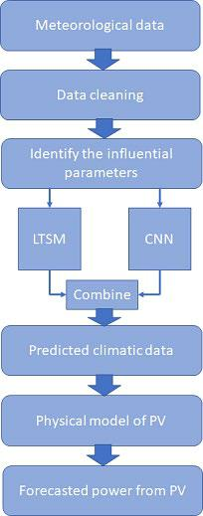

**FIGURE 1. Overview of the proposed method.**

VOLUME XX, 2017

This work is licensed under a Creative Commons Attribution 4.0 License. For more information, see https://creativecommons.org/licenses/by/4.0/.

This article has been accepted for publication in a future issue of this journal, but has not been fully edited. Content may change prior to final publication. Citation information: DOI 10.1109/ACCESS.2020.3011982, IEEE Access



Author Name: Preparation of Papers for IEEE Access (February 2017)

|  |  |  |  |  |  |  |  |  |  |  |  |  |  |  |
| --- | --- | --- | --- | --- | --- | --- | --- | --- | --- | --- | --- | --- | --- | --- |
|  |  |  |  | ⎡ ⎤ |  |  | ⎡ ⎤ |  |  | ⎡ | ⎤ |  | (5) |  |
| **FIGURE 2. LSTM general architecture.** | | | | | | | | |  |  |  |  |  |  |
|  |  | = | |  | , = | |  | , = | |  |  |  |  |
| where | |  |  |  | ⎦ |  |  |  |
|  |  | ⎣ ⎦ |  |  | ⎣ ⎦ |  |  | ⎣ |  |  |  |
| The |  | , , , | |  |  |  |  |  |  |  |  |  |  |  |
|  | and | represent the input gate, forget gate, | | | | | | | |  |
|  |  |  |  |  |  |
| cell candidate, and output gate, respectively. | | | | | | | | | | | | | |  |
|  | cell and hidden state at timestamp | | | | | | | | | | |  | are expressed by |  |
|  |  |  | = | | | ⊙ − + ⊙ | | | | | | (7) |  |
| (6) and (7), respectively. | | | | | | |  |  |  |  |  |  |  |
| where | |  |  | ℎ = ⨀ ( ) | | | | |  |  |  |  | (6) |  |
|  |  |  |  |  |  |  |  |  |  |  |  |  |  |
|  |  |  |  |  |  |  |  |  |  |  |
|  |  |  | denotes the Hadamard product (element-wise | | | | | | | | | | |  |
| multiplication of vectors) and | | | | | | | |  | denotes the state activation | | | | |  |
|  |  | ⊙ |  |  |  |  |  |  |  |
| function. The state activation | | | | | | | | function is compared by using | | | | | |  |
|  |  |  |  |  |  |  |

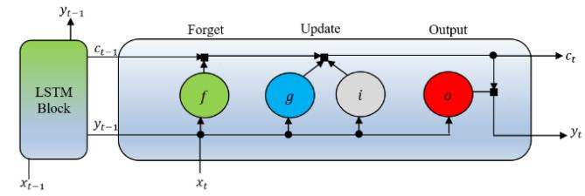

the hyperbolic tangent function (*tanh*) and *lstmLayer* function inMATLAB.

***C. CONVOLUTIONAL NEURAL NETWORK (CNN)***

The Convolutional Neural Network (CNN) is one of the most popular deep learning algorithms [21]. It has the advantage of extracting data features effectively. Therefore, the CNN is used widely in image recognition and classification. The CNN networks are like a visual cortex, with arrangements of simple and complex cells [18]. Similar to an RNN neural network, CNN is composed of three main components: the input layer, output layer, and hidden layers in between the input and output layers [23]. A general CNN structure is illustrated in Fig. 3. One or multiple convolutional layers may be involved in CNN as given in Fig. 3. The CNN used in this paper has four 2-D convolutional layers, BNL, ReLU

|  |  |  |  |  |  |  |
| --- | --- | --- | --- | --- | --- | --- |
| layer, and APL. These are followed by one | | | | DL, fully | |  |
| CNN (where |  | determine | × × |  |  |  |
| connected layer, and regression output layer, respectively. | | | | |  |  |
| specifies the | × |  |  |  |  |
| The influential input parameters of | | |  | are used in | |  |

size of each set, and

total number of dataset). The inputs are passed to the convolutional 2D network consists of neurons that

|  |  |  |  |  |  |  |  |  |  |  |  |  |  |  |
| --- | --- | --- | --- | --- | --- | --- | --- | --- | --- | --- | --- | --- | --- | --- |
| connect to sub-regions of input dataset or the output of the | | | | | | | | | | | | | |  |
| extracted | the | |  |  |  | ( ) |  |  |  |  |  |  |  |  |
| previous layer. The convolutional 2D network uses the set of | | | | | | | | | | | | | |  |
| weights called filter | | | | | |  | that convolved the input. This has | | | | | | |  |
|  |  |  | important | | | | features of the input dataset | | | | | for | |  |
|  |  |  | 2 |  |  |  | ( ) |  |  |  |  |  | , |  |
| accurate output prediction. Then, the batch normalization is | | | | | | | | | | | | | |  |
| The |  | ( | | ) |  |  |  | by calculating the mean | |  |  |  |  |  |
| used to normalize inputs | | | | | | |  |  |  |  |  |  |
| and variance | |  |  |  | over a mini-batch and each input | | | | channel. | | | | |  |
|  |  |  |  | ( |  | ) |  |  |

normalized activations can be obtained as in (8).

x�ı = mi−μB

�~~σ2~~~~B~~~~+ϵ~~ (8)

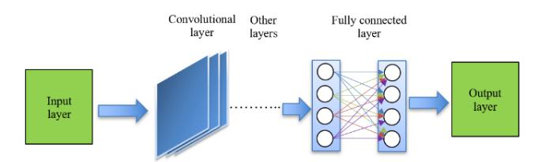

**FIGURE 3. Generic architecture of CNN.**

In (8), is the property Epsilon that improves the numerical stability when the mini-batch variance is very small. The batch normalization layers are followed by ReLU layer

|  |  |  |  |
| --- | --- | --- | --- |
| which acts as a threshold operation to the input with the | | |  |
| ()=� , ≥0 | | (9) |  |
| following relationship as given in (9). | |  |  |
| The ReLU layer is followed | by an APL, which performed | |  |
| 0, <0 |  |  |

|  |  |  |  |  |  |  |  |  |  |  |  |  |  |  |
| --- | --- | --- | --- | --- | --- | --- | --- | --- | --- | --- | --- | --- | --- | --- |
| down sampling. The input is divided into rectangular | | | | | | | | | | | | | |  |
| the pooling region | ( ) |  |  |  |  |  |  |  |  | × | |  |  |  |
| pooling regions to compute the average values in that | | | | | | | | | | | | | |  |
| layer down-sampled the | | | ( ) |  | ℎ | | × ℎ | |  |  |  | , and | |  |
| region. If the input |  | to the pooling layer is | | | | | | | |  |  |  |
|  | size |  |  | is |  |  |  |  | , then, the pooling | | | | |  |
|  |  |  | regions by | | | |  | [23]. The output | | | | |  |  |
| of a pooling layer for overlapping | | | | | | regions can be expressed | | | | | | | |  |
|  | ℎ |  |  |  | + 1) |  | ( ) |  |
| In the = ( − + 2 ∗)/( | | | | | | | | | | |  |  |  |
| as in (10). |  |  |  |  |  |  |  |  |  |  |  |  |  |  |
|  |  |  |  |  |  |  |  |  |  |  |  |  | (10) |  |
| final stage, | one | | DL, | fully | | | connected | | | | layer, and | | |  |

regression layer work together to prepare the output of the

|  |  |  |  |  |  |  |  |  |  |  |  |  |  |  |  |  |
| --- | --- | --- | --- | --- | --- | --- | --- | --- | --- | --- | --- | --- | --- | --- | --- | --- |
| CNN network. The dropout layer randomly sets the input | | | | | | | | | | | | | | | |  |
| ( ())< | | | | | | | | |  | the |  |  |  |  | mask |  |
| elements |  | to |  | zero | | given by | | | | dropout | | |  |  |
| the fully |  |  |  | |  |  |  |  | (where | |  | is the | |  | layer |  |
| input). The fully connected layer multiplies the input by a | | | | | | | | | | | | | | | |  |
| weight matrix | | |  |  | and adds the bias vector . In this case, | | | | | | | | | | |  |
|  | connected layer acts independently on each time | | | | | | | | | | | | | | |  |
| the regression layer is | | | | | |  |  |  | + | At time step | | | |  | , the |  |
| step with | | the | | sequential | | | | inputs. | |  |  |
| corresponding entry of | | | | | |  | is |  |  | . The loss | | | function of | | |  |
|  |  |  |  |  |  |  |

the half-mean-squared-error for the sequence-to-one regression networks of the predicted responses as in (11). This can be computed by a regression

|  |  |  |  |  |  |  |  |  |  |  |  |  |  |
| --- | --- | --- | --- | --- | --- | --- | --- | --- | --- | --- | --- | --- | --- |
| where |  | is the | = |  | ∑ | ( | | − | | ) |  |  |  |
| layer as given in (11). | | | |  |  |  |  |  |  | 2 |  |  |  |
|  |  |  |  |  |  |  |  |  |  |
| and |  |  |  | 2 | =1 |  |  |  |  |  |  |
|  |  |  |  | 1 |  |  |  |  |  |  |  | (11) |  |
|  |  |  | number of responses, | | | |  |  | is the target output, | | | |  |
|  | is the network’s prediction for response . | | | | | | | | | | |  |  |

**IV. METHODOLOGY**

The step-by-step methodology used in this paper is given in Fig. 4. The monthly dataset from 1990 to 2013 with one-hour time interval have been used here for the forecasting. Solar dataset for four locations in Queensland, e.g. Cairns, Gladstone, Rockhampton, and Townsville are considered to validate the proposed method.

VOLUME XX, 2017

This work is licensed under a Creative Commons Attribution 4.0 License. For more information, see https://creativecommons.org/licenses/by/4.0/.

This article has been accepted for publication in a future issue of this journal, but has not been fully edited. Content may change prior to final publication. Citation information: DOI 10.1109/ACCESS.2020.3011982, IEEE Access



Author Name: Preparation of Papers for IEEE Access (February 2017)

***Step 1: Prepare the initial dataset* -**The historic TypicalMeteorological Year (TMY) dataset from 1990-2013 with

*.tm2* file extension are used to generate the weather data forthe proposed algorithm. The System Advisor Model (SAM) is used to generate the energy output of the PV system [24]. The SAM is developed by the National Renewable Energy Laboratory (NREL) to estimate the energy output of renewable energy systems including PV generators by the physical model of the system. The PV system in SAM has been tuned using the manufacturer data of PV cell, inverters, AC lines, derating factors, and others. Using the specification of the physical model of PV plant and relevant TMY dataset, the SAM presents influential weather parameters like global horizontal irradiance (GHI), direct normal irradiance (DNI), diffuse horizontal irradiance (DHI), wet bulb, and dew point temperature in hourly and monthly duration. Fig. 5 illustrates the output of a PV plant estimated by SAM for a representative year in Cairns. The obtained output can be exported to a .csv format to use this as an input to the deep learning algorithm. The hourly and monthly energy outputs of the PV plants are also calculated using TMY and physical model specification in the SAM.

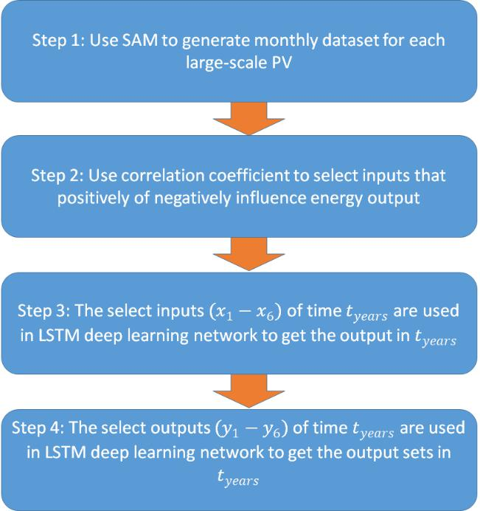

**FIGURE 4. Process flow.**

***Step 2: Input selection* -**Initially the generated weatherdata were analyzed using the correlation coefficient to find positive and negative Correlation Index (CI) for parameters associated with energy production. The CI values in this paper are calculated based on the Pearson product-moment correlation coefficient as= given∑( − �in)( (12)− �) [25]:

∑( − �)( − �) (12)

|  |  |  |  |
| --- | --- | --- | --- |
| The | | influential parameters are given in Table I. As | |
| I, |  | > ±0.5 |  |
| presented in Table I, the five major influential input values | | | |
| with | |  | are employed. As can be seen from Table |
|  | GHI and DNI are positively correlated while DHI, wet | | |

bulb, and dew point temperature are negatively correlated with energy the production.

***Step 3:*** In this step, the dataset are prepared for the trainingand testing of the hybrid deep learning structure. The

|  |  |  |  |  |  |  |
| --- | --- | --- | --- | --- | --- | --- |
| LSTM part of the hybrid deep learning technique has been | | | | | |  |
| to calculate PV output |  |  | | (this will be used in Step 4 | |  |
| used to predict inputs in | |  |  |  |
| hybrid structure). The brief | | |  | | using CNN part of the |  |
|  | for | |  |  |  |

overview of dataset preparation and hybrid deep learning is given next.

***Preparation of Dataset:*** From the available solar data,1990– 2014 (25 years), solar data from 1990 – 2013 are used for training and testing. Solar data of 2013 and 2014 are used for the validation. Fig. 7 shows the process flows which used to prepare dataset for training and testing. ***Dataset Standardization:*** The standardization process is

|  |  |  |  |  |  |  |  |  |  |  |  |  |  |  |
| --- | --- | --- | --- | --- | --- | --- | --- | --- | --- | --- | --- | --- | --- | --- |
| used to prepare the dataset to better fit and keep the | | | | | | | | | | | | | |  |
| and standard deviation are estimated to getℳ | | | | | | | | | | | | | , the mean |  |
| deviation minimum. For the dataset matrix | | | | | | | | | | | |  |  |
| dataset of . |  |  | = ∫ =1 | | | | | ℳ |  |  |  | standardizing | |  |
|  |  |  |  |  |  | (13) |  |
|  |  |  |  | � |  |  |  |  | � | |  |  | (14) |  |
|  |  |  |  | ∑ =1 ℳ −ℳ� | | | | | |  |  |  |  |
|  |  |  |  |  |  | −1 | |  |  |  |  |  |  |
| In (13)-(15), |  | is the = | | | |  |  |  |  |  |  |  |  |  |
|  |  |  | = |  |  | ℳ − | | |  |  |  |  | (15) |  |
|  | ℳ |  |  |  |  |  |  | |  |  |  |  |  |  |
| the dataset. |  | ***and*** | |  |  |  |  |  |  |  |  |
| ***Partition of Training*** | | |  |  |  |  |  | is the standardized | | |  |
|  |  |  | dataset matrix, | | | | | | |  |  |
| dataset, | is the mean, and | | | | |  |  | is the standard deviation of | | | | | |  |

***Test Data:*** The 90% of theavailable data are used for training, while, the other 10%

|  |  |  |
| --- | --- | --- |
| are used for testing. The training data size can be estimated | | |
| ***Prepare Predictors and*** | = 0.9 × sin( ) |  |
| as in (16): |  |  |
|  |  | (16) |
|  | ***Responses:*** The training sequences | |

are shifted by *n* time steps to forecast the value in future time. This has been done to make sure that the proposed method could learn to predict ahead of input sequences. The predictor and responses for the proposed algorithm can be obtained as in (17) and (18):

|  |  |  |
| --- | --- | --- |
| =(1:−)) | (17) |  |
| (18) |  |
| =(2:) |  |  |

VOLUME XX, 2017

This work is licensed under a Creative Commons Attribution 4.0 License. For more information, see https://creativecommons.org/licenses/by/4.0/.

This article has been accepted for publication in a future issue of this journal, but has not been fully edited. Content may change prior to final publication. Citation information: DOI 10.1109/ACCESS.2020.3011982, IEEE Access



Author Name: Preparation of Papers for IEEE Access (February 2017)

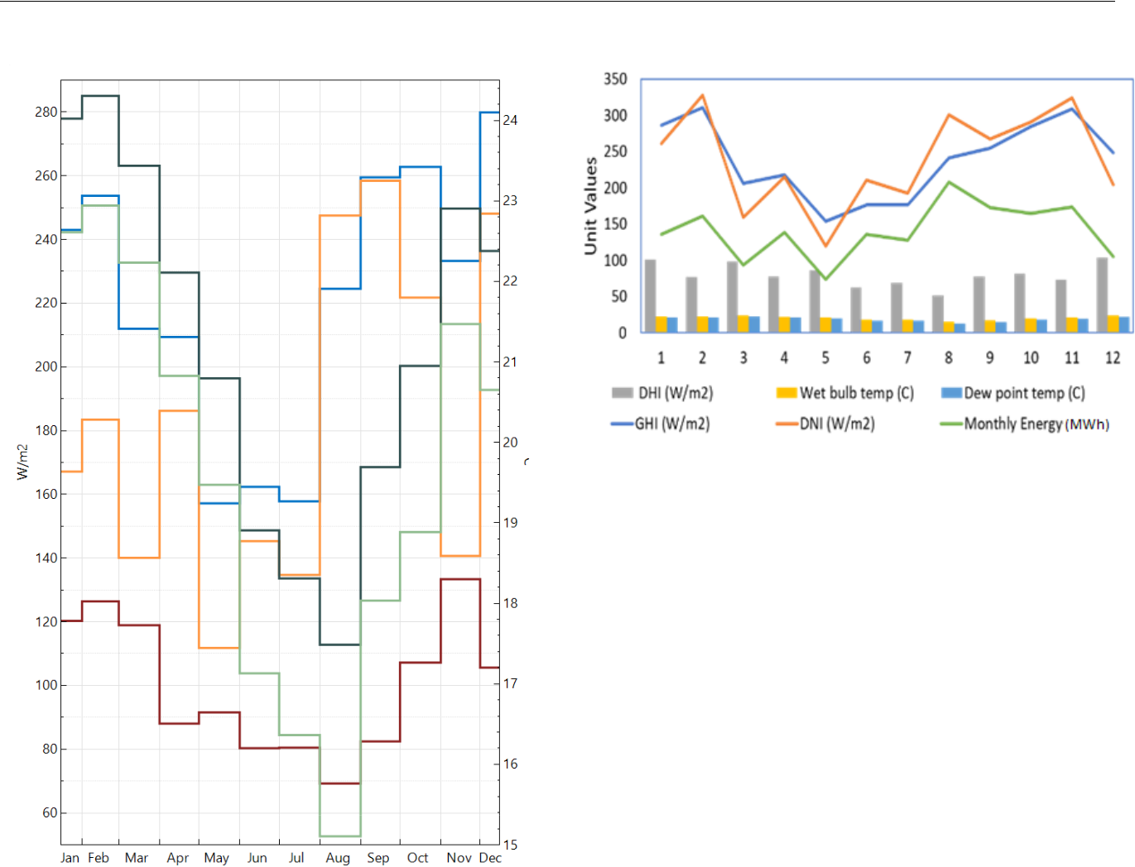

**FIGURE 5. One year meteorological output.**

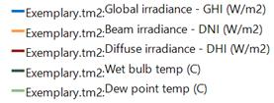

TABLE I

INFLUENTIAL WEATHER PARAMETERS

|  |  |  |  |  |  |  |  |
| --- | --- | --- | --- | --- | --- | --- | --- |
| **Influential parameters** |  | **Correlation** | |  | **Influential** | |  |
| **(Input)** |  |  |  |  | **parameters** | |  |
|  |  |  |  |  | **(output)** | |  |
| **GHI (W/m2)** |  | Positively |  |  |  |  |  |
| **DNI (W/m2)** |  | correlated |  |  | PV output |  |  |
|  |  |  | |  |  |  |
| **DHI (W/m2)** |  | Negatively |  |  |  |  |
| **Wet bulb temp (o C)** |  | correlated |  |  |  |  |  |
|  |  |  |  |  |  |  |  |
| **Dew point temp (o C)** |  |  |  |  |  |  |  |

**FIGURE 6. Influential input parameters.**

***Hybrid Deep Learning Architecture:*** The hybrid deeplearning (LSTM -CNN) architecture has been designed using LSTM and CNN deep learning techniques. Due to the weather variability, it is difficult to predict PV output accurately in longer time horizon. The CNN has intelligently adapting mechanism to understand complex relationships of properties in variable nature which motivated us to choose CNN over other deep learning methods to predict yearly PV output. As illustrated in Fig. 8, a deep learning network using two LSTM layers denoted

|  |  |  |  |  |  |  |  |  |  |  |  |  |  |
| --- | --- | --- | --- | --- | --- | --- | --- | --- | --- | --- | --- | --- | --- |
| as |  | and | |  |  |  | with 500 and 1000 hidden layers | | | | | |  |
|  | initially considered. These LSTM layers then combined | | | | | | | | | | | |  |
| are1 | |  |  |  | | 1 |  |  |  |  |  |  |  |
| with input data | | |  | | which is 5 by 12 matrix as presented | | | | | | | |  |
| in (19). | |  |  |  | 11 | − | 1 | =1…12 | |  |  |
|  |  |  |  |  | |  | (19) |  |
|  |  |  |  |  | − | − | − | � |  |  |  |
|  |  |  |  |  |  | =� 51 | |  | 5 |  |  |  |
| The LSTM network is | | | | | | designed with fully connected layer | | | | | | |  |
|  |  | − |  |  |  |  |  |
| and | regression | |  | output | | layer | | to get |  |  | outputs. The | |  |
| LSTM network was set with | | | | | | | | training option properties as | | | | |  |
|  |  | |  |  |  |

given in Table II.

The LSTM network is designed to predict input values in

|  |  |  |  |
| --- | --- | --- | --- |
| future time of *nyears* where *(nyears = years+n)*. The value | | | |
|  |  | 5 12 |  |
| of *n* can be replaced by any number of years. The output | | | |
|  | of LSTM network is |  | matrix which gives |

all influential input values of *n* years as presented in (20).

VOLUME XX, 2017

This work is licensed under a Creative Commons Attribution 4.0 License. For more information, see https://creativecommons.org/licenses/by/4.0/.

This article has been accepted for publication in a future issue of this journal, but has not been fully edited. Content may change prior to final publication. Citation information: DOI 10.1109/ACCESS.2020.3011982, IEEE Access



Author Name: Preparation of Papers for IEEE Access (February 2017)

|  |  |  |  |  |  |
| --- | --- | --- | --- | --- | --- |
|  | = [ | − | ] |  |  |
|  | 11 | =1…12 | (21) |  |
|  |  |  |

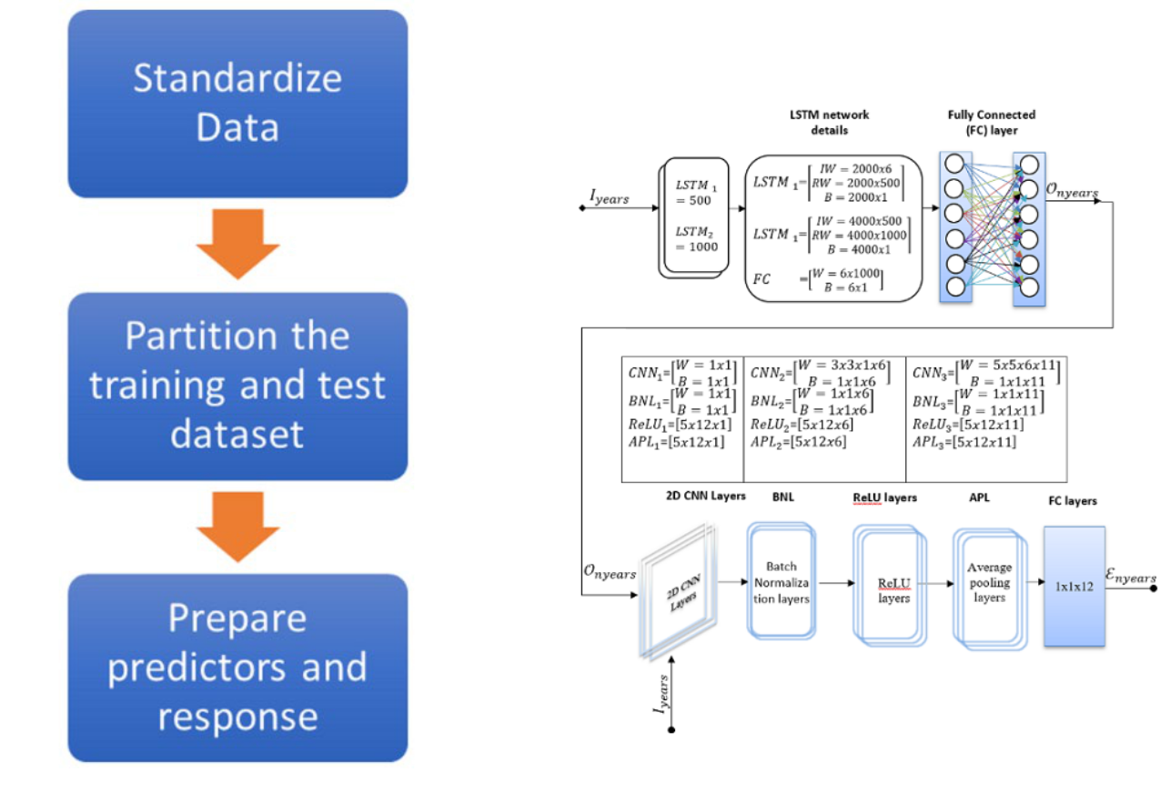

**FIGURE 8. Hybrid deep learning structure for long term PV forecasting.**

**FIGURE 7. Steps to prepare data for machine learning.**

TABLE II

LSTM TRAINING VALUES

|  |  |  |  |  |  |  |  |  |  |
| --- | --- | --- | --- | --- | --- | --- | --- | --- | --- |
|  | **Options** | |  |  |  | **Values** | |  |  |
|  | **Squared Gradient Decay Factor:** | | |  |  | 0.9000 | |  |  |
|  | **Epsilon** |  |  |  |  | 1.0000e-08 | |  |  |
|  | **Initial Learn Rate** |  |  |  |  | 0.0050 | |  |  |
|  | **Learn Rate Schedule Settings** | | |  |  | [1×1 struct] | |  |  |
|  | **L2Regularization** |  |  |  |  | 1.0000e-04 | |  |  |
|  | **Max Epochs** |  |  |  |  |  | 100 |  |  |
|  | **Mini Batch Size** |  |  |  |  |  | 128 |  |  |
|  |  | (5×12×1) | = � | 11 | − | 1 | =1..5 | (20) |  |
|  |  | − | − | − | � |  |  |
|  |  | |  |  |  |  |
|  | ***Step 4:*** The output from | |  | 1 | − |  |  |  |
|  |  |  | LSTM network used as the inputs | | | | | |  |

into the CNN network as presented in Fig. 8. The CNN network is designed with three 2D CNN deep learning networks followed by equal numbers of BNL, ReLU layers, and APL. The CNN network also added with DL to handle overfitting. Finally, it has fully connected layers of 12 outputs for each year which is followed by the regression layer. The network was set with training option properties as

|  |  |  |  |  |  |  |
| --- | --- | --- | --- | --- | --- | --- |
| given in Table III. The CNN network is then trained using | | | | | | |
| (21) (where value of |  | ℰ | |  |  |  |
| *Iyears* where *Iyears =* | 24 from 1990 to 2013. It was then used | | | | | |
| to predict output energy | |  |  | for |  | time as given in |
|  | = | | ). | | |  |

TABLE III

CNN TRAINING VALUES

|  |  |  |
| --- | --- | --- |
|  | **Options** | **Values** |
|  | **Initial Learn Rate** | 1.0000e-03 |
|  | **L2 Regularization** | 1.0000e-04 |
|  | **Momentum** | 0.9000 |
|  | **Learn Rate Schedule Settings** | [1×1 struct] |
|  | **L2 Regularization** | 1.0000e-04 |
|  | **Max Epochs** | 300 |
|  | **Mini Batch Size** | 128 |

**V. RESULTS AND DISCUSSIONS**

***A. PREDICTION RESULTS***

The forecasted performance is tested in North Queensland locations, e.g. Cairns, Gladstone, Rockhampton, and Townsville. However, due to the brevity, only the results related to Cairns are presented in this section. Historical meteorological data from 1990 to 2013 in Cairns has been used for the training of the model. The downloaded data files have some low quality, missing data, and format compliance to SAM and the proposed prediction model. To resolve these problems, data cleaning has been carried out based on the physical model. The SAM has also been used for data cleaning in this paper. For example, if the PV output obtained more than

VOLUME XX, 2017

This work is licensed under a Creative Commons Attribution 4.0 License. For more information, see https://creativecommons.org/licenses/by/4.0/.

This article has been accepted for publication in a future issue of this journal, but has not been fully edited. Content may change prior to final publication. Citation information: DOI 10.1109/ACCESS.2020.3011982, IEEE Access



Author Name: Preparation of Papers for IEEE Access (February 2017)

the capacity value for very low irradiance or output of PV at night, flagged as bad data. Sometimes the PV output could be obtained due to missing data. This is also flagged as bad data. Similar to [7], 5271 hours out of 5461 daytime are considered as good data in this work. The bad data are excluded from the training of the proposed method. Often the missing data have been filled based on the previous hour of measurements. The SAM model is later used to compare the forecast model with the baseline PV model.

After processing the monthly weather input parameters and energy output estimated by step 1 and step 2 given in Section IV. The historical dataset of 24 years with a list of input values

|  |  |  |  |  |  |  |
| --- | --- | --- | --- | --- | --- | --- |
| are established. These have been processed later to pepare a | | | | | |  |
| proposed |  | =24 | as in (18) for LSTM (see step 3). The | | |  |
| input matrix | |  |  |
| 6 years as illustrated in Fig. 9. | | | | =6 | for |  |
|  | LSTM algorithm predict output matix | | |  |  |

In Fig. 9, GHIs from 2014 to 2020 are presented. The predicted value of GHIs is compared with the actual measured values to validate the performance of the proposed method. From the results, it is evident that the forecasted values are well -matched with the actual measurements. The rest of the GHI values from 2015 to 2020 are predicted using

|  |  |  |  |
| --- | --- | --- | --- |
| the proposed hybrid algorithm. These predicted values then | | |  |
| to get the energy outputs | = 6 | as given in (19) |  |
| used with other predicted input |  |  |

from 2015 to 2020 in Cairns (Latitude -16.8833 and longitude 145.75).

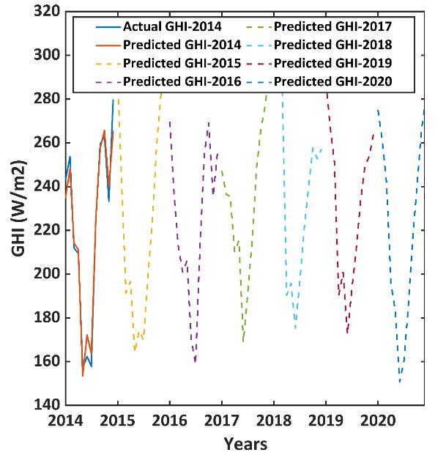

**FIGURE 9. Yearly forecasted GHI in Cairns.**

Fig. 10 shows the actual and predicted energy output for the PV system in Cairns for 2014 to validate the accuracy of the model. The physical model of the PV system and the actual meteorological data are used to get the actual value, whereas, the predicted meteorological data have been used to get the PV output for 2014 using the physical model of PV. From

the results given in Fig. 10, it is evident that the predicted energy output almost accurately matched with the actual energy output of 2014 with errors less than 3.3. It should be worth noting that energy prediction in May and September showed the highest positive errors, while August has the highest negative error. From the results in Fig. 10, it is evident that the forecasted energy value closely matched with the actual values of energy in 2014. Thereby, it is evident that the proposed method is able to forecast the long-term energy from PV systems.

The proposed method is further used to estimate the energy output of a PV system at Cairns. Yearly predicted energy outputs are given in Fig. 11 for 2015 to 2020. From the yearly predicted results, it is evident that the energy production would be high from September to January and low from February to August – which are the general trends for the PV systems in North Queensland.

***B. COMPARATIVE ANALYSIS***

There are no standard sets of performance comparison parameters to be used in the existing forecasting techniques. Hence, it is important to cover a reasonable range of performance parameters for benchmarking the proposed method. Four well-known forecasting performance parameters such as RMSE, nRMSE, mean absolute percent error (MAPE), and Rvalue are used to benchmark the proposed algorithm.

The RMSE is more sensitive to forecast errors [14], [26]. Hence, it is suitable where the small errors are more tolerable than the larger ones. The RMSE can be expressed as in (22) [14]:

|  |  |  |  |  |  |  |  |  |  |  |  |  |  |  |  |  |  |  |  |  |
| --- | --- | --- | --- | --- | --- | --- | --- | --- | --- | --- | --- | --- | --- | --- | --- | --- | --- | --- | --- | --- |
|  |  |  |  |  |  | = |  |  | 1 | × ∫ |  | � | − | | |  | � | 2 |  |  |
|  |  |  |  |  |  |  |  |  |  |  |  |  |  |  | (22) |  |
|  |  |  |  |  |  |  | � | | | =1 | |  |  |  |  |  |  |  |
| power, | | |  |  |  | |  |  |  |  |  |  |  |  |  |  |  |  |
| is |  |  |  |  | is actual |  |  | output power, | | | | |  |  | is forecasted | | | |  |
| In (22), | | | |  |  |  |  |  |  |
|  |  |  | and | | the number of observations. The RMSE error | | | | | | | | | | | | | | |  |
| of | to get nRMSE | | | | as given in | | | | | | (23). It should be noted | | | | | | | |  |
|  | nomalized with respect to maximum and minimum value | | | | | | | | | | | | | | | | | | |  |

that the lower the RMSE and nRMSE values, better the

|  |  |  |
| --- | --- | --- |
| = | ~~−~~ |  |
| performance of the algorithm for forecasting. | |  |
|  | | (23) |

The MAPE is widely used index to determine the forecast accuracy with respect of scale-independency and

|  |  |  |  |  |  |  |  |  |  |  |
| --- | --- | --- | --- | --- | --- | --- | --- | --- | --- | --- |
| interpretability. The MAPE and error variance can be | | | | | | | | | |  |
| where | is the(%) = | | | ∫ =1 | |  |  | |  |  |
| calculated as in (24) [17], [26], and [27]: | | | | | | | |  |  |  |
|  |  |  |  | 1 |  | − | | | (24) |  |
| power |  |  |  |  |  |  | |  |  |  |
| accuracy of | |  |  | | |  | is the peak output | |  |
|  |  | forecast horizon and | | | |  |  |  |
| at | time |  | . A higher |  |  |  | value means | | lower |  |

forecasting algorithms whereas lower MAPE value means high accuracy of the forecasting algorithms.

VOLUME XX, 2017

This work is licensed under a Creative Commons Attribution 4.0 License. For more information, see https://creativecommons.org/licenses/by/4.0/.

This article has been accepted for publication in a future issue of this journal, but has not been fully edited. Content may change prior to final publication. Citation information: DOI 10.1109/ACCESS.2020.3011982, IEEE Access



Author Name: Preparation of Papers for IEEE Access (February 2017)

**FIGURE 10. Monthly energy prediction at Cairns in 2014.**

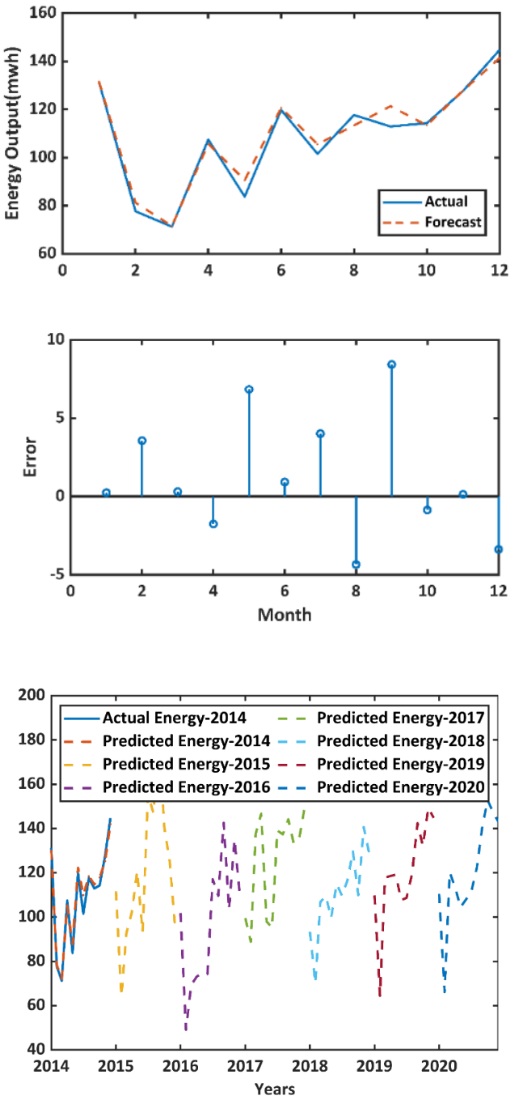

**FIGURE 11. Yearly predicted energy value.**

The Rvalue is the correlation between the predicted values and the observed values [27]-[29]. It gives an idea about the model generalization. An Rvalue close to one means, the forecasting values are highly close to the fitted regression line and it can be used in more generalized cases. The Rvalue can be calculated as in (25) [27]-[29]:

= �1 − ∑ − �2�

∑ �2 (25)

Table IV shows the baseline comparison of the proposed method against the four well-established methods given in

the literature to forecast the long-term energy from the PV system. All four benchmarking performance indices mentioned earlier are used for the comparison. From the results given in Table IV, it is evident that the proposed method has the RMSE of 3.89 which is very low compared to the other methods. The nRMSE value for the proposed method is 0.0529, considerably low with compared to others. However, this can be further improved with training. The given algorithm outperforms all other existing algorithms in MAPE which is 2.83 for the studied location. Furthermore, the Rvalue of the proposed method is 0.9. This indicates that the proposed method is very close to the fitted regression line. Moreover, it is worth noting that the Rvalue of the proposed method is higher with compared to statistical analysis. However, Rvalue of the given method is slightly low with compared to random forest and NNE. From the comparative results, it is evident that the proposed forecasting algorithm is more accurate for forecasting the long-term energy output from PV system.

Fig. 12 illustrated the values of RMSE and MAPE for all four studied locations in the North Queensland, e.g. Cairns, Gladstone, Rockhampton, and Townsville for the proposed method. From the results given in Fig. 12, it is evident that the RMSE values are lower than 15 in all studied locations for the given method. Moreover, the given algorithm has good forecast quality for various locations with RMSE ranging between 3.89 – 11.87. It should be worth to note that the MAPE values of the studied locations are ranging between 2.5 –7.8, which makes the proposed method more reliable in estimating long-term energy output of PV.

Further analyses are conducted to evaluate the reliability of the proposed method for different datasets and layers for LSTM. The RSME, MAPE, nRMSE, and Rvalue are used as the indices to measure the reliability of the proposed method. Table VI gives the performance of the proposed model under different lengths of training data (i.e. 5 years, 10 years, and 25 years).

TABLE IV

BENCHMARKING OF THE PROPOSED ALGORITHM -CARINS

|  |  |  |  |  |  |
| --- | --- | --- | --- | --- | --- |
|  | **Algorithm** | **RMSE** | **nRMSE** | **MAPE** | **Rvalue** |
|  | **ANN** | - | 0.2257 | 11.42 | - |
|  | **Random Forest** | 27.5 | 0.1356 | 8.84 | 0.94 |
|  | **NNE** | 80.62 | 0.1965 | 8.73 | 0.98 |
|  | **Statistical analysis** | 15.80 | 0.1171 | 5.67 | 0.69 |
|  | **Proposed deep** | 3.89 | 0.0529 | 2.83 | 0.90 |
|  | **learning method** |  |  |  |  |

Table VII shows the performance of the proposed method under different LSTM layers and standard deviation of indices in relation to result presented in Table IV. From the results given in Table VI and VII, it is evident that *the* mean standard deviations of all the indices are lower in relation to actual values presented in Table IV. For example, the average RMSE standard deviations varies in worst case scenarios is ± 1.2 only whereas ± 0.2 best case scenarios.

VOLUME XX, 2017

This work is licensed under a Creative Commons Attribution 4.0 License. For more information, see https://creativecommons.org/licenses/by/4.0/.

This article has been accepted for publication in a future issue of this journal, but has not been fully edited. Content may change prior to final publication. Citation information: DOI 10.1109/ACCESS.2020.3011982, IEEE Access



Author Name: Preparation of Papers for IEEE Access (February 2017)

Therefore, the performance indices for the given method are lower under various factors affecting the forecasting performance.

From the results given in Table VI, it should be worth noting that the Rvalue reduced significantly for the smaller training dataset. Moreover, the MAPE value for the lower training datasets is also high. However, the average changes are low which suggests that the proposed method is reliable.

**VI. CONCLUSIONS**

This paper proposed a new and reliable method forforecasting the long-term output of solar PV. The proposed method utilized the multivariate long and short-term memory and convolutional neural network to develop the technique for forecasting the PV output. This paper utilized the twenty-four years of historical data from various locations in North Queensland in Australia to validate the performance of the developed model. Additional meteorological parameters have been used in the proposed algorithm based on their positive and negative influences on the output of the PV system. From the given results and comparisons, it is evident that the proposed method may accurately predict the long-term output of the PV system for planning studies with RMSE lower than 15 for all studied locations. Moreover, the proposed method is robust compared to some well-established methods such as ANN, Random Forest, NNE, and others. The proposed algorithm was run in MATLAB R2018b (9.5) with the computational cost for training and prediction of 203.63 s. Therefore, it could be considered as a low computation cost algorithm compared to others.

TABLE VI

PERFORMANCE OF THE PROPOSED METHOD FOR VARIOUS LENGTH OF TRAINING DATA

|  |  |  |  |  |  |  |  |  |
| --- | --- | --- | --- | --- | --- | --- | --- | --- |
|  |  | **No of** | **RMSE** | **nRMSE** | **MAPE** | | **Rvalue** |  |
|  | **10** | | 4.69(±1.4) | 0.1342(±0.5) | 4.58( | ±5) | 0.83(±0.4) |  |
|  |  | **year** |  |  |  |  |  |  |
|  |  | **5** | 6.78( | 0.1458( | 13.50( | | 0.80( |  |
|  |  | | 3.89(±0) | 0.0529(±0) | 2.83(±0) | | 0.95(±0.06) |  |
|  |  | **25** |  |

TABLE VII

PERFORMANCE OF THE PROPOSED METHOD FOR VARIOUS LAYER OF

LSTM

|  |  |  |  |  |  |  |  |
| --- | --- | --- | --- | --- | --- | --- | --- |
|  | **No of** | **RMSE** | **nRMSE** |  | **MAPE** | **Rvalue** |  |
|  | **layer** |  |  |  |  |  |  |
|  | **in** | 4.89(±1.6) | 0.1229(±0.02) | 3.69(±1.5) | | 0.93(±0.01) |  |
|  | **2** |  |
|  | **LSTM** |  |  |  |  |  |  |
|  | **3** | ±0.5) | ±0.03) | 2. | ±0.4) | ±0.01) |  |
|  | **1** | 7.15( | 0.0946( | 5.89( | | 0.92( |  |
|  |  |  |  |  |  |  |  |
|  |  | 3.69(±0.1) | 0.0963(±0.02) |  | 95(±0.06) | 0.95(±0.03) |  |
|  |  |  |  |  |  |  |  |

TABLE V

RVALUE OF VARIOUS LOCATIONS

**Location** **Rvalue**

|  |  |  |
| --- | --- | --- |
|  | **Cairns** | 0.90 |
|  | **Gladstone** | 0.97 |
|  | **Rockhampton** | 0.99 |
|  | **Townsville** | 0.98 |

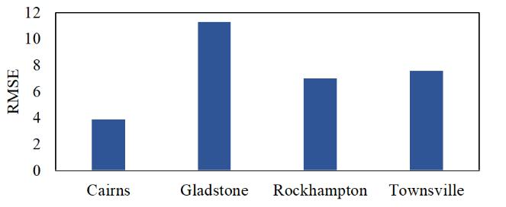

**(a)**

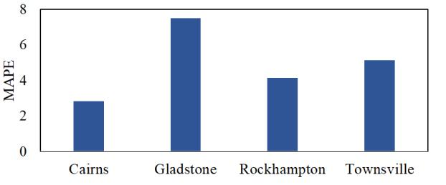

**(b)**

**FIGURE 12. Comparative results of various locations in North Queensland: (a) RMSE; (B) MAPE.**

In this study, several assumptions had to make for PV output forecasting. Therefore, further sensitivity study around this domain would be performed in the future. This work will be further extended to forecast the long-term generation reserve in power systems with high penetration of wind and solar in Australia.

**REFERENCES**

1. Y. P. Agalgaonkar, B. C. Pal, and R. A. Jabr, “Statistical distribution system operation considering voltage regulation risks in the presence of PV generation,” *IEEE Trans. Sustainable Energy,* vol. 6, no. 4, pp. 1315-1324, Oct. 2014.
2. M. Marinelli, P. Maule, A. N. Hahmann, O. Gehrke, P. B. Norgard, and N. A. Cutuluis, “Wind and photovoltaic large-scale regional models for hourly production evaluation,” *IEEE Trans. Sustainable Energy,* vol. 6, no. 3, pp. 916-923, 2015.
3. A. Tascikaraoglu *et. al.,* “Compressive spatio-temporal forecasting of meteorological quantities and photovoltaic power,” *IEEE Trans.* *Sustainable Energy*, vol. 7, no. 3, pp. 1295-1305, Jul. 2016.
4. E. Lorenz, J. Hurka, D. Heinemann, and H. G. Beyer, “Irradiance forecasting for the power prediction of grid connected photovoltaic systems,” *IEEE J. Special Topics Appl. Earth Obs. Remote Sens.,* vol. 2, no. 1, pp. 2-10, Mar. 2009.
5. M. P. Mittermaier, R. Bullock, “Using MODE to explore spatial and temporal characteristics of cloud cover forecasts from high-resolution NWP models,” *Meteorol. Appl.,* vol. 20, pp. 187-196, 2013.
6. F. Bizzari, M. Bongiorno, A. Brambilla, G. Gruosso, and G. S. Gajani,

VOLUME XX, 2017

This work is licensed under a Creative Commons Attribution 4.0 License. For more information, see https://creativecommons.org/licenses/by/4.0/.

This article has been accepted for publication in a future issue of this journal, but has not been fully edited. Content may change prior to final publication. Citation information: DOI 10.1109/ACCESS.2020.3011982, IEEE Access



Author Name: Preparation of Papers for IEEE Access (February 2017)

“Model of photovoltaic power plants for performance analysis and product forecast,” *IEEE Trans. Sustainable Energy,* vol. 4, no. 2, pp. 278-285, Apr. 2013.

1. X. Zhang, Y. Li, S. Lu, H. F. Hamann, B. Hodge, and B. Lehman, “A solar time-based analog ensemble method for regional solar power forecasting,” *IEEE Trans. Sustainable Energy,* vol. 10, no. 1, pp. 268-279, Jan. 2019.
2. D. P. Larson, L. Nonnenmacher, and C. F. M. Coimbra, “Day-ahead forecasting of solar power output from photovoltaic plants in the American Southwest,” *Renewable Energy,* vol. 91, pp. 11-20, Jun. 2016.
3. E. Zortia, H. V. Storch, “The analog method as a simple statistical downscaling technique; Comparison with more complicated methods,” *J. Clim.,* vol. 12, pp. 2474-2489, 1999.
4. R. Perez, S. Kivalov, J. Schlemmer, K. Hemker, D. Renne, and T. E. Hoff, “Validation of short and medium term operational solar radiation forecasts in the US,” *Solar Energy,* vol. 84, pp. 2161-2172. Dec. 2010.
5. C. Yang, A. A. Thatte, and L. Xie, “Multitime-scale data driven spatio temporal forecast of photovoltaic system,” *IEEE Trans. Sustainable* *Energy,* vol. 6, no. 1, pp. 104-112, Jan. 2015.
6. J. Liu, W. Fang, X. Zhang, and C. Yang, “An improved photovoltaic power forecasting model with the assistance of aerosol index data,” *IEEE Trans. Sustainable Energy,* vol. 6, no. 2, pp. 434-442, Apr. 2015.
7. Commonwealth Scientific and Industrial Research Organization (CSIRO), ‘Australian Solar Energy Forecasting System Final Report: Project, results, and Lessons Learnt,’ 2016. [Online]. Available: https://arena.gov.au/assets/2016/07/Aus-Solar-Energy-Forecasting-System-Final-Report.pdf .
8. L. Benali, G. Notton, A. Fouilloy, C. Voyant, R. Dizene, “Solar radiation forecasting using artificial neural network and random forest methods: Application to normal beam, horizontal diffuse and global components,” *Renewable Energy*, vol. 132, pp. 871-884, 2019.
9. A. Y. Alanis, L. J. Ricalde, C. Simetti, and F. Odone, “Neural model with particle swarm optimization Kalman learning for forecasting in smart grids,” *Math. Prob. Eng.*, vol. 2013, pp. 1-9, 2013.
10. D. Zhang, X. Han, and C. Deng, “Review on the research and practice of deep learning and reinforcement learning in smart grids,” *CSEE J.* *Power Energy Systems*, vol. 4, no. 3, pp. 362-370, 2018.
11. M. Q. Raza, N. Mithulananthan, J. Li, K. Y. Lee, and H. B. Gooi, “An ensemble framework for day-ahead forecast of PV output power in smart grids,” *IEEE Trans. Ind. Inf.*, vol. 15, no. 8, pp. 4624-4634, Aug. 2019.
12. K. Yan, W. Li, Y. Ji, M. Qi, and Y. Du, “A hybrid LSTM Neural network for energy consumption forecasting of individual households,” *IEEE ACCESS,* vol. 7, pp. 157633-157642, 2019.
13. Exemplary Energy Pty Ltd. [Online]. Available: [http://www.eemplary.com.au.](http://www.eemplary.com.au/)
14. H. D. Hubel, T. N. Wiesel, “Receptive fields of single neurons in the Cat’s striate cortex,” *J. Physiology*, vol. 148, pp. 574-591, 1959.
15. S. Hochreiter, J. Schmidhuber. "Long short-term memory." *Neural* *Computation,* vol. 9, no. 8, pp.1735–1780, 1997.
16. The MathWorks, Inc., 'Specify Layers of Convolutional Neural

Network,' 2017. [Online]. Available:

https://au.mathworks.com/help/deeplearning.

1. J. Nagi *et. al*., “Max-pooling convolutional neural networks for vision-based hand gesture recognition,” in Proc. *IEEE Int. Conf. Signal Image* *Processing Appl. (ICSIPA)*, Kuala Lumpur, pp. 342-347, 2011.
2. N. Blair, A. Dobos, J. Freeman, T. Neises, and M. Wagner, ‘System Advisor Model, SAM,’ 2014. [Online]. Available: <https://www.nrel.gov/docs/fy14osti/61019.pdf>
3. J. L. Rodgers, W. L. Nicewander, “Thirteen ways to look at the correlation coefficient,” *The American Statistician*, vol. 42, pp. 59-66, 1988.
4. A. Manthiri, ‘PSNR MSE R RMSE NRMSE MAPE Calculation,’ 2017. [Online]. Available: [https://au.mathworks.com/matlabcentral.](https://au.mathworks.com/matlabcentral)
5. A. Zagouras, H. T. Pedro, and C. F. Coimbra, "On the role of lagged exogenous variables and spatio–temporal correlations in improving the accuracy of solar forecasting methods," *Renewable Energy*, vol. 78, pp. 203-218, 2015.
6. B. Ray, R. Shah, "Performance assessment of prospective PV systems in Queensland and New South Wales of Australia," in Proc. *IEEE PES* *GTD Grand Int. Conf. Exp. Asia (GTD Asia)*, Thailand, pp. 200-205,

2019.

1. F. Li, C. Li, J. Shi, J. Zhao, X. Yang, and Z. Chen, “Evolution index system for photovoltaic systems characteristics under hazy weather conditions in central China,” *IET Renewable Power Generation,* vol. 11, no.14, pp. 1794-1803, 2017.

**BIPLOB RAY (M’14**) received his Ph.D. degreefrom the Deakin University, Australia in Information Technology. He is working as a senior lecturer in Information Technology at CQUniversity, with a background of mix of research, academic, and industry experience. His teaching and research are currently focused on networked intelligent systems, big data, security protocols, and privacy of mHealth. His high-quality



research work has been recognized by peers and cited extensively. He has more than 20 international journal and conference publications. He has appeared as a keynote/Plenary speaker at a number of international conferences.

**RAKIBUZZAMAN SHAH (M’14**) received thePh.D. degree from the University of Queensland, Brisbane, QLD, Australia. He is a Senior Lecturer in Smart Power Systems Engineering within the School of Engineering, Information Technology and Physical Sciences at Federation University Australia (FedUni Australia). Prior to join Federation University Australia, he has worked with the University of Manchester, the University



of Queensland, and Central Queensland University. He has experience working at, and consulting with, DNOs and TSOs on individual projects and collaborative work on large projects (EPSRC project on Multi-terminal HVDC, Scottish and Southern Energy Multi-infeed HVDC) - primarily on the dynamic impact of integrating new technologies and power electronics into large systems. He is an active member of the IEEE and CIGRE. He has more than 60 international journal and conference publications (including 18 journals in IEEE and IET) and have spoken at the leading power system conferences around the world. His research interest include Future power grids (i.e. Renewable energy integration, wide-area control), asynchronous grid connection through VSC -HVDC, power system stability and dynamics, application of data mining in power system, application of control theory in power system, distribution system energy management and low carbon energy system.

**MD RABIUL ISLAM (M’14–SM’16)** receivedthe Ph.D. degree from University of Technology Sydney (UTS), Sydney, Australia, in 2014 in electrical engineering.



He was appointed a lecturer at RUET in 2005 and promoted to full professor in 2017. In early 2018, he joined at the School of Electrical, Computer, and Telecommunications Engineering (SECTE), University of Wollongong (UOW), Wollongong,

Australia. He is also a member of Australian Power Quality and Reliability Center of UOW. He is a Senior Member of IEEE. His research interests are in the fields of power electronic converters, renewable energy technologies, power quality, electrical machines, electric vehicles, and smart grid. He has authored or co-authored 150 papers (including 40 IEEE Transactions papers) in international journals and conference proceedings. He has written or edited 4 technical books published by Springer. He has served as a Guest Editor for IEEE Transactions on Energy Conversion, IEEE Transactions on Applied superconductivity, and IET Electric Power Applications. He has been serving as an Editor for IEEE Transactions on Energy Conversion and IEEE Power Engineering Letters, and Associate Editor for IEEE Access. He has received several funding from Government and Industries including Australian Government ARC Discovery Project 2020 entitled “A Next Generation Smart Solid-State Transformer for Power Grid Applications”.

11

This work is licensed under a Creative Commons Attribution 4.0 License. For more information, see https://creativecommons.org/licenses/by/4.0/.

This article has been accepted for publication in a future issue of this journal, but has not been fully edited. Content may change prior to final publication. Citation information: DOI 10.1109/ACCESS.2020.3011982, IEEE Access



Author Name: Preparation of Papers for IEEE Access (February 2017)

**SYED ISLAM (FIEEE’19)** received the B.Sc.



degree in electrical engineering from the

Bangladesh University of Engineering and

Technology, Bangladesh, in 1979, and the M.Sc.

and Ph.D. degrees in electrical power engineering

from the King Fahd University of Petroleum and

Minerals, Dhahran, Saudi Arabia, in 1983 and

1988, respectively. He has been a Visiting

Professor with the Shanghai University of

Electrical Power, and Xian Jiatong University, China. He is currently the

Dean of the School of Engineering, Information Technology and Physical

Sciences, Federation University Australia, Australia. He received the

Dean’s medallion for research at Curtin University, in 1999. He has

published more than 300 technical articles in his area of expertise. His

research interests include condition monitoring of transformers, wind

energy conversion, and smart power systems. He was a member of the

Steering Committee of the Australian Power Institute and a member of the

WA EESA Board. He is a Fellow of the Engineers Australia, a Fellow of

the IET, and a Chartered Engineer in U.K. He received the IEEE T Burke

Haye’s Faculty Recognition Award, in 2000. He received the Curtin

University Inaugural Award for Research Development, in 2012. He

received the Sir John Madsen Medal, in 2011 and 2014, for the Best

Electrical Engineering Paper in Australia. He was a Founding Editor of the

IEEE TRANSACTION ON SUSTAINABLE ENERGY and currently an

Associate Editor of the IET Renewable Power Generation. He was the Guest

Editor-in-Chief of the IEEE TRANSACTION ON SUSTAINABLE

ENERGY special issue on Variable Power Generation Integration into Grid.

He has been a keynote speaker and invited speaker at many international

workshops and conferences.

12

This work is licensed under a Creative Commons Attribution 4.0 License. For more information, see https://creativecommons.org/licenses/by/4.0/.