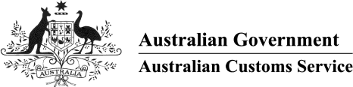

AUSTRALIAN CUSTOMS NOTICE NO. 2003/68

Revocation of unnecessary Tariff Concession Orders

The purpose of this notice is to advise that the Australian Customs Service (Customs)

is migrating Tariff Concession Orders (TCOs) to a new computer system as part of release 3 of the Cargo Management Re-Engineering Project.

Prior to the migration of data, Customs will be reviewing all TCOs and will be revoking any unnecessary TCOs. A TCO is considered to be unnecessary if the goods covered by that TCO can be imported under another, more recent TCO. Quite often, the more recent TCO covers a broader range of goods.

The TCOs to be revoked will be published in the *Gazette* at least 28 days before revocation. The notice in the *Gazette* will include details of the (more recent) TCO that should be used following the revocation action.

The process of reviewing and revoking unnecessary TCOs will be ongoing.

Importers and customs brokers will not be disadvantaged by the revocation action, as TCOs will continue to apply to the same range of goods. Before attempting to use a TCO, an importer or customs broker should check the list of concessional instruments to ensure that the TCO still exists.

Inquiries concerning this notice may be directed to the Tariff Concessions Section on telephone number (02) 6275 6489 or fax number (02) 6275 6376.

John Arndell

Acting National Manager Trade Branch CANBERRA ACT

November 2003

