

AUSTRALIAN CUSTOMS NOTICE NO. 2007/06

Notices of Objection to Importation - Trade Marks Act 1995

The *Trade Marks Act 1995* allows the registered owner, or in certain circumstances, the authorised user of a trade mark to lodge a Notice of Objection with the Australian Customs Service (Customs), objecting to the importation of goods which infringe their trade mark. Unless revoked, a Notice of Objection remains in force for a period of four years (effective 23 October 2006) from the date of commencement.

The attached Schedule sets out the registered owners and authorised users who have lodged Notices of Objection under the *Trade Marks Act 1995* since December 2006 (ACN 2006/61)*.* Descriptions of the relevant trade marks are also set out in the Schedule.

A detailed list of all current Notices of Objection is available on the Customs website at [http://www.customs.gov.au/site/page.cfm?u=493](http://cwww.customs.gov.au/internet/site/page.cfm?u=4934387.htm)

For each particular trade mark described, the Schedule makes reference to a particular “class” of goods. This refers to the classes of goods prescribed in Schedule 1 to the *Trade Marks Regulations 1995* and along with a description of the goods, is used to describe the type of goods for which the particular trade mark is registered. Prospective importers of such goods should seek further advice from Customs regarding the ambit of any Notice of Objection set out in the Schedule.

Goods referred to in this ACN, that are manufactured outside and imported into Australia, and are subject to the control of Customs under the meaning of the *Customs Act 1901* are liable to be seized by Customs if:

* they have applied to them, or in relation to them, a sign that is substantially identical with, or deceptively similar to, a trade mark listed in the attached Schedule; and
* are goods in respect of which the notified trade mark is registered;

unless it can be established that the goods do not infringe the relevant trade mark.

Part 12 of the *Trade Marks Act 1995* details the circumstances in which the use of a trade mark may, or may not, amount to an infringement. For example, a trade mark is not infringed where the mark in question has been applied to, or in relation to, goods with the consent of the registered owner of the trade mark. However, where the trade mark is applied by, or with the consent of, an overseas owner of the trade mark and the goods are imported into Australia without the consent of the Australian trade mark owner, this may still represent an infringement.

People who are intending to import goods that potentially may be liable to seizure under the provisions of the *Trade Marks Act 1995* should consider seeking advice from Customs, or a suitably qualified legal practitioner, as to the implications of the trade marks legislation, and the meaning of terms such as "substantially identical with", "deceptively similar to" and "an infringement of" a trade mark.

Where a registered trade mark owner or an authorised user with a current Notice of Objection in place request additional trade marks to be added to their Notice, only the additional trade marks are included at the end of this ACN. The inclusion of additional trade marks in the ACN is to ensure that ACN subscribers have all the appropriate up-to-date information.

Copies of the relevant Notices of Objection have been forwarded to the Customs office in the capital city of each State and Territory. Importers, or their advisers, who require further information regarding the Notices of Objection, or Customs role in respect of those Notices, should contact the Customs Information and Support Centre on 1300 363 263 or the Intellectual Property Rights Group on (02) 6275 6577.

Tim Chapman National Manager

Trade Policy & Regulation Branch CANBERRA ACT

January 2007



SCHEDULE TO ACN NO. 2007/06 TRADE MARK NOTICES OF OBJECTION

***Columbia Pictures, Inc. Australian Federation Against Copyright Theft Ph: (02) 9997 8011***

***Effective Date: 25 November 2006 File Ref: C06/18953 Trade Marks Class Goods***

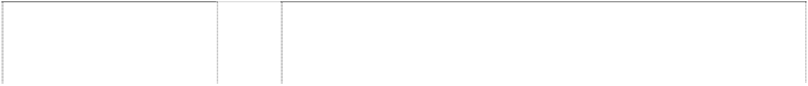

# COLUMBIA

sun, rays Statue of Liberty women holding torch Statue of Liberty

(70314)

# COLUMBIA PICTURES

(443297)

9 Silent picture films and talking picture films prepared for exhibition.

9 Motion picture films, video tapes, video cassettes and all other forms of movies and television programs included in this class.

# COLUMBIA PICTURES

Statue of Liberty woman, holding torch sun, rays (435909)

Statue of Liberty in front of cloud, all in rectangle (600693)

Statue of Liberty woman, holding torch sun, rays (435911)

9 Motion picture films, video tapes, video cassettes and all other forms of movies and television programs included in this class.

9 All goods in this class.

9 Motion picture films, video tapes, video cassettes, video discs, all forms of motion pictures and television programs included in this class; and all other goods in this class.



***Country Road Clothing Pty Ltd Freehills***

***Ph: (03) 9288 1577***

***Effective Date: 9 December 2006 File Ref: C07/00068***



|  |  |  |
| --- | --- | --- |
| ***Trade Marks*** | ***Class*** | ***Goods*** |
| **COUNTRY ROAD**  (413122) | 3 | All goods in this class. |
| **COUNTRY ROAD**  (513264) | 5 | All goods in this class. |
| **COUNTRY ROAD**  (513265) | 8 | All goods in this class. |
| **COUNTRY ROAD**  (513266) | 10 | All goods in this class. |
| **COUNTRY ROAD**  (513267) | 11 | All goods in this class. |
| **COUNTRY ROAD**  (513268) | 14 | All goods in this class. |
| **COUNTRY ROAD**  (505560) | 16 | All goods in class 16 except maps. |
| **COUNTRY ROAD**  (413119) | 18 | All goods in this class. |

# COUNTRY ROAD



(513269)

# COUNTRY ROAD

(513270)

# COUNTRY ROAD

(460315)

# COUNTRY ROAD

(466701)

# COUNTRY ROAD

(306379)

# COUNTRY ROAD

(466700)

# COUNTRY ROAD

(513272)

# COUNTRY ROAD

(513273)

# COUNTRY ROAD

(548520)

# COUNTRY ROAD

(548521)

1. All goods in this class.
2. All goods in this class.
3. All goods in this class.
4. All goods in this class.
5. Clothing and all other goods included in this class.
6. All goods in this class.
7. All goods in this class.
8. All goods in this class.
9. Meat, fish, poultry and game, and all other goods included in this class including anchovy, cheese, pate` preserved dried or cooked fruits and vegetables, jellies, jams, and preserves.
10. Coffee, tea, cocoa, and all other goods in this class including, biscuits, bread, buns, cakes, confectionery, honey, sauces, and spices.

***Global Tractors & Equipment Pty Ltd Madderns***

***Ph: (08) 8223 6666***

***Effective Date: 8 December 2006 File Ref: C06/19708*** ***Trade Marks Class Goods***

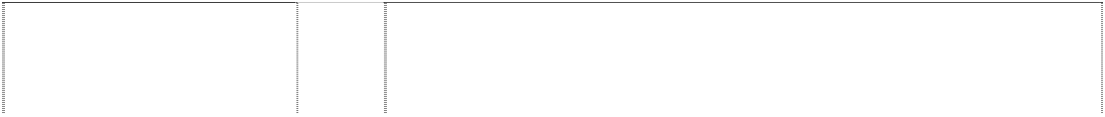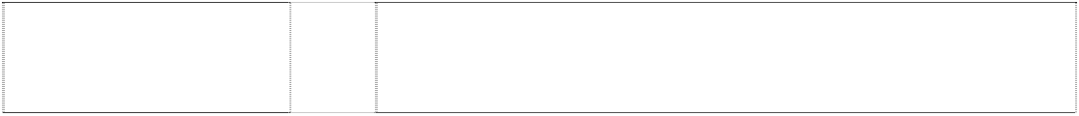

# BELSHINA

(1038850)

# BELSHINA

(1038850)

# BELSHINA

bull,silhouette in rectangle,2 convex-sides

(1038851)

# BELSHINA

bull,silhouette in rectangle,2 convex-sides

(1038851)

12 Vehicle tires, casing for pneumatic tires, inner tubes for pneumatic tires.

17 Rings of rubber.

12 Vehicle tires, casing for pneumatic tires, inner tubes for pneumatic tires.

17 Rings of rubber.

***Guangdong Foodstuffs Import and Export (Group) Corporation William R. Chamberlin***

***Ph: (03) 9802 9385***

***Effective Date: 27 November 2006 File Ref: C06/19205***



***Trade Marks***

***Class Goods***

# PEARL RIVER BRIDGE

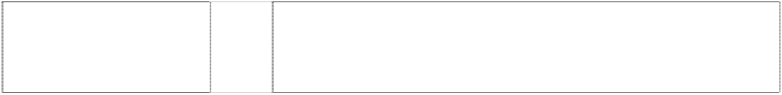

bridge and river scene in ellipse; atop chain around oval Chinese characters rectangle, rounded-corners

30 Coffee, tea, cocoa, sugar, rice, tapioca, sago artificial coffee; flour and

preparations made from cereals, bread, pastry and confectionery ices; honey, treacle; yeast, baking-powder; salt, mustard, vinegar, sauces (except salad dressings); spices; ice.

within rectangle (453536)

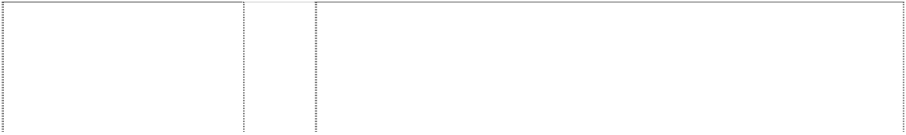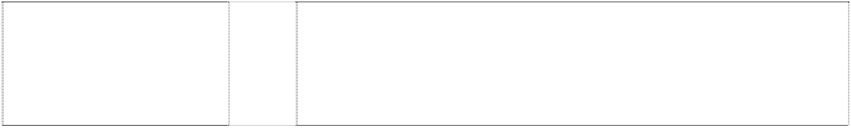

# PEARL RIVER BRIDGE

building, bridge buildings, skyscrapers ellipse, double characters, Chinese harbour scene, harbour

(293221)

# PEARL RIVER BRIDGE

building, bridge buildings, skyscrapers ellipse, double characters, Chinese scene, city

(293222)

# PEARL RIVER BRIDGE

building, bridge buildings, skyscrapers ellipse, double characters, Chinese scene, city

(293220)

32 Beer, fruit juices.

30 Confectionery, biscuits, condiments, rice and flour made products, cakes.

33 Wines, spirits and liqueurs.

***Hearst Holdings, Inc Baker & McKenzie Ph: (02) 9225 0200***

***Effective Date: 23 November 2006 File Ref: C06/18350 Trade Marks Class Goods***

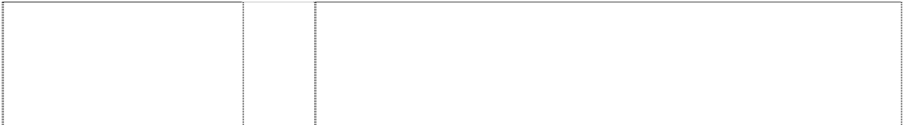

**BARNEY GOOGLE & SNUFFY SMITH** (163730)

**BARNEY GOOGLE & SNUFFY SMITH** (180745)

**BARNEY GOOGLE & SNUFFY SMITH** (180746)

# BEETLE BAILEY

(163729)

# BEETLE BAILEY

(180749)

# BEETLE BAILEY

(180744)

# BETTY BOOP

(986467)

# BETTY BOOP



(986467)

16 Paper and paper articles, cardboard and cardboard articles; printed matter, newspapers and periodicals, books, comic books and comic strips; bookbinding material; photographs; stationery, adhesive materials (stationery); artists' materials, paint brushes; typewriters and office requisites (other than furniture); instructional and teaching material (other than apparatus); playing cards, (printers') type and cliches (stereotype).

28 Games and playthings; gymnastic and sporting articles (except clothing); ornaments and decorations for Christmas trees.

30 Coffee, tea, cocoa, sugar, rice, tapioca, sago, coffee substitutes; flour, and preparations made from cereals; bread, biscuits, cakes, pastry and confectionery, ices; honey, treacle; yeast, baking-powder; salt, mustard, pepper, vinegar, sauces, spices; ice.

16 Paper and paper articles, cardboard and cardboard articles; printed matter, newspapers, periodicals, books, comic books and comic strips but excluding playing cards.

28 Playthings (but excluding games including board games), gymnastics and sporting articles (except clothing), ornaments and decorations for Christmas tree.

30 Coffee, tea, cocoa, sugar rice tapioca, sago, coffee substitutes; flour, and preparations made from cereals; bread, biscuits, cakes, pastry and confectionery ices; honey, treacle; yeast, baking powder; salt mustard, pepper, vinegar, sauces, spices; ice.

3 Bleaching preparations and other substances for laundry use; cleaning, polishing, scouring and abrasive preparations; soaps, perfumery, essential oils, cosmetics, hair lotions; dentifrices.

14 Wall clocks, clock dials, watch cases, electric clocks and watches, electronic clocks and watches, table clocks, wrist watches and pocket watches; precious metals and their alloys and goods in precious metals or coated therewith, not included in other classes; jewellery, precious stones.

# BETTY BOOP

(986467)

# BETTY BOOP

(986467)

# BETTY BOOP

(986467)

# BETTY BOOP

(986467)

# BETTY BOOP

woman cartoon on stool (412304)

# BETTY BOOP

woman cartoon on stool (412305)

# BLONDIE

(395634)

# BLONDIE

(395631)

# BLONDIE

(395630)

# BLONDIE

woman, cartoon-character, curly hair, walking & man, cartoon-character, spiky hair, hands in pocket, walking

(399684)

# BLONDIE

woman, cartoon-character, curly hair, walking & man, cartoon-character, spiky hair, hands in pocket, walking

(399686)

# BLONDIE

woman, cartoon-character, curly hair, walking & man, cartoon-character, spiky hair, hands in pocket, walking

(399687)

16 Labels, stickers, napkin paper, wrapping paper, writing and drawing paper, facial tissues, notebooks, memo paper, envelopes, pocket-size notebooks, scrapbooks, albums, writing pads, bookmarkers, writing tablets, fountain pens, ball-point pens, felt tip pens, mechanical pencils, pencils, pens, penholders, rubber erasers, loose-leaf binders, gums (adhesives) for stationery purposes, adhesive tapes for stationery purposes, folders for papers, pencil sharpeners, drawing pads, file binders, square rulers, letter holders, pencil holders, paper table linen, calendars, comic books, musical greeting cards, books, booklets, cheques, newspapers, greeting cards, postcards, postage stamps, diaries, magazines, posters.

18 Leather and imitations of leather goods made of these materials, animal skins, hides, trunks and travelling bags, belts, bags, purses, handbags, leather cases, brief cases, wallets, attache cases, luggage, suitcases, sports bags, tote bags, cosmetic bags, cosmetic cases, vanity cases, toiletry cases, backpacks, rucksacks, credit card bags, key holders, umbrellas, parasols and walking sticks, shoulder bags, knapsacks, billfolds, key chains, cheque book organisers, toiletry travel kits, duffel bags, garment bags, business card holders, change purses.

21 Small domestic utensils and containers, combs, brushes, glassware, porcelain and earthenware; ceramic ware (dishes, cups, figurines, and the like).

25 Clothing including T-shirts, sweatshirts, polo shirts, blouses, nightgowns, nightshirts, lingerie, pyjamas (short and long), jackets, vests, sweaters, skirts, shirts, jeans, pants, ties, scarves, gloves, shorts, belts, sweaters, head gear, swimwear, underwear, boots, shoes and slippers, all being articles of clothing.

16 All goods in this class.

25 All goods in this class.

16 All goods in this class.

25 T-shirts, sweat shirts, sleep wear, swim wear and lingerie being goods in this class, none of the foregoing being made from or comprising blonde lace, silk, tulle or washable cotton net.

30 All goods, being goods included in Class No. 30.

16 All goods included in Class No. 16.

1. All good included in Class No. 24.
2. T-shirts, sweat-shirts, sleep wear, swimwear and lingerie being goods in this class, none of the foregoing being made from or comprising blond lace, silk, tulle or washable cotton net.

**BLONDIE** 30 All good included in Class No. 30.

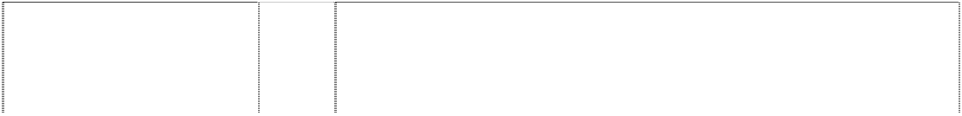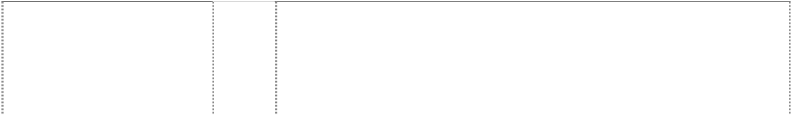

curly hair, walking & man,

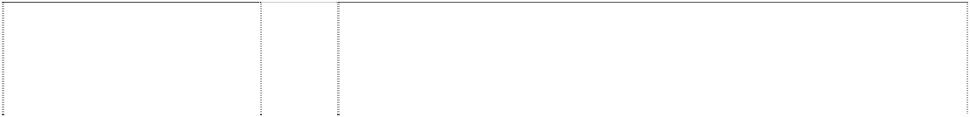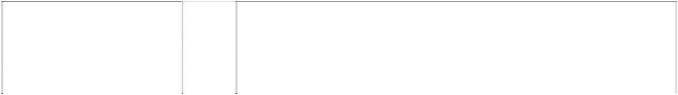

ers') type and cliches (stereotype).

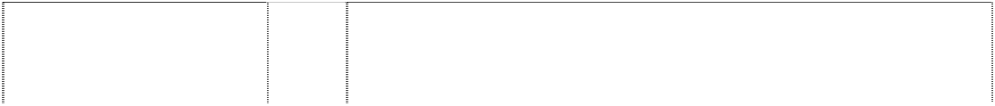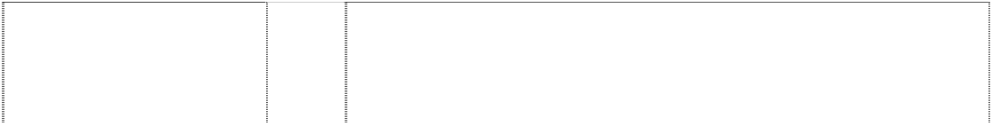

shoulders in circle (501749)

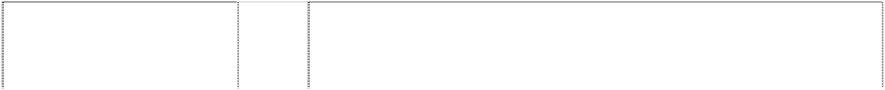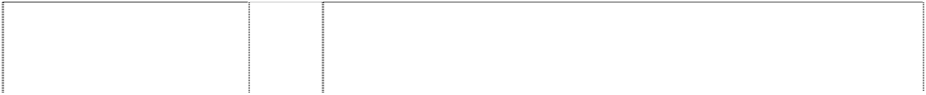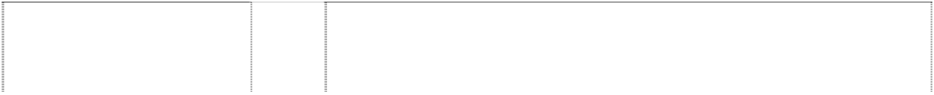

cartoon-character sailor head shoulders in circle

(501750)

cartoon-character sailor head shoulders in circle

(501751)

cartoon-character sailor head shoulders in circle

(501752)

cartoon-character sailor pipe, tobacco hat

(560319)

cartoon-character sailor pipe, tobacco hat

(447647)

cartoon-character sailor pipe, tobacco hat

(560318)

cartoon-character smiling baby with cap, scalloped collar in circle

(501734)

cartoon-character smiling baby with cap, scalloped collar in circle

(501735)

cartoon-character smiling baby with cap, scalloped collar in circle

(501736)

fat man cartoon-character head & shoulders bearded with cap in circle

(501731)

fat man cartoon-character head & shoulders bearded with cap in circle

(501732)

fat man cartoon-character head & shoulders bearded with cap in circle

(501733)

group of cartoon-characters has woman, sailor, 2 men & baby

(501754)

group of cartoon-characters has woman, sailor, 2 men & baby

(501755)

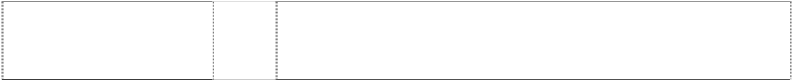

group of cartoon-characters has woman, sailor, 2 men & baby

(501756)

1. Meat, fish, poultry; dried and cooked fruits and vegetables; jellies, jams, milk and milk products; salad dressing.
2. Coffee, tea, cocoa, sugar, rice, flour, and preparations made from cereals; bread, pastry and confectionery, ices; salt, mustard; pepper.

32 Fruit juices and fruit drinks; mineral and aerated waters and other non- alcoholic drinks; syrups and other preparations for making beverages.

16 All goods in this class.

25 All goods in this class.

28 All goods in this class.

16 All goods in this class.

25 All goods in this class.

28 All goods in this class.

16 All goods in this class.

25 All goods in this class.

28 All goods in this class.

16 All goods in this class.

25 All goods in this class.

28 All goods in this class.

has woman, sailor, 2 men &

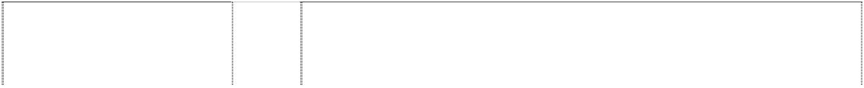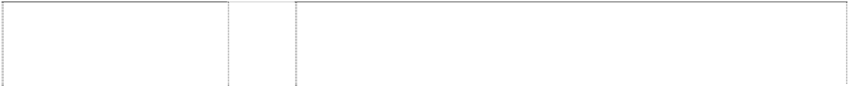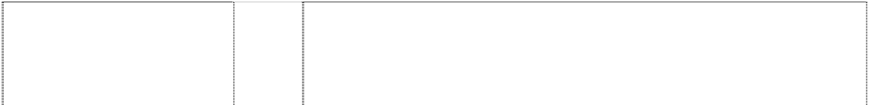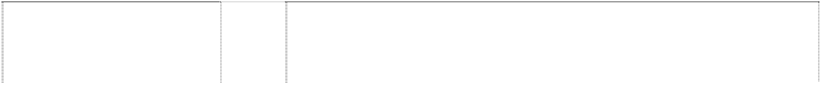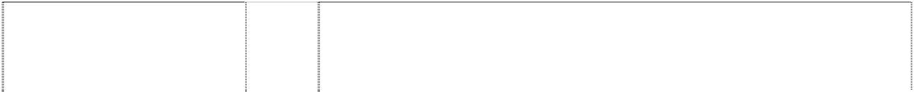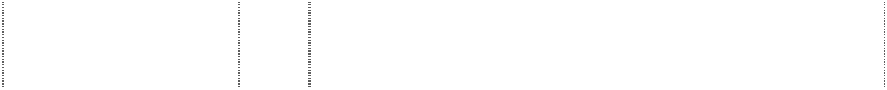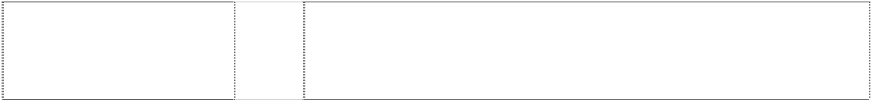

woman, cartoon cuts heart (986466)

woman, cartoon cuts heart (986466)

woman, cartoon cuts heart (986466)

stationery purposes, adhesive tapes for stationery purposes, folders for papers, pencil sharpeners, drawing pads, file binders, square rulers, letter holders, pencil holders, paper table linen, calendars, comic books, musical greeting cards, books, booklets, cheques, newspapers, greeting cards, postcards, postage stamps, diaries, magazines, posters.

18 Leather and imitations of leather goods made of these materials, animal skins, hides, trunks and travelling bags, belts, bags, purses, handbags, leather cases, brief cases, wallets, attache cases, luggage, suitcases, sports bags, tote bags, cosmetic bags, cosmetic cases, vanity cases, toiletry cases, backpacks, rucksacks, credit card bags, key holders, umbrellas, parasols and walking sticks, shoulder bags, knapsacks, billfolds, key chains, cheque book organisers, toiletry travel kits, duffel bags, garment bags, business card holders, change purses.

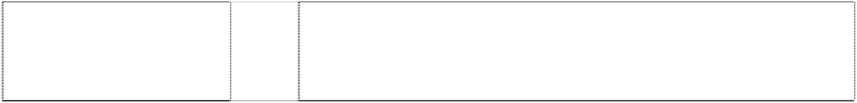

21 Small domestic utensils and containers, combs, brushes, glassware, porcelain and earthenware; ceramic ware (dishes, cups, figurines, and the like).

25 Clothing including T-shirts, sweatshirts, polo shirts, blouses, nightgowns, nightshirts, lingerie, pyjamas (short and long), jackets, vests, sweaters, skirts, shirts, jeans, pants, ties, scarves, gloves, shorts, belts, sweaters, head gear, swimwear, underwear, boots, shoes and slippers, all being articles of clothing.

***Microsoft Corporation Mallesons Stephen Jaques Ph: (02) 9296 2000***

***Effective Date: 18 December 2006 File Ref: C06/18356 Trade Marks Class Goods***



# 2

(1014906)

# 2

(1014906)

# 2

(1014906)

# 2



(1014906)

9 Computer programs, namely, game software for use on computers and video game players; computer game cartridges; prerecorded videotapes, audio tapes, CDs and DVDs featuring sound and video in the fields of music, live action programs, motion pictures and animated cartoons; motion picture films featuring comedy, drama, action, adventure and animation; motion picture films for broadcast on television featuring comedy, drama, action, adventure and animation; and plastic covers for computer game consoles.

16 Publications, namely, strategy guides, user manuals, comic books, series of fiction books, magazines and newsletters all in the field of computer games, science fiction, games and entertainment; pens, pencils, markers, stationery, stationery-type portfolios, clipboards, desk sets, pen and pencil holders, mounted and unmounted photographs, posters, magnetic boards, memo pads, binders, staplers, paperweights, paper coasters, calendars, notebooks, book covers, sticker books, greeting cards and note cards.

25 Shirts, vests, sweatshirts, sweaters, sweatpants, pants, overalls, shorts, rompers, jackets, caps, pyjamas, robes, night shirts, suspenders, jumpsuits, coats, sweatbands, scarves, gloves, mittens, socks, hosiery, stockings, underwear, footwear, headwear, hats, ties, visors, wrist bands, cloth bibs, aprons and Halloween and masquerade costumes.

28 Toys and games, namely, action figures and accessories therefor; balloons; bathtub toys; toy building blocks; dolls and accessories therefor; doll clothing; board games; card games; play cosmetics for children; costume masks; miniature die cast vehicles; toy airplanes and helicopters; battery operated remote controlled toy vehicles; flying discs; inflatable vinyl figures; jigsaw puzzles; kites; marbles; indoor slumber and play tents; plush toys; hand-held puppets; sit-in and ride-on toy vehicles; train sets; play shaving kits; skateboards; roller skates; toy banks; water squirting toys; toy pistols; Christmas tree ornaments; pinball and arcade game machines; hand-held units for playing electronic games; model craft kits of toy figures; playground balls; sport balls; basketballs; golf balls; golf ball markers; tennis balls; baseballs; rubber action balls; rubber sports balls; rubber

equipment; bags for carrying basketball equipment; bags for carrying

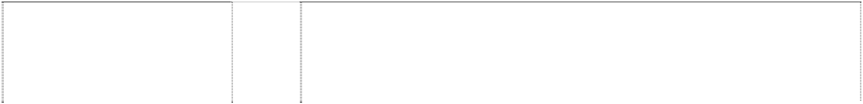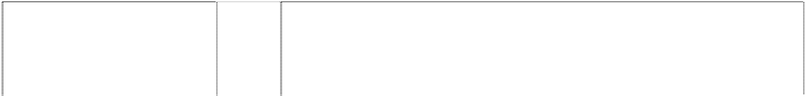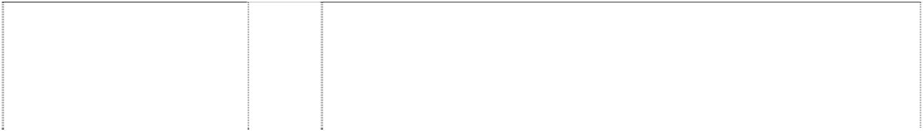

(932925)

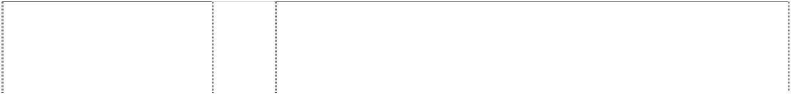

CDs and DVDs featuring, sound and

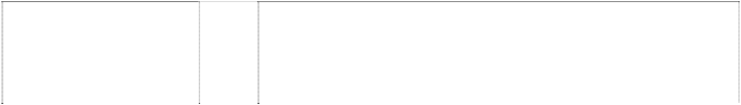

aprons and Halloween and masquerade costumes.



# E MICROSOFT INTERNET EXPLORER

ringed ltr in stacked rectangles (804869)

# ELEMENTS OF POWER

(968739)

# ENCARTA

(623477)

# ENCARTA

(623478)

# ENSEMBLE STUDIOS

(841940)

# ENSEMBLE STUDIOS

hexagons in disc form planet with explosion styl.; 2 rings around planet

(852402)

# ENTOURAGE

(858941)

# ESHOP

(623877)

# EXCEL

(1023817)

# FACTORY WINDOW

(612595)

# FALLEN KINGS

(932924)

# FASA STUDIO

(903527)

# FIST OF THE LOTUS

(930732)

9 Computer programs for connecting to remote computers and computer networks; computer programs for searching the contents of remote computers and computer networks; computer programs for transmitting and receiving data and files to and from remote computers and computer networks; computer programs for assisting users in navigating through computer networks, including global communication networks.

9 Computer programs, namely, game software for use on computers and video game players; prerecorded videotapes, audio tapes, CDs and DVDs featuring sound and video in the fields of music, live action programs, motion pictures and animated cartoons; motion picture films featuring comedy, drama, action, adventure and animation; motion picture films for broadcast on television featuring comedy, drama, action, adventure and animation; computer game cartridges; computer game cassettes; computer game tapes; video game cartridges; and video game cassettes.

9 Computer program and general reference data in the form of a multi-media encyclopedia on a variety of subjects, stored on a compact disc and all other goods in this class.

16 Instruction manuals, user guides and reference guides for a multi-media encyclopedia on a variety of subjects and all other goods in this class.

9 Computer game programs and instruction manuals sold as a unit therewith.

9 Computer game programs and instruction manuals sold as a unit therewith.

9 Computer programs for sharing, managing, viewing and editing files, documents, electronic mail messages, and internal network and global communications network communications; computer programs for meeting and events scheduling; computer programs for managing individual and group calendars; computer programs for task management, delegation and reporting; computer programs for recording notes; computer programs for transferring data to and from databases and to and from other computer programs and files; address book and contact information programs; computer programs for creating and distribution lists; telephone dialing and facsimile transmission programs; computer programs for correcting typographical and capitalisation errors; computer programs for tallying voting responses; and instruction manuals therefor sold as a unit.

9 Computer hardware and computer programs including computer hardware and computer programs for use in interactive retailing and shopping.

9 Computer software, namely, spreadsheet software; and computer programs for creating charts and graphs from electronic spreadsheets.

9 Computer Software.

9 Computer programs, namely, game software for use on computers and video game players.

9 Computer programs, namely, game software for use on computers and video game players.

9 Computer programs, namely, game software for use on computers and video game players; prerecorded videotapes, audio tapes, CDs and DVDs featuring sound and video in the fields of music, live action programs, motion pictures and animated cartoons; motion picture films featuring comedy, drama, action, adventure and animation; motion picture films for broadcast on television featuring comedy, drama, action, adventure and animation; computer game cartridges; computer game cassettes; computer game tapes; video game cartridges; and video game cassettes.

**FIST OF THE LOTUS** 16 Publications, namely, strategy guides, user manuals, comic books, series

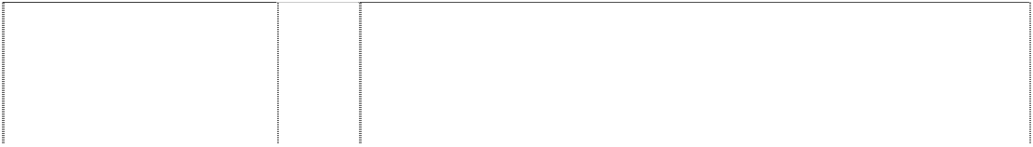

of fiction books, magazines and newsletters all in the field of computer

(930732) games, science fiction, games and entertainment; pens, pencils, markers, stationery, stationery-type portfolios, clipboards, desk sets, pen and pencil holders, mounted and unmounted photographs, posters, magnetic boards, memo pads, binders, staplers, paperweights, paper coasters, calendars, notebooks, book covers, sticker books, greeting cards and note cards.



# FIST OF THE LOTUS

(930732)

# FIST OF THE LOTUS

(930732)

# FORZA MOTORSPORT

(1019962)

# FORZA MOTORSPORT

(1019962)

# FORZA MOTORSPORT

(1019962)

# FOXPRO

(563074)

# FREELANCER

(769789)

# FRONTPAGE

(704575)

# FUZION FRENZY

(886161)

# HALO

(870872)



# HALO

(870872)

25 Shirts, vests, sweatshirts, sweaters, sweatpants, pants, overalls, shorts, rompers, jackets, caps, pyjamas, robes, night shirts, suspenders, jumpsuits, coats, sweatbands, scarves, gloves, mittens, socks, hosiery, stockings, underwear, footwear, headwear, hats, ties, visors, wrist bands, cloth bibs, aprons and Halloween and masquerade costumes.

28 Toys and games, namely, action figures and accessories therefor; balloons; bathtub toys; toy building blocks; dolls and accessories therefor; doll clothing; board games; card games; play cosmetics for children; costume masks; miniature die cast toy vehicles; toy airplanes and helicopters; battery operated remote controlled toy vehicles; flying discs; inflatable toy vinyl figures; jigsaw puzzles; kites; marbles; toy indoor slumber and play tents; plush toys; hand-held puppets; sit-in and ride-on toy vehicles; toy train sets; play shaving kits; skateboards; roller skates; toy banks; water squirting toys; toy pistols; target sets; Christmas tree ornaments; pinball and arcade game machines; hand-held units for playing electronic games; pinball machines; toy model hobby craft kits; playground balls; sports balls; basketballs; golf balls; golf ball markers; tennis balls; baseballs; rubber action balls; rubber sports balls; rubber playing balls; squeezable balls used to relieve stress; bags for carrying sports equipment, namely, golf, basketball, baseball and tennis equipment; manipulative puzzles and construction toys; crib mobiles; mobiles for children; target sets consisting of a target, rubber suction darts and toy dart gun; playing cards.

9 Computer programs, namely, game software for use on computers and video game players; prerecorded videotapes, audio tapes, CDs and DVDs featuring sound and video in the fields of music, live action programs, motion pictures and animated cartoons.

16 Publications, namely, strategy guides, user manuals, comic books, series of fiction books, magazines and newsletters all in the field of computer games, science fiction, games and entertainment; pens, pencils, markers, stationery, stationery-type portfolios, clipboards, desk sets, pen and pencil holders, mounted and unmounted photographs, posters, magnetic boards, memo pads, binders, staplers, paperweights, paper coasters, calendars, notebooks, book covers, sticker books, greeting cards and note cards.

28 Toy vehicles.

9 Computer programs in the field of general purpose database programs and application development programs.

9 Software for computer games and entertainment featuring interactive movies and/or motion pictures on compact discs and/or laser discs for use in game boxes such as personal computers or consoles excluding clip art or software used for creating graphical presentations.

9 Computer authoring software for use on computer communications networks, namely software for creating, editing and delivering textual and graphic information, locally and remotely.

9 Computer programs, namely, game software for use on computers and video game players.

9 Computer game software.

16 Publications, namely, comic books, series of fiction books, strategy guides, magazines, newsletters, magazines and newsletters distributed over computer networks and global communication networks, pens, pencils, markers, stationery, stationery-type portfolios, clipboards, desk sets, pen and pencil holders, mounted and unmounted photographs, posters, magnetic boards, memo pads, binders, staplers, paperweights, paper coasters, calendars, playing cards, notebooks, book covers, sticker books,

# HALO

(966957)

# HALO 2

(1014905)

# HALO 2

(1014905)

# HALO 2

(1014905)

# HDCD

(791726)

28 Toys and games, namely, action figures and accessories therefor; balloons; bathtub toys; toy building blocks; dolls and accessories therefor; doll clothing; board games; card games; play cosmetics for children; costume masks; miniature die cast vehicles; toy airplanes and helicopters; battery operated remote controlled toy vehicles; flying discs; inflatable vinyl figures; jigsaw puzzles; kites; marbles; indoor slumber and play tents; plush toys; hand-held puppets; sit-in and ride-on toy vehicles; train sets; play shaving kits; skateboards; roller skates; toy banks; water squirting toys; toy pistols; target sets; Christmas tree ornaments; pinball and arcade game machines; hand-held units for playing electronic games; pinball machines; model craft kits of toy figures; playground balls; sport balls; basketballs; golf balls; golf ball markers; tennis balls; baseballs; rubber action balls; rubber sports balls; rubber playing balls; squeezable balls used to relieve stress; bags for carrying golf equipment; bags for carrying basketball equipment; bags for carrying baseball equipment; bags for carrying tennis equipment; manipulative puzzles and construction toys; crib mobiles; mobiles for children; target sets consisting of a target, rubber suction darts and toy dart gun; playing cards.

9 Computer programs, namely, game software for use on computers and video game players; computer game cartridges; prerecorded videotapes, audio tapes, CDs and DVDs featuring sound and video in the fields of music, live action programs, motion pictures and animated cartoons; motion picture films featuring comedy, drama, action, adventure and animation; motion picture films for broadcast on television featuring comedy, drama, action, adventure and animation; and plastic covers for computer game consoles.

16 Publications, namely, strategy guides, user manuals, comic books, series of fiction books, magazines and newsletters all in the field of computer games, science fiction, games and entertainment; pens, pencils, markers, stationery, stationery-type portfolios, clipboards, desk sets, pen and pencil holders, mounted and unmounted photographs, posters, magnetic boards, memo pads, binders, staplers, paperweights, paper coasters, calendars, notebooks, book covers, sticker books, greeting cards and note cards.

28 Toys and games, namely, action figures and accessories therefor; balloons; bathtub toys; toy building blocks; dolls and accessories therefor; doll clothing; board games; card games; play cosmetics for children; costume masks; miniature die cast vehicles; toy airplanes and helicopters; battery operated remote controlled toy vehicles; flying discs; inflatable vinyl figures; jigsaw puzzles; kites; marbles; indoor slumber and play tents; plush toys; hand-held puppets; sit-in and ride-on toy vehicles; train sets; play shaving kits; skateboards; roller skates; toy banks; water squirting toys; toy pistols; Christmas tree ornaments; pinball and arcade game machines; hand-held units for playing electronic games; model craft kits of toy figures; playground balls; sport balls; basketballs; golf balls; golf ball markers; tennis balls; baseballs; rubber action balls; rubber sports balls; rubber playing balls; squeezable balls used to relieve stress; bags for carrying golf equipment; bags for carrying basketball equipment; bags for carrying baseball equipment; bags for carrying tennis equipment; manipulative puzzles and construction toys; crib mobiles; mobiles for children; target sets consisting of a target, rubber suction darts and toy dart gun; playing cards.

9 Sound recording and play-back equipment; namely, integrated circuit chips, analog-to-digital encoders, digital-to-analog decoders, compact disc players and digital audio tape players and recorders, pre-recorded compact discs and digital audio tapes featuring music; motion picture films, pre-recorded compact discs containing digital information for the display of filmed products (DVD), pre-recorded video tapes and videodiscs, pre-recorded mini discs, CD-roms, optical disc recorders and players, video tape and videodisc recorders and players, mini-disc players and recorders, compact disc recorders, digital television receivers; computer hardware, namely,

CD-rom and DVD-rom drives and other motion picture and sound recording and playback equipment.

**HDCD** 9 Software for transmitting, modifying and utilizing data, graphics, video and



(864223) sound via global computer networks, and other motion picture and sound recording and playback equipment, including personal computers, network terminal devices, personal digital assistants, pocket pcs and other portable devices.

# HEXIC



(975649)

# HIGH ROAD TO REVENGE

(926093)

# HIGHMAT

(950758)

# HOMECLICK

(809663)

# I

disc,extended parallelogram are ltrs in screen

(772774)

# INFOPATH

(959601)

# INKWRITER

(769616)

# INSIDE PITCH

(939723)

# INTELLIEYE



(801730)

9 Computer programs, namely, game software for use on computers and video game players; computer game cartridges; computer game cassettes; computer game tapes; video game cartridges; and video game cassettes.

9 Computer programs, namely, game software for use on computers and video game players; computer game cartridges, computer game cassettes and computer game tapes; video game cartridges; video game cassettes.

9 House mark for a full line of prerecorded discs featuring sound, still images, and video; consumer electronics devices for the recording, playing, and/or transmitting of image, sound, and video, namely, audio and video recorders, cameras, camcorders, radios, cable television receivers and decoders, satellite receivers and decoders, multi-channel sound processors, portable media recording devices, and stand-alone image viewing devices; multi-channel sound processor integrated circuits; audio and video amplifiers and receivers; audio and video receivers; video monitors; audio and video tuners; image, audio, and video digital disc players and recorders; optical disc drives and players such as DVD players, DVD recorders, mini disk players, removable media players and removable media recorders; computer printers; laser or inkjet printers for home use; network printers; printers with removable media support; remote control units for use with computers and imaging and audio and video devices; computers; computer modems; computer peripherals; computer chips; computer memory; recordable and preprogrammed removable digital storage media; removable data storage media, namely, compact flash, secure digital, PC card hard drives, compact discs, DVDs and mini disks, and packaged semiconductors; computer software for the recording and playback of data in memory or on removable media; computer software for the transmitting of images, audio, and video over computer networks, wireless networks, satellite networks, and global computer networks; telecommunications devices, namely, telephones and satellite dishes; computer software for recording, playing, and transmitting image, sound, and video; televisions; set-top boxes for televisions; projection systems;

set-top boxes for projection systems; motor vehicle image, video and audio players; networking equipment, namely, routers, wired and wireless hubs, networking cards, and adaptors; all conforming to certain technical standards and specifications.

9 Computer software for use in connecting home computers and other computer hardware devices into local area networks.

9 Software, namely operating system programs and utilities, software for use in accessing, displaying and exchanging data with interactive entertainment services in the nature of continuous, live and other interactive dramas presented through television and computer networks and global communications networks; computer hardware, television set top boxes and televisions.

9 Computer software, namely, software to design, create, edit and publish documents; computer programs that assist users in designing, creating, editing, publishing and completing documents; and computer programs for transmitting documents between users.

9 Computer software for manipulating text, data and graphics and other computer programs which interface with text, data, and graphics manipulation software applications.

9 Computer programs, namely, game software for use on computer and video game players; computer game cartridges; computer game cassettes; computer game tapes; video game cartridges; and video game cassettes.

9 Optical sensor devices for use in computer pointing devices; computer peripherals, namely pointing devices; computer programs, namely driver programs and utility programs for use in connection with computer pointing devices.

(750500)



clipboards, desk sets, pen and pencil

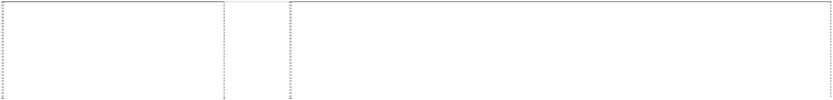

picture films featuring comedy, dram

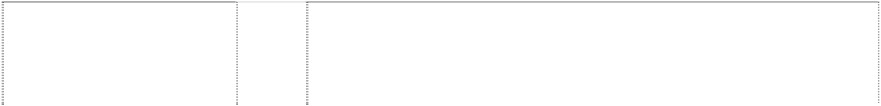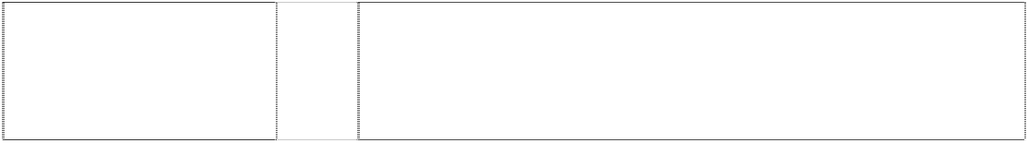

television or other display device and computer programs for use therewith;



tracking; computer hardware and computer software for use in connection



eights, paper coasters, calendars,

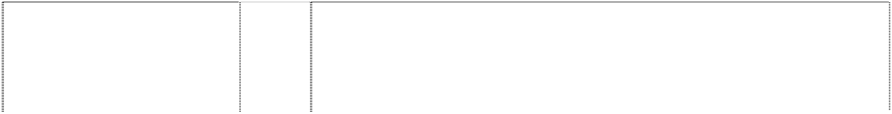

# MICROSOFT TAXSAVER

(777618)

# MICROSOFT TV

Pattern of squares break screen,tv

(873280)

# MICROSOFT TV

Pattern of squares break screen,tv

(873280)

# MICROSOFT TV

Pattern of squares break screen,tv

(873280)

# MICROSOFT VISUAL TOOLS L

3 interlocking squares

(702288)

# MICROSOFT.NET CONNECTED

2 arrows,halved form impeller,2-blade (946350)

# MIDTOWN MADNESS

(769617)

# MOBILE EXPLORER

(815177)

computer hardware and software for controlling the power supply and boot- up sequence of a computer.

9 Computer software for use in tax planning and the preparation and filing of tax returns and other tax-related materials.

9 Computer hardware, computer software for use in connection with personalised and interactive television programming, computer peripherals for personalised, interactive television programming; televisions; television and cable and satellite set-top boxes; remote control device for televisions; cable and satellite televisions and equipment therefor; home entertainment electronic equipment; video recording and playback devices, and monitors and displays therefor; video games; handheld units for playing video or computer games, and operating system software for use therewith; stand alone video output game machines, and operating system software for use therewith; video games players; video game interactive remote control units; electronic devices for accessing cable networks, wireless networks, computer networks and global communication networks; computer hardware and peripherals; keyboards; joysticks; pointing devices; computer software for playing computer games and video games; computer software for accessing and browsing cable networks, wireless networks, computer networks and global communication networks; computer programs for accessing cable networks, wireless networks, computer networks and global communication networks; computer graphical utilities programs; computer software for compressing and decompressing data and video images, word text editing, and email; and operating system software and utilities.

16 Manuals for use with computer hardware, software and peripherals for televisions, television peripheral remote controls, communication devices, transmitters, receivers and controls of software for use therewith; newsletters, pamphlets, informational flyers, catalogues, magazines, books, instruction manuals, user guides and reference guides all in the fields of television and personalised and interactive television programming and access thereto and equipment therefor; pens, pencils, stationery type portfolios, clipboards, desk sets, mounted and unmounted photographs, posters, memo pads, binders, paper staplers, paperweights, paper coasters, calendars, notebooks, portfolios, book covers, sticker books; and greeting cards.

28 Toys, games and sporting goods.

9 Computer programs for developing other computer programs, compiler programs, debugger programs and utility programs for creating graphical applications.

9 Computer software, namely, operating system software, server software, network management software and software for use in developing and executing other computer programs on computers, computer networks and global communications networks; software for use in navigating, browsing, transferring information and distributing and viewing other computer programs on computers, computer networks and global communication networks; a full line of computer application software and computer business software, namely, computer software for database management, accounting, word processing, purchasing, inventory control, retail management, marketing, electronic mail and global communications network browsing on computers, computer networks and global communication networks.

9 Computer programs, namely, game software for use on computers and video game players.



9 Browser programs; computer programs for use in accessing and searching remote computers, computer networks and global communication networks; computer programs for transmitting and receiving data and files

for assisting users in navigating through computer networks and global



connection with application service prov



stationery, stationery-type portfolios,

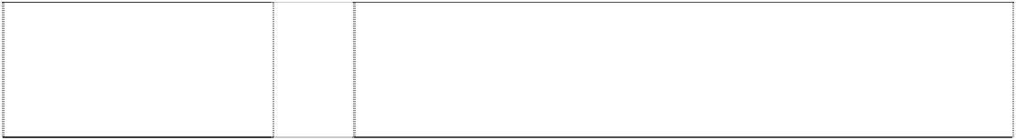

y vehicles; train sets; play shaving

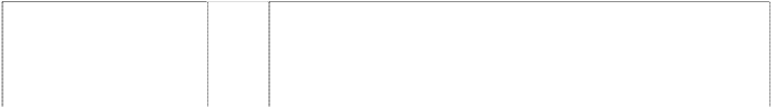

etic boards, memo pads, binders,



flying discs; inflatable vinyl figures;

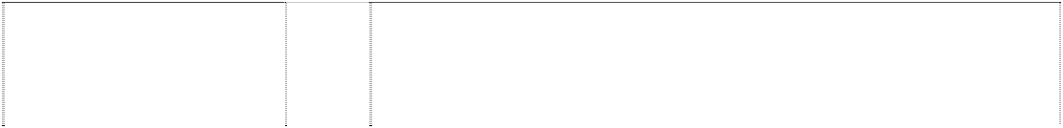

# SHADOWRUN

(1029736)

# SIDESHOW

(1098694)

# SIDEWINDER

(706112)

# SNEAKERS

(915243)

# SQLWindows

(543080)

# STARLANCER

(711599)

# START

word in rect & 4 pane window & squared dots

(705900)

# START SOMETHING

(1050564)

# STOMPED

(942322)

# SUDEKI

(944648)

assisting developers in creating program code for use in Internal computer networks and global communication networks; computer programs for running development programs and application programs in a common development environment; software for designing, creating, maintaining and accessing document management, authoring, storage and retrieval systems; software for document authoring, storage, retrieval, contention control, version history tracking, profiling, access control, and security; software for automatically notifying users when documents have been updated; software for meeting and event scheduling and notification and for posting announcements on internal network sites and global communication network sites; software for posting links to internal network sites and global communication network sites; software for categorising, searching and retrieving documents and data on internal computer networks; computer programs for use on and with computer networks and global communication networks, namely, user identification, registration and authorisation programs; programs for automating login procedures to access web sites or internal networks; security and encryption programs; programs for maintaining user privacy; programs for maintaining and updating user profiles; programs for maintaining server profiles; computer programs for use in and to facilitate electronic commerce and the secure transfer of user financial information for use in individual purchases; and computer software for use in developing computer programs.

9 Computer programs, namely, game software for use on computers and video game players.

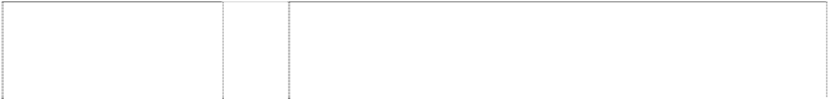

9 Operating systems software; computer utility programs; computer software platforms for developing and operating remote display devices; computer software development tools; computer peripherals; laptop computers including auxiliary displays; wireless computer peripherals; wireless telephones.

9 Joystick and keypad controller for use with video games.

9 Computer programs, namely, game software for use on computers and video game players

9 Computers and computer software.

9 Computer software as included in this class, including software for entertainment, including interactive movies or motion pictures, computer and video game entertainment for compact discs/laser discs used in a game box, such as a personal computer or a console; amusement apparatus adapted for use with audio and/or video receivers of all types, including games apparatus adapted for use with television receivers; games (electronic) for use with television receivers; computers and computer operating systems; computer memories; computer operating programmes (recorded); computer programmes (recorded); and parts of and accessories for such goods as are included in this class, including compact discs, optical and magnetic discs, floppy discs, video tapes.

9 Computers and parts therefor, computer peripherals, and computer programs and manuals therefor, sold as a unit in graphical applications.

9 Computer software, namely operating system software.

9 Computer programs, namely, game software for use on computers and video game players; computer game cartridges; computer game cassettes; computer game tapes; video game cartridges; and video game cassettes.



9 Computer programs, namely, game software for use on computers and video game players; computer game cartridges; computer game cassettes; computer game tapes; video game cartridges; video game cassettes; prerecorded videotapes, audio tapes, CDs and DVDs featuring sound and video in the fields of music, live action programs, motion pictures and

s featuring comedy, drama, action,



battery operated remote controlled toy vehicles; flying discs; inflatable toy

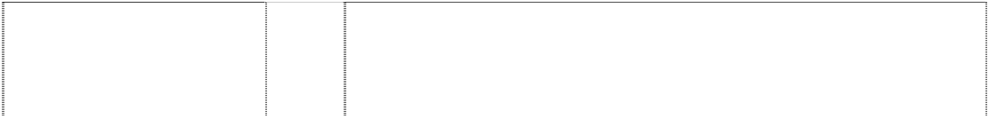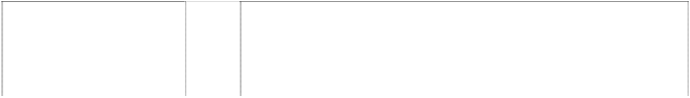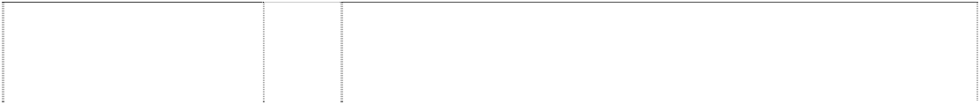

information manager programs with ca

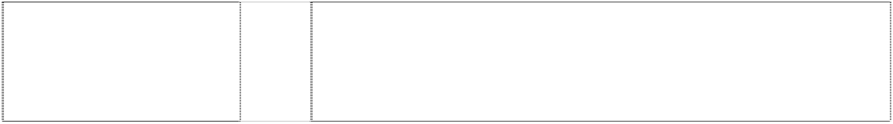

construction toys.



computer peripherals; cameras;



s, CDs and DVDs featuring sound and



messages over computer networks and global communication networks.

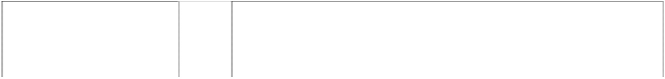

es; toy airplanes and helicopters; battery



operating system software for use ther



mputer game software; browser



encrypting and authenticating data;



top boxes for television, radio pagers;



window,sytl. in button (1090863)

therewith; computer keyboards; computer and video game joysticks; video game interactive control floor pads; television set-top boxes; remote controllers for audio devices, video devices and personal computers; and computer software for viewing, searching and playing pre-recorded audio and Internet radio.

16 Publications, namely, user manuals, instruction guides, reference guides, newsletters, magazines, books, all about computers, computer software and computer systems; pens, pencils, markers, stationery, stationery-type portfolios, clipboards, desk sets, pen and pencil holders, mounted and unmounted photographs, posters, magnetic boards, memo pads, binders, staplers, paperweights, paper coasters, calendars, notebooks, book covers, sticker books and greeting cards.



***QS Holdings Sarl Corrs Chambers Westgarth Ph: (03) 9672 3000***

***Effective Date: 23 December 2006 File Ref: C07/00012 Trade Marks Class Goods***

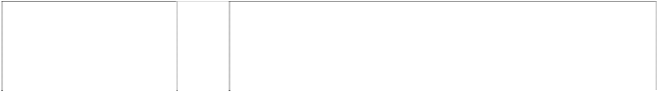

# BLACK DIAMOND

diamond,double (472703)

# BLACK DIAMOND

diamond,double (466498)

# BOARDRIDERS CLUB

(963330)

# BOARDRIDERS CLUB

(947950)

# BOARDRIDERS CLUB

(655536)

# CHICKEN JAM

(1092048)

9 Sunglasses, spectacles, frames for sunglasses and spectacles and cases for sunglasses and spectacles.

18 Bags, luggage and all class 18 goods.

25 Clothing, footwear, headgear, wetsuits, swimwear, singlets, T-shirts, shirts and casual tops with long and short sleeves, bodysuits, sweat tops, sweat hooded parkas, jackets, jumpers, shorts, board shorts, walk shorts, volley shorts, long pants, beach pants, trousers, jeans, dresses, skirts, sarongs, leisure wear, sporting and gymnastic wear, ski wear and snowboard wear including ski suits, ski pants, ski trousers, ski jackets, snowboard pants, snowboard trousers and snowboard jackets, skateboard wear, pyjamas, night clothes, underwear, lingerie, stockings, pantyhose, socks, vests, belts, braces, gloves, scarves, bandannas, beanies, headbands, hats, visors, caps, hoods and head coverings with canopy of sunshield, shoes, slippers, sandals, special sporting and gymnastic footwear, athletic shoes, boots, snow boots, snowboard boots, ski boots.

25 Clothing, footwear, headgear, wetsuits, swimwear, singlets, T-shirts, shirts and casual tops with long and short sleeves, bodysuits, sweat tops, sweat hooded parkas, jackets, jumpers, shorts, board shorts, walk shorts, volley shorts, long pants, beach pants, trousers, jeans, dresses, skirts, sarongs, leisure wear, sporting and gymnastic wear, ski wear and snowboard wear including ski suits, ski pants, ski trousers, ski jackets, snowboard pants, snowboard trousers and snowboard jackets, skateboard wear, pyjamas, night clothes, underwear, lingerie, stockings, pantyhose, socks, vests, belts, braces, gloves, scarves, bandanas, beanies, headbands, hats, visors, caps, hoods and head coverings with canopy of sunshield, shoes, slippers, sandals, special sporting and gymnastic footwear, athletic shoes, boots, snow boots, snowboard boots, ski boots.

25 Clothing, footwear and headgear.

16 Paper, cardboard and goods made from these materials in this class; printed matter; books; book covers; gift cards; calendars; stickers; decalcomanias; bumper stickers; posters; stationery; note pads; binders; memo pads; agendas; diaries; writing instruments; pens; pencils; markers; cases for pens and pencils; non-textile labels; photographs; banners of cardboard, paper and card; signs; clipboards; notice boards; programs.

**CHICKEN JAM** 18 Travel bags; carry bags; handbags; beach bags; tote bags; bath bags;



sports bags; pouches (bags); backpacks; purses; wallets; satchels; brief

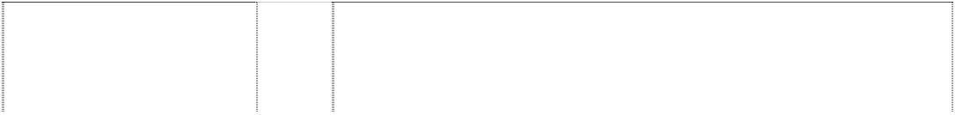

shield (1076912)



# QS

ellipse & vine are ltrs in shield

(1076912)

# QS

ellipse & vine are ltrs in shield

(642557)

# QUICK INC.

(980964)

# QUIK

(817668)

# QUIK

(1059608)

# QUIK SILVER QUIKSILVER

mountain,snowcapped & wave,both styl.

(982250)

# QUIKSILVER

(877471)

# QUIKSILVER

(947940)

# QUIKSILVER

(1056730)

# QUIKSILVER



(947940)

long and short sleeves, bodysuits, sweat tops, sweat hooded parkas, jackets, coats, sweaters, shorts, board shorts, walk shorts, volley shorts, long pants, beach pants, trousers, slacks, jean trousers, jean jackets, jean shirts, overalls, dresses, skirts, sarongs, ski wear and snowboard wear, ski suits, ski pants, ski trousers, ski jackets, snowboard pants, snowboard trousers and snowboard jackets, skateboard wear, aprons, pyjamas, night clothes, dressing gowns, bathrobes, underwear, lingerie, stockings, pantyhose, socks, vests, belts, braces for pants skirts and stockings, mittens, gloves, scarves, ear muffs, bandannas, beanies, headbands, hats, visors, caps, hoods and head coverings with canopy of sunshield, slippers, beach shoes, thonged and strapped sandals, shoes, sandals, thongs, athletic shoes, boots for sports, snow boots, snowboard boots, ski boots, kiteboard boots, surfboard boots, wetsuit boots, mountain boots, hiking shoes and boots, trekking shoes and boots, camping shoes and boots, climbing shoes; accessories in this class for the aforementioned goods.

28 Sporting apparatus, surfboards, bodyboards, kneeboards, wakeboards, sailboards, surf skis, snowboards, snow skis, water-skis, skateboards, kiteboards; sporting accessories, leg ropes and security leashes for sporting apparatus, ropes especially adapted and fitted as tow-in ropes and skiing ropes, ski bindings, ski poles, surfboard deck grips, swim fins including swim fins for bodyboarding, sailboard sails, kiteboard sails, surf ski paddles, wax for skis and surfboards; covers and protective bags for sporting apparatus including bags for surfboards, bodyboards, kneeboards, wakeboards, sailboards, surf skis, snowboards, snow skis, water-skis, skateboards and kiteboards.

28 Sporting articles in this class and all other goods in this class.

25 Clothing; footwear; headwear; neckwear.

25 Articles of clothing including wetsuits; footwear and headgear.

25 Articles of clothing including wetsuits; footwear and headgear.

25 Clothing, footwear, headgear, wetsuits.

3 Perfumes, fragrances, cosmetics, essential oils, soaps, hairlotions, sun screen preparations (cosmetics), sun tanning preparations, bath gels, bath oils, bath powders, deodorants, shower gels, shampoos, facial scrubs, face powders, skin soaps, skin moisturisers, body lotions, nail polish, lip balms, lip gloss, lipstick, facial makeup and eye makeup.

3 Perfumes, fragrances, cosmetics, essential oils, soaps, hair lotions, sun screen preparations, sun tanning preparations, bath gels, bath oils, bath powders, deodorants, shower gels, shampoos, facial scrubs, face powders, skin soaps, skin moisturisers, body lotions, nail polish, lip balms, lip gloss, lipstick, facial makeup and eye makeup.

5 Foodstuffs and beverages in this class; energy drinks in this class; nutritional powdered beverage products in this class; ready to drink meal replacement beverages in this class; dietetic foodstuffs and beverages adapted for medical purposes; nutritional supplements; dietary food supplements; dietary supplements; food supplements; vitamin supplements; mineral supplements; preparations in this class for making beverages in this class.

9 Optical goods in this class, eyewear, sunglasses, spectacles and goggles for sports; parts, fittings and accessories in this class for sunglasses, spectacles and goggles for sports including frames, cases, earstems, replacement lenses, nose pieces and foam strips (for cushioning the

sports including surfing, skateboardin



# QUIKSILVER

(947940)

# QUIKSILVER

(947940)

# QUIKSILVER

(947940)

# QUIKSILVER

(520993)

# QUIKSILVER

(540210)

# QUIKSILVER

(947940)

# QUIKSILVER

(540219)

# QUIKSILVER

(947940)

# QUIKSILVER

(274191)

# QUIKSILVER

(662517)

# QUIKSILVER

(1099207)

machines, not being watercraft instruments, apparatus or machines for marine use; testing apparatus not for medical purposes; electric theft prevention installations; video game cartridges; wind socks.

14 Watches and parts, fittings and accessories, watch bands, straps for wrist watches, containers for watches in the form of cases, housings for watch mechanisms; clocks; jewellery, jewels, precious stones; goods in precious metals or coated therewith, badges, purses, buckles and key rings in this class.

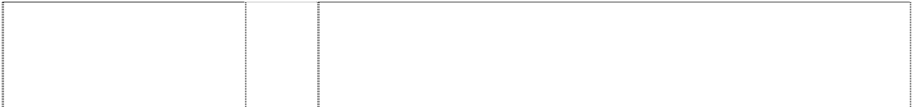

16 Paper, cardboard and goods made from these materials in this class; printed matter, books related to the subject of surfing, snowboarding and skiing, book covers, calendars, stickers, decalcomanias, bumper stickers, posters; stationery, note pads, binders, memo pads, agendas, diaries; writing instruments, pens, pencils, markers; cases for pens and pencils; non-textile labels; photographs.

18 Travel bags, carry bags, handbags, beach bags, tote bags, bath bags, sports bags, pouches (bags), backpacks, purses, wallets, satchels, brief cases, attache cases, suitcases, key cases; umbrellas.

18 Bags, including travel bags, carry bags, backpacks and all other goods in class 18.

22 All goods in this class.

24 Goods of textile, fabric or plastic material [substitute for fabrics] in this class, household linen, bed linen, table linen, towels, handtowels, bed and table covers, serviettes, labels in this class, banners, bunting; textiles and fabrics (woven and knitted).

1. All goods in this class.
2. Clothing, footwear, headgear, wetsuits, swimwear, singlets, T-shirts, shirts and casual tops with long and short sleeves, bodysuits, sweat tops, sweat hooded parkas, jackets, jumpers, shorts, board shorts, walk shorts, volley shorts, long pants, beach pants, trousers, jeans, dresses, skirts, sarongs, leisure wear, sporting and gymnastic wear, ski wear and snowboard wear including ski suits, ski pants, ski trousers, ski jackets, snowboard pants, snowboard trousers and snowboard jackets, skateboard wear, pyjamas, night clothes, underwear, lingerie, stockings, pantyhose, socks, vests, belts, braces, gloves, scarves, bandanas, beanies, headbands, hats, visors, caps, hoods and head coverings with canopy of sunshield, shoes, slippers, sandals, special sporting and gymnastic footwear, athletic shoes, boots, snow boots, snowboard boots, ski boots.

25 Articles of clothing including casual and beachwear, boots, shoes and slippers.

25 Clothing, footwear and headgear.

25 Clothing; footwear; headwear; wetsuits; swimwear; singlets; T-shirts; shirts and casual tops with long and short sleeves; sleeveless shirts; sleeveless tops; bodysuits; sweat tops; sweater vests; sweat hooded parkas; jackets; wind resistant jackets; blazers; suits; ties; neckwear; coats; jumpers; shorts; board shorts; walk shorts; volley shorts; long pants; beach pants; wind resistant pants; trousers; slacks; jeans; overalls; dresses; skirts; sarongs; leisure wear; sporting and gymnastic wear; ski wear and snowboard wear including ski suits, ski pants, ski trousers, ski jackets, snowboard pants, snowboard trousers and snowboard jackets; skateboard wear; aprons; pyjamas; night clothes; dressing gowns; bathrobes; underwear; lingerie; stockings; pantyhose; socks; vests; belts; braces; mittens; gloves; scarves; ear muffs; bandannas; beanies; headbands; hats; visors; caps; hoods and head coverings with canopy of sunshield; surf caps; surf hoods; slippers; boots; shoes; beach shoes; thonged and strapped sandals; sporting and gymnastic footwear; athletic shoes; boots for sports; snow boots; snowboard boots; ski boots; apres ski boots; kiteboard boots; surfboard boots; wakeboard boots; wetsuit boots; mountain boots; hiking shoes and



shoes.

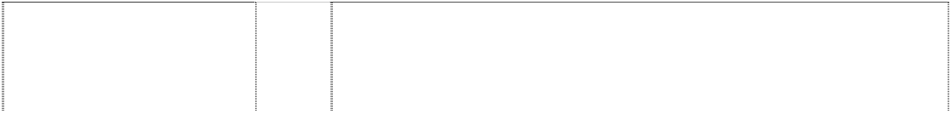

snowcapped mountain in wave all stylised (947941)



# QUIKSILVER

snowcapped mountain in wave all stylised (947941)

# QUIKSILVER

snowcapped mountain in wave all stylised (947941)

# QUIKSILVER

snowcapped mountain in wave all stylised (947941)

# QUIKSILVER

snowcapped mountain in wave all stylised (947941)

# QUIKSILVER

stitches coil around rect.,horiz.in rect.,also stitched

(999957)

# QUIKSILVER

wave, stylised over mountain, snowcapped stylised

(612313)



# QUIKSILVER METHOD

(1099029)

skiing, book covers, calendars, stickers, decalcomanias, bumper stickers, posters; stationery, note pads, binders, memo pads, agendas, diaries; writing instruments, pens, pencils, markers; cases for pens and pencils; non-textile labels; photographs.

18 Travel bags, carry bags, handbags, beach bags, tote bags, bath bags, sports bags, pouches (bags), backpacks, purses, wallets, satchels, brief cases, attache cases, suitcases, key cases; umbrellas.

1. Goods of textile, fabric or plastic material [substitute for fabrics] in this class, household linen, bed linen, table linen, towels, handtowels, bed and table covers, serviettes, labels in this class, banners, bunting; textiles and fabrics (woven and knitted).
2. Clothing, footwear, headgear, wetsuits, swimwear, singlets, T-shirts, shirts and casual tops with long and short sleeves, bodysuits, sweat tops, sweat hooded parkas, jackets, jumpers, shorts, board shorts, walk shorts, volley shorts, long pants, beach pants, trousers, jeans, dresses, skirts, sarongs, leisure wear, sporting and gymnastic wear, ski wear and snowboard wear including ski suits, ski pants, ski trousers, ski jackets, snowboard pants, snowboard trousers and snowboard jackets, skateboard wear, pyjamas, night clothes, underwear, lingerie, stockings, pantyhose, socks, vests, belts, braces, gloves, scarves, bandanas, beanies, headbands, hats, visors, caps, hoods and head coverings with canopy of sunshield, shoes, slippers, sandals, special sporting and gymnastic footwear, athletic shoes, boots, snow boots, snowboard boots, ski boots.

28 Sporting apparatus, surfboards, bodyboards, kneeboards, wakeboards, sailboards, surf skis, snowboards, snow skis, water-skis, skateboards, kiteboards; sporting accessories including leg ropes and security leashes for sporting apparatus, sporting apparatus being ropes especially adapted and fitted as tow-in ropes and skiing ropes, ski bindings, surfboard deck grips, swim fins including swim fins for bodyboarding, sailboard sails, kiteboard sails, wax for skis and surfboards; covers and protective bags for sporting apparatus including bags for surfboards, bodyboards, kneeboards, wakeboards, sailboards, surf skis, snowboards, snow skis, water-skis, skateboards and kiteboards.

25 Clothing, footwear, headgear, wetsuits, swimwear, singlets, T-shirts, shirts and casual tops with long and short sleeves, bodysuits, sweat tops, sweat hooded parkas, jackets, coats, jumpers, shorts, board shorts, walk shorts, volley shorts, long pants, beach pants, trousers, slacks, jeans, overalls, dresses, skirts, sarongs, leisure wear, sporting and gymnastic wear, ski wear and snowboard wear including ski suits, ski pants, ski trousers, ski jackets, snowboard pants, snowboard trousers and snowboard jackets, skateboard wear, aprons, pyjamas, night clothes, dressing gowns, bathrobes, underwear, lingerie, stockings, pantyhose, socks, vests, belts, braces, mittens, gloves, scarves, ear muffs, bandannas, beanies, headbands, hats, visors, caps, hoods and head coverings with canopy of sunshield, slippers, boots, shoes, beach shoes, thonged and strapped sandals, special sporting and gymnastic footwear, athletic shoes, boots for sports, snow boots, snowboard boots, ski boots, kiteboard boots, surfboard boots.

14 Jewellery, precious stones, horological and chronometric instruments.

5 Foodstuffs and beverages in this class; energy drinks in this class; nutritional powdered beverage products in this class; ready to drink meal replacement beverages in this class; dietetic foodstuffs and beverages adapted for medical purposes; nutritional supplements; dietary food supplements; dietary supplements; food supplements; vitamin supplements; mineral supplements; preparations in this class for making beverages in this class.

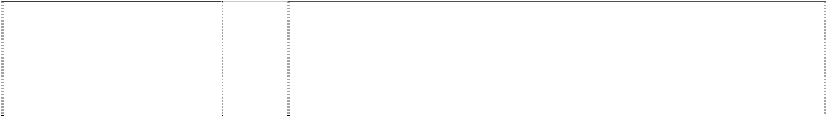

storing compact discs, audio cassettes, video tapes, digital video discs

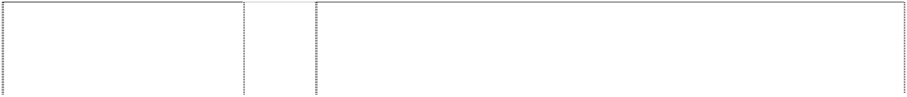

# ZQK

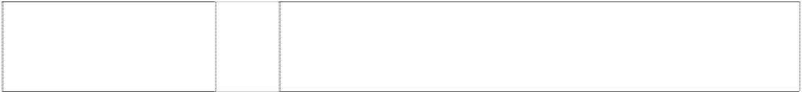

(893995)

# ZQK

(893995)

mountain stylised wave stylised

(345562)

mountain stylised wave stylised

(345564)

mountain stylised wave stylised

(345563)

snowcapped mountain in wave all stylised (877469)

snowcapped mountain in wave all stylised (947943)

snowcapped mountain in wave all stylised (947943)

snowcapped mountain in wave all stylised (955891)

snowcapped mountain in wave all stylised (947943)

snowcapped mountain in wave all stylised (947943)

snowcapped mountain in wave all stylised (947943)

snowcapped mountain in wave all stylised (947943)

snowcapped mountain in wave all stylised (947943)

18 Travel bags, carry bags, backpacks, purses, wallets, handbags, beach bags, tote bags, bath bags, sports bags, pouches (bags), satchels, portable bags, brief cases.

25 Articles of clothing including wetsuits; footwear and headgear.

16 Paper and paper articles; cardboard and cardboard articles; printed matter, newspapers and periodicals, books, photographs, stationery, playing cards, stickers, labels and transfers.

22 Textile or jute articles, including textile and jute bags all being goods included in Cl. 22.

24 Textile articles in Cl. 24, including towels.

3 Perfumes, fragrances, cosmetics, essential oils, soaps, hair lotions, sun screen preparations (cosmetics), suntanning preparations, bath gels, bath oils, bath powders, deodorants, shower gels, shampoos, facial scrubs, face powders, skin soaps, skin moisturisers, body lotions, nail polish, lip balms, lip gloss, lipstick, facial makeup and eye makeup.

3 Perfumes, fragrances, cosmetics, essential oils, soaps, hair lotions, sun screen preparations, sun tanning preparations, bath gels, bath oils, bath powders, deodorants, shower gels, shampoos, facial scrubs, face powders, skin soaps, skin moisturisers, body lotions, nail polish, lip balms, lip gloss, lipstick, facial makeup and eye makeup.

9 Optical goods in this class, eyewear, sunglasses, spectacles and goggles for sports; parts, fittings and accessories in this class for sunglasses, spectacles and goggles for sports including frames, cases, earstems, replacement lenses, nose pieces and foam strips (for cushioning the glasses or eyewear against the forehead); protective helmets for use in sports including surfing, skateboarding, snowboarding and skiing; recorded materials, pre-recorded video tapes, digital video discs and CD-ROMs; computer bags; bags for compact discs.

9 Wetsuits in this class.

14 Watches and parts, fittings and accessories, watch bands, straps for wrist watches, containers for watches in the form of cases, housings for watch mechanisms; clocks; jewellery, jewels, precious stones; goods in precious metals or coated therewith, badges, purses, buckles and key rings in this class.

16 Paper, cardboard and goods made from these materials in this class; printed matter, books related to the subject of surfing, snowboarding and skiing, book covers, calendars, stickers, decalcomanias, bumper stickers, posters; stationery, note pads, binders, memo pads, agendas, diaries; writing instruments, pens, pencils, markers; cases for pens and pencils; non-textile labels; photographs.

18 Travel bags, carry bags, handbags, beach bags, tote bags, bath bags, sports bags, pouches (bags), backpacks, purses, wallets, satchels, brief cases, attache cases, suitcases, key cases; umbrellas.

1. Goods of textile, fabric or plastic material [substitute for fabrics] in this class, household linen, bed linen, table linen, towels, handtowels, bed and table covers, serviettes, labels in this class, banners, bunting; textiles and fabrics (woven and knitted).
2. Clothing, footwear, headgear, wetsuits, swimwear, singlets, T-shirts, shirts and casual tops with long and short sleeves, bodysuits, sweat tops, sweat hooded parkas, jackets, jumpers, shorts, board shorts, walk shorts, volley shorts, long pants, beach pants, trousers, jeans, dresses, skirts, sarongs, leisure wear, sporting and gymnastic wear, ski wear and snowboard wear

snowboard trousers and snowboard jack

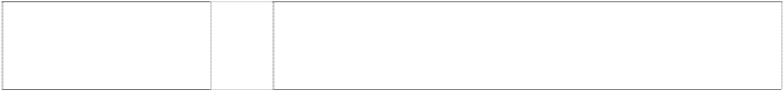

snowboard trousers and snowboard jack

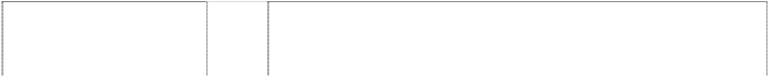

(449602)



wave, stylised over mountain, snowcapped stylised

(421856)

wave, stylised over mountain, snowcapped stylised

(533148)

25 Clothing, footwear, headgear.

28 Surfboards, sporting articles and all other goods in this class.

***Rocket Industries Pty Ltd. Corrs Chambers Westgarth Ph: (03) 9672 3000***

***Effective Date: 17 December 2006 File Ref: C07/00070 Trade Marks Class Goods***

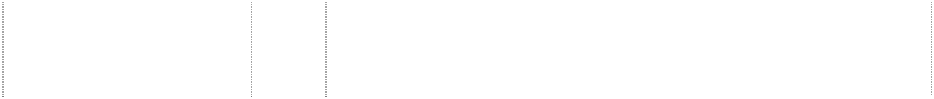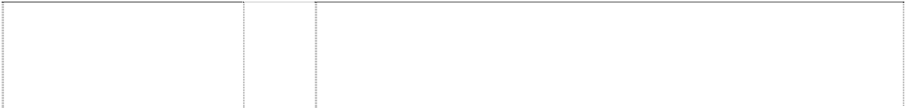

# AUTO GAGE

(963187)

# B&M

ltrs in parallelogram rounded corners

(623865)

# B&M

ltrs in parallelogram rounded corners

(623866)

# CVR HIGH PERFORMANCE ELECTRICAL PRODUCTS

2 flags,checkered,crossed

(956609)

# MSD

(900617)

# MSD IGNITION

(963900)

# PRO-COMP

(963901)

# RCI

(985604)

# RCI

(985603)

9 Automotive equipment in this class, including testing and measuring instruments including tachometers, speedometers and mechanical and electrical gauges and consoles and panels for holding gauges.

7 Marine engine, transmission and drive components in this class.

12 Automotive engine, transmission, and drive components in this class.

7 Automotive/marine electric water pumps (cast and billet); alternators, bracket kits for alternators; starter motors including gear reduction starter motor for automotive and marine applications; billet linkage brackets for carburetion; billet front timing cover (one and two piece); camshaft and valve train; induction; carburetion; magnetos; blocks, crankshafts, rods, pistons, cylinder heads and engine components; fuel injection and filter systems; nitrous systems, superchargers, turbo chargers, spark plugs, vehicle safety equipment in this class.

7 Parts and accessories in this class for motors and engines; igniting devices for internal combustion engines; fuel injector systems and components thereof in this class including ignitions, coils, distributors and engine governors.

7 Parts and accessories in this class for motors and engines; igniting devices for internal combustion engines; fuel injector systems and components thereof in this class including ignitions, coils, distributors and engine governors.

9 Automotive equipment in this class, including testing and measuring instruments including tachometers, speedometers and mechanical and electrical gauges and consoles and panels for holding gauges.

9 Protection devices for personal use against accidents; clothing and shoes for protection against accidents, irradiation and fire; protective helmets and helmet shields; goggles in this class; accessories, parts and components in this class for all of the foregoing; including all of the foregoing for use in the field of vehicle racing.

9 Protection devices for personal use against accidents; clothing and shoes for protection against accidents, irradiation and fire; protective helmets and helmet shields; goggles in this class; accessories, parts and components in this class for all of the foregoing; including all of the foregoing for use in the field of vehicle racing.

**RCI** 12 Vehicular equipment and accessories in this class; safety equipment and

(985604) accessories in this class, including for use in the field of vehicle racing; seats, seat covers, seat mounts and seat supports for vehicles; restraints, security harnesses and seat belts for vehicles; neck brace pads, harness pads and steering pads for vehicles; window nets and window net kits for vehicles; engine diapers and transmission blankets for vehicles; fuel cells, fuel tanks and fuel bladders for vehicles; fuel containers for vehicles; accessories, parts and components in this class for all of the foregoing.



# RCI

(985603)

# RCI

(985604)

# RCI

(985603)

# RCI

(985604)

# RCI

(985603)

# RCI

(985604)

# RCI

(985603)

# SPORT-COMP

(963898)

# SUPERCHIPS

(958975)

# SYSTEM 1

(965204)

# SYSTEM 1

(964650)

12 Vehicular equipment and accessories in this class; safety equipment and accessories in this class, including for use in the field of vehicle racing; seats, seat covers, seat mounts and seat supports for vehicles; restraints, security harnesses and seat belts for vehicles; neck brace pads, harness pads and steering pads for vehicles; window nets and window net kits for vehicles; engine diapers and transmission blankets for vehicles; fuel cells, fuel tanks and fuel bladders for vehicles; fuel containers for vehicles; accessories, parts and components in this class for all of the foregoing.

18 Bags, including bags for vehicle racing helmets, apparel, equipment and accessories; umbrellas.

18 Bags, including bags for vehicle racing helmets, apparel, equipment and accessories; umbrellas.

20 Containers in this class including those for liquid fuel; closures and caps in this class for containers including those for liquid fuel; plastic fuel jugs; accessories, parts and components in this class for containers including liquid fuel containers.

20 Containers in this class including those for liquid fuel; closures and caps in this class for containers including those for liquid fuel; plastic fuel jugs; accessories, parts and components in this class for containers including liquid fuel containers.

25 Clothing, footwear and headgear including for use in the field of vehicle racing; safety clothing, footwear and headgear in this class including for use in the field of vehicle racing; driving uniforms for racing; vehicle racing suits, jackets, pants, undergarments, hoods, shoes and gloves.

25 Clothing, footwear and headgear including for use in the field of vehicle racing; safety clothing, footwear and headgear in this class including for use in the field of vehicle racing; driving uniforms for racing; vehicle racing suits, jackets, pants, undergarments, hoods, shoes and gloves.

9 Automotive equipment in this class, including testing and measuring instruments including tachometers, speedometers and mechanical and electrical gauges and consoles and panels for holding gauges.

9 Automotive computer systems, namely, computerized engine tuners including such tuners with engine diagnostic functions.

7 Parts and components of machines, engines and motors; filters in this class including automotive oil and fuel filters and parts, components and accessories therefor; pumps in this class including automotive oil and sumps and parts, components and accessories therefor; machines and machine tools; motors and engines (except for land vehicles); machine coupling and transmission components (except for land vehicles).

7 Parts and components of machines, engines and motors; filters in this class including automotive oil and fuel filters and parts, components and accessories therefor; pumps in this class including automotive oil and sump pumps and parts, components and accessories therefor; machines and machine tools; motors and engines (except for land vehicles); machine coupling and transmission components (except for land vehicles).

***TAG Heuer S.A. Allens Arthur Robinson***

***Ph: (03) 9614 1011***

***Effective Date: 17 November 2006 File Ref: C06/18790 Trade Marks Class Goods***

# AQUAGRAPH

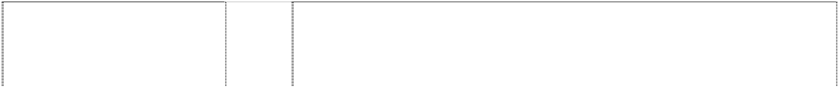

(933963)

# AQUARACER

(1011879)

# AUTAVIA

(916002)

# DIAMOND FICTION

(1096650)

# HEUER

pentagon (298495)

# MICROGRAPH

(784793)

# MICROSPLIT

(977906)

# MICROTIMER TAG HEUER

double-headed arrow forms ltr G in shield, double (987167)

# MICROTIMER TAG HEUER

double-headed arrow forms ltr G in shield, double (987167)

# MULTIGRAPH

(933164)

# PHYSICS

(903175)

# SEARACER

(734481)

# TAG HEUER

(748961)

# TAG HEUER

arrows, forming circle shield (434382)

# TAG HEUER

arrows, forming circle shield (434385)

# TAG HEUER

arrows, forming circle shield (434383)



# TAG HEUER

arrows, forming circle shield (434384)

14 Precious metals and their alloys and goods made of these materials or plated therewith included in this class; jewellery, precious stones; timepieces and chronometric instruments.

14 Precious metals and their alloys and goods made of these materials or plated therewith included in this class; jewellery, bijouterie, precious stones; horological and chronometric instruments.

14 Precious metals and their alloys and goods made of these materials or plated therewith included in this class, jewellery, bijouterie, precious stones, timepieces and chronometric instruments.

14 Horological and chronometric instruments.

14 Watches, clocks and chronometrical instruments of all kinds and parts and components therefore.

14 Precious metals and their alloys and goods made of these materials or plated therewith included in this class, jewellery, precious stones; timepieces and chronometric instruments.

14 All types of parts of timepieces.

9 Time measuring apparatus and instruments, as well as parts and accessories thereof, not included in other classes.

14 Precious metals and their alloys and goods made of or coated with these materials not included in other classes; jewellery, precious stones; timepieces and chronometric instruments, particularly watches, watchbands, chronometers, chronographs, clocks, as well as parts and accessories thereof included in this class.

14 Precious metals and their alloys and goods made of these materials or plated therewith included in this class; jewellery, precious stones; timepieces and chronometric instruments.

9 Eyewear, sunglasses, frames for eyeglasses, eyeglass lenses, eyeglass cases.

14 Precious metals and their alloys and goods in precious metals or coated therewith, not included in other classes; jewellery, precious stones; horological and chronometric instruments.

14 Precious metals and their alloys and goods in precious metals or coated therewith, not included in other classes; jewellery, precious stones; horological and chronometric instruments.

9 Time measuring instruments and apparatus in this class, including electronic time measuring instruments in this class and calculators incorporating watch functions; metronomes; parts of and accessories in this class for all of the aforementioned goods; time measuring articles in this class for sporting use.

14 Watches and time measuring instruments and apparatus in this class; including electronic watches, watches including a calculator as a secondary function; and parts of and accessories in this class for all the aforementioned goods; articles for time measurement or time keeping in this class for sporting use.

25 Sporting clothing including sports wear.

28 Sporting articles.

# TAG HEUER

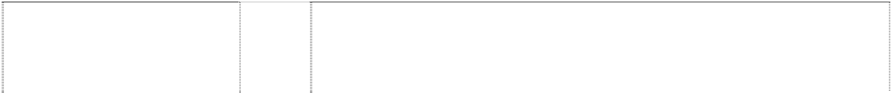

curved & angled arrows form ltr G; all in shield divided (813862)

# TAG HEUER

curved & angled arrows form ltr G; all in shield divided (813862)

# TAG HEUER

curved & angled arrows form ltr G; all in shield divided (813862)

# TAG HEUER

curved & angled arrows form ltr G; all in shield divided (813862)

# TAG HEUER

double-headed arrow makes ltr G, words in crest, divided (729143)

# TAG HEUER FORMULA 1

shield, double, halved arrow, double-headed forming letter G

(444776)

# TAG HEUER MONZA

(860929)

# TARGA FLORIO

(876688)

# VANQUISH

(1104814)

# VANQUISH

(1104814)

# What are you made of?

(905327)

# What are you made of?

(905327)

3 Soaps, perfumery, essential oils; cosmetics, hair lotions; dentifrices.

9 Apparatus for recording, transmission or reproduction of sound or images, in particular telephone apparatus, facsimile machines, video recorders, television apparatus, compact discs players, answering machines, dictating machines, apparatus for games adapted for use with television receivers only; magnetic and optical data carriers, in particular magnetic encoded cards, integrated circuit cards, compact discs, optical discs, disks, video game cartridges, optical fibres; calculating machines, data processing equipment and computers, in particular computer software, modems, notebook computers, electronic agendas, electronic notice boards; optical goods, in particular spectacle sunglasses, spectacles frames, spectacles cases, contact lenses.

16 Paper, cardboard and goods made from these materials, not included in other classes; photographs; stationery; office requisites, in particular pencils, pens and nibs; plastic for wrapping.

28 Games, in particular electronic games, toys; gymnastics and sporting articles not included in other classes.

18 Leather and imitations of leather, and goods made of these materials and not included in other classes; animal skins, hides; trunks and travelling bags; umbrellas, parasols and walking sticks; whips; harness and saddlery.

14 Watches and time measuring instruments and apparatus of all kinds, including electronic ones, as well as parts of all the aforementioned goods; microtechnical parts for watches.

14 Horological and chronometric instruments.

14 Precious metals and their alloys and goods in precious metals or coated therewith, not included in other classes; jewellery, precious stones; horological and chronometric instruments.

9 Time-measuring apparatus and instruments, as well as their parts and accessories, not included in other classes.

14 Precious metals and their alloys and goods in precious metals or coated therewith, not included in other classes; jewellery, precious stones; horological and chronometric instruments, namely watches, watchbands, chronometers, chronographs, clocks, as well as their parts and accessories included in this class.

9 Glasses, sunglasses; eyeglass cases; frames for eyeglasses; optical apparatus and instruments; optical goods; spectacle glass.

14 Precious metals and alloys thereof other than for dental use; jewellery, bijouterie, precious stones; timepieces; chronometric instruments; watches.

***The Saul Zaentz Company Chrysiliou Law Ph: (02) 9953 4222***

***Effective Date: 1 November 2006 File Ref: C06/15538***

***Class Goods***

***Trade Marks***



(900863)



# BILBO BAGGINS

(855099)

# BILBO BAGGINS

(855099)

# BILBO BAGGINS

(855099)

# BILBO BAGGINS

(855099)

# BILBO BAGGINS

(855099)

# BILBO BAGGINS

(855099)

# ELROND

(855089)

# ELROND

(855089)

# ELROND

(855089)

# ELROND

(855089)

# ELROND

(855089)

# ELROND

(855089)

# ELROND

(855089)

# ENT

(796358)

# EVENSTAR

(887531)

# EVENSTAR

(887531)

# FRODO

(887532)

# FRODO

(887532)

# FRODO

(887532)

14 Figurines and figural products, including collectible figurines and figurines incorporated into settings, made of precious metals and their alloys.

16 Printed matter, posters, wall charts, photographs, stationery, art prints, calendars, instructional and teaching materials, playing cards, and trading cards.

1. Figurines and figural products, including collectible figurines and figurines incorporated into settings, made of resin, wood, cork, reed, cane, wicker, horn, bone, ivory, whalebone, shell, amber, mother-of-pearl, meerschaum and substitutes for these materials, or of plastics.
2. Figurines and figural products, including collectible figurines and figurines incorporated into settings, made of glass, porcelain and earthenware.

25 Clothing, including T-shirts and sweatshirts, costumes, footwear, and headwear.

28 Toys, games, dolls, action figures and accessories therefor, play figures, puzzles, costume masks, puppets, Christmas tree ornaments.

6 Figurines and figural products, including collectible figurines and figurines incorporated into settings, made of common metals and their alloys.

14 Figurines and figural products, including collectible figurines and figurines incorporated into settings, made of precious metals and their alloys.

16 Printed matter, posters, wall charts, photographs, stationery, art prints, calendars, instructional and teaching materials, playing cards, and trading cards.

1. Figurines and figural products, including collectible figurines and figurines incorporated into settings, made of resin, wood, cork, reed, cane, wicker, horn, bone, ivory, whalebone, shell, amber, mother-of-pearl, meerschaum and substitutes for these materials, or of plastics.
2. Figurines and figural products, including collectible figurines and figurines incorporated into settings, made of glass, porcelain and earthenware.

25 Clothing, including T-shirts and sweatshirts, costumes, footwear, and headwear.

28 Toys, games, dolls, action figures and accessories therefor, play figures, puzzles, costume masks, puppets, Christmas tree ornaments.

21 Pewter ware, and goblets, models ornaments, sculptures, figurines, wall plaques and plates in pewter.

14 Jewellery; trinkets; cases of precious metals; watches and accessories therefor; clocks; precious stones and semi-precious stones; works of art of precious metal.

28 Toys, games, dolls, action figures and accessories therefor, play figures, puzzles, costume masks, puppets, Christmas tree ornaments.

9 Computer games software and hardware, including computer game programs and downloadable on-line interactive computer game programs having single and multi-player capability; computer games cartridges; apparatus for recording, transmission or reproduction of sound or images; audio, video and audio-video recordings and other carriers of sound or images.

16 Printed matter; posters; wall charts; photographs; stationery; art prints; calendars; playing cards; trading cards; bookmarks; sticker books; stickers; postcards; writing paper; note books; note pads; note cards; folders; pencils; pens; rulers; erasers; paperweights; holders for office supplies, pens, pencils and paperclips; series of fiction books and magazines; wrapping paper.

25 Clothing, including, T-shirts and sweatshirts, costumes, footwear and headwear.

**FRODO** 28 Toys, games, dolls, action figures and accessories therefor, play figures, puzzles, costume masks, puppets, Christmas tree ornaments.



(887532)

# FRODO BAGGINS

(855098)

# FRODO BAGGINS

(855098)

# FRODO BAGGINS

(855098)

# FRODO BAGGINS

(855098)

# FRODO BAGGINS

(855098)

# FRODO BAGGINS

(855098)

# FRODO BAGGINS

(855098)

# GALADRIEL

(796364)

# GALADRIEL

(855097)

# GALADRIEL

(855097)

# GALADRIEL

(855097)

# GALADRIEL

(855097)

# GALADRIEL

(796364)

# GALADRIEL

(855097)

# GALADRIEL

(855097)

# GALADRIEL

(855097)

# GANDALF

(789999)

# GANDALF

(789999)

# GANDALF

(789999)

# GANDALF

(789999)

# GANDALF

(789999)

# GANDALF

(796363)

6 Figurines and figural products, including collectible figurines and figurines incorporated into settings, made of common metals and their alloys.

14 Figurines and figural products, including collectible figurines and figurines incorporated into settings, made of precious metals and their alloys.

16 Printed matter, posters, wall charts, photographs, stationery, art prints, calendars, instructional and teaching materials, playing cards, and trading cards.

1. Figurines and figural products, including collectible figurines and figurines incorporated into settings, made of resin, wood, cork, reed, cane, wicker, horn, bone, ivory, whalebone, shell, amber, mother-of-pearl, meerschaum and substitutes for these materials, or of plastics.
2. Figurines and figural products, including collectible figurines and figurines incorporated into settings, made of glass, porcelain and earthenware.

25 Clothing, including T-shirts and sweatshirts, costumes, footwear, and headwear.

28 Toys, games, dolls, action figures and accessories therefor, play figures, puzzles, costume masks, puppets, Christmas tree ornaments.

6 Ornaments, sculptures, models, figurines, and wall plaques in this class.

6 Figurines and figural products, including collectible figurines and figurines incorporated into settings, made of common metals and their alloys.

14 Figurines and figural products, including collectible figurines and figurines incorporated into settings, made of precious metals and their alloys.

16 Printed matter, posters, wall charts, photographs, stationery, art prints, calendars, instructional and teaching materials, playing cards, and trading cards.

1. Figurines and figural products, including collectible figurines and figurines incorporated into settings, made of resin, wood, cork, reed, cane, wicker, horn, bone, ivory, whalebone, shell, amber, mother-of-pearl, meerschaum and substitutes for these materials, or of plastics.
2. Pewter ware and plates in pewter; ornaments, sculptures, models, figurines and wall plaques in this class.

21 Figurines and figural products, including collectible figurines and figurines incorporated into settings, made of glass, porcelain and earthenware.

25 Clothing, including T-shirts and sweatshirts, costumes, footwear, and headwear.

28 Toys, games, dolls, action figures and accessories therefor, play figures, puzzles, costume masks, puppets, Christmas tree ornaments.

6 Figurines, including collectible figurines made of common metals and their alloys.

9 Computer game programs, audio, video and audio-video recordings.

14 Figurines, including collectible figurines made of precious metals and their alloys.

16 Printed matter, posters, wall charts, photographs, stationery, instructional and teaching materials, playing cards and trading cards.

1. Figurines, including collectible figurines made of wood, cork, reed, cane, wicker, horn, bone, ivory, whalebone, shell, amber, mother-of-pearl, meerschaum and substitutes for these materials, or of plastics.
2. Pewter ware and ornaments, sculptures, models, figurines, wall plaques and plates in pewter.

**GANDALF** 21 Figurines, including collectible figurines made of glass, porcelain and



h oil, bath powder, body cream, body



topping (dairy and non-dairy based);



transportation cards; pre-paid te



# LOTR

(1043868)

# LOTR

(1043868)

# LOTR

(1043868)

household use; greeting cards; guest books; informational flyers and letters concerning musical plays; instructional manuals and strategy guides for games; invitation cards; iron-on patches; lithographic prints; lithographs; markers; memorandum boards; memorandum books; merchandise bags; musical greeting cards; nonelectronic personal planners and organizers; non-magnetic cards for use as credit cards; non-magnetically coded telephone calling cards; non-magnetically coded transportation fare cards; note books; note cards; note pad and pencil sets; note pads; office supplies; organisers for stationery use; original artwork prints; ornaments made of paper; painting sets for children; paper doorknob hangers; paper mache figures; paper napkins; paper party decorations; paper party hats; paper ribbons; paper table cloths; paper weights; patterns for making costumes; pencil cases; pencil sharpeners; pencils; pens; personal organizers; photograph albums; photographic prints; picture books; picture postcards; pocket calendars; pop-up books; postcards; poster books; posters; printed greeting cards with electronic information stored therein; printed holograms; printed invitations; printed paper patterns; prints; rub down transfers; school supplies; scrapbook albums; scrapbooks; sheet music; sketch books; social note cards; song books; souvenir programs concerning dramatic and musical performances; stamp albums; stationery; stationery sets comprised of paper, envelopes, seals and notepads; stationery writing paper and envelopes; stationery-type portfolios; stencils; sticker books; stickers; temporary tattoos; trading card milk bottle caps; trading cards; travel guide books; trivia cards; wall calendars; wall charts; writing pads.

20 Furniture, mirrors, picture frames; goods (not included in other classes) of wood, cork, reed, cane, wicker, horn, bone, ivory, whalebone, shell, amber, mother-of-pearl, meerschaum and substitutes for all these materials, or of plastics; ir mattresses for use when camping; chair pads; costume display stands; cushions; gazing globes; gift package decorations made of plastics; hand fans; holiday ornaments of plastic (not tree ornaments); jewellery and letter boxes and cases not of metal; key fobs not made of metal; nap mats; non-metal key chains; non-metal lock boxes; nonmetal key tags; non-metal money clips; non-metal safes; non-metal trophies; plaques; plastic and wood boxes; plastic cake decorations; plastic flags; plastic pill boxes; point of purchase displays; sleeping bags and mats; soft sculpture wall decorations; tool boxes and chests (furniture); window shades; wood boxes; wood carvings; wood knobs; wood signs.

25 Clothing, footwear, headgear; athletic shoes; bathrobes; belts; boxer shorts; caps; children's footwear; coats; costumes for use in role playing games; dresses; fitness tops; footwear; gloves; Halloween costumes; hats; head wear; headbands; hosiery; jackets; jogging suits; jumpsuits; long underwear; masquerade costumes, accessories, and masks sold in connection therewith; mittens; overalls; pyjamas; pants, parkas; rainwear; scarves; shirts; shorts; skirts; sleepwear; slippers; socks; special sporting and gymnastic clothing and footwear; suspenders; sweaters; sweatpants; sweatshirts; swim wear; tank tops; ties; tights; T-shirts; underwear; visors; warm-up suits; wind- resistant jackets; wristbands.

28 Games and playthings; gymnastic and sporting articles not included in other classes; decorations for Christmas trees; action figures; action skill games; action-type target games; amusement park rides; arcade games; backgammon sets; balloons; balls; bath toys; board games; card games; chess boards; chess games; chess pieces packaged separately and as a set; childrens toy mazes; Christmas tree ornaments; coin-operated pinball and video game machines; collectible marbles; collectible toy figures; construction toys; costume masks; craft sets for making toy jewellery; darts; doll clothing; dolls; electronic action toys; electronic educational game machines for children; equipment packaged as a unit for playing action type target games; equipment packaged as a unit for playing board games, card games and hand held electronic games; fantasy character toys; flying discs; hand held electronic toys; hand held units for playing video games; hobby craft sets consisting of play cosmetics; hobby craft sets for decorating hair; hobby craft sets for making beads; hobby craft sets for making crystals; hobby craft sets for making decorative objects with

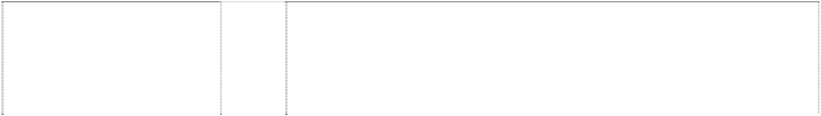

# MIDDLE EARTH

(919519)

# MIDDLE EARTH

(990869)

# MIDDLE EARTH

(790000)

# MIDDLE EARTH

(855104)

# MIDDLE EARTH

(790000)

# MIDDLE EARTH

(790000)

# MIDDLE EARTH

(790000)

# MIDDLE EARTH

(790000)

# MIDDLE EARTH

(790000)

magnets; hobby craft sets for making model buildings; hobby craft sets for making model figures; hobby craft sets for making sand art; hobby craft sets for making soap; hobby craft sets for making toy jewellery; hobby craft sets for moulding chocolate; inflatable toys; in-line skates; jigsaw puzzles; kites; LCD game machines; marbles; maze games; mechanical action toys; non-coin operated machines; non-motorized toy scooters; paper face masks; parlour games; pinball games and machines; play kits consisting of play cosmetics; play sets for action figures and masquerade games; playing cards; plush dolls with and without sound; plush toys; pool rings; positionable toy figures; puppets; rag dolls with and without sound; remote controlled action figures; role-playing games and toys; roller skates; sand toys; skateboards; soccer balls; soft sculpture toys; sporting equipment; stand alone video game machines; surf boards; swim floats for recreational use; talking toys; three-dimensional puzzles; toy action figures and accessories therefor; toy armour; toy arrows and bows; toy axes; toy banks; toy bobbing head figures; toy boxes; toy building blocks and connecting links for the same; toy buildings, castles, fences, forts, structures, trees and plants and accessories therefor; toy candy dispensers and holders; toy coin banks; toy cosmetic kits; toy daggers; toy engine powered model vehicles; toy figures; toy helmets; toy knives; toy ladders; toy maces; toy modelling compounds and dough; toy pedal cars; toy radio controlled vehicles; toy scooters; toy snow globes; toy swords; toy throwing discs; toy vehicles and accessories therefor; toy watches; toy weapons; toy whistles; transforming robotic toys; twodimensional puzzles, except crossword puzzles; wind-up toys; yo-yos.

3 Cosmetics, beauty and toiletry preparations, toilet soaps, pumice soap, bath salts, bath and shower gels, body lotions, salt scrubs, perfumery, essential oils, creams, soaps and lotions, pot pourri and fragrances, cleansing creams, hand creams, make-up removers, skin tightening cream and impurity removing cream, nail care products, hair lotions including shampoos and conditioners.

3 Bleaching preparations and other substances for laundry use; cleaning, polishing, scouring and abrasive preparations; soaps; perfumery, essential oils, cosmetics, hair lotions; dentifrices; aftershave lotions, baby oil, baby powder, baby shampoo, bath gel, bath oil, bath powder, body cream, body oil, body lotion, body powder, bubble bath, cologne, cosmetic pencils, dish detergents, essential oils for personal use, eye pencils, eye makeup, eye makeup remover, eye shadow, face powder, facial lotion, hair conditioners, hair dye, hair gel, hair shampoo, hair spray, hand cream, laundry detergents, lip gloss, lipstick, makeup, mascara, massage oil, non- medicated lip balm, non-medicated bath salts, mouthwash, nail polish, perfume, pre-moistened cosmetic wipes, rouge, shaving lotion, shaving cream, skin cleansing cream, skin lotion, skin moisturizer, skin soap, skin toner, sun screen preparations, talcum powder, toilet water, tooth gel, tooth paste.

6 Figurines, including collectible figurines made of common metals and their alloys.

1. Swords; pocket knives; decorative weaponry namely blades, side arms (other than fire arms), maces, axes and daggers.
2. Computer game programs, audio, video and audio-video recordings.

14 Figurines, including collectible figurines made of precious metals and their alloys.

16 Printed matter, posters, wall charts, photographs, stationery, instructional and teaching materials, playing cards and trading cards.

1. Figurines, including collectible figurines made of wood, cork, reed, cane, wicker, horn, bone, ivory, whalebone, shell, amber, mother-of-pearl, meerschaum and substitutes for these materials, or of plastics.



1. Figurines, including collectible figurines made of glass, porcelain and earthenware.

(790000)



colouring books, comic books, comic magazines, composition books,

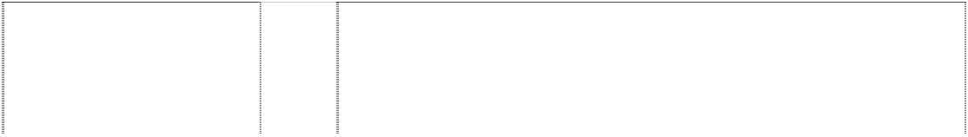

# NARSIL

(900864)

# NAZGUL

(855093)

# NAZGUL

(855093)

# NAZGUL

(855093)

# NAZGUL

(855093)

# NAZGUL

(855093)

# NAZGUL

(855093)

# NAZGUL

(855093)

# ONE RING TO RULE THEM ALL

(887538)

# ONE RING TO RULE THEM ALL

(887538)

# ONE RING TO RULE THEM ALL

(887538)

# ONE RING TO RULE THEM ALL

(887538)

# ONE RING TO RULE THEM ALL

(887538)

# ORC

(887533)

# ORC

(796357)

# ORC

(887533)

# ORC

(887533)

including toy castles and forts, toy swords, toy throwing discs, toy vehicle accessories, toy vehicles, toy watches, toy weapons, transforming robotic toys, two-dimensional puzzles, except crossword puzzles, toy whistles, wind-up toys, yo-yos.

8 Swords, pocket knives and decorative weaponry, including maces, axes, daggers and sidearms, not including firearms.

6 Figurines and figural products, including collectible figurines and figurines incorporated into settings, made of common metals and their alloys.

14 Figurines and figural products, including collectible figurines and figurines incorporated into settings, made of precious metals and their alloys.

16 Printed matter, posters, wall charts, photographs, stationery, art prints, calendars, instructional and teaching materials, playing cards, and trading cards.

1. Figurines and figural products, including collectible figurines and figurines incorporated into settings, made of resin, wood, cork, reed, cane, wicker, horn, bone, ivory, whalebone, shell, amber, mother-of-pearl, meerschaum and substitutes for these materials, or of plastics.
2. Figurines and figural products, including collectible figurines and figurines incorporated into settings, made of glass, porcelain and earthenware.

25 Clothing, including T-shirts and sweatshirts, costumes, footwear, and headwear.

28 Toys, games, dolls, action figures and accessories therefor, play figures, puzzles, costume masks, puppets, Christmas tree ornaments.

9 Computer games software and hardware, including computer game programs and downloadable on-line interactive computer game programs having single and multi-player capability; computer games cartridges; apparatus for recording, transmission or reproduction of sound or images; audio, video and audio-video recordings and other carriers of sound or images.

14 Jewellery; trinkets; cases of precious metals; watches and accessories therefor; clocks; precious stones and semi-precious stones; works of art of precious metal.

16 Printed matter; posters; wall charts; photographs; stationery; art prints; calendars; playing cards; trading cards; bookmarks; sticker books; stickers; postcards; writing paper; note books; note pads; note cards; folders; pencils; pens; rulers; erasers; paperweights; holders for office supplies, pens, pencils and paperclips; series of fiction books and magazines; wrapping paper.

25 Clothing, including, T-shirts and sweatshirts, costumes, footwear and headwear.

28 Toys, games, dolls, action figures and accessories therefor, play figures, puzzles, costume masks, puppets, Christmas tree ornaments.

16 Printed matter; posters; wall charts; photographs; stationery; art prints; calendars; playing cards; trading cards; bookmarks; sticker books; stickers; postcards; writing paper; note books; note pads; note cards; folders; pencils; pens; rulers; erasers; paperweights; holders for office supplies, pens, pencils and paperclips; series of fiction books and magazines; wrapping paper.

21 Pewter ware, and goblets, ornaments sculptures, models, figurines, wall plaques and plates in pewter.

25 Clothing, including, T-shirts and sweatshirts, costumes, footwear and headwear.



28 Toys, games, dolls, action figures and accessories therefor, play figures, puzzles, costume masks, puppets, Christmas tree ornaments.

(938427)



uring dramatic readings from stage



tattoos, travel guide books, tr



# THE LORD OF THE RINGS THE FELLOWSHIP OF THE RING



(893216)

# THE LORD OF THE RINGS THE FELLOWSHIP OF THE RING

(893216)

# THE LORD OF THE RINGS THE RETURN OF THE KING

(943111)

# THE LORD OF THE RINGS THE RETURN OF THE KING

(943111)

25 Clothing, including, T-shirts and sweatshirts, costumes, footwear and headwear.

28 Toys, games, dolls, action figures and accessories therefor, play figures, puzzles, costume masks, puppets, Christmas tree ornaments.

9 Scientific, nautical, surveying, electric, photographic, cinematographic, optical, weighing, measuring, signalling, checking (supervision), life-saving and teaching apparatus and instruments; apparatus for recording transmission or reproduction of sound or images; magnetic data carriers, recording discs; automatic vending machines and mechanisms for coin- operated apparatus; cash registers, calculating machines, data processing equipment and computers; fire-extinguishing apparatus; computers and computer accessories including apparatus for computer video games adapted for use with TV only; calculators; cameras; CD players; compact discs including compact discs featuring fantasy games, fantasy films, animated cartoons and music; computer game programs; software including computer game software; computer hardware; computer peripherals; downloadable online interactive computer game programs having single and multi-player capability; DVD players; headphones; interactive computer video games; interactive multimedia computer game programs; kaleidoscopes; magnetically encoded calling cards, transportation cards and credit cards; magnets; mousepads; audio cassettes, CD-ROMs, computer game discs, DVD discs, laser discs, phonograph records, video tapes, DVDs, video game cartridges; sunglasses; video discs including video discs featuring fantasy games, fantasy films and music; video game discs, video game machines for use with television sets, and video game software.

16 Paper, cardboard and goods made from these materials, not included in other classes; printed matter including books containing puzzles and games, books featuring photographic prints, books for role-playing, books on fantasy, books on myths, children's activity books, colouring books, comic books, comic magazines, puzzle books, picture books, pop-up books, fantasy magazines, maze books, composition books, copy books, calendars, gift books, greeting cards, guest books, poster books, posters, sticker books, stickers, temporary tattoos, rub down transfers, iron-on patches, invitations, cardboard figures, coin albums, collector albums, photograph albums, scrap book albums, sketchbooks, stamp albums, book marks, correspondence note paper, address books, bank cheques, blank note cards, holograms, paper napkins, paper party decorations, paper party hats, paper ribbons, paper table cloths, printed paper patterns, patterns for making costumes; non-magnetically coded telephone calling cards, non- magnetic cards used as credit cards, non-magnetically coded transportation fare cards; instructional and teaching material (except apparatus); instructional manuals and strategy guides for games; artists' materials; paint brushes; artist's brushes, original artwork prints, painting sets; lithographic prints; art prints, art reproductions; postcards; trading card milk bottlecaps, trading cards; adhesives for stationery or household purposes; bookbinding material; photographs; photographic prints; stationery and desk accessories including, desk baskets, desk pads and stationery sets comprised of paper, envelopes, seals and notepads, desk stands, desk holders for pens and pencils; desk top organizers, diaries, erasers, memorandum boards; personal organizers, non-electronic personal planners and organizers, notebooks, notepad and pencil sets, notepads, organizers for stationery use; pencils, pencil cases, pencil sharpeners, pens; stationery portfolios, stencils, writing pads, crayons; activity kits in this class including activity kits containing stamper makers, rubber stampers, ink pad, coloured pencils and stamper holder packaged as a unit; decorative rubber stamps; paper activity kits consisting of writing and drawing implements, paper doorknob hangers, paper mache figures; arts and craft drawing kits, arts and craft model-making kits including such

materials and compounds for use by children; typewriters and office



operated apparatus; cash registers,



and window shades.



marbles, collectible toy figures, cons

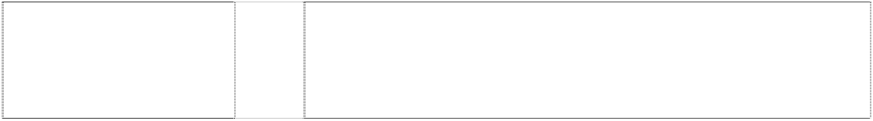

beads; hobby craft sets for making toy jewellery.



# TREEBEARD

(966540)

# URUK-HAI

(887544)

# URUK-HAI

(887544)

# URUK-HAI

(887544)

# URUK-HAI

(887544)

machines, coin-operated video game machines, collectible marbles, collectible toy figures, construction toys, costume masks, darts, doll clothing, dolls, electronic action toys, electronic educational game machines for children, equipment packaged as a unit for playing action type target games, equipment packaged as a unit for playing board games, equipment packaged as a unit for playing card games, equipment packaged as a unit for playing hand held electronic games, fantasy character toys, flying discs, hand held electronic toys, hand held units for playing video games, hobby craft sets for making model figures (toys), inflatable toys, in-line skates, jigsaw puzzles, kites, LCD game machines, marbles, maze games, mechanical action toys, noncoin operated machines, non-motorized toy scooters, paper face masks, parlor games, pinball games, pinball machines, play kits consisting of play cosmetics, play sets for action figures, play sets for masquerade games, playing cards, plush toys, pool rings, positionable toy figures, puppets, remote controlled action figures, role-playing games, role-playing toys, roller skates, sand toys, skateboards, soccer balls, soft sculpture toys, stand alone video game machines, surf boards, swim floats for recreational use, talking toys, three- dimensional puzzles, toy action figure accessories, toy action figures, toy armour, toy axes, toy banks, toy bows, toy arrows, toy boxes, toy building blocks and connecting links for the same, toy candy dispensers, toy candy holders, toy coin banks, toy cosmetic kits, toy daggers, toy engine powered model vehicles, toy figures, toy helmets, toy knives, toy maces, toy modeling compounds and dough, toy pedal cars, toy radio controlled vehicles, toy scooters, toy snow globes, toy structure accessories, namely, toy fences, trees, and ladders, toy structures, namely, toy castles and forts, toy swords, toy throwing discs, toy vehicle accessories, toy vehicles, toy watches, toy weapons, transforming robotic toys, twodimensional puzzles, except crossword puzzles, toy whistles, wind-up toys, and yo- yos; playing cards; gymnastic and sporting articles not included in other classes.

34 Tobacco; smokers' articles, including cigarette lighters not of precious metal, cigarette ash receptacles, ashtrays not of precious metal, cigarette cases not of precious metal, and cigarette lighters not for land vehicles; matches.



9 Computer games software and hardware, including computer game programs and downloadable on-line interactive computer game programs having single and multi-player capability; computer games cartridges; apparatus for recording, transmission or reproduction of sound or images; audio, video and audio-video recordings and other carriers of sound or images.

16 Printed matter; posters; wall charts; photographs; stationery; art prints; calendars; playing cards; trading cards; bookmarks; sticker books; stickers; postcards; writing paper; note books; note pads; note cards; folders; pencils; pens; rulers; erasers; paperweights; holders for office supplies, pens, pencils and paperclips; series of fiction books and magazines; wrapping paper.

25 Clothing, including, T-shirts and sweatshirts, costumes, footwear and headwear.

28 Toys, games, dolls, action figures and accessories therefor, play figures, puzzles, costume masks, puppets, Christmas tree ornaments.

***Tristar Pictures, Inc Australian Federation Against Copyright Theft Ph: (02) 9997 8011***

***Effective Date: 29 November 2006 File Ref: C06/18954***



***Trade Marks***

***Class Goods***

Winged horse & cloud, all in



square (600635)

9 All goods in this class.

***Twentieth Century Fox Film Corporation Australian Federation Against Copyright Theft***

***Ph: (02) 9997 8011***

***Effective Date: 29 November 2006 File Ref: C06/18582 Trade Marks Class Goods***



# 20TH CENTURY FOX

1. searchlights atop building, incomplete

(900630)

# 20TH CENTURY FOX

1. searchlights atop building, incomplete

(900629)

# 20TH CENTURY FOX HOME ENTERTAINMENT

2 searchlights atop building, incomplete

(900627)

# FOX

(638739)

# FOX

(785590)

# FOX 2000

(792328)

# TWENTIETH CENTURY- FOX

(366847)

9 Motion picture films; pre-recorded video tapes, video cassettes, video discs, DVDs and VCDs; pre-recorded audio tapes, audio cassettes, audio discs; computer software programs; computer and video game software.

9 Motion picture films; pre-recorded video tapes, video cassettes, video discs, DVDs and VCDS; pre-recorded audio tapes, audio cassettes, audio discs; computer software programs; computer and video game software.

9 Motion picture films; pre-recorded video tapes, video cassettes, video discs, DVDs and VCDs; pre-recorded audio tapes, audio cassettes, audio discs; computer software programs; computer and video game software.

9 Records, tapes, cassettes, and compact discs for the reproduction of sound; motion picture films; pre-recorded video tapes, video cassettes, and videodiscs.

9 Telecommunications equipment in this class; telephones including mobile telephones; sim cards and phone cards; computer software including computer software programs and CD-ROMS; goods in this class for recording, transmission or reproduction of sound and images; parts and accessories for all the aforesaid goods; none of the foregoing being for digital computer systems for management, data logging, monitoring, automatic and manual control of industrial processes.

9 Motion picture films; pre-recorded video tapes, video cassettes and video discs; pre-recorded audio tapes, audio cassettes and audio discs.

9 Motion picture films, phonograph records, pre-recorded audiomagnetic tapes, television programmes, pre-recorded video magnetic tapes, videodiscs.

***Vegas Enterprises Pty Ltd T/as Rusty Surfboards Trade Mark Investigations Services***

***Ph: (07) 3257 1083***

***Effective Date: 10 November 2006 File Ref: C06/18425 Trade Marks Class Goods***

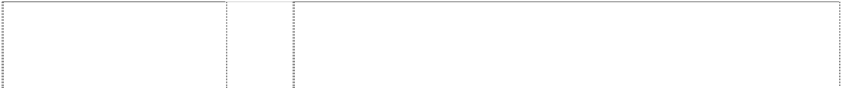

# R

stripes, irregular, oblique, horizontal and angled blot (457934)

# R.

brushstroke & dot form letter R

(474557)

# RED

square (841057)



# R PRECISION DESIGNS RUSTY PREISENDORFER

28 Fibreglass surfboards.

25 Clothing, namely T-shirts.

25 Clothing.

28 Fibreglass surfboards.

geometric shapes forming letter R



(457935)

# R TK

chevron with stripes, horizontal & vertical forming letter; disc or full stop; character, Greek, Pi

(479754)

# RUSTY

(479755)

# RUSTY

(479756)

# RUSTY

(970848)

# RUSTY ALL TERRAIN SERIES

(812025)

# RUSTYEXPERIMENTALDE NIM

(841058)

25 Clothing.

25 Clothing.

28 Surfboards.

9 Cellular telephone covers; cellular telephone headsets; CD carrying cases; computer carrying cases; computer screensaver software; pre-recorded video tapes and DVD’s featuring surf, skate and snowboard competitions; disposable cameras; eyeglasses; eyeglasses cases; eyeglasses rims and eyeglasses frames and related eyeglasses parts and accessories therefore; sunglasses; sunglasses cases; sunglasses rims and sunglasses frames and related sunglasses parts and accessories therefore.

25 Clothing, headgear and footwear.

25 Clothing.

***Warner Bros. Entertainment Inc. Australian Federation Against Copyright Theft Ph: (02) 9997 8011***

***Effective Date: 29 November 2006 File Ref: C06/18955 Trade Marks Class Goods***



# HP

winged ball breaks ellipse, incompl., lightning bolt is part of ltr P

(840771)

# HP

winged ball breaks ellipse, incompl., lightning bolt is part of ltr P

(840771)

9 Motion picture films featuring comedy, drama, action, adventure and/or animation, and motion picture films for broadcast on television featuring comedy, drama, action, adventure and/or animation; prerecorded vinyl records, audio tapes, audio-video tapes, audio-video cassettes, audio-video discs, and digital versatile discs all featuring music, comedy, drama, action, adventure, and/or animation; stereo headphones; batteries; hand-held calculators; telephones, cordless telephones, cellular telephones, compact disc players, digital audio tape recorders and players, electronic diaries, radios, mouse pads, video and computer game programs, phone cards, credit cards, cash cards and magnetic key cards all related to a series of publications and films, including, but not limited, to the names and images of characters, places and other indicia contained therein, about a young wizard in training.

16 Printed matter and paper goods - namely, books featuring characters from animated, action adventure, comedy and/or drama features, comic books, children's books, magazines featuring characters from animated, action adventure, comedy and/or drama features, colouring books, activity books; diaries, greeting cards, trading cards, lithographs; pencils, cases therefore, erasers, crayons, markers, coloured pencils, painting sets, chalk and chalkboards; decals, heat transfers; posters, photographs; book covers, book marks, calendars, gift wrapping paper; paper party favours and paper party decorations - namely, paper napkins, paper doilies, paper place mats, crepe paper, paper hats, invitations, paper table cloths, paper cake decorations; printed transfers for embroidery or fabric appliques; printed patterns for costumes, pyjamas, sweatshirts and T-shirts, all related to a

# HP

winged ball breaks ellipse, incompl., lightning bolt is part of ltr P

(840771)

# HP

winged ball breaks ellipse, incompl., lightning bolt is part of ltr P

(840771)

# WARNER HOME VIDEO WB

shield & scroll (706850)

# WB

shield, double (495292)

series of publications and films, including, but not limited, to the names and images of characters, places and other indicia contained therein, about a young wizard in training.

25 Clothing for men, women and children, including shirts, T-shirts, sweatshirts, jogging suits, trousers, jeans, shorts, tank tops, rainwear, cloth bibs, skirts, blouses, dresses, suspenders, sweaters, jackets, coats, raincoats, snow suits, ties, robes, sunvisors, belts, scarves, sleepwear, pyjamas, lingerie, underwear, swimwear, and costumes comprised of body suits and face masks; footwear; hats, caps and other headgear.



28 Toys and sporting goods in this class; games and playthings, including action figures and accessories therefor; plush toys; balloons; bathtub toys; ride-on toys; equipment sold as a unit for playing cards; toy vehicles; dolls; flying discs; hand-held unit for playing electronic games; a board game, a card game, a manipulative game, a parlour game, a parlour-type computer game, an action type target game; stand alone video output game machines; jigsaw and manipulative puzzles; paper face masks; skateboards; ice skates; water squirting toys; balls, including playground balls, soccer balls, baseballs, basketballs, baseball gloves; swimming floats for recreational use; kickboard flotation devices for recreational use; surfboards; swim boards for recreational use; swim fins; toy zip guns; toy bakeware and toy cookware; toy banks; and Christmas tree ornaments.

9 Motion picture and television films; apparatus for recording, transmission or reproduction of sound or images inclusive of prerecorded goods, prerecorded records, prerecorded audio and audio-video tapes, cassettes and discs; audio cassette and CD players; hand-held karoke players; audio, video, audio and video tape, cassette and disc playback and recording devices; radios, stereo headphones; batteries; cordless telephones; hand- held calculators; pagers; film clips within cassettes used with hand-held viewers or projectors; eyeglasses; sunglasses and cases therefor; computer hardware and software; games and game systems not included in other classes; magnets.

9 Motion picture and television films; prerecorded goods, namely, phonograph records and prerecorded audio and audio-video tapes, cassettes and discs.

***Westjade Pty Limited Spruson & Ferguson Lawyers Ph: (02) 9393 0300***

***Effective Date: 23 December 2006 File Ref: C07/00066 Trade Marks Class Goods***



# Audio Boss.

(626572)

# Audio Gods

(732985)

# AUDIO GODS BY HOLLYWOOD AUDIO PRODUCTS U.S.A.

grot imperial crown, incomplete (659034)

# Boss Audio

(702317)

# COMPEYE



(794039)

9 Motor car audio equipment, being radio cassette players, compact disc players and associated equipment in this class, being speakers, woofers, amplifiers and equalizers.

9 Audio products; speakers, radio/cassette players, compact disk players, woofers, sub-woofers, and equalisers.

9 Car radios, car speakers, car amplifiers, car equalizers, and car audio accessories.

9 Apparatus for recording, transmission and reproduction of sound; namely, motor car audio equipment being radio/cassette players, compact disc players, speakers, woofers, sub-woofers, amplifiers, equalizers and cross- over systems.

9 Electric, photographic, cinematographic, apparatus; apparatus for recording, transmission, or reproduction of sound or images; magnetic data

# Road master

(764822)

# Saint USA

(852875)

# TWISTER

(747750)

carriers, recording discs; calculating machines, data processing equipment and computers.

9 Apparatus for recording, transmission, and reproduction, of sound; namely audio equipment being; radio cassette players, compact disc players, speakers, woofers, sub-woofers, amplifiers, equalizers, and cross-over systems.



9 Apparatus for recording, transmission, and reproduction of sound; namely radio/cassette players, speakers, woofers, sub-woofers, amplifiers, equalisers and cross-over systems.

9 Audio products being speakers, radio/cassette players, compact disk players, woofers, sub-woofers, amplifiers, equalizers, tweeters and split- system speakers.

***Zarrin Import & Export Pty Ltd Ramensky Lawyers Ph: (02) 9957 4199***

***Effective Date: 06 December 2006 File Ref: C07/00010 Trade Marks Class Goods***



# 1&1

(736318)

arabic characters in disc in border of flowers

(736317)

29 Lime juice, ver juice (unripened grape juice), both being for cooking, pomegranate paste, canned tuna, tomato paste, pickled products being pickled cucumber, mixed pickles, lithe pickle being a fine mixed pickle, garlic pickle, sour cherry jam, kiwi jam, quince jam, peach jam, apple jam, apricot jam, and canned fruits and vegetables.

29 Canned tuna, canned foods, tomato paste, pickled products including pickled cucumber, mixed pickles, lithe pickle (a kind of pickle), haf bijar pickle (a kind of pickle), green peppers; jams including sour elteny jam, carrot jam, apricot jam, peach jam, apple jam; canned fruits.

***Zippo Manufacturing Company Watermark***

***Ph: (03) 9819 1664***

***Effective Date: 20 December 2006 File Ref: C06/18351 Trade Marks Class Goods***



# IT’S NOT JUST A LIGHTER, IT’S A ZIPPO

(741218)

# ZIP GUARD

(771314)

# ZIP GUARD

(771314)

# ZIPLIGHT

(811113)

# ZIPLIGHT

(811113)

# ZIPLIGHT

striped inverted triangle, truncated atop extension of ltr Z

(817309)



# ZIPPO

(678422)

34 Cigarette and cigar lighters not of precious metal.

11 Cigarette lighter cases containing flashlight inserts.

34 Cigarette lighters not of precious metal.

9 Batteries, battery packs including batteries and battery packs for flashlights.

11 Flashlights, torches, lighters; parts, fittings and accessories in this class for the aforesaid goods.

11 Flashlight inserts and flashlights.

3 Fragrances for personal use.



# ZIPPO

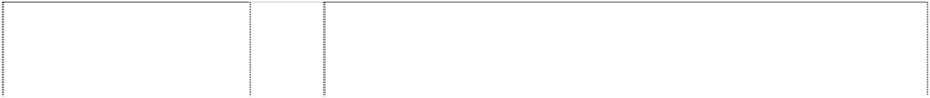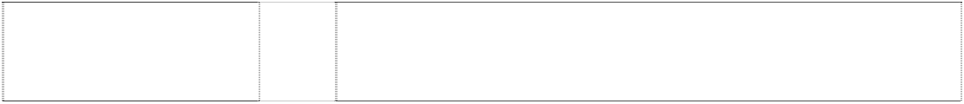

(975994)

# ZIPPO

zig-zag stripe, angled with flame atop form ltrs ZI (1021077)

# ZIPPO

zig-zag stripe, angled with flame atop form ltrs ZI (1021077)

# ZIPPO

zig-zag stripe, angled with flame atop form ltrs ZI (1021077)

# ZIPPO

zig-zag stripe, angled with flame atop form ltrs ZI (1021077)

# ZIPPO

zig-zag stripe, angled with flame atop form ltrs ZI (1021077)

# ZIPPO MOTORSPORTS

(927112)

*(Shape Trade Mark*) rectangular shaped cigarette lighter

(904846)

34 Smokers’ requisites, matches.

4 Fuels and fluid for lighters including pyrophoric lighters; lighting fuel.

11 Apparatus for lighting, heating and cooking; lighters including gas lighters; lighters and devices for lighting barbeques; flashlights and torches.

18 Leather, imitations of leather and goods made of these materials; handbags, purses, wallets, belts, key wallets, key cases, mobile telephone cases, credit card cases and holders, small pouches, document holders, document cases, briefcases, diaries, traveling and carrying bags, all made of leather or imitations of leather; backpacks, canvas bags, tote bags, beach bags, lumbar packs all made of leather or imitations of leather; umbrellas; parasols.

25 Clothing, footwear and headgear including shirts, T-shirts, polo shirts, sweat shirts, jumpers, gloves, hats, caps, scarves.

34 Lighters including pyrophoric lighters; smokers' articles including cigarette papers and filters, matches; flints for lighters including pyrophoric lighters; leather pouches for lighters.

34 Lighters, including pyrophoric lighters.

34 Cigarette, cigar and tobacco pipe lighters.

**ADDITIONAL TRADE MARKS**

***Crocs, Inc Freehills***

***Ph: (03) 9288 1577***

***Effective Date: 21 September 2006 File Ref: C06/17569***

Closed-cell polymer resin material for use in the manufacturing of footwear, clothing, sunglasses, luggage, luggage straps, watchbands, goggles, kneepads, and kneelers.

17

**CROSLITE**

(1121104)



***Trade Marks***

***Class Goods***