AUSTRALIAN CUSTOMS NOTICE NO. 2007/49

# Notices of Objection to Importation Trade Marks Act 1995

The *Trade Marks Act 1995* allows the registered owner, or in certain circumstances, the authorised user of a trade mark to lodge a Notice of Objection with the Australian Customs Service (Customs), objecting to the importation of goods which infringe their trade mark. Unless revoked, a Notice of Objection remains in force for a period of four years (effective 23 October 2006) from the date of commencement.

The attached Schedule sets out the registered owners and authorised users who have lodged Notices of Objection under the *Trade Marks Act 1995* since June 2007 (ACN 2007/32)*.* Descriptions of the relevant trade marks are also set out in the Schedule.

A detailed list of all current trade mark Notices of Objection is available on the Customs website at [www.customs.gov.au](http://www.customs.gov.au/) > media publications and forms> Customs notices > Intellectual Property – Notices of Objection > trade marks

For each particular trade mark described, the Schedule makes reference to a particular “class” of goods. This refers to the classes of goods prescribed in Schedule 1 to the *Trade Marks Regulations 1995* and along with a description of the goods, is used to describe the type of goods for which the particular trade mark is registered. Prospective importers of such goods should seek further advice from Customs regarding the ambit of any Notice of Objection set out in the Schedule.

Goods referred to in this ACN, that are manufactured outside and imported into Australia, and are subject to the control of Customs under the meaning of the *Customs Act 1901* are liable to be seized by Customs if:

* they have applied to them, or in relation to them, a sign that is substantially identical with, or deceptively similar to, a trade mark listed in the attached Schedule; and
* are goods in respect of which the notified trade mark is registered;

unless it can be established that the goods do not infringe the relevant trade mark.

Part 12 of the *Trade Marks Act 1995* details the circumstances in which the use of a trade mark may, or may not, amount to an infringement. For example, a trade mark is not infringed where the mark in question has been applied to, or in relation to, goods with the consent of the registered owner of the trade mark.

However, where the trade mark is applied by, or with the consent of, an overseas owner of the trade mark and the goods are imported into Australia without the consent of the Australian trade mark owner, this may still represent an infringement.

People who are intending to import goods that potentially may be liable to seizure under the provisions of the *Trade Marks Act 1995* should consider seeking advice from Customs, or a suitably qualified legal practitioner, as to the implications of the trade marks legislation, and the meaning of terms such as "substantially identical with", "deceptively similar to" and "an infringement of" a trade mark.

Where a registered trade mark owner or an authorised user with a current Notice of Objection in place request additional trade marks to be added to their Notice, only the additional trade marks are included at the end of this ACN. The inclusion of additional trade marks in the ACN is to ensure that ACN subscribers have all the appropriate up-to-date information.

Copies of the relevant Notices of Objection have been forwarded to the Customs office in the capital city of each State and Territory. Importers, or their advisers, who require further information regarding the Notices of Objection, or Customs role in respect of those Notices, should contact the Customs Information and Support Centre on 1300 363 263 or the Intellectual Property Rights Group on (02) 6275 6577.

John Potter

A/g National Manager

Trade Policy & Regulation Branch CANBERRA ACT

September 2007



**SCHEDULE TO ACN NO. 2007/49** **TRADE MARK NOTICES OF OBJECTION**

***Alfred Dunhill Limited Corrs Chambers Westgarth Ph: (03) 9672 3000***

***Effective Date: 21 July 2007 File Reference: C07/11817***

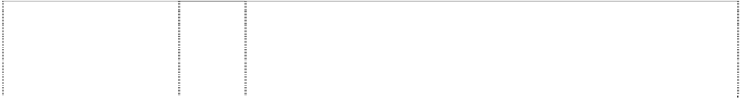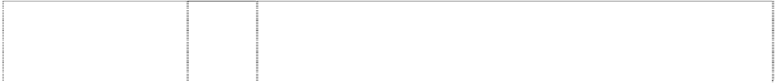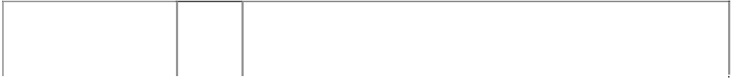

|  |  |  |
| --- | --- | --- |
| ***Trade Marks*** | ***Class*** | ***Goods*** |
| **ALFRED DUNHILL**  (782905) | 3 | Perfumes, eau de toilette, eau de parfum, colognes; essential oils; bath and shower preparations; toilet soaps; body deodorants; creams and gels for the face, the body and the hands; non- medicated toilet preparations; sun care preparations; hair care preparations; shampoos; gels, sprays, mousses and balms for hair styling and hair care; dentifrices; anti-perspirants; shaving  preparations; after-shave preparations. |
| **ALFRED DUNHILL**  (782905) | 9 | Optical apparatus and instruments, spectacles, sunglasses, cases and frames for spectacles and sunglasses, magnifying glasses; parts  and fittings for all the aforesaid goods. |
| **ALFRED DUNHILL**  (782905) | 14 | Precious metals and their alloys and goods in precious metals or coated therewith not included in other classes; jewellery, cufflinks; tie bars; tie clips; tie pins, collar and shirt studs; precious stones; horological and chronometric instruments; parts and fittings for all the  aforesaid goods. |
| **ALFRED DUNHILL**  (575934) | 16 | Paper, cardboard and goods made from these materials; printed matter; stationery; plastic materials for packaging; tickets, labels, wrapping materials, packets and boxes, all included in class 16; and  all other goods in this class. |
| **ALFRED DUNHILL**  (782905) | 18 | Leather and imitations of leather, and goods made of these materials, animal skins; trunks and travelling bags; umbrellas, parasols and walking sticks; whips, harness and saddlery; luggage, bags and cases; shooting sticks; briefcases, attache cases, document holders and cases, holdalls, pochettes, suit-carriers, credit card cases and holders, key cases, wallets, coin purses, passport holders, cheque book holders, travel organisers, tie holders, leather  key fobs; parts and fittings for all the aforesaid goods. |
| **ALFRED DUNHILL**  (782905) | 25 | Clothing, footwear and headgear; scarves, belts, ties. |
| **ALFRED DUNHILL**  (782905) | 33 | Alcoholic beverages. |
| **ALFRED DUNHILL**  (782905) | 34 | Smokers articles and matches. |
| **ALFRED DUNHILL DESIRE**  (836144) | 3 | Perfumes, eau de toilette, eau de perfume, colognes; essential oil; bath and shower preparations; toilet soaps; body deodorants; creams, lotions and gels for the face, the body and the hands; non- medicated toilet preparations; sun care preparations; hair care preparations; shampoos; gels, sprays, mousses and balms for hair styling and hair care; dentifrices; antiperspirants; shaving  preparations; after-shave preparations. |
| **D**  circle, halved (307641) | 3 | All goods in this class including non-medicated toilet preparations, soaps, talcum powder, cologne, after-shave lotion, shampoos. |
| **D**  circle, halved (307642) | 9 | All goods in this class including spectacles; spectacle cases;  spectacle frames and lenses; spectacles (anti-dazzle); radios, tape recorders, calculators and lighters included in this class. |
| **D**  circle halved (307643) | 14 | All goods in this class including smokers' articles made of precious metal or coated therewith; clocks, and watches with coating of gold  or silver and/or jewelled, jewellery made principally or wholly made of precious metal. |
| **D**  circle, halved (307644) | 16 | All goods in this class including writing cases; writing instruments and parts thereof. |

|  |  |  |
| --- | --- | --- |
| **D**  circle, halved (307645) | 18 | All goods in this class including umbrellas; parasols, and walking sticks, suitcases, trunks and other travelling goods, and luggage; purses, wallets, handbags, briefcases and other articles of leather or  imitation leather. |
| **D**  circle, halved (307646) | 25 | All goods in this class including articles of clothing and footwear. |
| **D**  circle, halved (307647) | 34 | Smokers' articles; matches; all other goods in this class excluding  tobacco, raw or manufactured, cigars, cigarettes and all other tobacco products. |
| **DUNHILL**  (195588) | 3 | Non-medicated toilet preparations, talcum powder, cologne, hair lotions and hair dressings, all for men; dentifrices, shampoos and non-medicated toilet soap, personal deodorants in the nature of toilet  preparations. |
| **DUNHILL**  (364399) | 6 | Keys, key rings of metal, safes and cash boxes and money clips (of metal). |
| **DUNHILL**  (202348) | 8 | All goods in this class. |
| **DUNHILL**  (324070) | 9 | All goods in this class. |
| **DUNHILL**  (202347) | 14 | All goods included in Class 14. |
| **DUNHILL**  (345753) | 16 | All goods in this class. |
| **DUNHILL**  (202346) | 18 | All goods included in Class 18. |
| **DUNHILL**  (392544) | 25 | All goods in class 25. |
| **DUNHILL**  (511319) | 25 | All goods included in class 25. |
| **DUNHILL**  (202345) | 33 | All goods included in Class 33. |
| **DUNHILL**  (345751) | 34 | All goods in this class excluding tobacco and tobacco products. |
| **DUNHILL**  (80116) | 34 | Tobacco pipes, cigar and cigarettes holders; pyrophoric lighters, including those of precious metals or of imitation precious metals or coated therewith. |
| **DUNHILL**  (403556) | 34 | All goods included in this class excluding cigarettes, cigars, tobacco and all other tobacco products. |
| circle, halved (407518) | 6 | All goods included in this Class. |

***Apple Pty Ltd Clayton Utz***

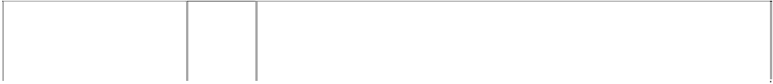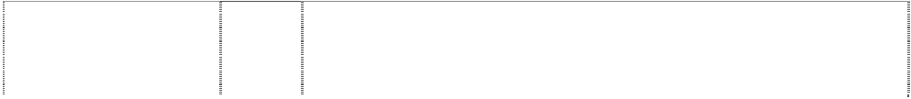

***Ph: (02) 9353 4859***

***Effective Date: 16 August 2007 File Reference: C07/13170***

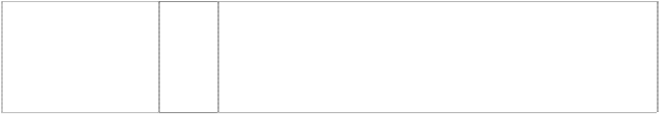

|  |  |  |
| --- | --- | --- |
| ***Trade Marks*** | ***Class*** | ***Goods*** |
| **APPLE**  (364209) | 9 | Computers, computer systems, computer visual display units, computer peripheral equipment, computer terminals, computer printers, and parts, fittings and ancillary equipment included in class 9 for all the aforesaid goods; none of the aforesaid goods being specifically adapted for use in the recording or reproduction of music or of performing artist works; pre-recorded computer software, none  being in the form of records of music or of performing artist works. |



|  |  |  |
| --- | --- | --- |
| **APPLE**  (490139) | 9 | Sound recordings and video recordings, including pre-recorded magnetic discs, tapes, tape cassettes and tape cartridges, gramophone records and optical discs, and recordings encoded in electrical, electronic, magnetic or optical devices; computer software in the form of records of music or of performing artist works, including software encoded on punched tape, punched cards, magnetic discs, tapes, tape cassettes and tape cartridges, optical discs or in electrical, electronic, magnetic or optical devices; cinematographic  films; transparencies. |
| **APPLE**  (721280) | 16 | Printed matter relating to: (i) electronic goods, including but not limited to computers and micro processors and micro processor control devices, and telecommunications equipment, data processing equipment, ancillary and peripheral equipment, and computer software of any kind on any medium, (ii) data processing services, data transmission services, broadcasting services, telecommunication services, and (iii) ancillary services relating to any of the foregoing, including without limitation, training, education,  maintenance, repair, financing and distribution. |
| **IPOD**  (1028187) | 9 | Scientific, nautical, surveying, photographic, cinematographic, optical, weighing, measuring, signalling, checking (supervision), life- saving and teaching apparatus and, instruments; apparatus and instruments for conducting, switching, transforming, accumulating, regulating or controlling electricity; apparatus for recording, transmission or reproduction of sound or images; magnetic data carriers, recording discs; automatic vending machines and mechanisms for coin operated apparatus; cash registers; calculating machines, data processing equipment and computers; apparatus for data storage; hard drives; miniature hard disk drive storage units; pre-recorded vinyl records, audio tapes, audio-video tapes, audio video cassettes, audio video discs; audio tapes (all being sold together with booklets); CD-ROMs; digital versatile discs; mouse pads; batteries; rechargeable batteries; chargers for electric batteries; headphones; stereo headphones; in-ear headphones; audio speakers; audio speakers for home; monitor speakers; speakers for computers; personal stereo speaker apparatus; digital  audio and video devices; audio cassette recorders and players, video cassette recorders and players, compact disc players, digital versatile disc recorders and players, digital audio tape recorders and players; radios; cameras; video cameras; bags and cases adapted or shaped to contain cameras and/or video cameras; cordless telephones; mobile telephones; parts and accessories for mobile telephones; mobile telephone covers; mobile telephone cases; mobile telephone cases made of leather or imitations of leather; mobile telephone covers made of cloth or textile materials; portable digital electronic devices and software related thereto; handheld digital electronic devices and software related thereto; MP3 players; hand held computers, personal digital assistants, electronic organizers, electronic notepads; magnetic data carriers; telephones, computer gaming machines, microprocessors, memories boards, monitors, displays, keyboards, cables, modems, printers, videophones, disk drives, cameras; pre-recorded computer programs for personal information management, database management software, character recognition software, telephony management software, electronic mail and messaging software, paging software, mobile telephone software; database synchronization software, computer programs for accessing, browsing and searching online databases, computer software and firmware, including operating system programs, data synchronization programs, and application development tool programs for personal and handheld computers; electronic handheld devices for the wireless receipt and/or transmission of data, particularly messages, and devices that enable the user to keep track of or manage personal information; software for the redirection of messages, Internet e-mail, and/or other data to one or more electronic handheld devices from a data store on or associated with a personal computer or a server; and software for  the synchronization of data between a remote station or device and a |

fixed or remote station or device; bags and cases adapted or shaped to contain MP3 players, hand held computers, personal digital assistants, electronic organizers and electronic notepads; parts and fittings for all the aforesaid goods.

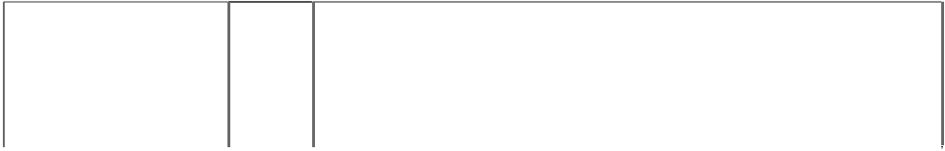

|  |  |  |
| --- | --- | --- |
| **IPOD**  (1028187) | 16 | Paper, cardboard and goods made from these materials, not included in other classes; printed matter; book binding material; photographs; stationery; adhesives for stationery or household purposes; artists' materials; paint brushes; typewriters and office requisites (except furniture); instructional and teaching material (except apparatus); plastic materials for packaging (not included in other classes); printers' type; printing blocks; printed publications; books; magazines; newsletters; brochures; booklets; pamphlets; manuals; journals; leaflets; greeting cards; advertising and promotional material; catalogues relating to computer software; computer brochures; computer handbooks; computer hardware publications; computer hardware reference manuals; computer hardware users guide; computer instruction manuals; computer manuals; publications relating to technology, digital technology and  gadgets; catalogues relating to musical apparatus and instruments; music books; music instruction manuals; music magazines. |
| **IPOD**  (1028187) | 18 | Leather and imitations of leather, and goods made of these materials and not included in other classes; animal skins, hides; trunks and travelling bags; umbrellas; athletic bags; beach bags; leather bags; school bags; shoe bags; waist bags; backpacks; fanny packs; waist  packs; wallets; purses; parts and accessories for all the aforesaid goods. |
| **IPOD**  (1028187) | 25 | Clothing, footwear, headgear; clothing for men, women and children, namely, shirts, T-shirts, sweatshirts, jogging suits, trousers, jeans, pants, shorts, tank tops, rainwear, skirts, blouses; dresses, sweaters, jackets, coats, raincoats, snow suits, ties, robes, hats, caps, sunvisors, belts, scarves, sleepwear, pyjamas, lingerie, underwear, boots, shoes, sneakers, sandals, booties, slipper socks; parts and  accessories for all the aforesaid goods. |
| **IPOD NANO**  (1072038) | 9 | Computers, computer hardware, computer peripherals, hand held computers, personal digital assistants, electronic organizers, electronic notepads, apparatus for recording, transmission and reproduction of sounds, images, or data; magnetic data carriers; mobile digital electronic devices, computer gaming machines, microprocessors, memory boards, monitors, displays, keyboards, cables, modems, printers, disk drives, cameras; computer software, prerecorded computer programs for personal information management, database management software, character recognition software, electronic mail and messaging software, paging software, database synchronization software, computer programs for accessing, browsing and searching online databases, computer software and firmware, operating system programs, data synchronization programs, and application development tool programs for personal and handheld computers; electronic handheld devices for the wireless receipt and/or transmission of data and messages, and electronic devices that enable the user to keep track of or manage personal information; software for the redirection of messages, Internet e-mail, and/or data to one or more electronic handheld devices from a data store on or associated with a personal computer or a server; software for the synchronization of data between a remote station or device and a fixed or remote station or device; stereo speakers; apparatus, instruments and materials for transmitting and/or receiving and/or recording sound and/or images; radio receivers, amplifiers, sound recording and reproducing apparatus, electric phonographs, record players, high fidelity stereo apparatus, tape recorders and reproducing apparatus, loudspeakers, multiple speaker units, microphones, and parts and fittings for all the  aforesaid goods. |

|  |  |  |
| --- | --- | --- |
| 2 interlocking arrows facing same direction from cross (1087011) | 9 | Portable and handheld digital electronic devices, and related peripherals and accessories, for recording, organizing, transmitting, manipulating, and reviewing data and audio files; computer software for use in organizing, transmitting, manipulating, and reviewing data  and audio files on portable and handheld digital electronic devices. |
| apple, silh, with bite missing apple, striped with bite missing (907398) | 9 | Computers, computer peripherals, hand held computers, computer terminals, personal digital assistants, electronic organizers, electronic notepads, apparatus for recording, transmission and reproduction of sounds, images, or other data; magnetic data carriers; mobile digital electronic devices, telephones, computer gaming machines, microprocessors, memory boards, monitors, displays, keyboards, cables, modems, printers, videophones, disk drives, cameras; computer software, prerecorded computer programs for personal information management, database management software, character recognition software, telephony management software, electronic mail and messaging software, paging software, database synchronization software, computer programs for accessing, browsing and searching online databases, computer software and firmware for operating system programs, data synchronization programs, and application development tool programs; electronic handheld devices for the wireless receipt, storage and/or transmission of data, particularly messages, and, devices that enable the user to keep track of or manage personal information; software for the redirection of messages, Internet e-mail, and/or other data to one or more electronic handheld devices from a data store on or associated with a personal computer or a server; and software for the synchronization of data between a remote station or device and a fixed or remote station or device; computer hardware and peripherals; facsimile machines, answering machines telephone-based information retrieval systems; adapters, adapter cards, connectors and drivers; blank computer storage media, fonts, typefaces, type designs and symbols; chips, discs and tapes bearing or for recording computer programs and software; random access memory, read only memory; solid state memory apparatus; electronic communication equipment and instruments; telecommunications apparatus and instruments; computer and electronic games; related computer equipment for use therewith; multimedia products comprising or for use with any of the aforesaid goods; interactive products comprising or for use with any of the aforesaid goods; parts and fittings for all the aforesaid goods; none of the aforesaid goods being specifically adapted for use in the recording or reproduction of music or of performing artist works and none of the aforesaid pre-recorded computer software being in the  form of records of music or of performing artist works. |

***Bottega Veneta International SARL Corrs Chambers Westgarth Ph: (03) 9672 3000***

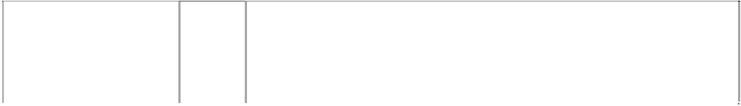

***Effective Date: 1 August 2007 File Reference: C07/12344***



|  |  |  |
| --- | --- | --- |
| ***Trade Marks*** | ***Class*** | ***Goods*** |
| **BOTTEGA VENETA**  (1080143) | 4 | Candles. |
| **BOTTEGA VENETA**  (1080143) | 8 | Table cutlery. |
| **BOTTEGA VENETA**  (707362) | 9 | Optical apparatus and instruments; agendas. |
| **BOTTEGA VENETA**  (707362) | 14 | Jewellery, including bracelets. |
| **BOTTEGA VENETA**  (707362) | 16 | Agendas. |
| **BOTTEGA VENETA**  (707362) | 18 | Bags, portfolios, keyholders, suitcases, agendas and small leather goods. |

|  |  |  |
| --- | --- | --- |
| **BOTTEGA VENETA**  (1080143) | 21 | Household or kitchen utensils and containers (not of precious metal or coated therewith); combs and sponges; brushes (except paintbrushes); brush-making materials; articles for cleaning purposes; steel wool; unworked or semi-worked glass (except glass used in building); glassware, porcelain and earthenware not included  in other classes. |
| **BOTTEGA VENETA**  (707362) | 25 | Clothing, footwear, headgear. |

***Burberry Limited Burberry Asia Limited***



***Ph: +852 2736 0388***

***Effective Date: 9 August 2007 File Reference: C07/12068***

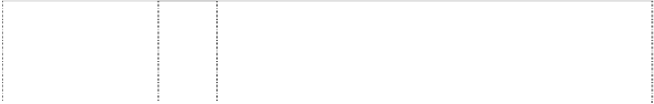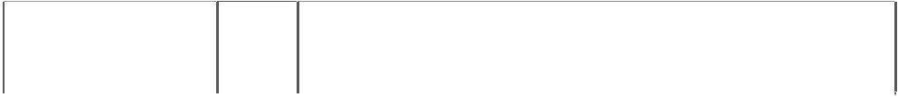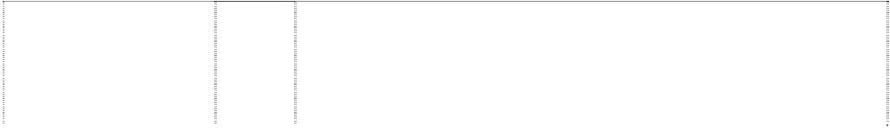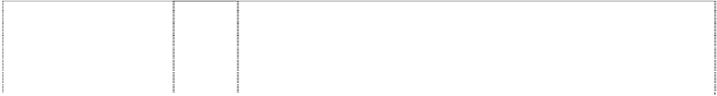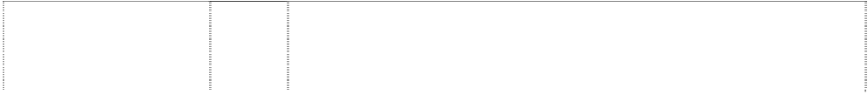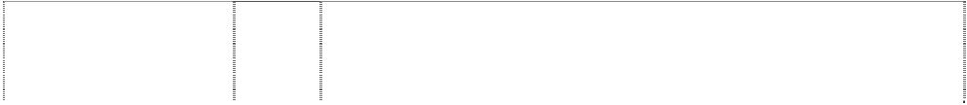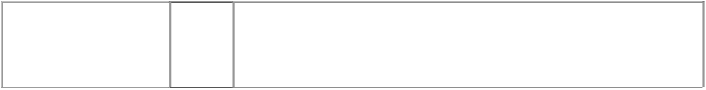

|  |  |  |
| --- | --- | --- |
| ***Trade Marks*** | ***Class*** | ***Goods*** |
| **BB PRORSUM**  knight riding horse carrying spear & shield ltr B on shield; ltr B & word on flag  (925821) | 9 | Sunglasses, combined sunglasses and goggles, goggles, spectacles, optical glasses, fitted frames and lenses for the aforesaid goods; cases and holders for the aforesaid goods; parts and fittings for all the aforesaid goods; cases and holders for portable computers and mobile telephones. |
| **BURBERRY**  (530991) | 3 | All goods in this class including non-medicated toilet preparations, perfumes, cosmetic preparations for the teeth and for the hair, soaps, shampoos, anti-perspirants, eau de cologne and toilet water,  essential oils, shaving preparations, pot pourri. |
| **BURBERRY**  (530995) | 4 | All goods in this class including candles, including scented candles, oils for the textile industry, oils for use in spinning, oils for the  preparation of leather, oils for leather. |
| **BURBERRY**  (718713) | 9 | Sunglasses, combined sunglasses and goggles, goggles, spectacles, optical glasses, fitted frames and lenses for the aforesaid goods; cases and holders for the aforesaid goods; parts and fittings  for all the aforesaid goods. |
| **BURBERRY**  (530774) | 14 | Watches, clocks and parts and fittings for all the aforesaid goods, especially wrist watches and straps and bracelets therefore and pocket watches, jewellery, imitation jewellery, tie-pins and cuff links; articles included in class 14 made of precious metals or coated  therewith. |
| **BURBERRY**  (530994) | 16 | All goods in this class including paper, paper articles, cardboard and articles, wrapping and packaging material, printed matter, books, periodical publications, stationery, advertising media included in class 16, labels, cards and pictures, drawer liners including scented  drawer liners. |
| **BURBERRY**  (824597) | 18 | Articles of luggage, suitcases, bags, travelling bags, holdalls, handbags, wallets, purses, shoulder bags; toiletries and cosmetic bags, brief cases, satchels and portfolios, parasols, umbrellas,  walking sticks; key fobs and key holders; dog coats. |
| **BURBERRY**  (530992) | 20 | All goods in this class including pillows, including scented pillows, coat-hangers including scented coat-hangers, picture frames, mirrors, non-illuminated signs, articles made of wood or of plastics,  embroidery frames, embroidery looms, all included in this class. |
| **BURBERRY**  (33671) | 24 | Clothes and stuffs of wool, worsted or hair. |
| **BURBERRY**  (33672) | 25 | Articles of clothing. |
| **BURBERRY**  (742886) | 33 | Alcoholic beverages in this class. |
| **BURBERRY BLACK LABEL**  (1083020) | 9 | Sunglasses, goggles, spectacles, optical glasses, fitted frames, lenses; cases and holders for the aforesaid goods; parts and fittings for all the aforesaid goods; holders and cases for portable audio systems, cassettes, compact discs, computers, mobile telephones;  mobile phone accessories; mobile phone fascia; mouse mats. |

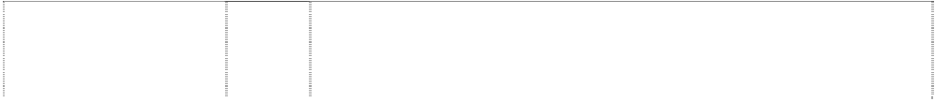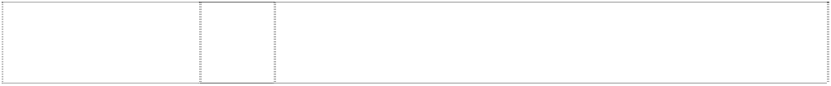

|  |  |  |
| --- | --- | --- |
| **BURBERRY BLACK LABEL**  (1083020) | 14 | Watches, clocks and parts and fittings for the aforesaid goods; jewellery, imitation jewellery, tie-pins, cuff links; articles made of precious metals or coated therewith included in class 14; jewellery  boxes and cases. |
| **BURBERRY BLACK LABEL**  (1083020) | 18 | Goods made of leather or imitations of leather; bags, trunks, valises, suitcases, travelling bags, garment bags, rucksacks, satchels, holdalls, handbags, shoulder bags, attache-cases, briefcases, camera cases, shopping bags and wheeled shopping bags; purses, pouches, wallets, key holders, card holders, passport and document holders, pochettes; luggage tags; vanity cases, cosmetic cases and bags; cases for manicure sets, jewellery rolls; umbrellas, parasols; walking sticks and canes; clothing for pets; horse blankets; collars  and leashes for animals. |
| **BURBERRY BLACK LABEL**  (1083020) | 25 | Clothing, footwear, headgear, belts. |
| **BURBERRY BLUE LABEL**  (1082830) | 9 | Sunglasses, goggles, spectacles, optical glasses, fitted frames, lenses; cases and holders for the aforesaid goods; parts and fittings for all the aforesaid goods; holders and cases for portable audio systems, cassettes, compact discs, computers, mobile telephones;  mobile phone accessories; mobile phone fascia; mouse mats. |
| **BURBERRY BLUE LABEL**  (1082830) | 14 | Watches, clocks and parts and fittings for the aforesaid goods; jewellery, imitation jewellery, tie-pins, cuff links; articles made of precious metals or coated therewith included in class 14; jewellery  boxes and cases. |
| **BURBERRY BLUE LABEL**  (1082830) | 18 | Goods made of leather or imitations of leather; bags, trunks, valises, suitcases, travelling bags, garment bags, rucksacks, satchels, holdalls, handbags, shoulder bags, attache-cases, briefcases, camera cases, shopping bags and wheeled shopping bags; purses, pouches, wallets, key holders, card holders, passport and document holders, pochettes; luggage tags; vanity cases, cosmetic cases and bags; cases for manicure sets, jewellery rolls; umbrellas, parasols; walking sticks and canes; clothing for pets; horse blankets; collars  and leashes for animals. |
| **BURBERRY BLUE LABEL**  (1082830) | 25 | Clothing, footwear, headgear, belts. |
| **BURBERRY BRIT**  (983958) | 3 | Non-medicated toilet preparations, perfumes, cosmetic preparations for teeth, soaps, anti-perspirants, eau de cologne and toilet water, essential oils, shaving preparations, potpourri; none of the foregoing  goods for use with hair. |
| **BURBERRYS**  (33669) | 24 | Clothes and stuffs of wool, worsted, or hair. |
| **BURBERRYS**  (33670) | 25 | Articles of clothing. |
| **BURBERRY TOUCH**  (852432) | 3 | Non-medicated toilet preparations, perfumes, cosmetics preparations for the teeth and for the hair, soaps, shampoos, anti-perspirants, eau  de cologne and toilet water, essential oils, shaving preparations, pot pourri. |
| **BURBERRYS B**  man knight on  horseback shield (17228) | 24 | Cloths and stuffs of wool, worsted and hair. |
| **BURBERRYS B**  man knight on horseback shield  (17229) | 25 | Articles of clothing. |
| **PRORSUM**  (1103645) | 3 | Non-medicated toilet preparations; perfumes, eaux de cologne and toilet waters; essential oils, cosmetic preparations for the teeth and  for the hair; soaps, shampoos; anti-perspirants and deodorants; shaving preparations; potpourris. |
| **PRORSUM**  (1103645) | 18 | Articles of luggage, suitcases, bags, travelling bags, holdalls, shoulder bags, handbags; wallets and purses; toiletries and cosmetic  bags; brief cases, satchels and portfolios; parasols, umbrellas, walking sticks; key holders; dog coats. |

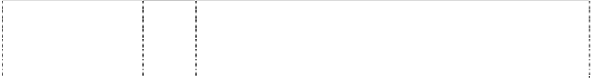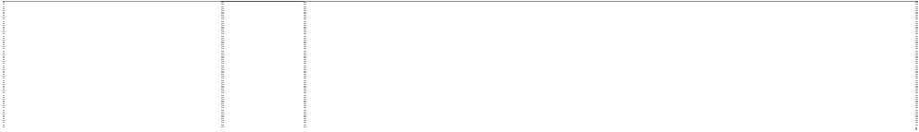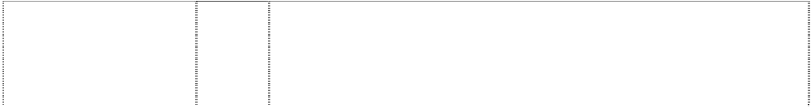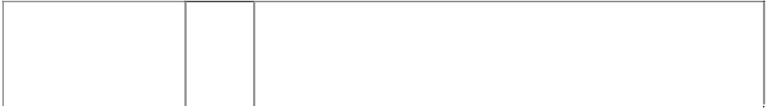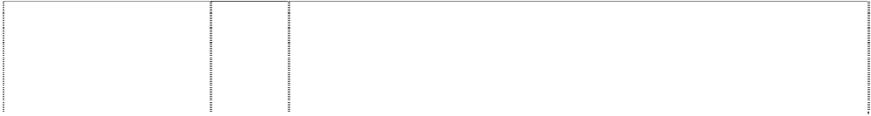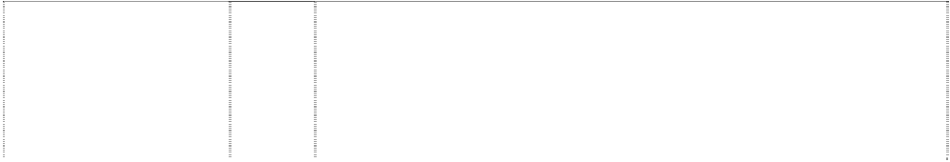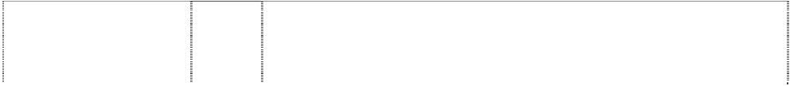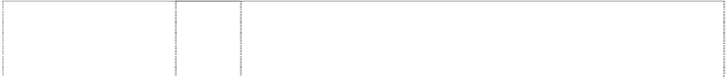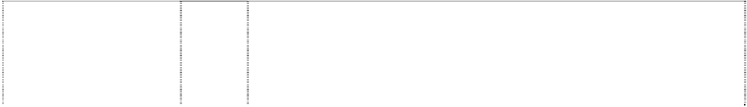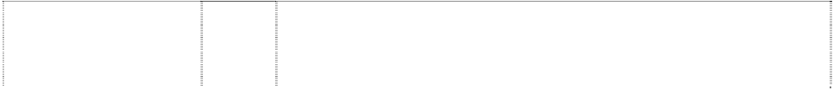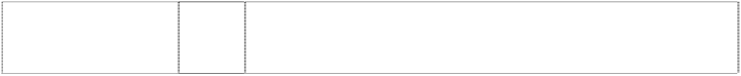

|  |  |  |
| --- | --- | --- |
| **PRORSUM**  (1103645) | 25 | Articles of outerclothing; headwear; footwear; raincoats, blousons, casual coats, polo shirts, blouses, dresses, skirts, jackets, trousers, suits, shirts; articles of underclothing; pyjamas; hosiery; sports clothing, sports footwear; tracksuits; ready made linings; ties, belts  (clothing), wraps, serapes, scarves, shawls and stoles; gloves. |
| **PRORSUM B**  knight riding horse carrying spear and shield  (531211) | 3 | All goods included in this class including non-medicated toilet preparations, perfumes, cosmetic preparations for the teeth included in this class and cosmetic preparations for the hair, soaps, shampoos, anti-perspirants, eau de cologne and toilet water,  essential oils, shaving preparations, pot pourri. |
| **PRORSUM B**  knight riding horse carrying spear and shield  (531210) | 4 | All goods in this class including candles, including scented candles, oils included in this class for use in the textile industry, oils included in this class for use in spinning, oils for the preparation of leather, oils for leather. |
| **PRORSUM B**  knight riding horse carrying spear and shield  (530772) | 14 | Watches, clocks and parts and fittings included in this class for all the aforesaid goods, especially wrist watches and straps and bracelets therefore and pocket watches, jewellery, imitation jewellery, tie-pins and cuff links; articles included in class 14 made of precious metals  or coated therewith. |
| **PRORSUM B**  knight riding horse carrying spear and shield  (531209) | 16 | All goods in this class including paper, paper articles, cardboard articles, wrapping and packaging material included in this class, printed matter, books, periodical publications, stationery, advertising material included in class 16, labels, cards and pictures, drawer  liners including scented drawer liners. |
| **PRORSUM B**  knight riding horse carrying spear and shield  (531207) | 20 | All goods in this class including pillows, including scented pillows, coathangers including scented coathangers, picture frames, mirrors, non-illuminated signs included in this class, articles included in this class made of wood or of plastics, embroidery frames, embroidery  looms, all the aforesaid goods being included in class 20. |
| **THOMAS BURBERRY** (824599) | 18 | Articles of luggage, suitcases, bags, travelling bags, holdalls, handbags, wallets, purses, shoulder bags; toiletries and cosmetic bags, brief cases, satchels and portfolios, cases for personal organisers, parasols, umbrellas, walking sticks; key fobs and key  holders; dog coats. |
| **THOMAS BURBERRY** (824599) | 25 | Articles of outerclothing, raincoats, blousons, casual coats, poloshirts, blouses, dresses, pyjamas, knitwear, shorts, trousers, suits, skirts, jackets, articles of underclothing, hosiery, headwear, footwear, sports clothing, sports footwear; tracksuits, ready-made linings, ties, belts (clothing), wraps, serapes, scarves, shawls and  stoles, gloves. |
| **WEEKEND BURBERRYS OF LONDON**  (748014) | 3 | Non-medicated toilet preparations, perfumes, soaps, shower and bath gels, deodorants, anti-perspirants, eau-de-cologne and toilet water, pre-shave lotion, after-shave lotion. |
| checked/tartan pattern has triple stripes each way  (824600) | 3 | Non-medicated toilet preparations, perfumes, cosmetics preparations for the teeth and for the hair, soaps, shampoos, anti-perspirants, eau  de cologne and toilet water, essential oils, shaving preparations, pot pourri. |
| checked/tartan pattern has triple stripes each way  (924914) | 9 | Sunglasses, combined sunglasses and goggles, goggles, spectacles, optical glasses, fitted frames and lenses for the aforesaid goods; cases and holders for the aforesaid goods; parts and fittings  for all the aforesaid goods; cases and holders for portable computers and mobile telephones. |
| checked/tartan pattern has triple stripes each way  (924914) | 14 | Watches, clocks and parts and fittings for all the aforesaid goods, wrist watches and straps and bracelets therefor and pocket watches,  jewellery, imitation jewellery, tie-pins and cuff links; articles included in this class made of precious metal or coated therewith. |
| checked/tartan pattern has triple stripes each way  (708955) | 18 | Luggage, travelling bags, holdalls, handbags, shoulderbags, toilet bags, suitcases, umbrellas and parasols. |
| checked/tartan pattern has triple stripes each way  (708955) | 25 | Articles of clothing, footwear, headgear. |

|  |  |  |
| --- | --- | --- |
| knight riding horse carrying spear & shield (824598) | 18 | Articles of luggage, suitcases, bags, travelling bags, holdalls, handbags, wallets, purses, shoulder bags; toiletries and cosmetic bags, brief cases, satchels and portfolios, cases for personal organisers, parasols, umbrellas, walking sticks; key fobs and key  holders; dog coats. |
| knight riding horse carrying spear & shield (824598) | 25 | Articles of outerclothing, raincoats, blousons, casual coats, poloshirts, blouses, dresses, pyjamas, knitwear, shorts, trousers, suits, skirts, jackets, articles of underclothing, hosiery, headwear, footwear, sports clothing, sports footwear; tracksuits, ready-made  linings, ties, belts (clothing), wraps, serapes, scarves, shawls and stoles, gloves. |
| rocking sheep in square (915274) | 3 | Non-medicated toilet preparations, perfumes, cosmetic preparations for the teeth and for the hair, soaps, shampoos, anti-perspirants, eau de cologne and toilet water, essential oils, pot pourri. |
| tartan pattern has triple stripes each way  (893228) | 24 | Woven materials and textiles for manufacturing clothing, luggage, bags and umbrellas. |
| tartan pattern has triple stripes each way (1061475) | 24 | Textile goods including household linen, bed linen, bath linen, table linen, quilts, blankets, duvets, eiderdowns, beach towels, wash cloths, picnic blankets, handkerchiefs, textile labels, furniture coverings, curtains, wall hangings, cushion covers, hot water bottle  covers. |

***Celine SA Corrs Chambers Westgarth***

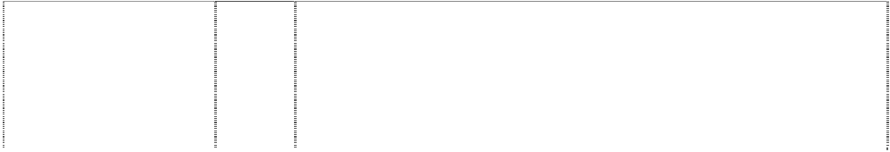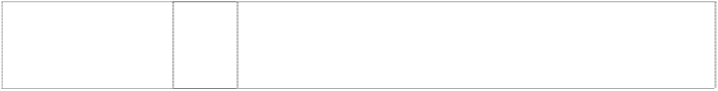

***Ph: (03) 9672 3000***

***Effective Date: 13 July 2007 File Reference: C07/11809***

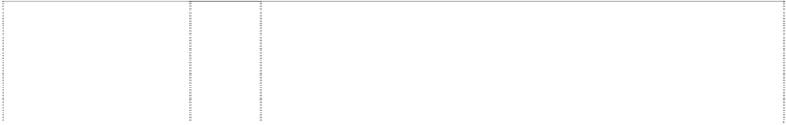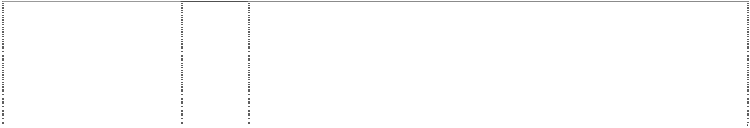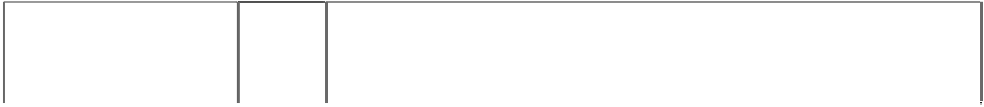

|  |  |  |
| --- | --- | --- |
| ***Trade Marks*** | ***Class*** | ***Goods*** |
| **CC**  rect.,2 convex & 2 concave sides with pattern; telephone receiver on each side is ltr C  (1029976) | 3 | Soaps, perfumery, eaux de toilette, eau-de-cologne, essential oils, cosmetics, including foundations, lipstick, eye shadows, mascara, shaving products, deodorants for personal use, shower and bath gels and preparations, powders, creams and lotions for the hair, face and body for cosmetic use, shampoos. |
| **CELINE**  (530443) | 14 | Precious metals and their alloys and goods in precious metals or coated therewith, not included in other classes; jewellery and imitations; precious stones; horological and chronometric instruments particularly watches for men and women, wristlets, miniature clocks, alarm clocks and parts thereof, particularly dials, presentation cases  and boxes for horological articles. |
| **CELINE**  (525417) | 18 | Leather and imitations of leather, and goods made of these materials and not included in other classes; bags in this class and handbags, trunks, valises, travelling bags and other luggage in this class including attache-cases, beauty-cases, vanity cases, pouches, cases, dressing cases, travelling toilet cases, make-up cases, wallets  and purses; umbrellas, parasols and walking sticks. |
| **CELINE**  (525418) | 25 | Clothing, footwear, headgear. |
| **CELINE**  (530441) | 3 | Soaps, perfumery, essential oils, cosmetics, hair lotions, dentifrices. |
| **CELINE**  (530442) | 9 | Spectacles, such as sun glasses, anti-glare glasses, sport glasses, spectacle glasses; spectacle cases, monocles, binoculars, lorgnettes, spectacle frames, lorgnette frames, contact lens, contact  lens cases. |
| **CELINE FEVER**  (1005607) | 3 | Soaps, perfumery products, eau-de-toilette, eau-de-cologne, essential oils, cosmetics, including foundations, lipsticks, eye shadows, mascara, shaving products, deodorants (deodorants for personal use), gels and preparations for showering, powders, creams and lotions for hair care, shampoos; bath preparations for  non-medical use; face and body powders, lotions and creams for cosmetic use. |

***Citizen Watches Australia Pty Ltd Citizen Watches Australia Pty Ltd Ph: (02) 9452 7300***

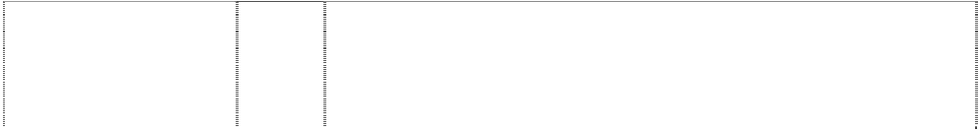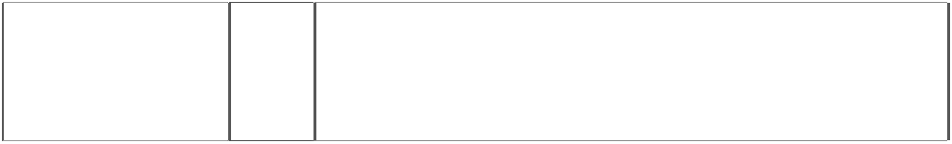

***Effective Date: 25 June 2007 File Reference: C07/09799***

|  |  |  |
| --- | --- | --- |
| ***Trade Marks*** | ***Class*** | ***Goods*** |
| **ADEC**  (346207) | 14 | Watches, clocks and parts and fitting included in Cl. 14 for the aforesaid goods. |
| **CAMPANOLA**  bell,stylized, indented (1125528) | 14 | Clocks and watches, movements for clock and watch-making, cases for clock and watch-making, watch glasses, watch bands and straps, dials for clock and watch-making, key rings, earrings, insignias of precious metal, buckles of precious metal, badges of precious metal, bonnet pins of precious metal, tie clips, tie pins, necklaces, bracelets, pendants, brooches, medals, rings, medallions, cuff links and  artificial gemstones in international class 14. |
| **CITIZEN**  (355377) | 7 | Machine tools and parts and fittings therefor included in Cl. 7. |
| **CITIZEN**  (196552) | 9 | Electric adding machines and other electric computing machines, parts thereof and accessories therefor. |
| **CITIZEN**  (544673) | 9 | Electronic and electrical apparatus and instruments in this class, including electronic diaries which can be used like pocket notebooks and have calculator, telephone directory, calendar, schedule and memo functions; electronic time tables which can store transportation schedules such as those of buses, trains and airplanes, and have a clock function; portable computers including dictionary and foreign language translation capabilities; telephone apparatus; batteries, and  all other goods in this class, but not including protective clothing. |
| **CITIZEN**  (407018) | 9 | Computers and peripheral equipment therefor in this class including videos for data communication terminals, printers, floppy disks, magnetic heads and floppy disk drives; applied electronic display apparatus in this class namely liquid crystal display panels, electrochromic displays and electroluminescent displays and electroluminescent displays; electronic communication machines and apparatus in this class including television apparatus, radios, cameras, and magnetic tapes for video recording; electronic clinical thermometers, scales and weighing instruments or devices in this  class; spectacles and parts thereof in this class; contact lenses. |
| **CITIZEN**  (579441) | 10 | All goods in this class including sphygmomanometers, clinical thermometers. |
| **CITIZEN**  (184105) | 14 | Watches and clocks and parts and fittings therefore. |
| **CITIZEN**  (397119) | 14 | Precious metals and their alloys and goods in precious metals or coated therewith, jewellery including bracelets, brooches, necklaces, earrings, rings, pendants, cuff links, pins, tiepins, tie tacks, tie chains and other ornaments, all in precious metals or coated therewith, and  precious stones. |
| **CITIZEN**  (246027) | 16 | Electric and manual typewriters, parts thereof and accessories therefor. |
| **CITIZEN**  (387373) | 28 | Games and playthings; gymnastic and sporting articles (except clothing); ornaments and decorations for Christmas tress. |
| **CITIZEN**  clock hands in disc in annulus in circle  (547670) | 14 | Watches, clocks and other horological instruments. |
| **CITIZEN**  clockface stylised disc hands of clock  (230107) | 14 | Watches, clocks, parts and accessories thereof. |
| **CITIZEN**  heart (958742) | 10 | Clinical thermometers, sphygmomanometers, blood glucose measuring apparatus, sphygmometers, sphygmographs, electrocardiographs, blood circulation measuring apparatus, sprayers for medical purposes, electric and electronic massage apparatus, far  ultra-red rayer mats and pads for medical purposes, hearing aids for the deaf. |

|  |  |  |
| --- | --- | --- |
| **CITIZEN BEYOND PRECISION** (1017229) | 14 | Watches, clocks, watch bands, watch cases, earrings, rings, necklaces, bracelets, pendants, tie clips, tie pins, cuff links, jewellery, rough agate, trophies and commemorative shields made of precious  metals or coated therewith. |
| **CITIZEN DOUBLE FACE**  (842957) | 14 | Watches, clocks and parts and fittings therefore. |
| **CITIZEN ECO-DRIVE**  map,world on globe,meridians in annulus  (667048) | 14 | Watches and clocks. |
| **CITIZEN ELEGANCE**  (824697) | 14 | Watches, clocks. |
| **CITIZEN FOOTBALL TIMER**  (838163) | 14 | Watches and clocks. |
| **CITIZEN HEALTH CARE**  heart (958741) | 10 | Clinical thermometers, sphygmomanometers, blood glucose measuring apparatus, sphygmometers, sphygmographs, electrocardiographs, blood circulation measuring apparatus, sprayers for medical purposes, electric and electronic massage apparatus, far ultra-red rayer mats and pads for medical purposes, hearing aids for  the deaf. |
| **ECO-DRIVE**  (772553) | 14 | Watches and clocks. |
| **ECO-DRIVE DUO**  (776308) | 14 | Watches, clocks. |
| **ECO-DRIVE INFINITUM**  (838036) | 14 | Watches and clocks. |
| **ECO-DRIVE VITRO**  (833758) | 14 | Watches, clocks. |
| **J-CLASS CITIZEN ECO-DRIVE**  globe,meridians with map,world in  annulus,halved (1070805) | 14 | Watches and clocks. |
| **PROMASTER**  (496664) | 14 | Watches, clocks, other horological instruments and parts and fittings  thereof, including watch bands and watch chains and all other goods in this class. |
| **PROMASTER PETIT**  (885335) | 14 | Watches and clocks. |
| **STILETTO**  (918682) | 14 | Watches and clocks. |
| **V VAGARY**  (760760) | 14 | Watches, including wrist-watches; clocks, including table-clocks, alarm clocks; chronometric instruments. |

***Clinuvel Pharmaceuticals Limited MinterEllison***

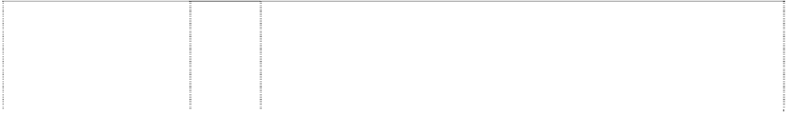

***Ph: (03) 8608 2000***

***Effective Date: 3 July 2007 File Reference: C07/10423***

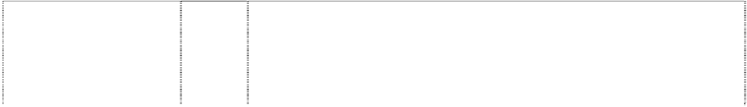

|  |  |  |
| --- | --- | --- |
| ***Trade Marks*** | ***Class*** | ***Goods*** |
| **EPITAN**  (862967) | 3 | Preparations for care of the skin; preparations for tanning the skin, including preparations for tanning without sunlight. |
| **EPITAN**  (825721) | 5 | Pharmaceutical, veterinary and sanitary preparations; dietetic substances adapted for medical use, food for babies; plasters, materials for dressing; material for stopping teeth, dental wax; disinfectants; preparations for destroying vermin; fungicides,  herbicides. |
| **MelanoTan**  (935505) | 3 | Preparations for care of the skin; preparations for tanning the skin, including preparations for tanning without sunlight. |

|  |  |  |
| --- | --- | --- |
| **MelanoTan**  (825722) | 5 | Pharmaceutical, veterinary and sanitary preparations; dietetic substances adapted for medical use, food for babies; plasters, materials for dressing; material for stopping teeth, dental wax; disinfectants; preparations for destroying vermin; fungicides,  herbicides. |

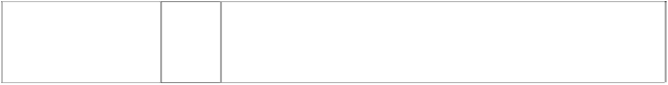***Expression Sports Australia Pty Ltd Middletons***

***Ph: (02) 9213 2300***

***Effective Date: 17 August 2007 File Reference: C07/13178***



|  |  |  |
| --- | --- | --- |
| ***Trade Marks*** | ***Class*** | ***Goods*** |
| **BURTON**  (574533) | 25 | Jackets, gloves, pants, headwear, headbands, earbands, vests,  sweaters, shirts, t-shirts, sweatshirts, sweatpants, undergarments, boots. |
| **BURTON**  574534) | 28 | Snowboards and parts, fittings and accessories therefore, including bindings, binding plates, straps, and leashes, scrapers and tool kits for snowboards; snowboard bags and cases. |

***Guru Denim, Inc. Cullen & Co.***

***Ph: (07) 3011 5555***

***Effective Date: 1 August 2007 File Reference: C07/12341***



|  |  |  |
| --- | --- | --- |
| ***Trade Marks*** | ***Class*** | ***Goods*** |
| **TRUE RELIGION** | 25 | Clothing, footwear, headgear, pants, slacks, jeans, shorts, overalls, |
| budha,cartoon, |  | shirts, T-shirts, blouses, vests, skirts, jackets, coats, sweaters, |
| seated,thumbs-up |  | sweatshirts, sweatpants, hats. |
| holds guitar |  |  |
| (1029224) |  |  |

***H.D. Lee Company, The Phillips Ormonde & Fitzpatrick Ph: (03) 9614 1944***

***Effective Date: 21 June 2007 File Reference: C07/09650***

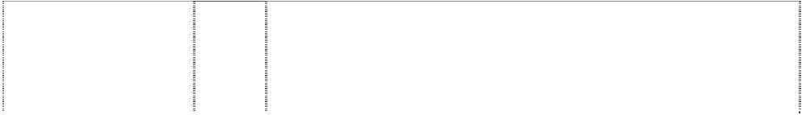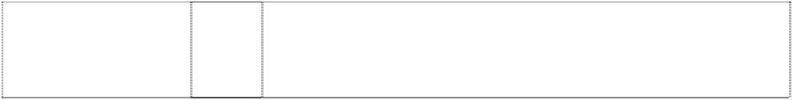

|  |  |  |
| --- | --- | --- |
| ***Trade Marks*** | ***Class*** | ***Goods*** |
| **LEE**  (277033) | 25 | Jeans (trousers and jackets) overalls and work shirts |
| **LEE**  (512578) | 25 | Denim trousers, jeans, shirts, jackets, corduroys, canvas trousers, chino trousers, gabardine pants, skirts, dresses, tops and t-shirts. |
| **LEE RIDERS**  (164383) | 25 | Articles of clothing. |
| **LEE X-LINE** [**WWW.LEE.COM**](http://WWW.LEE.COM/)  stitches,intersecting  form ltr X (1020552) | 25 | All articles of clothing, footwear and headgear. |
| **RIDERS**  (520914) | 25 | Articles of clothing including denim jeans and all other goods in this class. |
| *description of mark:* trousers showing two pockets with wavy stripe & stitches  (443999) | 25 | Articles of clothing having a pocket including jeans, jackets, shorts, vests, skirts and pants. |

***Jansport Apparel Corp Phillips Ormonde & Fitzpatrick Ph: (03) 9614 1944***

***Effective Date: 21 June 2007 File Reference: C07/09651***

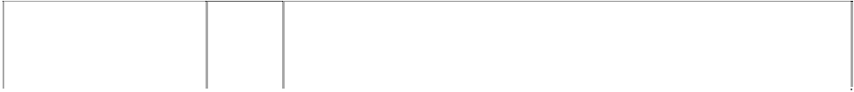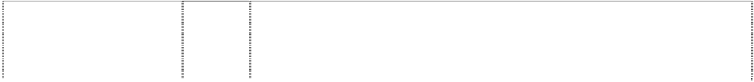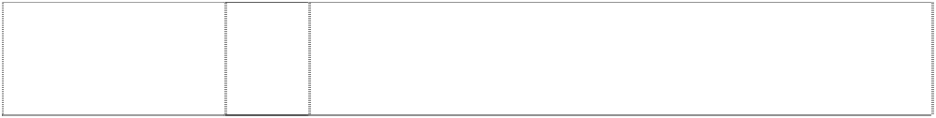

|  |  |  |
| --- | --- | --- |
| ***Trade Marks*** | ***Class*** | ***Goods*** |
| **AIRLIFT**  (991079) | 18 | All purpose bags, sporting bags, climbers bags, campers bags, luggage, soft luggage, luggage cases, travelling bags, backpacks, daypacks, fanny packs, bumbags, frame packs, knapsacks, ski  packs, book bags, tote bags, shopping bags, duffle bags, school bags, handbags, garment bags, clothing bags, belts and straps. |
| **BUILT TO RESIST**  (992284) | 18 | Leather and imitations of leather, and goods made from such materials and not included in other Classes, including: all purpose bags and sporting bags, soft and hard luggage, luggage cases, backpacks, day packs, fanny packs, frame packs, knapsacks, ski packs, books bags, tote bags, duffle bags, bicycle bags, hand bags, garment bags, clothing bags, suitcases, pullman cases, briefcases, wallets, umbrellas and parasols, business card cases and holders, billfolds and money clips, straps, pads and belts, trunks and  travelling bags, walking sticks; and all other related goods as are included in this Class. |
| **EASTPAK**  (543082) | 18 | Sporting articles namely, packs such as back packs, day packs, frame packs, ski packs and knapsacks, book bags, tote bags, duffle  bags, and bicycle bags; garment bags; briefcases; travelling bags and all other goods in this class. |
| **EASTPAK**  word in ellipse over  globe,meridian (720510) | 18 | All-purpose sporting bags, soft luggage, luggage cases, backpacks, day packs, frame packs, knapsacks, bookbags, tote bags, duffle  bags, garment bags, fanny packs, bum bags, personal carriers, clothing bags, suitcases and brief cases. |
| **EASTPAK**  word in ellipse over globe,meridian  (720510) | 25 | Men’s women’s and children’s clothing, headwear and footwear. |
| **JANSPORT**  (292897) | 18 | Leather and imitations of leather and articles made from these materials and not included in other classes; skins, hides; trunks and travelling bags; umbrellas, parasols and walking sticks; whips, harness and saddlery; backpacks, pack frames, pack bags,  rucksacks, stuff bags, and related accessories including straps, pads, and belts. |
| **JANSPORT**  (292898) | 20 | Furniture, mirrors, picture frames; sleeping bags; articles (not included in other classes) consisting or wood, cork, reeds, cane,  wicker, horn, bone, ivory, whalebone, shell, amber, mother-of-pearl, meerschaum, celluloid and substitutes for all these materials. |
| **JANSPORT**  (292899) | 22 | Ropes, string, nets, tents, awnings, tarpaulins, sails, sacks; padding or stuffing materials (hair, kapok, feathers, seaweed); raw fibrous textile materials. |
| **JANSPORT**  (292900) | 25 | Clothing, including parkas, jackets, vests, pants, shorts, hats and hiking, climbing and ski boots. |
| **LIFE SUPPORT SYSTEM** (991075) | 18 | All purpose bags, sporting bags, climbers bags, campers bags, luggage, soft luggage, luggage cases, travelling bags, backpacks, daypacks, fanny packs, bumbags, frame packs, knapsacks, ski packs, book bags, tote bags, shopping bags, duffle, school bags,  handbags, garment bags, clothing bags, belts and straps. |

***Jemella Australia Pty Ltd Fox Lawyers***

***Ph: (07) 3210 1180***

***Effective Date: 14 July 2007 File Reference: C07/11818***



|  |  |  |
| --- | --- | --- |
| ***Trade Marks*** | ***Class*** | ***Goods*** |
| **GHD**  (951664) | 9 | Electrical apparatus and instruments including electrical apparatus and instruments for curling, straightening or styling hair; electrical hair straightening irons; electrical curling irons; electrical hair crimping irons, apparatus for recording, transmission or reproduction of sounds or images; magnetic data carriers; pre-recorded audio, visual and audio-visual media in this class including tapes, cassettes, videos, DVDs and CDs and such goods with CD-ROM format for computer applications; eyewear and eyewear accessories in this  class. |

***Lifted Research Group, Inc. Davies Collison Cave Ph: (03) 9254 2888***

***Effective Date: 12 July 2007 File Reference: C07/11812***

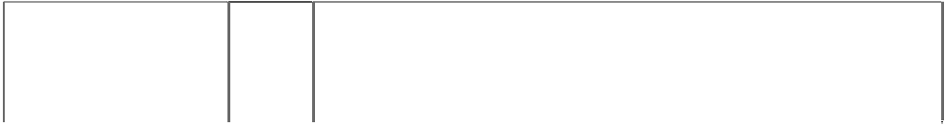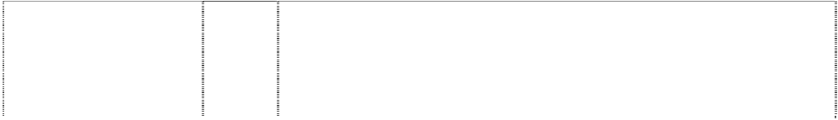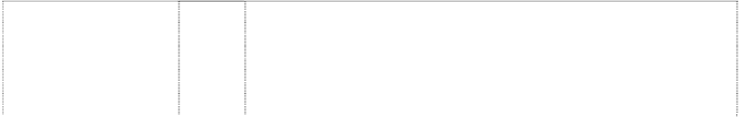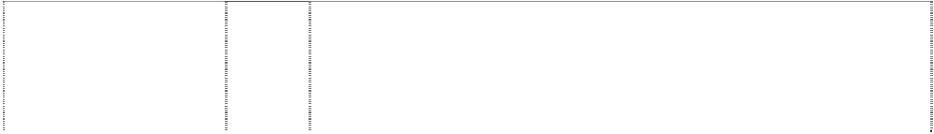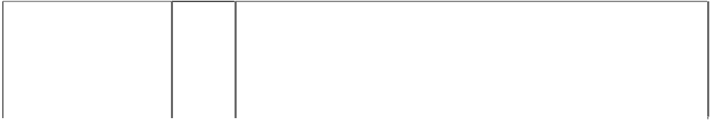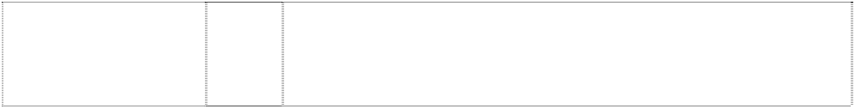

|  |  |  |
| --- | --- | --- |
| ***Trade Marks*** | ***Class*** | ***Goods*** |
| **LIFTED RESEARCH GROUP**  (895795) | 18 | Travel and overnight bags, garment and shoe bags for travel, duffel bags, gym bags, athletic bags, all purpose sports bags, luggage, back packs, fanny packs, knapsacks, tote bags, wrist mounted carryall bags, luggage bags with rollers, handbags, shoulder bags,  purses, wallets and billfolds in international class 18. |
| **LIFTED RESEARCH GROUP**  (891729) | 25 | Clothing, headwear and footwear including women's and girls' swimwear, coverups including pareos, tops, skirts, dresses, T-shirts, sweatshirts, blouses, sweaters, sport shirts, jerseys, shorts, trousers, pants, sweatpants, ski pants, racing pants, jeans, coats, vests, jackets, hats, visors, caps, gloves, belts, socks, sandals, shoes and  boots. |
| **L-R-G**  (895794) | 18 | Travel and overnight bags, garment and shoe bags for travel, duffel bags, gym bags, athletic bags, all purpose sports bags, luggage, back packs, fanny packs, knapsacks, tote bags, wrist mounted carryall bags, luggage bags with rollers, handbags, shoulder bags,  purses, wallets and billfolds in international class 18. |
| **L-R-G**  (850305) | 25 | Clothing, headwear and footwear including womens and girls swimwear, coverups including pareos, tops, skirts, dresses, T-shirts, sweatshirts, blouses, sweaters, sport shirts, jerseys, shorts, trousers, pants, sweatpants, ski pants, racing pants, jeans, coats, vests,  jackets, hats, visors, caps, gloves, belts, socks, sandals, shoes and boots. |
| **LUXIRIE**  (1129293) | 18 | Bags, including travel and overnight bags, garment bags, shoe bags for travel, gym bags, athletic bags, all purpose sport bags, luggage, fanny packs, knapsacks, tote bags, wrist mounted carry all bags, shoulder bags, purses, messenger bags, backpacks, bookbags,  wallets and billfolds. |
| **LUXIRIE**  (1127045) | 25 | Clothing, footwear and headwear, namely T-shirts, woven shirts, casual tops with long and short sleeves, bodysuits, sweatshirts, sweaters, vests, blazers, suits, jackets, coats, anoraks, parkas, jeans, pants, slacks, dresses, skirts, shorts, overalls, socks, belts,  gloves, mittens, athletic shoes, shoes, sandals, boots, dress shoes, swimwear, ski wear, snowboard wear, baseball caps, hats, beanies. |
| cross,greek, quartered in tree,pine,silhouette with roots  (1048575) | 18 | Bags and luggage including travel and overnight bags, garment and shoe bags for travel, duffel bags, gym bags, athletic bags, all purpose sports bags, back packs, fanny packs, knapsacks, tote bags, wrist mounted carryall bags, luggage bags with rollers,  handbags, shoulder bags, wallets and billfolds. |

|  |  |  |
| --- | --- | --- |
| cross,greek, quartered in tree,pine,silhouette with roots  (1104404) | 25 | Clothing, footwear, and headwear, including T-shirts, woven shirts, casual tops with long and short sleeves, body suits, sweatshirts, sweaters, vests, blazers, suits, jackets, coats, anoraks, parkas, jeans, pants, slacks, dresses, skirts, shorts, overalls, socks, belts, gloves, mittens, athletic shoes, slippers, sandals, boots, dress shoes, swimwear, pajamas, boxers, underwear, lingerie, panties, undershirts, ski wear, snowboard wear, sarongs, baseball caps, hats,  beanies, bandanas and scarves. |
| greek cross in tree,styl. with roots (987074) | 25 | Clothing, including button up shirts, tee shirts, blouses, pants, jackets, baseball caps, hats, knit caps, sweatshirts, jeans and shorts. |
| tree styl. with roots (1048863) | 18 | International class 18 for bags and luggage including travel and overnight bags, all purpose sports bags, back packs, fanny packs,  knapsacks, tote bags, wrist mounted carryall bags, luggage bags with rollers, handbags, shoulder bags, purses, wallets and billfolds. |
| tree styl. with roots (850303) | 25 | Clothing, headwear and footwear including womens and girls swimwear, coverups including pareos, tops, skirts, dresses, T-shirts, sweatshirts, blouses, sweaters, sport shirts, jerseys, shorts, trousers, pants, sweatpants, ski pants, racing pants, jeans, coats, vests, jackets, hats, visors, caps, gloves, belts, socks, sandals, shoes and  boots. |

***Loewe SA Corrs Chambers Westgarth***

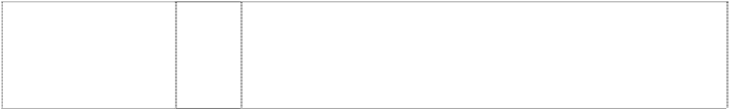

***Ph: (03) 9672 3000***

***Effective Date: 13 July 2007 File Reference: C07/11811***

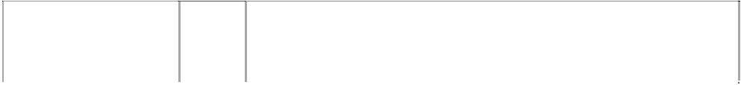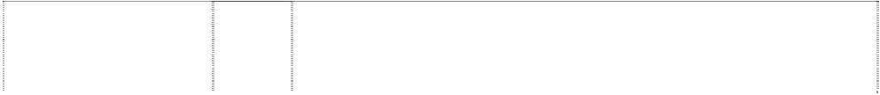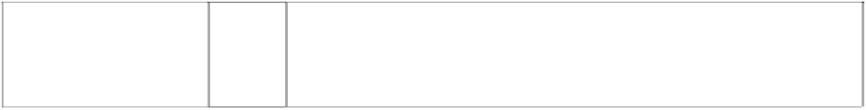

|  |  |  |
| --- | --- | --- |
| ***Trade Marks*** | ***Class*** | ***Goods*** |
| **AIRE**  (725172) | 3 | Perfumery, toilet water, eau de cologne, soaps, essential oils, cosmetics, hair lotions, dentifrices, beauty creams, lotions, personal deodorants, bath and shower gels and preparations, shaving  preparations, aftershaves, shampoos. |
| **AURA**  (725173) | 3 | Perfumery, toilet water, eau de cologne. |
| **ESENCIA LOEWE**  (725174) | 3 | Perfumery, toilet water, eau de cologne, soaps, essential oils, cosmetics, hair lotions, dentifrices, beauty creams, lotions, personal deodorants, bath and shower gels and preparations, shaving  preparations, aftershaves, shampoos. |
| **GALA DE DIA**  (724432) | 3 | Soaps, perfumery, essential oils, cosmetics, hair lotions, dentifrices,  personal deodorants, bath and shower gels, body creams, shampoos. |
| **L**  looped ltrs,mirror-  image form square (836948) | 9 | Optical apparatus and instruments, optical goods including spectacles, sunglasses, spectacle glasses, contact lenses, spectacle frames, spectacle or contact cases, opera glasses. |
| **L**  ltr is looped stripe (860982) | 9 | Sunglasses, spectacles, spectacle glasses and spectacle frames. |
| **L**  ltr is looped stripe (837250) | 18 | Goods made of leather or of imitations of leather not included in other classes including boxes of leather or of leatherboard, envelopes of leather for packaging; trunks, valises, travelling bags, travelling sets, garment bags for travel, vanity-cases, rucksacks, handbags, beach bags, shopping bags, shoulder bags, attache- cases, briefcases, pouches, fine leather goods including pocket wallets, purses, keyholders, card holders, chequebook holders, agenda cases, passport cases, key-ring cases, pencil cases, pen  cases; umbrellas, parasols, canes, walkingstick seats. |
| **L**  ltr is looped stripe (837250) | 25 | Clothing, footwear and headgear including underwear, belts, scarves, ties, shawls, jumpers, shirts, blouses, suits, waistcoats, waterproof clothing, skirts, coats, suspenders, trousers, pullovers, dresses, jackets, braces, gloves, tights, stockings, socks, bathing  suits, bath robes, shoes, boots, slippers. |

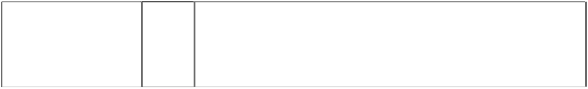

|  |  |  |
| --- | --- | --- |
| **LLLL**  arabesques form letters LLLL  monogram (495293) | 3 | All goods included in this class. |
| **LLLL**  arabesques form letters LLLL  monogram (495294) | 14 | All goods included in this class. |
| **LLLL**  arabesques form letters LLLL  monogram (495295) | 16 | All goods included in this class. |
| **LLLL**  arabesques form letters LLLL  monogram (495296) | 18 | All goods included in this class. |
| **LLLL**  arabesques form letters LLLL monogram  (495297) | 20 | All goods included in this class. |
| **LLLL**  arabesques form letters LLLL  monogram (495298) | 24 | All goods included in this class. |
| **LLLL**  arabesques form letters LLLL monogram  (495299) | 25 | All goods included in this class. |
| **LLLL**  arabesques form letters LLLL  monogram (495300) | 34 | All goods included in this class. |
| **LOEWE**  (290013) | 3 | Toilet water included in this class. |
| **LOEWE**  (836950) | 9 | Spectacle or contact lens cases; spectacles, sunglasses, spectacle glasses, spectacle frames. |
| **LOEWE**  (497624) | 14 | All goods included in this class. |
| **LOEWE**  (290015) | 16 | Document files, pencil holders, paper weights, autograph and address books, calendars, and pen boxes and cases. |
| **LOEWE**  (290016) | 18 | All goods included in this class. |
| **LOEWE**  (290017) | 20 | All goods in this class. |
| **LOEWE**  (497625) | 24 | All goods included in this class. |
| **LOEWE**  (290019) | 25 | Women’s clothing included in this class. |
| **LOEWE**  (290020) | 34 | Non-electric cigarette lighters, ashtrays, tobacco boxes, cigarette canisters and cigarette cases all of non-precious metal. |
| **LOEWE 1846 L XXV MADRID 1846**  column, arabesque, crown & words form pattern  (895544) | 18 | Leather and imitation leather; traveling bags, traveling sets (leatherware), trunks and suitcases, garment bags for travel, vanity cases, backpacks, shoulder bags, handbags, attache cases, document holders and briefcases of leather, clutch bags, wallets, purses, key cases, umbrellas. |

|  |  |  |
| --- | --- | --- |
| **LOEWE 1846 L XXV MADRID 1846**  column, arabesque, crown & words form pattern  (895544) | 25 | Clothing and underwear including sweaters, shirts, T-shirts, suits, lingerie, belts (clothing), scarves and sashes for wear, neckties, shawls, vests, skirts, raincoats, overcoats, suspenders, trousers, denim trousers, pullovers, dresses, jackets, gloves, tights, socks, bathing suits, bath robes, pajamas, nightgowns, shorts, pocket squares (clothing); high-heel shoes, flat shoes, sandals, boots,  slippers, tennis shoes; hats, caps, head bands (clothing). |

***Major League Baseball Properties, Inc Chrysiliou Law Ph: (02) 9953 4222***

***Effective Date: 14 June 2007 File Reference: C07/11814***

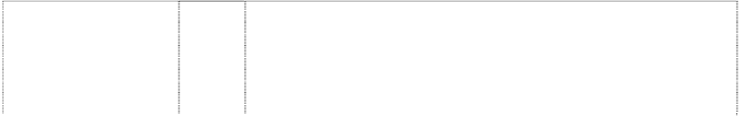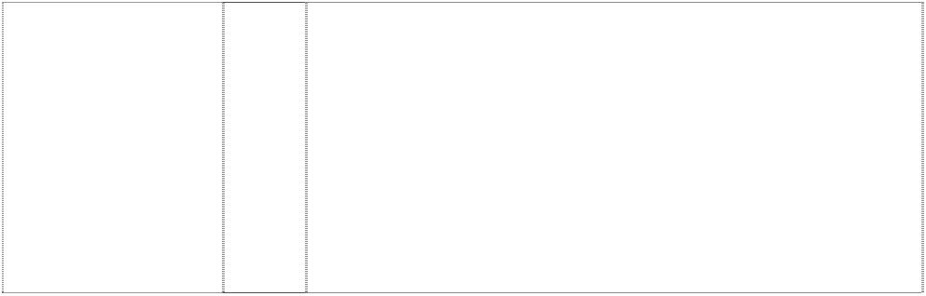

|  |  |  |
| --- | --- | --- |
| ***Trade Marks*** | ***Class*** | ***Goods*** |
| **A**  (857847) | 18 | Athletic bags, overnight bags, school bags, backpacks, duffel bags, tote bags, knapsacks, attache cases, briefcases, purses, handbags, wallets, billfolds, fanny packs, waist packs, cosmetic cases sold empty, toiletry cases sold empty, key cases, luggage, suitcases, garment bags for travel, trunks for travelling, umbrellas, canes, card  cases, dog collars and dog leashes but excluding surfboard bags. |
| **A**  (554829) | 25 | Clothing, footwear, headgear. |
| **A**  (857847) | 28 | Toys, games, playthings and sporting goods (not in other classes), including stuffed toys, plush toys, bean bag toys, puppets, balloons, marbles, checker sets, chess sets, board games, dart boards and dart board accessories, toy cars and trucks, toy mobiles, puzzles, yo- yo's, toy banks, toy figures, dolls and doll accessories, inflatable baseball bats, toy tattoos, flying discs, mini bats, neck and wrist lanyards for mini bats, mini baseballs, hand held video and electronic games, coin-operated pinball machines, baseballs and holders for baseballs, autographed baseballs, basketballs, footballs, playground balls, rubber action balls, golf balls, golf club covers, golf club bags, golf putters, bowling balls, bowling bags, baseball bases, pitcher's plates, baseball bats, catcher's masks, grip tape for baseball bats, baseball batting tees, pine tar bags for baseball, rosin bags for baseball, baseball glove oil, batting gloves, baseball gloves, mitts, umpire's protective equipment, chest protectors for sports, athletic supporters, baseball pitching machines, fishing tackle, party favours in the nature of noise makers, and Christmas tree ornaments; decorative wind socks being toys or playthings but excluding  surfboards and associated surfing hardware including deck grips and leg ropes. |
| **A**  diamond indents ltr A; zig-zag stripe in ltr A (1027046) | 25 | Clothing, including caps, hats, visors, knitted headwear, headbands, bandannas, shirts, T-shirts, tank tops, blouses, sweaters, turtlenecks, pullovers, vests, shorts, pants, slacks, dresses, skirts, overalls, bodysuits, baseball uniforms, jerseys, warm-up suits, jogging suits, sweatshirts, sweatpants, underwear, boxer shorts, robes, sleepwear, thermal loungewear, nightshirts, nightgowns, swimwear, clothing wraps, coats, jackets, ponchos, raincoats, cloth bibs, infant wear, infant diaper covers, cloth diaper sets with undershirt and diaper cover, jumpers, rompers, coveralls, creepers being romper suits, baby booties, toddler anklets, ties, suspenders, belts, money belts, mittens, gloves, wristbands, earmuffs, scarves, footwear, socks,  hosiery, slippers, aprons, sliding girdles and Halloween and masquerade costumes. |

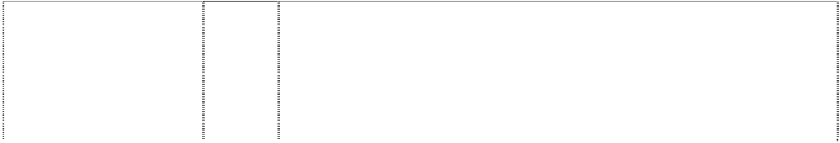

|  |  |  |
| --- | --- | --- |
| **A**  ltr A thru halo (1027008) | 25 | Clothing, including caps, hats, visors, knitted headwear, headbands, bandannas, shirts, T-shirts, tank tops, blouses, sweaters, turtlenecks, pullovers, vests, shorts, pants, slacks, dresses, skirts, overalls, bodysuits, baseball uniforms, jerseys, warm-up suits, jogging suits, sweatshirts, sweatpants, underwear, boxer shorts, robes, sleepwear, thermal loungewear, nightshirts, nightgowns, swimwear, clothing wraps, coats, jackets, ponchos, raincoats, cloth bibs, infant wear, infant diaper covers, cloth diaper sets with undershirt and diaper cover, jumpers, rompers, coveralls, creepers being romper suits, baby booties, toddler anklets, ties, suspenders, belts, money belts, mittens, gloves, wristbands, earmuffs, scarves, footwear, socks, hosiery, slippers, aprons, sliding girdles and Halloween and  masquerade costumes. |
| **A DIAMOND BACKS**  diamond indents ltr A; zig-zag stripe in ltr A (1027016) | 25 | Clothing, including caps, hats, visors, knitted headwear, headbands, bandannas, shirts, T-shirts, tank tops, blouses, sweaters, turtlenecks, pullovers, vests, shorts, pants, slacks, dresses, skirts, overalls, bodysuits, baseball uniforms, jerseys, warm-up suits, jogging suits, sweatshirts, sweatpants, underwear, boxer shorts, robes, sleepwear, thermal loungewear, nightshirts, nightgowns, swimwear, clothing wraps, coats, jackets, ponchos, raincoats, cloth bibs, infant wear, infant diaper covers, cloth diaper sets with undershirt and diaper cover, jumpers, rompers, coveralls, creepers being romper suits, baby booties, toddler anklets, ties, suspenders, belts, money belts, mittens, gloves, wristbands, earmuffs, scarves, footwear, socks,  hosiery, slippers, aprons, sliding girdles and Halloween and masquerade costumes. |
| **A’S**  (857835) | 18 | Athletic bags, overnight bags, school bags, backpacks, duffel bags, tote bags, knapsacks, attache cases, briefcases, purses, handbags, wallets, billfolds, fanny packs, waist packs, cosmetic cases sold empty, toiletry cases sold empty, key cases, luggage, suitcases,  garment bags for travel, trunks for travelling, umbrellas, canes, card cases, dog collars and dog leashes, money belts. |
| **A’S**  (857835) | 25 | Clothing, including, caps, hats, visors, knitted headwear, headbands, bandannas, shirts, T-shirts, tank tops, sweaters, turtlenecks, pullovers, vests, shorts, pants, dresses, skirts, overalls, bodysuits, baseball uniforms, jerseys, warm-up suits, sweatshirts, sweatpants, underwear, boxer shorts, robes, sleepwear, swimwear, clothing wraps, coats, jackets, ponchos, raincoats, cloth bibs, infant wear, infant diaper covers, cloth diaper sets with undershirt and diaper cover, jumpers, rompers, onesies, being all-in-one jumpsuits for babies, coveralls, creepers, being romper suits, baby booties, ties, suspenders, belts, mittens, gloves, wristbands, earmuffs, scarves, footwear, socks, hosiery, slippers, aprons, sliding girdles and  costumes. |
| **A’S**  (857835) | 28 | Toys, games, playthings and sporting goods (not in other classes), including stuffed toys, plush toys, bean bag toys, puppets, balloons, marbles, checker sets, chess sets, board games, dart boards and dart board accessories, toy cars and trucks, toy mobiles, puzzles, yo- yo's, toy banks, toy figures, dolls and doll accessories, inflatable baseball bats, decorative wind socks being toys or playthings, toy tattoos, flying discs, mini bats, neck and wrist lanyards for mini bats, mini baseballs, hand held video and electronic games, coin-operated pinball machines, baseballs and holders for baseballs, autographed baseballs, basketballs, footballs, playground balls, rubber action balls, golf balls, golf club covers, golf club bags, golf putters, bowling balls, bowling bags, baseball bases, pitcher's plates, baseball bats, catcher's masks, grip tape for baseball bats, baseball batting tees, pine tar bags for baseball, rosin bags for baseball, baseball glove oil, batting gloves, baseball gloves, mitts, umpire's protective equipment, chest protectors for sports, athletic supporters, baseball pitching machines, fishing tackle, party favours in the nature of noise makers,  and Christmas tree ornaments. |

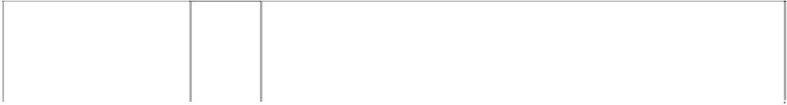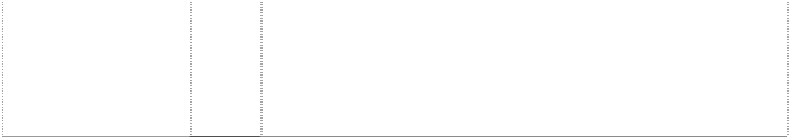

|  |  |  |
| --- | --- | --- |
| **A'S OAKLAND ATHLETICS**  ltr A in annulus (1027080) | 25 | Clothing, including caps, hats, visors, knitted headwear, headbands, bandannas, shirts, T-shirts, tank tops, blouses, sweaters, turtlenecks, pullovers, vests, shorts, pants, slacks, dresses, skirts, overalls, bodysuits, baseball uniforms, jerseys, warm-up suits, jogging suits, sweatshirts, sweatpants, underwear, boxer shorts, robes, sleepwear, thermal loungewear, nightshirts, nightgowns, swimwear, clothing wraps, coats, jackets, ponchos, raincoats, cloth bibs, infant wear, infant diaper covers, cloth diaper sets with undershirt and diaper cover, jumpers, rompers, coveralls, creepers being romper suits, baby booties, toddler anklets, ties, suspenders, belts, money belts, mittens, gloves, wristbands, earmuffs, scarves, footwear, socks, hosiery, slippers, aprons, sliding girdles and Halloween and  masquerade costumes. |
| **ALL-STAR GAME**  (523910) | 16 | Cardboard baseball swap cards, photo trading cards, stamps, decalcomanias, paper stickers, booklets, albums, bumper stickers,  posters, paper pennants, labels not of textile, magazines, comic books, books, pens, pencils and ball point pens. |
| **AMERICAN LEAGUE**  eagle, ribbon in mouth atop baseball in circle with stars  (554850) | 16 | Printed matter including books, magazines, calendars and other publications; albums; photographs, posters, stickers, decalcomania, labels; paper and cardboard novelty items in this class including pennants; table covers/napkins/mats in this class; stationery including writing implements; cards in this class; teaching materials  in the form of games; wrapping paper, paper tissues and all other paper goods in this class. |
| **AMERICAN LEAGUE**  eagle, ribbon in mouth atop baseball in circle with stars  (554991) | 18 | Bags and cases in this class; umbrellas, parasols and covers therefor; wallets, purses and key cases in this class; back packs and knapsacks in this class; leather goods in this class. |
| **AMERICAN LEAGUE**  eagle, ribbon in mouth atop baseball in circle with stars  (554988) | 21 | Household, kitchen or domestic goods in this class; containers and boxes in this class; ceramic, porcelain and earthenware goods in this class; glassware in this class; brushes in this class including toothbrushes; combs; coolers in this class; moulds in this class; goods in this class for eating and drinking purposes including mugs;  trinkets and decorative items in this class; statues and figurines in this class; stands and holders in this class. |
| **AMERICAN LEAGUE**  eagle, ribbon in mouth atop baseball in circle with stars  (554990) | 25 | Clothing, footwear, headgear. |
| **AMERICAN LEAGUE**  eagle, ribbon in mouth atop baseball in circle with stars  (554989) | 28 | Games and playthings including toys; sporting goods in this class. |
| **ANGELS**  (1027010) | 25 | Clothing, including caps, hats, visors, knitted headwear, headbands, bandannas, shirts, T-shirts, tank tops, blouses, sweaters, turtlenecks, pullovers, vests, shorts, pants, slacks, dresses, skirts, overalls, bodysuits, baseball uniforms, jerseys, warm-up suits, jogging suits, sweatshirts, sweatpants, underwear, boxer shorts, robes, sleepwear, thermal loungewear, nightshirts, nightgowns, swimwear, clothing wraps, coats, jackets, ponchos, raincoats, cloth bibs, infant wear, infant diaper covers, cloth diaper sets with undershirt and diaper cover, jumpers, rompers, coveralls, creepers being romper suits, baby booties, toddler anklets, ties, suspenders, belts, money belts, mittens, gloves, wristbands, earmuffs, scarves, footwear, socks, hosiery, slippers, aprons, sliding girdles and Halloween and  masquerade costumes. |
| **ANGELS**  halo on ltr A word forms arc (554926) | 16 | Printed matter including books, magazines, calendars and other publications; albums; photographs, posters, stickers, decalcomanias, labels; paper and cardboard novelty items in this class including pennants; table covers/napkins/mats in this class; stationery including writing implements; cards in this class; teaching materials in the form of games; wrapping paper, paper tissues and all other  paper goods in this class. |

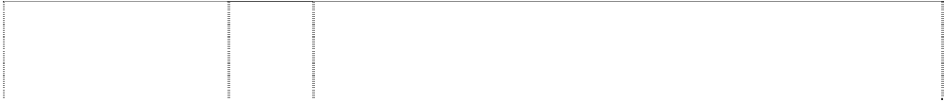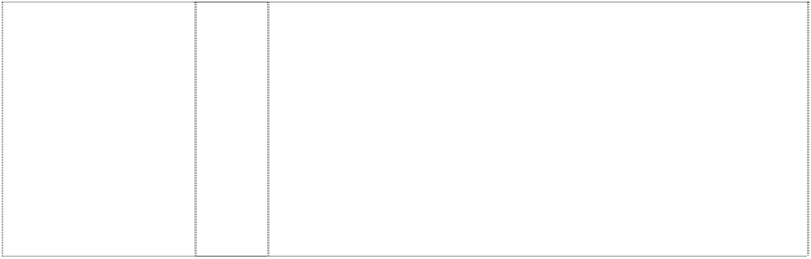

|  |  |  |
| --- | --- | --- |
| **ANGELS**  halo on ltr A word forms arc (554927) | 18 | Bags and cases in this class; umbrellas, parasols and covers therefor; wallets, purses and key cases in this class; back packs and knapsacks; leather goods in this class. |
| **ANGELS**  halo on ltr A word forms arc (554823) | 21 | Household, kitchen or domestic goods in this class; containers and boxes in this class; ceramic, porcelain and earthenware goods in this class; glass-ware in this class; coolers in this class; moulds in this class; goods in this class for eating and drinking purposes including mugs; trinkets in this class and decorative items in this class; statues and figurines in this class; stands and holders in this class; none of  the above being dispensers and containers for toiletry articles. |
| **ANGELS**  circle star, five-point map, California (429016) | 25 | Men's tank tops, sweatshirts, shorts and tops, cardigans, jogging suits, singlets, pyjamas, polo pyjamas, dressing gowns, tops and long pants sets, warm-up suits, hats, caps, visors in this class, scarves, jackets in this class, parkas, ponchos, belts in this class, baseball uniforms and warm-up jackets, baseball caps; ladies' shirts, sports clothes; children's pyjamas, bibs not made of paper, hooded wrap and bib sets made of towelling; babies' jackets; shoes;  sneakers; jogging shoes; rubber boots and canvas footwear. |
| **ANGELS**  halo on ltr A word forms arc  (554928) | 25 | Clothing, footwear, headgear, but excluding women's hosiery, gloves and nightgowns. |
| **ASTROS**  (1027061) | 25 | Clothing, including caps, hats, visors, knitted headwear, headbands, bandannas, shirts, T-shirts, tank tops, blouses, sweaters, turtlenecks, pullovers, vests, shorts, pants, slacks, dresses, skirts, overalls, bodysuits, baseball uniforms, jerseys, warm-up suits, jogging suits, sweatshirts, sweatpants, underwear, boxer shorts, robes, sleepwear, thermal loungewear, nightshirts, nightgowns, swimwear, clothing wraps, coats, jackets, ponchos, raincoats, cloth bibs, infant wear, infant diaper covers, cloth diaper sets with undershirt and diaper cover, jumpers, rompers, coveralls, creepers being romper suits, baby booties, toddler anklets, ties, suspenders, belts, money belts, mittens, gloves, wristbands, earmuffs, scarves, footwear, socks, hosiery, slippers, aprons, sliding girdles and Halloween and  masquerade costumes. |
| **ASTROS**  drum or flying-saucer or wheel, vehicle in atomic-orbits (429029) | 25 | Boy's and men’s' tank tops, sweatshirts, shorts and tops, cardigans, jogging suits, singlets, pyjamas, polo pyjamas, dressing gowns, tops and long pants sets, warm-up suits, hats, caps, visors in this class, scarves, jackets in this class, parkas, ponchos, belts in this class, baseball uniforms and warm-up jackets, baseball caps; ladies' pyjamas, nightgowns, nightshirts, shirts, sports clothes; children's pyjamas, shirts, bibs not made of paper, hooded wrap and bib sets made of towelling; babies' jackets; shoes; sneakers; jogging shoes;  rubber boots and canvas footwear. |
| **ATHLETICS**  (1027079) | 25 | Clothing, including caps, hats, visors, knitted headwear, headbands, bandannas, shirts, T-shirts, tank tops, blouses, sweaters, turtlenecks, pullovers, vests, shorts, pants, slacks, dresses, skirts, overalls, bodysuits, baseball uniforms, jerseys, warm-up suits, jogging suits, sweatshirts, sweatpants, underwear, boxer shorts, robes, sleepwear, thermal loungewear, nightshirts, nightgowns, swimwear, clothing wraps, coats, jackets, ponchos, raincoats, cloth bibs, infant wear, infant diaper covers, cloth diaper sets with undershirt and diaper cover, jumpers, rompers, coveralls, creepers being romper suits, baby booties, toddler anklets, ties, suspenders, belts, money belts, mittens, gloves, wristbands, earmuffs, scarves, footwear, socks, hosiery, slippers, aprons, sliding girdles and Halloween and  masquerade costumes. |

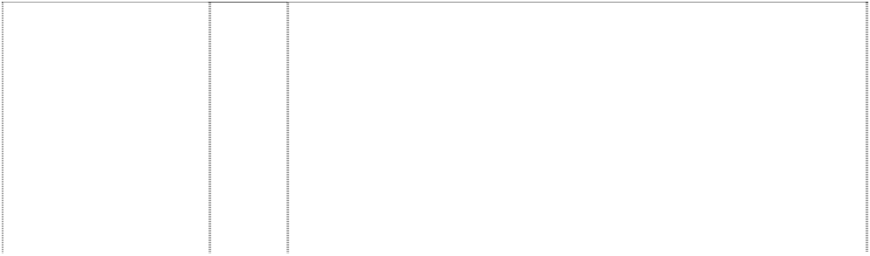

|  |  |  |
| --- | --- | --- |
| **ATLANTA BRAVES**  (858373) | 9 | Electrical and scientific apparatus, including, telephones, radios, clock radios, pre-recorded videotapes relating to baseball, pre- recorded videodiscs relating to baseball, pre-recorded compact discs relating to baseball, pre-recorded audio discs relating to baseball, records relating to baseball, pre-recorded audio tapes relating to baseball, binoculars, video viewers, cameras, kaleidoscopes, coin- operated arcade games, computer programs, electric switch plate covers, electric signs, luminous signs, neon signs, sunglasses, eyeglass and contact lens cases, eyeglass chains, eyeglass frames, eyeglass cords, eyeglass lenses and eyeglasses, magnets, protective clothing, protective helmets, camera cases, camera straps, whistles, batting helmets, catchers helmets, computer accessories such as mouse pads, screen savers, wrist pads, monitor frames, computer cases, compact disc cases, video and computer game cartridges, video and computer game discs, video and computer game cassettes, computer game programs, and computer  programs downloadable from a global computer network. |
| **ATLANTA BRAVES**  (857846) | 25 | Clothing, including, caps, hats, visors, knitted headwear, headbands, bandannas, shirts, t-shirts, tank tops, sweaters, turtlenecks, pullovers, vests, shorts, pants, dresses, skirts, overalls, bodysuits, baseball uniforms, jerseys, warm-up suits, sweatshirts, sweatpants, underwear, boxer shorts, robes, sleepwear, swimwear, clothing wraps, coats, jackets, ponchos, raincoats, cloth bibs, infant wear, infant diaper covers, cloth diaper sets with undershirt and diaper cover, jumpers, rompers, onesies, being all-in-one jumpsuits for babies, coveralls, creepers, being romper suits, baby booties, ties, suspenders, belts, mittens, gloves, wristbands, earmuffs, scarves,  footwear, socks, hosiery, slippers, aprons, sliding girdles and costumes. |
| **ATLANTA BRAVES**  (857846) | 28 | Toys, games, playthings and sporting goods (not in other classes), including stuffed toys, plush toys, bean bag toys, puppets, balloons, marbles, checker sets, chess sets, board games, dart boards and dart board accessories, toy cars and trucks, toy mobiles, puzzles, yo- yo's, toy banks, toy figures, dolls and doll accessories, inflatable baseball bats, decorative wind socks being toys or playthings, toy tattoos, flying discs, mini bats, neck and wrist lanyards for mini bats, mini baseballs, hand held video and electronic games, coin-operated pinball machines, baseballs and holders for baseballs, autographed baseballs, basketballs, footballs, playground balls, rubber action balls, golf balls, golf club covers, golf club bags, golf putters, bowling balls, bowling bags, baseball bases, pitcher's plates, baseball bats, catcher's masks, grip tape for baseball bats, baseball batting tees, pine tar bags for baseball, rosin bags for baseball, baseball glove oil, batting gloves, baseball gloves, mitts, umpire's protective equipment, chest protectors for sports, athletic supporters, baseball pitching  machines, fishing tackle, party favours in the nature of noise makers, and Christmas tree ornaments. |
| **B**  (857836) | 18 | Athletic bags, overnight bags, school bags, backpacks, duffel bags, tote bags, knapsacks, attache cases, briefcases, purses, handbags, wallets, billfolds, fanny packs, waist packs, cosmetic cases sold empty, toiletry cases sold empty, key cases, luggage, suitcases,  garment bags for travel, trunks for travelling, umbrellas, canes, card cases, dog collars and dog leashes. |
| **B**  (554820) | 25 | Caps and T-shirts. |



|  |  |  |
| --- | --- | --- |
| **B**  (1027049) | 25 | Clothing, including caps, hats, visors, knitted headwear, headbands, bandannas, shirts, T-shirts, tank tops, blouses, sweaters, turtlenecks, pullovers, vests, shorts, pants, slacks, dresses, skirts, overalls, bodysuits, baseball uniforms, jerseys, warm-up suits, jogging suits, sweatshirts, sweatpants, underwear, boxer shorts, robes, sleepwear, thermal loungewear, nightshirts, nightgowns, swimwear, clothing wraps, coats, jackets, ponchos, raincoats, cloth bibs, infant wear, infant diaper covers, cloth diaper sets with undershirt and diaper cover, jumpers, rompers, coveralls, creepers being romper suits, baby booties, toddler anklets, ties, suspenders, belts, money belts, mittens, gloves, wristbands, earmuffs, scarves, footwear, socks, hosiery, slippers, aprons, sliding girdles and Halloween and  masquerade costumes. |
| **B**  (857836) | 28 | Toys, games, playthings and sporting goods (not in other classes), including stuffed toys, plush toys, bean bag toys, puppets, balloons, marbles, checker sets, chess sets, board games, dart boards and dart board accessories, toy cars and trucks, toy mobiles, puzzles, yo- yo's, toy banks, toy figures, dolls and doll accessories, inflatable baseball bats, decorative wind socks being toys or playthings, toy tattoos, flying discs, mini bats, neck and wrist lanyards for mini bats, mini baseballs, hand held video and electronic games, coin-operated pinball machines, baseballs and holders for baseballs, autographed baseballs, basketballs, footballs, playground balls, rubber action balls, golf balls, golf club covers, golf club bags, golf putters, bowling balls, bowling bags, baseball bases, pitcher's plates, baseball bats, catcher's masks, grip tape for baseball bats, baseball batting tees, pine tar bags for baseball, rosin bags for baseball, baseball glove oil, batting gloves, baseball gloves, mitts, umpire's protective equipment, chest protectors for sports, athletic supporters, baseball pitching machines, fishing tackle, party favours in the nature of noise makers,  and Christmas tree ornaments. |
| **BALTIMORE ORIOLES**  bird, cartoon baseball- player annulus (429018) | 25 | Boys' and men's tank tops, sweatshirts, shorts and tops, cardigans, jogging suits, singlets, pyjamas, polo pyjamas, dressing gowns, tops and long pants sets, warm-up suits, hats, caps, visors in this class, scarves, jackets in this class, parkas, ponchos, belts in this class, baseball uniforms and warm-up jackets, baseball caps; ladies' pyjamas, nightgowns, nightshirts, shirts, sports clothes; children's pyjamas, shirts, bibs not made of paper, hooded wrap and bib sets made of towelling; babies' jackets; shoes; sneakers; jogging shoes;  rubber boots and canvas footwear. |
| **BM**  linked ltrs on crossed baseball bats all in diamond  (628867) | 16 | Paper goods and printed matter, namely, trading cards, bumper stickers, posters, stickers, decalcomania, book marks, scorebooks, scorecards, printed paper signs, writing pads, note paper, notebooks, colouring books, preprinted agenda organisers, magazines featuring baseball game programs, books and booklets featuring baseball, autograph books, book covers, calendars, wall calendars, desk calendars, playing cards, paper pennants, gift wrapping paper, paper gift wrap bows, paper gift and party bags, paper party decorations, paper coasters, paper flags, paper napkins, paper tablecloths, paper placemats, greeting cards, postcards, unmounted photographs, lithographs, doorsigns; photograph albums; scrapbooks; plastic baseball card holders and cases; baseball card albums; binders; portfolios; stationery folders; magnetic metal bulletin boards, bank cheques; chequebook covers; credit cards; paperweights; letter openers; paper clips; pens; pencils, markers; desk stands and holders for pens, pencils, and ink; non-electric erasers; pencil sharpeners; drafting and drawing rulers; aquariums; preprinted baseball contracts; collectable stamps; facial tissue; and pencil top  ornaments and all other goods in this class. |



|  |  |  |
| --- | --- | --- |
| **BM**  linked ltrs on crossed baseball bats all in diamond  (628868) | 25 | Clothing, namely, shirts, caps, shorts, dresses, skirts, T-shirts, jogging suits, warm-up suits, socks, underwear, jackets, sweaters, vests, pants, ponchos, visors, bodysuits, raincoats, hats, overalls, cloth bibs, infant diaper covers, cloth diaper sets with undershirt and diaper cover, jumpers, rompers, uniforms, uniform jerseys, wind resistant jackets, baby bootees, short sets, leotards, unitards, ties, bowties, neckties, suspenders, men's and women's formalwear, pyjamas, nightshirts, nightgowns, sweatpants, sweatshirts, mittens, gloves, knitted headwear, earmuffs, scarves, footwear, thongs, hosiery, socks, wristbands, headbands, robes, shoes, slippers, chef's hats, aprons, clothing wrap, sliding girdles, leg warmers, swimwear,  berets, bandannas, and all other goods in this class. |
| **BM**  linked ltrs on crossed baseball bats all in diamond  (628869) | 28 | Toys and sporting goods, including baseballs, stuffed toy animals, arm guards for athletic use, basketball backboards, bowling bags, bowling balls, puppets, bendable toy figurines, toy bakeware and cookware, balloons, basketballs, footballs, playground balls, rubber action balls, tennis balls, toy banks, umpire's equipment, baseball bases, pitcher's plates, baseball bats, catcher's masks, grip tape for baseball bats, baseball batting tees, pine tar bags for baseball, rosin bags for baseball, baseball olive oil, batting gloves, baseball gloves, mitts, bean bags, billiard game playing equipment, kites, marbles, checker sets, chess sets, dart boards and dart board accessories, toy trucks, toy mobiles, puzzles, toy banks, snow globes, yo-yo's, golf club covers, golf club bags, golf balls, golf putters, video game cartridges, chest protectors for sports, Christmas tree ornaments, toy figures, toy construction blocks, dolls and doll accessories, athletic supporters, dice, computer game programs, hand held video and electronic games, manually operated exercise equipment, baseball pitching machines, fishing tackle, fishing rods, swim floats for recreational use, board games, party favours in the nature of noise makers, coin-operated pinball machines, skateboards, playground slides, surfboards, snow sleds for recreational use, exercise trampolines, flying discs, autographed baseballs, inflatable baseball bats, wind socks (not being for decoration and being in the nature of  a toy or plaything), and toy tattoos. |
| **BOSTON RED SOX**  clothing, socks annulus ball, baseball (429017) | 25 | Boys' and men's tank tops, sweatshirts, shorts and tops, cardigans, jogging suits, singlets, pyjamas, polo pyjamas, dressing gowns, tops and long pants sets, warm-up suits, hats, caps, visors in this class, scarves, jackets in this class, parkas, ponchos, belts in this class, baseball uniforms not including socks, warm-up jackets, baseball caps; ladies' pyjamas, night gowns, nightshirts, shirts, sports clothes not including socks; children's pyjamas, shirts, bibs not made of  paper, hooded wrap and bib sets made of towelling; babies' jackets; shoes; sneakers; jogging shoes; rubber boots and canvas footwear. |
| **BOSTON RED SOX**  socks on baseball annulus  (554916) | 28 | Games and playthings including toys; sporting goods in this class. |
| **BRAVES**  (554919) | 16 | Printed matter including books, magazines, calendars and other publications; albums; photographs, posters, stickers, decalcomanias, labels; paper and cardboard novelty items in this class including pennants; table covers/napkins/mats in this class; stationery including writing implements; cards in this class; teaching materials in the form of games; wrapping paper, paper tissues and all other  paper goods in this class. |
| **BRAVES**  (606022) | 25 | Clothing, footwear, headgear. |



|  |  |  |
| --- | --- | --- |
| **BRAVES**  axe (858382) | 9 | Electrical and scientific apparatus, including, telephones, radios, clock radios, pre-recorded videotapes relating to baseball, pre- recorded videodiscs relating to baseball, pre-recorded compact discs relating to baseball, pre-recorded audio discs relating to baseball, records relating to baseball, pre-recorded audio tapes relating to baseball, binoculars, video viewers, cameras, kaleidoscopes, coin- operated arcade games, computer programs, electric switch plate covers, electric signs, luminous signs, neon signs, sunglasses, eyeglass and contact lens cases, eyeglass chains, eyeglass frames, eyeglass cords, eyeglass lenses and eyeglasses, magnets, protective clothing, protective helmets, camera cases, camera straps, whistles, batting helmets, catchers helmets, computer accessories such as mouse pads, screen savers, wrist pads, monitor frames, computer cases, compact disc cases, video and computer game cartridges, video and computer game discs, video and computer game cassettes, computer game programs, and computer  programs downloadable from a global computer network. |
| **BRAVES**  axe (554976) | 16 | Printed Matter including books, magazines, calendars and other publications; albums; photographs, posters, stickers, decalcomanias, labels; paper and cardboard novelty items in this class including pennants; table covers/napkins/mats in this class; stationery including writing implements; cards in this class; teaching materials in the form of games; wrapping paper, paper tissues and all other  paper goods in this class. |
| **BRAVES**  axe (554977) | 18 | Bags and cases in this class; umbrellas, parasols and covers  therefor; wallets, purses and key cases in this class; back packs and knapsacks; leather goods in this class. |
| **BRAVES**  axe (554848) | 21 | Household, kitchen or domestic goods in this class; containers and boxes in this class; ceramic, porcelain and earthenware goods in this class; glassware in this class; brushes in this class including toothbrushes; combs; coolers in this class; moulds in this class; goods in this class for eating and drinking purposes including mugs; trinkets and decorative items in this class; statues and figurines in  this class; stands and holders in this class. |
| **BRAVES**  axe (554978) | 25 | Clothing, footwear, headgear. |
| **BRAVES**  axe (1027047) | 25 | Clothing, including caps, hats, visors, knitted headwear, headbands, bandannas, shirts, T-shirts, tank tops, blouses, sweaters, turtlenecks, pullovers, vests, shorts, pants, slacks, dresses, skirts, overalls, bodysuits, baseball uniforms, jerseys, warm-up suits, jogging suits, sweatshirts, sweatpants, underwear, boxer shorts, robes, sleepwear, thermal loungewear, nightshirts, nightgowns, swimwear, clothing wraps, coats, jackets, ponchos, raincoats, cloth bibs, infant wear, infant diaper covers, cloth diaper sets with undershirt and diaper cover, jumpers, rompers, coveralls, creepers being romper suits, baby booties, toddler anklets, ties, suspenders, belts, money belts, mittens, gloves, wristbands, earmuffs, scarves, footwear, socks,  hosiery, slippers, aprons, sliding girdles and Halloween and masquerade costumes. |
| **BRAVES**  axe (554979) | 28 | Games and playthings including toys; sporting goods in this class. |
| **BRAVES**  man, American-Indian, head smiling  (429026) | 25 | Boys' and men's tank tops, sweatshirts, shorts and tops, cardigans, jogging suits, singlets, pyjamas, polo pyjamas, dressing gowns, tops and long pants sets, warm-up suits, hats, caps, visors in this class, scarves, jackets in this class, parkas, ponchos, belts in this class, baseball uniforms and warm-up jackets, baseball caps; ladies' pyjamas, nightgowns, nightshirts, shirts, sports clothes; children's pyjamas, shirts, bibs not made of paper, hooded wrap and bib sets  made of towelling; babies' jackets; shoes; sneakers; jogging shoes; rubber boots and canvas footwear. |



|  |  |  |
| --- | --- | --- |
| **BREWERS**  baseball in ellipse (1027067) | 25 | Clothing, including caps, hats, visors, knitted headwear, headbands, bandannas, shirts, T-shirts, tank tops, blouses, sweaters, turtlenecks, pullovers, vests, shorts, pants, slacks, dresses, skirts, overalls, bodysuits, baseball uniforms, jerseys, warm-up suits, jogging suits, sweatshirts, sweatpants, underwear, boxer shorts, robes, sleepwear, thermal loungewear, nightshirts, nightgowns, swimwear, clothing wraps, coats, jackets, ponchos, raincoats, cloth bibs, infant wear, infant diaper covers, cloth diaper sets with undershirt and diaper cover, jumpers, rompers, coveralls, creepers being romper suits, baby booties, toddler anklets, ties, suspenders, belts, money belts, mittens, gloves, wristbands, earmuffs, scarves, footwear, socks, hosiery, slippers, aprons, sliding girdles and Halloween and  masquerade costumes. |
| **BROWNS**  head, pixie with  antennae, two (606013) | 25 | Clothing, footwear, headgear. |
| **C CHICAGO CUBS**  arc circles, concentric,  2 incomplete form ltr C (554817) | 25 | Clothing, footwear, headgear. |
| **C CINCINNATI REDS**  man,baseball head running in ltr C (554811) | 6 | Key rings and key chains; money clips in this class and other clips; badges and plates in this class; metallic gift wrap in this class, foils of metal for wrapping and packaging; boxes and containers including money boxes; bells; hardware, fittings and other goods for domestic use in this class; pewter goods in this class; trinkets in this class; signs; statues and works of art; bottle closures and caps; weather vanes; towel dispensers; all of the aforesaid goods being qualified as  goods included in class 6. |
| **C CINCINNATI REDS**  man, baseball head running in ltr C (554899) | 16 | Printed matter including books, magazines, calendars and other publications; albums; photographs, posters, stickers, decalcomanias, labels not of cloth; paper and cardboard novelty items in this class including pennants; table covers/napkins/mats in this class; stationery including writing implements; cards in this class; teaching  materials in the form of games; wrapping paper, paper tissues and all other paper goods in this class. |
| **C CINCINNATI REDS**  man, baseball head running in ltr C (554900) | 18 | Bags and cases in this class; umbrellas, parasols and covers therefor; wallets, purses and key cases in this class; back packs and knapsacks; leather goods in this class. |
| **C CINCINNATI REDS**  man, baseball head running in ltr C (554898) | 21 | Household, kitchen or domestic goods in this class; containers and boxes in this class; porcelain and earthenware goods in this class; glassware in this class; brushes in this class including toothbrushes; combs; coolers in this class; moulds in this class; goods in this class for eating and drinking purposes including mugs; trinkets and decorative items in this class; statues and figurines in this class;  stands and holders in this class. |
| **C CINCINNATI REDS**  (554813) | 25 | Clothing, footwear, headgear. |
| **C CINCINNATI REDS**  man, baseball head  running in ltr C (554901) | 28 | Games and playthings including toys; sporting goods in this class. |
| **C REDS**  word indents drop is ltr C  (1027054) | 25 | Clothing, including caps, hats, visors, knitted headwear, headbands, bandannas, shirts, T-shirts, tank tops, blouses, sweaters, turtlenecks, pullovers, vests, shorts, pants, slacks, dresses, skirts, overalls, bodysuits, baseball uniforms, jerseys, warm-up suits, jogging suits, sweatshirts, sweatpants, underwear, boxer shorts, robes, sleepwear, thermal loungewear, nightshirts, nightgowns, swimwear, clothing wraps, coats, jackets, ponchos, raincoats, cloth bibs, infant wear, infant diaper covers, cloth diaper sets with undershirt and diaper cover, jumpers, rompers, coveralls, creepers being romper suits, baby booties, toddler anklets, ties, suspenders, belts, money belts, mittens, gloves, wristbands, earmuffs, scarves, footwear, socks, hosiery, slippers, aprons, sliding girdles and Halloween and  masquerade costumes. |

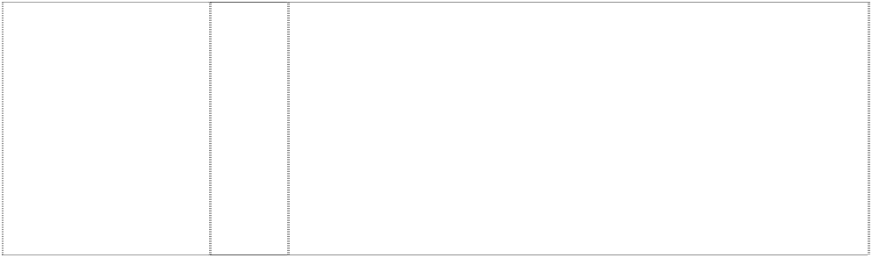

|  |  |  |
| --- | --- | --- |
| **CARDINAL**  (523685) | 16 | Books, periodicals, printed matter, photographs, stationery, instructional and teaching material in this class, and all other goods  in this class. |
| **CARDINALS**  bird sitting on baseball-bat (858383) | 9 | Electrical and scientific apparatus, including, telephones, radios, clock radios, pre-recorded videotapes relating to baseball, pre- recorded videodiscs relating to baseball, pre-recorded compact discs relating to baseball, pre-recorded audio discs relating to baseball, records relating to baseball, pre-recorded audio tapes relating to baseball, binoculars, video viewers, cameras, kaleidoscopes, coin- operated arcade games, computer programs, electric switch plate covers, electric signs, luminous signs, neon signs, sunglasses, eyeglass and contact lens cases, eyeglass chains, eyeglass frames, eyeglass cords, eyeglass lenses and eyeglasses, magnets, protective clothing, protective helmets, camera cases, camera straps, whistles, batting helmets, catchers helmets, computer accessories such as mouse pads, screen savers, wrist pads, monitor frames, computer cases, compact disc cases, video and computer game cartridges, video and computer game discs, video and  computer game cassettes, computer game programs, and computer programs downloadable from a global computer network. |
| **CARDINALS**  bird sitting on baseball-bat (857825) | 16 | Paper and cardboard goods (not included in other classes) and printed matter, including trading cards, playing cards, posters, stickers, decalcomanias, bumper stickers, score books, scorecards, game programs, magazines and books featuring baseball, writing pads, note paper, notebooks, binders; stationery-type portfolios, stationery folders, stationery sets, paper activity sets, preprinted agenda organizers, scrapbooks, autograph books, baseball card albums, book covers, calendars, greeting cards, postcards, bank cheques, chequebook covers, credit cards being card-formed printed matter, collectible stamps, gift wrapping paper, paper gift and party bags, paper party decorations, paper coasters, paper flags, paper napkins, paper tablecloths, mounted and unmounted photographs, photograph albums, lithographs, printed paper signs, printed paper door signs, plastic baseball card holders and collectors cases, business card holders, paperweights, letter openers, pens, pencils, pencil top ornaments, markers, desk stands and holder for pens,  pencils and ink, non-electric erasers, pencil sharpeners, ungraduated rulers, ticket holders and lanyards for ticket holders. |
| **CARDINALS**  bird sitting on baseball-bat (857825) | 25 | Clothing, including, caps, hats, visors, knitted headwear, headbands, bandannas, shirts, T-shirts, tank tops, sweaters, turtlenecks, pullovers, vests, shorts, pants, dresses, skirts, overalls, bodysuits, baseball uniforms, jerseys, warm-up suits, sweatshirts, sweatpants, underwear, boxer shorts, robes, sleepwear, swimwear, clothing wraps, coats, jackets, ponchos, raincoats, cloth bibs, infant wear, infant diaper covers, cloth diaper sets with undershirt and diaper cover, jumpers, rompers, onesies being all-in-one jumpsuits for babies, coveralls, creepers being romper suits, baby booties, ties, suspenders, belts, mittens, gloves, wristbands, earmuffs, scarves,  footwear, socks, hosiery, slippers, aprons, sliding girdles and costumes. |

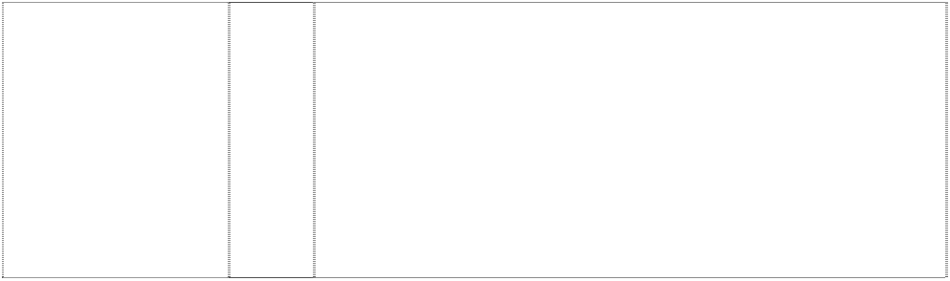

|  |  |  |
| --- | --- | --- |
| **CARDINALS**  bird sitting on baseball-bat (857825) | 28 | Toys, games, playthings and sporting goods (not in other classes), including stuffed toys, plush toys, bean bag toys, puppets, balloons, marbles, checker sets, chess sets, board games, dart boards and dart board accessories, toy cars and trucks, toy mobiles, puzzles, yo- yo's, toy banks, toy figures, dolls and doll accessories, inflatable baseball bats, decorative wind socks being toys or playthings, toy tattoos, flying discs, mini bats, neck and wrist lanyards for mini bats, mini baseballs, hand held video and electronic games, coin-operated pinball machines, baseballs and holders for baseballs, autographed baseballs, basketballs, footballs, playground balls, rubber action balls, golf balls, golf club covers, golf club bags, golf putters, bowling balls, bowling bags, baseball bases, pitcher's plates, baseball bats, catcher's masks, grip tape for baseball bats, baseball batting tees, pine tar bags for baseball, rosin bags for baseball, baseball glove oil, batting gloves, baseball gloves, mitts, umpire's protective equipment, chest protectors for sports, athletic supporters, baseball pitching machines, fishing tackle, party favours in the nature of noise makers,  and Christmas tree ornaments. |
| **CARDINALS**  two birds sitting on baseball-bat (857827) | 16 | Paper and cardboard goods (not included in other classes) and printed matter, including trading cards, playing cards, posters, stickers, decalcomanias, bumper stickers, score books, scorecards, game programs, magazines and books featuring baseball, writing pads, note paper, notebooks, binders; stationery-type portfolios, stationery folders, stationery sets, paper activity sets, preprinted agenda organizers, scrapbooks, autograph books, baseball card albums, book covers, calendars, greeting cards, postcards, bank cheques, chequebook covers, credit cards being card-formed printed matter, collectible stamps, gift wrapping paper, paper gift and party bags, paper party decorations, paper coasters, paper flags, paper napkins, paper tablecloths, mounted and unmounted photographs, photograph albums, lithographs, printed paper signs, printed paper door signs, plastic baseball card holders and collectors cases, business card holders, paperweights, letter openers, pens, pencils, pencil top ornaments, markers, desk stands and holder for pens, pencils and ink, non-electric erasers, pencil sharpeners, ungraduated  rulers, ticket holders and lanyards for ticket holders. |
| **CARDINALS**  two birds sitting on baseball-bat (555004) | 25 | Clothing, footwear, headgear but not including paper clothing. |
| **CARDINALS**  two birds sitting on baseball-bat (857827) | 25 | Clothing, including, caps, hats, visors, knitted headwear, headbands, bandannas, shirts, T-shirts, tank tops, sweaters, turtlenecks, pullovers, vests, shorts, pants, dresses, skirts, overalls, bodysuits, baseball uniforms, jerseys, warm-up suits, sweatshirts, sweatpants, underwear, boxer shorts, robes, sleepwear, swimwear, clothing wraps, coats, jackets, ponchos, raincoats, cloth bibs, infant wear, infant diaper covers, cloth diaper sets with undershirt and diaper cover, jumpers, rompers, onesies, being all-in-one jumpsuits for babies, coveralls, creepers being romper suits, baby booties, ties, suspenders, belts, mittens, gloves, wristbands, earmuffs, scarves, footwear, socks, hosiery, slippers, aprons, sliding girdles and  costumes. |

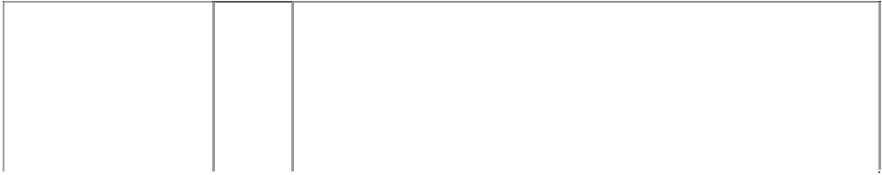

|  |  |  |
| --- | --- | --- |
| **CARDINALS**  two birds sitting on baseball-bat (857827) | 28 | Toys, games, playthings and sporting goods (not in other classes), including stuffed toys, plush toys, bean bag toys, puppets, balloons, marbles, checker sets, chess sets, board games, dart boards and dart board accessories, toy cars and trucks, toy mobiles, puzzles, yo- yo's, toy banks, toy figures, dolls and doll accessories, inflatable baseball bats, decorative wind socks being toys or playthings, toy tattoos, flying discs, mini bats, neck and wrist lanyards for mini bats, mini baseballs, hand held video and electronic games, coin-operated pinball machines, baseballs and holders for baseballs, autographed baseballs, basketballs, footballs, playground balls, rubber action balls, golf balls, golf club covers, golf club bags, golf putters, bowling balls, bowling bags, baseball bases, pitcher's plates, baseball bats, catcher's masks, grip tape for baseball bats, baseball batting tees, pine tar bags for baseball, rosin bags for baseball, baseball glove oil, batting gloves, baseball gloves, mitts, umpire's protective equipment, chest protectors for sports, athletic supporters, baseball pitching machines, fishing tackle, party favours in the nature of noise makers,  and Christmas tree ornaments. |
| **CHICAGO CUBS**  (858374) | 9 | Electrical and scientific apparatus, including, telephones, radios, clock radios, pre-recorded videotapes relating to baseball, pre- recorded videodiscs relating to baseball, pre-recorded compact discs relating to baseball, pre-recorded audio discs relating to baseball, records relating to baseball, pre-recorded audio tapes relating to baseball, binoculars, video viewers, cameras, kaleidoscopes, coin- operated arcade games, computer programs, electric switch plate covers, electric signs, luminous signs, neon signs, sunglasses, eyeglass and contact lens cases, eyeglass chains, eyeglass frames, eyeglass cords, eyeglass lenses and eyeglasses, magnets, protective clothing, protective helmets, camera cases, camera straps, whistles, batting helmets, catchers helmets, computer accessories such as mouse pads, screen savers, wrist pads, monitor frames, computer cases, compact disc cases, video and computer game cartridges, video and computer game discs, video and computer game cassettes, computer game programs, and computer  programs downloadable from a global computer network. |
| **CHICAGO CUBS**  (554903) | 16 | Printed matter including books, magazines, calendars and other publications; albums; photographs, posters, stickers, decalcomanias, labels not of cloth; paper and cardboard novelty items in this class including pennants; table covers/napkins/mats in this class; stationery including writing implements; cards in this class; teaching materials in the form of games; wrapping paper, paper tissues and all  other paper goods in this class. |
| **CHICAGO CUBS**  (554904) | 18 | Bags and cases in this class; umbrellas, parasols and covers  therefor; wallets, purses and key cases in this class; back packs and knapsacks; leather goods in this class. |
| **CHICAGO CUBS**  (554908) | 21 | Household, kitchen or domestic goods in this class; containers and boxes in this class; ceramic, porcelain and earthware goods in this class; glassware in this class; brushes in this class including toothbrushes; combs; coolers in this class; moulds in this class; goods in this class for eating and drinking purposes including mugs;  trinkets and decorative items in this class; statues and figuerines in this class; stands and holders in this class. |
| **CHICAGO CUBS**  (554905) | 25 | Clothing, footwear, headgear. |
| **CHICAGO CUBS**  (554906) | 28 | Games and playthings including toys; sporting goods in this class. |
| **CHICAGO SOX**  (606017) | 25 | Clothing, footwear, headgear, being goods in class 25, but not including socks and hosiery items. |



|  |  |  |
| --- | --- | --- |
| **CHICAGO WHITE SOX**  (858371) | 9 | Electrical and scientific apparatus, including, telephones, radios, clock radios, pre-recorded videotapes relating to baseball, pre- recorded videodiscs relating to baseball, pre-recorded compact discs relating to baseball, pre-recorded audio discs relating to baseball, records relating to baseball, pre-recorded audio tapes relating to baseball, binoculars, video viewers, cameras, kaleidoscopes, coin- operated arcade games, computer programs, electric switch plate covers, electric signs, luminous signs, neon signs, sunglasses, eyeglass and contact lens cases, eyeglass chains, eyeglass frames, eyeglass cords, eyeglass lenses and eyeglasses, magnets, protective clothing, protective helmets, camera cases, camera straps, whistles, batting helmets, catchers helmets, computer accessories such as mouse pads, screen savers, wrist pads, monitor frames, computer cases, compact disc cases, video and computer game cartridges, video and computer game discs, video and computer game cassettes, computer game programs and computer  programs downloadable from a global computer network. |
| **CHICAGO WHITE SOX**  (857842) | 25 | Clothing, including, caps, hats, visors, knitted headwear, headbands, bandannas, shirts, t-shirts, tank tops, sweaters, turtlenecks, pullovers, vests, shorts, pants, dresses, skirts, overalls, bodysuits, baseball uniforms, jerseys, warm-up suits, sweatshirts, sweatpants, underwear, boxer shorts, robes, sleepwear, swimwear, clothing wraps, coats, jackets, ponchos, raincoats, cloth bibs, infant wear, infant diaper covers, cloth diaper sets with undershirt and diaper cover, jumpers, rompers, onesies, being all-in-one jumpsuits for babies, coveralls, creepers, being romper suits, baby booties, ties, suspenders, belts, mittens, gloves, wristbands, earmuffs, scarves,  footwear, socks, hosiery, slippers, aprons, sliding girdles and costumes. |
| **CHICAGO WHITE SOX**  (857842) | 28 | Toys, games, playthings and sporting goods (not in other classes), including stuffed toys, plush toys, bean bag toys, puppets, balloons, marbles, checker sets, chess sets, board games, dart boards and dart board accessories, toy cars and trucks, toy mobiles, puzzles, yo- yo's, toy banks, toy figures, dolls and doll accessories, inflatable baseball bats, decorative wind socks being toys or playthings, toy tattooes, flying discs, mini bats, neck and wrist lanyards for mini bats, mini baseballs, hand held video and electronic games, coin-operated pinball machines, baseballs and holders for baseballs, autographed baseballs, basketballs, footballs, playground balls, rubber action balls, golf balls, golf club covers, golf club bags, golf putters, bowling balls, bowling bags, baseball bases, pitcher's plates, baseball bats, catcher's masks, grip tape for baseball bats, baseball batting tees, pine tar bags for baseball, rosin bags for baseball, baseball glove oil, batting gloves, baseball gloves, mitts, umpire's protective equipment, chest protectors for sports, athletic supporters, baseball pitching  machines, fishing tackle, party favours in the nature of noise makers, and Christmas tree ornaments. |
| **CINCINNATI REDS**  (554894) | 16 | Printed matter including books, magazines, calendars and other publications; albums; photographs, posters, stickers, decalcomanias, labels not of cloth; paper and cardboard novelty items in this class including pennants; table covers/napkins/mats in this class; stationery including writing implements; cards in this class; teaching materials in the form of games; wrapping paper, paper tissues and all  other paper goods in this class. |
| **CINCINNATI REDS**  (554895) | 18 | Bags and cases in this class; umbrellas, parasols and covers  therefor; wallets, purses and key cases in this class; back packs and knapsacks; leather goods in this class. |
| **CINCINNATI REDS**  (554896) | 25 | Clothing, footwear, headgear. |

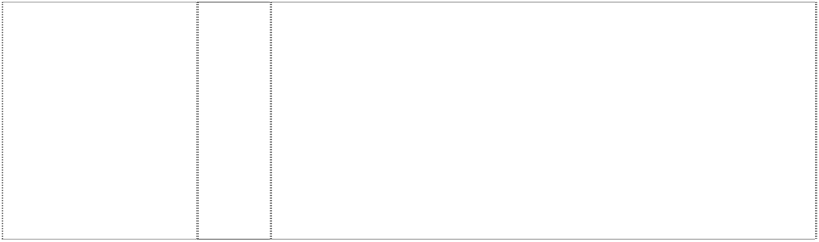

|  |  |  |
| --- | --- | --- |
| **CINCINNATI REDS C 27**  man, baseball player, cartoon baseball (429028) | 25 | Boys' and men's tank tops, sweatshirts, shorts and tops, cardigans, jogging suits, singlets, pyjamas, polo pyjamas, dressing gowns, tops and long pants sets, warm-up suits, hats, caps, visors in this class, scarves, jackets in this class, parkas, ponchos, belts in this class, baseball uniforms and warm-up jackets, baseball caps; ladies' pyjamas, nightgowns, nightshirts, shirts, sports clothes; children's pyjamas, shirts, bibs not made of paper, hooded wrap and bib sets made of towelling; babies' jackets; shoes; sneakers; jogging shoes;  rubber boots and canvas footwear. |
| **CLEVELAND INDIANS** (858380) | 9 | Electrical and scientific apparatus, including, telephones, radios, clock radios, pre-recorded videotapes relating to baseball, pre- recorded videodiscs relating to baseball, pre-recorded compact discs relating to baseball, pre-recorded audio discs relating to baseball, records relating to baseball, pre-recorded audio tapes relating to baseball, binoculars, video viewers, cameras, kaleidoscopes, coin- operated arcade games, computer programs, electric switch plate covers, electric signs, luminous signs, neon signs, sunglasses, eyeglass and contact lens cases, eyeglass chains, eyeglass frames, eyeglass cords, eyeglass lenses and eyeglasses, magnets, protective clothing, protective helmets, camera cases, camera straps, whistles, batting helmets, catchers helmets, computer accessories such as mouse pads, screen savers, wrist pads, monitor frames, and computer cases, compact disc cases, video and computer game cartridges, video and computer game discs, video  and computer game cassettes, computer game programs, and computer programs downloadable from a global computer network. |
| **CLEVELAND INDIANS** (555049) | 16 | Printed matter including books, magazines, calendars and other publications; albums; photographs, posters, stickers, decalcomanias, labels; paper and cardboard novelty items in this class including pennants; table covers/napkins/mats in this class; stationery including writing implements; cards in this class; teaching materials in the form of games; wrapping paper, paper tissues and all other  paper goods in this class. |
| **CLEVELAND INDIANS**  (555051) | 18 | Bags and cases in this class; umbrellas, parasols and covers  therefor; wallets, purses and key cases in this class; back packs and knapsacks; leather goods in this class. |
| **CLEVELAND INDIANS** (554873) | 21 | Household, kitchen or domestic goods in this class; containers and boxes in this class; ceramic, porcelain and earthenware goods in this class; glassware in this class; brushes in this class including toothbrushes; combs; coolers in this class; moulds in this class; goods in this class for eating and drinking purposes including mugs;  trinkets and decorative items in this class; statues and figurines in this class; stands and holders in this class. |
| **CLEVELAND INDIANS** (857856) | 25 | Clothing, including, caps, hats, visors, knitted headwear, headbands, bandannas, shirts, t-shirts, tank tops, sweaters, turtlenecks, pullovers, vests, shorts, pants, dresses, skirts, overalls, bodysuits, baseball uniforms, jerseys, warm-up suits, sweatshirts, sweatpants, underwear, boxer shorts, robes, sleepwear, swimwear, clothing wraps, coats, jackets, ponchos, raincoats, cloth bibs, infant wear, infant diaper covers, cloth diaper sets with undershirt and diaper cover, jumpers, rompers, onesies being all-in-one jumpsuits for babies, coveralls, creepers being romper suits, baby booties, ties, suspenders, belts, mittens, gloves, wristbands, earmuffs, scarves,  footwear, socks, hosiery, slippers, aprons, sliding girdles and costumes. |

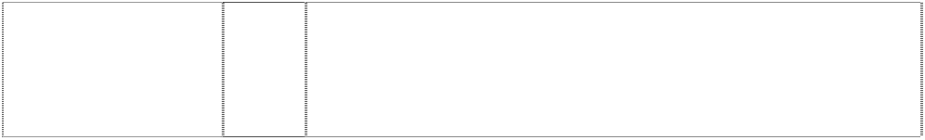

|  |  |  |
| --- | --- | --- |
| **CLEVELAND INDIANS** (857856) | 28 | Toys, games, playthings and sporting goods (not in other classes), including stuffed toys, plush toys, bean bag toys, puppets, balloons, marbles, checker sets, chess sets, board games, dart boards and dart board accessories, toy cars and trucks, toy mobiles, puzzles, yo- yo's, toy banks, toy figures, dolls and doll accessories, inflatable baseball bats, decorative wind socks being toys or playthings, toy tattoos, flying discs, mini bats, neck and wrist lanyards for mini bats, mini baseballs, hand held video and electronic games, coin-operated pinball machines, baseballs and holders for baseballs, autographed baseballs, basketballs, footballs, playground balls, rubber action balls, golf balls, golf club covers, golf club bags, golf putters, bowling balls, bowling bags, baseball bases, pitcher's plates, baseball bats, catcher's masks, grip tape for baseball bats, baseball batting tees, pine tar bags for baseball, rosin bags for baseball, baseball glove oil, batting gloves, baseball gloves, mitts, umpire's protective equipment, chest protectors for sports, athletic supporters, baseball pitching machines, fishing tackle, party favours in the nature of noise makers,  and Christmas tree ornaments. |
| **CLEVELAND INDIANS**  head of American- Indian, cartoon smiling (429019) | 25 | Boys' and men's tank tops, sweatshirts, shorts and tops, cardigans, jogging suits, singlets, pyjamas, polo pyjamas, dressing gowns, tops and long pants sets, warm-up suits, hats, caps, visors in this class, scarves, jackets in this class , parkas, ponchos, belts in this class, baseball uniforms and warm-up jackets, baseball caps; ladies' pyjamas, nightgowns, nightshirts, shirts, sports clothes; children's pyjamas, shirts, bibs not made of paper, hooded wrap and bib sets made of towelling; babies' jackets; shoes; sneakers; jogging shoes;  rubber boots and canvas footwear. |
| **COLORADO ROCKIES**  mountain with snow, baseball & arch stripes (559606) | 16 | Paper, cardboard and goods made from these materials, not included in other classes; printed matter; bookbinding material; photographs; stationery; adhesives for stationery or household purposes; artists' materials; paint brushes; typewriters and office requisites (except furniture); instructional and teaching material  (except apparatus); plastic materials for packaging (not included in other classes); playing cards; printers' type; printing blocks. |
| **COLORADO ROCKIES**  mountain with snow,  baseball & arch stripes (559605) | 18 | Leather and imitations of leather, and goods made of these materials and not included in other classes; animal skins, hides; trunks and travelling bags; umbrellas, parasols and walking sticks; whips, harness and saddlery. |
| **COLORADO ROCKIES**  mountain with snow, baseball & arch stripes (559604) | 21 | Household or kitchen utensils and containers (not of precious metal or coated therewith); combs and sponges; brushes (except paint brushes); brush-making materials; articles for cleaning purposes; steelwool; unworked or semi-worked glass (except glass used in building); glassware, porcelain and earthenware not included in other  classes. |
| **COLORADO ROCKIES**  mountain with snow,  baseball & arch stripes (559603) | 25 | Clothing, footwear, headgear. |
| **COLORADO ROCKIES**  mountain with snow, baseball & arch stripes (559602) | 28 | Games and playthings; gymnastic and sporting articles not included in other classes; decorations for Christmas trees. |
| **COOPERSTOWN COLLECTION AUTHENTIC**  baseballer with crowd behind in oval  (595250) | 25 | Clothing, footwear, headgear. |

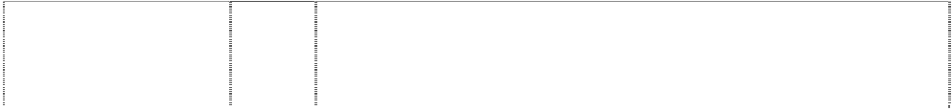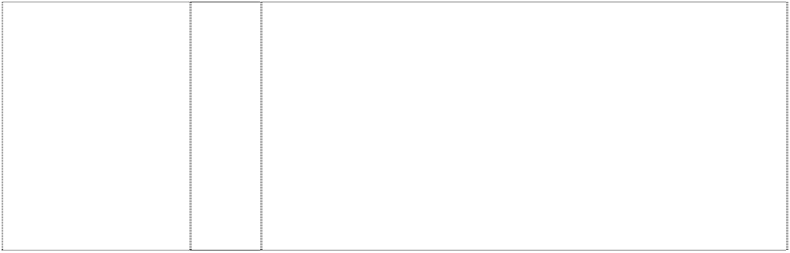

|  |  |  |
| --- | --- | --- |
| **CR**  (559613) | 16 | Paper, cardboard and goods made from these materials, not included in other classes; printed matter; bookbinding material; photographs; stationery; adhesives for stationery or household purposes; artists' materials; paint brushes; typewriters and office requisites (except furniture); instructional and teaching material (except apparatus); plastic materials for packaging (not included in  other classes); playing cards; printers; type; printing blocks. |
| **CR**  (559612) | 18 | Leather and imitations of leather, and goods made of these materials and not included in other classes; animal skins, hides; trunks and travelling bags; umbrellas, parasols and walking sticks; whips,  harness and saddlery. |
| **CR**  (559611) | 21 | Household or kitchen utensils and containers (not of precious metal or coated therewith); combs and sponges; brushes (except paint brushes); brush-making materials; articles for cleaning purposes; steelwool; unworked or semi-worked glass (except glass used in building); glassware, porcelain and earthenware not included in other  classes. |
| **CR**  (559610) | 25 | Clothing, footwear, headgear. |
| **CR**  (1027055) | 25 | Clothing, including caps, hats, visors, knitted headwear, headbands, bandannas, shirts, T-shirts, tank tops, blouses, sweaters, turtlenecks, pullovers, vests, shorts, pants, slacks, dresses, skirts, overalls, bodysuits, baseball uniforms, jerseys, warm-up suits, jogging suits, sweatshirts, sweatpants, underwear, boxer shorts, robes, sleepwear, thermal loungewear, nightshirts, nightgowns, swimwear, clothing wraps, coats, jackets, ponchos, raincoats, cloth bibs, infant wear, infant diaper covers, cloth diaper sets with undershirt and diaper cover, jumpers, rompers, coveralls, creepers being romper suits, baby booties, toddler anklets, ties, suspenders, belts, money belts, mittens, gloves, wristbands, earmuffs, scarves, footwear, socks,  hosiery, slippers, aprons, sliding girdles and Halloween and masquerade costumes. |
| **CR**  (559609) | 28 | Games and playthings; gymnastic and sporting articles not included in other classes; decorations for Christmas trees. |
| **CT**  ltr T breaks ellipse,extended, incomplete is ltr C (1027071) | 25 | Clothing, including caps, hats, visors, knitted headwear, headbands, bandannas, shirts, T-shirts, tank tops, blouses, sweaters, turtlenecks, pullovers, vests, shorts, pants, slacks, dresses, skirts, overalls, bodysuits, baseball uniforms, jerseys, warm-up suits, jogging suits, sweatshirts, sweatpants, underwear, boxer shorts, robes, sleepwear, thermal loungewear, nightshirts, nightgowns, swimwear, clothing wraps, coats, jackets, ponchos, raincoats, cloth bibs, infant wear, infant diaper covers, cloth diaper sets with undershirt and diaper cover, jumpers, rompers, coveralls, creepers being romper suits, baby booties, toddler anklets, ties, suspenders, belts, money belts, mittens, gloves, wristbands, earmuffs, scarves, footwear, socks, hosiery, slippers, aprons, sliding girdles and Halloween and  masquerade costumes. |
| **CUBS**  ltr C forms circle,incompl. in circle,concentric (1027051) | 25 | Clothing, including caps, hats, visors, knitted headwear, headbands, bandannas, shirts, T-shirts, tank tops, blouses, sweaters, turtlenecks, pullovers, vests, shorts, pants, slacks, dresses, skirts, overalls, bodysuits, baseball uniforms, jerseys, warm-up suits, jogging suits, sweatshirts, sweatpants, underwear, boxer shorts, robes, sleepwear, thermal loungewear, nightshirts, nightgowns, swimwear, clothing wraps, coats, jackets, ponchos, raincoats, cloth bibs, infant wear, infant diaper covers, cloth diaper sets with undershirt and diaper cover, jumpers, rompers, coveralls, creepers being romper suits, baby booties, toddler anklets, ties, suspenders, belts, money belts, mittens, gloves, wristbands, earmuffs, scarves, footwear, socks, hosiery, slippers, aprons, sliding girdles and Halloween and  masquerade costumes. |



|  |  |  |
| --- | --- | --- |
| **CUBS C**  word in circle stripe curved arc (858375) | 9 | Electrical and scientific apparatus, including, telephones, radios, clock radios, pre-recorded videotapes relating to baseball, pre- recorded videodiscs relating to baseball, pre-recorded compact discs relating to baseball, pre-recorded audio discs relating to baseball, records relating to baseball, pre-recorded audio tapes relating to baseball, binoculars, video viewers, cameras, kaleidoscopes, coin- operated arcade games, computer programs, electric switch plate covers, electric signs, luminous signs, neon signs, sunglasses, eyeglass and contact lens cases, eyeglass chains, eyeglass frames, eyeglass cords, eyeglass lenses and eyeglasses, magnets, protective clothing, protective helmets, camera cases, camera straps, whistles, batting helmets, catchers helmets, computer accessories such as mouse pads, screen savers, wrist pads, monitor frames, computer cases, compact disc cases, video and computer game cartridges, video and computer game discs, video and computer game cassettes, computer game programs, and computer  programs downloadable from a global computer network. |
| **CUBS C**  word in circle stripe curved arc (554909) | 16 | Printed matter including books, magazines, calendars and other publications; albums; photograghs, posters, stickers, decalcomanias, labels not of cloth; paper and cardboard novelty items in this class including pennants; table covers/napkins/mats in this class; stationery including writing implements; cards in this class; teaching materials in the form of games; wrapping paper, paper tissues and all  other paper goods in this class. |
| **CUBS C**  word in circle stripe curved arc  (554910) | 18 | Bags and cases in this class; umbrellas, parasols and covers therefor; wallets, purses and key cases in this class; back packs and knapsacks; leather goods in this class. |
| **CUBS C**  target circles, concentric (429027) | 25 | Boys'and men's tank tops, sweatshirts, shorts and tops, cardigans, jogging suits, singlets, pyjamas, polo pyjamas, dressing gowns, tops and long pants sets, warm-up suits, hats, caps, visors in this class, scarves, jackets in this class, parkas, ponchos, belts in this class, baseball uniforms and warm-up jackets, baseball caps; ladies' pyjamas, nightgowns, nightshirts, shirts, sports clothes; children's pyjamas, shirts, bibs not made of paper, hooded wrap and bib sets made of towelling; babies' jackets; shoes; sneakers; jogging shoes;  rubber boots and canvas footwear; all of the foregoing pertaining to or promoting baseball. |
| **CUBS C**  word in circle stripe curved arc (554911) | 28 | Games and playthings including toys; sporting goods in this class. |
| **D**  (554891) | 25 | Caps, t-shirts. |
| **D**  (1027057) | 25 | Clothing, including caps, hats, visors, knitted headwear, headbands, bandannas, shirts, T-shirts, tank tops, blouses, sweaters, turtlenecks, pullovers, vests, shorts, pants, slacks, dresses, skirts, overalls, bodysuits, baseball uniforms, jerseys, warm-up suits, jogging suits, sweatshirts, sweatpants, underwear, boxer shorts, robes, sleepwear, thermal loungewear, nightshirts, nightgowns, swimwear, clothing wraps, coats, jackets, ponchos, raincoats, cloth bibs, infant wear, infant diaper covers, cloth diaper sets with undershirt and diaper cover, jumpers, rompers, coveralls, creepers being romper suits, baby booties, toddler anklets, ties, suspenders, belts, money belts, mittens, gloves, wristbands, earmuffs, scarves, footwear, socks,  hosiery, slippers, aprons, sliding girdles and Halloween and masquerade costumes. |



|  |  |  |
| --- | --- | --- |
| **D**  tiger crawls through ornate ltr D (628858) | 16 | Paper goods and printed matter, namely, trading cards, bumper stickers, posters, stickers, decalcomania, book marks, scorebooks, scorecards, printed paper signs, writing pads, note paper, notebooks, colouring books, preprinted agenda organisers, magazines featuring baseball game programs, books and booklets featuring baseball, autograph books, book covers, calendars, wall calendars, desk calendars, playing cards, paper pennants, gift wrapping paper, paper gift wrap bows, paper gift and party bags, paper party decorations, paper coasters, paper flags, paper napkins, paper tablecloths, paper placemats, greeting cards, postcards, unmounted photographs, lithographs, doorsigns; photograph albums; scrapbooks; plastic baseball card holders and cases; baseball card albums; binders; portfolios; stationery folders; magnetic metal bulletin boards, bank cheques; chequebook covers; credit cards; paperweights; letter openers; paper clips; pens; pencils, markers; desk stands and holders for pens, pencils, and ink; non-electric erasers; pencil sharpeners; drafting and drawing rulers; aquariums; preprinted baseball contracts; collectable stamps; facial tissue; and pencil top  ornaments and all other goods in this class. |
| **D**  tiger crawls through ornate ltr D (628859) | 25 | Clothing, namely, shirts, caps, shorts, dresses, skirts, T-shirts, jogging suits, warm-up suits, socks, underwear, jackets, sweaters, vests, pants, ponchos, visors, bodysuits, raincoats, hats, overalls, cloth bibs, infant diaper covers, cloth diaper sets with undershirt and diaper cover, jumpers, rompers, uniforms, uniform jerseys, wind resistant jackets, baby bootees, short sets, leotards, unitards, ties, bowties, neckties, suspenders, men's and women's formalwear, pyjamas, nightshirts, nightgowns, sweatpants, sweatshirts, mittens, gloves, knitted headwear, earmuffs, scarves, footwear, thongs, hosiery, socks, wristbands, headbands, robes, shoes, slippers, chef's  hats, aprons, clothing wrap, sliding girdles, leg warmers, swimwear, berets, bandannas, and all other goods in this class. |
| **D**  tiger crawls through ornate ltr D (628860) | 28 | Toys and sporting goods, including baseballs, stuffed toy animals, arm guards for athletic use, basketball backboards, bowling bags, bowling balls, puppets, bendable toy figurines, toy bakeware and cookware, balloons, basketballs, footballs, playground balls, rubber action balls, tennis balls, toy banks, umpire's equipment in this class including protective masks, protective vests and shin guards, baseball bases, pitcher's plates, baseball bats, catcher's masks, grip tape for baseball bats, baseball batting tees, pine tar bags for baseball, rosin bags for baseball, batting gloves, baseball gloves, mitts, cushions filled with polystyrene pellets, billiard game playing equipment, kites, marbles, checker sets, chess sets, dart boards and dart board accessories, toy trucks, toy mobiles, puzzles, toy banks, snow globes, yo-yo's, golf club covers, golf club bags, golf balls, golf putters, video game cartridges, chest protectors for sports, Christmas tree ornaments, toy figures, toy construction blocks, dolls and doll accessories, athletic supporters, dice, hand held video and electronic games, manually operated exercise equipment, baseball pitching machines, fishing tackle, fishing rods, board games, party favours in the nature of noise makers, skateboards, playground slides, surfboards, snow sleds for recreational use, exercise trampolines, flying discs, autographed baseballs, inflatable baseball bats, wind socks (not being for decoration and being in the nature of a toy or  plaything), and toy tattoos. |
| **DETROIT TIGERS**  animal, tiger, head annulus  (429013) | 25 | Boys' and men's tank tops, sweatshirts, shorts and tops, cardigans, jogging suits, singlets, pyjamas, polo pyjamas, dressing gowns, tops and long pants sets, warm-up suits, hats, caps, visors in this class, scarves, jackets in this class, parkas, ponchos, belts in this class, baseball uniforms and warm-up jackets, baseball caps; ladies' pyjamas, nightgowns, nightshirts, shirts, sports clothes; children's pyjamas, shirts, bibs not made of paper, hooded wrap and bib sets made of towelling; babies' jackets; shoes; sneakers; jogging shoes;  rubber boots and canvas footwear. |



|  |  |  |
| --- | --- | --- |
| **DIAMOND COLLECTION AUTHENTIC**  baseballer in rect. in annulus in diamond in striped diamond  (595252) | 25 | Clothing, footwear, headgear. |
| **DIAMOND COLLECTION AUTHENTIC**  baseballer in rect. in annulus in diamond in  striped diamond (595253) | 28 | Games and playthings; gymnastic and sporting articles not included in other classes; decorations for Christmas trees all the foregoing pertaining to or otherwise associated with the game of baseball or baseball activity. |
| **DODGERS**  (857819) | 16 | Paper and cardboard goods (not included in other classes) and printed matter, including trading cards, playing cards, posters, stickers, decalcomanias, bumper stickers, score books, scorecards, game programs, magazines and books featuring baseball, writing pads, note paper, notebooks, binders; stationery-type portfolios, stationery folders, stationery sets, paper activity sets, preprinted agenda organizers, scrapbooks, autograph books, baseball card albums, book covers, calendars, greeting cards, postcards, bank cheques, chequebook covers, credit cards being card-formed printed matter, collectible stamps, gift wrapping paper, paper gift and party bags, paper party decorations, paper coasters, paper flags, paper napkins, paper tablecloths, mounted and unmounted photographs, photograph albums, lithographs, printed paper signs, printed paper door signs, plastic baseball card holders and collectors cases, business card holders, paperweights, letter openers, pens, pencils, pencil top ornaments, markers, desk stands and holder for pens,  pencils and ink, non-electric erasers, pencil sharpeners, ungraduated rulers, ticket holders and lanyards for ticket holders. |
| **DODGERS**  (857819) | 25 | Clothing, including, caps, hats, visors, knitted headwear, headbands, bandannas, shirts, T-shirts, tank tops, sweaters, turtlenecks, pullovers, vests, shorts, pants, dresses, skirts, overalls, bodysuits, baseball uniforms, jerseys, warm-up suits, sweatshirts, sweatpants, underwear, boxer shorts, robes, sleepwear, swimwear, clothing wraps, coats, jackets, ponchos, raincoats, cloth bibs, infant wear, infant diaper covers, cloth diaper sets with undershirt and diaper cover, jumpers, rompers, onesies, being all-in-one jumpsuits for babies, coveralls, creepers being romper suits, baby booties, ties, suspenders, belts, mittens, gloves, wristbands, earmuffs, scarves, footwear, socks, hosiery, slippers, aprons, sliding girdles and  costumes. |
| **DODGERS**  (857819) | 28 | Toys, games, playthings and sporting goods (not in other classes), including stuffed toys, plush toys, bean bag toys, puppets, balloons, marbles, checker sets, chess sets, board games, dart boards and dart board accessories, toy cars and trucks, toy mobiles, puzzles, yo- yo's, toy banks, toy figures, dolls and doll accessories, inflatable baseball bats being in the nature of toys or playthings, decorative wind socks being toys or playthings, toy tattoos, flying discs, mini bats, neck and wrist lanyards for mini bats, mini baseballs, hand held video and electronic games, coin-operated pinball machines, baseballs and holders for baseballs, autographed baseballs, basketballs, footballs, playground balls, rubber action balls, golf balls, golf club covers, golf club bags, golf putters, bowling balls, bowling bags, baseball bases, pitcher's plates, baseball bats, catcher's masks, grip tape for baseball bats, baseball batting tees, pine tar bags for baseball, rosin bags for baseball, baseball glove oil, batting gloves, baseball gloves, mitts, umpire's protective equipment, chest protectors for sports, athletic supporters, baseball pitching machines,  fishing tackle, party favours in the nature of noise makers, and Christmas tree ornaments. |

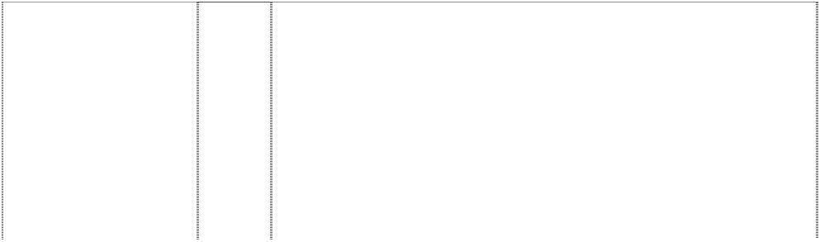

|  |  |  |
| --- | --- | --- |
| **DODGERS**  ball,baseball forms comet  (858358) | 9 | Electrical and scientific apparatus, including, telephones, radios, clock radios, pre-recorded videotapes relating to baseball, pre- recorded videodiscs relating to baseball, pre-recorded compact discs relating to baseball, pre-recorded audio discs relating to baseball, records relating to baseball, pre-recorded audio tapes relating to baseball, binoculars, video viewers, cameras, kaleidoscopes, coin- operated arcade games, computer programs, electric switch plate covers, electric signs, luminous signs, neon signs, sunglasses, eyeglass and contact lens cases, eyeglass chains, eyeglass frames, eyeglass cords, eyeglass lenses and eyeglasses, magnets, protective clothing, protective helmets, camera cases, camera straps, whistles, batting helmets, catchers helmets, computer accessories such as mouse pads, screen savers, wrist pads, monitor frames, computer cases, compact disc cases, video and computer game cartridges, video and computer game discs, video and computer game cassettes, computer game programs, and computer  programs downloadable from a global computer network. |
| **DODGERS**  ball,baseball forms comet  (857832) | 16 | Paper and cardboard goods (not included in other classes) and printed matter, including trading cards, playing cards, posters, stickers, decalcomanias, bumper stickers, score books, scorecards, game programs, magazines and books featuring baseball, writing pads, note paper, notebooks, binders; stationery-type portfolios, stationery folders, stationery sets, paper activity sets, preprinted agenda organizers, scrapbooks, autograph books, baseball card albums, book covers, calendars, greeting cards, postcards, bank cheques, chequebook covers, credit cards being card-formed printed matter, collectible stamps, gift wrapping paper, paper gift and party bags, paper party decorations, paper coasters, paper flags, paper napkins, paper tablecloths, mounted and unmounted photographs, photograph albums, lithographs, printed paper signs, printed paper door signs, plastic baseball card holders and collectors cases, business card holders, paperweights, letter openers, pens, pencils, pencil top ornaments, markers, desk stands and holder for pens, pencils and ink, non-electric erasers, pencil sharpeners, ungraduated  rulers, ticket holders and lanyards for ticket holders. |
| **DODGERS**  ball,baseball forms comet  (857832) | 25 | Clothing, including, caps, hats, visors, knitted headwear, headbands, bandannas, shirts, T-shirts, tank tops, sweaters, turtlenecks, pullovers, vests, shorts, pants, dresses, skirts, overalls, bodysuits, baseball uniforms, jerseys, warm-up suits, sweatshirts, sweatpants, underwear, boxer shorts, robes, sleepwear, swimwear, clothing wraps, coats, jackets, ponchos, raincoats, cloth bibs, infant wear, infant diaper covers, cloth diaper sets with undershirt and diaper cover, jumpers, rompers, onesies being all-in-one jumpsuits for babies, coveralls, creepers being romper suits, baby booties, ties, suspenders, belts, mittens, gloves, wristbands, earmuffs, scarves,  footwear, socks, hosiery, slippers, aprons, sliding girdles and costumes. |
| **DODGERS**  ball,baseball forms comet  (857832) | 28 | Toys, games, playthings and sporting goods (not in other classes), including stuffed toys, plush toys, bean bag toys, puppets, balloons, marbles, checker sets, chess sets, board games, dart boards and dart board accessories, toy cars and trucks, toy mobiles, puzzles, yo- yos, toy banks, toy figures, dolls and doll accessories, inflatable baseball bats being in the nature of toys or playthings, decorative wind socks being toys or playthings, toy tattoos, flying discs, mini bats, neck and wrist lanyards for mini bats, mini baseballs, hand held video and electronic games, coin-operated pinball machines, baseballs and holders for baseballs, autographed baseballs, basketballs, footballs, playground balls, rubber action balls, golf balls, golf club covers, golf club bags, golf putters, bowling balls, bowling bags, baseball bases, pitcher's plates, baseball bats, catcher's masks, grip tape for baseball bats, baseball batting tees, pine tar bags for baseball, rosin bags for baseball, baseball glove oil, batting gloves, baseball gloves, mitts, umpire's protective equipment, chest protectors for sports, athletic supporters, baseball pitching machines, fishing tackle, party favours in the nature of noise makers, and  Christmas tree ornaments. |

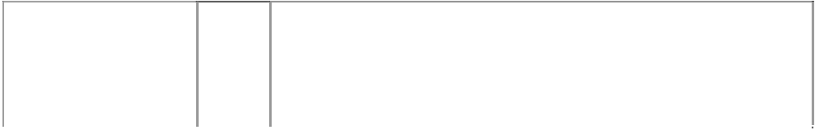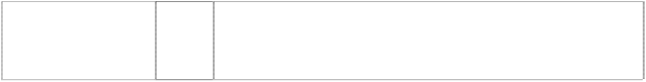

|  |  |  |
| --- | --- | --- |
| **DODGERS**  baseball & lines oblique (555040) | 6 | Key rings and key chains; money clips and other clips in this class; badges and plates in this class; metallic gift wrap in this class, foils of metal for wrapping and packaging; boxes and containers including money boxes; bells; hardware, fittings and other goods for domestic use in this class; pewter goods; trinkets in this class; signs; statues and works of art in this class; bottle closures and caps; weather vanes; towel dispensers; all of the aforesaid being qualified as goods  included in class 6. |
| **DODGERS LOS ANGELES DODGERS**  ball, baseball comet (412681) | 16 | Cardboard playing cards, photo trading cards, stamps, decals, stickers, booklets, albums, bumper stickers, posters, paper  pennants, labels, magazines, comic books, books, pens, pencils and ball point pens. |
| **DODGERS LOS ANGELES DODGERS**  ball, baseball comet (412689) | 25 | Boys' and men's tank tops, sweatshirts, shorts and tops, cardigans, jogging suits, singlets, pyjamas, polo pyjamas, dressing gowns, tops and long pants sets, warm-up suits, hats, caps, visors in this class, scarves, jackets in this class, parkas, ponchos, belts in this class, baseball uniforms and warm-up jackets, baseball caps; ladies' pyjamas, nightgowns, nightshirts, shirts, sports clothes; children's pyjamas, shirts, bibs not made of paper, hooded wrap and bib sets  made of towelling; babies' jackets; shoes; sneakers; jogging shoes; rubber boots and canvas footwear. |
| **DODGERS LOS ANGELES DODGERS**  ball, baseball comet (412686) | 28 | Baseballs; baseball bats; toy baseball helmets; baseball mitts; gloves and masks; bendable and nonbendable PVC figures; toy plastic baseballs and bats; foam baseball bats; plastic baseballs; foam baseballs; plastic baseball catchers' masks; plastic baseball gloves;  foam baseball gloves and all other goods in Class 28 closely associated with the game of baseball. |
| **EXPOS M**  (429030) | 25 | Boys' and men's tank tops, sweatshirts, shorts and tops, cardigans, jogging suits, singlets, pyjamas, polo pyjamas, dressing gowns, tops and long pants sets, warm-up suits, hats, caps, visors in this class, scarves, jackets in this class, parkas, ponchos, belts in this class, baseball uniforms and warm-up jackets, baseball caps; ladies' pyjamas, nightgowns, nightshirts, shirts, sports clothes; children's pyjamas, shirts, bibs not made of paper, hooded wrap and bib sets made of towelling; babies' jackets; shoes; sneakers; jogging shoes;  rubber boots and canvas footwear. |
| **F**  fish, marlin curled around ltr F (595256) | 16 | Paper, cardboard and goods made from these materials, not included in other classes; printed matter; bookbinding material; photographs; stationery; adhesives for stationery or household purposes; artist' materials; paint brushes; typewriters and office requisites (except furniture); instructional and teaching material (except apparatus); plastic materials for packaging (not included in  other classes); playing cards; printers' type; printing blocks. |
| **F**  fish, marlin curled around ltr F (595257) | 25 | Clothing, footwear, headgear. |
| **FLORIDA MARLINS**  marlin & baseball in annulus  (560151) | 16 | Paper, cardboard and goods made from these materials, not included in other classes; printed matter; bookbinding material; photographs; stationery; adhesives for stationery or household purposes; artists' materials; paint brushes; typewriters and office requisites (except furniture); instructional and teaching material (except apparatus); plastic materials for packaging (not included in other classes); playing cards; printers' type; printing blocks; but excluding paper knives, drawing squares, hand labelling devices,  paper cutters and punchers. |
| **FLORIDA MARLINS**  marlin & baseball in annulus  (560150) | 18 | Leather and imitations of leather, and goods made of these materials and not included in other classes; animal skins, hides; trunks and travelling bags; umbrellas, parasols and walking sticks; whips,  harness and saddlery. |
| **FLORIDA MARLINS**  marlin & baseball in annulus  (560149) | 25 | T-shirts, sweatshirts, tracksuits, baseball jackets and uniforms, sportswear, nightwear, dressing gowns, boxer shorts and non- insulated briefs, socks, infant and baby wear, hats and caps, ties and footwear; none of the foregoing being rainwear or wet weather gear  or in the nature of thermally insulated undergarments. |

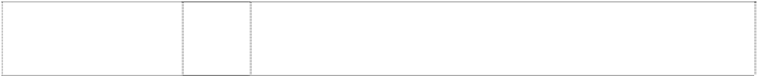

|  |  |  |
| --- | --- | --- |
| **FLORIDA MARLINS**  marlin & baseball in annulus  (1027059) | 25 | Clothing, including caps, hats, visors, knitted headwear, headbands, bandannas, shirts, T-shirts, tank tops, blouses, sweaters, turtlenecks, pullovers, vests, shorts, pants, slacks, dresses, skirts, overalls, bodysuits, baseball uniforms, jerseys, warm-up suits, jogging suits, sweatshirts, sweatpants, underwear, boxer shorts, robes, sleepwear, thermal loungewear, nightshirts, nightgowns, swimwear, clothing wraps, coats, jackets, ponchos, raincoats, cloth bibs, infant wear, infant diaper covers, cloth diaper sets with undershirt and diaper cover, jumpers, rompers, coveralls, creepers being romper suits, baby booties, toddler anklets, ties, suspenders, belts, money belts, mittens, gloves, wristbands, earmuffs, scarves, footwear, socks, hosiery, slippers, aprons, sliding girdles and Halloween and  masquerade costumes. |
| **FLORIDA MARLINS**  marlin & baseball in annulus  (560148) | 28 | Games and playthings; gymnastic and sporting articles not included in other classes but not including swimming caps; decorations for Christmas trees. |
| **GIANTS**  baseball with arc formed by word (554860) | 6 | Key rings and key chains; money clips and other clips in this class; badges and plates in this class; metallic gift wrap, foils for wrapping and packaging; boxes and containers including money boxes; bells; hardware, fittings and other goods for domestic use in this class; pewter goods; trinkets in this class; signs; statues and works of art in this class; bottle closures and caps; weather vanes; towel dispensers; all of the aforesaid goods being qualified as goods  included in class 6. |
| **GIANTS**  ball, baseball (429036) | 25 | Boy's and men’s' tank tops, sweatshirts, shorts and tops, cardigans, jogging suits, singlets, pyjamas, polo pyjamas, dressing gowns, tops and long pants sets, warm-up suits, hats, caps, visors in this class, scarves, jackets in this class, parkas, ponchos, belts in this class, baseball uniforms and warm-up jackets, baseball caps; ladies' pyjamas, nightgowns, nightshirts, shirts, sports clothes; children's pyjamas, shirts, bibs, hooded wrap and bib sets made of towelling; babies' jackets; shoes; sneakers; jogging shoes; rubber boots and  canvas footwear; all of the foregoing pertaining to or promoting baseball. |
| **GIANTS**  ball,baseball,styl. (1027085) | 25 | Clothing, including caps, hats, visors, knitted headwear, headbands, bandannas, shirts, T-shirts, tank tops, blouses, sweaters, turtlenecks, pullovers, vests, shorts, pants, slacks, dresses, skirts, overalls, bodysuits, baseball uniforms, jerseys, warm-up suits, jogging suits, sweatshirts, sweatpants, underwear, boxer shorts, robes, sleepwear, thermal loungewear, nightshirts, nightgowns, swimwear, clothing wraps, coats, jackets, ponchos, raincoats, cloth bibs, infant wear, infant diaper covers, cloth diaper sets with undershirt and diaper cover, jumpers, rompers, coveralls, creepers being romper suits, baby booties, toddler anklets, ties, suspenders, belts, money belts, mittens, gloves, wristbands, earmuffs, scarves, footwear, socks, hosiery, slippers, aprons, sliding girdles and Halloween and  masquerade costumes. |
| **GIANTS**  word forms arc across baseball  (555016) | 16 | Printed matter including books, magazines, calendars and other publications; albums; photographs, posters, stickers, decalcomanias, labels; paper and cardboard novelty items in this class including pennants; table covers/napkins/mats in this class; stationery including writing implements; cards in this class; teaching materials in the form of games; wrapping paper, paper tissues and all other paper goods in this class; all pertaining to or promoting baseball or  having a baseball related theme. |
| **GIANTS**  word forms arc across baseball  (555017) | 18 | Bags and cases in this class; umbrellas, parasols and covers therefor; wallets, purses and key cases in this class; back packs and knapsacks; leather goods in this class. |

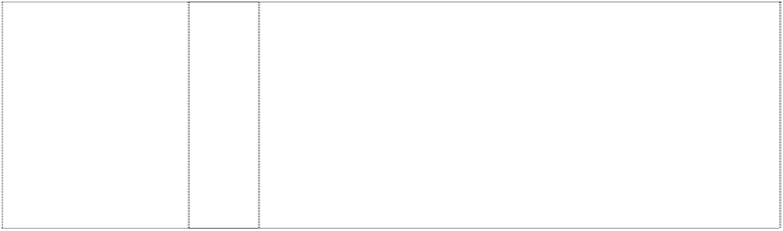

|  |  |  |
| --- | --- | --- |
| **GIANTS**  word forms arc across baseball  (555021) | 21 | Household, kitchen or domestic goods in this class; containers and boxes in this class; ceramic, porcelain and earthenware goods in this class; glassware in this class; brushes in this class including toothbrushes; combs; coolers in this class; moulds in this class; goods in this class for eating and drinking purposes including mugs; trinkets and decorative items in this class; statues and figurines in  this class; stands and holders in this class. |
| **GIANTS**  word forms arc across baseball  (555018) | 28 | Games and playthings including toys; sporting goods in this class; all pertaining to or promoting baseball or having a baseball related theme. |
| **GIANTS SAN FRANCISCO GIANTS**  baseball (518568) | 25 | Boy's and men's tank tops, sweat shirts, shirts, sweaters, vests, shorts and tops, cardigans, jogging suits, singlets, pyjamas, polo pyjamas, dressing gowns, tops and long pants sets, warm-up suits, headbands, wristbands, hats, caps, visors in this class, scarves, gloves, mittens, jackets in this class, parkas, raincoats, snowsuits, coats, ponchos, belts in this class, baseball uniforms and warm-up jackets, baseball caps; ladies pyjamas, nightgowns, nightshirts, shirts, skirts, dresses, socks, underwear, aprons, sports clothes; children's pyjamas, infantwear, shirts, diapers, bibs not made of paper, hooded wrap and bib sets made of towelling; babies' jackets; shoes; bath thongs; sneakers; athletic shoes; jogging shoes; rubber  boots and canvas footwear. |
| **HOUSTON ASTROS**  incomplete star in and breaking domed rectangle  (628864) | 16 | Paper goods and printed matter, namely, trading cards, bumper stickers, posters, stickers, decalcomania, book marks, scorebooks, scorecards, printed paper signs, writing pads, note paper, notebooks, colouring books, preprinted agenda organisers, magazines featuring baseball game programs, books and booklets featuring baseball, autograph books, book covers, calendars, wall calendars, desk calendars, playing cards, paper pennants, gift wrapping paper, paper gift wrap bows, paper gift and party bags, paper party decorations, paper coasters, paper flags, paper napkins, paper tablecloths, paper placemats, greeting cards, postcards, unmounted photographs, lithographs, doorsigns; photograph albums; scrapbooks; plastic baseball card holders and cases; baseball card albums; binders; portfolios; stationery folders; magnetic metal bulletin boards, bank cheques; chequebook covers; credit cards; paperweights; letter openers; paper clips; pens; pencils, markers; desk stands and holders for pens, pencils, and ink; non-electric erasers; pencil sharpeners; drafting and drawing rulers; aquariums; preprinted baseball contracts; collectable stamps; facial tissue; and pencil top  ornaments and all other goods in this class. |
| **HOUSTON ASTROS**  incomplete star in and breaking domed rectangle  (628865) | 25 | Clothing, namely, shirts, caps, shorts, dresses, skirts, T-shirts, jogging suits, warm-up suits, socks, underwear, jackets, sweaters, vests, pants, ponchos, visors, bodysuits, raincoats, hats, overalls, cloth bibs, infant diaper covers, cloth diaper sets with undershirt and diaper cover, jumpers, rompers, uniforms, uniform jerseys, wind resistant jackets, baby bootees, short sets, leotards, unitards, ties, bowties, neckties, suspenders, men's and women's formalwear, pyjamas, nightshirts, nightgowns, sweatpants, sweatshirts, mittens, gloves, knitted headwear, earmuffs, scarves, footwear, thongs, hosiery, socks, wristbands, headbands, robes, shoes, slippers, chef's  hats, aprons, clothing wrap, sliding girdles, leg warmers, swimwear, berets, bandannas, and all other goods in this class. |

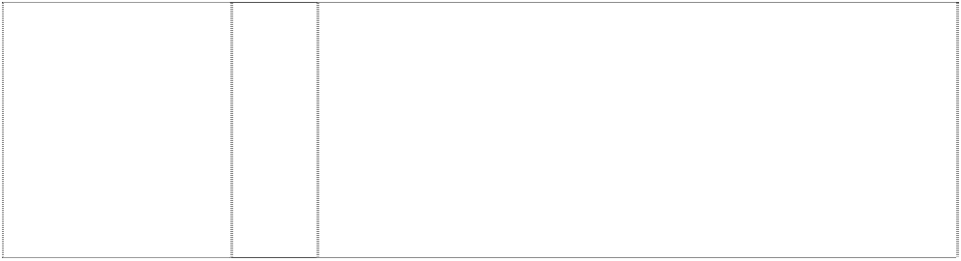

|  |  |  |
| --- | --- | --- |
| **HOUSTON ASTROS**  incomplete star in and breaking domed rectangle  (628866) | 28 | Toys and sporting goods, including baseballs, stuffed toy animals, arm guards for athletic use, basketball backboards, bowling bags, bowling balls, puppets, bendable toy figurines, toy bakeware and cookware, balloons, basketballs, footballs, playground balls, rubber action balls, tennis balls, toy banks, umpire's equipment, umpire's equipment in this class including protective masks, protective vests and shin guards, baseball bases, pitcher's plates, baseball bats, catcher's masks, grip tape for baseball bats, baseball batting tees, pine tar bags for baseball, rosin bags for baseball, batting gloves, baseball gloves, mitts, cushions filled with polystyrene pellets, billiard game playing equipment, kites, marbles, checker sets, chess sets, dart boards and dart board accessories, toy trucks, toy mobiles, puzzles, toy banks, snow globes, yo-yo's, golf club covers, golf club bags, golf balls, golf putters, video game cartridges, chest protectors for sports, Christmas tree ornaments, toy figures, toy construction blocks, dolls and doll accessories, athletic supporters, dice, hand held video and electronic games, manually operated exercise equipment, baseball pitching machines, fishing tackle, fishing rods, board games, party favours in the nature of noise makers, skateboards, playground slides, surfboards, snow sleds for recreational use, exercise trampolines, flying discs, autographed baseballs, inflatable baseball bats, wind socks (not being for decoration and being in the nature of a toy or plaything), and toy  tattoos. |
| **INDIANS**  (857843) | 16 | Paper and cardboard goods (not included in other classes) and printed matter, including trading cards, playing cards, posters, stickers, decalcomanias, temporary tattoos, bumper stickers, score books, scorecards, game programs, magazines and books featuring baseball, writing pads, note paper, notebooks, binders, stationery- type portfolios, stationery folders, stationery sets, paper activity sets, preprinted agenda organizers, scrapbooks, autograph books, baseball card albums, book covers, calendars, greeting cards, postcards, bank cheques, chequebook covers, credit cards, collectible stamps, gift wrapping paper, paper gift and party bags, paper party decorations, paper coasters, paper flags, paper napkins, paper tablecloths, mounted and unmounted photographs, photograph albums, lithographs, printed paper signs, printed paper door signs, plastic baseball card holders and collectors cases, business card holders, paperweights, letter openers, pens, pencils, pencil top ornaments, markers, desk stands and holder for pens, pencils and ink, non-electric erasers, pencil sharpeners, ungraduated  rulers, ticket holders and lanyards for ticket holders. |
| **INDIANS**  (857843) | 25 | Clothing, including, caps, hats, visors, knitted headwear, headbands, bandannas, shirts, t-shirts, tank tops, sweaters, turtlenecks, pullovers, vests, shorts, pants, dresses, skirts, overalls, bodysuits, baseball uniforms, jerseys, warm-up suits, sweatshirts, sweatpants, underwear, boxer shorts, robes, sleepwear, swimwear, clothing wraps, coats, jackets, ponchos, raincoats, cloth bibs, infant wear, infant diaper covers, cloth diaper sets with undershirt and diaper cover, jumpers, rompers, onesies, coveralls, creepers, baby booties, ties, suspenders, belts, mittens, gloves, wristbands, earmuffs,  scarves, footwear, socks, hosiery, slippers, aprons, sliding girdles and costumes. |

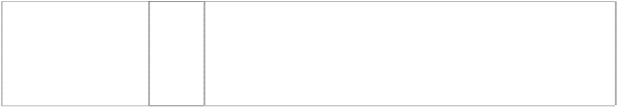

|  |  |  |
| --- | --- | --- |
| **INDIANS**  (857843) | 28 | Toys, games, playthings and sporting goods (not in other classes), including stuffed toys, plush toys, bean bag toys, puppets, balloons, marbles, checker sets, chess sets, board games, dart boards and dart board accessories, toy cars and trucks, toy mobiles, puzzles, yo- yo's, toy banks, toy figures, dolls and doll accessories, inflatable baseball bats, decorative wind socks being toys or playthings, toy tattoos, flying discs, mini bats, neck and wrist lanyards for mini bats, mini baseballs, toy figures and sports whistles, video game cartridges, hand held video and electronic games, coin-operated pinball machines, baseballs and holders for baseballs, autographed baseballs, basketballs, footballs, playground balls, rubber action balls, golf balls, golf club covers, golf club bags, golf putters, bowling balls, bowling bags, baseball bases, pitcher's plates, baseball bats, catcher's masks, grip tape for baseball bats, baseball batting tees, pine tar bags for baseball, rosin bags for baseball, baseball glove oil, batting gloves, baseball gloves, mitts, umpire's protective equipment, chest protectors for sports, athletic supporters, baseball pitching machines, fishing tackle, party favours in the nature of noise makers,  and Christmas tree ornaments. |
| **J**  bird,blue jay,head beside ltr J (1027092) | 25 | Clothing, including caps, hats, visors, knitted headwear, headbands, bandannas, shirts, T-shirts, tank tops, blouses, sweaters, turtlenecks, pullovers, vests, shorts, pants, slacks, dresses, skirts, overalls, bodysuits, baseball uniforms, jerseys, warm-up suits, jogging suits, sweatshirts, sweatpants, underwear, boxer shorts, robes, sleepwear, thermal loungewear, nightshirts, nightgowns, swimwear, clothing wraps, coats, jackets, ponchos, raincoats, cloth bibs, infant wear, infant diaper covers, cloth diaper sets with undershirt and diaper cover, jumpers, rompers, coveralls, creepers being romper suits, baby booties, toddler anklets, ties, suspenders, belts, money belts, mittens, gloves, wristbands, earmuffs, scarves, footwear, socks, hosiery, slippers, aprons, sliding girdles and Halloween and masquerade costumes; all the foregoing being goods that relate to  sport and/or the promotion of sport. |
| **JAYS**  bird,blue jay,head beside ltr J (1027093) | 25 | Clothing, including caps, hats, visors, knitted headwear, headbands, bandannas, shirts, T-shirts, tank tops, blouses, sweaters, turtlenecks, pullovers, vests, shorts, pants, slacks, dresses, skirts, overalls, bodysuits, baseball uniforms, jerseys, warm-up suits, jogging suits, sweatshirts, sweatpants, underwear, boxer shorts, robes, sleepwear, thermal loungewear, nightshirts, nightgowns, swimwear, clothing wraps, coats, jackets, ponchos, raincoats, cloth bibs, infant wear, infant diaper covers, cloth diaper sets with undershirt and diaper cover, jumpers, rompers, coveralls, creepers being romper suits, baby booties, toddler anklets, ties, suspenders, belts, money belts, mittens, gloves, wristbands, earmuffs, scarves, footwear, socks, hosiery, slippers, aprons, sliding girdles and Halloween and masquerade costumes; all the foregoing being goods that relate to  sport and/or the promotion of sport. |
| **KANSAS CITY ROYALS**  (554845) | 25 | Clothing, footwear, headgear. |
| **KC KANSAS CITY ROYALS**  (554844) | 25 | Clothing, footwear, headgear, all being goods pertaining to or promoting baseball or having a baseball related theme. |
| **KC R ROYALS**  coronet stylised atop shield crenellated (554973) | 16 | Printed matter including books, magazines, calendars, and other publications; albums; photographs, posters, stickers, decalcomania, labels; paper and cardboard novelty items in this class including pennants; table covers/napkins/mats in this class; stationery including writing implements; cards in this class; teaching materials in the form of games; wrapping paper, paper tissues and all other  paper goods in this class excluding royal paper. |

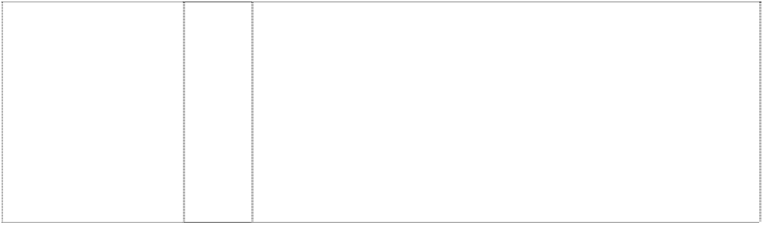

|  |  |  |
| --- | --- | --- |
| **KC R ROYALS**  coronet stylised atop shield crenellated (558847) | 21 | Household, kitchen or domestic goods in this class; containers and boxes in this class; ceramic, porcelain and earthenware goods in this class; glassware in this class; brushes in this class including toothbrushes; combs; coolers in this class; moulds in this class; goods in this class for eating and drinking purposes including mugs; trinkets and decorative items in this class; statues and figurines in  this class; stands and holders in this class. |
| **KC R ROYALS**  crest coronet, pointed silhouette shield, silhouette  (429014) | 25 | Boys' and mens tank tops, sweatshirts, shorts and tops, cardigans, jogging suits, singlets, pyjamas, polo pyjamas, dressing gowns, tops and long pants sets, warm-up suits, hats, caps, visors in this class, scarves, jackets in this class, parkas, ponchos, belts in this class, baseball uniforms and warm-up jackets, baseball caps; ladies' pyjamas, nightgowns, nightshirts, shirts, sports clothes; children's pyjamas, shirts, bibs not made of paper, hooded wrap and bib sets made of towelling; babies' jackets; shoes; sneakers; jogging shoes;  rubber boots and canvas footwear. |
| **KC ROYALS**  crest is crown, pointed atop shield with ltrs (1027065) | 25 | Clothing, including caps, hats, visors, knitted headwear, headbands, bandannas, shirts, T-shirts, tank tops, blouses, sweaters, turtlenecks, pullovers, vests, shorts, pants, slacks, dresses, skirts, overalls, bodysuits, baseball uniforms, jerseys, warm-up suits, jogging suits, sweatshirts, sweatpants, underwear, boxer shorts, robes, sleepwear, thermal loungewear, nightshirts, nightgowns, swimwear, clothing wraps, coats, jackets, ponchos, raincoats, cloth bibs, infant wear, infant diaper covers, cloth diaper sets with undershirt and diaper cover, jumpers, rompers, coveralls, creepers being romper suits, baby booties, toddler anklets, ties, suspenders, belts, money belts, mittens, gloves, wristbands, earmuffs, scarves, footwear, socks, hosiery, slippers, aprons, sliding girdles and Halloween and  masquerade costumes. |
| **LA**  (555047) | 16 | Printed matter including books, magazines, calendars and other publications; albums; photographs, posters, stickers, decals, labels; paper and cardboard novelty items in this class including pennants; table covers/napkins/mats in this class; stationery including writing implements; cards in this class; teaching materials in the form of games; wrapping paper, paper tissues and all other paper goods in  this class excluding crayons and markers. |
| **LA**  (555048) | 18 | Bags and cases in this class; umbrellas, parasols and covers therefor; wallets, purses and key cases in this class; back packs and knapsacks; leather goods in this class. |
| **LA**  (554871) | 21 | Household, kitchen or domestic goods in this class; containers and boxes in this class; ceramic, porcelain and earthenware goods in this class; glassware in this class; brushes in this class including toothbrushes; combs; coolers in this class; moulds in this class; goods in this class for eating and drinking purposes including mugs; trinkets and decorative items in this class; statues and figurines in  this class; stands and holders in this class. |
| **LA**  (528567) | 25 | Boys' and men's tank tops, sweat shirts, shirts, sweaters, vests, shorts and tops, cardigans, jogging suits, singlets, pyjamas, polo pyjamas, dressing gowns, tops and long pants sets, warm-up suits, headbands, wristbands, hats, caps, visors in this class, scarves, gloves in this class, mittens, jackets in this class, parkas, raincoats, snowsuits, coats, ponchos, belts in this class, baseball uniforms and warm-up jackets, baseball caps; ladies pyjamas, nightgowns, nightshirts, shirts, skirts, dresses, socks, underwear, aprons, sports clothes; children's pyjamas, infantwear, shirts, diapers, bibs not made of paper, hooded wrap and bib sets made of towelling; babies' jackets; shoes; bath thongs; sneakers; athletic shoes; jogging shoes;  rubber boots and canvas footwear. |

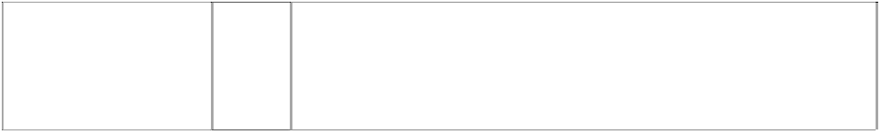

|  |  |  |
| --- | --- | --- |
| **LA**  (1027066) | 25 | Clothing, including caps, hats, visors, knitted headwear, headbands, bandannas, shirts, T-shirts, tank tops, blouses, sweaters, turtlenecks, pullovers, vests, shorts, pants, slacks, dresses, skirts, overalls, bodysuits, baseball uniforms, jerseys, warm-up suits, jogging suits, sweatshirts, sweatpants, underwear, boxer shorts, robes, sleepwear, thermal loungewear, nightshirts, nightgowns, swimwear, clothing wraps, coats, jackets, ponchos, raincoats, cloth bibs, infant wear, infant diaper covers, cloth diaper sets with undershirt and diaper cover, jumpers, rompers, coveralls, creepers being romper suits, baby booties, toddler anklets, ties, suspenders, belts, money belts, mittens, gloves, wristbands, earmuffs, scarves, footwear, socks, hosiery, slippers, aprons, sliding girdles and Halloween and  masquerade costumes. |
| **LA**  (857833) | 28 | Toys, games, playthings and sporting goods (not in other classes), including stuffed toys, plush toys, bean bag toys, puppets, balloons, marbles, checker sets, chess sets, board games, dart boards and dart board accessories, toy cars and trucks, toy mobiles, puzzles, yo- yo's, toy banks, toy figures, dolls and doll accessories, inflatable baseball bats, decorative wind socks being toys or playthings, toy tattoos, flying discs, mini bats, neck and wrist lanyards for mini bats, mini baseballs, hand held video and electronic games, coin-operated pinball machines, baseballs and holders for baseballs, autographed baseballs, basketballs, footballs, playground balls, rubber action balls, golf balls, golf club covers, golf club bags, golf putters, bowling balls, bowling bags, baseball bases, pitcher's plates, baseball bats, catcher's masks, grip tape for baseball bats, baseball batting tees, pine tar bags for baseball, rosin bags for baseball, baseball glove oil, batting gloves, baseball gloves, mitts, umpire's protective equipment, chest protectors for sports, athletic supporters, baseball pitching machines, fishing tackle, party favours in the nature of noise makers,  and Christmas tree ornaments. |
| LOS ANGELES DODGERS  (858376) | 9 | Electrical and scientific apparatus, including, telephones, radios, clock radios, pre-recorded videotapes relating to baseball, pre- recorded videodiscs relating to baseball, pre-recorded compact discs relating to baseball, pre-recorded audio discs relating to baseball, records relating to baseball, pre-recorded audio tapes relating to baseball, binoculars, video viewers, cameras, kaleidoscopes, coin- operated arcade games, computer programs, electric switch plate covers, electric signs, luminous signs, neon signs, sunglasses, eyeglass and contact lens cases, eyeglass chains, eyeglass frames, eyeglass cords, eyeglass lenses and eyeglasses, magnets, protective clothing, protective helmets, camera cases, camera straps, whistles, batting helmets, catchers helmets, computer accessories such as mouse pads, screen savers, wrist pads, monitor frames, computer cases, compact disc cases, video and computer game cartridges, video and computer game discs, video and  computer game cassettes, computer game programs, and computer programs downloadable from a global computer network. |
| **LS**  (606019) | 25 | Clothing, footwear, headgear. |
| **LST**  (857826) | 18 | Athletic bags, overnight bags, school bags, backpacks, duffel bags, tote bags, knapsacks, attache cases, briefcases, purses, handbags, wallets, billfolds, fanny packs, waist packs, cosmetic cases sold empty, toiletry cases sold empty, key cases, luggage, suitcases, garment bags for travel, trunks for travelling, umbrellas, canes, card  cases, dog collars and dog leashes. |

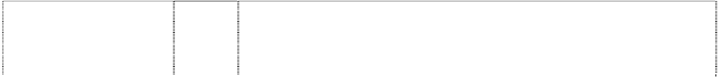

|  |  |  |
| --- | --- | --- |
| **LST**  (528569) | 25 | Boys' and men's tank tops, sweat shirts, shirts, sweaters, vests, shorts and tops, cardigans, jogging suits, singlets, pyjamas, polo pyjamas, dressing gowns, tops and long pants sets, warm-up suits, headbands, wristbands, hats, caps, visors in this class, scarves, gloves in this class, mittens, jackets in this class, parkas, raincoats, snowsuits, coats, ponchos, belts in this class, baseball uniforms and warm-up jackets, baseball caps; ladies pyjamas, nightgowns, nightshirts, shirts, skirts, dresses, socks, underwear, aprons, sports clothes; children's pyjamas, infantwear, shirts, diapers, bibs not made of paper, hooded wrap and bib sets made of towelling; babies' jackets; shoes; bath thongs; sneakers; athletic shoes; jogging shoes;  rubber boots and canvas footwear. |
| **LST**  (857826) | 28 | Toys, games, playthings and sporting goods (not in other classes), including stuffed toys, plush toys, bean bag toys, puppets, balloons, marbles, checker sets, chess sets, board games, dart boards and dart board accessories, toy cars and trucks, toy mobiles, puzzles, yo- yo's, toy banks, toy figures, dolls and doll accessories, inflatable baseball bats, decorative wind socks being toys or playthings, toy tattoos, flying discs, mini bats, neck and wrist lanyards for mini bats, mini baseballs, hand held video and electronic games, coin-operated pinball machines, baseballs and holders for baseballs, autographed baseballs, basketballs, footballs, playground balls, rubber action balls, golf balls, golf club covers, golf club bags, golf putters, bowling balls, bowling bags, baseball bases, pitcher's plates, baseball bats, catcher's masks, grip tape for baseball bats, baseball batting tees, pine tar bags for baseball, rosin bags for baseball, baseball glove oil, batting gloves, baseball gloves, mitts, umpire's protective equipment, chest protectors for sports, athletic supporters, baseball pitching machines, fishing tackle, party favours in the nature of noise makers,  and Christmas tree ornaments. |
| **M**  triangle curved under ltr M  (554806) | 25 | Caps and T-shirts. |
| **MAJOR LEAGUE BASEBALL** (858369) | 9 | Pre-recorded videotapes and videodiscs relating to baseball; video game cartridges, computer game cartridges and discs, all relating to baseball; pre-recorded compact discs relating to baseball, pre- recorded audio discs relating to baseball, records relating to baseball, pre-recorded audio tapes relating to baseball, coin- operated arcade games, computer programs, protective clothing for baseball, protective helmets for baseball, batting helmets, catchers helmets, computer accessories, compact disc cases, video and computer game discs, video and computer game cassettes, computer game programs and computer programs downloadable  from a global computer network. |
| **MAJOR LEAGUE BASEBALL** (555042) | 16 | Posters, stickers, bumper stickers, labels, calendars, decalcomanias, paper and cardboard printed cards, pennants in this class; stationery  including writing implements, stamps; printed matter relating to sporting activity. |
| **MAJOR LEAGUE BASEBALL**  (555043) | 25 | Headgear including caps, t-shirts, jackets, tops, socks, shorts, track suits and baseball uniforms. |
| **MAJOR LEAGUE BASEBALL**  (555044) | 28 | Toys and games relating to or in promotion of sporting activity; sporting equipment in this class including baseballs, gloves, masks, chest protectors, throat protectors, leg guards. |



|  |  |  |
| --- | --- | --- |
| **MAJOR LEAGUE BASEBALL**  baseball-player (858370) | 9 | Electrical and scientific apparatus, including, telephones, radios, clock radios, pre-recorded videotapes relating to baseball, pre- recorded videodiscs relating to baseball, pre-recorded compact discs relating to baseball, pre-recorded audio discs relating to baseball, records relating to baseball, pre-recorded audio tapes relating to baseball, binoculars, video viewers, cameras, kaleidoscopes, coin- operated arcade games, computer programs, electric switch plate covers, electric signs, luminous signs, neon signs, sunglasses, eyeglass and contact lens cases, eyeglass chains, eyeglass frames, eyeglass cords, eyeglass lenses and eyeglasses, magnets, protective clothing, protective helmets, camera cases, camera straps, whistles, batting helmets, catchers helmets, computer accessories such as mouse pads, screen savers, wrist pads, monitor frames, computer cases, compact disc cases, video and computer game cartridges, video and computer game discs, video and computer game cassettes, computer game programs, and computer  programs downloadable from a global computer network. |
| **MAJOR LEAGUE BASEBALL**  baseball-player (412680) | 16 | Cardboard playing cards, photo trading cards, stamps, decals, stickers, booklets, albums, bumper stickers, posters, paper pennants, labels, magazines, comic books, books, pens, pencils and  ball point pens. |
| **MAJOR LEAGUE BASEBALL**  baseball-player (412688) | 25 | Boys' and men's tank tops, sweatshirts, shorts and tops, cardigans, jogging suits, singlets, pyjamas, polo pyjamas, dressing gowns, tops and long pants sets, warm-up suits, hats, caps, visors in this class, scarves, jackets in this class, parkas, ponchos, belts in this class, baseball uniforms and warm-up jackets, baseball caps; ladies' pyjamas, nightgowns, nightshirts, shirts, sports clothes; children's pyjamas, shirts, bibs not made of paper, hooded wrap and bib sets  made of towelling; babies' jackets; shoes; sneakers; jogging shoes; rubber boots and canvas footwear. |
| **MAJOR LEAGUE BASEBALL**  baseball-player (412685) | 28 | Baseballs; baseball bats; toy baseball helmets; baseball mitts; gloves and masks; bendable and nonbendable PVC figures; toy plastic baseballs and bats; foam baseball bats; plastic baseballs; foam baseballs; plastic baseball catchers' masks; plastic baseball gloves;  foam baseball gloves and all other goods in Class 28 closely associated with the game of baseball. |
| **MAJOR LEAGUE BASEBALL**  baseballer & ball, silhouettes in rectangle (554869) | 21 | Household, kitchen or domestic goods in this class; containers and boxes in this class; ceramic, porcelain and earthenware goods in this class; glassware in this class; brushes in this class including toothbrushes; combs; coolers in this class; moulds in this class; goods in this class for eating and drinking purposes including mugs;  trinkets and decorative items in this class; statues and figurines in this class; stands and holders in this class. |
| **MARINERS**  baseball with triangles forms compass styl. (857830) | 16 | Paper and cardboard goods (not included in other classes) and printed matter, including trading cards, playing cards, posters, stickers, decalcomanias, bumper stickers, score books, scorecards, game programs, magazines and books featuring baseball, writing pads, note paper, notebooks, binders; stationery-type portfolios, stationery folders, stationery sets, paper activity sets, preprinted agenda organizers, scrapbooks, autograph books, baseball card albums, book covers, calendars, greeting cards, postcards, bank cheques, chequebook covers, credit cards being card-formed printed matter, collectible stamps, gift wrapping paper, paper gift and party bags, paper party decorations, paper coasters, paper flags, paper napkins, paper tablecloths, mounted and unmounted photographs, photograph albums, lithographs, printed paper signs, printed paper door signs, plastic baseball card holders and collectors cases, business card holders, paperweights, letter openers, pens, pencils, pencil top ornaments, markers, desk stands and holder for pens,  pencils and ink, non-electric erasers, pencil sharpeners, ungraduated rulers, ticket holders and lanyards for ticket holders. |

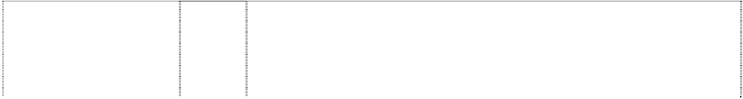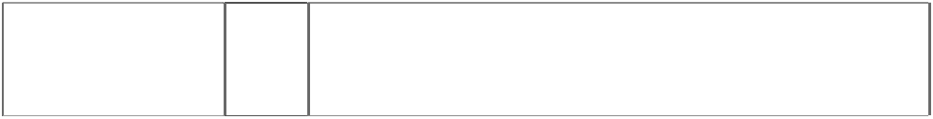

|  |  |  |
| --- | --- | --- |
| **MARINERS**  baseball with triangles forms compass styl. (857830) | 25 | Clothing, including, caps, hats, visors, knitted headwear, headbands, bandannas, shirts, T-shirts, tank tops, sweaters, turtlenecks, pullovers, vests, shorts, pants, dresses, skirts, overalls, bodysuits, baseball uniforms, jerseys, warm-up suits, sweatshirts, sweatpants, underwear, boxer shorts, robes, sleepwear, swimwear, clothing wraps, coats, jackets, ponchos, raincoats, cloth bibs, infant wear, infant diaper covers, cloth diaper sets with undershirt and diaper cover, jumpers, rompers, onesies, being all-in-one jumpsuits for babies, coveralls, creepers being romper suits, baby booties, ties, suspenders, belts, mittens, gloves, wristbands, earmuffs, scarves, footwear, socks, hosiery, slippers, aprons, sliding girdles and  costumes. |
| **MARINERS**  baseball with triangles forms compass styl. (857830) | 28 | Toys, games, playthings and sporting goods (not in other classes), including stuffed toys, plush toys, bean bag toys, puppets, balloons, marbles, checker sets, chess sets, board games, dart boards and dart board accessories, toy cars and trucks, toy mobiles, puzzles, yo- yos, toy banks, toy figures, dolls and doll accessories, inflatable baseball bats, decorative wind socks being toys or playthings, toy tattoos, flying discs, mini bats, neck and wrist lanyards for mini bats, mini baseballs, hand held video and electronic games, coin-operated pinball machines, baseballs and holders for baseballs, autographed baseballs, basketballs, footballs, playground balls, rubber action balls, golf balls, golf club covers, golf club bags, golf putters, bowling balls, bowling bags, baseball bases, pitcher's plates, baseball bats, catcher's masks, grip tape for baseball bats, baseball batting tees, pine tar bags for baseball, rosin bags for baseball, baseball glove oil, batting gloves, baseball gloves, mitts, umpire's protective equipment, chest protectors for sports, athletic supporters, baseball pitching machines, fishing tackle, party favours in the nature of noise makers,  and Christmas tree ornaments. |
| **MARLINS**  (557873) | 16 | Paper, cardboard and goods made from these materials, not included in other classes; printed matter; bookbinding material; photographs; stationery; adhesives for stationery or household purposes; artists' materials; paint brushes; and office requisites (except furniture); instructional and teaching material (except apparatus); plastic materials for packaging (not included in other classes); playing cards; printers' type; printing blocks; but not including office and teaching machinery or paper knives and  scissors. |
| **MARLINS**  (557874) | 18 | Leather and imitations of leather, and goods made of these materials and not included in other classes; animal skins, hides; trunks and travelling bags; umbrellas, parasols and walking sticks; whips,  harness and saddlery. |
| **MARLINS**  (557875) | 21 | Containers and holders in this class, namely mugs, water bottles, trays, dishes, trash cans, aluminium tankards, foam can holders, ceramic tankards, glass tankards, glasses, vacuum bottles, infant  nursers, training cups, bowls, ice buckets, lunch boxes, candlesticks, toothbrushes, hairbrushes and combs. |
| **MARLINS**  (557876) | 25 | T-shirts, sweatshirts, tracksuits, baseball jackets and uniforms, sportswear, nightwear, dressing gowns, boxer shorts and non- insulated briefs, socks, infant and baby wear, hats and caps, ties and footwear; none of the foregoing being rainwear or wet weather gear  or in the nature of thermally insulated undergarments. |



|  |  |  |
| --- | --- | --- |
| **METS**  (875821) | 16 | Paper and cardboard goods (not included in other classes) and printed matter, including trading cards, playing cards, posters, stickers, decalcomanias, bumper stickers, score books, scorecards, game programs, magazines and books featuring baseball, writing pads, note paper, notebooks, binders; stationery-type portfolios, stationery folders, stationery sets, paper activity sets, preprinted agenda organizers, scrapbooks, autograph books, baseball card albums, book covers, calendars, greeting cards, postcards, bank cheques, chequebook covers, credit cards being card-formed printed matter, collectible stamps, gift wrapping paper, paper gift and party bags, paper party decorations, paper coasters, paper flags, paper napkins, paper tablecloths, mounted and unmounted photographs, photograph albums, lithographs, printed paper signs, printed paper door signs, plastic baseball card holders and collectors cases, business card holders, paperweights, letter openers, pens, pencils, pencil top ornaments, markers, desk stands and holder for pens, pencils and ink, non-electric erasers, pencil sharpeners, ungraduated  rulers, ticket holders and lanyards for ticket holders. |
| **METS**  (554934) | 25 | Clothing, footwear, headgear. |
| **METS**  (875821) | 25 | Clothing, including, caps, hats, visors, knitted headwear, headbands, bandannas, shirts, T-shirts, tank tops, sweaters, turtlenecks, pullovers, vests, shorts, pants, dresses, skirts, overalls, bodysuits, baseball uniforms, jerseys, warm-up suits, sweatshirts, sweatpants, underwear, boxer shorts, robes, sleepwear, swimwear, clothing wraps, coats, jackets, ponchos, raincoats, cloth bibs, infant wear, infant diaper covers, cloth diaper sets with undershirt and diaper cover, jumpers, rompers, onesies, being all-in-one jumpsuits for babies, coveralls, creepers, being romper suits, baby booties, ties, suspenders, belts, mittens, gloves, wristbands, earmuffs, scarves,  footwear, socks, hosiery, slippers, aprons, sliding girdles and costumes. |
| **METS**  (875821) | 28 | Toys, games, playthings and sporting goods (not in other classes), including stuffed toys, plush toys, bean bag toys, puppets, balloons, marbles, checker sets, chess sets, board games, dart boards and dart board accessories, toy cars and trucks, toy mobiles, puzzles, yo- yo's, toy banks, toy figures, dolls and doll accessories, inflatable baseball bats being in the nature of toys or playthings, decorative wind socks being toys or playthings, toy tattoos, flying discs, mini bats, neck and wrist lanyards for mini bats, mini baseballs, hand held video and electronic games, coin-operated pinball machines, baseballs and holders for baseballs, autographed baseballs, basketballs, footballs, playground balls, rubber action balls, golf balls, golf club covers, golf club bags, golf putters, bowling balls, bowling bags, baseball bases, pitcher's plates, baseball bats, catcher's masks, grip tape for baseball bats, baseball batting tees, pine tar bags for baseball, rosin bags for baseball, baseball glove oil, batting gloves, baseball gloves, mitts, umpire's protective equipment, chest protectors for sports, athletic supporters, baseball pitching machines,  fishing tackle, party favours in the nature of noise makers, and Christmas tree ornaments. |



|  |  |  |
| --- | --- | --- |
| **METS**  (858377) | 9 | Electrical and scientific apparatus, including, telephones, radios, clock radios, pre-recorded videotapes relating to baseball, pre- recorded videodiscs relating to baseball, pre-recorded compact discs relating to baseball, pre-recorded audio discs relating to baseball, records relating to baseball, pre-recorded audio tapes relating to baseball, binoculars, video viewers, cameras, kaleidoscopes, coin- operated arcade games, computer programs, electric switch plate covers, electric signs, luminous signs, neon signs, sunglasses, eyeglass and contact lens cases, eyeglass chains, eyeglass frames, eyeglass cords, eyeglass lenses and eyeglasses, magnets, protective clothing, protective helmets, camera cases, camera straps, whistles, batting helmets, catchers helmets, computer accessories such as mouse pads, screen savers, wrist pads, monitor frames, computer cases, compact disc cases, video and computer game cartridges, video and computer game discs, video and computer game cassettes, computer game programs, and computer  programs downloadable from a global computer network. |
| **METS**  scene, city on baseball (554985) | 18 | Bags and cases in this class; umbrellas, parasols and covers  therefor; wallets, purses and key cases in this class; back packs and knapsacks; leather goods in this class. |
| **METS**  scene,city,silh. in baseball (1027072) | 25 | Clothing, including caps, hats, visors, knitted headwear, headbands, bandannas, shirts, T-shirts, tank tops, blouses, sweaters, turtlenecks, pullovers, vests, shorts, pants, slacks, dresses, skirts, overalls, bodysuits, baseball uniforms, jerseys, warm-up suits, jogging suits, sweatshirts, sweatpants, underwear, boxer shorts, robes, sleepwear, thermal loungewear, nightshirts, nightgowns, swimwear, clothing wraps, coats, jackets, ponchos, raincoats, cloth bibs, infant wear, infant diaper covers, cloth diaper sets with undershirt and diaper cover, jumpers, rompers, coveralls, creepers being romper suits, baby booties, toddler anklets, ties, suspenders, belts, money belts, mittens, gloves, wristbands, earmuffs, scarves, footwear, socks, hosiery, slippers, aprons, sliding girdles and Halloween and  masquerade costumes. |
| **METS NY**  scene, city on baseball (554849) | 6 | Key rings and key chains; money clips in this class and other clips; badges and plates in this class; metallic gift wrap in this class and foils of metal for wrapping and packaging; boxes and containers including money boxes; bells; hardware, fittings and other goods for domestic use in this class; pewter goods in this class; trinkets in this class; signs; statues and works of art in this class; bottle closures and caps; weather vanes; towel dispensers; all of the aforesaid  goods being qualified as goods in class 6. |
| **METS NY**  scene, city on baseball (554986) | 16 | Printed matter including books, magazines, calendars and other publications; albums; photographs, posters, stickers, decalcomanias, labels; paper and cardboard novelty items in this class including pennants; table covers/napkins/mats in this class; stationery including writing implements; cards in this class; teaching materials in the form of games; wrapping paper, paper tissues and all other  paper goods in this class. |
| **METS NY**  scene, city on baseball (554982) | 21 | Household, kitchen or domestic goods in this class; containers and boxes in this class; ceramic, porcelain and earthenware goods in this class; glassware in this class; brushes in this class including toothbrushes; combs; coolers in this class; moulds in this class; goods in this class for eating and drinking purposes including mugs; trinkets in this class and decorative items in this class; statues and  figurines in this class; stands and holders in this class |
| **METS NY**  scene, city on baseball (554984) | 28 | Games and playthings including toys; sporting goods in this class. |



|  |  |  |
| --- | --- | --- |
| **METS NY**  building, castle, silhouette building, bridge ball, baseball chevrons  (429031) | 25 | Boys' and men's tank tops, sweatshirts, shorts and tops, cardigans, jogging suits, singlets, pyjamas, polo pyjamas, dressing gowns, tops and long pants sets, warm-up suits, hats, caps, visors in this class, scarves, jackets in this class, parkas, ponchos, belts in this class, baseball uniforms and warm-up jackets, baseball caps; ladies' pyjamas, nightgowns, nightshirts, shirts, sports clothes, children's pyjamas, shirts, bibs not made of paper, hooded wrap and bib sets made of towelling; babies' jackets; shoes; sneakers; jogging shoes;  rubber boots and canvas footwear. |
| **MILWAUKEE BREWERS** (554884) | 16 | Printed matter including books, magazines, calendars and other publications; albums; photographs, posters, stickers, decalcomanias, labels, not of cloth; paper and cardboard novelty items in this class including pennants; table covers/napkins/mats in this class; stationery including writing implements; cards in this class; teaching materials in the form of games; wrapping paper, paper tissues and all  other paper goods. |
| **MILWAUKEE BREWERS MB**  hand, fist ball, baseball (429020) | 25 | Boys' and men's tank tops, sweatshirts, shorts and tops, cardigans, jogging suits, singlets, pyjamas, polo pyjamas, dressing gowns, tops and long pants sets, warm-up suits, hats, caps, visors in this class, scarves, jackets in this class, parkas, ponchos, belts in this class, baseball uniforms and warm-up jackets, baseball caps; ladies' pyjamas, nightgowns, nightshirts, shirts, sports clothes; children's pyjamas, shirts, bibs not made of paper, hooded wrap and bib sets made of towelling; babies' jackets; shoes; sneakers; jogging shoes;  rubber boots and canvas footwear. |
| **MINNESOTA TWINS**  words on ball, baseball (554805) | 21 | Household, kitchen or domestic goods in this class; containers and boxes in this class; ceramic, porcelain and earthenware goods in this class; glassware in this class; brushes in this class including toothbrushes; combs; coolers in this class, moulds in this class; goods in this class for eating and drinking purposes including mugs;  trinkets and decorative items in this class; statues and figurines in this class; stands and holders in this class. |
| **MINNESOTA TWINS**  baseball (1027068) | 25 | Clothing, including caps, hats, visors, knitted headwear, headbands, bandannas, shirts, T-shirts, tank tops, blouses, sweaters, turtlenecks, pullovers, vests, shorts, pants, slacks, dresses, skirts, overalls, bodysuits, baseball uniforms, jerseys, warm-up suits, jogging suits, sweatshirts, sweatpants, underwear, boxer shorts, robes, sleepwear, thermal loungewear, nightshirts, nightgowns, swimwear, clothing wraps, coats, jackets, ponchos, raincoats, cloth bibs, infant wear, infant diaper covers, cloth diaper sets with undershirt and diaper cover, jumpers, rompers, coveralls, creepers being romper suits, baby booties, toddler anklets, ties, suspenders, belts, money belts, mittens, gloves, wristbands, earmuffs, scarves, footwear, socks, hosiery, slippers, aprons, sliding girdles and Halloween and  masquerade costumes. |
| **MINNESOTA TWINS**  baseball; stripes, oblique, horizontal (518565) | 25 | Boy's and men's tank tops, sweat shirts, shirts, sweaters, vests, shorts and tops, cardigans, jogging suits, singlets, pyjamas, polo pyjamas, dressing gowns, tops and long pants sets, warm-up suits, headbands, wristbands, hats, caps, visors in this class, scarves, gloves, mittens, jackets in this class, parkas, raincoats, snowsuits, coats, ponchos, belts in this class, baseball uniforms and warm-up jackets, baseball caps; ladies pyjamas, nightgowns, nightshirts, shirts, skirts, dresses, socks, underwear, aprons, sports clothes; children's pyjamas, infantwear, shirts, diapers, bibs not made of paper, hooded wrap and bib sets made of towelling; babies' jackets; shoes; bath thongs; sneakers; athletic shoes; jogging shoes; rubber boots and canvas footwear but excluding ladies' and mens' fashion  footwear. |

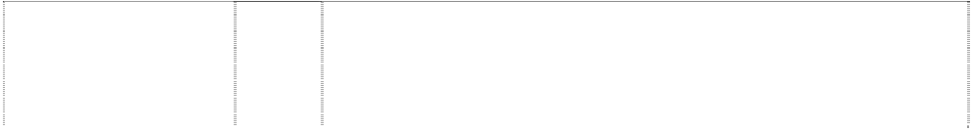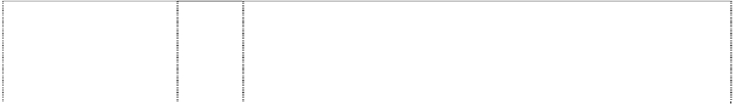

|  |  |  |
| --- | --- | --- |
| **MINNESOTA TWINS M STP**  baseball-players, two baseball bridge (429021) | 25 | Boys' and mens' tank tops, sweatshirts, shorts and tops, cardigans, jogging suits, singlets, pyjamas, polo pyjamas, dressing gowns, tops and long pants sets, warm-up suits, hats, caps, visors in this class, scarves, jackets in this class, parkas, ponchos, belts in this class, baseball uniforms and warm-up jackets, baseball caps; ladies' pyjamas, nightgowns, nightshirts, shirts, sports clothes; children's pyjamas, shirts, bibs not made of paper, hooded wrap and bib sets made of towelling; babies' jackets; shoes; sneakers; jogging shoes; rubber boots and canvas footwear but excluding ladies' and mens'  fashion footwear. |
| **MLB**  (1027094) | 25 | Clothing, including caps, hats, visors, knitted headwear, headbands, bandannas, shirts, T-shirts, tank tops, blouses, sweaters, turtlenecks, pullovers, vests, shorts, pants, slacks, dresses, skirts, overalls, bodysuits, baseball uniforms, jerseys, warm-up suits, jogging suits, sweatshirts, sweatpants, underwear, boxer shorts, robes, sleepwear, thermal loungewear, nightshirts, nightgowns, swimwear, clothing wraps, coats, jackets, ponchos, raincoats, cloth bibs, infant wear, infant diaper covers, cloth diaper sets with undershirt and diaper cover, jumpers, rompers, coveralls, creepers being romper suits, baby booties, toddler anklets, ties, suspenders, belts, money belts, mittens, gloves, wristbands, earmuffs, scarves, footwear, socks, hosiery, slippers, aprons, sliding girdles and Halloween and  masquerade costumes. |
| **MONTREAL EXPOS M**  baseball in annulus, divided  (595267) | 16 | Paper, cardboard and goods made from these materials, not included in other classes; printed matter; bookbinding material; photographs; stationery; adhesives for stationery or household purposes; artists' materials; paint brushes; typewriters and office requisites (except furniture); instructional and teaching material  (except apparatus); plastic materials for packaging (not included in other classes); playing cards; printers' type; printing blocks. |
| **MONTREAL EXPOS M**  baseball in annulus, divided  (595268) | 25 | Clothing, footwear, headgear. |
| **MONTREAL EXPOS M**  baseball in annulus, divided  (595269) | 28 | Games and playthings; gymnastic and sporting articles not included in other classes; decorations for Christmas trees. |
| **NATIONAL LEAGUE OF PROFESSIONAL BASEBALL CLUBS SINCE 1876**  baseball on shield, stars & stripes on eagle with bat on diamond  (555057) | 16 | Printed matter including books, magazines, calendars and other publications; albums; photographs, posters, stickers, decalcomanias, labels; paper and cardboard novelty items in this class including pennants; table covers/napkins/mats in this class; stationery including writing implements; cards in this class; teaching materials in the form of games; wrapping paper, paper tissues and all other paper goods in this class. |
| **NATIONAL LEAGUE OF PROFESSIONAL BASEBALL CLUBS SINCE 1876**  baseball on shield, stars & stripes on eagle with bat on diamond  (555055) | 18 | Bags and cases in this class; umbrellas, parasols and covers therefor; wallets, purses and key cases in this class; back packs and knapsacks; leather goods in this class. |



|  |  |  |
| --- | --- | --- |
| **NATIONAL LEAGUE OF PROFESSIONAL BASEBALL CLUBS SINCE 1876**  baseball on shield, stars & stripes on eagle with bat on diamond  (554876) | 21 | Household, kitchen or domestic goods in this class; containers and boxes in this class; ceramic, porcelain and earthenware goods in this class; glassware in this class; brushes in this class including toothbrushes; combs; coolers in this class; moulds in this class; goods in this class for eating and drinking purposes including mugs; trinkets and decorative items in this class; statues and figurines in this class; stands and holders in this class. |
| **NATIONAL LEAGUE OF PROFESSIONAL BASEBALL CLUBS SINCE 1876**  baseball on shield, stars & stripes on eagle with bat on diamond  (555056) | 25 | Clothing, footwear, headgear. |
| **NATIONAL LEAGUE OF PROFESSIONAL BASEBALL CLUBS SINCE 1876**  baseball on shield, stars & stripes on eagle with bat on diamond  (555054) | 28 | Games and playthings including toys; sporting goods in this class. |
| **NEW YORK METS**  (858378) | 9 | Electrical and scientific apparatus, including, telephones, radios, clock radios, pre-recorded videotapes relating to baseball, pre- recorded videodiscs relating to baseball, pre-recorded compact discs relating to baseball, pre-recorded audio discs relating to baseball, records relating to baseball, pre-recorded audio tapes relating to baseball, binoculars, video viewers, cameras, kaleidoscopes, coin- operated arcade games, computer programs, electric switch plate covers, electric signs, luminous signs, neon signs, sunglasses, eyeglass and contact lens cases, eyeglass chains, eyeglass frames, eyeglass cords, eyeglass lenses and eyeglasses, magnets, protective clothing, protective helmets, camera cases, camera straps, whistles, batting helmets, catchers helmets, computer accessories such as mouse pads, screen savers, wrist pads, monitor frames, computer cases, compact disc cases, video and computer game cartridges, video and computer game discs, video and  computer game cassettes, computer game programs, and computer programs downloadable from a global computer network. |
| **NEW YORK YANKEES** (858360) | 9 | Electrical and scientific apparatus, including, telephones, radios, clock radios, pre-recorded videotapes relating to baseball, pre- recorded videodiscs relating to baseball, pre-recorded compact discs relating to baseball, pre-recorded audio discs relating to baseball, records relating to baseball, pre-recorded audio tapes relating to baseball, binoculars, video viewers, cameras, kaleidoscopes, coin- operated arcade games, computer programs, electric switch plate covers, electric signs, luminous signs, neon signs, sunglasses, eyeglass and contact lens cases, eyeglass chains, eyeglass frames, eyeglass cords, eyeglass lenses and eyeglasses, magnets, protective clothing, protective helmets, camera cases, camera straps, whistles, batting helmets, catchers helmets, computer accessories such as mouse pads, screen savers, wrist pads, monitor frames, computer cases, compact disc cases, video and computer game cartridges, video and computer game discs, video and computer game cassettes, computer game programs, and computer  programs downloadable from a global computer network. |

# NEW YORK YANKEES YANKEES

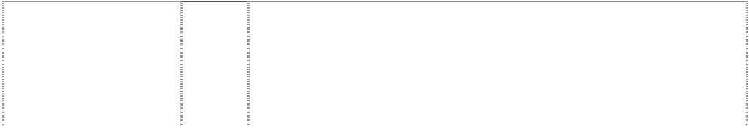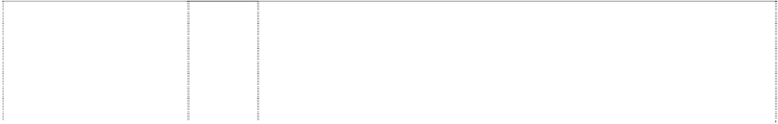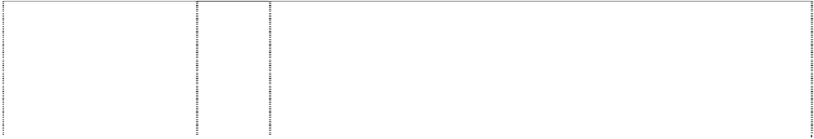

ball, baseball baseball- bat hat, top-hat stars & stripes

(412679)

# NEW YORK YANKEES YANKEES

ball, baseball baseball- bat hat, top-hat stars & stripes

(412690)

# NEW YORK YANKEES YANKEES

ball, baseball baseball- bat hat, top-hat stars & stripes

(412687) **NY** (554970)

# NY

(554971)

# NY

(857823)

# NY

(857820)

# NY

(554972)

# NY

(528568)

16 Cardboard playing cards, photo trading cards, stamps, decals, stickers, booklets, albums, bumper stickers, posters, paper pennants, labels, magazines, comic books, books, pens, pencils and ball point pens.

25 Boys' and men's tank tops, sweatshirts, shorts and tops, cardigans, jogging suits, singlets, pyjamas, polo pyjamas, dressing gowns, tops and long pants sets, warm-up suits, hats, caps, visors in this class, scarves, jackets in this class, parkas, ponchos, belts in this class, baseball uniforms and warm-up jackets, baseball caps; ladies' pyjamas, nightgowns, nightshirts, shirts, sports clothes; children's pyjamas, shirts, bibs not made of paper, hooded wrap and bib sets made of towelling; babies' jackets; shoes; sneakers; jogging shoes; rubber boots and canvas footwear.

28 Baseballs; baseball bats; toy baseball helmets; baseball mitts; gloves and masks; bendable and nonbendable PVC figures; toy plastic baseballs and bats; foam baseball bats; plastic baseballs; foam baseballs; plastic baseball catchers' masks; plastic baseball gloves; foam baseball gloves and all other goods in Class 28 closely associated with the game of baseball.

16 Printed matter including books, magazines, calendars and other publications; albums; photographs, posters, stickers, decalcomania, labels; paper and cardboard novelty items in this class including pennants; table covers/napkins/mats in this class; stationery including writing implements; cards in this class; teaching materials in the form of games; wrapping paper, paper tissues and all other paper goods in this class.

18 Bags and cases in this class; umbrellas, parasols and covers therefor; wallets, purses and key cases in this class; back packs and knapsacks in this class; leather goods in this class.

18 Athletic bags, overnight bags, school bags, backpacks, duffel bags, tote bags, knapsacks, attache cases, briefcases, purses, handbags, wallets, billfolds, fanny packs, waist packs, cosmetic cases sold empty, toiletry cases sold empty, key cases, luggage, suitcases, garment bags for travel, trunks for travelling, umbrellas, canes, card cases, dog collars and dog leashes.

18 Athletic bags, overnight bags, school bags, backpacks, duffel bags, tote bags, knapsacks, attache cases, briefcases, purses, handbags, wallets, billfolds, fanny packs, waist packs, cosmetic cases sold empty, toiletry cases sold empty, key cases, luggage, suitcases, garment bags for travel, trunks for travelling, umbrellas, canes, card cases, dog collars and dog leashes.

21 Household, kitchen or domestic goods in this class; containers and boxes in this class; ceramic, porcelain and earthware goods in this class; glassware in this class; brushes in this class including toothbrushes; combs; coolers in this class; moulds in this class; goods in this class for eating and drinking purposes including mugs; trinkets and decorative items in this class; statues and figurines in this class; stands and holders in this class.

25 Boys' and men's tank tops, sweat shirts, shirts, sweaters, vests, shorts and tops, cardigans, jogging suits, singlets, pyjamas, polo pyjamas, dressing gowns, tops and long pants sets, warm-up suits, headbands, wristbands, hats, caps, visors in this class, scarves, gloves in this class, mittens, jackets in this class, parkas, raincoats, snowsuits, coats, ponchos, belts in this class, baseball uniforms and warm-up jackets, baseball caps; ladies pyjamas, nightgowns, nightshirts, shirts, skirts, dresses, socks, underwear, aprons, sports clothes; children's pyjamas, infantwear, shirts, diapers, bibs not made of paper, hooded wrap and bib sets made of towelling; babies' jackets; shoes; bath thongs; sneakers; athletic shoes; jogging shoes; rubber boots and canvas footwear.



|  |  |  |
| --- | --- | --- |
| **NY**  (412904) | 25 | Boys' and men's tank tops, sweatshirts, shorts and tops, cardigans, jogging suits, singlets, pyjamas, polo pyjamas, dressing gowns, tops and long pants sets, warm-up suits, hats, caps, visors in this class, scarves, jackets in this class, parkas, ponchos, belts in this class, baseball uniforms and warm-up jackets, baseball caps; ladies' pyjamas, nightgowns, nightshirts, shirts, sports clothes; children's pyjamas, shirts, bibs not made of paper, hooded wrap and bib sets made of towelling; babies' jackets; shoes; sneakers; jogging shoes;  rubber boots and canvas footwear. |
| **NY**  (857820) | 25 | Toys, games, playthings and sporting goods (not in other classes), including stuffed toys, plush toys, bean bag toys, puppets, balloons, marbles, checker sets, chess sets, board games, dart boards and dart board accessories, toy cars and trucks, toy mobiles, puzzles, yo- yo's, toy banks, toy figures, dolls and doll accessories, inflatable baseball bats, decorative wind socks being toys or playthings, toy tattoos, flying discs, mini bats, neck and wrist lanyards for mini bats, mini baseballs, hand held video and electronic games, coin-operated pinball machines, baseballs and holders for baseballs, autographed baseballs, basketballs, footballs, playground balls, rubber action balls, golf balls, golf club covers, golf club bags, golf putters, bowling balls, bowling bags, baseball bases, pitcher's plates, baseball bats, catcher's masks, grip tape for baseball bats, baseball batting tees, pine tar bags for baseball, rosin bags for baseball, baseball glove oil, batting gloves, baseball gloves, mitts, umpire's protective equipment, chest protectors for sports, athletic supporters, baseball pitching machines, fishing tackle, party favours in the nature of noise makers,  and Christmas tree ornaments. |
| **NY**  (1027073) | 25 | Clothing, including caps, hats, visors, knitted headwear, headbands, bandannas, shirts, T-shirts, tank tops, blouses, sweaters, turtlenecks, pullovers, vests, shorts, pants, slacks, dresses, skirts, overalls, bodysuits, baseball uniforms, jerseys, warm-up suits, jogging suits, sweatshirts, sweatpants, underwear, boxer shorts, robes, sleepwear, thermal loungewear, nightshirts, nightgowns, swimwear, clothing wraps, coats, jackets, ponchos, raincoats, cloth bibs, infant wear, infant diaper covers, cloth diaper sets with undershirt and diaper cover, jumpers, rompers, coveralls, creepers being romper suits, baby booties, toddler anklets, ties, suspenders, belts, money belts, mittens, gloves, wristbands, earmuffs, scarves, footwear, socks,  hosiery, slippers, aprons, sliding girdles and Halloween and masquerade costumes. |
| **NY**  (1027074) | 25 | Clothing, including caps, hats, visors, knitted headwear, headbands, bandannas, shirts, T-shirts, tank tops, blouses, sweaters, turtlenecks, pullovers, vests, shorts, pants, slacks, dresses, skirts, overalls, bodysuits, baseball uniforms, jerseys, warm-up suits, jogging suits, sweatshirts, sweatpants, underwear, boxer shorts, robes, sleepwear, thermal loungewear, nightshirts, nightgowns, swimwear, clothing wraps, coats, jackets, ponchos, raincoats, cloth bibs, infant wear, infant diaper covers, cloth diaper sets with undershirt and diaper cover, jumpers, rompers, coveralls, creepers being romper suits, baby booties, toddler anklets, ties, suspenders, belts, money belts, mittens, gloves, wristbands, earmuffs, scarves, footwear, socks,  hosiery, slippers, aprons, sliding girdles and Halloween and masquerade costumes. |



|  |  |  |
| --- | --- | --- |
| **NY**  (857823) | 28 | Toys, games, playthings and sporting goods (not in other classes), including stuffed toys, plush toys, bean bag toys, puppets, balloons, marbles, checker sets, chess sets, board games, dart boards and dart board accessories, toy cars and trucks, toy mobiles, puzzles, yo- yos, toy banks, toy figures, dolls and doll accessories, inflatable baseball bats, decorative wind socks being toys or playthings, toy tattoos, flying discs, mini bats, neck and wrist lanyards for mini bats, mini baseballs, hand held video and electronic games, coin-operated pinball machines, baseballs and holders for baseballs, autographed baseballs, basketballs, footballs, playground balls, rubber action balls, golf balls, golf club covers, golf club bags, golf putters, bowling balls, bowling bags, baseball bases, pitcher's plates, baseball bats, catcher's masks, grip tape for baseball bats, baseball batting tees, pine tar bags for baseball, rosin bags for baseball, baseball glove oil, batting gloves, baseball gloves, mitts, umpire's protective equipment, chest protectors for sports, athletic supporters, baseball pitching machines, fishing tackle, party favours in the nature of noise makers,  and Christmas tree ornaments. |
| **OAKLAND ATHLETICS A’S**  circle (555035) | 6 | Key rings and key chains; money clips and other clips in this class; badges and plates in this class; metallic gift wrap in this class, foils of metal for wrapping and packaging; boxes and containers including money boxes; bells; hardware, fittings and other goods for domestic use in this class; pewter goods; trinkets in this class; signs; statues and works of art in this class; bottle closures and caps; weather  vanes; towel dispensers. |
| **OAKLAND ATHLETICS A’S**  circle (555036) | 21 | Household, kitchen or domestic goods in this class; containers and boxes in this class; ceramic, porcelain and earthenware goods in this class; glassware in this class; brushes in this class including toothbrushes; combs; coolers in this class; moulds in this class; goods in this class for eating and drinking purposes including mugs; trinkets and decorative items in this class; statues and figurines in  this class; stands and holders in this class. |
| **OAKLAND ATHLETICS A’S**  circle (437463) | 25 | Boys and mens tank tops; sweatshirts; shorts and tops; cardigans; jogging suits; singlets; pyjamas; polo pyjamas; dressing gowns; tops and long pants sets; warm-up suits; hats; caps; visors; scarves; jackets; parkas; ponchos; belts; baseball uniforms and warm-up jackets; baseball caps; ladies pyjamas; nightgowns; nightshirts; shirts, sports clothes; childrens' pyjamas; shirts, bibs; hooded towel and bib sets; babies jackets; shoes; sneakers; jogging shoes; rubber  boots and canvas footwear, being goods included in Class No. 25. |
| **ORIOLES**  (554943) | 16 | Printed matter including books, magazines, calendars and other publications; albums; photographs, posters, stickers, decalcomanias, labels; paper and cardboard novelty items in this class including pennants; table covers/napkins/mats in this class; stationery including writing implements; cards in this class; teaching materials in the form of games; wrapping paper, paper tissues and all other  goods in this class. |
| **ORIOLES**  (554944) | 18 | Bags and cases in this class; umbrellas, parasols and covers  therefor; wallets, purses and key cases in this class; back packs and knapsacks; leather goods in this class. |
| **ORIOLES**  (554830) | 21 | Household, kitchen or domestic goods in this class; containers and boxes in this class; ceramic, porcelain and earthenware goods in this class; glassware in this class; brushes in this class including toothbrushes; combs; coolers in this class; moulds in this class; goods in this class for eating and drinking purposes including mugs; trinkets in this class and decorative items in this class; statues and  figurines in this class; stands and holders in this class. |
| **ORIOLES**  (554948) | 25 | Clothing, footwear, headgear. |
| **ORIOLES**  (554945) | 28 | Games and playthings including toys; sporting goods in this class. |



|  |  |  |
| --- | --- | --- |
| **ORIOLES BALTIMORE**  bird perched atop word (595258) | 16 | Paper, cardboard and goods made from these materials, not included in other classes; printed matter; bookbinding material; photographs; stationery; adhesives for stationery or household purposes; artists' materials; paint brushes; typewriters and office requisites (except furniture); instructional and teaching material (except apparatus); plastic materials for packaging (not included in  other classes); playing cards; printers' type; printing blocks. |
| **ORIOLES BALTIMORE**  bird perched atop word (595259) | 25 | Clothing, footwear, headgear. |
| **ORIOLES BALTIMORE**  bird perched atop word (595260) | 28 | Games and playthings; gymnastic and sporting articles not included in other classes; decorations for Christmas trees. |
| **P**  (1027078) | 25 | Clothing, including caps, hats, visors, knitted headwear, headbands, bandannas, shirts, T-shirts, tank tops, blouses, sweaters, turtlenecks, pullovers, vests, shorts, pants, slacks, dresses, skirts, overalls, bodysuits, baseball uniforms, jerseys, warm-up suits, jogging suits, sweatshirts, sweatpants, underwear, boxer shorts, robes, sleepwear, thermal loungewear, nightshirts, nightgowns, swimwear, clothing wraps, coats, jackets, ponchos, raincoats, cloth bibs, infant wear, infant diaper covers, cloth diaper sets with undershirt and diaper cover, jumpers, rompers, coveralls, creepers being romper suits, baby booties, toddler anklets, ties, suspenders, belts, money belts, mittens, gloves, wristbands, earmuffs, scarves, footwear, socks,  hosiery, slippers, aprons, sliding girdles and Halloween and masquerade costumes. |
| **P**  stripe, curved, hooked ball, baseball (429032) | 25 | Boy's and mens' tank tops, sweatshirts, shorts and tops, cardigans, jogging suits, singlets, pyjamas, polo pyjamas, dressing gowns, tops and long pants sets, warm-up suits, hats, caps, visors in this class, scarves, jackets in this class, parkas, ponchos, belts in this class, baseball uniforms and warm-up jackets, baseball caps; ladies' pyjamas, nightgowns, nightshirts, shirts, sports clothes; children's pyjamas, shirts, bibs not made of paper, hooded wrap and bib sets  made of towelling; babies' jackets; shoes; sneakers; jogging shoes; rubber boots and canvas footwear. |
| **P PITTSBURGH PIRATES**  (554851) | 25 | Clothing and headgear. |
| **PADRES**  (554862) | 16 | Printed matter including books, magazines, calendars and other publications; albums; photographs, posters, stickers, decalcomanias, labels not of cloth; paper and cardboard novelty items in this class including pennants; table covers/napkins/mats in this class; stationery including writing implements; cards in this class; teaching materials in the form of games; wrapping paper, paper tissues and all  other paper goods in this class. |
| **PADRES**  (555026) | 18 | Bags and cases in this class; umbrellas, parasols and covers therefor; wallets, purses and key cases in this class; back packs and  knapsacks; leather goods in this class. |
| **PADRES**  (1027084) | 25 | Clothing, including caps, hats, visors, knitted headwear, headbands, bandannas, shirts, T-shirts, tank tops, blouses, sweaters, turtlenecks, pullovers, vests, shorts, pants, slacks, dresses, skirts, overalls, bodysuits, baseball uniforms, jerseys, warm-up suits, jogging suits, sweatshirts, sweatpants, underwear, boxer shorts, robes, sleepwear, thermal loungewear, nightshirts, nightgowns, swimwear, clothing wraps, coats, jackets, ponchos, raincoats, cloth bibs, infant wear, infant diaper covers, cloth diaper sets with undershirt and diaper cover, jumpers, rompers, coveralls, creepers being romper suits, baby booties, toddler anklets, ties, suspenders, belts, money belts, mittens, gloves, wristbands, earmuffs, scarves, footwear, socks, hosiery, slippers, aprons, sliding girdles and Halloween and  masquerade costumes. |
| **PADRES**  (555025) | 28 | Games and playthings including toys; sporting goods in this class. |

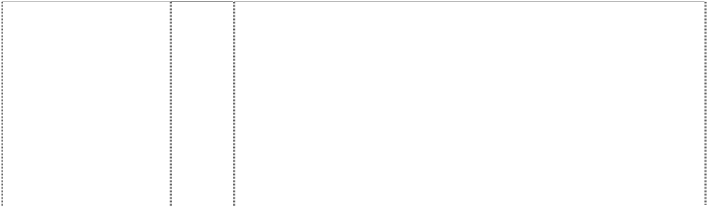

|  |  |  |
| --- | --- | --- |
| **PADRES SAN DIEGO BASEBALL CLUB**  annulus (554861) | 25 | Clothing, footwear, headgear. |
| **PADRES SAN DIEGO PADRES**  (518567) | 25 | Boy's and men's tank tops, sweat shirts, shirts, sweaters, vests, shorts, and tops, cardigans, jogging suits, singlets, pyjamas, polo pyjamas, dressing gowns, tops and long pants sets, warm-up suits, headbands, wristbands, hats, caps, visors in this class, scarves, gloves, mittens, jackets in this class, parkas, raincoats, snowsuits, coats, ponchos, belts in this class, baseball uniforms and warm-up jackets, baseball caps; ladies pyjamas, nightgowns, nightshirts, shirts, skirts, dresses, socks, underwear, aprons, sports clothes; children's pyjamas, infantwear, shirts, diapers, bibs not made of paper, hooded wrap and bib sets made of towelling; babies' jackets; shoes; bath thongs; sneakers; athletic shoes; jogging shoes; rubber  boots and canvas footwear. |
| **PHILLIES**  bell, silhouette with crack in double triangle, convex-side star is dot of ltr I (595273) | 16 | Paper, cardboard and goods made from these materials, not included in other classes; printed matter; bookbinding material; photographs; stationery; adhesives for stationery or household purposes; artists' materials; paint brushes; typewriters and office requisites (except furniture); instructional and teaching material (except apparatus); plastic materials for packaging (not included in other classes); playing cards; printers' type; printing blocks, being  goods included in class no. 16. |
| **PHILLIES**  bell, silhouette with crack in double triangle, convex-side  star is dot of ltr I (595274) | 25 | Clothing, footwear, headgear, being goods included in class no. 25. |
| **PHILLIES**  bell, silhouette with crack in double triangle, convex-side  star is dot of ltr I (595275) | 28 | Games and playthings; gymnastic and sporting articles not included in other classes; decorations for Christmas trees, being goods included in class no. 28. |
| **PIRATES**  head of pirate in diamond baseball-bats crossed on hat (554852) | 16 | Printed matter including books, magazines, calendars and other publications; albums; photographs, posters, stickers, decalcomania, labels; paper and cardboard novelty items in this class including pennants; table covers/napkins/mats in this class; stationery including writing implements; cards in this class; teaching materials in the form of games; wrapping paper, paper tissues and all other  paper goods in this class. |
| **PIRATES**  man, pirate, head skull & crossbones (429033) | 25 | Boys' and men's tank tops, sweatshirts, shorts and tops, cardigans, jogging suits, singlets, pyjamas, polo pyjamas, dressing gowns, tops and long pants sets, warm-up suits, hats, caps, visors in this class, scarves; jackets in this class, parkas, ponchos, belts in this class, baseball uniforms and warm-up jackets, baseball caps; ladies' pyjamas, nightgowns, nightshirts, shirts, sports clothes, children's pyjamas, shirts, bibs not made of paper, hooded wrap and bib sets made of towelling; babies' jackets; shoes; sneakers; jogging shoes;  rubber boots and canvas footwear. |
| **PIRATES**  pirate,head breaks 2 baseball bats,crossed forms crossbones, stylized  (1027081) | 25 | Clothing, including caps, hats, visors, knitted headwear, headbands, bandannas, shirts, T-shirts, tank tops, blouses, sweaters, turtlenecks, pullovers, vests, shorts, pants, slacks, dresses, skirts, overalls, bodysuits, baseball uniforms, jerseys, warm-up suits, jogging suits, sweatshirts, sweatpants, underwear, boxer shorts, robes, sleepwear, thermal loungewear, nightshirts, nightgowns, swimwear, clothing wraps, coats, jackets, ponchos, raincoats, cloth bibs, infant wear, infant diaper covers, cloth diaper sets with undershirt and diaper cover, jumpers, rompers, coveralls, creepers being romper suits, baby booties, toddler anklets, ties, suspenders, belts, money belts, mittens, gloves, wristbands, earmuffs, scarves, footwear, socks, hosiery, slippers, aprons, sliding girdles and Halloween and  masquerade costumes. |

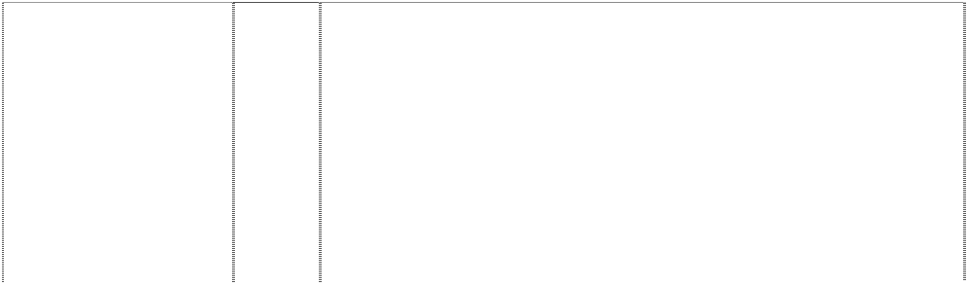

|  |  |  |
| --- | --- | --- |
| **PIRATES**  head of pirate in diamond baseball-bats  crossed on hat (554992) | 28 | Games and playthings including toys but excluding games and playthings in the nature of skate boards, surfboards and sailboards; sporting goods relating to baseball in this class; sporting goods in this class. |
| **PIRATES X PITTSBURGH PIRATES**  pirate, head in diamond, double (518566) | 25 | Boy's and men's tank tops, sweat shirts, shirts, sweaters, vests, shorts and tops, cardigans, jogging suits, singlets, pyjamas, polo pyjamas, dressing gowns, tops and long pants sets, warm-up suits, headbands, wristbands, hats, caps, visors in this class, scarves, gloves, mittens, jackets in this class, parkas, raincoats, snowsuits, coats, ponchos, belts in this class, baseball uniforms and warm-up jackets, baseball caps; ladies pyjamas, nightgowns, nightshirts, shirts, skirts, dresses, socks, underwear, aprons, sports clothes; children's pyjamas, infantwear, shirts, diapers, bibs not made of paper, hooded wrap and bib sets made of towelling; babies' jackets;  shoes; bath thongs; sneakers; athletic shoes; jogging shoes; rubber boots and canvas footwear. |
| **PITCH HIT AND RUN**  (620614) | 25 | Clothing, footwear, headgear. |
| **PITCH HIT AND RUN**  balls atop 3 baseballers, one swinging bat  (627295) | 25 | Clothing, footwear, headgear. |
| **RANGERS TR**  ball, baseball map,  Texas (429024) | 25 | Boys' and men's tank tops, sweatshirts, shorts and tops, cardigans, jogging suits, singlets, pyjamas, polo pyjamas, dressing gowns, tops and long pants sets, warm-up suits, hats, caps, visors in this class, scarves, jackets in this class, parkas, ponchos, belts in this class, baseball uniforms and warm-up jackets, baseball caps; ladies' pyjamas, nightgowns, nightshirts, shirts, sports clothes; childrens' pyjamas, shirts, bibs not made of paper, hooded wrap and bib sets made of towelling; babies' jackets; shoes not made of rubber  including sneakers and jogging shoes; canvas footwear. |
| **RED SOX**  (1027050) | 25 | Clothing, including caps, hats, visors, knitted headwear, headbands, bandannas, shirts, T-shirts, tank tops, blouses, sweaters, turtlenecks, pullovers, vests, shorts, pants, slacks, dresses, skirts, overalls, bodysuits, baseball uniforms, jerseys, warm-up suits, jogging suits, sweatshirts, sweatpants, underwear, boxer shorts, robes, sleepwear, thermal loungewear, nightshirts, nightgowns, swimwear, clothing wraps, coats, jackets, ponchos, raincoats, cloth bibs, infant wear, infant diaper covers, cloth diaper sets with undershirt and diaper cover, jumpers, rompers, coveralls, creepers being romper suits, baby booties, toddler anklets, ties, suspenders, belts, money belts, mittens, gloves, wristbands, earmuffs, scarves, footwear, socks, hosiery, slippers, aprons, sliding girdles and Halloween and  masquerade costumes. |
| **REDS**  oval, extended in ellipse pointed (595264) | 16 | Paper, cardboard and goods made from these materials, not included in other classes; printed matter; bookbinding material; photographs; stationery; adhesives for stationery or household purposes; artists' materials; paint brushes; typewriters and office requisites (except furniture); instructional and teaching material (except apparatus); plastic materials for packaging (not included in  other classes); playing cards; printers' type; printing blocks. |
| **REDS**  oval, extended in  ellipse pointed (595265) | 25 | Clothing, footwear, headgear. |
| **REDS**  oval, extended in  ellipse pointed (595266) | 28 | Games and playthings; gymnastic and sporting articles not included in other classes; decorations for Christmas trees. |



|  |  |  |
| --- | --- | --- |
| **ROCKIES**  (558256) | 16 | Paper, cardboard and goods made from these materials, not included in other classes; printed matter; bookbinding material; photographs; stationery; adhesives for stationery or household purposes; artists' materials; paint brushes; typewriters and office requisites (except furniture); instructional and teaching material (except apparatus); plastic materials for packaging (not included in  other classes); playing cards; printers' type; printing blocks. |
| **ROCKIES**  (558255) | 18 | Leather and imitations of leather, and goods made of these materials and not included in other classes; animal skins, hides; trunks and travelling bags; umbrellas, parasols and walking sticks; whips,  harness and saddlery. |
| **ROCKIES**  (558253) | 25 | Clothing, footwear, headgear. |
| **ROCKIES**  (1027056) | 25 | Clothing, including caps, hats, visors, knitted headwear, headbands, bandannas, shirts, T-shirts, tank tops, blouses, sweaters, turtlenecks, pullovers, vests, shorts, pants, slacks, dresses, skirts, overalls, bodysuits, baseball uniforms, jerseys, warm-up suits, jogging suits, sweatshirts, sweatpants, underwear, boxer shorts, robes, sleepwear, thermal loungewear, nightshirts, nightgowns, swimwear, clothing wraps, coats, jackets, ponchos, raincoats, cloth bibs, infant wear, infant diaper covers, cloth diaper sets with undershirt and diaper cover, jumpers, rompers, coveralls, creepers being romper suits, baby booties, toddler anklets, ties, suspenders, belts, money belts, mittens, gloves, wristbands, earmuffs, scarves, footwear, socks, hosiery, slippers, aprons, sliding girdles and Halloween and  masquerade costumes. |
| **ROCKIES**  (558252) | 28 | Games and playthings; gymnastic and sporting articles not included in other classes; decorations for Christmas trees. |
| **S**  baseball is part of compass on ltr S (595254) | 16 | Paper, cardboard and goods made from these materials, not included in other classes; printed matter; bookbinding material; photographs; stationery; adhesives for stationery or household purposes; artists' materials; paint brushes; typewriters and office requisites (except furniture); instructional and teaching material (except apparatus); plastic materials for packaging (not included in  other classes); playing cards; printers' type; printing blocks. |
| **S**  baseball is part of  compass on ltr S (595255) | 25 | Clothing, footwear, headgear. |
| **S**  baseball with triangles forms compass styl. (857829) | 18 | Athletic bags, overnight bags, school bags, backpacks, duffel bags, tote bags, knapsacks, attache cases, briefcases, purses, handbags, wallets, billfolds, fanny packs, waist packs, cosmetic cases sold empty, toiletry cases sold empty, key cases, luggage, suitcases, garment bags for travel, trunks for travelling, umbrellas, canes, card  cases, dog collars and dog leashes. |
| **S**  baseball with triangles forms compass styl. (857829) | 28 | Toys, games, playthings and sporting goods (not in other classes), including stuffed toys, plush toys, bean bag toys, puppets, balloons, marbles, checker sets, chess sets, board games, dart boards and dart board accessories, toy cars and trucks, toy mobiles, puzzles, yo- yo's, toy banks, toy figures, dolls and doll accessories, inflatable baseball bats, decorative wind socks being toys or playthings, toy tattoos, flying discs, mini bats, neck and wrist lanyards for mini bats, mini baseballs, hand held video and electronic games, coin-operated pinball machines, baseballs and holders for baseballs, autographed baseballs, basketballs, footballs, playground balls, rubber action balls, golf balls, golf club covers, golf club bags, golf putters, bowling balls, bowling bags, baseball bases, pitcher's plates, baseball bats, catcher's masks, grip tape for baseball bats, baseball batting tees, pine tar bags for baseball, rosin bags for baseball, baseball glove oil, batting gloves, baseball gloves, mitts, umpire's protective equipment, chest protectors for sports, athletic supporters, baseball pitching machines, fishing tackle, party favours in the nature of noise makers,  and Christmas tree ornaments. |



|  |  |  |
| --- | --- | --- |
| **SAN DIEGO PADRES**  man, monk circle bat, baseball  (429035) | 25 | Boy's and mens' tank tops, sweatshirts, shorts and tops, cardigans, jogging suits, singlets, pyjamas, polo pyjamas, dressing gowns, tops and long pants sets, warm-up suits, hats, caps, visors in this class, scarves, jackets in this class, parkas, ponchos, belts in this class, baseball uniforms and warm-up jackets, baseball caps; ladies' pyjamas, nightgowns, nightshirts, shirts, sports clothes; children's pyjamas, shirts, bibs not made of paper, hooded wrap and bib sets made of towelling; babies' jackets; shoes; sneakers; jogging shoes;  rubber boots and canvas footwear. |
| **SAN DIEGO PADRES BASEBALL CLUB**  annulus (555023) | 21 | Household, kitchen or domestic goods in this class; containers and boxes in this class; ceramic, porcelain and earthenware goods in this class; glassware in this class; brushes in this class including toothbrushes; combs; coolers in this class; moulds in this class; goods in this class for eating and drinking purposes including mugs; trinkets and decorative items in this class; statues and figurines in  this class; stands and holders in this class. |
| **SD**  (857854) | 18 | Athletic bags, overnight bags, school bags, backpacks, duffel bags, tote bags, knapsacks, attache cases, briefcases, purses, handbags, wallets, billfolds, fanny packs, waist packs, cosmetic cases sold empty, toiletry cases sold empty, key cases, luggage, suitcases, garment bags for travel, trunks for travelling, umbrellas, canes, card  cases, dog collars and dog leashes. |
| **SD**  (528571) | 25 | Boys' and men's tank tops, sweat shirts, shirts, sweaters, vests, shorts and tops, cardigans, jogging suits, singlets, pyjamas, polo pyjamas, dressing gowns, tops and long pants sets, warm-up suits, headbands, wristbands, hats, caps, visors in this class, scarves, gloves in this class, mittens, jackets in this class, parkas, raincoats, snowsuits, coats, ponchos, belts in this class, baseball uniforms and warm-up jackets, baseball caps; ladies pyjamas, nightgowns, nightshirts, shirts, skirts, dresses, socks, underwear, aprons, sports clothes; children's pyjamas, infantwear, shirts, diapers, bibs not made of paper, hooded wrap and bib sets made of towelling; babies' jackets; shoes; bath thongs; sneakers; athletic shoes; jogging shoes;  rubber boots and canvas footwear. |
| **SD**  (857854) | 28 | Toys, games, playthings and sporting goods (not in other classes), including stuffed toys, plush toys, bean bag toys, puppets, balloons, marbles, checker sets, chess sets, board games, dart boards and dart board accessories, toy cars and trucks, toy mobiles, puzzles, yo- yo's, toy banks, toy figures, dolls and doll accessories, inflatable baseball bats, decorative wind socks being toys or playthings, toy tattoos, flying discs, mini bats, neck and wrist lanyards for mini bats, mini baseballs, toy figures and sports whistles, video game cartridges, hand held video and electronic games, coin-operated pinball machines, baseballs and holders for baseballs, autographed baseballs, basketballs, footballs, playground balls, rubber action balls, golf balls, golf club covers, golf club bags, golf putters, bowling balls, bowling bags, baseball bases, pitcher's plates, baseball bats, catcher's masks, grip tape for baseball bats, baseball batting tees, pine tar bags for baseball, rosin bags for baseball, baseball glove oil, batting gloves, baseball gloves, mitts, umpire's protective equipment, chest protectors for sports, athletic supporters, baseball pitching machines, fishing tackle, party favours in the nature of noise makers,  and Christmas tree ornaments. |

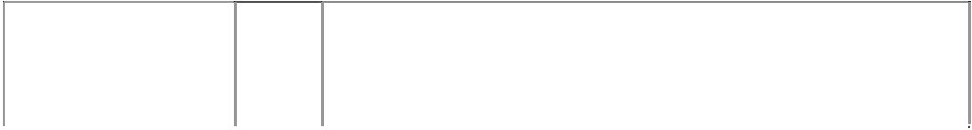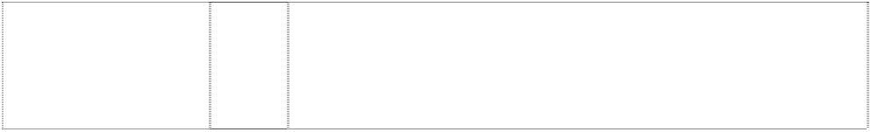

|  |  |  |
| --- | --- | --- |
| **SEATTLE MARINERS** (858363) | 9 | Electrical and scientific apparatus, including, telephones, radios, clock radios, pre-recorded videotapes relating to baseball, pre- recorded videodiscs relating to baseball, pre-recorded compact discs relating to baseball, pre-recorded audio discs relating to baseball, records relating to baseball, pre-recorded audio tapes relating to baseball, binoculars, video viewers, cameras, kaleidoscopes, coin- operated arcade games, computer programs, electric switch plate covers, electric signs, luminous signs, neon signs, sunglasses, eyeglass and contact lens cases, eyeglass chains, eyeglass frames, eyeglass cords, eyeglass lenses and eyeglasses, magnets, protective clothing, protective helmets, camera cases, camera straps, whistles, batting helmets, catchers helmets, computer accessories such as mouse pads, screen savers, wrist pads, monitor frames, computer cases, compact disc cases, video and computer game cartridges, video and computer game discs, video and computer game cassettes, computer game programs, and computer  programs downloadable from a global computer network. |
| **SEATTLE MARINERS**  baseball is part of compass in annulus (858355) | 9 | Electrical and scientific apparatus, including, telephones, radios, clock radios, pre-recorded videotapes relating to baseball, pre- recorded videodiscs relating to baseball, pre-recorded compact discs relating to baseball, pre-recorded audio discs relating to baseball, records relating to baseball, pre-recorded audio tapes relating to baseball, binoculars, video viewers, cameras, kaleidoscopes, coin- operated arcade games, computer programs, electric switch plate covers, electric signs, luminous signs, neon signs, sunglasses, eyeglass and contact lens cases, eyeglass chains, eyeglass frames, eyeglass cords, eyeglass lenses and eyeglasses, magnets, protective clothing, protective helmets, camera cases, camera straps, whistles, batting helmets, catchers helmets, computer accessories such as mouse pads, screen savers, wrist pads, monitor frames, computer cases, compact disc cases, video and computer game cartridges, video and computer game discs, video and  computer game cassettes, computer game programs, and computer programs downloadable from a global computer network. |
| **SEATTLE MARINERS**  baseball is part of compass in double annulus  (595270) | 16 | Paper, cardboard and goods made from these materials, not included in other classes; printed matter; bookbinding material; photographs; stationery; adhesives for stationery or household purposes; artists' materials; paint brushes; typewriters and office requisites (except furniture); instructional and teaching material  (except apparatus); plastic materials for packaging (not included in other classes); playing cards; printers' type; printing blocks. |
| **SEATTLE MARINERS**  baseball is part of compass in double annulus  (595271) | 25 | Clothing, footwear, headgear, being goods included in class no. 25. |
| **SEATTLE MARINERS**  baseball is part of compass in double annulus  (595272) | 28 | Games and playthings; gymnastic and sporting articles not included in other classes; decorations for Christmas trees, being goods included in class no. 28. |
| **SEATTLE MARINERS M**  star, five-point trident arrows, diverging, three  (429023) | 25 | Boys' and men's tank tops, sweatshirts, shorts and tops, cardigans, jogging suits, singlets, pyjamas, polo pyjamas, dressing gowns, tops and long pants sets, warm-up suits, hats, caps, visors in this class, scarves, jackets in this class, parkas, ponchos, belts in this class, baseball uniforms and warm-up jackets, baseball caps; ladies' pyjamas, nightgowns, nightshirts, shirts, sports clothes; children's pyjamas, shirts, bibs not made of paper, hooded wrap and bib sets made of towelling; babies' jackets; shoes; sneakers; jogging shoes;  rubber boots and canvas footwear. |
| **SF**  (857855) | 18 | Athletic bags, overnight bags, school bags, backpacks, duffel bags, tote bags, knapsacks, attache cases, briefcases, purses, handbags, wallets, billfolds, fanny packs, waist packs, cosmetic cases sold empty, toiletry cases sold empty, key cases, luggage, suitcases, garment bags for travel, trunks for travelling, umbrellas, canes, card  cases, dog collars and dog leashes. |



|  |  |  |
| --- | --- | --- |
| **SF**  (528570) | 25 | Boys' and men's tank tops, sweat shirts, shirts, sweaters, vests, shorts and tops, cardigans, jogging suits, singlets, pyjamas, polo pyjamas, dressing gowns, tops and long pants sets, warm-up suits, headbands, wristbands, hats, caps, visors in this class, scarves, gloves in this class, mittens, jackets in this class, parkas, raincoats, snowsuits, coats, ponchos, belts in this class, baseball uniforms and warm-up jackets, baseball caps; ladies pyjamas, nightgowns, nightshirts, shirts, skirts, dresses, socks, underwear, aprons, sports clothes; children's pyjamas, infantwear, shirts, diapers, bibs not made of paper, hooded wrap and bib sets made of towelling; babies' jackets; shoes; bath thongs; sneakers; athletic shoes; jogging shoes;  rubber boots and canvas footwear. |
| **SF**  (857855) | 28 | Toys, games, playthings and sporting goods (not in other classes), including stuffed toys, plush toys, bean bag toys, puppets, balloons, marbles, checker sets, chess sets, board games, dart boards and dart board accessories, toy cars and trucks, toy mobiles, puzzles, yo- yo's, toy banks, toy figures, dolls and doll accessories, inflatable baseball bats, decorative wind socks being toys or playthings, toy tattoos, flying discs, mini bats, neck and wrist lanyards for mini bats, mini baseballs, toy figures and sports whistles, video game cartridges, hand held video and electronic games, coin-operated pinball machines, baseballs and holders for baseballs, autographed baseballs, basketballs, footballs, playground balls, rubber action balls, golf balls, golf club covers, golf club bags, golf putters, bowling balls, bowling bags, baseball bases, pitcher's plates, baseball bats, catcher's masks, grip tape for baseball bats, baseball batting tees, pine tar bags for baseball, rosin bags for baseball, baseball glove oil, batting gloves, baseball gloves, mitts, umpire's protective equipment, chest protectors for sports, athletic supporters, baseball pitching machines, fishing tackle, party favours in the nature of noise makers,  and Christmas tree ornaments. |
| **SOX**  (858379) | 9 | Electrical and scientific apparatus, including, radios, clock radios, pre-recorded videotapes relating to baseball, prerecorded videodiscs relating to baseball, pre-recorded compact discs relating to baseball, pre-recorded audio discs relating to baseball, records relating to baseball, pre-recorded audio tapes relating to baseball, binoculars, video viewers, cameras, kaleidoscopes, coin-operated arcade games, computer programs, electric switch plate covers, electric signs, luminous signs, neon signs, sunglasses, eyeglass and contact lens cases, eyeglass chains, eyeglass frames, eyeglass cords, eyeglass lenses and eyeglasses, magnets, protective clothing, protective helmets, camera cases, camera straps, whistles, batting helmets, catchers helmets, computer accessories such as mouse pads, screen savers, wrist pads, monitor frames, computer cases, compact disc cases, video and computer game cartridges, video and computer game discs, video and computer game cassettes, computer game programs, and computer programs downloadable from a global computer network; none of the foregoing being in the  nature of telecommunications equipment, telephones, or computer programs for telecommunications equipment. |
| **SOX**  (554958) | 16 | Printed matter including books, magazines, calendars and other publications; albums; photographs, posters, stickers, decalcomanias, labels; paper and cardboard novelty items in this class including pennants; table covers/napkins/mats in this class; stationery including writing implements; cards in this class; teaching materials in the form of games; wrapping paper, paper tissues and all other  paper goods in this class. |
| **SOX**  (554836) | 21 | Household, kitchen or domestic goods in this class; containers and boxes in this class; ceramic, porcelain and earthenware goods in this class; glassware in this class; brushes in this class including toothbrushes; combs; coolers in this class; moulds in this class; goods in this class for eating and drinking purposes including mugs; trinkets and decorative items in this class; statues and figurines in  this class; stands and holders in this class. |
| **SOX**  (554960) | 25 | Clothing, footwear, headgear, being goods in class 25 but not including socks, leggings, stockings, tights, leg warmers or hosiery. |



|  |  |  |
| --- | --- | --- |
| **SOX**  (1027052) | 25 | Clothing, including caps, hats, visors, knitted headwear, headbands, bandannas, shirts, T-shirts, tank tops, blouses, sweaters, turtlenecks, pullovers, vests, shorts, pants, slacks, dresses, skirts, overalls, bodysuits, baseball uniforms, jerseys, warm-up suits, jogging suits, sweatshirts, sweatpants, underwear, boxer shorts, robes, sleepwear, thermal loungewear, nightshirts, nightgowns, swimwear, clothing wraps, coats, jackets, ponchos, raincoats, cloth bibs, infant wear, infant diaper covers, cloth diaper sets with undershirt and diaper cover, jumpers, rompers, coveralls, creepers being romper suits, baby booties, toddler anklets, ties, suspenders, belts, money belts, mittens, gloves, wristbands, earmuffs, scarves, footwear, socks, hosiery, slippers, aprons, sliding girdles and Halloween and  masquerade costumes. |
| **SOX**  (857844) | 28 | Toys, games, playthings and sporting goods (not in other classes), including stuffed toys, plush toys, bean bag toys, puppets, balloons, marbles, checker sets, chess sets, board games, dart boards and dart board accessories, toy cars and trucks, toy mobiles, puzzles, yo- yos, toy banks, toy figures, dolls and doll accessories, inflatable baseball bats, decorative wind socks being toys or playthings, toy tattoos, flying discs, mini bats, neck and wrist lanyards for mini bats, mini baseballs, hand held video and electronic games, coin-operated pinball machines, baseballs and holders for baseballs, autographed baseballs, basketballs, footballs, playground balls, rubber action balls, golf balls, golf club covers, golf club bags, golf putters, bowling balls, bowling bags, baseball bases, pitcher's plates, baseball bats, catcher's masks, grip tape for baseball bats, baseball batting tees, pine tar bags for baseball, rosin bags for baseball, baseball glove oil, batting gloves, baseball gloves, mitts, umpire's protective equipment, chest protectors for sports, athletic supporters, baseball pitching machines, fishing tackle, party favours in the nature of noise makers,  and Christmas tree ornaments. |
| **SOX CHICAGO WHITE SOX**  baseball-player, disc- head man, head & shoulders  (429015) | 25 | Boys' and men's tank tops, sweatshirts, shorts and tops, cardigans, jogging suits, singlets, pyjamas, polo pyjamas, dressing gowns, tops and long pants sets, warm-up suits, hats, caps, visors in this class, scarves, jackets in this class, parkas, ponchos, belts in this class, baseball uniforms not including socks, warm-up jackets, baseball caps; ladies' pyjamas, night gowns, nightshirts, shirts, sports clothes not including socks; children's pyjamas, shirts, bibs not made of paper, hooded wrap and bib sets made of towelling; babies' jackets;  shoes; sneakers; jogging shoes; rubber boots and canvas footwear. |
| **ST LOUIS CARDINALS** (858353) | 9 | Electrical and scientific apparatus, including, telephones, radios, clock radios, pre-recorded videotapes relating to baseball, pre- recorded videodiscs relating to baseball, pre-recorded compact discs relating to baseball, pre-recorded audio discs relating to baseball, records relating to baseball, pre-recorded audio tapes relating to baseball, binoculars, video viewers, cameras, kaleidoscopes, coin- operated arcade games, computer programs, electric switch plate covers, electric signs, luminous signs, neon signs, sunglasses, eyeglass and contact lens cases, eyeglass chains, eyeglass frames, eyeglass cords, eyeglass lenses and eyeglasses, magnets, protective clothing, protective helmets, camera cases, camera straps, whistles, batting helmets, catchers helmets, computer accessories such as mouse pads, screen savers, wrist pads, monitor frames, computer cases, compact disc cases, video and computer game cartridges, video and computer game discs, video and computer game cassettes, computer game programs, and computer  programs downloadable from a global computer network. |

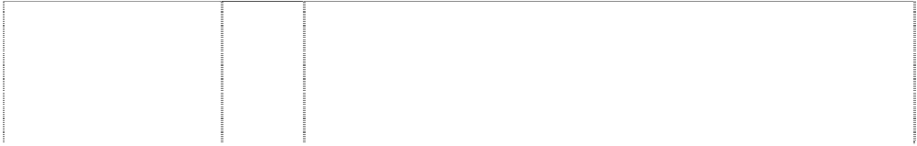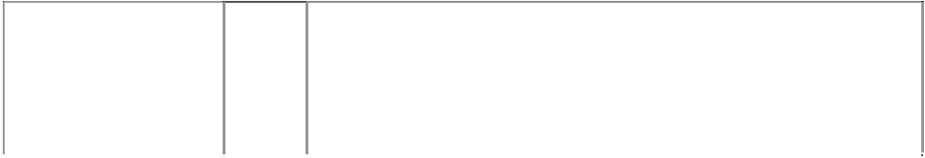

|  |  |  |
| --- | --- | --- |
| **ST LOUIS CARDINALS**  bird perched on bat, baseball in ball, baseball in annulus (429034) | 25 | Boy's and men’s' tank tops, sweatshirts, shorts and tops, cardigans, jogging suits, singlets, pyjamas, polo pyjamas, dressing gowns, tops and long pants sets, warm-up suits, hats, caps, visors in this class, scarves, jackets in this class, parkas, ponchos, belts in this class, baseball uniforms and warm-up jackets, baseball caps; ladies' pyjamas, nightgowns, nightshirts, shirts, sports clothes; children's pyjamas, shirts, bibs, hooded wrap and bib sets made of towelling; babies' jackets; shoes; sneakers; jogging shoes; rubber boots and canvas footwear; all of the foregoing pertaining to or promoting  baseball. |
| **ST. LOUIS CARDINALS**  bird standing on baseball-bat on baseball (555011) | 16 | Printed matter including books, magazines, calendars and other publications; albums; photographs, posters, stickers, decalcomania, labels; paper and cardboard novelty items in this class including pennants; table covers/napkins/mats in this class; stationery including writing implements; cards in this class; teaching materials in the form of games; wrapping paper, paper tissues and all other  paper goods in this class. |
| **ST. LOUIS CARDINALS**  bird standing on baseball-bat on baseball  (555012) | 18 | Bags and cases in this class; umbrellas, parasols and covers therefor; wallets, purses and key cases in this class; back packs and knapsacks in this class; leather goods in this class. |
| **ST. LOUIS CARDINALS**  bird standing on baseball-bat on  baseball (555013) | 28 | Games and playthings including toys; sporting goods in this class but not including fishing tackle. |
| **T**  (1027090) | 25 | Clothing, including caps, hats, visors, knitted headwear, headbands, bandannas, shirts, T-shirts, tank tops, blouses, sweaters, turtlenecks, pullovers, vests, shorts, pants, slacks, dresses, skirts, overalls, bodysuits, baseball uniforms, jerseys, warm-up suits, jogging suits, sweatshirts, sweatpants, underwear, boxer shorts, robes, sleepwear, thermal loungewear, nightshirts, nightgowns, swimwear, clothing wraps, coats, jackets, ponchos, raincoats, cloth bibs, infant wear, infant diaper covers, cloth diaper sets with undershirt and diaper cover, jumpers, rompers, coveralls, creepers being romper suits, baby booties, toddler anklets, ties, suspenders, belts, money belts, mittens, gloves, wristbands, earmuffs, scarves, footwear, socks,  hosiery, slippers, aprons, sliding girdles and Halloween and masquerade costumes. |
| **T TEXAS RANGERS**  (554838) | 25 | Clothing, footwear, headgear. |
| **TB**  fish,stingray (1027086) | 25 | Clothing, including caps, hats, visors, knitted headwear, headbands, bandannas, shirts, T-shirts, tank tops, blouses, sweaters, turtlenecks, pullovers, vests, shorts, pants, slacks, dresses, skirts, overalls, bodysuits, baseball uniforms, jerseys, warm-up suits, jogging suits, sweatshirts, sweatpants, underwear, boxer shorts, robes, sleepwear, thermal loungewear, nightshirts, nightgowns, swimwear, clothing wraps, coats, jackets, ponchos, raincoats, cloth bibs, infant wear, infant diaper covers, cloth diaper sets with undershirt and diaper cover, jumpers, rompers, coveralls, creepers being romper suits, baby booties, toddler anklets, ties, suspenders, belts, money belts, mittens, gloves, wristbands, earmuffs, scarves, footwear, socks,  hosiery, slippers, aprons, sliding girdles and Halloween and masquerade costumes. |



|  |  |  |
| --- | --- | --- |
| **TEXAS RANGERS BASEBALL CLUB**  five-point star in circle all in striped diamond (628861) | 16 | Paper goods and printed matter, including, trading cards, bumper stickers, posters, stickers, decalcomania, book marks, scorebooks, scorecards, printed paper signs, writing pads, note paper, stationery writing paper and envelopes, business cards, notebooks, colouring books, preprinted agenda organisers, magazines featuring baseball game programs, books and booklets featuring baseball, autograph books, book covers, calendars, wall calendars, desk calendars, playing cards, paper pennants, gift wrapping paper, paper gift wrap bows, paper gift and party bags, paper party decorations, paper coasters, paper flags, paper napkins, paper tablecloths, paper placemats, paper banners, paper towels, greeting cards, postcards, unmounted photographs, lithographs, doorsigns; photograph albums; scrapbooks; plastic baseball card holders and cases; baseball card albums; binders; portfolios; stationery folders; magnetic metal bulletin boards, bank cheques; chequebook covers; credit cards not included in other classes; paperweights; letter openers; paper clips; pens; pencils, markers; desk stands and holders for pens, pencils, and ink; non-electric erasers; pencil sharpeners; drafting and drawing rulers; aquariums, aquarium covers; preprinted baseball contracts; maps; crossword puzzles; collectable stamps; facial tissue; and pencil top  ornaments. |
| **TEXAS RANGERS BASEBALL CLUB**  five-point star in circle all in striped diamond (628862) | 25 | Clothing, namely, shirts, caps, shorts, dresses, skirts, T-shirts, jogging suits, warm-up suits, socks, underwear, jackets, sweaters, vests, pants, ponchos, visors, bodysuits, raincoats, hats, overalls, cloth bibs, infant diaper covers, cloth diaper sets with undershirt and diaper cover, jumpers, rompers, uniforms, uniform jerseys, wind resistant jackets, baby bootees, short sets, leotards, unitards, ties, bowties, neckties, suspenders, men's and women's formalwear, pyjamas, nightshirts, nightgowns, sweatpants, sweatshirts, mittens, gloves, knitted headwear, earmuffs, scarves, footwear, thongs, hosiery, socks, wristbands, headbands, robes, shoes, slippers, chef's hats, aprons, clothing wrap, sliding girdles, leg warmers, swimwear,  berets, bandannas, and all other goods in this class. |
| **TEXAS RANGERS BASEBALL CLUB**  five-point star in circle all in striped diamond (628863) | 28 | Toys and sporting goods, including baseballs, stuffed toy animals, arm guards for athletic use, basketball backboards, bowling bags, bowling balls, puppets, bendable toy figurines, toy bakeware and cookware, balloons, basketballs, footballs, playground balls, rubber action balls, tennis balls, toy banks, umpire's equipment, umpire's equipment in this class including protective masks, protective vests and shin guards, baseball bases, pitcher's plates, baseball bats, catcher's masks, grip tape for baseball bats, baseball batting tees, pine tar bags for baseball, rosin bags for baseball, batting gloves, baseball gloves, mitts, cushions filled with polystyrene pellets, billiard game playing equipment, kites, marbles, checker sets, chess sets, dart boards and dart board accessories, toy trucks, toy mobiles, puzzles, toy banks, snow globes, yo-yo's, golf club covers, golf club bags, golf balls, golf putters, video game cartridges, chest protectors for sports, Christmas tree ornaments, toy figures, toy construction blocks, dolls and doll accessories, athletic supporters, dice, hand held video and electronic games, manually operated exercise equipment, baseball pitching machines, fishing tackle, fishing rods, board games, party favours in the nature of noise makers, skateboards, playground slides, surfboards, snow sleds for recreational use, exercise trampolines, flying discs, autographed baseballs, inflatable baseball bats, wind socks (not being for decoration and being in the nature of a toy or plaything), and toy  tattoos. |

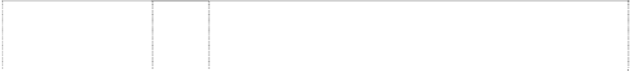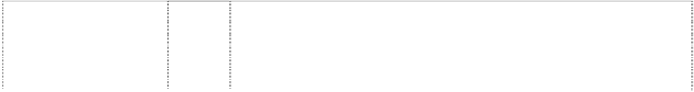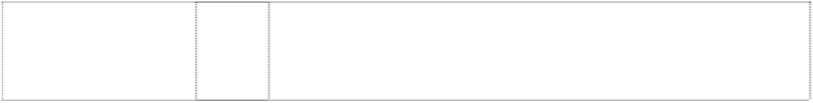

|  |  |  |
| --- | --- | --- |
| **TEXAS RANGERS T**  ltr T in baseball in annulus with 2 stars,5- point  (1027087) | 25 | Clothing, including caps, hats, visors, knitted headwear, headbands, bandannas, shirts, T-shirts, tank tops, blouses, sweaters, turtlenecks, pullovers, vests, shorts, pants, slacks, dresses, skirts, overalls, bodysuits, baseball uniforms, jerseys, warm-up suits, jogging suits, sweatshirts, sweatpants, underwear, boxer shorts, robes, sleepwear, thermal loungewear, nightshirts, nightgowns, swimwear, clothing wraps, coats, jackets, ponchos, raincoats, cloth bibs, infant wear, infant diaper covers, cloth diaper sets with undershirt and diaper cover, jumpers, rompers, coveralls, creepers being romper suits, baby booties, toddler anklets, ties, suspenders, belts, money belts, mittens, gloves, wristbands, earmuffs, scarves, footwear, socks, hosiery, slippers, aprons, sliding girdles and Halloween and  masquerade costumes. |
| **THE SWINGIN A’S**  ltr & baseball boots on baseball  (554864) | 16 | Printed matter including books, magazines, calendars and other publications; albums; photographs, posters, stickers, decalcomanias, labels; paper and cardboard novelty items in this class including pennants; table covers / napkins / mats in this class; stationery including writing implements; cards in this class; teaching materials  in the form of games; wrapping paper, paper tissues and all other paper goods in this class. |
| **THE SWINGIN A’S**  shoes with studs or spikes under in ball, baseball chevrons form arcs on ball (429022) | 25 | Boys' and men's tank tops, sweatshirts, shorts and tops, cardigans, jogging suits, singlets, pyjamas, polo pyjamas, dressing gowns, tops and long pants sets, warm-up suits, hats, caps, visors in this class, scarves, jackets in this class, parkas, ponchos, belts in this class, baseball uniforms and warm-up jackets, baseball caps; ladies' pyjamas, nightgowns, nightshirts, shirts, sports clothes; children's pyjamas, shirts, bibs not made of paper, hooded wrap and bib sets  made of towelling; babies' jackets; shoes; sneakers; jogging shoes; rubber boots and canvas footwear. |
| **THE SWINGIN A’S**  ltr & baseball boots on baseball  (555033) | 28 | Games and playthings including toys; sporting goods in this class. |
| **TORONTO BLUE JAYS**  head of bird & maple leaf on baseball (554842) | 16 | Printed matter including books, magazines, calendars and other publications; albums; photographs, posters, stickers, decalcomania, labels; paper and cardboard novelty items in this class including pennants; table covers/napkins/mats in this class; stationery including writing implements; cards in this class; teaching materials  in the form of games; wrapping paper, paper tissues and all other paper goods in this class. |
| **TORONTO BLUE JAYS**  head of bird & maple leaf on baseball  (554969) | 18 | Bags and cases in this class; umbrellas, parasols and covers therefor; wallets, purses and key cases in this class; back packs and knapsacks in this class; leather goods in this class. |
| **TORONTO BLUE JAYS**  head of bird & maple leaf on baseball (554967) | 21 | Household, kitchen or domestic goods in this class; containers and boxes in this class; ceramic, porcelain and earthware goods in this class; glassware in this class; brushes in this class including toothbrushes; combs; coolers in this class; moulds in this class; goods in this class for eating and drinking purposes including mugs; trinkets and decorative items in this class; statues and figurines in  this class; stands and holders in this class. |
| **TORONTO BLUE JAYS**  bird, head, stylised leaf, maple ball, baseball  (429025) | 25 | Boys' and men's tank tops, sweatshirts, shorts and tops, cardigans, jogging suits, singlets, pyjamas, polo pyjamas, dressing gowns, tops and long pants sets, warm-up suits, hats, caps, visors in this class, scarves, jackets in this class, parkas, ponchos, belts in this class, baseball uniforms and warm-up jackets, baseball caps; ladies' pyjamas, nightgowns, nightshirts, shirts, sports clothes; children's pyjamas, shirts, bibs not made of paper, hooded wrap and bib sets made of towelling; babies' jackets; shoes; sneakers; jogging shoes;  rubber boots and canvas footwear. |
| **TORONTO BLUE JAYS**  head of bird & maple leaf on baseball (554966) | 28 | Games and playthings including toys; sporting goods in this class. |

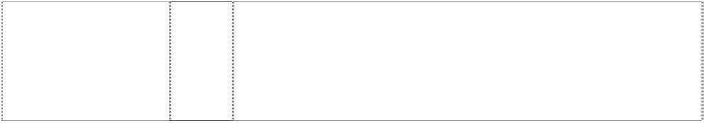

|  |  |  |
| --- | --- | --- |
| **TWINS MINNESOTA**  baseball with triangle, pointed underling word (554879) | 16 | Printer matter including books, magazines, calendars and other publications; albums; photographs, posters, stickers, decalcomanias, labels; paper and cardboard novelty items in this class including pennants; table covers/napkins/mats in this class; stationery including writing implements; cards in this class; teaching materials in the form of games; wrapping paper, paper tissues and all other  paper goods in this class. |
| **TWINS MINNESOTA**  baseball with triangle, pointed underling word (554880) | 18 | Bags and cases in this class; umbrellas, parasols and covers therefor; wallets, purses and key cases in this class; back packs and knapsacks; leather goods in this class. |
| **TWINS MINNESOTA**  baseball with triangle,  pointed underling word (554881) | 28 | Games and playthings including toys; sporting goods in this class. |
| **w**  (1032013) | 25 | Clothing, including caps, hats, visors, knitted headwear, headbands, bandannas, shirts, T-shirts, tank tops, blouses, sweaters, turtlenecks, pullovers, vests, shorts, pants, slacks, dresses, skirts, overalls, bodysuits, baseball uniforms, jerseys, warm-up suits, jogging suits, sweatshirts, sweatpants, underwear, boxer shorts, robes, sleepwear, thermal loungewear, nightshirts, nightgowns, swimwear, clothing wraps, coats, jackets, ponchos, raincoats, cloth bibs, infant wear, infant diaper covers, cloth diaper sets with undershirt and diaper cover, jumpers, rompers, coveralls, creepers being romper suits, baby booties, toddler anklets, ties, suspenders, belts, money belts, mittens, gloves, wristbands, earmuffs, scarves, footwear, socks,  hosiery, slippers, aprons, sliding girdles and Halloween and masquerade costumes. |
| **WHAT A GAME**  (822284) | 25 | Clothing, namely shirts, t-shirts, caps, shorts, dresses, skirts, jackets, sweaters, vests, pants, raincoats, ponchos, hats, berets, jerseys, uniform jerseys, turtlenecks, jumpers, coveralls, sleepwear, robes, sweatpants, sweatshirts, gloves, scarves, ties, suspenders, visors, footwear, thongs, shoes, slippers, socks, hosiery, headwear, earmuffs, bandannas, mittens, headbands, wristbands, belts for  clothing and baby onesie, rompers, cloth bibs and booties. |
| **WHITE SOX**  (554954) | 16 | Printed matter including books, magazines, calendars and other publications; albums; photographs, posters, stickers, decalcomania, labels; paper and cardboard novelty items in this class including pennants; table covers/napkins/mats in this class; stationery including writing implements; cards in this class; teaching materials in the form of games; wrapping paper, paper tissues and all other  paper goods in this class. |
| **WHITE SOX**  (554955) | 18 | Bags and cases in this class; umbrellas, parasols and covers  therefor; wallets, purses and key cases in this class; back packs and knapsacks in this class; leather goods in this class. |
| **WHITE SOX**  (554835) | 21 | Household, kitchen or domestic goods in this class; containers and boxes in this class; ceramic, porcelain and earthenware goods in this class; glassware in this class; brushes in this class including toothbrushes; combs; coolers in this class; moulds in this class; goods in this class for eating and drinking purposes including mugs;  trinkets and decorative items in this class; statues and figurines in this class; stands and holders in this class. |



|  |  |  |
| --- | --- | --- |
| **YANKEES**  (858362) | 9 | Electrical and scientific apparatus, including, telephones, radios, clock radios, pre-recorded videotapes relating to baseball, pre- recorded videodiscs relating to baseball, pre-recorded compact discs relating to baseball, pre-recorded audio discs relating to baseball, records relating to baseball, pre-recorded audio tapes relating to baseball, binoculars, video viewers, cameras, kaleidoscopes, coin- operated arcade games, computer programs, electric switch plate covers, electric signs, luminous signs, neon signs, sunglasses, eyeglass and contact lens cases, eyeglass chains, eyeglass frames, eyeglass cords, eyeglass lenses and eyeglasses, magnets, protective clothing, protective helmets, camera cases, camera straps, whistles, batting helmets, catchers helmets, computer accessories such as mouse pads, screen savers, wrist pads, monitor frames, computer cases, compact disc cases, video and computer game cartridges, video and computer game discs, video and computer game cassettes, computer game programs, and computer  programs downloadable from a global computer network. |
| **YANKEES**  (857824) | 16 | Paper and cardboard goods (not included in other classes) and printed matter, including trading cards, playing cards, posters, stickers, decalcomanias, bumper stickers, score books, scorecards, game programs, magazines and books featuring baseball, writing pads, note paper, notebooks, binders; stationery-type portfolios, stationery folders, stationery sets, paper activity sets, preprinted agenda organizers, scrapbooks, autograph books, baseball card albums, book covers, calendars, greeting cards, postcards, bank cheques, chequebook covers, credit cards being card-formed printed matter, collectible stamps, gift wrapping paper, paper gift and party bags, paper party decorations, paper coasters, paper flags, paper napkins, paper tablecloths, mounted and unmounted photographs, photograph albums, lithographs, printed paper signs, printed paper door signs, plastic baseball card holders and collectors cases, business card holders, paperweights, letter openers, pens, pencils, pencil top ornaments, markers, desk stands and holder for pens, pencils and ink, non-electric erasers, pencil sharpeners, ungraduated  rulers, ticket holders and lanyards for ticket holders. |
| **YANKEES**  (857824) | 25 | Clothing, including, caps, hats, visors, knitted headwear, headbands, bandannas, shirts, T-shirts, tank tops, sweaters, turtlenecks, pullovers, vests, shorts, pants, dresses, skirts, overalls, bodysuits, baseball uniforms, jerseys, warm-up suits, sweatshirts, sweatpants, underwear, boxer shorts, robes, sleepwear, swimwear, clothing wraps, coats, jackets, ponchos, raincoats, cloth bibs, infant wear, infant diaper covers, cloth diaper sets with undershirt and diaper cover, jumpers, rompers, onesies, being all-in-one jumpsuits for babies, coveralls, creepers, being romper suits, baby booties, ties, suspenders, belts, mittens, gloves, wristbands, earmuffs, scarves,  footwear, socks, hosiery, slippers, aprons, sliding girdles and costumes. |
| **YANKEES**  (857824) | 28 | Toys, games, playthings and sporting goods (not in other classes), including stuffed toys, plush toys, bean bag toys, puppets, balloons, marbles, checker sets, chess sets, board games, dart boards and dart board accessories, toy cars and trucks, toy mobiles, puzzles, yo- yo's, toy banks, toy figures, dolls and doll accessories, inflatable baseball bats, decorative wind socks being toys or playthings, toy tattoos, flying discs, mini bats, neck and wrist lanyards for mini bats, mini baseballs, hand held video and electronic games, coin-operated pinball machines, baseballs and holders for baseballs, autographed baseballs, basketballs, footballs, playground balls, rubber action balls, golf balls, golf club covers, golf club bags, golf putters, bowling balls, bowling bags, baseball bases, pitcher's plates, baseball bats, catcher's masks, grip tape for baseball bats, baseball batting tees, pine tar bags for baseball, rosin bags for baseball, baseball glove oil, batting gloves, baseball gloves, mitts, umpire's protective equipment, chest protectors for sports, athletic supporters, baseball pitching  machines, fishing tackle, party favours in the nature of noise makers, and Christmas tree ornaments. |

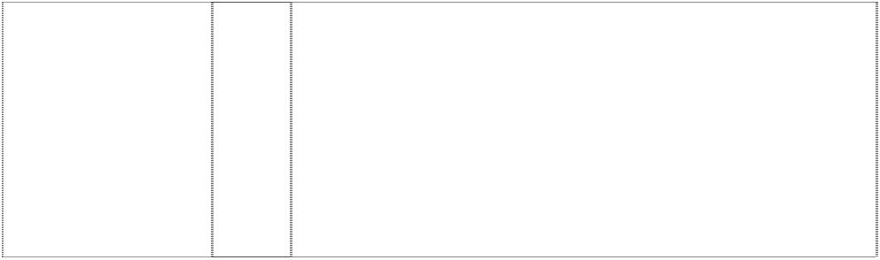

|  |  |  |
| --- | --- | --- |
| **YANKEES**  top hat on baseball-bat on baseball  (555008) | 6 | Key rings and key chains; money clips and other clips in this class; badges and plates in this class; metallic gift wrap in this class; foils of metal for wrapping and packaging; boxes and containers including money boxes; bells; fittings and other goods for domestic use in this class; pewter goods; trinkets in this class; signs; statues and works of art in this class; bottle closures and caps; weather vanes; towel dispensers; all of the aforesaid goods being qualified as goods included in class 6; but not including vises, hardware and other tools  in this class. |
| **YANKEES**  top hat on baseball-bat on baseball  (554857) | 16 | Paper and cardboard goods (not included in other classes) and printed matter, including trading cards, playing cards, posters, stickers, decalcomanias, bumper stickers, score books, scorecards, game programs, magazines and books featuring baseball, writing pads, note paper, notebooks, binders; stationery-type portfolios, stationery folders, stationery sets, paper activity sets, preprinted agenda organizers, scrapbooks, autograph books, baseball card albums, book covers, calendars, greeting cards, postcards, bank cheques, chequebook covers, credit cards being card-formed printed matter, collectible stamps, gift wrapping paper, paper gift and party bags, paper party decorations, paper coasters, paper flags, paper napkins, paper tablecloths, mounted and unmounted photographs, photograph albums, lithographs, printed paper signs, printed paper door signs, plastic baseball card holders and collectors cases, business card holders, paperweights, letter openers, pens, pencils, pencil top ornaments, markers, desk stands and holder for pens, pencils and ink, non-electric erasers, pencil sharpeners, ungraduated  rulers, ticket holders and lanyards for ticket holders. |
| **YANKEES**  top hat on baseball-bat on baseball  (554857) | 18 | Bags and cases in this class; umbrellas, parasols and covers therefor; wallets, purses and key cases in this class; back packs and knapsacks in this class; leather goods in this class. |
| **YANKEES**  top hat on baseball-bat on baseball  (555007) | 21 | Household, kitchen or domestic goods in this class; containers and boxes in this class; ceramic, porcelain and earthenware goods in this class; glassware in this class; brushes in this class including toothbrushes; combs; coolers in this class; moulds in this class; goods in this class for eating and drinking purposes including mugs; trinkets and decorative items in this class; statues and figurines in  this class; stands and holders in this class. |
| **YANKEES**  top hat on baseball-bat on baseball  (554857) | 25 | Clothing, including, caps, hats, visors, knitted headwear, headbands, bandannas, shirts, T-shirts, tank tops, sweaters, turtlenecks, pullovers, vests, shorts, pants, dresses, skirts, overalls, bodysuits, baseball uniforms, jerseys, warm-up suits, sweatshirts, sweatpants, underwear, boxer shorts, robes, sleepwear, swimwear, clothing wraps, coats, jackets, ponchos, raincoats, cloth bibs, infant wear, infant diaper covers, cloth diaper sets with undershirt and diaper cover, jumpers, rompers, onesies being all-in-one jumpsuits for babies, coveralls, creepers being romper suits, baby booties, ties, suspenders, belts, mittens, gloves, wristbands, earmuffs, scarves, footwear, socks, hosiery, slippers, aprons, sliding girdles and  costumes. |

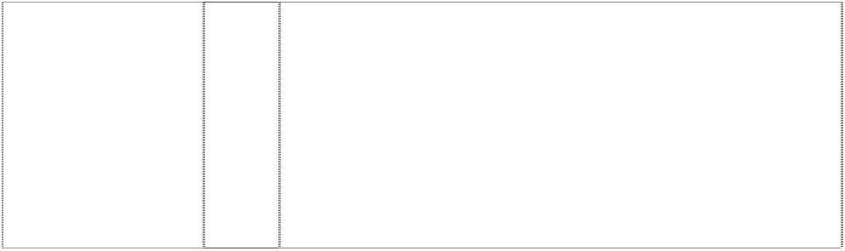

|  |  |  |
| --- | --- | --- |
| **YANKEES**  top hat on baseball-bat on baseball  (554857) | 28 | Toys, games, playthings and sporting goods (not in other classes), including stuffed toys, plush toys, bean bag toys, puppets, balloons, marbles, checker sets, chess sets, board games, dart boards and dart board accessories, toy cars and trucks, toy mobiles, puzzles, yo- yo's, toy banks, toy figures, dolls and doll accessories, inflatable baseball bats, decorative wind socks being toys or playthings, toy tattoos, flying discs, mini bats, neck and wrist lanyards for mini bats, mini baseballs, hand held video and electronic games, coin-operated pinball machines, baseballs and holders for baseballs, autographed baseballs, basketballs, footballs, playground balls, rubber action balls, golf balls, golf club covers, golf club bags, golf putters, bowling balls, bowling bags, baseball bases, pitcher's plates, baseball bats, catcher's masks, grip tape for baseball bats, baseball batting tees, pine tar bags for baseball, rosin bags for baseball, baseball glove oil, batting gloves, baseball gloves, mitts, umpire's protective equipment, chest protectors for sports, athletic supporters, baseball pitching machines, fishing tackle, party favours in the nature of noise makers,  and Christmas tree ornaments. |
| baseball-player (858366) | 9 | Electrical and scientific apparatus, including, telephones, radios, clock radios, pre-recorded videotapes relating to baseball, pre- recorded videodiscs relating to baseball, pre-recorded compact discs relating to baseball, pre-recorded audio discs relating to baseball, records relating to baseball, pre-recorded audio tapes relating to baseball, binoculars, video viewers, cameras, kaleidoscopes, coin- operated arcade games, computer programs, electric switch plate covers, electric signs, luminous signs, neon signs, sunglasses, eyeglass and contact lens cases, eyeglass chains, eyeglass frames, eyeglass cords, eyeglass lenses and eyeglasses, magnets, protective clothing, protective helmets, camera cases, camera straps, whistles, batting helmets, catchers helmets, computer accessories such as mouse pads, screen savers, wrist pads, monitor frames, computer cases, compact disc cases, video and computer game cartridges, video and computer game discs, video and computer game cassettes, computer game programs, and computer  programs downloadable from a global computer network. |
| baseball-player (857834) | 16 | Paper and cardboard goods (not included in other classes) and printed matter, including trading cards, playing cards, posters, stickers, decalcomanias, bumper stickers, score books, scorecards, game programs, magazines and books featuring baseball, writing pads, note paper, notebooks, binders; stationery-type portfolios, stationery folders, stationery sets, paper activity sets, preprinted agenda organizers, scrapbooks, autograph books, baseball card albums, book covers, calendars, greeting cards, postcards, bank cheques, chequebook covers, credit cards being card-formed printed matter, collectible stamps, gift wrapping paper, paper gift and party bags, paper party decorations, paper coasters, paper flags, paper napkins, paper tablecloths, mounted and unmounted photographs, photograph albums, lithographs, printed paper signs, printed paper door signs, plastic baseball card holders and collectors cases, business card holders, paperweights, letter openers, pens, pencils, pencil top ornaments, markers, desk stands and holder for pens,  pencils and ink, non-electric erasers, pencil sharpeners, ungraduated rulers, ticket holders and lanyards for ticket holders. |
| baseball-player (857834) | 25 | Clothing, including, caps, hats, visors, knitted headwear, headbands, bandannas, shirts, T-shirts, tank tops, sweaters, turtlenecks, pullovers, vests, shorts, pants, dresses, skirts, overalls, bodysuits, baseball uniforms, jerseys, warm-up suits, sweatshirts, sweatpants, underwear, boxer shorts, robes, sleepwear, swimwear, clothing wraps, coats, jackets, ponchos, raincoats, cloth bibs, infant wear, infant diaper covers, cloth diaper sets with undershirt and diaper cover, jumpers, rompers, onesies, being all-in-one jumpsuits for babies, coveralls, creepers being romper suits, baby booties, ties, suspenders, belts, mittens, gloves, wristbands, earmuffs, scarves,  footwear, socks, hosiery, slippers, aprons, sliding girdles and costumes. |



|  |  |  |
| --- | --- | --- |
| baseball-player (857834) | 28 | Toys, games, playthings and sporting goods (not in other classes), including stuffed toys, plush toys, bean bag toys, puppets, balloons, marbles, checker sets, chess sets, board games, dart boards and dart board accessories, toy cars and trucks, toy mobiles, puzzles, yo- yos, toy banks, toy figures, dolls and doll accessories, inflatable baseball bats, decorative wind socks being toys or playthings, toy tattoos, flying discs, mini bats, neck and wrist lanyards for mini bats, mini baseballs, hand held video and electronic games, coin-operated pinball machines, baseballs and holders for baseballs, autographed baseballs, basketballs, footballs, playground balls, rubber action balls, golf balls, golf club covers, golf club bags, golf putters, bowling balls, bowling bags, baseball bases, pitcher's plates, baseball bats, catcher's masks, grip tape for baseball bats, baseball batting tees, pine tar bags for baseball, rosin bags for baseball, baseball glove oil, batting gloves, baseball gloves, mitts, umpire's protective equipment, chest protectors for sports, athletic supporters, baseball pitching machines, fishing tackle, party favours in the nature of noise makers,  and Christmas tree ornaments. |
| head of American- Indian, cartoon smiling (554863) | 6 | Key rings and key chains; money clips and other clips in this class; badges and plates in this class; metallic giftwrap in this class, foils of metal for wrapping and packaging and aluminium foil; boxes and containers including money boxes; bells, hardware, fittings and other goods for domestic use in this class; pewter goods; trinkets in this class; signs; statues and works of art in this class; bottle closures and caps; weather vanes; towel dispensers; all of the aforesaid  goods being qualified as goods included in class 6. |
| head of American- Indian, cartoon smiling (585372) | 9 | Electrical and scientific apparatus, including, telephones, radios, clock radios, pre-recorded videotapes relating to baseball, pre- recorded videodiscs relating to baseball, pre-recorded compact discs relating to baseball, pre-recorded audio discs relating to baseball, records relating to baseball, pre-recorded audio tapes relating to baseball, binoculars, video viewers, cameras, kaleidoscopes, coin- operated arcade games, computer programs, electric switch plate covers, electric signs, luminous signs, neon signs, sunglasses, eyeglass and contact lens cases, eyeglass chains, eyeglass frames, eyeglass cords, eyeglass lenses and eyeglasses, magnets, protective clothing, protective helmets, camera cases, camera straps, whistles, batting helmets, catchers helmets, computer accessories such as mouse pads, screen savers, wrist pads, monitor frames, computer cases, compact disc cases, video and computer game cartridges, video and computer game discs, video and computer game cassettes, computer game programs, and computer  programs downloadable from a global computer network. |
| head of American- Indian, cartoon smiling (555027) | 16 | Printed matter including books, magazines, calendars and other publications; albums; photographs, posters, stickers, decalcomanias, labels; paper and cardboard novelty items in this class including pennants; table covers/napkins/mats in this class; stationery including writing implements; cards in this class; teaching materials in the form of games; wrapping paper, paper tissues and all other  paper goods in this class. |
| head of American- Indian, cartoon smiling (555031) | 21 | Household, kitchen or domestic goods in this class; containers and boxes in this class; ceramic, porcelain and earthenware goods in this class; glassware in this class; brushes in this class including toothbrushes; combs; coolers in this class; moulds in this class; goods in this class for eating and drinking purposes including mugs; trinkets and decorative items in this class; statues and figurines in  this class; stands and holders in this class. |

|  |  |  |
| --- | --- | --- |
| head of American- Indian, cartoon smiling (857845) | 25 | Clothing, including, caps, hats, visors, knitted headwear, headbands, bandannas, shirts, t-shirts, tank tops, sweaters, turtlenecks, pullovers, vests, shorts, pants, dresses, skirts, overalls, bodysuits, baseball uniforms, jerseys, warm-up suits, sweatshirts, sweatpants, underwear, boxer shorts, robes, sleepwear, swimwear, clothing wraps, coats, jackets, ponchos, raincoats, cloth bibs, infant wear, infant diaper covers, cloth diaper sets with undershirt and diaper cover, jumpers, rompers, onesies, being all-in-one jumpsuits for babies, coveralls, creepers, being romper suits, baby booties, ties, suspenders, belts,  mittens, gloves, wristbands, earmuffs, scarves, footwear, socks, hosiery, slippers, aprons, sliding girdles and costumes. |
| head of American-  Indian, cartoon smiling (555028) | 28 | Games and playthings including toys; sporting goods in this class. |
| magpie or oriole (554832) | 25 | Clothing, footwear, headgear; all the foregoing goods being related to or promoting baseball. |
| stripe forms star, five- point, incomplete and styl  (628857) | 25 | Clothing, including, shirts, caps, shorts, dresses, skirts, T-shirts, jogging suits, warm-up suits, socks, underwear, jackets, sweaters, vests, pants, ponchos, visors, bodysuits, raincoats, hats, overalls, cloth bibs, infant diaper covers, cloth diaper sets with undershirt and diaper cover, jumpers, rompers, uniforms, uniform jerseys, wind resistant jackets, baby bootees, short sets, leotards, unitards, ties, bowties, neckties, suspenders, men's and women's formalwear, pyjamas, nightshirts, nightgowns, sweatpants, sweatshirts, mittens, gloves, headgear including knitted headwear, earmuffs, scarves, footwear, thongs, hosiery, socks, wristbands, headbands, robes,  shoes, slippers, chef's hats, aprons, clothing wrap, sliding girdles, leg warmers, swimwear, berets, bandannas. |

***Marc Jacobs Trademarks LLC Corrs Chambers Westgarth Ph: (03) 9672 3000***

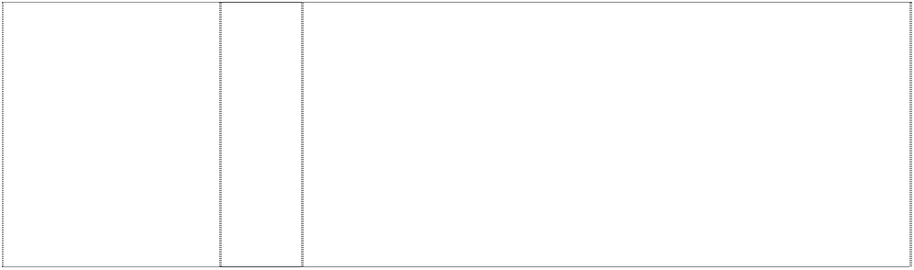

***Effective Date: 13 July 2007 File Reference: C07/11810***

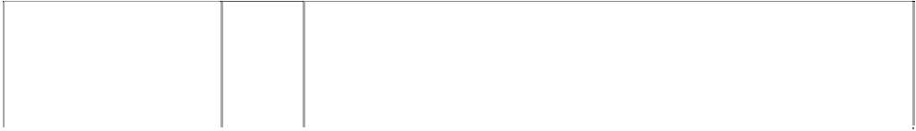

|  |  |  |
| --- | --- | --- |
| ***Trade Marks*** | ***Class*** | ***Goods*** |
| **LITTLE MARC**  (1145569) | 16 | Appointment book covers. |
| **LITTLE MARC**  (1145569) | 18 | Leather and imitation leather; traveling bags, traveling sets (leatherware), trunks and suitcases, garment bags for travel, vanity cases (not fitted), backpacks, shoulder bags, handbags, attache cases; document holders and briefcases of leather, clutch bags  (small handbags), wallets, purses, key cases, card cases; umbrellas. |
| **LITTLE MARC**  (1127571) | 25 | Children's clothing, namely, apparel, caps, hats. |
| **MARC JACOBS**  (1005835) | 14 | Jewellery including rings, key-rings, buckles, ear rings, cuff links,  bracelets, charms, brooches, necklaces, tie pins, ornamental pins; watches, watch cases, alarm clocks. |
| **MARC JACOBS**  (1083568) | 14 | Candlesticks of precious metal; mirrored compacts of precious metal; decorative boxes made of precious metal; jewelry boxes made of precious metal. |
| **MARC JACOBS**  (1005832) | 18 | Leather and imitations of leather; travelling bags, travelling sets (leatherware), trunks and valises, garment bags for travel, vanity- cases (not fitted), rucksacks, shoulder bags, handbags, attache- cases, briefcases, pouches, pocket wallets, purses, key-holders,  card holders; umbrellas. |
| **MARC JACOBS**  (1083568) | 21 | Vases; bowls; beverage glassware; combs; coasters made of leather. |
| **MARC JACOBS**  (729271) | 25 | Clothing namely underwear and hosiery, belts, scarves, ties, shawls, jumpers, shirts, blouses, suits, waistcoat, waterproof clothings, skirts, coats, suspenders trousers, pullovers, dresses, jackets, braces, gloves, tights, stockings, socks, bathing suits, bath robes, shorts,  sweaters; furs; footwear, shoes, boots, slippers, headgear, hat. |
| **MARC JACOBS**  (1112816) | 8 | Stainless steel cutlery, silver cutlery. |

***North Face Apparel Corp., The Phillips Ormonde & Fitzpatrick Ph: (03) 9614 1944***

***Effective Date: 21 June 2007 File Reference: C07/09653***



|  |  |  |
| --- | --- | --- |
| ***Trade Marks*** | ***Class*** | ***Goods*** |
| **A5**  (897596) | 9 | Scientific, nautical, surveying, electric, photographic, cinematographic, optical, weighing, measuring, signalling, checking (supervision), life-saving and teaching apparatus and instruments; apparatus for recording, transmission or reproduction of sound or images; magnetic data carriers, recording discs; automatic vending machines and mechanisms for coin operated apparatus; cash registers, calculating machines, data processing equipment and computers; fire-extinguishing apparatus; sunglasses, sports glasses and protective eyewear, and replacement lenses for all of the foregoing; optical frames for men, women and children; eyeglass  cases, goggles, and eyeglass and sunglass chains and bands, all in class 9. |
| **A5**  (897596) | 25 | Clothing, footwear and headgear including men’s women’s and children’s footwear; men’s women’s and children’s headgear, namely, hats, caps and headbands; men’s, women’s and children’s apparel, namely, T-shirts, sweatshirts, shirts, skirts, dresses, shorts, pants, swimsuits, swim trunks, parkas, vests, jackets, anoraks, ski bibs, ski suits, sweaters, gloves, mittens, underwear, belts and  socks, all in class 25. |
| **HyVent**  (1035733) | 18 | Leather goods in this class; luggage, trunks and travelling bags;  umbrellas and parasols; walking sticks; backpacks, rain covers, stuff sacks, organizer bags. |
| **HyVent**  (1035733) | 25 | Clothing, footwear and headgear including trekking boots and shoes, athletic shoes, jackets, bib pants, one-piece shell suits, mittens, rain gear, parkas, side zip pants, shells, gloves, wind jackets, hiking  boots and shoes, vests, pants. |
| **N**  arcs,concentric, three innominate device stripes curved  (344741) | 20 | Sleeping bags for campers, bivouac covers in this class for sleeping bags. |
| **N**  arcs,concentric, three innominate device  stripes curved (344741) | 20 | Sleeping bags for campers, bivouac covers in this class for sleeping bags. |
| **N**  arcs,concentric, three innominate device  stripes curved (344743) | 25 | Coats, parkas, jackets, vests, raingear in this class, anoraks, trousers, boots and shoes, gaiters, headgear in this class, snowshoes, pants and shirts. |
| **NEVER STOP EXPLORING** (1011793) | 18 | Leather and imitations of leather, and goods made of these materials and not included in other classes; animal skins, hides; trunks and travelling bags; umbrellas, parasols and walking sticks; whips, harness and saddlery; backpacks, rucksacks, haversacks, packs (in the nature of rucksacks) for carrying on the backs, backpacks with frame, backpacks for excursion, pack sacks, travelling bags for cyclists, attaché cases, briefcases, packing bags, purses, bags for climbers, clothing bags, handbags, handbags for climbers, handbags with baldrics, shoulder bags, shopping bags, tote bags, school bags, school bags for students, book bags, waist packs, fanny packs, day packs, bags for campers, suitcases, garment bags for travel, clothing bags for travel, holdalls, carryalls, various kinds of satchels, sport bags, duffel bags, stuffsacks and storage bags, ten storage bags, ten storage bags, knapsacks, camera bags, mountaineering bags,  Boston bags, internal frame packs and external frame packs. |



|  |  |  |
| --- | --- | --- |
| **NEVER STOP EXPLORING** (1011793) | 20 | Furniture, mirrors, picture frames; goods (not included in other classes) of wood, cork, reed, cane, wicker, horn, bone, ivory, whalebone, shell, amber, mother-of-pearl, meerschaum and substitutes for all these materials, or of plastics; sleeping bags; covers for sleeping bags; sleeping bag pads; bivouac sacks; covers for use in bivouacking; containers, not of metal (for transport and storage); ladders of wood or plastics; non-metallic equipment for  camping tents; compressor bags. |
| **NEVER STOP EXPLORING** (1011793) | 22 | Ropes, string, nets, tents, awnings, tarpaulins, sails, sacks and bags (not included in other classes); padding and stufting materials (except of rubber or plastics); raw fibrous textile materials; tent accessories for camping of climbing, including tent storage bags, rain flies, vinyl ground cloths, tent pole storage sacks, tent stakes, tent poles, and gear loft platforms; bivouac covers and accessories; bags (sacks) for the transport and storage of materials in bulk, sun shades; hammocks; eiderdowns; shade nets; string; nets, awnings, tarpaulins, sails, sacks and bags (not included in other classes); padding and stuffing materials (except of rubber or plastics); raw  fibrous textile materials. |
| **NEVER STOP EXPLORING** (1011793) | 25 | Clothing, footwear, headgear, including men’s, women’s, and children’s T-shirts, shirts, tops, sweatshirts, pants, shorts, trousers, jeans, vests, parkas, anoraks, coats, jackets, wind-resistant jackets, jacket hoods, pullovers, sweaters, caps, hats, coveralls, underwear, thermal underwear, sleepwear, lingerie, loungewear, hosiery, socks, tights, gloves, mittens, shells, one-piece shell suits, ski wear, ski suits, ski vests, ski jackets, ski bibs, bib pants, snowboard wear, snow pants, snow suits, rainwear, rain jackets, rain pants, gaiters, skirts, skorts, dresses, swimsuits, swim trunks, athletic shoes (sneakers), trail running shoes, climbing shoes, hiking shoes, slippers, climbing slippers, boots, trekking boots, hiking boots,  snowshoes, headbands, belts; cloth diapers; cloth bibs; infant wear; lab coats; uniforms; bandanas. |
| **NORTH FACE**  (294756) | 18 | All goods included in Class 18, including haversacks, back packs for hitch hiking and ski touring, travelling bags. |
| **THE NORTH FACE**  (870707) | 9 | Sunglasses, sport(s) glasses and protective eyewear, and replacement lenses for all of the foregoing, optical frames for men, women and children, and eyeglass cases, goggles, eyeglass and  sunglass chains and bands. |
| **THE NORTH FACE**  (344744) | 18 | Backpacks, travelling bags, stuffsacks and storage bags; all being goods included in this class. |
| **THE NORTH FACE**  (344740) | 18 | Backpacks, travelling bags, stuffsacks and storage bags; all being included in this class. |
| **THE NORTH FACE**  (344737) | 20 | Sleeping bags for campers, bivouac covers in this class for sleeping bags. |
| **THE NORTH FACE**  (344738) | 22 | Tents and accessories therefor in this class. |
| **THE NORTH FACE**  (344739) | 25 | Coats, jackets, vests, parkas, raingear, anoraks, trousers, boots and shoes, gaiters, headgear, pants and shirts; and all other goods  included in this class. |
| **THE NORTH FACE**  3 concentric arches, halved  (881155) | 9 | Sunglasses, sport(s) glasses and protective eyewear, and replacement lenses for all of the foregoing; optical frames for men, women and children, and eyeglass case, goggles, eyeglass and  sunglass chains and bands. |
| **STEEP TECH**  (1063853) | 9 | Eyewear , sunglasses, eyeglasses, sports glasses, eyepieces, spectacles, safety glasses, protective eyewear, and replacement lenses for all the foregoing; eyeglass frames, optical frames for men, women an children; eyeglass cases, goggles for use in swimming, diving, snow skiing, snow boarding, hiking, climbing, golfing, kayaking, tennis, motorcycling, boating, skateboarding, in-line skating, racquet ball and bicycling; binoculars, lorgnette, magnifying glasses, thermometers, altimeters, compasses, magnetic and directional compasses, pedometers, eyeglass and sunglass chains, bands and lanyards, glasses strings and other parts and fittings of glasses; protective helmets, camera bags; cases especially made for photographic apparatus and instruments; computer software, parts  and accessories for the aforegoing; computer sleeves. |



|  |  |  |
| --- | --- | --- |
| **STEEP TECH**  (1063853) | 18 | Leather and imitations of leather, and goods made of these materials and not included in other classes; animal skins, hides; trunks and travelling bags; umbrellas, parasols and walking sticks; whips,  harness and saddlery. |
| **TEKWARE**  (995469) | 9 | Eyewear, spectacles and optical goods in this class; sunglasses, sports glasses and protective eyewear, and replacement lenses for all of the foregoing; optical frames for men, women and children, and  eyeglass cases, goggles, eyeglass and sunglass chains and bands. |
| **TEKWARE**  (995469) | 25 | Clothing, including men’s women’ and children’s T-shirts, shirts, tops, sweatshirts, pants, shorts, trousers, jeans, vests, parkas, anoraks, coats, jackets, wind-resistant jackets, jacket hoods, pullovers, sweaters, caps, hats, coveralls, underwear, thermal underwear, sleepwear, lingerie, loungewear, hosiery, socks, tights, gloves, mittens, shells, one-piece shell suits, ski wear, ski suits, ski vests, ski jackets, ski bibs, bib pants, snowboard wear, snow pants, snow suits, rain wear, rain jackets, rain pants, gaiters, skirts, skorts, dresses, swimsuits, swim trunks; footwear, including athletic shoes (sneakers), trail running shoes, climbing shoes, hiking shoes, slippers, climbing slippers, boots, trekking boots, hiking boots, snowshoes; headgear, headbands, belts; cloth diapers; cloth bibs;  infant wear; lab coats; uniforms; bandannas. |
| **TNF**  (1102656) | 9 | Scientific, nautical, surveying, photographic, cinematographic, optical, weighting, measuring, signalling, checking (supervision), life- saving and teaching apparatus and instruments; apparatus and instruments for conducting, switching, transforming, accumulating, regulating or controlling electricity; apparatus for recording, transmission or reproduction of sound or images; magnetic data carriers, recording discs; automatic vending machines and mechanisms for coin-operated apparatus; cash registers, calculating machines, data processing equipment and computer; fire- extinguishing apparatus; eyewear, sunglasses, eyeglasses, sports glasses, eyepieces, spectacles, safety glasses, protective eyewear, and replacement lenses for all the foregoing; eyeglass frames, optical frames for men, women and children; eyeglass cases, goggles for use in swimming, diving, snow skiing, snow boarding, hiking, climbing, golfing, kayaking, tennis, motorcycling, boating, skateboarding, in-line skating, racquet ball and bicycling; binoculars, lorgnette, magnifying glasses, thermometers, altimeters, compasses, magnetic and directional compasses, pedometers, eyeglass and sunglass chains, bands and lanyards, glasses strings and other parts and fittings of glasses; protective helmets, camera bags; cases especially made for photographic apparatus and instruments;  computer software, parts and accessories for the aforegoing; computer sleeves. |



|  |  |  |
| --- | --- | --- |
| **TNF**  (1102656) | 18 | Leather and imitations of leather, and goods made of these materials and not included in other classes; animal skins, hides; trunks and travelling bags; umbrellas, parasols and walking sticks; whips, harness and saddlery; backpacks; backpacks of everyday use; rucksacks; haversacks; sacks for climbers and campers; packs (in the nature of rucksacks) for carrying on the back; all purpose sport bags; backpacks with frames; backpacks for excursion; backpacks for hitch hiking and ski touring; ski backpacks; packs sacks; travelling bags for cyclists, attaché cases, brief cases, packing bags, bags for climbers, trunks, handbags, handbags for climbers, handbags with baldrics, shoulder bags, messenger bags, shopping bags, tote bags, school bags, school bags for students, book bags, waist packs, fanny packs, day packs, bags for campers, valises, purses and wallets (leather), card cases and notecases (leather), credit card cases, travelling sets (leather ware), soft luggage, luggage cases, garment bags for travel, clothing bags for travel clothing bags, suitcases, suitcases with an extension handle, carpetbags, organizer bags, holdalls, carryalls, various kinds of satchels, duffel bags, stuffsacks and storage bags, tent storage bags, knapsacks, camera bags, mountaineering bags, Boston bags, internal frame packs and external frame packs; backpack bottle pockets, rain covers used to cover the aforesaid; hydration packs, namely, backpack hydration systems consisting of a backpack, a reservoir and a mouthpiece connected to the reservoir by a tube; shoulder harnesses, hip and lumbar packs, frames adapted for holding all the aforesaid goods; parts and fittings for all the aforesaid goods; walking sticks,  alpenstocks, trekking poles, umbrellas, parasols. |
| **TNF**  (1102656) | 20 | Furniture mirrors, picture frames; goods (not included in other classes) of wood, cord, reed, cane, wicker, horn, bone, ivory, whalebone, shell, amber, mother-of-pears, meerschaum and substitutes for all the materials, or of plastics; sleeping bags; covers for sleeping bags; sleeping bag pads; sleeping bag liners; bivouac sacks; covers for use in bivouacking; bivouac accessories; covers for camping; tent pegs, not of metal; tent poles, not of metal; tent pole storage sacks; tent stakes, not of metal; containers, not of metal (for transport and storage); ladders of wood or plastics; bags for  compressing, transporting and storing sleeping bags. |
| **TNF**  (1102656) | 22 | Ropes, string, nets, tents, awnings, tarpaulins, sails, sacks and bags (not included in other classes); padding and stuffing materials (except of rubber or plastics); raw fibrous textile materials; tents and tent accessories for camping or climbing, including tent storage bags, rain riles, ground cloths, vinyl ground cloths, tent pole storage sacks, tent stakes, tent poles, non-metallic equipment for camping tents, and gear lofts; bags (sacks) for the transport and storage of materials in bulk; sun shades being portable; hammocks; shade nets; string; ropes; nets; awnings; tarpaulins; sails; sacks and bags (not included in other classes); padding and stuffing materials (except of rubber or  plastics); raw fibrous textile materials. |
| **TNF**  (1102656) | 25 | Clothing, including men’s, women’s, and children’s T-shirts, shirts, tops, sweatshirts, sweatpants, pants, side zip pants, trousers, jeans, vests, parkas, anoraks, coats, jackets, wind-resistant jackets, jacket hoods, pullovers, sweaters, coveralls, underwear, thermal underwear, boxer briefs, sleepwear, lingerie, loungewear, hosiery, socks, tights, gloves, mittens, shells, one-piece shell suits, ski wear, ski suits, ski vests, ski jackets, ski bibs, bib overalls, bib pants, snowboard wear, snow pants, snow suits, rain wear, rain jackets, rain pants, gaiters, namely, neck gaiters, leg gaiters and ankle gaiters; skirts, skorts, dresses, swimsuits, swim trunks; footwear, including athletic shoes (sneakers), trail running shoes, climbing shoes, hiking shoes, slippers, climbing slippers, boots, trekking boats, hiking boots, snowshoes, clogs, sandals; headgear, including caps, hats, headbands, bandanas, scarves, earbands, earmuffs,  balaclavas, visors, beanies; belts. |

|  |  |  |
| --- | --- | --- |
| **VAPORWICK**  (1020869) | 1 | Chemicals and chemical preparations used in industry, including chemicals and chemical preparations for treatment of fabrics, protecting or sealing fabrics; chemicals and chemical preparations to  remove, disperse, repel, drain or absorb moisture. |
| **VAPORWICK**  (1020869) | 25 | Clothing, headgear and footwear, including T-shirts, tops, shorts, pants, bib pants, shells, sweatshirts, sweaters, jackets, parkas, vests, anoraks, ski suits, ski jackets, ski vests, hats, caps, and  gloves. |

***Playboy Enterprises, Inc Spruson & Ferguson Ph: (02) 9393 0300***

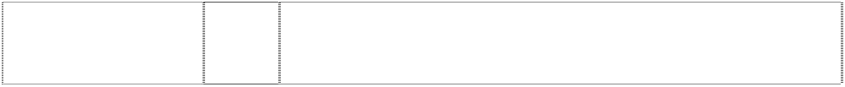

***Effective Date: 25 July 2007 File Reference: C07/11985***

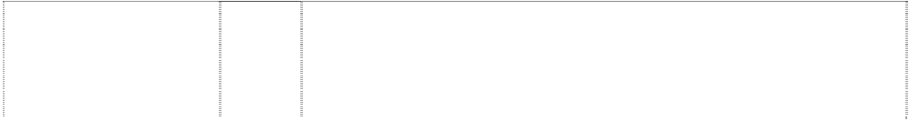

|  |  |  |
| --- | --- | --- |
| ***Trade Marks*** | ***Class*** | ***Goods*** |
| **BUNNY**  (184646) | 30 | Coffee, tea, cocoa, sugar, rice, tapioca, sago, coffee substitutes; flour, and preparations made from cereals; bread, biscuits, cakes,  pastry and confectionery, ices; honey, treacle; yeast, baking-powder; salt, mustard, pepper, vinegar, sauces, spices; ice. |
| **BUNNY**  (184647) | 33 | Wines, spirits and liqueurs. |
| **BUNNY**  head, rabbit wearing bowtie  (1044530) | 25 | Clothing, footwear, headgear. |
| **FEMLIN**  (868393) | 9 | Recording disks and apparatus for recording, transmission or  reproduction of sound or images including CD-ROMs and CD-ROM calendars and other electronic or digital recording media. |
| **FEMLIN**  (868393) | 16 | Paper, cardboard and goods made from these materials and printed matter including journals, address books, photo albums, boxed cards, books, gift boxes, calendars, date books and academic  planners. |
| **HMH**  (718735) | 34 | Tobacco; smokers' articles; matches. |
| **HUGH HEFNER**  (718736) | 34 | Tobacco; smokers' articles; matches. |
| **PLAYBOY**  (171000) | 3 | All goods. |
| **PLAYBOY**  (368120) | 5 | Air fresheners, deodorants and all other goods included in this class. |
| **PLAYBOY**  (211028) | 5 | Medicated cosmetics and medicated cosmetic articles, medicated toilet preparations and articles, medicated preparations for the hair,  deodorants. |
| **PLAYBOY**  (482618) | 6 | Common metals and their alloys; metal building materials; transportable buildings of metal; materials of metal for railway tracks; non-electric cables and wires of common metal; ironmongery in this class, small items of metal hardware; pipes and tubes of metal;  safes; goods of common metal not included in other classes; ores. |
| **PLAYBOY**  (774502) | 8 | Hand tools and implements (hand-operated); cutlery; side arms; razors. |
| **PLAYBOY**  (280840) | 9 | Records and tapes being goods included in this class. |
| **PLAYBOY**  (303188) | 9 | Sunglasses. |



|  |  |  |
| --- | --- | --- |
| **PLAYBOY**  (916178) | 9 | Scientific, nautical, surveying, electric, photographic, cinematographic, optical, weighing, measuring, signalling, checking (supervision), life-saving and teaching apparatus and instruments; apparatus for recording, transmission or reproduction of sound or images, including telephones, cordless telephones, mobile or cell telephones, mobile or cell phone face plates and mobile or cell phone accessories; magnetic data carriers, recording discs, automatic vending machines and mechanisms for coin-operated apparatus; cash registers; calculating machines and data processing equipment, fire extinguishing apparatus; and parts and accessories  to the aforementioned goods. |
| **PLAYBOY**  (892345) | 9 | Scientific, nautical, surveying, electric, photographic, cinematographic, optical, weighing, measuring, signalling, checking (supervision), life-saving and teaching apparatus and instruments; apparatus for recording, transmission or reproduction of sound or images; magnetic data carriers, recording discs; automatic vending machines and mechanisms for coin-operated apparatus, including coin-operated and automatic gaming machines such as slot machines and poker machines; cash registers, calculating machines, data processing equipment and computers; fire-extinguishing  apparatus. |
| **PLAYBOY**  (303906) | 9 | Optical frames, motorcycle and ski goggles and sport glasses and all other goods included in this class. |
| **PLAYBOY**  (589282) | 10 | Contraceptives in this class; condoms. |
| **PLAYBOY**  (1114945) | 10 | Contraceptives in this class; condoms. |
| **PLAYBOY**  (427867) | 12 | Motor vehicles; and automotive products, namely sun visor mirrors, gear shift knobs, anti-theft devices for automobiles, visor organisers (these being attachments to automobile sun visors for holding pens,  note paper and other items), dashtrays, all the foregoing being for motor vehicles; and all other goods in this class. |
| **PLAYBOY**  (280842) | 14 | Jewellery. |
| **PLAYBOY**  (476516) | 14 | Precious metals and their alloys and goods in precious metals or  coated therewith, not included in other classes; jewellery, precious stones; watches, horological and chronometric instruments. |
| **PLAYBOY**  (178658) | 16 | Magazines, periodicals and all other publications. |
| **PLAYBOY**  (341028) | 16 | Binders and other stationery materials in this class and all other goods in this class. |
| **PLAYBOY**  (489044) | 17 | Automotive accessories in this class; plastic extrusions for decoration on motor vehicles; motor vehicle door guards and all other goods in  this class. |
| **PLAYBOY**  (280844) | 18 | Leather wallets, leather traveling bags and cases, and other leather articles being articles not included in other classes. |
| **PLAYBOY**  (450672) | 18 | Umbrellas, parasols and walking sticks; leather and imitations of leather, and goods made of these materials and not included in other classes; animal skins, hides; trunks and travelling bags; whips,  harness and saddlery. |
| **PLAYBOY**  (1064915) | 18 | Products for pets and animals in this class including collars for animals, dog collars, harness for animals, horse blankets, horse  collars, leather leashes, and clothing for pets including bandanas. |
| **PLAYBOY**  (489045) | 20 | Automotive accessories in this class; coin holders of plastic and all other goods in this class. |
| **PLAYBOY**  (292791) | 21 | Glassware. |
| **PLAYBOY**  (954954) | 21 | Household or kitchen utensils and containers (not of precious metal or coated therewith), including bottle openers and magnetic bottle openers; combs and sponges; brushes (except paint brushes); brush-making materials; articles for cleaning purposes; steel wool;  unworked or semi-worked glass (except glass used in buildings); glassware, porcelain and earthenware not included in other classes. |
| **PLAYBOY**  (225216) | 24 | All goods included in this class but excluding shoe linings of textile materials. |



|  |  |  |
| --- | --- | --- |
| **PLAYBOY**  (438857) | 24 | Quilts, bedspreads and bed linen; piece goods; and all other textiles  and textile goods in this class. |
| **PLAYBOY**  (202954) | 25 | Boots and shoes. |
| **PLAYBOY**  (264463) | 25 | Articles of clothing including knitwear, shirts, socks and hosiery but excluding other footwear. |
| **PLAYBOY**  (315964) | 25 | Knitwear, knitted fleecy tops, jumpers, pullovers, cardigans, shirts, sweat shirts, T-shirts, neckwear, neckties, headwear, hats, caps, sleepwear, pyjamas, night-shirts, dressing-gowns, underwear,  singlets, underpants, socks and hosiery. |
| **PLAYBOY**  (351223) | 25 | Articles of clothing excluding: knitwear, shirts, shocks & hosiery. |
| **PLAYBOY**  (507821) | 25 | Clothing, footwear, headgear. |
| **PLAYBOY**  (308294) | 26 | All goods included in this class. |
| **PLAYBOY**  (1067316) | 27 | Carpets, rugs, mats and matting, and other materials for covering floors including mats for pets and pet food mats. |
| **PLAYBOY**  (280847) | 28 | Games and toys. |
| **PLAYBOY**  (991560) | 28 | Games and playthings; gymnastic and sporting articles not included in other classes; decorations for Christmas trees and festive holiday  ornaments including snow globes. |
| **PLAYBOY**  (949453) | 28 | Games, toys and playthings; including amusement machines, automatic and coin-operated amusement machines, backgammon games, billiard balls, billiard cue tips, billiard cues, billiard markers, billiard table cushions, billiard tables, coin-operated billiard tables, bingo cards, playing cards, chalk for billiard cues, checkerboards, checkers, chess games, chessboards, cups for dice, darts, dartboards, dice, dominoes, mah-jong, marbles for games, roulette  wheels. |
| **PLAYBOY**  (181198) | 29 | Foods included in this class. |
| **PLAYBOY**  (492296) | 30 | Coffee, tea, cocoa, sugar, rice, tapioca, sago, artificial coffee; flour and preparations made from cereals, bread, pastry and confectionery, ices; honey, treacle; yeast, baking-powder; salt,  mustard; vinegar, sauces (except salad dressings); spices; ice. |
| **PLAYBOY**  (280849) | 32 | Beer, ales and porter; mineral and aerated waters and other non-  alcoholic drinks; syrups and other preparations for making beverages. |
| **PLAYBOY**  (181199) | 33 | Liquors included in this class. |
| **PLAYBOY**  (251186) | 34 | All goods included in this class. |
| **PLAYBOY**  (306708) | 34 | Non-electric cigarette lighters, tobacco products, and all other goods in this class. |
| **PLAYBOY**  cricket-bat football (97771) | 25 | Boys' and youths' knitwear. |
| **PLAYBOY**  head, rabbit, silhouette wearing bowtie as letter O  (483316) | 24 | Textiles and textile goods, not included in other classes; bed and table covers. |
| **PLAYBOY**  head, playboy rabbit, silhouette wearing bowtie; square,  rounded-corners (168396) | 25 | Trousers, sportscoats, raincoats, overcoats, men's suits, but not including knitwear of any kind. |
| **PLAYBOY**  head, playboy rabbit, silhouette wearing  bowtie forms, letter O (356864) | 25 | Clothing, including boots, shoes and slippers. |



|  |  |  |
| --- | --- | --- |
| **PLAYBOY**  head, rabbit silhouette wearing bowtie as letter O  (483315) | 26 | Lace and embroidery, ribbons and braid; buttons, hooks and eyes, pins and needles; artificial flowers. |
| **PLAYBOY BUNNY**  (1044529) | 25 | Clothing, footwear, headgear. |
| **PLAYBOY FUNNIES**  (862776) | 16 | Printed matter, including calendars, date books, and academic calendars. |
| **PLAYGIRL**  (193886) | 3 | Cosmetics and cosmetic articles, nail polish, nail polish removing preparations, toilet preparations and articles included in class 3,  preparations for the hair, perfumed soap. |
| **PLAYGIRL**  (211027) | 5 | Medicated cosmetics and medicated cosmetic articles, medicated toilet preparations and articles, medicated preparations for the hair,  deodorants. |
| **PLAYMATE**  (193887) | 3 | Cosmetics and cosmetic articles, nail polish, nail polish removing  preparations, toilet preparations and articles, included in class 3, preparations for the hair, perfumed soap. |
| **PLAYMATE**  (211029) | 5 | Medicated cosmetics and medicated cosmetic articles, medicated toilet preparations and articles, medicated preparations for the hair, deodorants. |
| **PLAYMATE**  (482617) | 6 | Common metals and their alloys; metal building materials; transportable buildings of metal; materials of metal for railway tracks; non-electric cables and wires of common metal; ironmongery, small items of metal hardware; pipes and tubes of metal; safes; goods of  common metal not included in other classes; ores. |
| **PLAYMATE**  (371396) | 9 | Pre-recorded video disk, cassettes and tapes. |
| **PLAYMATE**  (482616) | 9 | Scientific, nautical, surveying, electric, photographic, cinematographic, optical, weighing, measuring, signalling, checking (supervision), life-saving and teaching apparatus and instruments; apparatus for recording, transmission or reproduction of sound or images; magnetic data carriers, recording discs; automatic vending machines and mechanisms for coin-operated apparatus; cash  registers, calculating machines and data processing equipment; fire- extinguishing apparatus; but none of the foregoing being a container. |
| **PLAYMATE**  (589281) | 10 | Contraceptives in this class; condoms. |
| **PLAYMATE**  (427868) | 12 | Motor vehicles; and automotive products, namely sun visor mirrors, gear shift knobs, anti-theft devices for automobiles, visor organisers (these being attachments to automobile sun visors for holding pens, note paper and other items), dashtrays, all the foregoing being for  motor vehicles; and all other goods in this class. |
| **PLAYMATE**  (280843) | 14 | Jewellery. |
| **PLAYMATE**  (476517) | 14 | Jewellery, precious stones, horological and chronometric instruments. |
| **PLAYMATE**  (436614) | 16 | Magazines, periodicals and all other publications; and all other goods included in this class. |
| **PLAYMATE**  (489046) | 17 | Automotive accessories in this class; plastic extrusions for decoration on motor vehicles; motor vehicle door guards and all other goods in  this class. |
| **PLAYMATE**  (280846) | 18 | Leather wallets, leather traveling bags and cases, ant other leather articles being articles not included in other classes |
| **PLAYMATE**  (450673) | 18 | Umbrellas, parasols and walking sticks; leather and imitations of leather, and goods made of these materials and not included in other  classes; animal skins, hides; trunks and travelling bags; whips, harness and saddlery. |
| **PLAYMATE**  (489047) | 20 | Automotive accessories in this class; coin holders of plastic and all other goods in this class. |
| **PLAYMATE**  (1068138) | 21 | Brushes (except paint brushes) including cosmetic brushes and nail brushes; cosmetic utensils. |
| **PLAYMATE**  (438858) | 24 | Quilts, bedspreads and bed linen; piece goods; and all other textiles and textile goods in this class. |



|  |  |  |
| --- | --- | --- |
| **PLAYMATE**  (20683) | 25 | Articles of clothing but excluding hosiery of all kinds. |
| **PLAYMATE**  (425735) | 25 | All goods included in this class. |
| **PLAYMATE**  (840473) | 28 | Games and playthings; gymnastic and sporting articles not included in other classes; decorations for Christmas trees. |
| **PLAYMATE**  (412515) | 32 | Beer, ales and porter; mineral and aerated waters and other non- alcoholic drinks; syrups and other preparations for making  beverages. |
| **PLAYMATE OF THE MONTH**  (450631) | 9 | Pre-recorded video tapes and all other sound and/or image carriers in this class. |
| **PLAYMATE OF THE MONTH**  (1114947) | 10 | Contraceptives in this class; condoms. |
| **PLAYMATE OF THE MONTH**  (458665) | 16 | Printed matter, including magazine publications. |
| **PLAYMATE OF THE YEAR**  (1067904) | 3 | Cosmetics including cosmetic creams and cosmetic lotions; cosmetic pencils and cosmetic kits; decorative transfers for cosmetic  purposes; perfumery, essential oils, hair lotions; soap. |
| **PLAYMATE OF THE YEAR**  (450630) | 9 | Pre-recorded video tapes and all other sound and/or image carriers in this class. |
| **PLAYMATE OF THE YEAR**  (634874) | 16 | Printed matter and all other goods in this class. |
| **PLAYMATE OF THE YEAR**  (1067904) | 21 | Brushes (except paint brushes) including nail brushes; cosmetic utensils |
| **PLAYMATE OF THE YEAR**  (860935) | 28 | Games and playthings, including board games, dolls, inflatable toys and sex toys for adults. |
| **PMOY**  (860936) | 28 | Games and playthings, including board games, dolls, inflatable toys and sex toys for adults. |
| **SPORT**  Head, rabbit silhouette wearing bowtie in letter O  (350883) | 3 | All goods included in this class. |
| **SPORT**  Head, rabbit silhouette wearing bowtie in letter O  (350884) | 5 | All goods in this class except insecticides, pesticides, fungicides and herbicides. |
| **VIDEO CENTREFOLD VIDEO CENTERFOLD**  (453695) | 9 | Pre-recorded video cassettes and tapes and all other sound and/or image carriers in this class. |
| head, playboy rabbit, silhouette wearing bowtie  (774501) | 8 | Hand tools and implements (hand-operated; cutlery; side arms; razors. |
| head, playboy rabbit, silhouette wearing bowtie; square,  rounded-corners (509462) | 3 | After shave, deodorant, shower gel, shampoo, shaving creme and perfume and all other goods in this class. |
| head, playboy rabbit, silhouette wearing bowtie; square,  rounded-corners (458664) | 3 | Automotive cleaning preparations in this class including waxes, polishes and car wash in this class; and all other bleaching preparations and cleaning, polishing, scouring and abrasive preparations in this class; soaps. |

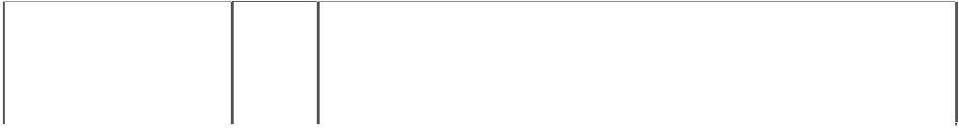

|  |  |  |
| --- | --- | --- |
| head, playboy rabbit, silhouette wearing bowtie; square,  rounded-corners (280839) | 3 | Perfume and cosmetics. |
| head, playboy rabbit, silhouette wearing bowtie; square,  rounded-corners (368119) | 5 | Air fresheners, deodorants and all other goods included in this class. |
| head, playboy rabbit, silhouette wearing bowtie; square,  rounded-corners (303189) | 9 | Sunglasses. |
| head,playboy rabbit, silhouette wearing bowtie; square,  rounded-corners (280841) | 9 | Records and tapes being goods included in this class. |
| head, playboy rabbit, silhouette wearing bowtie; square,  rounded-corners (303907) | 9 | Optical frames, motorcycle and ski goggles and sport glasses and all other goods included in this class. |
| head, playboy rabbit, silhouette wearing bowtie; square,  rounded-corners (427869) | 12 | Motor vehicles; and automotive products, namely sun visor mirrors, gear shift knobs, anti-theft devices for automobiles, visor organisers (these being attachments to automobile sun visors for holding pens, note paper and other items), dashtrays, all the foregoing being for  motor vehicles; and all other goods in this class. |
| head, playboy rabbit, silhouette wearing bowtie; square,  rounded-corners (282586) | 14 | Precious metals and their alloys and goods in precious metals or coated therewith (except cutlery, forks and spoons); jewellery; precious stones; horological and other chronometric instruments. |
| head, playboy rabbit, silhouette wearing bowtie; square,  rounded-corners (177119) | 16 | Printed periodicals and publications including monthly magazines. |
| head, playboy rabbit, silhouette wearing bowtie; square,  rounded-corners (341029) | 16 | Binders and other stationery materials in this class and all other goods in this class. |
| head, playboy rabbit, silhouette wearing bowtie; square,  rounded-corners (280845) | 18 | Leather goods. |
| head, playboy rabbit, silhouette wearing bowtie; square, rounded-corners  (450674) | 18 | Umbrellas, parasols and walking sticks; leather and imitations of leather, and goods made of these materials and not included in other classes; animal skins, hides; trunks and travelling bags; whips, harness and saddlery. |
| head, playboy rabbit, silhouette wearing bowtie; square,  rounded-corners (292792) | 21 | Glassware. |
| head, playboy rabbit, silhouette wearing bowtie; square,  rounded-corners (308295) | 24 | All goods included in this class. |



|  |  |  |
| --- | --- | --- |
| head, playboy rabbit, silhouette wearing bowtie; square,  rounded-corners (438859) | 24 | Quilts, bedspreads and bed linen; piece goods; and all other textiles and textile goods in this class. |
| head, playboy rabbit, silhouette wearing bowtie; square,  rounded-corners (312472) | 25 | All the goods in this class. |
| head, playboy rabbit, silhouette wearing bowtie; square,  rounded-corners (308296) | 26 | All goods included in this class. |
| head, playboy rabbit, silhouette wearing bowtie; square,  rounded-corners (280848) | 28 | Games and toys. |
| head, playboy rabbit, silhouette wearing bowtie; square,  rounded-corners (181200) | 29 | Foods included in this class. |
| head, playboy rabbit, silhouette wearing bowtie; square,  rounded-corners (280850) | 32 | Beer, ale and porter; mineral and aerated waters and other non- alcoholic drinks; syrups and other preparations for making beverages. |
| head, playboy rabbit, silhouette wearing bowtie; square,  rounded-corners (280851) | 34 | Smokers' articles. |
| head, rabbit silhouette wearing bowtie & life savers cap  (345459) | 16 | All goods in this class including magazines. |
| head, rabbit, silhouette & bowtie in square, rounded-corners  (489048) | 20 | Automotive accessories in this class; plastic extrusions for decoration on motor vehicles; motor vehicle door guards and all other goods in this class. |
| head, rabbit, silhouette & bowtie in square, rounded-corners  (489049) | 20 | Automotive accessories in this class; coin holders of plastic and all other goods in this class. |
| head, rabbit wearing bowtie in square, rounded-corners (482615) | 6 | Common metals and their alloys; metal building materials; transportable buildings of metal; materials of metal for railway tracks; non-electric cables and wires of common metal; ironmongery, small items of metal hardware; pipes and tubes of metal; safes; goods of  common metal not included in other clases; ores. |
| head, rabbit wearing bowtie in square, rounded-corners (482614) | 9 | Scientific, nautical, surveying, electric, photographic, cinematographic, optical, weighing, measuring, signalling, checking (supervision), life-saving and teaching apparatus and instruments; apparatus for recording, transmission or reproduction of sound or images; magnetic data carriers, recording discs; automatic vending machines and mechanisms for coin-operated apparatus; cash registers, calculating machines and data processing equipment; fire-  extinguishing apparatus. |
| nude woman, on her back, black stockings and gloves, laughing  (868394) | 9 | Recording disks and apparatus for recording, transmission or reproduction of sound or images including CD-ROMs and CD-ROM calendars and other electronic or digital recording media. |

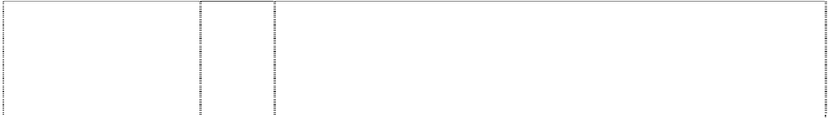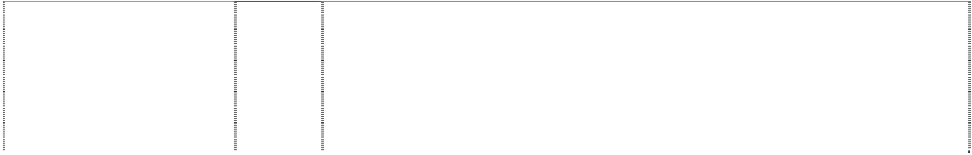

|  |  |  |
| --- | --- | --- |
| nude woman, on her back, black stockings and gloves, laughing  (868394) | 16 | Paper, cardboard and goods made from these materials and printed matter including journals, address books, photo albums, boxed cards, books, gift boxes, calendars, date books and academic  planners. |
| nude woman, kneeling, with black stockings and gloves, key  (458666) | 16 | Printed matter, including magazine publications. |
| rabbit, head, silh.  wears bowtie (1114946) | 10 | Contraceptives in this class; condoms. |
| rabbit, head, silh. wears bowtie (954951) | 21 | Household or kitchen utensils and containers (not of precious metal or coated therewith), including bottle openers and magnetic bottle openers; combs and sponges; brushes (except paint brushes); brush-making materials; articles for cleaning purposes; steel wool; unworked or semi-worked glass (except glass used in buildings);  glassware, porcelain and earthenware not included in other classes. |
| rabbit, head, silh. wears bowtie  (1067315) | 27 | Carpets, rugs, mats and matting, and other materials for covering floors including mats for pets and pet food mats. |
| rabbit, head, silh.  wears bowtie (991559) | 28 | Games and playthings; gymnastic and sporting articles not included  in other classes; decorations for Christmas trees and festive holiday ornaments including snow globes. |
| rabbit, head, silh. wears bowtie in square, rounded- corners (949454) | 28 | Games, toys and playthings; including amusement machines, automatic and coin-operated amusement machines, backgammon games, billiard balls, billiard cue tips, billiard cues, billiard marker, billiard table cushions, billiard tables, coin-operated billiard tables, bingo cards, playing cards, chalk for billiard cues, checkerboards, checkers, chess games, chessboards, cups for dice, darts, dartboards, dice, dominoes, mah-jong, marbles for games, roulette  wheels. |
| rabbit, head, stylised with bowtie  (181201) | 33 | Liquors included in this class. |
| rabbit head in bowtie in square rounded- corners  (589280) | 10 | Contraceptives in this class; condoms. |
| rabbit, head, silhouette with bowtie  (916179) | 9 | Scientific, nautical, surveying, electric, photographic, cinematographic, optical, weighing, measuring, signalling, checking (supervision), life-saving and teaching apparatus and instruments; apparatus for recording, transmission or reproduction of sound or images, including telephones, cordless telephones, mobile or cell telephones, mobile or cell phone face plates and mobile or cell phone accessories; magnetic data carriers, recording discs, automatic vending machines and mechanisms for coin-operated apparatus; cash registers; calculating machines and data processing equipment, fire extinguishing apparatus; and parts and accessories  to the aforementioned goods. |
| rabbit, head, stylised wearing bowtie; square, rounded- corners  (492297) | 30 | Coffee, tea, cocoa, sugar, rice, tapioca, sago, artificial coffee; flour and preparations made from cereals, bread, pastry and confectionery, ices; honey, treacle; yeast, baking-powder; salt, mustard; vinegar, sauces (except salad dressings); spices; ice. |
| rabbit, head wears bowtie  (1064916) | 18 | Products for pets and animals in this class including collars for  animals, dog collars, harness for animals, horse blankets, horse collars, leather leashes, and clothing for pets including bandanas. |
| woman dressed in rabbit costume  (playboy bunny) (190199) | 30 | Coffee, tea, cocoa, sugar, rice, tapioca, sago, coffee substitutes; flour, and preparations made from cereals; bread, biscuits, cakes,  pastry and confectionery, ices; honey, treacle; yeast, baking-powder; salt, mustard, pepper, vinegar, sauces, spices; ice. |
| woman dressed in rabbit costume  (playboy bunny) (190198) | 33 | Wines, spirits and liqueurs. |

***Rugby World Cup Limited Allens Arthur Robinson Ph: (02) 9230 4000***

***Effective Date: 9 August 2007 File Reference: C07/12808***



|  |  |  |
| --- | --- | --- |
| ***Trade Marks*** | ***Class*** | ***Goods*** |
| **iRB**  (774886) | 16 | Printed matter, periodical publications, books, magazines, brochures, programmes, posters, photographs, diaries, calendars, stickers, bookmarks, stationery, pens, pencils, crayons, ordinary playing cards, maps, stamps, postcards, greeting cards, paper shopping  bags, plastic bags for wrapping and packaging, desk sets, paper weights, pictures, flags, tickets. |
| **iRB**  (774886) | 25 | Clothing, footwear, headgear, sports and leisure clothing, underwear for men, ties, scarves, footwear for sports. |
| **iRB**  (774886) | 28 | Gymnastic and sporting articles; games; rugby balls; toys; protective headgear; scrum caps, protective paddings for sports, shoulder  padding, breast padding. |
| **RUGBY WORLD CUP**  (947324) | 16 | Paper, cardboard and goods made from these materials, not included in other classes; bookbinding material; stationery; adhesives for stationery or household purposes; artist's materials; paint brushes; typewriters and office requisites (except furniture); instructional and teaching material (except apparatus); plastic materials for packaging (not included in other classes); printers' type;  printing blocks. |
| **RUGBY WORLD CUP**  (914058) | 18 | Leather and imitations of leather, and goods made of these materials and not included in other classes; animal skins, hides; trunks and  travelling bags; umbrellas, parasols and walking sticks; whips, harness and saddlery. |
| **RUGBY WORLD CUP**  (899218) | 25 | Clothing, footwear, headgear. |
| **RUGBY WORLD CUP**  (914058) | 26 | Lace and embroidery, ribbons and braid; buttons, hooks and eyes, pins and needles; artificial flowers. |
| **RUGBY WORLD CUP**  (899218) | 28 | Games and playthings; gymnastic and sporting articles not included in other classes; decorations for Christmas trees. |
| **RUGBY WORLD CUP**  (947324) | 28 | Playing cards. |
| **RUGBY WORLD CUP**  football,striped (446275) | 28 | Games and playthings, gymnastic and sporting articles insofar as not comprised in other classes. |
| **RUGBY WORLD CUP**  football striped (446276) | 32 | Beer; mineral and aerated waters and other non alcoholic drinks; fruit drinks and fruit juices; syrups and other preparations for making  beverages. |
| **RUGBY WORLD CUP**  football,striped (446279) | 18 | Leather and imitations of leather, and goods made of these materials insofar as not comprised in other classes; animal skins, hides; trunks and travelling bags; umbrellas, parasols and walking sticks; whips  and saddlery. |
| **RUGBY WORLD CUP**  football,striped (446280) | 21 | Household or kitchen utensils and containers (not of precious metals or coated therewith); combs and sponges; brushes (except paint brushes); brush-making materials; articles for cleaning purposes; steel wool; unworked or semi-worked glass (except glass used in  building); glassware, porcelain and earthenware insofar as not comprised in other classes. |
| **RUGBY WORLD CUP**  football,striped (446281) | 24 | Textiles and textile goods in so far as not included in other classes; bed and table covers. |
| **RUGBY WORLD CUP**  football,striped (446282) | 25 | Clothing, footwear, headgear. |

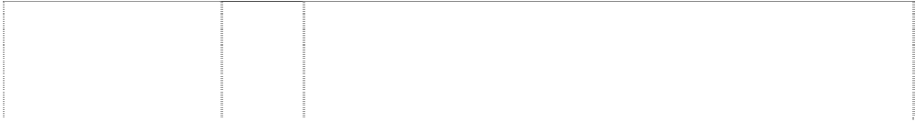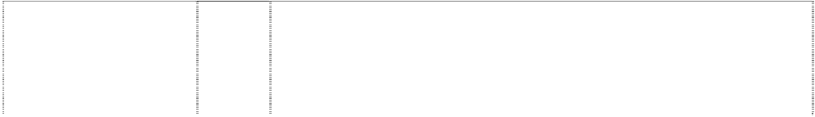

|  |  |  |
| --- | --- | --- |
| **RUGBY WORLD CUP**  football,striped (446283) | 9 | Scientific, nautical, surveying and electric apparatus and instruments insofar as not comprised in other classes, photographic, cinematographic, optical, weighing, measuring, signalling, checking (supervision), life-saving and teaching apparatus and instruments; apparatus for recording, transmission or reproduction of sound or images; magnetic data carriers, recording discs; automatic vending machines and mechanisms for coin-operated apparatus; cash registers, calculating machines and data processing equipment; fire-  extinguishing apparatus. |
| **RUGBY WORLD CUP**  football,striped (446284) | 12 | Vehicles; apparatus for locomotion by land, air or water. |
| **RUGBY WORLD CUP**  football,striped (446285) | 14 | Precious metals and their alloys and goods in precious metals or coated therewith, excluding cigar and cigarette boxes, cigar and cigarette holders and ashtrays of precious metals insofar as not comprised in other classes; jewellery, trinkets, precious stones;  horological and chronometric instruments. |
| **RUGBY WORLD CUP**  football,striped (446286) | 16 | Paper, cardboard and goods made from these materials, insofar as not comprised in other classes; printed matter; bookbinding material; photographs; stationery; adhesives for stationery or household purposes; artists' material; paint brushes; typewriters and office requisites (except furniture); instructional and teaching material (except apparatus); plastic materials for packaging, insofar as not  comprised in other classes; playing cards; printers' type; printing blocks. |
| **RUGBY WORLD CUP**  football,striped (446288) | 3 | Bleaching preparations and other substances for laundry use; cleaning, polishing, scouring and abrasive preparations; soaps; perfumery and essential oils, cosmetics, hair lotions; dentifrices. |
| **RUGBY WORLD CUP**  football,striped (446289) | 33 | Alcoholic beverages (except beers). |
| **RUGBY WORLD CUP**  oblique stripes form football in rectangle (560170) | 20 | Picture frames; non-metallic trays; bins and boxes of wood or plastic materials; chairs; cushions; wall plaques; all included in class 20; and all other goods in this class. |
| **RUGBY WORLD CUP**  oblique stripes form football in rectangle (560171) | 26 | Badges (not of precious metal); buttons; embroidery, all included in class 26; and all other goods in this class. |
| **RUGBY WORLD CUP**  oblique stripes form football in rectangle (560172) | 29 | Prepared food products, meals and snacks all made from meat, fish, poultry, game, soya, cheese and vegetables, singly or in combination; soups and preparations for making soups; prepared or cooked potatoes; potato crisps, potato snack products; prepared nuts; milk, milk shakes being milk beverages, the milk predominating; jams, preserves and marmalades; all included in class 29; and all  other goods in this class. |
| **RUGBY WORLD CUP**  oblique stripes form football in rectangle (560174) | 30 | Coffee, chicory, tea; cocoa; sandwiches; starch products for food; sauces for food; ice cream and frozen confections; confectionery, bakery products, biscuits, chocolate; snack food products made from flour or cereals; pies; pizzas; all included in class 30; and all other  goods in this class. |
| **RWC**  (919098) | 9 | Computer games adapted for use with television receivers, computer  games software, video games on disc; video games on tape and video games programs. |
| **RWC**  (919098) | 16 | Printed matter, periodical publications, books, magazines, brochures, programs, bookmarks, stationery, pens, pencils, crayons, posters, photographs, diaries, calendars, stickers, maps, stamps, postcards,  greeting cards, paper shopping bags, plastic bags for wrapping and packaging, desk accessories. |
| **RWC**  (919098) | 18 | Bags, travel bags, sports bags, plastic bags, umbrellas, key fobs, personal items of leather or imitation leather, wallets, purses. |
| **RWC**  (919098) | 25 | Clothing, footwear, headgear; sports and leisure clothing, underwear for men, ties, scarves, footwear for sport; headgear for sport. |
| **RWC**  (919098) | 26 | Badges (not of precious metal); buttons; embroidery. |

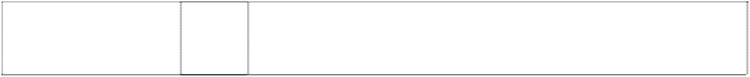

|  |  |  |
| --- | --- | --- |
| **RWC**  (919098) | 28 | Toys, games; computer games and video games being electronic computer games (coin or counter fed), other than those adapted for use with television receivers, automatic handheld computer games, electronic games incorporating their own visual display facilities, apparatus for electronic games other than those adapted for use with television receivers only; sporting and gymnastic articles; rugby balls;  ordinary playing cards. |
| **RWC03**  (919097) | 9 | Computer games adapted for use with television receivers, computer games software, video games on disc; video games on tape and  video games programs. |
| **RWC03**  (919097) | 16 | Printed matter, periodical publications, books, magazines, brochures, programs, bookmarks, stationery, pens, pencils, crayons, posters, photographs, diaries, calendars, stickers, maps, stamps, postcards, greeting cards, paper shopping bags, plastic bags for wrapping and  packaging, desk accessories. |
| **RWC03**  (919097) | 18 | Bags, travel bags, sports bags, plastic bags, umbrellas, key fobs, personal items of leather or imitation leather, wallets, purses. |
| **RWC03**  (919097) | 25 | Clothing, footwear, headgear; sports and leisure clothing, underwear for men, ties, scarves, footwear for sport; headgear for sport. |
| **RWC03**  (919097) | 26 | Badges (not of precious metal); buttons; embroidery. |
| **RWC03**  (919097) | 28 | Toys, games; computer games and video games being electronic computer games (coin or counter fed), other than those adapted for use with television receivers, automatic handheld computer games, electronic games incorporating their own visual display facilities, apparatus for electronic games other than those adapted for use with  television receivers only; sporting and gymnastic articles; rugby balls; ordinary playing cards. |
| patterned goblet on pedestal is trophy (754250) | 16 | Printed matter, periodical publications, books, magazines, brochures, programmes, posters, photographs, diaries, calendars, stickers, bookmarks, stationery, pens, pencils, crayons, ordinary playing cards, maps, stamps, postcards, greeting cards, paper shopping  bags, plastic bags for wrapping and packaging, desk sets, paper weights, pictures, flags, tickets. |
| patterned goblet on pedestal is trophy (754250) | 25 | Clothing, footwear, headgear, sports and leisure clothing, underwear for men, ties, scarves, footwear for sports. |
| patterned goblet on pedestal is trophy  (754250) | 28 | Gymnastic and sporting articles; games; rugby balls; toys. |
| ornate trophy has arabesques, figurehead handles,lid (754251) | 16 | Printed matter, periodical publications, books, magazines, brochures, programmes, posters, photographs, diaries, calendars, stickers, bookmarks, stationery, pens, pencils, crayons, ordinary playing cards, maps, stamps, postcards, greeting cards, paper shopping  bags, plastic bags for wrapping and packaging, desk sets, paper weights, pictures, flags, tickets. |
| ornate trophy has arabesques,  figurehead handles,lid (754251) | 25 | Clothing, footwear, headgear, sports and leisure clothing, underwear for men, ties, scarves, footwear for sports. |
| ornate trophy has arabesques,  figurehead handles,lid (754251) | 28 | Gymnastic and sporting articles; games; rugby balls; toys. |

***The Rotel Co. Ltd Clayton Utz***

***Ph: (03) 9286 6000***

***Effective Date: 23 August 2007 File Reference: C07/12802***



|  |  |  |
| --- | --- | --- |
| ***Trade Marks*** | ***Class*** | ***Goods*** |
| **ROTEL**  (1117931) | 9 | Apparatus for recording, transmission or reproduction of sound or images; loudspeakers, amplifiers, pre amplifiers, tuners, compact disc players, cassette recorders, turntables, receivers, radios, DVD players, DVD recorders, remote control apparatus, switch boxes, power sequencers, phono equalizers, video recorders, sound recording discs, sound recording carriers, compact discs, cassette  tapes, records; parts and fittings for all the aforesaid goods. |

***Wrangler Apparel Corp Phillips Ormonde & Fitzpatrick Ph: (03) 9614 1944***

***Effective Date: 21 June 2007 File Reference: C07/09652***



|  |  |  |
| --- | --- | --- |
| ***Trade Marks*** | ***Class*** | ***Goods*** |
| **20X**  (1115780) | 18 | Leather and imitations of leather and goods made of these materials not included in other classes; trunks, travelling and carry bags, sports bags, backpacks and other bags in this class; key rings in this class;  equestrian articles in this class; umbrellas, belts in this class. |
| **20X**  (1115780) | 25 | Clothing, including jeans, casual pants, shorts, shirts, T-shirts, blouses, tank tips, tops, knit shirts, jackets, hooded sweatshirts, boxer shorts, socks; apparel or clothing accessories in this class; footwear including boots and shoes; belts and buckles; headgear  including hats and caps. |
| **BLUE BELL**  bell inside circle (232329) | 25 | Work and sports clothes, overalls and dungarees, but not including  knitted outerwear, boots and shoes or leggings or articles of clothing made from leather. |
| **BLUE BELL**  bell_inside circle (152868) | 25 | Work and sports clothes, overalls and dungarees, but not including knitted outerwear, boots and shoes or leggings or articles of clothing made from leather. |
| **COWBOY CUT**  (788973) | 25 | Articles of clothing including men’s women’s and children’s jeans, pants, shorts, knit/woven tops, shirts, vests, jackets, sweater,  blouses, belts, shoes and stockings, but excluding socks. |
| **HERO BY WRANGLER** (910585) | 25 | Pants, jeans, slacks, trousers, shorts, shirts of all kinds, pullovers; skirts; sweaters, vests, jackets, and other clothing; belts and suspenders; hats, caps, bandanas, and other headwear; socks,  shoes, boots and other footwear. |
| **RUSTLER**  (711338) | 25 | Clothing, footwear and headgear. |
| **TIMBER CREEK BY WRANGLER** (916574) | 18 | Leather and imitations of leather, and goods made from these materials and not included in other classes; animal skins and hides including fur skins and moleskins; chinstraps (of leather), belts and suspenders in this class; bandoliers; trunks and traveling bags; backpacks, bags, beach bags, briefcases, cases (of leather or leatherboard), handbags, haversacks, rucksacks, satchels, shoulder  bags, suitcases, valises; umbrellas; parasol and walking sticks. |
| **TIMBER CREEK BY WRANGLER** (916574) | 25 | Clothing including jeans, casual pants, slacks, trousers, sweatpants, shorts, overalls, coveralls, button-front shirts, knit-shirts, woven shirts, pullover shirts, blouses, t-shirts, sweatshirts, hooded shirts, sweaters, skirts, casual dresses, vests, jackets with or without hoods, coats, gloves and mittens, socks and hosiery; headgear including  hats, caps and bandanas; belts and suspenders; but excluding all footwear other than socks and hosiery. |
| **TWENTY X**  (1115779) | 18 | Leather and imitations of leather and goods made of these materials not included in other classes; trunks, traveling and carry bags, sports  bags, backpacks and other bags in this class; key rings in this class; equestrian articles in this class; umbrellas, belts in this class. |



|  |  |  |
| --- | --- | --- |
| **TWENTY X**  (1115783) | 18 | Leather and imitations of leather and goods made of these materials not include in other classes; trunks, traveling and carry bags, sports bags, backpacks and other bags in this class; key rings in this class;  equestrian articles in this class; umbrellas, belts in this class. |
| **TWENTY X**  (1115779) | 25 | Clothing, including jeans, casual pants, shorts, shirts, T-shirts, blouses, tank tops, tops, knit shirts, jackets, hooded sweatshirts, boxer shorts, socks; apparel or clothing accessories in this class; footwear including boots and shoes; belts and buckles; headgear  including hats and caps. |
| **TWENTY X**  (1115783) | 25 | Clothing, including jeans, casual pants, shorts, shirts, T-shirts, blouses, tank tops, tops, knit shirts, jackets, hooded sweatshirts, boxer shorts, socks; apparel or clothing accessories in this class; footwear including boots and shoes; belts and buckles; headgear  including hats and caps. |
| **TWENTYX 20X**  (1115781) | 18 | Leather and imitations of leather and goods made of these materials not included in other classes; trunks, traveling and carry bags, sports bags, backpacks and other bags in this class; key rings in this class;  equestrian articles in this class; umbrellas, belts in this class. |
| **TWENTYX 20X**  (1115781) | 25 | Clothing, including jeans, casual pants, shorts, shirts, T-shirts, blouses, tank tips, tops, knit shirts, jackets, hooded sweatshirts, boxer shorts, socks; apparel or clothing accessories in this class; footwear including boots and shoes; belts and buckles; headgear  including hats and caps. |
| **W**  pocket with stitches forming ltr W (932801) | 14 | Precious metals and their alloys and goods in precious metals or coated therewith, not included in other classes; jewellery, precious stones; horological and chronometric instruments; alarm clocks; amulets; anchors; ashtrays, of precious metal, for smokers; badges of precious metal; barrels (clock - and watchmaking); boxes of precious metal; bracelets; brooches; buckles of precious metal; busts of precious metal; candelabra of precious metal, candle rings of precious metal, candlesticks of precious metal; cases for clock - and watchmaking, cases for watches (presentation); chain mesh purses of precious metal; chains; cigar boxes of precious metal; cigar cases of precious metal; cigarette cases of precious metal; cigarette holders of precious metal; clock cases; clock hands; clocks; clocks and watches, electric; clockworks; coffee services of precious metal; coffeepots, non-electric, of precious metal; coins; cruet stands of precious metal; cruets of precious metal; cuff links; dials (clock - and watchmaking); dishes of precious metal; earrings; egg cups of precious metal; epergnes of precious metal; figurines of precious metal; flasks of precious metal; goblets of precious metal; gold and silver ware, other than cutlery, forks and spoons; gold (objects of imitation - ); harness fittings of precious metal; hat ornaments (of precious metal); household containers of precious metal; household utensils of precious metal; jewel cases of precious metal; jugs of precious metal; key rings; kitchen containers of precious metal; kitchen utensils of precious metal, matchboxes of precious metal, match holders of precious metal, medallions, medals, movements for clocks and watches; napkin holders of precious metal, napkin rings of precious metal, necklaces, needle cases of precious metal, needles of precious metal, nutcrackers of precious metal; ormolu ware, ornamental pins, ornaments, pendulums (clock- and watchmaking); purses of precious metal, rings; salad bowls of precious metal, salt cellars of precious metal, salt shakers of precious metal, saucers of precious metal, services (tableware) of precious metal, shoe ornaments (of precious metal); silver ornaments, silver plate; snuff boxes of precious metal, soup bowls of precious metal, statues of precious metal, statuettes of precious metal, stopwatches, straps for wristwatches, sundials; table plates of precious metal, tankards of precious metal, tea caddies of precious metal, tea infusers of precious metal, tea services of precious metal, tea strainers of precious metal, teapots of precious metal; tie clips, tie pins, tobacco jars of precious metal; trays of precious metal, for household purposes, trinkets, urns of precious metal, vases of precious metal, watch bands, watch cases, watch chains, watch crystals, watch glasses, watch springs, watches, works of art of  precious metal, wristwatches; parts and fittings for the aforesaid goods. |



|  |  |  |
| --- | --- | --- |
| **W**  pocket with stitches forming ltr W (932801) | 18 | Leather and imitations of leather, and goods made of these materials and not included in other classes; animal skins, hides; trunks and travelling bags; umbrellas, parasols and walking sticks; whips, harness and saddlery; alpenstocks; attache cases; backpacks; bags of leather, for packaging; bags for campers; bags for climbers; bandoliers; bands of leather; beach bags; bits for animals; boxes of leather or leather board; boxes of vulcanised fibre; briefcases; canes; card cases; cases, of leather or leatherboard; chain mesh purses, not of precious metal; chamois leather, other than for cleaning purposes; chin straps, of leather; clothing for pets; collars for animals; coverings of skins (furs); covers for animals; dog collars; envelopes, of leather, for packaging; fastenings for saddles; frames for umbrellas or parasols; fur; furniture coverings of leather; fur-skins; game bags; garment bags for travel; halters; handbag frames; handbags; harness fittings, not of precious metal; harness fittings of iron; harness for animals; harness straps; harness traces; hat boxes of leather; haversacks; horse blankets; horse collars; imitation leather; key cases; laces; leather leads; leather leashes; leather shoulder belts; leather straps; leather thongs; leather thread; leather twists; leather, unworked or semi-worked; leatherboard; moleskin; mountaineering sticks; music cases; net bags for shopping; pelts; pocket wallets; pouches, of leather, for packaging; purses; reins; riding saddles; rucksacks; saddle cloths for horses; saddle trees; school bags; school satchels; shopping bags; shoulder belts (straps), of leather; skins of chamois, other than for cleaning purposes; sling bags for carrying infants; stirrup leathers; straps for skates; straps for soldiers' equipment; suitcase handles; suitcases; tool bags of leather (empty); travelling sets (leatherware); travelling trunks; trimmings of leather for furniture; umbrella covers; umbrella handles; umbrella or parasol ribs; umbrella rings; umbrella sticks; valises; vanity cases; walking cane handles; walking stick handles; walking stick seats; wallets; wheeled shopping bags; and parts and fittings for the  aforesaid goods. |
| **W**  pocket with stitches forming ltr W (932801) | 25 | Clothing, footwear, headgear; aprons, babies' diapers of textile; babies' pants, bandanas, bath robes, bath sandals; bath slippers, bathing caps, bathing suits, bathing trunks, beach clothes, beach shoes, belts, berets, boot uppers, boots, boots for sports, braces for clothing, brassieres, camisoles, cap peaks, caps (headwear), coats, collars (clothing), corselets, corsets, cuffs, cyclists' clothing, dressing gowns, ear muffs, esparto shoes or sandals, fittings of metal for shoes and boots, footwear uppers, frocks, fur stoles, furs (clothing), gabardines, gaiter straps, gaiters, galoshes, garters, girdles, gloves (clothing), hats, headbands, heelpieces, heels, hoods (clothing), hosiery, inner soles, jackets (clothing), jerseys, jumpers, knitwear (clothing), layettes (clothing), leggings, mittens, money belts, motorists' clothing, muffs (clothing), neckties, outerclothing, overalls, overcoats, pants, parkas, pelisses, petticoats, pullovers, pyjamas, sandals, saris, sashes for wear, scarfs, shawls, shirt yokes, shirts, shoes, shoulder wraps, shower caps, singlets, ski boots, skirts, skull caps, slippers, slips (undergarments), smocks, socks, soles for footwear, spats, sports shoes, stockings, suits, sun visors, suspenders, sweaters, swimsuits, tee-shirts, tights, topcoats, trouser  straps, trousers, underclothing, underwear, vests, waistcoats, waterproof clothing, wristbands. |
| **W WRANGLER**  pocket badge (285390) | 25 | Clothing, including jeans and jackets. |



|  |  |  |
| --- | --- | --- |
| **WRANGLER**  (941703) | 9 | Scientific, nautical, surveying, photographic, cinematographic, optical, weighing, measuring, signalling, checking (supervision), life- saving and teaching apparatus and instruments; apparatus and instruments for conducting, switching, transforming, accumulating, regulating or controlling electricity; apparatus for recording, transmission or reproduction of sound or images; automatic vending machines and mechanisms for coin-operated apparatus; cash registers and calculating machines; fire-extinguishing apparatus;  anti-dazzle shades; anti-glare glasses and visors; binoculars; contact lenses and containers for contact lenses; correcting lenses (optics); eyeglasses and eyeglass cases, chains, cords and frames; eyepieces; eyeshades; goggles for sports; lenses (optical); pince-nez and pince-nez cases, chains, cords and mountings; spectacles (optics) and spectacle cases, frames and glasses; sunglasses;  telescopes; accessories for eyewear in this class; none of the foregoing including computer hardware, firmware or software. |
| **WRANGLER**  (941704) | 9 | Scientific, nautical, surveying, photographic, cinematographic, optical, weighing, measuring, signalling, checking (supervision), life- saving and teaching apparatus and instruments; apparatus and instruments for conducting, switching, transforming, accumulating, regulating or controlling electricity; apparatus for recording, transmission or reproduction of sound or images; automatic vending machines and mechanisms for coin-operated apparatus; cash registers and calculating machines; fire-extinguishing apparatus;  anti-dazzle shades; anti-glare glasses and visors; binoculars; contact lenses and containers for contact lenses; correcting lenses (optics); eyeglasses and eyeglass cases, chains, cords and frames; eyepieces; eyeshades; goggles for sports; lenses (optical); pince-nez and pince-nez cases, chains, cords and mountings; spectacles (optics) and spectacle cases, frames and glasses; sunglasses; telescopes; accessories for eyewear in this class; none of the  foregoing including computer hardware, firmware or software. |
| **WRANGLER**  (941704) | 14 | Precious metals and their alloys and goods in precious metals or coated therewith, not included in other classes; jewellery, precious stones; horological and chronometric instruments; alarm clocks; amulets; anchors; ashtrays, of precious metal, for smokers; badges of precious metal; barrels (clock - and watchmaking); boxes of precious metal; bracelets; brooches; buckles of precious metal; busts of precious metal; candelabra of precious metal, candle rings of precious metal, candlesticks of precious metal; cases for clock - and watchmaking, cases for watches (presentation); chain mesh purses of precious metal; chains; cigar boxes of precious metal; cigar cases of precious metal; cigarette cases of precious metal; cigarette holders of precious metal; clock cases; clock hands; clocks; clocks and watches, electric; clockworks; coffee services of precious metal; coffeepots, non-electric, of precious metal; coins; cruet stands of precious metal; cruets of precious metal; cuff links; dials (clock - and watchmaking); dishes of precious metal; earrings; egg cups of precious metal; epergnes of precious metal; figurines of precious metal; flasks of precious metal; goblets of precious metal; gold and silver ware, other than cutlery, forks and spoons; gold (objects of imitation - ); harness fittings of precious metal; hat ornaments (of precious metal); household containers of precious metal; household utensils of precious metal; jewel cases of precious metal; jugs of precious metal; key rings; kitchen containers of precious metal; kitchen utensils of precious metal, matchboxes of precious metal, match holders of precious metal, medallions, medals, movements for clocks and watches; napkin holders of precious metal, napkin rings of precious metal, necklaces, needle cases of precious metal, needles of precious metal, nutcrackers of precious metal; ormolu ware, ornamental pins, ornaments, pendulums (clock - and watchmaking); purses of precious metal, rings; salad bowls of precious metal, salt cellars of precious metal, salt shakers of precious metal, saucers of precious metal, services (tableware) of  precious metal, shoe ornaments (of precious metal); silver ornaments, silver plate; snuff boxes of precious metal, soup bowls of |

precious metal, statues of precious metal, statuettes of precious metal, stopwatches, straps for wristwatches, sundials; table plates of precious metal, tankards of precious metal, tea caddies of precious metal, tea infusers of precious metal, tea services of precious metal, tea strainers of precious metal, teapots of precious metal; tie clips, tie pins, tobacco jars of precious metal; trays of precious metal, for household purposes, trinkets, urns of precious metal, vases of precious metal, watch bands, watch cases, watch chains, watch crystals, watch glasses, watch springs, watches, works of art of precious metal, wristwatches; parts and fittings for the aforesaid goods.



|  |  |  |
| --- | --- | --- |
| **WRANGLER**  (932799) | 14 | Precious metals and their alloys and goods in precious metals or coated therewith, not included in other classes; jewellery, precious stones; horological and chronometric instruments; alarm clocks; amulets; anchors; ashtrays, of precious metal, for smokers; badges of precious metal; barrels (clock-and watchmaking); boxes of precious metal; bracelets; brooches; buckles of precious metal; busts of precious metal; candelabra of precious metal, candle rings of precious metal, candlesticks of precious metal; cases for clock - and watchmaking, cases for watches (presentation); chain mesh purses of precious metal; chains; cigar boxes of precious metal; cigar cases of precious metal; cigarette cases of precious metal; cigarette holders of precious metal; clock cases; clock hands; clocks; clocks and watches, electric; clockworks; coffee services of precious metal; coffeepots, non-electric, of precious metal; coins; cruet stands of precious metal; cruets of precious metal; cuff links; dials (clock - and watchmaking); dishes of precious metal; earrings; egg cups of precious metal; epergnes of precious metal; figurines of precious metal; flasks of precious metal; goblets of precious metal; gold and silver ware, other than cutlery, forks and spoons; gold (objects of imitation - ); harness fittings of precious metal; hat ornaments (of precious metal); household containers of precious metal; household utensils of precious metal; jewel cases of precious metal; jugs of precious metal; key rings; kitchen containers of precious metal; kitchen utensils of precious metal, matchboxes of precious metal, match holders of precious metal, medallions, medals, movements for clocks and watches; napkin holders of precious metal, napkin rings of precious metal, necklaces, needle cases of precious metal, needles of precious metal, nutcrackers of precious metal; ormolu ware, ornamental pins, ornaments, pendulums (clock- and watchmaking); purses of precious metal, rings; salad bowls of precious metal, salt cellars of precious metal, salt shakers of precious metal, saucers of precious metal, services (tableware) of precious metal, shoe ornaments (of precious metal); silver ornaments, silver plate; snuff boxes of precious metal, soup bowls of precious metal, statues of precious metal, statuettes of precious metal, stopwatches, straps for wristwatches, sundials; table plates of precious metal, tankards of precious metal, tea caddies of precious metal, tea infusers of precious metal, tea services of precious metal, tea strainers of precious metal, teapots of precious metal; tie clips, tie pins, tobacco jars of precious metal; trays of precious metal, for household purposes, trinkets, urns of precious metal, vases of precious metal, watch bands, watch cases, watch chains, watch crystals, watch glasses, watch springs, watches, works of art of precious metal, wristwatches; parts and fittings for the aforesaid goods. |



|  |  |  |
| --- | --- | --- |
| **WRANGLER**  (932800) | 14 | Precious metals and their alloys and goods in precious metals or coated therewith, not included in other classes; jewellery, precious stones; horological and chronometric instruments; alarm clocks; amulets; anchors; ashtrays, of precious metal, for smokers; badges of precious metal; barrels (clock - and watchmaking); boxes of precious metal; bracelets; brooches; buckles of precious metal; busts of precious metal; candelabra of precious metal, candle rings of precious metal, candlesticks of precious metal; cases for clock - and watchmaking, cases for watches (presentation); chain mesh purses of precious metal; chains; cigar boxes of precious metal; cigar cases of precious metal; cigarette cases of precious metal; cigarette holders of precious metal; clock cases; clock hands; clocks; clocks and watches, electric; clockworks; coffee services of precious metal; coffeepots, non-electric, of precious metal; coins; cruet stands of precious metal; cruets of precious metal; cuff links; dials (clock - and watchmaking); dishes of precious metal; earrings; egg cups of precious metal; epergnes of precious metal; figurines of precious metal; flasks of precious metal; goblets of precious metal; gold and silver ware, other than cutlery, forks and spoons; gold (objects of imitation - ); harness fittings of precious metal; hat ornaments (of precious metal); household containers of precious metal; household utensils of precious metal; jewel cases of precious metal; jugs of precious metal; key rings; kitchen containers of precious metal; kitchen utensils of precious metal, matchboxes of precious metal, match holders of precious metal, medallions, medals, movements for clocks and watches; napkin holders of precious metal, napkin rings of precious metal, necklaces, needle cases of precious metal, needles of precious metal, nutcrackers of precious metal; ormolu ware, ornamental pins, ornaments, pendulums (clock- and watchmaking); purses of precious metal, rings; salad bowls of precious metal, salt cellars of precious metal, salt shakers of precious metal, saucers of precious metal, services (tableware) of precious metal, shoe ornaments (of precious metal); silver ornaments, silver plate; snuff boxes of precious metal, soup bowls of precious metal, statues of precious metal, statuettes of precious metal, stopwatches, straps for wristwatches, sundials; table plates of precious metal, tankards of precious metal, tea caddies of precious metal, tea infusers of precious metal, tea services of precious metal, tea strainers of precious metal, teapots of precious metal; tie clips, tie pins, tobacco jars of precious metal; trays of precious metal, for household purposes, trinkets, urns of precious metal, vases of precious metal, watch bands, watch cases, watch chains, watch crystals, watch glasses, watch springs, watches, works of art of precious metal, wristwatches; parts and fittings for the aforesaid  goods. |



|  |  |  |
| --- | --- | --- |
| **WRANGLER**  (932799) | 18 | Leather and imitations of leather, and goods made of these materials and not included in other classes; animal skins, hides; trunks and travelling bags; umbrellas, parasols and walking sticks; whips, harness and saddlery; alpenstocks; attache cases; backpacks; bags of leather, for packaging; bags for campers; bags for climbers; bandoliers; bands of leather; beach bags; bits for animals; boxes of leather or leather board; boxes of vulcanised fibre; briefcases; canes; card cases; cases, of leather or leatherboard; chain mesh purses, not of precious metal; chamois leather, other than for cleaning purposes; chin straps, of leather; clothing for pets; collars for animals; coverings of skins (furs); covers for animals; dog collars; envelopes, of leather, for packaging; fastenings for saddles; frames for umbrellas or parasols; fur; furniture coverings of leather; fur-skins; game bags; garment bags for travel; halters; handbag frames; handbags; harness fittings, not of precious metal; harness fittings of iron; harness for animals; harness straps; harness traces; hat boxes of leather; haversacks; horse blankets; horse collars; imitation leather; key cases; laces; leather leads; leather leashes; leather shoulder belts; leather straps; leather thongs; leather thread; leather twists; leather, unworked or semi-worked; leatherboard; moleskin; mountaineering sticks; music cases; net bags for shopping; pelts; pocket wallets; pouches, of leather, for packaging; purses; reins; riding saddles; rucksacks; saddle cloths for horses; saddle trees; school bags; school satchels; shopping bags; shoulder belts (straps), of leather; sling bags for carrying infants; stirrup leathers; straps for skates; straps for soldiers' equipment; suitcase handles; suitcases; tool bags of leather (empty); travelling sets (leatherware); travelling trunks; trimmings of leather for furniture; umbrella covers; umbrella handles; umbrella or parasol ribs; umbrella rings; umbrella sticks; valises; vanity cases; walking cane handles; walking stick handles; walking stick seats; wallets; wheeled shopping bags; and parts and  fittings for the aforesaid goods. |
| **WRANGLER**  (932800) | 18 | Leather and imitations of leather, and goods made of these materials and not included in other classes; animal skins, hides; trunks and travelling bags; umbrellas, parasols and walking sticks; whips, harness and saddlery; alpenstocks; attache cases; backpacks; bags of leather, for packaging; bags for campers; bags for climbers; bandoliers; bands of leather; beach bags; bits for animals; boxes of leather or leather board; boxes of vulcanised fibre; briefcases; canes; card cases; cases, of leather or leatherboard; chain mesh purses, not of precious metal; chamois leather, other than for cleaning purposes; chin straps, of leather; clothing for pets; collars for animals; coverings of skins (furs); covers or animals; dog collars; envelopes, of leather, for packaging; fastenings for saddles; frames for umbrellas or parasols; fur; furniture coverings of leather; fur-skins; game bags; garment bags for travel; halters; handbag frames; handbags; harness fittings, not of precious metal; harness fittings of iron; harness for animals; harness straps; harness traces; hat boxes of leather; haversacks; horse blankets; horse collars; imitation leather; key cases; laces; leather leads; leather leashes; leather shoulder belts; leather straps; leather thongs; leather thread; leather twists; leather, unworked or semi-worked; leatherboard; moleskin; mountaineering sticks; music cases; net bags for shopping; pelts; pocket wallets; pouches, of leather, for packaging; purses; reins; riding saddles; rucksacks; saddle cloths for horses; saddle trees; school bags; school satchels; shopping bags; shoulder belts (straps), of leather; sling bags for carrying infants; stirrup leathers; straps for skates; straps for soldier's equipment; suitcase handles; suitcases; tool bags of leather (empty); travelling sets (leatherware); travelling trunks; trimmings of leather for furniture; umbrella covers; umbrella handles; umbrella or parasol ribs; umbrella rings; umbrella sticks; valises; vanity cases; walking cane handles; walking stick handles; walking stick seats; wallets; wheeled shopping bags; and parts and  fittings for the aforesaid goods. |

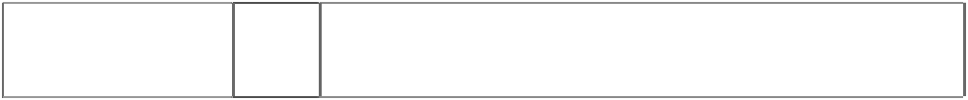

|  |  |  |
| --- | --- | --- |
| **WRANGLER**  (932799) | 25 | Clothing, footwear, headgear; aprons, babies' diapers of textile; babies' pants, bandanas, bath robes, bath sandals; bath slippers, bathing caps, bathing suits, bathing trunks, beach clothes, beach shoes, belts, berets, boot uppers, boots, boots for sports, braces for clothing, brassieres, camisoles, cap peaks, caps (headwear), coats, collars (clothing), corselets, corsets, cuffs, cyclists' clothing, dressing gowns, ear muffs, esparto shoes or sandals, fittings of metal for shoes and boots, footwear uppers, frocks, fur stoles, furs (clothing), gabardines, gaiter straps, gaiters, galoshes, garters, girdles, gloves (clothing), hats, headbands, heelpieces, heels, hoods (clothing), hosiery, inner soles, jackets (clothing), jerseys, jumpers, knitwear (clothing), layettes (clothing), leggings, mittens, money belts, motorists' clothing, muffs (clothing), neckties, outerclothing, overalls, overcoats, pants, parkas, pelisses, petticoats, pullovers, pyjamas, sandals, saris, sashes for wear, scarfs, shawls, shirt yokes, shirts, shoes, shoulder wraps, shower caps, singlets, ski boots, skirts, skull caps, slippers, slips (undergarments), smocks, socks, soles for footwear, spats, sports shoes, stockings, suits, sun visors, suspenders, sweaters, swimsuits, tee-shirts, tights, topcoats, trouser straps, trousers, underclothing, underwear, vests, waistcoats,  waterproof clothing, wristbands. |
| **WRANGLER**  (130296) | 25 | Jeans. |
| **WRANGLER**  (932800) | 25 | Clothing, footwear, headgear; aprons, babies' diapers of textile; babies' pants, bandanas, bath robes, bath sandals; bath slippers, bathing caps, bathing suits, bathing trunks, beach clothes, beach shoes, belts, berets, boot uppers, boots, boots for sports, braces for clothing, brassieres, camisoles, cap peaks, caps (headwear), coats, collars (clothing), corselets, corsets, cuffs, cyclists' clothing, dressing gowns, ear muffs, esparto shoes or sandals, fittings of metal for shoes and boots, footwear uppers, frocks, fur stoles, furs (clothing), gabardines, gaiter straps, gaiters, galoshes, garters, girdles, gloves (clothing), hats, headbands, heelpieces, heels, hoods (clothing), hosiery, inner soles, jackets (clothing), jerseys, jumpers, knitwear (clothing), layettes (clothing), leggings, mittens, money belts, motorists' clothing, muffs (clothing), neckties, outerclothing, overalls, overcoats, pants, parkas, pelisses, petticoats, pullovers, pyjamas, sandals, saris, sashes for wear, scarfs, shawls, shirt yokes, shirts, shoes, shoulder wraps, shower caps, singlets, ski boots, skirts, skull caps, slippers, slips (undergarments), smocks, socks, soles for footwear, spats, sports shoes, stockings, suits, sun visors, suspenders, sweaters, swimsuits, tee-shirts, tights, topcoats, trouser  straps, trousers, underclothing, underwear, vests, waistcoats, waterproof clothing, wristbands. |
| **WRANGLER**  (232328) | 25 | Jeans, boots and shoes, slacks, shorts, jackets, shirts (all such items woven and knitted), for men and boys; Jeans, boots and shoes,  slacks, dresses, shirts, shifts, blouses, sweaters, shorts (all such items knitted and woven,) for women and girls. |



|  |  |  |
| --- | --- | --- |
| **WRANGLER**  rope,looped forms word  (932798) | 14 | Precious metals and their alloys and goods in precious metals or coated therewith, not included in other classes; jewellery, precious stones; horological and chronometric instruments; alarm clocks; amulets; anchors; ashtrays, of precious metal, for smokers; badges of precious metal; barrels (clock-and watchmaking); boxes of precious metal; bracelets; brooches; buckles of precious metal; busts of precious metal; candelabra of precious metal, candle rings of precious metal, candlesticks of precious metal ; cases for clock – and watchmaking, cases for watches (presentation); chain mesh purses of precious metal; chins; cigar boxes of precious metal; cigar cases of precious metal; cigarette cases of precious metal; cigarette holders of precious metal; clock cases; clock hands; clocks; clocks and watches, electric; clockworks; coffee services of precious metal; coffeepots, non-electric, of precious metal; coins; cruet stands of precious metal; cruets of precious metal; cuff links; dials (clock – and watchmaking ); dishes of precious metal; earrings; egg cups of precious metal ; erpergnes of precious metal; figurines of precious metal; flasks of precious metal; goblets of precious metal; gold and silver ware, other than cutlery, forks and spoons; gold (objects of imitation - ); harmless fittings of precious metal; hat ornaments (of precious metal); household containers of precious metal; household utensils of precious metal; jewel cases of precious metal; jugs of precious metal ; key rings; kitchen containers of precious metal ; kitchen utensils of precious metal, matchboxes of precious metal, match holders of precious metal, medallions, medals, movements for clocks and watches; napkin holders of precious metal, napkin rings of precious metal, necklaces, needle cases of precious metal, needles of precious metal, nutcrackers of precious metal; ormolu ware, ornamental pins, ornaments, pendulums (clock- and watchmaking); purses of precious metal, rings; salad bowls of precious metal, salt cellars of precious metal, salt shakers of precious metal, saucers of precious, services (tableware) of precious metal, shoes ornaments (of precious metal); silver ornaments, silver plate; snuff boxes of precious metal, soup bowls of precious metal, statues of precious metal, statuettes of precious metal, stopwatches, straps for wristwatches, sundials; table plates of precious metal, tankards of precious metal, tea caddies of precious metal, tea infusers of precious metal, tea services of precious metal, tea strainers of precious metal, teapots of precious metal; tie clips, tie pins, tobacco jars of precious metal; trays of precious metal, for household purposes, trinkets, urns of precious metal, vases of precious metal, watch bands, watch cases, watch chains, watch crystals, watch glasses, watch springs, watches, works of art of precious metal, wristwatches; parts and fittings for the aforesaid  goods. |



|  |  |  |
| --- | --- | --- |
| **WRANGLER**  rope,looped forms word  (932798) | 18 | Leather and imitations of leather, and goods made of these materials and not included in other classes; animal skins, hides; trunks and traveling bags; umbrellas, parasols and walking sticks; whips, harness and saddlery; alpenstocks; attaché cases; backpacks; bags of leather, for packaging; bags for campers; bags for climbers; bandoliers; bands of leather; beach bags; bits for animals; boxes of leather or leather board; boxes of vulcanised fibre; briefcases; canes; card cases; cases, of leather or leatherboard; chain mesh purses, not of precious metal; chamois leather, other than for cleaning purposes; chin straps, of leather; clothing for pets; collars for animals; coverings of skins (furs); covers for animals; dog collars; envelopes, of leather, for packaging; fastenings for saddles; frames for umbrellas or parasols; fur; furniture coverings of leather; fur- skins; game bags; garment bags for travel; halters; handbag frames; handbags; harness fittings, not of precious metal; harness fittings of iron; harness for animals; harness straps; harness traces; hat boxes of leather; haversacks; horse blankets; horse collars; imitation leather; key cases; laces; leather leads; leather leashes; leather shoulder belts; leather straps; leather thongs; leather thread; leather twists; leather, unworked or semi-worked; leather board; moleskin; mountaineering sticks; music cases; net bags for shopping; pelts; pocket wallets; pouches, of leather, for packaging; purses; reins; riding saddles; rucksacks; saddle cloths for horses; saddle trees; school bags; school satchels; shopping bags; shoulder belts (straps), of leather; sling bags for carrying infants; stirrup leather; straps for skates; straps for soldiers’ equipment; suitcases; tool bags of leather (empty); traveling sets (leatherware); traveling trunks; trimmings of leather for furniture; umbrella covers; umbrella handles; umbrella or parasol ribs; umbrella rings; umbrella sticks; valises; vanity cases; walking cane handles; walking stick handles; walking stick seats; wallets; wheeled shopping bags; and parts and fittings for the  aforesaid goods. |
| **WRANGLER**  rope,looped forms word  (932798) | 25 | Clothing, footwear, headgear; aprons, babies’ diapers of textile; babies’ pants, bandanas, bath robes, bath sandal; bath slippers, bathing caps, bathing suits, bathing trunks, beach clothes, beach shoes, belts, berets, boot uppers, boots, boots for sports, braces for clothing, brassieres, camisoles, cap peaks, caps (headwear), coats, collars (clothing), corselets, corsets, cuffs, cyclists’ clothing, dressing gowns, ear muffs, esparto shoes or sandals, fittings of metal for shoes and boats, footwear uppers, frocks, fur stoles, furs (clothing), gabardines, gaiter straps, gaiters, galoshes, garters, girdles, gloves (clothing), hats, headbands, heelpieces, heels, hoods (clothing), hosiery, inner soles, jackets (clothing), jerseys, jumpers, knitwear (clothing), layettes (clothing), leggings, mittens, money belts, motorists’ clothing, muffs (clothing), neckties, outerclothing, overalls, overcoats, pants, parkas, pelisses, petticoats, pullovers, pyjamas, sandals, saris, sashes for wear, scarfs, shawls, shirt yokes, shirts, shoes, shoulder wraps, shower caps, singlets, ski books, skirts, skull caps, slippers, slips (undergarments), smocks, socks, soles for footwear, spats, sports shoes, stockings, suits, sun visors, suspenders, sweaters, swimsuits, tee-shirts, tights, topcoats, trouser straps, trousers, underclothing, underwear, vests, waistcoats,  waterproof clothing, wristbands. |

***Viaspan Pty Ltd Middletons***

***Ph: (03) 9205 2000***

***Effective Date: 29 June 2007 File Reference: C07/10476***

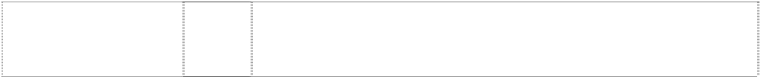

|  |  |  |
| --- | --- | --- |
| ***Trade Marks*** | ***Class*** | ***Goods*** |
| **ELWOOD**  (1043666) | 18 | Bags, courier bags, rucksacks, handbags, trunks and travel bags,  shopping bags satchels (school), purses, pack backs, shoulder bags, purses, wallets, key cases, haversacks. |
| **ELWOOD**  (873045) | 25 | Clothing; footwear; headgear; including shirts, T-shirts, shorts, pants, jeans, jackets and hats. |
| **ELWOOD DENIMS COMPANY**  silhouette of bulls head (822902) | 25 | Clothing, including shirts, t-shirts, shorts, pants, jeans, jackets and hats. |

**ADDITIONAL TRADE MARKS**

***adidas Australia Pty Ltd adidas Australia Pty Ltd Ph: (03) 9263 5242***

***Effective Date: 23 February 2007 File Reference: C07/12259***

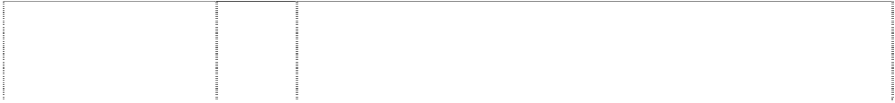

|  |  |  |
| --- | --- | --- |
| ***Trade Marks*** | ***Class*** | ***Goods*** |
| **300 SERIES**  (867695) | 18 | Golf umbrellas, luggage and bags, including non-canvas tote bags, for golfers. |
| **300 SERIES**  (867695) | 25 | Clothing, including hats, visors, caps, shirts, skirts, blouses,  sweaters, slacks, shorts, jackets, coats, pullovers, cardigans and shoes. |
| **300 SERIES**  (867695) | 28 | Golf equipment, including golf clubs, golf grips, putters, shafts, golf balls, golf gloves, golf tees, golf club covers, and golf bags. |
| **ABOVE THE RIM**  (553475) | 25 | All goods included in class 25. |
| **ABOVE THE RIM**  (577390) | 28 | Gymnastic and sporting articles in this class; toys, games and playthings in this class. |
| **ABOVE THE RIM HOOPWEAR**  basketball,hoop incomplete in triangle,double  (575537) | 25 | Clothing, footwear, headgear. |
| **AGSI**  (1091739) | 28 | Golf equipment, namely golf clubs, golf grips, putters, shafts, golf balls, golf clubheads, golf clubhead inserts, golf gloves, golf club  covers, and golf bags. |
| **ATR**  (947964) | 25 | Footwear, apparel and headwear. |
| **ATR**  ltrs,interlocking thru  ring,incompl. in shield (947965) | 25 | Footwear, apparel and headwear. |
| **BIG THINKING IN LITTLE SIZES**  (581470) | 25 | Clothing, footwear, headgear. |
| **BOKS**  (563736) | 25 | Footwear, headgear, t-shirts, sweatshirts and socks. |
| **CITY JAM**  (634287) | 25 | Clothing, footwear and headgear. |
| **COMPETITION YELLOW**  (1098897) | 28 | Golf equipment, namely golf clubs, golf grips, putters, shafts, golf balls, golf gloves, golf tees, golf club covers, and golf bags. |



|  |  |  |
| --- | --- | --- |
| **DRESSPORTS**  (485866) | 25 | Footwear in class 25. |
| **GRAPHLITE**  (580588) | 25 | Footwear, clothing and all other goods in this class. |
| **HEXALITE**  (516813) | 25 | All goods in this class. |
| **HYDRO-SHIELD**  (703063) | 25 | Clothing; footwear and components of footwear; headgear. |
| **HYDROSPORTS**  (729230) | 25 | Clothing, footwear and headgear. |
| **I3**  (948073) | 25 | Footwear, apparel and headwear. |
| **INSTAPUMP**  (634286) | 28 | Sporting goods in this class, toys, games and playthings. |
| **INSTA-PUMP**  (576391) | 25 | Clothing, including outer clothing and sportswear; footwear, including  components thereof; headgear; all of the foregoing for men, women and children. |
| **INSTRUCTOR**  (598268) | 25 | Clothing, footwear, headgear. |
| **INTIMIDATION BLACK**  (1098898) | 28 | Golf equipment, namely golf clubs, golf grips, putters, shafts, golf balls, golf gloves, golf tees, golf club covers, and golf bags. |
| **IVERSON**  (948072) | 25 | Footwear, apparel and headwear. |
| **L LOGOATHLETIC**  (805129) | 25 | Clothing, footwear, headgear. |
| **LOGOATHLETIC**  (805128) | 25 | Clothing, footwear, headgear. |
| **MWT**  (1097799) | 28 | Golf equipment, namely golf clubs, golf grips, putters, golf shafts, golf balls, golf gloves, golf tees, golf club covers, and golf bags. |
| **PLAY DRY**  (820523) | 25 | Footwear, apparel and headwear. |
| **PLAY DRY**  (1044655) | 28 | Sporting equipment. |
| **PRESEASON**  (572691) | 25 | Clothing, including outer clothing and sportswear; footwear, including  shoes for sports and leisure; headgear; all of the foregoing for men, women and children. |
| **R5**  (1075486) | 28 | Golf clubs, golf grips, wedges, irons, golf club heads, golf club shafts, and golf bags. |
| **R7**  (996329) | 28 | Golf equipment, golf clubs, golf grips, putters, golf club heads, golf club shafts, golf bags, golf gloves. |
| **RBK**  (928737) | 9 | Pre-recorded audio and video cassettes; eyewear, eyewear cases, eyewear neck cords, eyewear cleaning cloths, goggles, sunglasses; pedometers; heart rate monitors for fitness training, sports and recreational use; protective helmets for cycling, football, skiing,  hockey and auto racing. |
| **RBK**  (928737) | 14 | Jewellery. |
| **RBK**  (928737) | 18 | Luggage, all purpose sports bags, duffel bags, tote bags, knapsacks, shoulder bags. |
| **RBK**  (928737) | 25 | Footwear, apparel, headwear. |
| **RBK**  (928737) | 28 | Sports equipment. |
| **RBK**  (928737) | 32 | Beverages. |
| **RE AX**  (1131289) | 28 | Golf equipment, namely golf clubs, golf grips, putters, shafts. |
| **REEBOK**  (533008) | 9 | Optical goods, eyeglass cases, goggles, face shields, phonograph  records and players, photographic equipment, radios, audio and video tapes, magnets, batteries, calculators, life preservers. |
| **REEBOK**  (544823) | 12 | Cars, trims, fittings, accessories and parts for such cars, all the aforegoing being goods in this class. |
| **REEBOK**  (561595) | 14 | Jewellery, watches, clocks and all other goods in this class. |



|  |  |  |
| --- | --- | --- |
| **REEBOK**  (454803) | 18 | Bags in this class, including athletic bags and all other goods in this  class. |
| **REEBOK**  (483627) | 25 | Clothing, including outer clothing and sportswear; footwear, including shoes for sports and leisure; headgear; all of the foregoing for men, women and children. |
| **REEBOK**  (454804) | 28 | Toys, games and sporting goods in this class; all other goods included in this class. |
| **REEBOK**  arrowheads converging forming snowflake or flower, stylised  (340859) | 25 | Articles of clothing including footwear. |
| **ROCKPORT**  (588301) | 3 | All goods included in class 3. |
| **ROCKPORT**  (560580) | 18 | All goods included in class 18. |
| **ROCKPORT**  (321719) | 25 | All goods in this class. |
| **ROCSPORTS**  (361291) | 25 | Footwear, namely shoes and moccasins. |
| **SPEEDCORE**  (1012170) | 28 | Golf equipment, including golf balls |
| **SPEEDMANTLE**  (1012169) | 28 | Golf equipment, including golf balls. |
| **STEP REEBOK**  (571701) | 25 | Clothing; footwear; headgear. |
| **STEP REEBOK**  (572084) | 28 | All goods in this class. |
| **SUNDAY RED**  (1098899) | 28 | Golf equipment, namely golf clubs, golf grips, putters, shafts, golf balls, golf gloves, golf tees, golf club covers, and golf bags. |
| **T**  ltr T breaks oblique disc  (853423) | 25 | Clothing, including hats, visors, caps, shirts, skirts, blouses, sweaters, slacks, shorts, jackets, coats, pullovers, cardigans and shoes. |
| **T**  ltr T breaks oblique disc  (853423) | 28 | Golf equipment, including golf clubs, golf grips, putters, shafts, golf balls, golf gloves, golf tees, golf club covers, and golf bags. |
| **TAYLOR MADE**  (533162) | 18 | Golf umbrellas, golf parasols, luggage bags including tote bags, carry  bags, staff bags, bag covers, all the foregoing being included in this class. |
| **TAYLOR MADE**  (533163) | 25 | Golf clothing including gloves, shoes, hats, visors, caps, skirts, blouses, sweaters, slacks, shirts, rain covers, pullovers, and cardigans, all the foregoing being included in this class. |
| **TAYLOR MADE**  (532022) | 28 | Golf clubs and golf equipment included in this class. |
| **TAYLOR MADE**  (782202) | 6 | Metal marine hardware. |
| **TAYLOR MADE**  (782202) | 7 | Engine covers, including boat engine covers, and fabric engine covers for airplane jet engines. |
| **TAYLOR MADE**  (782202) | 8 | Hand tools, including tool sets for installing grommets and tools for installing fasteners. |
| **TAYLOR MADE**  (782202) | 9 | Wiring kits consisting essentially of insulated electrical wire for boat lights with or without a terminal board. |
| **TAYLOR MADE**  (782202) | 11 | Lights, and light fittings. |

|  |  |  |
| --- | --- | --- |
| **TAYLOR MADE**  (782202) | 12 | Fittings, components and structural parts for boats - including windshields and replacement parts therefor, hatches, fenders, prefabricated covers and tops, sunshade tops, ladders and parts therefor, rearview mirrors, tie downs, flagpole holders, and flag clips for securing flags to flagpoles, boat cover supports and sockets therefor; marine equipment, parts, accessories, and supplies, including plastic dock cleats; boat fender hangers; boat fender locks; hand pumps and hose adaptors and inflation needles for inflating boat fenders; watercraft mooring plastic tube and lines for use therewith; boat hooks; boat trailer electric winches; portholes; marine doors and door frames; marine windows; marine storage locker frames and storage compartments; marine seating upholstery; and marine rubs, scrubbers, brushes, squeegees, mop heads, and  handles therefor, and fabric snowmobile covers. |
| **TAYLOR MADE**  (782202) | 17 | Buoys, floats, dock bumpers, and all other marine hardware and accessories of plastic and/or rubber. |
| **TAYLOR MADE**  (782202) | 20 | Storage racks and shelving, bench ends, topiaries, wire form lawn and garden shapes, patio furniture covers, and wrought iron railings. |
| **TAYLOR MADE**  (782202) | 22 | Tarpaulins; tents; awnings; ties; ropes, including shock cords, shock cord hold downs; bags, including canvas bags; wind socks, boat  camper tops, tonneau covers, stern curtains, bimini boat tops, fabric display covers, and storage boots for boat tops when not in use. |
| **TAYLOR MADE**  (782202) | 24 | Textile goods, including side curtains, pennants, boat fender fabric covers; flags; gazebo covers; tarp repair kits; tarp zippers, hooks,  snaps, and swivels; and repair kits for boat tops consisting essentially of pieces of fabric or plastic and adhesive therefore. |
| **TAYLOR MADE**  (782202) | 28 | Swim area markers, and saddle numbers of race horses and other textile or fabric goods for sporting or recreational purposes. |
| **TAYLOR MADE GROUP**  (782203) | 6 | Metal marine hardware. |
| **TAYLOR MADE GROUP**  (782203) | 7 | Engine covers, including boat engine covers, and fabric engine covers for airplane jet engines. |
| **TAYLOR MADE GROUP** (782203) **TAYLOR MADE GROUP**  (782203) | 8  9 | Hand tools, including tool sets for installing grommets and tools for installing fasteners.  Wiring kits consisting essentially of insulated electrical wire for boat lights with or without a terminal board. |
| **TAYLOR MADE GROUP** (782203)  **TAYLOR MADE GROUP** | 11  12 | Lights, and light fittings.  Fittings, components and structural parts for boats - including windshields and replacement parts therefor, hatches, fenders, |

(782203)



**TAYLOR MADE GROUP** (782203) **TAYLOR MADE GROUP** (782203)

prefabricated covers and tops, sunshade tops, ladders and parts therefor, rearview mirrors, tie downs, flagpole holders, and flag clips for securing flags to flagpoles, boat cover supports and sockets therefor; marine equipment, parts, accessories, and supplies, including plastic dock cleats; boat fender hangers; boat fender locks; hand pumps and hose adaptors and inflation needles for inflating boat fenders; watercraft mooring plastic tube and lines for use therewith; boat hooks; boat trailer electric winches; portholes; marine doors and door frames; marine windows; marine storage locker frames and storage compartments; marine seating upholstery; and marine rubs, scrubbers, brushes, squeegees, mop heads, and handles therefor, and fabric snowmobile covers.

17 Buoys, floats, dock bumpers, and all other marine hardware and accessories of plastic and/or rubber.

20 Storage racks and shelving, bench ends, topiaries, wire form lawn and garden shapes, patio furniture covers, and wrought iron railings.



|  |  |  |
| --- | --- | --- |
| **TAYLOR MADE GROUP** (782203) | 22 | Tarpaulins; tents; awnings; ties; ropes, including shock cords, shock cord hold downs; bags, including canvas bags; wind socks, boat camper tops, tonneau covers, stern curtains, bimini boat tops, fabric  display covers, and storage boots for boat tops when not in use. |
| **TAYLOR MADE GROUP** (782203) | 24 | Textile goods, including side curtains, pennants, boat fender fabric covers; flags; gazebo covers; tarp repair kits; tarp zippers, hooks, snaps, and swivels; and repair kits for boat tops consisting  essentially of pieces of fabric or plastic and adhesive therefore. |
| **TAYLOR MADE GROUP** (782203) | 28 | Swim area markers, and saddle numbers of race horses and other textile or fabric goods for sporting or recreational purposes. |
| **TAYLORMADE**  ltr T breaks oblique disc  (853424) | 25 | Clothing, including hats, visors, caps, shirts, skirts, blouses, sweaters, slacks, shorts, jackets, coats, pullovers, cardigans and shoes. |
| **TAYLORMADE**  ltr T breaks oblique disc  (853424) | 28 | Golf equipment, including golf clubs, golf grips, putters, shafts, golf balls, golf gloves, golf tees, golf club covers, and golf bags. |
| **THE PUMP**  (631369) | 9 | Protective clothing and headgear including sports helmets. |
| **THE PUMP**  (559092) | 18 | Leather and imitations of leather and goods made of these materials and not included in other classes but excluding linings of leather for  boots and shoes; animal skins, hides; trunks and travelling bags; umbrellas, parasols and walking sticks; whips, harness and saddlery. |
| **THE PUMP**  (539233) | 25 | Sports shoes for athletics, aerobics, basketball, cross training and tennis; socks, caps, shirts, shorts, tracksuits, sweatshirts and gym wear. |
| **THE PUMP**  (582613) | 28 | Sporting goods in this class, toys, games and playthings. |
| **THE SPORT OF GOLF**  (1135300) | 18 | Golf umbrellas. |
| **THE SPORT OF GOLF**  (1135300) | 25 | Clothing, footwear and headgear. |
| **THE SPORT OF GOLF** (1135300) | 28 | Golf equipment, namely golf clubs, golf grips, putters, shafts, wedges, golf gloves, golf tees, golf club covers, and golf bags. |
| **TOUR PREFERRED**  (443575) | 28 | Golf clubs. |
| **TOUR SPEED**  (1085776) | 28 | Golf equipment, namely golf clubs, golf grips, putters, shafts, golf balls, golf club heads, golf club head inserts, golf gloves, golf tees,  golf club covers, and golf bags. |
| **TRAVEL TRAINER**  (933746) | 25 | Footwear, apparel, headwear. |
| **TT**  ltrs form Greek character,PI, extended (947963) | 25 | Footwear, apparel and headwear. |
| **WALK DRY**  (1044657) | 25 | Apparel, footwear and headwear. |
| **WEEBOK**  (454806) | 18 | Bags in Class 18, including game bags, and all other goods in this class. |
| **WEEBOK**  (454805) | 25 | Footwear and clothing in class 25; all other goods in this class. |
| **WEEBOK**  (454860) | 28 | Toys and games; all other goods in this class. |
| **WHAT DRIVES YOU**  (976130) | 28 | Golf equipment, golf clubs, golf grips, putters, wedges, irons, golf heads, golf club shafts, golf bags and golf gloves. |
| **XCS**  (660139) | 25 | Clothing, namely shirts, t-shirts, coats, headwear, jackets, pants, rainwear, shorts, socks, sweatpants, sports tops; footwear. |

|  |  |  |
| --- | --- | --- |
| *description of mark*  3 stipes on top part of slide sandal (1120119) | 25 | Footwear. |
| *shape trade mark:* pattern of shoe sole: 2 groups of 5 ellipses joined by stripes  (802345) | 25 | Footwear (excluding ballet shoes) and footwear components. |
| 2 triangles  (983323) | 25 | Footwear, apparel and headwear. |
| 3 leaves,styl. with 3 horiz. stripes  (1134330) | 25 | Clothing, footwear, headgear. |
| arrowheads converging to form  impeller, multi-blade (483628) | 25 | Clothing, including outer clothing and sportswear; footwear, including shoes for sports and leisure; headgear; all of the foregoing for men, women and children. |
| basketballer, backview  dribbles ball behind (610490) | 25 | Clothing, footwear and headgear. |
| running shoe with stripes, curved & intersecting on side; triangle, concave-side & stripe, curved form  pattern on shoe (454875) | 25 | Footwear, including sporting footwear. |
| tee in disk (436531) | 28 | Golf clubs, golf bags, golf balls, cloth golf head covers, and tee bags and all other goods in this class. |
| triangle curved divides triangle, curved & striped  (637655) | 9 | Video and audio tapes and cassettes; measuring and calculating instruments and apparatus; optical goods; computer software; divers' apparatus; floats for bathing and swimming; protective helmets; lifesaving apparatus and instruments; luminous signs; sound  producing apparatus. |
| triangle curved divides triangle, curved & striped  (703738) | 14 | Precious metals and their alloys and goods in precious metals or coated therewith, not included in other classes. |
| triangle curved divides triangle, curved & striped  (600406) | 18 | All purpose sport bags, duffel bags, tote bags, knapsacks and shoulder bags, all the foregoing being in this class; and all other goods in this class. |
| triangle curved divides triangle, curved & striped  (600359) | 25 | Clothing, footwear and headgear. |
| triangle curved divides triangle, curved & striped  (600408) | 28 | Toys, games and playthings; gymnastic and sporting articles not included in other classes; decorations for Christmas trees. |

***Crocs, Inc. Freehills***

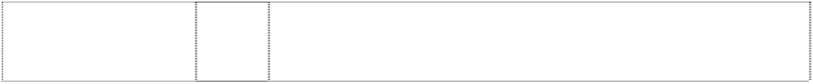

***Ph: (02) 9288 1577***

***Effective Date: 21 September 2006 File Reference: C06/17569***



|  |  |  |
| --- | --- | --- |
| ***Trade Marks*** | ***Class*** | ***Goods*** |
| **CROCSKIN**  (1084689) | 25 | Clothing; all made of woven or knitted fabrics comprising a proprietary synthetic fiber. |

***Dunphy Sports / Fishing Imports Pty Ltd Griffith Hack Lawyers Ph: (02) 9925 5900***

***Effective Date: 2 February 2006 File Reference: C06/03442***

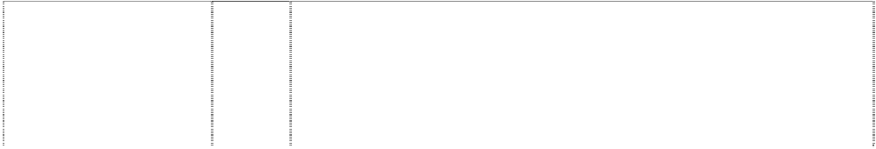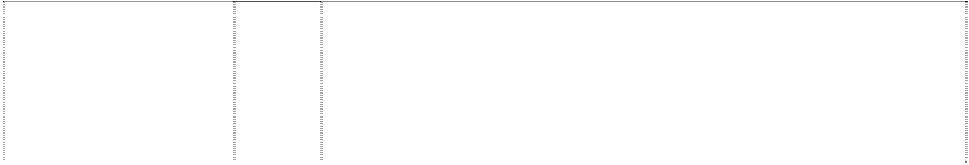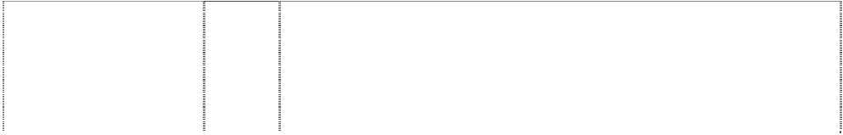

|  |  |  |
| --- | --- | --- |
| ***Trade Marks*** | ***Class*** | ***Goods*** |
| **AEROCAST**  (545487) | 28 | Fishing rods, fishing reels and other fishing tackle in class 28. |
| **AEROGLASS CONSTRUCTION**  star in winged disc breaks annulus  (1013060) | 28 | Fishing tackle, including reels, rods, lines, line guides, hooks, lures, artificial baits, creels, floats, sinkers, landing nets for anglers, fishing bags, fishing gloves, rod cases and tack containers. |
| **AEROWAVE**  (945939) | 28 | Fishing tackle, including reels for fishing, rods for fishing, lines for fishing, line guides (for use on fishing rods), hooks for fishing, lures (artificial) for fishing, artificial baits, creels (fishing equipment), floats for fishing, fishing weights including sinkers, landing nets for anglers,  fishing bags, fishing gloves; fishing rod cases and fishing tackle containers. |
| **A-RB**  (901835) | 28 | Fishing tackle, including reels, rods, lines, line guides, hooks, lures, artificial baits, creels, floats, sinkers, landing nets for anglers, fishing bags, fishing gloves, rod cases and tackle containers. |
| **ASPIRE**  (1081069) | 28 | Fishing tackles, including reels for fishing, rods for fishing, lines for fishing, line guides (for use on fishing rods), hooks for fishing, lures (artificial) for fishing, artificial baits, creels (fishing equipment), floats for fishing, fishing weights (namely sinkers), landing nets for anglers, fishing bags, fishing gloves; fishing rod cases and fishing tackle  containers, hip-guards specially made for fishing. |
| **BEASTMASTER**  (545491) | 28 | Fishing rods, fishing reels and other fishing tackle in class 28. |
| **BIOMASTER**  (545486) | 28 | Fishing rods, fishing reels and other fishing tackle in class 28. |
| **BLUE ROSE**  (1119013) | 28 | Fishing tackles, including reels for fishing, rods for fishing, lines for fishing, line guides (for use on fishing rods), hooks for fishing, lures (artificial) for fishing, artificial baits, creels (fishing equipment), floats for fishing, fishing weights (namely sinkers), landing nets for anglers,  fishing bags, fishing gloves; fishing rod cases and fishing tackle containers, hip-guards specially made for fishing. |
| **CALLISTO**  (940653) | 28 | Fishing tackle, including reels for fishing, rods for fishing, lines for fishing, line guides (for use on fishing rods), hooks for fishing, lures (artificial) for fishing, artificial baits, creels (fishing equipment), floats for fishing, fishing weights (namely, sinkers), landing nets for anglers, fishing bags, fishing gloves; fishing rod cases and fishing tackles  containers. |
| **CATANA**  (977692) | 28 | Fishing tackle, including reels for fishing, rods for fishing, lines for fishing, line guides (for use on fishing rods), hooks for fishing, lures (artificial) for fishing, artificial baits, creels (fishing equipment), floats for fishing, fishing weights (namely sinkers), landing nets for anglers, fishing bags, fishing gloves, fishing rod cases and fishing tackle containers, hip-guards specially made for fishing, accessories for  fishing. |
| **CHROMICA**  (1067447) | 28 | Fishing tackle, including reels for fishing, rods for fishing, lines for fishing, line guides (for use on fishing rods), hooks for fishing, lures (artificial) for fishing, artificial baits, creels (fishing equipment), floats for fishing, fishing weights (namely, sinkers), landing nets for anglers,  fishing bags, fishing gloves; fishing rod cases and fishing tackle containers, hip-guards specially made for fishing. |
| **CHRONARCH**  (951217) | 28 | Fishing tackle, including reels for fishing, rods for fishing, lines for fishing, line guides (for use on fishing rods), hooks for fishing, lures (artificial) for fishing, artificial baits, creels (fishing equipment), floats for fishing, fishing weights including sinkers, landing nets for anglers, fishing bags, fishing gloves; fishing rod cases and fishing tackle  containers. |



|  |  |  |
| --- | --- | --- |
| **CORVALUS**  (993402) | 28 | Fishing tackle, including reels for fishing, rods for fishing, lines for fishing, line guides (for use on fishing rods), hooks for fishing, lures (artificial) for fishing, artificial baits, creels (fishing equipment), floats for fishing, fishing weights (namely sinkers), landing nets for anglers, fishing bags, fishing gloves, fishing rod cases and fishing tackle containers, hip-guards specially made for fishing, accessories for  fishing. |
| **CRUCIAL**  (575694) | 28 | Fishing tackle in this class including reels and rods. |
| **CRUXIS**  (1013433) | 28 | Fishing tackle, including reels, rods, lines, line guides, hooks, lures,  artificial baits, creels, floats, sinkers, landing nets for anglers, fishing bags, fishing gloves, rod cases and tack containers. |
| **DYNA-BALANCE**  headphones,styl. atop disc  (951218) | 28 | Fishing tackle, including reels for fishing, rods for fishing, lines for fishing, line guides (for use on fishing rods), hooks for fishing, lures (artificial) for fishing, artificial baits, creels (fishing equipment), floats for fishing, fishing weights including sinkers, landing nets for anglers, fishing bags, fishing gloves; fishing rod cases and fishing tackles  containers. |
| **ELF**  (1064844) | 28 | Fishing tackle, including reels for fishing, rods for fishing, lines for fishing, line guides (for use on fishing rods), hooks for fishing, lures (artificial) for fishing, artificial baits, creels (fishing equipment), floats for fishing, fishing weights (namely sinkers), landing nets for anglers, fishing bags, fishing gloves; fishing rod cases and fishing tackle  containers, hip-guards specially made for fishing. |
| **FLUIDRIVE**  wavy stripe divided disc  (951219) | 28 | Fishing tackle, including reels for fishing, rods for fishing, lines for fishing, line guides (for use on fishing rods), hooks for fishing, lures (artificial) for fishing, artificial baits, creels (fishing equipment), floats for fishing, fishing weights including sinkers, landing nets for anglers,  fishing bags, fishing gloves; fishing rod cases and fishing tackle containers. |
| **FORCEMASTER**  (1081068) | 28 | Fishing tackles, including reels for fishing, rods for fishing, lines for fishing, line guides (for use on fishing rods), hooks for fishing, lures (artificial) for fishing, artificial baits, creels (fishing equipment), floats for fishing, fishing weights (namely sinkers), landing nets for anglers,  fishing bags, fishing gloves; fishing rod cases and fishing tackle containers, hip-guards specially made for fishing. |
| **GAME AR-C**  (992325) | 28 | Fishing tackle, including reels for fishing, rods for fishing, lines for fishing, line guides (for use on fishing rods), hooks for fishing, lures (artificial) for fishing, artificial baits, creels (fishing equipment), floats for fishing, fishing weights (namely sinkers), landing nets for anglers, fishing bags, fishing gloves, fishing rod cases and fishing tackle  containers, hip-guards specially made for fishing, accessories for fishing. |
| **HYPERLOOP**  (973512) | 28 | Fishing tackle, including reels for fishing, rods for fishing, lines for fishing, line guides (for use on fishing rods), hooks for fishing, lures (artifiicail) for fishing, artificial baits, creels (fishing equipment), floats for fishing, fishing weights (namely sinkers), landing nets for anglers, fishing bags, fishing gloves, fishing rod cases and fishing tackle  containers, hip-guards specially made for fishing, accessories for fishing. |
| **OCEA AR-C**  (992324) | 28 | Fishing tackle, including reels for fishing, rods for fishing, lines for fishing, line guides (for use on fishing rods), hooks for fishing, lures (artificial) for fishing, artificial baits, creels (fishing equipment), floats for fishing, fishing weights (namely sinkers), landing nets for anglers, fishing bags, fishing gloves, fishing rod cases and fishing tackle containers, hip-guards specially made for fishing, accessories for  fishing. |
| **P-3 POWER PRECISION PERFORMANCE**  (1009403) | 28 | Fishing tackle, including reels, rods, lines, line guides, hooks, lures, artificial baits, creels, floats, sinkers, landing nets for anglers, fishing bags, fishing gloves, rod cases and tackle containers. |



|  |  |  |
| --- | --- | --- |
| **PALADIN**  word breaks striped ellipse  (1139470) | 28 | Fishing tackles, including reels for fishing, rods for fishing, lines for fishing, line guides (for use on fishing rods), hooks for fishing, lures (artificial) for fishing, artificial baits, creels (fishing equipment), floats for fishing, fishing weights (namely sinkers), landing nets for anglers, fishing bags, fishing gloves; fishing rod cases and fishing tackle  containers, hip-guards specially made for fishing. |
| **POWERLOOP**  (545499) | 28 | Fishing rods, fishing reels and other fishing tackle in class 28. |
| **PROPULSION**  angled stripe on either side of word (1139469) | 28 | Fishing tackles, including reels for fishing, rods for fishing, lines for fishing, line guides (for use on fishing rods), hooks for fishing, lures (artificial) for fishing, artificial baits, creels (fishing equipment), floats for fishing, fishing weights (namely sinkers), landing nets for anglers, fishing bags, fishing gloves; fishing rod cases and fishing tackle  containers, hip-guards specially made for fishing. |
| **SARAGOSA**  (1090630) | 28 | Fishing tackle, including reels, rods, lines, line guides, hooks, lures, artificial baits, creels, floats, sinkers, landing nets for anglers, fishing  bags, fishing gloves, rod cases and tackle containers. |
| **SAROS**  (1139931) | 28 | Fishing tackles, including reels for fishing, rods for fishing, lines for fishing, line guides (for use on fishing rods), hooks for fishing, lures (artificial) for fishing, artificial baits, creels (fishing equipment), floats for fishing, fishing weights (namely sinkers), landing nets for anglers,  fishing bags, fishing gloves; fishing rod cases and fishing tackle containers, hip-guards specially made for fishing. |
| **SEDONA**  (764636) | 28 | Fishing tackle, including reels, rods, lines, line guides, hooks, jigs, lures, artificial baits, spinners and tackle containers. |
| **SLIDE’N’GRIP**  double endless-belt & circle interlocking (1102635) | 28 | Fishing tackle, including reels for fishing, rods for fishing, reel seats for fishing, lines for fishing, line guides (for use on fishing rods), hooks for fishing, lures (artificial) for fishing, artificial baits, creels (fishing equipment), floats for fishing, fishing weights (namely, sinkers), landing nets for anglers, fishing bags, fishing gloves; fishing  rod cases and fishing tackles containers, hip-guards specially made for fishing. |
| **SOCORRO**  (1090638) | 28 | Fishing tackle, including reels, rods, lines, line guides, hooks, lures, artificial baits, creels, floats, sinkers, landing nets for anglers, fishing  bags, fishing gloves, rod cases and tackle containers. |
| **SONATA**  (1092861) | 28 | Fishing tackles, including reels for fishing, rods for fishing, lines for fishing, line guides (for use on fishing rods), hooks for fishing, lures (artificial) for fishing, artificial baits, creels (fishing equipment), floats for fishing, fishing weights (namely sinkers), landing nets for anglers,  fishing bags, fishing gloves; fishing rod cases and fishing tackle containers, hip-guards specially made for fishing. |
| **SQUIDGY STIFFIES ; SQUIDGY STIFFY**  (1091633) | 28 | Fishing lures, fishing rods, fishing reels and other fishing tackle included in this class. |
| **SUPER SLOW OSCILLATION**  fishing reel,styl. in oval (932687) | 28 | Sporting articles; fishing tackles, including reels for fishing, rods for fishing, lines for fishing, line guides (for use on fishing rods), hooks for fishing, lures (artificial) for fishing, artificial baits, creels (fishing equipment), floats for fishing, fishing weights (namely, sinkers), landing nets for anglers, fishing bags, fishing gloves; fishing rod  cases and fishing tackle containers. |
| **SUPER STOPPER**  word cuts stop-sign (951214) | 28 | Fishing tackle, including reels for fishing, rods for fishing, lines for fishing, line guides (for use on fishing rods), hooks for fishing, lures (artificial) for fishing, artificial baits, creels (fishing equipment), floats for fishing, fishing weights including sinkers, landing nets for anglers, fishing bags, fishing gloves; fishing rod cases and fishing tackle  containers. |
| **SUPER STOPPER**  word cuts stop-sign (951214) | 28 | Fishing tackle, including reels for fishing, rods for fishing, lines for fishing, line guides (for use on fishing rods), hooks for fishing, lures (artificial) for fishing, artificial baits, creels (fishing equipment), floats for fishing, fishing weights including sinkers, landing nets for anglers,  fishing bags, fishing gloves; fishing rod cases and fishing tackle containers. |
| **SYMETRE**  (764635) | 28 | Fishing tackle, including reels, rods, lines, line guides, hooks, jigs, lures, artificial baits, spinners and tackle containers. |

|  |  |  |
| --- | --- | --- |
| **TEKOTA**  (926395) | 28 | Sporting articles; fishing tackle, including reels, rods, lines, line guides, hooks, lures, artificial baits, creels, floats, sinkers, landing nets for anglers, fishing bags, fishing gloves, rod cases and tackle  containers. |
| **THUNNUS**  (806706) | 28 | Fishing tackle, namely, reels, rods, lines, line guides, hooks, lures, artificial baits, rod cases and tackle containers. |
| **TIRALEJO**  (1065175) | 28 | Fishing tackle, including reels for fishing, rods for fishing, lines for fishing, line guides (for use on fishing rods), hooks for fishing, lures (artificial) for fishing, artificial baits, creels (fishing equipment), floats for fishing, fishing weights (namely, sinkers), landing nets for anglers,  fishing bags, fishing gloves; fishing rod cases and fishing tackle containers, hip-guards specially made for fishing. |
| **TODAY**  (545492) | 28 | Fishing rods, fishing reels and tackle in class 28. |
| **TORIUM**  (926393) | 28 | Sporting articles; fishing tackle, including reels, rods, lines, line guides, hooks, lures, artificial baits, creels, floats, sinkers, landing nets for anglers, fishing bags, fishing gloves, rod cases and tackle  containers. |
| **TORSA**  (926394) | 28 | Sporting articles; fishing tackle, including reels, rods, lines, line guides, hooks, lures, artificial baits, creels, floats, sinkers, landing nets for anglers, fishing bags, fishing gloves, rod cases and tackle  containers. |
| **TWINPOWER**  (545493) | 28 | Fishing rods, fishing reels and other fishing tackle in class 28. |
| **TYRNOS**  (970876) | 28 | Fishing tackles, including reels for fishing, rods for fishing, lines for fishing, line guides (for use on fishing rods), hooks for fishing, lures (artificial) for fishing, artificial baits, creels (fishing equipment), floats for fishing, fishing weights (namely sinkers), landing nets for anglers, fishing bags, fishing gloves; fishing rod cases and fishing tackle containers, hip-guards specially made for fishing, accessories for  fishing. |

***Unilever Australia Limited Unilever Australia Limited Ph: (02) 9869 6100***

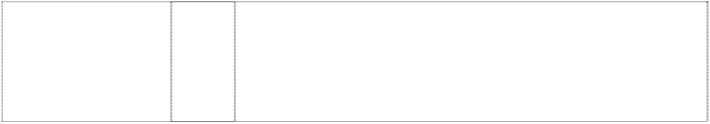

***Effective Date: 5 February 2006 File Reference: C06/02964***



|  |  |  |
| --- | --- | --- |
| ***Trade Marks*** | ***Class*** | ***Goods*** |
| **U UNILEVER**  ltr U,patterned (989851) | 1 | Chemicals used in industry, science, agriculture, horticulture and forestry; detergent and chemical cleaning preparations, all for use in industrial and manufacturing processes; unprocessed artificial resins; unprocessed plastics; fixing preparations for use in manufacture of soaps; chemical substances for use as auxiliaries in dyeing processes; bleaching substances included in this class; chemical substances included in this class for use in the treatment of textile fabrics; water softening preparations; fire extinguishing compositions; tempering and soldering preparations; chemical substances for preserving foodstuffs; tanning substances; adhesives for use in  industry. |
| **U UNILEVER**  ltr U,patterned (989851) | 3 | Soaps; liquid soaps; hand washing preparations; bath and shower preparations, including bath foam and shower gels; perfumery, essential oils; cosmetics; colognes, eau de toilette; aftershave; perfume body sprays; deodorants for personal use; anti-perspirants; shaving foam, shaving gel, pre-shaving and after-shaving lotions; talcum powder; pre-shave and aftershave preparations; preparations for the care of hair and scalp; shampoos and conditioners; hair colorants; hair dyes; hair lotions; hair waving preparations; hair sprays; hair powder; hair dressings; hair lacquers; hair mousses; hair glazes; hair gels; hair moisturisers; hair liquid; hair preservation treatments; hair desiccating treatments; hair oils; hair tonic; hair creams; dentifrices; non-medicated mouthwashes; preparations for the care of the mouth and the teeth; dental polish; tooth powder; toothpaste; non-medicated toilet preparations; oils, creams and  lotions for the skin; aromatherapy products; massage preparations; |

skin care preparations; depilatory preparations; sun-tanning and sun protection preparations; make-up and make-up removing preparations; petroleum jelly; lip care preparations; cotton wool, cotton sticks; cosmetics pads; tissues or wipes; pre-moistened or impregnated cleansing pads, tissues or wipes; beauty masks, facial packs; sachets for perfuming linen; cleaning preparations; hand- washes; detergents; detergents other than for use in manufacturing operations and for medical purposes; preparations and substances, all for laundry use; fabric conditioning preparations; fabric softeners; bleaching preparations; stain removing preparations; cleaning, polishing, scouring and abrasive preparations; preparations for dishwashing purposes; laundry starch; deodorizing and freshening preparations for use on clothing and textiles; soaps for brightening textiles; tissues impregnated with preparations and substances for cleaning and polishing.



|  |  |  |
| --- | --- | --- |
| **U UNILEVER**  ltr U,patterned (989851) | 5 | Pharmaceutical preparations; disinfectants; antiseptics; air and water purifying and freshening preparations; deodorants and air-freshening preparations; sanitary products and preparations; bandages; plasters; material for dressings; medicated skin and hair preparations; medicated preparations for the lips; preparations for the treatment and/or alleviation of sunburn; petroleum jelly for medical purposes; dietetic substances for medical use; herbal preparations for medical purposes; herbal supplements and herbal extracts; medicated herbal beverages; vitamins; minerals; nutritional supplements; sanitary preparations; preparations for destroying vermin, insects and noxious animals; fungicides; germicides; bactericides; parasiticides; algaecides; insecticides; weedkillers; insect repellents; plaque disclosing tablets and preparations. |
| **U UNILEVER**  ltr U,patterned (989851) | 7 | Machines for domestic laundry purposes; agricultural and horticultural machines; agricultural and horticultural implements included in this class; motors (not for land vehicles); power-operated tools; machines and pumps, all for use in agriculture, horticulture, building, decorating, plumbing, electrical supply, woodworking, metalworking, pottery and in-vehicle maintenance; washing and abrading machines; parts and fittings included in this class for all the aforesaid goods. |
| **U UNILEVER**  ltr U,patterned (989851) | 9 | Apparatus and media for recording, processing, broadcasting and reproducing music, sound, images, text, software and information; audio and video recordings; video recordings, music, sounds, images, text, signals, software and information provided by telecommunications networks, by on-line delivery and by way of the Internet and world-wide web; computer software relating to, or supplied from, the Internet; publications by electronic means or in electronic form; publications supplied by Internet, intranet, extranet or mail servers; electronic magazines, directories and newsletters; CD ROMs, media for storing information; insect killing apparatus; pest detectors; parts and fittings for all the aforesaid goods. |
| **U UNILEVER**  ltr U,patterned (989851) | 10 | Tongue scrapers; dental mirrors. |
| **U UNILEVER**  ltr U,patterned (989851) | 11 | Water dispensers, filtering and purifying apparatus and machines; water sterilizers and softeners; cooling appliances and machines; disinfectant apparatus; distillation apparatus; filters for drinking water and for water; cleaning foodstuffs; regulating and safety apparatus for temperature and chemical control of air and water; water softening apparatus; air deodorising and purification apparatus and machines; jugs and containers for purifying water and parts and fittings thereof being goods in this class. |
| **U UNILEVER**  ltr U,patterned (989851) | 16 | Printed matter; paper, paper articles and cardboard articles; cardboard; publications; books; periodicals, magazines; newspapers; newsletters; directories; stationery; adhesives for stationery or household purposes; instructional and teaching material (except apparatus); plastic materials for packaging. |



|  |  |  |
| --- | --- | --- |
| **U UNILEVER**  ltr U,patterned (989851) | 21 | Toothbrushes; utensils and articles for cleaning and the care of teeth, tongues and gums; toothpicks; toothbrush and toothpick holders, none being of precious metals; dental floss, wax, tape; toilet utensils; non-electronic instruments and materials, all for cleaning purposes; cleaning, dusting and polishing cloths; impregnated cloths for cleaning, dusting and polishing; dispensing devices; brushes; pads for scouring or for cleaning; sponges and squeegees; toilet cases and vanity cases; small domestic utensils and containers; wash- bags; combs; powder puffs; powder compacts; containers and dispensing devices for toilet preparations; portable water dispensers,  containers and pitchers. |
| **U UNILEVER**  ltr U,patterned (989851) | 29 | Meat, fish, poultry and game, none being live; meat extracts; canned, preserved, dried and cooked fruits and vegetables; thickening agents; jellies, jams, conserves, compotes, fruit sauces; fruit preserves and vegetable preserves; eggs, egg products, egg  replacers and substitutes; milk and milk products; dairy and dairy products; edible oils and fats. |
| **U UNILEVER**  ltr U,patterned (989851) | 30 | Coffee, tea and tea products, cocoa; decaffeinated coffee, artificial coffee; sugar, rice, tapioca, sago; flour and preparations made from cereals, bread and pastry; pastas; flavourings for cakes; flavourings for beverages; confectionery, desserts, biscuits, ice-creams, water ices, frozen confectionery, frozen yoghurts; frozen desserts; powders for ice cream; honey, treacle, syrups; yeast, baking-powder; salt, seasonings, mustard; vinegar, sauces (condiments); salad dressings,  mayonnaise; spices; ice; chewing gum and breath freshening confectionery. |
| **U UNILEVER**  ltr U,patterned (989851) | 31 | Agricultural, horticultural and forestry products and grains not included in other classes; live animals; fresh fruits and vegetables;  seeds, natural plants and flowers; foodstuffs for animals, malt. |
| **U UNILEVER**  ltr U,patterned (989851) | 32 | Beers; mineral and aerated waters and other non-alcoholic drinks; carbonated and non-carbonated tea drinks; carbonated and non-  carbonated iced tea; ice tea; fruit drinks and fruit juices; syrups and other preparations for making beverages; ice. |