AUSTRALIAN CUSTOMS NOTICE NO. 2007/58

# Notices of Objection to Importation Trade Marks Act 1995

The *Trade Marks Act 1995* allows the registered owner, or in certain circumstances, the authorised user of a trade mark to lodge a Notice of Objection with the Australian Customs Service (Customs), objecting to the importation of goods which infringe their trade mark. Unless revoked, a Notice of Objection remains in force for a period of four years (effective 23 October 2006) from the date of commencement.

The attached Schedule sets out the registered owners and authorised users who have lodged Notices of Objection under the *Trade Marks Act 1995* since September 2007 (ACN 2007/53)*.* Descriptions of the relevant trade marks are also set out in the Schedule.

A detailed list of all current trade mark Notices of Objection is available on the Customs website at [www.customs.gov.au](http://www.customs.gov.au/) > media publications and forms> Customs notices > Intellectual Property – Notices of Objection > trade marks

For each particular trade mark described, the Schedule makes reference to a particular “class” of goods. This refers to the classes of goods prescribed in Schedule 1 to the *Trade Marks Regulations 1995* and along with a description of the goods, is used to describe the type of goods for which the particular trade mark is registered. Prospective importers of such goods should seek further advice from Customs regarding the ambit of any Notice of Objection set out in the Schedule.

Goods referred to in this ACN, that are manufactured outside and imported into Australia, and are subject to the control of Customs under the meaning of the *Customs Act 1901* are liable to be seized by Customs if:

* they have applied to them, or in relation to them, a sign that is substantially identical with, or deceptively similar to, a trade mark listed in the attached Schedule; and
* are goods in respect of which the notified trade mark is registered;

unless it can be established that the goods do not infringe the relevant trade mark.

Part 12 of the *Trade Marks Act 1995* details the circumstances in which the use of a trade mark may, or may not, amount to an infringement. For example, a trade mark is not infringed where the mark in question has been applied to, or in relation to, goods with the consent of the registered owner of the trade mark. However, where the trade mark is applied by, or with the consent of, an overseas owner of the trade mark and the goods are imported into Australia without the consent of the Australian trade mark owner, this may still represent an infringement.

People who are intending to import goods that potentially may be liable to seizure under the provisions of the *Trade Marks Act 1995* should consider seeking advice from Customs, or a suitably qualified legal practitioner, as to the implications of the trade marks legislation, and the meaning of terms such as "substantially identical with", "deceptively similar to" and "an infringement of" a trade mark.

Where a registered trade mark owner or an authorised user with a current Notice of Objection in place request additional trade marks to be added to their Notice, only the additional trade marks are included at the end of this ACN. The inclusion of additional trade marks in the ACN is to ensure that ACN subscribers have all the appropriate up-to-date information.

Copies of the relevant Notices of Objection have been forwarded to the Customs office in the capital city of each State and Territory. Importers, or their advisers, who require further information regarding the Notices of Objection, or Customs role in respect of those Notices, should contact the Customs Information and Support Centre on 1300 363 263 or the Intellectual Property Rights Group on (02) 6275 6577.

John Potter

A/g National Manager

Trade Policy & Regulation Branch CANBERRA ACT

October 2007



**SCHEDULE TO ACN NO. 2007/58 TRADE MARK NOTICES OF OBJECTION**

***Australian Broadcasting Corporation Australian Broadcasting Corporation Ph: (02) 8333 5849***

***Effective Date: 6 September 2007 File Reference: C07/13931 Trade Marks Class Goods***

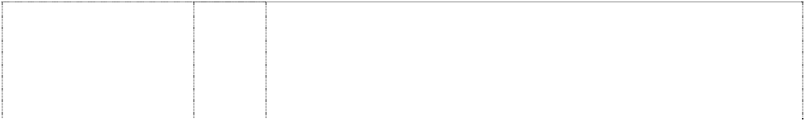

# BANANAS IN PYJAMAS

words between cartoon characters in pyjamas

(630036) **BANANAS IN PYJAMAS**

words between cartoon characters in pyjamas

(630037) **BANANAS IN PYJAMAS**

words between cartoon characters in pyjamas

(630038) **BANANAS IN PYJAMAS**

words between cartoon characters in pyjamas

(630039)

9 Video and audio tapes, compact discs, sound recordings, video discs, and devices in this class for the reproduction of sound and/or visual images.

16 Books, publications, printed matter, posters, friezes (being printed material), greeting cards, stationery, playing cards, teaching materials in this class, artists' supplies in this class, paper goods in this class.

25 Clothing, footwear and headgear.

28 Toys, games and playthings, including jigsaws and stuffed toys; sporting goods including balls.

***Canadelle Limited Partnership Allens Arthur Robinson Ph: (03) 9614 1011***

***Effective Date: 31 August 2007 File Reference: C07/14223***

***Trade Marks Class Goods***



# DAISYFRESH

(492709)

**THE ONE AND ONLY WONDERBRA** (636826)

**THE ONE AND ONLY WONDERBRA** (975631) **WONDERBRA** (587592) **WONDERBRA** (975967) **WONDERBRA BY CANADIAN LADY** (265503) **WONDERBUM** (894967) **WONDERBUNS** (894969)

25 Brassieres, panties and girdles.

25 Brassieres.

25 Clothing, including panties.

25 Brassieres.

25 Clothing, including panties.

25 Clothing including foundation garments and swimwear.

25 Clothing, underwear, lingerie, briefs, thongs.

25 Clothing, underwear, lingerie, briefs, thongs.

***Caroma Industries Limited Spruson & Ferguson Lawyers Ph: (02) 9393 0300***

***Effective Date: 24 September 2007 File Reference: C07/16476 Trade Marks Class Goods***

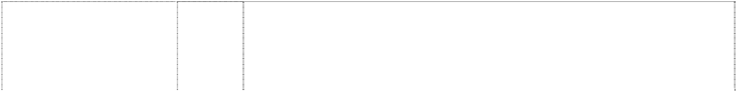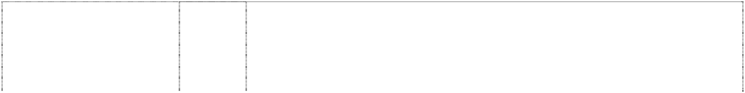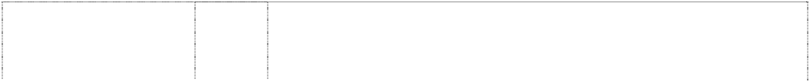

# "BATHMATES"

(414205)

# "DOMUS"

(414201)

**AQUA-SAVE** (481212) **AUSTRALIS** (427219) **BATH MATES** (335243) **BATH MATES** (291602) **CAMEO** (213696)

# CAMEO

(709589)

# CARAVELLE

(521125)

# CAROMA

(562882)

**CAROMA** (320706) **CAROMA** (161311) **CAROMA** (161312) **CAROMA** (269770) **CAROMA** (161313) **CAROMA** (206260) **CAROMA** (335245) **CAROMA** (368585) **CAROMA** (387976)

21 All goods in this class, including toilet brushes, toilet utensils, toilet sets, toilet brush holders and stands, toilet paper holders, soap dishes, tooth brush tidies and holders, tissue boxes, towel rails, towel rings, bath trays, for use in bathroom; large and small containers for miscellaneous use.

21 All goods in this class, including toilet brushes, toilet utensils, toilet sets, toilet brush holders and stands, toilet paper holders, soap dishes, toothbrush tidies and holders, metal boxes for dispensing paper towels, large and small containers in this class, all being goods in this class.

11 Flushing systems; installations for water supply and sanitary purposes.

11 Water taps and valves, faucets; tap handles, and other parts of and accessories for those goods included in this class.

11 Tapes included in this class and all other goods in Cl. 11.

20 Bathroom fittings included in Class 20.

11 Vanity basins and other washhand basins; other installations and equipment for water supply and sanitary purposes, especially those of china or earthenware.

11 Apparatus for water supply and sanitary purposes, including tapware, sanitaryware, vanity basins and other wash stands and basins; excluding appliances for heating water.

11 Apparatus and installations for water supply and sanitary purposes; sanitary ware, including toilets and urinals being water closets, toilet bowls, pans and cisterns, bidets, toilets seats, wash basins, hand basins, vanity basins, baths, showers, baths and/or shower installations; fittings and fixtures in this class including plumbing fittings and fixtures in this class and accessories in this class for all the aforesaid goods.

3 Cleaning, polishing, scouring and abrasive preparations; soaps; bleaching preparations and other substances for laundry use; deodorising preparations; disinfectants in this class, and all other goods in this class.

7 All goods included in this class.

1. Surgical, medical dental and veterinary instruments and apparatus.
2. Installations for water supply and sanitary purposes.

11 Clothes and other types of driers in Class 11, including portable driers.

17 Articles manufactured from plastics included in this Class.

20 Furniture.

1. All goods in this class inclusive of such bathroom fittings and furniture as are included in this class.
2. All goods in this class inclusive of toilet brushes, toilet brush stands, toilet roll holders and soap holders.

34 All goods included in this clas inclusive of smokers requisites.

# CAROMA AUSTRALIA

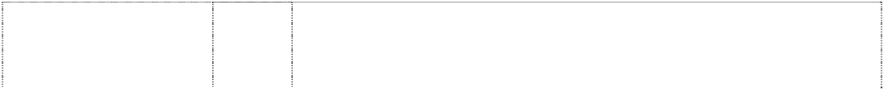

kangaroo against ayers rock in rect (727595)

# CAROMA AUSTRALIA

kangaroo against ayers rock in rect (727595)

# CAROMA CARE

(628963)

# CAROMA CARE

(601132)

# CAROMA QUIET FLOW

(762315)

**COLLEGA** (334128) **COLLEGA** (334131) **CONCORDE** (460058)

**CONCORDE** (311262) **CONCORDE** (535672) **CONCORDE** (535673)

**CONCORDE LOWLINE** (645115) **CONCORDE SLIMLINE** (703173)

**CONCORDE ULTRA LOW LEVEL** (645117)

# COSMO

(555679)

# DOMUS DUO MIXER

(424918)

# DUO 6 & 3

(600696)

11 Installations for water supply and sanitary purposes; sanitaryware in this class including toilets, toilet cisterns, toilet seats, bidets, wash basins, hand basins, baths, showers, bath and/or shower installations, bathing equipment in this class; parts and fittings in this class for all the foregoing; all the foregoing being goods produced in Australia.

21 Bathroom accessories in this class including soap holders, cups, cup holders, toilet paper holders, combs, sponges, toilet utensils, toilet brushes, toilet brush holders and stands, toilet sets; soap dispensers, soap boxes, metal boxes for dispensing paper towels; parts and fittings for all the foregoing; all the foregoing being goods produced in Australia.

1. Sanitaryware in this class, including such products in this class for use by the elderly and disabled; bathing equipment in this class, including wall mounted shower seats, shower benches, wall brackets and support apparatus; toilet equipment in this class.
2. Sanitaryware in this class, including toilets, toilet cisterns, toilet seats, parts and fittings in this class for all the foregoing; products in this class designed for use by the elderly and disabled; bathing equipment in this class.

11 Apparatus and installations for water supply and for sanitary purposes; sanitaryware, including toilets and urinals being water closets, toilet bowls, pans and cisterns, bidets; toilet seats; wash basins, hand basins, vanity basins, baths, showers, bath and/or shower installations; inlet valves; fittings and fixtures in this class and accessories in this class for all of the aforesaid goods.

11 All goods in this class inclusive of taps included in this class.

20 All goods in this class including those bathroom fittings included in this class.

11 Apparatus and installations for water supply and sanitary purposes; sanitary ware, including toilets and urinals being water closets, toilet bowls, pans and cisterns, bidets; toilet seats; wash basins, hand basins, vanity basins, baths, showers, bath and/or shower installations; fittings and fixtures (including plumbing fittings and fixtures) and accessories, for all of the aforesaid goods.

1. All goods included in this class including roofing materials.
2. All goods in this class for bathroom or sanitary use and purposes including bathroom fittings and bathroom furniture in this class.
3. Toilet brushes; toilet brush holders and stands; toilet paper holders; soap holders and dispensers; toothbrush tidies and holders; tissue boxes; towel rails and holders; containers, trays and utensils in this class for household use; all other items in this class for bathroom or sanitary use; none of the foregoing being made of or coated with precious metals.

11 Apparatus for water supply and sanitary purposes, including toilets, cisterns, tapware, toilet seats and connection plates and parts and fittings in this class for all the foregoing goods.

11 Apparatus for water supply and sanitary purposes, including toilets, cisterns, tapware, toilet seats, baths, vanities and showers, and parts and fittings in this class for all the foregoing goods.

11 Apparatus for water supply and sanitary purposes, including toilets, cisterns, tapware, toilet seats and connection plates and parts and fittings in this class for all the foregoing goods.

11 All goods in this class, including taps, shower and plumbing fittings, none of the aforesaid goods including electric hair drying appliances and attachments and parts thereof.

11 Tapware and all other goods in class 11.

11 Toilet cisterns and parts thereof; sanitaryware including toilets; apparatus and installations for water supply and sanitary purposes

# DUO-FLOW

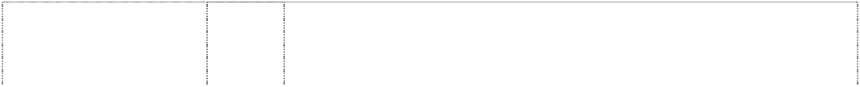

(595378)

# DUO-FLOW ; DUO- FLO ; DUOFLO ; DUOFLOW (596736)

**ECONOMIXER**

(669456)

# ELEGANCE

(719336)

# ELEGANCE

(719336)

# ENVIROFLUSH

(702284)

**FIORE** (492313) **FOWLER** (703415)

# FOWLER

(703415)

**FOWLER** (703415) **FOWLER** (703415) **FOWLER WARE** (68463)

**HITE-SAVER** (240027) **IMAGE** (478938)

# INSIGNIA

(624054)

# INTEGRA

(624050)

**KINGSWAY** (305017) **LASER** (393255)

11 Apparatus and installations for water supply and for sanitary purposes including toilets and associated fittings and accessories; cisterns; cistern mechanisms; all other goods in this class excluding filters and filter cartridges for use in filtration of liquids in the industrial, chemical coatings, pharmaceutical and food and beverages industries and their parts and accessories.

11 Apparatus and installations for water supply and for sanitary purposes including toilets and associated fittings and accessories; cisterns; cistern mechanisms; all other goods in this class excluding filters and filter cartridges for use in filtration of liquids in the industrial, chemical, coatings, pharmaceutical and food and beverages industries and their parts and accessories.

11 Apparatus for water supply and sanitary purposes, including cisterns, toilets, sanitary ware, toilet fittings, tapware and bathroom fittings in this class.

11 Apparatus for water supply and sanitary purposes, including toilets, cisterns, tapware, toilet seats, baths, vanities and showers, and parts and fittings in this class for all the foregoing goods.

21 Bathroom and toilet accessories in this class, including toilet brushes, toilet utensils, toilet sets, toilet brush holders and stands, toilet paper holders, soap dishes, toothbrush tidies and holders, dispensers of paper towels in this class.

11 Apparatus for water supply and sanitary purposes, including toilets, cisterns, tapware, toilet seats, baths, vanities and showers, and parts and fittings in this class for all the foregoing goods.

11 Water taps and valves, faucets; tap handles, and other parts of and accessories for those goods included in International class 11.

6 Brackets; hinges; small items of metal hardware; pipes and tubes of metal; springs; screws; washers of metal; plugs of metal; towel rails, towel rings and towel dispensers of metal; wall hooks.

11 Apparatus for water supply and sanitary purposes; cisterns, cistern lids, parts and accessories for cisterns including button sets and link pieces; toilet suites, toilet pans, toilet seats; bidets; slop hoppers in this class; urinals; flushing systems, including automatic and electronically controlled flushing systems; baths; basins, including hand basins, vanity basins, bathroom basins, hairdressers' basins; basin buttons; showers, shower bases; shower roses; pipes for sanitary installations; taps (faucets), valves, stopcocks, ballcocks and plugs in this class; tap washers and jumper valves; sinks of metal, including kitchen sinks and cleaners' sinks; shower bases and shower stalls of metal.

1. Shelves.
2. Toilet roll holders and toothbrush holders.

21 Porcelain and earthenware.

11 Adjustable sink trap fittings and connections made of plastic.

11 Apparatus and installations for water supply and sanitary purposes; sanitary ware, including toilets and urinals being water closets, toilet bowls, pans and cisterns, bidets; toilet seats; wash basins, hand basins, vanity basins, baths, showers, bath and/or shower installations; fittings and fixtures (including plumbing fittings and fixtures) and accessories, for all of the aforesaid goods.

11 Apparatus for water supply and sanitary purposes, including cisterns, toilets, sanitary ware, toilet fittings and bathroom fittings and tapware in this class.

11 Apparatus for water supply and sanitary purposes, including cisterns, toilets, sanitary ware, toilet fittings and bathroom fittings and tapware in this class.

20 Cabinets, stools, furniture and toilet mirrors in this class, none of the foregoing being made of metal.

11 All water supply and sanitary purpose goods in this class excluding boiling water dispensers and parts and accessories therefor.

**LASER** (392788) **LASER** (427356) **LEDA** (424839) **METRO** (708254) **MIDAS** (616040)

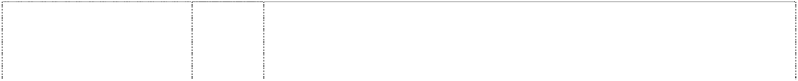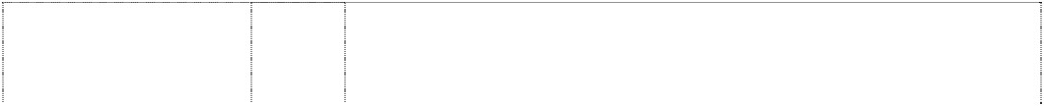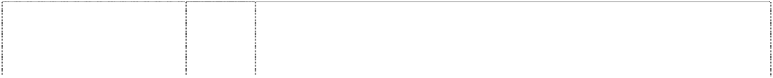

# MINI-UNISET mini-

**uniset** (589675) **MONARCH** (425659)

**MONTEGO** (709587) **MULTI-FIX** (675752)

**MULTISUITE** (562587) **NORDIC** (714922) **OASIS** (337168)

**OASIS** (337166) **OPAL** (589278) **OPAL** (589279)

**OPUS** (709591) **ORBIT** (213697)

**PEDIGREE** (227416) **PRISMA** (366276) **PRISMA**

rectangle (331340)

# R FOWLER LIMITED SYDNEY

man,nude kneeling with crossbow in annulus

(6196) **REFLECTIONS** (479029)

1. All bathroom and toilet goods in this class inclusive of basins (washstands) and vanity units.
2. Basins in this class.

11 Sanitary ware, including cisterns, pans, bidets, toilet suites, wash basins; apparatus for water supply and sanitary purposes.

11 Laundry sinks, sanitaryware and tapware.

11 Apparatus for water supply and sanitary purposes, including toilets, cisterns, tapware and parts and fittings for all the foregoing goods in this class.

11 Toilet cisterns and parts thereof; sanitaryware including toilets; apparatus and installations for water supply and sanitary purposes.

11 Installations for water supply and sanitary purposes; accessories and fittings therefor in this class inclusive of taps, cisterns and toilet pans and basins; none being apparatus for lighting, heating or drying.

11 Apparatus for water supply and sanitary purposes, including tapware, sanitaryware, vanity basins and other wash stands and basins.

21 Toilet brushes, toilet utensils, toilet seats in this class, toilet brush holders and stands, toilet paper holders, dispensers in this class of paper towels; bathroom accessories in this class and hardware items in this class including hooks.

11 Apparatus for water supply and sanitary purposes including sanitaryware and parts and accessories therefor.

11 Apparatus for water supply and sanitary purposes, including tapware and parts and fittings therefor.

11 Wash basins; taps and tap fittings included in this class but excluding those used in connection with electrically refrigerated water coolers, drinking fountains, humidifiers and dehumidifers, or similar installations.

20 Items of bathroom furniture, none being in the nature of dispensing containers.

11 Toilet cisterns, toilet pans, toilet seats, bidets, baths, shower bases, basins, vanity units, tapware.

21 Toilet brushes, toilet utensils, toilet brush holders and stands, toilet paper holders, soap dishes, toothbrush holders and tidies, dispensers of paper towels in this class, small domestic utensils and containers.

11 Apparatus for water supply and sanitary purposes, including tapware and sanitaryware; but excluding basins and wash stands.

11 Vanity basins and other washhand basins; other installations and equipment for water supply and sanitary purposes, especially those of china or earthenware.

11 All goods in Class 11.

21 Small domestic utensils and containers (not of precious metal coated therewith); soap holders, toilet brushes and toilet brush stands.

20 Mirrors, furniture and plastic fittings not included in other classes; all of the aforementioned goods being fittings for use in bathrooms.

11 Parts and fitting for heating, lighting, ventillating, water supply and sanitary purposes made of porcelain, earthenware, stoneware, terra cotta and fireclay.

6 Metal brackets for building and other metal building materials; small items of metal hardware; and all other goods in this class.

# REFLECTIONS

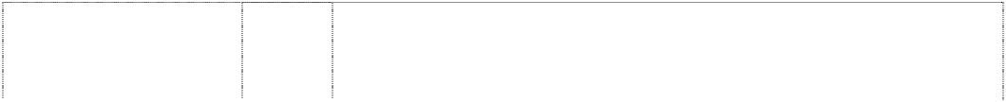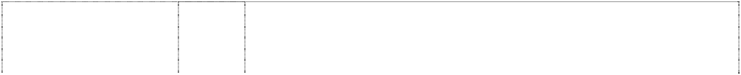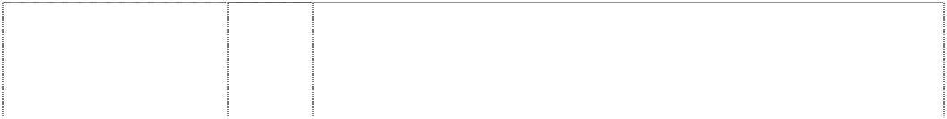

(479028)

**REFLECTIONS** (479027) **REFLECTIONS** (479026)

**REGAL** (616039) **ROYALE** (616044)

# SANIFIX

(467980)

# SANIFIX

(467979)

**SENATE** (475314) **SIESTA** (402712)

# SMALL WONDER

(592271)

# SOVEREIGN

(470631)

# ST TROPEZ SPAS

bubbles stripes, horizontal (379099)

**STT** (774305) **TRIDENT** (372410) **TRIDENT** (708698)

**UNISET** (244121) **UNISUITE** (562588) **VALET** (334129)

**VALET** (364990) **VENUS** (213698)

11 Apparatus and installations for water supply and for sanitary purposes; sanitary ware, including toilets and urinals being water closets, toilet bowls, pans and cisterns, bidets; toilet seats; wash basins, hand basins, vanity basins, baths, showers, bath and/or shower installations; fittings and fixtures in this class (including plumbing fittings and fixtures in this class) and accessories in this class for all of the aforesaid goods.

1. Furniture, tables and plastic fittings included in this class.
2. Toilet brushes, toilet utensils, toilet sets in this class, toilet brush holders and stands, toilet paper holders, soap dishes, toothbrush tidies and holders, dispensers of paper towels in this class, all the foregoing being made predominantly of vitreous china or plastic.

11 Apparatus for water supply and sanitary purposes, including toilets, cisterns, tapware and parts and fittings for all the foregoing goods.

11 Apparatus for water supply and sanitary purposes, including toilets, cisterns, tapware and parts and fittings in this class for all the foregoing goods.

6 Brackets for building, bindings, wrapping or binding bands, clips for cable and pipes, collars for fastening pipes, reinforcing materials for pipes, wall claddings, wall linings, wall plugs, pipes and pipe work, all of the aforementioned goods being made of metal.

11 Apparatus and installations for water supply and sanitary purposes; sanitary ware including toilets and urinals being water closets, toilet bowls, pans and cisterns, bidets; toilet seats; wash basins, hand basins, vanity basins, baths, showers, bath and/or shower installations; fittings and fixtures (including plumbing fittings and fixtures) in this class and accessories in this class, for all the aforesaidgoods.

11 Bath tubs and indoor spa baths; parts and accessories therefor in this class.

11 Ablution apparatus and fittings and parts thereof including baths and other bathroom and toilet fittings included in this Class.

11 Apparatus and installations for water supply and for sanitary purposes including toilets and associated fittings and accessories in this class.

11 Sanitary ware; bathroom fittings in this class being cisterns, basins, pans, bidets, baths, toilets, toilet bowls, toilet seats, showers and taps but excluding bath heaters.

11 Spa baths and spa pools.

11 Taps and parts and fittings for taps; plumbing and sanitary fittings in this class.

11 Baths, bathtubs for sitz-baths and bath fittings in this class; wash- hand basins and lavatory basins; spas.

11 Tapware, baths, bathtubs for sitz-baths and bath fittings in this class, wash-hand basins and lavatory basins, spas, toilets, toilet pans and toilet cisterns.

11 Toilet cisterns and parts thereof in Class 11.

11 Apparatus for water supply and sanitary purposes including sanitaryware and parts and accessories therefor.

1. Bathroom fittings included in this class, namely shower shelves and bathroom shelves, room tidies, cabinets, hand towel rings, single and double towel rails bathroom hooks, bathroom stools not being valets, mirrors in this class, toilet roll holders, soap holders and toothbrush holders, basin vanities included in this class.
2. Soap holders, toilet brushes and toilet brush stands.

11 Vanity basins and other washhand basins; other installations and equipment for water supply and sanitary purposes, especially those of china or earthenware.

**VICEROY** (399153) **VICEROY** (399154)



# VINTAGE

(540574)

**WALVIT** (203627) **WATER WAFER** (615503)

archer,squatting in double circle (708337)

11 All goods in this class including brass tapware, cisterns, basins, pans and bidets made from vitreous china and plastics.

20 All goods in this class inclusive of tap handles, basins, cisterns and pans made of plastic and plastic bathroom fittings and plastic furniture fittings.

11 Apparatus and installations in this class for water supply and sanitary purposes except manually operated apparatus for dispensing or vending liquids; other sanitaryware in this class; toilet seats; fittings and fixtures (including taps and other plumbing fittings and fixtures) and accessories in this class for all of the aforesaid goods; bathroom accessories in this class excluding manually operated apparatus for dispensing or vending liquids.

11 Water closet bowls, washhand basins or sinks of vitreous china or earthenware.

11 Toilets, toilet cisterns, and parts, accessories and fittings in this class for the aforesaid goods.

11 Apparatus for water supply and sanitary purposes; cisterns, cistern lids, parts and accessories for cisterns including button sets and link pieces; toilet suites, toilet pans, toilet seats; bidets; slop hoppers; urinals; flushing systems, including automatic and electronically controlled flushing systems; baths; basins, including hand basins, vanity basins, bathroom basins, hospital basins and hairdressers' basins; basin buttons; showers, shower bases; shower roses; pipes for sanitary installations; taps (faucets), valves, stopcocks and ballcocks; plugs; tap washers and jumper valves.

***Chloe S.A.S Corrs Chambers Westgarth***

***Ph: (03) 9672 3000***

***Effective Date: 18 September 2007 File Reference: C07/16040 Trade Marks Class Goods***

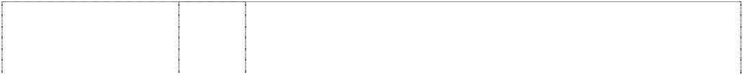

**CHLOE** (323685) **CHLOE** (436346) **CHLOE** (436347) **CHLOE** (476489)

**CHLOE** (502697) **CHLOE** (628249)

**CHLOE** (436349) **CHLOE** (436350) **CHLOE** (406019) **CHLOE** (436351)

# CHLOE LUNETTES

(503774)

# CHLOE NARCISSE

(569446)

3 Cosmetics, fragrances and all other goods included in this class.

9 All goods in this class.

14 All goods in this class.

16 Paper, cardboard and goods made from those materials, printed matter, diaries, posters, patterns for dressmaking, stationery; all other goods in this class.

16 All goods in this class.

18 Leather and imitations of leather and goods made of these materials and not included in other classes; animal skins, hides; trunks and traveling bags; umbrellas, parasols and walking sticks; whips, harness and saddlery.

21 All goods in this class.

1. All goods in this class.
2. Articles of clothing, excluding footwear.
3. Buttons and buckles not for footwear, ribbons and lace, ribbons and braid, needles and pins, artificial flowers and fruit.

9 Spectacles, sunglasses, other optical goods, their parts and fittings; all other goods in this class.

3 All goods included in international class 3, especially perfumes and fragrances.

# NARCISSE CHLOE

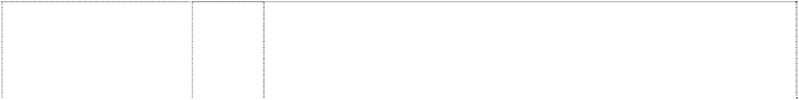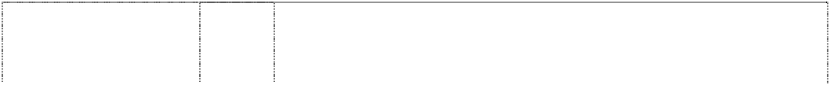

roses incomplete speckled in rectangle (584715)

# SEE BY CHLOE

(868592)

# SEE BY CHLOE

(868592)

# SEE BY CHLOE

(868592)

3 Soaps; perfumes, eau de toilette, eau de parfum, colognes, essential oils; non-medicated toilet preparations, skin creams and lotions, bath and shower preparations; preparations for the hair, dentifrices; anti- perspirants, deodorants for personal use; and all other goods in this class.

14 Goods made from precious metals or semi-precious metals; goods coated with precious metals or semi-precious metals; jewellery, precious stones; horological and chronometric instruments; parts and fittings for all the aforesaid goods.

18 Goods made of leather and imitations of leather; trunks and traveling bags; umbrellas, parasols and walking sticks; articles of luggage; bags and cases, holdalls, rucksacks, suitcases, backpacks, handbags, credit card holders, briefcases, personal organizers, attaché cases, purses, wallets, key cases; parts and fittings for all the aforesaid goods.

25 Clothing, footwear, headgear; lingerie, ties; scarves.

***Consitex SA Corrs Chambers Westgarth***

***Ph: (03) 9672 3000***

***Effective Date: 29 August 2007 File Reference: C07/12807***

***Trade Marks Class Goods***

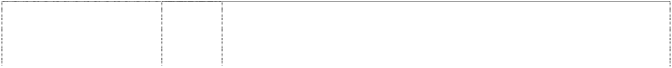

# 13 MILMIL 13

(788763)

# 13 MILMIL 13

(788763)

# 15 MILMIL 15

(717821)

# 15 MILMIL 15

(717821) **BOLGHERI** (608404) **CASHCO** (741185) **CASHCO** (741185) **COUNT ZEGNA** (206329)

**COUNT ZEGNA** (206330) **ERMENEGILDO ZEGNA** (912008) **ERMENEGILDO ZEGNA** (875229)

**ERMENEGILDO ZEGNA** (875229) **ERMENEGILDO ZEGNA** (281964) **ERMENEGILDO ZEGNA** (281965) **ERMENEGILDO ZEGNA** (281966)

1. Fabrics for use in manufacturing and tailoring of clothing.
2. Clothing, footwear, headgear.
3. Woollen fabrics for use in the manufacturing of clothing.
4. Suits, jackets, trousers, waistcoats.

25 All goods in class 25 particularly ties, scarves, formal clothes and sports suits, bathing suits and sweaters.

1. Fabrics for use in tailoring and in the manufacturing of clothing.
2. Suits, jackets, trousers, coats, waistcoats; all being adult clothing.
3. Piece goods bed and table covers, textile articles not included in other classes, whether made from wool, silk, cotton, synthetic or other material, or any mixture thereof.
4. Clothing, whether made from wool, silk, cotton, synthetic or other material, or any mixture thereof.

3 Bleaching preparations and other substances for laundry use; cleaning, polishing, scouring and abrasive preparations; soaps; perfumery, essential oils, cosmetics, hair lotions; dentifrices.

9 Spectacles, spectacle frames, spectacle glasses and lenses, sunglasses, eyeshields, eyeshades, eyeglasses, eyeglasses frames, eyeglass glasses, eyeglass materials, box and cases for glasses and eyeglasses.

14 Jewellery, precious stones, cuff links and tie pins, horological and chronometric instruments.

1. Yarns, threads.
2. Tissues (piece goods); bed and table covers; textile articles not included in other classes.
3. Clothing, including boots, shoes and slippers.

# ERMENEGILDO ZEGNA

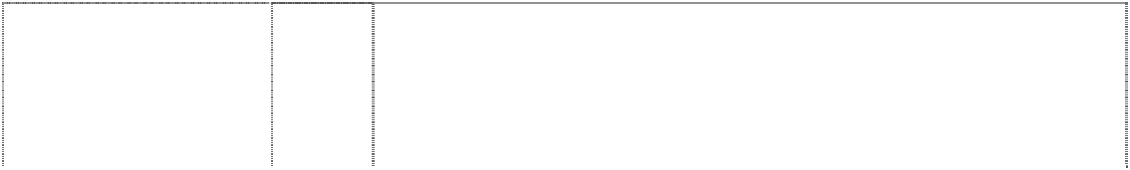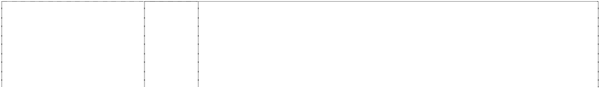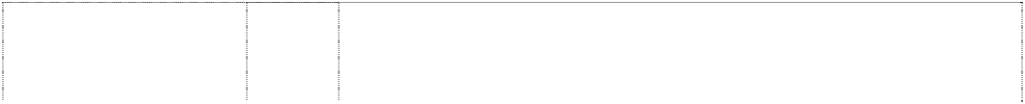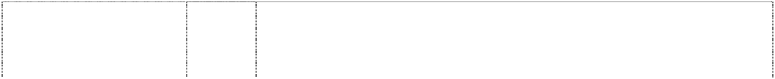

crest in seal, stationery with ribbon coronet, pointed and mantling shield, divided stars, three lion, rampant (248884) **ERMENEGILDO ZEGNA**

words in rectangle stitching-border in square, striped, vert. (983951) **ERMENEGILDO ZEGNA**

words in rectangle stitching-border in square, striped, vert. (983951) **ERMENEGILDO ZEGNA**

words in rectangle stitching-border in square, striped, vert. (983951) **ERMENEGILDO ZEGNA CASHMERE COMFORT**

(754515) **ERMENEGILDO ZEGNA CASHMERE COMFORT**

(754515) **ERMENEGILDO ZEGNA ESSENZA DI ZEGNA**

(946731) **EMENEGILDO SEGNA MICRONSPHERE**

greek character,mu is ltr M

(1075059) **EMENEGILDO SEGNA MICRONSPHERE**

greek character,mu is ltr M

(1075059) **EMENEGILDO SEGNA MICRONSPHERE**

greek character,mu is ltr M

(1075059) **ERMENEGILDO ZEGNA SU MISURA** (775033) **ERMENEGILDO ZEGNA TRAVELLER** (754516) **ERMENEGILDO ZEGNA TRAVELLER** (754516)

24 Tissues (piece goods); bed and table covers, textile articles.

3 Bleaching preparations and other substances for laundry use; cleaning, polishing, scouring and abrasive preparations; soaps; perfumery, essential oils, cosmetics, hair lotions; dentifrices.

18 Leather and imitations thereof, goods of these materials not included in other classes; animal skins and hides; trunks and suitcases; umbrellas, parasols and walking sticks; whips and saddlery.

25 Clothing, footwear, headgear.

1. Textiles and textile goods, not included in other classes; bed and table covers all including or comprised of cashmere.
2. Clothing, footwear, headgear.

3 Bleaching preparations and other substances for laundry use; cleaning, polishing, scouring and abrasive preparations; soaps; perfumery, essential oils, cosmetics, hair lotions; dentifrices.

18 Leather and imitation leather, goods made thereof not included in other classes; animal skins and hides; trunks and suitcases; umbrellas, parasols and walking sticks; whips, harness and saddlery.

1. Textiles and textile goods, not included in other classes; bed and table covers.
2. Clothing, footwear, headgear.

25 Clothing, including suits, jackets, trousers, waist coats and coats.

1. Textiles and textiles goods, not included in other classes; bed and table covers.
2. Clothing, footwear, headgear.

**ERMENEGILDO ZEGNA WHISPER** (556767) **ERMENEGILDO ZEGNA WHISPER** (556768) **ERMENEGILDO ZEGNA ZEN** (504831)

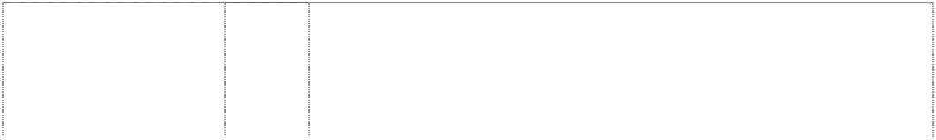

**MARIO ZEGNA** (1044076) **MARIO ZEGNA** (1044076) **MICROLITE** (912017) **MICRONSPHERE** (1053430)

**MICRONSPHERE** (1053430) **MICRONSPHERE** (1053430) **MICROTENE** (721674) **MICROTENE** (721674) **MICROTENE** (721674) **SELVANTI** (452296) **TINDARI** (241108)

**TINDARI** (546947) **TWINTECH** (721676)

# VELLUS AUREUM

(902112)

# VELLUS AUREUM

(902477)

# VELLUS AUREUM

(902477)

# VELLUS AUREUM

(902477)

# Z ERMENEGILDO ZEGNA

ltr in circle (830848)

# Z ERMENEGILDO ZEGNA

ltr in circle (830848)

**Z ERMENEGILDO ZEGNA** (1035812)

* 1. All goods in class 24 particularly tissues, but excluding furnishings predominantly of textiles and blinds in this class, including those made predominantly of fabric.
  2. All goods in class 25 particularly mens clothing.

24 Textiles and textile goods not included in other classes, bed covers and table covers in class 24.

1. Fabrics and textile goods, not included in other classes; bed and table covers.
2. Clothing, footwear, headgear.

24 Fabrics and textiles included in this class; bed and table covers.

18 Leather and imitation leather, goods made of these materials not included in other classes; animal skins, hides; trunks and suitcases; umbrellas, parasols and walking sticks; whips and saddlery.

1. Textiles and textile goods, not included in other classes; bed and table covers.
2. Clothing, footwear, headgear.

18 Rucksacks, bags.

1. Shuttle fabric based on polyester microfibre.
2. Jackets, blousons, capes, coats, raincoats, trousers, overalls, salopettes, sailors jackets, sailors suits, caps, gloves.

25 All goods in class 25.

1. Woven fabrics and all other piece goods, bed and table covers, textile articles not included in other classes, and all other goods in Class 24.
2. Suits, jackets, coats, trousers, waistcoats manufactured with woollen fabrics and other natural fibres.

25 Clothing, footwear, headgear.

1. Raw fibrous textile materials being wool.
2. Yarns and threads for textile purposes.
3. Fabrics and textiles (included in this class); bed and table covers.
4. Clothing, footwear, headgear.

18 Bags, handbags, briefcases, suitcases, purses, wallets, cheque holders, billfolds, key holders, document cases, trunks and travelling bags, belts, umbrellas, parasols and walking sticks, whips, harness and saddlery, attache-cases, shoulder bags, clutch bags, suit packs, cosmetic bags, change purses, business cases, tie cases for travelling, rucksacks, overnight cases, sport bags, hat boxes, leather cigarette cases.

25 Shirts, T-shirts, trousers, vests, raincoats, windproof garments, wintercoats, bermudas, shorts, skirts, scarves, ties, bow ties, hats and caps, socks, jackets, pyjamas, suits, coats, sweaters, cardigans, pullovers, waistcoats, gloves, mittens, bathing costumes, bathrobes, belts, kerchiefs, overalls, blazers, shoes, slippers, boots, underwear, knitwear, blousons, pants.

18 Leather and imitation leather articles, not included in other classes, in particular purses, small purses, small cases, suitcases, small bags, wallets, banknote holders, document holders, trunks and travelling bags, shoulder bags, handbags, garment bags for travel, vanity cases, change purses, key cases, document cases, tie holders for travel, rucksacks, overnight cases, sports bags, bags for hats, umbrellas, parasols and walking sticks; whips and saddlery.

**Z ERMENEGILDO ZEGNA** (1035812)

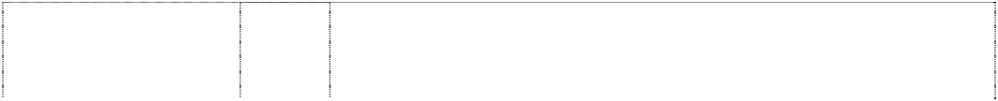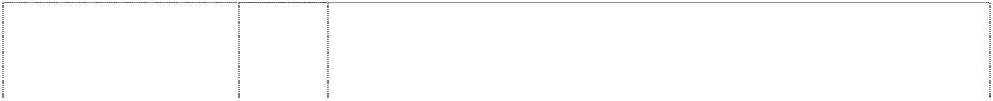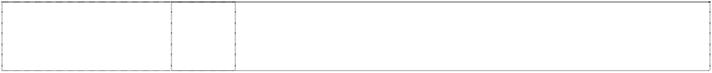

# Z ZENGA

(1020347)

**Z ZENGASPORT** (1023390) **ZEGNA**

(652471) **ZEGNA** (196759) **ZEGNA** (247527) **ZEGNA SPORT** (795089) **ZENGASPORT IJACKET** (1151008)

# ZS

(987256)

stripes,two,oblique on disc within circles,two, concentric

(358219)

stripes,two,oblique on disc within circles,two, concentric

(358218)

stripes,two,oblique on disc within circles,two, concentric

(358214)

25 Clothing, footwear, headgear; leather belts.

25 Clothing, footwear, headgear.

25 Clothing, footwear, headgear.

3 Fragrances, perfumes, cosmetics and all other goods in class 3.

1. Textile piece goods.
2. Articles of clothing.

25 Clothing in class 25, including sports jackets, trousers, sports outer knitwear, T-shirts, shirts, bathing suits, bathrobes.

25 Outdoor clothing, especially jackets, sports jackets, windbreakers, anoraks, blousons.

25 Clothing, shoes, headgear excluding outdoor clothing for women.

3 Bleaching preparations and other substances for laundry use; cleaning, polishing, scouring and abrasive preparations; soaps; perfumery, essential oils, cosmetics, hair lotions; dentifrices.

14 Precious metals and their alloys and goods in precious metals or coated therewith (except cutlery, forks and spoons); jewellery, precious stones; horological and other chronometric instruments.

25 Clothing, including boots, shoes and slippers.

***Dorf Clark Industries Limited Spruson & Ferguson Lawyers Ph: (02) 9393 0300***

***Effective Date: 24 September 2007 File Reference: C07/16477 Trade Marks Class Goods***

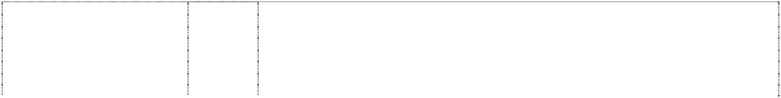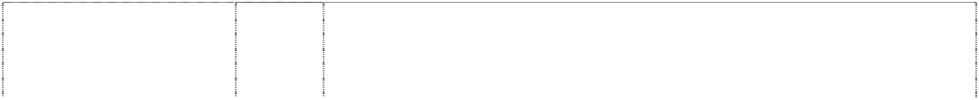

# ADELPHI

(758716)

# ALPES

(954042)

# ATLANTIC

(941546)

# ATLANTIS

(473771)

# AVANTI

(581903)

# AXIS

(897099)

# BANKSIA

(976991)

11 Apparatus and installations for water supply and sanitary purposes; tapware; bathroom accessories; sinks, basins and tubs for bathrooms, kitchens and laundries.

11 Apparatus and installations for water supply and sanitary purposes; tapware; kitchen and bathroom accessories; sinks, basins and tubs for bathrooms, kitchens and laundries.

11 Apparatus and installations for water supply and sanitary purposes not including water boilers, kitchen and bathroom accessories; sinks, basins and tubs for bathrooms, kitchens and laundries.

11 Pipes included in class 11; faucets, taps, spouts and nozzles included in class 11 including water taps, spouts and nozzles; bathroom fittings not being for invalid and disabled persons, and shower heads including fixed shower heads and hand held shower heads.

11 Water and gas supply and sanitary installations including; pipes; water or gas apparatus and pipes; faucets, taps, spouts and nozzles including water taps, spouts and nozzles; shower heads including fixed shower heads and hand held shower heads.

11 Apparatus and installations for water supply and sanitary purposes; tapware; kitchen and bathroom accessories; sinks, basins and tubs for bathrooms, kitchens and laundries.

11 Apparatus and installations for water supply and sanitary purposes; tapware; kitchen and bathroom accessories; sinks, basins and tubs for bathrooms, kitchens and laundries.

**BANQUET** (488173) **BARONESS** (473792)

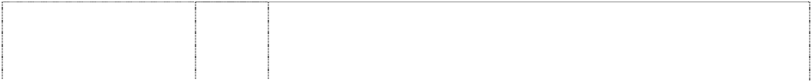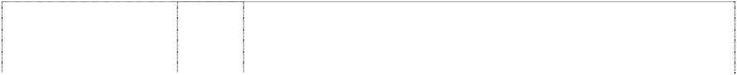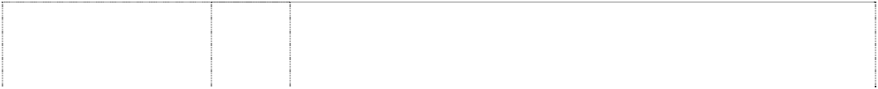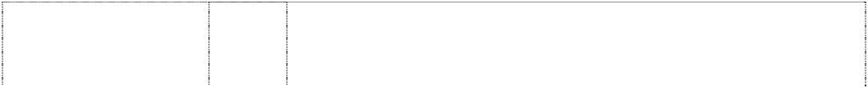

**BEAUTY LINE** (489494) **BELMORE** (579842)

# BLUSH

(954028)

# BLUSH

(954028)

# CASPIAN

(644643)

# CERADISC

(896302)

# CHEE

(954043)

# CHEE

(954043)

# CLASSIC MANOR

(579838)

**CONTESSA** (589320) **CONTESSA** (589321)

# D

stripe,curved, hooked (332962)

# D

ltr D is stripe,looped (904332)

# D

ltr D is stripe,looped (904332)

# D

ltr D is stripe,looped (904332)

# DANTE

(808371)

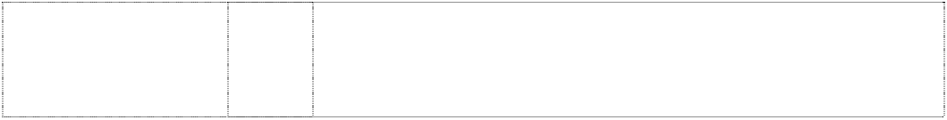**DIAMOND** (374253) **DONSON** (255122) **DONSON** (515535)

6 Sinks.

11 Water and gas pipes, faucets, taps, spouts and nozzles included in class 11; bath fittings and shower heads including fixed shower heads and hand held shower heads.

6 Stainless steel sinks and troughs included in this class.

11 All goods in class 11 including water pipes; water and gas apparatus and pipes; water supply installations including faucets, taps, spouts and nozzles including water taps, water spouts and water nozzles including fixed shower heads and hand held shower heads.

11 Apparatus and installations for water supply and sanitary purposes; tapware; kitchen and bathroom accessories; sinks, basins and tubs for bathrooms, kitchens and laundries.

21 Small domestic utensils and containers; cutting boards, colanders, sieves and drainers for kitchen use; food preparation utensils; kitchen and bathroom accessories including soap holders, toilet roll holders, toilet brush holders, toilet paper holders, toothbrush holders.

11 Apparatus for water supply and sanitary purposes including bath tubs, spa baths, vanity basins, hand basins; parts, fittings and accessories included in this class for the aforesaid goods; all other goods included in this class.

11 Apparatus and installations for water supply and sanitary purposes; tapware; kitchen and bathroom accessories; sinks, basins and tubs for bathrooms, kitchens and laundries.

11 Apparatus and installations for water supply and sanitary purposes; tapware; kitchen and bathroom accessories; sinks, basins and tubs for bathrooms, kitchens and laundries.

21 Small domestic utensils and containers; cutting boards, colanders, sieves and drainers for kitchen use; food preparation utensils; kitchen and bathroom accessories including soap holders, toilet roll holders, toilet brush holders, toilet paper holders, toothbrush holders.

11 Pipes, spouts and nozzles included in this class; bath and shower plumbing fixtures; faucets and taps, including water taps; shower heads including fixed shower heads and hand held shower heads.

11 Taps, shower and plumbing fittings, and all other fittings associated with water supply.

21 All goods in this class including small domestic utensils and containers, and including toothbrush holders, soap holders and soap dishes, toilet paper holders and toilet roll holders.

11 Taps, shower and plumbing fittings, and all other fittings associated with water supply in this class.

11 Apparatus and installations for water supply and sanitary purposes; tapware; kitchen and bathroom accessories; sinks, basins and tubs for bathrooms, kitchens and laundries.

1. Towel rings, towel rails, robe hooks.
2. Small domestic utensils and containers; cutting boards, colanders, sieves and drainers for kitchen use; food preparation utensils; kitchen and bathroom accessories including soap holders, toilet roll holders, toilet brush holders, toilet paper holders, toothbrush holders.

11 Metal laundry sinks and tubs; sanitary apparatus and fittings in this class including tubs, sinks, vanities, tapware, baths showers, toilet and cisterns.

11 Tap handles.

11 Cisterns and fittings therefor included in this class.

11 All goods in class11; pipes; water or gas apparatus and pipes; faucets, taps, spouts and nozzles including water taps, spouts and nozzles; bathroom fittings including baths, basins, toilets and toilet cisterns, showers and shower bases, shower heads including fixed shower heads and hand held shower heads.

# DONSON

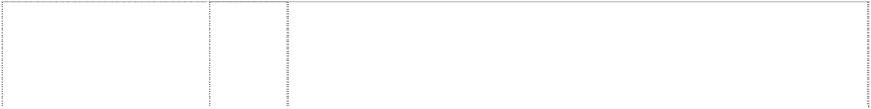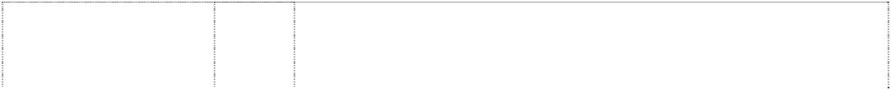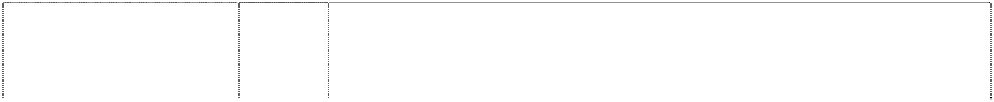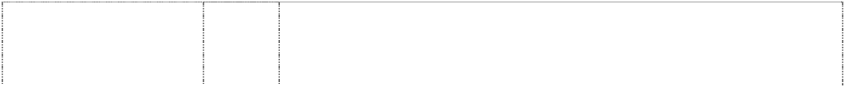

(51202)

# DORF, OF COURSE

(547298) **DORF** (414893) **DORF**

rectangle,double (161019)

# DORF

parallelograms,two and triangle from trapezium, striped (498014)

**DORF** (621677) **DORF** (382341)

**DORF** (621678) **DORF** (489555) **DORF** (621675) **DORF D**

lines (263464)

# DORF DESIGN

stripe,wavy in rectangle (634192) **DORF DESIGN**

stripe,wavy in rectangle (634191)

# DORF DESIGNER

(430006)

# DORF DESIGNER

(481151)

**DORF ORION** (757454) **DORF ORION** (757454)

**DORF SPA** (476786) **DORFMIX** (500986)

**EL TORO** (486235) **ENTERTAINER** (488172) **FITINONE** (755570)

# FITINONE

(755570)

6 Plumbers requisites being metal goods not included in other classes such as valves, not being parts of machinery, fittings for cisterns included in this class, and unions, tees, elbows and sockets.

20 All goods in this class, including towel rails, towel holders and towel rings.

11 Taps, shower and plumbing fittings, and all other fittings associated with water supply and parts therefor, being goods in Class 11.

11 Taps and other fittings associated with water supply.

11 Taps, shower and plumbing fittings, and all other fittings associated with water supply, including non-return valves, and parts therefore.

11 All goods included in class 11.

21 Small domestic utensils and containers, namely toothbrush holders, soap holders and soap dishes, toilet paper holders and toilet roll holders.

21 All goods included in class 21.

6 All goods in this class, including plumbing fittings in this class; metal sinks.

6 All goods included in class 6.

11 Fittings for water supply and sanitary purposes.

11 All goods included in class 11.

6 All goods included in class 6.

21 Small domestic utensils and containers, including tooth brush holders, soap holders and soap dishes, toilet paper holders and toilet roll holders, all the aforesaid goods being goods in Class 21.

6 All goods in this class, including towel rails, towel holders, towel rings, metal building materials, ironmongery, small items of metal hardware, and pipes and tubes of metal.

11 Tapware; bathroom accessories; sinks, basins and tubs for bathrooms, kitchens and laundries.

21 Bathroom accessories in this class including towel rails in this class, towel rings in this class, soap dishes and dispensers, toilet utensils, toothbrush holders and tidies, toilet paper holders and dispensers, toilet brush holders and stands.

11 Taps, shower and plumbing fittings, and all other fittings associated with water supply and parts therefor, being goods in class 11.

11 Taps, shower and plumbing fittings, and all other fittings associated with water supply and parts therefor, all being goods included in this class.

11 Taps and tap outlets for bathrooms, kitchens and laundries; shower fittings and plug and drain fittings.

6 Sinks.

11 Apparatus and installations for water supply and sanitary purposes; tapware; bathroom accessories; sinks, basins and tubs for bathrooms, kitchens and laundries.

21 Small domestic utensils and containers; bathroom accessories in this class including towel rails, towel rings, soap dishes and dispensers, toilet utensils, toothbrush holders and tidies, toilet paper holders and dispensers, toilet brush holders and stands.

# FIXINONE

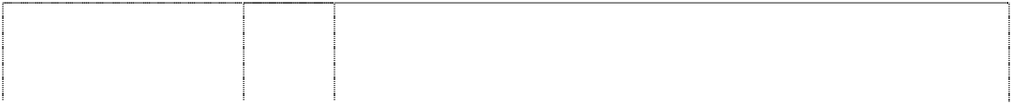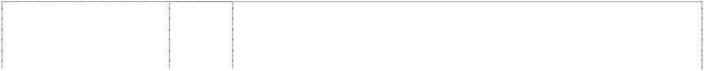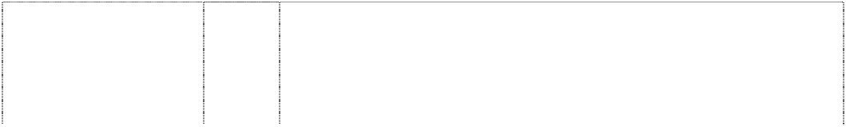

(755569)

# FIXINONE

(755569)

**FLICKMASTER** (397421) **FLICKMIXER** (388267) **INDUS** (954038)

# JUPITER

(941547)

# KEMI

(954045)

**KINGDOM** (586111) **KINGDOM** (586112)

# KISHNA

(954030)

# KOFU

(954041)

# KYTIN

(954040)

# LUSSO

(897098)

# M MYTTONS

folded ribbon form ltr M

(898965)

# M MYTTONS

folded ribbon form ltr M

(898965)

# M MYTTONS

folded ribbon form ltr M

(898965)

# M MYTTONS

triangle,trapezium & parallelogram forming m

(482262)

11 Apparatus and installations for water supply and sanitary purposes; tapware; bathroom accessories; sinks, basins and tubs for bathrooms, kitchens and laundries.

21 Small domestic utensils and containers; bathroom accessories in this class including towel rails, towel rings, soap dishes and dispensers, toilet utensils, toothbrush holders and tidies, toilet paper holders and dispensers, toilet brush holders and stands.

11 Taps, shower and plumbing fittings, and all other fittings associated with water supply but excluding pipes.

11 Plumbing fittings involving the mixing of fluids and associated with water supply, including taps and showers.

11 Apparatus and installations for water supply and sanitary purposes; tapware; kitchen and bathroom accessories; sinks, basins and tubs for bathrooms, kitchens and laundries.

11 Apparatus and installations for water supply and sanitary purposes; tapware; kitchen and bathroom accessories; sinks, basins and tubs for bathrooms, kitchens and laundries.

21 Small domestic utensils and containers; cutting boards, colanders, sieves and drainers for kitchen use; food preparation utensils; kitchen and bathroom accessories including soap holders, toilet roll holders, toilet brush holders, toilet paper holders, toothbrush holders.

11 Taps, shower and plumbing fittings associated with water supply.

21 All goods in this class including small domestic utensils and containers in this class, and including toothbrush holders, soap holders and soap dishes, toilet paper holders and toilet roll holders.

11 Apparatus and installations for water supply and sanitary purposes; tapware; kitchen and bathroom accessories; sinks, basins and tubs for bathrooms, kitchens and laundries.

11 Apparatus and installations for water supply and sanitary purposes; tapware; kitchen and bathroom accessories; sinks, basins and tubs for bathrooms, kitchens and laundries.

11 Apparatus and installations for water supply and sanitary purposes; tapware; kitchen and bathroom accessories; sinks, basins and tubs for bathrooms, kitchens and laundries.

11 Tapware.

6 Goods made of common metals and their alloys not included in other classes; building materials made of metal; items of metal hardware in this class; all containers, vessels and receptacles included in this class including troughs, drainers, tanks, pans, barrels, kegs and drums; articles and equipment included in this class for chemical processing or hospital use; goods made from sheet metal, including stainless steel, in this class.

11 Apparatus for refrigeration, apparatus for cooking, including extractor hoods for kitchens, framework for metal ovens, kitchen sinks; apparatus for water supply including, bath fittings, bath installations, bath linings, bath plumbing fixtures, bath tubs, bathroom sinks, cleaners sinks, drinking fountains, water troughs, shower bases, vanity basins, vanity tops with integral wash basins; apparatus for sanitary purposes, including bidets, cisterns, toilet bowls, toilet pans, toilet seats, toilets, wash-hand basins (parts of sanitary installations), wash-hand bowels (parts of sanitary installations), urinals and water closets; pressed bowls; wash troughs; domestic sinks, including kitchen sinks; sinks, basins and urinals.

21 Household or kitchen utensils and containers; articles for cleaning purposes including cleaning brushes; toilet brushes, toilet cases, toilet paper holders, toilet sponges and toilet utensils; glassware, porcelain and earthenware not included in other classes; holloware and tableware including holloware and tableware made of precious metals and their alloys; wash tubs; troughs for livestock.

6 Goods of non-precious metal not included in other classes.

**MAJESTIC** (539321) **MANOR HOUSE** (365159) **MANOR HOUSE** (493116)

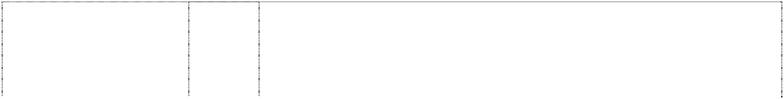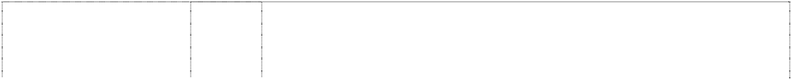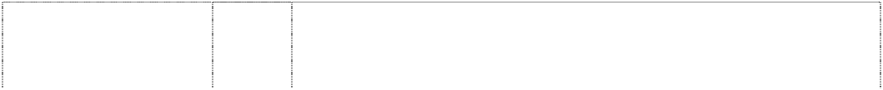

**MANOR HOUSE** (498892) **MANOR HOUSE** (556838)

# MOTIF

(897100)

# MYRIAD

(908094)

# MYRIAD

(908094)

# MYTTON

(237422)

**MYTTONS** (607620) **NEPTUNE** (531289) **NEVITE** (954037)

# NILO

(344773)

# NILUS

(954046)

**ORION** (757453) **ORION** (757453)

**PERMACOAT** (811238) **PERMACOAT** (814951) **PLUMBINONE** (755568)

# PLUMBINONE

(755568)

# PROJECT

(826785)

**PROJECT** (826785) **PROJECT** (826785)

11 Taps, shower and plumbing fittings, and all other fittings associated with water supply in this class.

11 Taps, shower and plumbing fittings and all other fittings associated with water supply in this class.

14 Toothbrush holders, soap holders and soap dishes, toilet paper holders and toilet roll holders all being goods of precious metal or coated therewith.

14 Mirrors, towel rails, towel holders, towel rings and shelves, all being goods of precious metal or coated therewith.

20 Mirrors, towel rails, towel holders, towel rings, shelves, grab rails, robe hooks and towel racks.

11 Apparatus and installations for water supply and sanitary purposes; tapware; kitchen and bathroom accessories; sinks, basins and tubs for bathrooms, kitchens and laundries.

11 Apparatus and installations for water supply and sanitary purposes; tapware; kitchen and bathroom accessories; sinks, basins and tubs for bathrooms, kitchens and laundries.

21 Small domestic utensils and containers; cutting boards, colanders, sieves and drainers for kitchen use; food preparation utensils; kitchen and bathroom accessories including towel rings and towel rails, soap holders, toilet roll holders, toilet brush holders, toilet paper holders, toothbrush holders.

6 All containers, vessels and receptacles included in this class including sinks, troughs, drainers, tanks, pans, basins, barrels, kegs and drums; articles and equipment included in this class for chemical processing or hospital use; urinals in this class, all goods of sheet metal, including stainless steel, in this class.

11 Sanitary fittings, including sinks, troughs, wash bowls, hand basins, shower bases, toilet pans and urinals.

11 Taps, shower and plumbing fittings, and tap handles.

11 Apparatus and installations for water supply and sanitary purposes; tapware; kitchen and bathroom accessories; sinks, basins and tubs for bathrooms, kitchens and laundries.

11 Plumbing fittings in this class including water taps and valves; wash basins, baths and other installations for water supply and sanitary purposes.

11 Apparatus and installations for water supply and sanitary purposes; tapware; kitchen and bathroom accessories; sinks, basins and tubs for bathrooms, kitchens and laundries.

11 Tapware; bathroom accessories; sinks, basins and tubs for bathrooms, kitchens and laundries.

21 Bathroom accessories in this class including towel rails in this class, towel rings in this class, soap dishes and dispensers, toilet utensils, toothbrush holders and tidies, toilet paper holders and dispensers, toilet brush holders and stands.

11 Apparatus for water supply and sanitary purposes; sinks, basins and tubs for bathrooms, kitchens and laundries.

20 Bathroom and laundry furniture, including laundry tub cabinets.

11 Apparatus and installations for water supply and sanitary purposes; tapware; bathroom accessories; sinks, basins and tubs for bathrooms, kitchens and laundries.

21 Small domestic utensils and containers; bathroom accessories in this class including towel rails, towel rings, soap dishes and dispensers, toilet utensils, toothbrush holders and tidies, toilet paper holders and dispensers, toilet brush holders and stands.

11 Apparatus and installations for water supply and sanitary purposes; tapware; bathroom accessories in this class; sinks, basins and tubs for bathrooms, kitchens and laundries.

1. Towel rails and towel rings in this class.
2. Bathroom accessories in this class including soap dishes and dispensers, toilet utensils, toothbrush holders and tidies, toilet paper holders and dispensers, toilet brush holders and stands.

**PROJECT** (826785) **PURAFIL** (250937) **PURAFIL** (250936) **PYCOS** (954047)

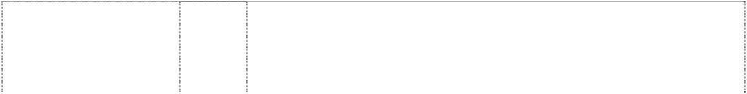

# QUATRO

(711363)

# SPARK

(954029)

# STATEMENT

(897097)

# STAYFAST

(896301)

# SUNFLOWER

(954039)

# TAGUS

(954031)

# TARIM

(954034)

**THE STUDIO COLLECTION** (553084)

**THE STUDIO COLLECTION** (553084) **TIGRIS** (954033)

**TOUCHLESS** (506454) **TOUCHLESS** (506455) **TUBMASTA** (768792) **VAND** (899512)

# VAND

(899512)

# VIPER

(954035)

# VITALITY

(954032)

6 Towel rails and towel rings in this class.

1 Chemical products for use in the treatment of water.

11 Water treatment apparatus and parts and accessories therefor.

11 Apparatus and installations for water supply and sanitary purposes; tapware; kitchen and bathroom accessories; sinks, basins and tubs for bathrooms, kitchens and laundries.

11 Apparatus for lighting, heating, steam generation, cooking, refrigerating, drying, ventilating, water supply and sanitary purposes; water distribution apparatus; pipes including pipes being parts of sanitary installations, faucets, taps and spouts for pipes and nozzles including water taps, and nozzles and spouts for water pipes; bathroom fittings and shower heads including fixed shower heads and hand held shower heads.

11 Apparatus and installations for water supply and sanitary purposes; tapware; kitchen and bathroom accessories; sinks, basins and tubs for bathrooms, kitchens and laundries.

11 Apparatus and installations for water supply and sanitary purposes; tapware; kitchen and bathroom accessories; sinks, basins and tubs for bathrooms, kitchens and laundries.

11 Apparatus and installations for water supply and sanitary purposes; tapware; kitchen and bathroom accessories; sinks, basins and tubs for bathrooms, kitchens and laundries.

11 Apparatus and installations for water supply and sanitary purposes; tapware; kitchen and bathroom accessories; sinks, basins and tubs for bathrooms, kitchens and laundries.

11 Apparatus and installations for water supply and sanitary purposes; tapware; kitchen and bathroom accessories; sinks, basins and tubs for bathrooms, kitchens and laundries.

11 Apparatus and installations for water supply and sanitary purposes; tapware; kitchen and bathroom accessories; sinks, basins and tubs for bathrooms, kitchens and laundries.

11 Taps, shower and plumbing fittings in this class. and all other fittings associated with water supply in this class.

21 Bathroom utensils and containers in this class and all other bathroom accessories in this class.

11 Apparatus and installations for water supply and sanitary purposes; tapware; kitchen and bathroom accessories; sinks, basins and tubs for bathrooms, kitchens and laundries.

11 Apparatus for drying and water supply, including hand dryers, taps, showers and plumbing fittings.

21 Household utensils, including soap dispensers.

11 Sinks and laundry tubs, including laundry tubs with integrated supporting cabinets.

11 Apparatus and installations for water supply and sanitary purposes; tapware; kitchen and bathroom accessories; sinks, basins and tubs for bathrooms, kitchens and laundries.

21 Small domestic utensils and containers; cutting boards, colanders, sieves and drainers for kitchen use; food preparation utensils; kitchen and bathroom accessories including towel rings and towel rails, soap holders, toilet roll holders, toilet brush holders, toilet paper holders, toothbrush holders.

11 Apparatus and installations for water supply and sanitary purposes; tapware; kitchen and bathroom accessories; sinks, basins and tubs for bathrooms, kitchens and laundries.

11 Tapware; apparatus and installations for water supply and sanitary purposes being bath, shower and plumbing apparatus and installations; sinks, basins and tubs for bathrooms, kitchens and laundries.

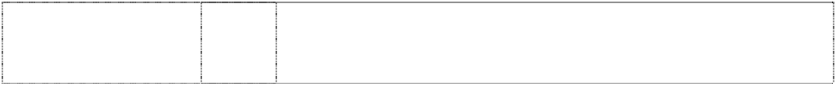

**WET ; Wet**

(1005921)

11

**WINGLINE** (377137) **YALU** (954036)

11

11

**YUKON**

(954044)

21

Tapware, including tap handles, tap outlets such as faucets and shower outlets; and parts, fittings and accessories in this class for the aforesaid goods.

Fittings and tubes for plumbing, air-conditioning, refrigeration or irrigation, all being goods included in this class.

Apparatus and installations for water supply and sanitary purposes; tapware; kitchen and bathroom accessories; sinks, basins and tubs for bathrooms, kitchens and laundries.

Small domestic utensils and containers; cutting boards, colanders, sieves and drainers for kitchen use; food preparation utensils; kitchen and bathroom accessories including soap holders, toilet roll holders, toilet brush holders, toilet paper holders, toothbrush holders.

***Dux Manufacturing Limited Spruson & Ferguson Lawyers Ph: (02) 9393 0300***

***Effective Date: 24 September 2007 File Reference: C07/16482 Trade Marks Class Goods***

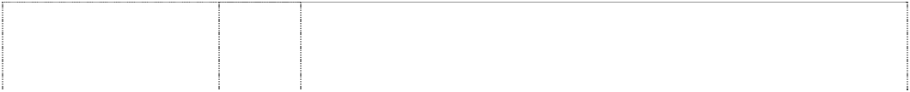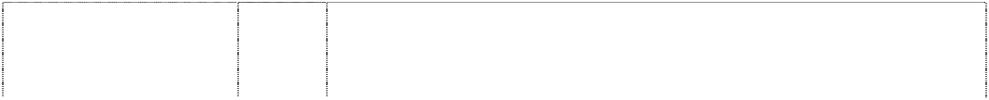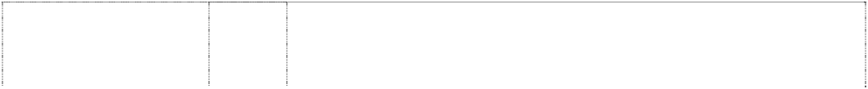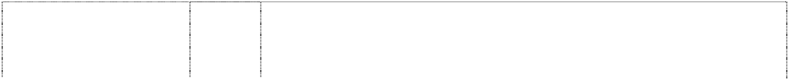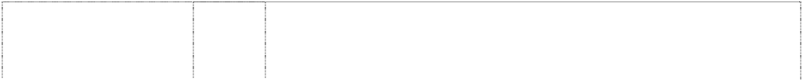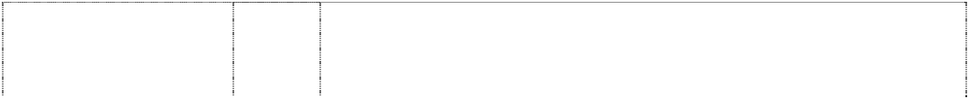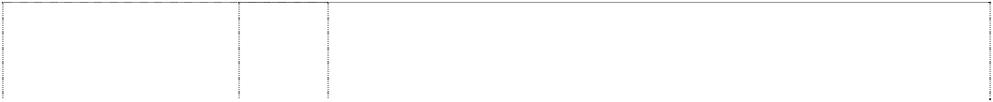

# AIROHEAT

(1061490)

# AXIOM

(938530)

**CENTAUR** (845156) **DUX** (102764)

# DUX

(731729)

# DUX

word in double oval is badge

(1107686) **DUX ASSIST** (1090845)

# DUX ENDURANCE

(946589)

# DUX THINKHOTWATER

word in double oval is badge

(1107687) **DUXSTREAM** (748103)

# ECOSMART

(1036402)

11 Electric and gas water heaters, and parts therefor in this class; installations for heating, steam generating, cooking, refrigerating, drying, ventilating, water supply and sanitary purposes, including air conditioners and hot water systems.

11 Electric and gas water heaters, and parts therefor in this class; installations for heating, steam generating, cooking, refrigerating, drying, ventilating, water supply and sanitary purposes, including air conditioners and hot water systems.

11 Heating apparatus in this class including gas water heaters and electric water heaters; all heaters in this class.

11 Electric storage water heaters; installations for heating, steam generating, cooking, refrigerating, drying, ventilating, water supply and sanitary purposes, including air conditioners and hot water systems.

11 Electric and gas water heaters and parts therefor in this class; installations for heating, steam generating, cooking, refrigerating, drying, ventilating, water supply and sanitary purposes, including air conditioners and hot water systems.

11 Apparatus for water supply and sanitary purposes, baths, spa baths, sinks, tubs, basins, showers, shower screens and trays, toilets, taps and parts and fittings for all of the foregoing.

11 Electric and gas water heaters, and parts therefor in this class; installations for heating, steam generating, cooking, refrigerating, drying, ventilating, water supply and sanitary purposes, including air conditioners and hot water systems.

11 Electric and gas water heaters, and parts therefor in this class; installations for heating, steam generating, cooking, refrigerating, drying, ventilating, water supply and sanitary purposes including air conditioners and hot water systems.

11 Apparatus for water supply and sanitary purposes, baths, spa baths, sinks, tubs, basins, showers, shower screens and trays, toilets, taps and parts and fittings for all of the foregoing.

11 Electric and gas water heaters and parts therefor in this class; installations for heating, steam generating, cooking, refrigerating, drying, ventilating, water supply and sanitary purposes, including air conditioners and hot water systems.

11 Installations for steam generating, cooking, refrigerating, drying, ventilating, water supply and sanitary purposes; electric and gas water heaters and parts therefor in this class; hot water systems; solar heating apparatus and systems including those for water heating.

# ECOSMART

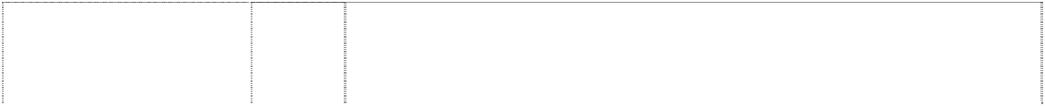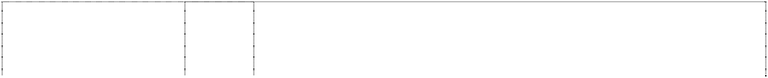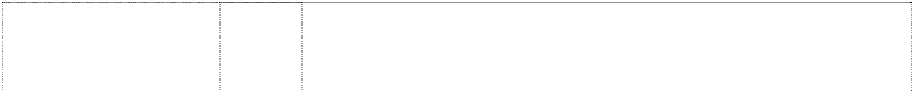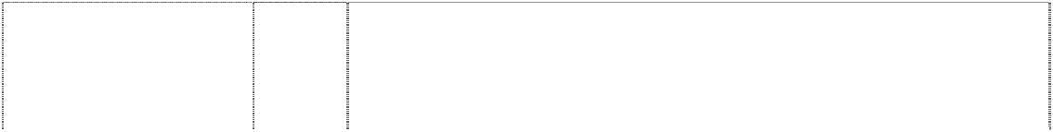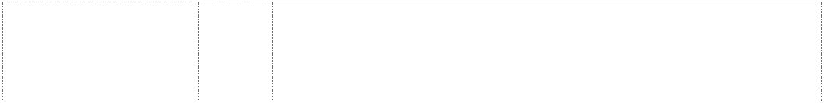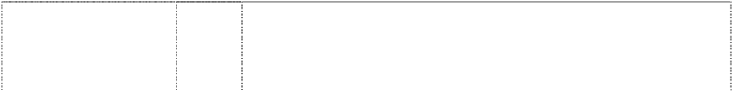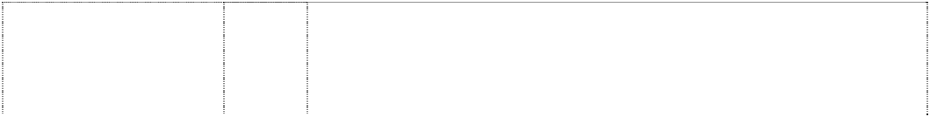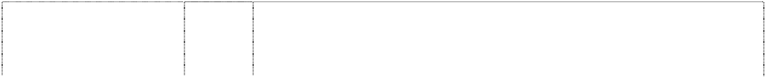

sun,rays with hill behind (1039977)

**ECOSMART WATER GUARDIAN** (1121413)

# ENSIGN

(1068470)

# EZYGAS

(952563)

**FORTE** (770572) **HEATPRO** (953334)

**HOT LOGIC** (1032104) **HOT LOGIC** (1032104)

# HOTTIE

(1074937)

# HOTTY

(1067279)

# MERCURY

(1049751)

**PANTHER** (1070883) **PLATINUM SOLAR**

# SOLUTIONS SERIES

sun,rays in oval with wavy stripe & 2 arcs (1050985) **PLATINUM SOLAR SOLUTIONS SERIES**

sun,rays in oval with wavy stripe & 2 arcs (1050985) **POWERED BY THE AUSTRALIAN SUN** (1036131)

# PRODIGY

(937770)

**PROFLOW** (767260) **READYHOT** (1047679)

11 Installations for steam generating, cooking, refrigerating, drying, ventilating, water supply and sanitary purposes; electric and gas water heaters and parts therefor in this class; hot water systems; solar heating apparatus and systems including those for water heating.

7 Pumps including those used in the supply and distribution of water.

11 Electric and gas water heaters, and parts therefor in this class; installations for heating, steam generating, cooking, refrigerating, drying, ventilating, water supply and sanitary purposes, including air conditioners and hot water systems.

11 Electric and gas water heaters, and parts therefor in this class; installations for heating, steam generating, cooking, refrigerating, drying, ventilation, water supply and sanitary purposes, including air conditioning and hot water systems.

11 Water heaters including gas and electric water heaters and parts therefor in this class.

11 Electric and gas water heaters, and parts therefor in this class; installations for heating, steam generating, cooking, refrigerating, drying, ventilating, water supply and sanitary purposes, including air conditioners and hot water systems.

9 Computer hardware and software including that used for energy management and control of solar heating systems.

11 Installations for lighting, heating, steam generating, refrigerating, drying, ventilating, cooking, water supply and sanitary purposes; water heating apparatus; solar heating systems.

11 Electric and gas water heaters, and parts therefor in this class; installations for heating, steam generating, cooking, refrigerating, drying, ventilating, water supply and sanitary purposes, including air conditioners and hot water systems.

11 Electric and gas water heaters, and parts therefor in this class; installations for heating, steam generating, cooking, refrigerating, drying, ventilating, water supply and sanitary purposes, including air conditioners and hot water systems.

11 Installations for heating, steam generating, cooking, drying, water supply and sanitary purposes; electric and gas water heaters and parts therefor in this class; hot water systems and parts therefor in this class; solar heating apparatus and systems including those for water heating.

11 Hot water heaters.

9 Solar panels; solar cells.

11 Apparatus for heating water; apparatus for storing hot water; apparatus for supplying hot water.

11 Installations for heating, steam generating, cooking, refrigerating, drying, ventilating, water supply and sanitary purposes; electric and gas water heaters and parts therefor in this class; hot water systems; solar heating apparatus and systems including those for water heating.

11 Electric and gas water heaters, and parts therefor in this class; installations for heating, steam generating, cooking, refrigerating, drying, ventilating, water supply and sanitary purposes, including air conditioners and hot water systems.

11 Water heaters including gas and electric water heaters and parts therefor in this class.

7 Pumps including those used in the supply and distribution of water.

# READYHOT

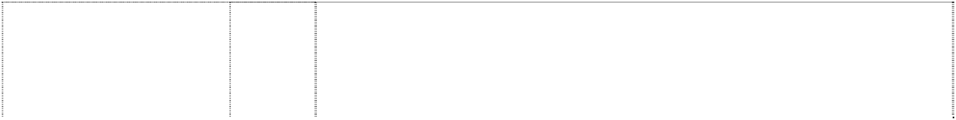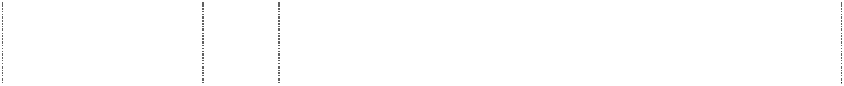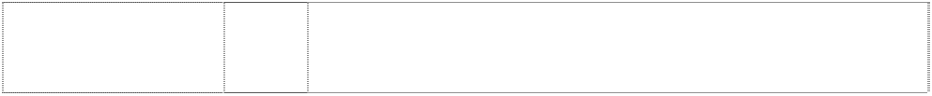

(1047679)

# SUNPRO

(950281)

**TEMPSMART** (963043) **TEMPSMART** (963043) **TEMPSMART** (963043)

# TEMPSMART

(963043)

**TEMPSMART** (963043) **THERMOLOGIC** (1046508)

# TRADEMASTER

(1066731)

# VECTOR

(1069863)

# WATER GUARDIAN

(1121414)

**YOU CAN RELAX WITH A DUX** (927134)

11 Installations for heating, steam generating, cooking, refrigerating, drying, ventilating, water supply and sanitary purposes; electric and gas water heaters and parts therefor in this class; hot water systems; solar heating apparatus and systems including those for water heating.

11 Electric and gas water heaters and parts therefor in this class; installations for heating, steam generating, cooking, refrigerating, drying, ventilating, water supply and sanitary purposes including air conditioners and hot water systems; solar heating apparatus and systems, including solar water heating apparatus and parts therefor in this class.

1. Metal valves in this class for use in relation to water heating systems; items of metal hardware.
2. Valves being parts of machines; electric motors.

9 Measuring and signalling apparatus; electrical and electronic components in this class, including those for use in relation to water heating systems; temperature control and measuring apparatus in this class.

11 Electric and gas water heaters and parts therefor in this class; installations for heating, steam generating, cooking, refrigerating, drying, ventilating, water supply and sanitary purposes including air conditioners and hot water systems; solar heating apparatus and systems, including solar water heating apparatus and parts therefor in this class.

20 Plastic valves in this class; plastic components not classified in other classes.

11 Installations for heating, steam generating, cooking, refrigerating, drying, ventilating, water supply and sanitary purposes; electric and gas water heaters and parts therefor in this class; hot water systems; solar heating apparatus and systems including those for water heating.

11 Electric and gas water heaters, and parts therefor in this class; installations for heating, steam generating, cooking, refrigerating, drying, ventilating, water supply and sanitary purposes, including air conditioners and hot water systems.

11 Electric and gas water heaters, and parts therefor in this class, including hot water systems.

7 Pumps including those used in the supply and distribution of water.

11 Electric and gas water heaters and parts therefore in this class; installations for heating, steam generating, cooking, refrigerating, drying, ventilating, water supply and sanitary purposes, including air conditioners and hot water systems.

***Fitness Quest Inc Swaab Attorneys***

***Ph: (02) 9233 5544***

***Effective Date: 19 September 2007 File Reference: C07/16045***



***Trade Marks***

***Class***

***Goods***

**LEG MAGIC**

(1122910)

28

Manually operated exercise equipment.

***GWA International Limited Spruson & Ferguson Lawyers Ph: (02) 9393 0300***

***Effective Date: 14 September 2007 File Reference: C07/16038***



***Trade Marks***

***Class***

***Goods***

# G

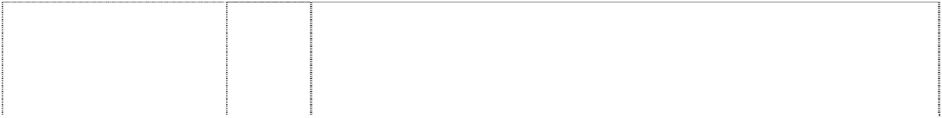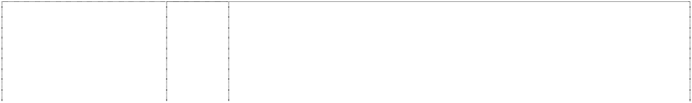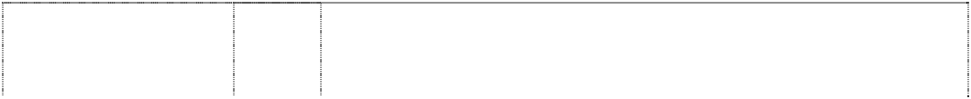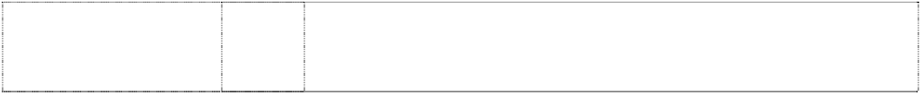

circle,incompl., extended with p/gram forms ltr G

(1053514)

# G

circle,incompl., extended with p/gram forms ltr G

(1053514) **GWA** (1053512)

# GWA

(1053512)

# GWAIL

(1053513)

# GWAIL

(1053513)

11 Installations for water supply and sanitary purposes; taps and tap fittings; bathroom fittings; plumbing fixtures and fittings; toilet bowls, toilet suites, urinals, toilet cisterns, bidets, bidettes, toilet seats; hand basins, wash basins, vanity basins, baths, showers, shower bases; clothes dryers and other dryers in this class; apparatus for lighting, heating, drying and ventilating.

21 Small domestic utensils and containers; toilet brushes, toilet brush stands, toilet roll holders, soap holders and dispensers, toilet paper holders, toothbrush tidies and holders; cups; containers, trays and utensils not of precious metal for household use.

11 Installations for water supply and sanitary purposes; taps and tap fittings; bathroom fittings; plumbing fixtures and fittings; toilet bowls, toilet suites, urinals, toilet cisterns, bidets, bidettes, toilet seats; hand basins, wash basins, vanity basins, baths, showers, shower bases; clothes dryers and other dryers in this class; apparatus for lighting, heating, drying and ventilating.

21 Small domestic utensils and containers; toilet brushes, toilet brush stands, toilet roll holders, soap holders and dispensers, toilet paper holders, toothbrush tidies and holders; cups; containers, trays and utensils not of precious metal for household use.

11 Installations for water supply and sanitary purposes; taps and tap fittings; bathroom fittings; plumbing fixtures and fittings; toilet bowls, toilet suites, urinals, toilet cisterns, bidets, bidettes, toilet seats; hand basins, wash basins, vanity basins, baths, showers, shower bases; clothes dryers and other dryers in this class; apparatus for lighting, heating, drying and ventilating.

21 Small domestic utensils and containers; toilet brushes, toilet brush stands, toilet roll holders, soap holders and dispensers, toilet paper holders, toothbrush tidies and holders; cups; containers, trays and utensils not of precious metal for household use.

***GWA Taps Manufacturing Limited Spruson & Ferguson Lawyers Ph: (02) 9393 0300***

***Effective Date: 14 September 2007 File Reference: C07/16039***



***Trade Marks***

***Class***

***Goods***

**IRWELL**

(702726)

11

Taps and tapware in this class.

***HBI Branded Apparel Enterprises, LLC Allens Arthur Robinson Ph: (03) 9614 1011***

***Effective Date: 31 August 2007 File Reference: C07/14222 Trade Marks Class Goods***



# 18 HOUR EIGHTEEN HOUR

(213062) **AIRFORM** (1064912)

**AIRFORM** (1064912) **BALI** (924583)

# BODY LANGUAGE

(732163)

25 Feminine undergarments, including girdles, corsets and brassieres.

1. Fabrics, fabric composites and textile piece goods including fabrics, fabric composite and textile piece goods for use in the manufacture of brassieres.
2. Clothing, intimate apparel including brassieres, fabric and textile fabric piece goods sold as a component of brassieres.

25 Clothing, namely intimate apparel, not being goods made in Bali.

25 Clothing and intimate apparel including brassieres, panties and girdles.

# C

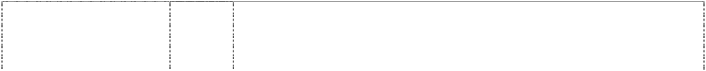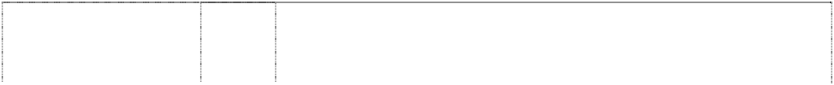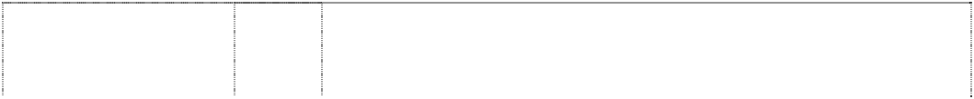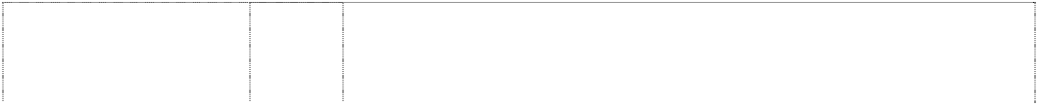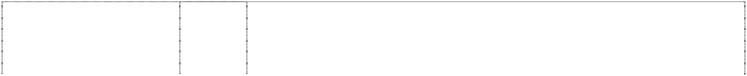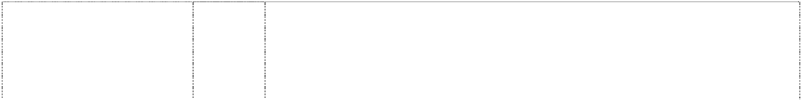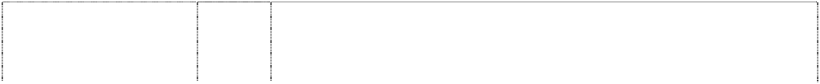

2 vert. stripes, 1 notched divide ellipse, incompl., pointed is ltr C

(1023310)

# C

vertical line halves ellipse, incomplete (719512)

# C

vertical line halves ellipse, incomplete (719512)

# C

vertical line halves ellipse, incomplete (719512)

# C

vertical line halves ellipse, incomplete (719512)

# C

vertical line halves ellipse, incomplete (719512)

# C

vertical line halves ellipse, incomplete (341084)

# C

vertical line halves ellipse, incomplete (719512)

# C

vertical line halves ellipse, incomplete (719512)

# C

vertical stripe halves ellipse, incompl. is ltr c (991979)

# C9 BY CHAMPION

(1013246)

# C9 BY CHAMPION

(1013246)

# C CHAMPION

ltr c is vertical line halves ellipse, incomplete (428976)

# C CHAMPION

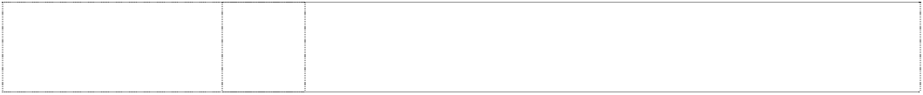vertical stripe halves ellipse, incompl is ltr C (809530)

# C CHAMPION

vertical stripe halves ellipse, incompl is ltr C (809530)

25 Clothing, footwear and headwear.

14 Key rings.

16 Stickers.

18 Wallets, umbrellas, backpacks, bags, gym bags, tote bags, fanny packs.

21 Bottles, drink bottles, drinking vessels, mugs.

1. Towels.
2. Clothing including casual clothing; active sportswear; athletic uniforms; physical education wear; shirts; pants and shorts; sweat shits and sweat pants’ warm-up suits; jackets; sweaters; hats and caps, swim suits’ women’s and girls apparel including blouses, jumpers and rainwear; night shirts and caps; vests and sashes for convention use; arm bands being sporting apparel; aprons and bibs; footwear including casual and athletic footwear and hosiery.

25 Sweatbands, headbands, wristbands.

28 Games, playthings, gymnastic articles, sporting articles, inflatable sporting balls, volleyballs, basketballs, footballs, soccer balls, baseballs.

14 Precious metals and their alloys and goods in precious metals or coated therewith, not included in other classes; jewellery, precious stones; time pieces and chronometric instruments, particularly watches, watch bands, chronometers, chronographs, clocks as well as parts and accessories thereof included in this class.

18 Bags including school bags, gym bags, sporting bags, bum bags, travel bags, backpacks; purses and wallets.

25 Clothing, footwear and headgear.

25 Clothing, footwear, headgear in class 25 including; casual clothing, leisurewear, sportswear, suits, jackets, vests, coats, shirts, sweat shirts, T-shirts, blouses, sweaters, jumpers, cardigans, trousers, pants, track pants, sweat pants, shorts, track suits, warm-up suits, physical education wear, team uniforms, athletic uniforms, arm bands, sweat bands, pyjamas, night shirts, night caps, swim suits, sashes, ties, cravats, scarves, rainwear, aprons, bibs, hats, caps, beanies, berets, hosiery and socks; but excluding all other footwear.

14 Key rings.

16 Stickers.

# C CHAMPION

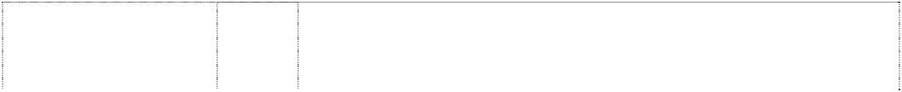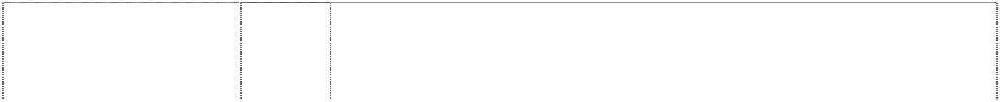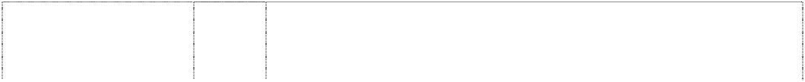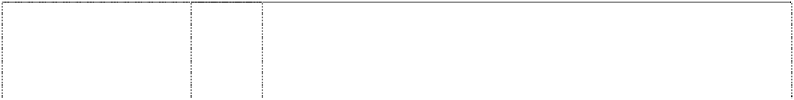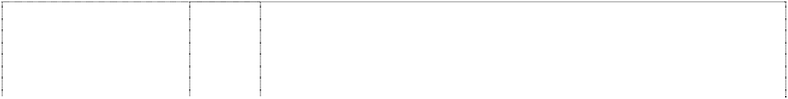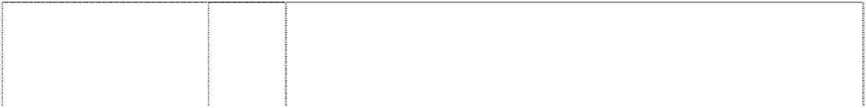

vertical stripe halves ellipse, incompl is ltr C (809530)

# C CHAMPION

vertical stripe halves ellipse, incompl is ltr C (809530)

# C CHAMPION

vertical stripe halves ellipse, incompl is ltr C (809530)

# C CHAMPION

vertical stripe halves ellipse, incompl is ltr C (809530)

# C CHAMPION

vertical stripe halves ellipse, incompl is ltr C (809530)

**CHAMPION** (809529) **CHAMPION** (991980)

**CHAMPION** (809529) **CHAMPION** (809529) **CHAMPION** (809529) **CHAMPION** (64394) **CHAMPION** (809529) **CHAMPION** (61142)

**CHAMPION** (782749) **CHAMPION** (809529)

# CHAMPION

(809529)

# CHAMPION

ltr c is vertical line halves ellipse, incomplete (732900) **CHAMPION**

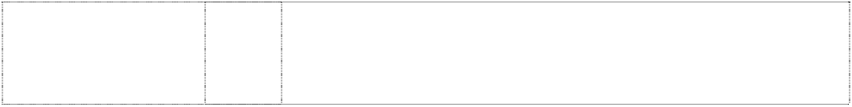ltr c is vertical line halves ellipse, incomplete (719513) **CHAMPION**

ltr c is vertical line halves ellipse, incomplete (719513)

18 Wallets, umbrellas, backpacks, bags, gym bags, tote bags, bum bags.

21 Bottles, drink bottles, drinking vessels, mugs.

1. Towels.
2. Clothing; headgear; footwear, excluding soles, heels and insoles, and stops or studs for football boots and for other sporting footwear; sweatbands; headbands and wristbands.

28 Games, playthings, gymnastic articles, sporting articles, inflatable sporting balls, volleyballs, basketballs, footballs, soccer balls, baseballs.

14 Key rings.

14 Precious metals and their alloys and goods in precious metals or coated therewith, not included in other classes; jewellery, precious stones; time pieces and chronometric instruments, particularly watches, watch bands, chronometers, chronographs, clocks as well as parts and accessories thereof included in this class.

16 Stickers.

18 Wallets, umbrellas, backpacks, bags, gym bags, tote bags, bum bags.

21 Bottles, drink bottles, driving vessels, mugs.

24 Cotton piece goods.

1. Towels.
2. Articles of clothing (knitted or made of woven fabric of wool, cotton or silk, or mixtures thereof) for men, women and children; but not including boots, shoes and similar footwear.

25 Footwear, excluding Esparto shoes, and soles, heels and insoles, and stops or studs for football boots and for other sporting footwear.

25 Clothing; headgear; footwear, excluding soles, heels and insoles, and stops or studs for football boots and for other sporting footwear; sweatbands; headbands and wristbands.

28 Games, playthings, gymnastic articles, sporting articles, inflatable sporting balls, volleyballs, basketballs, footballs, soccer balls, baseballs.

9 Optical goods for the eyes, eyeglasses, eye spectacles, sunglasses, eye lenses, eyeshades, frames for any of the foregoing goods, eyeglass frames, sunglasses frames, cases for any of the foregoing goods, eyeglass cases and sunglasses cases; parts and accessories in class 9 for any of the foregoing goods.

14 Key rings.

16 Stickers.

# CHAMPION

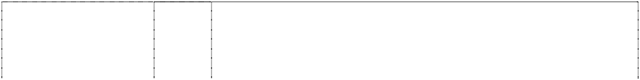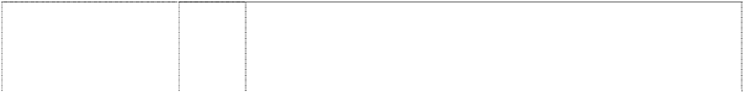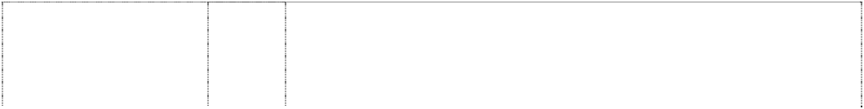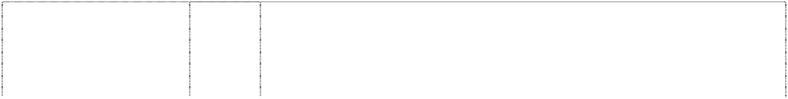

ltr c is vertical line halves ellipse, incomplete (719513) **CHAMPION**

ltr c is vertical line halves ellipse, incomplete (719513) **CHAMPION**

ltr c is vertical line halves ellipse, incomplete (719513) **CHAMPION**

ltr c is vertical line halves ellipse, incomplete (719513) **CHAMPION**

ltr c is vertical line halves ellipse, incomplete (414674) **CHAMPION**

ltr c is vertical line halves ellipse, incomplete (543435)

# CHAMPION

ltr c is vertical line halves ellipse, incomplete (719513)

18 Wallets, umbrellas, backpacks, bags, gym bags, tote bags, fanny packs.

21 Bottles, drink bottles, drinking vessels, mugs.

1. Towels.
2. Sweatbands, headbands, wristbands.

25 Sportswear and leisurewear for men, women and children but excluding footwear.

25 Clothing, footwear, headgear in class 25 including; casual clothing, leisurewear, sportswear, suits, jackets, vests, coats, shirts, sweat shirts, T-shirts, blouses, sweaters, jumpers, cardigans, trousers, pants, track pants, sweat pants, shorts, track suits, warm-up suits, physical education wear, team uniforms, athletic uniforms, arm bands, sweat bands, pyjamas, night shirts, night caps, swim suits, sashes, ties, cravats, scarves, rainwear, aprons, bibs, hats, caps, beanies, berets, hosiery and socks; but excluding all other footwear.

28 Games, playthings, gymnastic articles, sporting articles, inflatable sporting balls, volleyballs, basketballs, footballs, soccer balls, baseballs.

# CHAMPION



vertical stripe halves ellipse, incompl. is ltr c (1084971)

# CHAMPION U.S.A.

(646413)

# CHAMPION U.S.A.

(809532)

**COMFORTFLEX** (420888) **COMFIT STRAP** (640224)

**CRISS CROSS** (308549) **CROSS-YOUR- HEART** (195618) **CROSS YOUR**

# HEART BEAUTY LIFT

(275120) **DOUBLE DRY** (1071056) **ELOQUENCE** (838284)

28 Exercise equipment, namely treadmills, step machines, stair- stepping machines, elliptical trainers, stationary exercise bikes, rowing machines, jump ropes, exercise doorway gym bars, pull-up or chin bars, exercise benches, exercise platforms, exercise trampolines, weight lifting benches and bench accessories, exercise weight cuffs, athletic training devices, namely weighted vests, weighted belts, exercise weights, weight plates and barbells, wrist and ankle weights for exercise, weight lifting belts, weight lifting gloves, stress relief balls for hand exercise, abdominal boards, chest expanders, resistance bands and exercise straps; multipurpose home gyms; sports equipment, namely, badminton nets, badminton rackets, badminton shuttlecocks, ball carts, ball lockers, baseball accessories, baseball chest protectors, baseball masks, baseball safeguards, baseball gloves, baseballs, bases, basketball bags, basketball nets, basketball trainers, basketballs, bats, batting helmets, batting tees, batons, beach paddles, beachballs, bowling pins, cage balls, cricket bats, cricket balls, cricket gloves, cricket pads, cricket protectors, cricket bags, cricket sets, cricket stumps, deck tennis rings, dodge balls, discus, equipment bags, exercise and training balls, exercise tubing, field hockey nets, field markers, fleece balls, flying discs, foam balls, foam dice, foam discs, foam hands, football belts, football kicking tees, footballs, golf balls, golf bags, golf clubs, gym markers, hockey goals, hockey nets, hockey sticks, hockey gloves, homeplates, hula hoops, jump ropes, knee pads, lacrosse balls, lacrosse goals, lacrosse nets, medicine balls, megaphones, paddleball rackets, parachutes, personal equipment bags, pinnies, pitching machine baseballs, pitching machine softballs, pitching rubbers, plastic baseballs, plastic discs, plastic golfballs, plastic paddles, plastic softballs, playground balls, polo sets, pumps, racquetball racquets, relay batons, foam ball sets, foam balls, ring toss, scoop ball, scooters, shinguards, shot and discus carrier, shot puts, shuffleboard, soccer goalie gloves, soccer nets, soccer shinguards, soccer balls, sport ball carriers, hockey sets and sticks, lacrosse sets, softball chest protectors, softballs, softball gloves, starting blocks, starting pistols, table tennis sets, table tennis paddles, table tennis balls, tennis balls, tennis nets, tennis racquets, tetherballs, training balls, tug of war ropes, umpire chest protectors, umpire shinguards, volleyball carts, volleyball knee pads, volleyball nets, volleyball trainers, volleyballs.

25 Clothing, footwear, headgear in class 25 including: casual clothing, leisurewear, sportswear, suits, jackets, vests, coats, shirts, sweat shirts, T-shirts, blouses, sweaters, jumpers, cardigans, trousers, pants, track pants, sweat pants shorts, track suits, warm-up suits, physical education wear, team uniforms, athletic uniforms, arm bands, sweat bands, pyjamas, night shirts, night caps, swim suits, sashes, ties, cravats, scarves, rainwear, aprons, bibs, hats, caps, beanies, berets, hosiery and socks; but excluding all other footwear.

25 Footwear, shoes, casual shoes and athletic shoes; all excluding soles, heels and insoles, and stops or studs for football boots and for other sporting footwear.

25 Articles of clothing and underclothing in class 25.

25 Ladies underwear and foundation garments including brassieres.

25 Brassieres.

25 Outer clothing and under clothing, including brassieres, girdles and corsets.

25 Brassieres.

25 Clothing, footwear and headwear.

Clothing including hosiery and hosiery items, including pantyhose, stockings, tights, socks.

# EVERY BODY FEELS GOOD IN PLAYTEX (976243)

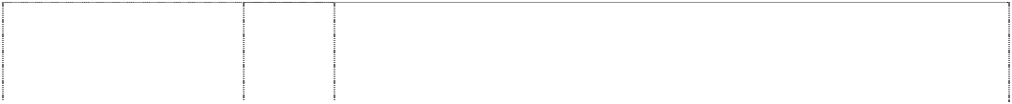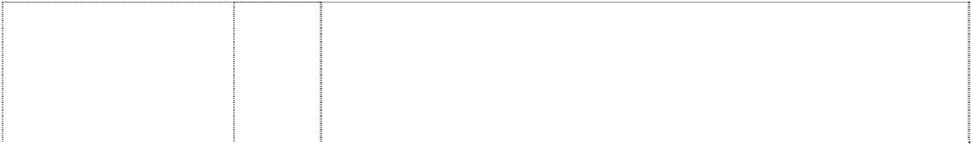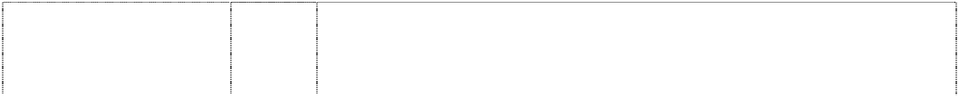

**INTIMATE TOUCH**

(481342)

**I CAN’T BELIEVE** (250884) **JOGBRA** (558554)

**L’EGGS** (237937) **L’EGGS**

ellipse incomplete is part of egg (571889)

**L’EGGS LIGHTS** (400451) **L’EGGS SHEER ELEGANCE** (386842)

**MOTION CONTROL REQUIREMENTS** (757587)

# NOTHING BEATS A GREAT PAIR OF L’EGGS

ellipse incomplete part of egg

(571890)

**NOTHING MATTERS BUT THE GAME** (780426)

**NOTHING MATTERS BUT THE GAME** (780426)

**OUTER BANKS** (548821) **PLAYTEX** (75640)

# PLAYTEX ANSWERS

(742501) **PLAYTEX FITS BEAUTIFULLY** (399147)

# PLAYTEX SECRETS

(458380) **PLAYTEX SENSATIONS** (726850) **PLAYTEX SUPER LOOK**

(305764)

# PLAYTEX SUPPORT CAN BE BEAUTIFUL (277079)

**REVERSE WEAVE**

(719511)

25 Clothing, including brassieres and panties.

25 Ladies’ underwear, foundation garments and hosiery.

25 Articles of underclothing; foundation garments; hosiery; panty hose; and swimwear not including in other classes.

25 All goods included in this class.

25 All goods in this class including ladies’ hosiery and panty hose.

25 Hosiery and pantyhose.

25 Clothing industry hosiery but excluding trousers of all kinds.

25 All goods in this class, including ladies hosiery and pantyhose, but excluding trousers of all kinds.

25 Sports and exercise clothing, clothing tops, brassieres and sports brassieres.

25 Hosiery and pantyhose.

18 Leather and imitations of leather, and goods made of these materials and not included in other classes; trunks and travelling bags; backpacks, tote bags, gym bags, belt bags, duffel bags, book bags, shopping bags, wallets, umbrellas, parasols and walking sticks.

25 Clothing including casual clothing, active sportswear, athletic uniforms, physical education wear; shirts; pants and shorts; sweat shirts and sweat pants; warm-up suits; jackets; sweaters; swim suits, underwear, jackets; women's and girl's apparel including blouses, jumpers, sports bras, and rainwear; night shirts and caps, vests and sashes for conventional use; arm bands being sporting apparel; aprons and bibs; headgear including hats and caps, footwear, including casual and athletic footwear and hosiery.

25 Articles of clothing including men's, women's and children's knitted shirts and sweaters and pants.

25 Articles of clothing.

25 Intimate apparel including brassieres, briefs, panties, foundation garments, and lingerie.

25 All goods in this class.

25 Articles of clothing and underclothing for ladies in class 25.

25 Clothing and intimate apparel including brassieres, panties, foundation garments and lingerie.

25 Articles of clothing.

25 Foundation Garments.

25 Clothing tops, shirts, sweatshirts.

**SENSATIONS BY PLAYTEX** (705070) **SENSATIONS BY**

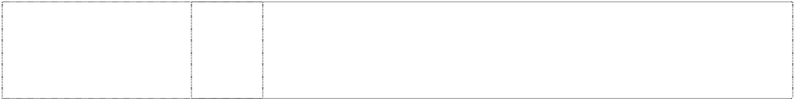

**PLAYTEX – VALUE THAT FITS** (705072)

**SHEER ENERGY** (286959) **SILKEN MIST** (804475) **SMOOTH SILHOUETTES** (751329)

# SOFT SIDER

(266214)

ltr c is vertical line halves eclipse incomplete (733758)

25 Clothing and intimate apparel including brassieres, panties, foundation garments and lingerie.

25 Clothing and intimate apparel including brassieres, panties, foundation garments and lingerie.

25 Hosiery, pantyhose, stockings and socks.

25 Clothing including hosiery and hosiery items, including pantyhose, stockings, tights, socks.

25 Hosiery and pantyhose.

25 Foundation garments, in particular, brassieres, girdles and panty hose.

9 Optical goods for the eyes, eyeglasses, eye spectacles, sunglasses, eye lenses, eyeshades, frames for any of the foregoing goods, eyeglass frames, sunglasses frames, cases for any of the foregoing goods, eyeglass cases and sunglasses cases; parts and accessories in class 9 for any of the foregoing goods.

***HBI Branded Apparel Limited, Inc Allens Arthur Robinson Ph: (03) 9614 1011***

***Effective Date: 31 August 2007 File Reference: C07/14228 Trade Marks Class Goods***

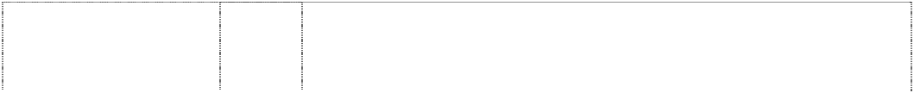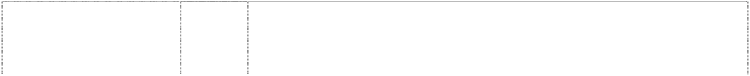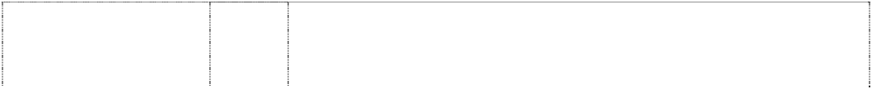

**BEEFY** (545483) **BEEFY –T** (355802) **BEEFY-T**

t-shirt forms ltr T (583804)

**Comfort Memory** (1079837) **COMFORTSOFT** (828802) **COMFORTSOFT** (828802) **CUSHIONMAX** (668668)

**FIT-T** (828801) **H**

arc & 2 rectangles form ltr H in rectangle (583802)

# H HANES

quadrants, two within semi-circles, two (466188)

# H HANES EDGE

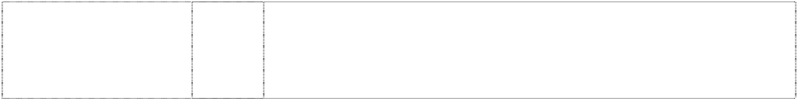arc & 2 rectangles forms ltr H in rect. (640147)

# H HANES JUST MY SIZE

arc & 2 rectangles forms ltr H in frame (633810)

25 Clothing, particularly shirts, pants, socks, underwear and outerwear.

25 Clothing, including, underwear, outerwear, T-shirts.

25 All goods included in this class.

25 Underwear, boxers, boxer briefs, briefs, panties, T-shirts, shirts and tank tops.

1. Fabric in this class.
2. Clothing including underwear and T-shirts.

25 Clothing including hosiery items including pantyhose, socks, stockings and tights.

25 T-shirts for men and women.

25 All goods included in this class.

25 Shirts, sweatshirts, sweatpants, warm-ups and other goods in class 25.

25 Clothing, headgear, footwear.

25 All goods included in class 25.

# H HANES MADE FOR ME

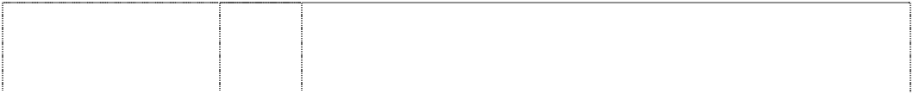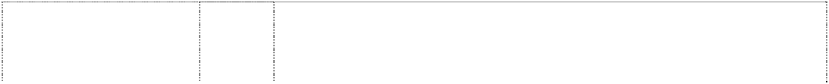

arc & 2 rectangles forms ltr H in rectangle (639292)

**HANES** (244603) **HANES** (346370) **HANES** (583803) **HANES**

nameplate (17936) **HANES**

nameplate (171186) **HANES**

words in rectangle, oblique, curved-sides is flag

(1027168) **HANES ALIVE LIGHTS** (577367)

# HANES BEEFY-T

bulls head forms ltr T; ltr T is t-shirt (1082913)

**HANES DAYTRIPPERS** (633953) **HANES JMS** (631822)

# HANES JUST MY SIZE

(633806)

# HANES MADE FOR ME

(639294)

# HANES PRINTABLES

(384716)

# HANES RELIABLES

(633809) **HANES SATIN SECRETS** (633808) **HANES SHEER LUXURY** (475056)

# HANES SHEERS

(473571) **HANES SIMPLY SILKY**

(633807) **HANES SPORT** (802945)

# HANES SPORT

disc-head running in oval

(772231) **HANES TOO** (344587)

25 Hosiery, panty hose, socks, tights, brassieres, panties, girdles, lingerie, clothing for men, women and children including sweat pants, sweat shirts, fleece cover-ups, T-shirts, cardigans, shirts, shorts, robes, tank tops and turtle necks.

25 Hosiery, including panty hose.

25 Hosiery, including panty hose.

25 All goods included in this class.

25 Articles of clothing such as combinations suits, shirts and drawers of ribbed knitted material.

25 Men's and boy's briefs, trunks, undershorts, undershirts, singlets, shirts, sport shirts and sleepwear.

25 Clothing, footwear and headgear.

25 Hosiery, pantyhose and all other goods in this class.

25 Clothing, footwear and headgear.

25 Hosiery.

25 All goods included in class 25.

25 All goods included in class 25.

25 Hosiery, panty hose, socks, tights, brassieres, panties, girdles, lingerie, clothing for men, women and children including sweat pants, sweat shirts, fleece cover-ups, T-shirts, cardigans, shirts, shorts, robes, tank tops and turtle necks.

25 Clothing, including underwear, outwear, T-Shirts and socks, all included in class 25.

25 Clothing, headgear, footwear.

25 Clothing, headgear, footwear.

25 Ladies’ hosiery and pantyhose and all other goods in this class.

25 Articles of clothing including ladies’ hosiery and panty hose.

25 Clothing, headgear, footwear.

25 Underwear, brassieres, lingerie, socks, footwear, hosiery, thermal tops and bottoms, sweatshirts, shirts, sweat pants, shorts, pants, T- shirts, jogging suits, wind resistant tops and bottoms.

25 Clothing including men's and boys' T-shirts, shorts, pants, fleecy track pants, sweaters, polo tops, underwear, and socks, and ladies' intimate apparel, T-shirts, shorts, pants, fleecy track pants, sweaters, polo tops, underwear and socks.

25 Hosiery, including panty house.

**SHEER HANES** (473572) **SLENDERALLS** (314801)

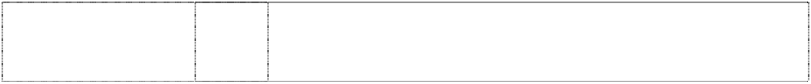

# TEAM HANES

(633705)

curved & angled stripes in disc-head person styl. running (802946)

25 Articles of clothing including ladies’ hosiery and panty hose.

25 Women’s clothing including underwear and hosiery.

25 Clothing, footwear, headgear; excluding waterproof clothing.

25 Underwear, brassieres, lingerie, socks, footwear, hosiery, thermal tops and bottoms, sweatshirts, shirts, sweat pants, shorts, pants, T- shirts, jogging suits, wind resistant tops and bottoms.

***H-D Michigan, Inc Spruson & Ferguson Lawyers Ph: (02) 9393 0300***

***Effective Date: 27 July 2007 File Reference: C07/12069 Trade Marks Class Goods***

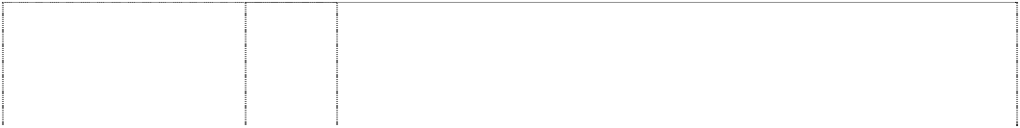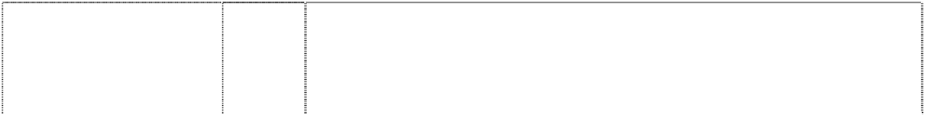

# BLACKLINE

(1105345)

**BLACKLINE** (1105346) **BLACKLINE** (1105345)

# BLACKLINE

(1105345)

# BLAST

(823568)

**BUELL** (715128) **BUELL** (715128)

# BUELL

(715128)

9 Eyeglasses, eyeglass frames, sunglasses, goggles, protective helmets, gauges, radios, speedometers, tachometers, batteries, wiring, cruise controls, switches, breaker points, terminals, starters, circuit breakers, thermostats, battery chargers, armatures, voltage regulators, emergency warning lights, pre-recorded and blank video tapes and discs, audio and video equipment, television sets, stereo equipment, CD players, cassette players, pre-recorded and blank audio tapes and discs, juke boxes, disc players, telephones, recorded computer software, automatic slot machines, magnets, mouse pads, neon signs, luminous signs, electric signs, compact disc cases, eyeglass cases, anti-theft warning apparatus, vending machines, dog whistles, gloves for protection against accidents, welding face shields, compasses, radios.

12 Motorcycles, motorcycle engines and parts and accessories therefore not included in other classes.

1. Outerclothing, sweaters, suspenders, scarves, bandannas, jackets, coats, vests, gloves, jeans, chaps, shirts, jerseys, shorts, caps, hats, headgear for wear, knit hats, rain hats, belts, wristbands, coveralls, hosiery, halter tops, neckties, nightgowns, night shirts, pajamas, pants, rain suits, rain coats, waterproof clothing, sweatshirts, sweat pants, tank tops, T-shirts, underwear, suits, head bands, leg warmers, aprons, mittens, lingerie, leather clothing, swimsuits, skirts, bibs, footwear, namely shoes and boots, and parts of footwear, namely boot tips, sole plates, heel guards.
2. Buttons, hooks and eyes, pins and needles; ornaments for hair and clothing not of precious metal, belt buckles not of precious metal, belt clasps, slide fasteners, zippers, shoe buckles, shoe ornaments not of precious metal, pins other than jewellery, badges, embroidered patches, decorative boot straps.

12 Vehicles; apparatus for locomotion by land including motorcycles, motorcycle engines and parts and accessories therefore not included in other classes; all of the above excluding wheelchairs and power chairs and bicycles and tricycles and parts and accessories therefore.

7 Motorcycle electrical parts and gauges in this class, including spark plugs, breaker points, ignition parts.

9 Eyeglasses; sunglasses; goggles; protective helmets; motorcycle electrical parts and gauges in this class, including speedometers, tachometers, batteries, wiring, cruise controls, switches, ignition cables, radios, terminals, starters, circuit breakers, thermostats, battery chargers, armatures, voltage regulators.

12 Vehicles for locomotion by land, water, rail, and parts therefore not included in other classes including turn signals and horns.

# BUELL

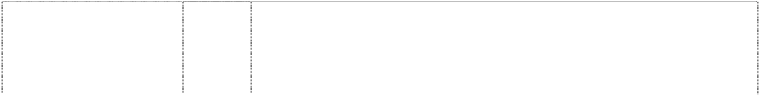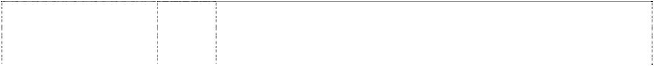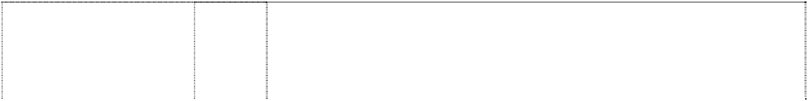

(939658)

# BUELL

(715128)

# BUELL

lightning indents Pegasus, styl. (736741)

# BUELL

lightning indents Pegasus, styl. (736741) **BUELL**

lightning indents Pegasus, styl. (736741)

# CYCLONE

(823566)

# DYNA

(823558) **ELECTRA GLIDE** (823560) **ELECTRA GLIDE** (1036760)

# ELECTRA GLIDE

(1036760)

18 Saddlery, purses, wallets, backpacks, duffel bags, motorcycle saddlebags, key fobs and key holders made of leather, garment bags, business card holders, backpacks, visor organizers, seat back organizers, key cases, suitcases, tote bags, briefcases, attache cases, luggage, travel bags, handbags, hip bags, haversacks, satchels, rucksacks, umbrellas and parasols, valises, trunks, pouches and note pad holders made of leather, dog leashes, dog collars, dog clothing, cat collars.

25 Outerclothing, sweaters, suspenders, scarves, bandannas, handkerchiefs, jackets, coats, vests, gloves, jeans, chaps, shirts, shorts, caps, hats, headgear for wear, knit hats, rain hats, belts, wristbands; coveralls, hosiery, halter tops, neckties, nightgowns, night shirts, pyjamas, pants, rain suits, rain coats, shirts, sweatshirts, sweat pants, tank tops, T-shirts, underwear, suits, head bands, leg warmers, aprons, mittens, lingerie, leather clothing, swimsuits, skirts, bibs; footwear, including shoes and boots; and parts of footwear, including boot tips, sole plates, heel guards, and decorative boot straps.

9 Eyeglasses; sunglasses; goggles; protective helmets; and motorcycle electrical parts and gauges, namely, speedometers, tachometers, batteries, wiring, cruise signals, terminals, horns, starters, circuit breakers, thermostats, battery chargers, armature, and voltage regulators.

12 Motorcycles and motorcycle parts, namely rear forks, footboards, gas tank medallions, fairings, fenders and fender supports, forks, frame parts, and windshields.

25 Sweaters, suspenders, scarves, bandannas, handkerchiefs, jackets, coats, vests, gloves, jeans, chaps, shirts, shorts, caps, hats, knit hats, rain hats, belts, wristbands, coveralls, hosiery, halter tops, neckties, nightgowns, night shirts, pyjamas, pants, rain suits, rain coats, shirts, sweatshirts, sweat pants, tank tops, T-shirts, underwear, head bands, leg warmers, aprons, mittens, lingerie, leather clothing, swimsuits, skirts, and bibs; footwear, namely, shoes and boots; and parts of footwear, namely, boot tips, sole plates, heel guards and decorative boot straps.

25 Clothing for motorcyclists including outer clothing, sweaters, suspenders, scarves, bandanas, jackets, coats, vests, gloves, jeans, chaps, shirts, shorts, headgear including caps, hats, headgear for wear, knit hats, rain hats, belts, wristbands, coveralls, pants, rain suits, rain coats, shirts, sweatshirts, sweat pants, tank tops, T-shirts, head bands, leg warmers, mittens, leather clothing, skirts, bibs, none for use by cyclists.

12 Motorcycles, motorcycle engines and parts and accessories therefore not included in other classes.

12 Motorcycles; motorcycle engines and parts and accessories therefore not included in other classes.

26 Buttons, hooks and eyes, pins and needles; ornaments for hair and clothing not of precious metal, belt buckles not of precious metal, belt clasps, slide fasteners, zippers, shoe buckles, shoe ornaments not of precious metal, pins other than jewellery, badges, medallions, embroidered patches, decorative boot straps.

28 Games and playthings; decorations for Christmas trees; stuffed toy animals, toy banks, model kits, rocking horses, darts, dartboards, remote controlled vehicles, toy vehicles, electronically operated toy vehicles, ride-on toy vehicles, scale model vehicles, trains, and air planes, model trains, play balloons, inflatable toys, dolls, doll clothes, billiard tables, billiard balls, billiard cues and other billiard equipment and pinball machines, game machines, snow sleds, aerial discs, balls for games, parlor games, die cast models, golf balls, golf tees, golf ball markers, toy building blocks, toy boxes, card games, puzzles, dog toys, cat toys, fishing rods and tackle; playing cards.

# FAT BOB

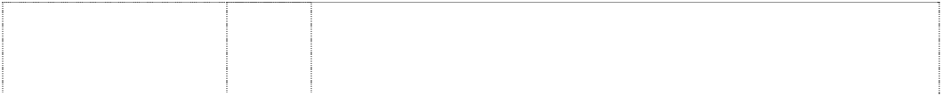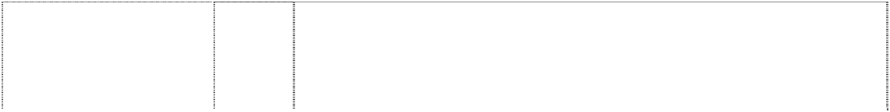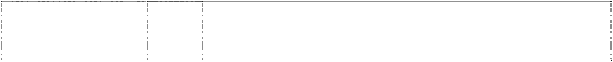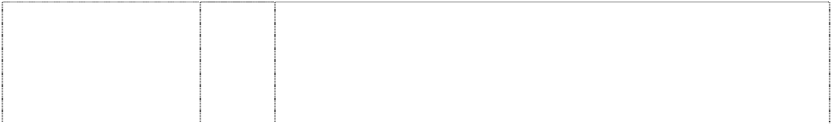

(1008802)

**FAT BOY** (823562) **FAT BOY** (669134)

# FATBOY

(1036757)

**FIRE BOLT** (864723) **FIREBOLT** (939634)

**FIREBOLT** (932527) **FIREBOLT** (939635)

# FIREBOLT

(939636)

**FIREBOLT** (871145) **FXRG** (780701)

# HARLEY

(1036770)

# HARLEY

(1036770)

# HARLEY

(1036770)

12 Vehicles; apparatus for locomotion by land, air or water; parts and accessories therefore not included in other classes; motorcycles, motorcycle engines, and motorcycle parts and accessories therefore not included in other classes; bicycles and bicycling accessories not included in other classes.

12 Motorcycles, motorcycle engines and parts and accessories therefore not included in other classes.

1. Clothes, footwear, headgear, T-shirts, polo-shirts, shorts, sweaters, jackets, trousers, underwear, socks, shoes, thongs, sandals, jumpers, singlets, caps, hats, boots, headbands, jeans, cardigans; and accessories in this class for such goods.
2. Buttons, hooks and eyes, pins and needles; ornaments for hair and clothing not of precious metal, belt buckles not of precious metal, belt clasps, slide fasteners, zippers, shoe buckles, shoe ornaments not of precious metal, pins other than jewelry, badges, medallions, embroidered patches, decorative boot straps.

12 Buses, passenger cars, truck, trailer, sports car, motor cycles, field car, steering wheels for automobiles, and wheels for automobiles.

9 Eyeglasses, eyeglass frames, sunglasses, goggles, protective helmets, motorcycle electrical parts, gauges, radios, speedometers, tachometers, batteries, wiring, cruise controls, switches, breaker points, terminals, starters, circuit breakers, thermostats, battery chargers, armatures, voltage regulators, emergency warning lights, pre-recorded and blank video tapes and discs, audio and video equipment, television sets, stereo equipment, CD players, cassette players, pre-recorded and blank audio tapes and discs, juke boxes, disc players, telephones, recorded computer software, magnets, mouse pads, neon signs, luminous signs, electric signs, vending machines.

12 Motorcycles and structural parts therefore.

16 Stationery, postcards, books, bumper stickers, checkbook covers, calendars, decalcomanias, photo albums, posters, printed publications and printed matter, road atlases, service manuals for motorcycles, parts catalogues for motorcycles, accessory catalogues and lists, instruction books and handbooks, greeting cards, banners of paper and cardboard relating to motorcycling, note paper, pens and pencils, paper hats, paper table covers, paper napkins, photographs, pictures, wrapping paper, bags of paper or plastic for wrapping and packing, tattoos (removable).

18 Saddlery, purses, wallets, backpacks, duffel bags, motorcycle saddlebags, key fobs and key holders made of leather, garment bags, business card holders, backpacks, visor organizers, seat back organizers, key cases, suitcases, tote bags, briefcases, attache cases, luggage, travel bags, handbags, hip bags, haversacks, satchels, rucksacks, umbrellas and parasols, valises, trunks, pouches and note pad holders made of leather, dog leashes, dog collars, dog clothing, cat collars.

25 Jackets, sweatshirts and T-shirts.

25 Outerclothing, sweaters, shirts, sweatshirts, jackets, coats, rain coats, jeans, pants, sweatpants, chaps, vests, gloves, caps, hats, headgear for wear, belts, bibs, coveralls, rain suits, underwear, lingerie, leather clothing and footwear.

3 Cleaning, polishing, scouring and abrasive preparations for use on motorcycles including windshield and surface cleaning and polishing preparations; degreasing preparations for use on motorcycles; rust removing preparations for use on motorcycles; creams, polishes and bleaching preparations for use on leather articles for motorcyclists.

6 Badges of metal for motorcycles; tool boxes and tool chests of metal for holding and carrying motorcycle tools; key rings of metal for motorcyclists; metal locks and padlocks for motorcycles.

8 Hand tools and implements (hand-operated) for motorcycles and motorcyclists; knives, pocket knives.

# HARLEY

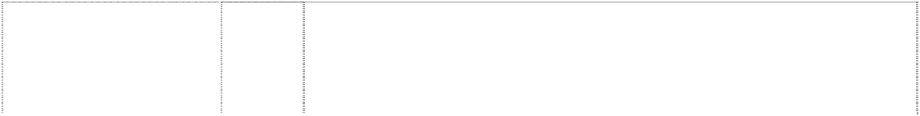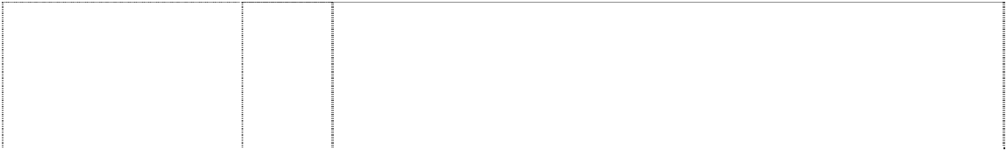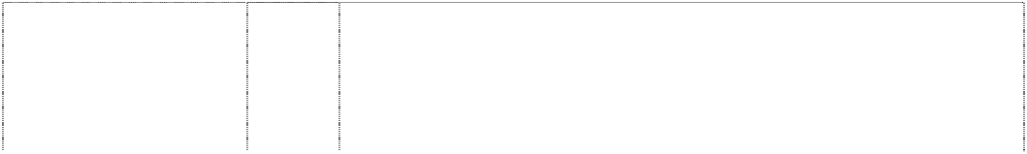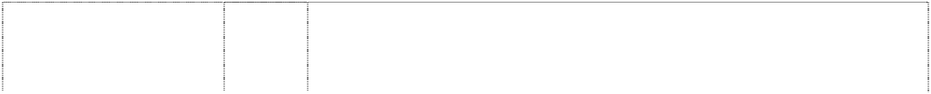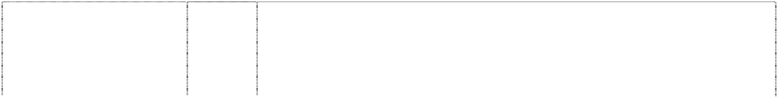

(1036770)

**HARLEY** (406657) **HARLEY** (869395)

# HARLEY

(594472)

# HARLEY

(554402)

**HARLEY** (1036770) **HARLEY** (1036770)

# HARLEY

(869395)

**HARLEY** (554403) **HARLEY** (1036770)

# HARLEY

(1036770)

# HARLEY-DAVIDSON

(487046)

# HARLEY-DAVIDSON

(526819)

# HARLEY-DAVIDSON

(1036771)

# HARLEY-DAVIDSON

(576883)

# HARLEY-DAVIDSON

(607256)

# HARLEY-DAVIDSON

(515297)

9 Sunglasses including sunglasses for motorcyclists; goggles and protective helmets for motorcyclists; gauges, radios, speedometers, tachometers, batteries, wiring, cruise controls, switches, breaker points, terminals, starters, circuit breakers, thermostats, battery chargers, armatures, voltage regulators and emergency warning lights for motorcycles.

12 Motor cycles, motor cycle combinations, and parts of and accessories for such goods included in this class.

14 Jewellery, ankle bracelets, bracelets, earrings, necklaces, tie tacks, ornamental lapel pins, stick pins, clocks, watches, rings, charms, key fobs, belt buckles of precious metal, watchbands, money clips, collar tips, boot chains, hat pins, pewter plates, figurines of precious metal.

16 Books, periodicals, magazines and newsletters, all the foregoing relating to motor cycles, motorcycling or motorcyclists; motorcycle repair manuals; motorcycle parts manuals; calendars and posters featuring motorcycles; greeting cards featuring motorcycles; paper banners featuring motorcycles; note pads and other paper goods featuring motorcycles.

18 Luggage for motorcycles, namely rack bags, saddle bags and liners therefore, saddle bag kits, saddle bag guard bags, windshield bags and pouches, fender and fork bags, sissy bar bags and pouches, duffle bags, touring cases, leather tool boxes and bags and liners therefore, back packs, sport bags, belt bags; bags for helmets and boots; leather yoke panels for motorcycles.

1. Motorcycle figurines of wood, wax, plastic or plaster.
2. Articles for cleaning purposes, chamois leather for cleaning, cleaning rags (cloth), polishing cloths and polishing gloves for motorcycles and motorcyclists; motorcycle figurines of porcelain, terracotta or glass; mugs, glassware, cups.
3. Outerclothing, sweaters, suspenders, scarves, bandannas, jackets, coats, vests, gloves, jeans, chaps, shirts, shorts, caps, hats, headgear for wear, knit hats, rain hats, belts, wristbands, coveralls, hosiery, halter tops, neckties, nightgowns, night shirts, pyjamas, pants, rain suits, rain coats, sweatshirts, sweat pants, tank tops, T- shirts, underwear, suits, head bands, leg warmers, aprons, mittens, lingerie, leather clothing, swimsuits, skirts, bibs; footwear, namely shoes and boots, and parts of footwear, namely boot tips, sole plates, heel guards.
4. Belt buckles and cloth patches.

28 Motorcycle model kits; remote controlled motorcycle toys and playthings; toy motorcycles; electronically operated toy motorcycles; ride-on toy motorcycles; scale model motorcycles; die cast motorcycle models.

34 Cigarette lighters, ashtrays.

1. Cosmetics, perfumes, cleaning preparations; and all other goods in this class.
2. Oils, greases, lubricants, fuel additives in this class, fuels (including motor spirit), lubricating oil.

6 Badges of metal for vehicles, tool boxes of metal, tool chests, clothes hooks of metal, door knockers, hooks, key rings of metal, knife handles of metal, metal locks, safes, vaults, pad locks, signboards of metal, signs non-luminous and non-mechanical of metal, tins.

1. Sport knives, hunting knives, folding pocket knives, knife cases, hand tools, razors, and all other goods in this class.
2. Pre-recorded and blank video tapes and discs, video recorders and players, video tape rewinders, radio, television sets, stereo equipment, pre-recorded and blank audio tapes and discs, audio recorders and players, audio speakers, disc players, receivers, amplifiers, telephones, and protective eyewear.

9 Protective wear in this class for motorcyclists; sun glasses and protective helmets for motorcyclists.

# HARLEY-DAVIDSON

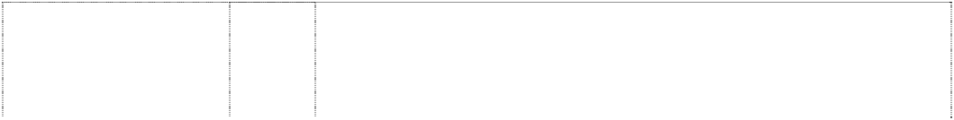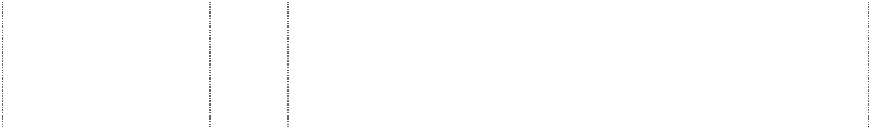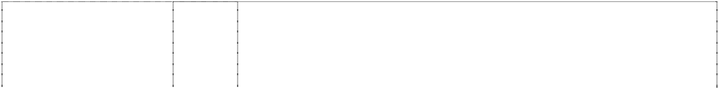

(221756)

# HARLEY-DAVIDSON

(244129)

# HARLEY-DAVIDSON

(576884)

# HARLEY-DAVIDSON

(576885)

# HARLEY-DAVIDSON

(518127)

# HARLEY-DAVIDSON

(499421)

# HARLEY-DAVIDSON

(1036771)

# HARLEY-DAVIDSON

(576886)

# HARLEY-DAVIDSON

(1036771)

# HARLEY-DAVIDSON

(846103)

# HARLEY-DAVIDSON

(385331)

# HARLEY-DAVIDSON

(518126)

# HARLEY-DAVIDSON

(576887)

12 Motor cycles, motor cycle combinations, and parts of and accessories for such goods included in this class.

12 All goods in class 12, including commercial motor vehicles, golf cars, snowmobiles and parts of such goods included in class 12.

14 Ankle bracelets, bracelets, earrings, necklaces, rings, tie tacks, watch bands, watches, ornamental lapel pins, stick pins, clocks, charms, key fobs, belt buckles, money clips, collar tips, boot chains, hat pins, pewter plates, all being goods in this class, and all other goods in this class.

16 Books, bumper stickers, cheque book covers, playing cards, calendars, decalcomanias, photo albums, posters, magazines relating to motorcycling; pens, mechanical pencils, paper banners and road atlases, newsletters relating to motorcycling, parts and service manuals for motorcycles, parts catalogues for motorcycles, accessory catalogues and lists, instruction books and handbooks, greeting cards, paper banners including those relating to motorcycles, note paper, pens and pencils, paper table covers, paper napkins, puzzles in this class, children's books, and all other goods in this class.

18 Wallets, knife pouches, purses, leather bags, luggage, and all other goods in this class.

18 Leather goods; goods of leather and goods of imitation leather, including wallets, non-metal key rings and parts for key rings such as fall into this class, purses, motorcycle saddle bags, luggage.

1. Furniture, mirrors, picture frames; chairs, sofas, sleeping bags, pet beds, tables, clothes hangers, deck chairs, desks, display boards, cushions, figurines of wood, wax, plastic or plaster, picture frames, footstools, furniture, knife handles not of metal, pillows, keyboards for hanging keys, decorative wall plaques not of textile, plates not of metal, stools, benches, wood racks, curio cabinets, bars, mirrors.
2. Drinking glasses, mugs, steins in this class, shaving brushes, shaving mugs, travel coolers, pitchers, pictures printed on plate glass, coasters not of paper and other than table linen, decanters, cups not of precious metal, cookie jars, insulated drinking steins, glassware in this class, insulated can holders, commemorative plates in this class, toothbrushes, quencher cups in this class and figurines of porcelain, terra-cotta or glass, lunch pails, and all other goods in this class.
3. Textiles and textile goods, not included in other classes; bed and table covers; banners, blankets, sheets, pillow shams, pillow cases, quilts, rags, place mats, bed spreads, towels, woven labels, cloth labels, sleeping bags, table linen, upholstery fabrics, fabric, handkerchiefs.
4. Outerclothing, sweaters, suspenders, scarves, bandanas, jackets, coats, vests, gloves, jeans, chaps, shirts, shorts, caps, hats, headgear for wear, knit hats, rain hats, belts, wristbands, coveralls, hosiery, halter tops, neckties, nightgowns, night shirts, pyjamas, pants, rain suits, rain coats, sweatshirts, sweat pants, tank tops, T- shirts, underwear, suits, head bands, leg warmers, aprons, mittens, lingerie, leather clothing, swimsuits, skirts, bibs; footwear, including shoes and boots, and parts of footwear, including boot tips, sole plates, heel guards.
5. Leather and cloth jackets, rain suits, leather and cloth vests, cloth hats and caps, leather skirts, leather gloves in this class and mittens, leather boots, bandanas, riding suits, leather chaps, leather belts (clothing), T-shirts and scarves, and clothing accessories in this class.
6. Belt buckles, patches, and all other goods in this class.

28 Stuffed toy animals, toy banks, model kits, rocking horses, dartboards, toy trucks, model toy motorcycles, miniature motorcycle replicas, model toy trucks, electronically operated toy motorcycles, model airplanes, snow sleds, model trains, model kits of motorcycles, balloons, puzzles, toy flying discs, toy cars, inflatable figures, Christmas tree ornaments, all being goods in this class, and all other goods in this class.

# HARLEY-DAVIDSON



(506772)

# HARLEY-DAVIDSON

(611988)

# HARLEY-DAVIDSON

(611988)

# HARLEY-DAVIDSON ADVENTURE TOURS (760317)

**HARLEY-DAVIDSON AUTHORIZED RENTALS**

scroll around globe in annulus breaking star (845797)

# HARLEY-DAVIDSON AUTHORIZED RENTALS

scroll around globe in annulus breaking star (1036772)

# HARLEY-DAVIDSON CAFÉ

triangle inverted breaks stripes under word

(630818)

# HARLEY-DAVIDSON MOTOR CLOTHES AN AMERICAN LEGEND

eagle, wings outstretched atop divided shield & scroll (1036764)

32 Beers; mineral and aerated waters and other non-alcoholic drinks; fruit drinks and fruit juices; syrups and other preparations for making beverages; and all other goods as are included in this class.

34 Cigarette cases, lighter cases, cigarette lighters, snuff can holders, ashtrays, and holders for cigarette lighters, none of the foregoing being made of or coated with precious metal, and all other goods in this class.

34 Tobacco; smokers’ articles; matches; tobacco and tobacco products; smokers’ articles, in particular cigarette cases, cigarette lighters, snuff cans, snuff can holders; ashtray (not of precious metal), holders for cigarette lighters; matches.

25 Clothing and headgear; including outer clothing, sweaters, suspenders, scarves, bandanas, handkerchiefs, jackets, coats, vests, gloves, jeans, chaps, shirts, shorts, caps, hats, headgear for wear, knit hats, rain hats, belts, wristbands, coveralls, hosiery, halter tops, neckties, nightgowns, night shirts, pyjamas, pants, rain suits, rain coats, sweatshirts, sweat pants, tank tops, T-shirts, underwear, suits, head bands, leg warmers, aprons, mittens, lingerie, leather clothing, swimsuits, skirts, bibs; footwear, including shoes and boots; parts of footwear, including boot tips, sole plates, heel guards.

25 Outerclothing, sweaters, bandanas, jackets, coats, hats, caps, shirts, sweatshirts, T-shirts.

25 Clothing, footwear, headgear; clothing, headwear, footwear, outerclothing, sweaters, suspenders, scarves, bandannas, jackets, coats, vests, gloves, jeans, chaps, shirts, jerseys, shorts, caps, hats, headgear for wear, knit hats, rain hats, belts, wristbands, coveralls, hosiery, halter tops, neckties, nightgowns, night shirts, pajamas, pants, rain suits, rain coats, waterproof clothing, sweatshirts, sweat pants, tank tops, T-shirts, underwear, suits, head bands, leg warmers, aprons, mittens, lingerie, leather clothing, swimsuits, skirts, bibs, footwear, namely shoes and boots, and parts of footwear, namely boot tips, sole plates, heel guards.

25 Clothing, namely sweat pants, sweaters, suspenders, scarves, bandannas, jackets, vests, gloves, jeans, chaps, tops, boots, shorts, caps, belts, wristbands, coveralls, halter tops, hats, neckties, nightgowns, night shirts, pants, rain suits, shirts, socks, sweatshirts, tank tops, athletic shoes, shoes, T-shirts, underwear, motorcycle riding suits, head bands, ladies underwear, knit hats, leg warmers, knit tops, headwear, aprons, mittens, lingerie, rain coats, rain hats, leather clothing, footwear, sportswear, skirts, nightwear, children's wear, coats, bibs not of paper; parts of footwear, namely boot tips, sole plates, heel shifter spurs, heel guards, decorative boot straps, and heel spurs; and all other goods in this class.

14 Precious metals and their alloys and goods in precious metals or coated therewith, not included in other classes; jewelry, precious stones; watches, watch bands, clocks, cases for watches, badges of precious metal, buckles of precious metal, charms, pendants, tie clips, tie pins, money clips, conchos, coins, cuff links, earrings, figurines of precious metal, flasks of precious metal, hat ornaments, key rings, key fobs, medallions of precious metal, necklaces, bracelets, ankle bracelets, shoe ornaments of precious metal, pins, rings, body jewelry, jewelry made of precious metal and precious stones.

# HARLEY-DAVIDSON MOTOR CLOTHES AN AMERICAN LEGEND



eagle, wings outstretched atop divided shield & scroll (1036764)

# HARLEY DAVIDSON MOTOR CLOTHES AN AMERICAN LEGEND

eagle, wings outspread & divided shield atop scroll (869397)

# HARLEY DAVIDSON MOTOR CLOTHES AN AMERICAN LEGEND

eagle, wings outspread & divided shield atop scroll (869397)

# HARLEY-DAVIDSON MOTOR CLOTHES AN AMERICAN LEGEND

eagle, wings outstretched atop divided shield & scroll (1036764)

# HARLEY DAVIDSON MOTOR CLOTHES AN AMERICAN LEGEND

eagle, wings outspread & divided shield atop scroll (869397)

# HARLEY DAVIDSON MOTOR CLOTHES AN AMERICAN LEGEND

eagle, wings outspread & divided shield atop scroll (598683)

# HARLEY-DAVIDSON MOTOR CLOTHES AN AMERICAN LEGEND

eagle, wings outstretched atop divided shield & scroll (1036764)

16 Printed matter; stationery; adhesives for stationery or household purposes; artists' materials; instructional and teaching material (except apparatus); postcards, books, bumper stickers, checkbook covers, calendars, decalcomanias, photo albums, posters, printed publications and printed matter, road atlases, service manuals for motorcycles, parts catalogs for motorcycles, accessory catalogs and lists, instruction books and handbooks, greeting cards, banners relating to motorcycling, note paper, pens and pencils, paper hats, paper table covers, paper napkins, photographs, pictures, wrapping paper, bags of paper or plastic for wrapping and packing tattoos (removable); lottery tickets.

18 Saddlery, purses, wallets, backpacks, duffel bags, motorcycle saddlebags, key fobs and key holders made of leather, garment bags, key cases, suitcases, tote bags, briefcases, attache cases, chequebook clutches, luggage, travel bags; handbags, hip bags, haversacks, satchels, rucksacks, umbrellas and parasols, valises, trunks, pouches and note pad holders made of leather.

21 Leather beverage container holders.

1. Textiles and textile goods, not included in other classes; bed and table covers; banners, blankets, sheets, pillow shams, pillow cases, quilts, rags, place mats, bed spreads, towels, woven labels, cloth labels, sleeping bags, table linen, upholstery fabrics, fabric, handkerchiefs.
2. Outerclothing, sweaters, suspenders, scarves, bandannas, jackets, coats, vests, gloves, jeans, chaps, shirts, shorts, caps, hats, headgear for wear, knit hats, rain hats, belts, wristbands, coveralls, hosiery, halter tops, neckties, nightgowns, night shirts, pyjamas, pants, rain suits, rain coats, sweatshirts, sweat pants, tank tops, T- shirts, underwear, suits, head bands, leg warmers, aprons, mittens, lingerie, leather clothing, swimsuits, skirts, bibs; footwear, namely shoes and boots, and parts of footwear, namely boot tips, sole plates, heel guards.
3. Clothing, namely sweat pants, sweaters, suspenders, scarves, bandannas, jackets, vests, gloves, jeans, chaps, tops, shorts, caps, belts, wristbands, coveralls, halter tops, hats, neckties, nightgowns, night shirts, pants, rain suits, shirts, socks, sweatshirts, tank tops, T-shirts, underwear, motorcycle riding suits, head bands, ladies underwear, knit hats, leg warmers, knit tops, headwear, aprons, mittens, lingerie, rain coats, rain hats, leather clothing, sportswear, skirts, nightwear, children's wear and coats; footwear including boots, shoes, slippers and athletic shoes; headgear; parts of footwear including boot tips, sole plates, heel shifter spurs, heel guards, decorative boot straps and heel spurs; bibs not of paper.
4. Buttons, hooks and eyes, pins and needles; ornaments for hair and clothing not of precious metal, belt buckles not of precious metal, belt clasps, slide fasteners, zippers, shoe buckles, shoe ornaments not of precious metal, pins other than jewelry, badges, medallions, embroidered patches, decorative boot straps.

# HARLEY-DAVIDSON MOTOR CYCLES



eagle, wings outstretched atop shield divided by rect. (1036765)

# HARLEY-DAVIDSON MOTOR CYCLES

eagle, wings outstretched atop shield divided by rect. (1036765)

# HARLEY-DAVIDSON MOTOR CYCLES

eagle, wings outstretched atop shield divided by rect. (1036765)

# HARLEY-DAVIDSON MOTOR CYCLES

eagle, wings outstretched atop shield divided by rect. (1036765)

# HARLEY-DAVIDSON MOTOR CYCLES

eagle, wings outstretched atop shield divided by rect. (1036765)

# HARLEY-DAVIDSON MOTOR CYCLES

eagle, wings outstretched atop shield divided by rect. (1036765)

# HARLEY-DAVIDSON MOTOR CYCLES

eagle, wings outstretched atop shield divided by rect. (1036765)

# HARLEY-DAVIDSON MOTOR CYCLES

eagle, wings outstretched atop shield divided by rect. (1036765)

6 Badges of metal for vehicles, tool boxes of metal, tool chests, clothes hooks of metal, door knockers, hooks, key rings of metal, knife handles of metal, metal locks, safes, vaults, pad locks, signboards of metal, signs non-luminous and non-mechanical of metal, tins.

8 Hand tools and implements (hand-operated); can openers (non- electric), hand tools, wrenches, multifunction hand tools, knives, pliers.

12 Vehicles; apparatus for locomotion by land, air or water; motorcycles, motorcycle engines, and motorcycle parts and accessories therefor not included in other classes, bicycles and bicycling accessories not included in other classes, automobiles and automobile parts and accessories.

14 Precious metals and their alloys and goods in precious metals or coated therewith, not included in other classes; jewelry, precious stones; watches, watch bands, clocks, cases for watches, badges of precious metal, buckles of precious metal, charms, pendants, tie clips, tie pins, money clips, conchos, coins, cuff links, earrings, figurines of precious metal, flasks of precious metal, hat ornaments, key rings, key fobs, medallions of precious metal, necklaces, bracelets, ankle bracelets, shoe ornaments of precious metal, pins, rings, body jewelry, jewelry made of precious metal and precious stones.

16 Printed matter; stationery; adhesives for stationery or household purposes; artists' materials; instructional and teaching material (except apparatus); postcards, books, bumper stickers, checkbook covers, calendars, decalcomanias, photo albums, posters, printed publications and printed matter, road atlases, service manuals for motorcycles, parts catalogs for motorcycles, accessory catalogs and lists, instruction books and handbooks, greeting cards, banners relating to motorcycling, note paper, pens and pencils, paper hats, paper table covers, paper napkins, photographs, pictures, wrapping paper, bags of paper or plastic for wrapping and packing tattoos (removable); lottery tickets.

18 Leather and imitations of leather, and goods made of these materials and not included in other classes; trunks and traveling bags; umbrellas, purses, wallets, backpacks, duffel bags, motorcycle saddlebags, key fobs and key holders made of leather, garment bags, business card holders, visor organizers, seat back organizers.

21 Household or kitchen utensils and containers (not of precious metal or coated therewith); brushes (except paint brushes); articles for cleaning purposes; glassware, porcelain and earthenware not included in other classes; polishing cloths, bottle openers, ice buckets, mugs, bowls, brushes, cake models, candle extinguishers not of precious metal, candle holders not of precious metal, cake models, chamois leather for cleaning, china ornaments, cleaning rags (cloth), cloths for cleaning, plates, decanters, coasters (not made of paper), coolers, corkscrews, glassware cups (not of precious metal), soap dishes, soap dispensers, drinking flasks, trash cans, polishing gloves, pottery, salt and peppershakers (not of precious metal), figurines of porcelain, terracotta or glass, tableware tankards.

1. Textiles and textile goods, not included in other classes; bed and table covers; banners, blankets, sheets, pillow shams, pillow cases, quilts, rags, place mats, bed spreads, towels, woven labels, cloth labels, sleeping bags, table linen, upholstery fabrics, fabric, handkerchiefs.

# HARLEY-DAVIDSON MOTOR CYCLES

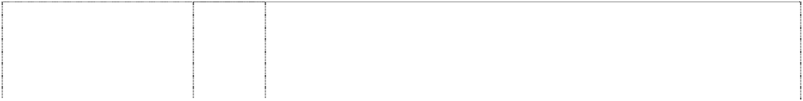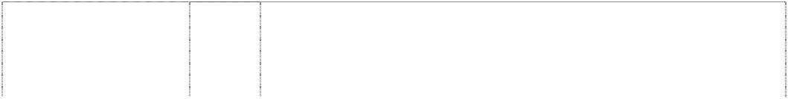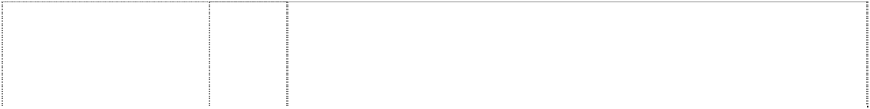

eagle, wings outstretched atop shield divided by rect. (1036765)

# HARLEY-DAVIDSON MOTOR CYCLES

eagle, wings outstretched atop shield divided by rect. (1036765)

# HARLEY-DAVIDSON MOTOR CYCLES

eagle, wings outstretched atop shield divided by rect. (1036765)

# HARLEY-DAVIDSON MOTOR CYCLES

eagle, wings outstretched atop shield divided by rect. (1036765)

# HARLEY-DAVIDSON MOTOR CYCLES

rect., double divides shield, double (823555)

# HARLEY-DAVIDSON MOTOR CYCLES

rect., double divides shield, double (1036768)

# HARLEY-DAVIDSON MOTOR CYCLES

rect., double divides shield, double (1036768)

# HARLEY-DAVIDSON MOTOR CYCLES

rect., double divides shield, double (823555)

# HARLEY-DAVIDSON MOTOR CYCLES

rect., double divides shield, double (823555)

1. Clothing, footwear, headgear; clothing, headwear, footwear, outerclothing, sweaters, suspenders, scarves, bandannas, jackets, coats, vests, gloves, jeans, chaps, shirts, jerseys, shorts, caps, hats, headgear for wear, knit hats, rain hats, belts, wristbands, coveralls, hosiery, halter tops, neckties, nightgowns, night shirts, pajamas, pants, rain suits, rain coats, waterproof clothing, sweatshirts, sweat pants, tank tops, T-shirts, underwear, suits, head bands, leg warmers, aprons, mittens, lingerie, leather clothing, swimsuits, skirts, bibs, footwear, namely shoes and boots, and parts of footwear, namely boot tips, sole plates, heel guards.
2. Buttons, hooks and eyes, pins and needles; ornaments for hair and clothing not of precious metal, belt buckles not of precious metal, belt clasps, slide fasteners, zippers, shoe buckles, shoe ornaments not of precious metal, pins other than jewelry, badges, medallions, embroidered patches, decorative boot straps.

28 Games and playthings; decorations for Christmas trees; stuffed toy animals, toy banks, model kits, rocking horses, darts, dartboards, remote controlled vehicles, toy vehicles, electronically operated toy vehicles, bicycling pads, ride-on toy vehicles, scale model vehicles, trains, and air planes, model trains, play balloons, inflatable toys, dolls, doll clothes, billiard tables, billiard balls, billiard cues and other billiard equipment and pinball machines, game machines, snow sleds, aerial discs, balls for games, parlor games, die cast models, golf balls, golf tees, golf ball markers, toy building blocks, toy boxes, card games, puzzles, dog toys, cat toys, fishing rods and tackle; playing cards.

34 Tobacco; smokers' articles; matches; tobacco and tobacco products; smokers' articles, in particular cigarette cases, cigarette lighters, snuff cans, snuff can holders, ashtray (not of precious metal), holders for cigarette lighters; matches.

3 After-shave lotion and cologne, perfume, soap, personal care products, hair care products, cleaning and polishing preparations, leather care products.

6 Badges of metal for vehicles, tool boxes of metal, tool chests, clothes hooks of metal, door knockers, hooks, key rings of metal, knife handles of metal, metal locks, safes, vaults, pad locks, signboards of metal, signs non-luminous and non-mechanical of metal, tins.

1. Hand tools and implements (hand-operated); can openers (non- electric), hand tools, wrenches, multifunction hand tools, knives, pliers.
2. Eyeglasses; sunglasses; goggles; protective helmets; motorcycle electrical parts and gauges, namely, radios, speedometers, tachometers, batteries, wiring, cruise controls, switches, spark plugs, breaker points, ignition parts, radios, turn signals, terminals, horns, starters, circuit breakers, thermostats, battery chargers, armatures, voltage regulators; pre-recorded and blank video tapes and discs, audio and video equipment, television sets, stereo equipment, pre-recorded and blank audio tapes and discs, juke boxes, disc players, recorded computer software, automatic slot machines and pinball machines.

12 Motorcycles, motorcycle engines and parts and accessories therefore not included in other classes.

# HARLEY-DAVIDSON MOTOR CYCLES

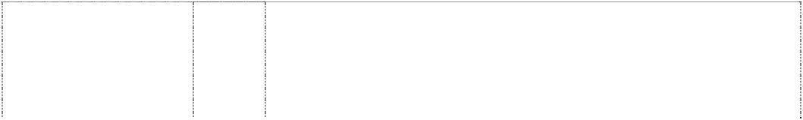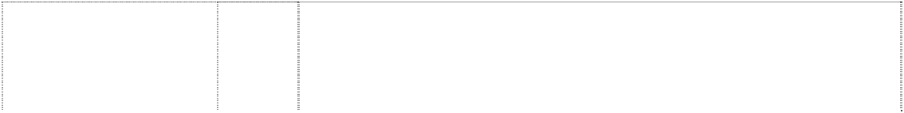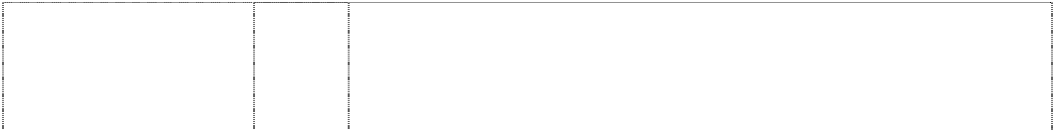

rect., double divides shield, double (823555)

# HARLEY-DAVIDSON MOTOR CYCLES

rect, double divides shield, double (566941)

# HARLEY-DAVIDSON MOTOR CYCLES

rect, double divides shield, double (566944)

# HARLEY-DAVIDSON MOTOR CYCLES

rect., double divides shield, double (1036768)

# HARLEY-DAVIDSON MOTOR CYCLES

rect, double divides shield, double (598681)

# HARLEY-DAVIDSON MOTOR CYCLES

rect., double divides shield, double (1036768)

# HARLEY-DAVIDSON MOTOR CYCLES

rect, double divides shield, double (566943)

# HARLEY-DAVIDSON MOTOR CYCLES

rect, double divides shield, double (566942)

# HARLEY-DAVIDSON MOTOR CYCLES

rect., double divides shield, double (1036768)

# HARLEY-DAVIDSON MOTOR CYCLES

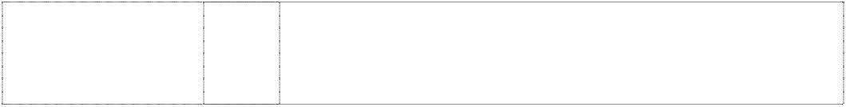rect, double divides shield, double (598682)

# HARLEY-DAVIDSON MOTOR CYCLES

rect., double divides shield, double (1036768)

14 Jewellery, ankle bracelets, bracelets, earrings, necklaces, tie tacks, ornamental lapel pins, stick pins, clocks, watches, rings, charms, key fobs, belt buckles of precious metal, watchbands, money clips, collar tips, boot chains, hat pins, pewter plates, figurines of precious metal.

16 Paper and printed material, namely, books, periodicals, magazines, newsletters relating to motor cycles, motor cycle repair manuals, motor cycle parts manuals, greeting cards, playing cards, calendars, posters, wind socks made of paper, banners, note pads, business card holders, and all other goods in this class.

18 Leather goods, namely, wallets, tote bags, leather key holders, luggage, garment bags, purses, saddle bags, travel bags, leather knife cases, belt pouches.

1. Furniture, mirrors, picture frames; chairs, sofas, sleeping bags, pet beds, tables, clothes hangers, deck chairs, desks, display boards, cushions, figurines of wood, wax, plastic or plaster, picture frames, footstools, furniture, knife handles not of metal, pillows, keyboards for hanging keys, decorative wall plaques not of textile, plates not of metal, stools, benches, wood racks, curio cabinets, bars, mirrors.
2. Drinking glasses, mugs, steins in this class, shaving brushes, shaving mugs, travel coolers, pitchers, pictures printed on plate glass, coasters not of paper and other than table linen, decanters, cups not of precious metal, cookie jars, insulated drinking steins, glassware in this class, insulated can holders, commemorative plates in this class, toothbrushes, quencher cups in this class and figurines of porcelain, terra-cotta or glass.
3. Textiles and textile goods, not included in other classes; bed and table covers; banners, blankets, sheets, pillow shams, pillow cases, quilts, rags, place mats, bed spreads, towels, woven labels, cloth labels, sleeping bags, table linen, upholstery fabrics, fabric, handkerchiefs.
4. Clothing, namely, T-shirts, sweatshirts, sweat pants, pants, shirts, jackets, vests, underwear, skirts, vests, chaps, bandannas, socks, shoes, boots, hats, caps, coats, suspenders, belts, boot straps, gloves, mittens, hosiery, halter tops, shorts, jeans, sleepwear, children's clothing, and all other goods in this class.
5. Belt buckles, embroidered patches, pins, badges.

28 Games and playthings; decorations for Christmas trees; stuffed toy animals, toy banks, model kits, rocking horses, darts, dartboards, remote controlled vehicles, toy vehicles, electronically operated toy vehicles, bicycling pads, ride-on toy vehicles, scale model vehicles, trains, and air planes, model trains, play balloons, inflatable toys, dolls, doll clothes, billiard tables, billiard balls, billiard cues and other billiard equipment and pinball machines, game machines, snow sleds, aerial discs, balls for games, parlor games, die cast models, golf balls, golf tees, golf ball markers, toy building blocks, toy boxes, card games, puzzles, dog toys, cat toys, fishing rods and tackle; playing cards.

34 Cigarette cases, cigarette lighters, snuff can holders, ashtrays, holders for cigarette lighters, none of the foregoing being made of or coated with precious metal.

34 Tobacco; smokers' articles; matches; tobacco and tobacco products; smokers' articles, in particular cigarette cases, cigarette lighters, snuff cans, snuff can holders, ashtray (not of precious metal), holders for cigarette lighters; matches.

# HARLEY-DAVIDSON MOTOR CYCLES

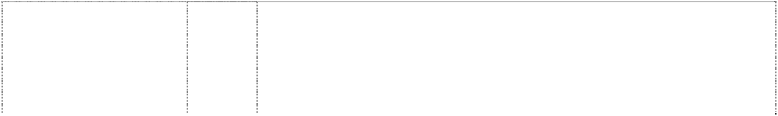

rect divides shield (352989)

# HARLEY-DAVIDSON MOTOR CYCLES 1903 2003 100

rectangle breaks shield in wing, stylised (886996)

# HARLEY-DAVIDSON MOTOR CYCLES 1903 2003 100

rectangle breaks shield in wing, stylised (886996)

# HARLEY-DAVIDSON MOTOR CYCLES 1903 2003 100

rectangle breaks shield in wing, stylised (886996)

# HARLEY-DAVIDSON MOTOR CYCLES 1903 2003 100

rectangle breaks shield in wing, stylised (886996)

# HARLEY-DAVIDSON MOTOR CYCLES 1903 2003 100

rectangle breaks shield in wing, stylised (886996)

# HARLEY-DAVIDSON MOTOR CYCLES 1903 2003 100

rectangle breaks shield in wing, stylised (886996)

# HARLEY-DAVIDSON MOTOR CYCLES 1903 2003 100

rectangle breaks shield in wing, stylised (886996)

# HARLEY-DAVIDSON MOTOR CYCLES 1903 2003 100

rectangle breaks shield in wing, stylised (886996)

12 Motorcycles, motor tricycles, sidecars for motor cycles and all parts and accessories in this class of and for motorcycles, motor tricycles and motorcycle sidecars.

9 Eyeglasses; sunglasses; goggles; eyeglass cases; protective helmets; motorcycle electrical parts and gauges, namely, radios, speedometers, tachometers, batteries, wiring, cruise controls, switches, breaker points, terminals, starters, circuit breakers, thermostats, battery chargers, armatures, voltage regulators; pre- recorded and blank video tapes and discs, audio and video equipment, television sets, stereo equipment, pre-recorded and blank audio tapes and discs, juke boxes, disc players, telephones, recorded computer software, computer games, mouse pads, magnets, automatic slot machines, pinball machines in this class.

12 Motorcycles, motorcycle engines and parts and accessories therefore not included in other classes, including motorcycle turn signals.

14 Jewellery, medallions, ankle bracelets, bracelets, earrings, necklaces, tie tacks, ornamental lapel pins, stick pins, clocks, watches, rings, charms, key fobs, belt buckles of precious metal, watchbands, money clips, collar tips, boot chains, hat pins, pewter plates, figurines of precious metal, bells of precious metal, bowls of precious metal, coins.

16 Stationery, books, bumper stickers, chequebook covers not of leather, journals, address books, folders, playing cards, calendars, decalcomanias, photo albums, posters, printed publications and printed matter, road atlases, service manuals for motorcycles, parts catalogues for motorcycles, accessory catalogues and lists, instruction books and handbooks, greeting cards, banners relating to motorcycling, note paper, pens and pencils, paper hats, paper table covers, paper napkins, paper coasters, photographs, pictures, bags of paper or plastic for wrapping and packing, stamps, pen and pencil holders, coin albums, coin holders, paintings, art reproductions, paper flags, desk sets, desk top planners, bookends.

18 Saddlery, purses, wallets, backpacks, duffel bags, motorcycle saddlebags, key fobs and key holders made of leather, garment bags, key cases, suitcases, tote bags, briefcases, attache cases, chequebook clutches, luggage, travel bags, handbags, hip bags, haversacks, satchels, rucksacks, umbrellas and parasols, valises, trunks, pouches, note pad holders made of leather, luggage tags , pen or pencil holders made of leather, money clips made of leather.

21 Drinking glasses, mugs, steins, shaving brushes, shaving mugs, travel coolers, pitchers, pictures printed on plate glass, coasters not of paper, beverage container holders, decanters, cups, cookie jars, insulated drinking steins, glassware, buckets, insulated can holders, commemorative plates , toothbrushes, quencher cups, bottle openers, corkscrews, kitchen utensils, bowls, statues and figurines.

1. Outerclothing, sweaters, suspenders, scarves, bandannas, jackets, coats, vests, gloves, jeans, chaps, shirts, shorts, caps, hats, headgear for wear, knit hats, rain hats, belts, wristbands, coveralls, hosiery, halter tops, neckties, nightgowns, night shirts, pyjamas, pants, rain suits, rain coats, sweatshirts, sweat pants, tank tops, T- shirts, underwear, suits, headbands, leg warmers, aprons, mittens, lingerie, leather clothing, swimsuits, skirts, bibs; footwear, namely shoes and boots; parts of footwear, namely boot tips, sole plates, heel guards.
2. Ornaments for hair and clothing not of precious metal, belt buckles not of precious metal, embroidery, buttons, slide fasteners, pins other than jewellery, badges, embroidered patches, decorative boot straps.

# HARLEY-DAVIDSON MOTOR CYCLES 1903 2003 100

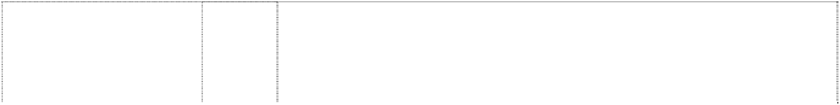

rectangle breaks shield in wing, stylised (886996)

# HARLEY-DAVIDSON MOTOR CYCLES ADVENTURE TOURS

rectangle halves shield on badge

(760318)

# HARLEY DAVIDSON USA

star, 5-point in badge with wings. styl., outstretched (1036761)

# HARLEY-DAVIDSON USA

star, 5-point in badge with wings, styl (939646)

# HARLEY-DAVIDSON USA

star, 5-point in badge with wings, styl (939647)

# HARLEY-DAVIDSON USA

star, 5-point in badge with wings, styl (939648)

# HARLEY DAVIDSON USA

star, 5-point in badge with wings. styl., outstretched (1036761)

28 Toys, stuffed toy animals, toy banks, model kits, rocking horses, darts, dartboards, toy trucks, remote controlled vehicles, toy vehicles; scale model vehicles, trains and aeroplanes; snow sleds, model trains, model kits of vehicles, play balloons, puzzle games, billiard tables, billiard cues, pinball machines in this class, aerial discs, inflatable toys, ornaments for Christmas trees, fishing rods and tackle, dolls, doll clothes, parlour games, balls for games weight lifting belts.

25 Clothing and headgear; including outer clothing, sweaters, suspenders, scarves, bandanas, handkerchiefs, jackets, coats, vests, gloves, jeans, chaps, shirts, shorts, caps, hats, headgear for wear, knit hats, rain hats, belts, wristbands, coveralls, hosiery, halter tops, neckties, nightgowns, night shirts, pyjamas, pants, rain suits, rain coats, sweatshirts, sweat pants, tank tops, T-shirts, underwear, suits, head bands, leg warmers, aprons, mittens, lingerie, leather clothing, swimsuits, skirts, bibs; footwear, including shoes and boots; parts of footwear, including boot tips, sole plates, heel guards.

9 Eyeglasses, eyeglass frames, sunglasses, goggles, protective helmets, gauges, radios, speedometers, tachometers, batteries, wiring, cruise controls, switches, breaker points, terminals, starters, circuit breakers, thermostats, battery chargers, armatures, voltage regulators, emergency warning lights, pre-recorded and blank video tapes and discs, audio and video equipment, television sets, stereo equipment, CD players, cassette players, pre-recorded and blank audio tapes and discs, juke boxes, disc players, telephones, recorded computer software, automatic slot machines, magnets, mouse pads, neon signs, luminous signs, electric signs, compact disc cases, vending machines.

12 Motorcycles, motorcycle engines, and motorcycle parts and accessories therefore not included in other classes, bicycles and bicycling accessories not included in other classes, automobiles and automobile parts and accessories.

16 Stationery, postcards, books, bumper stickers, checkbook covers, calendars, decalcomanias, photo albums, posters, printed publications and printed matter, road atlases, service manuals for motorcycles, parts catalogues for motorcycles, accessory catalogues and lists, instruction books and handbooks, greeting cards, paper banners relating to motorcycling, note paper, pens and pencils, paper hats, paper table covers, paper napkins, photographs, pictures, wrapping paper, bags of paper or plastic for wrapping and packing, tattoos (removable) and decalcomanias.

1. Outerclothing, sweaters, suspenders, scarves, bandannas, jackets, coats, vests, gloves, jeans, chaps, shirts, shorts, caps, hats, headgear for wear, knit hats, rain hats, belts, wristbands, coveralls, hosiery, halter tops, neckties, nightgowns, night shirts, pajamas, pants, rain suits, rain coats, sweatshirts, sweat pants, tank tops, T- shirts, underwear, suits, head bands, leg warmers, aprons, mittens, lingerie, leather clothing, swimsuits, skirts, bibs, footwear, namely shoes and boots, and parts of footwear, namely boot tips, sole plates, heel guards.
2. Buttons, hooks and eyes, pins and needles; ornaments for hair and clothing not of precious metal, belt buckles not of precious metal, belt clasps, slide fasteners, zippers, shoe buckles, shoe ornaments not of precious metal, pins other than jewelry, badges, medallions, embroidered patches, decorative boot straps.

# HARLEY-DAVIDSON USA



star, 5-point in badge with wings, styl (939649)

# HARLEY OWNERS GROUP

(576892)

# HARLEY OWNERS GROUP

(576893)

# HARLEY OWNERS GROUP

(1036776)

**H-D** (823553) **H-D** (823553)

**H-D HD** (537455) **H-D HD** (537456)

# H-D HD

(537457)

28 Toys, stuffed toy animals, toy banks, model kits, rocking horses, darts, dartboards, toy trucks, remote controlled vehicles, toy vehicles, electronically operated toy vehicles, bicycling pads in this class, including knee pads and elbow pads, ride-on toy vehicles, scale model vehicles, trains, and air planes, model trains, model kits of vehicles, play balloons, inflatable toys, ornaments for Christmas trees, dolls, doll clothes, and other toys and dolls, billiard tables, billiard balls, billiard cues and other billiard equipment, and pinball machines, game machines, snow sleds, aerial discs, balls for games, weight lifting belts and other sporting and gymnastic implements, darts, dart boards, parlour games, die cast models, golf balls, golf tees, golf ball markers, toy building blocks, toy boxes, card games, flying discs, puzzles, dog toys, cat toys, rocking horses, fishing rods and tackle.

16 Books, bumper stickers, cheque book covers, playing cards, calendars, decalcomanias, photo albums, posters, magazines relating to motorcycling; pens, mechanical pencils, paper banners and road atlases, newsletters relating to motorcycling, parts and service manuals for motorcycles, parts catalogues for motorcycles, accessory catalogues and lists, instruction books and handbooks, greeting cards, paper banners including those relating to motorcycles, note paper, pens and pencils, paper table covers, paper napkins, puzzles in this class, children's books, and all other goods in this class.

1. Clothing, namely sweat pants, sweaters, suspenders, scarves, bandannas, jackets, vests, gloves, jeans, chaps, tops, boots, shorts, caps, belts, wristbands, coveralls, halter tops, hats, neckties, nightgowns, night shirts, pants, rain suits, shirts, socks, sweatshirts, tank tops, athletic shoes, shoes, T-shirts, underwear, motorcycle riding suits, head bands, ladies underwear, knit hats, leg warmers, knit tops, headwear, aprons, mittens, lingerie, rain coats, rain hats, leather clothing, footwear, sportswear, skirts, nightwear, children's wear, coats; bibs not of paper; parts of footwear namely boot tips, sole plates, heel shifter spurs, heel guards, decorative boot straps and heel spurs.
2. Buttons, hooks and eyes, pins and needles; ornaments for hair and clothing not of precious metal, belt buckles not of precious metal, belt clasps, slide fasteners, zippers, shoe buckles, shoe ornaments not of precious metal, pins other than jewelry, badges, medallions, embroidered patches, decorative boot straps.

12 Motorcycles, motorcycle engines and parts and accessories therefore not included in other classes.

25 Outerclothing, sweaters, suspenders, scarves, bandannas, jackets, coats, vests, gloves, jeans, chaps, shirts, shorts, caps, hats, headgear for wear, knit hats, rain hats, belts, wristbands, coveralls, hosiery, halter tops, neckties, nightgowns, night shirts, pyjamas, pants, rain suits, rain coats, shirts, sweatshirts, sweat pants, tank tops, T-shirts, underwear, suits, head bands, leg warmers, aprons, mittens, lingerie, leather clothing, swimsuits, skirts, bibs; footwear, namely shoes and boots, and parts of footwear, namely boot tips, sole plates, heel guards.

12 Motorcycles and motorcycle parts such as are in this class.

18 Wallets, purses, tote bags, leather bags and pouches, briefcases, travel bags, key fobs of leather, tool bags of leather, fashion accessory bags, coin pouches.

25 Clothing, namely vests, chaps, belts, jackets, gloves, shirts, t-shirts, sweaters, sweatshirts, socks, headwraps, caps, footwear, boots, bandanas.

# HERITAGE SOFTAIL

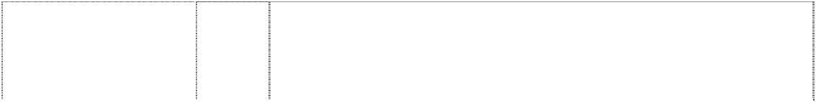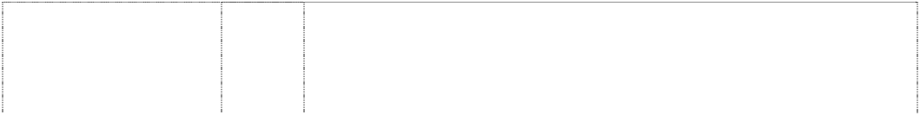

(654868)

# HG

wheel, vehicle (528517)

**HOG** (823554) **HOG** (576894)

# HOG

(1036775)

# HOG

(1036775)

# HOG

wheel, spoked forms ltr O

(823551)

# HOG HARLEY OWNERS GROUP

eagle, wings outstretched atop wheel, spoked atop scroll

(577003)

25 Sweaters, suspenders, scarves, bandanas, jackets, vests, gloves, jeans, chaps, tops, shorts, caps, hats, knit hats, rain hats, belts, wristbands, coveralls, halter tops, neckties, nightgowns, night shirts, pyjamas, pants, rain coats, shirts, socks, sweatshirts, sweat pants, tank tops, T-shirts, underwear, motorcycle riding suits, head bands, ladies underwear, leg warmers, aprons, mittens, lingerie, leather clothing, sportswear, skirts, children's wear, coats, bibs; footwear and parts of footwear, namely boot tips, sole plates, heel guards, and decorative boot straps.

25 Clothing and footwear, including boots, sweatshirts, jeans, hats, caps, scarves, motorcycle riding suits, neckties, shirts, T-shirts, Headbands, jackets, vests, gloves, chaps, shorts, sweat pants, ladies' underwear and tops, bandannas, socks; and all other goods in this class.

12 Motorcycles, motorcycle engines and parts and accessories therefore not included in other classes.

16 Books, bumper stickers, removable tattoos, cheque book covers, playing cards, calendars, decals, photo albums, posters, magazines relating to motorcycling; pens, mechanical pencils, paper banners and road atlases, newsletters relating to motorcycling, parts and service manuals for motorcycles, parts catalogues for motorcycles, accessory catalogues and lists, instruction books and handbooks, greeting cards, banners relating to motorcycling, note paper, pens and pencils, paper table covers, paper napkins, puzzles in this class, children's books, and all other goods in this class.

1. Clothing, footwear, headgear; clothing, headwear, footwear, outerclothing, sweaters, suspenders, scarves, bandannas, jackets, coats, vests, gloves, jeans, chaps, shirts, jerseys, shorts, caps, hats, headgear for wear, knit hats, rain hats, belts, wristbands, coveralls, hosiery, halter tops, neckties, nightgowns, night shirts, pajamas, pants, rain suits, rain coats, waterproof clothing, sweatshirts, sweat pants, tank tops, T-shirts, underwear, suits, head bands, leg warmers, aprons, mittens, lingerie, leather clothing, swimsuits, skirts, bibs, footwear, namely shoes and boots, and parts of footwear, namely boot tips, sole plates, heel guards.
2. Buttons, hooks and eyes, pins and needles; ornaments for hair and clothing not of precious metal, belt buckles not of precious metal, belt clasps, slide fasteners, zippers, shoe buckles, shoe ornaments not of precious metal, pins other than jewelry, badges, medallions, embroidered patches, decorative boot straps.

16 Stationery, books, bumper stickers, checkbook covers, playing cards, calendars, decalcomanias, photo albums, posters, printed publications and printed matter road atlases, service manuals for motorcycles, parts catalogues for motorcycles, accessory catalogues and lists, instruction books and handbooks, greeting cards, banners relating to motorcycling, note paper, pens and pencils, paper table covers, paper napkins, photographs, pictures, bags of paper or plastic for wrapping and packing.

16 Books, bumper stickers, cheque book covers, playing cards, calendars, decalcomanias, photo albums, posters, magazines relating to motorcycling; pens, mechanical pencils, paper banners and road atlases, newsletters relating to motorcycling, parts and service manuals for motorcycles, parts catalogues for motorcycles, accessory catalogues and lists, instruction books and handbooks, greeting cards, paper banners including those relating to motorcycles, note paper, pens and pencils, paper table covers, paper napkins, puzzles in this class, children's books, and all other goods in this class.

# HOG HARLEY OWNERS GROUP



eagle, wings outstretched atop wheel, spoked atop scroll

(577006)

# HOG HARLEY OWNERS GROUP

eagle, wings outstretched atop wheel, spoked atop scroll

(577005)

# HOG LADIES OF HARLEY

ltr O is wheel, spoke with wings, outstretched (939650)

# LEGENDARY HARLEY-DAVIDSON MOTOR CYCLES HARLEY-DAVIDSON

eagle, wings outstretched, atop shield divided by rectangle, atop & breaking triple ellipse (706968) **LIGHTNING** (736028) **LIGHTNING** (823569)

# LIGHTNING

(939638)

# LIGHTNING

(939639)

1. Clothing, namely sweat pants, sweaters, suspenders, scarves, bandannas, jackets, vests, gloves, jeans, chaps, tops, boots, shorts, caps, belts, wristbands, coveralls, halter tops, hats, neckties, nightgowns, night shirts, pants, rain suits, shirts, socks, sweatshirts, tank tops, athletic shoes, shoes, T-shirts, underwear, motorcycle riding suits, head bands, ladies underwear, knit hats, leg warmers, knit tops, headwear, aprons, mittens, lingerie, rain coats, rain hats, leather clothing, footwear, sportswear, skirts, nightwear, children's wear, coats; bibs not of paper; parts of footwear, namely boot tips, sole plates, heel shifter spurs, heel guards, decorative boot straps and heel spurs; and all other goods in this class.
2. Belt buckles, embroidered patches, pins in this class, badges in this class, and all other goods in this class.

25 Outerclothing, sweaters, suspenders, scarves, bandannas, jackets, coats, vests, gloves, jeans, chaps, shirts, shorts, caps, hats, headgear for wear, knit hats, rain hats, belts, wristbands, coveralls, hosiery, halter tops, neckties, nightgowns, night shirts, pajamas, pants, rain suits, rain coats, sweatshirts, sweat pants, tank tops, T- shirts, underwear, suits, head bands, leg warmers, aprons, mittens, lingerie, leather clothing, swimsuits, skirts, bibs, footwear, namely shoes and boots, and parts of footwear, namely boot tips, sole plates, heel guards.

3 Soaps, perfumery, essential oils, cosmetics, hair lotions, dentifrices.

12 Motorcycles, excluding passenger motor vehicles.

25 Clothing including outer clothing, sweaters, suspenders, scarves, bandanas, jackets, coats, vests, gloves, jeans, chaps, shirts, shorts, headgear including caps, hats, headgear for wear, knit hats, rain hats, belts, wristbands, coveralls, pants, rain suits, rain coats, shirts, sweatshirts, sweat pants, tank tops, T-shirts, head bands, leg warmers, mittens, leather clothing, skirts, bibs; footwear, namely shoes and boots, and parts of footwear, namely boot tips, sole plates, heel guards.

1. Outerclothing, sweaters, suspenders, scarves, bandannas, jackets, coats, vests, gloves, jeans, chaps, shirts, shorts, caps, hats, headgear for wear, knit hats, rain hats, belts, wristbands, coveralls, hosiery, halter tops, neckties, nightgowns, night shirts, pajamas, pants, rain suits, rain coats, sweatshirts, sweat pants, tank tops, T- shirts, underwear, suits, head bands, leg warmers, aprons, mittens, lingerie, leather clothing, swimsuits, skirts, bibs, footwear, namely shoes and boots, and parts of footwear, namely boot tips, sole plates, heel guards.
2. Ornaments for hair and clothing not of precious metal, belt buckles not of precious metal, belt clasps, bows for gift wrapping, ribbons for gift wrapping, embroidery, buttons, shoe buckles, shoe ornaments not of precious metal, pins other than jewellery, badges, medallions in class 26 including clothing ornaments, embroidered patches, decorative boot straps.

# MOTORCLOTHES



(1036762)

# MOTORCLOTHES

(1036762)

# MOTORCLOTHES

(1036762)

# MOTORCLOTHES

(1036762)

# MOTORCLOTHES

(585363)

# MOTORCLOTHES

(1036762)

14 Precious metals and their alloys and goods in precious metals or coated therewith, not included in other classes; jewelry, precious stones; watches, watch bands, clocks, cases for watches, badges of precious metal, buckles of precious metal, charms, pendants, tie clips, tie pins, money clips, conchos, coins, cuff links, earrings, figurines of precious metal, flasks of precious metal, hat ornaments, key rings, key fobs, medallions of precious metal, necklaces, bracelets, ankle bracelets, shoe ornaments of precious metal, pins, rings, body jewelry, jewelry made of precious metal and precious stones.

16 Printed matter; stationery; adhesives for stationery or household purposes; artists' materials; instructional and teaching material (except apparatus); postcards, books, bumper stickers, checkbook covers, calendars, decalcomanias, photo albums, posters, printed publications and printed matter, road atlases, service manuals for motorcycles, parts catalogs for motorcycles, accessory catalogs and lists, instruction books and handbooks, greeting cards, banners relating to motorcycling, note paper, pens and pencils, paper hats, paper table covers, paper napkins, photographs, pictures, wrapping paper, bags of paper or plastic for wrapping and packing tattoos (removable); lottery tickets.

18 Leather and imitations of leather, and goods made of these materials and not included in other classes; trunks and traveling bags; umbrellas, purses, wallets, backpacks, duffel bags, motorcycle saddlebags, key fobs and key holders made of leather, garment bags, business card holders, visor organizers, compact disc cases, seat back organizers.

21 Household or kitchen utensils and containers (not of precious metal or coated therewith); brushes (except paint brushes); articles for cleaning purposes; glassware, porcelain and earthenware not included in other classes; polishing cloths, bottle openers, ice buckets, mugs, bowls, brushes, cake models, candle extinguishers not of precious metal, candle holders not of precious metal, cake models, chamois leather for cleaning, china ornaments, cleaning rags (cloth), cloths for cleaning, plates, decanters, coasters (not made of paper), coolers, corkscrews, glassware cups (not of precious metal), soap dishes, soap dispensers, drinking flasks, trash cans, polishing gloves, pottery, salt and peppershakers (not of precious metal), figurines of porcelain, terracotta or glass, tableware tankards.

1. Clothing; footwear including boots, shoes and slippers; headgear; sweat pants, sweaters, suspenders, scarves, bandanas, jackets, vests, gloves, jeans, chaps, tops, boots, shorts, caps, belts, wristbands; parts of footwear, including boot tips, sole plates, heel shifter spurs, heel guards, and decorative boot straps; coveralls, halter tops, hats, heel spurs, neckties, nightgowns, night shirts, pants, rain suits, shirts, socks, sweatshirts, tank tops, athletic shoes, shoes, T-shirts, underwear, motorcycle riding suits, head bands clothing , ladies underwear, knit hats, leg warmers, knit tops, headwear, aprons, mittens, lingerie, rain coats, rain hats, leather clothing, sportswear, skirts, nightwear, children's wear, coats, bibs.
2. Buttons, hooks and eyes, pins and needles; ornaments for hair and clothing not of precious metal, belt buckles not of precious metal, belt clasps, slide fasteners, zippers, shoe buckles, shoe ornaments not of precious metal, pins other than jewelry, badges, medallions, embroidered patches, decorative boot straps.

# NIGHT ROD

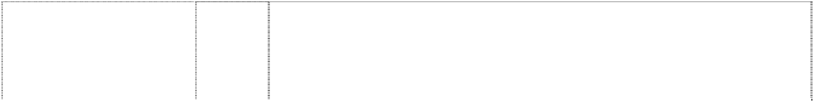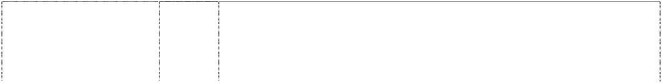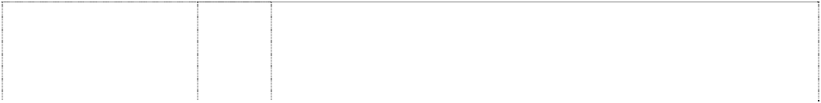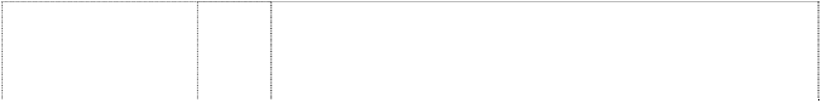

(1052715)

# NIGHT ROD

(1052715)

# NIGHT TRAIN

(1036755)

# NIGHT TRAIN

(1036755)

# NIGHT TRAIN

(1036755)

**REVOLUTION** (776246) **REVOLUTION** (776246)

**ROAD GLIDE** (823559) **ROAD GLIDE** (1036759)

# ROAD GLIDE

(1036759)

# ROAD KING

(823556)

9 Eyeglasses, eyeglass frames, sunglasses, goggles, protective helmets, gauges, radios, compasses, global position systems, speedometers, tachometers, batteries, wiring, cruise controls, switches, breaker points, terminals, starters, circuit breakers, thermostats, battery chargers, armatures, voltage regulators, emergency warning lights, pre-recorded and blank video tapes and discs, audio and video equipment, television sets, stereo equipment, CD players, cassette players, pre-recorded and blank audio tapes and discs, juke boxes, disc players, telephones, recorded computer software, automatic slot machines, magnets, mouse pads, neon signs, luminous signs, electric signs, compact disc cases, vending machines.

12 Vehicles; apparatus for locomotion by land, air or water; parts and accessories therefor not included in other classes; motorcycles and motorcycle parts and accessories therefor not included in other classes; bicycles and bicycling accessories not included in other classes.

12 Vehicles; apparatus for locomotion by land, air or water; motorcycles, motorcycle engines, and motorcycle parts and accessories therefor not included in other classes, bicycles and bicycling accessories not included in other classes, automobiles and automobile parts and accessories.

26 Buttons, hooks and eyes, pins and needles; ornaments for hair and clothing not of precious metal, belt buckles not of precious metal, belt clasps, slide fasteners, zippers, shoe buckles, shoe ornaments not of precious metal, pins other than jewelry, badges, medallions, embroidered patches, decorative boot straps.

28 Games and playthings; decorations for Christmas trees; stuffed toy animals, toy banks, model kits, rocking horses, darts, dartboards, remote controlled vehicles, toy vehicles, electronically operated toy vehicles, bicycling pads, ride-on toy vehicles, scale model vehicles, trains, and air planes, model trains, play balloons, inflatable toys, dolls, doll clothes, billiard tables, billiard balls, billiard cues and other billiard equipment and pinball machines, game machines, snow sleds, aerial discs, balls for games, parlor games, die cast models, golf balls, golf tees, golf ball markers, toy building blocks, toy boxes, card games, puzzles, dog toys, cat toys, fishing rods and tackle; playing cards.

12 Motorcycle engines, parts and accessories therefore.

16 Printed matter; books, magazines, brochures, newsletters, instruction books and handbooks, notepaper, greeting cards, calendars, posters, pens and pencils, manuals and catalogues.

12 Motorcycles, motorcycle engines and parts and accessories therefore not included in other classes.

26 Buttons, hooks and eyes, pins and needles; ornaments for hair and clothing not of precious metal, belt buckles not of precious metal, belt clasps, slide fasteners, zippers, shoe buckles, shoe ornaments not of precious metal, pins other than jewelry, badges, medallions, embroidered patches, decorative boot straps.

28 Games and playthings, not being scooters; decorations for Christmas trees; stuffed toy animals, toy banks, model kits, rocking horses, darts, dartboards, remote controlled vehicles, electronically operated toy vehicles, scale model vehicles, trains, and air planes, model trains, play balloons, inflatable toys, dolls, doll clothes, billiard tables, billiard balls, billiard cues and other billiard equipment and pinball machines, game machines, snow sleds, aerial discs, balls for games, parlor games, die cast models, golf balls, golf tees, golf ball markers, toy building blocks, toy boxes, card games, puzzles, dog toys, cat toys, fishing rods and tackle; playing cards.

12 Motorcycles, motorcycle engines and parts and accessories therefore not included in other classes.

# ROAD KING



(1036758)

# ROAD KING

(1036758)

**ROCKER** (1140120) **ROCKERTAIL** (1140122)

**SCREAMIN’ EAGLE** (939652) **SCREAMIN’ EAGLE** (939653)

# SCREAMIN’ EAGLE

(939654)

# SCREAMIN’ EAGLE

(939655)

26 Buttons, hooks and eyes, pins and needles; ornaments for hair and clothing not of precious metal, belt buckles not of precious metal, belt clasps, slide fasteners, zippers, shoe buckles, shoe ornaments not of precious metal, pins other than jewelry, badges, medallions, embroidered patches, decorative boot straps.

28 Games and playthings; decorations for Christmas trees; stuffed toy animals, toy banks, model kits, rocking horses, darts, dartboards, remote controlled vehicles, toy vehicles, electronically operated toy vehicles, bicycling pads, ride-on toy vehicles, scale model vehicles, trains, and air planes, model trains, play balloons, inflatable toys, dolls, doll clothes, billiard tables, billiard balls, billiard cues and other billiard equipment and pinball machines, game machines, snow sleds, aerial discs, balls for games, parlor games, die cast models, golf balls, golf tees, golf ball markers, toy building blocks, toy boxes, card games, puzzles, dog toys, cat toys, fishing rods and tackle; playing cards.

12 Motorcycles and structural parts thereof.

12 Motorcycles and structural parts thereof.

4 Oils, greases, lubricants, fuel additives in this class, fuels (including motor spirit), lubricating oil.

7 Mufflers, muffler end caps, exhaust systems, pistons, piston pins, generators, starters, and contact points, motorcycle electrical parts, brushes, generators, motorcycle replica miniature gasoline powered engines, spark plugs, ignition wires, breaker points, ignition switches, ignition systems comprised of terminals, spark coils, spark plug cable, ignition modules, carburettors and carburettor parts, namely carburettor float pins, carburettor jet plugs and carburettor adjusting screws, ball check valves, needle valves, valve seats and spark plug wires and ignition coils, pistons and alternators, condensers, knives and special shop tools for motorcycle repairs and tests, namely, pliers, screw drivers, wrenches, reamers, taps, laps, adapters, arbors, machinists' clamps, files, grinders, facers, lappers, piston squaring plates, pullers for wheels, hubs, sprockets, bearings, tappet guides, gears, bushings, clutches, lifters for valve springs, riveters, bars, mechanics' wedges, levers, hammers, vises, vise jaws, mallets, intake port air test plugs, spacers, setters, cutters, machine assembly guides, truing tools, tool holders, spring compressors, key tools, stands, drills, bushing tools, ring tools, chain tools, assembly tools, draining and flushing machines, parts cleaners and washers, ring inserting tools, oil seal tools, carburettor clean-up tools, valve tools, all being in class 7.

9 Eyeglasses, eyeglass frames, sunglasses, goggles, protective helmets, motorcycle electrical parts, gauges, radios, speedometers, tachometers, batteries, wiring, cruise controls, switches, breaker points, terminals, starters, circuit breakers, thermostats, battery chargers, armatures, voltage regulators, emergency warning lights, pre-recorded and blank video tapes and discs, audio and video equipment, television sets, stereo equipment, CD players, cassette players, pre-recorded and blank audio tapes and discs, juke boxes, disc players, telephones, recorded computer software, magnets, mouse pads, neon signs, luminous signs, electric signs, vending machines.

12 Motorcycles, motorcycle engines, and motorcycle parts and accessories therefor not included in other classes, bicycles and bicycling accessories not included in other classes, automobiles and automobile parts and accessories.

# SCREAMIN’ EAGLE

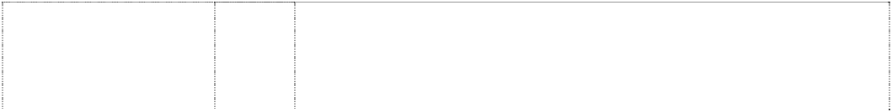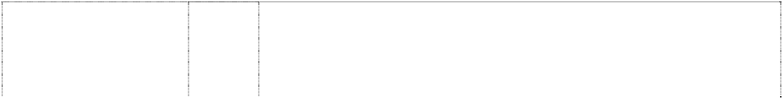

(939656)

# SCREAMIN’ EAGLE

(1036777)

# SCREAMIN’ EAGLE

(1036777)

# SCREAMIN’ EAGLE

eagle head,styl. breaks ellipse, incomplete (1036778) **SCREAMIN’ EAGLE**

eagle head,styl. breaks ellipse, incomplete (1036778)

# SCREAMIN’ EAGLE

eagle head,styl. breaks ellipse, incomplete (1036778)

# SCREAMIN’ EAGLE

eagle head,styl. breaks ellipse, incomplete (1036778) **SCREAMIN’ EAGLE**

eagle head,styl. breaks ellipse, incomplete (1036778)

1. Outerclothing, sweaters, suspenders, scarves, bandannas, jackets, coats, vests, gloves, jeans, chaps, shirts, shorts, caps, hats, headgear for wear, knit hats, rain hats, belts, wristbands, coveralls, hosiery, halter tops, neckties, nightgowns, night shirts, pajamas, pants, rain suits, rain coats, sweatshirts, sweat pants, tank tops, T- shirts, underwear, suits, head bands, leg warmers, aprons, mittens, lingerie, leather clothing, swimsuits, skirts, bibs, footwear, namely shoes and boots, and parts of footwear, namely boot tips, sole plates, heel guards.
2. Buttons, hooks and eyes, pins and needles; ornaments for hair and clothing not of precious metal, belt buckles not of precious metal, belt clasps, slide fasteners, zippers, shoe buckles, shoe ornaments not of precious metal, pins other than jewelry, badges, medallions, embroidered patches, decorative boot straps.

28 Games and playthings; decorations for Christmas trees, stuffed toy animals, toy banks, model kits, rocking horses, darts, dartboards, remote controlled vehicles, toy vehicles, electronically operated toy vehicles, bicycling pads, ride-on toy vehicles, scale model vehicles, trains, and air planes, model trains, play balloons, inflatable toys, dolls, doll clothes, billiard tables, billiard balls, billiard cues and other billiard equipment and pinball machines, game machines, snow sleds, aerial discs, balls for games not for golf, parlor games, die cast models, toy building blocks, toy boxes, card games, puzzles, dog toys, cat toys, fishing rods and tackle; playing cards.

4 Industrial oils and greases; lubricants; dust absorbing, wetting and binding compositions; fuels (including motor spirit) and illuminants; candles and wicks for lighting; oils, greases, fuel additives in this class, transmission fluid; candles.

1. Hand tools and implements (hand-operated); can openers (non- electric), hand tools, wrenches, multifunction hand tools, knives, pliers; badges of metal for vehicles, tool boxes of metal, tool chests, clothes hooks of metal, door knockers, hooks, key rings of metal, knife handles of metal, metal locks, safes, vaults, pad locks, signboards of metal, signs non-luminous and non-mechanical of metal, tins.
2. Eyeglasses, eyeglass frames, sunglasses, goggles, protective helmets, gauges, radios, speedometers, tachometers, batteries, wiring, cruise controls, switches, breaker points, terminals, starters, circuit breakers, thermostats, battery chargers, armatures, voltage regulators, emergency warning lights, pre-recorded and blank video tapes and discs, audio and video equipment, television sets, stereo equipment, CD players, cassette players, pre-recorded and blank audio tapes and discs, juke boxes, disc players, telephones, recorded computer software, automatic slot machines, magnets, mouse pads, neon signs, luminous signs, electric signs, compact disc cases, vending machines.

12 Vehicles; apparatus for locomotion by land, air or water; motorcycles, motorcycle engines, and motorcycle parts and accessories therefor not included in other classes, bicycles and bicycling accessories not included in other classes, automobiles and automobile parts and accessories.

1. Clothing, footwear, headgear; clothing, headwear, footwear, outerclothing, sweaters, suspenders, scarves, bandannas, jackets, coats, vests, gloves, jeans, chaps, shirts, jerseys, shorts, caps, hats, headgear for wear, knit hats, rain hats, belts, wristbands, coveralls, hosiery, halter tops, neckties, nightgowns, night shirts, pajamas, pants, rain suits, rain coats, waterproof clothing, sweatshirts, sweat pants, tank tops, T-shirts, underwear, suits, head bands, leg warmers, aprons, mittens, lingerie, leather clothing, swimsuits, skirts, bibs, footwear, namely shoes and boots, and parts of footwear, namely boot tips, sole plates, heel guards.

# SCREAMIN’ EAGLE



eagle head,styl. breaks ellipse, incomplete (1036778) **SCREAMIN’ EAGLE**

eagle head,styl. breaks ellipse, incomplete (1036778)

**SOFTAIL** (823563) **SOFTAIL** (654865)

# SOFTAIL

(1036754)

# SOFTAIL

(1036754)

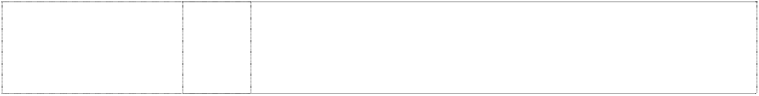**SOFTAIL ROCKER** (1140121) **SPORTSTER** (823564) **SPORTSTER** (617943) **SPORTSTER** (617944) **SPORTSTER** (1036751)

1. Buttons, hooks and eyes, pins and needles; ornaments for hair and clothing not of precious metal, belt buckles not of precious metal, belt clasps, slide fasteners, zippers, shoe buckles, shoe ornaments not of precious metal, pins other than jewelry, badges, medallions, embroidered patches, decorative boot straps.

28 Games and playthings; decorations for Christmas trees, stuffed toy animals, toy banks, model kits, rocking horses, darts, dartboards, remote controlled vehicles, toy vehicles, electronically operated toy vehicles, bicycling pads, ride-on toy vehicles, scale model vehicles, trains, and air planes, model trains, play balloons, inflatable toys, dolls, doll clothes, billiard tables, billiard balls, billiard cues and other billiard equipment and pinball machines, game machines, snow sleds, aerial discs, balls for games, excluding golf balls, parlor games, die cast models, toy building blocks, toy boxes, card games, puzzles, dog toys, cat toys, fishing rods and tackle; playing cards.

12 Motorcycles, motorcycle engines and parts and accessories therefore not included in other classes.

1. Sweaters, suspenders, scarves, bandanas, jackets, vests, gloves, jeans, chaps, tops, shorts, caps, hats, knit hats, rain hats, belts, wristbands, coveralls, halter tops, neckties, nightgowns, night shirts, pyjamas, pants, rain coats, shirts, socks, sweatshirts, sweat pants, tank tops, T-shirts, underwear, motorcycle riding suits, head bands, ladies underwear, leg warmers, aprons, mittens, lingerie, leather clothing, sportswear, skirts, children's wear, coats, bibs; footwear and parts of footwear, namely boot tips, sole plates, heel guards, and decorative boot straps.
2. Buttons, hooks and eyes, pins and needles; ornaments for hair and clothing not of precious metal, belt buckles not of precious metal, belt clasps, slide fasteners, zippers, shoe buckles, shoe ornaments not of precious metal, pins other than jewelry, badges, medallions, embroidered patches, decorative boot straps.

28 Games and playthings; decorations for Christmas trees; stuffed toy animals, toy banks, model kits, rocking horses, darts, dartboards, remote controlled vehicles, toy vehicles, electronically operated toy vehicles, bicycling pads, ride-on toy vehicles, scale model vehicles, trains, and air planes, model trains, play balloons, inflatable toys, dolls, doll clothes, billiard tables, billiard balls, billiard cues and other billiard equipment and pinball machines, game machines, snow sleds, aerial discs, balls for games, parlor games, die cast models, golf balls, golf tees, golf ball markers, toy building blocks, toy boxes, card games, puzzles, dog toys, cat toys, fishing rods and tackle; playing cards.

12 Motorcycles and structural parts thereof.

12 Motorcycles, motorcycle engines and parts and accessories therefore not included in other classes.

12 Motorcycles and parts and accessories therefore as are in this class.

1. Clothing, footwear, headgear, and all other goods in this class.
2. Buttons, hooks and eyes, pins and needles; ornaments for hair and clothing not of precious metal, belt buckles not of precious metal, belt clasps, slide fasteners, zippers, shoe buckles, shoe ornaments not of precious metal, pins other than jewelry, badges, medallions, embroidered patches, decorative boot straps.

# SPORTSTER

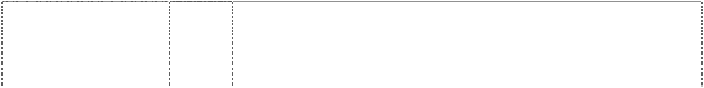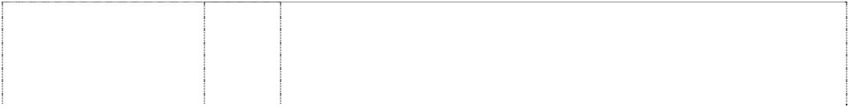

(1036751)

# STREET BOB

(1047708)

# STREET BOB

(1047708)

# STREET GLIDE

(1046842)

# STREET GLIDE

(1046842)

**SUPER GLIDE** (823561) **SUPER GLIDE** (1036780)

# SUPER GLIDE

(1036780)

# T-SPORT

(823565)

28 Games and playthings; decorations for Christmas trees; stuffed toy animals, toy banks, model kits, rocking horses, darts, dartboards, remote controlled vehicles, toy vehicles, electronically operated toy vehicles, bicycling pads, ride-on toy vehicles, scale model vehicles, trains, and air planes, model trains, play balloons, inflatable toys, dolls, doll clothes, billiard tables, billiard balls, billiard cues and other billiard equipment and pinball machines, game machines, snow sleds, aerial discs, balls for games, parlor games, die cast models, golf balls, golf tees, golf ball markers, toy building blocks, toy boxes, card games, puzzles, dog toys, cat toys, fishing rods and tackle; playing cards.

9 Eyeglasses, eyeglass frames, sunglasses, goggles, protective helmets, gauges, radios, compasses, global position systems, speedometers, tachometers, batteries, wiring, cruise controls, switches, breaker points, terminals, starters, circuit breakers, thermostats, battery chargers, armatures, voltage regulators, emergency warning lights, pre-recorded and blank video tapes and discs, audio and video equipment, television sets, stereo equipment, CD players, cassette players, pre-recorded and blank audio tapes and discs, juke boxes, disc players, telephones, recorded computer software, automatic slot machines, magnets, mouse pads, neon signs, luminous signs, electric signs, compact disc cases, vending machines.

12 Vehicles; apparatus for locomotion by land, air or water; parts and accessories therefore not included in other classes; motorcycles and motorcycle parts and accessories therefore not included in other classes; bicycles and bicycling accessories not included in other classes.

9 Eyeglasses, eyeglass frames, sunglasses, goggles, protective helmets, gauges, radios, compasses, global position systems, speedometers, tachometers, batteries, wiring, cruise controls, switches, breaker points, terminals, starters, circuit breakers, thermostats, battery chargers, armatures, voltage regulators, emergency warning lights, pre-recorded and blank video tapes and discs, audio and video equipment, television sets, stereo equipment, CD players, cassette players, pre-recorded and blank audio tapes and discs, juke boxes, disc players, telephones, recorded computer software, automatic slot machines, magnets, mouse pads, neon signs, luminous signs, electric signs, compact disc cases, vending machines.

12 Vehicles; apparatus for locomotion by air or water; parts and accessories therefor not included in other classes; motorcycles and motorcycle parts and accessories therefor not included in other classes; bicycles and bicycling accessories not included in other classes.

12 Motorcycles, motorcycle engines and parts and accessories therefore not included in other classes.

26 Buttons, hooks and eyes, pins and needles; ornaments for hair and clothing not of precious metal, belt buckles not of precious metal, belt clasps, slide fasteners, zippers, shoe buckles, shoe ornaments not of precious metal, pins other than jewelry, badges, medallions, embroidered patches, decorative boot straps.

28 Games and playthings; decorations for Christmas trees, stuffed toy animals, toy banks, model kits, rocking horses, darts, dartboards, remote controlled vehicles, toy vehicles, electronically operated toy vehicles, bicycling pads, ride-on toy vehicles, scale model vehicles, trains, and air planes, model trains, play balloons, inflatable toys, dolls, doll clothes, billiard tables, billiard balls, billiard cues and other billiard equipment and pinball machines, game machines, snow sleds, aerial discs, balls for games, parlor games, die cast models, golf balls, golf tees, golf ball markers, toy building blocks, toy boxes, card games, puzzles, dog toys, cat toys, fishing rods and tackle; playing cards.

12 Motorcycles, motorcycle engines and parts and accessories therefore not included in other classes.

# T-SPORT



(823565)

# T-SPORT

(823565)

# TRIHAWK

(1143293)

# TWIN-CAM 88

(758624)

**ULTRA CLASSIC ELECTRA GLIDE** (908029)

**V-ROD** (860260) **V-ROD** (939657)

# V-ROD

(1036779)

# V-ROD

(1036779)

# WIDE GLIDE

(1036753)

16 Stationery, books, bumper stickers, checkbook covers, playing cards, calendars, decalcomanias, photo albums, posters, printed publications and printed matter road atlases, service manuals for motorcycles, parts catalogues for motorcycles, accessory catalogues and lists, instruction books and handbooks, greeting cards, banners relating to motorcycling, note paper, pens and pencils, paper hats, paper table covers, paper napkins, photographs, pictures, bags of paper or plastic for wrapping and packing.

25 Outerclothing, sweaters, suspenders, scarves, bandannas, jackets, coats, vests, gloves, jeans, chaps, shirts, shorts, caps, hats, headgear for wear, knit hats, rain hats, belts, wristbands, coveralls, hosiery, halter tops, neckties, nightgowns, night shirts, pyjamas, pants, rain suits, rain coats, shirts, sweatshirts, sweat pants, tank tops, T-shirts, underwear, suits, head bands, leg warmers, aprons, mittens, lingerie, leather clothing, swimsuits, skirts, bibs; footwear, namely shoes and boots, and parts of footwear, namely boot tips, sole plates, heel guards.

12 Vehicles.

25 Outerclothing, sweaters, suspenders, scarves, bandannas, handkerchiefs, jackets, coats, vests, gloves, jeans, chaps, shirts, shorts, caps, hats, headgear for wear, knit hats, rain hats, belts, wristbands, coveralls, hosiery, halter tops, neckties, nightgowns, night shirts, pyjamas, pants, rain suits, rain coats, shirts, sweatshirts, sweat pants, tank tops, T-shirts, underwear, suits, head bands, leg warmers, aprons, mittens, lingerie, leather clothing, swimsuits, skirts, bibs, footwear, namely shoes and boots, and parts of footwear, namely boot tips, sole plates, heel guards, and decorative boot straps.

12 Motorcycles; motorcycle engines and parts and accessories therefore not included in other classes.

12 Motorcycles and structural parts therefore, excluding rods.

1. Outerclothing, sweaters, suspenders, scarves, bandannas, jackets, coats, vests, gloves, jeans, chaps, shirts, shorts, caps, hats, headgear for wear, knit hats, rain hats, belts, wristbands, coveralls, hosiery, halter tops, neckties, nightgowns, night shirts, pajamas, pants, rain suits, rain coats, sweatshirts, sweat pants, tank tops, T- shirts, underwear, suits, head bands, leg warmers, aprons, mittens, lingerie, leather clothing, swimsuits, skirts, bibs, footwear, namely shoes and boots, and parts of footwear, namely boot tips, sole plates, heel guards.
2. Buttons, hooks and eyes, pins and needles; ornaments for hair and clothing not of precious metal, belt buckles not of precious metal, belt clasps, slide fasteners, zippers, shoe buckles, shoe ornaments not of precious metal, pins other than jewelry, badges, medallions, embroidered patches, decorative boot straps.

28 Games and playthings; decorations for Christmas trees, stuffed toy animals, toy banks, model kits, rocking horses, darts, dartboards, remote controlled vehicles, toy vehicles, electronically operated toy vehicles, bicycling pads, ride-on toy vehicles, scale model vehicles, trains, and air planes, model trains, play balloons, inflatable toys, dolls, doll clothes, billiard tables, billiard balls, billiard cues and other billiard equipment and pinball machines, game machines, snow sleds, aerial discs, balls for games, parlor games, die cast models, golf balls, golf tees, golf ball markers, toy building blocks, toy boxes, card games, puzzles, dog toys, cat toys; playing cards.

12 Vehicles; apparatus for locomotion by land, air or water; motorcycles, motorcycle engines, and motorcycle parts and accessories therefor not included in other classes, bicycles and bicycling accessories not included in other classes, automobiles and automobile parts and accessories.

# WIDE GLIDE

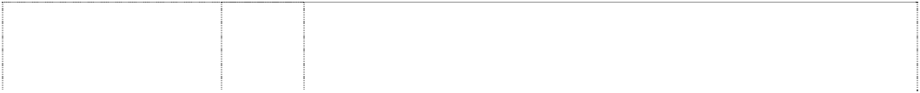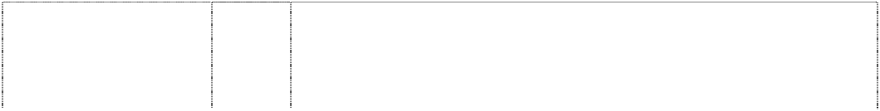

(1036753)

# WIDE GLIDE

(1036753)

Lightning indents Pegasus, styl (939640)

Lightning indents Pegasus, styl (939641)

Lightning indents Pegasus, styl (939642)

Lightning indents Pegasus, styl (939643)

Rect, double divides shield, double (489023)

Rect, double divides shield, double (1036769)

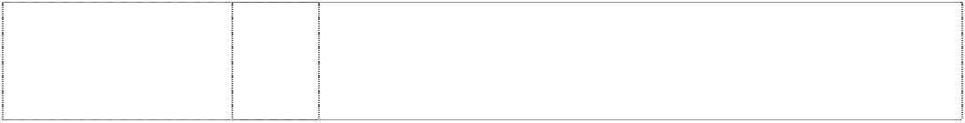Rect, double divides shield, double (1036769)

Rect, double divides shield, double (607255)

26 Buttons, hooks and eyes, pins and needles; ornaments for hair and clothing not of precious metal, belt buckles not of precious metal, belt clasps, slide fasteners, zippers, shoe buckles, shoe ornaments not of precious metal, pins other than jewelry, badges, medallions, embroidered patches, decorative boot straps.

28 Games and playthings; decorations for Christmas trees; stuffed toy animals, toy banks, model kits, rocking horses, darts, dartboards, remote controlled vehicles, toy vehicles, electronically operated toy vehicles, bicycling pads, ride-on toy vehicles, scale model vehicles, trains, and air planes, model trains, play balloons, inflatable toys, dolls, doll clothes, billiard tables, billiard balls, billiard cues and other billiard equipment and pinball machines, game machines, snow sleds, aerial discs, balls for games, parlor games, die cast models, golf balls, golf tees, golf ball markers, toy building blocks, toy boxes, card games, puzzles, dog toys, cat toys, fishing rods and tackle; playing cards.

9 Eyeglasses, eyeglass frames, sunglasses, goggles, protective helmets, motorcycle electrical parts, gauges, radios, speedometers, tachometers, batteries, wiring, cruise controls, switches, breaker points, terminals, starters, circuit breakers, thermostats, battery chargers, armatures, voltage regulators, emergency warning lights, pre-recorded and blank video tapes and discs, audio and video equipment, television sets, stereo equipment, CD players, cassette players, pre-recorded and blank audio tapes and discs, juke boxes, disc players, telephones, recorded computer software, magnets, mouse pads, neon signs, luminous signs, electric signs, vending machines.

12 Motorcycles, motorcycle engines, and motorcycle parts and accessories therefor not included in other classes, bicycles and bicycling accessories not included in other classes, automobiles and automobile parts and accessories.

18 Saddlery, purses, wallets, backpacks, duffel bags, motorcycle saddlebags, key fobs and key holders made of leather, garment bags, business card holders, backpacks, visor organizers, seat back organizers, key cases, suitcases, tote bags, briefcases, attache cases, luggage, travel bags, handbags, hip bags, haversacks, satchels, rucksacks, umbrellas and parasols, valises, trunks, pouches and note pad holders made of leather, dog leashes, dog collars, dog clothing, cat collars.

25 Outerclothing, sweaters, suspenders, scarves, bandannas, jackets, coats, vests, gloves, jeans, chaps, shirts, shorts, caps, hats, headgear for wear, knit hats, rain hats, belts, wristbands, coveralls, hosiery, halter tops, neckties, nightgowns, night shirts, pajamas, pants, rain suits, rain coats, sweatshirts, sweat pants, tank tops, T- shirts, underwear, suits, head bands, leg warmers, aprons, mittens, lingerie, leather clothing, swimsuits, skirts, bibs, footwear, namely shoes and boots, and parts of footwear, namely boot tips, sole plates, heel guards.

3 Cosmetics, perfumes, cologne and fragrances, and all other goods in this class.

6 Badges of metal for vehicles, tool boxes of metal, tool chests, clothes hooks of metal, door knockers, hooks, key rings of metal, knife handles of metal, metal locks, safes, vaults, pad locks, signboards of metal, signs non-luminous and non-mechanical of metal, tins.

1. Hand tools and implements (hand-operated); can openers (non- electric), hand tools, wrenches, multifunction hand tools, knives, pliers.
2. Pre-recorded and blank video tapes and discs, video recorders and players, video tape rewinders, radio, television sets, stereo equipment, pre-recorded and blank audio tapes and discs, audio recorders and players, audio speakers, disc players, receivers, amplifiers, telephones, and protective eyewear.

Rect, double divides shield, double (576888)

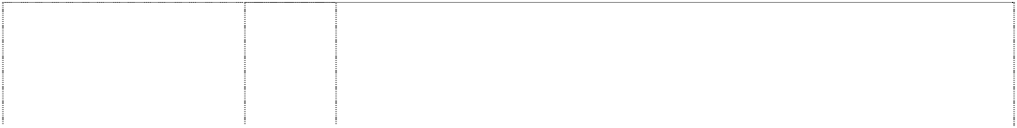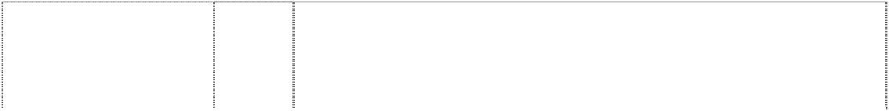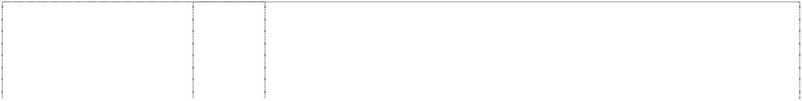

Rect, double divides shield, double (499424)

Rect., double divides shield, double (869393)

Rect, double divides shield, double (1036769)

Rect, double divides shield, double (499423)

Rect, double divides shield, double (1036769)

Rect, double divides shield, double (576889)

Rect, double divides shield, double (1036769)

Rect, double divides shield, double (489022)

Rect, double divides shield, double (576890)

Rect, double divides shield, double (1036769)

Rect, double divides shield, double (506769)

9 Sunglasses; goggles; motorcycle helmets; telephones; motorcycle electrical parts and gauges, namely, speedometers, tachometers, batteries, wiring, cruise controls, switches, breaker points, ignition parts, radios, terminals, circuit breakers, thermostats, battery chargers, armatures, voltage regulators, and all other goods in this class.

12 Motorcycles and parts therefore.

14 Jewellery, ankle bracelets, bracelets, earrings, necklaces, tie tacks, ornamental lapel pins, stick pins, clocks, watches, rings, charms, key fobs, belt buckles of precious metal, watchbands, money clips, collar tips, boot chains, hat pins, pewter plates, figurines of precious metal.

16 Printed matter; stationery; adhesives for stationery or household purposes; artists' materials; instructional and teaching material (except apparatus); postcards, books, bumper stickers, checkbook covers, calendars, decalcomanias, photo albums, posters, printed publications and printed matter, road atlases, service manuals for motorcycles, parts catalogs for motorcycles, accessory catalogs and lists, instruction books and handbooks, greeting cards, banners relating to motorcycling, note paper, pens and pencils, paper hats, paper table covers, paper napkins, photographs, pictures, wrapping paper, bags of paper or plastic for wrapping and packing tattoos (removable); lottery tickets.

18 Leather goods; goods of leather and goods of imitation leather, including wallets, non-metal key rings and parts for key rings such as fall into this class, purses, motorcycle saddle bags, luggage.

1. Furniture, mirrors, picture frames; chairs, sofas, sleeping bags, pet beds, tables, clothes hangers, deck chairs, desks, display boards, cushions, figurines of wood, wax, plastic or plaster, picture frames, footstools, furniture, knife handles not of metal, pillows, keyboards for hanging keys, decorative wall plaques not of textile, plates not of metal, stools, benches, wood racks, curio cabinets, bars, mirrors.
2. Drinking glasses, mugs, steins, shaving brushes, shaving mugs, travel coolers, pitchers, pictures printed on plate glass, coasters, decanters, cups, cookie jars, insulated drinking steins, glassware, insulated can holders, commemorative plates, toothbrushes, quencher cups and figurines, and all other goods in this class.
3. Textiles and textile goods, not included in other classes; bed and table covers; banners, blankets, sheets, pillow shams, pillow cases, quilts, rags, place mats, bed spreads, towels, woven labels, cloth labels, sleeping bags, table linen, upholstery fabrics, fabric, handkerchiefs.
4. Clothing, namely, boots, sweat shirts, jeans, hats, caps, motorcycle riding suits, neck ties, shirts, t-shirts, jackets, vests, ladies tops, bandannas, scarves and sox.
5. Belt buckles, embroidered patches, pins, badges, and all other goods in this class.

28 Games and playthings; decorations for Christmas trees; stuffed toy animals, toy banks, model kits, rocking horses, darts, dartboards, remote controlled vehicles, toy vehicles, electronically operated toy vehicles, bicycling pads, ride-on toy vehicles, scale model vehicles, trains, and air planes, model trains, play balloons, inflatable toys, dolls, doll clothes, billiard tables, billiard balls, billiard cues and other billiard equipment and pinball machines, game machines, snow sleds, aerial discs, balls for games, parlor games, die cast models, golf balls, golf tees, golf ball markers, toy building blocks, toy boxes, card games, puzzles, dog toys, cat toys, fishing rods and tackle; playing cards.

32 Beers; mineral and aerated waters and other non-alcoholic drinks; fruit drinks and fruit juices; syrups and other preparations for making beverages; and all other goods as are included in this class.

Rect, double divides shield, double (576891)



34 Cigarette cases, lighter cases, cigarette lighters, snuff can holders, ashtrays, and holders for cigarette lighters, and all other goods in this class.

***Khalil Arjah Slaters IP Lawyers***

***Ph: (02) 9818 1813***

***Effective Date: 14 August 2007 File Reference: C07/13177***



***Trade Marks***

***Class***

***Goods***

**KALAAJIEH**

(881404)

30

Sesame sauce (tahina), halawa.

***Mambo Graphics Pty Ltd Halford & Co***

***Ph: (02) 9264 8388***

***Effective Date: 27 August 2007 File Reference: C07/13720 Trade Marks Class Goods***

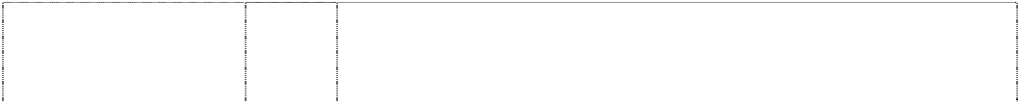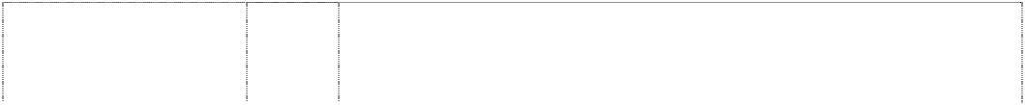

# 100% MAMBO

(496512)

# 100% MAMBO

(493610)

# 100% MAMBO

(438874)

# 100% MAMBO

(442834)

# mambo

(852260)

# mambo

(946349)

**MAMBO** (595330) **MAMBO** (624148)

**MAMBO** (547908) **MAMBO** (528575) **MAMBO BEER** (702539)

9 All goods in this class including spectacles and sunglasses and parts and accessories therefor included in this class.

18 Goods made of leather or imitations of leather; all other goods included in this class.

25 Manufactured clothing.

28 Surfboards in this class, surfskis, sailboards and any other watercraft in this class.

3 Skin care preparations; body care preparations; cosmetics; hair care including shampoos, conditioners, hair colors and tints; bleaching preparations; toothpastes; aromatherapy products; essential oils, massage oils; soaps; bath salts; perfumes; deodorants.

5 Pharmaceutical, veterinary and sanitary preparations; disinfectants, vermin destroying preparations; fungicides, anti-bacterial preparations and poisons; antiseptics; pharmaceutical preparations for skin, hair and scalp including acne treatment preparations, protective creams, sunblocking and skin protection lotions; medicated or therapeutic bath preparations including bath oils and bath salts in this class; dermatological preparations; all being goods in class 5.

14 Horological and chronometric instruments including watches and clocks; jewellery; all other goods included in this class.

18 Leather and imitations of leather, and goods made of these materials and not included in other classes; animal skins, hides; trunks and travelling bags; luggage; handbags; wallets; backpacks; umbrellas, parasols and walking sticks; all other goods included in this class.

1. Textiles and textile goods in this class including furnishing and curtain fabrics, bed linen; all other goods in this class.
2. Clothing, footwear and headgear.

32 Beers; mineral and aerated waters and other non-alcoholic drinks; fruit drinks and fruit juices.

***Mazda Australia Pty Ltd Mazda Australia Pty Ltd Ph:* (03) 8540 1800**

***Effective Date: 26 September 2007 File Reference: C07/16475***

Motor Vehicles.

12

**ASTINA**

(519659)



**ATENZA** (956421) **AXELA** (956423) **B2600 MARVIE** (608490) **BRAVO** (565833) **BRAVO BOSS** (717775)



**CAB PLUS** (406530) **CLUBMAN** (607174) **DEMIO** (865646)

# DIRECO

(775272)

# DISI

(1020693)

**ECLIPSE** (607172) **EUNOS** (572785) **EUNOS V**

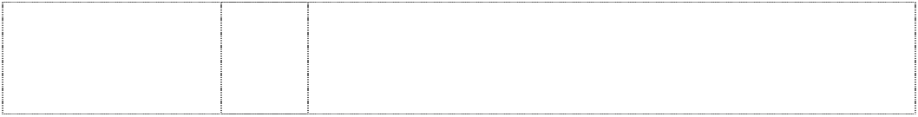

v is stacked chevrons in circle on shield round-bottom (537624)

12 Motor vehicles and parts for motor vehicles.

12 Motor vehicles and parts for motor vehicles.

12 Motor vehicles and structural parts thereof including engines for motor land vehicles; and all other goods in this class.

12 Motor vehicles and motor vehicle parts.

12 Commercial motor vehicles.

12 Vehicles including trucks and parts thereof in this class.

12 Motor vehicles and motor vehicle parts.

12 Automobiles, parts and fittings thereof; engines for land vehicles; suspension systems for land vehicles; shock absorbers and springs for land vehicle suspension systems; drive shafts for land vehicles; wheel bearings and shaft couplings for land vehicles; transmissions for land vehicles; brakes for land vehicles; alternating current motors for land vehicles; direct current motors for land vehicles; anti-theft alarms for land vehicles.

12 Automobiles, parts and fittings thereof; motorcycles, bicycles, parts and fittings thereof; engines for land vehicles; suspensions, shock absorbers and springs for land vehicles; shafts, bearings and shaft couplings for land vehicles; power transmission equipment for land vehicles; brakes for land vehicles; alternating current motors and direct current motors for land vehicles; anti-theft alarms for vehicles.

12 Automobiles, parts and fittings thereof; two-wheeled motor vehicles and bicycles, parts and fittings thereof; engines for automobiles excluding direct injection spark ignition engines; motors and engines for other land vehicles (excluding their parts and excluding direct injection spark ignition engines); suspension systems for land vehicles; shock absorbers and springs for land vehicles; shafts and axles for land vehicles; wheel bearings and shaft couplings for land vehicles; transmissions and gearings for land vehicles; brakes for land vehicles; anti-theft alarms for vehicles.

12 Motor Vehicles and motor vehicle parts in this class.

12 Automobiles and parts and accessories therefor in this class.

12 Vehicles; apparatus for locomotion by land, air or water.

# M O

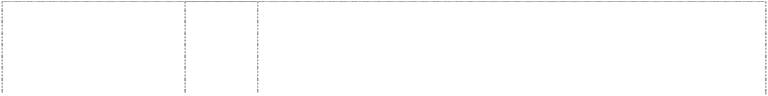

ltr M on ring or ltr O (947545)

# M O

ltr M on ring or ltr O (947545)

# M O

ltr M on ring or ltr O (947545)

# M O

ltr M on ring or ltr O (947545)

# M O

ltr M on ring or ltr O (727060)



# M O

ltr M on ring or ltr O (710957)

1. Acidulated water for recharging batteries, anti-frothing solutions for batteries, salts for galvanic batteries, ion exchangers, liquids for removing sulphates from batteries, anti-knock substances for internal combustion engines, chemicals in this class including chemical additives to motor fuel, anti-boil preparations for engine coolants, chemical condensation preparations, coolants for vehicle engines, chemical preparations for decarbonising engines, detergent additives to gasoline, distilled water, anti-freeze, anti-static preparations (other than for household purposes), power steering fluid, fluids for hydraulic circuits, brake fluid, transmission fluid, industrial chemicals, colour brightening chemicals for industrial purposes, bromine for chemical purposes, adhesives for industrial purposes, auxiliary fluids for use with abrasives, foundry binding substances, foundry moulding preparations, mould-release preparations, brazing fluxes, brazing preparations, ceramic compositions for sintering, alumina, carbon black for industrial purposes, carbon for filters, activated carbons, catalysts, biochemical catalysts, anti-tarnishing chemicals for windows, glass- staining chemicals, cement for pneumatic tyres, chemical intensifiers for rubber, compositions for repairing inner tubes of tyres, tyre repairing compositions, mastic for tyres, fire extinguishing compositions, fireproofing preparations.
2. Anti-rust greases, anti-rust oils, anti-rust preparations, coatings, paints, undercoating for vehicle chassis, primers, aluminium powder for painting, siccatives (drying agents) for paints.
3. Abrasives, abrasive cloth, abrasive paper, toiletries, soap, cosmetic kits, cakes of toilet soap, colourants for toilet purposes, dentifrices, eau de cologne, perfumes, aromatics (essential oils), cosmetic preparations for baths, bleaching preparations for laundry, colour brightening chemicals for household purposes, cleaning preparations, polishing preparations including polishing wax, waxes for leather, boot polish, boot cream, windshield cleaning liquids.
4. Fuel, motor fuel, gasoline, gas oil, diesel oil, fuel gas, kerosene, vaporized fuel mixtures, fuel with an alcoholic base, additives (non- chemical) to motor-fuel, industrial grease, industrial oil, lubricants, lubricating grease, motor oil, industrial wax, carnauba wax, grease for leather.
5. Metal key rings, metal key chains, metal key holders, metal key blanks, metal keys for automobiles; metal locks for automobiles; metal badges for automobiles; metal tool boxes.
6. Metal working machines and tools; mining machines and tools; construction machines and tools; motive power machines and apparatus (excluding those for land vehicles); fan belts, ignition coils, chain tensioners, timing chains, contact points for vehicle's distributors, oil filters, piston rings, pistons, fuel filters, starters, valves, cylinders, radiator fans, radiator hoses, water pumps and silencers for automobile internal combustion engines; other parts for automobile internal combustion engines; alternators; power transmission equipment (excluding those for land vehicles); shock absorbers and springs (excluding those for land vehicles); brakes (excluding those for land vehicles).

# M O



ltr M on ring or ltr O (947545)

# M O

ltr M on ring or ltr O (710957)

# M O



ltr M on ring or ltr O (947545)

9 Accumulators (electric) for vehicles, batteries (electric), battery boxes, battery chargers, solar batteries, electronic agendas, calculating machines, camcorders, cameras, facsimile machines, telephone apparatus, portable telephones, alarms, anti-theft warning apparatus, buzzers, signal bells, amusement apparatus adapted for use with television receivers only, computer game programs, recorded computer software, computer programs (including downloadable), compact discs (read-only memory), electronic publications (including downloadable), electronic tags for goods, radios (vehicle radios), cassette players, compact disc players, compact discs for audio-video, navigation apparatus for vehicles, navigational instruments, television apparatus, headphones, antennas, eyeglasses, eyeglass cases, eyeglass chains, eyeglass cords, filters for respiratory masks, protective helmets, anti-dazzle shades, anti-glare glasses, life jackets, solenoid valves (electromagnetic switches), choking coils (impedance), coils (electric), electromagnetic coils, holders for electric coils, fuse wire, fuses, electricity junction boxes, locks (electric), door closers (electric), door openers (electric), central processing units, integrated circuit cards (smart cards), integrated circuits, distance measuring apparatus, distance recording apparatus, heat regulating apparatus, heliographic apparatus, electric apparatus for remote ignition, inclinometers, speed indicators, water level indicators, mileage recorders for vehicles, air analysis apparatus, manometers, meters, relays (electric), resistance (electric), voltage regulators for vehicles, switches (electric), tachometers, thermostats for vehicles, aerometers, altimeters, ammeters, amplifiers, balancing apparatus, barometers, automatic indicators of low pressure in vehicle tyres, diagnostic apparatus (not for medical purposes), self-regulating fuel pumps, gas testing instruments, gasoline gauges, electric installations for the remote control of industrial operations, radar apparatus, simulators for the steering and control of vehicles, electricity cell switches, cigar lighters for automobiles, vehicle breakdown warning triangles, mouse pads, conductors (electric), electricity connectors, wires (electric), cables (electric), fibre optic cables, junction sleeves for electric cables, wires of metal alloys (fuse wire) and parts and fittings for the aforesaid goods.

12 Automobiles, parts and fittings therof, engines for land vehicles; shock absorbers and springs for land vehicles; shafts, bearings and shaft couplings for land vehicles; power transmission equipment for land vehicles; brakes for land vehicles; alternating current motors and direct current motors for land vehicles; anti-theft alarms for vehicles.

14 Watches, clocks, alarm clocks, atomic clocks, stopwatches, watch bands, badges of precious metal, ashtrays of precious metal for smokers, cigar boxes of precious metal, cigar cases of precious metal, cigarette cases of precious metal, boxes of precious metal, household containers of precious metal, cups of precious metal, dishes of precious metal, gold and sliver ware (other than cutlery, forks and spoons), jewellery, chains (jewellery), ornaments (jewellery), cuff links, buckles of precious metal, ornamental pins, tie pins, shoe ornaments of precious metal, medals and parts and fittings for the aforesaid goods.

# M O

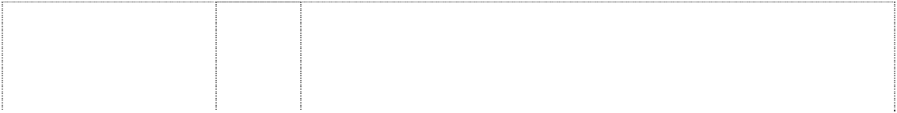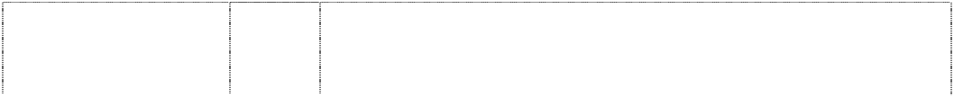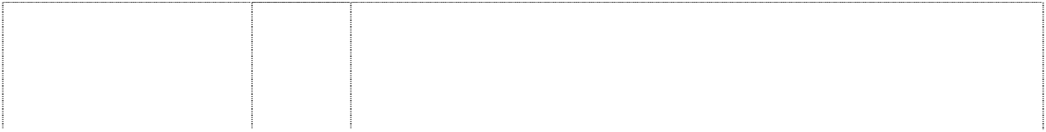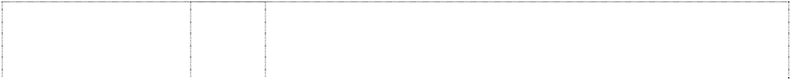

ltr M on ring or ltr O (947545)

# M O

ltr M on ring or ltr O (947545)

# M O

ltr M on ring or ltr O (947545)

# M O

ltr M on ring or ltr O (947545)

# M O

ltr M on ring or ltr O (947545)

# MAZDA

(405509)

**MAZDA** (157716) **MAZDA** (423722) **MAZDA** (457982) **MAZDA** (495589) **MAZDA** (495590) **MAZDA** (539573)

**MAZDA** (539574) **MAZDA** (539575)

# MAZDA

(582052)

# MAZDA

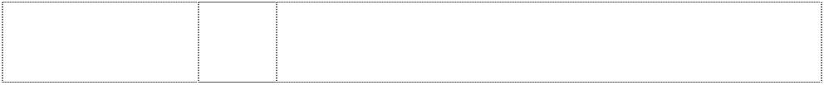

(539576)

16 Stationery, writing materials, bookends, clipboards, clips for offices, envelopes, erasing products, rubber erasers, erasing shields, pens, fountain pens, pencil lead holders, pencils, paper knives for office use, paper cutters for office use, paper shredders for office use, paper clips, paperweights, pen cases, pencil holders, pencil sharpeners, penholders, punches for office use, note books, wrapping paper, writing pads, writing paper, paper and paper goods, files for office use, folders for papers, pastes for stationery or household purposes, stapling presses for office use, printed matter, printed publications, prospectuses, books, booklets, comic books, magazines, newsletters, newspapers, catalogues, calendars, postcards, posters, bookmarkers, geographical maps, photograph stands, photographs, drawing materials, stickers, tickets, coasters of paper, handkerchiefs of paper, table napkins of paper, towels of paper, pastels, crayons.

18 Suitcases, attache cases, backpacks, bags including garment bags for travel, bags (envelopes, pouches) of leather for packaging, briefcases, shopping bags, card cases (notecases), purses (not of precious metal), bands of leather, leather straps, parasols, umbrellas, fur skins.

25 Clothing, ready-made clothing, jackets, jumpers, liveries, motorists' clothing, overalls, overcoats, pants, shirts, T-shirts, parkas, coats, skirts, cuffs, underwear, socks, scarfs, bandanas, neckerchiefs, headgear for wear, caps, hats, gloves, footwear, shoes, belts.

1. Carpets for automobiles, floor coverings, vinyl floor coverings, bath mats, door mats, wallpaper.
2. Toys and playthings, toy masks, toy pistols, toy vehicles, scale model vehicles, radio-controlled toy vehicles, apparatus for electronic games other than those adapted for use with television receivers only, sporting articles, games, balls for games, golf bags (with or without wheels), golf clubs, golf gloves, playing cards, dolls, spinning tops, dice, kites, building games, butterfly nets, cosaques (toy fireworks), novelties for parties and dances.

12 Vehicles, apparatus for locomotion by land, air or water, but excluding lamps, signals and similar lighting equipments for vehicles.

12 Motor land vehicles, parts and fittings therefor but not including lamps for motor land vehicles.

25 Hats, jackets, sports jerseys, sports shoes, and all other goods included in this class.

4 All goods included in this class.

16 All goods in this class.

24 All goods in this class.

1. Mold releasing agents, catalysts, fire extinguishing agents, puncture proofing agents for tyres, flattening agents, stripping agents, fuel economizing agents, anti-freeze agents, damp proofing agents. water proofing agents, rubber cement, plastic adhesives, water glass and all other goods included in this class.
2. Synthetic resin paints, anti-rust paints, painting putty and all other goods included in this class.
3. Soaps, cleaning preparations for radiators, automobile bodies, chassis, engine parts and glass, namely windshield glass, glass windows in vehicles and mirrors; and all other goods in this class.
4. Air freshening preparations and deodorants in this class, air purifying preparations, adhesive bands for medical purposes, adhesive tapes for medical purposes, first-aid boxes, medical bandages in this class, sanitary towels and all other goods in this class.
5. Metal moulds for die-casting, metal moulds for reging, metal moulds for pressing, keys, key rings of metal, badges of metal for vehicles, locks of metal for vehicles, money boxes of metal, rings of metal, ropes of metal, metal belts or engines, tool boxes of metal.

# MAZDA

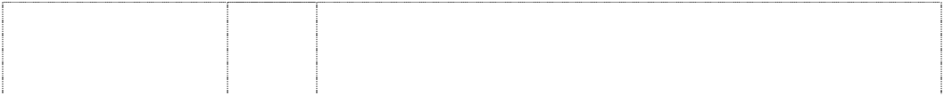

(539577)

# MAZDA

(539578)

# MAZDA

(539579)

# MAZDA

(539581)

# MAZDA

(539582)

**MAZDA** (539583) **MAZDA** (539584)

**MAZDA** (539585) **MAZDA** (539586) **MAZDA** (539587) **MAZDA** (539588)

# MAZDA

(539589)

# MAZDA 1

(885601)

# MAZDA 2



(885602)

1. Grinding machines, lathes, honing machines, oil hydraulic presses, pneumatic hammers, cemented cutter tips, cemented carbide cutting tools, wear resistant tools in this class, rock drills, excavators, turbines, concrete machines, concrete breakers, alternators, condensors, conversion apparatus for internal combustion engines, crank shafts, igniting devices for internal combustion engines, lubricating pumps, pistons for engines, pulleys, sparking plugs for combustion engines, speed governors for machines; engines and motors in this class; turbocompressors, universal joints and washing installations for vehicles.
2. Wire brushes in this class, spanners, screw drivers, pliers, pinchers, hammers, hand drills, borers and wrenches, non-electric can openers.

14 Precious metals and their alloys and goods of precious metal or coated therewith, not included in other classes, and none being horological or nautical or chronometric instruments; jewellery, precious stones; necklaces and necktie pins.

1. Rubber engine mounts; connecting hoses for vehicle radiators; structural parts in this class for vehicles; rubber goods in this class including rubber mats for vehicles and rubber shock absorbers; synthetic rubber; synthetic resins (semifinished products); parts in this class of air conditioners; all the foregoing being for use in vehicles.
2. Folding briefcases, briefcases, handbags, shopping bags, purses, pass cases, card cases, umbrellas and parasols and all other goods included in this class.
3. Chairs, mirrors, cushions, straws, flat fans and all other goods included in this class.
4. Mess tins; tableware in this class, ice boxes in this class, canteens in this class, vacuum bottles, bottle openers in this class, pan-mats and pot-stands in this class, trays, garbage cans in this class, waste baskets, dusters, clothes brushes, deodorizing apparatus in this class, shopping baskets in this class, money boxes in this class, shoe brushes, shoe horns, shoe shine cloths, convenient shoe cleaners in this class including disposable shoe cleaners.
5. Ropes, nets (excluding wire nets) and all other goods included in this class.
6. Buckles, sewing boxes, pincushions, needle boxes and all other goods included in this class.
7. Carpets for automobiles and all other goods included in this class.
8. Toys, dolls, kites, dice, chess games, toy cars and other playthings; sporting goods in this class including golf. bags, golf clubs, rackets, balls for games, batting gloves, darts, fish hooks and other fishing tackle; Christmas trees in this class.

34 Cigarette cases, ash trays, lighters, matches and all other goods included in this class.

12 Automobiles, parts and fittings thereof, two-wheeled motor vehicles and bicycles, parts and fittings thereof, but excluding lamps, signals, and similar lighting equipment for vehicles, engines for automobiles, motors and engines for other land vehicles, suspension systems for land vehicles, shock absorbers and springs for land vehicles, shafts and axles for land vehicles, wheel bearings and shaft couplings for land vehicles, transmissions for land vehicles, brakes for land vehicles, anti-theft alarms for land vehicles.

12 Automobiles, parts and fittings thereof, two-wheeled motor vehicles and bicycles, parts and fittings thereof, but excluding lamps, signals, and similar lighting equipment for vehicles, engines for automobiles, motors and engines for other land vehicles, suspension systems for land vehicles, shock absorbers and springs for land vehicles, shafts and axles for land vehicles, wheel bearings and shaft couplings for land vehicles, transmissions for land vehicles, brakes for land vehicles, anti-theft alarms for land vehicles.

# MAZDA 3



(885603)

# MAZDA 4

(885605)

# MAZDA 5

(885606)

# MAZDA 6

(885607)

# MAZDA 7

(885608)

# MAZDA 8

(885609)

# MAZDA 9

(885610)

**MAZDA ACTIVEHICLE** (806505)



12 Automobiles, parts and fittings thereof, two-wheeled motor vehicles and bicycles, parts and fittings thereof, but excluding lamps, signals, and similar lighting equipment for vehicles, engines for automobiles, motors and engines for other land vehicles, suspension systems for land vehicles, shock absorbers and springs for land vehicles, shafts and axles for land vehicles, wheel bearings and shaft couplings for land vehicles, transmissions for land vehicles, brakes for land vehicles, anti-theft alarms for land vehicles.

12 Automobiles, parts and fittings thereof, two-wheeled motor vehicles and bicycles, parts and fittings thereof, but excluding lamps, signals, and similar lighting equipment for vehicles, engines for automobiles, motors and engines for other land vehicles, suspension systems for land vehicles, shock absorbers and springs for land vehicles, shafts and axles for land vehicles, wheel bearings and shaft couplings for land vehicles, transmissions for land vehicles, brakes for land vehicles, anti-theft alarms for land vehicles.

12 Automobiles, parts and fittings thereof, two-wheeled motor vehicles and bicycles, parts and fittings thereof, but excluding lamps, signals, and similar lighting equipment for vehicles, engines for automobiles, motors and engines for other land vehicles, suspension systems for land vehicles, shock absorbers and springs for land vehicles, shafts and axles for land vehicles, wheel bearings and shaft couplings for land vehicles, transmissions for land vehicles, brakes for land vehicles, anti-theft alarms for land vehicles.

12 Automobiles, parts and fittings thereof, two-wheeled motor vehicles and bicycles, parts and fittings thereof, but excluding lamps, signals, and similar lighting equipment for vehicles, engines for automobiles, motors and engines for other land vehicles, suspension systems for land vehicles, shock absorbers and springs for land vehicles, shafts and axles for land vehicles, wheel bearings and shaft couplings for land vehicles, transmissions for land vehicles, brakes for land vehicles, anti-theft alarms for land vehicles.

12 Automobiles, parts and fittings thereof, two-wheeled motor vehicles and bicycles, parts and fittings thereof, but excluding lamps, signals, and similar lighting equipment for vehicles, engines for automobiles, motors and engines for other land vehicles, suspension systems for land vehicles, shock absorbers and springs for land vehicles, shafts and axles for land vehicles, wheel bearings and shaft couplings for land vehicles, transmissions for land vehicles, brakes for land vehicles, anti-theft alarms for land vehicles.

12 Automobiles, parts and fittings thereof, two-wheeled motor vehicles and bicycles, parts and fittings thereof, but excluding lamps, signals, and similar lighting equipment for vehicles, engines for automobiles, motors and engines for other land vehicles, suspension systems for land vehicles, shock absorbers and springs for land vehicles, shafts and axles for land vehicles, wheel bearings and shaft couplings for land vehicles, transmissions for land vehicles, brakes for land vehicles, anti-theft alarms for land vehicles.

12 Automobiles, parts and fittings thereof, two-wheeled motor vehicles and bicycles, parts and fittings thereof, but excluding lamps, signals, and similar lighting equipment for vehicles, engines for automobiles, motors and engines for other land vehicles, suspension systems for land vehicles, shock absorbers and springs for land vehicles, shafts and axles for land vehicles, wheel bearings and shaft couplings for land vehicles, transmissions for land vehicles, brakes for land vehicles, anti-theft alarms for land vehicles.

12 Automobiles, parts and fittings thereof; engines for land vehicles; suspension systems for land vehicles; shock absorbers and springs for land vehicle suspension systems; drive shafts for land vehicles; wheel bearings and shaft couplings for land vehicles; transmissions for land vehicles; brakes for land vehicles; alternating current motors for land vehicles; direct current motors for land vehicles; anti-theft alarms for land vehicles.

# MAZDA CX-7



(1045466)

# MAZDA CX-9

(1045469)

# MAZDA MPV

(865645)

# MAZDA MX-5

(947638)

# MAZDA MX-5

(865644)

# MAZDA MX-5

(947638)

# MAZDA MX-5



(947638)

12 Automobiles, parts and fittings thereof (excluding tires, lamps, signals and similar lighting equipment for automobiles); engines for automobiles (excluding their parts); motors and engines for other land vehicles (excluding their parts); suspension systems for automobiles; shock absorbers and springs for land vehicles; shafts and axles for land vehicles; wheel bearings and shaft couplings for land vehicles; transmissions for land vehicles; and brakes for land vehicles.

12 Automobiles, parts and fittings thereof (excluding tires, lamps, signals and similar lighting equipment for automobiles); engines and motors for automobiles (excluding their parts); suspension systems for automobiles; shock absorbers and springs for automobiles; shafts and axles for automobiles; wheel bearings and shaft couplings for automobiles; transmissions for automobiles; and brakes for automobiles.

12 Automobiles, parts and fittings thereof, but excluding lamps, signals and similar lighting equipment for vehicles, and also excluding tires; engines for land vehicles; suspension systems for land vehicles; shock absorbers and springs for land vehicle suspension systems; drive shafts for land vehicles; wheel bearings and shaft couplings for land vehicles; transmissions for land vehicles; brakes for land vehicles; alternating current motors for land vehicles; direct current motors for land vehicles; anti-theft alarms for land vehicles.

9 Computer game programs; recorded computer software; computer programs (including downloadable); CD-ROM (compact discs read- only memory); electronic publications (including downloadable); electronic tags for goods; compact discs for audio-video; eyeglasses; eyeglass cases; eyeglass chains; eyeglass cords; filters for respiratory masks; protective helmets; anti-dazzle shades; anti- glare glasses; life jackets; gasoline gauges; cigar lighters for automobiles; vehicle breakdown warning triangles; mouse pads; straps for portable telephones.

12 Automobiles, parts and fittings thereof, but excluding lamps, signals and similar lighting equipment for vehicles, and also excluding tires; engines for land vehicles; suspension systems for land vehicles; shock absorbers and springs for land vehicle suspension systems; drive shafts for land vehicles; wheel bearings and shaft couplings for land vehicles; transmissions for land vehicles; brakes for land vehicles; alternating current motors for land vehicles; direct current motors for land vehicles; anti-theft alarms for land vehicles.

14 Watches; clocks, alarm clocks (other than those for nautical use); atomic clocks; stop watches (other than those for nautical use); watch bands; badges of precious metal; ashtrays, of precious metal, for smokers; cigar boxes, of precious metal; cigar cases, of precious metal; cigarette cases, of precious metal; boxes of precious metal; household containers of precious metal; cups of precious metal; dishes of precious metal; gold and silver ware, other than cutlery, forks and spoons; jewellery; chains (jewellery); ornaments (jewellery); cuff links; buckles of precious metal; ornamental pins; tie pins; shoe ornaments of precious metal; medals.

16 Stationery; writing materials; bookends; clipboards; clips for offices; envelopes; erasing products; rubber erasers: erasing shields; pens; fountain pens; pencil lead holders; pencils; paper knives for office use, paper cutters for office use; paper shredders for office use; paper-clips; paperweights; pen cases; pencil holders; pencil sharpeners: penholders; punches for office use; note books; wrapping paper; writing pads; writing paper; paper; files for office use; folders for papers; pastes for stationery or household purposes; stapling presses for office use; printed matter; printed publications; prospectuses; books; booklets; comic books; magazines; newsletters; newspapers; catalogues; calendars; postcards; posters; bookmarkers; geographical maps; photograph stands; photographs; drawing materials; stickers; tickets; coasters of paper; handkerchiefs of paper; table napkins of paper; towels of paper; pastels, crayons.

# MAZDA MX-5

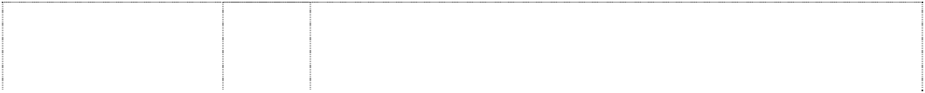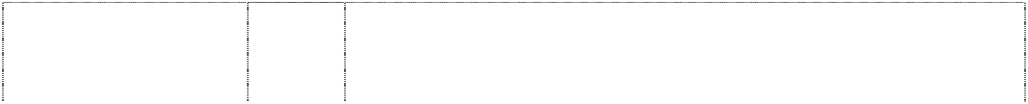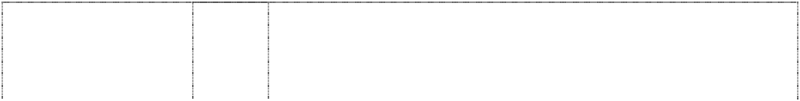

(947638)

# MAZDA MX-5

(947638)

**MAZDA MX-5** (947638) **MAZDA MX-5** (947638)

# MAZDA RX-5

(869735)

# MAZDA RX-8

(947637)

# MAZDA RX-8

(869734)

# MAZDA RX-8

(947637)

# MAZDA RX-8

(947637)

# MAZDA RX-8

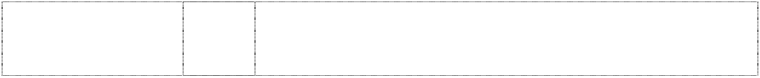

(947637)

18 Suitcases; attache cases; backpacks; garment bags for travel; bags, envelopes, pouches of leather, for packaging; briefcases; shopping bags; card cases, notecases; purses, not of precious metal; bands of leather; leather straps; parasols; umbrellas; fur-skins.

25 Clothing; ready-made clothing; jackets; jumpers; liveries; motorists' clothing; overalls; overcoats; pants; shirts; T-shirts; parkas; coats; skirts; cuffs; underwear; socks; scarfs; bandanas, neckerchiefs; headgear for wear; caps; hats; gloves; footwear; shoes; belts.

1. Carpets for automobiles; floor coverings; vinyl floor coverings; bath mats; door mats; wallpaper.
2. Toys; toy masks; toy pistols; toy vehicles; scale model vehicles; radio-controlled toy vehicles; games; balls for games; golf bags, with or without wheels; golf clubs; golf gloves; playing cards; dolls; spinning tops; dice; kites; building games; butterfly nets; cosaques, toy fireworks; novelties for parties, dances.

12 Automobiles, parts and fittings thereof, but excluding lamps, signals and similar lighting equipment for automobiles; engines for land vehicles; suspension systems for land vehicles; shock absorbers and springs for land vehicle suspension systems; drive shafts for land vehicles; wheel bearings and shaft couplings for land vehicles; transmissions for land vehicles; brakes for land vehicles.

9 Computer game programs; recorded computer software; computer programs (including downloadable); CD-ROM (compact discs read- only memory); electronic publications (including downloadable); electronic tags for goods; compact discs for audio-video; eyeglasses; eyeglass cases; eyeglass chains; eyeglass cords; filters for respiratory masks; protective helmets; anti-dazzle shades; anti- glare glasses; life jackets; gasoline gauges; cigar lighters for automobiles; vehicle breakdown warning triangles; mouse pads; straps for portable telephones.

12 Automobiles, parts and fittings thereof, but excluding lamps, signals and similar lighting equipment for automobiles; engines for land vehicles; suspension systems for land vehicles; shock absorbers and springs for land vehicle suspension systems; drive shafts for land vehicles; wheel bearings and shaft couplings for land vehicles; transmissions for land vehicles; brakes for land vehicles.

14 Watches; clocks, alarm clocks (other than those for nautical use); atomic clocks; stop watches (other than those for nautical use); watch bands; badges of precious metal; ashtrays, of precious metal, for smokers; cigar boxes, of precious metal; cigar cases, of precious metal; cigarette cases, of precious metal; boxes of precious metal; household containers of precious metal; cups of precious metal; dishes of precious metal; gold and silver ware, other than cutlery, forks and spoons; jewellery; chains (jewellery); ornaments (jewellery); cuff links; buckles of precious metal; ornamental pins; tie pins; shoe ornaments of precious metal; medals.

16 Stationery; writing materials; bookends; clipboards; clips for offices; envelopes; erasing products; rubber erasers: erasing shields; pens; fountain pens; pencil lead holders; pencils; paper knives for office use, paper cutters for office use; paper shredders for office use; paper-clips; paperweights; pen cases; pencil holders; pencil sharpeners: penholders; punches for office use; note books; wrapping paper; writing pads; writing paper; paper; files for office use; folders for papers; pastes for stationery or household purposes; stapling presses for office use; printed matter; printed publications; prospectuses; books; booklets; comic books; magazines; newsletters; newspapers; catalogues; calendars; postcards; posters; bookmarkers; geographical maps; photograph stands; photographs; drawing materials; stickers; tickets; coasters of paper; handkerchiefs of paper; table napkins of paper; towels of paper; pastels, crayons.

18 Suitcases; attache cases; backpacks; garment bags for travel; bags, envelopes, pouches of leather, for packaging; briefcases; shopping bags; card cases, notecases; purses, not of precious metal; bands of leather; leather straps; parasols; umbrellas; fur-skins.

# MAZDA RX-8

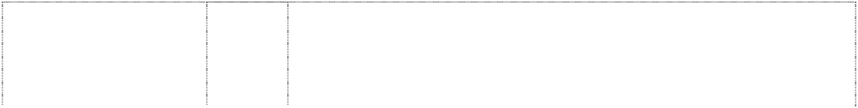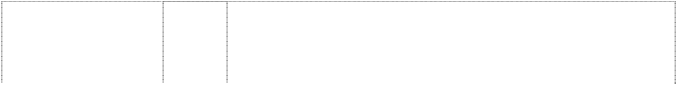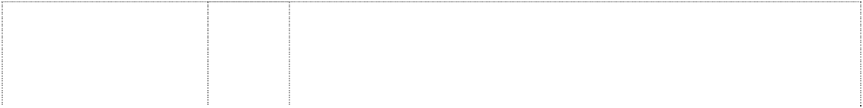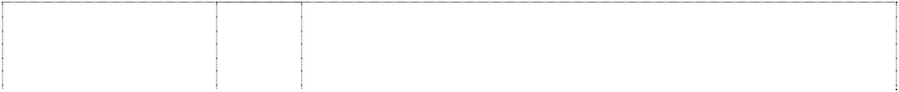

(947637)

**MAZDA RX-8** (947637) **MAZDA RX-8** (947637)

# MAZDASPEED

(979090)

# MAZDASPEED

(979090)

# MAZDASPEED

(979090)

# MAZDASPEED

(979090)

# MAZDASPEED

(979090)

# MAZDASPEED

(979090)

**MILLENIA** (758019) **MPS** (1014731)



25 Clothing; ready-made clothing; jackets; jumpers; liveries; motorists' clothing; overalls; overcoats; pants; shirts; T-shirts; parkas; coats; skirts; cuffs; underwear; socks; scarfs; bandanas, neckerchiefs; headgear for wear; caps; hats; gloves; footwear; shoes; belts.

1. Carpets for automobiles; floor coverings; vinyl floor coverings; bath mats; door mats; wallpaper.
2. Toys; toy masks; toy pistols; toy vehicles; scale model vehicles; radio-controlled toy vehicles; games; balls for games; golf bags, with or without wheels; golf clubs; golf gloves; playing cards; dolls; spinning tops; dice; kites; building games; butterfly nets; cosaques, toy fireworks; novelties for parties, dances.

4 Fuel, motor fuel, gasoline, gas oil, diesel oil, fuel gas, kerosene, vaporized fuel mixtures, fuel with an alcoholic base, additives (non- chemical) to motor fuel, industrial grease, industrial oil, lubricants, lubricating grease, motor oil, industrial wax, carnauba wax, grease for leather.

7 Fan belts for engines, chain tensioners for engines, timing chains, oil filters, piston rings for engines, pistons for engines, fuel filters, starters for engines, valves for engines, cylinders for engines, radiator fans, water pumps and silencers for automobile internal combustion engines; other parts for automobile internal combustion engines; alternators; power transmission equipment (excluding those for land vehicles); shock absorbers and springs (excluding those for land vehicles); brakes (excluding those for land vehicles); bearings for land vehicles.

12 Automobiles, parts and fittings thereof; engines for land vehicles; shock absorbers and springs for land vehicles; shafts and shaft couplings for land vehicles; power transmission equipment for land vehicles; brakes for land vehicles; alternating current motors and direct current motors for land vehicles; anti-theft alarms for vehicles.

14 Watches, clocks, alarm clocks, atomic clocks, stopwatches, watch bands, badges of precious metal, ashtrays of precious metal for smokers, cigar boxes of precious metal, cigar cases of precious metal, cigarette cases of precious metal, boxes of precious metal, household containers of precious metal, cups of precious metal, dishes of precious metal, gold and silver ware (other than cutlery, forks and spoons), jewellery, chains (jewellery), ornaments (jewellery), cuff links, buckles of precious metal, ornamental pins, tie pins, shoe ornaments of precious metal, medals.

16 Stationery, writing materials, bookends, clipboards, clips for offices, envelopes, erasing products, rubber erasers, erasing shields, fountain pens, pencils, paper knives for office use, paper cutters for office use, paper shredders for office use, paperweights, pen cases, pencil holders, pencil sharpeners, penholders, punches for office use, note books, wrapping paper, writing pads, writing paper, paper, folders for papers, pastes for stationery or household purposes, stapling presses for office use, printed matter, printed publications, prospectuses, books, booklets, comic books, magazines, newsletters, newspapers, catalogues, calendars, postcards, posters, bookmarkers, geographical maps, photograph stands, photographs, drawing materials, stickers, tickets, coasters of paper, handkerchiefs of paper, table napkins of paper, towels of paper, pastels, crayons.

25 Clothing, ready-made clothing, jackets, jumpers, liveries, motorists' clothing, overalls, overcoats, pants, shirts, T-shirts, parkas, coats, skirts, cuffs, underwear, socks, scarfs, bandanas, neckerchiefs, headgear for wear, caps, hats, gloves, footwear, shoes, belts.

12 Motor vehicle and parts for motor vehicles.

12 Automobiles, parts and fittings thereof; two-wheeled motor vehicles and bicycles, parts and fittings thereof; engines for automobiles; motors and engines for other land vehicles; suspension systems for automobiles; shock absorbers and springs for land vehicles; shafts and axles for land vehicles; wheel bearings and shaft couplings for land vehicles; transmissions for land vehicles; brakes for land vehicles; anti-theft alarms for vehicles.

# NEOSPACE

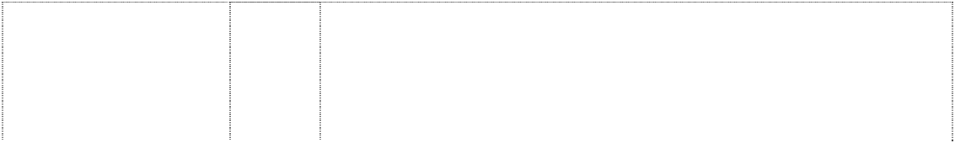

(806504)

# NEXTOURER

(806503)

**PARKWAY** (301822) **PREMACY** (761996)

**PROTÉGÉ** (630404) **TRAVELLER** (827517) **TRIBUTE** (798729)

**RENESIS** (899121) **RX-1** (870616)

# RX-10

(870623)

# RX-3

(870617)

# RX-5



(870618)

12 Automobiles, parts and fittings thereof; engines for land vehicles; suspension systems for land vehicles; shock absorbers and springs for land vehicle suspension systems; drive shafts for land vehicles; wheel bearings and shaft couplings for land vehicles; transmissions for land vehicles; brakes for land vehicles; alternating current motors for land vehicles; direct current motors for land vehicles; anti-theft alarms for land vehicles.

12 Automobiles, parts and fittings thereof; engines for land vehicles; suspension systems for land vehicles; shock absorbers and springs for land vehicle suspension systems; drive shafts for land vehicles; wheel bearings and shaft couplings for land vehicles; transmissions for land vehicles; brakes for land vehicles; alternating current motors for land vehicles; direct current motors for land vehicles; anti-theft alarms for land vehicles.

12 Motor vehicles and all other goods included in this class.

12 Automobiles, parts and fittings thereof; engines for land vehicles; suspensions, shock absorbers and springs for land vehicles; shafts, bearings and shaft couplings for land vehicles; power transmission equipment for land vehicles; brakes for land vehicles; alternating current motors and direct current motors for land vehicles; anti-theft for vehicles.

12 Motor vehicles and motor vehicle parts.

12 Motor vehicles and motor vehicle parts.

12 Automobiles, parts and fittings thereof; engines for land vehicles; suspension systems for land vehicles; shock absorbers and springs for land vehicle suspension systems; drive shafts for land vehicles; wheel bearings and shaft couplings for land vehicles; transmissions for land vehicles; brakes forland vehicles; alternating current motors for land vehicles; direct current motors for land vehicles; anti-theft alarms for land vehicles.

12 Automobiles, parts and fittings thereof; engines for automobiles.

12 Automobiles, parts and fittings thereof, but excluding tires; engines for land vehicles; suspension systems for land vehicles; shock absorbers and springs for land vehicle suspension systems; drive shafts for land vehicles; wheel bearings and shaft couplings for land vehicles; transmissions for land vehicles; brakes for land vehicles; alternating current motors for land vehicles; direct current motors for land vehicles; anti-theft alarms for land vehicles.

Automobiles, parts and fittings thereof, but excluding tires; engines for land vehicles; suspension systems for land vehicles; shock absorbers and springs for land vehicle suspension systems; drive shafts for land vehicles; wheel bearings and shaft couplings for land vehicles; transmissions for land vehicles; brakes for land vehicles; alternating current motors for land vehicles; direct current motors for land vehicles; anti-theft alarms for land vehicles.

12 Automobiles, parts and fittings thereof, but excluding tires; engines for land vehicles; suspension systems for land vehicles; shock absorbers and springs for land vehicle suspension systems; drive shafts for land vehicles; wheel bearings and shaft couplings for land vehicles; transmissions for land vehicles; brakes for land vehicles; alternating current motors for land vehicles; direct current motors for land vehicles; anti-theft alarms for land vehicles.

12 Automobiles, parts and fittings thereof, but excluding tires; engines for land vehicles; suspension systems for land vehicles; shock absorbers and springs for land vehicle suspension systems; drive shafts for land vehicles; wheel bearings and shaft couplings for land vehicles; transmissions for land vehicles; brakes for land vehicles; alternating current motors for land vehicles; direct current motors for land vehicles; anti-theft alarms for land vehicles.

# RX-6



(870619)

# RX-7

(870620)

# RX-8

(870621)

# RX-9

(870622)

# RX-EVOLV

(806501)

# ZOOM-ZOOM

(910195)

# ZOOM-ZOOM

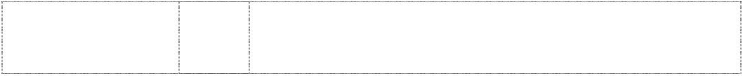

(910195)

12 Automobiles, parts and fittings thereof, but excluding tires; engines for land vehicles; suspension systems for land vehicles; shock absorbers and springs for land vehicle suspension systems; drive shafts for land vehicles; wheel bearings and shaft couplings for land vehicles; transmissions for land vehicles; brakes for land vehicles; alternating current motors for land vehicles; direct current motors for land vehicles; anti-theft alarms for land vehicles.

12 Automobiles, parts and fittings thereof, but excluding tires; engines for land vehicles; suspension systems for land vehicles; shock absorbers and springs for land vehicle suspension systems; drive shafts for land vehicles; wheel bearings and shaft couplings for land vehicles; transmissions for land vehicles; brakes for land vehicles; alternating current motors for land vehicles; direct current motors for land vehicles; anti-theft alarms for land vehicles.

Automobiles, parts and fittings thereof, but excluding tires; engines for land vehicles; suspension systems for land vehicles; shock absorbers and springs for land vehicle suspension systems; drive shafts for land vehicles; wheel bearings and shaft couplings for land vehicles; transmissions for land vehicles; brakes for land vehicles; alternating current motors for land vehicles; direct current motors for land vehicles; anti-theft alarms for land vehicles.

12 Automobiles, parts and fittings thereof, but excluding tires; engines for land vehicles; suspension systems for land vehicles; shock absorbers and springs for land vehicle suspension systems; drive shafts for land vehicles; wheel bearings and shaft couplings for land vehicles; transmissions for land vehicles; brakes for land vehicles; alternating current motors for land vehicles; direct current motors for land vehicles; anti-theft alarms for land vehicles.

12 Automobiles, parts and fittings thereof; engines for land vehicles; suspension systems for land vehicles; shock absorbers and springs for land vehicle suspension systems; drive shafts for land vehicles; wheel bearings and shaft couplings for land vehicles; transmissions for land vehicles; brakes for land vehicles; alternating current motors for land vehicles; direct current motors for land vehicles; anti-theft alarms for land vehicles.

14 Precious metals; tableware made of precious metal; nutcrackers, pepper shakers, sugar bowls, salt shakers, egg stands, napkin holders, napkin rings, tray and toothpick stands, all made of precious metal; vases and basins made of precious metal; needle boxes made of precious metal; jewel boxes made of precious metal; candle extinguishers and candle stands made of precious metal; pouches and purses made of precious metal; shoes ornaments made of precious metal; compacts made of precious metal; smokers' articles made of precious metal; personal ornaments (exclusive of cuff links); cuff links; jewels, raw ore of jewels and their imitations; timepieces; trophies, commemorative shields; key holders.

18 Raw leather, raw skin, tanned hide; fur; leather cord; bags, sacks; portable cases for cosmetic utensils; metal fittings for bags, clasps for pouches; umbrellas and parasols; sticks, canes, metal fittings for canes, shafts of canes; horse riding equipment; clothing for pets.

# ZOOM-ZOOM



(910195)

2 crescents & disc on oval

(559648)

4 chevrons stacked in disc double

(572788)

globe, meridians with left

(1050975)

21 Glass basic products (exclusive of those used for building); pans, coffee pots (exclusive of those operated by electricity or made of precious metals), iron kettles, kettles; tableware (exclusive of those made of precious metals); ice pails, whisks, fish skewers; portable coldboxes, strainers, pepper box, sugar bowls and salt- shaker (exclusive of those made of precious metals), egg cups (exclusive of those made of precious metals), napkin-holder and napkin ring (exclusive of those made of precious metals), trays (exclusive of those made of precious metals), toothpick holders (exclusive of those made of precious metals), rice chests, bamboo baskets, shakers, ladle, hand-operated coffee grinders and pepper grinders, funnels, glass bottles for preserving foods, canteens, wooden pestles, earthenware mortars, bottle openers and corkscrews, radish graters, tart scoops, pan-rest, chopsticks, chopstick boxes, dippers, sieves, chopping boards, vacuum bottles; rolling pins, gridirons, toothpicks, lemon squeezers, waffle irons (exclusive of those operated by electricity), cleaning and washing tools; household gloves; cosmetic utensils (exclusive of electric tooth brushes); electric tooth brushes; dental floss; brushes for pails, metal brushes, brushes for pipe, industrial brushes, brushes for ships; hog bristle for brushes; clothes brushes; shoe brushes, shoe horn, shoe shine cloth, handy and convenient shoe cleaner, shoe trees; glass packing containers (exclusive of glass stoppers and glass covers); ceramic packing containers; glass stoppers, glass covers; feeding troughs; poultry rings; ironing boards, feeding bowls for pets, pet brushes, flower pots, utensils for hydroponically growing plants in domestic gardening, household sieves for sifting cinders, metal boxes for dispensing paper towels, sprayer, boot jacks, flat iron stands, bird- cages, bird-baths; watering cans; simple chamber pots, coal scuttles; soap dispensers; moneyboxes (exclusive of those made of precious metals); toilet paper holder; mouse traps; fly swatters; spatula stand; sticks for stirring hot water in bathtubs, hand pails for bathrooms; candle extinguishers and candle stands (exclusive of those made of precious metals); vases (exclusive of those made of precious metals), glass or ceramic standing signboards; incense burners; basins (exclusive of those made of precious metals).

12 Motor vehicles and structural parts thereof including engines for motor land vehicles.

12 Automobiles and parts and accessories therefor in this class.

12 Automobiles, parts and fittings thereof; two-wheeled motor vehicles, namely, motorcycles and two-wheeled trolleys, non-motorized bicycles, and parts and fittings thereof; engines for automobiles; motors and engines for other land vehicles (excluding their parts); suspension systems for land vehicles; shock absorbers and springs for land vehicles; shafts and axles for land vehicles; wheel bearings and shaft couplings for land vehicles; transmissions for land vehicles; brakes for land vehicles; and anti-theft alarms for vehicles.

***McIlwraith-Davey Pty Ltd Spruson & Ferguson Lawyers Ph: (02) 9393 0300***

***Effective Date: 14 September 2007 File Reference: C07/16044 Trade Marks Class Goods***



**ADVANCE COLLECTION** (758710) **ADVANCE SERIES** (758714)

11 Apparatus and installations for water supply and sanitary purposes; tapware; bathroom accessories; sinks, basins and tubs for bathrooms, kitchens and laundries.

11 Apparatus and installations for water supply and sanitary purposes; tapware; bathroom accessories; sinks, basins and tubs for bathrooms, kitchens and laundries.

# B

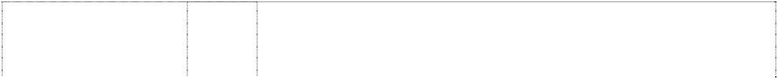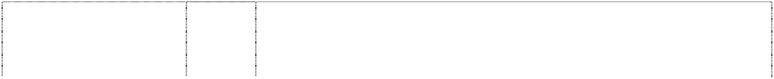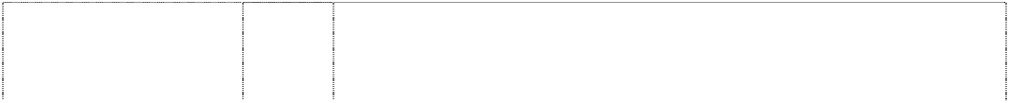

drop in rectangle,notched- side,rounded-corners forms toilet seat (569065) **BEAUTYWARE** (569053)

# CADET

(523896)

**CANDICE** (498705) **CARMEL** (498706)

# CASLAKE

(571504)

**CELLINI** (498708) **CERINA** (591641)

# CHERBOY

(593201)

# CLAIREMONT

(571506)

**CLARK** (509138) **CLARK**

triangle in chevron forms ltr A (893365)

# CLARK

triangle in chevron forms ltr A (893365)

**CLARK ADVANCE COLLECTION** (758708)

# CLARK ADVANCE SERIES

(758712) **CLARK LINEA** (755134)

# CLARK THE GREAT AUSTRALIAN SINK COMPANY

stripes,horizontal rectangle, incomplete (429954)

# CLARK THE GREAT AUSTRALIAN SINK COMPANY

(617345) **CLIPPER** (973513)

# CLOUD

cloud (498707)

11 Baths, shower trays, hand basins included in this class; all other goods included in this class.

11 Baths, shower trays, hand basins and bathroom accessories included in this class.

11 Apparatus for sanitary purposes; water closets and urinals including wall-mounted urinals, and other urinals for installation; apparatus for water supply; all other goods included in this class.

6 Sinks, tubs and cabinets all of metal; metal fittings; small items of metal hardware; and all other goods in this class.

6 Metallic sinks and tubs, cabinets of metal in this class integral therewith; metal fittings and items of metal hardware for use in connection with same.

11 Basins for water supply and sanitary purposes, including vanity basins and basins (bathroom fittings); sinks, bath tubs and laundry tubs; all being made of metal.

6 Sinks of metal and parts and fittings in this class used in relation thereto.

11 Basins for water supply and sanitary purposes, including vanity basins and basins (bathroom fittings); sinks, bath tubs and laundry tubs.

11 Basins for water supply and sanitary purposes, including vanity basins and basins (bathroom fittings); sinks, bath tubs and laundry tubs.

11 Basins for water supply and sanitary purposes, including vanity basins and basins (bathroom fittings); sinks, bath tubs and laundry tubs; all being made of metal.

6 Sinks, tubs, basins, wash tub units, all being of metal; metal plumbing fittings and hardware in this class.

11 Apparatus and installations for water supply and sanitary purposes; tapware; kitchen and bathroom accessories; sinks, basins and tubs for bathrooms, kitchens and laundries.

21 Small domestic utensils and containers; cutting boards, colanders, sieves and drainers for kitchen use; food preparation utensils.

11 Sinks, tubs, basins, wash tub units.

11 Sinks, tubs, basins, wash tub units.

11 Sinks, tubs, basins, wash tub units.

6 Sinks, tubs and cabinets in this class, all being made of metal.

11 Sinks, tubs, basins, wash tub units.

11 Apparatus and installations for sanitary purposes; tapware; kitchen and bathroom accessories; sinks, basins and tubs for bathrooms, kitchens and laundries.

6 Sinks, tubs and cabinets; metal fittings and small items of metal hardware; all being goods included in this class; and all other goods in this class.

**CUISINE** (454510) **CUISINE** (454511) **EPURE** (893366)



# EPURE

(893367)

**EPURE** (893366) **EPURE** (893367) **EUREKA** (593869) **GARBAGE GOBBLER** (463828) **RADIANT** (554158)

**RADIANT** (680996) **RADIANT** (640990) **RADIANT** (640991)

# RADIANT

(640992)

# RADIANT

(640993)

# VANTAGE

(538429)

disc,striped in square,striped both vertically

(554159)

6 Sinks in this class.

19 Sinks in this class.

11 Apparatus and installations for water supply and sanitary purposes; tapware; kitchen and bathroom accessories; sinks, basins and tubs for bathrooms, kitchens and laundries.

11 Apparatus and installations for water supply and sanitary purposes; tapware; kitchen and bathroom accessories; sinks, basins and tubs for bathrooms, kitchens and laundries.

21 Small domestic utensils and containers; cutting boards, colanders, sieves and drainers for kitchen use; food preparation utensils.

21 Small domestic utensils and containers; cutting boards, colanders, sieves and drainers for kitchen use; food preparation utensils.

11 Tubs, utility sinks and laundry wash tub units.

7 Machines for internal domestic use including waste disposals; parts and accessories therefor.

6 Metal sinks and tubs, sink accessories including metal drainer trays, drainer baskets of metal and metal coated with plastics; metal hardware included in this class; pipes of metal included in this class, and all other goods in this class but excluding lead pipes; lead sheet, shot, lead wire, strip, rod and wool; metal alloys including casting alloys; bearing metals, low melting point alloys; window lead; solders; metallic flashing.

1. Storage bins included in this class.
2. Waste disposal units; all other goods included in this class.

11 Laundry tubs, troughs and draining trays; bath tubs, babies' baths; shower bases, shower trays; hand basins, vanity basins; sinks, strainers included in this class, janitors' sinks; urinals; ablution troughs; pedestal pans; toilet pans; hot water dispensers; bar bowls; drinking fountains; sanitary towel dispensers and incinerators; electric burner disposal units; kitchen cooking equipment and commercial kitchen installations included in this class.

1. Metal benches and work surfaces; storage bins, cabinets, cupboards and modular kitchen units, the aforesaid being goods included in this class.
2. Drainers and strainers included in this class; kitchen cooking equipment and commercial kitchen cooking equipment included in this class; cutting and food preparation boards.

6 Sinks, basins and tubs of metal; parts and accessories therefor included in this class.

6 Metal sinks and tubs, sink accessories including metal drainer trays, drainer baskets of metal and metal coated with plastics; metal hardware included in this class; pipes of metal included in this class, and all other goods in this class but excluding lead pipes, lead sheet, shot, lead wire, strip, rod and wool; metal alloys including casting alloys; bearing metals, low melting point alloys; window lead; solders; metallic flashing.

***Metro-Goldwyn-Mayer Studios Inc. Metro-Goldwyn-Mayer Studios Inc.***

***Ph: (+310) 449 3000***

***Effective Date: 21 September 2007 File Reference: C07/16491 Trade Marks Class Goods***



# ARS GRATIA ARTIS

lion, head in annulus; clown, face with heart shaped mouth atop grain, ears; scroll (526091)

**FILMWAYS** (335930) **M.G.M.** (129999)

# METRO GOLDWYN MAYER ARS GRATIA ARTIS

lion,head in annulus with scrolls atop mask in wreath

(943074)

# METRO GOLDWYN MAYER ARS GRATIA ARTIS

lion,head in annulus; clown,face with heart shaped mouth atop grain,ears; scroll (492230)

# METRO GOLDWYN MAYER ARS GRATIA ARTIS

lion,head in annulus; clown,face with heart shaped mouth atop grain,ears; scroll (492229)

16 Paper and paper articles, namely, trading cards; stationery; paper- cut figures; gift wrap; party goods, namely, party hats, cake decorations and table cloths; pictures, posters, mounted and unmounted photographs; publications, namely, books, magazines, newsletters and bulletins; address books; photo and stamp albums; comic books, and newspaper comic strips; cartoons, coloring and children's books; instructional and educations picture books; game books; fictional novels and short story books; screenplays; bumper stickers; decals; staplers; household glue and paste; pencil cups; calendars; pens and pencils; pen and pencil cases; erasers, markers; crayons; chalk; greeting, note, blank and playing cards; writing, note paper, pads and envelopes; notebooks; book covers; desk sets and organisers; paper napkins, bathroom and facial tissue; tissue paper; place mats; and rubber stamps.

9 Television and theatrical motion pictures, films and all other goods included in this class containing or incorporating film.

9 Phonograph records and motion picture films.

9 Scientific, nautical, surveying, photographic, cinematographic, optical, weighing, measuring, signalling, checking (supervision), life- saving and teaching apparatus and instruments; apparatus and instruments for conducting, switching, transforming, accumulating, regulating or controlling electricity; apparatus for recording, transmission or reproduction of sound or images; magnetic data carriers, recording discs; automatic vending machines and mechanisms for coin-operated apparatus; cash registers, calculating machines, data processing equipment and computers; fire- extinguishing apparatus; motion picture films; pre-recorded video cassettes; pre-recorded audio and video tapes and pre-recorded videodiscs and digital video discs; sound recordings and other audio- visual materials; computer software programs and CD-ROMs; computer games and computer game cartridges, cassettes, programs, tapes and CD-ROMs; video and computer game cassettes and cartridges adapted for use with television receivers; video output machines; computer hardware and software for multimedia and interactive computer games.

14 Precious metals and their alloys and goods in precious metal or coated therewith, not included in other classes; jewellery, precious stones; horological and chronometric instruments.

16 Paper, cardboard and goods made from these these materials, not included in other classes; printed matter; bookbinding material; photographs; stationery; adhesives for stationery or household purposes; artists' materials; paint brushes; typewriters and office requisites (except furniture); instructional and teaching material (except apparatus); plastic materials for packaging (not included in other classes); playing cards; printers' type; printing blocks.

# METRO GOLDWYN MAYER ARS GRATIA ARTIS



lion,head in annulus; clown,face with heart shaped mouth atop grain,ears; scroll (492228)

# METRO GOLDWYN MAYER ARS GRATIA ARTIS

lion,head in annulus; clown,face with heart shaped mouth atop grain,ears; scroll (492227)

# METRO GOLDWYN MAYER ARS GRATIA ARTIS

lion,head in annulus; clown,face with heart shaped mouth atop grain,ears; scroll (492226)

# METRO GOLDWYN MAYER ARS GRATIA ARTIS

lion,head in annulus; clown,face with heart shaped mouth atop grain,ears; scroll (492225)

# METRO GOLDWYN MAYER HOME ENTERTAINMENT AUSTRALIA

lion,head in annulus with scrolls atop mask in wreath

(974917)

# METRO-GOLDWYN- MAYER

(318517)

18 Leather and imitations of leather, and goods made of these materials and not included in other classes; animal skins, hides, trunks and travelling bags, umbrellas, parasols and walking sticks; whips harness and saddlery.

1. Furniture, mirrors, picture frames; goods (not included in other classes) of wood, cork, reed, cane, wicker, horn, bone, ivory, whalebone, shell, amber, mother-of-pearl, meerschaum and sustitutes for all these materials, or of plastics.
2. Household or kitchen utensils and containers (not of precious metal or coated therewith); combs and sponges; brushes (except paint brushes); brush-making materials; articles for cleaning purposes; steelwool; unworked or semi-worked glass (except glass used in building); glassware, porcelain and earthenware not included in other classes.

25 Clothing, footwear, headgear.

9 Scientific, nautical, surveying, photographic, cinematographic, optical, weighing, measuring, signalling, checking (supervision), life- saving and teaching apparatus and instruments; apparatus and instruments for conducting, switching, transforming, accumlating, regulating or controlling electricity; apparatus for recording, transmission or reproduction of sound or images; motion picture films; pre-recorded video cassettes; pre-recorded audio and video tapes and pre-recorded videodiscs and DVDs; sound recordings and other audio-visual materials; computer software programs and CD- ROMs; computer games and computer game cartridges, cassettes, programs, tapes and CD-ROMs; video and computer game cassettes and cartridges adapted for use with television receivers; computer hardware and software for multimedia and interactive computer games; magnetic data carriers, recording discs; automatic vending machines and mechanisms for coin-operated apparatus; cash registers, calculating machines, data processing equipment and computers; fire-extinguishing apparatus.

9 Printed cinematographic films, cinematographic scenery, transparencies in Cl. 9.

# MGM



(943073)

# MGM MEANS GREAT MOVIES

(837514)

# MGM/UA HOME VIDEO ARS GRATIA ARTIS

lion, head in annulus scrolls

(441687) **ORION** (325321)

# PINK PANTHER

(392226)

# PINK PANTHER

(392227)

# PINK PANTHER

pink panther standing, hands on hips (644844)

9 Scientific, nautical, surveying, photographic, cinematographic, optical, weighing, measuring, signalling, checking (supervision), life- saving and teaching apparatus and instruments; apparatus and instruments for conducting, switching, transforming, accumulating, regulating or controlling electricity; apparatus for recording, transmission or reproduction of sound or images; magnetic data carriers, recording discs; automatic vending machines and mechanisms for coin-operated apparatus; cash registers, calculating machines, data processing equipment and computers; fire- extinguishing apparatus; motion picture films; pre-recorded video cassettes; pre-recorded audio and video tapes and pre-recorded videodiscs and digital video discs; sound recordings and other audio- visual materials; computer software programs and CD-ROMs; computer games and computer game cartridges, cassettes, programs, tapes and CD-ROMs; video and computer game cassettes and cartridges adapted for use with television receivers; video output machines; computer hardware and software for multimedia and interactive computer games.

9 Motion picture films; pre-recorded video cassettes; pre-recorded audio and video tapes and pre-recorded videodiscs and DVDs; sound recordings and other audio-visual materials; computer software programs and CD-ROMs; computer games and computer game cartridges, cassettes, programs tapes and CD-ROMs; video and computer game cassettes and cartridges adapted for use with television receivers; video output machines; computer hardware and software for multimedia and interactive computer games.

9 Sound and video cassettes, discs, films and other media for reproduction of sound and images in this Class.

9 Motion picture and television films; sound and video records, tapes, cassettes and cartridges, photograph records.

16 All goods included in this class.

28 All goods included in this class.

9 Video and audio tapes, cassettes, discs and records, apparatus for recording, producing, reproducing and projecting sound and visual images, motion pictures, photographic slides, sunglasses, anti-glare glasses, protective and safety glasses and lenses, frames and cases therefor, radios, televisions, transceivers, telephones, thermometers, compasses, rules, measuring tapes, telescopes, microscopes, periscopes, binoculars, magnifying glasses, calculators; computers, computer software, software used as computer and video screen savers; computer peripheral apparatus, alarms, signalling bells, signal and warning lights and devices, reflecting discs and strips for wear, warning triangle and other vehicle breakdown signs, life jackets, protective helmets and clothing, water diving apparatus, snorkel tubes, swim masks, swim goggles, cameras, film slide projectors, batteries, flashlights and lanterns, electronic games, all included in class 9.

# PINK PANTHER



pink panther standing, hands on hips (831712)

# PINK PANTHER

pink panther standing, hands on hips (831712)

# PINK PANTHER

pink panther standing, hands on hips (831712)

# POLTERGEIST

(710072)

16 Paper and paper articles, namely, trading cards; stationery; paper cut-out figures; gift wrap; party goods; namely paper party hats, paper cake decorations and paper table cloths; pictures; posters; mounted and unmounted photographs; publications, namely, books, magazines, newsletters and bulletins, comic books, and newspaper comic strips; address books; photo and stamp albums; cartoons; colouring and children's books; instructional and educational picture books; game books; fictional novels and short story books; screenplays; banners; bumper stickers; decals; bulletin boards;

staplers; household glue and paste; pencil cups; calendars; pens and pencils; pen and pencil cases; erasers; markers; crayons; chalk; arts and crafts paint kits; greeting, note and blank cards; playing cards; writing and note paper; note pads and envelopes; notebooks; book covers; desk sets and organizers; paper napkins; bathroom and facial tissue; tissue paper; place mats; and rubber stamps.

25 Clothing for men, women and children, namely, T-shirts; tanktops; vests; shirts; sweat suits; sweatshirts; sweat pants; exercise wear; jogging suits; sweaters; skirts; dresses; blouses; pants; suits; jeans; shorts; playsuits; jumpsuits; bodysuits; swimwear; underwear; briefs; boxer shorts; undershirts; sleepwear; nightgowns; robes and pyjamas; loungewear; nightshirts; shoes; boots; galoshes; sneakers; slippers; casual footwear; sandals; headwear; caps; hats; visors; headbands; sweatbands; coats; jackets; gloves; neckwear; scarves; neckties; bandannas; belts; suspenders; socks; rainwear; masquerade and Halloween costumes; and aprons.

28 Toys, games, playthings and sporting goods, namely, action figure toys and accessories therefor; action skill games; board games; card games; electronic game equipment containing memory devices, namely, hand-held units with a watch function, hand-held units for playing electronic and video games; video game machines; sports balls; playground balls; foam balls; toy basketball hoop sets; basketball backboards; skateboards; play action figures; figurines and accessories therefor, namely, toy figures with magnetic features and talking toys: hobbycraft kits for making dolls and figurines; toy banks; bath tub toys; children's multiple activity toys; water squirting toys; wind-up toys; jigsaw and manipulative puzzles; mechanical toys; battery-operated toys; dolls and puppets and accessories therefor; kites; paper and plastic party favours in the nature of small toys and noisemakers; stuffed and plush toys; latex squeeze toys; musical toys; Christmas tree decorations; toy guns; toy musical instruments; toy cars, trucks and other toy vehicles; inflatable bath, swimming and ride-on toys.

9 Scientific, nautical, surveying, electric, photographic, cinematographic, optical, weighing, measuring, signalling, checking (supervision), life-saving and teaching apparatus and instruments; apparatus for recording, transmission or reproduction of sound or images; magnetic data carriers, recording discs; automatic vending machines and mechanisms for coin operated apparatus; cash registers, calculating machines and data processing equipment and computers; fire-extinguishing apparatus; pre-recorded video tapes and laser discs featuring entertainment; phonograph musical sound recordings; prerecorded audio tapes featuring music and entertainment; eyewear, namely eyeglasses, sunglasses, and cases therefor; blank audio and video tapes, cassettes and discs, audio, video and camera equipment, namely, cameras; tripods; exposed film; stereos; CD players and recorders; tape and cassette players and recorders; television and monitors; video recorders and players; radios, speakers; headphones; answering machines; computer game cartridges, programs and tapes; and computer programs recorded on discs, cartridges and tapes for use in the education and entertainment fields, in International class 9.

# POLTERGEIST



(710072)

# POLTERGEIST

(710072)

# POLTERGEIST

(710072)

# ROBOCOP

(458103)

16 Paper, cardboard and goods made from these materials, not included in other classes; printed matter; bookbinding material; photographs; stationery; adhesives for stationery or household purposes; artists' materials; paint brushes; typewriters and office requisites (except furniture); instructional and teaching material (except apparatus); plastic materials for packaging (not included in other classes); playing cards; printers' type; printing blocks; paper and paper articles, namely, trading cards, stationery; paper cut-out figures; gift wrap; party goods, namely, party hats, cake decorations and table cloths; pictures, posters, mounted and unmounted photographs; publications, namely, books, magazines, newsletter, and bulletins; address books; photo and stamp albums; banners; comic books, and newspaper comic strips; cartoons; coloring and children's books; bulletin boards, calendars, pens and pencils; pen and pencil cases; erasers, markers; crayons; chalk; arts and crafts paint kits; greeting, note, blank and playing cards; writing and note paper and pads; notebooks, book covers; educational picture books; decalcomanias; desk sets and organizers; paper napkins; bathroom and facial tissue; tissue paper; place mats; and rubber stamps, in International class 16.

25 Clothing, footwear, headgear including clothing for men, women, and children, namely, exercise wear; warm up suits; jogging suits; sweat suits; sweat pants and sweatshirts; bodysuits, leotards; leg warmers; wet suits; ski suits; ski pants, ski bibs; ski jackets; swimwear; bathing suits; beach and bathing cover ups; suits; tuxedos; slacks; trousers; pants; jeans; shorts; sweat shorts; gym shorts; tops; jackets; coats; sport coats; shirts; sport shirts, T-shirts, knit shirts, polo shirts; pullovers; sweaters; vests; tank tops; blazers; jumpsuits; playsuits; overcoats; parkas; wind resistant jackets; leather jackets; footwear; shoes; boots; slippers; athletic footwear; basketball shoes; casual footwear; sandals; headwear; hats, caps, visors, hoods, berets, headbands; sweatbands; wristbands; ear muffs; neckwear; neckties; neckerchieves; scarves; bandannas; sleepwear; robes; pyjamas; nightshirts; rainwear; gloves; mittens; galoshes; loungewear; underwear; briefs; underpants; boxer shorts; undershirts; suspenders; hosiery; socks; belts; masquerade and halloween costumes; and aprons, in International class 25.

28 Games and playthings; gymnastic and sporting articles not included in other classes; decorations for Christmas trees including toys, sporting goods, namely, basketballs; basketball boards; skateboards; figures, figurines and accessories therefor; sports goggles; action figure toys and accessories therefor; sports balls; playground balls; foam balls; toy basketball hoop sets; hobby craft doll and figurine kits; toy banks; bath tub toys; children's multiple activity toys; water squirting toys; toy vehicles; wind-up toys; action skill games; board games; card games; electronic game equipment containing memory devices, namely, hand-held units with a watch function; hand-held units for playing electronic and video games; video output machines; coin and non-coin operated game tables; pinball machines and pinball type games; jigsaw and manipulative puzzles; mechanical toys; battery-operated toys; dolls and puppets and accessories therefor; kites; paper and plastic party favours in the nature of small toys and noisemakers; stuffed and plush toys; latex squeeze toys; musical toys; inflatable bath, swimming, and ride-on toys, in International class 28.

28 Toys and games, including computer games in class 28.

# SPECIES



(680681)

# SPECIES

(680682)

# SPECIES

(680683)

# STARGATE

(628612)

# STARGATE

(628613)

# THE OUTER LIMITS

(669570)

9 Eyewear, namely, eyeglasses, sunglasses and cases therefor; prerecorded audio and video tapes, discs and cassettes featuring information, education, music, and entertainment; phonograph musical sound recordings; blank audio and video tapes, cassettes and discs; audio, video and camera equipment, namely, cameras; tripods; exposed film; stereos; CD players and recorders; tape and cassette players and recorders; televisions and monitors; video recorders and players; radios; speakers; headphones; batteries and battery packs; tuners; receivers; amplifiers; equalizers; telephones; answering machines; and computer programs recorded on discs, cartridges and tapes for use in the sports, education and entertainment fields.

16 Paper and paper articles, namely, trading cards; stationary; paper cut-out figures; gift wrap; party goods, namely, party hats, cake decorations and table cloths; pictures, posters, mounted and unmounted photographs; publications, namely, books, magazines, newsletters and bulletins; address books; photo and stamp albums; banners; comic books, and newspaper comic strips; cartoons; colouring and children's books; bulletin boards; calenders; pens and pencils; pen and pencil cases; erasers; markers; crayons; chalk; arts and craft paint kits; greeting note, blank and playing cards; writing and note paper and pads; notebooks; book covers; educational picture books; decals; desk sets and organizers; paper napkins; bathroom and facial tissue; tissue paper; place mats; and rubber stamps.

25 Clothing for men, women, and children, namely, exercise wear; warm up suits; jogging suits; sweat suits; sweat pants and sweatshirts; bodysuits; leotards; leg warmers; wet suits; ski suits; ski pants, ski bibs; ski jackets; swimwear; bathing suits; beach and bathing coverups; suits; tuxedos; slacks; trousers; pants; jeans; shorts; sweat shorts; gym shorts; tops; jackets; coats; sports coats; shirts; sport shirts, T-shirts, knit shirts; polo shirts; pullovers; sweaters; vests; tank tops, blazers, jumpsuits; playsuits; overcoats; parkas; wind resistant jackets; leather jackets; footwear; shoes; boots; slippers; athletic footwear; basketball shoes; casual footwear; sandals; headwear; hats, caps, visors, hoods, berets, headbands; sweat bands; wristbands; ear muffs; neckwear; neckties, neckerchieves; scarves; bandannas; sleepwear; robes; pajamas; nightshirts; rainwear; gloves; mittens; galoshes; loungewear; underwear; briefs; underpants; boxer shorts; undershirts; suspenders; hosiery; socks; belts; masquerade and halloween costumes; and aprons.

25 T-shirts, sweatshirts, baseball caps, hats, night shirts, night gowns, pyjamas, underwear, boys underwear, collarless shirts, knit shirts, knit shorts, knit pants, and costumes and all other goods in this class.

28 Hand held, wrist and tabletop LCD games, toys, namely, toy vehicles, action figures and accessories, dolls, role playing accessories for children, play environments, plush and stuffed puppets, ride on toys, jigsaw puzzles, manipulative puzzles, three dimensional puzzles, tracing plates, removable tattoos, vinyl model kits, plastic model kits, toy weapon and target sets, sound target sets, shotgun target sets, board games, bagatelle games, bop bags, shooting arcade games, squirt guns, projectile guns, light and sound guns, card games, banks, pinball machines, mechanical and electronic action toys, battery powered and electrically powered road race sets, construction sets, party favours in the nature of small toys, balloons, pinatas, and roller skates and all other goods in this class.

9 Audio and/or visual goods in this class inclusive of motion picture films, prerecorded video tapes, video discs, laser discs, CD Roms, audio tapes, audio discs and compact discs; computer hardware and software; games and game equipment in this class; electrical apparatus and instruments in this class; magnets; photographic goods in this class.

# THE OUTER LIMITS

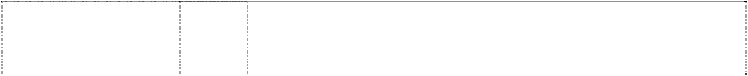

(669571)

# THE OUTER LIMITS

(669572)

# THE OUTER LIMITS

(669573)

# UNITED ARTISTS

(272319)

# UNITED ARTISTS

star, multi-point (660961)

# UNITED ARTISTS

star, multi-point (660963)

# UNITED ARTISTS UA

innominate device stripe, hooked, oblique (371109)

# UNITED ARTISTS UA

innominate device stripe, hooked, oblique (371110)

disc head lion's silhouette (332030)

lion (78579)

lion, head in circle, double; film-strip forms scroll

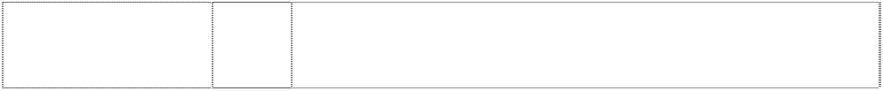(405905)

lion, head in circle, double; film-strip forms scrolls

(405906)

14 Paper, paper products, cardboard articles; stationery inclusive of pens, pencils, erasers, binders; portfolios, albums; photographs, posters; calendars, diaries and organisers; greeting cards, trading cards, collectible discs made of paper or cardboard, bulletin and/or magnetic boards, stamps and stamp pads in this class, stickers, decalcomanias; programs, souvenir books, guides, books and other printed matter.

25 Clothing, footwear, headgear inclusive of T-shirts, tank tops, blouses, sweat shirts, sweat pants, sweat shorts, sweat suits, shorts, pants, sleep wear, sweat bands, scarves, hats, socks, bathing suits, jogging suits, sun visors, sweaters, ties, undergarments, jackets, coats, snowsuits, snow pants, vest, wrist bands, belts, athletic shoes and slippers.

28 Games, toys and playthings inclusive of action figures and accessories therefor, action skill games, action toys, cases for action figures, cases for play accessories, amusement park rides in this class, stuffed toys, board games, balls, balloons, toy banks, jigsaw puzzles, card games, face masks, costume masks, costumes, flying discs, computer game cassettes, computer game cartridges, computer game equipment in this class containing memory devices, namely, discs, computer game programs in this class, video game machines in this class, pinball-type games in this class, ride-on toys, toy vehicles and toy boxes; recreational, sporting and amusement goods in this class; decorations in this class.

9 Phonograph records, sound and video recordings on tape, wire, film and all other types of recording media; sound and video recording and reproducing instruments, apparatus and their parts.

9 Motion picture films, prerecorded video tapes, video discs, laser discs, CD Roms, computer software, audio tapes, audio discs and compact discs.

16 Paper, paper products, stationery, binders, portfolios, photographs, calendars, greeting cards, trading cards, collectable discs made of paper, stickers, decalcomanias, writing implements, erasers, posters, programs, guides and books.

9 All goods included in this class.

16 All goods included in this class.

9 Cinematograhic films,films, phonograph records, and pre-recorded magnetic tapes and cartridges.

9 Films for use in connection with synchronized apparatus for simultaneously reproducing co-ordinated light and sound effects; films with sound, words, and/or music recorded thereon; films without sound recorded thereon adapted for synchronization with separate sound, words and/or music films and records; films and records with sound, words, and/or music recorded thereon, adapted for synchronization with separate picture films; motion pictures, all the foregoing goods being goods included in this class.

9 Motion picture films, videotapes, videocassettes, videodiscs; records, tapes and cassettes for reproducing sound; other media for recording and reproducing sound and visual images.

16 Printed matter, books, magazines, photographs and posters.

***Pars Ram Brothers (Australia) Pty Ltd Sharma Lawyers Ph: (07) 3379 3699***

***Effective Date: 26 September 2007 File Reference: C07/16481***



***Trade Marks***

***Class***

***Goods***

**MAAZA**

(977254)

32

Fruit and vegetable - juices (beverages).

***Rip Curl Pty Ltd Griffith Hack***

***Ph: (03) 9243 8340***

***Effective Date: 28 August 2007 File Reference: C07/12805 Trade Marks Class Goods***

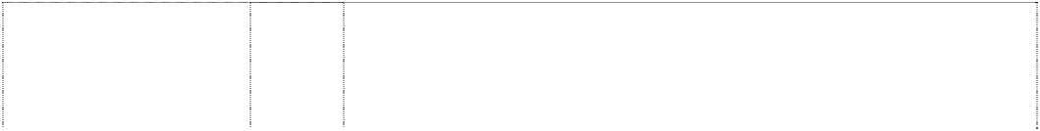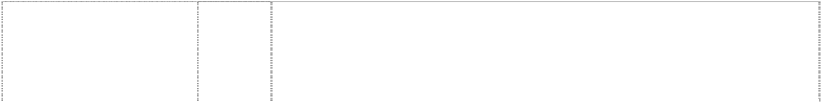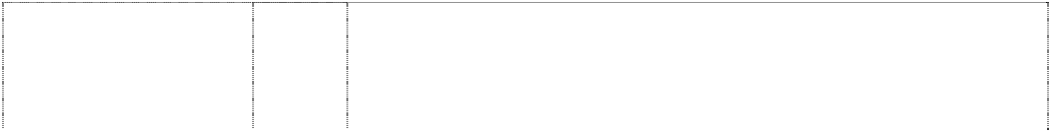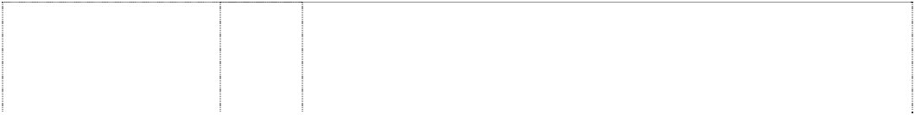

# CODE STL

(954199)

**PEAK** (501075) **PEAK** (501074)

**PEAK** (501073) **RC**

wave stylised is ltrs RC in diamond triple concave-sides (744663)

# RC

wave stylized is ltrs RC in diamond triple concave-sides (547715)

# RC

wave stylized is ltrs RC in diamond triple concave-sides (547728)

# RC

wave stylized is ltrs RC in diamond triple concave-sides (550362)

# RC RIP CURL

ltrs form wave,styl. (1059480)

# RC RIP CURL

ltrs form wave,styl. (1059480)

# RC RIP CURL

ltrs form wave,styl. (1059480)

# RC RIP CURL

ltrs form wave,styl. (1059480)

25 Articles of clothing, including casual wear, beachwear and sportswear, and also including protective clothing for swimming, surfing and diving; wetsuits, wetsuit vests, wetsuit trousers and shorts; protective clothing for snow skiing; footwear and headgear.

9 Wet suits in this class.

18 Carry bags, being hand luggage and including duffle bags; school bags of all kinds; lightweight backpacks suitable for beach and surf use.

25 Wetsuits included in this class, T-shirts, sweat shirts, sweat pants and casual clothes.

14 Goods in precious metal or coated therewith, not included in other classes; jewellery, horological and chronometric instruments.

18 All goods in this class; including bags.

25 All goods in this class; including clothing and wetsuits.

28 All goods in this class including surfboards, sailboards and surf sailing boards, and accessories therefor, including harnesses, leashes, leg ropes, fins, skegs and sails; water skis, knee skis and belly boards.

9 Wetsuits; optical goods in this class, eyewear, sunglasses, spectacles, goggles for sports, parts, fittings and accessories in this class for sunglasses, spectacles and goggles for sports including frames and cases, protective helmets for use in sports including surfing, skateboarding, snowboarding and skiing.

14 Goods in precious metals or coated therewith, not included in other classes; jewellery, horological and chronometric instruments; watches and their parts and accessories.

18 Bags, handbags, clutch bags, shoulder bags, wallets, purses, brief cases, folio cases, attache cases, backpacks, key cases, key rings, credit card cases, bill folds, coin purses, organisers, telephone cases and holders, bum bags, pocket cases, passport wallets, travel bags, haversacks, luggage, umbrellas, trunks, bag tags.

25 Clothing including casual wear, beachwear, sportswear and protective clothing for swimming, surfing, diving, snow skiing, snow boarding and sporting activities; footwear; headgear; wetsuits, wetsuit vests, wetsuit trousers and shorts; money belts

# RC RIP CURL

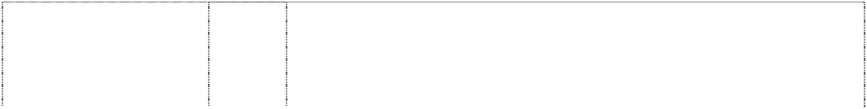

ltrs form wave,styl. (1059480)

# RIP CURL

(454541)

# RIP CURL

(454543)

# RIP CURL

(254858)

**RIP CURL** (477193) **RIP CURL** (454544) **RIP CURL** (877644)

# RIP CURL

(426767)

# RIP CURL

(316155)

**RIP CURL** (901580) **RIP CURL** (426768)

28 Sporting and gymnastic apparatus and equipment; surfboards, boogie boards, bodyboards, kneeboards, wakeboards, sailboards, surf skis, snowboards, snow skis, water-skis, skateboards, kiteboards, ski equipment and snowboarding equipment; waterski equipment; toys, games and playthings; bags for surfboards, boogie boards, bodyboards, kneeboards, wakeboards, sailboards, surf skis, snowboards, snow skis, water-skis, skateboards and kiteboards; sporting accessories including fins, leg ropes and security leashes for sporting apparatus, sporting apparatus being ropes especially adapted and fitted as tow-in ropes and skiing ropes, ski bindings, surfboard deck grips, swim fins including swim fins for bodyboarding, sailboard sails, kiteboard sails, wax for skis and surfboards; covers and protective bags for sporting apparatus including bags for surfboards, bodyboards, kneeboards, wakeboards, sailboards, surf skis, snowboards, snow skis, water-skis, skateboards and kiteboards.

3 All goods in this class, including soaps, perfumery, essential oils, cosmetics, hair lotions, toothpastes and powders, suntanning and sunscreen preparations, all being goods in class 3.

9 All goods in this class, including nautical, electric, photographic, cinematographic, optical, including sunglasses, life-saving and teaching, apparatus and instruments; apparatus for recording, transmission or reproduction of sound or images; recording discs; automatic vending machines and mechanisms for coin-operated apparatus.

9 Protective clothing for swimming, surfing and diving including wet suits, wet suit vests, wet suit trousers or shorts, swimming flippers, snorkels and masks (not being toys), and other diving equipment.

12 All goods in this class.

14 All goods in this class, including horological and chronometric instruments.

16 Stationery, including school stationery; office supplies in this class; school student equipment; writing instruments, including pens, fountain pens, ball point pens and pencils; writing paper; erasers; pencil boxes and cases; pencil sharpeners; diaries and calendars; notebooks; binders; folders; photo frames and photo albums.

18 All goods included in this class, bags; including travel bags, carry bags, back-packs, wallets, surfboard and sailboard bags, cases and bags for snow skis and water skis, sail bags, harnesses and leashes.

25 Articles of clothing, including casual wear, beach wear and sports, and including protective clothing for snow skiing, all being goods included in Class 25.

25 Clothing, footwear, headgear.

28 All goods in this class, including surfboards and accessories therefor, including harnesses, leashes, leg ropes, fins and skegs; water skis, knee skis and belly boards.

***Sara Lee Australia Baker & McKenzie***

***Ph: (02) 9225 0200***

***Effective Date: 29 August 2007 File Reference: C07/13937 Trade Marks Class Goods***



**2MOTION** (1150781) **2MOTION** (1150781) **3VOLUTION** (1080639)

# AIRBAL CAR FRESH

(354542)

5 Air freshening preparations, air deodorising preparations; deodorants not for personal use; preparations to neutralise bad odors.

11 Air deodorising apparatus.

5 Air freshening preparations, air deodorising preparations; deodorants not for personal use; preparations to neutralise bad odours.

5 Pesticides; insect and moth repellants; insecticidal collars, bands and medallions; disinfectants; germicidal and sanitary substances; cold de-congestants; air fresheners and deodorants.

# AMBI PUR

ltr P indents disc forms crescent; words in square, round corners (923576)

# AMBI PUR

ltr P indents disc forms crescent; words in square, round corners (923576)

# AMBI PUR

ltr P indents disc forms crescent; words in square, round corners (923576)

# AMBI PUR CAR

car is ltr a; curled stripe is ltr p indents disc forms crescent (1046392)

# AMBI PUR CAR

car is ltr a; curled stripe is ltr p indents disc forms crescent (1046392)

**AMBI-PUR** (844195) **AMBI-PUR** (553318)

3 Bleaching preparations and other substances for laundry use; cleaning, polishing, scouring, degreasing and abrasive preparations; soaps.

5 Air freshening preparations, air deodorising preparations; deodorants not for personal use; preparations to neutralise bad odours.

11 Air deodorising apparatus.

5 Air freshening preparations, air deodorising preparations; deodorants not for personal use; preparations to neutralise bad and undesirable odours.

11 Air deodorising apparatus.

3 Cleaning, polishing, scouring, degreasing and abrasive preparations; soaps.

5 Air fresheners, and deodorants other than for personal use.

# AMBI-PUR



(844195)

# AMBI-PUR FLUSH

(773054)

# AMBI-PUR FLUSH

(773054)

**AMBI-PUR FRAGRANT MIST** (726588)

# ALL FRESH DU LUNDI MOIST CLEAN-UP SQUARES

leaves (279412) **AQUA FLUSH** (257834)

# AQUA FLUSH

(341421)

**AQUATICS** (570757) **AQUA-VELVA** (108616) **BABYDAS** (206941) **BABYLON** (973870) **BABYLON** (973870) **BADEDAS** (173569) **BADEDAS** (179178)

11 Air deodorising apparatus.

3 Cleaning preparations.

5 Air fresheners and deodorants other than for personal use; preparations to neutralize bad odours.

5 Airfreshening preparations and deodorants other than for personal use; preparations to neutralise bad odours.

3 All goods in this class including soaps, perfumery, essential oils, cosmetics, hair lotions and pre-moistened cleaning towelettes.

11 Chemical dispensers for use in toilet or urinal flush tank for dispensing cleaners, disinfectants or deodorants to toilet bowls or urinals.

3 Chemical compositions for use in toilet or urinal flush tanks basically for cleaning toilet bowls or urinals with some disinfecting and deodorizing properties.

3 Bleaching preparations and other substances for laundry use; cleaning preparations, toilet cleaners and toilet water colourants.

3 After-shaving preparations.

3 Cosmetic bath additives, bath oils, bath extracts, bath tablets, bath- water, bath soap and bath salts.

5 Air freshening preparations, air deodorising preparations; deodorants not for personal use; preparations to neutralise bad odours.

21 Perfume burners.

3 Cosmetic bath additives; bath oils; bath extracts; bath tablets; bath- water; bath soap; bath salts.

5 Medicinal bath additives, bath oils, bath extracts, bath extracts, bath tablets, bath-water, bath soap, bath salts.

# BAMA

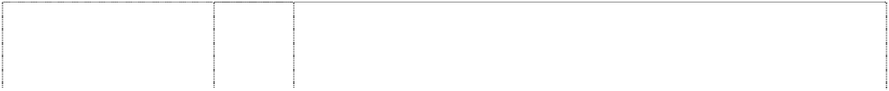

(264756)

# BATHROOM PLUS

oval in dome (314436)

# BATHROOM PLUS

oval in dome (314437) **BEHOLD** (202351) **BLACK KIWI**

bird, kiwi in tin cylinder (279423)

# BLOCK & WHITE

(718076)

**BON AMI** (242203) **BON AMI** (49408) **BON AMI** (188451)

# BON AMI DUST-N- WAX

(188448) **BON AMI SUPERFINE**

bird, chick & egg, broken

(234848) **BRYLCREEM** (62142) **BRYLCREEM**

lion passant (290794) **BRYLCREEM**

canister lion stylised (295727) **BRYLCREEM DRY STYLE**

(273255) **BRYLFIX** (80907) **BRYLFOAM** (73248) **BRYLSET** (80908) **BRYLSHAVE** (126933) **BRYLTONE** (80909) **CATCH** (604181) **CAVALIER**

man cavalier with sword

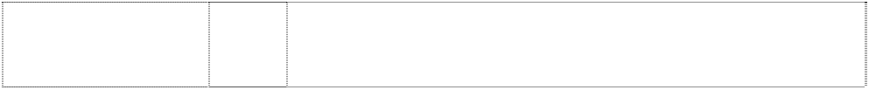(197847)

# CAVALIER

man, cavalier man, in period costume (198291)

25 Boots, slippers, stockings, boot liners including socks with inner layer of special fleece and covering for protection against cold and damp in heavy boots, insoles for boots and shoes.

3 Bleaching preparations and other substances for laundry use; cleaning, polishing, scouring and abrasive preparations; degreasing preparations included in this class and stain removing preparations; detergents included in this class; soaps.

5 Fungicides, disinfectants, air fresheners and deodorants.

3 Soaps; waxes; and cleaning, polishing, scouring and abrasive preparations.

3 Boot polishes and all other polishing and cleaning preparations and materials included in this class.

3 Soaps; perfumery; essential oils; hair lotions; cosmetics; toiletries; facial, skin and body lotions; facial washes; facial and body skin whitener lotions.

1 Detergents.

3 Common soap, detergents, and starch, blue and other preparations for laundry purposes.

5 Sanitary substances, including toilet bowl cleaners; disinfectant and antiseptic preparations.

3 Liquids, sprays, and aerosols, including those for wax coating or polishing surfaces of furniture, woodwork, upholstery and other articles.

3 Bleaching preparations and other substances for laundry use, cleaning, polishing, scouring and abrasive preparations, soap.

3 Toilet creams (not medicated).

3 All goods in this class including cosmetics, essential oils, hair lotions and creams, perfumery and soaps.

3 All goods in this class including anti-perspirants, perfumes, non- medicated toilet preparations, cosmetic preparations, dentifrices, shampoos and soaps.

3 Preparations for the hair and all other goods in this class.

3 Perfumery, including toilet articles, preparations for the teeth and hair, and perfumed soap.

3 Shampoo preparations for the hair.

3 Perfumery, including toilet articles, preparations for the teeth and hair, and perfumed soap.

3 Shaving cream, toilet cream, shaving soap and toilet preparations for use in connection with the removal of surplus hair.

3 Perfumery, including toilet articles, preparations for the teeth and hair, and perfumed soap.

5 Preparations for destroying vermin and weeds; insecticides; fungicides; herbicides.

3 Bleaching preparations and other substitutes for laundry use, cleaning; polishing, scouring and abrasive preparations, soaps.

26 Boot and shoe laces.

# COCONUT RUSH

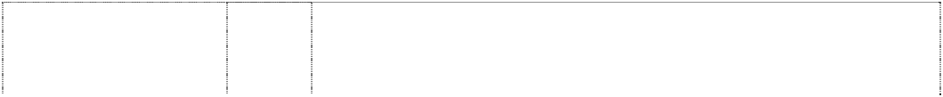

(942980)

**COTTON SKY** (959374) **DESERT SUN** (934670) **DIRECT** (449658)

# DON’T WASTE A WASH

(949075)

# DRANEX

(134227)

# DRIP DRY KING

(150315) **DU LUNDI** (163438) **DU LUNDI** (163441)

# DU LUNDI BODY MIST

(158335) **ENDUST** (198076)

**ENVI** (325394) **ESKINOL** (718074) **FISSAN** (96912) **FISSAN** (96913) **FIZZ-CLEEN** (951004)

**FIZZ-CLEEN** (951004) **FRESH FORCE** (946405)

# FRESH FORCE

(921917)

**FRESH FORCE** (946405) **FRESH'INS** (1120659) **GLOWASH** (125150) **GOLDEN SIL** (161891)

3 Soaps, liquid soaps, shower and bath gel, shower and bath foam; perfumery, fragrances; cosmetics; essential oils; hair lotions and hair care preparations, hair shampoo; dentifrices; toilet waters, eau de cologne; non-medicated salts, oils and other additives for use in bath and in showers; creams, lotions, milks, oils, powders and ointments for the care and the cleansing of the skin, body, hands and feet; deodorants and anti-perspirants for use on the person; talcum powder; after-and pre-shaving preparations, shaving cream, shaving mousse, shaving gel and shaving foam; cosmetic suntanning preparations, cosmetic sun-protecting preparations, cosmetic preparations against sun-burn.

5 Air freshening preparations, air deodorising preparations; deodorants not for personal use; preparations to neutralise bad odours.

5 Air freshening preparations, air deodorising preparations; deodorants not for personal use; preparations to neutralise bad odours.

3 Bleaching preparations and other substances for laundry use; cleaning, polishing, scouring and abrasive preparations; soaps; perfumery, essential oils, cosmetics, hair lotions; dentifrices.

3 Bleaching preparations and other substances for laundry use; detergents; fabric softeners for laundry use; cleaning, polishing, scouring, degreasing and abrasive preparations; stain removing preparations; soaps.

3 Drain cleaning preparations.

3 Preparations for laundry use, including bleaching and washing preparations.

3 Toilet waters.

5 Deodorants.

5 Deodorant preparations.

3 Bleaching preparations and other substances for laundry use, cleaning polishing, scouring and abrasive preparations, soaps, perfumery, essential oils, cosmetics, hair lotions, dentifrices.

5 Pharmaceutical, veterinary and sanitary substances and preparations.

3 Soaps; perfumery; essential oils; hair lotions; cosmetics; toiletries; facial, skin and body lotions; facial washes.

5 Chemical substances prepared for use in medicine and pharmacy.

3 Perfumery, including toilet articles, preparations for the teeth and hair, and perfumed soap.

3 Bleaching preparations; fabric softeners for laundry use; cleaning, polishing, scouring, degreasing and abrasive preparations; stain removing preparations.

5 Sanitary substances including toilet bowl cleaners; disinfectants and antiseptic preparations.

3 Bleaching preparations and other substances for laundry use; cleaning, polishing, scouring and abrasive preparations; soaps; cleaning gel and cleaning liquid for shoes

5 Combination antifungal spray for feet and deodorant spray for footwear; shoe deodorisers; airfreshening preparations, airdeodorising preparations and deodorants other than for personal use.

22 Mesh bags to be used in conjunction with washing shoes in washing machines.

25 Insoles for footwear; non-slippery fittings, heel grippers and heel cushions for footwear; socks and stockings.

3 Detergents.

3 All goods included in this Class.

**GOLDEN SIL** (162226) **HANDSPA** (870408)

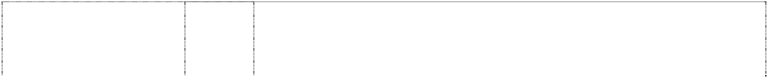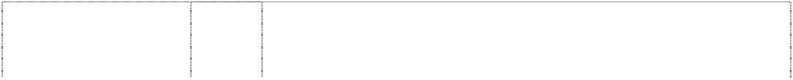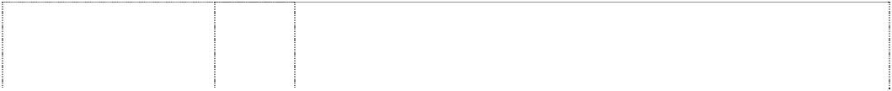

**HARMONY** (133142) **HASN’T**

# SCRATCHED YET

bird, chick & egg shell (58464)

# HIDE 'N' CLEAN

(1023267)

# HIDE 'N' CLEAN

(1023267) **ICE BLUE** (159798) **INSPIRA** (995910)

**INSTANTMATIC** (1134340) **JANOLA** (759357) **JANOLA PLUS** (757005) **JUMBUCK** (336058)

**KIWAX** (195907) **KIWI** (18138)

**KIWI** (48153) **KIWI**

bird, kiwi (204789) **KIWI**

bird, kiwi (204788) **KIWI**

bird, kiwi (359026) **KIWI**

bird, kiwi (39190)

# KIWI

bird, kiwi (204790) **KIWI**

bird, kiwi (164820)

5 All goods included in this Class.

3 Soaps, liquid soaps, shower and bath gel, shower and bath foam; perfumery, fragrances; cosmetics; essential oils; hair lotions and hair care preparations, hair shampoo; dentifrices; toilet waters, eau de cologne; non-medicated salts, oils and other additives for use in bath and in showers; creams, lotions, milks, oils, powders and ointments for the care and the cleansing of the skin, body, hands and feet; deodorants and anti-perspirants for use on the person; talcum powder; after- and pre-shaving preparations, shaving cream, shaving mousse, shaving gel and shaving foam; cosmetic suntanning preparations, cosmetic sun-protecting preparations, cosmetic preparations against sun-burn.

3 Furniture polishing and furniture cleaning preparations included in this class.

3 Soaps for polishing and cleaning purposes and detergents.

3 Bleaching preparations and other substances for laundry use; detergents; fabric softeners for laundry use; cleaning, polishing, scouring, degreasing and abrasive preparation; stain removing preparations; soaps.

5 Sanitary substances including toilet bowl cleaners; disinfectants and antiseptic preparations.

3 After shaving preparations and cosmetic preparations.

5 Air freshening preparations, air deodorizing preparations; deodorants not for personal use; preparations to neutralize bad odours.

5 Air freshening preparations, air deodorising preparations; deodorants not for personal use; preparations to neutralise bad odours.

3 Cleaning preparations; bleaching preparations; preparations for laundry use.

3 Cleaning preparations; bleaching preparations; preparations for laundry use.

3 Liquid detergents, washing compounds and bleaching and other preparations for laundering woollen articles, all being goods included in this class.

3 Cleaning and polishing preparations all containing wax.

3 Boot cleaning and polishing outfits, and polishing pads, and boot polish and all other polishing included in this class, but excluding furniture cream and plate polish.

21 Brushes.

1. Dressings for leather (not being oil), included in this class.
2. Stains for leather; inks for leather.
3. Bleaching preparations and other substances for laundry use; cleaning, polishing, and scouring abrasive preparations.
4. Boot polishes and all other polishing and cleaning preparations and materials included in this class, dubbin; bleaching preparations and other substances for laundry use; scouring and abrasive preparations.
5. Dressings for leather (being oil), included in this class.
6. Sanitary substances, disinfectants, deodorizers, deodorants, preparations for killing weeds and destroying vermin.

# KIWI

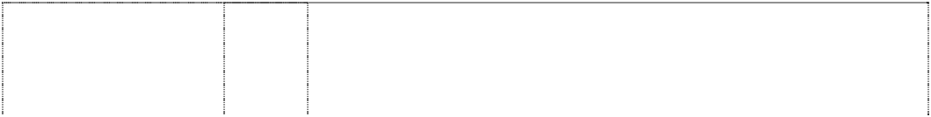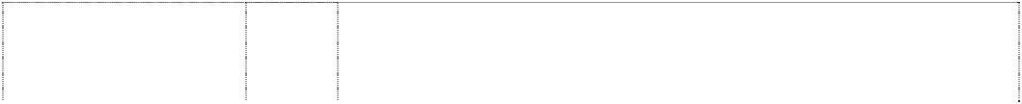

kiwi bird (882379) **KIWI**

bird, kiwi (113723) **KIWI**

bird, kiwi (167071) **KIWI**

bird, kiwi, stylised (359025)

# KIWI

bird, kiwi ribbon (9219)

# KIWI

bird, kiwi circle in disc, double endless-belt rectangle, curved (240232)

# KIWI

bird, kiwi on nameplate double

(571753)

# KIWI

bird, kiwi on nameplate double

(571754)

# KIWI

bird, kiwi on nameplate double

(571755)

# KIWI ALOE VERA

woman,incompl. wears high-heel seated on chair in disc; kiwi,silh. in rect.,curved,convex- side; 3 shoe & boot, each in disc; aloe vera in rectangle

(1092005)

# KIWI ALOE VERA

woman,incompl. wears high-heel seated on chair in disc; kiwi,silh. in rect.,curved,convex- side; 3 shoe & boot, each in disc; aloe vera in rectangle

(1092005)

# KIWI EXPRESS CREAM NO BUFF SHINE AUTOBRILLANTE BRILLE SANS FROTTER

bird,kiwi in rect.,curved,convex- sideatop curl in bottle (1027933)

1. Footwear; non-slipping devices for shoes; heel plates, heel grippers, heel cushions, foot socks and insoles; socks and stockings.
2. Boot and shoe laces of nylon.

26 Laces for footwear and other articles.

5 Sanitary substances; disinfectants; preparations for killing weeds and destroying vermin; air fresheners; deodorants.

3 Boot polishes and all other polishes included in class 3 but excluding furniture cream and plate polish.

3 Boot polishes and all other polishing and cleaning preparations.

1. Waterproofing chemicals for leather or textile; adhesives for repairing shoes, rainwear and other leather, rubber, nylon, plastics, canvas and vinyl surfaces; shoe stretching compositions.
2. Stains, dyes and inks for footwear and leather goods.
3. Polishes, creams and pigmented dressings all for footwear and leather goods and being goods in this class; leather preservatives; dry chemical cleaning bar and other cleaning preparations for leather, suede, vinyl, plastics and goods made of these materials; scuff remover from leather and vinyl goods; cleaning and polishing preparations for floors, furniture and bathroom equipment; detergents for laundry use; soaps.

3 Cleaning, polishing, scouring and abrasive preparations; polishes, creams and pigmented dressings all for footwear and leather goods; leather preservatives; scuff remover from leather and vinyl goods; tissues impregnated with polishing preparations.

21 Clothes-pegs, shoehorns, shoe trees, polishing cloths and sponges; shoe brushes.

3 Cleaning, polishing, scouring and abrasive preparations; polishes, creams and pigmented dressings all for footwear and leather goods; leather preservatives; scuff remover from leather and vinyl goods; soaps.

# KIWI EXPRESS CREAM NO BUFF SHINE AUTOBRILLANTE BRILLE SANS FROTTER

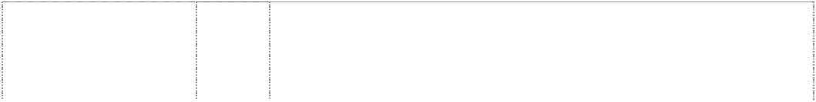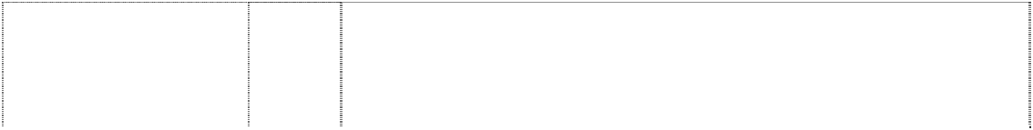

bird,kiwi in rect.,curved,convex- side atop curl in bottle (1027934) **KIWISPORT**

(94011) **KIWI_KWIK-BRITE** (118443)

# LECTRIC SHAVE

(82872)

**MAGIC KING** (127805) **MARTEEKO** (202209) **MARVEER**

panel triangle (73329) **MARVEER** (322603) **MATEY** (260094) **MELTONIAN** (70203)

**MONSAV** (188404) **NATREEN** (301220) **NATRENA** (198327) **NEUTREX** (640084) **ODOR GUARD** (579223) **ODYSSEY** (973871)

**ODYSSEY** (973871) **OXY-LIFT** (974423)

# P

curled stripe is ltr P indents disc forms crescent

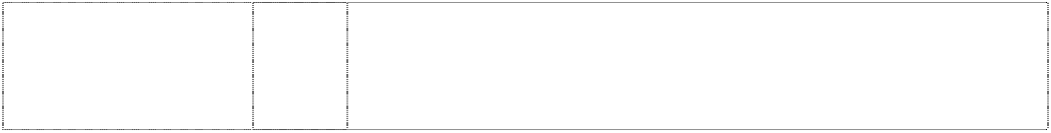(923577)

# P

curled stripe is ltr P indents disc forms crescent

(923577)

3 Cleaning, polishing, scouring and abrasive preparations; polishes, creams and pigmented dressings all for footwear and leather goods; leather preservatives; scuff remover from leather and vinyl goods; soaps.

3 Leather dressings; cleaning preparations and material other than those used for laundry purposes.

3 Floor polish and other polishing preparations.

3 Preparations for treating the skin and conditioning the beard before shaving, such preparations having incidental properties as a skin lotion after shaving.

3 Bleaching and other preparations and materials for laundry purposes and detergents.

3 Cleaning and polishing preparations of all kinds.

3 Cleaning and polishing fluid for furniture, woodwork, and floors.

3 Cleaning and polishing fluid for furniture, woodwork and floors.

3 Children’s bubble bath preparations.

3 Preparations included in Class 3 for cleaning, dressing, preserving, and polishing boots, shoes, leather and other goods (but not including furniture cream and plate polish).

3 Cleaning and cleansing preparations, soaps, perfumery, cosmetics, hair lotions, shampoos, personal deodorants and dentifrices.

5 Dietetic sweetening agents.

5 Diatetic sweetening agents containing sodium cyclamate.

5 Air fresheners and deodorants other than for personal use; preparations to neutralize bad odours.

25 Insoles.

5 Air freshening preparations, air deodorising preparations; deodorants not for personal use; preparations to neutralise bad odours, none for personal use.

21 Perfume burners.

3 Bleaching preparations and other substances for laundry use; detergents; fabric softeners for laundry use; cleaning, polishing, scouring, degreasing and abrasive preparations; stain removing preparations; soaps; all of the aforesaid goods excluding skincare preparations for the treatment of acne and problem skin.

3 Bleaching preparations and other substances for laundry use; cleaning, polishing, scouring, degreasing and abrasive preparations; soaps.

5 Air freshening preparations, air deodorising preparations; deodorants not for personal use; preparations to neutralise bad odours.

# P

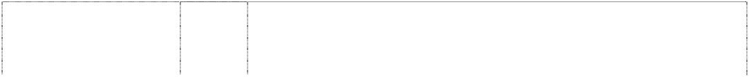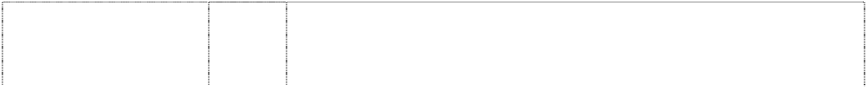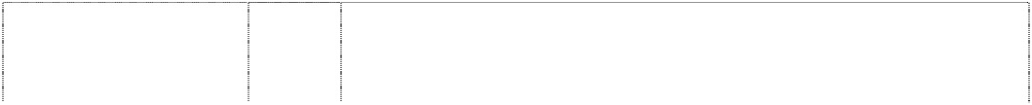

curled stripe is ltr P indents disc forms crescent

(923577) **PARADE GLOSS** (310625) **PARRY’S** (421192)

# PINEX

man skier snow scene (191580)

# PITRALON

(109010)

# PITRALON

(109012)

# POWER BURST

(969955)

**POWER BURST** (969955) **POWER CLEAN** (578220)

**PUR INSPIRATION** (1022815) **PURIF'AIR** (1080638) **PURESSE** (1097202) **QUENTY**

(301331) **QUENTY** (370636)

# QUENTY-BEAUTY

(487832)

**QUENTY-SPORTY** (487833) **QUICKIES**

(73886)

# RADOX

stripe, curved atop word all in leaf, styl.; ltr, extended (937699)

**RADOX** (75686) **RADOX** (211382)

# RADOX

(75685)

11 Air deodorising apparatus.

3 Shoe polish.

3 Household cleaning and deodorising products namely deodorant blocks, room air fresheners, carpet and room deodorisers, toilet bowl deodorisers and cleansers, cistern colourants and cleansers.

5 A pine disinfectant.

5 Chemical substances used for sanitary purposes, including disinfectants in this class; pharmaceutical products, being medicated antiseptic, toilet waters, medicated powder, and medicated creams for the cleansing and treatment of the skin.

3 Cosmetic products and preparations being in the nature of powders and creams for cleansing and treatment of the skin, skin waters, shaving waters, face waters, perfumed soaps, volatile oils and hair waters.

3 Bleaching preparations and other substances for laundry use; detergents; fabric softeners for laundry use; cleaning, polishing, scouring, degreasing and abrasive preparations; stain removing preparations; soaps.

5 Sanitary substances including toilet bowl cleaners; disinfectants and antiseptic preparations.

3 Toilet bowl cleaners including in-cistern toilet bowl cleaners and manual toilet bowl cleaners.

5 Air freshening preparations, air deodorizing preparations; deodorants not for personal use; preparations to neutralize bad odours.

5 Air freshening preparations, air deodorising preparations; deodorants not for personal use; preparations to neutralise bad odours.

5 Air freshening preparations, air deodorising preparations; deodorants not for personal use; preparations to neutralise bad odours.

3 Cosmetics.

3 Cosmetics, namely skin care preparations.

3 Cosmetic skin care preparations and all other cosmetic preparations in this class.

3 Cosmetic skin care preparations and all other cosmetic preparations in this class.

3 Perfumery, including toilet articles, preparations for the teeth and hair, and perfumed soap.

3 Soaps, liquid soaps, shower and bath gel, shower and bath foam; perfumery, fragrances; cosmetics; essential oils; hair lotions and hair care preparations, hair shampoo; dentifrices; toilet waters, eau de cologne; non-medicated salts, oils and other additives for use in bath and in showers; creams, lotions, milks, oils, powders and ointments for the care and the cleansing of the skin, body, hands and feet; deodorants and anti-perspirants for use on the person; talcum powder; after- and pre-shaving preparations, shaving cream, shaving mousse, shaving gel and shaving foam; cosmetic suntanning preparations, cosmetic sun-protecting preparations, cosmetic preparations against sun-burn.

3 Bath salts (not medicated) including salts for foot baths.

3 Bleaching preparations and other substances for laundry use; cleaning, polishing, scouring and abrasive preparations, soaps, perfumery, essential oils, cosmetics including medicated and non- medicated talcum powders.

5 Medicated bath salts including salts for foot baths.

**RADOX** (229531) **RECHARGE** (915954)

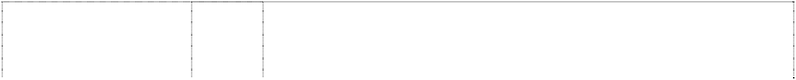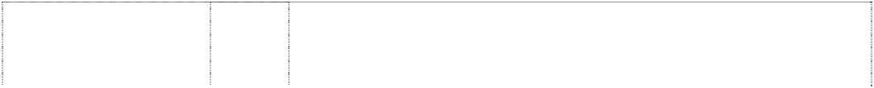

**RESIGUARD** (207750) **SANEX** (819922)

# SANEX

(525859)

# SANEX

(824673)

# SANEX

(832801)

# SANEX

(833111)

# SANEX

(819922)

# SANEX

(824673)

# SCUFF ZAPPER

(579224)

**SENSATOL** (273990) **SENSATOL** (273991)

5 Pharmaceutical and medicinal preparations.

3 Soaps, liquid soaps, shower and bath gel, shower and bath foam; perfumery, fragrances; cosmetics; essential oils; hair lotions and hair care preparations, hair shampoo; dentifrices; toilet waters, eau de cologne; non-medicated salts, oils and other additives for use in bath and in showers; creams, lotions, milks, oils, powders and ointments for the care and the cleansing of the skin, body, hands and feet; deodorants and anti-perspirants for use on the person; talcum powder; after-and pre-shaving preparations, shaving cream, shaving mousse, shaving gel and shaving foam; cosmetic suntanning preparations, cosmetic sun-protecting preparations, cosmetic preparations against sun-burn.

5 All goods included in Class 5.

1 Chemicals used in industry, science and agriculture; ingredients for cleaning and disinfecting preparations; all being for the use in surface cleaning and disinfecting preparations not for household or personal use.

3 Perfumery, essential oils, cosmetics, hair lotions; toilet soap, soapy gels, bath and shower foam, shampoos, deodorants for personal use.

3 Soaps, liquid soaps, shower and bath gel, shower and bath foam; perfumery, fragrances; cosmetics; essential oils; hair lotions and hair care preparations, hair shampoo; dentifrices; toilet waters, eau de cologne; non-medicated salts, oils and other additives for use in bath and in showers; creams, lotions, milks, oils, powders and ointments for the care and the cleansing of the skin, body, hands and feet; deodorants and anti-perspirants for use on the person; talcum powder; after and pre-shaving preparations, shaving cream, shaving mousse, shaving gel and shaving foam; cosmetic suntanning preparations, cosmetic sun-protecting preparations, cosmetic preparations against sun-burn; cleaning preparations for personal use, industrial hand cleaning preparations.

3 Cleaning and disinfecting preparations in this class for personal and household use; soaps, detergents and gels in this class for personal and household use; soaps, detergents and gels for cleaning and disinfecting hands.

3 Soaps, liquid soaps, shower and bath gel, shower and bath foam; perfumery, fragrances; cosmetics; essential oils; hair lotions and hair care preparations; hair shampoo; dentifrices; toilet waters, eau de cologne; non-medicated salts, oils and other additives for use in bath and in showers; creams, lotions, milks, oils, powders and ointments for the care and the cleansing of the skin, body, hands and feet; deodorants and anti-perspirants for use on the person; talcum powder; after- and pre-shaving preparations, shaving cream, shaving mousse, shaving gel and shaving foam; cosmetic suntanning preparations, cosmetic sun-protecting preparations, cosmetic preparations against sun-burn.

5 Cleaning, disinfecting and sanitary preparations for medical purposes; sanitizers and fungicides in this class; all being for cleaning and disinfecting surfaces not being goods for household or personal use.

5 Pharmaceutical creams, lotions, milks, oils, powders and ointments for the care and the cleansing of the skin, body, hands and feet; medicated cleaning preparations for personal hygiene; sanitary preparations for personal hygiene; medicated industrial hand cleaning preparations.

3 Polishes, creams and pigmented dressings all for footwear and leather goods; leather preservatives; scuff removing preparations for leather and vinyl goods; all the foregoing goods being included in class 3.

3 All goods in this class including cosmetics and beauty preparations and dental products in particular toothpaste.

5 An adontotherapeutic, against Hyperesthesia of the Dental Neck.

# SHOE SAVER

(152487) **SIL** (81269) **SIL** (161890)

# SIL-EASE-E-CARE

(276350)

# SIL-EASE-E-CARE

(276351) **SIL PINE** (161894)

**SMILING FEET** (1120658) **SNO-WHITE**

bath drapes shirt wavy lines

(117141) **SNO-WHITE** (187357)

# SOFT KING

(293642)

# SOLE SECRETS

(1037632)

# SPORT EXPRESS

(974051)

**SPRING** (137347) **SPRING** (161892) **SPRING** (161893) **SPRING FRESH** (627173)

**SWAT** (71939) **TANA** (613536)

**TANA** (613537) **TANA** (613538)

# TANA

(613539)

# TANA

(613540)

1 Chemical compositions used to impart water repellency.

3 A cleanser.

3 All goods included in this Class.

3 All goods included in this class.

5 All goods included in this class.

5 Pharmaceutical, veterinary and sanitary substances; disinfectants; preparations for killing weeds and destroying vermin, all being goods made from or containing pine oils.

25 Insoles for footwear; non-slippery fittings, heel grippers and heel cushions for footwear; socks and stockings.

3 Mildew removers; laundry bleaches; washing preparations; and antiseptics and deodorants for laundry purposes, including antiseptic preparations usable for washing, deodorizing, bleaching and mildew removing purposes.

3 Mildew removers; laundry bleaches; washing preparations and washing and laundry preparations incorporating deodorant, deodorising and antiseptic properties.

3 Bleaching preparations, detergents in this class, and other preparations for laundry use.

25 Insoles for footwear; non-slippery fittings, heel grippers and heel cushions for footwear; socks and stockings.

3 Bleaching preparations and other substances for laundry use; cleaning, polishing, scouring, degreasing and abrasive preparations; soaps.

3 Detergents.

3 Detergents and cleaning preparations.

5 All goods.

3 Toilet cleaning preparations and toilet bowl cleaners included in this class.

5 Insect destroying sprays and powders.

1. Waterproofing chemicals for leather or textile; adhesives for repairing shoes, rainwear and other leather, rubber, nylon, plastics, canvas and vinyl surfaces; shoe stretching compositions.
2. Stains, dyes and inks for footwear and leather goods.
3. Cleaning, polishing, scouring and abrasive preparations; creams, polishes and wax for shoes, boots, leather and articles made of leather; leather preservatives being polishes; scuff remover for leather and vinyl goods.

5 Combination antifungal spray for feet and deodorant spray for footwear; airfreshening preparations and deodorants other than for personal use; disinfectants; insecticides.

21 Shoehorns, shoe trees, polish impregnated shine sponges; shoe brushes.

**TANA** (613541) **TANA** (613542) **TOILET KING** (185690) **TUXAN** (136776)

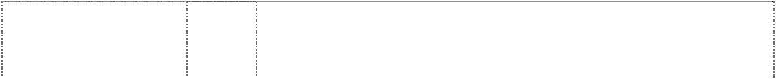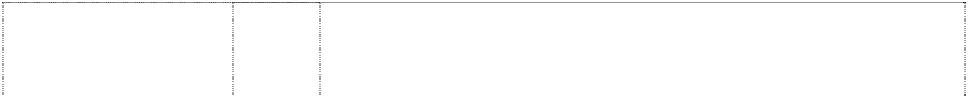

# TY-D-BOL

(608140)

1. Non-slipping devices for shoes; heel plates, heel grippers, heel cushions, foot socks and insoles; socks and stockings.
2. Shoe laces.

3 Cleansing, scouring and abrasive preparations.

3 Polishes and dressings for leather goods.

3 Toilet bowl cleaners.

# UNWIND

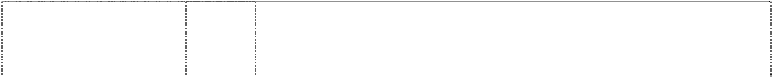

(918456)

# VANILLA SPLASH

(942981)

**WHITE KING** (99233) **WHITE KING WIPEOUT** (674935)

# WHITE KING WIPE- OUT

(1037339)

# WHITE KING WIPE- OUT

(1037339)

# WHITE MAGIC

birds, gulls panels (110201)

# WHITE MAGIC

drop waves (273226)

# WILLIAMS F1 TEAM

driver in racing car,styl. in disc (1044373) **WOOL KING** (129201)

# ZWITSAL

(397137)

# ZWITSAL

(397137)

# ZWITSAL

(397137)

bird, kiwi, stylised (359029)

bird, kiwi, stylised (359028)

bird, kiwi (27884)

bird, kiwi, stylised (359027)

3 Soaps, liquid soaps, shower and bath gel, shower and bath foam; perfumery, fragrances; cosmetics; essential oils; hair lotions and hair care preparations, hair shampoo; dentifrices; toilet waters, eau de cologne; non- medicated salts, oils and other additives for use in bath and in showers; creams, lotions, milks, oils, powders and ointments for the care and the cleansing of the skin, body, hands and feet; deodorants and anti-perspirants for use on the person; talcum powder; after- and pre-shaving preparations, shaving cream, shaving mousse, shaving gel and shaving foam; cosmetic suntanning preparations, cosmetic sun-protecting preparations, cosmetic preparations against sun-burn.

3 Soaps, liquid soaps, shower and bath gel, shower and bath foam; perfumery, fragrances; cosmetics; essential oils; hair lotions and hair care preparations, hair shampoo; toilet waters, eau de cologne; non- medicated salts, oils and other additives for use in bath and in showers; creams, lotions, milks, oils, powders and ointments for the care and the cleansing of the skin, body, hands and feet; deodorants and anti-perspirant for use on the person; talcum powder; after-and pre-shaving preparations, shaving cream, shaving mousse, shaving gel and shaving foam; cosmetic suntanning preparations, cosmetic sun-protecting preparations, cosmetic preparations against sun-burn; all the aforementioned goods being for personal use and excluding body paints including latex based body paints.

3 Bleaching and other preparations for laundry purposes.

3 Bleaching preparations and other substances for laundry use; detergents; fabric softeners for laundry use; cleaning, polishing, scouring and abrasive preparations; soaps.

3 Bleaching preparations and other substances for laundry use; detergents; fabric softeners for laundry use; cleaning, polishing, scouring, degreasing and abrasive preparations; stain removing preparations; soaps.

5 Sanitary substances including toilet bowl cleaners; disinfectants and antiseptic preparations.

3 A bleaching preparation.

3 Bleaching preparations.

5 Air freshening preparations, air deodorizing preparations, deodorants not for personal use; preparations to neutralise bad odours.

3 Liquid detergents, washing compounds and bleaching and other preparations for laundering woollen articles, all being goods included in this class.

3 Bleaching preparations and other substances for laundry use; cleaning, polishing, scouring and abrasive preparations; soaps; perfumery, essential oils, cosmetics, hair lotions.

5 Pharmaceutical and sanitary preparations; dietetic substances; plasters, material for dressings; disinfectants, and all other goods included in this class.

16 Paper tissues; and all other goods included in this class.

1. Stains and inks for footwear and leather goods.
2. Bleaching preparations and other substances for laundry use; cleaning, polishing, scouring and abrasive preparations.

3 Boot polishes and all other polishes included in this class. Furniture cream and plate polish are specifically excluded.

5 Sanitary substances; disinfectants; preparations for killing weeds and destroying vermin; air fresheners; deodorants being goods included in class 5.

disc face tiger tiger’s head

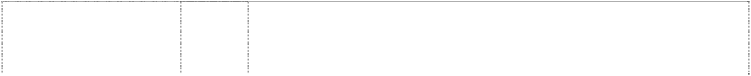

(342988)

disc face tiger’s face (342987)

disc face tiger tiger’s face

(342986)

stripe,zigzag, 3 points like drill bit

(651653)

man in evening dress, & monocle

(70204)

1. Paints, varnishes, lacquers; preservatives against rusts and against deterioration of wood; rust protective coatings; colouring matters.
2. Cleaning, polishing, scouring and abrasive preparations, including waxes and detergents.

21 Cleaning materials (not being cleaning preparations or soaps) and polishing materials (not being polishes) including polishing cloths and polishing leathers; washing cloths; and polishing and cleaning appliances, all being goods in this class, e.g. sponges.

5 Sanitary preparations; disinfectants; preparations for repelling or destroying vermin and insects; insecticides; fungicides; herbicides.

3 Preparations for cleaning, dressing, preserving, and polishing boots, shoes, leather and other goods (but not including furniture cream and plate polish).



***Sebel Furniture Limited Spruson & Ferguson Lawyers Ph: (02) 9393 0300***

***Effective Date: 24 September 2007 File Reference: C07/16483***



***Trade Marks***

***Class***

***Goods***

|  |  |  |
| --- | --- | --- |
| **AUDITTO** | 20 | All goods included in this class. |
| (299235) |  |  |
| **BEZIQUE**  (217396) | 20 | Furniture. |
| **CABARET** | 20 | Furniture; and all other goods in this class. |
| (381171) |  |  |
| **CELEBRITY**  (484898) | 20 | Furniture. |
| **CHARTWELL** | 20 | Furniture. |
| (231382) |  |  |
| **CLASSMATE** | 20 | All goods included in this class. |
| (299604) |  |  |
| **CONRAD**  (432252) | 20 | Furniture. |
| **CORONET** | 20 | Chairs for use in restaurants, hotel banquet rooms, dining facilities |
| (756666) |  | and conference rooms. |
| **COURTLEIGH** | 20 | Furniture. |
| (366068) |  |  |
| **ENCORE**  (462796) | 20 | Furniture (excluding beds). |
| **ERGOS** | 20 | Furniture. |
| (1032451) |  |  |
| **ERGO-S ; ERGOs** | 20 | Furniture. |
| (1032198) |  |  |
| **FOCUS**  (217395) | 20 | Furniture. |
| **FOLD-A-BYE** | 20 | Furniture. |
| (90802) |  |  |
| **HOBNOB**  (231383) | 20 | Furniture. |
| **IMPREZA** | 20 | Furniture, including tables and chairs. |
| (625120) |  |  |
| **INTEGRA** | 20 | Furniture. |
| (239416) |  |  |
| **LE CAFE**  (333230) | 20 | Furniture. |
| **LIDO** | 20 | Furniture; and all other goods in this class. |
| (510622) |  |  |
| **MAITRE D** | 20 | Furniture. |
| (239415) |  |  |

**METRO** (510623) **MONARCH** (153091) **OMEGA** (179709) **OPTIMA** (239414) **OPUS** (196798) **PERFORMA** (437146) **PODIUM** (677835) **POSTURA** (642509) **PROGRAM** (439604) **PROTEUS** (264684) **REGENT** (381170) **ROMANCE** (233192) **RONDO** (515884)

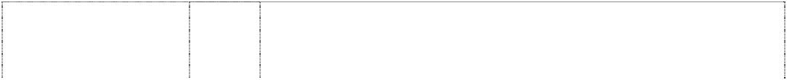

**SEA BREEZE SEABREEZE** (520088) **SEBEL** (151851)

**SEBEL DESIGN** (718601) **SEBELOUNGER** (366067) **SEBEL'S GREAT AUSTRALIAN SUNLOUNGE** (381934)

**SLIM'N COMFY** (406746) **SLIMSTAK** (524607) **SOLITAIRE** (264685) **STOW MATE** (310464)

**TEMPO** (196800) **VENUE** (231384) **VISTA** (190184) **WORKEZI** (506440)

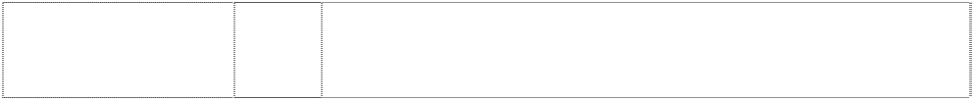*shape trade mark:* armchair, 6 perspective views (1054080)

*shape trade mark:* armchair, 6 perspective views (1054083)

20 Chairs.

20 Furniture.

20 Furniture.

20 Furniture.

20 Furniture.

20 Furniture.

20 Chairs including stadium seating.

20 Furniture, including tables and chairs.

20 Furniture.

20 Furniture.

20 Furniture.

20 Furniture.

20 Furniture, including chairs.

20 Furniture, including chairs and sun lounges.

20 Furniture, but not including cabinets or stands especially adapted for supporting radio-receiving apparatus, television-receiving apparatus, gramophones or radio-gramophones.

20 Furniture, including tables, chairs, seating, office furniture and outdoor furniture.

20 Lounge furniture.

20 Furniture; and all other goods in this class.

20 Chairs and seating.

20 Furniture and all other goods in this class.

20 Furniture.

20 Storage boxes, and storage units for supporting storage boxes. All of the foregoing being in the nature of furniture; and all other goods included in this class.

20 Furniture.

20 Furniture.

20 Furniture.

20 Furniture.

20 Armchairs moulded from plastics material.

20 Sidechairs moulded from plastics material.

*shape trade mark:* chair, 5 perspective views



(1054076)

man,disc-head seated (473117)

20 Sidechairs moulded from plastics materials.

20 Furniture.

***Seiko Kabushiki Kaisha (t/as Seiko Corporation) Griffith Hack***

***Ph: (03) 9243 8300***

***Effective Date: 5 August 2007 File Reference: C07/12342 Trade Marks Class Goods***



# ARCTURA

(722843)

**AUTO RELAY** (777551) **COUTURA** (999042)

# EMBLEM

(738199)

# KINETIC

(605021)

**LORUS** (370234) **PREMIER** (938399)

**PULSAR** (280597) **SEIKO** (161860) **SEIKO** (334966)

# SEIKO 5

number in shield, double

(440020) **SEIKO RIVOLI** (430001) **SEIKO SPRING DRIVE** (1033032) **SENFINA** (723610)

**SENFINA** (723610) **SENFINA** (668776) **SPORTURA** (729276)

# S-YARD

(946164)

# S-YARD

(946164)

14 Watches, clocks, stop watches, horological and chronometric apparatus and instruments; cases, parts, watch boxes and fittings for all the aforesaid goods.

14 Watches.

14 Watches, clocks, stop watches, horological and chronometric apparatus and instruments; cases and parts for all the aforesaid goods.

14 Watches, clocks, stop watches, horological and chronometric apparatus and instruments; cases, parts, watch boxes and fittings for all the aforesaid goods.

14 Watches, clocks, stop watches, horological and chronometric apparatus and instruments; cases, parts, watch boxes and fittings for all the aforesaid goods; all other goods in this class.

14 Watches, clocks and other horological instruments and parts thereof in this class, all being goods included in this class.

14 Watches, clocks, stopwatches; horological and chronometric apparatus and instruments; cases, parts, fittings for all the aforesaid goods; watch boxes, all included in international class 14.

14 Horological and chronometric instruments, including watches.

14 Watches, clocks and other horological instruments, and parts thereof.

14 Watches, clocks and other horological instruments and parts thereof in this class.

14 All goods in this class.

14 Clocks, watches and horological instruments and parts thereof within this class.

14 Watches, clocks, stopwatches; horological and chronometric apparatus and instruments; cases, parts, and fittings for all the aforesaid goods; watch boxes.

18 Bags, sports bags, shoe bags and cases, game bags, garment bags for travel, key cases, umbrellas, leather shoulder straps, suitcases, wallets.

28 Golf bags of leather and imitations of leather.

28 Golf clubs; golf balls; golf bags; parts and fittings for all the aforesaid goods.

14 Watches, clocks, stop watches, horological and chronometric apparatus and instruments; cases, parts, watch boxes and fittings for all the aforesaid goods.

18 Articles made of leather or imitation leather; sports bags, golf shoe cases made of leather; umbrellas; all included in International class 18.

28 Golfing equipment in this class, including golf bags, golf caddie bags, golf gloves, golf balls and golf clubs.



**S-YARD** (639949) **VIVACE** (606369)

28

14

**VELATURA**

(1132688)

14

Golf clubs; parts and accessories thereof; and all other goods in this class.

Watches, clocks, stopwatches, horological and chronometric apparatus and instruments; cases, parts, watch boxes for all the aforesaid goods.

Watches and parts thereof.

***Sony Computer Entertainment Australia Pty Ltd Sony Computer Entertainment Australia Pty Ltd***

***Ph: (02) 9324 9500***

***Effective Date: 13 August 2007 File Reference: C07/13165 Trade Marks Class Goods***



# DUAL SHOCK

(759822)

# eyeToy

(904336)

# EYE TOY

ltr Y forms body of person,styl.; eyes in ltr O form head

(945819)

# PLATINUM

(779753)

# PLATINUM

(779753)

9 Memory unit or hand held unit for playing electronic games, CD-ROM recorded virtual reality games software, ROM cartridge recorded virtual reality games software; CD-ROM encoded computer game software, ROM cartridge coded computer game software, memory cartridges for personal computer games, joysticks for personal computer games, video game apparatus for personal use, video game apparatus for commercial use, analogue controllers for video games, video game interactive remote control units, interactive remote control unit for personal computers, joysticks for video games and memory cards for video games.

9 Computer hardware; computer and video game apparatus; computer game consoles; computer and video games; computer and video game programmes; computer software; computer peripherals; audio and video tapes; cassettes; magnetic data media; compact discs; video discs; DVD's; audio and video recordings; cinematographic films; electronic apparatus and instruments; optical apparatus and instruments; cameras; films; audio and video apparatus; sunglasses; spectacles; sunglasses and spectacles frames; parts and accessories for all of the aforesaid goods.

9 Computer hardware; computer and video game apparatus; computer game consoles; computer and video games; computer and video game programmes; computer software; computer peripherals; audio and video tapes; cassettes; magnetic data media; compact discs; video discs; DVD's; audio and video recordings; cinematographic films; electronic apparatus and instruments; optical apparatus and instruments; cameras; films; audio and video apparatus; sunglasses; spectacles; sunglasses and spectacles frames; parts and accessories for all the aforesaid goods.

9 Computer and video games; computer games programs; audio and video recordings; phonograph records; cassettes; tapes; and video discs.

28 Toys; games and playthings; electronic handheld games.

# PlayStation



(773817)

# PLAYSTATION

(642678)

9 Computers and peripheral equipment for computers; printers for use with computers; computer hardware and software; animated cartoons; apparatus for recording, transmission or reproduction of sound or images; central processing units; photocopiers; floppy disks; cinematographic films and apparatus for editing films; optical apparatus and instruments; optical disk drives; optical disk cases; electron tubes; cathode ray tubes; batteries; semi-conductors; electric cables; electronic circuits; integrated circuits; large scale integrated circuits; modems; programmed data carrying electronic circuits; recorded computer programs; programmed data carrying magnetic disks; programmed data carrying magnetic tapes; programmed data carrying optical disks; game consoles containing memory devices, namely computer disks; programmed-data-carrying electronic CD-ROMs; programmed-data-carrying electronic ROM- cartridges CD-ROM drivers; CD-ROM cases; CD-ROM recorded virtual reality game software; ROM-cartridge recorded virtual reality game software; CD-ROM encoded video game software; ROM- cartridge encoded video game software; CD-ROM encoded computer game software; ROM-cartridge encoded computer game software; EEPROM (Electrically Erasable Programmable Read Only Memory) cards; memory cartridges for personal computer game; video game apparatus for personal use; video game apparatus for commercial use; analog controllers for video game; memory cartridges for video game; virtual reality game software recorded on optical disks; video game software recorded on optical disks; computer game software recorded on optical disks; computer game cartridges; computer game joysticks; amusement machines; video game disks; video game cartridges; video game joysticks; record players; compact discs; compact disc players; memory cards; tape recorders; optical disk drives; loudspeakers; records; encoded magnetic cards and pre-recorded audio magnetic cards; encoded magnetic sheets and pre-recorded audio magnetic sheets; encoded magnetic tapes and pre-recorded audio magnetic tapes; encoded optical disks and pre-recorded audio optical disks; video disk drives; video tape recorders; encoded video disks; video tapes; game equipment containing memory devices namely electronic magnetic discs for use with television receivers; electronic devices for generating graphic image reflecting audio signals for use with television receivers; parts, fittings and accessories in respect of all the aforesaid goods.

9 Computer game players combined with CD-ROM drives and software therefor.

# PLAYSTATION



(1084900)

# PLAYSTATION

(1083465)

9 Audio-visual cables; amplifiers; automatic performance programs for electronic musical instruments; battery chargers; blank optical discs; electric cables; car adapters; controllers especially designed for CD recorders; controllers especially designed for DVD players; controllers especially designed for DVD recorders; controllers especially designed for DVD video recorders; controllers especially designed for DVD-ROM players; downloadable electronic publications; digital still cameras; displays; electronic tags for electronic discernment; optical scanners; FM transmitters; global positioning system (GPS); hard disc recorders; hard disk drives; keyboards; keyboards for use with video games with television for personal use only; liquid crystal displays; liquid crystal monitors; loud speakers; memory cards; microphones; modems; mouses for computers; optical disc players including controllers; optical disc recorders including controllers; optical fiber cables; portable digital audio players; programs for hand-held games with liquid crystal displays; receiving tuners for satellite television broadcasting; receiving tuners for terrestrial digital broadcasting; rechargeable batteries; recorded optical discs featuring computer programs; remote controllers for use with hand-held games with liquid crystal displays only; remote controllers especially designed for CD players; remote controllers especially designed for DVD players; remote controllers for use with computers; remote controllers for use with portable audio-visual players only; remote controllers for use with portable digital audio players only; remote controllers for use with video games with television for personal use only; routers; sound recorded compact discs; sound recorded magnetic cards, sheets and tapes; tuners for television receivers; video recorded optical discs; video recorded optical magnetic discs, apparatus for games adapted for use with television receivers only.

9 Audio-visual cables; amplifiers; automatic performance programs for electronic musical instruments; battery chargers; blank optical discs; electric cables; car adapters; controllers especially designed for CD recorders; controllers especially designed for DVD players; controllers especially designed for DVD recorders; controllers especially designed for DVD video recorders; controllers especially designed for DVD-ROM players; downloadable electronic publications; digital still cameras; displays; electronic tags for electronic discernment; optical scanners; FM transmitters; global positioning system(GPS); hard disc recorders; hard disk drives; keyboards; keyboards for use with video games with television for personal use only; liquid crystal displays; liquid crystal monitors; loud speakers; memory cards; microphones; modems; mouses for computers; optical disc players including controllers; optical disc recorders including controllers; optical fiber cables; portable digital audio players; programs for hand-held games with liquid crystal displays; receiving tuners for satellite television broadcasting; receiving tuners for terrestrial digital broadcasting; rechargeable batteries; recorded optical discs featuring computer programs; remote controllers for use with hand-held games with liquid crystal displays only; remote controllers especially designed for CD players; remote controllers especially designed for DVD players; remote controllers for use with computers; remote controllers for use with portable audio-visual players only; remote controllers for use with portable digital audio players only; remote controllers for use with video games with television for personal use only; routers; sound recorded compact discs; sound recorded magnetic cards, sheets and tapes; tuners for television receivers; video recorded optical discs; video recorded optical magnetic discs.

# PLAYSTATION



(1083465)

# PLAYSTATION

(1083465)

# PLAYSTATION

(1083465)

14 Alarm clocks; automobile clocks; candle extinguishers and candlesticks of precious metal; clock and watch hands; commemorative shields; dials for clocks and watches; earrings; tie pins; pendants; brooches; jewellery; trinket rings; bracelets; flower vases and bowls of precious metal; jewel cases of precious metal; keyrings; needle cases of precious metal; nutcrackers of precious metal; pepper pots of precious metal; sugar bowls of precious metal; salt shakers of precious metal; egg cups of precious metal; napkin holders of precious metal; napkin rings of precious metal; trays of precious metal; toothpick holders of precious metal; other parts and accessories of clocks and watches; pendulums; pocket watches; powder compacts of precious metal; precious metals and their alloys; purses and wallets of precious metal; shoe ornaments of precious metal; smokers' articles of precious metal; stopwatches; table clocks; trophies; unwrought and semi-wrought precious stones and their imitations; wall clocks; watch and clock cases; watch and clock springs; watch bands and straps; watch chains; watch glasses; wrist watches; drinking cups, dishes, teapots, jugs of precious metal.

16 Addressing machines; adhesive tapes for stationery or household purposes; albums; automatic stamp putting-on machines; babies' diapers of paper; baggage tags; ball-point pens; banners of paper; blueprinting machines; bookmarkers; books; calendars; cards, stationary; catalogues; crayons; decorators' paintbrushes; diaries; drawing boards, painters' article; drawing instruments; electric pencil sharpeners; electric staplers for offices; envelope sealing machines for offices; envelopes; felt writing pens; flags of paper; food wrapping plastic film for household purposes; franking machines; garbage bags of paper for household use; garbage bags of plastics for household use; geographical maps; glass bowls for live goldfish; indoor aquaria; hand towels of paper; handkerchiefs of paper; hygienic paper; inking ribbons; instruction manuals; magazines; marking templates; mechanical pencils; memo pads containing adhesive on one side of the sheets for attachment to surfaces; mimeographs; newsletters; newspapers; note books; paintings and their reproductions; engravings; pamphlets; paper patterns; paper shredders for office use; paperboard boxes for industrial packaging; pen cases; pencils; photograph stands; photographs; picture postcards; pocket memorandum books; printed lottery tickets other than toys; printed timetables; printers' reglets; printing paper; toilet paper; filter paper; postcard paper; printing type; relief duplicators; rotary duplicators; rubber erasers; rulers for stationery and office use; sealing wax; seals, stationery; sheet music; sketchbooks; song books; specification manuals for video game programs; stamp obliterating machines; stands for pens and pencils; stapling presses, non-electric; stickers, stationary; strategic manuals for video games; table cloths of paper; table napkins of paper; tags containing adhesive on one side of the sheets for attachment to surfaces; tailors' chalk; towels of paper; typewriters; underlays for writing paper; writing pads; adhesives for stationary or household purposes.

18 Backpacks; boston bags; business card cases; canes; card cases; carry-on bags; clothing for domestic pets; day packs; folding briefcases; handbags; handles of canes or walking-sticks; industrial packaging containers of leather; key cases; metal bag fittings; metal parts of canes and walking-sticks; pouches and cases for cosmetics; purse clasps; riding saddle; saddle cloths for horses; whips; shoulder bags; suitcases; umbrellas; unworked or semi-worked leather, namely leather straps, rawhides, raw skins, and tanned leather; vanity cases, not fitted; walking sticks; wallets not of precious metal.

# PLAYSTATION

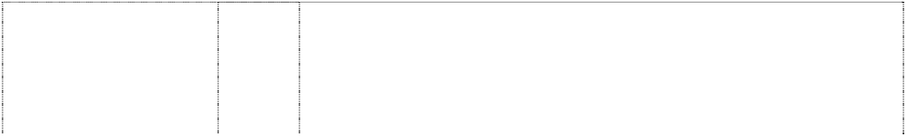

(1083465)

# PLAYSTATION

(1083465)

# PlayStation

(773817)

# PLAYSTATION 2

(826700)

# PLAYSTATION 2

(826700)

# PLAYSTATION 2

(826700)

# PLAYSTATION 2

(826700)

# PLAYSTATION 2

(826700)

# PLAYSTATION 2

(826700) **PLAYSTATION PLATINUM** (779754) **PLAYSTATION PLATINUM** (779754) **PLAYSTATION PLATINUM** (779754)

# PlayStation Portable

(1018806)

25 Anoraks; aprons for wear; baseball shoes; basketball sneakers; belts for clothing; cuffs; sports shirt; blouses; polo shirts; shirts for suits; garters; gloves and mittens for wear; golf shoes; headbands for clothing; headgear for wear; jackets; suits; skirts; trousers; dresses; Japanese traditional clothing; masquerade costumes; mufflers; neckerchieves; neckties; nightcaps; other special sports footwear; pyjamas; bath robes; rain boots; training shoes; sandals; shoes; boots; women's shoes; infants' shoes; raincoats; overcoats; scarves; shawls; ski boots; soccer shoes; socks and stockings; sports overuniforms; stocking suspenders; suspenders; sweaters; cardigans; vests; swimming caps; swimwear; T-shirts; tennis shoes; undershirts; slips; panties; shorts; briefs; brassieres; waistbands; wind-jackets; wristbands.

28 Amusement machines for use in amusement parks other than arcade video game machines; stuffed toys; go games; chess games; playing cards; billiard cues; billiard balls; billiard tables; baseball gloves; electric-driven toys; fishing rods; fishing reels; butterfly nets; golf balls; golf gloves; golf tees; hand-held games with liquid crystal displays; skis.

28 Board games; game apparatus other than coin operated and those adapted for use with television receivers only; gloves for games; parts and fittings for all the aforesaid goods; toys; toy pistols; toy masks.

9 Computer hardware; computer and video game apparatus; computer game consoles; computer and video games; computer and video game programmes; computer software; computer peripherals; audio and video tapes; cassettes; magnetic data media; compact discs; video discs; DVDs; audio and video recordings; cinematographic films; electronic apparatus and instruments; optical apparatus and instruments; cameras; films; audio and video apparatus; sunglasses; spectacles; sunglasses and spectacles frames; parts and accessories for all the aforesaid goods.

14 Horological and chronometric apparatus and instruments; jewellery; precious stones and metals; goods made from precious stones and metals and imitations thereof.

16 Books, manuals, printed matter, publications; stationery.

18 Bags, baggage; luggage; purses; wallets; goods made from leather or imitation leather; umbrellas.

25 Clothing; footwear; headgear.

28 Toys, games and playthings, hand-held electronic games.

9 Computer and video games; computer game programs; audio and video recordings; phonograph records; cassettes; tapes; video discs.

16 Printed matter; books; publications; stationery.

18 Toys; games and playthings; electronic handheld games.

9 CD players; compact discs (audio-video); consumer video game machines adapted for use with television receivers only; controllers, joysticks, memory cards, volume controllers and mouse for consumer video game machines adapted for use with television receivers only; DVD players; downloadable digital image recordings; downloadable music recordings; downloadable sound recordings; downloadable video recordings; electronic circuits, CD-ROMs, optical discs and other memory media recorded programs for hand-held games with liquid crystal displays; electronic publications (downloadable); programs for arcade video game machines; programs for consumer video games; recorded discs bearing images; recorded DVD-ROMs; recorded video discs and tapes; sound recorded magnetic cards and tapes; sound recorded optical discs.

# PlayStation Portable

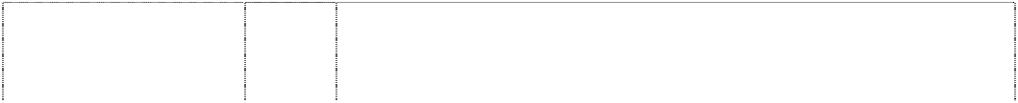

(1018806)

# PS

curved & hooked stripes form ltrs (642679)

# PS

curved & hooked stripes form ltrs (773818)

# PS

curved & hooked stripes form ltrs (773818)

# PS ONE

(837114)

28 Hand-held games with liquid crystal displays; pocket-sized electronic games; games adapted for use with dot matrix liquid crystal displays; video game amusement apparatus not adapted for use with television receivers.

9 Computer game players combined with CD-ROM drives and software therefor.

9 Computers and peripheral equipment for computers; printers for use with computers; computer hardware and software; animated cartoons; apparatus for recording, transmission or reproduction of sound or images; central processing units; photocopiers; floppy disks; cinematographic films and apparatus for editing films; optical apparatus and instruments; optical disk drives; optical disk cases; electron tubes; cathode ray tubes; batteries; semi-conductors; electric cables; electronic circuits; integrated circuits; large scale integrated circuits; modems; programmed data carrying electronic circuits; recorded computer programs; programmed data carrying magnetic disks; programmed data carrying magnetic tapes; programmed data carrying optical disks; game consoles containing memory devices, namely computer disks; programmed-data-carrying electronic CD-ROMs; CD-ROM programmed-data-carrying electronic ROM-cartridges CD-ROM drivers; CD-ROM cases; recorded virtual reality game software; ROM-cartridge recorded virtual reality game software; CD-ROM encoded video game software; ROM-cartridge encoded video game software; CD-ROM encoded computer game software; ROM-cartridge encoded computer game software; EEPROM (Electrically Erasable Programmable Read Only Memory) cards; memory cartridges for personal computer game; video game apparatus for personal use; video game apparatus for commercial use; analog controllers for video game; memory cartridges for video game; virtual reality game software recorded on optical disks; video game software recorded on optical disks; computer game software recorded on optical disks; computer game cartridges; computer game joysticks; amusement machines; video game disks; video game cartridges; video game joysticks; record players; compact discs; compact disc players; memory cards; tape recorders; optical disk drives; loudspeakers; records; encoded magnetic cards and pre- recorded audio magnetic cards; encoded magnetic sheets and pre- recorded audio magnetic sheets; encoded magnetic tapes and pre- recorded audio magnetic tapes; encoded optical disks and pre- recorded audio optical disks; video disk drives; video tape recorders; encoded video disks; video tapes; game equipment containing memory devices namely electronic magnetic discs for use with television receivers; electronic devices for generating graphic image reflecting audio signals for use with television receivers; parts, fittings and accessories in respect of all the aforesaid goods.

28 Board games; game apparatus other than coin-operated and those adapted for use with television receivers only; gloves for games; parts and fittings for all the aforesaid goods; toys; toy pistols; toy masks.

9 Abacuses; accumulator boxes; accumulators, electric; accumulators, electric, for vehicles; acoustic couplers; adding machines; aerials; ammeters; amplifiers; amplifying tubes; amplifying valves; amusement apparatus adapted for use with television receivers only; amusement machines, automatic and coin-operated; animated cartoons; anode batteries; answering machines; anti-glare glasses; anti-glare visors; apparatus for games adapted for use with television receivers only; audiovisual teaching apparatus; bar code readers; batteries for pocketlamps; batteries, electric; batteries, electric, for vehicles; battery boxes; battery chargers; beacons, luminous; binoculars; blueprint apparatus; buzzers; cabinets for loudspeakers; cables electric; calculating machines; camcorders; capacitors; cases especially made for photographic apparatus and instruments; cassette players; chargers for electric batteries; cigar lighters for automobiles; cinematographic cameras; circuit breakers; circuit

closers; cleaning apparatus for phonograph records; cleaning apparatus for sound recording discs; coils electric; coin-operated gates for car parks or parking lots; coin-operated mechanisms for television sets; compact discs for audio or video; compact disc players; comparators; computer keyboards; computer memories; computer mouses; computer operating programs, recorded; computer peripheral devices; computers; conductors electric; connections for electric lines; connections, electric; contact lenses; contacts, electric; contacts, electric, of precious metal; containers for contact lenses; controller for games adapted for use with television receivers only; converters, electric; counters; couplings, electric; current rectifiers; data processing apparatus; demagnetizing apparatus for magnetic tapes; detectors; dictating machines; digital versatile disc roms; discharge tubes, electric, other than for lighting; distribution machines, automatic; divers' apparatus; divers' masks; diving suits; dressmakers' measures; drying apparatus for photographic prints; editing appliances for cinematographic films; electricity conduits; electromagnetic coils; electronic agendas; electronic notice boards; electronic pocket translators; electronic tags for goods; encoded cards, magnetic; ergometers; eyeglass cases; eyeglass chains; eyeglass cords; eyeglass frames; eyeglasses; eyepieces; eyeshades; facsimile machines; film cutting apparatus; films, exposed; flat irons, electric; floats for bathing and swimming; floppy disks; frames for photographic transparencies; frequency meters; fuse wire; fuses; galvanic batteries; glazing apparatus for photographic prints; hair-curlers, electrically heated; high tension batteries; high-frequency apparatus; holders for electric coils; holograms; horns for loudspeakers, identification threads for electric wires; identity cards, magnetic; integrated circuits; intercommunication apparatus; joysticks for games adapted for use with television receivers only; junction sleeves for electric cables; kaleidoscopes; laptop computers; large scale integrated circuits; lens hoods; lenses for astrophotography; letter scales; locks, electric; loudspeakers; magnetic data media; magnetic encoders; magnetic tapes; magnetic wires; magnets; masts for wireless aerials; metronomes; micrometer gauges; micrometers; microphones; microprocessors; microscopes; microtomes; modems; money counting and sorting machines; navigational instruments; needles for record players; notebook computers, optical apparatus and instruments; optical character readers; optical data media; optical discs; optical glass; optical lenses; pedometers; phonograph records; phototelegraphy apparatus; photovoltaic cells; plates for batteries; plotters; pocket calculators; postage stamp meters; printed circuits; printers for use with computers; projection apparatus; projection screens; punched card machines for offices; radar apparatus; radios; radiotelegraphy sets; radiotelephony sets; record players; regulating apparatus, electric; relays, electric; resistance, electric; scales; screens for photoengraving; semi-conductors; simulators for the steering and control of vehicles; slide callipers; slide projectors; slide- rules; slot machines, automatic; software for games adapted for use with television receivers only; solar batteries; sound alarms; sound recording apparatus; sound recording carriers; sound recording discs; sound recording strips; sound reproduction apparatus; sound transmitting apparatus; spectacle cases; spectacle frames; spectacle glasses; speed regulators for record players; stands for photographic apparatus; styli for record players; sunglasses; swimming jackets; switchboards; switches, electric; tape recorders; teaching apparatus; telegraph wires; telephone apparatus; telephone receivers; telephone transmitters; telephone wires; teleprinters; telescopes; teletypewriters; television apparatus; thermometers, not for medical purposes; thermostats; time recording apparatus; time switches, automatic; tone arms for record players; transmitters of electronic signals; transparency projection apparatus; tripods for cameras; vehicle radios; vending machines; video cassettes; video game cartridges; video recorders; video screens; video telephones; videotapes; wires, electric; word processors; magnetic discs, optical



# PS2

(800713)

# PS2

(826702)

# PS2

(826702)

**PS2** (826702) **PS2** (826702)

discs, magnetic optical discs, CD-ROMs (compact disc roms), magnetic tapes and digital versatile disc roms encoding magazines, books, newspapers, maps, pictures, images and literal information; magnetic discs, optical discs, magnetic optical discs, CD-ROMs (compact disc roms), magnetic tapes and digital versatile disc roms encoding softwares of apparatus for games adapted for use with television receivers only.

9 Electric switches; electric relays; circuit breakers; power controllers; current rectifiers; electric connectors; electric circuit closers; electric capacitors; electric resistors; local switches; power distributing boxes; switchboards (distribution boards); fuses for electric current; lightning arresters; electric transformers; induction voltage regulators; rotary inverters (electric); dry cells; wet cells; accumulators and batteries; photovoltaic cells; electric wires; electric cables; photographic apparatus and instruments; cinematographic apparatus; optical apparatus and instruments; telephone apparatus; wire communication apparatus; frequency carrier apparatus; broadcasting apparatus; radiocommunication apparatus; radio application apparatus; remote control telemetering apparatus; audio frequency apparatus; video frequency apparatus; parts accessories for electric communication apparatus & instruments; EP records (extended play records); LP records (long-playing records); encoded magnetic cards; encoded .magnetic sheets; encoded magnetic tapes; encoded compact disc; metronomes; shielding cases for magnetic disks; electrostatic copying machines; computers (including central processing units; programmed-data-encoded electronic circuits; magnetic disks; magnetic tapes; and peripheral equipment for computers); electron microscopes; electronic desk calculators; word processors; photo-sensitive tubes; vacuum tubes; rectifier tubes; cathode ray tubes; discharge tubes; thermistors; diodes; transistors; integrated circuits; large scale integrated circuits; video game machines for commercial use; machines and instruments for amusement park; slot machines for game; video game with television for personal use; magnetic cores; resistance wires; electrodes; exposed cinematographic films; exposed slides films; transparencies; slide film mounts; performance recording machines; photo-copying machines; manually operated calculators; electric calculators; punch card office machines; magnetic discs, optical discs, CD-ROMS (Compact Disc Roms) magnetic tapes and Digital Versatile Disc ROMS which are encoded with, and are used for encoding magazines, books, newspapers, maps, pictures, images and literal information; controllers, joysticks, memory cards, volume controller, mouse and other parts and accessories for video games with television for personal use; electric circuits, magnetic discs, optical discs, magnetic optical discs, CD-ROMS (compact disc roms) Digital Versatile Disc ROMS and magnetic tapes which are encoded with video game programs for business use; controllers, joysticks, memory cards, volume controller, mouse and other parts and accessories for video games with television for personal use; arcade games; coin operated video games.

9 Computer hardware; computer and video game apparatus; computer game consoles; computer and video games; computer and video game programmes; computer software; computer peripherals; audio and video tapes; cassettes; magnetic data media; compact discs; video discs; DVDs; audio and video recordings; cinematographic films; electronic apparatus and instruments; optical apparatus and instruments; cameras; films; audio and video apparatus; sunglasses; spectacles; sunglasses and spectacles frames; parts and accessories for all the aforesaid goods.

14 Horological and chronometric apparatus and instruments; jewellery; precious stones and metals; goods made from precious stones and metals and imitations thereof.

16 Books, manuals, printed matter, publications; stationery.

18 Bags, baggage; luggage; purses; wallets; goods made from leather or imitation leather; umbrellas.

**PS2** (826702) **PS2** (826702)



# PS2 PLAYSTATION 2

(800714)

25 Clothing; footwear; headgear.

28 Toys, games and playthings, hand-held electronic games.

9 Electric switches; electric relays; circuit breakers; power controllers; current rectifiers; electric connectors; electric circuit closers; electric capacitors; electric resistors; local switches; power distributing boxes; switchboards (distribution boards); fuses for electric current; lightning arresters; electric transformers; induction voltage regulators; rotary inverters (electric); dry cells; wet cells; accumulators and batteries; photovoltaic cells; electric wires; electric cables; photographic apparatus and instruments; cinematographic apparatus; optical apparatus and instruments; telephone apparatus; wire communication apparatus; frequency carrier apparatus; broadcasting apparatus; radiocommunication apparatus; radio application apparatus; remote control telemetering apparatus; audio frequency apparatus; video frequency apparatus; parts accessories for electric communication apparatus & instruments; EP records (extended play records); LP records (long-playing records); encoded magnetic cards; encoded .magnetic sheets; encoded magnetic tapes; encoded compact disc; metronomes; shielding cases for magnetic disks; electrostatic copying machines; computers (including central processing units; programmed-data-encoded electronic circuits; magnetic disks; magnetic tapes; and peripheral equipment for computers); electron microscopes; electronic desk calculators; word processors; photo-sensitive tubes; vacuum tubes; rectifier tubes; cathode ray tubes; discharge tubes; thermistors; diodes; transistors; integrated circuits; large scale integrated circuits; video game machines for commercial use; machines and instruments for amusement park; slot machines for game; video game with television for personal use; magnetic cores; resistance wires; electrodes; exposed cinematographic films; exposed slides films; transparencies; slide film mounts; performance recording machines; photo-copying machines; manually operated calculators; electric calculators; punched card office machines; magnetic discs, optical discs, magnetic optical discs, CD-ROMs (compact disc ROMs), magnetic tapes and digital versatile disc ROMs encoding magazines, books, news papers, maps, pictures, images and literal information; electric circuits, magnetic discs, optical discs, magnetic optical discs and CD- ROMs (compact disc ROMs), magnetic tapes and digital versatile disc ROMs encoding video game programs for business use; electric circuits, magnetic discs, optical discs, magnetic optical discs, CD- ROMs (compact disc ROMs), magnetic tapes and digital versatile disc ROMs encoding video game programs for personal use; controllers, joysticks, memory cards, volume controller, mouse and other parts and accessories for video games with television for personal use; arcade games; coin-operated video games.

# PS3



(1084899)

# PS3

(1083494)

9 Audio-visual cables; amplifiers; automatic performance programs for electronic musical instruments; battery chargers; blank optical discs; electric cables; car adapters; controllers especially designed for CD recorders; controllers especially designed for DVD players; controllers especially designed for DVD recorders; controllers especially designed for DVD video recorders; controllers especially designed for DVD-ROM players; downloadable electronic publications; digital still cameras; displays; electronic tags for electronic discernment; optical scanners; FM transmitters; global positioning system (GPS); hard disc recorders; hard disk drives; keyboards; keyboards for use with video games with television for personal use only; liquid crystal displays; liquid crystal monitors; loud speakers; memory cards; microphones; modems; mouses for computers; optical disc players including controllers; optical disc recorders including controllers; optical fiber cables; portable digital audio players; programs for hand-held games with liquid crystal displays; receiving tuners for satellite television broadcasting; receiving tuners for terrestrial digital broadcasting; rechargeable batteries; recorded optical discs featuring computer programs; remote controllers for use with hand-held games with liquid crystal displays only; remote controllers especially designed for CD players; remote controllers especially designed for DVD players; remote controllers for use with computers; remote controllers for use with portable audio-visual players only; remote controllers for use with portable digital audio players only; remote controllers for use with video games with television for personal use only; routers; sound recorded compact discs; sound recorded magnetic cards, sheets and tapes; tuners for television receivers; video recorded optical discs; video recorded optical magnetic discs, apparatus for games adapted for use with television receivers only.

9 Audio-visual cables; amplifiers; automatic performance programs for electronic musical instruments; battery chargers; blank optical discs; electric cables; car adapters; controllers especially designed for CD recorders; controllers especially designed for DVD players; controllers especially designed for DVD recorders; controllers especially designed for DVD video recorders; controllers especially designed for DVD-ROM players; downloadable electronic publications; digital still cameras; displays; electronic tags for electronic discernment; optical scanners; FM transmitters; global positioning system (GPS); hard disc recorders; hard disk drives; keyboards; keyboards for use with video games with television for personal use only; liquid crystal displays; liquid crystal monitors; loud speakers; memory cards; microphones; modems; mouses for computers; optical disc players including controllers; optical disc recorders including controllers; optical fiber cables; portable digital audio players; programs for hand-held games with liquid crystal displays; receiving tuners for satellite television broadcasting; receiving tuners for terrestrial digital broadcasting; rechargeable batteries; recorded optical discs featuring computer programs; remote controllers for use with hand-held games with liquid crystal displays only; remote controllers especially designed for CD players; remote controllers especially designed for DVD players; remote controllers for use with computers; remote controllers for use with portable audio-visual players only; remote controllers for use with portable digital audio players only; remote controllers for use with video games with television for personal use only; routers; sound recorded compact discs; sound recorded magnetic cards, sheets and tapes; tuners for television receivers; video recorded optical discs; video recorded optical magnetic discs.

# PS3



(1083494)

# PS3

(1083494)

# PS3

(1083494)

14 Alarm clocks; automobile clocks; candle extinguishers and candlesticks of precious metal; clock and watch hands; commemorative shields; dials for clocks and watches; earrings; tie pins; pendants; brooches; jewellery; trinket rings; bracelets; flower vases and bowls of precious metal; jewel cases of precious metal; keyrings; needle cases of precious metal; nutcrackers of precious metal; pepper pots of precious metal; sugar bowls of precious metal; salt shakers of precious metal; egg cups of precious metal; napkin holders of precious metal; napkin rings of precious metal; trays of precious metal; toothpick holders of precious metal; other parts and accessories of clocks and watches ; pendulums; pocket watches; powder compacts of precious metal; precious metals and their alloys; purses and wallets of precious metal; shoe ornaments of precious metal; smokers' articles of precious metal; stopwatches; table clocks; trophies; unwrought and semi-wrought precious stones and their imitations; wall clocks; watch and clock cases; watch and clock springs; watch bands and straps; watch chains; watch glasses; wrist watches; drinking cups, dishes, teapots, jugs of precious metal.

16 Addressing machines; adhesive tapes for stationery or household purposes; albums; automatic stamp putting-on machines; babies' diapers of paper; baggage tags; ball-point pens; banners of paper; blueprinting machines; bookmarkers; books; calendars; cards, stationary; catalogues; crayons; decorators' paintbrushes; diaries; drawing boards, painters' article; drawing instruments; electric pencil sharpeners; electric staplers for offices; envelope sealing machines for offices; envelopes; felt writing pens; flags of paper; food wrapping plastic film for household purposes; franking machines; garbage bags of paper for household use; garbage bags of plastics for household use; geographical maps; glass bowls for live goldfish; indoor aquaria; hand towels of paper; handkerchiefs of paper; hygienic paper; inking ribbons; instruction manuals; magazines; marking templates; mechanical pencils; memo pads containing adhesive on one side of the sheets for attachment to surfaces; mimeographs; newsletters; newspapers; note books; paintings and their reproductions; engravings; pamphlets; paper patterns; paper shredders for office use; paperboard boxes for industrial packaging; pen cases; pencils; photograph stands; photographs; picture postcards; pocket memorandum books; printed lottery tickets other than toys; printed timetables; printers' reglets; printing paper; toilet paper; filter paper; postcard paper; printing type; relief duplicators; rotary duplicators; rubber erasers; rulers for stationery and office use; sealing wax; seals, stationery; sheet music; sketchbooks; song books; specification manuals for video game programs; stamp obliterating machines; stands for pens and pencils; stapling presses, non-electric; stickers, stationary; strategic manuals for video games; table cloths of paper; table napkins of paper; tags containing adhesive on one side of the sheets for attachment to surfaces; tailors' chalk; towels of paper; typewriters; underlays for writing paper; writing pads; adhesives for stationary or household purposes.

18 Backpacks; boston bags; business card cases; canes; card cases; carry-on bags; clothing for domestic pets; day packs; folding briefcases; handbags; handles of canes or walking-sticks; industrial packaging containers of leather; key cases; metal bag fittings; metal parts of canes.

# PS3



(1083494)

# PS3

(1083494)

# PS3

ltrs & num are angled stripes

(815195)

25 Anoraks; aprons for wear; baseball shoes; basketball sneakers; belts for clothing; cuffs; sports shirt; blouses; polo shirts; shirts for suits; garters; gloves and mittens for wear; golf shoes; headbands for clothing; headgear for wear; jackets; suits; skirts; trousers; dresses; Japanese traditional clothing; masquerade costumes; mufflers; neckerchieves; neckties; nightcaps; other special sports footwear; pyjamas; bath robes; rain boots; training shoes; sandals; shoes; boots; women's shoes; infants' shoes; raincoats; overcoats; scarves; shawls; ski boots; soccer shoes; socks and stockings; sports overuniforms; stocking suspenders; suspenders; sweaters; cardigans; vests; swimming caps; swimwear; T-shirts; tennis shoes; undershirts; slips; panties; shorts; briefs; brassieres; waistbands; wind-jackets; wristbands.

28 Amusement machines for use in amusement parks other than arcade video game machines; stuffed toys; go games; chess games; playing cards; billiard cues; billiard balls; billiard tables; baseball gloves; electric-driven toys; fishing rods; fishing reels; butterfly nets; golf balls; golf gloves; golf tees; hand-held games with liquid crystal displays; skis.

9 Electric switches; electric relays; circuit breakers; power controllers; current rectifiers; electric connectors; electric circuit closers; electric capacitors; electric resistors; local switches; power distributing boxes; switchboards (distribution boards); fuses for electric current; lighting arresters; electric transformers; induction voltage regulators; rotary inverters (electric); dry cells; wet cells; accumulators and batteries; photovoltaic cells; electric wires; electric cable; photographic apparatus and instruments; cinematographic apparatus; optical apparatus and instuments; telephone apparatus; wire communicaiton apparatus; frequency carrier apparatus; broadcasting apparatus; radiocommunication apparatus; radio application apparatus; remote control telemetering appartus; audio frequency apparatus; video frequency apparatus; parts accessories for electric communication apparatus and instruments; EP records (extended play records); LP records (long-playing records); encoded magnetic cards; encoded magnetic sheets; encoded magnetic tapes; encoded compact disc; metronomes; shielding cases for magnetic disks; electrostatic copying machines; computers (including central processing units; programmed-data-encoded electronic circuits; magnetic disks; magnetic tapes; and peripheral equipment for computers); electron microscopes, electronic desk calculators; word processors; photo-sensitive tubes; vacuum tubes; rectifier tubes; cathode ray tubes; discharge tubes; thermistors; diodes; transistors; integrated circuits; large scale integrated circuits; video game machines for commercial use; machines and instruments for amusement park; slot machines for game; video game with television for personal use; magnetic cores; resistance wires; electrodes; exposed cinematographic films; exposed slides films; transparencies; slide film mounts; performance recording machines; photo-copying machines; manually operated calculators; electric calculators; punched card office machines; magnetic discs, optical discs, magnetic optical discs, CD-ROMs (compact disc roms), magnetic tapes and digital versatile disc ROMs encoding magazines, books, news papers, maps, pictures, images and literal information; electric circuits, magnetic discs, optical discs, magnetic optical discs and CD- ROMs (compact disc roms), magnetic tapes and digital versatile disc ROMs encoding video game programs for business use; electric circuits, magnetic discs, optical discs, magnetic optical discs, CD- ROMs (compact disc roms), magnetic tapes and digital versatile disc ROMs encoding video game programs for personal use; controllers, joysticks, memory cards, volume controller, mouse and other parts and accessories for video games with television for personal use; arcade games; coin-operated video games.

# PSP

(953231)

9 Abacuses; accounting machines; accumulators, electric; acid hydrometers; acidimeters for batteries; acoustic conduits; acoustic couplers; actinometers; adding machines; aerometers; air analysis apparatus; alarm bells, electric; alcoholmeters; alidades; altimeters; ammeters; amplifiers; amplifying tubes; amusement apparatus adapted for use with television receivers only; anemometers; animated cartoons; anodes; answering machines; antennas; anti- dazzle shades; anti-glare glasses; anti-interference devices (electricity); anti- theft warning apparatus; anticathodes; apertometers (optics); apparatus and instruments for astronomy; apparatus and instruments for physics; apparatus for fermentation, laboratory apparatus; apparatus for changing record player needles; apparatus for games adapted for use with television receivers only; apparatus for measuring the thickness of skins; apparatus to check stamping mail; appliances for measuring the thickness of leather; armatures (electricity); asbestos clothing for protection against fire; asbestos gloves for protection against accidents; audio receivers and video receivers; audiovisual teaching apparatus; automatic indicators of low pressure in vehicle tires; azimuth instruments; balancing apparatus; bar code readers; barometers; batteries for lighting; batteries for pocketlamps; batteries, electric; batteries, electric, for vehicles; battery boxes; battery chargers; battery jars; beacons, luminous; bells (warning devices); betatrons; binoculars; blueprint apparatus; boiler control instruments; branch boxes (electricity); breathing apparatus for underwater swimming; breathing apparatus, except for artificial respiration; broadcast satellite downlink terminals; bullet-proof waistcoats; buzzers; buzzers, electric; cabinets for loudspeakers; cables, electric; calculating disks; calculating machines; calibrating rings; calipers; camcorders; cameras (photography); capacitors; capacity measures; capillary tubes; carpenters' rules; carriers for dark plates (photography); cases especially made for photographic apparatus and instruments; cases fitted with dissecting instruments (microscopy); cash registers; cassette players; cathodes; cathodic anti-corrosion apparatus; cell switches (electricity); centering apparatus for photographic transparencies; central processing units (processors); chargers for electric batteries; chemistry apparatus and instruments; chips (integrated circuits); choking coils (impedance); chromatography apparatus for laboratory use; chronographs (time recording apparatus); cigar lighters for automobiles; cinematographic cameras; cinematographic film (exposed); circuit breakers; circuit closers; cleaning apparatus for phonograph records; clinometers; clothing for protection against accidents, irradiation and fire; clothing for protection against fire; coaxial cables; coaxial cables; coils, electric; coin-operated gates for car parks or parking lots; coin-operated mechanisms for television sets; collectors, electric; commutators; compact disc players; compact discs (audio- video); compact discs (read-only memory); comparators; compasses (measuring instruments); computer game programs; computer keyboards; computer memories; computer operating programs, recorded; computer peripheral devices; computer programmes, recorded; computer programs (downloadable software); computer software (recorded); computers; conductors, electric; connections for electric lines; connections, electric; connectors (electricity); contact lenses; contacts, electric; contacts, electric, of precious metal; containers for contact lenses; containers for microscope slides; control panels (electricity); converters, electric; copper wire, insulated; correcting lenses (optics); cosmographic instruments; counters; couplers (data processing equipment); covers for electric outlets; cupels (laboratory); current rectifiers; cyclotrons; computer based image processing devices; computer software for document imaging and scanning, computer graphics software; electronic image and sound data for computer graphics; computer software for creating and displaying computer graphics; computer software for processing, transmission and grouping text data, sound data and image data; computer software for processing digital image data; computer

interface cards for image processing; darkroom lamps (photography); darkrooms (photography); data processing apparatus; decompression chambers; decorative magnets; demagnetizing apparatus for magnetic tapes; densimeters; densitometers; detectors; diagnostic apparatus, not for medical purposes; diaphragms (acoustics); diaphragms (photography); diaphragms for scientific apparatus; dictating machines; diffraction apparatus (microscopy); digital versatile disc ROM players; digital versatile disc recorders; digital versatile disc video recorders; digital versatile disc players; directional compasses; discharge tubes, electric, other than for lighting; disk drives for computers; distance measuring apparatus; distance recording apparatus; distillation apparatus for scientific purposes; distribution boards (electricity); distribution boxes (electricity); distribution consoles (electricity); distribution machines, automatic; divers' apparatus; divers' masks; diving suits; dog whistles; door closers, electric; door openers, electric; dosage dispensers; drainers for use in photography; dressmakers' measures; drying apparatus for photographic prints; drying racks (photography); ducts (electricity); dynamometers; apparatus and instruments for document image processing, document image management, report generation and document indexing and database management; ear plugs; ear plugs for divers; editing appliances for cinematographic films; egg timers (sandglasses); egg- candlers; electric apparatus for commutation; electric arc cutting apparatus; electric arc welding apparatus; electric devices for attracting and killing insects; electric door bells; electric installations for the remote control of industrial operations; electric loss indicators; electric welding apparatus; electrical apparatus for sealing plastics, packaging; electricity conduits; electrified fences; electrified rails for mounting spot lights; electro- dynamic apparatus for the remote control of railway points; electro-dynamic apparatus for the remote control of signals; electrolysers; electromagnetic coils; electromagnetic switches; electronic agendas; electronic notice boards; electronic pens (visual display units); electronic pocket translators; electronic publications (downloadable); electronic tags for goods; electroplating apparatus; encoded cards, magnetic; enlarging apparatus (photography); epidiascopes; ergometers; exposure meters (light meters); eyeglass cases; eyeglass chains; eyeglass cords; eyeglass frames; eyeglasses; eyepieces; eyeshades; electronic circuits, magnetic disks, magnetic tapes, CD- ROMS, optical disks, magneto-optical disks and DVD-ROMs, encoded static images, animation cartoons and motion picture; facsimile machines; false coin detectors; fiber optic cables; film cutting apparatus; films, exposed; filters (photography); filters for respiratory masks; filters for ultraviolet rays, for photography; fire alarms; fire beaters; fire blankets; fire boats; fire engines; fire escapes; fire extinguishing apparatus; fire hose nozzles; flash-bulbs (photography); flashing lights (luminous signals); flashlights (photography); flat irons, electric; floats for bathing and swimming; floppy disks; fluorescent screens; fog signals, non- explosive; food analysis apparatus; frames for photographic transparencies; frequency meters; fuel dispensing pumps for service stations; furniture especially made for laboratories; fuse wire; fuses; galena crystals (detectors); galvanic batteries; galvanic cells; galvanizing apparatus; galvanometers; garments for protection against fire; gas testing instruments; gasoline gauges; gasoline pumps for service stations; gasometers; gauges; gene chips; glass covered with an electrical conductor; glazing apparatus for photographic prints; gloves for divers; gloves for protection against

X-rays for industrial purposes; gloves for protection against accidents; goggles for sports; grids for batteries; hair-curlers, electrically heated; hard disc drive recorders; hard disc drive video recorders; head cleaning tapes (recording); headphones; heat regulating apparatus; heliographic apparatus; hemline markers; high tension batteries; high-frequency apparatus; holders for electric coils; holograms; horns for loudspeakers; hydrometers; hygrometers; identification sheaths for electric wires; identification threads for

electric wires; identity cards, magnetic; igniting apparatus, electric, for igniting at a distance; incubators for bacteria culture; indicators (electricity); inductors (electricity); instruments containing eyepieces; integrated circuit cards (smart cards); integrated circuits; intercommunication apparatus; interfaces for computers; inverters (electricity); invoicing machines; ionisation apparatus, not for the treatment of air; integrated circuits for image processing; jigs (measuring instruments); juke boxes (musical); juke boxes for computers; junction boxes (electricity); junction sleeves for electric cables; kilometer recorders for vehicles; knee-pads for workers; laboratory trays; lactodensimeters; lactometers; lasers, not for medical purposes; lens hoods; lenses for astrophotography; letter scales; levelling instruments; levelling staffs (surveying instruments); levels (instruments for determining the horizontal); life belts; life buoys; life jackets; life nets; life saving apparatus and equipment; life-saving rafts; lift operating apparatus; light conducting filaments (optical fibers); light dimmers (electric); light-emitting electronic pointers; lighting ballasts; lightning arresters; limiters (electricity); locks, electric; logs (measuring instruments); loudspeakers; magic lanterns; magnetic data media; magnetic disks; magnetic encoders; magnetic tape units for computers; magnetic tapes; magnetic wires;

magnets; magnifying glasses (optics); make-up removing appliances, electric; marine compasses; marine depth finders; marking buoys; marking gauges (joinery); masts for wireless aerials; material for electricity mains(wires or cables); material testing instruments and machines; mathematical instruments; measures; measuring apparatus; measuring devices, electric; measuring glassware; measuring instruments; measuring spoons; mechanical signs; mechanisms for coin operated apparatus; mechanisms for counter- operated apparatus; megaphones; mercury levels; metal detectors for industrial or military purposes; meteorological balloons; meteorological instruments; metronomes; micrometer gauges; micrometer screws for optical instruments; microphones; microprocessors; microscopes; microtomes; mirrors (optics); mirrors for inspecting work; modems; money counting and sorting machines; monitoring apparatus, electric; monitors (computer hardware); monitors (computer programs); motor fire engines; mouse (data processing equipment); mouse pads; nautical apparatus and instruments; naval signalling apparatus; navigation apparatus for vehicles (on-board computers); navigational instruments; needles for record players; neon signs; nets for protection against accidents; nose clips for divers and swimmers; notebook computers; objectives (optics); observation instruments; octants; ohmmeters; optical apparatus and instruments; optical character readers; optical condensers; optical data media; optical discs; optical glass; optical goods; optical lamps; optical lenses; oscillographs; ovens for laboratory experiments; oxygen transvasing apparatus; ozonators; parking meters; particle accelerators; pedometers; peepholes for doors; periscopes; personal stereos; phonograph records; photocopiers (photographic, electrostatic, thermic); photometers; phototelegraphy apparatus; photovoltaic cells; pince-nez chains; pipettes; plane tables (surveying instruments); planimeters; plates for batteries; plotters; plugs, sockets and other contacts (electric connections); plumb bobs; plumb lines; pocket calculators; polarimeters; postage stamp meters; precision balances; precision measuring apparatus; pressure gauges; pressure indicator plugs for valves; pressure indicators; pressure measuring apparatus; printed circuits; printers for use with computers; prisms (optics); probes for scientific purposes; projection apparatus; projection screens; protection devices against X-rays, not for medical purposes; protection devices for personal use against accidents; protective helmets; protective helmets for sports; protective masks; protective suits for aviators; protractors (measuring instruments); punched card machines for offices; push buttons for bells; pyrometers; portable telephones; photograph machines and instruments equipped with computer based image processing devices; quantity indicators; radar

apparatus; radio pagers; radiological apparatus for industrial purposes; radiology screens for industrial purposes; radios; radiotelegraphy sets; radiotelephony sets; railway traffic safety appliances; readers (data processing equipment); record players; reflecting discs for wear, for the prevention of traffic accidents; refractometers; refractors; regulating apparatus, electric; relays, electric; remote control apparatus; resistances, electric; respirators for filtering air; respiratory masks other than for artificial respiration; resuscitation mannequins (teaching apparatus); retorts; retorts' stands; revolution counters; rheostats; road signs, luminous or mechanical; rods for water diviners; roentgen apparatus not for medical purposes; rulers (measuring instruments); rules (measuring instruments); saccharometers; safety restraints other than for vehicle seats and sports equipment; safety tarpaulins; salinometers; satellite navigational apparatus; satellites for scientific purposes; scales; scanners (data processing equipment); screens (photography); screens for photoengraving; screw- tapping gauges; self-regulating fuel pumps; semi- conductors; sextants; sheaths for electric cables; shoes for protection against accidents, irradiation and fire; shutter releases (photography); shutters (photography); sighting telescopes for firearms; signal bells; signal lanterns; signalling buoys; signalling panels, luminous or mechanical; signalling whistles; signals, luminous or mechanical; signs, luminous; simulators for the steering and control of vehicles; sirens; slide calipers; slide- rules; slope indicators; smoke detectors; socks, electrically heated; solar batteries; solderers' helmets; soldering irons, electric; sonars; sound alarms; sound locating instruments; sound recording apparatus; sound recording carriers; sound recording strips; sound reproduction apparatus; sound transmitting apparatus; sounding apparatus and machines; sounding leads; sounding lines; spark-guards; speaking tubes; spectacle cases; spectacle frames; spectacle glasses; spectacles (optics); spectrograph apparatus; spectroscopes; speed checking apparatus for vehicles; speed indicators; speed measuring apparatus (photography); speed regulators for record players; spherometers; spirit levels; spools (photography); sprinkler systems for fire protection; stage lighting regulators; stands for photographic apparatus; starter cables for motors; steelyards (lever scales); steering apparatus, automatic, for vehicles; stereoscopes; stereoscopic apparatus; stills for laboratory experiments; sulphitometers; sunglasses; surveying apparatus and instruments; surveying chains; surveying instruments; surveyors' levels; swimming belts; swimming jackets; switchboards; switchboxes (electricity); switches, electric; tachometers; tape recorders; taximeters; teaching apparatus; teeth protectors; telegraph wires; telegraphs (apparatus); telemeters; telephone apparatus; telephone receivers; telephone transmitters; telephone wires; teleprompters; telerupters; telescopes; teletypewriters; television apparatus; temperature indicators; terminals (electricity); test tubes; testing apparatus not for medical purposes; theft prevention installations, electric; theodolites; thermionic lamps and tubes; thermionic valves (radio); thermometers, not for medical purposes; thermostats; thermostats for vehicles; thread counters; ticket dispensers; time recording apparatus; time recording devices; time switches, automatic; tone arms for record players; totalizators; transformers (electricity); transistors (electronic); transmitters (telecommunication); transmitters of electronic signals; transmitting sets (telecommunication); transparencies (photography); transparency projection apparatus; tripods for cameras; tuners for television set; turnstiles, automatic; urinometers; vacuum gauges; vacuum tubes (radio); variometers; vehicle breakdown warning triangles; vehicle radios; verniers; video cassettes; video game cartridges; video recorders; video screens; video telephones; videotapes; viewfinders, photographic; viscosimeters; voltage regulators for vehicles; voltage surge protectors; voltmeters; voting machines; wafers (silicon slices); walkie-talkies; washing trays (photography); water level indicators; wavemeters; weighbridges; weighing apparatus and instruments;

# PSP

(997313)

# PSP

(954819)

**PSP** (954819) **PSP** (954819) **PSP** (953231)

weighing machines; weights; welding apparatus, electric; welding electrodes; whistle alarms; wind socks for indicating wind direction; wire connectors (electricity); wires, electric; word processors; workmen's protective face-shields; wrist rests for use with computers; X-ray films, exposed; X-ray photographs, other than for medical purposes; X-rays producing apparatus and installations, not for medical purposes; X-rays tubes not for medical purposes.

9 CD players; compact discs (audio-video); consumer video game machines adapted for use with television receivers only; controllers, joysticks, memory cards, volume controllers and mice for consumer video game machines adapted for use with television receivers only; DVD players; downloadable images and character data of magazines, books, newspapers, maps, pictures and drawings; downloadable music; downloadable video images; electronic circuits, CD-ROMs and other memory media recorded programs for hand- held games with liquid crystal displays; electronic publications; programs for arcade video game machines; programs for consumer video games; recorded DVD-ROMs; recorded video discs and tapes; sound recorded magnetic cards, sheets and tapes; sound recorded optical discs.



9 Computer hardware; computer and video game apparatus; computer game consoles; computer and video game programmes; computer software; computer peripherals; audio and video tapes; cassettes; magnetic data media; compact discs; video discs; DVD's; audio and video recordings; cinematographic films; electronic apparatus and instruments all for use in computer and video gaming; optical apparatus and instruments; cameras; films; audio and video apparatus; sunglasses; spectacles; sunglasses and spectacles frames; parts and accessories for all the aforesaid goods.

16 Books, manuals, printed matter, publications; stationery.

28 Toys, games and playthings, hand-held electronic games; computer and video games.

28 Air pistols (toys); ammunition for paintball guns (sporting apparatus); amusement machines, automatic and coin- operated; apparatus for electronic games other than those adapted for use with television receivers only; appliances for gymnastics; archery implements; artificial fishing bait; artificial snow for Christmas trees; automatic games other than those adapted for use with television receivers only; backgammon games; bags especially designed for skis and surfboards; balls for games; baseball gloves; bats for games; batting gloves (accessories for games); bells for Christmas trees; billiard balls; billiard cue tips; billiard cues; billiard markers; billiard table cushions; billiard tables; bingo cards; bite indicators (fishing tackle); bite sensors (fishing tackle); bladders of balls for games; board games; bob-sleighs; body boards; body- training apparatus; bowling apparatus and machinery; bows for archery; boxing gloves; building blocks (toys); building games; butterfly nets; candle holders for Christmas trees; caps for pistols (toys); chalk for billiard cues; checkerboards; checkers (games); chess games; chessboards; chest expanders (exercisers); Christmas tree stands; Christmas trees of synthetic material; clay pigeon traps; clay pigeons (targets); climbers' harness; coin-operated billiard tables; confetti; conjuring apparatus; counters for games; creels (fishing equipment); cricket bags; cups of dice; darts; dice; discuses for sports; divot repair tools (golf accessories); dolls; dolls' beds; dolls' clothes; dolls' feeding bottles; dolls' houses; dolls' rooms; dominoes; dumb-bells; edges of skis; elbow guards (sports articles); electronic targets for game; explosive bonbons (Christmas crackers); fairground ride apparatus; fencing gauntlets; fencing masks; fencing weapons; fish hooks; fishing tackle; flippers for swimming; floats for fishing; flying discs (toys); foils for fencing; gloves for games; golf bags, with or without wheels; golf clubs; golf gloves; gut for fishing; gut for rackets; hang gliders; harness for sailboards; harpoon guns (sports articles); hockey sticks; horseshoe games; hunting game calls; ice skates; in- line roller skates; jigsaw puzzles; kaleidoscopes; kite reels; kites;

# PSP

(997313)

# PSP

ltrs in ring (1034012)

# PSP

ltrs in ring (1034012) **PSP**

ltrs in ring (1034012)

# SingStar

(977951)

# SingStar

(977951)

# SingStar

(977951) **UNIVERSAL MEDIA DISC**

(953232)

knee guards (sports articles); landing nets for anglers; lines for fishing; lures for hunting or fishing; machines for physical exercises; mah-jong; marbles for games; marionettes; masts for sailboards; mobiles (toys); nets for sports; ninepins; novelties for parties, dances (party favors, favours); ornaments for Christmas trees (except illumination articles and confectionery); paintball guns (sporting apparatus); para-gliders; parlor games; percussion caps (toys); pinatas; play balloons; playing balls; playing cards; plush toys; practical jokes (novelties); protective paddings (parts of sports suits); punching bags; quoits; rackets; radio-controlled toy vehicles; rattles (playthings); reels for fishing; ring games; rocking horses; rods for fishing; roller skates; rollers for stationary exercise bicycles; rosin used by athletes; roulette wheels; sailboards; scale model vehicles; scooters (toys); scrapers for skis; seal skins (coverings for skis); shin guards (sports articles); shuttlecocks; skateboards; skating boots with skates attached; ski bindings; skis; skittles; sleighs (sports articles); slides (playthings); sling shots (sports articles); snow globes; snowshoes; soap bubbles (toys); sole coverings for skis; spinning tops (toys); spring boards (sporting articles); starting blocks for sports; stationary exercise bicycles; strings for rackets; surf boards; surf skis; surfboard leashes; swimming pools (play articles); swings; tables for indoor football; tables for table tennis; targets; teddy bears; tennis ball throwing apparatus; tennis nets; theatrical masks; toy masks; toy pistols; toy vehicles; toys; toys for domestic pets; twirling batons; waterskis; wax for skis; weight lifting belts (sports articles).

28 Hand-held games with liquid crystal displays (including "exclusive earphones connected and used for hand-held games with liquid crystal displays and other accessories"); pocket-sized electronic games.



9 Computer hardware; computer and video game apparatus; computer game consoles; computer and video game programmes; computer software; computer peripherals; audio and video tapes; cassettes; magnetic data media; compact discs; video discs; DVDs; audio and video recordings; cinematographic films; electronic apparatus and instruments all for use in computer and video gaming; optical apparatus and instruments; cameras; films; audio and video apparatus; sunglasses; spectacles; sunglasses and spectacles frames; parts and accessories for all the aforesaid goods.

16 Books, manuals, printed matter, publications; stationery.

28 Toys, games and playthings; hand-held electronic games; computer and video games.

9 Computer hardware; computer and video game apparatus; computer game consoles; computer and video game; computer and video games programmes; computer software; computer peripherals; audio and video tapes; cassettes; magnetic data media; compact discs; video discs; DVD's; audio and video recordings; cinematographic films; electronic apparatus and instruments, all for use in computer and video gaming; optical apparatus and instruments; cameras; films; audio and video apparatus; sunglasses; spectacles; sunglasses and spectacles frames; parts and accessories for all the aforesaid goods.

16 Books, manuals, printed matter, publications; stationery.

28 Toys, games and playthings, hand-held electronic games; computer and video games.

9 Abacuses; accounting machines; accumulators, electric; acid hydrometers; acidimeters for batteries; acoustic conduits; acoustic couplers; actinometers; adding machines; aerometers; air analysis apparatus; alarm bells, electric; alcoholmeters; alidades; altimeters; ammeters; amplifiers; amplifying tubes; anemometers; animated cartoons; anodes; answering machines; antennas; anti-dazzle shades; anti-glare glasses; anti-interference devices (electricity);

anti- theft warning apparatus; anticathodes; apertometers (optics); apparatus and instruments for astronomy; apparatus and instruments for physics; apparatus for fermentation, laboratory apparatus; apparatus for changing record player needles; apparatus for measuring the thickness of skins; apparatus to check stamping mail; appliances for measuring the thickness of leather; armatures (electricity); asbestos clothing for protection against fire; asbestos gloves for protection against accidents; automatic indicators of low pressure in vehicle tires; azimuth instruments; balancing apparatus; bar code readers; barometers; batteries for lighting; batteries for pocketlamps; batteries, electric; batteries, electric, for vehicles; battery boxes; battery chargers; battery jars; beacons, luminous; bells (warning devices); betatrons; binoculars; blueprint apparatus; boiler control instruments; branch boxes (electricity); breathing apparatus for underwater swimming; breathing apparatus, except for artificial respiration; broadcast satellite downlink terminals; bullet- proof waistcoats; buzzers; buzzers, electric; cabinets for loudspeakers; cables, electric; calculating machines; calibrating rings; calipers; camcorders; cameras (photography); capacitors; capacity measures; capillary tubes; carpenters' rules; carriers for dark plates (photography); cases especially made for photographic apparatus and instruments; cases fitted with dissecting instruments (microscopy); cash registers; cassette players; cathodes; cathodic anti-corrosion apparatus; cell switches (electricity); centering apparatus for photographic transparencies; central processing units (processors); chargers for electric batteries; chemistry apparatus and instruments; choking coils (impedance); chromatography apparatus for laboratory use; chronographs (time recording apparatus); cigar lighters for automobiles; cinematographic cameras; cinematographic film (exposed); circuit breakers; circuit closers; cleaning apparatus for phonograph records; clinometers; clothing for protection against accidents, irradiation and fire; clothing for protection against fire; coaxial cables; coaxial cables; coils, electric; coin-operated gates for car parks or parking lots; coin-operated mechanisms for television sets; collectors, electric; commutators; comparators; compasses (measuring instruments); computer keyboards; conductors, electric; connections for electric lines; connections, electric; connectors (electricity); contact lenses; contacts, electric; contacts, electric, of precious metal; containers for contact lenses; containers for microscope slides; control panels (electricity); converters, electric; copper wire, insulated; correcting lenses (optics); cosmographic instruments; counters; couplers (data processing equipment); covers for electric outlets; cupels (laboratory); current rectifiers; cyclotrons; darkroom lamps (photography); darkrooms (photography); decompression chambers; decorative magnets; demagnetizing apparatus for magnetic tapes; densimeters; densitometers; detectors; diagnostic apparatus, not for medical purposes; diaphragms (acoustics); diaphragms (photography); diaphragms for scientific apparatus; dictating machines; diffraction apparatus (microscopy); directional compasses; discharge tubes, electric, other than for lighting; disk drives for computers; distance measuring apparatus; distance recording apparatus; distillation apparatus for scientific purposes; distribution boards (electricity); distribution boxes (electricity); distribution consoles (electricity); distribution machines, automatic; divers' apparatus; divers' masks; diving suits; dog whistles; door closers, electric; door openers, electric; dosage dispensers; drainers for use in photography; dressmakers' measures; drying apparatus for photographic prints; drying racks (photography); ducts (electricity); dynamometers; ear plugs; ear plugs for divers; editing appliances for cinematographic films; egg timers (sandglasses); egg-candlers; electric apparatus for commutation; electric arc cutting apparatus; electric arc welding apparatus; electric devices for attracting and killing insects; electric door bells; electric installations for the remote control of industrial operations; electric loss indicators; electric welding apparatus; electrical apparatus for sealing plastics, packaging; electricity conduits; electrified fences;

electrified rails for mounting spot lights; electro- dynamic apparatus for the remote control of railway points; electro-dynamic apparatus for the remote control of signals; electrolysers; electromagnetic coils; electromagnetic switches; electronic tags for goods; electroplating apparatus; encoded cards, magnetic; enlarging apparatus (photography); epidiascopes; ergometers; exposure meters (light meters); eyeglass cases; eyeglass chains; eyeglass cords; eyeglass frames; eyeglasses; eyepieces; eyeshades; electronic circuits, facsimile machines; false coin detectors; fiber optic cables; film cutting apparatus; films, exposed; filters (photography); filters for respiratory masks; filters for ultraviolet rays, for photography; fire alarms; fire beaters; fire blankets; fire boats; fire engines; fire escapes; fire extinguishing apparatus; fire hose nozzles; flash-bulbs (photography); flashing lights (luminous signals); flashlights (photography); flat irons, electric; floats for bathing and swimming; floppy disks; fluorescent screens; fog signals, non-explosive; food analysis apparatus; frames for photographic transparencies; frequency meters; fuel dispensing pumps for service stations; furniture especially made for laboratories; fuse wire; fuses; galena crystals (detectors); galvanic batteries; galvanic cells; galvanizing apparatus; galvanometers; garments for protection against fire; gas testing instruments; gasoline gauges; gasoline pumps for service stations; gasometers; gauges; gene chips; glass covered with an electrical conductor; glazing apparatus for photographic prints; gloves for divers; gloves for protection against X-rays for industrial purposes; gloves for protection against accidents; goggles for sports; grids for batteries; hair-curlers, electrically heated; head cleaning tapes (recording); heat regulating apparatus; heliographic apparatus; hemline markers; high tension batteries; high-frequency apparatus; holders for electric coils; holograms; horns for loudspeakers; hydrometers; hygrometers; identification sheaths for electric wires; identification threads for electric wires; identity cards, magnetic; igniting apparatus, electric, for igniting at a distance; incubators for bacteria culture; indicators (electricity); inductors (electricity); instruments containing eyepieces; inverters (electricity); invoicing machines; ionisation apparatus, not for the treatment of air; jigs (measuring instruments); junction boxes (electricity); junction sleeves for electric cables; kilometer recorders for vehicles; knee-pads for workers; laboratory trays; lactodensimeters; lactometers; lasers, not for medical purposes; lens hoods; lenses for astrophotography; letter scales; levelling instruments; levelling staffs (surveying instruments); levels (instruments for determining the horizontal); life belts; life buoys; life jackets; life nets; life saving apparatus and equipment;

life-saving rafts; lift operating apparatus; light conducting filaments (optical fibers); light dimmers (electric); light-emitting electronic pointers; lighting ballasts; lightning arresters; limiters (electricity); locks, electric; logs (measuring instruments); loudspeakers; magic lanterns; magnets; magnifying glasses (optics); make-up removing appliances, electric; marine compasses; marine depth finders; marking buoys; marking gauges (joinery); masts for wireless aerials; material for electricity mains(wires or cables); material testing instruments and machines; mathematical instruments; measures; measuring apparatus; measuring devices, electric; measuring glassware; measuring instruments; measuring spoons; mechanical signs; mechanisms for coin operated apparatus; mechanisms for counter-operated apparatus; megaphones; mercury levels; metal detectors for industrial or military purposes; meteorological balloons; meteorological instruments; metronomes; micrometer gauges; micrometer screws for optical instruments; microscopes; microtomes; mirrors (optics); mirrors for inspecting work; money counting and sorting machines; monitoring apparatus, electric; monitors (computer hardware); monitors (computer programs); motor fire engines; mouse (data processing equipment); mouse pads; nautical apparatus and instruments; naval signalling apparatus; navigation apparatus for vehicles (on-board computers); navigational instruments; needles for record players; neon signs; nets for protection against accidents;

nose clips for divers and swimmers; objectives (optics); observation instruments; octants; ohmmeters; optical apparatus and instruments; optical character readers; optical glass; optical goods; optical lamps; optical lenses; oscillographs; ovens for laboratory experiments; oxygen transvasing apparatus; ozonators; parking meters; particle accelerators; pedometers; peepholes for doors; periscopes; phonograph records; photocopiers (photographic, electrostatic, thermic); photometers; phototelegraphy apparatus; photovoltaic cells; pince-nez chains; pipettes; plane tables (surveying instruments); planimeters; plates for batteries; plotters; plugs, sockets and other contacts (electric connections); plumb bobs; plumb lines; pocket calculators; polarimeters; postage stamp meters; precision balances; precision measuring apparatus; pressure gauges; pressure indicator plugs for valves; pressure indicators; pressure measuring apparatus; printers for use with computers; prisms (optics); probes for scientific purposes; projection apparatus; projection screens; protection devices against X-rays, not for medical purposes; protection devices for personal use against accidents; protective helmets; protective helmets for sports; protective masks; protective suits for aviators; protractors (measuring instruments); punched card machines for offices; push buttons for bells; pyrometers; portable telephones; quantity indicators; radar apparatus; radio pagers; radiological apparatus for industrial purposes; radiology screens for industrial purposes; radios; radiotelegraphy sets; radiotelephony sets; railway traffic safety appliances; record players; reflecting discs for wear, for the prevention of traffic accidents; refractometers; refractors; regulating apparatus, electric; relays, electric; remote control apparatus; resistances, electric; respirators for filtering air; respiratory masks other than for artificial respiration; resuscitation mannequins (teaching apparatus); retorts; retorts' stands; revolution counters; rheostats; road signs, luminous or mechanical; rods for water diviners; roentgen apparatus not for medical purposes; rulers (measuring instruments); rules (measuring instruments); saccharometers; safety restraints other than for vehicle seats and sports equipment; safety tarpaulins; salinometers; satellite navigational apparatus; satellites for scientific purposes; scales; scanners (data processing equipment); screens (photography); screens for photoengraving; screw- tapping gauges; self-regulating fuel pumps; semi- conductors; sextants; sheaths for electric cables; shoes for protection against accidents, irradiation and fire; shutter releases (photography); shutters (photography); sighting telescopes for firearms; signal bells; signal lanterns; signalling buoys; signalling panels, luminous or mechanical; signalling whistles; signals, luminous or mechanical; signs, luminous; simulators for the steering and control of vehicles; sirens; slide calipers; slide- rules; slope indicators; smoke detectors; socks, electrically heated; solar batteries; solderers' helmets; soldering irons, electric; sonars; sound alarms; sound locating instruments; sounding apparatus and machines; sounding leads; sounding lines; spark-guards; speaking tubes; spectacle cases; spectacle frames; spectacle glasses; spectacles (optics); spectrograph apparatus; spectroscopes; speed checking apparatus for vehicles; speed indicators; speed measuring apparatus (photography); speed regulators for record players; spherometers; spirit levels; spools (photography); sprinkler systems for fire protection; stage lighting regulators; stands for photographic apparatus; starter cables for motors; steelyards (lever scales); steering apparatus, automatic, for vehicles; stereoscopes; stereoscopic apparatus; stills for laboratory experiments; sulphitometers; sunglasses; surveying apparatus and instruments; surveying chains; surveying instruments; surveyors' levels; swimming belts; swimming jackets; switchboards; switchboxes (electricity); switches, electric; tachometers; tape recorders; taximeters; teaching apparatus; teeth protectors; telegraph wires; telegraphs (apparatus); telemeters; telephone apparatus; telephone receivers; telephone transmitters; telephone wires; teleprompters; telerupters; telescopes; teletypewriters; television apparatus; temperature indicators;

# UNIVERSAL MEDIA DISC

(953232)

terminals (electricity); test tubes; testing apparatus not for medical purposes; theft prevention installations, electric; theodolites; thermionic lamps and tubes; thermionic valves (radio); thermometers, not for medical purposes; thermostats; thermostats for vehicles; thread counters; ticket dispensers; time recording apparatus; time recording devices; time switches, automatic; tone arms for record players; totalizators; transformers (electricity); transistors (electronic); transmitters (telecommunication); transmitting sets (telecommunication); transparencies (photography); transparency projection apparatus; tripods for cameras; tuners for television set; turnstiles, automatic; urinometers; vacuum gauges; vacuum tubes (radio); variometers; vehicle breakdown warning triangles; vehicle radios; verniers; video screens; video telephones; videotapes; viewfinders, photographic; viscosimeters; voltage regulators for vehicles; voltage surge protectors; voltmeters; voting machines; wafers (silicon slices); walkie-talkies; washing trays (photography); water level indicators; wavemeters; weighbridges; weighing apparatus and instruments; weighing machines; weights; welding apparatus, electric; welding electrodes; whistle alarms; wind socks for indicating wind direction; wire connectors (electricity); wires, electric; word processors; workmen's protective face-shields; wrist rests for use with computers; X-ray films, exposed; X-ray photographs, other than for medical purposes; X-rays producing apparatus and installations, not for medical purposes; X-rays tubes not for medical purposes.

28 Air pistols (toys); ammunition for paintball guns (sporting apparatus); appliances for gymnastics; archery implements; artificial fishing bait; artificial snow for Christmas trees backgammon games; bags especially designed for skis and surfboards; balls for games; baseball gloves; bats for games; batting gloves (accessories for games); bells for Christmas trees; billiard balls; billiard cue tips; billiard cues; billiard markers; billiard table cushions; billiard tables; bingo cards; bite indicators (fishing tackle); bite sensors (fishing tackle); bladders of balls for games; board games; bob-sleighs; body boards; body-training apparatus; bowling apparatus and machinery; bows for archery; boxing gloves; building blocks (toys); building games; butterfly nets; candle holders for Christmas trees; caps for pistols (toys); chalk for billiard cues; checkerboards; checkers (games); chess games; chessboards; chest expanders (exercisers); Christmas tree stands; Christmas trees of synthetic material; clay pigeon traps; clay pigeons (targets); climbers' harness; coin-operated billiard tables; confetti; conjuring apparatus; counters for games; creels (fishing equipment); cricket bags; cups of dice; darts; dice; discuses for sports; divot repair tools (golf accessories); dolls; dolls' beds; dolls' clothes; dolls' feeding bottles; dolls' houses; dolls' rooms; dominoes; dumb-bells; edges of skis; elbow guards (sports articles); electronic targets for game; explosive bonbons (Christmas crackers); fairground ride apparatus; fencing gauntlets; fencing masks; fencing weapons; fish hooks; fishing tackle; flippers for swimming; floats for fishing; flying discs (toys); foils for fencing; gloves for games; golf bags, with or without wheels; golf clubs; golf gloves; gut for fishing; gut for rackets; hang gliders; harness for sailboards; harpoon guns (sports articles); hockey sticks; horseshoe games; hunting game calls; ice skates; in-line roller skates; jigsaw puzzles; kaleidoscopes; kite reels; kites; knee guards (sports articles); landing nets for anglers; lines for fishing; lures for hunting or fishing; machines for physical exercises; mah-jong; marbles for games; marionettes; masts for sailboards; mobiles (toys); nets for sports; ninepins; novelties for parties, dances (party favors, favours); ornaments for Christmas trees (except illumination articles and confectionery); paintball guns (sporting apparatus); para-gliders; parlor games; percussion caps (toys); pinatas; play balloons; playing balls; playing cards; plush toys; practical jokes (novelties); protective paddings (parts of sports suits); punching bags; quoits; rackets; radio- controlled toy vehicles; rattles (playthings); reels for fishing; ring games; rocking horses; rods for fishing; roller skates; rollers for



# XROSS MEDIA BAR

(984373)

stationary exercise bicycles; rosin used by athletes; roulette wheels; sailboards; scale model vehicles; scooters (toys); scrapers for skis; seal skins (coverings for skis); shin guards (sports articles); shuttlecocks; skateboards; skating boots with skates attached; ski bindings; skis; skittles; sleighs (sports articles); slides (playthings); sling shots (sports articles); snow globes; snowshoes; soap bubbles (toys); sole coverings for skis; spinning tops (toys); spring boards (sporting articles); starting blocks for sports; stationary exercise bicycles; strings for rackets; surf boards; surf skis; surfboard leashes; swimming pools (play articles); swings; tables for indoor football; tables for table tennis; targets; teddy bears; tennis ball throwing apparatus; tennis nets; theatrical masks; toy masks; toy pistols; toy vehicles; toys; toys for domestic pets; twirling batons; waterskis; wax for skis; weight lifting belts (sports articles).

9 Abacuses; accounting machines; accumulators, electric; acid hydrometers; acidimeters for batteries; acoustic conduits; acoustic couplers; actinometers; adding machines; aerometers; air analysis apparatus; alarm bells, electric; alcoholmeters; alidades; altimeters; ammeters; amplifiers; amplifying tubes; amusement apparatus adapted for use with television receivers only; anemometers; animated cartoons; anodes; answering machines; antennas; anti- dazzle shades; anti-glare glasses; anti-interference devices [electricity]; anti-theft warning apparatus; anticathodes; apertometers [optics]; apparatus and instruments for astronomy; apparatus and instruments for physics; apparatus for fermentation, laboratory apparatus; apparatus for changing record player needles; apparatus for games adapted for use with television receivers only; apparatus for measuring the thickness of skins; apparatus to check stamping mail; appliances for measuring the thickness of leather; armatures [electricity]; asbestos clothing for protection against fire; asbestos gloves for protection against accidents; audio receivers and video receivers; audiovisual teaching apparatus; automatic indicators of low pressure in vehicle tires; azimuth instruments; balancing apparatus; bar code readers; barometers; batteries for lighting; batteries for pocketlamps; batteries, electric; batteries, electric, for vehicles; battery boxes; battery chargers; battery jars; beacons, luminous; bells [warning devices]; betatrons; binoculars; blueprint apparatus; boiler control instruments; branch boxes [electricity]; breathing apparatus for underwater swimming; breathing apparatus, except for artificial respiration; broadcast satelite downlink terminals; bullet-proof waistcoats; buzzers; buzzers, electric; cabinets for loudspeakers; cables, electric; calculating disks; calculating machines; calibrating rings; calipers; camcorders; cameras [photography]; capacitors; capacity measures; capillary tubes; carpenters' rules; carriers for dark plates [photography]; cases especially made for photographic apparatus and instruments; cases fitted with dissecting instruments [microscopy]; cash registers; cassette players; cathodes; cathodic anti-corrosion apparatus; cell switches [electricity]; centering apparatus for photographic transparencies; central processing units [processors]; chargers for electric batteries; chemistry apparatus and instruments; chips [integrated circuits]; choking coils [impedance]; chromatography apparatus for laboratory use; chronographs [time recording apparatus]; cigar lighters for automobiles; cinematographic cameras; cinematographic film [exposed]; circuit breakers; circuit closers; cleaning apparatus for phonograph records; clinometers; clothing for protection against accidents, irradiation and fire; clothing for protection against fire; coaxial cables; coaxial cables; coils, electric; coin-operated gates for car parks or parking lots; coin-operated mechanisms for television sets; collectors, electric; commutators; compact disc players; compact discs [audio-video]; compact discs [read-only memory]; comparators; compasses [measuring instruments]; computer game programs; computer keyboards; computer memories; computer operating programs, recorded; computer peripheral devices; computer programmes, recorded; computer programs [downloadable software]; computer software

[recorded]; computers; conductors, electric; connections for electric lines; connections, electric; connectors [electricity]; contact lenses; contacts, electric; contacts, electric, of precious metal; containers for contact lenses; containers for microscope slides; control panels [electricity]; converters, electric; copper wire, insulated; correcting lenses [optics]; cosmographic instruments; counters; couplers [data processing equipment]; covers for electric outlets; cupels [laboratory]; current rectifiers; cyclotrons; darkroom lamps [photography]; darkrooms [photography]; data processing apparatus; decompression chambers; decorative magnets; demagnetizing apparatus for magnetic tapes; densimeters; densitometers; detectors; diagnostic apparatus, not for medical purposes; diaphragms [acoustics]; diaphragms [photography]; diaphragms for scientific apparatus; dictating machines; diffraction apparatus [microscopy]; digital versatile disc ROM players; digital versatile disc recorders; digital versatile disc video recorders; digital versatile disc players; directional compasses; discharge tubes, electric, other than for lighting; disk drives for computers; distance measuring apparatus; distance recording apparatus; distillation apparatus for scientific purposes; distribution boards [electricity]; distribution boxes [electricity]; distribution consoles [electricity]; distribution machines, automatic; divers' apparatus; divers' masks; diving suits; dog whistles; door closers, electric; door openers, electric; dosage dispensers; drainers for use in photography; dressmakers' measures; drying apparatus for photographic prints; drying racks [photography]; ducts [electricity]; dynamometers; ear plugs; ear plugs for divers; editing appliances for cinematographic films; egg timers [sandglasses]; egg-candlers; electric apparatus for commutation; electric arc cutting apparatus; electric arc welding apparatus; electric devices for attracting and killing insects; electric door bells; electric installations for the remote control of industrial operations; electric loss indicators; electric welding apparatus; electrical apparatus for sealing plastics, packaging; electricity conduits; electrified fences; electrified rails for mounting spot lights; electro-dynamic apparatus for the remote control of railway points; electro-dynamic apparatus for the remote control of signals; electrolysers; electromagnetic coils; electromagnetic switches; electronic agendas; electronic notice boards; electronic pens [visual display units]; electronic pocket translators; electronic publications [downloadable]; electronic tags for goods; electroplating apparatus; encoded cards, magnetic; enlarging apparatus [photography]; epidiascopes; ergometers; exposure meters [light meters]; eyeglass cases; eyeglass chains; eyeglass cords; eyeglass frames; eyeglasses; eyepieces; eyeshades; facsimile machines; false coin detectors; fiber optic cables; film cutting apparatus; films, exposed; filters [photography]; filters for respiratory masks; filters for ultraviolet rays, for photography; fire alarms; fire beaters; fire blankets; fire boats; fire engines; fire escapes; fire extinguishing apparatus; fire hose nozzles; flash-bulbs [photography]; flashing lights [luminous signals]; flashlights [photography]; flat irons, electric; floats for bathing and swimming; floppy disks; fluorescent screens; fog signals, non-explosive; food analysis apparatus; frames for photographic transparencies; frequency meters; fuel dispensing pumps for service stations; furniture especially made for laboratories, fuse wire; fuses; galena crystals [detectors]; galvanic batteries; galvanic cells; galvanizing apparatus; galvanometers; garments for protection against fire; gas testing instruments; gasoline gauges; gasoline pumps for service stations; gasometers; gauges; gene chips; glass covered with an electrical conductor; glazing apparatus for photographic prints; gloves for divers; gloves for protection against X-rays for industrial purposes; gloves for protection against accidents; goggles for sports; grids for batteries; hair-curlers, electrically heated; hard disc drive recorders; hard disc drive video recorders; head cleaning tapes [recording]; headphones; heat regulating apparatus; heliographic apparatus; hemline markers; high tension batteries; high-frequency apparatus; holders for electric coils; holograms; horns for

loudspeakers; hydrometers; hygrometers; identification sheaths for electric wires; identification threads for electric wires; identity cards, magnetic; igniting apparatus, electric, for igniting at a distance; incubators for bacteria culture; indicators [electricity]; inductors [electricity]; instruments containing eyepieces; integrated circuit cards [smart cards]; integrated circuits; intercommunication apparatus; interfaces for computers; inverters [electricity]; invoicing machines; ionisation apparatus, not for the treatment of air; jigs [measuring instruments]; juke boxes [musical]; juke boxes for computers; junction boxes [electricity]; junction sleeves for electric cables; kilometer recorders for vehicles; knee-pads for workers; laboratory trays; lactodensimeters; lactometers; lasers, not for medical purposes; lens hoods; lenses for astrophotography; letter scales; levelling instruments; levelling staffs [surveying instruments]; levels [instruments for determining the horizontal]; life belts; life buoys; life jackets; life nets; life saving apparatus and equipment; life-saving rafts; lift operating apparatus; light conducting filaments [optical fibers]; light dimmers [electric]; light-emitting electronic pointers; lighting ballasts; lightning arresters; limiters [electricity]; locks, electric; logs [measuring instruments]; loudspeakers; magic lanterns; magnetic data media; magnetic disks; magnetic encoders; magnetic tape units for computers; magnetic tapes; magnetic wires;

magnets; magnifying glasses [optics]; make-up removing appliances, electric; marine compasses; marine depth finders; marking buoys; marking gauges [joinery]; masts for wireless aerials; material for electricity mains(wires or cables); material testing instruments and machines; mathematical instruments; measures; measuring apparatus; measuring devices, electric; measuring glassware; measuring instruments; measuring spoons; mechanical signs; mechanisms for coin-operated apparatus; mechanisms for counter- operated apparatus; megaphones; mercury levels; metal detectors for industrial or military purposes; meteorological balloons; meteorological instruments; metronomes; micrometer gauges; micrometer screws for optical instruments; microphones; microprocessors; microscopes; microtomes; mirrors [optics]; mirrors for inspecting work; modems; money counting and sorting machines; monitoring apparatus, electric; monitors [computer hardware]; monitors [computer programs]; motor fire engines; mouse [data processing equipment]; mouse pads; nautical apparatus and instruments; naval signalling apparatus; navigation apparatus for vehicles [on-board computers]; navigational instruments; needles for record players; neon signs; nets for protection against accidents; nose clips for divers and swimmers; notebook computers; objectives [optics]; observation instruments; octants; ohmmeters; optical apparatus and instruments; optical character readers; optical condensers; optical data media; optical discs; optical glass; optical goods; optical lamps; optical lenses; oscillographs; ovens for laboratory experiments; oxygen transvasing apparatus; ozonators; parking meters; particle accelerators; pedometers; peepholes for doors; periscopes; personal stereos; phonograph records; photocopiers [photographic, electrostatic, thermic]; photometers; phototelegraphy apparatus; photovoltaic cells; pince-nez chains; pipettes; plane tables [surveying instruments]; planimeters; plates for batteries; plotters; plugs, sockets and other contacts [electric connections]; plumb bobs; plumb lines; pocket calculators; polarimeters; postage stamp meters; precision balances; precision measuring apparatus; pressure gauges; pressure indicator plugs for valves; pressure indicators; pressure measuring apparatus; printed circuits; printers for use with computers; prisms [optics]; probes for scientific purposes; projection apparatus; projection screens; protection devices against X-rays, not for medical purposes; protection devices for personal use against accidents; protective helmets; protective helmets for sports; protective masks ; protective suits for aviators; protractors [measuring instruments]; punched card machines for offices; push buttons for bells; pyrometers; quantity indicators; radar apparatus; radio pagers; radiological apparatus for

industrial purposes; radiology screens for industrial purposes; radios; radiotelegraphy sets; radiotelephony sets; railway traffic safety appliances; readers [data processing equipment]; record players; reflecting discs for wear, for the prevention of traffic accidents; refractometers; refractors; regulating apparatus, electric; relays, electric; remote control apparatus; resistances, electric; respirators for filtering air; respiratory masks other than for artificial respiration; resuscitation mannequins [teaching apparatus]; retorts; retorts' stands; revolution counters; rheostats; road signs, luminous or mechanical; rods for water diviners; roentgen apparatus not for medical purposes; rulers [measuring instruments]; rules [measuring instruments]; saccharometers; safety restraints other than for vehicle seats and sports equipment; safety tarpaulins; salinometers; satellite navigational apparatus; satellites for scientific purposes; scales; scanners [data processing equipment]; screens [photography]; screens for photoengraving; screw-tapping gauges; self-regulating fuel pumps; semi-conductors; sextants; sheaths for electric cables; shoes for protection against accidents, irradiation and fire; shutter releases [photography]; shutters [photography]; sighting telescopes for firearms; signal bells; signal lanterns; signalling buoys; signalling panels, luminous or mechanical; signalling whistles; signals, luminous or mechanical; signs, luminous; simulators for the steering and control of vehicles; sirens; slide calipers; slide-rules; slope indicators; smoke detectors; socks, electrically heated; solar batteries; solderers' helmets; soldering irons, electric; sonars; sound alarms; sound locating instruments; sound recording apparatus; sound recording carriers; sound recording strips; sound reproduction apparatus; sound transmitting apparatus; sounding apparatus and machines; sounding leads; sounding lines; spark-guards; speaking tubes; spectacle cases; spectacle frames; spectacle glasses; spectacles [optics]; spectrograph apparatus; spectroscopes; speed checking apparatus for vehicles; speed indicators; speed measuring apparatus [photography]; speed regulators for record players; spherometers; spirit levels; spools [photography]; sprinkler systems for fire protection; stage lighting regulators; stands for photographic apparatus; starter cables for motors; steelyards [lever scales]; steering apparatus, automatic, for vehicles; stereoscopes; stereoscopic apparatus; stills for laboratory experiments; sulphitometers; sunglasses; surveying apparatus and instruments; surveying chains; surveying instruments; surveyors' levels; swimming belts; swimming jackets; switchboards; switchboxes [electricity]; switches, electric; tachometers; tape recorders; taximeters; teaching apparatus; teeth protectors; telegraph wires; telegraphs [apparatus]; telemeters; telephone apparatus; telephone receivers; telephone transmitters; telephone wires; teleprompters; telerupters; telescopes; teletypewriters; television apparatus; temperature indicators; terminals [electricity]; test tubes; testing apparatus not for medical purposes; theft prevention installations, electric; theodolites; thermionic lamps and tubes; thermionic valves [radio]; thermometers, not for medical purposes; thermostats; thermostats for vehicles; thread counters; ticket dispensers; time recording apparatus; time recording devices; time switches, automatic; tone arms for record players; totalizators; transformers [electricity]; transistors [electronic]; transmitters [telecommunication]; transmitters of electronic signals; transmitting sets [telecommunication]; transparencies [photography]; transparency projection apparatus; tripods for cameras; tuners for television set; turnstiles, automatic; urinometers; vacuum gauges; vacuum tubes [radio]; variometers; vehicle breakdown warning triangles; vehicle radios; verniers; video cassettes; video game cartridges; video recorders; video screens; video telephones; videotapes; viewfinders, photographic; viscosimeters; voltage regulators for vehicles; voltage surge protectors; voltmeters; voting machines; wafers [silicon slices]; walkie-talkies; washing trays [photography]; water level indicators; wavemeters; weighbridges; weighing apparatus and instruments; weighing machines; weights; welding apparatus, electric; welding electrodes; whistle alarms; wind

triangle, circle, cross and rectangle all in circles

(758247)

socks for indicating wind direction; wire connectors [electricity]; wires, electric; word processors; workmen's protective face-shields; wrist rests for use with computers; X-ray films, exposed; X-ray photographs, other than for medical purposes; X-rays producing apparatus and installations, not for medical purposes; X-rays tubes not for medical purposes; portable telephones; computer based image processing devices; photograph machines and instruments equipped with computer based image processing devices; computer software for document imaging and scanning, document image processing, document image management, report generation, document indexing and database management; computer graphics software; electronic image and sound data for computer graphics; computer software for creating and displaying computer graphics; computer software for processing, transmission and grouping text data, sound data and image data; computer software for processing digital image data; electronic circuits, magnetic disks, magnetic tapes, CD-ROMS, optical disks, magneto-optical disks and DVD- ROMs, encoded static images, animation cartoons and motion picture; computer interface cards for image processing; integrated circuits for image processing.

9 Integrated circuits including large scale integrated circuits; cathode ray tubes; computers (including central processing units and peripheral equipment for computers); CD-ROM drivers, CD-ROM cases; electron tubes; semi-conductor elements (semi-conductor devices); electronic circuits (excluding those carrying computer programs); programmed data-carrying electronic circuits; programmed data-carrying electronic magnetic disks; programmed data-carrying electronic magnetic tapes; programmed data-carrying electronic CD-ROMs; programmed data-carrying electronic ROM- cartridges; game equipment containing memory devices namely electronic magnetic discs for use with television receivers; electronic devices for generating graphic image reflecting audio signals for use with television receivers; memory units for hand held unit for playing electronic games; CD-ROM recorded virtual reality game software; ROM-cartridge recorded virtual reality game software; CD-ROM encoded video game software; ROM-cartridge encoded video game software; CD-ROM encoded computer game software; ROM- cartridge encoded computer game software; memory cartridges for personal computer games; joysticks for personal computer games; video game apparatus for personal use; video game apparatus for commercial use; analogue controllers for video games; video game discs; video game interactive remote control units; interactive remote control units for personal computers; memory cartridges for video games; joysticks for video games; compact disk players; memory cards for video games; EEPROM (electrically erasable programmable read only memory) cards; loudspeakers and other accessories and fittings of video games.



triangle, circle, cross and rectangle all in circles

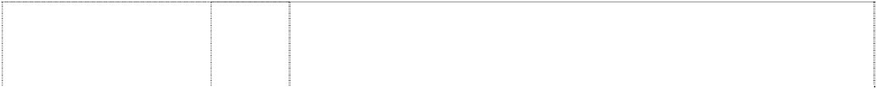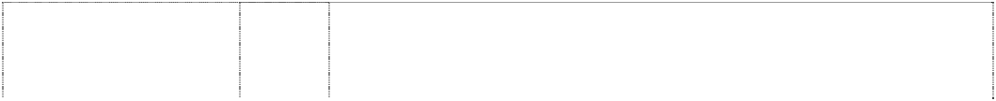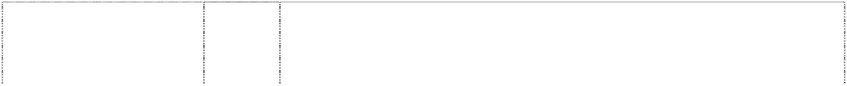

(758248)

triangle, circle, cross and rectangle all in circles

(758247)

triangle, circle, cross and rectangle all in circles

(758248)

triangle, circle, cross and rectangle all in circles

(758247)

triangle, circle, cross and rectangle all in circles

(758248)

triangle, circle, cross and rectangle all in circles

(758247)

triangle, circle, cross and rectangle all in circles

(758248)

9 Integrated circuits including large scale integrated circuits; cathode ray tubes; computers (including central processing units and peripheral equipment for computers); CD-ROM drivers, CD-ROM cases; electron tubes; semi-conductor elements (semi-conductor devices); electronic circuits (excluding those carrying computer programs); programmed data-carrying electronic circuits; programmed data-carrying electronic magnetic disks; programmed data-carrying electronic magnetic tapes; programmed data-carrying electronic CD-ROMs; programmed data-carrying electronic ROM- cartridges; game equipment containing memory devices namely electronic magnetic discs for use with television receivers; electronic devices for generating graphic image reflecting audio signals for use with television receivers; memory units for hand held unit for playing electronic games; CD-ROM recorded virtual reality game software; ROM-cartridge recorded virtual reality game software; CD-ROM encoded video game software; ROM-cartridge encoded video game software; CD-ROM encoded computer game software; ROM- cartridge encoded computer game software; memory cartridges for personal computer games; joysticks for personal computer games; video game apparatus for personal use; video game apparatus for commercial use; analogue controllers for video games; video game discs; video game interactive remote control units; interactive remote control units for personal computers; memory cartridges for video games; joysticks for video games; compact disk players; memory cards for video games; EEPROM (electrically erasable programmable read only memory) cards; loudspeakers and other accessories and fittings of video games.

16 Printed publications including books and magazines; stationery.

16 Printed publications including books and magazines; stationery.

25 Clothing including gloves, mufflers, neckties, scarves, socks, stockings, T-shirts, articles of outer clothing.

25 Clothing including gloves, mufflers, neckties, scarves, socks, stockings, T-shirts, articles of outer clothing.

28 Games and playthings including electrical and electronic toys and games; parts and fittings for all the aforesaid goods in this class.

28 Games and playthings including electrical and electronic toys and games; parts and fittings for all the aforesaid goods in this class.

***Starion Tapware Pty Ltd Spruson & Ferguson Lawyers Ph: (02) 9393 0300***

***Effective Date: 14 September 2007 File Reference: C07/16047***



***Trade Marks***

***Class***

***Goods***

# V BY SEIDLER

(891946)

11 Apparatus for water supply and sanitary purposes, including toilets,

cisterns, tapware, toilet seats, baths, shower bases, vanities, wash basins and bidets, and parts and fittings in this class for all the foregoing goods.

# V BY SEIDLER

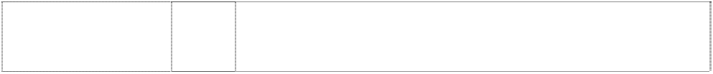

(891946)

# SEIDLER V

(891949)

# SEIDLER V

(891949)

# STARION

(940588)

21 Bathroom accessories in this class including toilet brushes, toilet brush stands, toilet roll holders, soap holders and dispensers, toilet paper holders, toothbrush tidies and holders; containers, trays and utensils for household use (not of precious metal).

11 Apparatus for water supply and sanitary purposes, including toilets, cisterns, tapware, toilet seats, baths, shower bases, vanities, wash basins and bidets, and parts and fittings in this class for all the foregoing goods.

21 Bathroom accessories in this class including toilet brushes, toilet brush stands, toilet roll holders, soap holders and dispensers, toilet paper holders, toothbrush tidies and holders; containers, trays and utensils for household use (not of precious metal).

11 Tapware; apparatus for water supply and sanitary purposes, including toilets, cisterns, toilet seats, baths, shower bases, vanities, wash basins and bidets, and parts and fittings in this class for all the foregoing goods.

***Strong Technologies Pty Ltd Spruson & Ferguson Ph: (02) 9393 0300***

***Effective Date: 13 August 2007 File Reference: C07/13166***



***Trade Marks***

***Class***

***Goods***

**S STRONG**

ltr is striped (840660)

9

Electric, electronic and telecommunications apparatus and instruments excluding cinematographic apparatus and equipment.

***Stylus Pty Ltd Spruson & Ferguson Lawyers***

***Ph: (02) 9393 0300***

***Effective Date: 14 September 2007 File Reference: C07/16043 Trade Marks Class Goods***

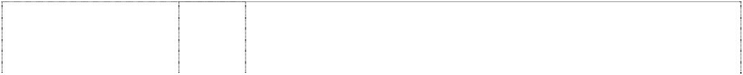

**AIRFORCE** (594218) **BATHWORKS** (668611) **BOREAL** (974077)

# ECONOLUX

(758940)

**HYDRO-HEAVEN** (758369) **KARRAN** (453051)

# KARRAN

(594216)

**maxxum** (471245) **MINUET** (974076)

# PARADISE

(1154661)

**SMART THINKING IN BATHROOMWARE** (928774)

11 Bath apparatus in class 11.

11 Baths, showers, shower trays, shower screens in this class; all goods in this class.

11 Apparatus for water supply and sanitary purposes, baths, spa baths, sinks, tubs, basins, showers, shower screens and trays, toilets, taps and parts and fittings for all of the foregoing.

11 Baths, showers, laundry tubs, basins, kitchen sinks and fittings, bath fittings, shower fittings, sanitary ware and taps.

11 Baths, showers, laundry tubs, basins, kitchen sinks and fittings, bath fittings, shower fittings, santitary ware and taps.

1 Chemical products for use in industry including polymeric materials especially acrylic polymers, methyl, methacrylates and modified methyacrylates for use in moulding processes all being goods included in class 1.

11 Sinks in class 11.

11 Spa pools; spa baths; sanitary ware including tubs, basins, toilets, bidets, baths and sinks.

11 Apparatus for water supply and sanitary purposes, baths, spa baths, sinks, tubs, basins, showers, shower screens and trays, toilets, taps and parts and fittings for all of the foregoing.

11 Spa baths.

11 Apparatus for water supply and sanitary purposes, baths, spa baths, sinks, tubs, basins, showers, shower screens and trays, toilets, taps and parts and fittings for the foregoing goods.

**SMART THINKING IN SPA POOLS** (928782)

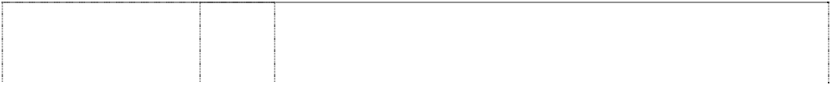

# SONATA

(932345)

# STYLUS

(928781)

# STYLUS

(1014494)

**STYLUS** (928781) **STYLUS** (1014494) **STYLUS** (1014494)

# STYLUS

(1014494)

# STYLUS

word breaks horizontal stripes

(358227)

**Sultan** (848004) **TERRACE** (758374) **THERA SPA** (758367) **VENECIA** (974079)

19 Pools in this class including spa pools and parts and fittings therefore.

11 Apparatus for water supply and sanitary purposes, baths, spa baths, sinks, tubs, basins, showers, shower bases and trays, taps and parts and fittings for the foregoing goods.

11 Apparatus for water supply and sanitary purposes, baths, spa baths, sinks, tubs, basins, showers, shower screens and trays, toilets, taps and parts and fittings for the foregoing goods.

11 Installations for water supply and sanitary purposes; sanitary ware; plumbing fittings and fixtures in this class; wash basins, hand basins, vanity basins, baths in this class, bathtubs, showers, shower bases, shower screens; toilets, toilet suites, cisterns and pans; bidets and bidettes; urinals; toilet cistern buttons; toilet seats; tapware and faucets; clothes dryers and other dryers in this class, including portable dryers; apparatus for lighting, heating, drying, refrigerating, cooking and ventilating; fittings, fixtures and accessories in this class for all the aforesaid goods.

19 Pools in this class including spa pools and parts and fittings therefore.

1. Pools in this class including spa pools and parts and fittings therefor.
2. Furniture, including furniture made from plastic; bathroom furniture and fittings in this class; cabinets and shelves for storage, towel rails, towel dispensers, curtain rails, curtain rods, curtain rings, medicine cabinets, mirrors, chairs, stools, tables, cupboards; coat hooks not of metal; plastic fittings included in this class; articles (not included in other classes) of plastic, horn, bone, ivory, shell, amber, mother-of- pearl, meerschaum, celluloid, wood, cork, reeds, cane, wicker or substitutes for all these materials.
3. Small domestic utensils and containers; bathroom accessories in this class; tumblers and tumbler holders, toilet brushes and toilet brush holders and stands; combs, hair brushes, nail brushes and general cleaning brushes; sponges; make-up cases, comb cases, nail brush cases; bath trays for use in the bathroom; trays for holding bathroom utensils; large and small containers in this class for miscellaneous uses including wastepaper and general tidy bins, dustbins (including those made from plastic) and containers in which to place cottonwool balls and soaps; soap holders and dispensers in this class; toilet roll holders and dispensers, toilet paper holders and dispensers; toothbrush tidies and holders; toothbrushes; cups; towel rails and holders in this class; paper towel dispensers in this class; containers, trays and utensils (not of precious metal) for household use; articles of plastic in this class; glassware, porcelain and earthenware not included in other classes.

11 Baths, hand basins, shower units and associated bathroom fittings in this class.

11 Baths, spa baths, bathroom accessories, toilets, basins, vanities, shower screens.

11 Baths, showers, laundry tubs, basins, kitchen sinks and fittings, bath fittings, shower fittings, sanitary ware and taps.

11 Baths, showers, laundry tubs, basins, kitchen sinks and fittings, bath fittings, shower fittings, santitary ware and taps.

11 Apparatus for water supply and sanitary purposes, baths, spa baths, sinks, tubs, basins, showers, shower screens and trays, toilets, taps and parts and fittings for all of the foregoing.

**ADDITIONAL TRADE MARKS**

***Acushnet Australia Pty Ltd Allens Arthur Robinson Ph: (03) 9614 1011***

***Effective Date: 12 July 2006 File Reference: C06/11578 Trade Marks Class Goods***

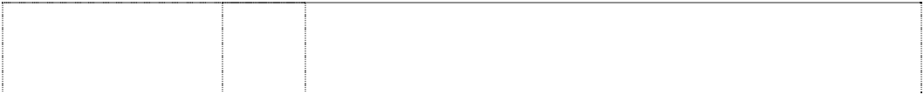

# BV

ltrs,winged (1079669) **COBRA** (738726) **COBRA** (738726)

**DRYJOYS** (540333) **GREENJOYS** (298151) **GREEN-JOYS** (314520)

# KING S COBRA

ltr is snake wearing crown in ellipse (738724)

# NXT DISTANCE

(886618)

# SCOTT CAMERON

(573412)

# SCOTTY CAMERON

(932365)

# VOKEY DESIGN

(1079669)

28 Golf equipment, including golf clubs; parts and accessories for golf equipment; gymnastic and sporting articles not included in other classes; games and playthings; decorations for Christmas trees.

25 Clothing including shirts, T-shirts, sweatshirts, sweaters, pants, shorts, jackets and hats, but excluding footwear.

28 Golf bag covers, golf bags, golf balls, golf club heads, golf club inserts, golf club shafts, golf clubs, hand grips for golf clubs, head covers for golf clubs, golf gloves, golf irons, golf putter covers, golf putters and golf tees.

25 Footwear, particularly golf shoes; and all other goods in this class.

25 Clothing, including golf shoes and footwear included in class 25.

9 Footwear included in this class.

28 Golf clubs, golf bag covers, golf bags, golf balls, golf club heads, golf club shafts, golf club grips, head covers for golf clubs, golf gloves, golf irons, golf putter covers, golf putters and golf tees.

28 Golf equipment, namely golf balls.

28 Golf putters.

28 Golf apparatus, equipment and accessories, including golf clubs, golf tees, golf gloves, golf bags, golf putters, golf drivers, golf woods, golf irons, golf green repair tools, golf club covers, and golf bag covers.

28 Golf equipment, including golf clubs; parts and accessories for golf equipment; gymnastic and sporting articles not included in other classes; games and playthings; decorations for Christmas trees.

***Décor Corporation Pty Ltd, The Allens Arthur Robinson Ph: (03) 9614 1011***

***Effective Date: 9 May 2007 File Reference: C07/14816 Trade Marks Class Goods***



**POWERSQUEEZE** (1156567) **SPEEDMITT** (1156580)

21 Mops, brooms, brushes, mitts, and other cleaning utensils in class 21.

21 Mops, brooms, brushes, mitts, and other cleaning utensils in class 21.

***GM Holden Ltd Global Brand Protection***

***Ph: (03) 9415 8104***

***Effective Date: 16 August 2006 File Reference: C06/17666***

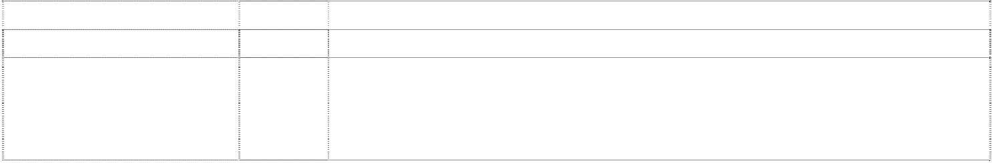

***Trade Marks***

***Class***

***Goods***

**VXR**

(1068859)

6

Small items of metal hardware; metal signs; metal containers; metal trinkets, keys and key rings; car badges (of metal); metal licence, number and registration plates; metal surrounds for licence, number and registration plates.

# VXR

(1068859)

# VXR

(1068859)

# VXR

(1068859)

# VXR

(1068859)

# VXR

(1068859)

# VXR

(1068859)

# VXR

(1068859)

**VXR** (1068859) **VXR** (1068859) **VXR** (1068859)

racing car, stylised (1121601)

9 Apparatus and instruments for the recording, transmission or reproduction of sound or images including photographic film, video tapes, audio tapes, and computer discs; containers and carriers for compact discs and/or tapes; electronic games including video games on disc and tape and programmed video games; computer games; vehicle race simulators; magnets; fridge magnets; telecommunication apparatus and instruments; mobile telephones; parts of and accessories for mobile telephones in this class; mobile telephone covers; anti-theft warning and detection apparatus; motor vehicle navigation systems; motor vehicle location systems; systems and apparatus to automatically notify the deployment of vehicle airbags; computers and parts thereof including micro-chips, and controllers; computer software for use in motor vehicles; computer software for use in the motor vehicle trade and industry; cigar and cigarette lighters for motor vehicles; sun glasses; eye glass frames; eye glass chains, cords, cases and other eye glass accessories in this class.

12 Aircraft; caravans and trailers; cycles and bicycles; motor land vehicles; cars, buses, trucks and motorcycles; land vehicles; wheeled baby and children's carriers; prams; strollers; parts and accessories for all the foregoing.

14 Containers, utensils and other goods made of precious metals; jewellery, watches, wall clocks and other timepieces; trophies and plaques.

16 Stationery, pens, pencils, posters, stickers, decalcomanias, flags and banners made of paper, promotional material in this class, coasters made of paper, magazines and publications; calendars and diaries; postage stamps; printed material in this class.

1. Small household items in this class; furniture in this class; nursery furniture; cots; cradles; bassinettes; change tables; high chairs; rocking chairs; baby carriers; baby change tables; mirrors; picture frames; bedding in this class; bins; display boards and stands; boxes, cases and containers; containers and carriers for compact discs and/or tapes; garment storage covers; deck chairs; drinking straws; fans for personal use; hampers; headrests; keyboards for hanging keys; non-metal keys, key chains and key rings; containers (not of metal) for liquid fuel; lockers; locks; car badges (not of metal); non-metal licence, number and registration plates; non-metal surrounds for licence, number and registration plates; pillows; cushions; cushions filled with polystyrene pellets; placards of wood or plastics; decorative wall plaques; statues and statuettes of wood, wax, plaster or plastic; free standing barriers; non-metal bottle carriers.
2. Utensils, containers and trophies in this class; household and kitchen utensils; glassware, porcelain and earthenware in this class; crystal, crockery, mugs and cups; holders for drink containers; bottle openers; cork screws; cocktail stirrers; portable coolers; thermally insulated containers for food and beverages.
3. Textiles and textile goods; bedding, linen, towels, tea towels and face washers; cloth badges, flags and banners; bar towels and mats including rubber backed bar mats; loose covers for furniture; cushion covers; covers to be filled with polystyrene pellets to form seats and cushions; furniture coverings of textile; curtains of textile and fabric.
4. Clothing, headgear and footwear; jackets, caps, shirts, jumpers, wind breakers, socks, underwear, driving suits and overalls; sleepwear.
5. Floor coverings including mats and rugs; floor coverings for vehicles in this class; carpets and mats for motor vehicles.
6. Games, toys, playthings and sporting equipment in this class; play development toys in this class; play mats; rocking horses; toy cars, model cars and slot cars and parts thereof; playing cards and jigsaw puzzles; bags for sporting equipment; golf equipment and accessories in this class; golf bags, golf clubs and golf balls.

6 Small items of metal hardware; metal signs; metal containers; metal trinkets, keys and key rings; car badges (of metal); metal licence, number and registration plates; metal surrounds for licence, number and registration plates; metal gravestones and tombstones; metal coffin fittings; metal monuments; metal statues and statuettes; metal



racing car, stylised (1121601)

racing car, stylised (1121601)

racing car, stylised (1121601)

racing car, stylised (1121601)

racing car, stylised (1121601)

racing car, stylised (1121601)

racing car, stylised (1121601)

racing car, stylised (1121601)

racing car, stylised (1121601)

racing car, stylised (1121601)

works of art; metallic plaques.

9 Apparatus and instruments for the recording, transmission or reproduction of sound or images including photographic film, video tapes, audio tapes, and computer discs; containers and carriers for compact discs and/or tapes; electronic games including video games on disc and tape and programmed video games; computer games; vehicle race simulators; magnets; fridge magnets; telecommunication apparatus and instruments; mobile telephones; parts of and accessories for mobile telephones in this class; mobile telephone covers; anti-theft warning and detection apparatus; motor vehicle navigation systems; motor vehicle location systems; systems and apparatus to automatically notify the deployment of vehicle airbags; computers and parts thereof including micro-chips, and controllers; computer software for use in motor vehicles; computer software for use in the motor vehicle trade and industry; cigar and cigarette lighters for motor vehicles; sun glasses; eye glass frames; eye glass chains, cords, cases and other eye glass accessories in this class.

1. Lighting and cooling apparatus for vehicles; air conditioners for vehicles; heating and defrosters for vehicles, reflectors for vehicles; lighting, heating, cooking, refrigerating, drying and ventilating apparatus; portable apparatus for lighting, heating, cooling, refrigerating, drying and ventilating; lighting, heating, cooling, refrigerating, drying and ventilating apparatus adapted to be powered by a motor vehicle engine and/or battery.
2. Aircraft; boats; caravans and trailers; cycles and bicycles; motor vehicles; cars, buses, trucks and motorcycles; land vehicles; wheeled baby and children's carriers; prams; strollers; parts and accessories for all the foregoing.

14 Containers, utensils and other goods made of precious metals; jewellery, watches, wall clocks and other timepieces; trophies.

16 Stationery, pens, pencils, posters, stickers, decalcomanias, flags and banners made of paper, promotional material in this class, coasters made of paper, magazines and publications; calendars and diaries; postage stamps; printed material in this class.

18 Leather and imitation leather goods; goods in class 18 made from leather and imitation leather, trunks, carry bags, travelling bags and brief cases; wallets; luggage tags; key pouches and business card holders in class 18; belts in class 18; umbrellas, parasols and walking sticks.

1. Small household items in this class; furniture in this class; nursery furniture; cots; cradles; bassinettes; change tables; high chairs; rocking chairs; baby carriers; baby change tables; mirrors; picture frames; bedding in this class; bins; display boards and stands; boxes, cases and containers; garment storage covers; deck chairs; drinking straws; fans for personal use; hampers; headrests; keyboards for hanging keys; non-metal keys, key chains and key rings; containers (not of metal) for liquid fuel; lockers; locks; car badges (not of metal); non-metal licence, number and registration plates; non-metal surrounds for licence, number and registration plates; pillows; cushions; cushions filled with polystyrene pellets; placards of wood or plastics; decorative wall plaques; statues and statuettes of wood, wax, plaster or plastic; free standing barriers; non-metal bottle carriers; coffins and coffin fittings not of metal.
2. Utensils, containers and trophies in this class; household and kitchen utensils; glassware, porcelain and earthenware in this class; crystal, crockery, mugs and cups; holders for drink containers; bottle openers; cork screws; cocktail stirrers; portable coolers; thermally insulated containers for food and beverages.
3. Textiles and textile goods; bed blankets, bed clothes, bed covers, bed linen, household linen, bath linen, table linen, towels, tea towels and face washers; flags and banners; bar towels and mats including rubber backed bar mats; loose covers for furniture; cushion covers; covers to be filled with polystyrene pellets to form seats and cushions; furniture coverings of textile; curtains of textile and fabric.
4. Clothing, headgear and footwear; jackets, caps, shirts, jumpers, wind breakers, socks, underwear, driving suits and overalls; sleepwear.

racing car, stylised (1121601)

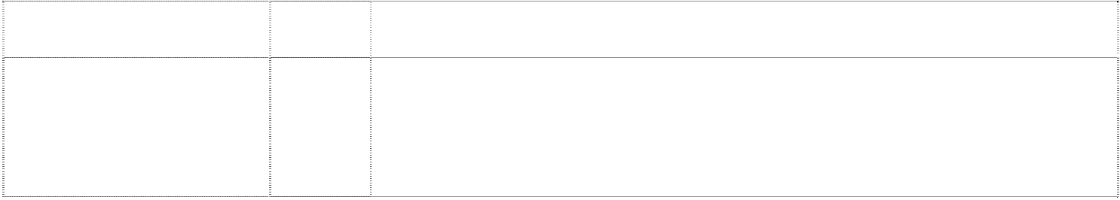

racing car, stylised (1121601)

1. Floor coverings including mats and rugs; floor coverings for vehicles in this class; carpets and mats for motor vehicles.
2. Games, toys, playthings and sporting equipment in this class; play development toys in this class; play mats; rocking horses; toy cars, model cars and slot cars and parts thereof; playing cards and jigsaw puzzles; bags for sporting equipment; golf equipment and accessories in this class; golf bags, golf clubs and golf balls.

***Zippo Manufacturing Company Watermark Patent & Trade Mark Attorneys Ph: (03) 9819 1664***

***Effective Date: 20 December 2006 File Reference: C06/18351 Trade Marks Class Goods***



**BLU** (1136054) **BLU** (1136054)



4 Fuels and fluid for lighters including cigarette and cigar lighters; lighting fuel.

34 Lighters including cigarette and cigar lighters; leather pouches for lighters.