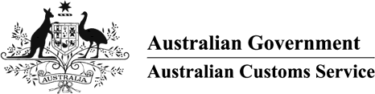

# AUSTRALIAN CUSTOMS NOTICE NO. 2007/59

**Amendments to the *Customs (Prohibited Imports) Regulations 1956* and the *Customs (Prohibited Exports) Regulations 1958***

# Terrorist Material

Regulation 4A of the *Customs (Prohibited Imports) Regulations 1956*

(PI Regulations) and Regulation 3 of the *Customs (Prohibited Exports) Regulations 1958* (PE Regulations) prohibit without permission, respectively, the importation or exportation, of objectionable goods.

In response to a Government initiative to ensure that material that advocates the doing of terrorist acts is not lawfully available within Australia, amendments to Regulation 4A of the PI Regulations and Regulation 3 of the PE regulations insert new prohibitions on the importation and exportation, respectively, of publications and goods which advocate the doing of a terrorist act. The importation or exportation of such publications or goods are now prohibited unless the Attorney-General or an authorised person had given written permission to import or export the goods. The amendments specify when a publication or good advocates, or does not advocate, the doing of a terrorist act and provides that the term ‘terrorist act’ has the same meaning as given to the term by section 100.1 of the *Criminal Code*.

These amendments complement recent amendments made to the *Classification (Publication, Films and Computer Games) Act 1995* which require publications, films or computer games that advocate the doing of terrorist act to be ‘Refused Classification’.

The amending Regulations commenced on 20 October 2007.

Enquiries regarding this notice may be directed to Community Protection Policy on telephone (02) 6275 6114 or via email to [community.protection@customs.gov.au](mailto:community.protection@customs.gov.au).

John Potter

A/g National Manager

Trade Policy and Regulation Branch CANBERRA ACT

October 2007