AUSTRALIAN CUSTOMS NOTICE NO. 2008/01

# Notices of Objection to Importation Trade Marks Act 1995

The *Trade Marks Act 1995* allows the registered owner, or in certain circumstances, the authorised user of a trade mark to lodge a Notice of Objection with the Australian Customs Service (Customs), objecting to the importation of goods which infringe their trade mark. Unless revoked, a Notice of Objection remains in force for a period of four years (effective 23 October 2006) from the date of commencement.

The attached Schedule sets out the registered owners and authorised users who have lodged Notices of Objection under the *Trade Marks Act 1995* since October 2007 (ACN 2007/58)*.* Descriptions of the relevant trade marks are also set out in the Schedule.

A detailed list of all current trade mark Notices of Objection is available on the Customs website at [www.customs.gov.au](http://www.customs.gov.au/) > media publications and forms> Customs notices > Intellectual Property – Notices of Objection > trade marks

For each particular trade mark described, the Schedule makes reference to a particular “class” of goods. This refers to the classes of goods prescribed in Schedule 1 to the *Trade Marks Regulations 1995* and along with a description of the goods, is used to describe the type of goods for which the particular trade mark is registered. Prospective importers of such goods should seek further advice from Customs regarding the ambit of any Notice of Objection set out in the Schedule.

Goods referred to in this ACN, that are manufactured outside and imported into Australia, and are subject to the control of Customs under the meaning of the *Customs Act 1901* are liable to be seized by Customs if:

* they have applied to them, or in relation to them, a sign that is substantially identical with, or deceptively similar to, a trade mark listed in the attached Schedule; and
* are goods in respect of which the notified trade mark is registered;

unless it can be established that the goods do not infringe the relevant trade mark.

Part 12 of the *Trade Marks Act 1995* details the circumstances in which the use of a trade mark may, or may not, amount to an infringement. For example, a trade mark is not infringed where the mark in question has been applied to, or in relation to, goods with the consent of the registered owner of the trade mark. However, where the trade mark is applied by, or with the consent of, an overseas owner of the trade mark and the goods are imported into Australia without the consent of the Australian trade mark owner, this may still represent an infringement.

People who are intending to import goods that potentially may be liable to seizure under the provisions of the *Trade Marks Act 1995* should consider seeking advice from Customs, or a suitably qualified legal practitioner, as to the implications of the trade marks legislation, and the meaning of terms such as "substantially identical with", "deceptively similar to" and "an infringement of" a trade mark.

Where a registered trade mark owner or an authorised user with a current Notice of Objection in place request additional trade marks to be added to their Notice, only the additional trade marks are included at the end of this ACN. The inclusion of additional trade marks in the ACN is to ensure that ACN subscribers have all the appropriate up-to-date information.

Copies of the relevant Notices of Objection have been forwarded to the Customs office in the capital city of each State and Territory. Importers, or their advisers, who require further information regarding the Notices of Objection, or Customs role in respect of those Notices, should contact the Customs Information and Support Centre on 1300 363 263 or the Intellectual Property Rights Group on (02) 6275 6577.

John Potter

A/g National Manager

Trade Policy & Regulation Branch CANBERRA ACT

December 2007



**SCHEDULE TO ACN NO. 2008/01 TRADE MARK NOTICES OF OBJECTION**

***Adobe Systems Incorporated Mallesons Stephen Jaques Ph: (02) 9296 2000***

***Effective Date: 7 November 2007 File Reference: C07/18944 Trade Marks Class Goods***



# ACROBAT

(593140)

**ADOBE** (475806) **ADOBE A**

triangle incomplete is ltr A in square (599870)

**ADOBE ILLUSTRATOR** (468319)

**ADOBE PREMIERE** (587085) **CREATIVE SUITE** (1040789)

9 Computer programs in the field of electronic document storage, manipulation, transfer and retrieval, and manuals for use therewith, sold as a unit.

9 Computer programs included in this class.

9 Computer programs for use in creating, viewing, manipulating, distributing, printing, storing, transferring and retrieving computer- aided graphics, text documents, fonts, multi-media applications, digital movies, video images, audio recordings, animation and still images; computer hardware, namely computer peripherals, integrated circuits and facsimile machines; and all other goods included in this class.

9 Computer programmes.

9 Computer programs for creating and editing digital movies, video images, audio recordings, animation, still images and graphics.

9 Computer software; computer programs for use in desktop publishing, electronic publishing, digital publishing, web publishing, graphic design, illustration, animation, imaging, typesetting or printing; computer programs for page layout and design; computer programs for creating, editing, manipulating, viewing, managing, indexing, cataloguing, sorting, organizing, storing, transferring, synchronizing, printing and exchanging digital photographs, digital and graphic images, data, text, audio, video, multimedia and interactive documents and recorded information; computer programs for artistic and technical drawing and illustration; computer programs for the creation, conversion, storage, annotation, manipulation, transfer, sharing and retrieval of electronic documents and forms; business software; computer programs for web authoring; computer software used for the development, content creation, maintenance, administration and management of web sites; computer software for project management, asset management, file management, collaborative workflow, file sharing and file transfer via computer networks, wireless networks and global communication networks in the fields of graphic design and publishing; computer software to search, preview and track changes in electronic documents and files; computer software for electronic data management and tracking, file browsing, electronic data sharing, digital rights management and collaborative workflow automation; computer programs for accessing and converting photographic, digital, and graphic images, data and text documents, audio, video and multimedia works, and recorded information to various file formats; computer software for creating, processing, exchanging and managing metadata, or machine- readable labels about information or content, in electronic files, databases and digital assets; computer software for transferring digital photographs, digital and graphic images, data, text, audio, video, multimedia and interactive documents and works, text documents, and recorded information to CD-ROM discs and digital video discs; electronic publications, namely, user manuals and instruction books featuring information in the fields of computer software, graphic design and publishing, recorded on machine- readable data carriers, printed instructional books and manuals sold as a unit therewith.

# DREAMWEAVER

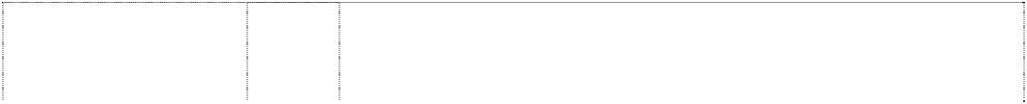

(740201)

# FLASH

(993587)

**FREEHAND** (705475) **INDESIGN** (793127)

**PHOTOSHOP** (539638) **PHOTOSHOP LIGHTROOM** (1111036)

looped trefoil/tricuspid (671119)

9 Computer hardware; computer peripherals; computer software including that for use in developing internal and external web sites, and accessories in this class; user manuals for use with the foregoing sold as a unit.

9 Computer software; user manuals and instructional books sold as a unit therewith; and user manuals and instructional books in electronic form.

9 Computer software, computer hardware and computer manuals.

9 Computer software; computer programs for the use in the fields of desktop publishing, electronic publishing, digital publishing, printing, graphics, imaging, illustration, animation or typesetting; computer programs for creating, editing, manipulating, transferring or retrieving text, graphics, illustrations or images; computer software for publishing, printing, imaging or typesetting via a local or global computer or communications network; computer programs for use in accessing, creating, manipulating, editing, downloading or transferring data via a local or global computer or communications network, and instructional books and manuals sold as a unit therewith.

9 Computer programs for creating and manipulating graphic images on a computer.

9 Electrical and electronic apparatus and instruments; computer hardware and computer peripheral devices; communications apparatus and instruments; printers; scanners; magnetic data carriers; recordings discs; calculating machines; data processing equipment and computers; computer software; computer software for use in the field of digital photography and photography; computer software for digital photography workflow and digital photo storage and management; computer software for creating, importing, processing, viewing, manipulating, editing, managing, indexing, cataloguing, archiving, sorting, organizing, storing, transferring, synchronizing, exporting, printing, and exchanging digital photographs, digital images and graphics; computer software for transferring digital photographs, images and graphics to CD-ROM discs and digital video discs; computer software for transferring digital photographs, images and graphics for use over computer networks, wireless networks and global communication networks and wireless devices; computer programs and computer tutorial software for creating, sending, managing, and storing greeting cards, books, documents, automated PDF slide shows, photo galleries and albums; file management software for converting digital photographs, images and graphics to various file formats; printed users' manuals and instructional books sold as a unit therewith; electronic publications, namely, user manuals and instructional books in the fields of digital imaging and photography, recorded on computer media.

9 Computer software, computer hardware, pre-recorded CD Roms and users' manuals sold together as a unit all being goods in class 9.

***ALDI Stores ALDI Stores***

***Ph: (02) 9675 9000***

***Effective Date: 25 October 2007 File Reference: C07/18295***

Artificial sweetening preparations, artificial preservatives, preservatives for food; glycerine for industrial purposes.

1

**ALDI**

(783718)



***Trade Marks***

***Class***

***Goods***

# ALDI

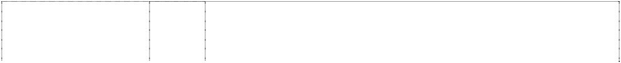

(783718)

# ALDI

(783718)

**ALDI** (783718) **ALDI** (783718)

# ALDI

(783718)

# ALDI

(783718)

3 Abrasive preparations and materials; cleaning materials and preparations; degreasing preparations; detergents, fabric conditioning preparations; grease removing materials; laundry blue and laundry use products, lavatory cleansers, soap and soap preparations in hard, soft, liquid and powdered form; liquid stain removers; pumice stone preparations for washing, cleaning and polishing purposes; washing agents and preparations, washing starch; washing-up liquids, soaps and powder; dishwasher liquid and powder; starch and starch preparations for washing and ironing purposes; personal hygiene preparations; anti-dandruff shampoos, bodycare products, hair tonics, lotions, shampoos and conditioners, hairsprays, preparations for washing, care of and improving the appearance of hair, scalp treatment preparations, shower gels, bath preparations and gels, beauty care products; perfumes and perfume products; cosmetic preparations and oils; toiletries, toilet articles, toilet soaps, water and preparations, dentifrices, mouthwashes (non- medicated); deodorants, teeth cleaning materials and preparations, toothpaste, essential oils, ethereal oils; dyeing preparations and additives; bleaches, bleaching agents and preparations, bleaching soda, soda; polishing agents, materials and preparations; scouring preparations; shoe cleaning preparations; stain preparations, stain remover sticks and paste; wax in this class; make-up removal and face wipes; cotton wool.

1. Medicated anti-dandruff shampoos, deodorants, disinfectants; glycerine and glycerine preparations for medical purposes; material for stopping teeth, plasters for medicinal purposes, material for dressings; medicinal oils and fats; air fresheners in aerosol or solid preparations; food for babies; dental wax; dietetic foods for infants and invalids; healthcare products, pharmaceutical preparations; female hygiene articles, sanitary preparations, tampons, towels and liners; veterinary preparations; wax preparations for ointments in this class.
2. Aluminium foil, foils, metal foils for wrapping; box-like receptacles (particularly rigid cased boxes) of metal.
3. Electrical kitchen appliances for chopping and grinding; electric coffee makers, electric hand mixers, electric irons, electric knives, electric stirrers, electric waffle irons; coffee filter machines, electric can openers, food processing machines (not cooking or refrigerating), smoothing irons; drill attachment, drill chuck, drill bits and screwing attachment for electric drills, drilling screws with storage battery; electrical garden appliances, power operated garden appliances, power operated saws.

11 Fans, fan heaters; hair dryers; toasters; food processing machines (cooking or refrigerating), kettles, microwave ovens; electric deep fryers; lamp attachments with spotlights and charging units, light bulbs; battery powered torches, lamps.

16 Cardboard and cardboard articles; cardboard carrying cases, cardboard cartons and boxes; paper goods and signs; box-like receptacles (particularly rigid cased boxes) of cardboard or paper; adhesives for stationery or household purposes; artists' materials; disposable nappies made of paper, babies' nappies, pants, liners; bin liners, refuse sacks; bookbinding materials; carrier bags and sacks; cellulose products; display strips made of plastic film or paper; handkerchieves of paper, hand towels, kitchen paper, kitchen rolls; napkins; paper, paper articles; printed matter; bags, serviettes, signs, tablecloths, tissues, tissue articles, toilet tissue, toilet paper; paint brushes; pasteboards; plastic film for wrapping, plastic packaging material; playing cards, photographs; printers type, printing blocks; stationery; teaching materials; typewriters and office requisites; wrapping sheets; writing materials.

# ALDI



(783718)

**ALDI** (783718) **ALDI** (783718)

# ALDI

(783718)

# ALDI

(783718)

21 Glassware, beer glasses, spirit glasses, wine glasses; brushes; cooking pots (non-electric); dish cloths, dusters, articles for cleaning purposes, brushes, combs; cloths and pads for scouring, cleaning or polishing (not impregnated with cleaning agents), dishcloths for cleaning purposes, dusters; rubber gloves for domestic and household use, sponges; earthenware jugs, porcelain goods and signs, box-like receptacles; cooking pots.

1. Games, playthings, toys.
2. Alcohol-free mixed milk drinks (not with added cocoa or chocolate); dessert meals based on milk; milk - skimmed, powder, tinned, cows' milk and cows' milk products, milk (concentrated, condensed, liquid or powdered); cream for nutrition purposes, cream - powdered or blended, dairy products; sweetened whey powder; custards (not custard powder or instant custard powder), blancmanges (ready made); butter; cheese and cheese products; cream cheese with fruits and/or fine bakery products, fat-free edible quark, fruit and herb quark; yoghurts, fruit and herb yoghurt, diet yoghurt and diet margarine; game; chicken and chicken pieces (fresh or frozen); meat, meat products, extracts, canned meat, curried meat and meat stew with dumplings; seafood, seafood products and frozen seafood; fish; freeze dried vegetables, fruit, meat and fish; fish fingers, frozen fish foods, poultry, game, vegetables, fruit, ready meals consisting of meat, poultry, fish, vegetables and pasta; almonds, baked beans (canned), canned foods, cooking oils and fats; edible oils and fats; eggs and preserved eggs; fruits (canned, cooked, dried, frozen or preserved); gelatine; gravies and preparations for making gravy; jams, jellies and preparations for making jellies; margarine; marmalade; mashed potato (instant); nuts (prepared), peanuts (processed or salted), peanut butter, pickles, potato crisps and snack foods; poultry and curried poultry; preserved pulses; soups (canned or packet) and preparations for making soup, stock cubes; soup herbs; sweet pie fillings (canned); vegetables (canned, cooked, dried, frozen or preserved); frozen prepared meals.
3. Bakery products; ready meals consisting of fine bakery and patisserie items or goods, pasties, sweet pastries, pastries; biscuits, bread, bread rolls and bread cakes, scones, cakes and cake mixes, sponges, snack foods, cheesecake and frozen cheesecake, fruit buns, gingerbread, groats; flour, flour preparations and confectionery; salad dressings, mayonnaise, sauces (including brown sauce and tomato ketchup, salad cream); baking powder, cereals; breakfast cereals and cereal preparations; chicory and chicory mixtures, chicory/coffee mixtures; chicory/barley mixtures; tea, teabags, tea preparations; chocolates, chocolate bars or coated bars, dairy chocolates, chocolate coated nougat and caramel bars, chocolate products, chocolate and sugar products filled with spirits or wine, confectionery - non medicated dairy, chocolate or sugar; cocoa, coffee extracts, essences and oils, coffee substitutes; drinking chocolate; crisps; custard powder, dessert preparations; farinaceous products for food for human consumption, frozen prepared meals; honey; ice, refrigerating ice; lasagne, lasagne sheets; malt and malt extract; marzipan; molasses and molasses syrup; mustard; noodles for soup and sauces, oats (crushed), pasta, pasta twists and shells and pasta sauce; pearl barley; pies; hamburgers; pizzas, prepared meals; quiche; ready meals (with separately packaged constituents); rice; pepper; salt (table and cooking); spices, cooking spices; sago; semi-prepared meals; semolina; spaghetti; sugar and sugar products, sweeteners, syrup; tapioca; vanilla, vanilla sugar, vinegar; waffles; yeast.
4. Animal foodstuffs; pet foods; cat litter; forestry products; flowers, horticultural products; agricultural products; malt; plants, seeds, seed grain; fresh fruit; vegetables (fresh).

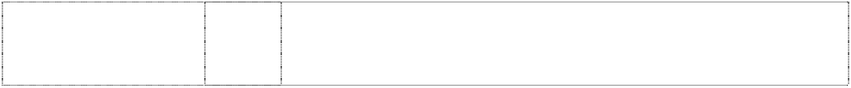

**ALDI**

(783718)

32

**ALDI**

(783718)

33

Alcohol-containing mixed milk drinks (not with added cocoa or chocolate) in this class; aerated waters and aerated mineral water; ale, alcohol-free beverages/drinks; beer; beverage preparations; carbonated drinks, carbonated water, fruit drinks, fruit juices and fruit juice drinks, fruit extracts (non-alcoholic), fruit based squashes; fruit flavoured squashes; lager; malt based preparations for making beverages; mineral waters, non-alcoholic drinks and preparations for making such drinks; porter; syrups and preparations for making beverages; soft drinks; vegetable juices (from root, bulbous, tuberous, stem, shoot, leaf, floret, crop or seed vegetable).

Alcoholic beverages, alcohol, brandy, cider, champagne and sparkling wines, cognac, liqueurs and cream liqueurs, sherry and other fortified wines, spirits, vodka, wines, wine-containing drinks, alcohol-containing drinks similar to wine.

***All India Foods Pty Ltd All India Foods Pty Ltd Ph: (07) 3391 1420***

***Effective Date: 6 December 2007 File Reference: C07/18943 Trade Marks Class Goods***



# GANESHA BRAND

(1103179) **INDYA BRAND** (1103507)

# Lashand

(915828)

# Lashand

(915828)

30 Rices and spices.

30 Spices and condamints.

1. Preserved, dried and cooked lentils and beans.
2. Flour, rice and spices.

***Andrew Bolton Chrysiliou Law***

***Ph: (02) 9953 4222***

***Effective Date: 2 October 2007 File Reference: C07/16962 Trade Marks Class Goods***

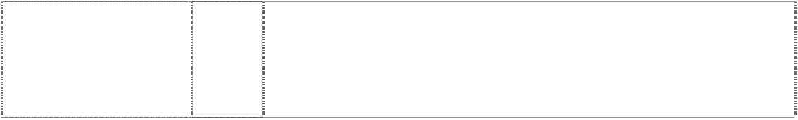

# VENOM RACING

snake,stylised (890375)

28 Toys, games and playthings, and parts and accessories therefor; toy models, including, toy cars, toy planes and toy boats, and parts and accessories therefor; hobby craft sets, including, hobby craft sets for construction, and parts and accessories therefor; model kits, including, radio controlled model kits, and parts and accessories therefor; radio controlled toy kits and parts and accessories therefor.

***Aristocrat Technologies Australia Pty Limited Aristocrat Technologies Australia Pty Limited***

***Ph: (02) 9413 6300***

***Effective Date: 7 November 2007 File Reference: C07/18975 Trade Marks Class Goods***



**ARISTOCRAT** (154646) **ARISTOCRAT** (787428)

9 Coin-freed apparatus, coin-freed automatic machines, coin-freed automatic distributors.

9 Gaming machines, including poker machines, in this class; computer hardware and software used for the operation of a jackpot system; data collection and processing systems in this class associated with gaming.

# ARISTOCRAT

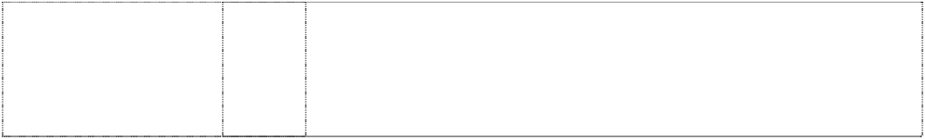

(1077493)

# ARISTOCRAT

(1077493)

9 Computer hardware; computer software, including computer software for gaming purposes and on-line gaming; gaming machines and parts and accessories for gaming machines in this class, including software modules, storage media and components and erasable programmable read-only memory (EPROM) chips; magnetic data carriers, recording discs; apparatus for recording, transmission, reproduction or display of sound or images; headphones; telecommunication apparatus and accessories therefor; storage media including compact discs, digital versatile discs; data processing equipment; electronic systems for linking gaming and poker machines; virtual reality game software; virtual reality game hardware; parts, accessories and peripheral devices in this class for the aforesaid goods.

28 Gaming machines; gaming machines comprising of software modules and components including game symbols, mathematics, sound effects and other configurable items embedded in erasable programmable read-only memory (EPROM) chips or other storage media; poker machines; parts, accessories and peripheral devices in this class for the aforesaid goods.

***Atomic Fashion Marketing Pty Ltd Trade Mark Investigation Services Ph: (07) 3257 1083***

***Effective Date: 7 November 2007 File Reference: C07/16052 Trade Marks Class Goods***



# EMILY

girl's head in disc (892657)

# EMILY

girl's head in disc (892657)

# EMILY

girl's head in disc (892657) **OOPSY DAISY** (897169) **OOPSY DAISY** (897169)

16 Stickers and posters.

18 Purses, wallets, coin purses, handbags and backpacks.

25 Clothing, namely, shirts, sweatshirts, t-shirts, tank tops, pants, shorts, dresses, pyjamas, socks, hats and hoods.

16 Stickers and posters.

18 Purses, wallets, coin purses, handbags and backpacks.

***British American Tobacco Australasia Limited Davies Collison Cave***

***Ph: (02) 9293 1000***

***Effective Date: 12 September 2007 File Reference: C07/16042 Trade Marks Class Goods***

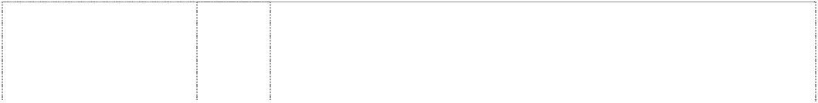

# 555 STATE EXPRESS

crest crown, imperial & scroll seal, stationery & disc

(169131) **ARDATH** (12010) **ARDATH** (289033) **BARCLAY** (510319)

34 Tobacco, raw or manufactured; smokers’ articles; matches.

34 Manufactured tobacco.

34 Smokers’ articles and matches.

34 Tobacco, raw or manufactured; smokers’ articles.

# BARCLAY

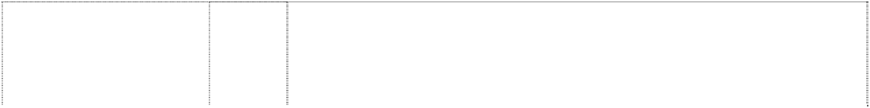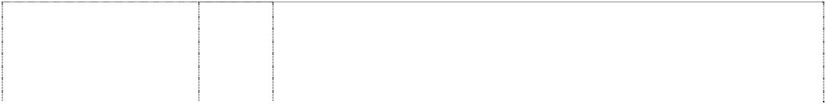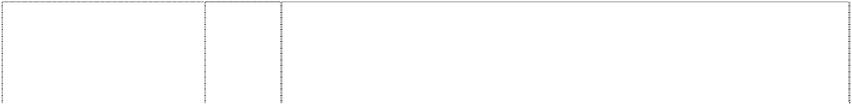

coat-of-arms coronet, pointed lions, rampant, two supporters shield, quartered stripes, horizontal

(443639)

# BENSON & HEDGES

(107302) **BENSON AND HEDGES**

coat-of-arms helmet, knight crowned horses, rampant two supporters shield quartered by cross, greek star, six-point in shield wreath flowers above scroll

(261344)

# BENSON & HEDGES B&H STERLING

coat-of-arms crown and mantling shield, quartered grain, ears (372202) **CAMBRIDGE** (727952)

# CAPSTAN

(21076)

# CAPTAIN BLACK

(85762)

# CAPTAIN BLACK

sailing ship atop hexagon and coat-of- arms

(784595) **CRAVEN** (2933) **CRAVEN A**

coat-of-arms coronet, pointed atop shield, halved with six fleur- de-lis lions, two, winged, supporters (161761)

# D DUNHILL

ltr d in square, rounded-corners below coat-of-arms in rect. (1003241)

# D DUNHILL

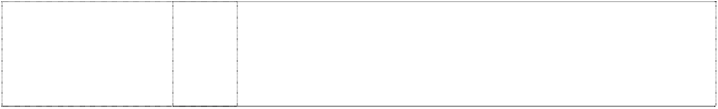ltr d in square, rounded-corners below coat-of-arms in rect. (1028841)

# D DUNHILL ESSENCE

ltr D in 3 squares, concentric in corner of larger square (1130026)

34 Tobacco, raw or manufactured; smokers’ articles.

34 Cigarettes, cigars and smoking tobacco.

34 Tobacco, raw or manufactured, smokers’ articles; matches.

34 Cigarettes.

34 Tobacco; cigarettes and cigars.

34 Tobacco whether manufactured or unmanufactured.

34 Tobacco pipes.

34 Pipe tobacco, cigars, cigarillos, roll-you-own tobacco, cigarettes, tobacco and tobacco products; lighters, matches and smokers’ requisites.

34 Tobacco; cigarettes and cigars and snuff.

34 Filter-Tip Cigarettes.

34 Cigarettes, cigars, cigarillos, roll your own tobacco, pipe tobacco, tobacco and tobacco products.

34 Cigarettes, cigars, cigarillos, roll your own tobacco, pipe tobacco, tobacco and tobacco products.

34 Cigarettes, cigars, cigarillos, roll your own tobacco, pipe tobacco, tobacco and tobacco products.

# D DUNHILL ESSENCE

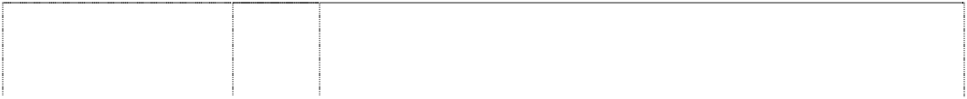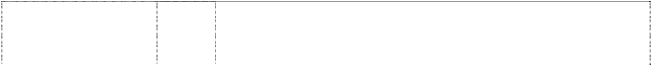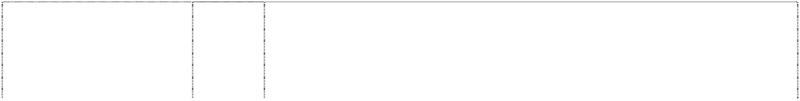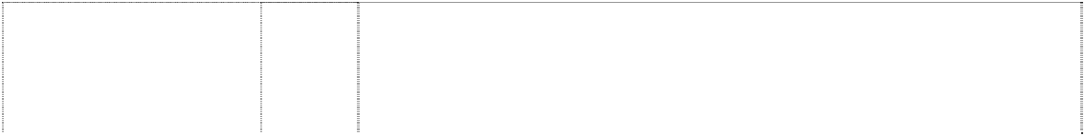

ltr D in 3 squares, concentric in corner of larger square (1154117)

# D DUNHILL ESSENCE

ltr D in 3 squares, concentric in corner of larger square (1167623)

# DUNHILL

coat of arms atop word in rect., striped, vert. (1091110)

# DUNHILL

coat of arms atop word in rect., striped, vert. (1091112)

# DUNHILL D TOP LEAF

coat of arms; leaf, styl. In square, all in frame (926661)

# DUNHILL MY MIXTURE

loop around ltr M in double circular frame (1068832)

# Dunhill Refinado

(1167625)

# FC DUNHILL FINE CUT

ltrs FC in square atop ltr D in square, all in rect., striped (1129999) **FREEDOM**

(567306)

# HOLIDAY

word between stripes above striped rect, sun, rays, 3 parallelograms, sail; (761372)

**HOLIDAY KINGS** (896975) **HOLIDAY KINGS BLUE**

coat-of-arms: 2 horses support quartered shield with crown, leaves

(1075422) **HOLIDAY KINGS GOLD**

coat-of-arms: 2 horses support quartered shield with crown, leaves

(1075423)

34 Cigarettes, cigars, cigarillos, roll your own tobacco, pipe tobacco, tobacco and tobacco products.

34 Cigarettes, cigars, cigarillos, roll your own tobacco, pipe tobacco, tobacco and tobacco products.

34 Cigarettes, cigars, cigarillos, pipe tobacco, roll your own tobacco, tobacco and tobacco products.

34 Cigarettes, cigars, cigarillos, pipe tobacco, roll your own tobacco, tobacco and tobacco products.

34 Cigarettes, cigars, cigarillos, roll your own tobacco, pipe tobacco, tobacco and tobacco products.

34 Cigarettes, cigars, cigarillos, roll your own tobacco, pipe tobacco, tobacco and tobacco products.

34 Cigarettes, cigars, cigarillos, pipe tobacco, roll your own tobacco, tobacco and tobacco products.

34 Cigarettes, cigars, cigarillos, roll-your-own tobacco, pipe tobacco and tobacco products.

34 All goods in this class.

34 Cigarettes, tobacco and tobacco products’ lighters, matches and smokers’ requisites.

34 Cigarettes, tobacco, tobacco products, smokers’ articles, lighters, matches.

34 Cigarettes, tobacco, tobacco products, smokers’ articles, lighters, matches.

34 Cigarettes, tobacco, tobacco products, smokers’ articles, lighters, matches.

# HOLIDAY KINGS GREEN

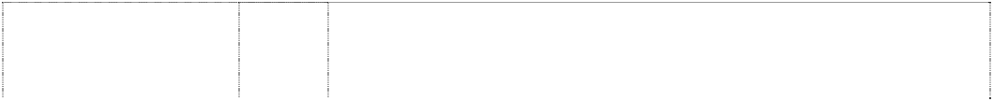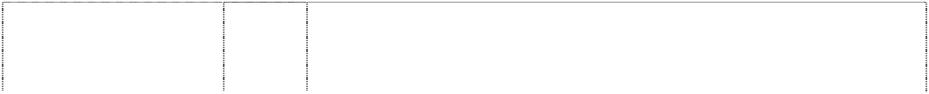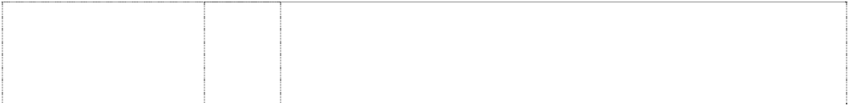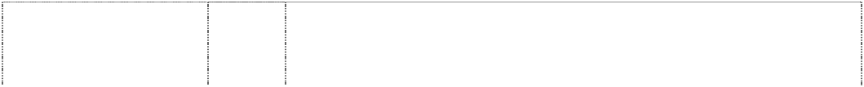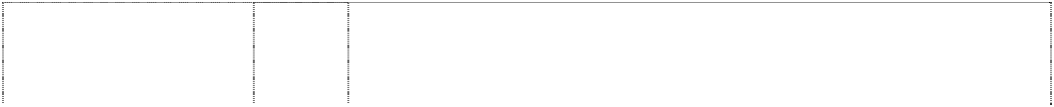

coat-of-arms: 2 horses support quartered shield with crown, leaves

(1075420) **HOLIDAY KINGS GREY**

coat-of-arms: 2 horses support quartered shield with crown, leaves

(1075421) **HOLIDAY KINGS PURPLE**

coat-of-arms: 2 horses support quartered shield with crown, leaves

(1075424)

# KENT

3 rings, concentric, segmented, broken (1143631)

# KENT

castle horizontal lines scrolls

(204765)

# KENT

cigarette box with rings, concentric, segmented, broken (1100938)

# KENT

palace or church, styl in rect atop word (774312)

**KOOL** (153276) **KOOL**

cigarette label panels bird, penguin (76959)

# LUCKY STRIKE (151409) LUCKY STRIKE LUCKIES IT’S TOASTED AN AMERICAL ORIGINAL

disc inside circles, concentric; stripe, horizontal (482934)

34 Cigarettes, tobacco, tobacco products, smokers’ articles, lighters, matches.

34 Cigarettes, tobacco, tobacco products, smokers’ articles, lighters, matches.

34 Cigarettes, tobacco, tobacco products, smokers’ articles, lighters, matches.

34 Cigarettes, tobacco, tobacco products, smokers' articles, lighters, matches.

34 Cigarettes.

34 Cigarettes, tobacco, tobacco products, smokers' articles, lighters, matches.

34 Cigarettes, tobacco, tobacco products, smokers' articles, lighters, matches.

34 Tobacco, raw or manufactured.

34 Manufactured tobacco.

34 Manufactured tobacco.

34 Cigarettes, tobacco; smokers’ articles; matches.

# PALL MALL WHEREVER PARTICULAR PEOPLE CONGREGATE PER ASPERA AD ASTRA

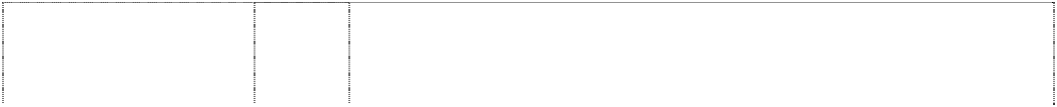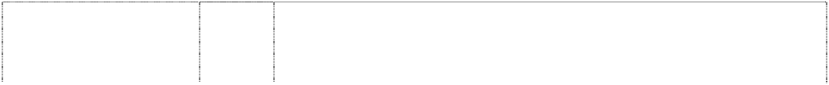

coat-of-arms helmet,knight crowned lions stylised,rampant crowned supporters shield,ellipse,annulus quartered towers,chesspieces,ro oks in two quarters grain,ears in two quarters scroll (261343) **PARLIAMENT** (109107) **PARLIAMENT**

coat-of-arms with

crown, horses rampant, shield & scroll atop rect., striped (1140953) **ROTHMANS** (94351)

# ROTHMANS PALL MALL

(96987) **ROTHMANS SPECIAL MILD R**

coat-of-arms with coronet,leaves,shield & lions,rampant, two stripe,oblique on cigarette carton (466640)

# SILK CUT

words in square in border

(741703)

# ST. MORITZ

coat-of-arms in double rectangle

(783958)

# STATE EXPRESS

(12014)

# STATE EXPRESS 555

coat-of-arms crest crown, imperial medallion seal, stationery chevrons, two one dotted (373042)

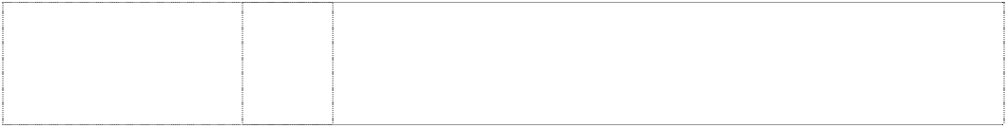**STATE EXPRESS NO.555 NO.555** (112380) **STRADBROKE** (578305) **STRADBROKE S**

stripes, double, three, oblique; stripes, three, curved, form S (469064)

34 Tobacco, raw or manufactured; smokers’ articles; matches.

34 Cigarettes.

34 Cigarettes, tobacco, tobacco products, smokers’ articles, lighters, matches.

34 Tobacco whether manufactured or unmanufactured.

34 Cigarettes.

34 Cigarettes.

Cigarettes, tobacco products, smokers’ articles, lighters, matches.

34 Cigarettes, tobacco and tobacco products; lighters, matches and smokers’ requisites.

34 Manufactured tobacco.

14 Precious metals and their alloys and goods in precious metals or coated therewith (except cutlery, forks, spoons); jewellery; precious stones; horological and other chronometric instruments.

34 Manufactured tobacco.

34 Raw and manufactured tobacco, smokers’ articles and matches.

34 Tobacco, smokers’ articles; matches.

**TURF** (27555) **TURF**

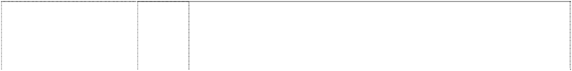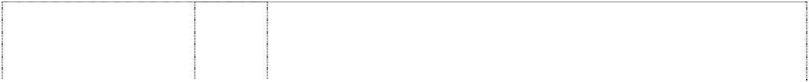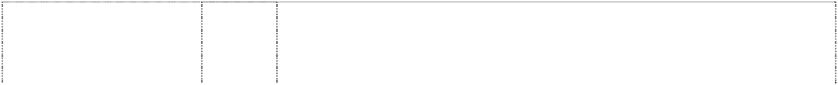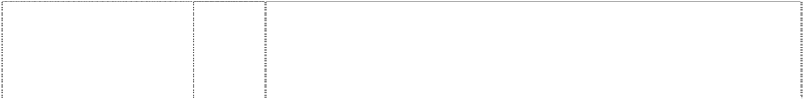

horse, winged (27554) **VICEROY** (151410) **VOGUE** (126298)

# W WINFIELD

chevron, double under coat of arms, leaves, 2 horses rampant (786027)

# WILLS

2 birds, styl. In flight atop stripe, horiz. (734994) **WINFIELD** (751560)

**WINFIELD** (751560) **WINFIELD** (751560)

# WINFIELD

(751560)

# WINFIELD

(751560)

**WINFIELD** (751560) **WINFIELD** (369487) **WINFIELD**

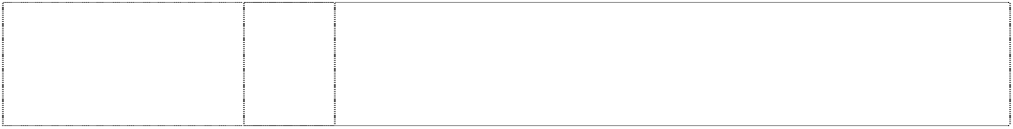coat-of-arms atop three chevrons in square, indented (657297) **WINNIES** (709246) **WINFIELD W**

coat of arms above chevron in rectangle, divided

(917043)

34 Tobacco whether manufactured or un-manufactured.

34 Tobacco whether manufactured or un-manufactured.

34 Manufactured tobacco.

34 Tobacco and tobacco products, whether raw or manufactured, including cigarettes.

34 Tobacco; smokers' articles; matches.

34 Cigarettes, tobacco, smokers’ articles, matches.

9 Apparatus and instruments for the recording, transmission, broadcasting, reception, storage, display, and reproduction of sound, images and data; photographic, cinematographic, optical, weighing, measuring, checking (supervision), life-saving and teaching apparatus and instruments; sunglasses; magnetic data carriers; computers, computer programs’ computer software’ apparatus and instruments for the encoding and decoding of electrical signals; satellite dishes; automatic vending machines and mechanisms for coin-operated apparatus; cash registers; calculating machines; data processing equipment; tapes, discs and cartridges all bearing or for the recordal of sound or images; audio and/or video recordings; multi-media communication, recording, transmission, broadcasting,

storage, display, reception and reproduction devices; parts and fitting for all the aforesaid goods.

12 Motor vehicles.

14 Precious metals and their alloys and goods in precious metals or coated therewith, not included in other classes; jewellery, precious stones; horological and chronometric instruments.

16 Paper, cardboard and goods made from these materials, not included in other classes; printed matter; bookbinding material; photographs; stationery; adhesives for stationery or household purposes; artist’ materials; paint brushes; typewriters and office requisites (except furniture); instructional and teaching material (except apparatus); plastic materials for packaging (not included in other classes); playing cards; printers’ type.

18 Leather and imitations of leather, and goods made of these materials and not included in other classes; animal skins, hides; trunks and traveling bags; umbrealls, parasols and walking sticks; whips, harness and saddlery.

25 Clothing, footwear and headgear.

34 Cigarettes.

34 Cigarettes, tobacco and tobacco products; lighters, matches.

34 Tobacco; smokers' articles; matches.

34 Cigarettes, tobacco, tobacco products, smokers' articles, lighters, matches.

***Energizer Australia Pty Limited Callinans***

***Ph: (03) 9809 7500***

***Effective Date: 20 October 2007 File Reference: C07/17529 Trade Marks Class Goods***

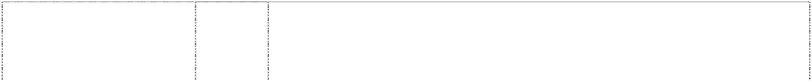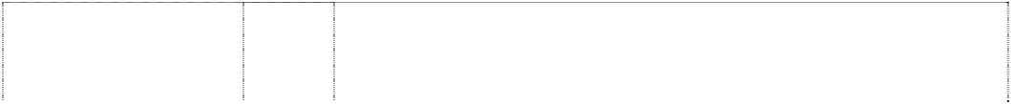

# E2

(804382)

**ENERGIZER** (386073) **ENERGIZER** (1120496)

**ENERGIZER** (382408) **ENERGIZER**

2 stripes with loop at end are grot. spoon with long handle (681600)

# ENERGIZER

brushstroke or blade underlines word (761781) **ENERGIZER**

brushstroke or blade underlines word (761781) **EVEREADY** (79952)

9 Dry cells and other electric batteries in this class; batteries for

lighting; batteries for pocket lamps and flashlights (torches); battery charges and re-charges.

9 Electric dry cells and batteries.

9 Battery-powered charging units or recharging units for mobile phones; battery-powered power packs for electronic games, electronic audio playback devices, and other electronic devices; battery chargers, battery rechargers; battery chargers for both embedded and loose batteries, including portable chargers; electrical and electronic apparatus and equipment, including battery powered sources of electrical energy and battery packs, but excluding hardware or software mechanisms used as aids in testing the behaviour of computer subsystems.

11 Electric flashlights and lanterns being goods in Class 11.

9 Electric accumulators; alarms and personal alarms of all types included in this class; fire extinguishers and fire extinguishing apparatus; indicators of low pressure in vehicle tyres; smoke detectors and smoke activated lamps; electric candles; electrical and electronic apparatus and instruments included in this class, including battery chargers, time switches, smoke activated switching apparatus, light activated timers, light activated power supply controllers, light activated lamps, power failure activated switches and lamps; batteries, electric dry cells and all other electric batteries included in this class; electric torches in this class; audio and video cassettes, magnetic tapes and computer tapes in this class.

9 Dry cells and other electric batteries in this class; batteries for lighting; batteries for pocket lamps; battery chargers and re-chargers.

11 Apparatus for lighting; torches and flashlights; light bulbs; electric lamps and lanterns; shades; reflectors; parts and accessories and fittings for the aforementioned goods.

9 Electric torches, electric batteries and dry cells.

***Ferrero S.p.A. Johnson Winter & Slattery***

***Ph: (02) 8274 9555***

***Effective Date: 5 October 2007 File Reference: C07/16961 Trade Marks Class Goods***

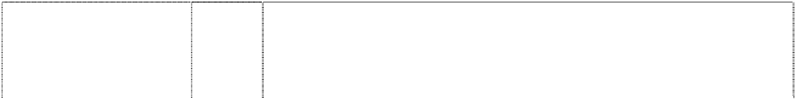

# FERRERO ROCHER

3 chocolates on doiley in oval,divide striped ribbon

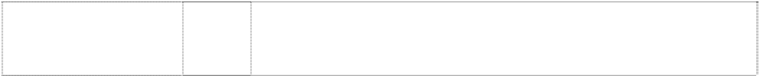(599013)

# FERRERO ROCHER

border, lace doiley food, cakes (407184)

30 Chocolate and confectionery.

30 Chocolate confectionery.

# FERRERO ROCHER

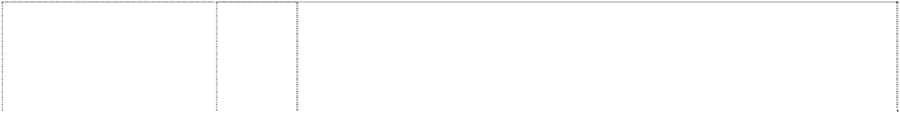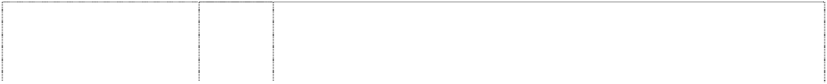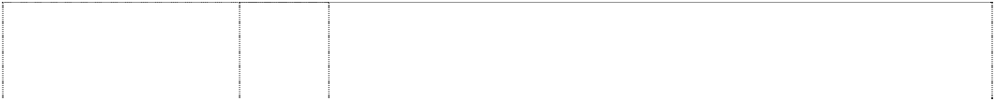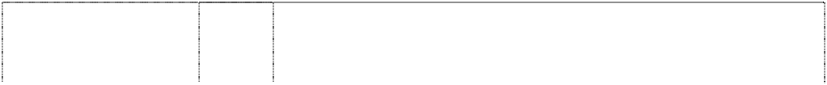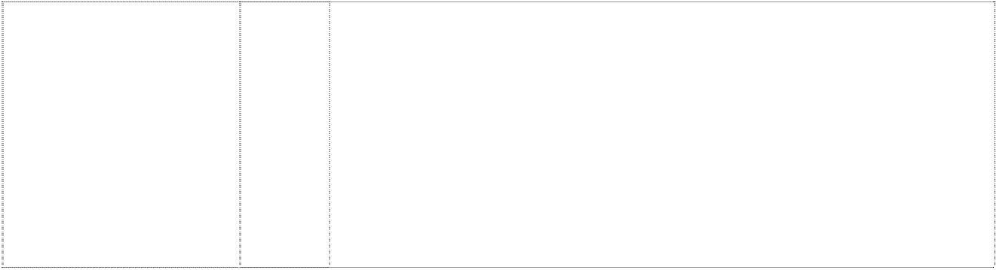

doiley grotesque on box with wrapped chocolates (599015)

# FERRERO ROCHER

wrapped chocolate in paper cup between praline & hazelnut with leaf, all break ellipse,triple

(951434)

*shape trade mark:* doiley on box with wrapped chocolates (922340)

*shape trade mark:* doiley on packet with wrapped chocolates (922350)

*shape trade mark:* wrapped chocolate in paper cup

(923171)

wrapped chocolate in paper cup between praline & hazelnut with leaf, all break ellipse,triple

(950881)

30 Chocolate and confectionery.

30 Coffee, tea, cocoa, sugar, rice, tapioca, sago, artificial coffee; flours and milled cereal products (except for fodder); bread, biscuits, cakes, pastry and confectionery, edible ice; honey, treacle; yeast, baking powder; cooking salt, mustard; pepper, vinegar, sauces; spices; ice for refreshment, cocoa, cocoa products, namely paste for cocoa beverages, chocolate paste, toppings and, including, chocolate toppings, chocolate, pralines, chocolate articles for christmas-tree decorations, food products consisting of an edible chocolate casing filled with an alcoholic liquid, sweet products, pastries, including fine pastry and longlife pastry; chewing-gum, sugarless chewing gum, sugarless candies.

30 Chocolate confectionery.

30 Chocolate confectionery.

30 Chocolate confectionery.

30 Coffee, tea, cocoa, sugar, rice, tapioca, sago, artificial coffee; flours and milled cereal products (except for fodder); bread, biscuits, cakes, pastry and confectionery, edible ice; honey, treacle; yeast, baking powder; cooking salt, mustard; pepper, vinegar, sauces; spices; ice for refreshment, cocoa, cocoa products, namely paste for cocoa beverages, chocolate paste, toppings and, in particular, chocolate toppings, chocolate, pralines, chocolate articles for christmas-tree decorations, food products consisting of an edible chocolate casing filled with an alcoholic liquid, sweet products, pastries, including fine pastry and longlife pastry; chewing-gum, sugar-free chewing gum, sugar-free sweets.

***GA Modefine S.A. Minter Ellisons Lawyers Ph: (03) 8608 2000***

***Effective Date: 18 November 2007 File Reference: C07/19611 Trade Marks Class Goods***

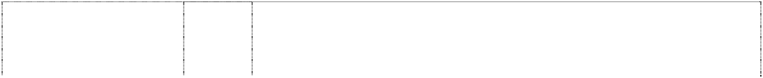

# A ARMANI / DOLCI

ltr A in rectangle (1031165)

# A ARMANI / DOLCI

ltr A in rectangle (1031165)

**A X ARMANI EXCHANGE** (901664)

1. Meat, fish, poultry and game; meat extracts; preserved, dried and

cooked fruit and vegetables; jellies, jams, compotes; eggs, milk and dairy products; edible oils and fats.

1. Coffee, tea, cocoa, sugar, rice, tapioca, sago, artificial coffee; flours and preparations made from cereals, bread, pastry and confectionery, ices; honey, treacle; yeast, baking powder; salt, mustard; vinegar, sauces (condiments); spices, ice for refreshment.

9 Scientific, nautical, surveying, electric, photographic, cinematographic, optical, weighing, measuring, signalling, checking (supervision), life-saving and teaching apparatus and instruments; apparatus for recording, transmitting and reproducing sound and images; magnetic recording media, sound recording disks; automatic vending machines and mechanisms for coin-operated apparatus; cash registers, calculating machines, data processing and computer equipment; fire extinguishers.

**A X ARMANI EXCHANGE** (901664)

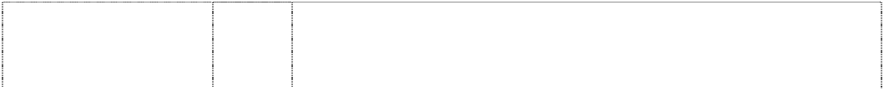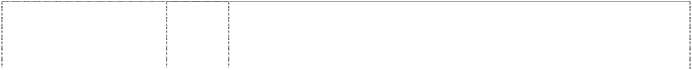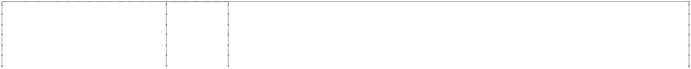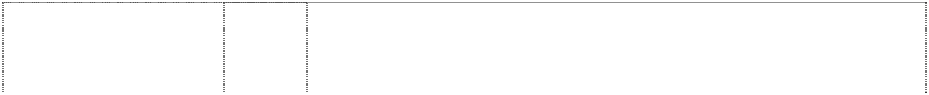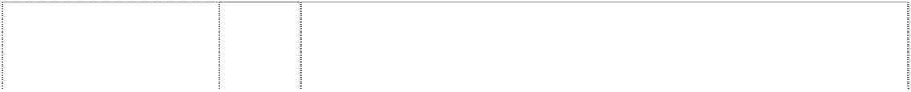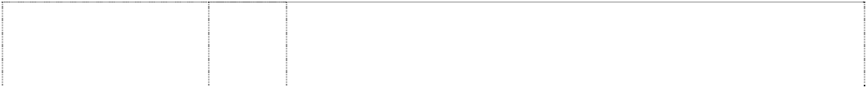

**A X ARMANI EXCHANGE** (901664)

**A X ARMANI EXCHANGE** (901664)

**A X ARMANI EXCHANGE** (901664)

**A X ARMANI EXCHANGE** (901664)

**A X ARMANI EXCHANGE** (901664)

# A/X

(733784)

# A/X

(733784)

**A/X ARMANI EXCHANGE** (877601)

# ACQUA DI GIO’

(872758)

# AHR

ltrs form circle, broken, divided

(1039868)

# AHR

ltrs form circle, broken, divided

(1039868)

# AHR

ltrs form circle, broken, divided

(1039868)

# AHR

ltrs form circle, broken, divided

(1039868)

# AHR

ltrs form circle, broken, divided

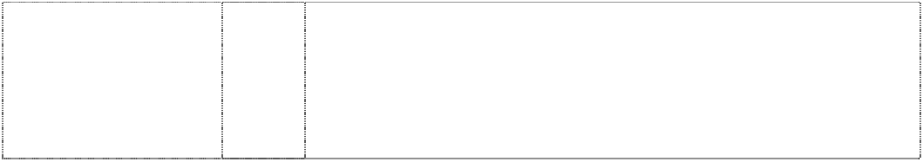(1039868)

# AHR

ltrs form circle, broken, divided

(1039868)

14 Precious metals and their alloys and goods made of or coated with these materials not included in other classes; jewellery, precious stones, timepieces and chronometric instruments.

16 Paper, cardboard and goods made thereof, not included in other classes; printed matter; bookbinding material; photographs; stationery, adhesives for stationery or household purposes; artists' supplies; paintbrushes; typewriters and office articles (except furniture), instructional or teaching material (except apparatus); plastic materials for packaging (not included in other classes); playing cards; printer's type, printing blocks.

18 Leather and imitation leather, goods made thereof not included in other classes; animal skins and hides; trunks and suitcases; umbrellas, parasols and walking sticks; whips and saddlery.

1. Textiles and textile goods not included in other classes; bed and table covers.
2. Clothing, footwear, headgear.

28 Games, toys, gymnastics and sports articles not included in other classes; christmas tree decorations.

18 Bags including handbags and clutch bags; wallets.

25 Underwear, brassieres, corsets, hosiery, petticoats, nightgowns, pyjamas, pullovers, dressing gowns, bath robes, gloves, cardigans, hats, jerseys, ties, foulards, scarves, sweaters, socks, stockings, trousers, leggings, skirts, jackets, jerkins, shirts, vests, jumpers, track suits, blouses, jeans, pants, bermuda shorts, T-shirts, caps, panties, sweat-shirts, suits and dresses, overcoats, coats, anoraks, raincoats, bathing suits, belts, shoes, boots, slippers.

3 Bleaching preparations and other substances for laundry use; cleaning, polishing, scouring and abrasive preparations; soaps; perfumery, essential oils, cosmetics; hair lotions; dentifrices; personal care items in this class.

3 Bleaching preparations and other substances for laundry use; cleaning, polishing, scouring and abrasive preparations; soaps; perfumery, essential oils, cosmetics; hair lotions; dentifrices.

3 Bleaching preparations and other substances for laundry use; cleaning, polishing, scouring and abrasive preparations; soaps; perfumery, essential oils, cosmetics, hair lotions; dentifrices.

8 Hand tools and implements (hand-operated); cutlery (knives, forks and spoons); side arms; razors.

1. Apparatus for lighting, heating, steam generating, cooking, refrigerating, drying, ventilating, water supply and sanitary purposes.
2. Vehicles; apparatus for locomotion by land, air or water

14 Precious metals and their alloys and goods made of these materials or plated therewith included in this class, jewellery, precious stones, horological and chronometric instruments.

16 Paper, cardboard and goods made thereof, included in this class; printed matter; bookbinding material; photographs; stationery; adhesives for stationery or household purposes; artists' materials; paintbrushes; typewriters and office articles (except furniture); instructional or teaching material (except apparatus); plastic materials for packaging (included in this class); printers' type; printing blocks.

# AHR

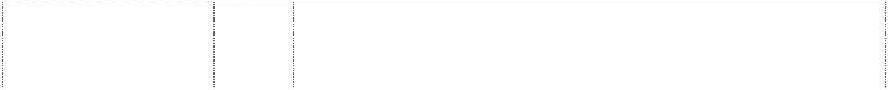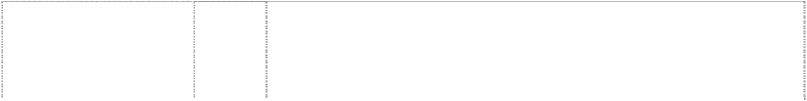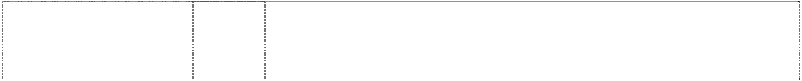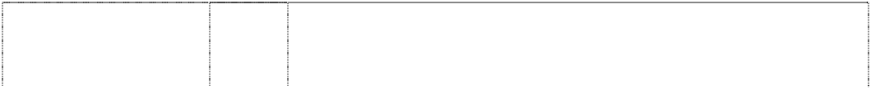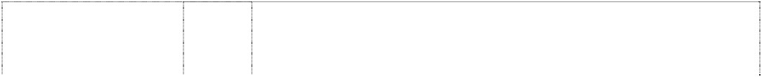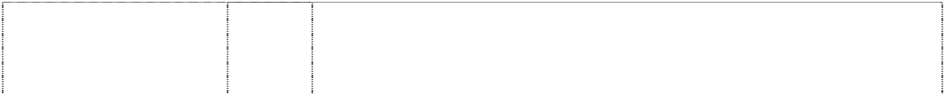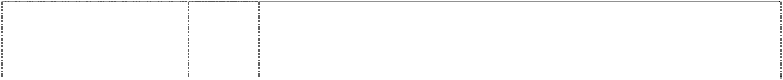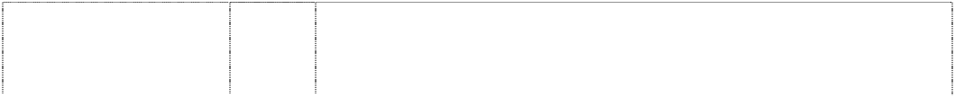

ltrs form circle, broken, divided

(1039868)

# AHR

ltrs form circle, broken, divided

(1039868)

# AHR

ltrs form circle, broken, divided

(1039868)

# AHR

ltrs form circle, broken, divided

(1039868)

# AHR

ltrs form circle, broken, divided

(1039868)

# AHR

ltrs form circle, broken, divided

(1039868)

# AHR

ltrs form circle, broken, divided

(1039868)

# AJ ARMANI JEANS

(1027992)

# AJ ARMANI JEANS

(838663)

# AJ ARMANI JEANS

(838663) **ARMANI** (755805)

# ARMANI

(755805)

# ARMANI

(755805)

# ARMANI

(755805)

# ARMANI

(755805)

**Armani** (965940) **ARMANI** (1027392)

# ARMANI / DOLCI

(1028828)

18 Leather and imitation leather, goods made thereof included in this class; animal skins, hides; trunks and suitcases; umbrellas, parasols and walking sticks; whips and saddlery.

1. Furniture, mirrors, frames; products, included in this class, of wood, cork, reed, cane, wicker, horn, bone, ivory, whalebone, shell, amber, mother-of-pearl, meerschaum and substitutes for all these materials, or of plastics.
2. Household or kitchen utensils and containers (not of precious metal or coated therewith); combs and sponges; brushes (except paint brushes); brush-making materials; cleaning equipment; steel wool; unworked or semi-worked glass (except for building glass); glassware, porcelain and earthenware included in this class.
3. Fabrics and textiles (included in this class); bed and table covers.
4. Clothing, footwear, headgear.

27 Carpets, rugs, mats and matting, linoleum and other materials for covering existing floors; wall hangings (non-textile).

32 Beers, mineral and aerated waters and other non-alcoholic beverages; fruit beverages and fruit juices; syrups and other preparations for making beverages.

14 Precious metals and their alloys and goods in precious metals or coated therewith not included in other classes; jewellery, precious stones; horological and chronometric instruments.

18 Leather and imitations of leather, and goods made of these materials and not included in other classes; animal skins, hides; trunks and travelling bags; umbrellas, parasols and walking sticks; whips, harness and saddlery.

25 Clothing, footwear, headgear.

3 Bleaching preparations and other substances for laundry use; cleaning, polishing, scouring and abrasive preparations; soaps; perfumery, essential oils, cosmetics, hair lotions; dentifrices.

9 Scientific, nautical, surveying, electric, photographic, cinematographic, optical, weighing, measuring, signalling, checking (supervision), life-saving and teaching apparatus and instruments; apparatus for recording, transmission or reproduction of sound or images; magnetic data carriers, recording discs; automatic vending machines and mechanisms for coin-operated apparatus; cash registers, calculating machines, data processing equipment and computers; fire-extinguishing apparatus.

14 Precious metals and their alloys and goods in precious metals or coated therewith, not included in other classes; jewellery, precious stones; horological and chronometric instruments.

18 Leather and imitations of leather, and goods made of these materials and not included in other classes; animal skins, hides; trunks and travelling bags; umbrellas, parasols and walking sticks; whips, harness and saddlery.

25 Clothing articles, footwear, headwear.

33 Alcoholic beverages except beer.

33 Alcoholic beverages (except beers).

1. Meat, fish, poultry and game; meat extracts; preserved, dried and cooked fruit and vegetables; jellies, jams, compotes; eggs, milk and dairy products; edible oils and fats.

# ARMANI / DOLCI

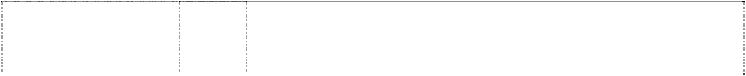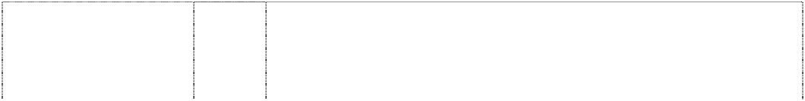

(1028828)

# ARMANI / FLOWERS

(1041977) **ARMANI CASA** (914519)

# ARMANI CASA

(914519)

**ARMANI CASA** (914519) **ARMANI CASA** (914519)

# ARMANI CASA

(914519)

# ARMANI CASA

(914519)

# ARMANI CASA

(914519)

# ARMANI CASA

(914519)

# ARMANI CASA

(914519)

**ARMANI CASA** (914519) **ARMANI CASA** (914519) **ARMANI CASA** (914519) **ARMANI CASA** (914519) **ARMANI CASA** (914519) **ARMANI CASA** (914519) **ARMANI CASA**

lamp (914520)

# ARMANI CASA

lamp (914520)

# ARMANI CASA

lamp (914520)

# ARMANI CASA

lamp (914520)

1. Coffee, tea, cocoa, sugar, rice, tapioca, sago, artificial coffee; flours and preparations made from cereals, bread, pastry and confectionery, ices; honey, treacle; yeast, baking powder; salt, mustard; vinegar, sauces (condiments); spices, ice for refreshment.
2. Natural seeds, plants and flowers, dried flowers.
3. Bleaching preparations and other substances for laundry use; cleaning, polishing, scouring and abrasive preparations; soaps; perfumery goods, essential oils, cosmetics, hair lotions; dentifrices.
4. Industrial oils and greases; lubricants; dust-absorbing, wetting and binding compositions; fuel (including fuel for engines) and lighting materials; candles, wicks.

8 Manually-operated hand-held tools and implements; cutlery, forks and ladles; side arms; razors.

11 Apparatus for lighting, heating, steam generating, cooking, refrigerating, drying, ventilation, for water distribution and for plumbing systems (sanitary facilities).

14 Precious metals and their alloys and products made of these substances or plated with them, not included in other classes; jewellery, precious stones; timepieces and chronometric instruments.

16 Paper, cardboard and products made of these materials not included in other classes; printing products; bookbinding products; photographs; stationery; adhesives (sticking materials) for stationery or household use; artists' requisites; paintbrushes; typewriters and office articles (excluding furniture); instructive or educational material (excluding apparatus); plastic materials for wrapping (not included in other classes); playing cards; printing type; printing blocks.

18 Leather and artificial leather, as well as articles in these materials not included in other classes, animal hides, trunks and suitcases, umbrellas, parasols and walking sticks; whips and saddlery.

1. Furniture, mirrors (looking glasses), picture frames; goods not included in other classes made of wood, cork, reed, cane, wicker, horn, bone, ivory, whalebone, shell, amber, mother-of-pearl, sea foam (sepiolite), substitutes of all such materials or plastics.
2. Household or kitchen utensils and containers (not made of precious metals, nor plated); combs and sponges; brushes (excluding paintbrushes); brush equipment; cleaning equipment; steel wool; unworked or semi-worked glass (excluding building glass); glassware, chinaware and earthenware not included in other classes.
3. Fabric and textiles not included in other classes; bed covers and tablecloths.
4. Clothing, footwear and millinery.
5. Lace and embroidery, ribbon and laces; buttons, hooks and eyes, pins and needles, artificial flowers.
6. Rugs, door mats, mats, linoleum and other floor coverings; non- textile wall hangings.
7. Games, toys; sports' and gymnastics' items not included in other classes; christmas tree decorations.

34 Tobacco; smokers' articles; matches.

1. Bleaching preparations and other substances for laundry use; cleaning, polishing, scouring and abrasive preparations; soaps; perfumery goods, essential oils, cosmetics, hair lotions; dentifrices.
2. Industrial oils and greases; lubricants; dust-absorbing, wetting and binding compositions; fuel (including fuel for engines) and lighting materials; candles, wicks.

8 Manually-operated hand-held tools and implements; cutlery, forks and ladles; side arms; razors.

11 Apparatus for lighting, heating, steam generating, cooking, refrigerating, drying, ventilation, for water distribution and for plumbing systems (sanitary facilities).

# ARMANI CASA

lamp (1054413)

11 Apparatus for lighting, heating, steam generating, cooking, refrigerating, drying, ventilating, water supply and sanitary purposes.

# ARMANI CASA

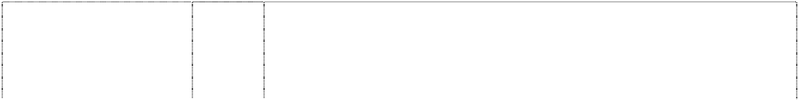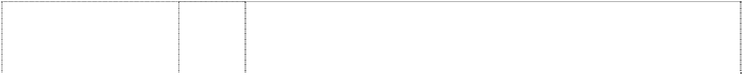

lamp (914520)

# ARMANI CASA

lamp (914520)

# ARMANI CASA

lamp (914520)

# ARMANI CASA

lamp (914520)

# ARMANI CASA

lamp (1054413)

# ARMANI CASA

lamp (914520)

# ARMANI CASA

lamp (914520)

# ARMANI CASA

lamp (914520)

# ARMANI CASA

lamp (914520)

# ARMANI CASA

lamp (914520)

# ARMANI CASA

lamp (914520)

# ARMANI CASA

lamp (914520) **ARMANI COLLEZIONI** (860744) **ARMANI COLLEZIONI** (860744)

**ARMANI COLLEZIONI** (860744)

# ARMANI EXCHANGE

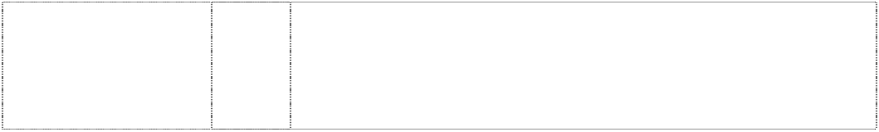(733892)

# ARMANI EXCHANGE

(733892)

14 Precious metals and their alloys and products made of these substances or plated with them, not included in other classes; jewellery, precious stones; timepieces and chronometric instruments.

16 Paper, cardboard and products made of these materials not included in other classes; printing products; bookbinding products; photographs; stationery; adhesives (sticking materials) for stationery or household use; artists' requisites; paintbrushes; typewriters and office articles (excluding furniture); instructive or educational material (excluding apparatus); plastic materials for wrapping (not included in other classes); playing cards; printing type; printing blocks.

18 Leather and artificial leather, as well as articles in these materials not included in other classes, animal hides, trunks and suitcases, umbrellas, parasols and walking sticks; whips and saddlery.

20 Furniture, mirrors (looking glasses), picture frames; goods not included in other classes made of wood, cork, reed, cane, wicker, horn, bone, ivory, whalebone, shell, amber, mother-of-pearl, sea foam (sepiolite), substitutes of all such materials or plastics.

1. Furniture, mirrors, picture frames; products (not included in other classes) of wood, cork, reed, cane, wicker, horn, bone, ivory, whalebone, shell, amber, mother-of-pearl, meerschaum and substitutes for all these materials, or of plastics.
2. Household or kitchen utensils and containers (not made of precious metals, nor plated); combs and sponges; brushes (excluding paintbrushes); brush equipment; cleaning equipment; steel wool; unworked or semi-worked glass (excluding building glass); glassware, chinaware and earthenware not included in other classes.
3. Fabric and textiles not included in other classes; bed covers and tablecloths.
4. Clothing, footwear and millinery.
5. Lace and embroidery, ribbon and laces; buttons, hooks and eyes, pins and needles, artificial flowers.
6. Rugs, door mats, mats, linoleum and other floor coverings; non- textile wall hangings.
7. Games, toys; sports' and gymnastics' items not included in other classes; christmas tree decorations.

34 Tobacco; smokers' articles; matches.

14 Precious metals and their alloys and goods in precious metals or coated therewith, not included in other classes; jewellery, precious stones; horological and chronometric instruments.

18 Leather and imitations of leather, and goods made of these materials and not included in other classes; animal skins, hides; trunks and travelling bags; umbrellas, parasols and walking sticks; whips, harness and saddlery.

25 Clothing, footwear, headgear.

9 Eyeglasses, sunglasses, glasses cases, sport glasses, glasses chains, glasses frames, glasses lenses, pince-nez.

14 Earrings, bracelets, necklaces, rings, pendants, brooches, chains, pins, diadems, medallions, cufflinks, tie clips; jewellery, imitation jewellery; watches, clocks, chronometers, watch straps; jewellery; and watch cases made of precious metals, trays and ashtrays of precious metals, cigarette boxes of precious metals, napkin rings of precious metals.

# ARMANI EXCHANGE

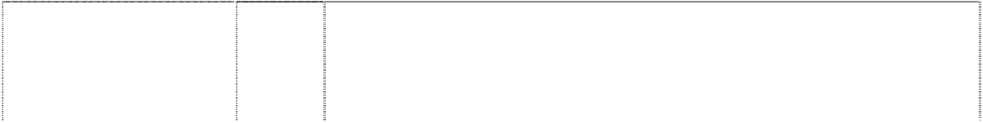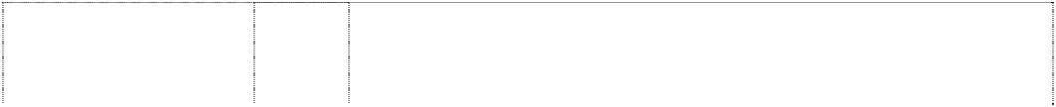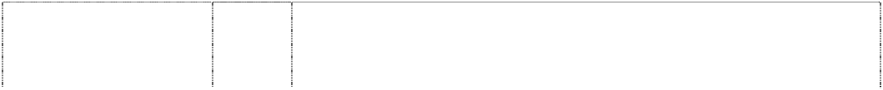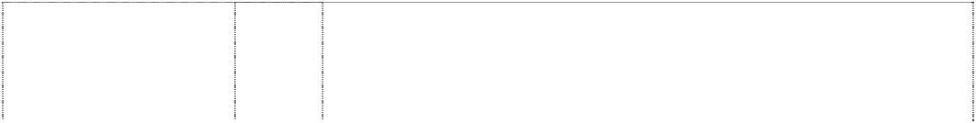

(733892)

# ARMANI EXCHANGE

(733892)

# ARMANI J

*description of mark:* pocket design with vertical tab and eagle (831557)

# ARMANI JEANS GA

bird, eagle, stylised, wings outstretched (363989)

# ARMANI JUNIOR

(1149811)

**ARMANI JUNIOR** (1149811) **ARMANIMANIA** (776325)

**AX ARMANI EXCHANGE** (569105) **AX ARMANI EXCHANGE** (569108) **AX ARMANI EXCHANGE** (569107) **AX ARMANI EXCHANGE** (569106)

# EMPORIO ARMANI CAFFE

bird, eagle, stylised, striped wings, outstretched (810681) **EMPORIO ARMANI CAFFE**

bird, eagle, stylised, striped wings, outstretched (810681)

18 Handbags, luggage, shoulder bags, beach bags, clutch bags, all purpose sports bags, attache cases, school bags, tote bags, travelling bags, credit card cases, document cases, passport cases, cosmetic cases sold empty, keycases, knapsacks, rucksacks, briefcases, purses, wallets, travelling trunks, suitcases, umbrellas, parasols, walking sticks.

25 Underwear, brassieres, corsets, hosiery, petticoats, nightgowns, pyjamas, pullovers, dressing gowns, bath robes, gloves, cardigans, hats, jerseys, ties, foulards, scarves, sweaters, socks, stockings, trousers, leggings, skirts, jackets, jerkins, shirts, vests, jumpers, track suits, blouses, jeans, pants, bermuda shorts, T-shirts, caps, panties, sweat-shirts, suits and dresses, overcoats, coats, anoraks, raincoats, bathing suits, belts, shoes, boots, slippers.

25 Clothing articles being jeans, jeans skirts, slacks, trousers, pants and like goods.

25 Men's and women's jeans.

18 Leather and imitation thereof, goods made of these materials not included in other classes; animal skins and hides; trunks and suitcases; umbrellas, parasols and walking sticks; whips and saddlery.

25 Clothing, footwear, headgear.

3 Perfumery, in particular perfumes, toilet waters; gel and salts (not for medical use) for bath and shower; toilet soaps; deodorants for personal use; cosmetics, in particular creams, milks, lotions, gel and powders for cosmetic use, all for the face, body and/or hands; cosmetic preparations for tanning the skin; make-up products; shampoos, gels, mousses, balsams and products in sprays for hair setting and hair care, hair lacquers, bleaches for cosmetic use; hair perming preparations; essential oils; dentifrices.

9 Sunglasses, frames for glasses.

14 Watches, imitation jewellery namely: necklaces, earrings, bracelets, brooches, rings, necktie pins, badges.

18 Handbags, wallets, name card cases, hiking bags, credit-card cases, suitcases, travelling bags, articles in this class for holding keys, trunks; umbrellas, walking sticks.

25 Work clothing, trousers, skirts, coats, overcoats, raincoats, jumpers, jackets, jeans, shorts, jerkins, shirts, sweaters, cardigan jackets, blouses, sport shirts, polo shirts, underwear, track suits, swimming suits, sweat shirts, sweat pants, pullovers, gloves, hosiery, neckties, hats and caps, shoes, sandals, boots, slippers.

21 Household or kitchen utensils and containers (not of precious metal or coated therewith); combs and sponges; brushes (except paint brushes); brush-making materials; articles for cleaning purposes; steelwool; unworked or semi-worked glass (except glass used in building); glassware, porcelain and earthenware not included in other classes.

1. Textiles and textile goods, not included in other classes; bed and table covers.

# EMPORIO ARMANI CAFFE

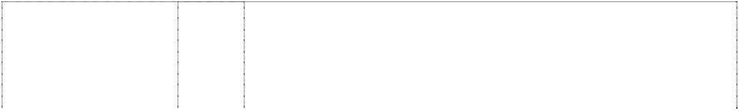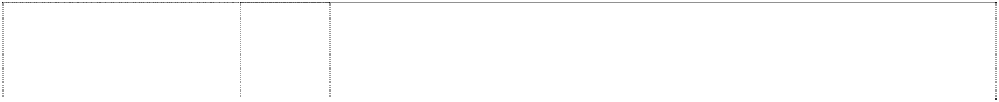

bird, eagle, stylised, striped wings, outstretched (810681) **EMPORIO ARMANI GA**

bird, eagle, stylised, striped wings, outstretched; rectangle (490556)

# EMPORIO ARMANI GA

bird, eagle, stylised, striped wings, outstretched; rectangle (490557)

# EMPORIO ARMANI GA

bird, eagle, stylised, striped wings, outstretched; rectangle (490558)

# EMPORIO ARMANI GA

bird, eagle, stylised, striped wings, outstretched; rectangle (490559)

# EMPORIO ARMANI GA

bird, eagle, stylised, striped wings, outstretched; rectangle (490560)

# EMPORIO ARMANI GA …LEI ELLE SHE ELLA …

striped eagle, styl. with wings outstretched; woman, silh. & Chinese characters (875709)

# EMPORIO ARMANI GA …LUI IL HE EL …

striped eagle, styl. with wings outstretched; man, silh. & Chinese characters

(875246)

# GA

ltrs form circle, broken, divided

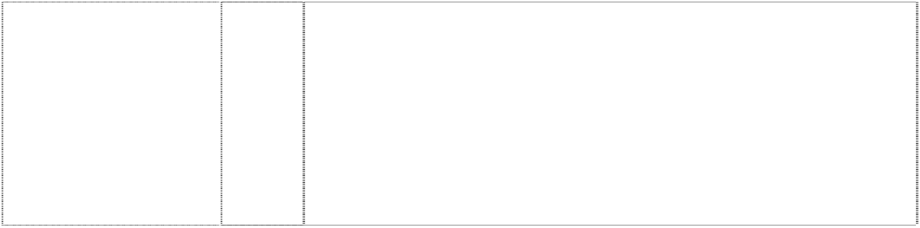(1023461)

# GA

ltrs form circle, broken, divided

(1023461)

1. Clothing articles, footwear, headwear.

3 Bleaching preparations and other substances for laundry use; cleaning, polishing, scouring and abrasive preparations; soaps; perfumery, essential oils, cosmetics, hair lotions; dentifrices.

9 Glasses and spectacles.

14 Precious metals and their alloys and goods in precious metals or coated therewith, not included in other classes; jewellery, precious stones; horological and chronometric instruments.

18 Leather and imitations of leather; animal skins, hides; trunks and travelling bags; umbrellas, parasols and walking sticks; whips, harness and saddlery.

25 Clothing, footwear, headgear.

3 Bleaching preparations and other substances for laundry use; cleaning, polishing, scouring and abrasive preparations; soaps; perfumery, essential oils, cosmetics; hair lotions; dentifrices.

3 Bleaching preparations and other substances for laundry use; cleaning, polishing, scouring and abrasive preparations; soaps; perfumery, essential oils, cosmetics; hair lotions; dentifrices.

3 Bleaching preparations and other substances for laundry use; cleaning, polishing, scouring and abrasive preparations; soaps; perfumery, essential oils, cosmetics, hair lotions; dentifrices.

9 Scientific, nautical, surveying, photographic, cinematographic, optical, weighing, measuring, signalling, checking (supervision), life- saving and teaching apparatus and instruments; apparatus and instruments for conducting, distributing, converting, storing, regulating or controlling electricity; apparatus for recording, transmitting and reproducing sound or images; magnetic recording media, sound recording disks; automatic vending machines and mechanisms for coin-operated apparatus; cash registers, calculating machines, data processing and computer equipment; fire extinguishers.

# GA

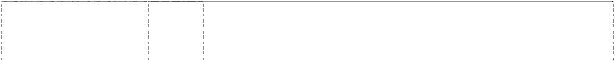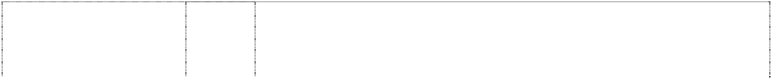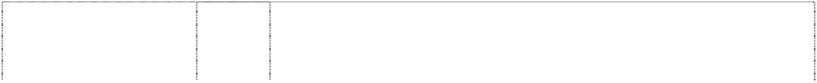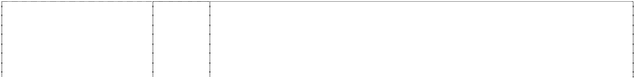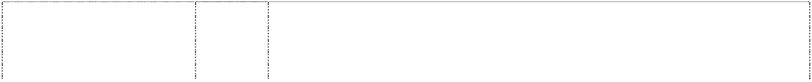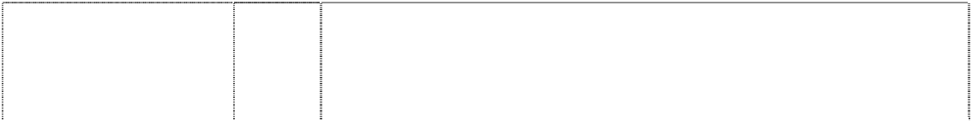

ltrs form circle, broken, divided

(1023461)

# GA

ltrs form circle, broken, divided

(1023461)

# GA

ltrs form circle, broken, divided

(1023461)

# GA

ltrs form circle, broken, divided

(1023461)

# GA

ltrs form circle, broken, divided

(1023461)

# GA

stripes form bird, prey, wings outstretched, stylised

(745885)

# GA

stripes form bird, prey, wings outstretched, stylised

(745885)

# GA

stripes form bird, prey, wings outstretched, stylised

(745885)

# GA

striped eagle, styl. with wings outstretched (932462)

# GA

striped eagle, styl. with wings outstretched (932462)

# GA

striped eagle, styl. with wings outstretched (932462)

# GA

striped eagle, styl. with wings outstretched (932462)

# GA

striped eagle, styl. with wings outstretched (932462)

14 Precious metals and their alloys and goods made of or coated with these materials not included in other classes; jewellery, bijouterie, precious stones; horological and chronometric instruments.

16 Paper, cardboard and goods made from these materials, not included in other classes; printed matter; bookbinding material; photographs; stationery; adhesives for stationery or household purposes; artists' supplies; paintbrushes; typewriters and office requisites (except furniture); instructional or teaching material (except apparatus); plastic packaging materials (not included in other classes); printers' type; printing blocks.

18 Leather and imitation leather, goods made of these materials not included in other classes; animal skins, hides; trunks and suitcases; umbrellas, parasols and walking sticks; whips and saddlery.

1. Textiles and textile goods, not included in other classes; bed and table covers.
2. Clothing, footwear, headgear.

3 Perfumes, toilet water, personal deodorants, essential oils for personal use, body lotions, shower gel, bubble bath, hair shampoos, hair sprays, hair lotions, bath oils, bath pearls, skin soaps, aftershave lotions, cosmetic pencils, foundation make-up, face powders, talcum powder, rouges, lipsticks, mascaras, skin cleansing creams, skin cleansing lotions, sun screen preparation, nail polish remover, face creams, body creams, dentifrices.

9 Eyeglasses, sunglasses, glasses cases, sport glasses, glasses chains, glasses frames, glasses lenses, pince-nez.

14 Earrings, bracelets, necklaces, rings, pendants, brooches, chains, pins, diadems, medallions, cufflinks, tie clips; jewellery, imitation jewellery; watches, clocks, chronometers, watch straps; jewellery and watch cases made of precious metals, trays and ashtrays of precious metals, cigarette boxes of precious metals, napkin rings of precious metals.

16 Paper, cardboard and goods made thereof (included in this class); printed matter; bookbinding material; photographs; stationery, adhesives for stationery or household purposes; artists' supplies; paintbrushes; typewriters and office articles (excluding furniture), instructional or teaching equipment (excluding apparatus); plastic materials for packaging (included in this class); printer's type, printing blocks.

18 Leather and imitation leather, goods made thereof included in this class; animal skins and hides; trunks and suitcases; umbrellas, parasols and walking sticks; whips and saddlery.

1. Furniture, mirrors, frames; goods made of wood, cork, reed, rushwork, wicker, horn, bone, ivory, whalebone, tortoiseshell, amber, mother-of-pearl, meerschaum (included in this class), substitutes for all these materials or of plastics.
2. Household or kitchen utensils and containers (not of precious metal or coated therewith); combs and sponges; brushes (except paintbrushes); brushware materials; cleaning equipment; steelwool; unworked or semiworked glass (except building glass); glassware, porcelain and earthenware included in this class.
3. Fabrics and textiles included in this class; bed and table covers.

# GA

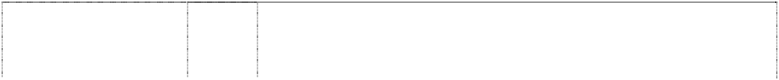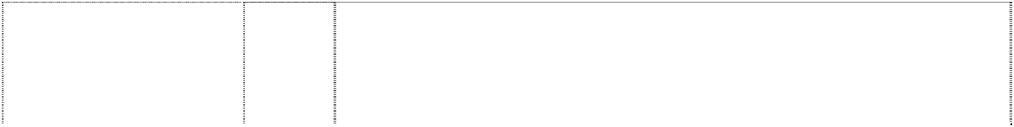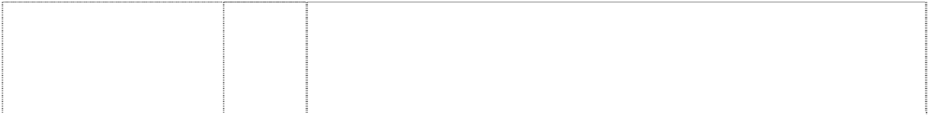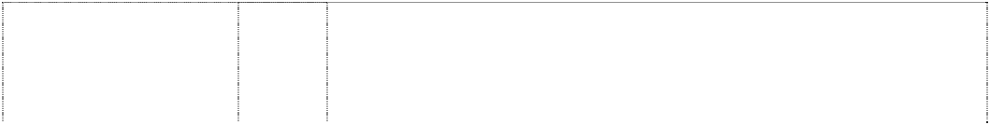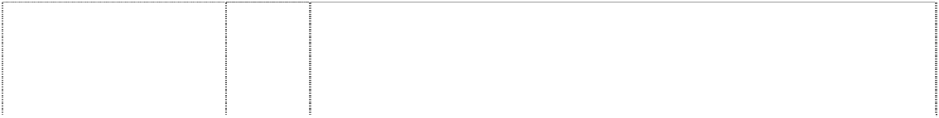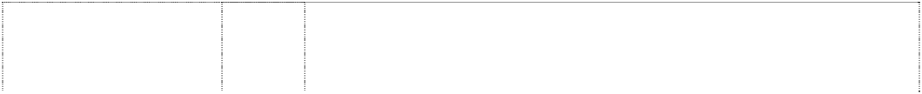

striped eagle, styl. with wings outstretched (932462)

# GA

striped eagle, style wings outstretched atop chevron, stitched in pocket

(976012)

# GA

striped eagle, styl. with wings outstretched (932462)

# GA EMPORIO ARMANI

striped eagle, styl. with wings outstretched (938700)

# GA EMPORIO ARMANI

striped eagle, styl. with wings outstretched (938700)

# GA EMPORIO ARMANI

striped eagle, styl. with wings outstretched (938700)

GA EMPORIO ARMANI

# striped eagle, style with wings outstretched (975959)

**GA EMPORIO ARMANI**

striped eagle, styl. with wings outstretched (938700)

# GA EMPORIO ARMANI

striped eagle, styl. with wings outstretched (938700)

# GA EMPORIO ARMANI

striped eagle, styl. with wings outstretched (938700)

# GA V

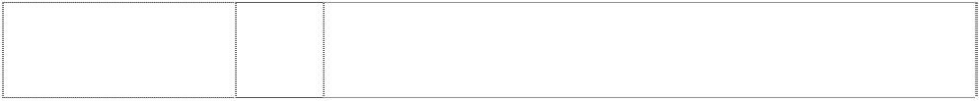eagle wings outstretched (370250) **GA V**

eagle wings outstretched (370261)

1. Clothing, shoes, headgear.
2. Clothing.
3. Lace and embroidery, ribbons and braids; buttons, hooks and eyelets, pins and needles, artificial flowers.

3 Bleaching preparations and other substances for laundry use; cleaning, polishing, scouring and abrasive preparations; soaps; perfumery, essential oils, cosmetics, hair lotions; dentifrices.

9 Scientific, nautical, surveying, photographic, cinematographic, optical, weighing, measuring, signaling, checking (supervision), emergency (life-saving) and teaching apparatus and instruments; apparatus and instruments for conveying, distributing, transforming, storing, regulating or controlling electric current; apparatus for recording, transmitting and reproducing sound or images; magnetic recording media, sound recording disks; automatic vending machines and mechanisms for coin-operated apparatus; cash registers, calculating machines, data processing equipment and computers; fire extinguishers.

14 Precious metals and their alloys and goods made of or coated with these materials not included in other classes; jewellery, precious stones, horological and chronometric instruments.

16 Paper, cardboard and goods made from these materials, not included in other classes; printing products; bookbinding material; photographs; stationery; adhesives for stationery or household purposes; artists' supplies; paintbrushes; typewriters and office requisites (except furniture); instructional or teaching material (except apparatus); plastic materials for packaging (not included in other classes); printing type; printing blocks.

18 Leather and imitation leather, goods made of these materials not included in other classes; animal skins, hides; trunks and suitcases; umbrellas, parasols and walking sticks; whips and saddlery.

1. Textiles and textile goods not included in other classes; bed and table covers.
2. Clothing, footwear, headgear.

18 Bags in this class, money-bags, wallets, purses and umbrellas.

25 Clothing articles for men and women, in particular suits and dresses, jackets, mantles, scarves, coats, over coats, blouses, trousers, costumes, vests, skirts, shirts, foulards, ties, belts and footwear.

**GIO DE GIORGIO ARMANI** (575027)

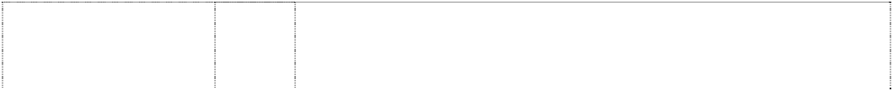

# GIORGIO ARMANI

(318953)

# GIORGIO ARMANI

(893654)

# GIORGIO ARMANI

(893654)

# GIORGIO ARMANI

(318954)

# GIORGIO ARMANI

(949910)

# GIORGIO ARMANI

(318950)

# GIORGIO ARMANI

(893654)

# GIORGIO ARMANI

(893654)

# GIORGIO ARMANI

(318952)

# GIORGIO ARMANI

(650036)

# GIORGIO ARMANI

(318951)

# GIORGIO ARMANI

(893654) **MANI** (530362)

**MANI** (530361) **MANIA** (812977)

# MICROFIL

(906841)

# NIGHT EMPORIO ARMANI GA

striped eagle, styl. with wings outstretched (946684)

# SENSI

(869204)

3 Perfumes, lipsticks, face powders, talcum powder, nail varnishes, face creams, rouges, eye make-up, essential oils and deodorants for personal use, hair lotions, skin soaps, beauty masks.

3 Perfumery (perfumes, eau-de-Cologne, after-shave) soaps and shaving soaps, cosmetics.

1. Table cutlery.
2. Scientific, nautical, surveying, photographic, cinematographic, optical, weighing, measuring, signalling, monitoring (supervision), emergency (life-saving) and teaching apparatus and instruments; apparatus for the magnetic recording, transmission and reproduction of sound or images; magnetic recording media, sound recording disks; automatic vending machines and mechanisms for coin- operated apparatus; cash registers, calculating machines and data processing equipment; fire extinguishers.

14 Imitation jewellery, in particular bracelets, eardrops, brooches, necklaces, rings, watches.

16 Paper, cardboard and goods made thereof, not included in other classes; printing products; bookbinding material; photographs; stationery, adhesives for stationery or household purposes; materials for artists; paintbrushes; typewriters and office articles (except furniture), instructional or teaching material (except apparatus); plastic materials for packaging (not included in other classes); printers' type, printing blocks.

18 Umbrellas, bags, handbags, wallets, purses, money bags, included in this class.

1. Furniture, mirrors, picture frames; products for interior decoration made of wood, cork, reed, rush, wicker, horn, bone, ivory, whalebone, shell, amber, mother-of-pearl, meerschaum, substitutes for all these materials or of plastic materials.
2. Household and kitchen containers (neither of precious metals, nor coated therewith); combs and sponges; brushes (except paintbrushes); brush-making materials; cleaning equipment; steel wool; unworked and semi-worked glass (except building glass); table services, plates and dishes, cooking pot sets, buckets, vases of glass, porcelain and earthenware; glassware, porcelain and earthenware.
3. Bed, table and bath-linen, textile piece goods and handkerchieves.
4. All goods in this class including clothing articles, headwear, footwear, belts.

25 Clothing articles for men and women, in particular suits and dresses, jackets, cloaks, coats, trousers, tailleurs, waistcoats, mantles, skirts, scarves, foulards, ties, belts.

34 Tobacco; smokers' articles; matches.

18 Leather and leather imitations, articles of said material, not included in other classes; skins, hides; trunks and suitcases; umbrellas and walking sticks; whips, harnesses and other articles of saddlery.

25 Textile and knitted outer wear and underwear, including boots, shoes and slippers.

3 Bleaching preparations and other substances for laundry use; cleaning, polishing, scouring and abrasive preparations; soaps; perfumery, essential oils, cosmetics, hair lotions; dentifrices.

3 Bleaching preparations and other substances for laundry use; cleaning, polishing, grease removing and abrasive preparations; soaps; perfumery, essential oils, cosmetics, hair lotions.

3 Perfumes, eaux de toilette; shower and bath gels and salts (for non- medical use); toilet soaps, deodorants for personal use; cosmetics, in particular cosmetic creams, milks, lotions, gels and powders for the face, body and hands; cosmetic suntan lotions; make-up products; shampoos, gels, aerosol products, mousses, balms for hair styling and care; hair sprays; hair dyes and bleaching products; hair-curling and setting products; essential oils for personal use.

3 Perfumery products.

**SENSI GIORGIO ARMANI** (1143120)



# TERRA DI ARMANI

(776326)

3 Perfumery products.

3 Bleaching preparations and other substances for laundry use; cleaning, polishing, scouring and abrasive preparations; soaps; perfumery, essential oils, cosmetics, hair lotions; dentifrices.

***Gainsborough Hardware Industries Limited Spruson & Ferguson***

***Ph: (02) 9393 0300***

***Effective Date: 30 October 2007 File Reference: C07/18538 Trade Marks Class Goods***

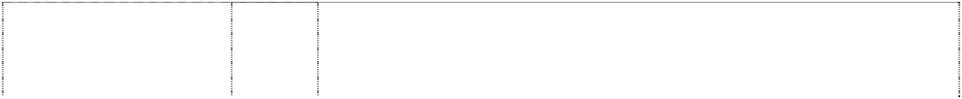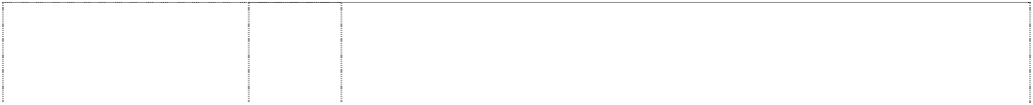

# CONTRACTOR

(719209) **CONTRACTOR** (719209) **CONTRACTOR** (719209) **CONTRACTOR SERIES** (1126368) **CONTRACTOR SERIES** (1126368) **CONTRACTOR SERIES** (1126368) **DURABRASS** (633973) **GAINSBOROUGH** (710977) **GAINSBOROUGH** (1134320)

# GAINSBOROUGH

(669452)

# GAINSBOROUGH

(710977)

# GAINSBOROUGH

(1134320)

# GAINSBOROUGH

(669452)

# GAINSBOROUGH

head of lady in ellipse frame forms cameo (559562) **GAINSBOROUGH**

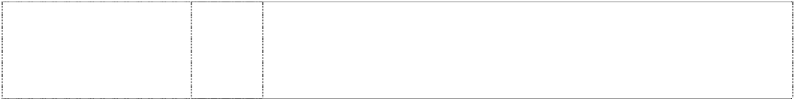head of lady in ellipse frame forms cameo (559563) **GAINSBOROUGH**

portrait,woman head in period costume in frame

(715062)

6 Metallic door furniture; metallic door handles, metallic door knobs,

locks; metallic door fittings; metallic security fittings.

1. Non-metallic door furniture; non-metallic door handles, non-metallic door knobs, non-metallic door fittings; non-metallic security fittings.
2. Door handles and knobs of porcelain.

6 Metallic door furniture; metallic door handles, metallic door knobs, locks; metallic door fittings; metallic security fittings.

1. Non-metallic door furniture; non-metallic door handles, non-metallic door knobs, non-metallic door fittings; non-metallic security fittings.
2. Door handles and knobs of porcelain.

6 Handles and knobs included in class 6; locks; metal furniture for doors and windows; all other goods in class 6.

6 Metallic door furniture; metallic door handles, metallic door knobs, locks; metallic door fittings.

6 Metallic door furniture; metallic door handles, metallic door knobs, locks; metallic door fittings; metallic security fittings; metal locksets; entrance, privacy, passage, dummy, deadbolt and combination deadbolt and entrance door sets of metal.

11 Apparatus for water supply and sanitary purposes, including cisterns, toilets, sanitary ware, toilet fittings, tapware and bathroom fittings in this class.

20 Non-metallic door furniture; non-metallic door handles, non-metallic door knobs and door knobs of ceramic or glass material, non-metallic door fittings.

1. Non-metallic door furniture; non-metallic door handles, non-metallic door knobs and door knobs of ceramic or glass material, non-metallic door fittings.
2. Bathroom accessories and toilet accessories, including toilet brushes, toilet utensils, toilet seats, toilet brush holders and stands, toilet paper holders, soap dishes, toothbrush tidies and holders.

6 Door furniture of metal; metallic door handles, metallic door knobs, locks; and all other goods in class 6.

20 Non-metallic door furniture; non-metallic door handles, non-metallic door knobs; door handles and door knobs of ceramic or glass material.

19 Building materials not of metal; wall boards; floor boards; lining boards; building panels not of metal and planks; construction materials not of metal; door frames and casing not of metal; folding doors and gates not of metal; timber; window frames not of metal.

**GAINSBOROUGH ASPECT SERIES** (1036978)

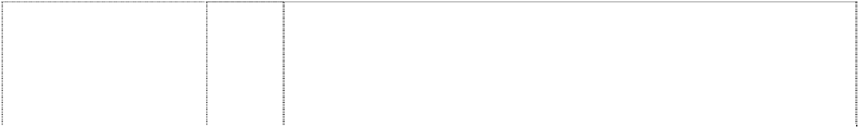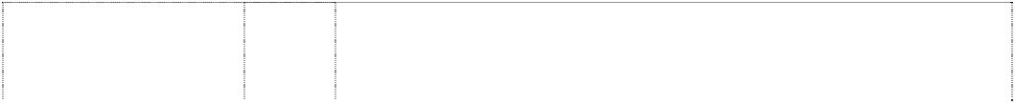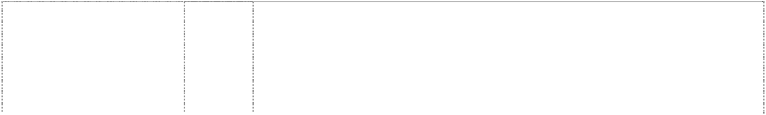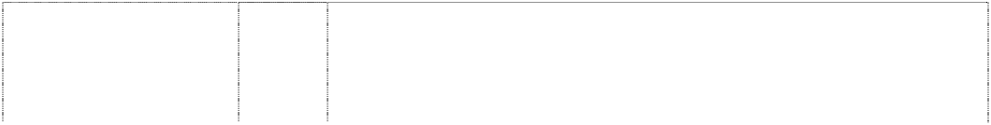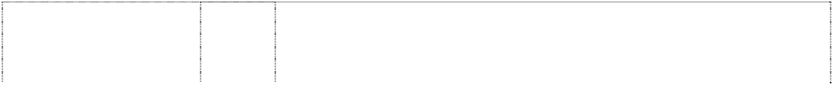

# GAINSBOROUGH ASPECT SERIES

stripes,horizontal form house,striped with chimney

(1037485) **GAINSBOROUGH ASPECT SERIES** (1036978) **GAINSBOROUGH ASPECT SERIES**

stripes,horizontal form house,striped with chimney

(1037485) **GAINSBOROUGH RENOVATOR SERIES**

(719381) **GAINSBOROUGH RENOVATOR SERIES**

(719381) **GAINSBOROUGH RENOVATOR SERIES**

roof atop horiz. stripe forms house,styl. (994311) **GAINSBOROUGH RENOVATOR SERIES**

roof atop horiz. stripe forms house,styl. (994311) **HOMECRAFT** (880066)

# MODE

(1043737)

# MODE

(1043737)

# STRONGHOLD SERIES

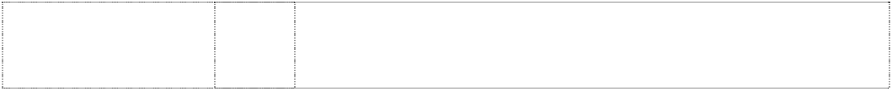lines horizontal forming key (446652)

# TRI LOCK

keyhole in cylinder in ltr O,3 dots betw words (633676)

6 Metallic door furniture; metallic door handles, metallic door knobs, locks; metallic door fittings; metallic security fittings; metal locksets; entrance, privacy, passage, dummy, deadbolt and combination deadbolt and entrance door sets of metal.

6 Metallic door furniture; metallic door handles, metallic door knobs, locks; metallic door fittings; metallic security fittings; metal locksets; entrance, privacy, passage, dummy, deadbolt and combination deadbolt and entrance door sets of metal.

20 Non-metallic door furniture; non-metallic door handles, non-metallic door knobs and door knobs of ceramic or glass material, non-metallic door fittings; non-metallic security fittings.

20 Non-metallic door furniture; non-metallic door handles, non-metallic door knobs and door knobs of ceramic or glass material, non-metallic door fittings; non-metallic security fittings.

6 Metallic door furniture; metallic door handles, metallic door knobs, locks; metallic door fittings; metallic security fittings.

20 Non-metallic door furniture; non-metallic door handles, non-metallic door knobs and door knobs of ceramic or glass material, non-metallic door fittings; non-metallic security fittings.

6 Metallic door furniture; metallic door handles, metallic door knobs, locks; metallic door fittings; metallic security fittings.

20 Non-metallic door furniture; non-metallic door handles, non-metallic door knobs and door knobs of ceramic or glass material, non-metallic door fittings; non-metallic security fittings.

6 Metallic door furniture; metallic door handles, metallic door knobs, locks; metallic door fittings; metallic security fittings; parts and accessories for the aforesaid goods.

6 Metallic door furniture; metallic door handles, metallic door knobs, locks; metallic door fittings; metallic security fittings; metal locksets; entrance, privacy, passage, dummy, deadbolt and combination deadbolt and entrance door sets of metal none being intended for use with window blinds, roller blinds for windows or window covers.

20 Non-metallic door furniture; non-metallic door handles, non-metallic door knobs and door knobs of ceramic or glass material, non-metallic door fittings; non-metallic security fittings none being intended for use with window blinds, roller blinds for windows or window covers.

6 Keylocks including cylindrical keylocks.

6 Locks for doors or windows; all other goods in this class.

# TRI LOCK 3 IN 1 SECURITY CONTEMPORARY

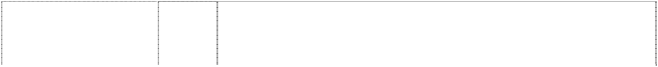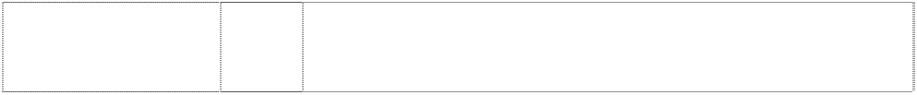

keyhole in cylinder in ltr O; 3 dots between words

(1053262) **TRILOCK** (1053266)

**TRILOCK CONTEMPORARY** (1053265)

6 Metallic door furniture; metallic door handles, metallic door knobs, locks; metallic door fittings; metallic security fittings; metal locksets; entrance, privacy, passage, dummy, and deadbolt combination deadbolt and entrance door sets of metal.

6 Metallic door furniture; metallic door handles, metallic door knobs, locks; metallic door fittings; metallic security fittings; metal locksets; entrance, privacy, passage, dummy, deadbolt and combination deadbolt and entrance door sets of metal.

6 Metallic door furniture; metallic door handles, metallic door knobs, locks; metallic door fittings; metallic security fittings; metal locksets; entrance, privacy, passage, dummy, deadbolt and combination deadbolt and entrance door sets of metal.

***Gray-Nicolls Sports Pty Ltd Griffith Hack Lawyers Ph: (03) 9243 8340***

***Effective Date: 23 September 2007 File Reference: C07/16046 Trade Marks Class Goods***

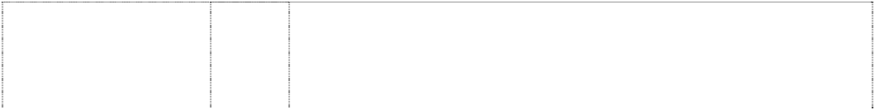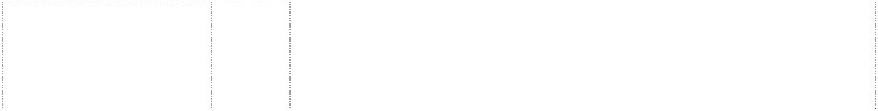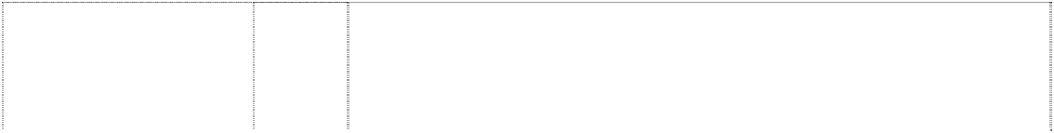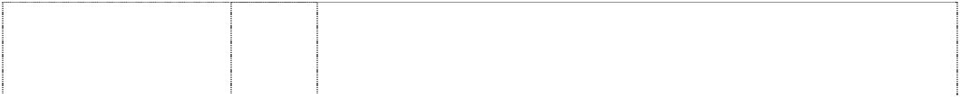

# CARBONEX

(313626) **COUNTY** (401007) **GRAYS** (650686)

# GRAY-NICOLLS

cricket-bat handle (312856)

# MAVIS

(331879) **MUSCLE POWER** (936164)

# POWER CUSHION

(936162) **RDX** (997998)

**STEEDEN** (335652) **V-CON** (963163)

# YY

2 triangles, inverted and discs form ltrs YY (741142)

**YONEX** (298664) **YONEX** (298665) **YONEX** (269371)

28 Tennis rackets and badminton rackets in Class 28.

28 All goods in this class.

28 Hockey sticks and all items of hockey equipment and hockey accessories in class 28.

28 Cricket equipment in this class including cricket bats, cricket balls, cricket stumps and bails therefor.

28 Games and playthings; gymnastic and sporting articles (except clothing) and Shuttle-cocks for Badminton.

28 Gymnastic and sporting articles, including badminton rackets, squash rackets, tennis rackets, badminton shuttlecocks, tennis balls, golf clubs, skis, snowboards, accessories for snowboards, accessories for badminton rackets and tennis rackets, gloves for games, golf bags, nets for badminton and tennis, strings for rackets.

25 Clothing, shoes and footwear, headgear.

28 Gymnastic and sporting articles, including badminton rackets, squash rackets, tennis rackets, badminton shuttlecocks, tennis balls, golf clubs, skis, snowboards, accessories for snowboards, accessories for badminton rackets and tennis rackets, gloves for games, golf bags, nets for badminton and tennis, strings for rackets.

28 Sporting goods included in this class.

28 Gymnastic and sporting articles, including badminton rackets, squash rackets, tennis rackets, badminton shuttlecocks, tennis balls, golf clubs, skis, snowboards, accessories for snowboards, accessories for badminton rackets and tennis rackets, gloves for games, golf bags, nets for badminton and tennis, strings for rackets.

28 Toys, games and playthings; gymnastic and sporting articles (except clothing); ornaments and decorations for Christmas trees.

18 Sports bags in this class.

25 Sports wears and sports shoes.

28 Sporting articles including games rackets.

***Honda Australia Pty Ltd Honda Australia Pty Ltd Ph: (03) 9285 5555***

***Effective Date: 2 October 2007 File Reference: C07/16960 Trade Marks Class Goods***

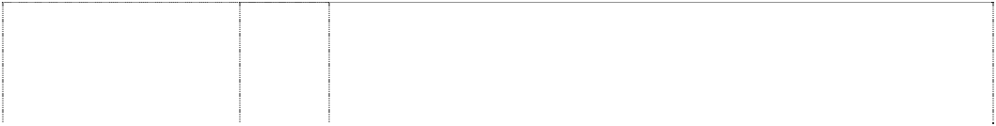

# @125

symbol,at (1103367) **ACCORD EURO** (957062) **ACURA** (1048377)

**ADVANCED 4 TECHNOLOGY** (1061463)

**BUFFALO** (523527) **CBF** (1103369)

**CBR 1100 SUPER BLACKBIRD XX** (676027)

# CHF

(1103363)

# CRF

(1103352)

# CR-V

(676025)

**FIREBLADE** (563665) **GOLD WING** (277993)

# H

ltr in rectangle,rounded- corners

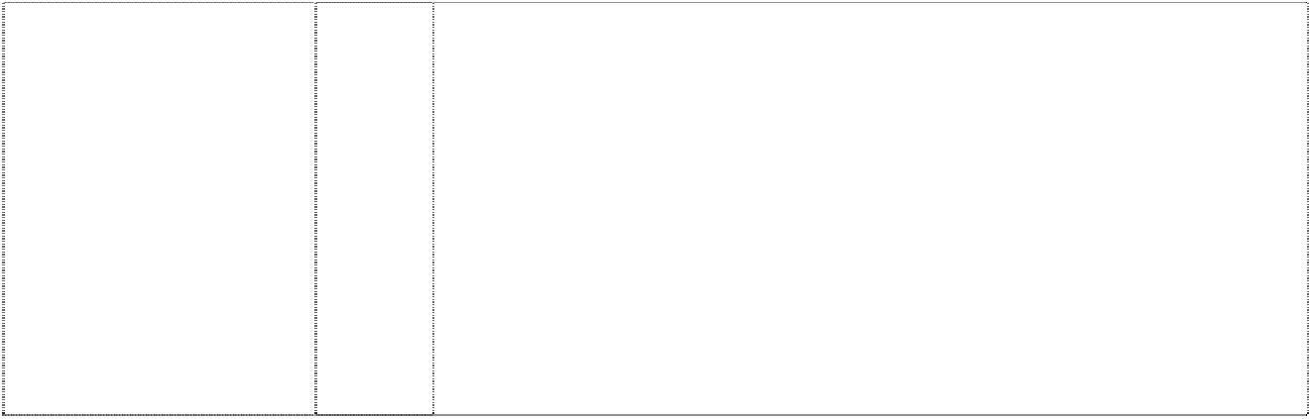(834560)

# H

ltr in rectangle,rounded- corners

(834560)

12 Motorcycles and their parts vehicles; apparatus for locomotion by

land, air or water and parts and accessories for the above-mentioned goods included in class 12.

12 Motor vehicles, parts and accessories for motor vehicles in this class.

12 Vehicles; apparatus for locomotion by land, air or water and parts and fittings in this class for the above-mentioned goods.

7 Machines and machine tools; motors and engines (except for land vehicles); machine coupling and transmission components (except for land vehicles); agricultural implements other than hand operated; lawn mowers; brush cutters; generators; tillers; rotary hoes; engines; hedge cutters; machines which blow air; vacuums for use in the garden; pumps; power carriers; motorised wheelbarrows; outboard motors; parts and accessories for any of the foregoing.

7 Motor mowers and such parts and accessories as are included in this class.

12 Motorcycles and their parts vehicles; apparatus for locomotion by land, air or water and parts and accessories for the above-mentioned goods included in class 12

12 Vehicles; apparatus for locomotion by land, air and water; automobiles and motorcycles; parts and accessories for the above mentioned goods in this class.

12 Motorcycles and their parts vehicles; apparatus for locomotion by land, air or water and parts and accessories for the above-mentioned goods included in class 12.

12 Motorcycles and their parts vehicles; apparatus for locomotion by land, air or water and parts and accessories for the above-mentioned goods included in class 12.

12 Vehicles; apparatus for locomotion by land, air and water; automobiles and motorcycles; parts and accessories in this class for the above mentioned goods.

12 Motorcycles and their parts; and all other goods in this class.

12 Two wheeled vehicles, being mopeds and parts thereof included in this class.

4 Industrial oils and greases; lubricants; dust absorbing, wetting and binding compositions; fuels (including motor spirit) and illuminants; candles, wicks.

7 Machines and machine tools; motors and engines (except for land vehicles); machine coupling and transmission components (except for land vehicles); agricultural implements other than hand-operated; incubators for eggs; especially, snowploughs, sprayers, washing apparatus, current generators, filters, pumps, power carriers, brush cutters, cultivators, outboards, lawnmowers, cargo handling machines and apparatus, motors other than for land vehicles, pneumatic or hydraulic machines and instruments, agricultural machines, starters, alternating or direct current motors (other than for land vehicles), dishwashers, painting machines, washing installations for vehicles, waste compacting machines, waste crushing/shredding apparatus, control mechanisms; parts and fittings for the above mentioned goods in this class.

# H

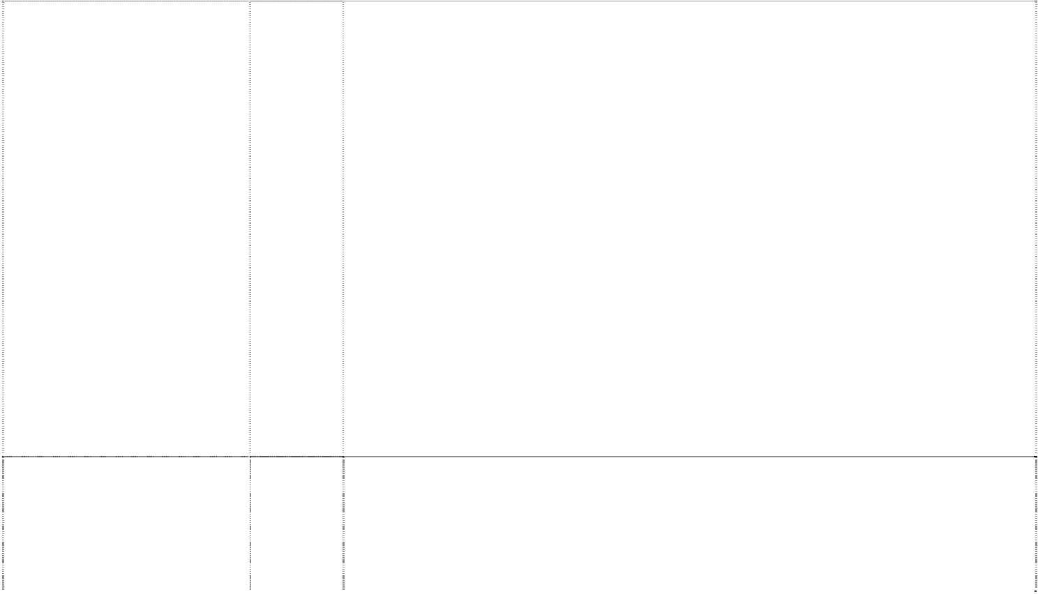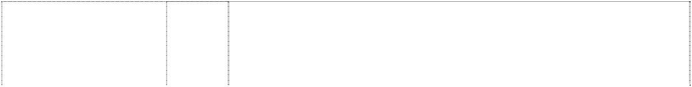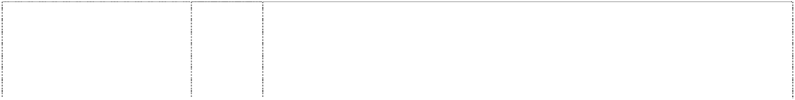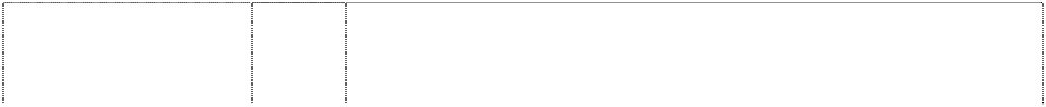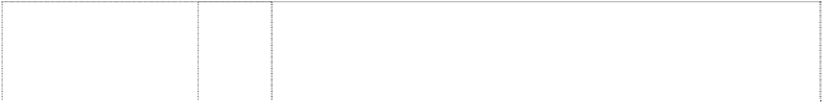

ltr in rectangle,rounded- corners

(834560)

# H

ltr in rectangle,rounded- corners

(834560)

# H

chevron,indented forms ltr h in square,rounded- corners, convex-sides (1048394)

# H

ltr in rectangle,rounded- corners

(834560)

# H

ltr in rectangle,rounded- corners

(834560)

# H

ltr in rectangle,rounded- corners

(834560)

# H

ltr in trapezium with rounded-corners (998009)

# H

ltr in trapezium with rounded-corners (998009)

# H

ltr in rectangle,rounded- corners

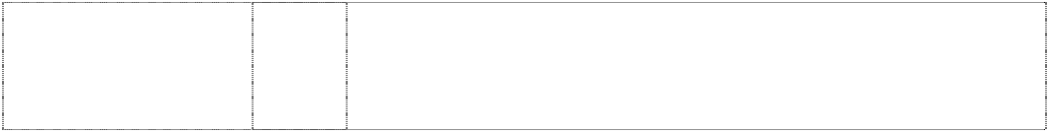(834560)

# H

ltr in rectangle,rounded- corners

(834560)

9 Scientific, nautical, surveying, electric, photographic, cinematographic, optical, weighing, measuring, signalling, checking (supervision), lifesaving and teaching apparatus and instruments; electric accumulators and batteries; ammeters; cigar lighters for automobiles; electric connectors and couplings; electricity control panels; current rectifiers; electricity distribution boards; self- regulating fuel pumps; quantity indicators; speed indicators; kilometer recorders for vehicles; pressure gauges; gasoline gauges; protective helmets; thermometers, not for medical purposes; thermostats; electricity transformers; voltage regulators for vehicles; electric welding apparatus; electric batteries for vehicles; apparatus for recording, transmission or reproduction of sound or images; radiotelephony sets; sound alarms; magnetic data carriers, recording disks; vehicle radios; automatic vending machines and mechanisms for coin operated apparatus; cash registers, calculating machines, data processing equipment and computers; fire-extinguishing apparatus; parts and fittings for the aforementioned goods.

12 Vehicles; apparatus for locomotion by land, air and water; automobiles and motorcycles; parts and fittings for the above mentioned goods in this class.

12 Vehicles; apparatus for locomotion by land, air or water and parts and fittings in this class for the above-mentioned goods.

14 Precious metals and their alloys and goods in precious metals or coated therewith, not included in other classes; jewellery, precious stones; horological and chronometric instruments.

16 Paper, cardboard and goods made from these materials, not included in other classes; printed matter; bookbinding material; photographs; stationery; adhesives for stationery or household purposes; artists' materials; paint brushes; typewriters and office requisites (except furniture); instructional and teaching material (except apparatus); plastic materials for packaging (not included in other classes); playing cards; printers' type; printing blocks; stickers; pamphlets.

18 Leather and imitations of leather, and goods made of these materials and not included in other classes; animal skins, hides; trunks and travelling bags; umbrellas, parasols and walking sticks; whips, harness and saddlery.

21 Household or kitchen utensils and containers (not of precious metal or coated therewith); combs and sponges; brushes (except paint brushes); brush-making materials; articles for cleaning purposes; steelwool; unworked or semi-worked glass (except glass used in building); glassware, porcelain and earthenware not included in other classes.

1. Textiles and textile goods, not included in other classes; bed and table covers.
2. Clothing, footwear, headgear.
3. Lace and embroidery, ribbons and braid; buttons, hooks and eyes, pins and needles; artificial flowers.

# H

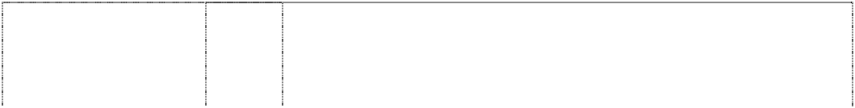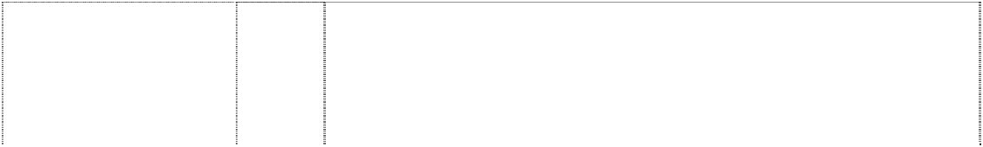

ltr in rectangle,rounded- corners

(834560)

# H

ltr in rectangle,rounded- corners

(834560)

# H

ltr in trapezium with rounded-corners (998009)

# HONDA

(900256)

# HONDA

(900256)

# HONDA

(997609)

# HONDA

(997609)

# HONDA

(998008)

1. Carpets, rugs, mats and mattings, linoleum and other materials for covering existing floors; wall hangings (non-textile); carpets for vehicles.
2. Games and playthings; gymnastic and sporting articles not included in other classes; decorations for Christmas trees.

34 Tobacco; smokers' articlers; matches.

1 Chemicals used in industry, science and photography, as well as in agriculture, horticulture and forestry; unprocessed artificial resins, unprocessed plastics; manures; fire extinguishing compositions; tempering and soldering preparations; chemical substances for preserving foodstuffs; tanning substances; adhesives used in industry; and parts and fittings for the aforesaid goods.

4 Industrial oils and greases; lubricants; dust absorbing, wetting and binding compositions; fuels (including motor spirit) and illuminants; candles, wicks; and parts and fittings for the aforesaid goods.

7 Metal working machines and tools, mining machines and tools, constructions machines and tools, cargo handling machines and apparatus, chemical machines and apparatus, plastic process machines and apparatus, semi-conductor manufacturing machines and apparatus, rubber articles manufacturing machines and apparatus, motive power machines and apparatus (excluding those for land vehicles), parts of motive power machines and apparatus for land vehicles, pneumatic and hydraulic machines and apparatus, agricultural machines and apparatus, fishing machines and apparatus, starters, alternating current motors and direct current motors (excluding those for land vehicles), alternating current generators, direct current generators, automatic parking machines, lawnmowers, repairing machines and equipment, dish washing machines, coating and painting machines and apparatus, washing machines for vehicles, compressing machines and apparatus for waste materials, smashing machines and apparatus for waste materials, machines elements (excluding those for land vehicles).

12 Ships and water crafts and parts and accessories thereof; aircraft and parts and accessories of aircraft; rail rolling stock and parts and assemblies, motor vehicles and parts and accessories of motor vehicles; motorcycles and parts and accessories thereof; bicycles and parts and accessories thereof; motor tricycles and parts and accessories thereof; strollers, wheelchairs, rickshaws, sledges, hand cars (wheelbarrows), carts, horse drawn carriages, rear (pull) cars; aerial ropeways for cargo; car-dumpers, car-pushers, car-pullers, wreckers; motive power machines for land vehicles (excluding their parts); machines elements for land vehicles; alternating current motors or direct current motors for land vehicles (excluding their parts); adhesive rubber patches for repairing tires or tubes, anti-theft alarms for vehicles; parachutes.

14 Precious metals and their alloys and goods in precious metals or coated therewith, not included in other classes; jewellery, precious stones; horological and chronometric instruments.

# HONDA

(1090432)

# HONDA

(998008)

# HONDA

(998008)

**HONDA** (998008) **HONDA** (998008) **HONDA** (1090432) **HONDA** (998008) **HONDA** (1090432) **HONDA** (998008) **HONDA NSX** (528020) **HONDA RACING** (867803) **HONDAS2000** (757406)

**HRC** (491458) **HRC HONDA RACING** (868569)

**HRC HONDA RACING** (868569)

# HRC HONDA RACING

Vehicles; apparatus for locomotion by land, air and water; automobiles and motorcycles.

12

(868569) **HR-V** (769516)



16 Paper and cardboard, industrial packaging containers of paper, food wrapping plastic film for household use, garbage bags of paper (for household use), garbage bags of plastics (for household use), hygienic paper, paper patterns, towels of paper, table cloths of paper, table napkins of paper, hand towels of paper, banners of paper, flags of paper, handkerchiefs of paper, blinds of paper, babies' diapers of paper, tailors' chalk, baggage tags, printed matter, paintings and calligraphic works, photographs, photograph stands, stickers, miscellaneous stationery, pastes and other adhesives for stationery or household purposes, addressing machines, printers' reglets (interline leads), inking ribbons, printing types, hectograph machines, automatic stamp putting on machines, electric staplers for offices, envelope sealing machines for offices, stamp obliterating machines, drawing instruments, decorators' paintbrushes, typewriters, checkwriters, mimeographs, relief duplicators, paper shredders (for office use), sealing wax, marking templates, franking machines (stamping machines), rotary duplicators, indoor aquaria and their fittings.

18 Leather and imitations of leather, and goods made of .these materials and not included in other classes; animal skins, hides; trunks and travelling bags; umbrellas, parasols and walking sticks; whips, harness and saddlery.

21 Household or kitchen utensils and containers (not of precious metal or coated therewith); combs and sponges; brushes (except paint brushes); brush-making materials; articles for cleaning purposes; steelwool; unworked or semi-worked glass (except glass used in building); glassware, porcelain and earthenware not included in other classes.

1. Textiles and textile goods, not included in other classes; bed and table covers.
2. Clothing, footwear, headgear.
3. Automobile carpets, floor coverings, artificial turf, wall hangings (non- textile).
4. Games and playthings; gymnastic and sporting articles not included in other classes; decorations for Christmas trees.

28 Playing cards.

34 Tobacco; smokers' articles; matches.

12 Motor cars and motorcycles and parts and accessories therefor included in class 12.

12 Vehicles, apparatus for locomotion by land, air or water.

12 Vehicles; apparatus for locomotion by land, air and water; automobiles and motorcycles; parts and fittings for the above mentioned goods in this class.

9 Protective equipment, namely: protective clothing, helmets and goggles for personal use against accidents.

7 Machines and machine tools; motors and engines (except for land vehicles); machine coupling and transmission components (except for land vehicles); agricultural implements other than hand-operated; incubators for eggs.

9 Scientific nautical, surveying, electric, photographic, cinematographic, optical, weighing, measuring, signalling, checking (supervision), life-saving and teaching apparatus and instruments; apparatus for recording, transmission or reproduction of sound or images; magnetic data carriers, recording discs; automatic vending machines and mechanisms for coin- operated apparatus; cash registers, calculating machines, data processing equipment and computers; fire- extinguishing apparatus.

12 Vehicles; apparatus for locomotion by land, air or water.



**INTEGRA** (412374) **i-VTEC** (856299)

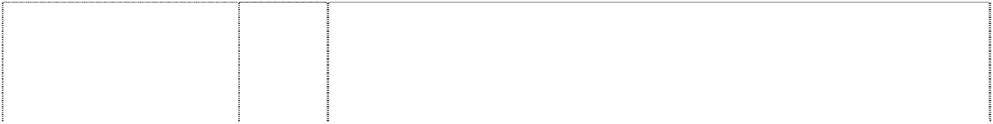

**JAZZ** (874094) **LEGEND** (425158) **MDX** (906727)

**ODYSSEY** (389098) **POWERED BY HONDA** (1039625)

**POWERED BY HONDA** (1094858)

**PRELUDE** (318297) **RED RIDERS**

motorcyclist in helmet leans on trailbike onstand

(1067137) **SH-AWD** (1002857)

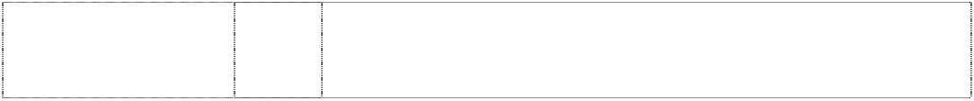**THE POWER OF DREAMS** (848073)

12 Vehicles, apparatus for locomotion by land, air or water, engines for motor vehicles in this class.

12 Vehicles; apparatus for locomotion by land, air or water, and parts, including engines for motorcars, and accessories for the above- mentioned goods, included in class 12.

12 Vehicles; apparatus for locomotion by land, air or water and parts and fittings for the above-mentioned goods.

12 Motor vehicles and parts and accessories therefor, all being goods in Class 12, excluding electric golf cars.

12 Vehicles; apparatus for locomotion by land, air and water; automobiles and motorcycles; parts and fittings for the above mentioned goods in this class.

12 Motor vehicles and parts and accessories therefor included in this class.

7 Generators and power generation device which has cogeneration function; bush cutters (power trimmers); lawn mowers; power sprayers; parts of prime movers for land vehicles included in class 7; machines and machine tools; motors and engines (except for land vehicles); machine couplings and transmission components (except for land vehicles); agricultural implements other than hand-operated; incubators for eggs; parts and fittings for the above-mentioned goods, included in international class 7.

7 Metalworking machines and tools, mining machines and apparatus, construction machines and apparatus, loading-unloading machines and apparatus, fishing machines and instruments, chemical processing machines and apparatus, textile machines and apparatus, food or beverage processing machines and apparatus; lumbering, woodworking, or veneer or plywood making machines and apparatus; pulp making, papermaking or paper-working machines and apparatus; printing or bookbinding machines and apparatus, sewing machines, agricultural machines and implements, shoe making machines, leather tanning machines, tobacco processing machines, glassware manufacturing machines and apparatus, painting machines and apparatus, packaging or wrapping machines and apparatus, power-operated potters' wheels, plastic processing machines and apparatus, semiconductor manufacturing machines and systems, machines and apparatus for manufacturing rubber goods, stone working machines and apparatus, non-electric prime movers (not for land vehicles), pneumatic or hydraulic machines and instruments, adhesive tape dispensing machines, automatic stamping machines, dishwashing machines, electric wax- polishing machines, washing machines, vacuum cleaners, electric food blenders, mechanical lifting apparatus for moving and parking cars, vehicle washing installations, power sprayers for disinfecting, insecticides and deodorants (not for agricultural purposes), machine elements (not for land vehicles), lawnmowers, electrically operated curtain drawing devices, waste compacting machines and apparatus, waste crushing machines, starters for motors and engines, AC motors and DC motors (not including those for land vehicles but including parts for any AC motors and DC motors), AC generators (alternators), DC generators, dynamo brushes, power generation devices with cogeneration functions.

12 All land vehicles and parts thereof in this class.

25 Clothing, footwear, head gear; T-shirts; polo shirts; shirts; jumpers; sweatshirts; jackets; tracksuit pants; trousers; jeans; socks; shoes; boots; mittens; gloves; scarves; hats; caps; helmets.

12 Four-wheel drive system for automobiles; vehicles; apparatus for locomotion by land, air or water; and parts and fittings for all the above-mentioned goods.

7 Machines and machine tools; motors an engines (except for land vehicles); machine coupling and transmission components (except for land vehicles); agricultural implements other than hand-operated; incubators for eggs.

**THE POWER OF DREAMS** (848073) **TODAY** (1103357)



**TRX** (856769) **VTR** (866400) **VTX** (1103355)

wing,styl. (998007)

wing,styl. (986225)

wing,styl. (986225)

wing,styl. (998007)

wing,styl. (1008701)

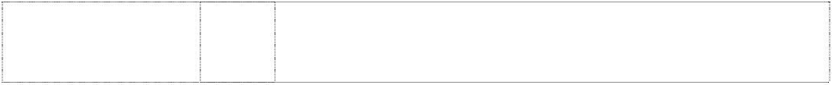wing,styl. (998007)

12 Vehicles; apparatus for locomotion by land, air or water; and their parts and fittings included in this class.

12 Motorcycles and their parts vehicles; apparatus for locomotion by land, air or water and parts and accessories for the above-mentioned goods included in class 12.

12 Four-wheel buggies.

12 Motorcycles; and their parts and fittings in this class.

12 Motorcycles and their parts vehicles; apparatus for locomotion by land, air or water and parts and accessories for the above-mentioned goods included in class 12.

4 Industrial oils and greases; lubricants; dust absorbing, wetting and binding compositions; fuels (including motor spirit) and illuminants; candles and wicks for lighting.

7 Cargo handling machines and apparatus, motive power machines and apparatus (excluding those for land vehicles), pneumatic and hydraulic machines and apparatus, agricultural machines and apparatus, starters, alternating current motors and direct current motors (excluding those for land vehicles), alternating current generators, direct current generators, lawnmowers, dish washing machines, coating and painting machines and apparatus, washing machines for vehicles, compressing machines and apparatus for waste materials, smashing machines and apparatus for waste materials, machines elements (excluding those for land vehicles).

12 Ships and water crafts and parts and accessories thereof; aircrafts and parts and accessories of aircrafts; motor vehicles and parts and accessories of motor vehicles; motorcycles and parts and accessories thereof; bicycles and parts and accessories thereof; motor tricycles and parts and accessories thereof; strollers, wheelchairs, rickshaws, sledges, hand cars (wheelbarrows), carts, horse drawn carriages, rear(pull) cars; aerial ropeways for cargo; car-dumpers, car-pushers, car-pullers, wreckers; motive power

machines for land vehicles (excluding their parts); machine elements for land vehicles; alternating current motors or direct current motors for land vehicles (excluding their parts); adhesive rubber patches for repairing tires or tubes; anti-theft alarms for vehicles.

14 Precious metals and their alloys and goods in precious metals or coated therewith, not included in other classes; jewellery, precious stones; horological and chronometric instruments.

16 Paper and cardboard, industrial packaging containers of paper, food wrapping plastic film for household use, garbage bags of paper, garbage bags of plastics, hygienic paper, paper patterns, towels of paper, table cloths of paper, table napkins of paper, hand towels of paper, banners of paper, flags of paper, handkerchiefs of paper, blinds of paper, babies' diapers of paper, tailor's chalk, baggage tags, printed matter, paintings and calligraphic works, photographs, photograph stands, stickers, miscellaneous stationery, pastes and other adhesives for stationery or household purposes, addressing machines, printers' reglets (interline leads), inking ribbons, printing types, hectograph machines, automatic stamp putting-on machines, electric staplers for offices, envelop sealing machines for offices, stamp obliterating machines, drawing instruments, decorators' paintbrushes, typewriters, checkwriters, mimeographs, relief duplicators, paper shredder, sealing wax, marking templates, franking machines (stamping machines), rotary duplicators, indoor aquaria and their fittings.

18 Leather and imitations of leather, and goods made of these materials and not included in other classes; animal skins, hides; trunks and travelling bags; umbrellas, parasols and walking sticks; whips, harness and saddlery.



wing,styl. (998007)

21

wing,styl. (998007)

wing,styl. (998007)

wing,styl. (1008701)

wing,styl. (998007)

24

25

Household or kitchen utensils and containers (not of precious metal or coated therewith); combs and sponges; brushes (except paint brushes); brush-making materials; articles for cleaning purposes; steelwool; unworked or semi-worked glass (except glass used in building); glassware, porcelain and earthenware not included in other classes.

Textiles and textile goods, not included in other classes; bed and table covers.

Clothing, footwear, headgear.

27

28

Automobile carpets, floor coverings, artificial turf, wall hangings (non- textile).

Games and playthings; gymnastic and sporting articles not included in other classes; decorations for Christmas trees.

***Jamo International APS Clayton Utz***

***Ph: (03) 9286 6000***

***Effective Date: 5 December 2007 File Reference: C07/20843***

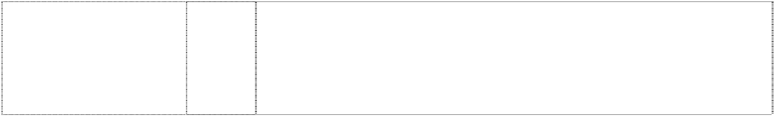

***Trade Marks***

***Class***

***Goods***

**JAMO**

(381216)

9

**JAMO**

(992447)

9

Electrical and electronic apparatus and instruments; radio apparatus, loudspeakers, all for the stereophonic reproduction of sound, parts and fittings for all of the aforesaid goods included in this class.

Apparatus for recording, transmission or reproduction of sound or images; loudspeakers for stereophonic and multi-channel reproduction of sound; screens and television sets; set-up boxes; discs and other media players; computer hardware and software; analogue and digital radio receiving and transmitting sets; magnetic discs; electric cables and connectors; mobile phones; PDAs.

***Joby, Inc Clayton Utz***

***Ph: (02) 9353 4000***

***Effective Date: 10 December 2007 File Reference: C07/20002 Trade Marks Class Goods***

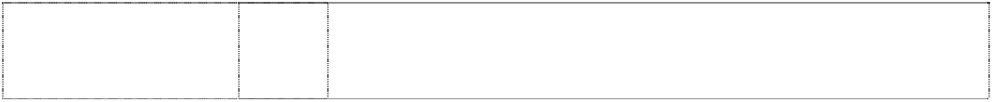

# GORILLAPOD

8 dots form circle is ltr O

(1190866)

9 Consumer electronics accessories, namely a flexible tripod for use

with cameras, camera flashes, flashlights, and other consumer electronics.

***Kimberly-Clark Australia Pty Limited Kimberly-Clark Australia Pty Limited Ph: (02) 9963 8888***

***Effective Date: 15 October 2007 File Reference: C07/17476 Trade Marks Class Goods***



# HUGGIES

(642211) **HUGGIES** (1032741)

**HUGGIES** (1032741) **HUGGIES** (463304)

3 Impregnated wipes in this class.

3 Baby shampoo, baby bath soaps and cleansers, baby lotions and powders; disposable wash mitts impregnated with skin cleansers, disposable washcloths impregnated with skin cleansers.

5 Diaper rash creams and ointments.

16 Disposable diapers, bibs and baby wipes, all being predominantly of paper and/or cellulose.

# HUGGIES

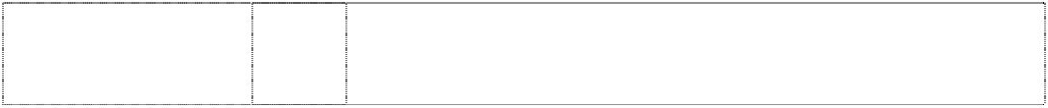

(1005401)

**HUGGIES** (1032741) **HUGGIES** (307608) **HUGGIES DRY COMFORT** (979515) **HUGGIES LITTLE SWIMMERS** (776806) **HUGGIES LITTLE SWIMMERS** (776806)

# HUGGIES PULL-UPS

(550615)

# HUGGIES PULL-UPS DRY NITES

(714181)

# HUGGIES SUPREME

stripes divide circles,concentric (616732)

16 Paper products in this class, including disposable paper products including disposable diapers, diaper liners, bibs and baby wipes, disposable training pants and absorbent underpants for babies, infants and young children, disposable swim wear for children, disposable changing pads for babies and infants, all being predominantly of paper and/or cellulose.

16 Disposable washcloths, disposable wash mitts, and disposable changing pads.

25 Clothing, including disposable diapers, all for infants.

16 Disposable diapers, disposable diaper liners and disposable training pants.

16 Disposable swim wear for children.

25 Disposable swim wear for children.

25 Clothing for young children, inclusive of, but not limited to, disposable underpants used for training young children in the proper use of the toilet.

16 Disposable, absorbent underpants and disposable training pants for infants and young children.

16 Disposable diapers and training pants for infants, babies and toddlers.

***L.C. Licensing Inc Corrs Chambers Westgarth Ph: (03) 9672 3000***

***Effective Date: 10 October 2007 File Reference: C07/17475 Trade Marks Class Goods***

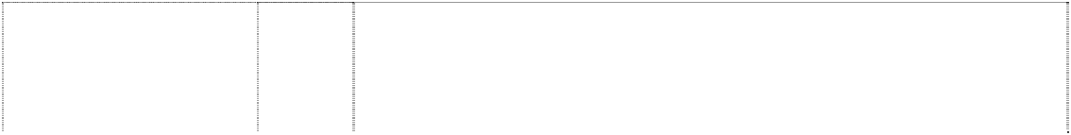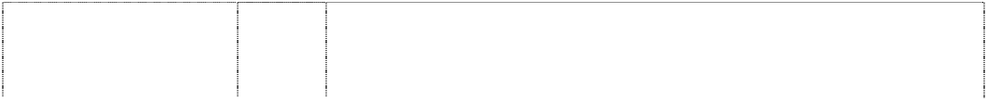

**ACCESS** (748833) **ENYCE** (1022578)

# ENYCE

(1022578)

# ENYCE

(1022580)

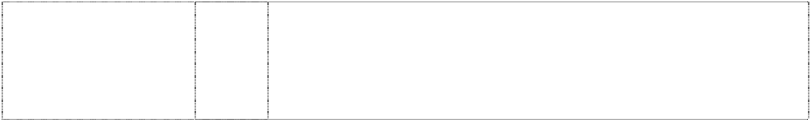**JUICY** (834267) **JUICY BABY** (924925)

25 Clothing, gloves, and mitts, footwear and headgear.

14 Goods in precious metals or coated therewith, (not included in other classes), including candle holders made wholly or primarily of precious metals; horological and chronometric instruments including clocks and watches; jewellery, including necklaces, bracelets, anklets, rings, earrings, pendants, jewellery pins and cufflinks; pill boxes.

18 Leather and imitations of leather, and goods made of these materials and not included in other classes, including purses, handbags, wallets, credit card cases, key cases, passport cases and cosmetic cases (sold empty); trunks and travelling bags, including luggage, sports bags and backpacks; umbrellas.

25 Clothing and clothing accessories, including shirts, pants, sweaters, skirts, dresses, coats, suits, neckties, belts, swimwear, underwear, bras, lingerie, socks, hosiery, pyjamas, gloves, mittens, and scarves; footwear; headwear.

25 Clothing, namely, shirts, dresses, pants, skirts, jackets, hats and caps.

25 Clothing, footwear, headgear, neckties, scarves, belts, shirts, sweaters, coats, suits, dressing gowns, hats, socks, caps, dresses, bathing suits; skirts, jackets, jogging suits, sweatshirts, sweatpants, shorts, jeans, pants, underwear, lingerie, knit tops, camisoles, tank tops, gloves, suspenders, boxer shorts, undershirts, trousers, blazers, leggings, leotards, panties, bras, bustiers, teddies.

# JUICY COUTURE

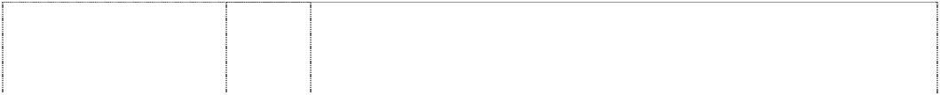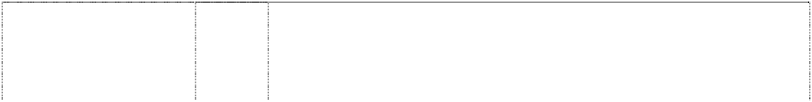

(924924)

# JUICY COUTURE

(1033026)

# JUICY COUTURE

(1033026)

# JUICY COUTURE

(917238)

# JUICY COUTURE

(834265) **JUICY JEANS** (834266)

# LIZ CLAIBORNE

(1055480)

3 Soaps, cosmetics, perfumery, essential oils, cosmetics, hair lotions, dentifrices, perfume, eau de toilette, body splash, after shave, body lotions, body scrubs, bath soaps, bubble baths, bath oils, bath and shower gels, hair shampoo, hair conditioner, hair spray, hair treatment lotions, facial masks, sunscreens, skin moisturizers, body gels, lip gloss, lipstick, blush, eye shadows, mascara, eyeliner, foundation, compacts, nail polish, nail polish remover, body powder and talc lotion.

9 Scientific, optical, photographic, weighing, measuring and teaching apparatus and instruments; eyewear and accessories therefor; eyeglasses; sunglasses; eyewear cases; eyewear frames; chains and cords for eyewear.

14 Precious metals and their alloys and goods in precious metals or coated therewith, not included in other classes; jewellery including necklaces, bracelets, anklets, rings, earrings, pendants, jewellery pins and cufflinks; pill boxes; precious stones; horological and chronometric instruments; clocks and watches.

18 Luggage, tote bags, hand bags, knapsacks, beach bags, all purpose sport and carrying bags, umbrellas, duffel bags, athletic bags, shoulder bags, backpacks, brief cases, diaper bags, toiletry kits, garment bags, luggage tags, key cases, leather key chains, and wallets; leather and imitations of leather and goods made of these materials and not included in other classes.

25 Clothing, namely, shirts, dresses, pants, skirts, jackets, hats and caps.

25 Clothing, namely, shirts, dresses, pants, skirts, jackets, hats and caps.

18 Luggage.

***Liz Claiborne, Inc. Corrs Chambers Westgarth Ph: (03) 9672 3000***

***Effective Date: 10 October 2007 File Reference: C07/17531 Trade Marks Class Goods***



**BORA BORA LIZ CLAIBORNE** (882730) **CLAIBORNE** (582480) **CLAIBORNE** (508662) **CLAIBORNE** (450812) **CLAIBORNE** (450803) **CLAIBORNE** (449124)

# CURVE

(667149)

**LIZ** (339992) **LIZ** (339991) **LIZGOLF** (986658)

# LIZ CLAIBORNE

(431696)

# LIZ CLAIBORNE

(450098)

3 Frangrances; perfumed products; cosmetics.

3 Cologne, toilet soap, after-shave lotion and toiletry products of all kinds.

3 Cologne, toilet soap, after-shave lotion and toiletry products of all kinds.

9 Eyeglasses and eyeglass frames.

18 Umbrellas, leather goods in this class including wallets, brief cases and key cases.

25 Men's clothing of all kinds included in this class and men's accessories included in this class, including scarves, gloves, socks, hats, belts, shoes, boots and sneakers.

3 Skin care, treatment and cleansing substances and preparations, including perfumes, colognes, body creams, dusting powder, bath soap, toilet soap, bath gel, shower gel and body scrub.

1. Tissues (piece goods); bed and table covers; textile articles not included in other classes.
2. Clothing.

25 Clothing, footwear and headgear.

3 Perfumes and cosmetics.

9 Eyeglasses and eyeglass frames; eyeglass cases.

# LIZ CLAIBORNE

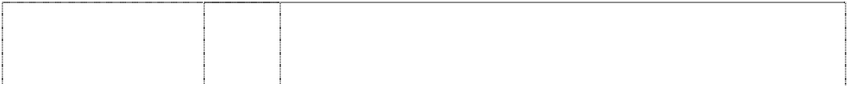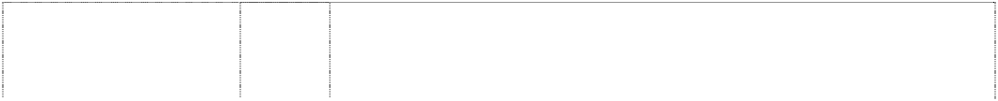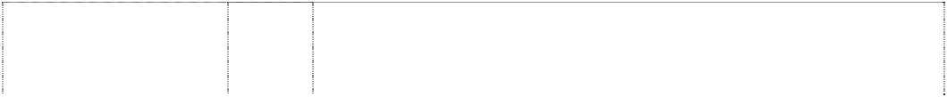

(450099)

# LIZ CLAIBORNE

(950249)

# LIZ CLAIBORNE

(450100)

# LIZ CLAIBORNE

(1029217)

# LIZ CLAIBORNE

(1029217)

# LIZ CLAIBORNE

(450010)

# LIZ CLAIBORNE

(448180)

# LIZ CLAIBORNE

(341724)

**LIZ CLAIBORNE WOMAN** (913083)

**LIZ & CO** (887058) **MONET** (561555) **MONET** (239166) **MONET** (592470) **MONET** (541805) **MONET** (541811) **REALITIES** (617733)

**SPARK LIZ CLAIBORNE** (916586) **TRIFARI** (132568)

16 All goods included in class 16 including executive stationery accessories included in this class, appointment books, address books, calendars, agenda pieces, notebooks, organizers.

14 Precious metals and their alloys and goods in precious metals or coated therewith, not included in other classes; jewellery, precious stones; horological and chronometric instruments, including clocks and watches.

18 Umbrellas, handbags, wallets, change purses, portfolios, cosmetic cases in this class, document bags, briefcases, key cases, attache cases.

20 Furniture.

24 Fabrics; household linens, including, towels, washcloths, sheets, pillowcases, blankets, comforters, bedskirts, table cloths, napkins made of textiles, curtains and draperies, shower curtains made of cloth.

1. Household furnishings namely towels, sheets, pillowcases, bedspreads, comforters, pillow shams, dust ruffles and duvet covers in class no. 24.
2. Skirts, shirts, blouses, pants, jackets, sweaters, dresses, shorts, jeans, jerseys, culottes, jumpsuits, scarves, tunics, capes, blazers and outerwear, namely, coats, jackets, hats, hoods and gloves; belts, pantyhose, dress hosiery, sport hosiery, socks, footlets, legwarmers; bodywear, namely, leotards and tights; neckwear, namely mufflers, bow ties, collars and dickies; shoes, boots and sneakers.

25 Articles of clothing, including footwear, and including ladies' sportswear, namely, skirts, shirts, blouses, pants, jackets, sweaters, dresses, shorts, scarves, tunics, capes, blazers and outerwear, namely, coats, jackets, hats, hoods and gloves.

25 Clothing, footwear, headgear.

25 Clothing, footwear, headgear.

9 Optical goods in this class including eye glasses, sun glasses, eye glass frames, eye glass cases, and neck cords.

14 All goods in Class 14, including jewellery, custom jewellery and precious stones.

14 All items of costume jewellery, including pins, earrings, necklaces and bracelets; and watches.

18 All goods in this class.

25 All goods in this class.

3 All goods in class 3 including perfumes, colognes, toilet water, toilet soap, perfumed talc, moisturizing skin cream, cleansing cream and cosmetics and beauty products of all kinds included in this class.

3 Soaps including bath soap and toilet soap; bath gel, shower gel and body scrub; perfumery and cologne; body cream, body lotion; talcum powder; essential oils, cosmetics and hair lotions.

14 Jewellery for personal wear including brooches, earrings, necklaces and bracelets, but not including watches.

***Lucky Brands Dungarees, Inc. Corrs Chambers Westgarth Ph: (03) 9672 3000***

***Effective Date: 10 October 2007 File Reference: C07/17477 Trade Marks Class Goods***



**LUCKY BRAND** (986655) **LUCKY BRAND** (986655)

9 Glasses, sunglasses, eyeglass frames, eyeglass cases and eyeglass retainer cords.

14 Jewellery and watches.

**LUCKY BRAND** (986655) **LUCKY BRAND** (622036)

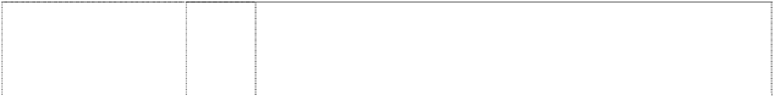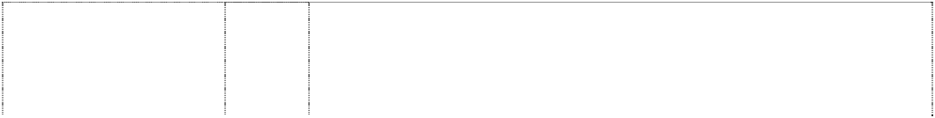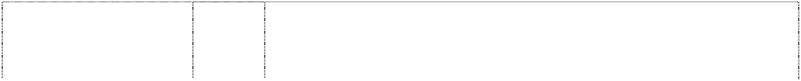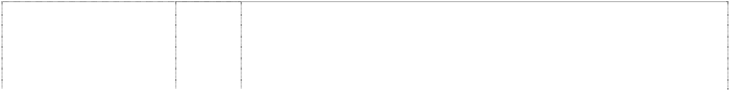

# LUCKY BRAND DUNGAREES

4-leaf clover with scroll across

(986656) **LUCKY BRAND DUNGAREES**

4-leaf clover with scroll across

(986656) **LUCKY BRAND DUNGAREES**

4-leaf clover with scroll across

(986656) **LUCKY BRAND DUNGAREES**

4-leaf clover with scroll across

(986656)

# LUCKY YOU

2 4 leaf,clovers in rect.,vert. (990666)

# LUCKY YOU

words & 2 4-leaf clovers in vertical rectangle (711919)

# LUCKY YOU LUCKY BRAND

(986654)

18 Handbags, purses, wallets, tote bags, duffel bags, luggage, cosmetic cases, toiletry bags, briefcase type portfolios, knapsacks, rucksacks.

25 Clothing and footwear, including shirts, blouses, T-shirts, tank tops, tops, vests, sweaters, dresses, skirts, jumpers, jumpsuits, rompers, overalls, jackets, blazers, sports coats, boxer shorts, pants, jeans, shorts, leggings, bottoms, sweatshirts, sweat pants, sweat suits, jogging suits, suits, rain coats, snow suits, sleepwear, socks, hosiery, tights, leotards, bodysuits, shoes, boots, sneakers, sandals, slippers, ties, gloves, mittens, belts, aprons, bandannas, swimwear, headbands, suspenders, robes, lingerie.

9 Glasses, sunglasses, eyeglass frames, eyeglass cases and eyeglass retainer cords.

14 Jewellery and watches.

18 Handbags, purses, wallets, tote bags, duffel bags, luggage, cosmetic cases, toiletry bags, briefcase type portfolios, knapsacks, rucksacks.

25 Jeans, pants, jackets, skirts, shirts, blouses, vests, sweaters, dresses, culottes, shorts, belts, underwear; sleepwear, coats, hats, caps, hoods, gloves, mittens, scarves, socks, tights, rainwear, swimwear, shoes, boots, slippers, sandals and sneakers.

25 Jeans, pants, jackets, skirts, blouses, vests, sweaters, dresses, culottes, shorts, belts, underwear; sleepwear, coats, hats, caps, hoods, gloves, mittens, scarves, socks, tights, rainwear, swimwear, shoes, boots, slippers, sandals and sneakers.

25 Clothing including jeans, shorts, boxer shorts, pants, pyjamas and overalls; footwear, headgear.

3 Perfumes, colognes, toilet soaps, dusting powder, shower gel, bath gel, shaving cream and aftershave lotion.

***Maxim’s Caterers Limited Blake Dawson Waldron Lawyers Ph: (02) 9258 6000***

***Effective Date: 12 October 2007 File Reference: C07/17536 Trade Marks Class Goods***

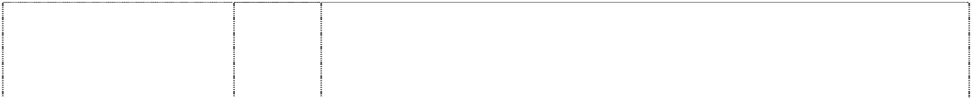

# MEI-XIN

(1039002)

# MEI-XIN

(1039002)

6 Packaging containers of metal; aluminium foil; boxes of common

metal; tin cans; tinfoil; common metals and their alloys; metal building materials; goods of common metal not included in other classes.

16 Envelopes (stationery); forms (printed); handbooks (manuals); magazines (periodicals); manuals (handbooks); newsletters; note books; pamphlets; paper; paper sheets (stationery); coupons; paper ribbons; periodicals; printed matter; printed publications; prospectuses; stationery; wrapping paper; packaging; writing instruments; writing materials; writing or drawing books; writing pads; writing paper; cardboard and goods made from these materials, not included in other classes; photographs; plastic materials for packaging (not included in other classes); plastic bag; plastic packaging bag; plastic wrapper; plastic stickers; plastic blister; plastic packaging materials.

# MEI-XIN

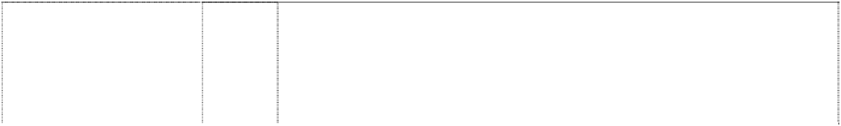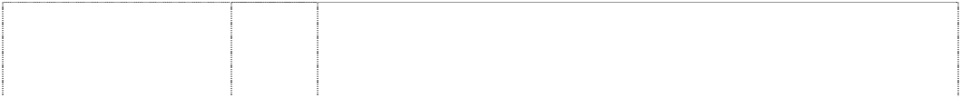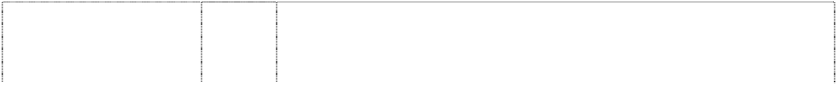

(1039002)

**MEI-XIN** (1039002) **MEI-XIN** (1039002) **MEI-XIN** (1039002) **MEI-XIN** (1039002)

# MEI-XIN

(1039002)

# MEI-XIN CAKES

heart,styl. with vertical stripe

(1038994)

# MEI-XIN CAKES

heart,styl. with vertical stripe

(1038994)

# MEI-XIN CAKES

heart,styl. with vertical stripe

(1038994)

# MEI-XIN CAKES

heart,styl. with vertical stripe

(1038994)

# MEI-XIN CAKES

heart,styl. with vertical stripe

(1038994)

# MEI-XIN CAKES

heart,styl. with vertical stripe

(1038994)

# MEI-XIN CAKES

heart,styl. with vertical stripe

(1038994)

20 Plastic cup; boxes of wood or plastic; goods (not included in other classes) of wood, and substitutes for all these materials, or of plastics; plastic containers.

1. Clothing; footwear; headgear.
2. Ribbon.
3. Games and playthings; gymnastic and sporting articles not included in other classes; decorations for Christmas trees.
4. Meat and preserved meat; fish; poultry and game; meat extracts; preserved, dried and cooked fruits and vegetables; jellies; jams; fruit sauces; compotes; eggs; milk and milk products; milk powder; cream; edible oils and fats; yogurt; mayonnaise; sandwich spread on the basis of milk; nuts; pickles; preserved and dried sea products (except fish).
5. Coffee, artificial coffee, coffee substitutes; tea, tea leaves and tea products; cocoa, cocoa powder and cocoa products; soup stock; bread; biscuits; cakes; snacks; cookies; crackers; Chinese cakes and western style cakes; Chinese dumplings; almond flakes; chocolate; bread sticks; pancakes; desserts; puddings; pastry and confectionery; macaroni, spaghetti, noodles and pasta products; flour and preparation made from cereals; honey; treacle; yeast, baking- powder; salt; sugar; vinegar; mustard; pepper; spices; horseradish sauces; sauces (condiment); salad dressings; ketchup; curry; ice; rice; tapioca; sago; ice cream.

6 Packaging containers of metal; aluminium foil; boxes of common metal; tin cans; tinfoil; common metals and their alloys; metal building materials; goods of common metal not included in other classes.

16 Envelopes (stationery); forms (printed); handbooks (manuals); magazines (periodicals); manuals (handbooks); newsletters; note books; pamphlets; paper; paper sheets (stationery); coupons; paper ribbons; periodicals; printed matter; printed publications; prospectuses; stationery; wrapping paper; packaging; writing instruments; writing materials; writing or drawing books; writing pads; writing paper; cardboard and goods made from these materials, not included in other classes; photographs; plastic materials for packaging (not included in other classes); plastic bag; plastic packaging bag; plastic wrapper; plastic stickers; plastic blister; plastic packaging materials.

20 Plastic cup; boxes of wood or plastic; goods (not included in other classes) of wood, and substitutes for all these materials, or of plastics; plastic containers.

1. Clothing; footwear; headgear.
2. Ribbon.
3. Games and playthings; gymnastic and sporting articles not included in other classes; decorations for Christmas trees.
4. Meat and preserved meat; fish; poultry and game; meat extracts; preserved, dried and cooked fruits and vegetables; jellies; jams; fruit sauces; compotes; eggs; milk and milk products; milk powder; cream; edible oils and fats; yogurt; mayonnaise; sandwich spread on the basis of milk; nuts; pickles; preserved and dried sea products (except fish).

# MEI-XIN CAKES

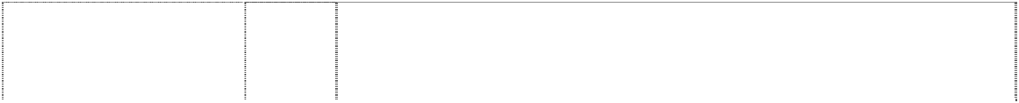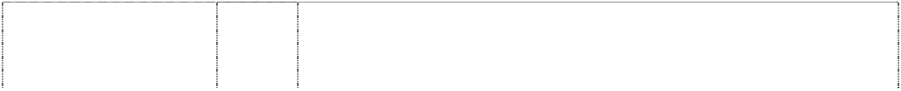

heart,styl. with vertical stripe

(1038994)

2 chinese characters

(1038982)

2 chinese characters

(1038982)

2 chinese characters

(1038982)

2 chinese characters

(1038982)

2 chinese characters

(1038982)

2 chinese characters

(1038982)

2 chinese characters

(1038982)

2 chinese characters

(1038982)

6 chinese characters

(1038992)

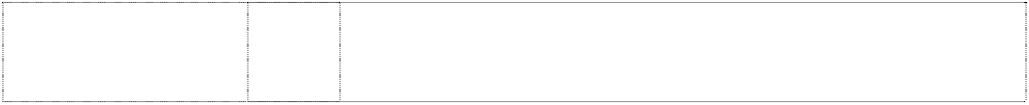6 chinese characters

(1038993)

1. Coffee, artificial coffee, coffee substitutes; tea, tea leaves and tea products; cocoa, cocoa powder and cocoa products; soup stock; bread; biscuits; cakes; snacks; cookies; crackers; Chinese cakes and western style cakes; Chinese dumplings; almond flakes; chocolate; bread sticks; pancakes; desserts; puddings; pastry and confectionery; macaroni, spaghetti, noodles and pasta products; flour and preparation made from cereals; honey; treacle; yeast, baking- powder; salt; sugar; vinegar; mustard; pepper; spices; horseradish sauces; sauces (condiment); salad dressings; ketchup; curry; ice; rice; tapioca; sago; ice cream.

6 Packaging containers of metal; aluminium foil; boxes of common metal; tin cans; tinfoil; common metals and their alloys; metal building materials; goods of common metal not included in other classes.

16 Envelopes (stationery); forms (printed); handbooks (manuals); magazines (periodicals); manuals (handbooks); newsletters; note books; pamphlets; paper; paper sheets (stationery); coupons; paper ribbons; periodicals; printed matter; printed publications; prospectuses; stationery; wrapping paper; packaging; writing instruments; writing materials; writing or drawing books; writing pads; writing paper; cardboard and goods made from these materials, not included in other classes; photographs; plastic materials for packaging (not included in other classes); plastic bag; plastic packaging bag; plastic wrapper; plastic sticker; plastic blister; plastic packaging materials.

20 Plastic containers; plastic cup; boxes of wood or plastic; goods (not included in other classes) of wood, and substitutes for all these materials, or of plastics**.**

1. Clothing; footwear; headgear.
2. Ribbon.
3. Games and playthings; gymnastic and sporting articles not included in other classes; decorations for Christmas trees.
4. Meat and preserved meat; fish; poultry and game; meat extracts; preserved, dried and cooked fruits and vegetables; jellies; jams; fruit sauces; compotes; eggs; milk and milk products; milk powder; cream; edible oils and fats; yogurt; mayonnaise; sandwich spread on the basis of milk; nuts; pickles; preserved and dried sea products (except fish).
5. Coffee, artificial coffee, coffee substitutes; tea, tea leaves and tea products; cocoa, cocoa powder and cocoa products; soup stock; bread; biscuits; cakes; snacks; cookies; crackers; Chinese cakes and western style cakes; Chinese dumplings; almond flakes; chocolate; bread sticks; pancakes; desserts; puddings; pastry and confectionery; macaroni, spaghetti, noodles and pasta products; flour and preparation made from cereals; honey; treacle; yeast, baking- powder; salt; sugar; vinegar; mustard; pepper; spices; horseradish sauces; sauces (condiment); salad dressings; ketchup; curry; ice; rice; tapioca; sago; ice-cream.

6 Packaging containers of metal; aluminium foil; boxes of common metal; tin cans; tinfoil; common metals and their alloys; metal building materials; goods of common metal not included in other classes.

6 Packaging containers of metal; aluminium foil; boxes of common metal; tin cans; tinfoil; common metals and their alloys; metal building materials; goods of common metal not included in other classes.

6 chinese characters



(1038992)

6 chinese characters

(1038993)

6 chinese characters

(1038992)

6 chinese characters

(1038993)

6 chinese characters

(1038992)

6 chinese characters

(1038993)

6 chinese characters

(1038992)

6 chinese characters

(1038993)

6 chinese characters

(1038992)

6 chinese characters

(1038993)

6 chinese characters

(1038992)

6 chinese characters

(1038993)

6 chinese characters

(1038992)

16 Envelopes (stationery); forms (printed); handbooks (manuals); magazines (periodicals); manuals (handbooks); newsletters; note books; pamphlets; paper; paper sheets (stationery); coupons; paper ribbons; periodicals; printed matter; printed publications; prospectuses; stationery; wrapping paper; packaging; writing instruments; writing materials; writing or drawing books; writing pads; writing paper; cardboard and goods made from these materials, not included in other classes; photographs; plastic materials for packaging (not included in other classes); plastic bag; plastic packaging bag; plastic wrapper; plastic sticker; plastic blister; plastic packaging materials.

16 Envelopes (stationery); forms (printed); handbooks (manuals); magazines (periodicals); manuals (handbooks); newsletters; note books; pamphlets; paper; paper sheets (stationery); coupons; paper ribbons; periodicals; printed matter; printed publications; prospectuses; stationery; wrapping paper; packaging; writing instruments; writing materials; writing or drawing books; writing pads; writing paper; cardboard and goods made from these materials, not included in other classes; photographs; plastic materials for packaging (not included in other classes); plastic bag; plastic packaging bag; plastic wrapper, plastic sticker; plastic blister; plastic packaging materials.

20 Plastic containers; plastic cup; boxes of wood or plastic; goods (not included in other classes) of wood, and substitutes for all these materials, or of plastics.

20 Plastic containers; plastic cup; boxes of wood or plastic; goods (not included in other classes) of wood, and substitutes for all these materials, or of plastics.

25 Clothing; footwear; headgear.

1. Clothing; footwear; headgear.
2. Ribbon.

26 Ribbon.

28 Games and playthings; gymnastic and sporting articles not included in other classes; decorations for Christmas trees.

1. Games and playthings; gymnastic and sporting articles not included in other classes; decorations for Christmas trees.
2. Meat and preserved meat; fish; poultry and game; meat extracts; preserved, dried and cooked fruits and vegetables; jellies; jams; fruit sauces; compotes; eggs; milk and milk products; milk powder; cream; edible oils and fats; yogurt; mayonnaise; sandwich spread on the basis of milk; nuts; pickles; preserved and dried sea products (except fish).
3. Meat and preserved meat; fish; poultry and game; meat extracts; preserved, dried and cooked fruits and vegetables; jellies; jams; fruit sauces; compotes; eggs; milk and milk products; milk powder; cream; edible oils and fats; yogurt; mayonnaise; sandwich spread on the basis of milk; nuts; pickles; preserved and dried sea products (except fish).
4. Coffee, artificial coffee, coffee substitutes; tea, tea leaves and tea products; cocoa, cocoa powder and cocoa products; soup stock; bread; biscuits; cakes; snacks; cookies; crackers; Chinese cakes and Western style cakes; Chinese dumplings; almond flakes; chocolate; bread sticks; pancakes; desserts; puddings; pastry and confectionery; macaroni, spaghetti, noodles and pasta products; flour and preparation made from cereals; honey; treacle; yeast, baking- powder; salt; sugar; vinegar; mustard; pepper; spices; horseradish sauces; sauces (condiment); salad dressings; ketchup; curry; ice; rice; tapioca; sago; ice-cream.

6 chinese characters

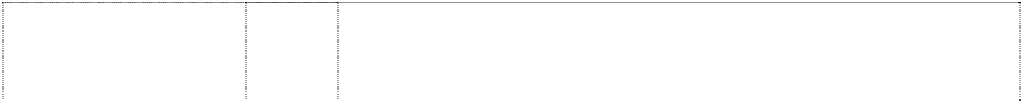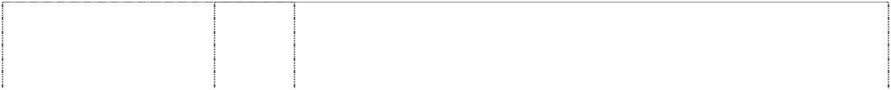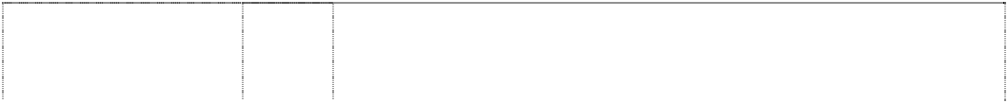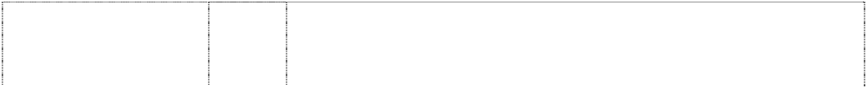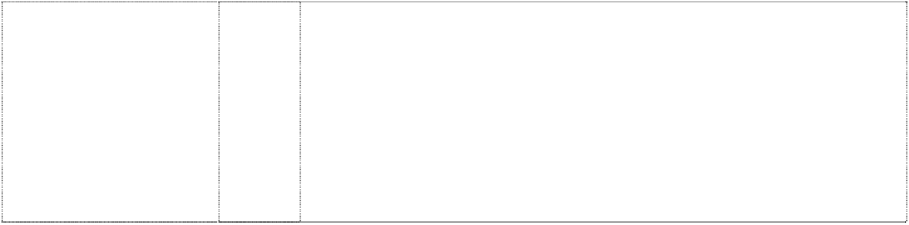

(1038993)

6 chinese chars.,2 chars in heart,styl. with vertical stripe (1038995)

6 chinese chars.,2 chars in heart,styl. with vertical stripe (1038995)

6 chinese chars.,2 chars in heart,styl. with vertical stripe (1038995)

6 chinese chars.,2 chars in heart,styl. with vertical stripe (1038995)

6 chinese chars.,2 chars in heart,styl. with vertical stripe (1038995)

6 chinese chars.,2 chars in heart,styl. with vertical stripe (1038995)

6 chinese chars.,2 chars in heart,styl. with vertical stripe (1038995)

6 chinese chars.,2 chars in heart,styl. with vertical stripe (1038995)

30 Coffee, artificial coffee, coffee substitutes; tea, tea leaves and tea products; cocoa, cocoa powder and cocoa products; soup stock; bread; biscuits; cakes; snacks; cookies; crackers; Chinese cakes and western style cakes; Chinese dumplings; almond flakes; chocolate; bread sticks; pancakes; desserts; puddings; pastry and confectionery; macaroni, spaghetti, noodles and pasta products; flour and preparation made from cereals; honey; treacle; yeast, baking- powder; salt; sugar; vinegar; mustard; pepper; spices; horseradish sauces; sauces (condiment); salad dressings; ketchup; curry; ice; rice; tapioca; sago; ice-cream.

6 Packaging containers of metal; aluminium foil; boxes of common metal; tin cans; tinfoil; common metals and their alloys; metal building materials; goods of common metal not included in other classes.

16 Envelopes (stationery); forms (printed); handbooks (manuals); magazines (periodicals); manuals (handbooks); newsletters; note books; pamphlets; paper; paper sheets (stationery); coupons; paper ribbons; periodicals; printed matter; printed publications; prospectuses; stationery; wrapping paper; packaging; writing instruments; writing materials; writing or drawing books; writing pads; writing paper; cardboard and goods made from these materials, not included in other classes; photographs; plastic materials for packaging (not included in other classes); plastic bag; plastic packaging bag; plastic wrapper; plastic sticker; plastic blister and plastic packaging materials.

20 Plastic containers; plastic cup; boxes of wood or plastic; goods (not included in other classes) of wood, and substitutes for all these materials, or of plastics.

1. Clothing; footwear; headgear.
2. Ribbon.
3. Games and playthings; gymnastic and sporting articles not included in other classes; decorations for Christmas trees.
4. Meat and preserved meat; fish; poultry and game; meat extracts; preserved, dried and cooked fruits and vegetables; jellies; jams; fruit sauces; compotes; eggs; milk and milk products; milk powder; cream; edible oils and fats; yogurt; mayonnaise; sandwich spread on the basis of milk; nuts; pickles; preserved and dried sea products (except fish).
5. Coffee, artificial coffee, coffee substitutes; tea, tea leaves and tea products; cocoa, cocoa powder and cocoa products; soup stock; bread; biscuits; cakes; snacks; cookies; crackers; Chinese cakes and western style cakes; Chinese dumplings; almond flakes; chocolate; bread sticks; pancakes; desserts; puddings; pastry and confectionery; macaroni, spaghetti, noodles and pasta products; flour and preparation made from cereals; honey; treacle; yeast, baking- powder; salt; sugar; vinegar; mustard; pepper; spices; horseradish sauces; sauces (condiment); salad dressings; ketchup; curry; ice; rice; tapioca; sago; ice cream.

***NBA Properties, Inc. Chrysiliou Law***

***Ph: (02) 9953 4222***

***Effective Date: 18 September 2007 File Reference: C07/16050***

***Goods***

***Class***

***Trade Marks***



# 76ERS

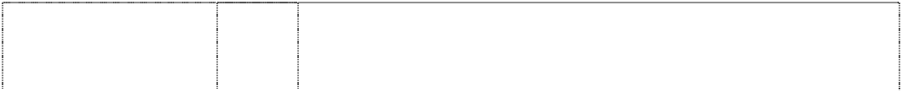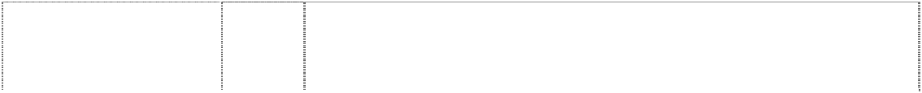

basketball is comet with star at end of tail (726278)

# 76ERS

basketball is comet with star at end of tail (726278)

# 76ERS

basketball is comet with star at end of tail (726278)

# 76ERS

basketball is comet with star at end of tail (726278)

# ATLANTA HAWKS

eagle with wings outstretched on globe meridians

(652394)

# BOSTON CELTICS

man leaning on stick waistcoat, flowered & ball on finger on annulus

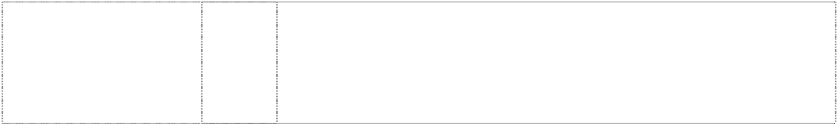(515936)

# CHICAGO BULLS

bull, head (515942)

9 Pre-recorded audio and video tapes, cassettes, and compact discs; computer software; video game software and computer accessories; games and game systems and parts therefore (not included in other classes); teaching apparatus for sporting activity; magnets.

16 Publications and printed matter; paper and cardboard articles not included in other classes; photographs; stationery; playing cards.

25 Articles of clothing for sports and leisure wear, including footwear and headgear.

28 Toys, games and sporting goods (not included in other classes) inclusive of basketballs, golf balls, playground balls, sports balls, rubber action balls and foam action balls, basketball nets, basketball backboards, pumps for inflating basketballs, and needles therefor, golf clubs, electronic basketball table top games, basketball table top games, basketball board games, basketball kit comprised of a basketball net and whistle, dolls, stuffed toys, jigsaw puzzles; Christmas tree ornaments.

25 Clothing, leisure wear, sportswear, uniforms, babywear, underwear, underpants, boxer shorts, singlets, leotards, shirts, sports shirts, blouses, T-shirts, sweatshirts, tank tops, polo shirts, skivvies, rugby tops, grandpa tops, shorts, board shorts, tracksuits, warm-up suits, pants, warm-up pants, sweat pants, trousers, jeans, dresses, skirts, clothing belts, knitwear, jumpers, sweaters, guernseys, jerseys, cardigans, vests, neckwear, cravats, neckties, scarves, jackets, bomber jackets, blazers, formal wear, suits, coats, parkas, anoraks, rainwear, raincoats, swimsuits, sleepwear, pyjamas, nightshirts, night gowns, dressing gowns, bath robes, cloth bibs, aprons, gloves, mittens, headwear, hats, caps, berets, beanies, ear muffs, clothing hoods, visors, headbands, wristbands, socks, stockings, hosiery, footwear, shoes, boots, sandals and slippers.

25 Clothing, underwear, underpants, singlets, shirts, T-shirts, shorts, pants, trousers, tracksuits, clothing belts, knitwear, jumpers, cardigans, sweatshirts, neckwear, jackets, coats, scarves, rainwear, swimwear, sleepwear, pyjamas, nightshirts, dressing gowns, headwear, hats, caps, socks, hosiery, footwear, shoes, boots, slippers, and all other goods in class 25.

25 Clothing, underwear, underpants, singlets, shirts, T-shirts, shorts, pants, trousers, tracksuits, clothing belts, knitwear, jumpers, cardigans, sweatshirts, neckwear, jackets, coats, scarves, rainwear, swimwear, sleepwear, pyjamas, nightshirts, dressing gowns, headwear, hats, caps, socks, hosiery, footwear, shoes, boots, slippers, and all other goods in class 25.

# CLEVELAND CAVALIERS



words break basketball; sword thru ltr C

(950357)

# CLEVELAND CAVALIERS

words break basketball; sword thru ltr C

(950357)

9 Scientific, nautical, surveying, electric, photographic, cinematographic, optical, weighing, measuring, signalling, checking (supervision), life saving and teaching apparatus and instruments; apparatus for recording, transmission or reproduction of sound, data or images; magnetic data carriers; recording apparatus; automatic vending machines and mechanism for coin-operated apparatus; cash registers, calculating machines, data processing equipment and computers; fire extinguishing apparatus; audio, video, computer and laser discs, pre-recorded audio and video cassettes, pre-recorded audio and video tapes, pre-recorded compact discs, pre-recorded computer discs, all related to basketball; computer accessories, including mouse pads, mice, disc cases, computer carry-on cases, keyboard wrist pads, computer monitor cardboard frames, all related to basketball; computer programs for viewing information, statistics or trivia about basketball; computer software featuring basketball, including screen savers; video game software, video game cartridges and video game machines for use with televisions; radio and telephone; binoculars; sunglasses; eyeglass ties; eyewear straps and chains; eyeglass and sunglass cases; magnets; credit cards and prepaid telephone calling cards magnetically encoded, video recordings, video stream recordings, and audio recordings in the field of basketball provided over the Internet; computer software for gaining access to and for viewing databases of information, statistical information, trivia, polling information, and interactive polling in the field of basketball provided over the Internet; computer game software; video game programs, interactive video games and trivia game software provided over the Internet; computer software for use as screensavers, wallpaper, browser skins, and cursors provided over the Internet; electronic publications in the nature of magazines and newsletters in the field of basketball provided over the Internet; colour books in the nature of drawings and pictures being electronic publications provided over the Internet; electronic catalogues provided over the Internet featuring an array of basketball themed products; electronic video arcade game machines; arcade games; video recordings, video stream recordings, audio recordings in the field of basketball, cell phone accessories including face plates and cell phone covers; downloadable coloring books in the nature of drawings and pictures provided over the Internet; trivia information games and board games provided over the Internet.

16 Paper, cardboard and goods made from these materials, not included in other classes; printed matter; book binding material; photographs; stationery; adhesives for stationery or household purposes; artists' materials; paint brushes; typewriters and office requisites (except furniture); instructional and teaching material (except apparatus); plastic materials for packaging (not included in other classes); printers' type; printing blocks; publications and printed matter, including basketball trading cards, dance team trading cards, mascot trading cards, entertainment trading cards, stickers, decalcomanias, commemorative basketball stamps, collectible cardboard trading cards discs, memo boards, clipboards, paper coasters, post cards, place mats of paper, note cards, memo pads, ball point pens, pencils, pen and paper holders, desktop document stands, scrap books, rubber stamps, paper banners and flags, bookmarks, 3-ring binders, stationery folders, wirebound notebooks, portfolio notebooks, unmounted and mounted photographs, posters, calendars, bumper stickers, book covers, wrapping paper, children's activity books, statistical books, guide books and reference books for basketball, magazines in the field of basketball, commemorative game programs, paper pennants, stationery, stationery-type portfolios, and statistical sheets for basketball topics, newsletters and pamphlets in the field of basketball, bank cheques, cheque book covers, cheque book holders, credit cards and telephone calling cards not magnetically encoded.

# CLEVELAND CAVALIERS



words break basketball; sword thru ltr C

(950357)

# CLEVELAND CAVALIERS

words break basketball; sword thru ltr C

(950357)

# CLEVELAND CAVALIERS

words break basketball; sword thru ltr C

(950357)

18 Leather and imitations of leather, and goods made of these materials and not included in other classes; animal skins, hides; trunks and travelling bags; umbrellas, parasols and walking sticks; whips, harness and saddlery; athletic bags, shoe bags for travel, overnight bags, backpacks, baby backpacks, duffel bags, tote bags, luggage, luggage tags, patio umbrellas, valises, attache cases, billfolds, wallets, briefcases, canes, business card cases, book bags, all purpose sports bags, golf umbrellas, gym bags, purses, coin purses, fanny packs, wrist packs, cosmetic cases sold empty, garment bags for travel, handbags, key cases, knapsacks, suitcases, toiletry cases sold empty, trunks for travelling and rucksacks.

25 Clothing, footwear, headgear; basketball shoes, basketball sneakers, clothing including hosiery, T- shirts, shirts, sweatshirts, sweatpants, pants, tank tops, jerseys, shorts, pyjamas, sport shirts, rugby shirts, sweaters, belts, ties, night shirts, hats, warm-up suits, warm-up pants, warm-up tops, jackets, parkas, coats, cloth bibs, head bands, wrist bands, aprons, boxer shorts, slacks, caps, ear muffs, gloves, mittens, woven and knit shirts.

28 Games and playthings; gymnastic and sporting articles not included in other classes; decorations for Christmas trees; toys, games and sporting goods, including basketballs, golf balls, playground balls, sports balls, rubber action balls and foam action balls, plush balls, basketball nets, pumps for inflating basketballs and needles therefor being sporting goods, golf clubs, golf bags, golf putters, golf ball gift sets with divot repair tools, or tees or ball markers, golf accessories, including golf bag covers, club head covers, golf gloves, golf ball sleeves, bicycle tags being sporting goods for identifying bicycles, electronic basketball table top games, basketball table top games, basketball board games, electronic video arcade game machines, basketball kit comprised of a basketball net and whistle, dolls, toy action figures, stuffed toys, jigsaw puzzles and Christmas tree ornaments; action skill games, arcade games, adults' and children's party games; basketball backboards; playing cards.

# DALLAS MAVERICKS

horse, head in basketball break shield (848256)

9 Apparatus for recording, transmission, reproduction or transfer of sound, images or data; audio, video, computer and laser discs, pre- recorded audio and video cassettes, pre-recorded audio and video tapes, pre-recorded compact discs, pre-recorded computer discs; computer accessories, including, mouse pads, mice, disc cases, computer carry-on cases, keyboard wrist pads, computer monitor cardboard frames; computer programs including computer programs featuring information, trivia and/or statistics about basketball; computer operating systems including computer operating systems in the field of basketball; computer software including computer software featuring basketball, and screensavers; computer software featuring publications in an electronic format in the field of basketball including magazines and news letters; computer software featuring colouring books including colouring books in the nature of drawings and pictures; computer software featuring action skill games, arcade games, adults' and children's party games, trivia information games, and board games; catalogues in the form of computer software featuring a host of products; catalogues in the form of computer software featuring audio recordings, video recordings, computer accessories, computer games, computer software, computer databases, video games, telephones, binoculars, eyeware, magnets, collectible and novelty items, collectible coins, medallions, albums, scrap books, photo frames, sports memorabilia, timepieces, jewellery, jewellery boxes, credit cards, calling cards, publications, calendars, catalogues, organisers, directories, stationery, school supplies, giftware, gift sets, portfolios, posters, photos, trading cards, books, card holders, pamphlets, pennants, flags, banners, souvenirs, bank checks, bags, travel bags, travel bags, travel cases, sports bags, lunch boxes, wallets, umbrellas, clothing, toys, games, sporting goods, Christmas ornaments, decorations, housewares, lamps, lighting fixtures, beverageware, kitchenware, household supplies, containers, boxes, bed and bath and table linen, furniture, office furniture and accessories, lockers and footlockers; video game software; video game cartridges and video game machines for use with television; radios and telephones; binoculars; sunglasses, eyeglass frames, eyewear straps and chains, eyeglass and sunglass cases; magnets; computer hardware; video recordings, video stream recordings, and audio recordings in the field of basketball provided over a global computer network; computer software including computer software featuring information, statistical information, trivia, database of information, database of statistical information, database of trivia, polling information, and interactive polling in the field of basketball provided over a global computer network; computer game software, video game programs, interactive video games, and trivia game software provided over a global computer network; computer software for use as screensavers, wallpaper, browser skins, and cursors provided over a global computer network.

# DALLAS MAVERICKS



horse, head in basketball break shield (848256)

# DALLAS MAVERICKS

horse, head in basketball break shield (848256)

# DALLAS MAVERICKS

horse, head in basketball break shield (848256)

# DALLAS MAVERICKS

horse, head in basketball break shield (848256)

16 Publications and printed matter, including basketball trading cards, dance team trading cards, mascot trading cards, entertainment trading cards, stickers, decalcomanias, commemorative basketball stamps, collectible cardboard trading cards, collectible trading discs, memo boards, clipboards, paper coasters, post cards, place mats of paper, note cards, memo pads, ball point pens, pencils, pen and paper holders, standing boards, scrap books, rubber stamps, paper banners, and flags, bookmarks, 3-ring binders, stationery folders, wirebound notebooks, portfolio notebooks, unmounted and mounted photographs, posters, calendars, bumper stickers, book covers, wrapping paper, children's activity books, statistical books, guide books and reference books for basketball, magazines in the field of basketball, commemorative game programs, paper pennants, stationery, stationery-type portfolios, and statistical sheets for basketball topics, newsletters and pamphlets in the field of basketball; paper, cardboard and goods made from these materials; instructional and teaching materials; electronic materials; colouring books; catalogues featuring audio recordings, video recordings, computer accessories, computer games, computer software, computer databases, video games, telephones, binoculars, eyewear, magnets, collectible and novelty items, collectible coins, medallions, albums, scrapbooks, photo frames, sports memorabilia, timepieces, jewellery, jewellery boxes, credit cards, calling cards, publications, calendars, catalogues, organisers, directories, stationery, school supplies, giftware, gift sets, portfolios, posters, photos, trading cards, books, card holders, pamphlets, pennants, flags, banners, souvenirs, bank checks, bags, travel bags, travel cases, sports bags, lunch boxes, wallets, umbrellas, clothing, toys, games, sporting goods, Christmas ornaments, decorations, housewares, lamps, lighting fixtures, beverageware, kitchenware, household supplies, containers, boxes, bed, bath and table linens, furniture, office furniture and accessories, lockers and footlockers; catalogues featuring a host of products.

18 Leather and imitations of leather, and goods made of these materials and not included in other classes; athletics bags, shoe bags, overnight bags, beach bags, school bags, backpacks, baby backpacks, duffle bags, tote bags, luggage, luggage tags, umbrellas, patio umbrellas, cases, valises, attache cases, billfolds, wallets, briefcases, cases of leather or imitation leather, canes, business card cases, book bags, all purpose sport bags, golf umbrellas, gym bags, purses, fanny packs, waist packs, cosmetic cases sold empty, garment bags for travel, handbags, keycases, knapsacks, suitcases, toiletry cases sold empty, trunks for clothing, belts, haversacks, rucksacks, satchels, travelling bags, vanity cases, travelling sets and trunks.

25 Clothing, footwear and headgear, including hosiery, footwear, t- shirts, sweatshirts, sweatpants, pants, tank tops, jerseys, shorts, pyjamas, sport shirts, rugby shirts, sweaters, belts, ties, night shirts, hats, warm-up suits, jackets, parkas, coats, cloth bibs, head bands, wrist bands, aprons, boxer shorts, slacks, caps, ear muffs, gloves, mittens, woven and knit shirts.

28 Toys, games and sporting goods, including, basketballs, golf balls, playground balls, sports balls, rubber action balls and foam action balls, plush balls, basketball nets, basketball backboards, pumps for inflating basketballs, and needles therefor, golf clubs, golf bags, golf putters, golf ball sets with divot repair tools; tees or ball markers, golf accessories, including, golf bag covers, club head covers, golf gloves, golf ball sleeves; bicycles tags, electronic basketball table top games, basketball table top games, basketball board games, electronic video arcade game machines, basketball kit comprised of a basketball net and whistle; dolls, toy action figures, stuffed toys, jigsaw puzzles, playthings and gymnastic articles included in this class and Christmas tree ornaments; games including action skill games, arcade games, adults' and children's party games, trivia information games, and board games.

# DENVER NUGGETS



scroll under snowcapped mountain, styl. (615549)

# DETROIT PISTONS

ball,basketball in circle (1063731)

# DETROIT PISTONS

ball,basketball in circle (1063731)

25 Clothing, leisure wear, sports wear, underwear, underpants, singlets, shirts, T-shirts, shorts, pants, trousers, tracksuits, clothing belts, knitwear, jumpers, cardigans, sweatshirts, neckwear, jackets, coats, scarves, rainwear, swimwear, sleepwear, pyjamas, nightshirts, dressing gowns, headwear, hats, caps, socks, hosiery, footwear, shoes, boots, slippers, and all other goods in class 25.

9 Audio recordings and video recordings in the field of basketball, audio, video, computer and laser discs, pre-recorded audio and video cassettes, pre-recorded audio and video tapes, pre-recorded compact discs, pre-recorded computer discs, all related to basketball; computer accessories, namely mouse pads, mice, disc cases, computer carry-on cases, keyboard wrist pads, computer monitor cardboard frames, all related to basketball; computer programs for viewing information, statistics or trivia about basketball, computer software, namely screen savers featuring basketball themes, computer software to access and view computer wallpaper, computer browsers, computer skins and computer cursors; computer game software, video game software, video game cartridges and video game machines for use with televisions; radios, telephones, and cell phone accessories, namely face plates and cell phone covers; video monitors, computer monitors, binoculars; sunglasses; eyeglass frames; eyewear straps and chains; eyeglass and sunglass cases; magnets; disposable cameras; credit cards and pre-paid telephone calling cards magnetically encoded, downloadable video recordings, video stream recordings, and audio recordings in the field of basketball provided over the Internet; downloadable computer software for viewing databases of information, statistical information, trivia, polling information, and interactive polling in the field of basketball provided over the Internet; downloadable computer game software; video game programs, interactive video games and trivia game software provided over the Internet; downloadable computer software for use as screensavers, wallpaper, browsers, skins, avatars and cursors over the Internet; downloadable electronic publications in the nature of magazines, newsletters, colouring books, game schedules all in the field of basketball provided over the Internet; downloadable catalogues provided over the Internet featuring an array of basketball-themed products; downloadable greeting cards provided over the Internet.

16 Publications and printed matter, namely basketball trading cards, trading cards, stickers, decalcomania, commemorative basketball stamps, collectible cardboard trading discs, memo boards, clipboards, paper coasters, post cards, place mats of paper, facial tissues, note cards, memo pads, note pads, ball point pens, rubber bands, pencils, pen and paper holders, desktop document stands, scrap books, rubber stamps, paper banners and flags, bookmarks, 3- ring binders, stationery folders, wirebound notebooks, portfolio notebooks, unmounted and mounted photographs, posters, calendars, bumper stickers, book covers, bookmarks, wrapping paper, children's activity books, children's colouring books, statistical books, guide books, and reference books in the field of basketball, magazines in the field of basketball, catalogues featuring basketball, commemorative game and souvenir programs, paper pennants, stationery, stationery-type portfolios, post cards, invitation cards, printed certificates, greeting cards, Christmas cards, holiday cards, statistical sheets for basketball topics, newsletters, brochures, pamphlets, and game schedules in the field of basketball, bank cheques, cheque book covers, cheque book holders, credit cards and telephone calling cards not magnetically encoded.

# DETROIT PISTONS



ball,basketball in circle (1063731)

# DETROIT PISTONS

ball,basketball in circle (1063731)

# DETROIT PISTONS

ball,basketball in circle (1063731)

# HARDWOOD CLASSICS VINTAGE

basketball is globe with ring in square frame; basketballer, silh. bounces basketball in rect.,rounded-corners (936178)

18 Athletic bags, shoe bags for travel, overnight bags, umbrellas, backpacks, baby backpacks, knapsacks, duffel bags, tote bags, beach bags, beach tote bags, drawstring pouches, luggage, luggage tags, patio umbrellas, beach umbrellas, valises, attache cases, billfolds, wallets, briefcases, canes, business card cases, book bags, all purpose sports bags, golf umbrellas, gym bags, purses, coin purses, fanny packs, waist packs, cosmetic cases sold empty, garment bags for travel, handbags, key cases, leather key chains, knapsacks, suitcases, toiletry cases sold empty, trunks for travelling and rucksacks, pet clothing, pet leashes, and pet collars.

25 Clothing, namely hosiery, footwear, basketball shoes, basketball sneakers, T-shirts, shirts, polo shirts, sweatshirts, sweatpants, pants, tank tops, jerseys, shorts, pyjamas, sport shirts, rugby shirts, sweaters, belts, ties, nightshirts, hats, caps, visors, warm-up suits, warm-up pants, warm-up tops/shooting shirts, jackets, wind resistant jackets, parkas, coats, baby bibs not of paper, head bands, wrist bands, aprons, undergarments, boxer shorts, slacks, caps, ear muffs, gloves, mittens, scarves, woven and knit shirts, jersey dresses, dresses, cheerleading dresses and uniforms, swim wear, bathing suits, swimsuits, bikinis, tankinis, swim trunks, bathing trunks, board shorts, wet suits, beach cover-ups, bathing suit cover- ups, bathing suit wraps, sandals, beach sandals, beach hats, sun visors, swim caps, bathing caps, novelty headwear with wigs.

28 Toys, games and sporting goods, namely basketballs, golf balls, playground balls, sports balls, rubber action balls and foam action balls, plush balls, basketball nets, basketball backboards, pumps for inflating basketballs, and needles therefor, golf clubs, golf bags, golf putters, golf accessories, namely, divot repair tools, tees, ball markers, golf bag covers, club head covers, golf gloves, golf ball sleeves, electronic basketball table top games, basketball table top games, basketball board games, action skill games, adult's and children's party games, trivia information games and electronic video arcade game machines, basketball kit comprised of a net and whistle, dolls, decorative dolls, collectible dolls, toy action figures, bobblehead action figures, stuffed toys, novelty plush toys with wigs, jigsaw puzzles and Christmas tree ornaments, Christmas stockings; toy vehicles in the nature of cars, trucks and vans, all containing basketball themes, novelty foam toys in the shapes of fingers and trophies, toy trophies, playing cards, card games, noisemakers, pet toys, beach toys, pool toys, basketballs, beach balls, sports balls, plastic balls, inflatable balls, toy pails, toy shovels, inflatable toys, sand toys, sand box toys, water-squirting toys; beach and pool accessories, namely swim floats, pool floats, foam floats, swim rings, pool rings, foam rings, water rafts, body boards, surf boards, swim fins, surf fins, arm floats and water wing swim aids for recreational use; basketball game kits, volleyball game kits, and water polo game kits.

25 Clothing, footwear, headgear, including, hosiery, basketball shoes, basketball sneakers, T-shirts, shirts, sweatshirts, sweatpants, pants, tank tops, jerseys, shorts, pyjamas, sport shirts, rugby shirts, sweaters, belts, ties, night shirts, hats, warm-up suits, warm-up pants, warm-up tops, jackets, wind resistant jackets, parkas, coats, cloth bibs, head bands, wrist bands, aprons, boxer shorts, slacks, caps, ear muffs, gloves, mittens, scarves, woven and knit shirts, cheerleading dresses and uniforms.

# HOUSTON ROCKETS R



ltr R,extended forms rocket,styl. thru ellipse,incompl. (959794)

# HOUSTON ROCKETS R

ltr R,extended forms rocket,styl. thru ellipse,incompl. (959794)

9 Scientific, nautical, surveying, electric, photographic, cinematographic, optical, weighing, measuring, signalling, checking (supervision), life-saving and teaching apparatus and instruments; apparatus for recording, transmission or reproduction of sound, data or images; magnetic data carriers; recording apparatus; automatic vending machines and mechanism for coin-operated apparatus; cash registers, calculating machines, data processing equipment and computers; fire extinguishing apparatus; audio, video, computer and laser discs, pre-recorded audio and video cassettes, pre-recorded audio and video tapes, pre-recorded compact discs, pre-recorded computer discs, all related to basketball; computer accessories, including mouse pads, mice, disc cases, computer carry-on cases, keyboard wrist pads, computer monitor cardboard frames, all related to basketball; computer programs for viewing information, statistics or trivia about basketball; computer software featuring basketball, including screen savers; video game software, video game cartridges and video game machines for use with televisions; radio and telephone; binoculars; sunglasses; eyeglass frames; eyewear straps and chains; eyeglass and sunglass cases; magnets; credit cards and prepaid telephone calling cards magnetically encoded, video recordings, video stream recordings, and audio recordings in the field of basketball provided over the Internet; computer software for gaining access to and for viewing databases of information, statistical information, trivia, polling information, and interactive polling in the field of basketball provided over the Internet; computer game software; video game programs, interactive video games and trivia game software provided over the Internet; computer software for use as screensavers, wallpaper, browser skins, and cursors provided over the Internet; electronic publications in the nature of magazines and newsletters in the field of basketball provided over the Internet; colour books in the nature of drawings and pictures being electronic publications provided over the Internet; electronic catalogues provided over the Internet featuring an array of basketball themed products; electronic video arcade game machines; arcade games; video recordings, video stream recordings, audio recordings in the field of basketball, cell phone accessories including face plates and cell phone covers; electronic publications in the nature of magazines and newsletters in the field of basketball provided over the Internet, colouring books in the nature of drawings and pictures provided over the Internet; catalogues provided over the Internet featuring an array of basketball theme products.

16 Paper, cardboard and goods made from these materials, not included in other classes; printed matter; book binding material; photographs; stationery; adhesives for stationery or household purposes; artists' materials; paint brushes; typewriters and office requisites (except furniture); instructional and teaching material (except apparatus); plastic materials for packaging (not included in other classes); printers' type; printing blocks; publications and printed matter, including basketball trading cards, dance team trading cards, mascot trading cards, entertainment trading cards, stickers, decalcomanias, commemorative basketball stamps, collectible cardboard trading cards discs, memo boards, clipboards, paper coasters, post cards, place mats of paper, note cards, memo pads, ball point pens, pencils, pen and paper holders, desktop document stands, scrap books, rubber stamps, paper banners and flags, bookmarks, 3-ring binders, stationery folders, wirebound notebooks, portfolio notebooks, unmounted and mounted photographs, posters, calendars, bumper stickers, book covers, wrapping paper, children's activity books, statistical books, guide books and reference books for basketball, magazines in the field of basketball, commemorative game programs, paper pennants, stationery, stationery-type portfolios, and statistical sheets for basketball topics, newsletters and pamphlets in the field of basketball, bank cheques, cheque book covers, cheque book holders, credit cards and telephone calling cards not magnetically encoded.

# HOUSTON ROCKETS R

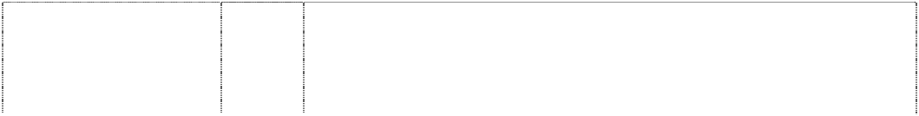

ltr R,extended forms rocket,styl. thru ellipse,incompl. (959794)

# HOUSTON ROCKETS R

ltr R,extended forms rocket,styl. thru ellipse,incompl. (959794)

# HOUSTON ROCKETS R

ltr R,extended forms rocket,styl. thru ellipse,incompl. (959794)

# JAZZ UTAH

circle double broken by word jazz, scene, mountains above (708054)

# JAZZ UTAH

circle double broken by word jazz, scene, mountains above (708054)

# JAZZ UTAH

circle double broken by word jazz, scene, mountains above (708054)

# JAZZ UTAH

circle double broken by word jazz, scene, mountains above (708054)

18 Leather and imitations of leather, and goods made of these materials and not included in other classes; animal skins, hides; trunks and travelling bags; umbrellas, parasols and walking sticks; whips, harness and saddlery; athletic bags, shoe bags for travel, overnight bags, backpacks, baby backpacks, duffel bags, tote bags, luggage, luggage tags, patio umbrellas, valises, attache cases, billfolds, wallets, briefcases, canes, business card cases, book bags, all purpose sports bags, golf umbrellas, gym bags, purses, coin purses, fanny packs, wrist packs, cosmetic cases sold empty, garment bags for travel, handbags, key cases, knapsacks, suitcases, toiletry cases sold empty, trunks for travelling and rucksacks.

25 Clothing, footwear, headgear; basketball shoes, basketball sneakers, clothing including hosiery, T-shirts, shirts, sweatshirts, sweatpants, pants, tank tops, jerseys, shorts, pyjamas, sport shirts, rugby shirts, sweaters, belts, ties, night shirts, hats, warm-up suits, warm-up pants, warm-up tops, jackets, parkas, coats, cloth bibs, head bands, wrist bands, aprons, boxer shorts, slacks, caps, ear muffs, gloves, mittens, woven and knit shirts.

28 Games and playthings; gymnastic and sporting articles not included in other classes; decorations for Christmas trees; toys, games and sporting goods, including basketballs, golf balls, playground balls, sports balls, rubber action balls and foam action balls, plush balls, basketball nets, pumps for inflating basketballs and needles therefor being sporting goods, golf clubs, golf bags, golf putters, golf ball gift sets with divot repair tools, or tees or ball markers, golf accessories, including golf bag covers, club head covers, golf gloves, golf ball sleeves, bicycle tags being sporting goods for identifying bicycles, electronic basketball table top games, basketball table top games, basketball board games, electronic video arcade game machines, basketball kit comprised of a basketball net and whistle, dolls, toy action figures, stuffed toys, jigsaw puzzles and Christmas tree ornaments; action skill games, arcade games, adults' and children's party games, trivia information games; basketball backboards; playing cards.

9 Apparatus for recording, transmission and/or reproduction of sound and/or images inclusive of pre-recorded audio and video cassettes, audio and video tapes, compact discs; games and game systems in this class inclusive of video games tapes, video game cassettes, video game cartridges and video game discs; computer discs, computer operating programs, computer programs, computer software and video game software; magnets; teaching apparatus for sporting activity; protective helmets; computer accessories in this class.

16 Publications and printed matter; paper articles and cardboard articles not included in other classes; bulletin boards and magnetic boards; printed matter and publications inclusive of books and magazines; greeting cards, trading cards and collector cards; playing cards; gift wrap; stationery; photographs, pictures, posters, prints; stickers and decalcomania; albums, diaries, calendars and organisers.

25 Articles of clothing for sports and leisure wear, including footwear and headgear.

28 Toys, games and sporting goods (not included in other classes) inclusive of basketballs, golf balls, playground balls, sports balls, rubber action balls and foam action balls, basketball nets, basketball backboards, pumps for inflating basketballs, and needles therefor, golf clubs, electronic basketball table top games, basketball table top games, basketball board games, basketball kit comprised of a basketball net and whistle, dolls, stuffed toys, jigsaw puzzles; equipment for exercising and/or physical fitness; Christmas tree ornaments.

# KNICKS



ball, basketball in bottom of triangle, inverted

(515938)

# LOS ANGELES CLIPPERS

2 stripes & words on basketball

(515955)

# LOS ANGELES LAKERS

basketball (515951)

# MEMPHIS GRIZZLIES

grizzly bear's head atop words (1001913)

25 Clothing, underwear, underpants, singlets, shirts, T-shirts, shorts, pants, trousers, tracksuits, clothing belts, knitwear, jumpers, cardigans, sweatshirts, neckwear, jackets, coats, scarves, rainwear, swimwear, sleepwear, pyjamas, nightshirts, dressing gowns, headwear, hats, caps, socks, hosiery, footwear, shoes, boots, slippers, and all other goods in class 25.

25 Clothing, underwear, underpants, singlets, shirts, T-shirts, shorts, pants, trousers, tracksuits, clothing belts, knitwear, jumpers, cardigans, sweatshirts, neckwear, jackets, coats, scarves, rainwear, swimwear, sleepwear, pyjamas, nightshirts, dressing gowns, headwear, hats, caps, socks, hosiery, footwear, shoes, boots, slippers, and all other goods in class 25.

25 Clothing, underwear, underpants, singlets, shirts, T-shirts, shorts, pants, trousers, tracksuits, clothing belts, knitwear, jumpers, cardigans, sweatshirts, neckwear, jackets, coats, scarves, rainwear, swimwear, sleepwear, pyjamas, nightshirts, dressing gowns, headwear, hats, caps, socks, hosiery, footwear, shoes, boots, slippers, and all other goods in class 25.

9 Scientific, nautical, surveying, electric, photographic, cinematographic, optical, weighing, measuring, signalling, checking (supervision), life-saving and teaching apparatus and instruments; apparatus for recording, transmission or reproduction of sound, data or images; magnetic data carriers; recording apparatus; automatic vending machines and mechanism for coin-operated apparatus; cash registers, calculating machines, data processing equipment and computers; fire extinguishing apparatus; audio recordings and video recordings; audio, video, computer and laser discs, pre-recorded audio and video cassettes, pre-recorded audio and video tapes, pre- recorded compact discs, pre-recorded computer discs, all related to basketball; computer accessories, including mouse pads, mice, disc cases, computer carry-on cases, keyboard wrist pads, computer monitor cardboard frames, all related to basketball; computer programs for viewing information, statistics or trivia about basketball; computer software including screen savers; computer software to access and view computer wallpaper, computer browsers, computer skins and computer cursors; video game software, video game cartridges and video game machines for use with televisions; radios and telephones; video monitors, computer monitors, binoculars; sunglasses; eyeglass frames; eyewear straps and chains; eyeglass and sunglass cases; magnets; disposable cameras; credit cards and prepaid telephone calling cards magnetically encoded, downloadable video recordings, video stream recordings, and audio recordings in the field of basketball provided over the Internet; downloadable computer software for gaining access to and for viewing databases of information, statistical information, trivia, polling information, and interactive polling in the field of basketball provided over the Internet; computer game software; downloadable computer game software; video game programs, interactive video games and trivia game software provided over the Internet; downloadable computer software for use as screensavers, wallpaper, browsers skins, avatars and cursors provided over the Internet; downloadable electronic publications in the nature of magazines, newsletters, coloring books, game schedules all in the field of basketball provided over the Internet; colour books in the nature of drawings and pictures being electronic publications provided over the Internet; downloadable catalogues provided over the Internet featuring an array of basketball themed products; electronic video arcade game machines; arcade games; video recordings, video stream recordings, audio recordings in the field of basketball, cell phone accessories including face plates and cell phone covers; downloadable greeting cards provided over the Internet, downloadable colouring books in the nature of drawings and pictures provided over the Internet; catalogues provided over the Internet featuring an array of basketball-themed products.

# MEMPHIS GRIZZLIES



grizzly bear's head atop words (1001913)

# MEMPHIS GRIZZLIES

grizzly bear's head atop words (1001913)

# MEMPHIS GRIZZLIES

grizzly bear's head atop words (1001913)

16 Paper, cardboard and goods made from these materials, not included in other classes; printed matter; book binding material; photographs; stationery; adhesives for stationery or household purposes; artists' materials; paint brushes; typewriters and office requisites (except furniture); instructional and teaching material (except apparatus); plastic materials for packaging (not included in other classes); printers' type; printing blocks; publications and printed matter, including basketball trading cards, dance team trading cards, mascot trading cards, entertainment trading cards, trading cards, stickers, decalcomanias, commemorative basketball stamps, collectible cardboard trading cards discs, memo boards, clipboards, paper coasters, post cards, place mats of paper, note cards, playing cards, memo pads, note pads, ball point pens, rubber bands, pencils, pen and paper holders, desktop document stands, scrap books, rubber stamps, paper banners and flags, bookmarks, 3-ring binders, stationery folders, wirebound notebooks, portfolio notebooks, unmounted and mounted photographs, posters, calendars, bumper stickers, book covers, bookmarks, wrapping paper, children's activity books, children's coloring books, statistical books, guide books and reference books for basketball, magazines in the field of basketball, catalogues featuring basketball, commemorative game and souvenir programs, paper pennants, stationery, stationery-type portfolios, postcards, invitation cards, certificates, greeting cards, Christmas cards, holiday cards, statistical sheets for basketball topics, newsletters, brochures, pamphlets, and game schedules in the field of basketball, bank cheques, cheque book covers, cheque book holders, credit cards and telephone calling cards not magnetically encoded.

18 Leather and imitations of leather, and goods made of these materials and not included in other classes; animal skins, hides; trunks and travelling bags; umbrellas, parasols and walking sticks; whips, harness and saddlery; athletic bags, shoe bags for travel, overnight bags, backpacks, baby backpacks, duffel bags, tote bags, beach bags, drawstring pouches, luggage, luggage tags, patio umbrellas, valises, attache cases, billfolds, wallets, briefcases, canes, business card cases, book bags, all purpose sports bags, golf umbrellas, gym bags, purses, coin purses, fanny packs, waist packs, cosmetic cases sold empty, garment bags for travel, handbags, key cases, leather key chains, knapsacks, suitcases, toiletry cases sold empty, trunks for travelling and rucksacks, pet clothing, pet leashes, and pet collars.

25 Clothing, footwear, headgear; basketball shoes, basketball sneakers, clothing including hosiery, T-shirts, shirts, sweatshirts, sweatpants, pants, tank tops, jerseys, shorts, pyjamas, sport shirts, rugby shirts, sweaters, belts, ties, night shirts, hats, visors, warm-up suits, warm- up pants, warm-up tops, shooting shirts, jackets, parkas, wind resistant jackets, coats, baby bibs not of paper, head bands, wrist bands, aprons, undergarments, boxer shorts, slacks, caps, ear muffs, gloves, mittens, scarves, woven and knit shirts, jersey dresses, dresses, cheerleading dresses and uniforms, swimwear, bathing suits, beach cover-ups, bathing suit cover-ups, bath suit wraps, beach sandals, novelty headwear with wigs.

# MEMPHIS GRIZZLIES

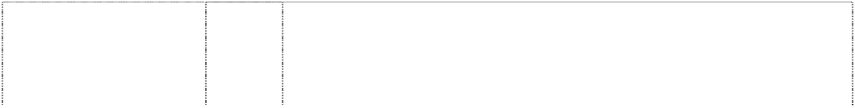

grizzly bear's head atop words (1001913)

# MIAMI HEAT

flaming basketball falling through hoop (515961)

# MILWAUKEE BUCKS

deer head breaks triangle inverted (615546)

# MINNESOTA TIMBER WOLVES

wolf head between pine trees (708055)

# MINNESOTA TIMBER WOLVES

wolf head between pine trees (708055)

# MINNESOTA TIMBER WOLVES

wolf head between pine trees (708055)

# MINNESOTA TIMBER WOLVES

wolf head between pine trees (708055)

28 Games and playthings; gymnastic and sporting articles not included in other classes; decorations for Christmas trees; toys, games and sporting goods, including basketballs, golf balls, playground balls, sports balls, rubber action balls and foam action balls, plush balls, basketball nets, pumps for inflating basketballs and needles therefor being sporting goods, golf clubs, golf bags, golf putters, golf ball gift sets, golf accessories, including divot repair tools, tees, ball markers, golf bag covers, club head covers, golf gloves, golf ball sleeves, bicycle tags being sporting goods for identifying bicycles, electronic basketball table top games, basketball table top games, basketball board games, electronic video arcade game machines, basketball kit comprised of a basketball net and whistle, dolls, decorative dolls, collectible dolls, toy action figures, bobblehead action figures, stuffed toys, novelty plush toys with wigs, jigsaw puzzles and Christmas tree ornaments; Christmas stockings; toy vehicles in the nature of cars, trucks and vans, all containing basketball themes, toy fingers, card games, playing cards, noisemakers, pet toys, action skill games, arcade games, adults' and children's party games, trivia information games, and board games; basketball backboards, playing cards.

25 Clothing, underwear, underpants, singlets, shirts, T-shirts, shorts, pants, trousers, tracksuits, clothing belts, knitwear, jumpers, cardigans, sweatshirts, neckwear, jackets, coats, scarves, rainwear, swimwear, sleepwear, pyjamas, nightshirts, dressing gowns, headwear, hats, caps, socks, hosiery, footwear, shoes, boots, slippers, and all other goods in class 25.

25 Clothing, leisure wear, sports wear, underwear, underpants, singlets, shirts, T-shirts, shorts, pants, trousers, tracksuits, clothing belts, knitwear, jumpers, cardigans, sweatshirts, neckwear, jackets, coats, scarves, rainwear, swimwear, sleepwear, pyjamas, nightshirts, dressing gowns, headwear, hats, caps, socks, hosiery, footwear, shoes, boots, slippers, and all other goods in class 25.

9 Apparatus for recording, transmission and/or reproduction of sound and/or images inclusive of pre-recorded audio and video cassettes, audio and video tapes, compact discs; games and game systems in this class inclusive of video games tapes, video game cassettes, video game cartridges and video game discs; computer discs, computer operating programs, computer programs, computer software and video game software; magnets; teaching apparatus for sporting activity; protective helmets; computer accessories in this class.

16 Publications and printed matter; paper articles and cardboard articles not included in other classes; bulletin boards and magnetic boards; printed matter and publications inclusive of books and magazines; greeting cards, trading cards and collector cards; playing cards; gift wrap; stationery; photographs, pictures, posters, prints; stickers and decalcomania; albums, diaries, calendars and organisers.

25 Articles of clothing for sports and leisure wear, including footwear and headgear.

28 Toys, games and sporting goods (not included in other classes) inclusive of basketballs, golf balls, playground balls, sports balls, rubber action balls and foam action balls, basketball nets, basketball backboards, pumps for inflating basketballs, and needles therefor, golf clubs, electronic basketball table top games, basketball table top games, basketball board games, basketball kit comprised of a basketball net and whistle, dolls, stuffed toys, jigsaw puzzles; equipment for exercising and/or physical fitness; Christmas tree ornaments.

# NBA

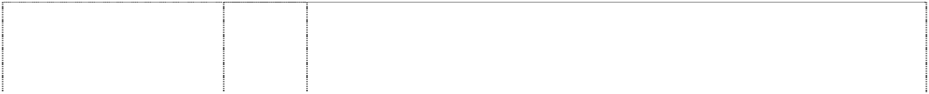

(619609)

# NBA

(619610)

# NBA

(619611)

# NBA

ball, basketball basketballer (396985)

# NBA

ball, basketball man, basketballer (396985)

# NBA

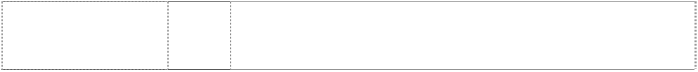ball, basketball man, basketballer (396983)

# NBA

ball, basketball man, basketballer (396984)

16 Printed matter, printed publications, books, magazines, newspapers, activity books, statistical books, guide books, reference books, newsletters, pamphlets, printed entertainment programs, printed game programs; printed matter for the radio, television and print media; stationery diaries, memo pads, folders, note books, multi-ring binders, book covers, portfolios, printed statistics sheets, writing instruments, ball point pens, pencils, cards, playing cards, trading cards, sports trading cards, basketball trading cards, dance team trading cards, mascot trading cards, entertainment trading cards, post cards, note cards, stamps, sports stamps, basketball stamps, posters, calendars, stickers, bumper stickers, decalcomanias, paper pennants, albums, photographs, mounted photographs, paper, wrapping paper, paper place mats and line art colouring boards.

25 Clothing, leisure wear, sports wear, uniforms, underwear underpants, singlets, shirts, sport shirts, T-shirts, sweatshirts, tank tops, shorts, pants, sweatpants, trousers, suits, tracksuits, warm-up suits, knitwear, jumpers, cardigans, sweaters, jerseys, jackets, coats, parkas, rainwear, swimwear, sleepwear, pyjamas, nightshirts, dressing gowns, neckwear, neckties, scarves, headwear, hats, caps, berets, ear muffs, head bands, wrist bands, footwear, socks, hosiery, shoes, boots, sandals, slippers, aprons, clothing belts and gloves.

28 Games, playthings, sporting goods in class 28, balls for games, playballs, rubber action balls, foam action balls, balls for sports, golf balls, basketballs, toy basketballs, miniature basketballs, pumps for inflating sporting balls, needles for such pumps, sports nets, basketball backboards, basketball rings, basketball nets, sports gloves, golf gloves, golf clubs, golf bags, golf tees, exercise and physical training apparatus and articles, toys, stuffed toys, toy vehicles, toy cars, dolls, jigsaw puzzles, board games, christmas tree decorations; self contained apparatus and instruments for playing games including mechanical games, electronic games, computerised games, battery operated games, games that are portable, games that include a built-in display, games that include a built-in program, games that receive one or more programs; hand held portable self contained apparatus and instruments for playing games; parts, fittings and accessories in class 28 for the aforesaid goods; but excluding games that are adapted or intended for use with a separate television or computer monitor or other separate display apparatus and also excluding games that are coin and/or counter freed or coin and/or counter operated.

9 Audio, video, computer and laser discs; pre-recorded goods inclusive of pre-recorded audio and video cassettes, pre-recorded audio and video tapes; games and game systems in this class; video games tapes, video game cassettes, video game cartridges and video game discs; compact discs, computer discs, computer operating programs, computer programs, and computer software; magnets; protective helmets.

16 Paper and paper articles; cardboard and cardboard articles; printed matter, newspapers and periodicals, books; book-binding material; photographs; stationery, adhesive materials (stationery); artists materials; paint brushes; typewriters and office requisites (other than furniture); instructional and teaching material (other than apparatus); playing cards; printers' type and cliches (stereotype); and all other goods in class 16.

28 Games and playthings; gymnastic and sporting articles (except clothing); ornaments and decorations for christmas trees; and all other goods in class 28.

25 Clothing, including boots, shoes and slippers.

# NBA

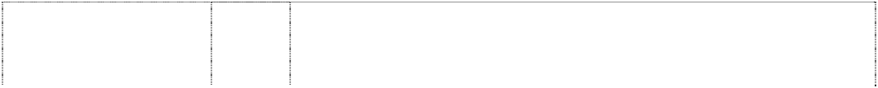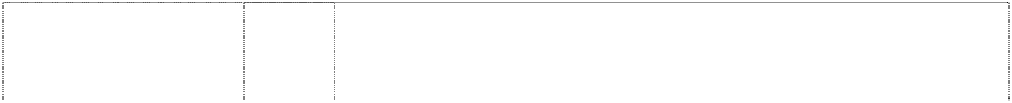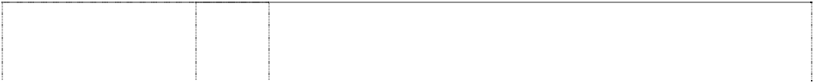

basketballer in rect,rounded corners (839644)

# NETS

basketball & word in shield with ring (726279)

# NETS

basketball & word in shield with ring (726279)

# NETS

basketball & word in shield with ring (726279)

# NETS

basketball & word in shield with ring (726279)

18 Leather and imitations of leather, and goods made of these materials and not included in other classes; athletics bags, shoe bags, overnight bags, beach bags, school bags, backpacks, baby backpacks, duffle bags, tote bags, umbrellas, patio umbrellas, cases, valises, attache cases, billfolds, wallets, briefcases, cases of leather or imitation leather, canes, business card cases, book bags, all purpose sport bags, golf umbrellas, gym bags, purses, fanny packs, waist packs, cosmetic cases sold empty, garment bags for travel, handbags, keycases, knapsacks, suitcases, toiletry cases sold empty, trunks for clothing, belts, haversacks, rucksacks, satchels, travelling bags, vanity cases, travelling sets and trunks.

9 Pre-recorded audio and video tapes, cassettes, and compact discs; computer software; video game software and computer accessories; games and game systems and parts therefor (not included in other classes); teaching apparatus for sporting activity; magnets.

16 Publications and printed matter; paper and cardboard articles not included in other classes; photographs; stationery; playing cards.

25 Articles of clothing for sports and leisure wear, including footwear and headgear.

28 Toys, games and sporting goods (not included in other classes) inclusive of basketballs, golf balls, playground balls, sports balls, rubber action balls and foam action balls, basketball nets, basketball backboards, pumps for inflating basketballs, and needles therefor, golf clubs, electronic basketball table top games, basketball table top games, basketball board games, basketball kit comprised of a basketball net and whistle, dolls, stuffed toys, jigsaw puzzles; Christmas tree ornaments.

# NEW ORLEANS HORNETS H



wasp,cartoon wears shoes & gloves with ltr H on chest & basketball

(950624)

# NEW ORLEANS HORNETS H

wasp,cartoon wears shoes & gloves with ltr H on chest & basketball

(950624)

9 Scientific, nautical, surveying, electric, photographic, cinematographic, optical, weighing, measuring, signalling, checking (supervision), lifesaving and teaching apparatus and instruments; apparatus for recording, transmission or reproduction of sound, data or images; magnetic data carriers; recording apparatus; automatic vending machines and mechanism for coin-operated apparatus; cash registers, calculating machines, data processing equipment and computers; fire extinguishing apparatus; audio, video, computer and laser discs, pre-recorded audio and video cassettes, pre-recorded audio and video tapes, pre-recorded compact discs, pre-recorded computer discs, all related to basketball; computer accessories, including mouse pads, mice, disc cases, computer carry-on cases, keyboard wrist pads, computer monitor cardboard frames, all related to basketball; computer programs for viewing information, statistics or trivia about basketball; computer software featuring basketball, including screen savers; video game software, video game cartridges and video game machines for use with televisions; radios and telephones; binoculars; sunglasses; eyeglass frames; eyewear straps and chains; eyeglass and sunglass cases; magnets; credit cards and prepaid telephone calling cards magnetically encoded, video recordings, video stream recordings, and audio recordings in the field of basketball provided over the Internet; computer software for gaining access to and for viewing databases of information, statistical information, trivia, polling information, and interactive polling in the field of basketball provided over the Internet; computer game software; video game programs, interactive video games and trivia game software provided over the Internet; computer software for use as screensavers, wallpaper, browser skins, and cursors provided over the Internet; electronic publications in the nature of magazines and newsletters in the field of basketball provided over the Internet; colour books in the nature of drawings and pictures being electronic publications provided over the Internet; electronic catalogues provided over the Internet featuring an array of basketball themed products; electronic video arcade game machines; arcade games; video recordings, video stream recordings, audio recordings in the field of basketball, cell phone accessories including face plates and cell phone covers; downloadable colouring books in the nature of drawings and pictures provided over the internet; catalogues provided over the internet.

16 Paper, cardboard and goods made from these materials, not included in other classes; printed matter; book binding material; photographs; stationery; adhesives for stationery or household purposes; artists' materials; paint brushes; typewriters and office requisites (except furniture); instructional and teaching material (except apparatus); plastic materials for packaging (not included in other classes); printers' type; printing blocks; publications and printed matter, including basketball trading cards, dance team trading cards, mascot trading cards, entertainment trading cards, stickers, decalcomanias, commemorative basketball stamps, collectible cardboard trading cards discs, memo boards, clipboards, paper coasters, post cards, place mats of paper and plastic, note cards, playing cards, memo pads, ball point pens, pencils, pen and paper holders, desktop document stands, scrap books, rubber stamps, paper banners and flags, bookmarks, 3-ring binders, stationery folders, wirebound notebooks, portfolio notebooks, unmounted and mounted photographs, posters, calendars, bumper stickers, book covers, wrapping paper, children's activity books, statistical books, guide books and reference books for basketball, magazines in the field of basketball, commemorative game programs, paper pennants, stationery, stationery-type portfolios, and statistical sheets for basketball topics, newsletters and pamphlets in the field of basketball, bank cheques, cheque book covers, cheque book holders, credit cards and telephone calling cards not magnetically encoded.

# NEW ORLEANS HORNETS H



wasp,cartoon wears shoes & gloves with ltr H on chest & basketball

(950624)

# NEW ORLEANS HORNETS H

wasp,cartoon wears shoes & gloves with ltr H on chest & basketball

(950624**)**

18 Leather and imitations of leather, and goods made of these materials and not included in other classes; animal skins, hides; trunks and travelling bags; umbrellas, parasols and walking sticks; whips, harness and saddlery; athletic bags, shoe bags for travel, overnight bags, backpacks, baby backpacks, duffel bags, tote bags, luggage, luggage tags, patio umbrellas, valises, attache cases, billfolds, wallets, briefcases, canes, business card cases, book bags, all purpose sports bags, golf umbrellas, gym bags, lunch boxes, purses, coin purses, fanny packs, wrist packs, cosmetic cases sold empty, garment bags for travel, handbags, key cases, knapsacks, suitcases, toiletry cases sold empty, trunks for travelling and rucksacks.

25 Clothing, footwear, headgear; basketball shoes, basketball sneakers, clothing including hosiery, T-shirts, shirts, sweatshirts, sweatpants, pants, tank tops, jerseys, shorts, pyjamas, sport shirts, rugby shirts, sweaters, belts, ties, night shirts, hats, warm-up suits, warm-up pants, warm-up tops, jackets, parkas, coats, cloth bibs, head bands, wrist bands, aprons, boxer shorts, slacks, caps, ear muffs, gloves, mittens, woven and knit shirts.

# NEW ORLEANS HORNETS H

wasp,cartoon wears shoes & gloves with ltr H on chest & basketball

(950624)

# ORLANDO MAGIC A

basketball with comet tail, five pointed stars (812390)

# ORLANDO MAGIC A

basketball with comet tail, five pointed stars (812390)

28 Games and playthings; gymnastic and sporting articles not included in other classes; decorations for Christmas trees; toys, games and sporting goods, including basketballs, golf balls, playground balls, sports balls, rubber action balls and foam action balls, plush balls, basketball nets, pumps for inflating basketballs and needles therefor being sporting goods, golf clubs, golf bags, golf putters, golf ball gift sets with divot repair tools, or tees or ball markers, golf accessories, including golf bag covers, club head covers, golf gloves, golf ball sleeves, bicycle tags being sporting goods for identifying bicycles, electronic basketball table top games, basketball table top games, basketball board games, electronic video arcade game machines, basketball kit comprised of a basketball net and whistle, dolls, toy action figures, stuffed toys, jigsaw puzzles and Christmas tree ornaments; action skill games, arcade games, adults' and children's party games, trivia information games, and board games provided over the Internet; basketball backboards; playing cards.

9 Audio, video, computer and laser discs, pre-recorded audio and video cassettes, pre-recorded audio and video tapes, pre-recorded compact discs, pre-recorded computer discs, all related to basketball; computer accessories, namely, mouse pads, mice, disc cases, computer carry-on cases, keyboard wrist pads, computer monitor cardboard frames, all related to basketball; computer programs featuring information, statistics and/or trivia about basketball; computer operating systems in the field of basketball; computer software featuring basketball, namely, screen savers; video game software; video game cartridges and video game machines for use with televisions; radios and telephones; binoculars; sunglasses, eyeglass frames, eyewear straps, chains and eyeglass cases; magnets; video game cartridges.

16 Basketball trading cards, dance team trading cards, mascot trading cards, entertainment trading cards, stickers, decalcomanias, commemorative basketball stamps, collectible cardboard trading discs, memo boards, clipboards, paper coasters, post cards, place mats of paper, note cards, memo pads, ball point pens, pencils, pen and paper holders, standing boards, scrap books, rubber stamps, paper banners and flags, bookmarks, 3-ring binders, stationery folders, wirebound notebooks, portfolio notebooks; unmounted and mounted photographs; posters, calendars, bumper stickers, book covers, wrapping paper, children's activity books, statistical books; guide books and reference books for basketball; magazines in the field of basketball; commemorative game programs, paper pennants, stationery, stationery-type portfolios, and statistical sheets for basketball topics; newsletters and pamphlets in the field of basketball for distribution to the television and radio media.

# ORLANDO MAGIC A



basketball with comet tail, five pointed stars (812390)

# ORLANDO MAGIC A

basketball with comet tail, five pointed stars (812390)

# P PACERS

basketball lines extended in letter P (566985) **PHOENIX SUNS**

basketball forms comet in rectangle (515954)

# PORTLAND BLAZERS

striped impeller two- blade

(897387)

25 Hosiery, footwear, T-shirts, sweatshirts, sweatpants, pants, tank tops, jerseys, shorts, pyjamas, sport shirts, rugby shirts, sweaters, belts, ties, nightshirts, hats, warm-up suits, jackets, parkas, coats, cloth bibs, head bands, wrist bands, aprons, boxer shorts, slacks, caps, ear muffs, and gloves.

28 Basketballs, golf balls, playground balls, sports balls, rubber action balls and foam action balls, basketball nets, basketball backboards, pumps for inflating basketballs, and needles therefor; golf clubs, golf bags, golf putters; golf ball gift sets with divot repair tools, and/or tees and ball markers; golf accessories, including golf bag covers, club head covers, golf bag den caddy, golf gloves, golf ball sleeves; tags for bicycle identification, electronic basketball table top games, basketball table top games, basketball board games, electronic video arcade game machines, basketball kit comprised of a basketball net and whistle; dolls, stuffed toys, jigsaw puzzles and Christmas tree ornaments.

25 All goods in class 25 but excluding the following goods namely boys' and men's trousers and shorts.

25 Clothing, underwear, underpants, singlets, shirts, T-shirts, shorts, pants, trousers, tracksuits, clothing belts, knitwear, jumpers, cardigans, sweatshirts, neckwear, jackets, coats, scarves, rainwear, swimwear, sleepwear, pyjamas, nightshirts, dressing gowns, headwear, hats, caps, socks, hosiery, footwear, shoes, boots, slippers, and all other goods in class 25.

9 Scientific, nautical, surveying, electric, photographic, cinematographic, optical, weighing, measuring, signalling, checking (supervision), life-saving and teaching apparatus and instruments; apparatus for recording, transmission or reproduction of sound, data or images; magnetic data carriers; recording apparatus; automatic vending machines and mechanism for coin-operated apparatus; cash registers, calculating machines, data processing equipment and computers; fire extinguishing apparatus; audio, video, computer and laser discs, pre-recorded audio and video cassettes, pre-recorded audio and video tapes, pre-recorded compact discs, pre-recorded computer discs, all related to basketball; computer accessories, including mouse pads, mice, disc cases, computer carry-on cases, keyboard wrist pads, computer monitor cardboard frames, all related to basketball; computer programs for viewing information, statistics or trivia about basketball; computer software featuring basketball, including screen savers; video game software, video game cartridges and video game machines for use with televisions; radio and telephone; binoculars; sunglasses; eyeglass frames; eyewear straps and chains; eyeglass and sunglass cases; magnets; credit cards and prepaid telephone calling cards magnetically encoded, video recordings, video stream recordings, and audio recordings in the field of basketball provided over a global computer network; computer software for gaining access to and for viewing databases of information, statistical information, trivia, polling information, and interactive polling in the field of basketball provided over a global computer network; computer game software; video game programs, interactive video games and trivia game software provided over a global computer network; computer software for use as screensavers, wallpaper, browser skins, and cursors provided over a global computer network; electronic publications in the nature of magazines and newsletters in the field of basketball provided over a global computer network; colour books in the nature of drawings and pictures being electronic publications provided over a global computer network; catalogues provided over a global computer network featuring an array of basketball-themed products; electronic video arcade game machines; arcade games.

# PORTLAND BLAZERS



striped impeller two- blade

(897387)

# PORTLAND BLAZERS

striped impeller two- blade

(897387)

# PORTLAND BLAZERS

striped impeller two- blade

(897387)

# PORTLAND BLAZERS

striped impeller two- blade

(897387)

# SACRAMENTO KINGS

crown atop rect, concave-side with basketball & crossed lances

(622368)

16 Paper, cardboard and goods made from these materials, not included in other classes; printed matter; book binding material; photographs; stationery; adhesives for stationery or household purposes; artists' materials; paint brushes; typewriters and office requisites (except furniture); instructional and teaching material (except apparatus); plastic materials for packaging (not included in other classes); playing cards, printers' type; printing blocks; publications and printed matter, including basketball trading cards, dance team trading cards, mascot trading cards, entertainment trading cards, stickers, decalcomanias, commemorative basketball stamps, collectible cardboard trading cards discs, memo boards, clipboards, paper coasters, post cards, place mats of paper, note cards, memo pads, ball point pens, pencils, pen and paper holders, desktop document stands, scrap books, rubber stamps, paper banners and flags, bookmarks, three-ring binders, stationery folders, wirebound notebooks, portfolio notebooks, unmounted and mounted photographs, posters, calendars, bumper stickers, book covers, wrapping paper, children's activity books, statistical books, guide books and reference books for basketball, magazines in the field of basketball, commemorative game programs, paper pennants, stationery, stationery-type portfolios, and statistical sheets for basketball topics, newsletters and pamphlets in the field of basketball, bank cheques, cheque book covers, cheque book holders, credit cards and telephone calling cards not magnetically encoded; basketball blackboards.

18 Leather and imitations of leather, and goods made of these materials and not included in other classes; animal skins, hides; trunks and travelling bags; umbrellas, parasols and walking sticks; whips, harness and saddlery; athletic bags, shoe bags for travel, overnight bags, backpacks, baby backpacks, duffel bags, tote bags, luggage, luggage tags, patio umbrellas, valises, attache cases, billfolds, wallets, briefcases, canes, business card cases, book bags, all purpose sports bags, golf umbrellas, gym bags, purses, coin purses, fanny packs, wrist packs, cosmetic cases sold empty, garment bags for travel, handbags, key cases, knapsacks, suitcases, toiletry cases sold empty, trunks for travelling and rucksacks.

25 Clothing, footwear, headgear; clothing including, hosiery, basketball shoes, basketball sneakers, T-shirts, shirts, sweatshirts, sweatpants, pants, tank tops, jerseys, shorts, pyjamas, sport shirts, rugby shirts, sweaters, belts, ties, night shirts, hats, warm-up suits, warm-up pants, warm-up tops, jackets, parkas, coats, cloth bibs, head bands, wrist bands, aprons, boxer shorts, slacks, caps, ear muffs, gloves, mittens, woven and knit shirts.

28 Games and playthings; gymnastic and sporting articles not included in other classes; decorations for Christmas trees; toys, games and sporting goods, including basketballs, golf balls, playground balls, sports balls, rubber action balls and foam action balls, plush balls, basketball nets, pumps for inflating basketballs, and needles therefor, golf clubs, golf bags, golf putters, golf ball gift sets with divot repair tools, or tees or ball markers, golf accessories, including golf bag covers, club head covers, golf gloves, golf ball sleeves, bicycle tags being sporting goods for identifying bicycles, electronic basketball table top games, basketball table top games, basketball board games, basketball kit comprised of a basketball net and whistle, dolls, toy action figures, stuffed toys, jigsaw puzzles and Christmas tree ornaments; action skill games, adults' and children's party games, trivia information games, and board games provided over a global computer network.

25 Clothing, leisure wear, sports wear, underwear, underpants, singlets, shirts, T-shirts, shorts, pants, trousers, tracksuits, clothing belts, knitwear, jumpers, cardigans, sweatshirts, neckwear, jackets, coats, scarves, rainwear, swimwear, sleepwear, pyjamas, nightshirts, dressing gowns, headwear, hats, caps, socks, hosiery, footwear, shoes, boots, slippers, and all other goods in class 25.

# SAN ANTONIO SPURS

ltr u is spur,styl. breaks rect.,curved,notched- corners

(927831)

# S SEATTLE SONICS

ltr S breaks basketball in disc indents keystone

(886184)

25 Clothing, footwear, headgear.

9 Scientific, nautical, surveying, electric, photographic, cinematographic, optical, weighing, measuring, signalling, checking (supervision), life-saving and teaching apparatus and instruments; apparatus for recording, transmission or reproduction of sound, data or images; magnetic data carriers; recording apparatus; automatic vending machines and mechanism for coin-operated apparatus; cash registers, calculating machines, data processing equipment and computers; fire extinguishing apparatus; audio, video, computer and laser discs, pre-recorded audio and video cassettes, pre-recorded audio and video tapes, pre-recorded compact discs, pre-recorded computer discs, all related to basketball; computer accessories, including mouse pads, mice, disc cases, computer carry-on cases, keyboard wrist pads, computer monitor cardboard frames, all related to basketball; computer programs for viewing information, statistics or trivia about basketball; computer software featuring basketball, including screen savers; video game software, video game cartridges and video game machines for use with televisions; radio and telephone; binoculars; sunglasses; eyeglass frames; eyewear straps and chains; eyeglass and sunglass cases; magnets; credit cards and prepaid telephone calling cards magnetically encoded, video recordings, video stream recordings, and audio recordings in the field of basketball provided over the Internet; computer software for gaining access to and for viewing databases of information, statistical information, trivia, polling information, and interactive polling in the field of basketball provided over the Internet; computer game software; video game programs, interactive video games and trivia game software provided over the Internet; computer software for use as screensavers, wallpaper, browser skins, and cursors provided over the Internet; electronic publications in the nature of magazines and newsletters in the field of basketball provided over the Internet; colour books in the nature of drawings and pictures being electronic publications provided over the Internet; electronic catalogues provided over the Internet featuring an array of basketball themed products; electronic video arcade game machines; arcade games; video recordings, video stream recordings, audio recordings in the field of basketball.

# S SEATTLE SONICS



ltr S breaks basketball in disc indents keystone

(886184)

# S SEATTLE SONICS

ltr S breaks basketball in disc indents keystone

(886184)

# S SEATTLE SONICS

ltr S breaks basketball in disc indents keystone

(886184)

# S SEATTLE SONICS

ltr S breaks basketball in disc indents keystone

(886184)

16 Paper, cardboard and goods made from these materials, not included in other classes; printed matter; book binding material; photographs; stationery; adhesives for stationery or household purposes; artists' materials; paint brushes; typewriters and office requisites (except furniture); instructional and teaching material (except apparatus); plastic materials for packaging (not included in other classes); playing cards, printers' type; printing blocks; publications and printed matter, including basketball trading cards, dance team trading cards, mascot trading cards, entertainment trading cards, stickers, decalcomanias, commemorative basketball stamps, collectible cardboard trading cards discs, memo boards, clipboards, paper coasters, post cards, place mats of paper, note cards, playing cards, memo pads, ball point pens, pencils, pen and paper holders, desktop document stands, scrap books, rubber stamps, paper banners and flags, bookmarks, 3-ring binders, stationery folders, wirebound notebooks, portfolio notebooks, unmounted and mounted photographs, posters, calendars, bumper stickers, book covers, wrapping paper, children's activity books, statistical books, guide books and reference books for basketball, magazines in the field of basketball, commemorative game programs, paper pennants, stationery, stationery-type portfolios, and statistical sheets for basketball topics, newsletters and pamphlets in the field of basketball, bank cheques, cheque book covers, cheque book holders, credit cards and telephone calling cards not magnetically encoded.

18 Leather and imitations of leather, and goods made of these materials and not included in other classes; animal skins, hides; trunks and travelling bags; umbrellas, parasols and walking sticks; whips, harness and saddlery; athletic bags, shoe bags for travel, overnight bags, backpacks, baby backpacks, duffel bags, tote bags, luggage, luggage tags, patio umbrellas, valises, attache cases, billfolds, wallets, briefcases, canes, business card cases, book bags, all purpose sports bags, golf umbrellas, gym bags, purses, coin purses, fanny packs, wrist packs, cosmetic cases sold empty, garment bags for travel, handbags, key cases, knapsacks, suitcases, toiletry cases sold empty, trunks for travelling and rucksacks.

25 Clothing, footwear, headgear; clothing including, hosiery, basketball shoes, basketball sneakers, T-shirts, shirts, sweatshirts, sweatpants, pants, tank tops, jerseys, shorts, pyjamas, sport shirts, rugby shirts, sweaters, belts, ties, night shirts, hats, warm-up suits, warm-up pants, warm-up tops, jackets, parkas, coats, cloth bibs, head bands, wrist bands, aprons, boxer shorts, slacks, caps, ear muffs, gloves, mittens, woven and knit shirts.

28 Games and playthings; gymnastic and sporting articles not included in other classes; decorations for Christmas trees; toys, games and sporting goods, including basketballs, golf balls, playground balls, sports balls, rubber action balls and foam action balls, plush balls, basketball nets, pumps for inflating basketballs and needles therefor being sporting goods, golf clubs, golf bags, golf putters, golf ball gift sets with divot repair tools, or tees or ball markers, golf accessories, including golf bag covers, club head covers, golf gloves, golf ball sleeves, bicycle tags being sporting goods for identifying bicycles, electronic basketball table top games, basketball table top games, basketball board games, basketball kit comprised of a basketball net and whistle, dolls, toy action figures, stuffed toys, jigsaw puzzles and Christmas tree ornaments; action skill games, arcade games, adults' and children's party games, trivia information games, and board games provided over the Internet; basketball blackboards.

# TORONTO RAPTORS

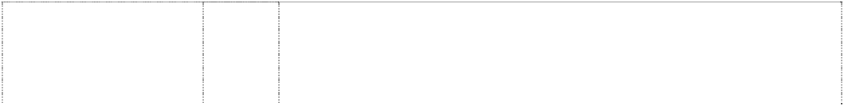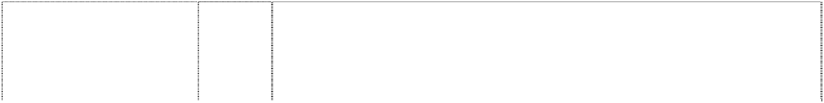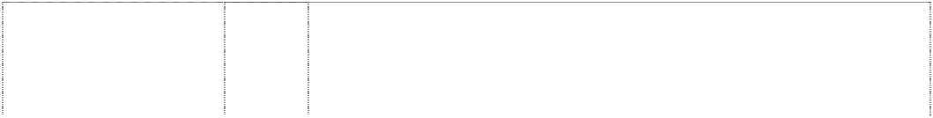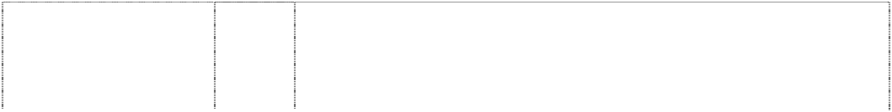

dinosaur clothed bouncing basketball in front of annulus (627757)

# WARRIORS

warrior holds lightning bolt & breaks basketball

(704168)

# WARRIORS

warrior holds lightning bolt & breaks basketball

(704168)

# WARRIORS

warrior holds lightning bolt & breaks basketball

(704168)

# WARRIORS

warrior holds lightning bolt & breaks basketball

(704168)

# WIZARDS W

styl wizard dancing across crescent moon, star, basketball (725826)

# WIZARDS W

styl wizard dancing across crescent moon, star, basketball (725826)

# WIZARDS W

styl wizard dancing across crescent moon, star, basketball (725826)

# WIZARDS W

styl wizard dancing across crescent moon, star, basketball (725826)

25 Clothing, leisure wear, sports wear, underwear, infantwear, knitwear, underpants, boxer shorts, singlets, shirts, sport shirts, rugby shirts, T- shirts, sweatshirts, tank tops, shorts, pants, sweatpants, trousers, slacks, suits, tracksuits, warm-up suits, jumpers, cardigans, sweaters, jerseys, jackets, coats, parkas, rainwear, swimwear, sleepwear, pyjamas, nightshirts, dressing gowns, neckwear, ties, scarves, headwear, hats, caps, beanies, berets, ear muffs, head bands, wrist bands, footwear, socks, hosiery, shoes, boots, sandals, slippers, aprons, clothing belts, gloves, cloth bibs, all goods in class 25.

9 Apparatus for recording, transmission and/or reproduction of sound and/or images inclusive of pre-recorded audio and video cassettes, audio and video tapes, compact discs; games and game systems in this class inclusive of video game tapes, video game cassettes, video game cartridges and video game discs; computer discs, computer operating programs, computer programs, and computer software; magnets; teaching apparatus for sporting activity; protective helmets.

16 Paper articles and cardboard articles; bulletin boards and magnetic boards included in this class; printed matter and publications inclusive of books and magazines; greeting cards, trading cards and collector cards; playing cards; gift wrap; stationery; photographs, pictures, posters, prints; stickers and decalcomania; albums, diaries, calendars and organisers.

25 Articles of clothing; footwear and headgear for sports or leisure wear.

28 Games, toys and playthings; sporting articles not included in other classes; equipment for exercising and/or physical fitness.

9 Pre-recorded audio and video tapes, cassettes, and compact discs; computer software; video game software and computer accessories; games and game systems and parts therefor (not included in other classes); teaching apparatus for sporting activity; magnets.

16 Publications and printed matter, excluding comic books, namely, basketball trading cards, dance team trading cards, mascot trading cards, entertainment trading cards, stickers, decalcomania, commemorative basketball stamps, collectible cardboard trading discs, post cards, place mats, note cards, memo pads, ball point pens, pencils, 3-ring binders, stationery folders, wirebound notebooks, portfolio notebooks, posters, calendars, bumper stickers, book covers, wrapping paper, childrens' activity books, statistical books, guide books and reference books for basketball, magazines in the field of basketball, commemorative game programs, paper pennants, stationery, stationery-type portfolios and statistical sheets for basketball topics, newsletters and pamphlets in the field of basketball for distribution to the television and radio media, all of the foregoing goods being related to or promoting the sport of basketball.

25 Articles of clothing for sports and leisure wear, including footwear and headgear.

28 Toys, games and sporting goods (not included in other classes) inclusive of basketballs, golf balls, playground balls, sports balls, rubber action balls and foam action balls, basketball nets, basketball backboards, pumps for inflating basketballs, and needles therefor, golf clubs, electronic basketball table top games, basketball table top games, basketball board games, basketball kit comprised of a basketball net and whistle, dolls, stuffed toys, jigsaw puzzles; Christmas tree ornaments.

***OshKosh B’Gosh, Inc. Spruson & Ferguson Ph: (02) 9393 0300***

***Effective Date: 1 November 2007 File Reference: C07/18942 Trade Marks Class Goods***



**B’GOSH** (299631) **BABY B’GOSH** (766394)

**GENUINE BLUES** (808763) **GENUINE GIRL** (808762)

# JOSH B’GOSH

(863171)

# OSH KOSH

(52194)

# OSHKOSH 1895

quatrefoil (969931)

# OSHKOSH B’GOSH

(802823)

# OSHKOSH B’GOSH

(802823)

# OSHKOSH B’GOSH

(792094)

**OSHKOSH B’GOSH** (410590) **OSHKOSH B’GOSH** (512212) **OSHKOSH B’GOSH** (802823)

# OSHKOSH B’GOSH THE GENUINE ARTICLE

rectangle horizontal stripes form underline (545236)

25 Clothing.

1. Bed sheets, bed skirts, dust ruffles, pillow cases, pillow shams, crib sheets, crib bed skirts, crib cushions, crib bumper pads, receiving blankets, blankets, duvets, duvet covers, slumber bags, comforters, quilts, quilt covers, bedspreads, bath towels, wash cloths, beach towels, fabric wall hangings, and window treatments, namely curtains, drapes, and valances.
2. Clothing, footwear, and headgear.

25 Clothing, footwear, and headgear.

16 Paper, cardboard and goods made from these materials, not included in other classes; printed matter; bookbinding material; photographs; stationery; adhesives for stationery or household purposes; artists’ materials; paint brushes; typewriters and office requisites (except furniture); instructional and teaching material (except apparatus); plastic materials for packaging (not included in other classes); playing cards; printers’ types; printing blocks.

25 Articles of clothing.

25 Clothing, footwear and headwear.

16 Publications, printed material and goods made from paper including children's books, paper pads, baby and child memory books, keepsake and scrap books, photo albums, and mail order catalogs; children's paint sets; book and toy sets.

18 Backpacks, fanny packs, handbags, bottle bags, travel bags, tote bags, garment bags for travel, all purpose sports bags, diaper bags, duffle bags, belt packs, baby carriers, holdalls, purses, haversacks, rucksacks, attache cases, briefcases, toilet bags, wallets, school bags, satchels, bags for campers and climbers, luggage, suitcases, trunks, book bags.

1. Bed sheets, bed skirts, dust ruffles, pillow cases, pillow shams, crib sheets, crib bed skirts, crib cushions, crib bumper pads, receiving blankets, blankets, duvets, duvet covers, slumber bags, comforters, quilts, quilt covers, bedspreads, bath towels, wash cloths, beach towels, fabric wall hangings, and window treatments, namely curtains, drapes, and valances.
2. All goods in this Class including clothing, footwear and headgear.

25 Clothing and shoes.

28 Games and playthings including plush toys, dolls, baby multiple activity toys, educational toys and games, push-pull wheel toys, building blocks, construction and building sets, play sets, peg boards, beads, rattles, puzzles, bath and water toys, balls, trains, play outfits and costumes, doll accessories and clothing, puppets, floor and play mats, magnetic play sets, board games, memory games, talking and sound toys, arts and craft kits, electronic games, swings, bouncers, jonny jump-ups, mobiles.

25 All goods in this class.

# OSHKOSH B’GOSH VESTBAK GENUINE ARTICLE

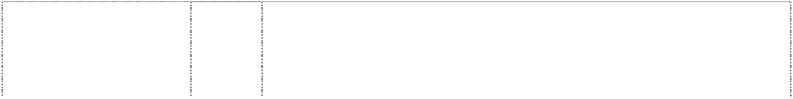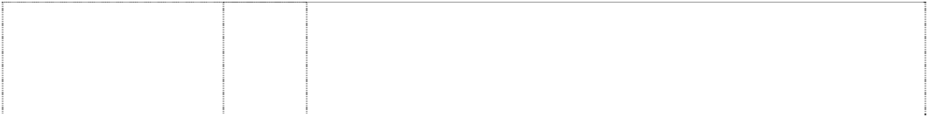

triangle inverted (512213) **OSHKOSH BABY B’GOSH** (766395)

# OSHKOSH B-GOSH

quatrefoil (512211)

# OSHKOSH EST. 1895

(957572)

# THE OSHKOSH WORKWEAR CO. 18

**95**

quatrefoil in circle (964242)

*description of mark:* triangular patch on shoulder straps of overalls

(802824)

leaf,clover,four-leaf quatrefoil

(114759)

quatrefoil (981852)

teddy bear wears striped overalls & holds book,open (863169)

25 Clothing and shoes.

1. Bed sheets, bed skirts, dust ruffles, pillow cases, pillow shams, crib sheets, crib bed skirts, crib cushions, crib bumper pads, receiving blankets, blankets, duvets, duvet covers, slumber bags, comforters, quilts, quilt covers, bedspreads, bath towels, wash cloths, beach towels, fabric wall hangings, and window treatments, namely curtains, drapes, and valances.
2. Clothing and shoes.

25 Clothing, footwear and headwear.

25 Clothing, footwear, headwear.

25 Clothing being overalls, bib shortalls, coveralls, swimmers, and other bib-type garments.

25 Scarves, ties, squares, and all other neckwear; sportswear; and shirts, all being goods included in class 25.

25 Clothing, footwear, headgear.

16 Paper, cardboard and goods made from these materials, not included in other classes; printed matter; bookbinding material; photographs; stationery; adhesives for stationery or household purposes; artists’ materials; paint brushes; typewriters and office requisites (except furniture); instructional and teaching material (except apparatus); plastic materials for packaging (not included in other classes); playing cards; printers’ types; printing blocks.

***Pat Chun International Limited Mallesons Stephen Jaques Ph: (03) 9643 4000***

***Effective Date: 9 November 2007 File Reference: C07/19103 Trade Marks Class Goods***



# PAT CHUN

(674502)

30 Seasonings, flavourings for foodstuffs, spices, vinegar, sauce; oyster sauce.

# PAT CHUN

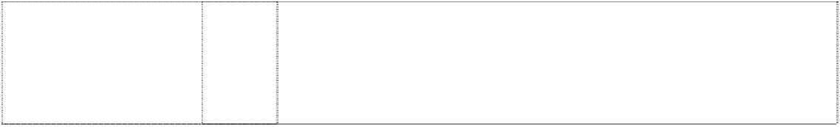chinese chars in irreg ellipse below circle, above rect; all breaking rect (764643)

# PAT CHUN

shield styl. is stripes, horiz & oblique above & below 2 Chinese characters

(885706)

30 Coffee, tea, cocoa, sugar, rice, tapioca, sago, artificial flour and preparations made from cereals, bread, pastry and confectionery, ices; honey, treacle; yeast, baking-powder; salt, mustard; vinegar, rice vinegar, vinegar sauces (condiments); spices; ice.

30 A seasoning, flavourings for foodstuffs, spices, vinegar, sauces; oyster sauce.

# PAT CHUN



shield styl. is stripes, horiz & oblique above & below chars Chinese (715049)

# PC

fish in circle (715050)

2 Chinese characters

(715051)

30 A seasoning, flavourings for foodstuffs, spices, vinegar, sauces; oyster sauce.

30 Seasonings, flavourings for foodstuffs, spices, vinegar, sauce; oyster sauce.

30 A seasoning, flavourings for foodstuffs, spices, vinegar, sauces; oyster sauce.

***Rover Mowers Limited Spruson & Ferguson Ph: (02) 9393 0300***

***Effective Date: 18 October 2007 File Reference: C07/17852 Trade Marks Class Goods***

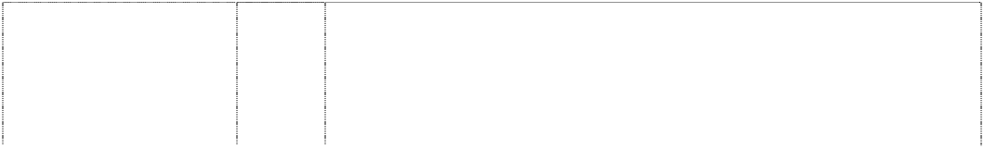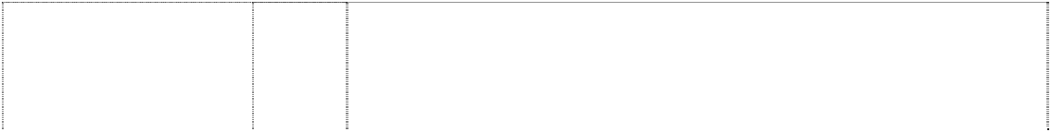

# BARON

(297750)

# BIG HONCHO

(881347)

**CHALLENGER** (277284) **COLT** (182417) **COMBAT** (299173) **COMBAT** (299179)

# DURABLE MULCH 'N CATCH

(881351)

# EASY GO

(551352)

**ECONOMOW** (351038) **GLOVEBOX** (826356)

# GLOVEBOX

(826356)

7 Agricultural and horticultural implements and machinery included in

this class, being mowing machines, rotary lawn mowers, mini tractors incorporating grass cutting attachments and attachments therefor being scraper blades, rakes, cultivators and trailers, cultivating and tilling machines; grass catchers for mowing machines and lawn mowers and parts of all of the forementioned goods included in this class but not including pumps of any type or parts of pumps or goods in the nature of electrical components and parts included in this class.

7 Mowing machines, machine tools, tilling machines and cultivators for domestic and small farm use, mowers for domestic use including ride on, self drive and push mowers; agricultural implements, engines for mowers, line trimmers and brush cutters including battery operated hand held line trimmers and brush cutters and parts for the aforementioned goods.

7 Mowing machines, grass catchers for mowing machines and parts and attachments for the aforesaid goods.

7 Lawnmowers, cultivators, tillers, grass-catchers for lawnmowers, and parts of the aforesaid goods, but excluding motors of all kinds.

7 All goods included in this class.

12 All goods included in this class but excluding offensive and defensive vehicles used by the armed forces.

7 Mowing machines, machine tools, tilling machines and cultivators for domestic and small farm use, mowers for domestic use including ride on, self drive and push mowers; agricultural implements, engines for mowers, line trimmers and brush cutters including battery operated hand held line trimmers and brush cutters and parts for the aforementioned goods.

7 Mowing machines, machine tools, tilling machines and cultivators for domestic and small farm use, mowers for domestic use including ride on, self drive and push mowers; agricultural implements, line trimmers and brush cutters including battery operated hand held line trimmers and brush cutters being goods in class 7.

7 Grass mowing machines and parts thereof and fittings therefor but excluding baling machines of all descriptions.

7 Mowing machines, tilling machines and cultivators for domestic and small farm use, lawn mowers for domestic use including ride on and push mowers; and parts for the aforementioned goods.

18 Carry bags and sacks for holding articles; bags and sacks for holding articles and capable of attachment to lawn mowers for storing mowing accessories; specially adapted bags and sacks incorporating attachment mechanisms enabling attachment to and support by hand operated machines including lawn mowers.

# JOEY POUCH

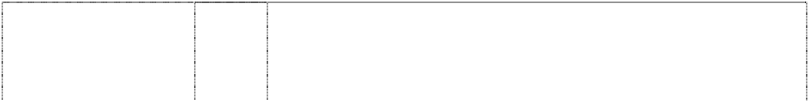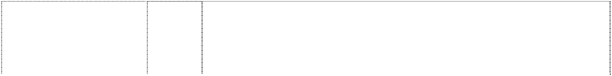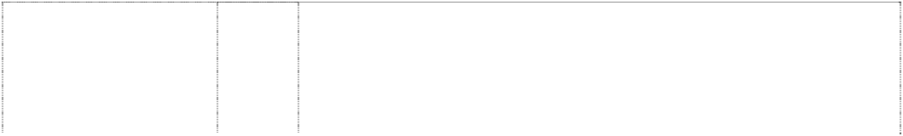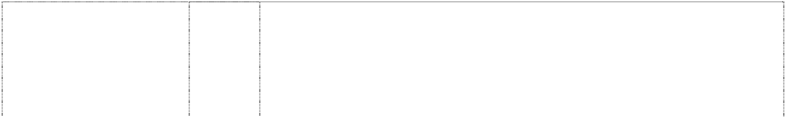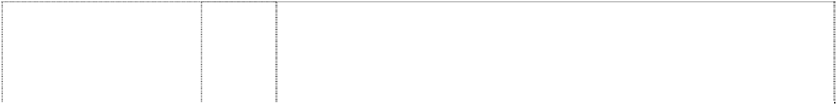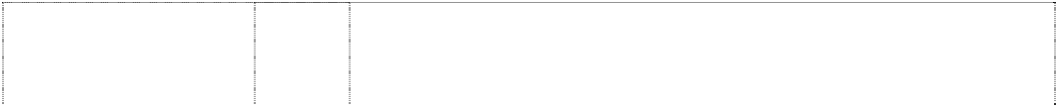

(826355)

# JOEY POUCH

(826355)

# KANGAROO POUCH

(826358)

# KANGAROO POUCH

(826358)

**LASER** (417308) **LAWN KING** (289904) **LEADER** (881349)

# MAXI MUNCHER

(565618)

**MOW TUFF** (569268) **MULCH'N CATCH ROVER**

triangle, horiz breaks ring; chevron is ltr v in hexagon

(735931) **MUNCHER** (404963) **PARAMOUNT** (881348)

**PEDIGREE** (218630) **POWERMASTER** (260068)

# Q Start

(1116739)

**RAIDER** (430773) **RANCHER** (274969)

# RANCHER

(274970)

7 Mowing machines, tilling machines and cultivators for domestic and small farm use, lawn mowers for domestic use including ride on and push mowers; and parts for the aforementioned goods.

18 Carry bags and sacks for holding articles; bags and sacks for holding articles and capable of attachment to lawn mowers for storing mowing accessories; specially adapted bags and sacks incorporating attachment mechanisms enabling attachment to and support by hand operated machines including lawn mowers.

7 Mowing machines, tilling machines and cultivators for domestic and small farm use, lawn mowers for domestic use including ride on and push mowers.

18 Carry bags and sacks for holding articles; bags and sacks for holding articles and capable of attachment to lawn mowers for storing mowing accessories; specially adapted bags and sacks incorporating attachment mechanisms enabling attachment to and support by hand operated machines including lawn mowers.

7 Lawn mowers.

7 Domestic lawn mowers included in this class.

7 Mowing machines, machine tools, tilling machines and cultivators for domestic and small farm use, mowers for domestic use including ride on, self drive and push mowers; agricultural implements, line trimmers and brush cutters including battery operated hand held line trimmers and brush cutters and parts for the aforementioned goods being goods in class 7.

7 All goods in this class inclusive of garden refuse shredders, mulchers and chippers and parts and accessories therefor, but excluding other waste disposal machines, namely comminuting machines and shredding machines for waste water and sewer applications.

7 Mowing machines and parts thereof and attachments therefor included in this class.

7 Mowing machines including domestic lawn mowers and mulching machines, cultivators for domestic and small farm use and parts and fittings for the aforesaid goods.

7 Shredding and mulching machines and parts thereof included in this class, all such goods being for the reduction of garden refuse.

7 Mowing machines, machine tools, tilling machines and cultivators for domestic and small farm use, mowers for domestic use including ride on, self drive and push mowers; agricultural implements, line trimmers and brush cutters including battery operated hand held line trimmers and brush cutters and parts for the aforementioned goods being goods in class 7.

7 All goods included in this class.

7 Non-electric mowing machines.

7 Mowing machines, tilling machines and cultivators for domestic and small farm use, mowers for domestic use including ride on, self drive and push lawn mowers; engines for mowers; line trimmers and brush cutters including battery operated hand held line trimmers and brush cutters and parts for the aforementioned goods being in class 7.

7 Lawn mowers and parts therefore.

7 Large agricultural implements being in the nature of machines and machinery including mowing machines, tilling machines, cultivators and grass catchers for mowing machines and parts of all the aforementioned goods included in this class.

12 Self-propelled motor-mowers, mini-tractors and parts thereof but excluding trailers, livestock trailers and trailer equipment and parts thereof.

# RANGER

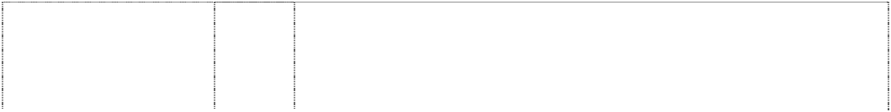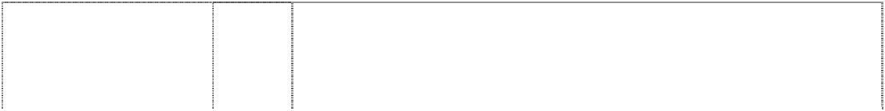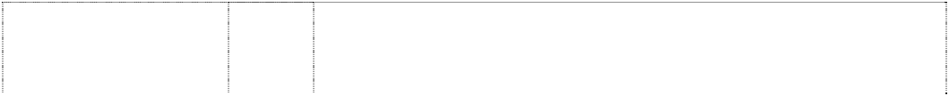

(493599)

**RANGER** (552096) **RANGER** (208893) **REBEL** (278313) **ROO POUCH** (826357)

# ROO POUCH

(826357)

# ROVER

(129075)

# ROVER

(279531)

**ROVER** (279532) **ROVER** (279528)

# ROVER

(279529)

# ROVER

ltr v is chevron, triangle under word in & breaking ellipses (733117)

# ROVER AUTO DRIVE

(474120)

# ROVER CATCH'N CART

ltr v is chevron,word in rect,all in triangle; words break arcs (759075)

7 Mowing machines including rotary lawn mowers, ride-on mowers, cultivators and tilling machines; grass catchers for mowing machines and parts in this class for the aforesaid goods.

7 Ride-on mowers and parts in this class for the aforesaid goods.

12 Ride-on lawn mowers, mini-tractors; lawn tractors and garden tractors.

7 Hand propelled rotary mowers.

7 Mowing machines, tilling machines and cultivators for domestic and small farm use, lawn mowers for domestic use including ride on and push mowers; and parts for the aforementioned goods.

18 Carry bags and sacks for holding articles; bags and sacks for holding articles and capable of attachment to lawn mowers for storing mowing accessories; specially adapted bags and sacks incorporating attachment mechanisms enabling attachment to and support by hand operated machines including lawn mowers.

7 Mowing machines, tilling machines and cultivators, for domestic and small-farm use, mowers for domestic use, grass catchers for mowing machines.

1. Agricultural implements of the larger kind; and machines; crushing machines; dairy machines; disintegrators and shredding machines; drying machines; hoists, excluding jacks; Fertilizer distributing machines; garden pumps and rollers; concrete and mortar mixing machines; gearboxes and speed governors for machines; presses included in this class; saw benches and sawing machines and other wood working machines and parts of all the aforementioned goods included in this class; parts of mowing machines, tilling machines and cultivators for domestic and small farm use included in this class.
2. All goods included in this class excluding hand jacks.
3. Electro-thermic tools and apparatus; cleaing and polishing apparatus included in this class; dust blowers and exhausters; control apparatus and instruments, all the aforementioned goods being included in Class 9 and parts of all the aforementioned goods included in Class 9 and parts and fittings included in this class for mowing machines, tilling machines and cultivators for domestic and small farm use and mowers for domestic purposes.

11 Cooking apparatus, including stoves, ovens and grilling plates, barbecue units; drying cabinets; incinerators and heating apparatus; irrigation equipment; and parts and fittings included in this class for mowing machines, tilling machines and cultivators for small farm use and domestic mowers.

7 Agricultural implements and machines of the larger kind; crushing machines, dairy machines; disintegrators and shredding machines; drying machines; hoists excluding jacks; fertilizer distributing machines; garden pumps and rollers; concrete and mortar mixing machines; gear boxes and speed governors for machines; presses included in this class; saw benches and sawing machines and other wood working machines and parts of all the aforementioned goods included in this class; mowing machines; machines and cultivators in the nature of machines for domestic and small farm use; mowers for domestic use; grass catchers for mowing machines and parts of the aforementioned goods included in this class.

7 Mowing machines, tilling machines and cultivators for domestic and small farm use, mowers for domestic use, gears, engines for mowing machines and parts for the aforementioned goods being goods included in class 7.

7 Mowing machines including domestic lawn mowers and mulching machines, cultivators for domestic and small farm use and parts and fittings for the aforesaid goods including collecting devices such as grass catchers.

**ROVER CHIP N SHRED** (650541)

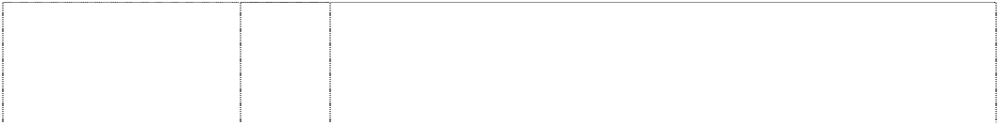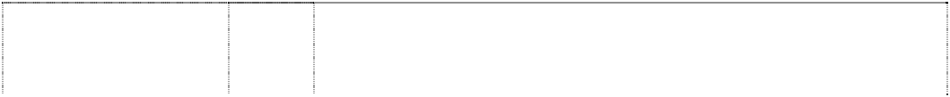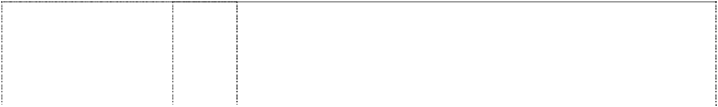

# ROVER EASY PUSH

triangle,horiz breaks ring;chevron forms ltr v in hexagon

(716766)

# ROVER EASY START XTRA

triangle,horiz breaks ring;chevron forms ltr v in hexagon

(716767)

# ROVER EASYMOW

triangle,horiz breaks ring;chevron forms ltr v in hexagon

(734136)

# ROVER EasyTrim

(827913)

# ROVER MUNCHER

(362450) **ROVER POWERSTART** (560914) **ROVER**

**PROFESSIONAL SUPERCUT** (680680)

# ROVER SUPERCUT

(389483) **ROVER TURBOTHRUST** (465753)

# SCOTT BONNAR

(224756)

# Scott Bonnar Easy Trim

(1011510)

# SUPREMO

(881346)

# THOROUGHBRED

(220413)

# V ROVER

arrowhead (320434)

7 Shredding machines and parts thereof and accessories therefor included in this class.

7 Mowing machines including domestic lawn mowers and mulching machines, cultivators for domestic and small farm use and parts and fittings for the aforesaid goods.

7 Mowing machines including domestic lawn mowers and mulching machines, cultivators for domestic and small farm use and parts and fittings for the aforesaid goods.

7 Mowing machines including domestic lawn mowers and mulching machines, cultivators for domestic and small farm use and parts and fittings for the aforesaid goods.

7 Mowing machines, tilling machines and cultivators for domestic and small farm use, mowers for domestic use including ride on and push mowers; engines for mowers; line trimmers and brush cutters including battery operated hand held line trimmers and brush cutters and parts for the aforementioned goods being goods in class 7.

7 Shredding and mulching machines and parts thereof included in this class.

7 Mowing machines, tilling machines and cultivators for small farm use, mowers for domestic use, grass catchers for mowing machines and parts and fittings for the aforementioned goods included in this class.

7 Mowing machines, tilling machines and cultivators for domestic and small farm use, mowers for domestic use, gears, engines for mowing machines and parts for the aformentioned goods.

7 Lawn mowers.

7 Mowing machines, tilling machines and cultivators, lawnmowers and lawnmower parts and attachments such as grass-catchers included in this Class.

7 Mowers, turf aerators, scarifiers and top dressing machines.

7 Mowing machines, tilling machines and cultivators for domestic and small farm use, mowers for domestic use including ride on and push mowers; engines for mowers; line trimmers and brush cutters including battery operated hand held line trimmers and brush cutters and parts for the aforementioned goods being in class 7.

7 Mowing machines, machine tools, tilling machines and cultivators for domestic and small farm use, mowers for domestic use including ride on, self drive and push mowers; agricultural implements, engines for mowers, line trimmers and brush cutters including battery operated hand held line trimmers and brush cutters and parts for the aforementioned goods.

7 Mowing machines, tilling machines, cultivators, grass catchers for mowing machines; and parts of the aforementioned goods.

7 Agricultural implements and machines of the larger kind; crushing machines, dairy machines; disintegrators and shredding machines; drying machines; hoists excluding jacks; fertilizer distributing machines; garden pumps and rollers; concrete and mortar mixing machines; gear boxes and speed governors for machines; presses included in this class; saw benches and sawing machines and other wood working machines and parts of all the aforementioned goods included in this class; mowing machines; tilling machines and cultivators in the nature of machinery for domestic and small farm use; mowers for domestic use; grass catchers for mowing machines and parts of the aforementioned goods included in this class.



**VARI-TILT**

(733116)

7

**WAYFARER**

(230406)

7

Mowing machines including domestic lawn mowers and mulching machines, cultivators for domestic and small farm use and parts and fittings for the aforesaid goods.

Mowing machines, tilling machines, cultivators, and grass catchers for mowing machines.

***Take 2 Interactive Software Pty Ltd Henry Davis York Ph: (02) 9947 6000***

***Effective Date: 14 October 2007 File Reference: C07/17530 Trade Marks Class Goods***

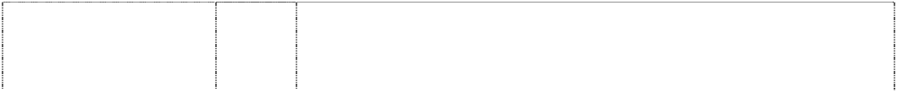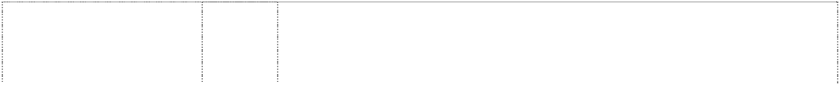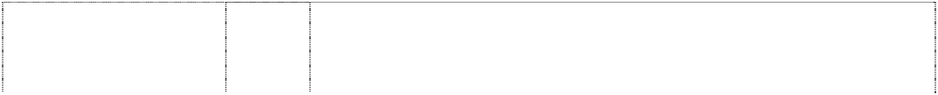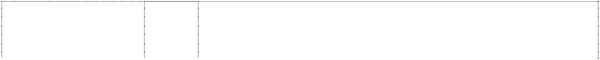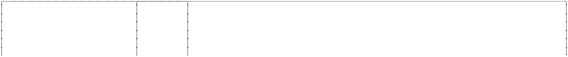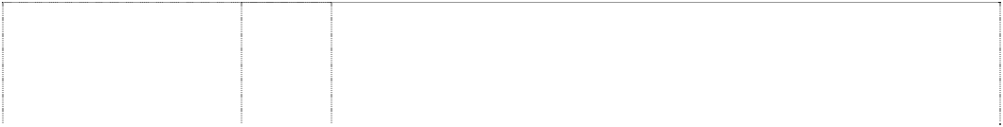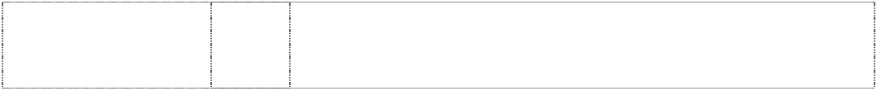

# A T 2 COMPANY

ltr T is made up of 2 rectangles (878432)

# BULLY

(1062800)

**JACK OF ALL GAMES** (787111)

# JACK OF ALL GAMES

ring around map in disc breaks annulus forming wheel (787088) **JOYTECH** (787110)

# JOYTECH

(787085)

# R

star,5-point beside ltr R in square,rounded- corners

(1003522)

**T2 TAKE TWO INTERACTIVE** (1003523)

9 Peripheral equipment for computer games; software including

computer game software; electronic games adapted for use with television receivers, monitor or some other form of display apparatus, parts, fittings and accessories therefor.

9 Software including computer games software; peripheral equipment for computer games; electronic games adapted for use with television receivers, monitors or some other form of display apparatus; electronic games, parts, fittings and accessories.

9 Peripheral equipment for computer games; software including computer game software; electronic games adapted for use with television receivers, monitor or some other form of display apparatus, parts, fittings and accessories therefor.

9 Peripheral equipment for computer games; software including computer game software; electronic games adapted for use with television receivers, monitor or some other form of display apparatus, parts, fittings and accessories therefor.

9 Peripheral equipment for computer games; software including computer game software; electronic games adapted for use with television receivers, monitor or some other form of display apparatus, parts, fittings and accessories therefor.

9 Peripheral equipment for computer games; software including computer game software; electronic games adapted for use with television receivers, monitor or some other form of display apparatus, parts, fittings and accessories therefor.

9 Peripheral equipment for computer games; software including computer games software; electronic games adapted for use with television receivers, monitors or some other form of display apparatus; electronic games, parts, fittings and accessories therefor.

9 Peripheral equipment for computer games; software namely computer games software; electronic games adapted for use with television receivers, monitors or some other form of display apparatus; electronic games, parts, fittings and accessories therefor.

***Twentieth Century Fox Film Corporation (The Simpsons) Trade Mark Investigations Service***

***Ph: (07) 3252 8599***

***Effective Date: 13 September 2007 File Reference: C07/14994***

Motion picture films, video tapes, video cassettes, videodiscs, records, tapes and cassettes for reproducing sound.

9

**THE SIMPSONS**

(636514)



***Trade Marks***

***Class***

***Goods***

# THE SIMPSONS

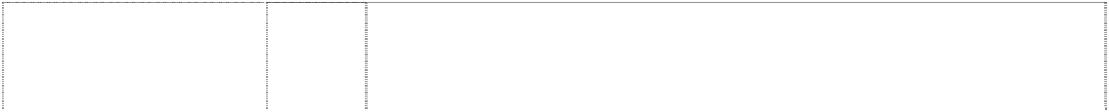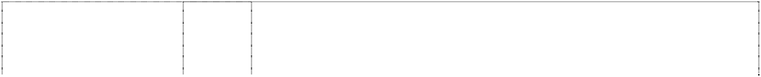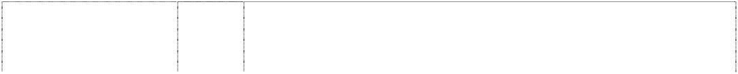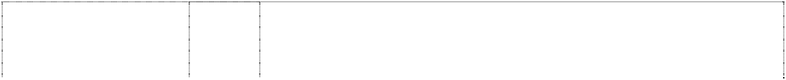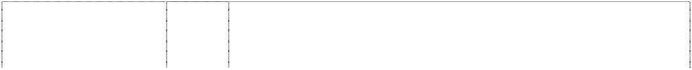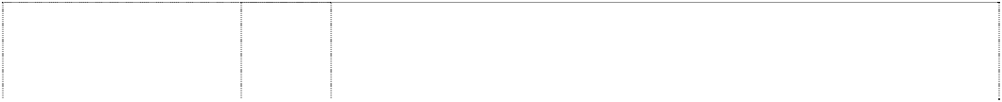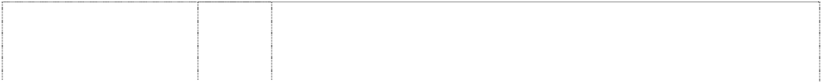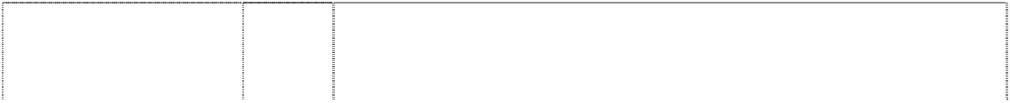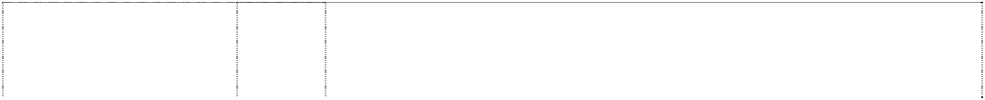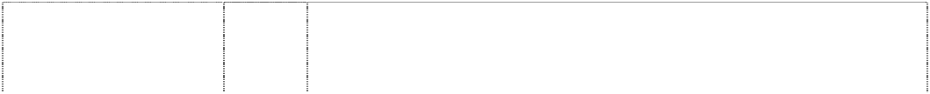

family stylised in annulus (534841)

# THE SIMPSONS

family stylised in annulus (534842)

# THE SIMPSONS

family stylised in annulus (534843)

# THE SIMPSONS

family stylised in annulus (534844)

# THE SIMPSONS

family stylised in annulus (534845)

# THE SIMPSONS

family stylised in annulus (534846)

# THE SIMPSONS

family stylised in annulus (534847)

# THE SIMPSONS

family stylised in annulus (534848)

# THE SIMPSONS

family stylised in annulus (534849)

# THE SIMPSONS

family stylised in annulus (534850)

# THE SIMPSONS

family stylised in annulus (534851)

# THE SIMPSONS

family stylised in annulus (534852)

# THE SIMPSONS

family stylised in annulus (534853)

# THE SIMPSONS

family stylised in annulus (534854)

# THE SIMPSONS

family stylised in annulus (534855)

1. Paints in this class for use by artists and for use on model airplanes and cars; and all other goods in this class.
2. Laundry, dish and bathroom soaps, shampoos, perfumes, blusher, eye makeup, lipstick, nail polish, toothpaste; all the foregoing goods being goods included in this class; flavourings (essential oils) for beverages; and all other goods in this class.

5 Bandages, vitamins, pesticides, air fresheners; and all other goods in this class.

1. Motion picture films, video tapes, video cassettes, videodiscs, records, tapes and cassettes for reproducing sound; and all other goods in this class.
2. Pacifiers, teething rings; and all other goods in this class.
3. Table and desk lamps, night lights being goods included in this class.
4. Jewellery, watches, watchbands and clocks; and all other goods in this class.
5. Guitars, horns, flutes, drums, pianos, music boxes; and all other goods in this class.
6. Staplers, pencil containers including pencil containers in the nature of pencil cups, desk organisers, household adhesives, paint brushes; printed material including stationery, photographs, instructional and teaching material, playing cards, books, comic books, posters, paper table covers, calendars, greeting cards, cartoons, colouring books, napkins and wrapping paper; water colours in this class for use by artists and for use on model air planes and cars; and all other goods in this class.

18 Umbrellas, luggage, briefcases, knapsacks, purses and wallets; and all other goods in this class.

1. Tables, chairs, desks, beds, children's furniture, bedding, pillows, mirrors, picture frames, plastic key chains and plastic key chain tags; and all other goods in this class.
2. Glasses, cups, plates, bowls, combs, brushes; and all other goods in this class.
3. Table cloths, bed covers, bath towels, beach towels, kitchen towels, fabrics for the manufacture of clothing; and all other goods in this class.
4. T-shirts, shirts, pants, underwear, hats, gloves, socks, shoes, boots, coats, sweatshirts, sweaters, skirts, ties, pyjamas, nightgowns, slippers and robes; and all other goods in this class.
5. Carpets, rugs, wall coverings, wall hangings and wallpaper; all the foregoing goods being goods included in this class; and all other goods in this class.

# THE SIMPSONS

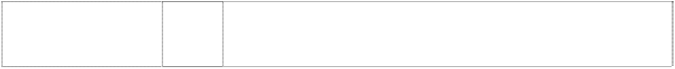

family stylised in annulus (534856)

# THE SIMPSONS

family stylised in annulus (534857)

# THE SIMPSONS

family stylised in annulus (534858)

# THE SIMPSONS

family stylised in annulus (534859)

1. Toys and games, Christmas tree decorations, computer games, dolls, action figures and accessories, skate boards; all the foregoing goods being goods included in this class; and all other goods in this class.
2. Jams and jellies, preserves, cheeses; dried, canned and frozen fruits and vegetables; potato chips; and all other goods in this class.
3. Cocoa, breads, cakes, pastry and confection, breakfast cereals, ice cream, sherbet ices, flavourings (other than essential oils) including flavourings for beverages; corn chips; and all other goods in this class.

32 Fruit drinks and juices, carbonated and non-carbonated non- alcoholic beverages, syrups and other preparations for making beverages; sherbet beverages; and all other goods in this class.

***Unity Agencies Pty Ltd Unity Agencies Pty Ltd Ph: (07) 3397 8777***

***Effective Date: 27 October 2007 File Reference: C07/18027***



***Trade Marks***

***Class***

***Goods***

**CUTEK** (1086190) **WAHL** (1047961)

8

Electric hair utensils.

8

**WAHL** (1047961) **WAHL** (96157)

11

8

Electric hair clippers and trimmers and accessories therefor, electric shavers, animal clippers/trimmers, curling irons and stylers; hand operated tools, namely steel or wire brushes.

Dryers, including hair dryers, hand-held hair dryers, hand dryers, clothes dryers.

Hair clippers and cutters.

***Urge Footwear Pty Ltd Slaters Intellectual Property Lawyers Ph: (02) 9818 1813***

***Effective Date: 23 October 2007 File Reference: C07/18146 Trade Marks Class Goods***

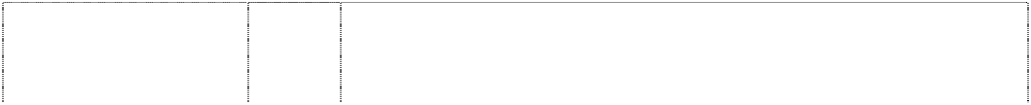

# Easyflex

(868704) **ESSENCE** (868712)

# Indulge

(868713)

# Mistress

(966481)

# Mistress

(966480)

**Squeeze** (886293) **U**

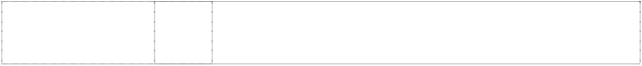ltr U & 3 discs form footprint,stylised (1091654)

# U

ltr U & 3 discs form footprint,stylised (1091654)

25 Footwear.

25 Shoes only.

25 Shoes only.

18 Handbags.

25 Footwear.

25 Shoes only.

9 Sunglasses.

18 Handbags and belts.

|  |  |  |
| --- | --- | --- |
| **U**  ltr U & 3 discs form footprint,stylised | 25 | Footwear, clothing and headgear. |
| (1091654) |  |  |
| **URGE**  (913144) | 9 | Sunglasses. |
| **Urge** | 18 | Handbags. |
| (877422) |  |  |
| **URGE** | 25 | Footwear. |
| (932650) |  |  |
| **urge**  (1091645) | 25 | Clothing and headgear. |
| dress,sytl.,indented | 18 | Handbags. |
| (989232) |  |  |
| dress,sytl.,indented | 25 | Footwear. |
| (989232) |  |  |

***Ve Wong Corporation Comasters Law Frim and Notary Public Ph: (02) 9288 0300***



***Effective Date: 29 October 2007 File Reference: C07/18539 Trade Marks Class Goods***



# KIM VE WONG

3 Chinese characters

(585838)

30 All goods in this class; soy sauce.

***Volcom Australia Pty Ltd Trade Mark Investigation Services Ph: (07) 3257 1083***

***Effective Date: 31 October 2007 File Reference: C07/16051 Trade Marks Class Goods***

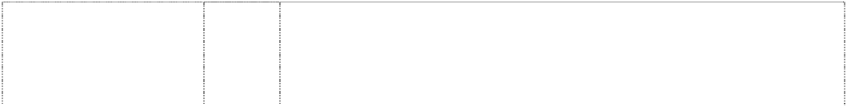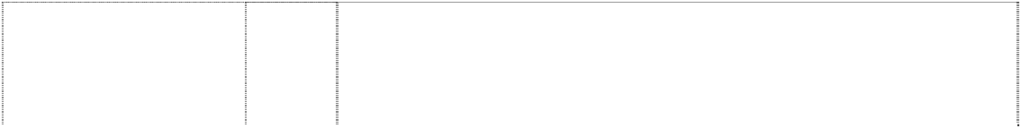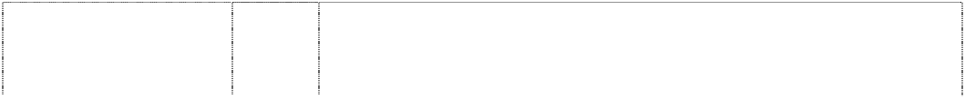

# VEECO

**PRODUCTIONS** (1048472) **VOLCOM** (863320) **VOLCOM** (1061308)

# VOLCOM

(1061308)

**VOLCOM** (863320) **VOLCOM** (863320) **VOLCOM** (1061308)

# VOLCOM

(584800)

9 Prerecorded video tapes, DVDs and motion picture films, all featuring

sports and active lifestyle entertainment.

9 Compact disks; cassettes; videos, exposed films and DVDs.

9 Recording discs; audio and video cassettes, compact discs, CD- ROMs, digital video discs, video games, computer games and electronic games; games for use with television receivers; electronic publications; spectacles including sunglasses, eyeglass frames and protective eyewear; sporting helmets.

14 Precious metals and their alloys and goods in this class made from them; jewel cases of precious metal; purses and wallets of precious metal; powder compacts of precious metal; ornaments (jewellery); cuff links; semi-worked precious stones and their imitations; clocks and watches; trophies; commemorative shields.

16 Paper goods and printed matter.

18 Sports and athletic bags.

18 Leather and imitation leather goods in this class; belts; umbrellas and parasols; bags, duffel bags, athletic bags, backpacks, purses, wallets and cases in this class; souvenir key cases, coin purses, purses, belts, wallets, bags, duffel bags, athletic bags.

25 Articles of clothing including active wear.

# VOLCOM

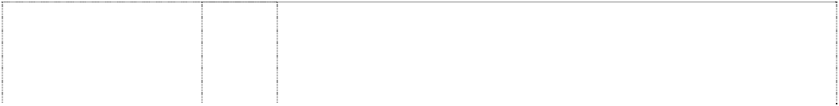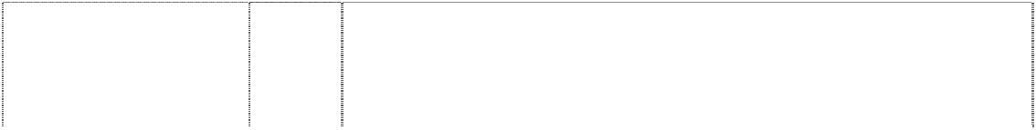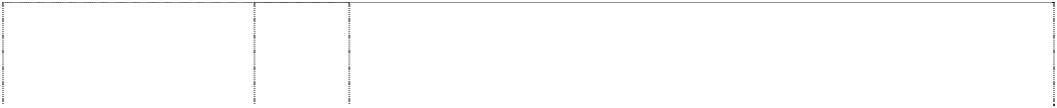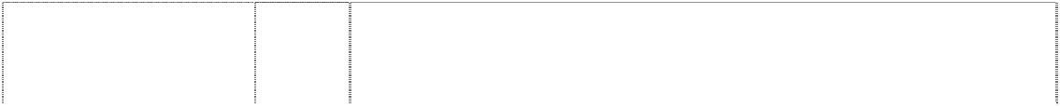

(1061308)

# VOLCOM

(1061308)

**VOLCOM** (905589) **VOLCOM**

# EN"TER.TAIN'MENT

gem in oval forms ltr O in explosion, irregular (872847)

# VOLCOM EN"TER.TAIN'MENT

gem in oval forms ltr O in explosion, irregular (872847)

gem (863321)

gem (1061369)

gem (863321)

gem (1061369)

gem (863321)

gem (863321)

gem (1061369)

gem (1061369)

gem (863321)

25 Clothing, headgear and footwear; vests; trousers; T-shirts; ties, sweat shirts; sweat pants; sweat bands; sweat shorts; sweat suits; sweaters; swim wear; swim suits; sport shirts; sleep shirts; sleepwear; slippers; shorts; scarves; rain boots, coats, jackets, suits, and rainwear; polo shirts; ponchos; fur stoles; shawls; hoods; neckerchiefs; neckties; neckwear; knit shirts; jackets; hats; caps; headwear; gym shorts; gym suits; caps; belts for clothing; shoes and boots; gloves and mittens.

28 Games, toys and playthings, sporting goods in class 28; exercise and physical training apparatus and articles, toys, toy vehicles, toy cars, dolls, jigsaw puzzles, board games, card games, playing cards, electronic toys and equipment for playing electronic games; video games; hand-held units for playing electronic games; self contained apparatus and instruments for playing games including mechanical games, electronic games, computerised games, battery operated games, games that are portable, games that include a built-in display, games that include a built-in program, games that receive one or more programs, hand held portable self contained apparatus and instruments for playing games; parts, fittings and accessories for the aforesaid goods.

28 Skateboards, skimboards, snowboards, surfboards, skates and non- motorised scooters.

9 Prerecorded audio and digital tapes and compact

Discs all featuring music and musical sounds recordings, video tapes video discs, laser discs, video game discs and video game cartridges, motion picture films featuring sports, music and active lifestyle entertainment.

25 Clothing, headgear, and footwear.

9 Apparatus for recording, transmission, or reproduction of sound or images and recording discs.

9 Apparatus for recording, transmission or reproduction of sound or images; magnetic data carriers, recording discs; audio and video cassettes, compact discs, CD-ROMs, digital video discs, video games, computer games and electronic games; games for use with television receivers; electronic publications; spectacles including sunglasses, eyeglass frames and protective eyewear; sporting helmets.

12 Vehicles; apparatus for locomotion by land, air or water.

14 Precious metals and their alloys and goods in this class made from them; jewel cases of precious metal; purses and wallets of precious metal; powder compacts of precious metal; cuff links; clocks and watches; trophies; commemorative shields.

16 Paper goods and printed matter.

18 Sports and athletic bags.

18 Leather and imitation leather goods in this class including belts; umbrellas and parasols; bags, duffel bags, athletic bags, backpacks, purses, wallets and cases in this class; souvenir key cases, coin purses, purses, belts, wallets, bags, duffel bags, athletic bags.

25 Clothing, headgear and footwear; vests; trousers; T-shirts; ties, sweat shirts; sweat pants; sweat bands; sweat shorts; sweat suits; sweaters; swim wear; swim suits; sport shirts; sleep shirts; sleepwear; slippers; shorts; scarves; rain boots, coats, jackets, suits, and rainwear; polo shirts; ponchos; fur stoles; shawls; hoods; neckerchiefs; neckties; neckwear; knit shirts; jackets; hats; caps; headwear; gym shorts; gym suits; caps; belts for clothing; shoes and boots; gloves and mittens.

25 Clothing, headgear, and footwear.

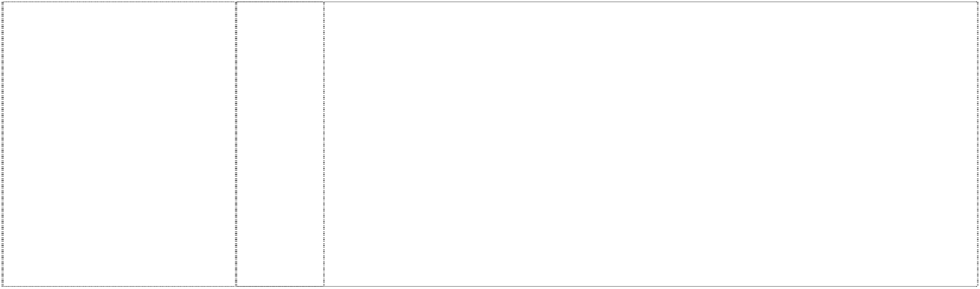

gem (710779)

25

gem (1061369)

28

Hats; clothing including jackets, pants, shirts, sweatpants, sweatshirts, swimtrunks, tanktops, T-shirts, underwear, walking shorts.

Games, toys and playthings, sporting goods in class 28; exercise and physical training apparatus and articles, toys, toy vehicles, toy cars, dolls, jigsaw puzzles, board games, card games, playing cards, electronic toys and equipment for playing electronic games; video games; hand-held units for playing electronic games; self contained apparatus and instruments for playing games including mechanical games, electronic games, computerised games, battery operated games, games that are portable, games that include a built-in display, games that include a built-in program, games that receive one or more programs, hand held portable self contained apparatus and instruments for playing games; parts, fittings and accessories for the aforesaid goods.

***Wiggles International Pty Ltd, The Trade Mark Investigation Services Ph: (07) 3257 1083***

***Effective Date: 3 December 2007 File Reference: C07/20801 Trade Marks Class Goods***



# BIG RED CAR

(741559)

# BIG RED CAR

(726436)

5 Sunscreen, sunscreen lip balm in this class, absorbent cotton,

adhesive bands for medical purposes, adhesive plaster, adhesive tapes for medical purposes, antiseptics, balms for medical purposes, bandages for dressings, therapeutic preparations for the bath, medicated bath preparations, bath salts for medical purposes, cod liver oil, deodorants in this class, dietetic foods in this class, medical dressings, surgical dressings, gauze for dressings, lip balms in this class, lotions for pharmaceutical purposes, oils in this class, pharmaceutical preparations for skincare, sponges, stick liquorice for pharmaceutical purposes, sticking plasters, glucose, glucose drinks, sunburn ointments, sunburn preparations, tissues, vitamins.

9 Computer software, computer programmes, compact discs, cassettes, records, video tapes and compact discs read only memory, teaching apparatus and instruments, apparatus for recording, transmission or reproduction of sound or images, magnetic data carriers, recording discs, magnets, jukeboxes, spectacle frames, spectacles, sunglasses, eyewear, spectacle cases, binoculars, animated cartoons, films, kaleidoscopes, lifejackets, magnetic tapes, video recorders, cassette recorders, television and video games, computer games, digital audio tapes, digital video tapes, rides and amusement machines (automatic and coin operated).

# BIG RED CAR



(744652)

# BIG RED CAR

(743840)

# BIG RED CAR

(743840)

# BIG RED CAR

(726436)

# BIG RED CAR

(726436)

# BIG RED CAR

(743840)

9 Abacuses, amusement machines, animated cartoons; anti-dazzle shades; anti-glare visors, not being protective clothing; apparatuses for editing cinematographic film, apparatuses for games (adapted for use with TV receivers only), automatic and coin operated audio- visual teaching apparatuses; automatic, mechanical and coin operated rides in this class; binoculars; cameras, cassette players, compact disc players, compasses, computer games, computer keyboards; computers; contact lenses; digital audiotapes, digital videotapes; divers' masks, not being protective clothing; eyeshades; eyewear; films (exposed); floating aids for bathing and swimming; integrated circuit chips, jukeboxes for computers, musical juke boxes, kaleidoscopes, lanterns (magic); magnetic discs; magnetic tapes; magnets; magnifying glasses; microphones; microscopes; modems; pocket calculators; radios; recorded computer programmes; recording discs; rulers; safety restraints; spectacle cases; spectacle chains; spectacle cords; spectacle frames; spectacle glasses; sunglasses; swimming belts; swimming jackets, not being protective clothing; tape recorders; teaching apparatuses; telescopes; video game cartridges; video games; viewfinders (photographic).

11 Lamp shades.

14 Alarm clocks, bracelets, brooches, cases for clocks, cases for watches, chains, jewellery charms, tie clips, clocks, electric clocks and watches, liquid crystal display watches, moulded flip top liquid crystal display watches, quartz analogue watches, earrings, gold and silverware (other than cutlery, forks and spoons), hat ornaments of precious metal, household containers of precious metal, household utensils of precious metal, objects of imitation gold, jewellery, keyrings, cufflinks, medallions, necklaces, ornamental pins, ornaments, pins, tie pins, plated articles, rings, stopwatches, straps for wristwatches, trinkets, watchbands, watch chains, watch straps, watches and wrist watches.

16 Stationery, cards, note cards and writing paper, paper partyware, bibs of paper, coasters, book markers, stickers, calenders, greeting cards, drawing pads, general feature magazines for children and magazines for adults dealing with children's issues, pen and pencil cases, pen holders, pencils, crayons, pens, pencil sharpeners, mounted and unmounted photographs, decorative mounted and unmounted pictures, playing cards, stamps, stamp pads, stencils, paper napkins, books including, comic books, picture books, drawing books, music books, coloring books, sticker books, story books, squeaky books, pop up books, pull tab books, glow in the dark books, bath books, chunky board books, scrap books, activity books, paper coasters, paper, plastic and vinyl placemats, paper hats, paper napkins, paper party favors, paper whistles and noise makers in the nature of Christmas crackers, show bags, boards, manuals, brochures and teaching materials namely, textbooks for teaching reading, writing, mathematics, music, spelling, drama and magic tricks to children, charts, friezes, colour and count sets, activity packs, writing slates and posters.

18 Bags, game bags, bags for campers, bags for climbers, bags for packaging, beach bags, belts, briefcases, leather cases, pocket wallets, purses, chain metal purses (not of precious metal), collars for animals, covers for animals, handbags, haversacks, music cases, rucksacks, school satchels, school bags, shopping bags, sling bags for carrying infants, travelling bags, travelling trunks, umbrellas.

21 Food containers of metal, household containers of metal, dishes of metal, egg cups of metal, jugs of metal, kitchen containers of metal, kitchen utensils of metal, bowls of metal, table plates of metal, trays of metal for household purposes.

# BIG RED CAR



(743840)

# BIG RED CAR

(726436)

# BIG RED CAR

(743840)

# BIG RED CAR

(743840)

# BIG RED CAR

(726436)

# BIG RED CAR

(746258)

1. Adhesive fabric for application by heat, banners, covers for bags filled with polystyrene beads, bed linen (except clothing), bed blankets, bed clothes, bed covers, bed covers of paper, bedspreads, blinds of textile, canvas for tapestry or embroidery, coasters made of table linen, cotton fabrics, coverlets for bedspreads, comforter sets, covers for cushions, covers for furniture, curtains of textile or plastic, down filled blankets, door curtains, eiderdowns, fabric, fabrics for textile use, facewashers, floor mats of terry towelling and textile material, friezes, loose covers for furniture, furniture coverings of plastic, furniture coverings of textile, gummed cloths other than for stationery, handkerchiefs of textile, handtowels, jersey, knitted fabric, cloth labels, diapered linen, household linen, linen cloth, lingerie fabric, placemats in this class, mattress covers, mattress protectors, pillow shams, pillow cases, plastic material (substitute for fabrics), blankets of textile, quilts, quilt covers, quilt cover sets, travelling rugs, table runners, serviettes of textile, rod pocket curtains, rugs, sheets, sleeping bags (sheeting), sunshades for affixing to windows, tablecloths (not of paper), table linen (textile), tablemats (not of paper), table napkins of textile, tapestry (wall hangings) of textile, towels, traced cloth for embroidery, upholstery fabrics, valances, velour bath towels, velour beach towels, velour towels, wall hangings of textile, woollen cloth, woollen fabric.
2. Clothing, headgear, T-shirts, baseball caps, pyjamas, sweatshirts, tracksuits, sleepwear, babywear, babies' pants, babies' caps, babies' hats, babies' suits, babies' T-shirts, mess shirts, babies' long sleeve T-shirts, babies' overalls, babies' pullovers, bonnets, bibs, socks, tights, booties, blankets, cloth bibs, underwear, briefs, singlets, crop top sets, boxer shorts, ties, bow ties, scarves, shoes, swimsuits, beach wear, uniforms, sports apparel, shorts, wind-resistant jackets, jerseys, pants and leotards, aprons, bathing suits, shoes, footwear, slippers, waterproof clothing, coats, boots, jackets, ponchos and rain hats, beanies, hats, character costumes, shirts, trousers, dresses, skirts, sweaters, pullovers, cardigans, bath robes, gloves, headbands, belts, waistcoats, ties, children's co-ordinates.
3. Badges for wear of metal, buckles of common metal for clothing.
4. Floor mats of textile, wool and nylon.
5. Toys, playthings, games, gymnastic and sporting articles not included in other classes, swim masks and diving masks, play swimming pools, surf boards, spinning tops, action skill games, card games and manipulative games, board games, kites, balls, puppets, balloons, Christmas tree decorations, dolls' houses, computer and video games, puzzles, jigsaw puzzles, skateboards, inflatable toys, inflatable furniture, inflatable chairs, inflatable tables, inflatable mascots, inflatable balls, inflatable cars, dolls, plush toys, soft toys, finger puppets, toy microphones, toy drum kits, toy cymbals, toy guitars (electronic and non-electronic), tambourines, toy electronic keyboards, musical instruments, toy money bank, cars, car parts.
6. Butter, chocolate nut butter, peanut butter, coconut, potato crisps, potato chips (hot), snack foods, crystallised fruits, dates, salted foods, frosted fruits, frozen fruits, preserved fruit, cooked fruit, dried fruit, fruit jellies, jelly, fruit peel, fruit pulp, fruit salads, stewed fruit, jams, vegetable juices, margarine, marmalade, broth, milk, milk products, cheese, nuts, soups, vegetable salads, cooked vegetables, dried vegetables, preserved vegetables, almonds, anchovy, beans, coconut butter, caviar, coconut oil, dessicated coconut, dairy products, edible oils, eggs, fish, food preserves, herbs, gelatine, gherkins, cream, ham, herrings, sardines, lentils, meat jellies, meat in this class, sausages, mushrooms, mussels, olive oil, olives, preserved onions, sauerkraut, oil, processed peanuts, peas, pickles, poultry, game, chicken and chicken products in this class, raisins, salads, salmon, sesame oil, soup, suet, soya beans, sunflower oil, tomato juice, tuna, vegetable juices, yoghurt and baked beans, whipped cream.

# BIG RED CAR

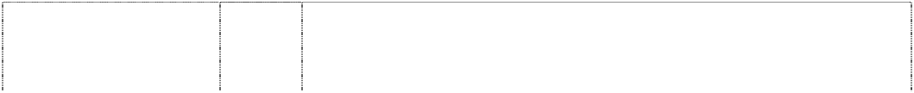

(745351)

**CAPTAIN FEATHERSWORD** (720133) **CAPTAIN FEATHERSWORD** (720133)

**CAPTAIN FEATHERSWORD** (741568)

**CAPTAIN FEATHERSWORD** (712748) **CAPTAIN FEATHERSWORD** (667708)

1. Biscuits, bread, buns, cakes, cake powder, breakfast cereal,chewing gum, chocolate, chocolate based beverages, confectionery, cookies, decorations for cakes (edible), edible ices, ginger, ice cream, liquorice, lozenges, meat pies, noodles, pizzas, popcorn and health bars in this class being cereal-based snack foods; spreads in this class for sandwiches, cornflakes, muesli, oat flakes, oat-based food, pasta, pasta in sauce, spaghetti, canned spaghetti in sauce, peanut confectionery, snack foods, puddings, rice, bread rolls, rusks, sherbet, almond confectionery, aniseed, barley, cocoa-based beverages, beverage flavourings, ice cream flavourings, candy, caramels, cereal preparations, spices, coffee, coffee substitutes, condiments, sauces, corn, farinaceous foods, flavourings, flour for food, gingerbread, glucose, golden syrup, gum, sweets, honey, ices, tomato sauce, macaroni, maize, malt, marzipan, mint, mustard, oatmeal, pancakes, pancake mix, pastries, pralines, ravioli, vermicelli, sago, sandwiches, seasonings, semolina, sugar, sugar confectionery, natural sweeteners, candy sweeteners, tapioca, tarts, tea, vanilla flavour, waffles, yeast, hamburgers in this class, hotdogs in this class.

3 Soaps, bath salts, oils, cosmetics, cleaning preparations, creams, deodorants, detergents, perfume, make-up, bleach, lipsticks, nail polish, bubble bath and toothpaste.

5 Food for babies and children, adhesive dressings and materials, sticking plaster, bath salts, medicated candy, chewing gum, medicated confectionery, medicinal drinks, first aid boxes, food preparations in this class and medicated toothpaste.

5 Sunscreen, sunscreen lip balm in this class, absorbent cotton, adhesive bands for medical purposes, adhesive plaster, adhesive tapes for medical purposes, antiseptics, balms for medical purposes, bandages for dressings, therapeutic preparations for the bath, medicated bath preparations, bath salts for medical purposes, cod liver oil, deodorants in this class, dietetic foods in this class, medical dressings, surgical dressings, gauze for dressings, lip balms in this class, lotions for pharmaceutical purposes, oils in this class, pharmaceutical preparations for skincare, sponges, stick liquorice for pharmaceutical purposes, sticking plasters, glucose, glucose drinks, sunburn ointments, sunburn preparations, tissues, vitamins.

1. Cutlery, scissors, knives, forks, spoons, garden tools and spades, hanging knife, spoon and fork set.
2. Computer software, computer programmes, compact discs, cassettes, records, video tapes, CD Roms, spectacles, eyewear, sunglasses, spectacle cases, spectacle frames, binoculars, animated cartoons, films, juke boxes, kaleidoscopes, lifejackets, magnetic tapes, magnets, sound recording apparatuses, sound recording disks, sound recording, amplifying, reproducing and transmitting apparatuses, tapes, teaching apparatuses, television apparatuses, video recorders, video games, digital audio tapes and digital video tapes.

**CAPTAIN FEATHERSWORD** (744655)

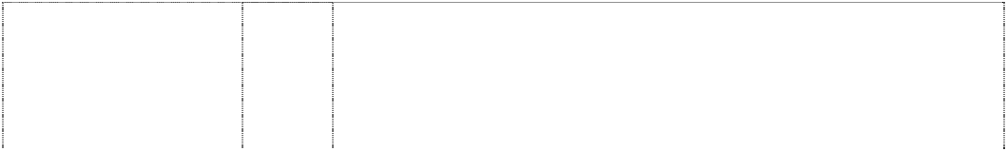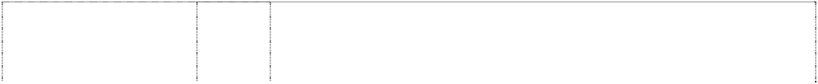

**CAPTAIN FEATHERSWORD** (743839) **CAPTAIN FEATHERSWORD** (743839)

**CAPTAIN FEATHERSWORD** (608394) **CAPTAIN FEATHERSWORD** (712748)

**CAPTAIN FEATHERSWORD** (712748) **CAPTAIN FEATHERSWORD** (712748)

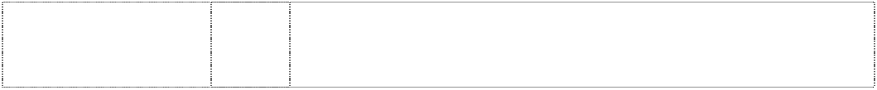**CAPTAIN FEATHERSWORD** (743839)

9 Abacuses, amusement machines, animated cartoons; anti-dazzle shades; anti-glare visors, apparatuses for editing cinematographic film, apparatus for games (adapted for use with TV receivers only), audio-visual teaching apparatuses (automatic and coin operated); automatic, mechanical and coin operated rides in this class; binoculars; cameras, cassette players, compact disc players, compasses, computer games, computer keyboards; computers; contact lenses; digital audiotapes, digital videotapes; divers' masks; eyeshades; eyewear; films (exposed); floating aids for bathing and swimming; integrated circuit chips, jukeboxes (musical), jukeboxes (for computers); kaleidoscopes, lanterns (magic); life belts, life jackets; life saving apparatuses and equipment; magnetic discs; magnetic tapes; magnets; magnifying glasses; microphones; microscopes; modems; pocket calculators; protective helmets; radios; recorded computer programmes; recording discs; rulers; safety restraints; spectacle cases, spectacle chains, spectacle cords, spectacle frames, spectacle glasses, sunglasses; swimming belts, swimming jackets; tape recorders; teaching apparatuses; telescopes; video game cartridges; video games; viewfinders (photographic).

11 Lamp shades.

14 Alarm clocks, bracelets, brooches, cases for clocks, cases for watches, chains, jewellery charms, tie clips, clocks, electric clocks and watches, liquid crystal display watches, moulded flip top liquid crystal display watches, quartz analogue watches, earrings, gold and silverware (other than cutlery, forks and spoons), hat ornaments of precious metal, household containers of precious metal, household utensils of precious metal, objects of imitation gold, jewellery, keyrings, cufflinks, medallions, necklaces, ornamental pins, ornaments, pins, tie pins, plated articles, rings, stopwatches, straps for wristwatches, trinkets, watchbands, watch chains, watch straps, watches and wrist watches.

16 All goods in class 16.

18 Bags, game bags, bags for campers, bags for climbers, bags for packaging, beach bags, belts in this class, briefcases, leather cases, pocket wallets, purses, chain metal purses (not of precious metal), collars for animals, covers for animals, handbags, haversacks, music cases, rucksacks, school satchels, school bags, shopping bags, sling bags for carrying infants, travelling bags, travelling trunks, umbrellas.

1. Playpens, sleeping bags, statuettes of wood, wax, plaster or plastic, tables, chairs, stools, furniture, trays (not of metal), desks.
2. Cups, mugs, bowls, plates, dinner sets, canteens, lunch boxes, tumblers, drinking containers, basins, bins, bottles, soap boxes, brushes, combs, crockery, soap dishes, dustbins, egg cups, drinking flasks, money boxes, tableware and toothbrushes, vinyl placemats.

21 Food containers of metal, household containers of metal, dishes of metal, egg cups of metal, jugs of metal, kitchen containers of metal, kitchen utensils of metal, bowls of metal, table plates of metal, trays of metal for household purposes.

**CAPTAIN FEATHERSWORD** (743839)



**CAPTAIN FEATHERSWORD** (608395)

**CAPTAIN FEATHERSWORD** (743839) **CAPTAIN FEATHERSWORD** (743839) **CAPTAIN FEATHERSWORD** (608396)

**CAPTAIN FEATHERSWORD** (746259)

1. Adhesive fabric for application by heat, banners, covers for bags filled with polystyrene beads, bed linen (except clothing), bed blankets, bed clothes, bed covers, bed covers of paper, bedspreads, blinds of textile, canvas for tapestry or embroidery, coasters made of table linen, cotton fabrics, coverlets for bedspreads, comforter sets, covers for cushions, covers for furniture, curtains of textile or plastic, down filled blankets, door curtains, eiderdowns, fabric, fabrics for textile use, facewashers, floor mats of terry towelling and textile material, friezes, loose covers for furniture, furniture coverings of plastic, furniture coverings of textile, gummed cloths other than for stationery, handkerchiefs of textile, handtowels, jersey, knitted fabric, cloth labels, diapered linen, household linen, linen cloth, lingerie fabric, placemats in this class, mattress covers, mattress protectors, pillow shams, pillow cases, plastic material (substitute for fabrics), blankets of textile, quilts, quilt covers, quilt cover sets, travelling rugs, table runners, serviettes of textile, rod pocket curtains, rugs, sheets, sleeping bags (sheeting), sunshades for affixing to windows, tablecloths (not of paper), table linen (textile), tablemats (not of paper), table napkins of textile, tapestry (wall hangings) of textile, towels, traced cloth for embroidery, upholstery fabrics, valances, velour bath towels, velour beach towels, velour towels, wall hangings of textile, woollen cloth, woollen fabric.
2. All goods in class 25 including T-shirts, baseball caps, pyjamas, sweatshirts, tracksuits, nightwear, babywear, bibs, (not of paper), underwear, socks, ties, bowties, scarves, hankerchiefs, knitwear, shoes, swimsuits, uniforms, sports apparel.
3. Badges for wear of metal, buckles of common metal for clothing.
4. Floor mats of textile, wool and nylon.
5. All goods in class 28 including toys, masks in this class, swimming pools being sports or play articles, surfboards, spinning tops, soft toys, dolls, games, board games, kites, puppets, bon bons, balloons, decorations in this class, and dolls' houses.
6. Butter, chocolate nut butter, peanut butter, coconut, potato crisps, potato chips (hot), snack foods, crystallised fruits, dates, salted foods, frosted fruits, frozen fruits, preserved fruit, cooked fruit, dried fruit, fruit jellies, jelly, fruit peel, fruit pulp, fruit salads, stewed fruit, jams, vegetable juices, margarine, marmalade, broth, milk, milk products, cheese, nuts, soups, vegetable salads, cooked vegetables, dried vegetables, preserved vegetables, almonds, anchovy, beans, coconut butter, caviar, coconut oil, dessicated coconut, dairy products, edible oils, eggs, fish, food preserves, herbs, gelatine, gherkins, cream, ham, herrings, sardines, lentils, meat jellies, meat in this class, sausages, mushrooms, mussels, olive oil, olives, preserved onions, sauerkraut, oil, processed peanuts, peas, pickles, poultry, game, chicken and chicken products in this class, raisins, salads, salmon, sesame oil, soup, suet, soya beans, sunflower oil, tomato juice, tuna, vegetable juices, yoghurt and baked beans, whipped cream.

**CAPTAIN FEATHERSWORD** (745352)

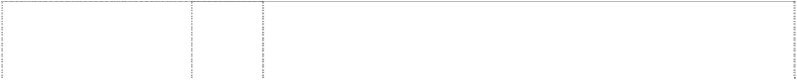

**DOROTHY THE DINOSAUR** (676238)

**DOROTHY THE DINOSAUR** (720130) **DOROTHY THE DINOSAUR** (720130)

**DOROTHY THE DINOSAUR** (741562)

**DOROTHY THE DINOSAUR** (712745) **DOROTHY THE DINOSAUR** (667706)

1. Biscuits, bread, buns, cakes, cake powder, breakfast cereal, chewing gum, chocolate, chocolate based beverages, confectionery, cookies, decorations for cakes (edible), edible ices, ginger, ice cream, liquorice, lozenges, meat pies, noodles, pizzas, popcorn and health bars in this class being cereal-based snack foods; spreads in this class for sandwiches, cornflakes, muesli, oat flakes, oat-based food, pasta, pasta in sauce, spaghetti, canned spaghetti in sauce, peanut confectionery, snack foods, puddings, rice, bread rolls, rusks, sherbet, almond confectionery, aniseed, barley, cocoa-based beverages, beverage flavourings, ice cream flavourings, candy, caramels, cereal preparations, spices, coffee, coffee substitutes, condiments, sauces, corn, farinaceous foods, flavourings, flour for food, gingerbread, glucose, golden syrup, gum, sweets, honey, ices, tomato sauce, macaroni, maize, malt, marzipan, mint, mustard, oatmeal, pancakes, pancake mix, pastries, pralines, ravioli, vermicelli, sago, sandwiches, seasonings, semolina, sugar, sugar confectionery, natural sweeteners, candy sweeteners, tapioca, tarts, tea, vanilla flavour, waffles, yeast, hamburgers in this class, hotdogs in this class.

3 Bath salts, bubble bath, skin care preparations, cosmetics, creams, deodorants, cologne, hair colourants, hair dyes, lotions in this class, hair waving preparations, lipsticks, make-up, cosmetic kits, nail polish, essential oils, perfume, shampoos, shoe polish, soaps, toiletries, sun tanning preparations in this class, sun screen in this class, sun screen lip balm in this class, talcum powder, toothpaste; all the aforesaid being primarily for children.

3 Soaps, bath salts, oils, cosmetics, cleaning preparations, creams, deodorants, detergents, perfume, make-up, bleach, lipsticks, nail polish, bubble bath and toothpaste.

5 Food for babies and children, adhesive dressings and materials, sticking plaster, bath salts, medicated candy, chewing gum, medicated confectionery, medicinal drinks, first aid boxes, food preparations in this class and medicated toothpaste.

5 Sunscreen, sunscreen lip balm in this class, absorbent cotton, adhesive bands for medical purposes, adhesive plaster, adhesive tapes for medical purposes, antiseptics, balms for medical purposes, bandages for dressings, therapeutic preparations for the bath, medicated bath preparations, bath salts for medical purposes, cod liver oil, deodorants in this class, dietetic foods in this class, medical dressings, surgical dressings, gauze for dressings, lip balms in this class, lotions for pharmaceutical purposes, oils in this class, pharmaceutical preparations for skincare, sponges, stick liquorice for pharmaceutical purposes, sticking plasters, glucose, glucose drinks, sunburn ointments, sunburn preparations, tissues, vitamins.

1. Cutlery, scissors, knives, forks, spoons, garden tools and spades, hanging knife, spoon and fork set.
2. Computer software, computer programmes, compact discs, cassettes, records, video tapes, CD Roms, spectacles, eyewear, sunglasses, spectacle cases, spectacle frames, binoculars, animated cartoons, films, juke boxes, kaleidoscopes, lifejackets, magnetic tapes, magnets, sound recording apparatuses, sound recording disks, sound recording, amplifying, reproducing and transmitting apparatuses, tapes, teaching apparatuses, television apparatuses, video recorders, video games, digital audio tapes and digital video tapes.

**DOROTHY THE DINOSAUR** (744660)

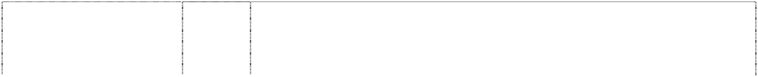

**DOROTHY THE DINOSAUR** (743842) **DOROTHY THE DINOSAUR** (737434)

**DOROTHY THE DINOSAUR** (743842)

**DOROTHY THE DINOSAUR** (607885) **DOROTHY THE DINOSAUR** (712745)

**DOROTHY THE DINOSAUR** (712745) **DOROTHY THE DINOSAUR** (712745)

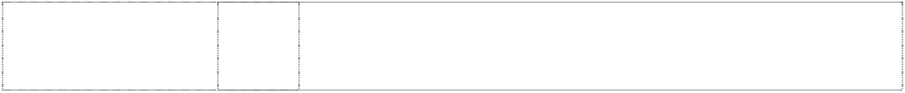**DOROTHY THE DINOSAUR** (743842)

9 Abacuses, amusement machines, animated cartoons; anti-dazzle shades; anti-glare visors, apparatuses for editing cinematographic film, apparatus for games (adapted for use with TV receivers only), audio-visual teaching apparatuses (automatic and coin operated); automatic, mechanical and coin operated rides in this class; binoculars; cameras, cassette players, compact disc players, compasses, computer games, computer keyboards; computers; contact lenses; digital audiotapes, digital videotapes; divers' masks; eyeshades; eyewear; films (exposed); floating aids for bathing and swimming; integrated circuit chips, jukeboxes (musical), jukeboxes (for computers); kaleidoscopes, lanterns (magic); life belts, life jackets; life saving apparatuses and equipment; magnetic discs; magnetic tapes; magnets; magnifying glasses; microphones; microscopes; modems; pocket calculators; protective helmets; radios; recorded computer programmes; recording discs; rulers; safety restraints; spectacle cases, spectacle chains, spectacle cords, spectacle frames, spectacle glasses, sunglasses; swimming belts, swimming jackets; tape recorders; teaching apparatuses; telescopes; video game cartridges; video games; viewfinders (photographic).

1. Lamp shades.
2. Baby carriages, covers for baby carriages, hoods for baby carriages, safety seats for children for vehicles, safety seat covers for children for vehicles, safety belts for the seats and carriages for vehicles, pushchairs and strollers, pushchair covers and hoods, stroller covers and hoods, bicycles, bicycle saddles, bicycle brakes, bicycle chains, bicycle frames, bicycle handle bars, bicycle pumps, bicycle rims, bicycle spokes, bicycle stands, bicycle tyres, bells for bicycles, boats, cars, automobiles, horns for cars and automobiles, horns for tricycles and bicycles, seat covers for cars and automobiles, tricycles and sleeping berths for vehicles, rearview mirrors.

14 Alarm clocks, bracelets, brooches, cases for clocks, cases for watches, chains, jewellery charms, tie clips, clocks, electric clocks and watches, liquid crystal display watches, moulded flip top liquid crystal display watches, quartz analogue watches, earrings, gold and silverware (other than cutlery, forks and spoons), hat ornaments of precious metal, household containers of precious metal, household utensils of precious metal, objects of imitation gold, jewellery, keyrings, cufflinks, medallions, necklaces, ornamental pins, ornaments, pins, tie pins, plated articles, rings, stopwatches, straps for wristwatches, trinkets, watchbands, watch chains, watch straps, watches and wrist watches.

16 All goods in class 16.

18 Bags, game bags, bags for campers, bags for climbers, bags for packaging, beach bags, belts in this class, briefcases, leather cases, pocket wallets, purses, chain metal purses (not of precious metal), collars for animals, covers for animals, handbags, haversacks, music cases, rucksacks, school satchels, school bags, shopping bags, sling bags for carrying infants, travelling bags, travelling trunks, umbrellas.

1. Playpens, sleeping bags, statuettes of wood, wax, plaster or plastic, tables, chairs, stools, furniture, trays (not of metal), desks.
2. Cups, mugs, bowls, plates, dinner sets, canteens, lunch boxes, tumblers, drinking containers, basins, bins, bottles, soap boxes, brushes, combs, crockery, soap dishes, dustbins, egg cups, drinking flasks, money boxes, tableware and toothbrushes, vinyl placemats.

21 Food containers of metal, household containers of metal, dishes of metal, egg cups of metal, jugs of metal, kitchen containers of metal, kitchen utensils of metal, bowls of metal, table plates of metal, trays of metal for household purposes.

**DOROTHY THE DINOSAUR** (743842)



**DOROTHY THE DINOSAUR** (607886)

**DOROTHY THE DINOSAUR** (743842) **DOROTHY THE DINOSAUR** (743842) **DOROTHY THE DINOSAUR** (607887)

**DOROTHY THE DINOSAUR** (746260)

1. Adhesive fabric for application by heat, banners, covers for bags filled with polystyrene beads, bed linen (except clothing), bed blankets, bed clothes, bed covers, bed covers of paper, bedspreads, blinds of textile, canvas for tapestry or embroidery, coasters made of table linen, cotton fabrics, coverlets for bedspreads, comforter sets, covers for cushions, covers for furniture, curtains of textile or plastic, down filled blankets, door curtains, eiderdowns, fabric, fabrics for textile use, facewashers, floor mats of terry towelling and textile material, friezes, loose covers for furniture, furniture coverings of plastic, furniture coverings of textile, gummed cloths other than for stationery, handkerchiefs of textile, handtowels, jersey, knitted fabric, cloth labels, diapered linen, household linen, linen cloth, lingerie fabric, placemats in this class, mattress covers, mattress protectors, pillow shams, pillow cases, plastic material (substitute for fabrics), blankets of textile, quilts, quilt covers, quilt cover sets, travelling rugs, table runners, serviettes of textile, rod pocket curtains, rugs, sheets, sleeping bags (sheeting), sunshades for affixing to windows, tablecloths (not of paper), table linen (textile), tablemats (not of paper), table napkins of textile, tapestry (wall hangings) of textile, towels, traced cloth for embroidery, upholstery fabrics, valances, velour bath towels, velour beach towels, velour towels, wall hangings of textile, woollen cloth, woollen fabric.
2. All goods in class 25 including T-shirts, baseball caps, pyjamas, sweatshirts, tracksuits, nightwear, babywear, bibs, (not of paper), underwear, socks, ties, bowties, scarves, hankerchiefs, knitwear, shoes, swimsuits, uniforms, sports apparel.
3. Badges for wear of metal, buckles of common metal for clothing.
4. Floor mats of textile, wool and nylon.
5. All goods in class 28 including toys, masks, swimming pools, surfboards, spinning tops, soft toys, dolls, games, board games, kites, puppets, balloons, bon bons, decorations for Christmas trees and dolls' houses.
6. Butter, chocolate nut butter, peanut butter, coconut, potato crisps, potato chips (hot), snack foods, crystallised fruits, dates, eggs, salted foods, frosted fruits, frozen fruits, preserved fruit, cooked fruit, dried fruit, fruit jellies, jelly, fruit peel, fruit pulp, fruit salads, stewed fruit, jams, vegetable juices, margarine, marmalade, broth, milk, milk products, cheese, yoghurt, nuts, raisins, salmon, soups, vegetable salads, cooked vegetables, dried vegetables, preserved vegetables, almonds, anchovy, beans, coconut butter, caviar, coconut oil, dessicated coconut, dairy products, edible oils, fish, food preserves, herbs, gelatine, gherkins, cream, ham, herrings, sardines, lentils, meat jellies, meat in this class, hamburger meats and patties, sausages, frankfurts in batter, frankfurts including frankfurts for hot dogs, mushrooms, mussels, olive oil, olives, preserved onions, sauerkraut, cooking oil, processed peanuts, peas, pickles, poultry, game, chicken and chicken products in this class, salads, sesame oil, suet, soya beans, sunflower oil, tuna, baked beans, whipped cream.

**DOROTHY THE DINOSAUR** (676239)



**DOROTHY THE DINOSAUR** (745353)

**DOROTHY THE DINOSAUR** (676240)

**HENRY THE OCTOPUS** (720131) **HENRY THE OCTOPUS** (720131)

**HENRY THE OCTOPUS** (741565)

**HENRY THE OCTOPUS** (712746)

1. Biscuits, bread, buns, cakes, breakfast cereal, chewing gum, chocolate, chocolate based beverages, confectionery, cookies, decorations for cakes (edible), edible ices, ginger, ice cream, liquorice, lozenges, meat pies, noodles, pastries, sweets, pizzas, popcorn and health bars in this class being cereal-based snack foods; spreads in this class for sandwiches, cornflakes, muesli, oat flakes, oat-based food, pasta, pasta in sauce, spaghetti, canned spaghetti in sauce, peanut confectionery, snack foods, puddings, bread rolls, rusks, sherbet, almond confectionery, aniseed, barley, cocoa-based beverages, beverage flavourings, ice cream flavourings, candy, caramels, cereal preparations, sauces, corn, farinacious foods, flavourings, gingerbread, glucose, golden syrup, gum, sweets, honey, ices, tomato sauce, malt, marzipan, mint, oatmeal, pancakes, pancake mix, pastries, pralines, sago, sandwiches, semolina, sugar, sugar confectionery, natural sweeteners, candy sweeteners, tapioca, tarts, vanilla flavour, waffles, whipped cream.

30 Biscuits, bread, buns, cakes, cake powder, breakfast cereal, chewing gum, chocolate, chocolate based beverages, confectionery, cookies, decorations for cakes (edible), edible ices, ginger, ice cream, liquorice, lozenges, meat pies, noodles, pastries, sweets, pizzas, popcorn and health bars in this class being cereal-based snack foods; spreads in this class for sandwiches, cornflakes, muesli, oat flakes, oat-based food, pasta, pasta in sauce, spaghetti, canned spaghetti in sauce, peanut confectionery, snack foods, puddings, rice, bread rolls, rusks, sherbet, almond confectionery, aniseed, barley, cocoa-based beverages, beverage flavourings, ice cream flavourings, candy, caramels, cereal preparations, spices, coffee, coffee substitutes, condiments, sauces, corn, farinaceous foods, flavourings, flour for food, gingerbread, glucose, golden syrup, gum, honey, ices, tomato sauce, macaroni, maize, malt, marzipan, mint, mustard, oatmeal, pancakes, pancake mix, pralines, ravioli, vermicelli, sago, sandwiches, seasonings, semolina, sugar, sugar confectionery, natural sweeteners, candy sweeteners, tapioca, tarts, tea, vanilla flavour, waffles, yeast.

32 Aerated water, non alcoholic beverages, fruit juices, ginger beer, lemonades, mineral water, effervescing beverages, preparations for making beverages, sherbets (beverages), soft drinks, syrups for beverages, syrups for lemonades, waters (beverages).

3 Soaps, bath salts, oils, cosmetics, cleaning preparations, creams, deodorants, detergents, perfume, make-up, bleach, lipsticks, nail polish, bubble bath and toothpaste.

5 Food for babies and children, adhesive dressings and materials, sticking plaster, bath salts, medicated candy, chewing gum, medicated confectionery, medicinal drinks, first aid boxes, food preparations in this class and medicated toothpaste.

5 Sunscreen, sunscreen lip balm in this class, absorbent cotton, adhesive bands for medical purposes, adhesive plaster, adhesive tapes for medical purposes, antiseptics, balms for medical purposes, bandages for dressings, therapeutic preparations for the bath, medicated bath preparations, bath salts for medical purposes, cod liver oil, deodorants in this class, dietetic foods in this class, medical dressings, surgical dressings, gauze for dressings, lip balms in this class, lotions for pharmaceutical purposes, oils in this class, pharmaceutical preparations for skincare, sponges, stick liquorice for pharmaceutical purposes, sticking plasters, glucose, glucose drinks, sunburn ointments, sunburn preparations, tissues, vitamins.

8 Cutlery, scissors, knives, forks, spoons, garden tools and spades, hanging knife, spoon and fork set.

**HENRY THE OCTOPUS** (667709)

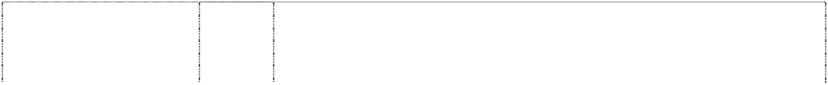

**HENRY THE OCTOPUS** (744659)

**HENRY THE OCTOPUS** (743838) **HENRY THE OCTOPUS** (743838)

**HENRY THE OCTOPUS** (608398) **HENRY THE OCTOPUS** (712746)

**HENRY THE OCTOPUS** (712746) **HENRY THE OCTOPUS** (712746)

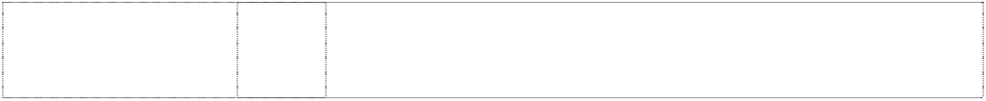**HENRY THE OCTOPUS** (743838)

9 Computer software, computer programmes, compact discs, cassettes, records, video tapes, CD Roms, spectacles, eyewear, sunglasses, spectacle cases, spectacle frames, binoculars, animated cartoons, films, juke boxes, kaleidoscopes, lifejackets, magnetic tapes, magnets, sound recording apparatuses, sound recording disks, sound recording, amplifying, reproducing and transmitting apparatuses, tapes, teaching apparatuses, television apparatuses, video recorders, video games, digital audio tapes and digital video tapes.

9 Abacuses, amusement machines, animated cartoons; anti-dazzle shades; anti-glare visors, apparatuses for editing cinematographic film, apparatus for games (adapted for use with TV receivers only), audio-visual teaching apparatuses (automatic and coin operated); automatic, mechanical and coin operated rides in this class; binoculars; cameras, cassette players, compact disc players, compasses, computer games, computer keyboards; computers; contact lenses; digital audiotapes, digital videotapes; divers' masks; eyeshades; eyewear; films (exposed); floating aids for bathing and swimming; integrated circuit chips, jukeboxes (musical), jukeboxes (for computers); kaleidoscopes, lanterns (magic); life belts, life jackets; life saving apparatuses and equipment; magnetic discs; magnetic tapes; magnets; magnifying glasses; microphones; microscopes; modems; pocket calculators; protective helmets; radios; recorded computer programmes; recording discs; rulers; safety restraints; spectacle cases, spectacle chains, spectacle cords, spectacle frames, spectacle glasses, sunglasses; swimming belts, swimming jackets; tape recorders; teaching apparatuses; telescopes; video game cartridges; video games; viewfinders (photographic).

11 Lamp shades.

14 Alarm clocks, bracelets, brooches, cases for clocks, cases for watches, chains, jewellery charms, tie clips, clocks, electric clocks and watches, liquid crystal display watches, moulded flip top liquid crystal display watches, quartz analogue watches, earrings, gold and silverware (other than cutlery, forks and spoons), hat ornaments of precious metal, household containers of precious metal, household utensils of precious metal, objects of imitation gold, jewellery, keyrings, cufflinks, medallions, necklaces, ornamental pins, ornaments, pins, tie pins, plated articles, rings, stopwatches, straps for wristwatches, trinkets, watchbands, watch chains, watch straps, watches and wrist watches.

16 All goods in class 16.

18 Bags, game bags, bags for campers, bags for climbers, bags for packaging, beach bags, belts in this class, briefcases, leather cases, pocket wallets, purses, chain metal purses (not of precious metal), collars for animals, covers for animals, handbags, haversacks, music cases, rucksacks, school satchels, school bags, shopping bags, sling bags for carrying infants, travelling bags, travelling trunks, umbrellas.

1. Playpens, sleeping bags, statuettes of wood, wax, plaster or plastic, tables, chairs, stools, furniture, trays (not of metal), desks.
2. Cups, mugs, bowls, plates, dinner sets, canteens, lunch boxes, tumblers, drinking containers, basins, bins, bottles, soap boxes, brushes, combs, crockery, soap dishes, dustbins, egg cups, drinking flasks, money boxes, tableware and toothbrushes, vinyl placemats.

21 Food containers of metal, household containers of metal, dishes of metal, egg cups of metal, jugs of metal, kitchen containers of metal, kitchen utensils of metal, bowls of metal, table plates of metal, trays of metal for household purposes.

**HENRY THE OCTOPUS** (743838)



**HENRY THE OCTOPUS** (608398)

**HENRY THE OCTOPUS** (743838) **HENRY THE OCTOPUS** (743838) **HENRY THE OCTOPUS** (608398)

**HENRY THE OCTOPUS** (746262)

**HENRY THE OCTOPUS** (746262)

1. Adhesive fabric for application by heat, banners, covers for bags filled with polystyrene beads, bed linen (except clothing), bed blankets, bed clothes, bed covers, bed covers of paper, bedspreads, blinds of textile, canvas for tapestry or embroidery, coasters made of table linen, cotton fabrics, coverlets for bedspreads, comforter sets, covers for cushions, covers for furniture, curtains of textile or plastic, down filled blankets, door curtains, eiderdowns, fabric, fabrics for textile use, facewashers, floor mats of terry towelling and textile material, friezes, loose covers for furniture, furniture coverings of plastic, furniture coverings of textile, gummed cloths other than for stationery, handkerchiefs of textile, handtowels, jersey, knitted fabric, cloth labels, diapered linen, household linen, linen cloth, lingerie fabric, placemats in this class, mattress covers, mattress protectors, pillow shams, pillow cases, plastic material (substitute for fabrics), blankets of textile, quilts, quilt covers, quilt cover sets, travelling rugs, table runners, serviettes of textile, rod pocket curtains, rugs, sheets, sleeping bags (sheeting), sunshades for affixing to windows, tablecloths (not of paper), table linen (textile), tablemats (not of paper), table napkins of textile, tapestry (wall hangings) of textile, towels, traced cloth for embroidery, upholstery fabrics, valances, velour bath towels, velour beach towels, velour towels, wall hangings of textile, woollen cloth, woollen fabric.
2. All goods in class 25 including T-shirts, baseball caps, pyjamas, sweatshirts, tracksuits, nightwear, babywear, bibs, (not of paper), underwear, socks, ties, bowties, scarves, handkerchiefs, knitwear, shoes, swimsuits, uniforms, sports apparel.
3. Badges for wear of metal, buckles of common metal for clothing.
4. Floor mats of textile, wool and nylon.
5. All goods in class 28 including toys, masks in this class, swimming pools being sports or play articles, surfboards, spinning tops, soft toys, dolls, games, board games, kites, puppets, balloons, bon bons, decorations in this class and dolls' houses.
6. Butter, chocolate nut butter, peanut butter, coconut, potato crisps, potato chips (hot), snack foods, crystallised fruits, dates, eggs, salted foods, frosted fruits, frozen fruits, preserved fruit, cooked fruit, dried fruit, fruit jellies, jelly, fruit peel, fruit pulp, fruit salads, stewed fruit, jams, vegetable juices, margarine, marmalade, broth, milk, milk products, cheese, yoghurt, nuts, raisins, salmon, soups, vegetable salads, cooked vegetables, dried vegetables, preserved vegetables, almonds, anchovy, beans, coconut butter, caviar, coconut oil, dessicated coconut, dairy products, edible oils, fish, food preserves, herbs, gelatine, gherkins, cream, ham, herrings, sardines, lentils, meat jellies, meat in this class, hamburger meats and patties, sausages, frankfurts in batter, frankfurts including frankfurts for hot dogs, mushrooms, mussels, olive oil, olives, preserved onions, sauerkraut, cooking oil, processed peanuts, peas, pickles, poultry, game, chicken and chicken products in this class, salads, sesame oil, suet, soya beans, sunflower oil, tuna, baked beans, whipped cream.

32 Orange juice, fruit juice.

**HENRY THE OCTOPUS** (745354)



# LITTLE WIGGLES

(1049799)

# LITTLE WIGGLES

(1049799)

# LITTLE WIGGLES

(1049799)

# LITTLE WIGGLES

(1049799)

# LITTLE WIGGLES

(1049799)

1. Biscuits, bread, buns, cakes, cake powder, breakfast cereal, chewing gum, chocolate, chocolate based beverages, confectionery, cookies, decorations for cakes (edible), edible ices, ginger, ice cream, liquorice, lozenges, meat pies, noodles, pizzas, popcorn and health bars in this class being cereal-based snack foods; spreads in this class for sandwiches, cornflakes, muesli, oat flakes, oat-based food, pasta, pasta in sauce, spaghetti, canned spaghetti in sauce, peanut confectionery, snack foods, puddings, rice, bread rolls, rusks, sherbet, almond confectionery, aniseed, barley, cocoa-based beverages, beverage flavourings, ice cream flavourings, candy, caramels, cereal preparations, spices, coffee, coffee substitutes, condiments, sauces, corn, farinaceous foods, flavourings, flour for food, gingerbread, glucose, golden syrup, gum, sweets, honey, ices, tomato sauce, macaroni, maize, malt, marzipan, mint, mustard, oatmeal, pancakes, pancake mix, pastries, pralines, ravioli, vermicelli, sago, sandwiches, seasonings, semolina, sugar, sugar confectionery, natural sweeteners, candy sweeteners, tapioca, tarts, tea, vanilla flavour, waffles, yeast, hamburgers in this class, hotdogs in this class.

3 Soaps, bath salts, cosmetics, cleaning preparations, creams, deodorants, detergents, perfume, make-up, bleach, lipsticks, nail polish, bubble bath, toothpaste, skin care preparations, creams, cologne, hair colorants, hair dyes, hair lotions, hair waving preparations, cosmetic kits, essential oils, shampoos, shoe polish, toiletries, sun tanning preparations in this class, sun screen in this class, sun screen lip balm in this class, talcum powder.

5 Food for babies and children, sticking plaster, bath salts, medicated candy and chewing gum, medicated confectionery, medicinal drinks, first aid boxes, medicated toothpaste, adhesive dressings, food preparations in this class, sunscreen and sunscreen lip balm in this class, absorbent cotton, adhesive bands for medical purposes, adhesive plaster, adhesive tapes for medical purposes, antiseptics, balms for medical purposes, bandages for dressings, therapeutic preparations for the bath, medicated bath preparations, bath salts for medical purposes, cod liver oil, deodorants in this class, dietetic foods in this class, medical dressings, surgical dressings, gauze for dressings, lip balms in this class, lotions for pharmaceutical purposes, oils in this class, pharmaceutical preparations for skincare, sponges, stick liquorice for pharmaceutical purposes, glucose, glucose drinks, sunburn ointments, sunburn preparations, tissues in this class, vitamins.

1. Cutlery, scissors, knives, forks, spoons, garden tools and spades; hanging knife, spoon and fork sets.
2. Computer software programs, compact discs, audio cassettes, phonograph records, digital video discs (DVD) and pre-recorded videotapes featuring entertainment for children, namely, music, stories, costumed characters and animation; pre-recorded audio and audio visual devices; pre-recorded multimedia publications; videotapes featuring animated cartoons; blank digital audio tapes and digital videotapes; computer and video game disks and cartridges; eyewear, namely, spectacles, eyeglasses, sunglasses and eyeglass frames; binoculars; juke boxes; lifejackets; audio recorders, video recorders; video games; sound amplifiers; audio tape cassette players, video cassette players, phonograph record players, compact disc players; radios; television sets; swim masks and diving masks.

12 Baby carriages, covers for baby carriages, hoods for baby carriages, safety seats for children for vehicles, safety seat covers for children for vehicles, safety belts for the seats and carriages for vehicles, pushchairs and strollers, pushchair covers and hoods, stroller covers and hoods, bicycles, bicycle saddles, bicycle brakes, bicycle chains, bicycle frames, bicycle handle bars, bicycle pumps, bicycle rims, bicycle spokes, bicycle stands, bicycle tyres, bells for bicycles, boats, cars, automobiles, horns for cars and automobiles, horns for tricycles and bicycles, seat covers for cars and automobiles, tricycles and sleeping berths for vehicles, rear-view mirrors.

# LITTLE WIGGLES



(1049799)

# LITTLE WIGGLES

(1049799)

# LITTLE WIGGLES

(1049799)

# LITTLE WIGGLES

(1049799)

# LITTLE WIGGLES

(1049799)

# LITTLE WIGGLES

(1049799)

14 Alarm clocks, bracelets, brooches, cases for clocks, cases for watches, chains, jewellery charms, tie clips, clocks, electric clocks and watches, liquid crystal display watches, moulded flip top liquid crystal display watches, quartz analogue watches, earrings, gold and silverware (other than cutlery, forks and spoons), hat ornaments of precious metal, household containers of precious metal, household utensils of precious metal, objects of imitation gold, jewellery, key rings, cufflinks, medallions, necklaces, ornamental pins, ornaments, pins, tie pins, plated articles, rings, stopwatches, straps for wristwatches, trinkets, watchbands, watch chains, watch straps, watches and wrist watches.

16 Stationery, cards, note cards and writing paper, paper partyware, bibs of paper, coasters, book markers, stickers, calendars, greeting cards, drawing pads, general feature magazines for children and magazines for adults dealing with children's issues, pen and pencil cases, pen holders, pencils, crayons, pens, pencil sharpeners, mounted and unmounted photographs, decorative mounted and unmounted pictures, stamps, stamp pads, stencils, paper napkins, books including, comic books, picture books, drawing books, music books, colouring books, sticker books, story books, squeaky books, pop up books, pull tab books, glow in the dark books, bath books, chunky board books, scrap books, activity books, paper coasters, paper, paper napkins, show bags, boards, manuals, brochures and teaching materials namely, textbooks for teaching reading, writing, mathematics, music, spelling, drama and magic tricks to children, charts, colour and count sets, activity packs, writing slates and posters.

18 Bags, game bags, bags for campers, bags for climbers, bags for packaging, beach bags, belts, briefcases, leather cases, pocket wallets, purses, chain metal purses (not of precious metal), collars for animals, covers for animals, handbags, haversacks, music cases, rucksacks, school satchels, school bags, shopping bags, sling bags for carrying infants, travelling bags, travelling trunks, umbrellas.

1. Playpens, sleeping bags, statuettes of wood, wax, plaster or plastic, tables, chairs, stools, furniture, trays (not of metal), desks.
2. Cups, mugs, bowls, plates, dinner sets, canteens, lunch boxes, tumblers, drinking containers, basins, bins, bottles, soap boxes, brushes, combs, crockery, soap dishes, dustbins, egg cups, drinking flasks, money boxes, tableware and toothbrushes, food containers of metal, household containers of metal, dishes of metal, egg cups of metal, jugs of metal, kitchen containers of metal, kitchen utensils of metal, bowls of metal, table plates of metal, trays of metal for household purposes.
3. Adhesive fabric for application by heat, banners, covers for bags filled with polystyrene beads, bed linen (except clothing), bed blankets, bed clothes, bed covers, bed covers of paper, bedspreads, blinds of textile, canvas for tapestry or embroidery, coasters made of table linen, cotton fabrics, coverlets for bedspreads, comforter sets, covers for cushions, covers for furniture, curtains of textile or plastic, down filled blankets, door curtains, eiderdowns, fabric, fabrics for textile use, face washers, friezes, loose covers for furniture, furniture coverings of plastic, furniture coverings of textile, gummed cloths other than for stationery, handkerchiefs of textile, handtowels, jersey, knitted fabric, cloth labels, diapered linen, household linen, linen cloth, lingerie fabric, placemats in this class including plastic and vinyl placemats, mattress covers, mattress protectors, pillow shams, pillow cases, plastic material (substitute for fabrics), blankets of textile, quilts, quilt covers, quilt cover sets, travelling rugs, table runners, serviettes of textile, rod pocket curtains, rugs, sheets, sleeping bags (sheeting), sunshades for affixing to windows, tablecloths (not of paper), table linen (textile), tablemats (not of paper), table napkins of textile, tapestry (wall hangings) of textile, towels, traced cloth for embroidery, upholstery fabrics, valances, velour bath towels, velour beach towels, velour towels, wall hangings of textile, woollen cloth, woollen fabric.

# LITTLE WIGGLES

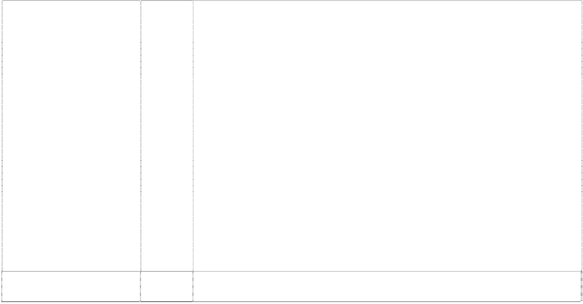

(1049799)

# LITTLE WIGGLES

(1049799)

# LITTLE WIGGLES

(1049799)

# LITTLE WIGGLES

(1049799)

# LITTLE WIGGLES

(1049799)

# LITTLE WIGGLES

(1049799)

# LITTLE WIGGLES

(1049799)

1. Clothing, headgear, T-shirts, baseball caps, pyjamas, sweatshirts, tracksuits, sleepwear, babywear, babies' pants, babies' caps, babies' hats, babies' suits, babies' T-shirts, mess shirts, babies' long sleeve T-shirts, babies' overalls, babies' pullovers, bonnets, bibs, socks, tights, booties, blankets, cloth bibs, underwear, briefs, singlets, crop top sets, boxer shorts, ties, bow ties, scarves, swimsuits, beach wear, uniforms, sports apparel, shorts, wind-resistant jackets, jerseys, pants and leotards, aprons, bathing suits, shoes, footwear, slippers, waterproof clothing, coats, boots, jackets, ponchos and rain hats, beanies, hats, character costumes, shirts, trousers, dresses, skirts, sweaters, pullovers, cardigans, bath robes, gloves, headbands, belts, waistcoats, ties, children's co-ordinates.
2. Badges for wear of metal, buckles of common metal for clothing.
3. Floor mats of textile, wool and nylon; wallpaper; friezes (non-textile); floor mats of terry towelling.
4. Toys, playthings, games, gymnastic and sporting articles not included in other classes, surf boards, spinning tops, action skill games, card games, manipulative games, board games, kites, balls, puppets, balloons, Christmas tree decorations, dolls' houses, computer games, puzzles, jigsaw puzzles, skateboards, inflatable toys, inflatable furniture, inflatable chairs, inflatable tables, inflatable mascots, inflatable balls, inflatable cars, dolls, plush toys, soft toys, finger puppets, toy microphones, toy drum kits, toy cymbals, toy guitars (electronic and non-electronic), tambourines, toy electronic keyboards, musical instruments, toy money banks, cars, car parts; swimming pools being play or sport articles, decorations in this class; kaleidoscopes; playing cards; paper hats; paper party favours, paper whistles and noise makers in the nature of Christmas crackers.
5. Butter, chocolate nut butter, peanut butter, coconut, potato crisps, potato chips, snack foods, crystallized fruits, dates, eggs, salted foods, frosted fruits, frozen fruits, preserved fruit, cooked fruit, dried fruit, fruit jellies, jelly, fruit peel, fruit pulp, fruit salads, stewed fruit, jams, vegetable juices, margarine, marmalade, broth, milk, milk products, cheese, yoghurt, whipped cream, nuts, raisins, salmon, soups, vegetable salads, cooked vegetables, dried vegetables, preserved vegetables, almonds, anchovy, beans, coconut butter, caviar, coconut oil, desiccated coconut, dairy products, edible oils, eggs, fish, food preserves, herbs, gelatine, gherkins, cream, ham, herrings, sardines, lentils, meat jellies, mushrooms, mussels, olive oil, olives, preserved onions, oil, processed peanuts, peas, pickles, poultry, raisins, salads, salmon, sesame oil, soup, suet, soya beans, sunflower oil, tomato juice, fruit juice, tuna, vegetable juices, baked beans.
6. Biscuits, bread, buns, cakes, cake powder, breakfast cereal, chewing gum, chocolate, chocolate based beverages, confectionery, cookies, decorations for cakes (edible), edible ices, ginger, ice cream, liquorice, lozenges, meat pies, noodles, pastries, sweets, pizzas, popcorn and health bars in this class being cereal-based snack foods; spreads in this class for sandwiches, cornflakes, muesli, oat flakes, oat-based food, pasta, pasta in sauce, spaghetti, canned spaghetti in sauce, peanut confectionery, snack foods, puddings, rice, bread rolls, rusks, sherbet, almond confectionery, aniseed, barley, cocoa-based beverages, beverage flavourings, ice cream flavourings, candy, caramels, cereal preparations, spices, coffee, coffee substitutes, condiments, sauces, corn, farinaceous foods, flavourings, flour for food, gingerbread, glucose, golden syrup, gum, sweets, honey, ices, tomato sauce, macaroni, maize, malt, marzipan, mint, mustard, oatmeal, pancakes, pancake mix, pastries, pralines, ravioli, vermicelli, sago, sandwiches, seasonings, semolina, sugar, sugar confectionery, natural sweeteners, candy sweeteners, tapioca, tarts, tea, vanilla flavour, waffles, yeast.
7. Fresh fruits and vegetables.

# LITTLE WIGGLES



(1049799)

**THE LITTLE WIGGLES** (1049772)

**THE LITTLE WIGGLES** (1049772)

**THE LITTLE WIGGLES** (1049772) **THE LITTLE WIGGLES** (1049772)

**THE LITTLE WIGGLES** (1049772)

**THE LITTLE WIGGLES** (1049772)

1. Aerated water, non alcoholic beverages, fruit juices, ginger beer, lemonades, mineral water, effervescing beverages, preparations for making beverages, sherbets (beverages), soft drinks, syrups for beverages, syrups for lemonades, waters (beverages).

3 Soaps, bath salts, cosmetics, cleaning preparations, creams, deodorants, detergents, perfume, make-up, bleach, lipsticks, nail polish, bubble bath, toothpaste, skin care preparations, creams, cologne, hair colorants, hair dyes, hair lotions, hair waving preparations, cosmetic kits, essential oils, shampoos, shoe polish, toiletries, sun tanning preparations in this class, sun screen in this class, sun screen lip balm in this class, talcum powder.

5 Food for babies and children, sticking plaster, bath salts, medicated candy and chewing gum, medicated confectionery, medicinal drinks, first aid boxes, medicated toothpaste, adhesive dressings, food preparations in this class, sunscreen and sunscreen lip balm in this class, absorbent cotton, adhesive bands for medical purposes, adhesive plaster, adhesive tapes for medical purposes, antiseptics, balms for medical purposes, bandages for dressings, therapeutic preparations for the bath, medicated bath preparations, bath salts for medical purposes, cod liver oil, deodorants in this class, dietetic foods in this class, medical dressings, surgical dressings, gauze for dressings, lip balms in this class, lotions for pharmaceutical purposes, oils in this class, pharmaceutical preparations for skincare, sponges, stick liquorice for pharmaceutical purposes, glucose, glucose drinks, sunburn ointments, sunburn preparations, tissues in this class, vitamins.

1. Cutlery, scissors, knives, forks, spoons, garden tools and spades; hanging knife, spoon and fork sets.
2. Computer software programs, compact discs, audio cassettes, phonograph records, digital video discs (DVD) and pre-recorded videotapes featuring entertainment for children, namely, music, stories, costumed characters and animation; pre-recorded audio and audio visual devices; pre-recorded multimedia publications; videotapes featuring animated cartoons; blank digital audio tapes and digital videotapes; computer and video game disks and cartridges; eyewear, namely, spectacles, eyeglasses, sunglasses and eyeglass frames; binoculars; juke boxes; lifejackets; audio recorders, video recorders; video games; sound amplifiers; audio tape cassette players, video cassette players, phonograph record players, compact disc players; radios; television sets; swim masks and diving masks.

12 Baby carriages, covers for baby carriages, hoods for baby carriages, safety seats for children for vehicles, safety seat covers for children for vehicles, safety belts for the seats and carriages for vehicles, pushchairs and strollers, pushchair covers and hoods, stroller covers and hoods, bicycles, bicycle saddles, bicycle brakes, bicycle chains, bicycle frames, bicycle handle bars, bicycle pumps, bicycle rims, bicycle spokes, bicycle stands, bicycle tyres, bells for bicycles, boats, cars, automobiles, horns for cars and automobiles, horns for tricycles and bicycles, seat covers for cars and automobiles, tricycles and sleeping berths for vehicles, rear-view mirrors.

14 Alarm clocks, bracelets, brooches, cases for clocks, cases for watches, chains, jewellery charms, tie clips, clocks, electric clocks and watches, liquid crystal display watches, moulded flip top liquid crystal display watches, quartz analogue watches, earrings, gold and silverware (other than cutlery, forks and spoons), hat ornaments of precious metal, household containers of precious metal, household utensils of precious metal, objects of imitation gold, jewellery, key rings, cufflinks, medallions, necklaces, ornamental pins, ornaments, pins, tie pins, plated articles, rings, stopwatches, straps for wristwatches, trinkets, watchbands, watch chains, watch straps, watches and wrist watches.

**THE LITTLE WIGGLES** (1049772)



**THE LITTLE WIGGLES** (1049772)

**THE LITTLE WIGGLES** (1049772) **THE LITTLE WIGGLES** (1049772)

**THE LITTLE WIGGLES** (1049772)

16 Stationery, cards, note cards and writing paper, paper partyware, bibs of paper, coasters, book markers, stickers, calendars, greeting cards, drawing pads, general feature magazines for children and magazines for adults dealing with children's issues, pen and pencil cases, pen holders, pencils, crayons, pens, pencil sharpeners, mounted and unmounted photographs, decorative mounted and unmounted pictures, stamps, stamp pads, stencils, paper napkins, books including, comic books, picture books, drawing books, music books, colouring books, sticker books, story books, squeaky books, pop up books, pull tab books, glow in the dark books, bath books, chunky board books, scrap books, activity books, paper coasters, paper, paper napkins, show bags, boards, manuals, brochures and teaching materials namely, textbooks for teaching reading, writing, mathematics, music, spelling, drama and magic tricks to children, charts, colour and count sets, activity packs, writing slates and posters.

18 Bags, game bags, bags for campers, bags for climbers, bags for packaging, beach bags, belts, briefcases, leather cases, pocket wallets, purses, chain metal purses (not of precious metal), collars for animals, covers for animals, handbags, haversacks, music cases, rucksacks, school satchels, school bags, shopping bags, sling bags for carrying infants, travelling bags, travelling trunks, umbrellas.

1. Playpens, sleeping bags, statuettes of wood, wax, plaster or plastic, tables, chairs, stools, furniture, trays (not of metal), desks.
2. Cups, mugs, bowls, plates, dinner sets, canteens, lunch boxes, tumblers, drinking containers, basins, bins, bottles, soap boxes, brushes, combs, crockery, soap dishes, dustbins, egg cups, drinking flasks, money boxes, tableware and toothbrushes, food containers of metal, household containers of metal, dishes of metal, egg cups of metal, jugs of metal, kitchen containers of metal, kitchen utensils of metal, bowls of metal, table plates of metal, trays of metal for household purposes.
3. Adhesive fabric for application by heat, banners, covers for bags filled with polystyrene beads, bed linen (except clothing), bed blankets, bed clothes, bed covers, bed covers of paper, bedspreads, blinds of textile, canvas for tapestry or embroidery, coasters made of table linen, cotton fabrics, coverlets for bedspreads, comforter sets, covers for cushions, covers for furniture, curtains of textile or plastic, down filled blankets, door curtains, eiderdowns, fabric, fabrics for textile use, face washers, friezes, loose covers for furniture, furniture coverings of plastic, furniture coverings of textile, gummed cloths other than for stationery, handkerchiefs of textile, handtowels, jersey, knitted fabric, cloth labels, diapered linen, household linen, linen cloth, lingerie fabric, placemats in this class including plastic and vinyl placemats, mattress covers, mattress protectors, pillow shams, pillow cases, plastic material (substitute for fabrics), blankets of textile, quilts, quilt covers, quilt cover sets, travelling rugs, table runners, serviettes of textile, rod pocket curtains, rugs, sheets, sleeping bags (sheeting), sunshades for affixing to windows, tablecloths (not of paper), table linen (textile), tablemats (not of paper), table napkins of textile, tapestry (wall hangings) of textile, towels, traced cloth for embroidery, upholstery fabrics, valances, velour bath towels, velour beach towels, velour towels, wall hangings of textile, woollen cloth, woollen fabric.

**THE LITTLE WIGGLES** (1049772)



**THE LITTLE WIGGLES** (1049772) **THE LITTLE WIGGLES** (1049772) **THE LITTLE WIGGLES** (1049772)

**THE LITTLE WIGGLES** (1049772)

**THE LITTLE WIGGLES** (1049772)

1. Clothing, headgear, T-shirts, baseball caps, pyjamas, sweatshirts, tracksuits, sleepwear, babywear, babies' pants, babies' caps, babies' hats, babies' suits, babies' T-shirts, mess shirts, babies' long sleeve T-shirts, babies' overalls, babies' pullovers, bonnets, bibs, socks, tights, booties, blankets, cloth bibs, underwear, briefs, singlets, crop top sets, boxer shorts, ties, bow ties, scarves, swimsuits, beach wear, uniforms, sports apparel, shorts, wind-resistant jackets, jerseys, pants and leotards, aprons, bathing suits, shoes, footwear, slippers, waterproof clothing, coats, boots, jackets, ponchos and rain hats, beanies, hats, character costumes, shirts, trousers, dresses, skirts, sweaters, pullovers, cardigans, bath robes, gloves, headbands, belts, waistcoats, ties, children's co-ordinates.
2. Badges for wear of metal, buckles of common metal for clothing.
3. Floor mats of textile, wool and nylon; wallpaper; friezes (non-textile); floor mats of terry towelling.
4. Toys, playthings, games, gymnastic and sporting articles not included in other classes, surf boards, spinning tops, action skill games, card games, manipulative games, board games, kites, balls, puppets, balloons, Christmas tree decorations, dolls' houses, computer games, puzzles, jigsaw puzzles, skateboards, inflatable toys, inflatable furniture, inflatable chairs, inflatable tables, inflatable mascots, inflatable balls, inflatable cars, dolls, plush toys, soft toys, finger puppets, toy microphones, toy drum kits, toy cymbals, toy guitars (electronic and non-electronic), tambourines, toy electronic keyboards, musical instruments, toy money banks, cars, car parts; swimming pools being play or sport articles, decorations in this class; kaleidoscopes; playing cards; paper hats; paper party favours, paper whistles and noise makers in the nature of Christmas crackers.
5. Butter, chocolate nut butter, peanut butter, coconut, potato crisps, potato chips, snack foods, crystallized fruits, dates, eggs, salted foods, frosted fruits, frozen fruits, preserved fruit, cooked fruit, dried fruit, fruit jellies, jelly, fruit peel, fruit pulp, fruit salads, stewed fruit, jams, vegetable juices, margarine, marmalade, broth, milk, milk products, cheese, yoghurt, whipped cream, nuts, raisins, salmon, soups, vegetable salads, cooked vegetables, dried vegetables, preserved vegetables, almonds, anchovy, beans, coconut butter, caviar, coconut oil, desiccated coconut, dairy products, edible oils, eggs, fish, food preserves, herbs, gelatine, gherkins, cream, ham, herrings, sardines, lentils, meat jellies, mushrooms, mussels, olive oil, olives, preserved onions, oil, processed peanuts, peas, pickles, poultry, raisins, salads, salmon, sesame oil, soup, suet, soya beans, sunflower oil, tomato juice, fruit juice, tuna, vegetable juices, baked beans.
6. Biscuits, bread, buns, cakes, cake powder, breakfast cereal, chewing gum, chocolate, chocolate based beverages, confectionery, cookies, decorations for cakes (edible), edible ices, ginger, ice cream, liquorice, lozenges, meat pies, noodles, pastries, sweets, pizzas, popcorn and health bars in this class being cereal-based snack foods; spreads in this class for sandwiches, cornflakes, muesli, oat flakes, oat-based food, pasta, pasta in sauce, spaghetti, canned spaghetti in sauce, peanut confectionery, snack foods, puddings, rice, bread rolls, rusks, sherbet, almond confectionery, aniseed, barley, cocoa-based beverages, beverage flavourings, ice cream flavourings, candy, caramels, cereal preparations, spices, coffee, coffee substitutes, condiments, sauces, corn, farinaceous foods, flavourings, flour for food, gingerbread, glucose, golden syrup, gum, sweets, honey, ices, tomato sauce, macaroni, maize, malt, marzipan, mint, mustard, oatmeal, pancakes, pancake mix, pastries, pralines, ravioli, vermicelli, sago, sandwiches, seasonings, semolina, sugar, sugar confectionery, natural sweeteners, candy sweeteners, tapioca, tarts, tea, vanilla flavour, waffles, yeast.

**THE LITTLE WIGGLES** (1049772) **THE LITTLE WIGGLES** (1049772)



# THE LITTLE WIGGLES

words in blot (1054632)

# THE LITTLE WIGGLES

words in blot (1054632)

# THE LITTLE WIGGLES

words in blot (1054632) **THE LITTLE WIGGLES**

words in blot (1054632)

# THE LITTLE WIGGLES

words in blot (1054632)

1. Fresh fruits and vegetables.
2. Aerated water, non alcoholic beverages, fruit juices, ginger beer, lemonades, mineral water, effervescing beverages, preparations for making beverages, sherbets (beverages), soft drinks, syrups for beverages, syrups for lemonades, waters (beverages).

3 Soaps, bath salts, cosmetics, cleaning preparations, creams, deodorants, detergents, perfume, make-up, bleach, lipsticks, nail polish, bubble bath, toothpaste, skin care preparations, creams, cologne, hair colorants, hair dyes, hair lotions, hair waving preparations, cosmetic kits, essential oils, shampoos, shoe polish, toiletries, sun tanning preparations in this class, sun screen in this class, sun screen lip balm in this class, talcum powder.

5 Food for babies and children, sticking plaster, bath salts, medicated candy and chewing gum, medicated confectionery, medicinal drinks, first aid boxes, medicated toothpaste, adhesive dressings, food preparations in this class, sunscreen and sunscreen lip balm in this class, absorbent cotton, adhesive bands for medical purposes, adhesive plaster, adhesive tapes for medical purposes, antiseptics, balms for medical purposes, bandages for dressings, therapeutic preparations for the bath, medicated bath preparations, bath salts for medical purposes, cod liver oil, deodorants in this class, dietetic foods in this class, medical dressings, surgical dressings, gauze for dressings, lip balms in this class, lotions for pharmaceutical purposes, oils in this class, pharmaceutical preparations for skincare, sponges, stick liquorice for pharmaceutical purposes, glucose, glucose drinks, sunburn ointments, sunburn preparations, tissues in this class, vitamins.

1. Cutlery, scissors, knives, forks, spoons, garden tools and spades; hanging knife, spoon and fork sets.
2. Computer software programs, compact discs, audio cassettes, phonograph records, digital video discs (DVD) and pre-recorded videotapes featuring entertainment for children, namely, music, stories, costumed characters and animation; pre-recorded audio and audio visual devices; pre-recorded multimedia publications; videotapes featuring animated cartoons; blank digital audio tapes and digital videotapes; computer and video game disks and cartridges; eyewear, namely, spectacles, eyeglasses, sunglasses and eyeglass frames; binoculars; juke boxes; lifejackets; audio recorders, video recorders; video games; sound amplifiers; audio tape cassette players, video cassette players, phonograph record players, compact disc players; radios; television sets; swim masks and diving masks.

12 Baby carriages, covers for baby carriages, hoods for baby carriages, safety seats for children for vehicles, safety seat covers for children for vehicles, safety belts for the seats and carriages for vehicles, pushchairs and strollers, pushchair covers and hoods, stroller covers and hoods, bicycles, bicycle saddles, bicycle brakes, bicycle chains, bicycle frames, bicycle handle bars, bicycle pumps, bicycle rims, bicycle spokes, bicycle stands, bicycle tyres, bells for bicycles, boats, cars, automobiles, horns for cars and automobiles, horns for tricycles and bicycles, seat covers for cars and automobiles, tricycles and sleeping berths for vehicles, rear-view mirrors.

# THE LITTLE WIGGLES

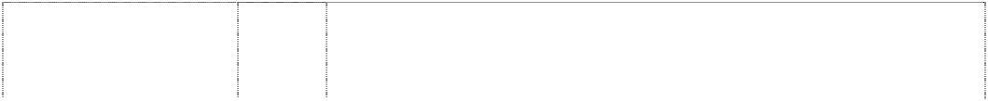

words in blot (1054632)

# THE LITTLE WIGGLES

words in blot (1054632)

# THE LITTLE WIGGLES

words in blot (1054632)

# THE LITTLE WIGGLES

words in blot (1054632) **THE LITTLE WIGGLES**

words in blot (1054632)

14 Alarm clocks, bracelets, brooches, cases for clocks, cases for watches, chains, jewellery charms, tie clips, clocks, electric clocks and watches, liquid crystal display watches, moulded flip top liquid crystal display watches, quartz analogue watches, earrings, gold and silverware (other than cutlery, forks and spoons), hat ornaments of precious metal, household containers of precious metal, household utensils of precious metal, objects of imitation gold, jewellery, key rings, cufflinks, medallions, necklaces, ornamental pins, ornaments, pins, tie pins, plated articles, rings, stopwatches, straps for wristwatches, trinkets, watchbands, watch chains, watch straps, watches and wrist watches.

16 Stationery, cards, note cards and writing paper, paper partyware, bibs of paper, coasters, book markers, stickers, calendars, greeting cards, drawing pads, general feature magazines for children and magazines for adults dealing with children's issues, pen and pencil cases, pen holders, pencils, crayons, pens, pencil sharpeners, mounted and unmounted photographs, decorative mounted and unmounted pictures, stamps, stamp pads, stencils, paper napkins, books including, comic books, picture books, drawing books, music books, colouring books, sticker books, story books, squeaky books, pop up books, pull tab books, glow in the dark books, bath books, chunky board books, scrap books, activity books, paper coasters, paper, paper napkins, show bags, boards, manuals, brochures and teaching materials namely, textbooks for teaching reading, writing, mathematics, music, spelling, drama and magic tricks to children, charts, colour and count sets, activity packs, writing slates and posters.

18 Bags, game bags, bags for campers, bags for climbers, bags for packaging, beach bags, belts, briefcases, leather cases, pocket wallets, purses, chain metal purses (not of precious metal), collars for animals, covers for animals, handbags, haversacks, music cases, rucksacks, school satchels, school bags, shopping bags, sling bags for carrying infants, travelling bags, travelling trunks, umbrellas.

1. Playpens, sleeping bags, statuettes of wood, wax, plaster or plastic, tables, chairs, stools, furniture, trays (not of metal), desks.
2. Cups, mugs, bowls, plates, dinner sets, canteens, lunch boxes, tumblers, drinking containers, basins, bins, bottles, soap boxes, brushes, combs, crockery, soap dishes, dustbins, egg cups, drinking flasks, money boxes, tableware and toothbrushes, food containers of metal, household containers of metal, dishes of metal, egg cups of metal, jugs of metal, kitchen containers of metal, kitchen utensils of metal, bowls of metal, table plates of metal, trays of metal for household purposes.

# THE LITTLE WIGGLES



words in blot (1054632)

# THE LITTLE WIGGLES

words in blot (1054632)

# THE LITTLE WIGGLES

words in blot (1054632) **THE LITTLE WIGGLES**

words in blot (1054632) **THE LITTLE WIGGLES**

words in blot (1054632)

1. Adhesive fabric for application by heat, banners, covers for bags filled with polystyrene beads, bed linen (except clothing), bed blankets, bed clothes, bed covers, bed covers of paper, bedspreads, blinds of textile, canvas for tapestry or embroidery, coasters made of table linen, cotton fabrics, coverlets for bedspreads, comforter sets, covers for cushions, covers for furniture, curtains of textile or plastic, down filled blankets, door curtains, eiderdowns, fabric, fabrics for textile use, face washers, friezes, loose covers for furniture, furniture coverings of plastic, furniture coverings of textile, gummed cloths other than for stationery, handkerchiefs of textile, handtowels, jersey, knitted fabric, cloth labels, diapered linen, household linen, linen cloth, lingerie fabric, placemats in this class including plastic and vinyl placemats, mattress covers, mattress protectors, pillow shams, pillow cases, plastic material (substitute for fabrics), blankets of textile, quilts, quilt covers, quilt cover sets, travelling rugs, table runners, serviettes of textile, rod pocket curtains, rugs, sheets, sleeping bags (sheeting), sunshades for affixing to windows, tablecloths (not of paper), table linen (textile), tablemats (not of paper), table napkins of textile, tapestry (wall hangings) of textile, towels, traced cloth for embroidery, upholstery fabrics, valances, velour bath towels, velour beach towels, velour towels, wall hangings of textile, woollen cloth, woollen fabric.
2. Clothing, headgear, T-shirts, baseball caps, pyjamas, sweatshirts, tracksuits, sleepwear, babywear, babies' pants, babies' caps, babies' hats, babies' suits, babies' T-shirts, mess shirts, babies' long sleeve T-shirts, babies' overalls, babies' pullovers, bonnets, bibs, socks, tights, booties, blankets, cloth bibs, underwear, briefs, singlets, crop top sets, boxer shorts, ties, bow ties, scarves, swimsuits, beach wear, uniforms, sports apparel, shorts, wind-resistant jackets, jerseys, pants and leotards, aprons, bathing suits, shoes, footwear, slippers, waterproof clothing, coats, boots, jackets, ponchos and rain hats, beanies, hats, character costumes, shirts, trousers, dresses, skirts, sweaters, pullovers, cardigans, bath robes, gloves, headbands, belts, waistcoats, ties, children's co-ordinates.
3. Badges for wear of metal, buckles of common metal for clothing.
4. Floor mats of textile, wool and nylon; wallpaper; friezes (non-textile); floor mats of terry towelling.
5. Toys, playthings, games, gymnastic and sporting articles not included in other classes, surf boards, spinning tops, action skill games, card games, manipulative games, board games, kites, balls, puppets, balloons, Christmas tree decorations, dolls' houses, computer games, puzzles, jigsaw puzzles, skateboards, inflatable toys, inflatable furniture, inflatable chairs, inflatable tables, inflatable mascots, inflatable balls, inflatable cars, dolls, plush toys, soft toys, finger puppets, toy microphones, toy drum kits, toy cymbals, toy guitars (electronic and non-electronic), tambourines, toy electronic keyboards, musical instruments, toy money banks, cars, car parts; swimming pools being play or sport articles, decorations in this class; kaleidoscopes; playing cards; paper hats; paper party favours, paper whistles and noise makers in the nature of Christmas crackers.

# THE LITTLE WIGGLES

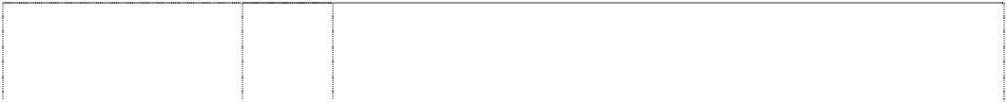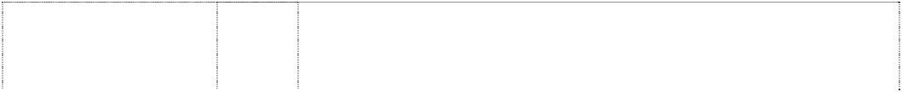

words in blot (1054632)

# THE LITTLE WIGGLES

words in blot (1054632)

# THE LITTLE WIGGLES

words in blot (1054632) **THE LITTLE WIGGLES**

words in blot (1054632)

# THE WIGGLES

(676235)

# THE WIGGLES

(720128)

# THE WIGGLES

(720128)

# THE WIGGLES

(741552)

1. Butter, chocolate nut butter, peanut butter, coconut, potato crisps, potato chips, snack foods, crystallized fruits, dates, eggs, salted foods, frosted fruits, frozen fruits, preserved fruit, cooked fruit, dried fruit, fruit jellies, jelly, fruit peel, fruit pulp, fruit salads, stewed fruit, jams, vegetable juices, margarine, marmalade, broth, milk, milk products, cheese, yoghurt, whipped cream, nuts, raisins, salmon, soups, vegetable salads, cooked vegetables, dried vegetables, preserved vegetables, almonds, anchovy, beans, coconut butter, caviar, coconut oil, desiccated coconut, dairy products, edible oils, eggs, fish, food preserves, herbs, gelatine, gherkins, cream, ham, herrings, sardines, lentils, meat jellies, mushrooms, mussels, olive oil, olives, preserved onions, oil, processed peanuts, peas, pickles, poultry, raisins, salads, salmon, sesame oil, soup, suet, soya beans, sunflower oil, tomato juice, fruit juice, tuna, vegetable juices, baked beans.
2. Biscuits, bread, buns, cakes, cake powder, breakfast cereal, chewing gum, chocolate, chocolate based beverages, confectionery, cookies, decorations for cakes (edible), edible ices, ginger, ice cream, liquorice, lozenges, meat pies, noodles, pastries, sweets, pizzas, popcorn and health bars in this class being cereal-based snack foods; spreads in this class for sandwiches, cornflakes, muesli, oat flakes, oat-based food, pasta, pasta in sauce, spaghetti, canned spaghetti in sauce, peanut confectionery, snack foods, puddings, rice, bread rolls, rusks, sherbet, almond confectionery, aniseed, barley, cocoa-based beverages, beverage flavourings, ice cream flavourings, candy, caramels, cereal preparations, spices, coffee, coffee substitutes, condiments, sauces, corn, farinaceous foods, flavourings, flour for food, gingerbread, glucose, golden syrup, gum, sweets, honey, ices, tomato sauce, macaroni, maize, malt, marzipan, mint, mustard, oatmeal, pancakes, pancake mix, pastries, pralines, ravioli, vermicelli, sago, sandwiches, seasonings, semolina, sugar, sugar confectionery, natural sweeteners, candy sweeteners, tapioca, tarts, tea, vanilla flavour, waffles, yeast.
3. Fresh fruits and vegetables.
4. Aerated water, non alcoholic beverages, fruit juices, ginger beer, lemonades, mineral water, effervescing beverages, preparations for making beverages, sherbets (beverages), soft drinks, syrups for beverages, syrups for lemonades, waters (beverages).

3 Bath salts, bubble bath, skin care preparations, cosmetics, creams, deodorants, cologne, hair colourants, hair dyes, hair lotions, hair waving preparations, lipsticks, make-up, cosmetic kits, nail polish, essential oils, perfume, shampoos, shoe polish, soaps, toiletries, sun tanning preparations in this class, sun screen in this class, sun screen lip balm in this class, talcum powder; all the aforesaid being primarily for children.

3 Soaps, bath salts, oils, cosmetics, cleaning preparations, creams, deodorants, detergents, perfume, make-up, bleach, lipsticks, nail polish, bubble bath and toothpaste.

5 Food for babies and children, sticking plaster, bath salts, medicated candy, chewing gum, medicated confectionery, medicinal drinks, first aid boxes, medicated toothpaste, adhesive dressings and food preparations in this class.

5 Sunscreen, sunscreen lip balm, absorbent cotton, adhesive bands for medical purposes, adhesive plaster, adhesive tapes for medical purposes, antiseptics, balms for medical purposes, bandages for dressings, therapeutic preparations for the bath, medicated bath preparations, bath salts for medical purposes, cod liver oil, deodorants in this class, dietetic foods in this class, medical dressings, surgical dressings, gauze for dressings, lip balms, lotions for pharmaceutical purposes, oils in this class, pharmaceutical preparations for skincare, sponges, stick liquorice for pharmaceutical purposes, sticking plasters, glucose drinks, sunburn ointments, sunburn preparations, tissues, vitamins.

# THE WIGGLES

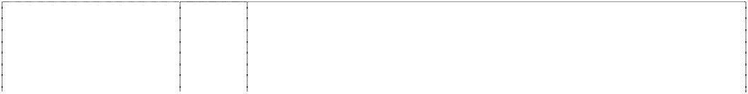

(712749)

# THE WIGGLES

(666653)

# THE WIGGLES

(744656)

# THE WIGGLES

(743837)

# THE WIGGLES

(737342)

# THE WIGGLES

(743837)

# THE WIGGLES

(608390)

# THE WIGGLES

(712749)

# THE WIGGLES

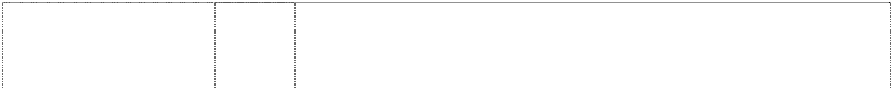(712749)

# THE WIGGLES

(712749)

1. Cutlery, scissors, knives, forks, spoons, garden tools and spades, hanging knife, spoon and fork set.
2. Computer software, computer programmes, compact discs, cassettes, records, video tapes and compact discs read only memory, teaching apparatus and instruments, apparatus for recording, transmission or reproduction of sound or images, magnetic data carriers and recording discs.

9 Abacuses, amusement machines, animated cartoons; anti-dazzle shades; anti-glare visors, apparatuses for editing cinematographic film, apparatus for games (adapted for use with TV receivers only), audio-visual teaching apparatuses (automatic and coin operated); automatic, mechanical and coin operated rides in this class; binoculars; cameras, cassette players, compact disc players, compasses, computer games, computer keyboards; computers; contact lenses; digital audiotapes, digital videotapes; divers' masks; eyeshades; eyewear; films (exposed); floating aids for bathing and swimming; integrated circuit chips, jukeboxes (musical), jukeboxes (for computers); kaleidoscopes, lanterns (magic); life belts, life jackets; life saving apparatuses and equipment; magnetic discs; magnetic tapes; magnets; magnifying glasses; microphones; microscopes; modems; pocket calculators; protective helmets; radios; recorded computer programmes; recording discs; rulers; safety restraints; spectacle cases, spectacle chains, spectacle cords, spectacle frames, spectacle glasses, sunglasses; swimming belts, swimming jackets; tape recorders; teaching apparatuses; telescopes; video game cartridges; video games; viewfinders (photographic).

1. Lamp shades.
2. Baby carriages, covers for baby carriages, hoods for baby carriages, safety seats for children for vehicles, safety seat covers for children for vehicles, safety belts for the seats and carriages for vehicles, pushchairs and strollers, pushchair covers and hoods, stroller covers and hoods, bicycles, bicycle saddles, bicycle brakes, bicycle chains, bicycle frames, bicycle handle bars, bicycle pumps, bicycle rims, bicycle spokes, bicycle stands, bicycle tyres, bells for bicycles, boats, cars, automobiles, horns for cars and automobiles, horns for tricycles and bicycles, seat covers for cars and automobiles, tricycles and sleeping berths for vehicles, rearview mirrors.

14 Alarm clocks, bracelets, brooches, cases for clocks, cases for watches, chains, jewellery charms, tie clips, clocks, electric clocks and watches, liquid crystal display watches, moulded flip top liquid crystal display watches, quartz analogue watches, earrings, gold and silverware (other than cutlery, forks and spoons), hat ornaments of precious metal, household containers of precious metal, household utensils of precious metal, objects of imitation gold, jewellery, keyrings, cufflinks, medallions, necklaces, ornamental pins, ornaments, pins, tie pins, plated articles, rings, stopwatches, straps for wristwatches, trinkets, watchbands, watch chains, watch straps, watches and wrist watches.

16 All goods in class 16.

18 Bags, game bags, bags for campers, bags for climbers, bags for packaging, beach bags, belts in this class, briefcases, leather cases, pocket wallets, purses, chain metal purses (not of precious metal), collars for animals, covers for animals, handbags, haversacks, music cases, rucksacks, school satchels, school bags, shopping bags, sling bags for carrying infants, travelling bags, travelling trunks, umbrellas.

1. Playpens, sleeping bags, statuettes of wood, wax, plaster or plastic, tables, chairs, stools, furniture, trays (not of metal), desks.
2. Cups, mugs, bowls, plates, dinner sets, canteens, lunch boxes, tumblers, drinking containers, basins, bins, bottles, soap boxes, brushes, combs, crockery, soap dishes, dustbins, egg cups, drinking flasks, money boxes, tableware and toothbrushes, vinyl placemats.

# THE WIGGLES

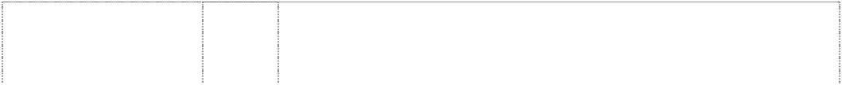

(743837)

# THE WIGGLES

(743837)

# THE WIGGLES

(608391)

# THE WIGGLES

(743837)

# THE WIGGLES

(743837)

# THE WIGGLES

(608392)

# THE WIGGLES

(721652)

# THE WIGGLES

(676236)

21 Food containers of metal, household containers of metal, dishes of metal, egg cups of metal, jugs of metal, kitchen containers of metal, kitchen utensils of metal, bowls of metal, table plates of metal, trays of metal for household purposes.

1. Adhesive fabric for application by heat, banners, covers for bags filled with polystyrene beads, bed linen (except clothing), bed blankets, bed clothes, bed covers, bed covers of paper, bedspreads, blinds of textile, canvas for tapestry or embroidery, coasters made of table linen, cotton fabrics, coverlets for bedspreads, comforter sets, covers for cushions, covers for furniture, curtains of textile or plastic, down filled blankets, door curtains, eiderdowns, fabric, fabrics for textile use, facewashers, floor mats of terry towelling and textile material, friezes, loose covers for furniture, furniture coverings of plastic, furniture coverings of textile, gummed cloths other than for stationery, handkerchiefs of textile, handtowels, jersey, knitted fabric, cloth labels, diapered linen, household linen, linen cloth, lingerie fabric, placemats in this class, mattress covers, mattress protectors, pillow shams, pillow cases, plastic material (substitute for fabrics), blankets of textile, quilts, quilt covers, quilt cover sets, travelling rugs, table runners, serviettes of textile, rod pocket curtains, rugs, sheets, sleeping bags (sheeting), sunshades for affixing to windows, tablecloths (not of paper), table linen (textile), tablemats (not of paper), table napkins of textile, tapestry (wall hangings) of textile, towels, traced cloth for embroidery, upholstery fabrics, valances, velour bath towels, velour beach towels, velour towels, wall hangings of textile, woollen cloth, woollen fabric.
2. All goods in class 25 including T-shirts, baseball caps, pyjamas, sweatshirts, tracksuits, nightwear, babywear, bibs, (not of paper), underwear, socks, ties, bowties, scarves, hankerchiefs, knitwear, swimsuits, shoes, uniforms, sports apparel.
3. Badges for wear of metal, buckles of common metal for clothing.
4. Floor mats of textile, wool and nylon
5. All goods in class 28 including toys, masks in this class, swimming pools being play or sport articles, surfboards, spinning tops, soft toys, dolls, games, board games, kites, puppets, balloons, bon bons, decorations in this class, and dolls' houses.
6. Butter, chocolate nut butter, peanut butter, coconut, potato crisps, potato chips, snack foods, crystallized fruits, dates, eggs, salted foods, frosted fruits, frozen fruits, preserved fruit, cooked fruit, dried fruit, fruit jellies, jelly, fruit peel, fruit pulp, fruit salads, stewed fruit, jams, vegetable juices, margarine, marmalade, broth, milk, milk products, cheese, yoghurt, nuts, raisins, salmon, soups, vegetable salads, cooked vegetables, dried vegetables, preserved vegetables, almonds, anchovy, beans, coconut butter, caviar, coconut oil, dessicated coconut, dairy products, edible oils, eggs, fish, food preserves, herbs, gelatine, gherkins, cream, ham, herrings, sardines, lentils, meat jellies, mushrooms, mussels, olive oil, olives, preserved onions, oil, processed peanuts, peas, pickles, poultry, raisins, salads, salmon, sesame oil, soup, suet, soya beans, sunflower oil, tomato juice, fruit juice, tuna, vegetable juices, yoghurt and baked beans.
7. Biscuits, bread, buns, cakes, breakfast cereal, chewing gum, chocolate, chocolate based beverages, confectionery, cookies, decorations for cakes (edible), edible ices, ginger, ice cream, liquorice, lozenges, meat pies, noodles, pastries, sweets, pizzas and popcorn.

# THE WIGGLES

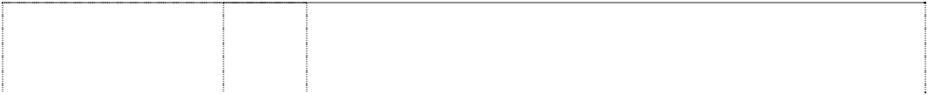

(716547)

# THE WIGGLES

(676237)

# THE WIGGLES

irregular blot (741556)

# THE WIGGLES

words in a blot indented (725821)

# THE WIGGLES

*shape trade mark:* hat or cap with eyes (877977)

# WAGS THE DOG

(720132)

# WAGS THE DOG

(720132)

# WAGS THE DOG

(741567)

30 Biscuits, bread, buns, cakes, cake powder, breakfast cereal, chewing gum, chocolate, chocolate based beverages, confectionery, cookies, decorations for cakes (edible), edible ices, ginger, ice cream, liquorice, lozenges, meat pies, noodles, pastries, sweets, pizzas, popcorn and health bars in this class being cereal-based snack foods; spreads in this class for sandwiches, cornflakes, muesli, oat flakes, oat-based food, pasta, pasta in sauce, spaghetti, canned spaghetti in sauce, peanut confectionery, snack foods, puddings, rice, bread rolls, rusks, sherbert, almond confectionery, aniseed, barley, cocoa-based beverages, beverage flavourings, ice cream flavourings, candy, caramels, cereal preparations, spices, coffee, coffee substitutes, condiments, sauces, corn, farinaceous foods, flavourings, flour for food, gingerbread, glucose, golden syrup, gum, sweets, honey, ices, tomato sauce, macaroni, maize, malt, marzipan, mint, mustard, oatmeal, pancakes, pancake mix, pastries, pralines, ravioli, vermicelli, sago, sandwiches, seasonings, semolina, sugar, sugar confectionery, natural sweeteners, candy sweeteners, tapioca, tarts, tea, vanilla flavour, waffles, whipped cream, yeast.

32 Aerated water, non alcoholic beverages, fruit juices, ginger beer, lemonades, mineral water, effervescing beverages, preparations for making beverages, sherbets (beverages), soft drinks, syrups for beverages, syrups for lemonades, waters (beverages).

5 Sunscreen, sunscreen lip balm in this class, absorbent cotton, adhesive bands for medical purposes, adhesive plaster, adhesive tapes for medical purposes, antiseptics, balms for medical purposes, bandages for dressings, therapeutic preparations for the bath, medicated bath preparations, bath salts for medical purposes, cod liver oil, deodorants in this class, dietetic foods in this class, medical dressings, surgical dressings, gauze for dressings, lip balms in this class, lotions for pharmaceutical purposes, oils in this class, pharmaceutical preparations for skincare, sponges, stick liquorice for pharmaceutical purposes, sticking plasters, glucose, glucose drinks, sunburn ointments, sunburn preparations, tissues, vitamins.

9 Computer software, computer programmes, compact discs, cassettes, records, video tapes and compact discs read only memory, teaching apparatus and instruments, apparatus for recording, transmission or reproduction of sound or images, magnetic data carriers, recording discs, magnets, jukeboxes, spectacle frames, spectacles, sunglasses, eyewear, spectacle cases, binoculars, animated cartoons, films, kaleidoscopes, lifejackets, magnetic tapes, video recorders, cassette recorders, television and video games, computer games, digital audio tapes, digital video tapes; automatic, mechanical and coin operated rides in this class; amusement machines (automatic and coin operated).

25 Headgear including hats.

***\*\*The trade mark consists of the three dimensional shape and configuration of the hat as depicted in the picture register\*\****

3 Soaps, bath salts, oils, cosmetics, cleaning preparations, creams, deodorants, detergents, perfume, make-up, bleach, lipsticks, nail polish, bubble bath and toothpaste.

5 Food for babies and children, adhesive dressings and materials, sticking plaster, bath salts, medicated candy, chewing gum, medicated confectionery, medicinal drinks, first aid boxes, food preparations in this class and medicated toothpaste.

5 Sunscreen, sunscreen lip balm in this class, absorbent cotton, adhesive bands for medical purposes, adhesive plaster, adhesive tapes for medical purposes, antiseptics, balms for medical purposes, bandages for dressings, therapeutic preparations for the bath, medicated bath preparations, bath salts for medical purposes, cod liver oil, deodorants in this class, dietetic foods in this class, medical dressings, surgical dressings, gauze for dressings, lip balms in this class, lotions for pharmaceutical purposes, oils in this class, pharmaceutical preparations for skincare, sponges, stick liquorice for pharmaceutical purposes, sticking plasters, glucose, glucose drinks, sunburn ointments, sunburn preparations, tissues, vitamins.

# WAGS THE DOG



(712747)

# WAGS THE DOG

(667701)

# WAGS THE DOG

(744653)

# WAGS THE DOG

(743841)

# WAGS THE DOG

(737346)

# WAGS THE DOG

(743841)

# WAGS THE DOG

(667702)

1. Cutlery, scissors, knives, forks, spoons, garden tools and spades, hanging knife, spoon and fork set.
2. Computer software, computer programmes, compact discs, cassettes, records, video tapes, CD Roms, spectacles, eyewear, sunglasses, spectacle cases, spectacle frames, binoculars, animated cartoons, films, juke boxes, kaleidoscopes, lifejackets, magnetic tapes, magnets, sound recording apparatuses, sound recording disks, sound recording, amplifying, reproducing and transmitting apparatuses, tapes, teaching apparatuses, television apparatuses, video recorders, video games, digital audio tapes and digital video tapes.

9 Abacuses, amusement machines, animated cartoons; anti-dazzle shades; anti-glare visors, apparatuses for editing cinematographic film, apparatuses for games (adapted for use with TV receivers only), audio-visual teaching apparatuses (automatic and coin operated); automatic, mechanical and coin operated rides in this class; binoculars; cameras, cassette players, compact disc players, compasses, computer games, computer keyboards; computers; contact lenses; digital audiotapes, digital videotapes; divers' masks; eyeshades; eyewear; films (exposed); floating aids for bathing and swimming; integrated circuit chips, jukeboxes (musical), jukeboxes (for computers); kaleidoscopes, lanterns (magic); life belts, life jackets; life saving apparatuses and equipment; magnetic discs; magnetic tapes; magnets; magnifying glasses; microphones; microscopes; modems; pocket calculators; protective helmets; radios; recorded computer programmes; recording discs; rulers; safety restraints; spectacle cases, spectacle chains, spectacle cords, spectacle frames, spectacle glasses, sunglasses; swimming belts, swimming jackets; tape recorders; teaching apparatuses; telescopes; video game cartridges; video games; viewfinders (photographic)

1. Lamp shades.
2. Baby carriages, covers for baby carriages, hoods for baby carriages, safety seats for children for vehicles, safety seat covers for children for vehicles, safety belts for the seats and carriages for vehicles, pushchairs and strollers, pushchair covers and hoods, stroller covers and hoods, bicycles, bicycle saddles, bicycle brakes, bicycle chains, bicycle frames, bicycle handle bars, bicycle pumps, bicycle rims, bicycle spokes, bicycle stands, bicycle tyres, bells for bicycles, boats, cars, automobiles, horns for cars and automobiles, horns for tricycles and bicycles, seat covers for cars and automobiles, tricycles and sleeping berths for vehicles, rearview mirrors.

14 Alarm clocks, bracelets, brooches, cases for clocks, cases for watches, chains, jewellery charms, tie clips, clocks, electric clocks and watches, liquid crystal display watches, moulded flip top liquid crystal display watches, quartz analogue watches, earrings, gold and silverware (other than cutlery, forks and spoons), hat ornaments of precious metal, household containers of precious metal, household utensils of precious metal, objects of imitation gold, jewellery, keyrings, cufflinks, medallions, necklaces, ornamental pins, ornaments, pins, tie pins, plated articles, rings, stopwatches, straps for wristwatches, trinkets, watchbands, watch chains, watch straps, watches and wrist watches.

16 Printed material, stationery, letterhead, posters, stickers, note cards, writing paper, drawing pads, bibs of paper, books, manuals, brochures, book markers, calendars, drawing pads, pen cases, pencil holders, pencils, pens, pencil sharpeners, photographs, pictures, playing cards, stamp pads, stencils, napkins, teaching materials, comic books, story books, picture books, drawing books, activity books, music books, paper coasters, paper place mats, place mats in this class, advertising and promotional material in this class, paper labels, envelopes, paper hats, paper napkins, paper whistles, party favours, noise makers, bon bons, bags of paper, figurines of paper mache, folders, greeting cards, magazines, stamps, paint boxes, paint brushes, painters' brushes, pamphlets, pen holders, rulers, tickets and paper handkerchiefs.

# WAGS THE DOG



(712747)

# WAGS THE DOG

(712747)

# WAGS THE DOG

(712747)

# WAGS THE DOG

(743841)

# WAGS THE DOG

(743841)

# WAGS THE DOG

(759144)

# WAGS THE DOG

(743841)

# WAGS THE DOG

(743841)

# WAGS THE DOG

(667704)

18 Bags, game bags, bags for campers, bags for climbers, bags for packaging, beach bags, belts in this class, briefcases, leather cases, pocket wallets, purses, chain metal purses (not of precious metal), collars for animals, covers for animals, handbags, haversacks, music cases, rucksacks, school satchels, school bags, shopping bags, sling bags for carrying infants, travelling bags, travelling trunks, umbrellas.

1. Playpens, sleeping bags, statuettes of wood, wax, plaster or plastic, tables, chairs, stools, furniture, trays (not of metal), desks.
2. Cups, mugs, bowls, plates, dinner sets, canteens, lunch boxes, tumblers, drinking containers, basins, bins, bottles, soap boxes, brushes, combs, crockery, soap dishes, dustbins, egg cups, drinking flasks, money boxes, tableware and toothbrushes, vinyl placemats.

21 Food containers of metal, household containers of metal, dishes of metal, egg cups of metal, jugs of metal, kitchen containers of metal, kitchen utensils of metal, bowls of metal, table plates of metal, trays of metal for household purposes.

1. Adhesive fabric for application by heat, banners, covers for bags filled with polystyrene beads, bed linen (except clothing), bed blankets, bed clothes, bed covers, bed covers of paper, bedspreads, blinds of textile, canvas for tapestry or embroidery, coasters made of table linen, cotton fabrics, coverlets for bedspreads, comforter sets, covers for cushions, covers for furniture, curtains of textile or plastic, down filled blankets, door curtains, eiderdowns, fabric, fabrics for textile use, facewashers, floor mats of terry towelling and textile material, friezes, loose covers for furniture, furniture coverings of plastic, furniture coverings of textile, gummed cloths other than for stationery, handkerchiefs of textile, handtowels, jersey, knitted fabric, cloth labels, diapered linen, household linen, linen cloth, lingerie fabric, placemats in this class, mattress covers, mattress protectors, pillow shams, pillow cases, plastic material (substitute for fabrics), blankets of textile, quilts, quilt covers, quilt cover sets, travelling rugs, table runners, serviettes of textile, rod pocket curtains, rugs, sheets, sleeping bags (sheeting), sunshades for affixing to windows, tablecloths (not of paper), table linen (textile), tablemats (not of paper), table napkins of textile, tapestry (wall hangings) of textile, towels, traced cloth for embroidery, upholstery fabrics, valances, velour bath towels, velour beach towels, velour towels, wall hangings of textile, woollen cloth, woollen fabric.
2. Clothing; headgear; T-shirts; baseball caps; pyjamas; sweatshirts; track suits; nightwear; nightshirts; babywear; babies' pants; babies' caps, babies' hats; babies' suits; babies' T-shirts; mess shirts; babies' long sleeve T-shirts; babies' overalls; babies' pullovers; bonnets; bibs (not of paper); socks; tights; booties; cloth bibs; underwear; chemises; camisoles; kimonos; briefs; singlets; crop top sets; boxer shorts; ties; bow ties; scarves; shoes; swimsuits; beachwear; uniforms; sportswear; shorts; wind-resistant jackets; jerseys; pants and leotards; aprons; bathing suits; shoes; footwear; slippers; waterproof clothing; raincoats; coats; boots; jackets; ponchos and rain hats; beanies; hats; costumes; shirts; trousers; dresses; skirts; sweaters; pullovers; cardigans; jackets; bathrobes; gloves; headbands; belts; waistcoats; children's co-ordinates; knitwear; babies' napkins of textile; jumpers.
3. Badges for wear of metal, buckles of common metal for clothing.
4. Floor mats of textile, wool and nylon
5. Toys, swimming and diving masks, swimming pools (sports or play articles), surfboards, spinning tops, plush toys, soft toys, dolls' houses, games, board games, kites, puppets, balloons, stuffed toys, computer games, jigsaw puzzles, puzzles, skateboards, sports balls, building blocks, flippers for swimming, fishing lines, toy percussion caps, puppets, rattles, reels for fishing, roller skates, scooters, spinning tops, theatrical masks, Christmas decorations, Christmas tree decorations, inflatable toys, inflatable furniture, inflatable chairs and inflatable tables.

# WAGS THE DOG

(746263)

# WAGS THE DOG

(745355)

# WAGS THE DOG

(746263)

# WIGGLE AND LEARN

(1106504)

1. Butter, chocolate nut butter, peanut butter, coconut, potato crisps, potato chips (hot), snack foods, crystallised fruits, dates, eggs, salted foods, frosted fruits, frozen fruits, preserved fruit, cooked fruit, dried fruit, fruit jellies, jelly, fruit peel, fruit pulp, fruit salads, stewed fruit, jams, vegetable juices, margarine, marmalade, broth, milk, milk products, cheese, yoghurt, nuts, raisins, salmon, soups, vegetable salads, cooked vegetables, dried vegetables, preserved vegetables, almonds, anchovy, beans, coconut butter, caviar, coconut oil, dessicated coconut, dairy products, edible oils, fish, food preserves, herbs, gelatine, gherkins, cream, ham, herrings, sardines, lentils, meat jellies, meat in this class, hamburger meats and patties, sausages, frankfurts in batter, frankfurts including frankfurts for hot dogs, mushrooms, mussels, olive oil, olives, preserved onions, sauerkraut, cooking oil, processed peanuts, peas, pickles, poultry, game, chicken and chicken products in this class, salads, sesame oil, suet, soya beans, sunflower oil, tuna, baked beans, whipped cream.
2. Biscuits, bread, buns, cakes, cake powder, breakfast cereal, chewing gum, chocolate, chocolate based beverages, confectionery, cookies, decorations for cakes (edible), edible ices, ginger, ice cream, liquorice, lozenges, meat pies, noodles, pizzas, popcorn and health bars in this class being cereal-based snack foods; spreads in this class for sandwiches, cornflakes, muesli, oat flakes, oat-based food, pasta, pasta in sauce, spaghetti, canned spaghetti in sauce, peanut confectionery, snack foods, puddings, rice, bread rolls, rusks, sherbet, almond confectionery, aniseed, barley, cocoa-based beverages, beverage flavourings, ice cream flavourings, candy, caramels, cereal preparations, spices, coffee, coffee substitutes, condiments, sauces, corn, farinaceous foods, flavourings, flour for food, gingerbread, glucose, golden syrup, gum, sweets, honey, ices, tomato sauce, macaroni, maize, malt, marzipan, mint, mustard, oatmeal, pancakes, pancake mix, pastries, pralines, ravioli, vermicelli, sago, sandwiches, seasonings, semolina, sugar, sugar confectionery, natural sweeteners, candy sweeteners, tapioca, tarts, tea, vanilla flavour, waffles, yeast, hamburgers in this class, hotdogs in this class.

32 Orange juice, fruit juice.

9 Computer software programs, compact discs, audio cassettes, phonograph records, digital video discs (DVD) and pre-recorded videotapes featuring entertainment for children, namely, music, stories, costumed characters and animation; pre-recorded audio and audio visual devices; pre-recorded multimedia publications; videotapes featuring animated cartoons; audio and audio visual media, pre-recorded multimedia publications, sound recordings, compact discs (read-only-memory), digital video discs (DVD), video recordings and video disk recordings containing educational and informational programs and content; blank digital audio tapes and digital videotapes; computer and video game disks and cartridges; eyewear, namely, spectacles, eyeglasses, sunglasses and eyeglass frames; binoculars; juke boxes; lifejackets; audio recorders, video recorders; video games; sound amplifiers; audio tape cassette players, video cassette players, phonograph record players, compact disc players; radios; television sets; swim masks and diving masks.

# WIGGLE AND LEARN



(1106504)

# WIGGLE AND LEARN

(1106504)

# WIGGLE AND LEARN

ltr a wears hat, mortarboard (1117194)

# WIGGLE AND LEARN

ltr a wears hat, mortarboard (1117194)

16 Stationery, cards, note cards and writing paper, paper partyware, bibs of paper, coasters, book markers, stickers, calendars, greeting cards, drawing pads, general feature magazines for children and magazines for adults dealing with children's issues, pen and pencil cases, pen holders, pencils, crayons, pens, pencil sharpeners, mounted and unmounted photographs, decorative mounted and unmounted pictures, stamps, stamp pads, stencils, paper napkins, books including comic books, picture books, drawing books, music books, colouring books, sticker books, story books, squeaky books, pop up books, pull tab books, glow in the dark books, bath books, chunky board books, scrap books, activity books, paper coasters, paper, paper napkins, show bags, boards, manuals, brochures and teaching materials namely, textbooks for teaching reading, writing, mathematics, music, spelling, drama and magic tricks to children; charts, colour and count sets, activity packs, writing slates and posters.

28 Toys, playthings, games, gymnastic and sporting articles not included in other classes, surf boards, spinning tops, action skill games, card games, manipulative games, board games, kites, balls, puppets, balloons, Christmas tree decorations, dolls' houses, computer games, puzzles, jigsaw puzzles, skateboards, inflatable toys, inflatable furniture, inflatable chairs, inflatable tables, inflatable mascots, inflatable balls, inflatable cars, dolls, plush toys, soft toys, finger puppets, toy microphones, toy drum kits, toy cymbals, toy guitars (electronic and non-electronic), tambourines, toy electronic keyboards, musical instruments, toy money banks, cars, car parts; swimming pools being play or sport articles, decorations in this class; kaleidoscopes; playing cards; paper hats; paper party favours, paper whistles and noise makers in the nature of Christmas crackers

9 Computer software programs, compact discs, audio cassettes, phonograph records, digital video discs (DVD) and pre-recorded videotapes featuring entertainment for children, namely, music, stories, costumed characters and animation; pre-recorded audio and audio visual devices; pre-recorded multimedia publications; videotapes featuring animated cartoons; audio and audio visual media, pre-recorded multimedia publications, sound recordings, compact discs (read-only-memory), digital video discs (DVD), video recordings and video disk recordings containing educational and informational programs and content; blank digital audio tapes and digital videotapes; computer and video game disks and cartridges; eyewear, namely, spectacles, eyeglasses, sunglasses and eyeglass frames; binoculars; juke boxes; lifejackets; audio recorders, video recorders; video games; sound amplifiers; audio tape cassette players, video cassette players, phonograph record players, compact disc players; radios; television sets; swim masks and diving masks.

16 Stationery, cards, note cards and writing paper, paper partyware, bibs of paper, coasters, book markers, stickers, calendars, greeting cards, drawing pads, general feature magazines for children and magazines for adults dealing with children's issues, pen and pencil cases, pen holders, pencils, crayons, pens, pencil sharpeners, mounted and unmounted photographs, decorative mounted and unmounted pictures, stamps, stamp pads, stencils, paper napkins, books including comic books, picture books, drawing books, music books, colouring books, sticker books, story books, squeaky books, pop up books, pull tab books, glow in the dark books, bath books, chunky board books, scrap books, activity books, paper coasters, paper, paper napkins, show bags, boards, manuals, brochures and teaching materials namely, textbooks for teaching reading, writing, mathematics, music, spelling, drama and magic tricks to children; charts, colour and count sets, activity packs, writing slates and posters.

# WIGGLE AND LEARN



ltr a wears hat, mortarboard (1117194)

# WIGGLE BAY

octopus, dinosaur, dog all cartoon with pirate 2 with snorkel cut by splash

(1124454)

# WIGGLE BAY

octopus, dinosaur, dog all cartoon with pirate 2 with snorkel cut by splash

(1124454)

# WIGGLE BAY

octopus, dinosaur, dog all cartoon with pirate 2 with snorkel cut by splash

(1124454)

# WIGGLE BAY

octopus, dinosaur, dog all cartoon with pirate 2 with snorkel cut by splash

(1124454)

# WIGGLE BAY

octopus, dinosaur, dog all cartoon with pirate 2 with snorkel cut by splash

(1124454)

28 Toys, playthings, games, gymnastic and sporting articles not included in other classes, surf boards, spinning tops, action skill games, card games, manipulative games, board games, kites, balls, puppets, balloons, Christmas tree decorations, dolls' houses, computer games, puzzles, jigsaw puzzles, skateboards, inflatable toys, inflatable furniture, inflatable chairs, inflatable tables, inflatable mascots, inflatable balls, inflatable cars, dolls, plush toys, soft toys, finger puppets, toy microphones, toy drum kits, toy cymbals, toy guitars (electronic and non-electronic), tambourines, toy electronic keyboards, musical instruments, toy money banks, cars, car parts; swimming pools being play or sport articles, decorations in this class; kaleidoscopes; playing cards; paper hats; paper party favours, paper whistles and noise makers in the nature of Christmas crackers

3 Soaps, bath salts, cosmetics, cleaning preparations, creams, deodorants, detergents, perfume, make-up, bleach, lipsticks, nail polish, bubble bath, toothpaste, skin care preparations, creams, cologne, hair colorants, hair dyes, hair lotions, hair waving preparations, cosmetic kits, essential oils, shampoos, shoe polish, toiletries, sun tanning preparations in this class, sun screen in this class, sun screen lip balm in this class, talcum powder.

5 Food for babies and children, sticking plaster, bath salts, medicated candy and chewing gum, medicated confectionery, medicinal drinks, first aid boxes, medicated toothpaste, adhesive dressings, food preparations in this class, sunscreen and sunscreen lip balm in this class, absorbent cotton, adhesive bands for medical purposes, adhesive plaster, adhesive tapes for medical purposes, antiseptics, balms for medical purposes, bandages for dressings, therapeutic preparations for the bath, medicated bath preparations, bath salts for medical purposes, cod liver oil, deodorants in this class, dietetic foods in this class, medical dressings, surgical dressings, gauze for dressings, lip balms in this class, lotions for pharmaceutical purposes, oils in this class, pharmaceutical preparations for skincare, sponges, stick liquorice for pharmaceutical purposes, glucose, glucose drinks, sunburn ointments, sunburn preparations, tissues in this class, vitamins.

1. Cutlery, scissors, knives, forks, spoons, garden tools and spades; hanging knife, spoon and fork sets.
2. Computer software programs, compact discs, audio cassettes, phonograph records, digital video discs (DVD) and pre-recorded videotapes featuring entertainment for children, namely, music, stories, costumed characters and animation; pre-recorded audio and audio visual devices; pre-recorded multimedia publications; videotapes featuring animated cartoons; blank digital audio tapes and digital videotapes; computer and video game disks and cartridges; eyewear, namely, spectacles, eyeglasses, sunglasses and eyeglass frames; binoculars; juke boxes; lifejackets; audio recorders, video recorders; video games; sound amplifiers; audio tape cassette players, video cassette players, phonograph record players, compact disc players; radios; television sets; swim masks and diving masks.

12 Baby carriages, covers for baby carriages, hoods for baby carriages, safety seats for children for vehicles, safety seat covers for children for vehicles, safety belts for the seats and carriages for vehicles, pushchairs and strollers, pushchair covers and hoods, stroller covers and hoods, bicycles, bicycle saddles, bicycle brakes, bicycle chains, bicycle frames, bicycle handle bars, bicycle pumps, bicycle rims, bicycle spokes, bicycle stands, bicycle tyres, bells for bicycles, boats, cars, automobiles, horns for cars and automobiles, horns for tricycles and bicycles, seat covers for cars and automobiles, tricycles and sleeping berths for vehicles, rear-view mirrors.

# WIGGLE BAY



octopus, dinosaur, dog all cartoon with pirate 2 with snorkel cut by splash

(1124454)

# WIGGLE BAY

octopus, dinosaur, dog all cartoon with pirate 2 with snorkel cut by splash

(1124454)

# WIGGLE BAY

octopus, dinosaur, dog all cartoon with pirate 2 with snorkel cut by splash

(1124454)

# WIGGLE BAY

octopus, dinosaur, dog all cartoon with pirate 2 with snorkel cut by splash

(1124454)

# WIGGLE BAY

octopus, dinosaur, dog all cartoon with pirate 2 with snorkel cut by splash

(1124454)

14 Alarm clocks, bracelets, brooches, cases for clocks, cases for watches, chains, jewellery charms, tie clips, clocks, electric clocks and watches, liquid crystal display watches, moulded flip top liquid crystal display watches, quartz analogue watches, earrings, gold and silverware (other than cutlery, forks and spoons), hat ornaments of precious metal, household containers of precious metal, household utensils of precious metal, objects of imitation gold, jewellery, key rings, cufflinks, medallions, necklaces, ornamental pins, ornaments, pins, tie pins, plated articles, rings, stopwatches, straps for wristwatches, trinkets, watchbands, watch chains, watch straps, watches and wrist watches.

16 Stationery, cards, note cards and writing paper, paper partyware, bibs of paper, coasters, book markers, stickers, calendars, greeting cards, drawing pads, general feature magazines for children and magazines for adults dealing with children's issues, pen and pencil cases, pen holders, pencils, crayons, pens, pencil sharpeners, mounted and unmounted photographs, decorative mounted and unmounted pictures, stamps, stamp pads, stencils, paper napkins, books including, comic books, picture books, drawing books, music books, colouring books, sticker books, story books, squeaky books, pop up books, pull tab books, glow in the dark books, bath books, chunky board books, scrap books, activity books, paper coasters, paper, paper napkins, show bags, boards, manuals, brochures and teaching materials namely, textbooks for teaching reading, writing, mathematics, music, spelling, drama and magic tricks to children, charts, colour and count sets, activity packs, writing slates and posters.

18 Bags, game bags, bags for campers, bags for climbers, bags for packaging, beach bags, belts, briefcases, leather cases, pocket wallets, purses, chain metal purses (not of precious metal), collars for animals, covers for animals, handbags, haversacks, music cases, rucksacks, school satchels, school bags, shopping bags, sling bags for carrying infants, travelling bags, travelling trunks, umbrellas.

1. Playpens, sleeping bags, statuettes of wood, wax, plaster or plastic, tables, chairs, stools, furniture, trays (not of metal), desks.
2. Cups, mugs, bowls, plates, dinner sets, canteens, lunch boxes, tumblers, drinking containers, basins, bins, bottles, soap boxes, brushes, combs, crockery, soap dishes, dustbins, egg cups, drinking flasks, money boxes, tableware and toothbrushes, food containers of metal, household containers of metal, dishes of metal, egg cups of metal, jugs of metal, kitchen containers of metal, kitchen utensils of metal, bowls of metal, table plates of metal, trays of metal for household purposes.

# WIGGLE BAY

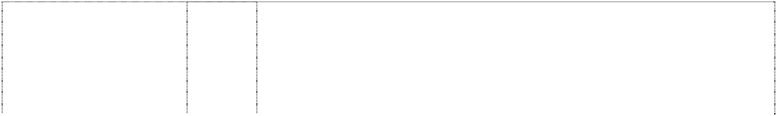

octopus, dinosaur, dog all cartoon with pirate 2 with snorkel cut by splash

(1124454)

# WIGGLE BAY

octopus, dinosaur, dog all cartoon with pirate 2 with snorkel cut by splash

(1124454)

# WIGGLE BAY

octopus, dinosaur, dog all cartoon with pirate 2 with snorkel cut by splash

(1124454)

# WIGGLE BAY

octopus, dinosaur, dog all cartoon with pirate 2 with snorkel cut by splash

(1124454)

# WIGGLE BAY

octopus, dinosaur, dog all cartoon with pirate 2 with snorkel cut by splash

(1124454)

1. Adhesive fabric for application by heat, banners, covers for bags filled with polystyrene beads, bed linen (except clothing), bed blankets, bed clothes, bed covers, bed covers of paper, bedspreads, blinds of textile, canvas for tapestry or embroidery, coasters made of table linen, cotton fabrics, coverlets for bedspreads, comforter sets, covers for cushions, covers for furniture, curtains of textile or plastic, down filled blankets, door curtains, eiderdowns, fabric, fabrics for textile use, face washers, friezes, loose covers for furniture, furniture coverings of plastic, furniture coverings of textile, gummed cloths other than for stationery, handkerchiefs of textile, handtowels, jersey, knitted fabric, cloth labels, diapered linen, household linen, linen cloth, lingerie fabric, placemats in this class including plastic and vinyl placemats; mattress covers, mattress protectors, pillow shams, pillow cases, plastic material (substitute for fabrics), blankets of textile, quilts, quilt covers, quilt cover sets, travelling rugs, table runners, serviettes of textile, rod pocket curtains, rugs, sheets, sleeping bags (sheeting), sunshades for affixing to windows, tablecloths (not of paper), table linen (textile), tablemats (not of paper), table napkins of textile, tapestry (wall hangings) of textile, towels, traced cloth for embroidery, upholstery fabrics, valances, velour bath towels, velour beach towels, velour towels, wall hangings of textile, woollen cloth, woollen fabric.
2. Clothing, headgear, T-shirts, baseball caps, pyjamas, sweatshirts, tracksuits, sleepwear, babywear, babies' pants, babies' caps, babies' hats, babies' suits, babies' T-shirts, mess shirts, babies' long sleeve T-shirts, babies' overalls, babies' pullovers, bonnets, bibs, socks, tights, booties, blankets, cloth bibs, underwear, briefs, singlets, crop top sets, boxer shorts, ties, bow ties, scarves, swimsuits, beach wear, uniforms, sports apparel, shorts, wind-resistant jackets, jerseys, pants and leotards, aprons, bathing suits, shoes, footwear, slippers, waterproof clothing, coats, boots, jackets, ponchos and rain hats, beanies, hats, character costumes, shirts, trousers, dresses, skirts, sweaters, pullovers, cardigans, bath robes, gloves, headbands, belts, waistcoats, ties, children's co-ordinates.
3. Badges for wear of metal, buckles of common metal for clothing.
4. Floor mats of textile, wool and nylon; wallpaper; friezes (non-textile); floor mats of terry towelling.
5. Toys, playthings, games, gymnastic and sporting articles not included in other classes, surf boards, spinning tops, action skill games, card games, manipulative games, board games, kites, balls, puppets, balloons, Christmas tree decorations, dolls' houses, computer games, puzzles, jigsaw puzzles, skateboards, inflatable toys, inflatable furniture, inflatable chairs, inflatable tables, inflatable mascots, inflatable balls, inflatable cars, dolls, plush toys, soft toys, finger puppets, toy microphones, toy drum kits, toy cymbals, toy guitars (electronic and non-electronic), tambourines, toy electronic keyboards, musical instruments, toy money banks, cars, car parts; swimming pools being play or sport articles, decorations in this class; kaleidoscopes; playing cards; paper hats; paper party favours, paper whistles and noise makers in the nature of Christmas crackers.

# WIGGLE BAY



octopus, dinosaur, dog all cartoon with pirate 2 with snorkel cut by splash

(1124454)

# WIGGLE BAY

octopus, dinosaur, dog all cartoon with pirate 2 with snorkel cut by splash

(1124454)

# WIGGLE BAY

octopus, dinosaur, dog all cartoon with pirate 2 with snorkel cut by splash

(1124454)

# WIGGLE BAY

octopus, dinosaur, dog all cartoon with pirate 2 with snorkel cut by splash

(1124454) **WIGGLES** (866096)

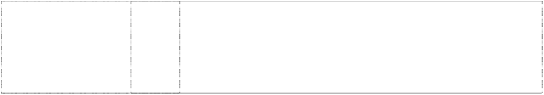**WIGGLES** (866096) **WIGGLES WORLD**

words in blot indented (1073307)

1. Butter, chocolate nut butter, peanut butter, coconut, potato crisps, potato chips, snack foods, crystallized fruits, dates, eggs, salted foods, frosted fruits, frozen fruits, preserved fruit, cooked fruit, dried fruit, fruit jellies, jelly, fruit peel, fruit pulp, fruit salads, stewed fruit, jams, vegetable juices, margarine, marmalade, broth, milk, milk products, cheese, yoghurt, whipped cream, nuts, raisins, salmon, soups, vegetable salads, cooked vegetables, dried vegetables, preserved vegetables, almonds, anchovy, beans, coconut butter, caviar, coconut oil, desiccated coconut, dairy products, edible oils, eggs, fish, food preserves, herbs, gelatine, gherkins, cream, ham, herrings, sardines, lentils, meat jellies, mushrooms, mussels, olive oil, olives, preserved onions, oil, processed peanuts, peas, pickles, poultry, raisins, salads, salmon, sesame oil, soup, suet, soya beans, sunflower oil, tomato juice, fruit juice, tuna, vegetable juices, baked beans.
2. Biscuits, bread, buns, cakes, cake powder, breakfast cereal, chewing gum, chocolate, chocolate based beverages, confectionery, cookies, decorations for cakes (edible), edible ices, ginger, ice cream, liquorice, lozenges, meat pies, noodles, pastries, sweets, pizzas, popcorn and health bars in this class being cereal-based snack foods; spreads in this class for sandwiches, cornflakes, muesli, oat flakes, oat-based food, pasta, pasta in sauce, spaghetti, canned spaghetti in sauce, peanut confectionery, snack foods, puddings, rice, bread rolls, rusks, sherbet, almond confectionery, aniseed, barley, cocoa-based beverages, beverage flavourings, ice cream flavourings, candy, caramels, cereal preparations, spices, coffee, coffee substitutes, condiments, sauces, corn, farinaceous foods, flavourings, flour for food, gingerbread, glucose, golden syrup, gum, sweets, honey, ices, tomato sauce, macaroni, maize, malt, marzipan, mint, mustard, oatmeal, pancakes, pancake mix, pastries, pralines, ravioli, vermicelli, sago, sandwiches, seasonings, semolina, sugar, sugar confectionery, natural sweeteners, candy sweeteners, tapioca, tarts, tea, vanilla flavour, waffles, yeast.
3. Fresh fruits and vegetables.
4. Aerated water, non alcoholic beverages, fruit juices, ginger beer, lemonades, mineral water, effervescing beverages, preparations for making beverages, sherbets (beverages), soft drinks, syrups for beverages, syrups for lemonades, waters (beverages).

9 Computer software programs, compact discs, audio cassettes, phonograph records, digital video discs (DVD) and prerecorded videotapes featuring entertainment for children, namely, music, stories, costumed characters and animation; pre-recorded audio and audio visual devices; pre-recorded multimedia publications; videotapes featuring animated cartoons; blank digital audio tapes and digital videotapes; computer and video game disks and cartridges; eyewear, namely, spectacles, eyeglasses, sunglasses and eyeglass frames; binoculars; kaleidoscopes; juke boxes; lifejackets; audio recorders, video recorders; sound amplifiers; audio tape cassette players, video cassette players, phonograph record players, compact disc players; radios; television sets.

20 Decorative refrigerator magnets.

3 Soaps, bath salts, cosmetics, cleaning preparations, creams, deodorants, detergents, perfume, make-up, bleach, lipsticks, nail polish, bubble bath, toothpaste, skin care preparations, creams, cologne, hair colorants, hair dyes, hair lotions, hair waving preparations, cosmetic kits, essential oils, shampoos, shoe polish, toiletries, sun tanning preparations in this class, sun screen in this class, sun screen lip balm in this class, talcum powder.

# WIGGLES WORLD



words in blot indented (1073307)

# WIGGLES WORLD

words in blot indented (1073307)

# WIGGLES WORLD

words in blot indented (1073307)

# WIGGLES WORLD

words in blot indented (1073307)

# WIGGLES WORLD

words in blot indented (1073307)

5 Food for babies and children, sticking plaster, bath salts, medicated candy and chewing gum, medicated confectionery, medicinal drinks, first aid boxes, medicated toothpaste, adhesive dressings, food preparations in this class, sunscreen and sunscreen lip balm in this class, absorbent cotton, adhesive bands for medical purposes, adhesive plaster, adhesive tapes for medical purposes, antiseptics, balms for medical purposes, bandages for dressings, therapeutic preparations for the bath, medicated bath preparations, bath salts for medical purposes, cod liver oil, deodorants in this class, dietetic foods in this class, medical dressings, surgical dressings, gauze for dressings, lip balms in this class, lotions for pharmaceutical purposes, oils in this class, pharmaceutical preparations for skincare, sponges, stick liquorice for pharmaceutical purposes, glucose, glucose drinks, sunburn ointments, sunburn preparations, tissues in this class, vitamins.

1. Cutlery, scissors, knives, forks, spoons, garden tools and spades; hanging knife, spoon and fork sets.
2. Computer software programs, compact discs, audio cassettes, phonograph records, digital video discs (DVD) and pre-recorded videotapes featuring entertainment for children, namely, music, stories, costumed characters and animation; pre-recorded audio and audio visual devices; pre-recorded multimedia publications; videotapes featuring animated cartoons; blank digital audio tapes and digital videotapes; computer and video game disks and cartridges; eyewear, namely, spectacles, eyeglasses, sunglasses and eyeglass frames; binoculars; juke boxes; lifejackets; audio recorders, video recorders; video games; sound amplifiers; audio tape cassette players, video cassette players, phonograph record players, compact disc players; radios; television sets; swim masks and diving masks.

12 Baby carriages, covers for baby carriages, hoods for baby carriages, safety seats for children for vehicles, safety seat covers for children for vehicles, safety belts for the seats and carriages for vehicles, pushchairs and strollers, pushchair covers and hoods, stroller covers and hoods, bicycles, bicycle saddles, bicycle brakes, bicycle chains, bicycle frames, bicycle handle bars, bicycle pumps, bicycle rims, bicycle spokes, bicycle stands, bicycle tyres, bells for bicycles, boats, cars, automobiles, horns for cars and automobiles, horns for tricycles and bicycles, seat covers for cars and automobiles, tricycles and sleeping berths for vehicles, rear-view mirrors.

14 Alarm clocks, bracelets, brooches, cases for clocks, cases for watches, chains, jewellery charms, tie clips, clocks, electric clocks and watches, liquid crystal display watches, moulded flip top liquid crystal display watches, quartz analogue watches, earrings, gold and silverware (other than cutlery, forks and spoons), hat ornaments of precious metal, household containers of precious metal, household utensils of precious metal, objects of imitation gold, jewellery, key rings, cufflinks, medallions, necklaces, ornamental pins, ornaments, pins, tie pins, plated articles, rings, stopwatches, straps for wristwatches, trinkets, watchbands, watch chains, watch straps, watches and wrist watches.

# WIGGLES WORLD



words in blot indented (1073307)

# WIGGLES WORLD

words in blot indented (1073307)

# WIGGLES WORLD

words in blot indented (1073307)

# WIGGLES WORLD

words in blot indented (1073307)

# WIGGLES WORLD

words in blot indented (1073307)

16 Stationery, cards, note cards and writing paper, paper partyware, bibs of paper, coasters, book markers, stickers, calendars, greeting cards, drawing pads, general feature magazines for children and magazines for adults dealing with children's issues, pen and pencil cases, pen holders, pencils, crayons, pens, pencil sharpeners, mounted and unmounted photographs, decorative mounted and unmounted pictures, stamps, stamp pads, stencils, paper napkins, books including, comic books, picture books, drawing books, music books, colouring books, sticker books, story books, squeaky books, pop up books, pull tab books, glow in the dark books, bath books, chunky board books, scrap books, activity books, paper coasters, paper, paper napkins, show bags, boards, manuals, brochures and teaching materials namely, textbooks for teaching reading, writing, mathematics, music, spelling, drama and magic tricks to children, charts, colour and count sets, activity packs, writing slates and posters.

18 Bags, game bags, bags for campers, bags for climbers, bags for packaging, beach bags, belts, briefcases, leather cases, pocket wallets, purses, chain metal purses (not of precious metal), collars for animals, covers for animals, handbags, haversacks, music cases, rucksacks, school satchels, school bags, shopping bags, sling bags for carrying infants, travelling bags, travelling trunks, umbrellas.

1. Playpens, sleeping bags, statuettes of wood, wax, plaster or plastic, tables, chairs, stools, furniture, trays (not of metal), desks.
2. Cups, mugs, bowls, plates, dinner sets, canteens, lunch boxes, tumblers, drinking containers, basins, bins, bottles, soap boxes, brushes, combs, crockery, soap dishes, dustbins, egg cups, drinking flasks, money boxes, tableware and toothbrushes, food containers of metal, household containers of metal, dishes of metal, egg cups of metal, jugs of metal, kitchen containers of metal, kitchen utensils of metal, bowls of metal, table plates of metal, trays of metal for household purposes.
3. Adhesive fabric for application by heat, banners, covers for bags filled with polystyrene beads, bed linen (except clothing), bed blankets, bed clothes, bed covers, bed covers of paper, bedspreads, blinds of textile, canvas for tapestry or embroidery, coasters made of table linen, cotton fabrics, coverlets for bedspreads, comforter sets, covers for cushions, covers for furniture, curtains of textile or plastic, down filled blankets, door curtains, eiderdowns, fabric, fabrics for textile use, face washers, friezes, loose covers for furniture, furniture coverings of plastic, furniture coverings of textile, gummed cloths other than for stationery, handkerchiefs of textile, handtowels, jersey, knitted fabric, cloth labels, diapered linen, household linen, linen cloth, lingerie fabric, placemats in this class including plastic and vinyl placemats, mattress covers, mattress protectors, pillow shams, pillow cases, plastic material (substitute for fabrics), blankets of textile, quilts, quilt covers, quilt cover sets, travelling rugs, table runners, serviettes of textile, rod pocket curtains, rugs, sheets, sleeping bags (sheeting), sunshades for affixing to windows, tablecloths (not of paper), table linen (textile), tablemats (not of paper), table napkins of textile, tapestry (wall hangings) of textile, towels, traced cloth for embroidery, upholstery fabrics, valances, velour bath towels, velour beach towels, velour towels, wall hangings of textile, woollen cloth, woollen fabric.

# WIGGLES WORLD



words in blot indented (1073307)

# WIGGLES WORLD

words in blot indented (1073307)

# WIGGLES WORLD

words in blot indented (1073307)

# WIGGLES WORLD

words in blot indented (1073307)

# WIGGLES WORLD

words in blot indented (1073307)

# WIGGLES WORLD

words in blot indented (1073307)

1. Clothing, headgear, T-shirts, baseball caps, pyjamas, sweatshirts, tracksuits, sleepwear, babywear, babies' pants, babies' caps, babies' hats, babies' suits, babies' T-shirts, mess shirts, babies' long sleeve T-shirts, babies' overalls, babies' pullovers, bonnets, bibs, socks, tights, booties, blankets, cloth bibs, underwear, briefs, singlets, crop top sets, boxer shorts, ties, bow ties, scarves, swimsuits, beach wear, uniforms, sports apparel, shorts, wind-resistant jackets, jerseys, pants and leotards, aprons, bathing suits, shoes, footwear, slippers, waterproof clothing, coats, boots, jackets, ponchos and rain hats, beanies, hats, character costumes, shirts, trousers, dresses, skirts, sweaters, pullovers, cardigans, bath robes, gloves, headbands, belts, waistcoats, ties, children's co-ordinates.

28 Toys, playthings, games, gymnastic and sporting articles not included in other classes, surf boards, spinning tops, action skill games, card games, manipulative games, board games, kites, balls, puppets, balloons, Christmas tree decorations, dolls' houses, computer games, puzzles, jigsaw puzzles, skateboards, inflatable toys, inflatable furniture, inflatable chairs, inflatable tables, inflatable mascots, inflatable balls, inflatable cars, dolls, plush toys, soft toys, finger puppets, toy microphones, toy drum kits, toy cymbals, toy guitars (electronic and non-electronic), tambourines, toy electronic keyboards, musical instruments, toy money banks, cars, car parts; swimming pools being play or sport articles, decorations in this class; kaleidoscopes; playing cards; paper hats; paper party favours, paper whistles and noise makers in the nature of Christmas crackers.

1. Badges for wear of metal, buckles of common metal for clothing.
2. Floor mats of textile, wool and nylon; wallpaper; friezes (non-textile); floor mats of terry towelling.
3. Butter, chocolate nut butter, peanut butter, coconut, potato crisps, potato chips, snack foods, crystallized fruits, dates, eggs, salted foods, frosted fruits, frozen fruits, preserved fruit, cooked fruit, dried fruit, fruit jellies, jelly, fruit peel, fruit pulp, fruit salads, stewed fruit, jams, vegetable juices, margarine, marmalade, broth, milk, milk products, cheese, yoghurt, whipped cream, nuts, raisins, salmon, soups, vegetable salads, cooked vegetables, dried vegetables, preserved vegetables, almonds, anchovy, beans, coconut butter, caviar, coconut oil, desiccated coconut, dairy products, edible oils, eggs, fish, food preserves, herbs, gelatine, gherkins, cream, ham, herrings, sardines, lentils, meat jellies, mushrooms, mussels, olive oil, olives, preserved onions, oil, processed peanuts, peas, pickles, poultry, raisins, salads, salmon, sesame oil, soup, suet, soya beans, sunflower oil, tomato juice, fruit juice, tuna, vegetable juices, baked beans.
4. Biscuits, bread, buns, cakes, cake powder, breakfast cereal, chewing gum, chocolate, chocolate based beverages, confectionery, cookies, decorations for cakes (edible), edible ices, ginger, ice cream, liquorice, lozenges, meat pies, noodles, pastries, sweets, pizzas, popcorn and health bars in this class being cereal-based snack foods; spreads in this class for sandwiches, cornflakes, muesli, oat flakes, oat-based food, pasta, pasta in sauce, spaghetti, canned spaghetti in sauce, peanut confectionery, snack foods, puddings, rice, bread rolls, rusks, sherbet, almond confectionery, aniseed, barley, cocoa-based beverages, beverage flavourings, ice cream flavourings, candy, caramels, cereal preparations, spices, coffee, coffee substitutes, condiments, sauces, corn, farinaceous foods, flavourings, flour for food, gingerbread, glucose, golden syrup, gum, sweets, honey, ices, tomato sauce, macaroni, maize, malt, marzipan, mint, mustard, oatmeal, pancakes, pancake mix, pastries, pralines, ravioli, vermicelli, sago, sandwiches, seasonings, semolina, sugar, sugar confectionery, natural sweeteners, candy sweeteners, tapioca, tarts, tea, vanilla flavour, waffles, yeast.

# WIGGLES WORLD



words in blot indented (1073307)

# WIGGLES WORLD

words in blot indented (1073307)

# WIGGLES WORLD

octopus, pirate, dinosaur & dog, all cartoon

(1073353)

# WIGGLES WORLD

octopus, pirate, dinosaur & dog, all cartoon

(1073353)

# WIGGLES WORLD

octopus, pirate, dinosaur & dog, all cartoon

(1073353)

# WIGGLES WORLD

octopus, pirate, dinosaur & dog, all cartoon

(1073353)

# WIGGLES WORLD

octopus, pirate, dinosaur & dog, all cartoon

(1073353)

1. Fresh fruits and vegetables.
2. Aerated water, non alcoholic beverages, fruit juices, ginger beer, lemonades, mineral water, effervescing beverages, preparations for making beverages, sherbets (beverages), soft drinks, syrups for beverages, syrups for lemonades, waters (beverages).

3 Soaps, bath salts, cosmetics, cleaning preparations, creams, deodorants, detergents, perfume, make-up, bleach, lipsticks, nail polish, bubble bath, toothpaste, skin care preparations, creams, cologne, hair colorants, hair dyes, hair lotions, hair waving preparations, cosmetic kits, essential oils, shampoos, shoe polish, toiletries, sun tanning preparations in this class, sun screen in this class, sun screen lip balm in this class, talcum powder.

5 Food for babies and children, sticking plaster, bath salts, medicated candy and chewing gum, medicated confectionery, medicinal drinks, first aid boxes, medicated toothpaste, adhesive dressings, food preparations in this class, sunscreen and sunscreen lip balm in this class, absorbent cotton, adhesive bands for medical purposes, adhesive plaster, adhesive tapes for medical purposes, antiseptics, balms for medical purposes, bandages for dressings, therapeutic preparations for the bath, medicated bath preparations, bath salts for medical purposes, cod liver oil, deodorants in this class, dietetic foods in this class, medical dressings, surgical dressings, gauze for dressings, lip balms in this class, lotions for pharmaceutical purposes, oils in this class, pharmaceutical preparations for skincare, sponges, stick liquorice for pharmaceutical purposes, glucose, glucose drinks, sunburn ointments, sunburn preparations, tissues in this class, vitamins.

1. Cutlery, scissors, knives, forks, spoons, garden tools and spades; hanging knife, spoon and fork sets.
2. Computer software programs, compact discs, audio cassettes, phonograph records, digital video discs (DVD) and pre-recorded videotapes featuring entertainment for children, namely, music, stories, costumed characters and animation; pre-recorded audio and audio visual devices; pre-recorded multimedia publications; videotapes featuring animated cartoons; blank digital audio tapes and digital videotapes; computer and video game disks and cartridges; eyewear, namely, spectacles, eyeglasses, sunglasses and eyeglass frames; binoculars; juke boxes; lifejackets; audio recorders, video recorders; video games; sound amplifiers; audio tape cassette players, video cassette players, phonograph record players, compact disc players; radios; television sets; swim masks and diving masks.

12 Baby carriages, covers for baby carriages, hoods for baby carriages, safety seats for children for vehicles, safety seat covers for children for vehicles, safety belts for the seats and carriages for vehicles, pushchairs and strollers, pushchair covers and hoods, stroller covers and hoods, bicycles, bicycle saddles, bicycle brakes, bicycle chains, bicycle frames, bicycle handle bars, bicycle pumps, bicycle rims, bicycle spokes, bicycle stands, bicycle tyres, bells for bicycles, boats, cars, automobiles, horns for cars and automobiles, horns for tricycles and bicycles, seat covers for cars and automobiles, tricycles and sleeping berths for vehicles, rear-view mirrors.

# WIGGLES WORLD

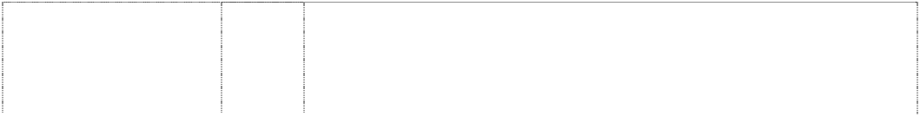

octopus, pirate, dinosaur & dog, all cartoon

(1073353)

# WIGGLES WORLD

octopus, pirate, dinosaur & dog, all cartoon

(1073353)

# WIGGLES WORLD

octopus, pirate, dinosaur & dog, all cartoon

(1073353)

# WIGGLES WORLD

octopus, pirate, dinosaur & dog, all cartoon

(1073353)

# WIGGLES WORLD

octopus, pirate, dinosaur & dog, all cartoon

(1073353)

14 Alarm clocks, bracelets, brooches, cases for clocks, cases for watches, chains, jewellery charms, tie clips, clocks, electric clocks and watches, liquid crystal display watches, moulded flip top liquid crystal display watches, quartz analogue watches, earrings, gold and silverware (other than cutlery, forks and spoons), hat ornaments of precious metal, household containers of precious metal, household utensils of precious metal, objects of imitation gold, jewellery, key rings, cufflinks, medallions, necklaces, ornamental pins, ornaments, pins, tie pins, plated articles, rings, stopwatches, straps for wristwatches, trinkets, watchbands, watch chains, watch straps, watches and wrist watches.

16 Stationery, cards, note cards and writing paper, paper partyware, bibs of paper, coasters, book markers, stickers, calendars, greeting cards, drawing pads, general feature magazines for children and magazines for adults dealing with children's issues, pen and pencil cases, pen holders, pencils, crayons, pens, pencil sharpeners, mounted and unmounted photographs, decorative mounted and unmounted pictures, stamps, stamp pads, stencils, paper napkins, books including, comic books, picture books, drawing books, music books, colouring books, sticker books, story books, squeaky books, pop up books, pull tab books, glow in the dark books, bath books, chunky board books, scrap books, activity books, paper coasters, paper, paper napkins, show bags, boards, manuals, brochures and teaching materials namely, textbooks for teaching reading, writing, mathematics, music, spelling, drama and magic tricks to children, charts, colour and count sets, activity packs, writing slates and posters.

18 Bags, game bags, bags for campers, bags for climbers, bags for packaging, beach bags, belts, briefcases, leather cases, pocket wallets, purses, chain metal purses (not of precious metal), collars for animals, covers for animals, handbags, haversacks, music cases, rucksacks, school satchels, school bags, shopping bags, sling bags for carrying infants, travelling bags, travelling trunks, umbrellas.

1. Playpens, sleeping bags, statuettes of wood, wax, plaster or plastic, tables, chairs, stools, furniture, trays (not of metal), desks.
2. Cups, mugs, bowls, plates, dinner sets, canteens, lunch boxes, tumblers, drinking containers, basins, bins, bottles, soap boxes, brushes, combs, crockery, soap dishes, dustbins, egg cups, drinking flasks, money boxes, tableware and toothbrushes, food containers of metal, household containers of metal, dishes of metal, egg cups of metal, jugs of metal, kitchen containers of metal, kitchen utensils of metal, bowls of metal, table plates of metal, trays of metal for household purposes.

# WIGGLES WORLD

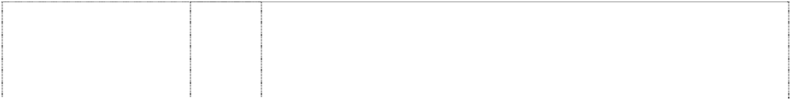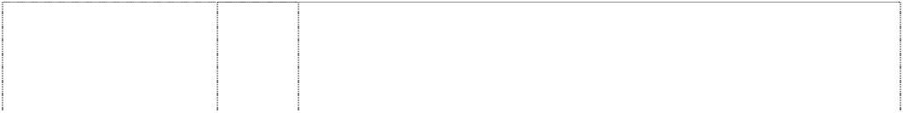

octopus, pirate, dinosaur & dog, all cartoon

(1073353)

# WIGGLES WORLD

octopus, pirate, dinosaur & dog, all cartoon

(1073353)

# WIGGLES WORLD

octopus, pirate, dinosaur & dog, all cartoon

(1073353)

# WIGGLES WORLD

octopus, pirate, dinosaur & dog, all cartoon

(1073353)

# WIGGLES WORLD

octopus, pirate, dinosaur & dog, all cartoon

(1073353)

1. Adhesive fabric for application by heat, banners, covers for bags filled with polystyrene beads, bed linen (except clothing), bed blankets, bed clothes, bed covers, bed covers of paper, bedspreads, blinds of textile, canvas for tapestry or embroidery, coasters made of table linen, cotton fabrics, coverlets for bedspreads, comforter sets, covers for cushions, covers for furniture, curtains of textile or plastic, down filled blankets, door curtains, eiderdowns, fabric, fabrics for textile use, face washers, friezes, loose covers for furniture, furniture coverings of plastic, furniture coverings of textile, gummed cloths other than for stationery, handkerchiefs of textile, handtowels, jersey, knitted fabric, cloth labels, diapered linen, household linen, linen cloth, lingerie fabric, placemats in this class including plastic and vinyl placemats, mattress covers, mattress protectors, pillow shams, pillow cases, plastic material (substitute for fabrics), blankets of textile, quilts, quilt covers, quilt cover sets, travelling rugs, table runners, serviettes of textile, rod pocket curtains, rugs, sheets, sleeping bags (sheeting), sunshades for affixing to windows, tablecloths (not of paper), table linen (textile), tablemats (not of paper), table napkins of textile, tapestry (wall hangings) of textile, towels, traced cloth for embroidery, upholstery fabrics, valances, velour bath towels, velour beach towels, velour towels, wall hangings of textile, woollen cloth, woollen fabric.
2. Clothing, headgear, T-shirts, baseball caps, pyjamas, sweatshirts, tracksuits, sleepwear, babywear, babies' pants, babies' caps, babies' hats, babies' suits, babies' T-shirts, mess shirts, babies' long sleeve T-shirts, babies' overalls, babies' pullovers, bonnets, bibs, socks, tights, booties, blankets, cloth bibs, underwear, briefs, singlets, crop top sets, boxer shorts, ties, bow ties, scarves, swimsuits, beach wear, uniforms, sports apparel, shorts, wind-resistant jackets, jerseys, pants and leotards, aprons, bathing suits, shoes, footwear, slippers, waterproof clothing, coats, boots, jackets, ponchos and rain hats, beanies, hats, character costumes, shirts, trousers, dresses, skirts, sweaters, pullovers, cardigans, bath robes, gloves, headbands, belts, waistcoats, ties, children's co-ordinates.
3. Badges for wear of metal, buckles of common metal for clothing.
4. Floor mats of textile, wool and nylon; wallpaper; friezes (non-textile); floor mats of terry towelling.
5. Toys, playthings, games, gymnastic and sporting articles not included in other classes, surf boards, spinning tops, action skill games, card games, manipulative games, board games, kites, balls, puppets, balloons, Christmas tree decorations, dolls' houses, computer games, puzzles, jigsaw puzzles, skateboards, inflatable toys, inflatable furniture, inflatable chairs, inflatable tables, inflatable mascots, inflatable balls, inflatable cars, dolls, plush toys, soft toys, finger puppets, toy microphones, toy drum kits, toy cymbals, toy guitars (electronic and non-electronic), tambourines, toy electronic keyboards, musical instruments, toy money banks, cars, car parts; swimming pools being play or sport articles, decorations in this class; kaleidoscopes; playing cards; paper hats; paper party favours, paper whistles and noise makers in the nature of Christmas crackers.

# WIGGLES WORLD

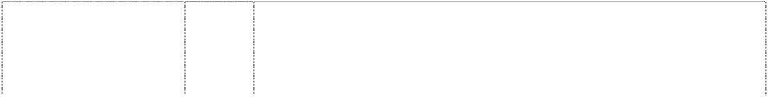

octopus, pirate, dinosaur & dog, all cartoon

(1073353)

# WIGGLES WORLD

octopus, pirate, dinosaur & dog, all cartoon

(1073353)

# WIGGLES WORLD

octopus, pirate, dinosaur & dog, all cartoon

(1073353)

# WIGGLES WORLD

octopus, pirate, dinosaur & dog, all cartoon

(1073353) **WIGGLEWORKS** (677727) **WIGGLEWORKS** (677728) **WIGGLY** (866098)

# WIGGLY

(866098)

1. Butter, chocolate nut butter, peanut butter, coconut, potato crisps, potato chips, snack foods, crystallized fruits, dates, eggs, salted foods, frosted fruits, frozen fruits, preserved fruit, cooked fruit, dried fruit, fruit jellies, jelly, fruit peel, fruit pulp, fruit salads, stewed fruit, jams, vegetable juices, margarine, marmalade, broth, milk, milk products, cheese, yoghurt, whipped cream, nuts, raisins, salmon, soups, vegetable salads, cooked vegetables, dried vegetables, preserved vegetables, almonds, anchovy, beans, coconut butter, caviar, coconut oil, desiccated coconut, dairy products, edible oils, eggs, fish, food preserves, herbs, gelatine, gherkins, cream, ham, herrings, sardines, lentils, meat jellies, mushrooms, mussels, olive oil, olives, preserved onions, oil, processed peanuts, peas, pickles, poultry, raisins, salads, salmon, sesame oil, soup, suet, soya beans, sunflower oil, tomato juice, fruit juice, tuna, vegetable juices, baked beans.
2. Biscuits, bread, buns, cakes, cake powder, breakfast cereal, chewing gum, chocolate, chocolate based beverages, confectionery, cookies, decorations for cakes (edible), edible ices, ginger, ice cream, liquorice, lozenges, meat pies, noodles, pastries, sweets, pizzas, popcorn and health bars in this class being cereal-based snack foods; spreads in this class for sandwiches, cornflakes, muesli, oat flakes, oat-based food, pasta, pasta in sauce, spaghetti, canned spaghetti in sauce, peanut confectionery, snack foods, puddings, rice, bread rolls, rusks, sherbet, almond confectionery, aniseed, barley, cocoa-based beverages, beverage flavourings, ice cream flavourings, candy, caramels, cereal preparations, spices, coffee, coffee substitutes, condiments, sauces, corn, farinaceous foods, flavourings, flour for food, gingerbread, glucose, golden syrup, gum, sweets, honey, ices, tomato sauce, macaroni, maize, malt, marzipan, mint, mustard, oatmeal, pancakes, pancake mix, pastries, pralines, ravioli, vermicelli, sago, sandwiches, seasonings, semolina, sugar, sugar confectionery, natural sweeteners, candy sweeteners, tapioca, tarts, tea, vanilla flavour, waffles, yeast.
3. Fresh fruits and vegetables.
4. Aerated water, non alcoholic beverages, fruit juices, ginger beer, lemonades, mineral water, effervescing beverages, preparations for making beverages, sherbets (beverages), soft drinks, syrups for beverages, syrups for lemonades, waters (beverages).

9 Software products; video and audio products in this class; cassettes and CD-Roms.

16 Books, manuals, other publications and printed matter in this class.

9 Computer software programs, compact discs, audio cassettes, phonograph records, digital video discs (DVD) and prerecorded videotapes featuring entertainment for children, namely, music, stories, costumed characters and animation; pre-recorded audio and audio visual devices; pre-recorded multimedia publications; videotapes featuring animated cartoons; blank digital audio tapes and digital videotapes; computer and video game disks and cartridges; eyewear, namely, spectacles, eyeglasses, sunglasses and eyeglass frames; binoculars; kaleidoscopes; juke boxes; lifejackets; audio recorders, video recorders; sound amplifiers; audio tape cassette players, video cassette players, phonograph record players, compact disc players; radios; television sets.

20 Decorative refrigerator magnets.

# WIGGLY SAFARI

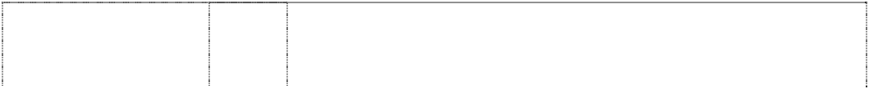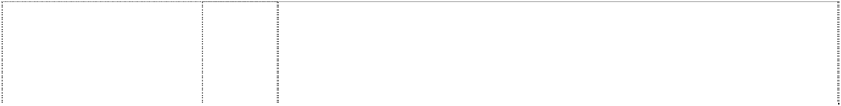

(907335)

dinosaur,spotted, styl,wearing hat,skipping (607889)

dinosaur,spotted, styl,wearing hat,skipping (607890)

dinosaur,spotted, styl,wearing hat,skipping (607891)

dinosaur,spotted, styl,wearing hat,skipping (667707)

cartoon dinosaur wearing hat & carrying flower

(737347)

cartoon dinosaur,wears hat,holds flower,waving (743843)

cartoon dinosaur,wears hat,holds flower,waving (743843)

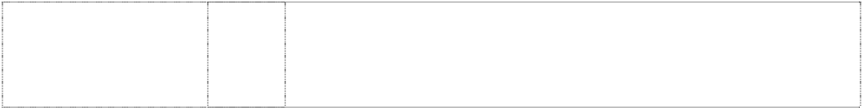cartoon dinosaur,wears hat,holds flower,waving (743843)

9 Computer software programs, compact discs, audio cassettes, phonograph records, digital video discs (DVD) and prerecorded videotapes featuring entertainment for children, namely, music, stories, costumed characters and animation; pre-recorded audio and audio visual devices; pre-recorded multimedia publications; videotapes featuring animated cartoons; blank digital audio tapes and digital videotapes; computer and video game disks and cartridges; eyewear, namely, spectacles, eyeglasses, sunglasses and eyeglass frames; binoculars; juke boxes; lifejackets; audio recorders, video recorders; sound amplifiers; audio tape cassette players, video cassette players, phonograph record players, compact disc players; radios; television sets.

16 All goods in class 16.

25 All goods in class 25 including T-shirts, baseball caps, pyjamas, sweatshirts, tracksuits, nightwear, babywear, bibs, (not of paper), underwear, socks, ties, bowties, scarves, hankerchiefs, knitwear, shoes, swimsuits, uniforms, sports apparel.

28 All goods in class 28 including toys, masks, swimming pools, surfboards, spinning tops, soft toys, dolls, games, board games, kites, puppets, balloons, bon bons, decorations for Christmas trees and dolls' houses.

9 Computer software, computer programmes, compact discs, cassettes, records, video tapes, CD Roms, spectacles, eyewear, sunglasses, spectacle cases, spectacle frames, binoculars, animated cartoons, films, juke boxes, kaleidoscopes, lifejackets, magnetic tapes, magnets, sound recording apparatuses, sound recording disks, sound recording, amplifying, reproducing and transmitting apparatuses, tapes, teaching apparatuses, television apparatuses, video recorders, video games, digital audio tapes and digital video tapes.

12 Baby carriages, covers for baby carriages, hoods for baby carriages, safety seats for children for vehicles, safety seat covers for children for vehicles, safety belts for the seats and carriages for vehicles, pushchairs and strollers, pushchair covers and hoods, stroller covers and hoods, bicycles, bicycle saddles, bicycle brakes, bicycle chains, bicycle frames, bicycle handle bars, bicycle pumps, bicycle rims, bicycle spokes, bicycle stands, bicycle tyres, bells for bicycles, boats, cars, automobiles, horns for cars and automobiles, horns for tricycles and bicycles, seat covers for cars and automobiles, tricycles and sleeping berths for vehicles, rearview mirrors.

11 Lamp shades.

14 Alarm clocks, bracelets, brooches, cases for clocks, cases for watches, chains, jewellery charms, tie clips, clocks, electric clocks and watches, liquid crystal display watches, moulded flip top liquid crystal display watches, quartz analogue watches, earrings, gold and silverware (other than cutlery, forks and spoons), hat ornaments of precious metal, household containers of precious metal, household utensils of precious metal, objects of imitation gold, jewellery, keyrings, cufflinks, medallions, necklaces, ornamental pins, ornaments, pins, tie pins, plated articles, rings, stopwatches, straps for wristwatches, trinkets, watchbands, watch chains, watch straps, watches and wrist watches.

21 Food containers of metal, household containers of metal, dishes of metal, egg cups of metal, jugs of metal, kitchen containers of metal, kitchen utensils of metal, bowls of metal, table plates of metal, trays of metal for household purposes.

cartoon dinosaur,wears hat,holds flower,waving (743843)

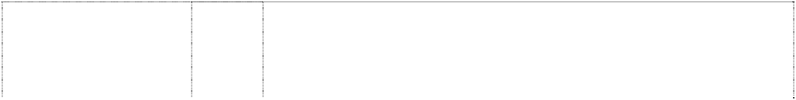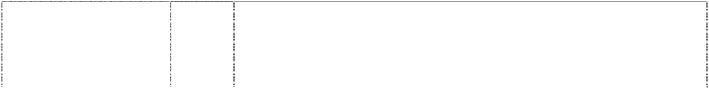

cartoon dinosaur,wears hat,holds flower,waving (743843)

cartoon dinosaur,wears hat,holds flower,waving (743843)

dinosaur,cartoon wears hat with rose; roses around head (1550517)

dinosaur,spotted, styl,wearing hat,skipping (746261)

24 Adhesive fabric for application by heat, banners, covers for bags filled with polystyrene beads, bed linen (except clothing), bed blankets, bed clothes, bed covers, bed covers of paper, bedspreads, blinds of textile, canvas for tapestry or embroidery, coasters made of table linen, cotton fabrics, coverlets for bedspreads, comforter sets, covers for cushions, covers for furniture, curtains of textile or plastic, down filled blankets, door curtains, eiderdowns, fabric, fabrics for textile use, facewashers, floor mats of terry towelling and textile material, friezes, loose covers for furniture, furniture coverings of plastic, furniture coverings of textile, gummed cloths other than for stationery, handkerchiefs of textile, handtowels, jersey, knitted fabric, cloth labels, diapered linen, household linen, linen cloth, lingerie fabric, placemats in this class, mattress covers, mattress protectors, pillow shams, pillow cases, plastic material (substitute for fabrics), blankets of textile, quilts, quilt covers, quilt cover sets, travelling rugs, table runners, serviettes of textile, rod pocket curtains, rugs, sheets, sleeping bags (sheeting), sunshades for affixing to windows, tablecloths (not of paper), table linen (textile), tablemats (not of paper), table napkins of textile, tapestry (wall hangings) of textile, towels, traced cloth for embroidery, upholstery fabrics, valances, velour bath towels, velour beach towels, velour towels, wall hangings of textile, woollen cloth, woollen fabric.

1. Badges for wear of metal, buckles of common metal for clothing.
2. Floor mats of textile, wool and nylon

9 Computer software programs, compact discs, audio cassettes, phonograph records, digital video discs (DVD) and pre-recorded videotapes featuring entertainment for children, namely, music, stories, costumed characters and animation; pre-recorded audio and audio visual devices; pre-recorded multimedia publications; videotapes featuring animated cartoons; blank digital audio tapes and digital videotapes; computer and video game disks and cartridges; eyewear, namely, spectacles, eyeglasses, sunglasses and eyeglass frames; binoculars; juke boxes; lifejackets; audio recorders, video recorders; video games; sound amplifiers; audio tape cassette players, video cassette players, phonograph record players, compact disc players; radios; television sets; swim masks and diving masks.

29 Butter, chocolate nut butter, peanut butter, coconut, potato crisps, potato chips (hot), snack foods, crystallised fruits, dates, eggs, salted foods, frosted fruits, frozen fruits, preserved fruit, cooked fruit, dried fruit, fruit jellies, jelly, fruit peel, fruit pulp, fruit salads, stewed fruit, jams, vegetable juices, margarine, marmalade, broth, milk, milk products, cheese, yoghurt, nuts, raisins, salmon, soups, vegetable salads, cooked vegetables, dried vegetables, preserved vegetables, almonds, anchovy, beans, coconut butter, caviar, coconut oil, dessicated coconut, dairy products, edible oils, fish, food preserves, herbs, gelatine, gherkins, cream, ham, herrings, sardines, lentils, meat jellies, meat in this class, hamburger meats and patties, sausages, frankfurts in batter, frankfurts including frankfurts for hot dogs, mushrooms, mussels, olive oil, olives, preserved onions, sauerkraut, cooking oil, processed peanuts, peas, pickles, poultry, game, chicken and chicken products in this class, salads, sesame oil, suet, soya beans, sunflower oil, tuna, baked beans, whipped cream.

dinosaur,spotted, styl,wearing hat holds rose & waves (744654)

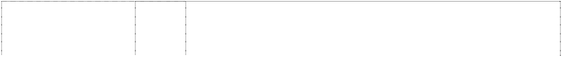

dinosaur,spotted, styl,wearing hat,skipping (676241)

dinosaur,spotted, styl,wearing hat,skipping (720129)

dinosaur,spotted, styl,wearing hat,skipping (720129)

dinosaur,spotted, styl,wearing hat,skipping (712750)

dinosaur,spotted, styl,wearing hat,skipping (712750)

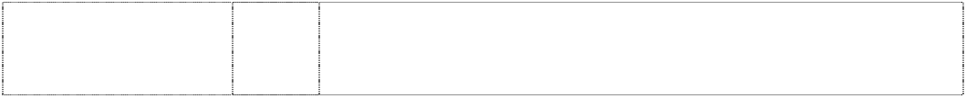dinosaur,spotted, styl,wearing hat,skipping (712750)

dinosaur,spotted, styl,wearing hat,skipping (712750)

9 Abacuses, amusement machines, animated cartoons; anti-dazzle shades; anti-glare visors, apparatuses for editing cinematographic film, apparatus for games (adapted for use with TV receivers only), audio-visual teaching apparatuses (automatic and coin operated); automatic, mechanical and coin operated rides in this class; binoculars; cameras, cassette players, compact disc players, compasses, computer games, computer keyboards; computers; contact lenses; digital audiotapes, digital videotapes; divers' masks; eyeshades; eyewear; films (exposed); floating aids for bathing and swimming; integrated circuit chips, jukeboxes (musical), jukeboxes (for computers); kaleidoscopes, lanterns (magic); life belts, life jackets; life saving apparatuses and equipment; magnetic discs; magnetic tapes; magnets; magnifying glasses; microphones; microscopes; modems; pocket calculators; protective helmets; radios; recorded computer programmes; recording discs; rulers; safety restraints; spectacle cases, spectacle chains, spectacle cords, spectacle frames, spectacle glasses, sunglasses; swimming belts, swimming jackets; tape recorders; teaching apparatuses; telescopes; video game cartridges; video games; viewfinders (photographic).

3 Bath salts, bubble bath, skin care preparations, cosmetics, creams, deodorants, cologne, hair colourants, hair dyes, lotions in this class, hair waving preparations, lipsticks, make-up, cosmetic kits, nail polish, essential oils, perfume, shampoos, shoe polish, soaps, toiletries, sun tanning preparations in this class, sun screen in this class, sun screen lip balm in this class, talcum powder, toothpaste; all the aforesaid being primarily for children.

3 Soaps, bath salts, oils, cosmetics, cleaning preparations, creams, deodorants, detergents, perfume, make-up, bleach, lipsticks, nail polish, bubble bath and toothpaste.

5 Food for babies and children, adhesive dressings and materials, sticking plaster, bath salts, medicated candy, chewing gum, medicated confectionery, medicinal drinks, first aid boxes, food preparations in this class and medicated toothpaste.

8 Cutlery, scissors, knives, forks, spoons, garden tools and spades, hanging knife, spoon and fork set.

18 Bags, game bags, bags for campers, bags for climbers, bags for packaging, beach bags, belts in this class, briefcases, leather cases, pocket wallets, purses, chain metal purses (not of precious metal), collars for animals, covers for animals, handbags, haversacks, music cases, rucksacks, school satchels, school bags, shopping bags, sling bags for carrying infants, travelling bags, travelling trunks, umbrellas.

1. Playpens, sleeping bags, statuettes of wood, wax, plaster or plastic, tables, chairs, stools, furniture, trays (not of metal), desks.
2. Cups, mugs, bowls, plates, dinner sets, canteens, lunch boxes, tumblers, drinking containers, basins, bins, bottles, soap boxes, brushes, combs, crockery, soap dishes, dustbins, egg cups, drinking flasks, money boxes, tableware and toothbrushes, vinyl placemats.

dinosaur,spotted, styl,wearing hat,skipping (676243)

dinosaur,spotted, styl,wearing hat,skipping (676242)

dinosaur,spotted, styl,wearing hat,waving (745356)

dinosaur,spotted, wearing hat, flower,waving (741564)

*shape and colour trade mark:*

dinosaur tail (782468)

*shape trade mark:* toy sword (877978)

*shape trade mark:* toy sword (877979)

30 Biscuits, bread, buns, cakes, breakfast cereal, chewing gum, chocolate, chocolate based beverages, confectionery, cookies, decorations for cakes (edible), edible ices, ginger, ice cream, liquorice, lozenges, meat pies, noodles, pastries, sweets, pizzas, popcorn and health bars in this class being cereal based snack foods; spreads in this class for sandwiches, cornflakes, muesli, oat flakes, oat-based food, pasta, pasta in sauce, spaghetti, canned spaghetti in sauce, peanut confectionery, snack foods, puddings, bread rolls, rusks, sherbet, almond confectionery, aniseed, barley, cocoa-based beverages, beverage flavourings, ice cream flavourings, candy, caramels, cereal preparations, sauces, corn, farinaceous foods, flavourings, gingerbread, glucose, golden syrup, gum, sweets, honey, ices, tomato sauce, malt, marzipan, mint, oatmeal, pancakes, pancake mix, pastries, pralines, sago, sandwiches, semolina, sugar, sugar confectionery, natural sweeteners, candy sweeteners, tapioca, tarts, vanilla flavour, waffles, whipped cream.

32 Aerated water, non alcoholic beverages, fruit juices, ginger beer, lemonades, mineral water, effervescing beverages, preparations for making beverages, sherbets (beverages), soft drinks, syrups for beverages, syrups for lemonades, waters (beverages).

30 Biscuits, bread, buns, cakes, cake powder, breakfast cereal, chewing gum, chocolate, chocolate based beverages, confectionery, cookies, decorations for cakes (edible), edible ices, ginger, ice cream, liquorice, lozenges, meat pies, noodles, pastries, sweets, pizzas, popcorn and health bars in this class being cereal-based snack foods; spreads in this class for sandwiches, cornflakes, muesli, oat flakes, oat-based food, pasta, pasta in sauce, spaghetti, canned spaghetti in sauce, peanut confectionery, snack foods, puddings, rice, bread rolls, rusks, sherbet, almond confectionery, aniseed, barley, cocoa-based beverages, beverage flavourings, ice cream flavourings, candy, caramels, cereal preparations, spices, coffee, coffee substitutes, condiments, sauces, corn, farinaceous foods, flavourings, flour for food, gingerbread, glucose, golden syrup, gum, sweets, honey, ices, tomato sauce, macaroni, maize, malt, marzipan, mint, mustard, oatmeal, pancakes, pancake mix, pastries, pralines, ravioli, vermicelli, sago, sandwiches, seasonings, semolina, sugar, sugar confectionery, natural sweeteners, candy sweeteners, tapioca, tarts, tea, vanilla flavour, waffles, whipped cream, yeast.

5 Sunscreen, sunscreen lip balm in this class, absorbent cotton, adhesive bands for medical purposes, adhesive plaster, adhesive tapes for medical purposes, antiseptics, balms for medical purposes, bandages for dressings, therapeutic preparations for the bath, medicated bath preparations, bath salts for medical purposes, cod liver oil, deodorants in this class, dietetic foods in this class, medical dressings, surgical dressings, gauze for dressings, lip balms in this class, lotions for pharmaceutical purposes, oils in this class, pharmaceutical preparations for skincare, sponges, stick liquorice for pharmaceutical purposes, sticking plasters, glucose, glucose drinks, sunburn ointments, sunburn preparations, tissues, vitamins.

28 Toys and playthings being a stuffed toy tail.

**The trade mark consists of the three dimensional shape and colours of a stuffed toy tail, the colours being green and yellow as depicted in the picture register**

28 Toys and playthings including stuffed toys.

**The trade mark consists of the three dimensional shape of toy sword as depicted in the picture register**

28 Toys and playthings including toys made of feathers or feather-like material.

**The trade mark consists of the three dimensional shape of toy sword as depicted in the picture register**

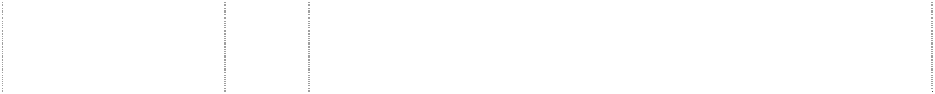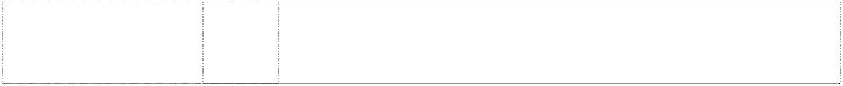

***Williamson-Dickie Manufacturing Company Spruson & Ferguson***

***Ph: (02) 9393 0300***

***Effective Date: 26 September 2007 File Reference: C07/12343 Trade Marks Class Goods***

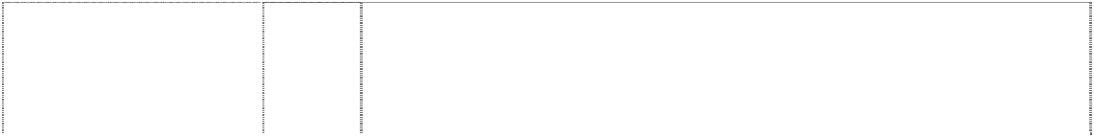

# A LEGEND IN WORK

(1005313)

# A LEGEND IN WORK

(1005313)

# D DICKIES

horseshoe is ltr D in oval, halved broken by p/gram

(488659)

# D DICKIES DICKIES AUSTRALIAN WORKER OF THE YEAR

horseshoe is ltr D in oval broken by p/gram (964197)

# D DICKIES DICKIES WORKER OF THE YEAR

horseshoe is ltr D in oval broken by p/gram (964159)

# D DICKIES GIRL

horseshoe is ltr D in oval broken by p/gram, rounded-corners (952569)

# D DICKIES GIRL

horseshoe is ltr D in oval broken by p/gram, rounded-corners (952569)

# DICKIES GIRL

(952564)

# DICKIES GIRL

(952564)

18 Bags, backpacks, school bags, tote bags, purses, wallets, and belts.

25 Clothing, footwear and headgear for men, women and children.

25 Men's and boys' trousers, jeans, shirts, coveralls, overalls, jackets and shorts; none of the foregoing being made out of towelling.

25 Clothing, headgear and footwear; non of the foregoing being shave coats, dressing gowns, bathrobes or goods made out of towelling.

25 Clothing, headgear and footwear; none of the foregoing being shave coats, dressing gowns, bathrobes or goods made out of towelling.

18 Goods made from leather and imitations of leather; belts, wallets, purses; bags including tote bags, school bags, book bags and back packs.

25 Clothing and apparel for girls and women, including long and short sleeved T-shirts, tops, baseball-style tops, tank tops, shirts, sweatshirts, sweaters, jackets, bib-overalls, short-alls, shirt-alls, skirts, dresses, pants, jeans and slacks, excluding dressing gowns, bathrobes and clothing made from towelling; headgear including hats and caps; footwear.

18 Goods made from leather and imitations of leather; belts, wallets, purses; bags including tote bags, school bags, book bags and back packs.

25 Clothing and apparel for girls and women, including long and short sleeved T-shirts, tops, baseball-style tops, tank tops, shirts, sweatshirts, sweaters, jackets, bib-overalls, short-alls, skirt-alls, skirts, dresses, pants, jeans and slacks, excluding dressing gowns, bathrobes and clothing made from towelling; headgear including hats and caps; footwear.

**ADDITIONAL TRADE MARKS**

***Décor Corporation Pty Ltd, The Allens Arthur Robinson Ph: (03) 9614 1011***

***Effective Date: 9 May 2007 File Reference: C06/06525***

# Trade Marks Class Goods



**DECOR STYLE**

(1156341)

# DECOR STYLE

(1156341)

# DECOR STYLE

(1156341)

8 Cutlery being knives, forks and spoons; scrapers, vegetable cutters; can openers, being of metal but not of precious metal; hand tools and instruments; shredders.

21 Domestic and/or household utensils and containers (not of precious metal or coated therewith), including: ice pails, insulated ice pails, containers for food and/or beverages, cups, beakers, mugs and other drinking vessels, jugs, jars, bottles, bottle stands and cradles, drink carriers, bowls, basins, dishes, ice cube trays, plates, saucers, trays, strainers, colanders, scoops, spice sets, table utensils and kitchen utensils, bottle openers, chopsticks, graters, servers and other table utensils, domestic ware and kitchen utensils, goblets, mugs, the aforesaid goods being wholly or principally of plastics material and/or of metal, including stainless steel; flowerpots included in this class, saucers in this class for use with flowerpots, hanging baskets in this class for use with plants, and planters of all types included in this class; lunch boxes; beverage bottles; bottles in this class; portable cold boxes and bags; insulated and insulating containers for domestic use; insulated bags containing chiller bottles; picnicware, including picnic baskets.

24 Table cloths, table mats, table linen, table napkins.

***British American Tobacco Australasia Limited Davies Collison Cave***

***Ph: (02) 9293 1000***

***Effective Date: 12 September 2007 File Reference: C07/06042***

# Trade Marks Class Goods



**CAPTAIN BLACK AMBER COAST** (116679) **CAPTAIN BLACK CHERISE** (1137958) **CAPTAIN BLACK CINNABAR SEA** (1116680)

34 Cigarettes, cigars, cigarillos, pipe tobacco, roll-your-own tobacco, tobacco and tobacco products, tobacco pipes, lighters, matches and smokers’ requisites.

34 Cigarettes, tobacco, tobacco products, smokers’ articles, lighters, matches, cigars, pipe tobacco, roll your own tobacco.

34 Cigarettes, cigars, cigarillos, pipe tobacco, roll-your-own tobacco, tobacco and tobacco products, tobacco pipes, lighters, matches and smokers’ requisites.

***HIT Entertainment Limited Shelston IP***

***Ph: (02) 9777 1111***

***Effective Date: 11 December 2007 File Reference: C07/21020***

# Trade Marks Class Goods

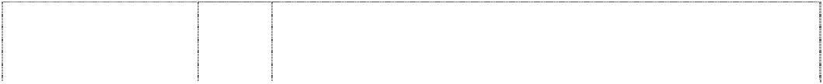

**THOMAS & FRIENDS**

words in cloud (1184328)

# THOMAS & FRIENDS



words in cloud (1184328)

18 Bags, athletic bags, school bags, duffle bags, beach bags, diaper bags, coin purses, fanny packs, key cases, vanity cases sold empty, suitcases, handbags, umbrellas, back packs, luggage, tote bags, synthetic fabric lunch bags, wallets.

1. Sleeping bags, pillows, cake decorating kits consisting of plastic cake decorations, toy boxes, drinking straws.

# THOMAS & FRIENDS

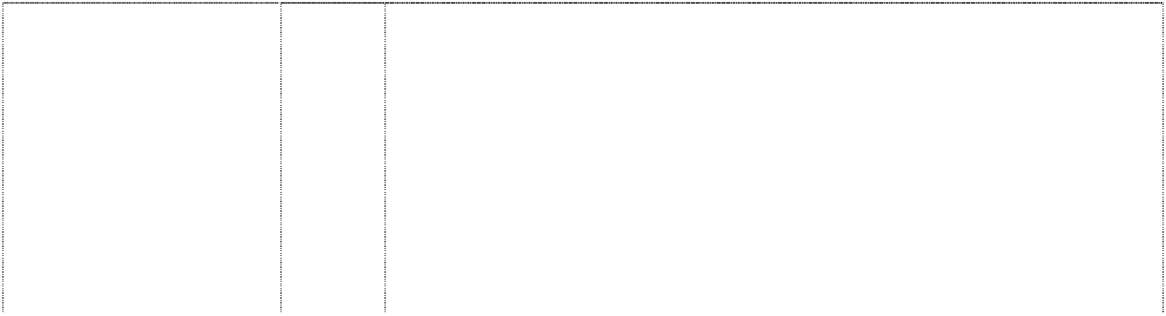

words in cloud (1184328)

# THOMAS & FRIENDS

words in cloud (1184328)

# THOMAS & FRIENDS

words in cloud (1184328)

# THOMAS & FRIENDS

words in cloud (1184328)

1. Household and kitchen utensils and containers (not of precious metal or coated therewith); glassware, porcelain, earthenware (included in this class); bowls, cups and plates; bottles, glasses, lunch boxes, thermal insulated containers for food or beverage, infant cups; bathroom accessories, namely, tooth brushes, wastebaskets, holders for facial tissues, holders for tooth brushes and pump-bottle dispensers for liquid soap or similar household products; money boxes, metal cake pans, cookie cutters; hair brushes, hair combs.
2. Candied fruit snacks, jams, jellies, fruit jellies; nuts; pickles; milk and milk products; yogurt, cheese; preserved, dried, cooked and canned fruits and vegetables; edible oils and fats; fruit toppings; salads except macaroni, rice and pasta salad; fish, meat, poultry and game; meat extracts; beans; peanut butter; potato chips; food products made from fish; potato crisps; raisins; soups; apple sauce.
3. Sugar, rice, tapioca, sago, artificial coffee; flour and preparations made from cereals; bread; treacle; salt; mustard; vinegar; sauces; spices; ginger bread; golden syrup; tea, coffee, cocoa, beverages with cocoa and chocolate base; breakfast cereals, cereal bars, muesli, cornflakes, processed cereals; pastries and confectioneries, chocolate, candies, candy bars, biscuits, cookies, cakes, crackers, rusks; chocolate syrups and chocolate toppings; ice cream and frozen confections, frozen yoghurt; honey; mash mallows; snack mix consisting primarily of crackers, pretzels, nuts and /or popped popcorn; ketchup; pasta; mayonnaise; pies; pancakes; pizzas; ravioli; sandwiches; ice; fruit sauces; salad dressings.

32 Mineral and aerated waters and other non-alcoholic drinks; fruit drinks and fruit juices; frozen drink concentrates; sweetened powdered drink mixes.

***Wrangler Apparel Corp. Phillips Ormonde Fitzpatrick Ph: (03) 9614 1944***

***Effective Date: 12 November 2007 File Reference: C07/09652***

Perfumes, colognes and fragrances for the body; air fragrances; essential oils; toiletries, cosmetics, beauty products; personal care products for the hair, body, face or nails; deodorants and anti- perspirants, powders for the body, face and hands; soaps; hair and skin care care preparations; dentifrices.

3

**WRANGLER**

(1157889)

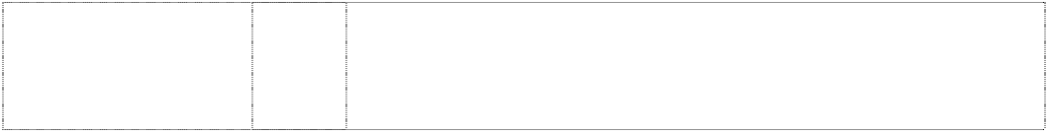

**Trade Marks**

**Class Goods**