Australian Government

**Australian Customs and Border Protection Service**

**AUSTRALIAN CUSTOMS AND BORDER PROTECTION NOTICE NO. 2012/47**

**Customs (Prohibited Imports) Amendment Regulation 2012 (No. 2) Changes to Weapons Import Requirements and Regulation 4F Definitions**

New regulations in place from 21 August 2012 introduce minor amendments to the Customs *(Prohibited Imports) Regulations 1956* (the Regulations) regarding the legitimate end-users for some weapons items.

The change does not affect Customs and Border Protection 's current intervention activity at the border-the same range of weapons are still subject to import controls. However, the regulation amendment expands the legitimate users for body armour and extendable batons within the 'specified person test' to include licensed retailers for sale to licensed end-users.

The definitions of *firearm* accessory , *firearm magazine* and *firearm part* within 4F to the Regulations have also been amended to clarify the current operation of the controls on these items. The amendment confirms that these goods will continue to be controlled *' whether or not complete, damaged , temporarily or permanently inoperable or unfinished ' .* The change does not affect Customs and Border Protection 's current intervention activity at the border but clarifies the existing controls on these items.

Further information about the changes, including fact sheets, can be found on the Firearms and Weapons page on the Customs and Border Protection website.

Inquiries concerning this notice may be directed to [weaponspolicy@custom s.gov.au](mailto:weaponspolicy@customs.gov.au) or Supervisor Firearms & Weapons on telephone number (02) 6245 5478 or fax number (02) 6275 6699.

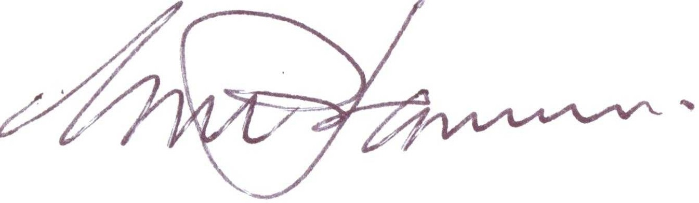

Geoff Johannes National Manager

Trade Policy & Implementation Branch CANBERRA ACT

*dS/* August2012