......,,_1-,l .- =

**Australian Government**

* 1-t' **Australian Customs and**

**Border Protection Service**

**AUSTRALIAN CUSTOMS AND BORDER PROTECTION NOTICE NO. 2013/02**

**New Military End Use Law**

The Australian Government has recently introduced new measures to strengthen Australia's export controls.

New section 112BA of the *Customs Act 1901* (the Act) provides the Minister for Defence with a power to prohibit the export of otherwise non-regulated goods that may contribute to a military end-use that may prejudice Australia's security, defence or international relations.

In the context of this new law, goods are or may be for a military end-use if they are or may be for use in operations, exercises or other activities conducted by an armed force or an armed group, whether or not the armed force or armed group forms part of the armed forces of the government of a foreign country. An armed force or armed group may include, but is not limited to:

* + Military or Defence Forces;
  + Police forces;
  + Coast guard;
  + Militant or insurgent groups;
  + Private security companies; and
  + Terrorist or criminal organisations.

Where the Minister for Defence suspects that a particular good, if exported, would or may be for a military end-use contrary to Australia's security and/or national interest, then the Minister may issue a notice to prohibit the export. A prohibition notice will remain in force for up to 12 months, unless revoked by the Minister.

Contravention of a prohibition notice is an offence and attracts a maximum penalty of 10 years imprisonment or 2,500 penalty units, or both.

The military end-use law complements measures introduced in the *Defence Trade Controls Act 2012,* which also addresses other export control matters including brokering, providing of services and intangible technology transfers.

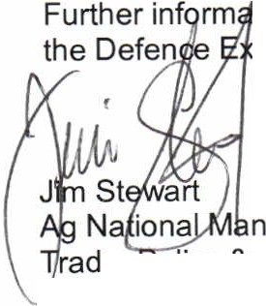tion on this new law can be found at [www.defence.gov.au/deco](http://www.defence.gov.au/deco) or by contacting port Control Office on [deco@defence.gov.au](mailto:deco@defence.gov.au) or 1800 66 10 66.

ager

e, Implementation Branch

*J* January 2013

