Australian Government

**Australian Customs and Border Protection Service**

**AUSTRALIAN CUSTOMS AND BORDER PROTECTION NOTICE NO: 2013 /04**

**Update to ACN 2012/71 - Repeal of regulation 9AAA - export of bulk wheat**

Australian Customs Notice 2012/71, of 10 December 2012 advised that the export of bulk wheat will no longer be controlled under regulation 9AAA of the *Customs (Prohibited Export) Regulations 1958,* resulting from passing of the *Wheat Export Marketing Amendments Act 2012.* Requirements for Port Terminal Operator exporters of bulk wheat will be administered by the Department of Agriculture, Fisheries and Forestry (DAFF) and continuous disclosure compliance will be monitored by the Australian Competition and Consumer Commission **(ACCC).**

The information contained in ACN 2012/71 is correct, however, this notice is to clarify that whilst the requirement to produce a Wheat Export Australia (WEA) Permit, is no longer necessary when exporting bulk wheat, there are other DAFF-Biosecurity permit or regulatory requirements that still apply. All existing permit and regulatory requirements must still be met before exporting wheat from Australia .

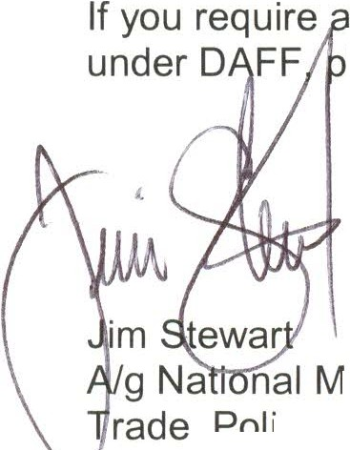ny further information relating to the existing permit and regulatory requirements lease refer to the DAFF website at [www.daff.gov.au.](http://www.daff.gov.au/)

anager

, cy and Implantation Branch

**1 1** January 2013