•

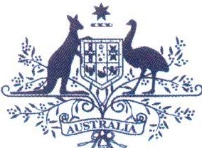**Australian Government**

**Australian Customs and Border Protection Service**

# AUSTRALIAN CUSTOMS NOTICE NO. 2013/28

**REPEAL OF CONTROLS ON XYLITOL AND OIL OF WORMWOOD FROM SCHEDULE 8 TO THE**

# CUSTOMS (PROHIBITED IMPORTS) REGULATIONS 1956

Regulation SH of *the Customs (Prohibited Imports) Regulations 1956* (PI Regulations) has been amended to remove item 12A of Schedule 8 (*oil of wormwood and preparations containingoil of wormwood),* and item 17 of Schedule 8 *(xylitol and preparations containing xylitol).*

Xylitol is typically used in small quantities as an artificial sweetener in products such as confectionery and chewing gum. Oil of wormwood is an essential oil containing thujone and santonin and is found in products such as absinth. These substances do not have a potential safety risk unless consumed at high doses.

Importers must comply with requirements under the *Australian and New Zealand Food Standards Code* and the *Therapeutic Goods Act 1989* to import products containing these substances. Imported food is monitored under the *Imported Food Inspection Scheme* to ensure food imports meet the *Australia New Zealand Food Standards Code.* Therapeutic goods are assessed by the *Therapeutic Goods Administration* and must be registered on the *Australian Register of Therapeutic Goods* before they can be supplied in Australia .

The amendment aligns the legislation with current policy and enforcement activities and removes the administrative burden on importers to satisfy requirements imposed by multiple agencies without compromising the safety of the Australian public.

A minor consequential amendment was also made to the *Customs Regulations 1926* to remove *oil of wormwood and preparations containing oil of wormwood,* and *xylitol and preparations containing xylitol* from the post import permission regime.

The amending Regulations came into effect on 13 July 2013.

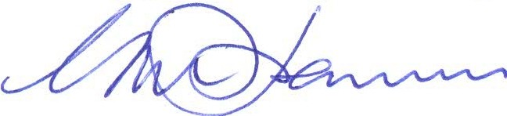Enquiries regarding this notice should be directed via email to [community.protection@customs.gov.au](mailto:community.protection@customs.gov.au) or telephone (02) 6275 6114.

Geoff Johannes National Manager

Trade, Policy and Implementation CANBERRA ACT

-<L- July 2013