# Australian Government

**Australian Customs and Border Protection Service**

# AUSTRALIAN CUSTOMS AND BORDER PROTECTION NOTICE NO. 2013/63

**Import Processing Charges Amendment Bill 2013**

The Import Processing Charges Amendment Bill 2013 was recently introduced into Parliament. This Bill will amend the *Import Processing Charges Act 2001* to increase the import processing charges that will be levied on air, sea and post consignments with a value of $10,000 or more from 1 January 2014. If this Bill is passed through both Houses of Parliament in the current sitting period, the new charges come into effect on 1 January 2014. The new charges will introduce a two tiered charging arrangement with increased charges applying for air, sea and post consignments valued at $10,000 or more. The charging arrangements that will apply from

1 January 2014, should the legislation be passed, are as follows;

* for all consignments valued at more than $1,000 but less than $10,000, the current rates of import processing charges will continue to apply;
* for sea consignments lodged electronically with a value of $10,000 or more, the import processing charge will increase from $50.00 to $152.60;
* for sea consignments lodged manually with a value of $10,000 or more, the import processing charge will increase from $65.75 to $152.60;
* for air and post consignments lodged electronically with a value of $10,000 or more, the import processing charge will increase from $40.20 to $122.10; and
* for air and post consignments lodged manually with a value of $10,000 or more, the import processing charge will increase from $48.85 to $122.10.

There will continue to be no import processing charge for consignments valued at

$1,000 or less.

Inquiries concerning this notice may be directed to Customs Information and Support Centre at [cargosupport@customs.gov.au.](mailto:cargosupport@customs.gov.au)

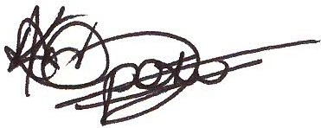

Naa Opoku

Acting National Manager Customs Branch

Trade and Customs Division 1 December 2013