**UNCLASSIFIED**

Australian Government

**Australian Customs and Border Protection Service**

**AUSTRALIAN CUSTOMS AND BORDER PROTECTION NOTICE NO. 2014/17**

**Update on the classification of devices commonly known as laser pointers**

In July 2008 an import control on the importation of high powered hand held goods, commonly known as laser pointers, with an accessible emission level greater than 1 mW was introduced . This control is currently captured in Schedule 13 of the *Customs (Prohibited Imports) Regulations 1956* (the Regulations).

The control captured items such as standard laser pointers and laser pens. Additional devices have also been captured under the control such as laser sights, laser medical devices and other laser devices able to be used in a similar manner to a pointer.

A review of the scope of the control has determined that the following items are not commonly known as laser pointers, and are not subject to the control within Schedule 13 to the Regulations:

* Laser sights (excluding those for use with items of warfare)
* Laser bore sighters
* Medical lasers (excluding those same in appearance to a laser pointer or pen)
* Surveying and construction lasers, such as laser levellers
* Laser guns (excluding those captured as firearms or imitation firearms)
* Laser range finders

Lasers devices that are captured under the control include the following:

* Laser pens
* Laser pointers, including large scale laser pointers such as the Arctic, Lunar, Krypton and Inferno style laser pointers and similar items
* Flashlights or torches with a laser pointer incorporated
* Other laser devices with the appearance of a standard laser pointer or laser pen

Permission to import is required for all laser devices commonly known as laser pointers as described above.

Inquiries concerning this notice may be directed to Weapons & Strategic Goods via email at [fwp@customs.gov.au](mailto:fwp@customs.gov.au) or on telephone number (02) 6245 5478 or fax number (02) 6275 6699.

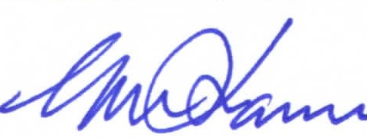

Geoff Johannes National Manager Trade Branch CANBERRA ACT

**J** April 2014

**UNCLASSIFIED**