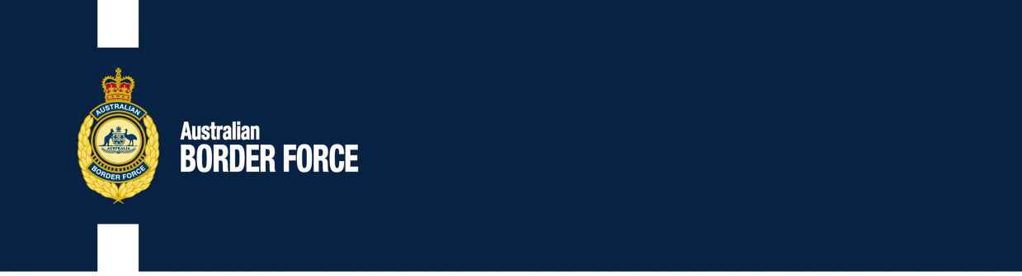Australian Customs Notice No. 2019/35

Application for Customs Broker Licences

The following individuals and companies have applied to the Comptroller-General of Customs for a customs broker licence:

|  |  |  |
| --- | --- | --- |
| **INDIVIDUALS:** | **COMPANY:** | **COMPANY:** |
| Danny Drewett | Cargo-Partner Logistics | World Customs Consultants |
| David Moschos | ABN 57 632 655 835 | ABN 79 608 140 825 |
| Luke Perer  Mila Turson | Unit 5, 99-101 Western Avenue | Level 4, 17-19 Bridge Street |
| Quenton Walsh | Tullamarine VIC 3043 | Sydney NSW 2000 |
| Thomas Whitfield Raymond Williams | Trading Name | Trading Name |
| Stephen Wilson | Cargo-Partner Logistics Pty Ltd | World Customs Consultants Pty Ltd |
|  | Person in Authority Murat Gumus  Nominee Broker John Chambers | Person in Authority Russell Wilkinson Maree Wilkinson  Nominee Broker Russell Wilkinson |

Any person wishing to make written representation in respect of any of these applicants should address the correspondence, by 18 October 2019, to:

Broker Licensing

Australian Border Force Or email:

5 Constitution Avenue [brokers.licensing@abf.gov.au](mailto:brokers.licensing@abf.gov.au) CANBERRA ACT 2601

Principles of procedural fairness in respect of information that is potentially adverse to the applicant will be applied and if information is received that is considered credible, relevant and significant, the applicant will be made aware of the substance of the representation and given the opportunity to respond to the representation.

[SIGNED]

Auneesh Kishore

A/g Director, Customs Licensing

Trusted Trader and Trade Services Branch | Customs Group Australian Border Force

CANBERRA ACT

2 October 2019