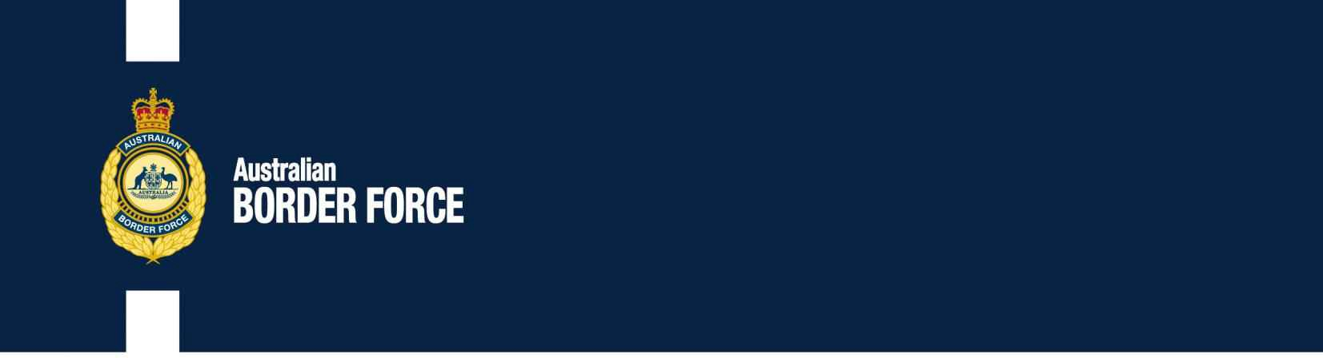Australian Customs Notice No. 2019/43

Kava and Prohibited Substances changes to the Prohibited Exports and Imports Regulations

On 17 December 2019 the *Customs (Prohibited Imports) (Kava) Approval 2019* (the Approval), and the *Customs Legislation Amendment (Prohibited Exports and Imports) Regulations 2019* (the Amendment) will come into effect.

# The Approval – Kava – Personal Importation Pilot

The Approval eases the restrictions on the importation of kava by increasing the quantity of kava that may be imported for personal use from 2 kilograms to 4 kilograms.

From 17 December 2019 the Approval enables the personal importation into Australia of kava that is in root or dried form, or in the form of a beverage obtained by aqueous suspension of kava root in cold water only, by passengers aged over 18 years who have arrived in Australia by ship or aircraft and have imported the kava in their accompanied personal effects.

# The Amendment – Prohibited Substances

Australia is a signatory to the United Nations Commission on Narcotic Drugs for the *Single Convention on Narcotic Drugs of 1961*, as amended by the *1972 Protocol,* the *Convention on Psychotropic Substances of 1971* and the *United Nations Convention against Illicit Traffic in Narcotic Drugs and Psychotropic Substances 1988* (the Narcotic Conventions).

The amendments set out in the table below will ensure Australia’s continuing compliance with the Narcotic Conventions by adding the newly scheduled substances to the *Customs (Prohibited Exports) Regulations 1958* (the Prohibited Exports Regulations) and the *Customs (Prohibited Imports) Regulations 1956* (the Prohibited Imports Regulations). This will minimise diversion and misuse of these substances.

## The Prohibited Exports Regulations – Schedule 8 (Drugs)

|  |  |  |
| --- | --- | --- |
| **Substance** | **Part** | **Item Number** |
| Cyclopropylfentanyl | Part 1 | 27C |
| Methoxyacetylfentanyl | Part 1 | 64A |
| Orthofluorofentanyl | Part 1 | 88B |
| Parafluorobutyrylfentanyl | Part 1 | 90A |

***Australia’s customs service***

|  |  |  |
| --- | --- | --- |
| **Substance** | **Part** | **Item Number** |
| ADB-CHMINACA - otherwise known as MAB-CHMINACA | Part 2 | 1AB |
| ADB-FUBINACA | Part 2 | 1AC |
| CUMYL-4CN-BINACA | Part 2 | 6A |
| N-ethylnorpentylone otherwise known as ephylone | Part 2 | 12AAA |
| FUB-AMB - otherwise known as MMB-FUBINACA or AMB-FUBINACA | Part 2 | 13AC |
| Alpha-phenylacetoacetamide - otherwise known as APAA | Part 3 | 1AA |
| 3,4-MDP-2-P methyl glycidate - otherwise known as PMK glycidate | Part 3 | 17A |
| 3,4-MDP-2-P methyl glycidic acid - otherwise known as PMK glycidic | Part 3 | 17B |
| acid |  |  |

## The Prohibited Imports Regulations – Schedule 4 (Drugs)

|  |  |
| --- | --- |
| **Substance** | **Item Number** |
| ADB-CHMINACA (otherwise known as MAB-CHMINACA | 4D |
| ADB-FUBINACA | 4E |
| Alpha-phenylacetoacetamide - otherwise known as APAA | 11AA |
| CUMYL-4CN-BINACA | 49FA |
| Cyclopropylfentanyl | 49H |
| N-ethylnorpentylone - otherwise known as ephylone | 87AA |
| FUB-AMB - otherwise known as MMB-FUBINACA or AMB-FUBINACA | 97DA |
| 3,4-MDP-2-P methyl glycidate - otherwise known as PMK glycidate | 127A |
| 3,4-MDP-2-P methyl glycidic acid - otherwise known as PMK glycidic acid | 127B |
| Methoxyacetylfentanyl | 139AB |
| Orthofluorofentanyl | 173B |
| Parafluorobutyrylfentanyl | 177A |
| Thalidomide* | 224A |

* Domestically, Australia has rescheduled thalidomide and preparations containing thalidomide from Schedule 8 of the Prohibited Imports Regulations to Schedule 4 of the Prohibited Imports Regulations to enable travellers who legitimately use thalidomide under prescription to enter Australia without having to obtain import permission under regulation 5.

# Repealed provisions - Prohibited Imports Regulations

## Regulation 5A (Importation of antibiotic substances*)

This will reduce regulatory burden on importers and delays for shortages or for time critical patients. The border control is no longer considered necessary as part of the National Antimicrobial Research Strategy 2015-2019.

Antibiotics

**Reason**

**Substance**

* Regulation 5F (Reason for refusal to be given) is also repealed as consequential to the repeal of regulation 5A.

**Schedule 8 (Goods the importation of which is prohibited if permission is not granted under regulation 5G)**

|  |  |  |
| --- | --- | --- |
| **Good** | **Item Number** | **Reason** |
| Advertising matter (including booklets, pamphlets, leaflets and circulars) relating to preparations, instruments, appliances, and other goods, that purport to be for therapeutic purposes and containing any statements or claims that are misleading, false or extravagant. | 2 | Reference to these products is unnecessary as the advertising provisions in the *Therapeutic Goods Act 1989* address these matters. |
| Preparations of food, drink and oral medication for human consumption containing glycol or a derivative of a glycol other than propylene glycol | component of Item 10 | Reference to glycol or a derivative of a glycol other than propylene glycol is no longer required for monitoring purposes. |
| Preparations that purport to be a remedy for drunkenness, alcoholic habit or drug habit. | 13 | The item is antiquated and does not align with modern prescription only medicines to treat these disorders. It will also reduce the regulatory burden on prescription only medicines. |
| Thalidomide and preparations containing thalidomide | 15 | Moved to Schedule 4. |

# Further information

For further information regarding these changes, please consult the legislation directly, including the explanatory statement:

* + The Amendment (https://[www.legislation.gov.au/Details/F2019L01615)](http://www.legislation.gov.au/Details/F2019L01615))
  + The Approval (https://[www.legislation.gov.au/Details/F2019L01616)](http://www.legislation.gov.au/Details/F2019L01616))

For more information on exporting or importing drugs from/to Australia, please see: https://[www.abf.gov.au/importing-exporting-and-manufacturing/prohibited-goods.](http://www.abf.gov.au/importing-exporting-and-manufacturing/prohibited-goods)

[Signed]

Matthew Duckworth Assistant Secretary

Customs and Border Revenue Branch Customs Group

16 December 2019