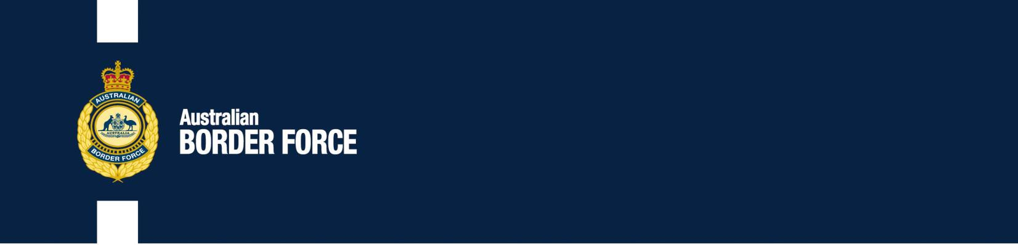Australian Customs Notice No. 2020/09

Working Days and Hours

The *Customs Act 1901* (the Act) and the *Customs Regulation 2015* (the Regulation) prescribe the days and times that Australian Border Force (ABF) officers must be available to undertake specified border clearance functions in each State and Territory.

Prescribed border clearance functions, operating times and locations

ABF officers must be available 24 hours/ day, 7 days/ week in each State and Territory to:

* Board and clear aircraft and examine passengers baggage at international airports1
* Examine ship's passengers' baggage at a seaport or wharf appointed under the Customs Act.

ABF Officers must be available Monday - Friday 8:00am to 4:30pm in the Northern Territory; and Monday - Friday 8:30am to 5:00pm in all other States and Territories to:

* Perform any other function for the purposes of the Customs Acts at an appointed or licensed airport, seaport, wharf, boarding station, Customs depot or warehouse, or international mail gateway.

No hours are prescribed to perform border clearance functions at other places, such as at an airport or port which has not been appointed under the Customs Act.

Providing border clearance functions outside of prescribed times and locations

The Act provides that upon request, officers may be made available to perform border clearance functions outside of the hours prescribed above. In these situations, an **overtime fee** and **travel expenses** are payable by the person requesting the service. The overtime fee is always payable for any attendance at a place which is not appointed or licensed under the Act.

The current rate for **overtime** is $43.35 per hour.

**Travel expenses** include the cost of travel by taxi, motor vehicle, bus, aircraft, boat, or train plus an accommodation allowance paid to an officer by the Commonwealth.2

1 Defined as Adelaide, Brisbane, Cairns, Coolangatta, Darwin, Hobart, Melbourne, Perth, Sunshine Coast (Maroochydore), Sydney and Townsville airports.

2 Prescribed travel expenses are 58c per km for travel by motor vehicle; the bus, aircraft, boat, or train fare; 110% of the taxi fare if Cabcharge is used; plus any accommodation allowance paid to the officer.

1

***Australia's customs service***

The Act also provides that requests may be made for border clearance functions to be provided at a place at which such functions are not normally performed, during the hours prescribed for that function. In such cases, a **location fee** and **travel expenses** are payable by the person requesting the service.

The current **location fee** is $40.10 per hour.

**Travel expenses** include the cost of travel by taxi, motor vehicle bus, aircraft, boat, or train plus an accommodation allowance paid to an officer by the Commonwealth (refer footnote #2).

Request for border clearance functions outside of prescribed times and locations

Where a request has been made, and has been approved, for border clearance functions to be performed outside of prescribed operating times and / or at places where border clearance functions are not normally performed, the approval advice will include an estimate of the fees payable for the functions to be performed.

Alice Stanley Assistant Secretary Traveller Branch Customs Group

27 February 2020

| 2