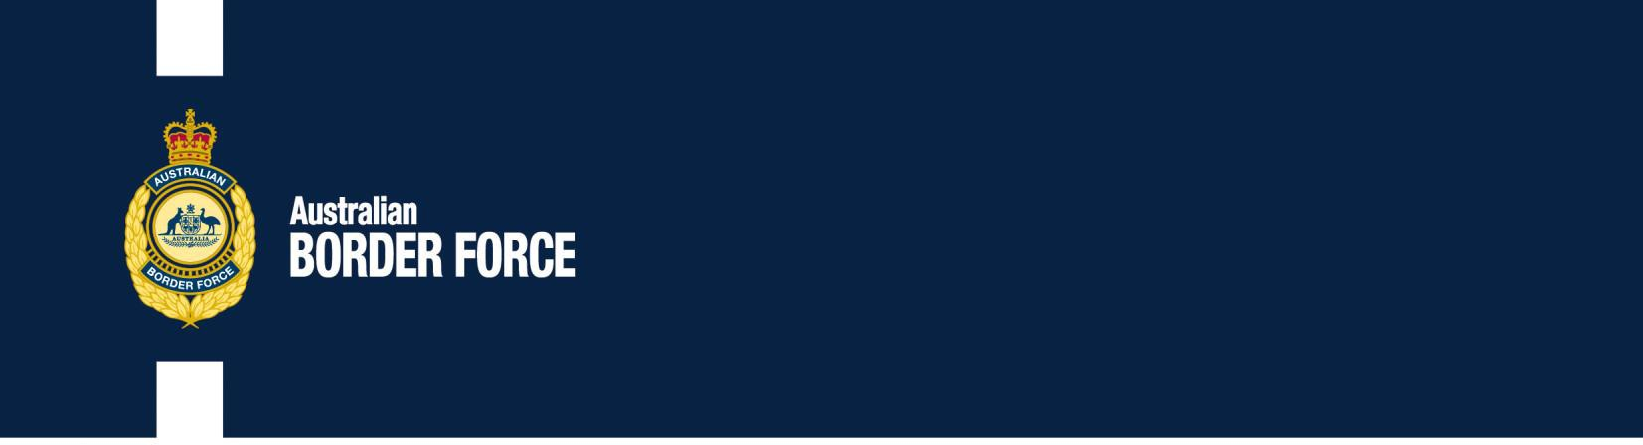Australian Customs Notice No. 2020/23

Chemical Weapons – Amendments to the

*Customs (Prohibited Imports) Regulations 1956*

From 7 June 2020, Part 2 of Schedule 11 of the *Customs (Prohibited Imports) Regulations 1956* (the Regulations) has been amended to prohibit from import four new toxic chemicals that can be used as chemical warfare agents. The chemicals are known as ‘Novichok’ nerve agents.

# ‘Novichok’ nerve agents

In November 2019, the ‘Novichok’ nerve agents were added to the *Convention on the Prohibition of the Development, Production, Stockpiling and Use of Chemical Weapons and on their Destruction* (the CWC). In accordance with Australia’s obligations under the CWC, listed chemicals are prohibited from import into Australia by Regulation 5J. This amendment aligns the Regulations and the CWC.

The prohibited ‘Novichok’ nerve agents are described by chemical compound or group of compounds, and the CAS number in Part 2 of Schedule 11 of the Regulations. Please consult the relevant legislation for details, at https://[www.legislation.gov.au/Details/F2020L00637.](http://www.legislation.gov.au/Details/F2020L00637)

# Permission to import

The import of chemicals listed in Part 2 of Schedule 11 of the Regulations from countries not party to the Convention is prohibited absolutely. Import from a country that is a party to the Convention is prohibited unless the Minister for Foreign Affairs or an authorised person has given permission.

For further information, please consult the Australian Safeguards and Non-proliferation Office (ASNO). More information is available at https://[www.dfat.gov.au/international-](http://www.dfat.gov.au/international-) relations/security/asno/Pages/australian-safeguards-and-non-proliferation-office-asno.

[Signed]

Matthew Duckworth Assistant Secretary Customs and Trade Policy

2 June 2020

***Australia’s customs service***